**UNIT – I**

**IRRIGATION ENGINEERING :** Benefits and ill effects of irrigation – Methods of irrigation – Quality of irrigation water – Duty and Delta – Irrigation efficiencies – Irrigation water requirements – Assessment of Irrigation water - Crop Seasons – Principle crops – Rotation of crops.

**UNIT – II**

**CANALS :** Classification of canals – Canal alignment – Kennedy’s and Lacey’s theories – Design – Balancing depth – Effects, causes and prevention of water logging – Types of lining – Design of lined canals – Canal outlets – Falls – CD works.

**UNIT – III**

**DIVERSION HEAD WORKS:** Location of diversion head works – Components – Causes of failure of weirs and remedial measures – Bligh’s and Khosla’s theories of design of weirs and permeable foundation.

**UNIT – IV**

**STORAGE HEAD WORKS:** Types of dams – Site selection and Reservoir Planning – Forces acting on and causes of failure of a gravity dam – Elementary and practical profiles – Stability analysis – Single and multiple step methods of design – Grouting – Multipurpose projects.

**UNIT – V**

**SPILLWAYS :** Requirements, components and types of spillways – Design principles of ogee spillway – Methods of energy dissipation below spillways – effect of TWC and JHC – Scour protection below spillways Stilling basins and appurtenances – Hydraulic design of energy dissipaters.

**UNIT – I**

**IRRIGATION ENGINEERING**

Benefits and ill effects of irrigation – Methods of irrigation – Quality of irrigation water – Duty and Delta – Irrigation efficiencies – Irrigation water requirements – Assessment of Irrigation water - Crop Seasons – Principle crops – Rotation of crops.

Objective:

1. **DEFINITION:**

Plants are living beings and do require water and air for their survival, as do human beings require. Their requirement of water varies with their type. Different types of plants, require different quantities of water, and at different times, till they grow up completely. Water is normally supplied to these plants by nature through direct rain or through the flood waters of rivers which inundate large land areas during floods. The flood water may saturate the land before the flood is subsided. The water absorbed by the land during floods, supplements the water requirement of the crop during dry season. These natural processes, whereby, the water is supplied to the crops for their growth, are dependent upon 'nature' or 'God', whatever we may call it. Sometimes, there may be very heavy rains creating serious floods and damaging the crops, and sometimes, there may not be any rains at all, creating scarcity of water for the crops. Thus, famine and scarcity conditions are created. In his bid to control the nature, man discovered various methods by which the water can be stored during the periods of excess rainfall. and to use that stored water during periods of 'less rainfall' or 'no rainfall'. ***The art or the science by which It is accomplished, is generally, termed, as irrigation. Irrigation may, therefore, be defined as the science of artificial application of water to the land, in accordance with the 'crop requirements' throughout the 'crop period' for full-fledged nourishment of the crops.***

1. **NECESSITY OF IRRIGATION IN INDIA:**

India is a. tropical country with a vast diversity of climate, topography and vegetation. Rainfall in India, varies considerably in its place of occurrence, as well as in its amount. Even at a particular place, the rainfall is highly erratic and irregular, as it occurs only during a few particular months of the year. Crops cannot, therefore, be raised successfully, over the entire land, without providing artificial irrigation of fields. More than seventy percent of our population directly depends on agriculture, and the remaining depends indirectly on agriculture: Out of a-total-geographical-area-of about-328 million hectares, about 184 million hectares is the cultivable area. In order to save this area from the complete wishes and vagaries of nature, and to ensure full growth of crops, it is necessary to provide adequate artificial irrigation facilities. In order to achieve this, the Indian Government is trying hard and spending enormously to provide irrigation facilities for the entire cultivable land.

1. **BENEFITS OF IRRIGATION**:

Every irrigation project is designed, keeping in view of its economics, i.e. the expenditure likely to be incurred and the benefit likely to occur. There is a capital investment on the project and the future recurring charges for maintenance and opera-tion. The project estimate is generally sanctioned when the benefit gives at least about 8% interest on the capital outlay. Sometimes, unproductive projects are also sanctioned in view of their general public benefits. There is hardly any point in emphasizing the importance and advantages of irrigation during the times of acute food shortages and growing population of our country. Even then, some of the advantages of irrigation are summarised below:

**(1)** ***Increase in Food Production.*** Irrigation helps in increasing crop yields, and hence, to attain self-sufficiency in food.

***(2) Optimum Benefits.*** Optimum utilization of water is made possible by irrigation. By optimum utilisation, we generally mean, obtaining maximum crop yield with required amount of water. In other words, yield will be smaller for any quantity lesser than or in excess of this optimum quantity.

***(3) Elimination of Mixed Cropping.*** In the areas, where irrigation is not assured, generally mixed cropping is adopted. By mixed cropping, we mean, sowing together of two or more crops in the same field. If the weather conditions are not favorable to one of the crops, they may be better suitable for the other; and thus, the farmer may get at least some yield. Mixed cropping, is thus, found necessary and also economical when irrigation facilities are lacking, and especially during periods of Crash programmes in under-developed countries. But if irrigation is assured, mixed cropping can be eliminated.

Mixed cropping is generally not acceptable, because different crops require different types of field preparations and different types of waterings, manurings, etc. If two crops are mixed together, the field preparations, waterings, manurings, etc. cannot be made to suit the special needs of either. Moreover, during the time of harvesting, the crops get intermixed with each other, reducing the purity of each other. But, when regular and permanent water supply is assured, a single superior crop can be sown, depending upon the conditions of the soil and the needs of the country.

***(4) General Prosperity.*** Revenue returns with well-developed irrigation, is sometimes, quite high, and helps in all round development of the country and prosperity of the entire nation and community.

***(5) Generation of Hydro-electric power.*** Cheaper power generation can be obtained from-water development projects, primarily designed for irrigation alone. Canal outlets from dams and Canal falls on irrigation canals can be used for power generation. For example, Ganga and Sarda Canals, constructed for irrigation, are now generating hydro-electric power as a side product, up to about 80,000 kilo-watts.

***(6) Domestic Water Supply.*** Development of irrigation facilities in an area helps in augmenting the water supply in nearby villages and towns, where other sources of water are not available or are scarcely available. It also helps in providing drinking water for animals, and water for swimming, bathing, etc.

***(7) Facilities of Communications.*** Irrigation channels are generally provided with embankments and inspection roads. These inspection paths provide good roadways to the villagers for walking, cycling or sometimes even for motoring.

***(8) Inland Navigation.*** Sometimes, larger irrigation canals can be used and developed for navigation purposes.

***(9) Afforestation.*** Trees are generally grown along the banks of the channels, which increase the timber wealth of the country and also help in reducing soil erosion and air polluition.

**4. ILL-EFFECTS OF IRRIGATION:**

(1) Irrigation may contribute in various ways to the problem of water pollution. One of these is the seepage into the ground water of the nitrates, that have been applied to the soil as fertilizer. Sometimes, up to 50% of nitrates applied to the soil, sinks into the underground reservoir. The underground water may thus get ***polluted***, and if consumed by people through wells, etc., it is likely to ***cause diseases*** such as anemia. Whether it will ultimately affect the fishing on way to the sea, or as the tides carry the polluted water ahead into the ocean, is yet a matter of research.

(2) Irrigation may result in colder and ***damper climate***, resulting in **marshy lands** ***and breeding of mosquitoes, causing outbreak*** of diseases like malaria & dengu.

(3) Over-irrigation may lead to ***water-logging*** and may reduce crop yields.

(4) Procuring and supplying irrigation water is ***complex and expensive*** in itself. Sometimes, subsidised cheaper water has to be provided at the cost of the government, which ***reduces revenue returns***.

**5. TYPES OF IRRIGATIONS**

Irrigation may broadly be classified into :

1. Surface irrigation ; and

2. Sub-swface irrigation

**(1) Surface irrigation** can be further classified into : (a) Flow irrigation ; and (b) Lift irrigation.

When the water is available at a higher level, and it is supplied to lower level, by the mere action of gravity, then it is called Flow Irrigation. But, if the water is lifted up by some mechanical or manual means, such as by pumps, etc. and then supplied for irrigation, then it is called Lift Irrigation. Use of wells and tubewells for supplying irrigation water fall under this category of irrigation.

**(a) Flow irrigation** can be further sub-divided into : (i) Perennial irrigation, and (ii) Flood irrigation.

***(i) Perennial Irrigation.*** In perennial system of irrigation, constant and continuous water supply is assured to the crops in accordance with the requirements of the crop, throughout the 'crop period'. In this system of irrigation, water is supplied through storage canal head works and canal distribution system.

When irrigation is done from the direct runoff of a river, or by diverting the river runoff into some canal by constructing a diversion weir or a barrage across 'the river, it is called Direct Irrigation. Ganga Canal System is an example of this type of irrigation. But, if a dam is constructed across a river to store water during monsoons, so as to supply water in the off-taking channels during periods of low flow, then it is termed as Storage Irrigation. Ram-Ganga Dam project in U.P. is an example of storage type of irrigation system. In the regions of peninsula India, where rivers are generally seasonal, storage irrigation is an absolute necessity, whereas, in Indo-gangetic region, direct irrigation is feasible, since the rivers are perennial, getting their supplies from the melting of snow. Direct irrigation is always simple, easy and economical. The perennial system of irrigation, is most important and is mostly practiced in India.

***(ii) Flood Irrigation.*** This kind of irrigation, is sometimes called as inundation irrigation. In this method of irrigation, soil is kept submerged and thoroughly flooded with water, so as to cause thorough saturation of the land. The moisture soaked by the soil, when occasionally supplemented by natural rainfall or minor waterings, brings the crop to maturity.

**(2) Sub-surface Irrigation.** It is termed as sub-surface irrigation, because in this type of irrigation, water does not wet the soil surface. The underground water nourishes the plant roots by capillarity. It may be divided into the following two types :

(a) Natural sub-irrigation ; and

(b) Artificial sub-irrigation.

***(a) Natural sub-irrigation.*** Leakage water from channels, etc., goes underground, and during passage through the sub-soil, it may irrigate crops, sown on lower lands, by capillarity. Sometimes, leakage causes the water-table to rise up, which helps in irrigation of crops by capillarity. When underground irrigation is achieved, simply by natural processes, without any additional extra efforts, it is called natural sub-irrigation.

***(b) Artificial sub-irrigation.*** When a system of open jointed drains is artificially laid below the soil, so as to supply water to the crops by capillarity, then it is known as artificial sub-irrigation. It is a very costly process and hence, adopted in India on a very small scale. It may be recommended only in some special cases with favourable soil conditions and for cash crops of very high return. Sometimes, irrigation water may be intentionally collected in some ditches near the fields, the percolation water may then come up to the roots through capillarity.

**6. METHODS OF IRRIGATION or TECHNIQUES OF WATER DISTRIBUTION IN THE FARMS**

There are various. ways in which the irrigation water can be applied to the fields.

Their main classification is as follows:

(1) Free ﬂooding (2) Border ﬂooding

(3) Check ﬂooding (4) Basin ﬂooding

(5) Furrow irrigation methbd (6) Sprinkler irrigation method ’

(7) Drip irrigation method.

These methods are briefly discussed below”

1. **Free flooding or Ordinary flooding.** In this method, ditches are. Excavated in the field, and they may be either on the contour or up and down the slope. Water from these ditches ﬂows across the ﬁeld. After the water leaves the ditches, no attempt is made to control the flow by means of levees, etc. Since the movement of water is not restricted it is sometimes called wild ﬂooding. Although the initial cost of land preparation is low, labour requirements are usually high and ‘water application efficiency is also low.

Wild ﬂooding, is most suitable for close growing crops, pastures. etc., particularly where the land is steep. Contour ditches called laterals or subsidiary ditches, are generally spaced at about 20 to 50 metres apart, depending upon the slope, texture of soil, crops to be grown, etc. this method may be used on rolling land where boarders, checks, basins, and furrows are not feasible.

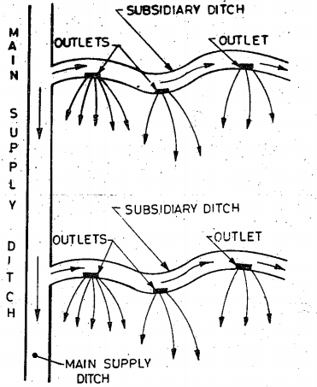

**Fig 1.1 Free** Flooding (aerial View)

1. **Border flooding.** In this method, the land is divided into a number of strips, separated by low levees called borders. The land areas confined in each strip is of the order of 10 to 20 metres in width, and 100 to 400 metres in length, as shown in Fig. 1.2. Ridges between borders should be sufficiently high to prevent overtopping during irrigation.

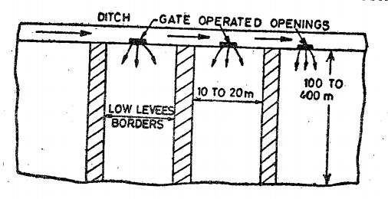

**Fig 1.2** Border flooding

To prevent water from concentrating on either side of the border, the land should be levelled perpendicular to the flow. Water is made to flow from the supply ditch into each strip. The water flows slowly towards the lower end, and infiltrates into the soil as it advances. When the advancing water reaches the lower end of the strip, the supply of water to the strip is turned off.

The supply ditch, also called irrigation stream, may either be in the form of an earthen channel or a lined channel or an underground concrete pipe having risers at intervals. The size of the supply ditch depends upon the infiltration rate of the soil, and the width of the border strip. Coarse textured soils with high infiltration rates will require high discharge rate and therefore larger-supply ditch, in order -to spread water over the entire strip rapidly, and to avoid excessive losses due to deep percolation at the upper reaches. On the other hand, fine textured soils with low infiltration rates, require smaller ditches to avoid excessive losses due to run off at the lower reaches.

A relationship between the discharge through the supply ditch (Q), the average depth of water flowing over the strip (y), the rate of infiltration of the soil (f), the area of the land irrigated (A), and the approximate time required to cover the f\given area with water (t), is given by the equation:

T = 2.3 $\frac{y}{f}$ $\log_{10}\left(\frac{Q}{Q-fA}\right)$

* *

Where Q = Discharge through the supply ditch

y = depth of water flowing over the boarder strip

f = rate of infiltration of soil

A = Area of land strip to be irrigated

T = time required to cover the given area A.

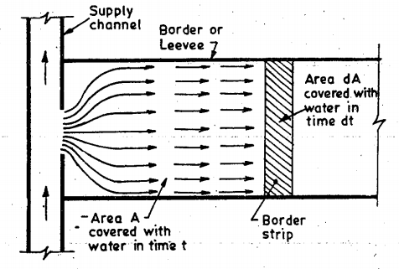

**Fig 1.3** Typical area for the application of the equation

1. **Check flooding:** Check flooding is similar to ordinary flooding except that the water is controlled by surrounding the check area with low and flat a\levees. Levees are generally constructed along the contours, having vertical interval of about 5 to 10 cm. these levees are connected with cross-levees at convenient places as shown n Fig. 1.4. the confined plot area varies from 0.2 to 0.8 hectare.

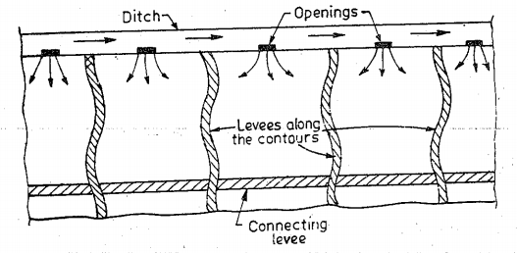

**Fig. 1.4.** Aerial view of the plot

In check flooding, the check is filled with water at a fairly high rate and allowed to stand until the water infiltrates.

This method is suitable for more permeable soils as well as for less permeable soils. The water can be quickly spread in case of high permeable soils, thus reducing the percolation losses. The water can also be held on the surface for & longer time in case of less permeable soils, for assuring adequate penetration. These checks, are sometimes used to absorb water, where the stream-flow is diverted during periods of high run off.

1. **Basin flooding.** This method is a special type of check flooding and is adopted specially for orchard trees. One or more trees are generally placed in the basin, and the surface is flooded as in check method, by ditch water, as shown in **Fig. 1.5.**

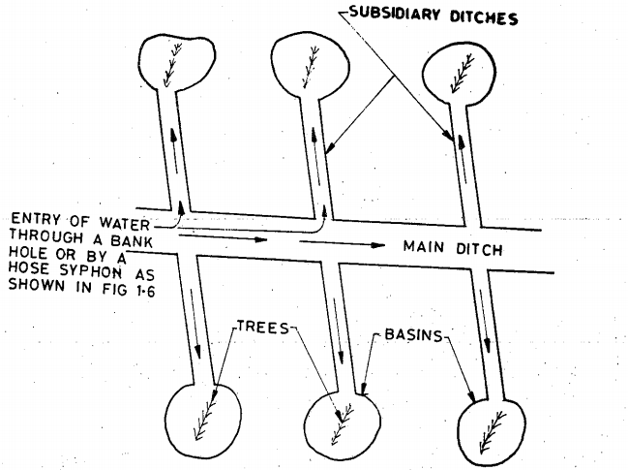

**Fig 1.5.** Aerial View of the plot

1. **Furrow irrigation method.** In flooding methods, described above, water covers the entire surface; while in furrow irrigation method (**Fig. 1.6**), only one fifth to one half of the land surface in wetted by water. It therefore, results in less evaporation, less pudding of soil, and permits cultivation sooner after irrigation. Furrows are narrow field ditches, excavated between rows of plants and carry irrigation water through them. Spacing of furrows is determined by the proper spacing of the plants. Furrows vary from 8 to 30 cm deep, and may be as much as 400 metres long.

Excessive long furrows may result in too much percolation near the upper end, and too little water near the down-slope end, Deep furrows are widely used for row crops. Small shallow furrows called corrugations, are particularly suitable for relatively irregular topography and close growing crops, such as meadows and small grains. Water may be diverted into the furrows by an opening in the bank of the supply ditch or preferably by using rubber hose tubing, which can be primed by immersion in the ditch. The use of hose prevents the necessity of breaking the ditch bank and provides a uniform flow into the furrow. **Fig. 1.7** shows such different devices which are used for distributing water into the fields from the supply ditch.

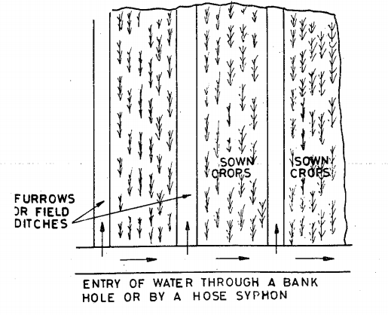

**Fig 1.6** Aerial view of the plot

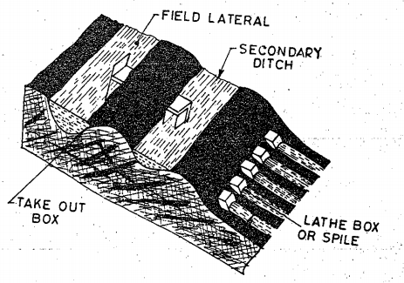

1. **Spiles or Lathe Box**

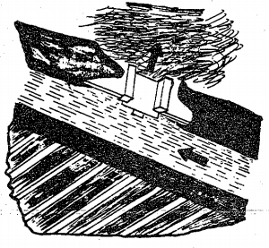 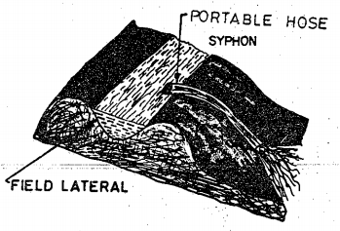

1. Plastic tube Syphons (c) Boarder take out

**Fig 1.7**: Different devices which are used for distributing water into the fields

**(6) Sprinkler irrigation method.** In this farm-water application method, water is applied to the soil in the form of a spray through a network of pipes and pumps. It is a kind of an artificial rain and, therefore, gives very good results. It is a costly process and widely used in U.S.A. It can be used for all types of soils and for widely different topographies and slopes. It can advantageously be used for many crops, because it fulfils the normal requirement of uniform distribution of water. This method possesses great potentialities for irrigating areas in Rajasthan in India, where other types of surface or sub-surface irrigation are very difficult. Inspite of the numerous advantages which this method possesses over the other methods, it has not become popular in India for the simple reason that ours is a poor and a developing nation. This method is not only costly but requires a lot of technicalities. The correct design and efficient operation are very important for the success of this method. Special steps have to be taken for preventing entry of silt and debris, which are very harmful for the sprinkler equipment. Debris-choke nozzles, interfere with the application of water on the land: while the abrasive action of slit causes excessive wear on pump impellers, sprinkler nozzles, and bearings. The system is to be designed in such a way that the entire sprayed water seeps into the soil, and there is no runoff from the irrigated area.

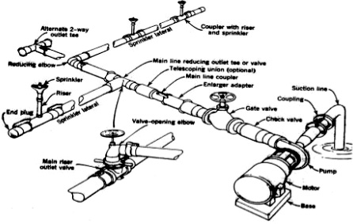

**Fig 1.8**: Components of Sprinkler Irrigation System

The **advantages of sprinkler irrigation** are enumerated below

(i) Seepage losses, which occur in earthen channels of surface irrigation methods, are completely eliminated. Moreover, only optimum quantity of water is used in this method.

(ii) Land levelling is not required, and thus avoiding removal of top fertile soil, as happens in other surface irrigation methods.

(iii) No cultivation area is lost for making ditches, as happens in surface irrigation methods. It, thus,.results in increasing about 16% of the cropped area.

(iv) In sprinkler system, the water is to be applied at a rate lesser than the infiltration capacity of the soil, and thus avoiding surface run off, and its bad effects, such as loss of water, washing of top soil, etc.

(v) Fertilisers can be uniformly applied, because they are mixed with irrigation water itself.

(vi) This method leaches down salts and prevents water-logging or salinity.

(vii) It is less labour oriented, and hence useful where labour is costly and scarce.

(viii) Upto 80% efficiency can be achieved, i.e. upto 80% of applied water can be stored in the root zone of plants.

The **limitations of sprinkler irrigation** are also enumerated below :

1. High winds may distort sprinkler pattern, causing non-uniform spreading of water on the crops.
2. In areas of high temperature and high wind velocity, considerable evaporation losses of water may take place.
3. They are not suited to crops requiring frequent and larger depths of irrigation. such as paddy.
4. Initial cost of the system is very high, and the system squires a high technical skill.
5. Only sand and silt free water can be used, as otherwise pump impellers lifting such waters will get damaged.
6. It requires larger electrical power.
7. Heavy soil with poor intake cannot be irrigated efficiently.
8. A constant water supply is needed for commercial use of equipment.

***Note.*** The widely known Indian Commercial Company which specialises in install-ing sprinkler irrigation systems, is "Premier Irrigation Equipments (Pvt. Ltd.), Calcutta." with its Delhi office also. This firm and its publications can be referred to, for specialised knowledge in this branch of field irrigation.

**(7) Drip Irrigation Method.** Drip irrigation, also called trickle irrigation, is the latest field irrigation technique, and is meant for adoption at places where there exists acute scarcity of irrigation water and other salt problems. In this method, water is slowly and directly applied to the root zone of the plants, thereby minimising the losses by evaporation and percolation.

This system involves laying of a system of head, mains, sub-mains, larerals, and drop nozzles. Water oozes out of these small drip nozzzles uniformly and at a very small rate, directly into the plant roots area.

The head consists of a pump to lift water, so as to produce the desired pressure of about 2.5 atmosphere, for ensuring proper flow of water through the system. The lifted irrigation water is passed through a fertiliser tank, so as to mix the fertiliser directly in the irrigation water, and then through a filter, so as to remove the suspended particles from the water, to avoid clogging of drip nozzles.

The mains and sub-mains are the specially designed small sized pipes, made of flexible material like black PVC. These are generally buried or laid on the ground. as shown in **Fig. 1.9.** Their sizes should be sufficient to carry the design discharge of the system.

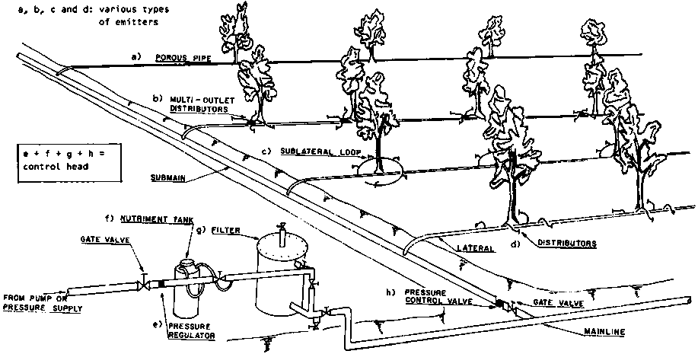

**Fig 1.9**: Layout and components of drip irrigation system

The laterals are very small sized (usually 1 to 1.25 cm dia.), specially designed. black PVC pipes, taking off from the mains or sub-mains, Laterals can usually be up to 50 m long, and one lateral line is laid for each row of crop. Hardie Biwall is a patented. name of a special dual chambered micro tubing, manufactured from a linear low density polyethylene, and is being used these days for laterals. The drip nozzles, also called emitters, or valves, are fixed on laterals, at regular intervals of about 0.5 to -1 m or so, discharging water at very small rates of the order of 2 to 10 litres per hour. Like the sprinkler system, this method also involves specialised knowledge, and is not being adopted by our ordinary farmers. This method, is however, being used for small nurseries, orchards, or gardcns. The widely known Commercial Indian Company, which specialises' in this field irrigation method, is known as "Jain Irrigation Systems Ltd., Jalgaon" (Post Box No. 20), Pin Code : 425001. This firm can be contacted in special needs-for layout of such an irrigation system.

**7. QUALITY OF IRRIGATION WATER**

Just as every water is not suitable for human beings, in the same may, every water is not suitable for plant life. Water containing impurities, which are injurious to plant growth, is not satisfactory for irrigation, and is called the unsatisfactory water.

The quality of suitable irrigation water is very much influenced by the constituents of the soil which is to be irrigated. Particular water may be harmful for irrigation on a particular soil, but the same water may be tolerable or even useful for irrigation on some other soil. The various types of impurities, which make the water unfit for irrigation, are classified as :

1. Sediment concentration in water.
2. Total concentration of soluble salts in, water.
3. Proportion of sodium ions to other.cations
4. Concentration of potentially toxic elements present in water.
5. Bicarbonate concentration as related to the concentration of calcium plus magnesium.
6. Bacterial contamination.

The effects of these impurities are discussed below:

1. **Sediment**: The effect of sediment present in the irrigation water depends upon the type of irrigated land. When fine sediment from water is deposited on sandy soils, the fertility is improved. On the other hand, if the sediment has been derived from the eroded areas, it may reduce the fertility or decrease the soil permeability. Sedimented water creates troubles in irrigation canals, as it increases their siltation and maintenance costs. In general, ground water or surface water from reservoirs, etc. does not have sufficient sediment to cause any serious problems in irrigation.
2. **Total concentration of soluble salts.** Salts of calcium, magnesium sodium and potassium, present in the irrigation water may prove injurious to plants. When present in excessive quantities, they reduce the osmotic activities of the plants, and may prevent adequate aeration, causing injuries to plant growth. The injurious effects of salts on the plant growth depend upon the concentration of salts left in the soil.

The concentration of salts in water, may not appear to be harmful to the plants, but the concentration of salts which remain in the soil after the saline water is used up by the plants is much more than the first, and may prove to be harmful. In other words, at the beginning of irrigation with undesirable water, no harm may be evident, but with the passage of time, the salt concentration in the soil may increase to a harmful level, as the soil solution gets concentrated by evaporation. Hence, the effects of salts on plant growth depend largely upon the total amount of salts present in the soil solution. The salinity concentration of the soil solution (Cs) after the consumptive water (Cu) has been extracted from the soil, is given by

Cs =

where, Q = the quantity of water required

Cu = Consumptive use of water, i.e. the total amount of water used by the plant for its growth

Peff = Useful rainfall

Cu-Peff = used up irrigation water

C = Concentration of slat in irrigation water

CQ = Total salt applied to soil with Q amount of irrigation water

The salt concentration is generally expressed by ppm or by mg/l, both units being equal. The critical salt concentration in the irrigation water depends upon many factors, yet however, amount in excess of 700 ppm are harmful to some plants, and more than 2000 ppm are injurious to all crops.

The salt concentration is generally measured by determining the electrical conductivity of water. They are directly proportional to each other. Electrical conductivity is expressed in micro mhos per centimetre. When its value is up to 250 micro mhos/cm at 25°C, it is called low conductivity water (CI) ; when its value is between 250 to 750, it is called Medium Conductivity water (C2) ; when its value is between 750 to 2250, it is called High Conductivity water (C3) : and the values above 2250, are classified as very High Conductivity water (C4). The suitabilities of these four types of waters for irrigation supplies are discussed in Table 1.1. This classification which is shown in Table 1.1 was given by U.S.D.A. Handbook No. 60 (1954).

**Table 1.1**

|  |  |  |
| --- | --- | --- |
| **S. No.** | **Type of water** | **Use in irrigation** |
| **1** | Low salinity water (**C1**). Conductivity between 100 to 250 micro mhos/cm at 25°. | Can be used for irrigation for almost all crops and Can be used for irrigation for almost all crops and may develop, which may require slight leaching: but it is permissible under normal irrigation practices except in soils of extremely low permeability’s. |
| **2** | Medium salinity water (**C2**). Conductivity between 250 to 750 micro mhos/cm at 25°C. | Can be used, if a moderate amount of leaching occurs. Normal salt-tolerant plains can be grown without much salinity control. |
| **3** | High salinity water (**C3**). Conductivity between 750 to 2250 micro mhos/cm at 25°C. | Cannot be used on soils with restricted drainage. Special precautions and measures are undertaken for salinity control and only high-salt tolerant plants can be grown. |
| **4** | Very high salinity water (**C4**). Conductivity more than 2250 micro mhos/cm at 25°C. | Generally not suitable for irrigation. |

**(3) Proportion of sodium ions to other cations.** Most of the soils contain calcium and magnesium ions and small quantities of sodium ions. The percentage of the sodhim ions is generally les; than 5% of the total exchangeable- cations:1f- this percentage increases to about 10% or more, the aggregation of soil grains breaks down. The soil becomes less permeable and of poorer filth. It starts crusting when dry and its pH increases towards that of an alkaline soil. High sodium soils are, therefore, plastic, sticky when wet, and are prone to form clods, and they crust on drying.

The proportion of sodium ions present in the soils, is generally measured by a factor called Sodium-Absorption Ratio (SAR) and represents the sodium hazards of water. SAR is defined as:

SAR = $\frac{{Na}^{+}}{\sqrt{\frac{{Ca}^{++}+{Mg}^{++}}{2}}}$

Where, the concentration of the ions is expressed in equivalent per million(epm); epm is obtained by dividing the concentration of slat in mg/l of ppm by its combining weight (i.e., Atomic wt. + Valence)

The suitabilities of different kinds of water for irrigation are discussed in **Table 1.2**

**Table 1.2**

|  |  |  |
| --- | --- | --- |
| **SNo.** | **Type of water** | **Use in irrigation** |
| **1** | Low sodium water (**S1** ). SAR value lying between 0 to 10. | Can be used for irrigation on almost all soils and for almost all crops except those which are highly sensitive to sodium, such as stone- fruit trees and adocados. etc. |
| **2** | Medium sodium water (**S2**). SAR value lying between 10 to 18. | Appreciably hazardous in fine textured soils, which may require gypsum. etc. : but may be used on course-textured or organic soils with good permeability. |
| **3** | High sodium water (**S3**). SAR value lying between 18 to 26. | May prove harmful on almost all the soils, and do require good drainage, high leaching, gypsum addition etc. for proper irrigation, |
| **4** | Very high sodium water **(S4**). SAR value above 26. | Generally, not suitable for irrigation |

Depending on the Electric Conductivity EC of water the exchangeable sodium percentage ESP, and the pH value of the soil, the soils are classified as saline, alkaline, or saline-alkali, as shown in **Table 1.3.**

**Table 1.3**

|  |  |  |  |  |
| --- | --- | --- | --- | --- |
| Sl. No. | Classification | Electrical Conductivity (EC) in vitro-mho/cm | Exchangeable Sodium Percentage (ESP) Percentage (ESP) | value |
| 1. | Saline soil or white alkali | > 4000 | < 15 | ≤ 8.5 |
| 2. | Alkaline soil or Non-saline alkali or Sadie soil or Black alkali | <4000 | >15 | 8.5 to 10.0 |
| 3. | Saline-alkali soil | >4000 | >15 | < 8.5 |

**(4) Concentration of potentially toxic elements.** A large number of elements such as boron, selenium, etc. may be toxic to plants. Traces of Boron are essential to plant growth, but its concentrations above 0.3 ppm may prove toxic to certain plants. The concentration above 0.5 ppm is dangerous to nuts, citrus fruits and deciduous fruits. Cotton, Cereals and certain truck crops are moderately tolerant to boron, while Dates, Beets, Asparagus etc. are quite tolerant. Even for the most tolerant crops, the boron concentration should not exceed 4 ppm. Boron is generally present in various soaps. The waste water containing soap, etc. should, therefore, be used with great care in irrigation. Selenium, even in low concentration, is toxic, and must be avoided.

**(5) Bicarbonate concentration as related to concentration of calcium plus magneisum.** High concentration of bi-carbonate ions may result in precipitation of calcium and magnesium bicarbonates from the soil-solution, increasing the relative proportion of sodium ions and causing sodium hazards.

(**6) Bacterial contamination.** Bacterial contamination of irrigation water is not a serious problem, unless the crops irrigated with highly contaminated water are directly eaten, without being cooked. Cash crops like cotton, nursery stock, etc. which are processed after harvesting, can, therefore, use contaminated waste waters, without any trouble.

**PROBLEM**

1. **(a) What is the classification of irrigation water having the following characteristics: Concentration of Na, Ca and Mg are 22, 3 and 1.5 milli-equivalents per litre respectively, and the electrical conductivity is 200 micro mhos per cm at 25°C ? (b) What Problems might arise in using this water on fine textured soils ? (c) What remedies do you suggest to overcome this trouble .?**

**Sol**: SAR = 14.67

1. **If SAR is in between 10 to 18, then it is classified as medium sodium water and is represented by S2.**

Electric conductivity is 200 micro-mhos per cm at 25oC.

According to Table 1.1, the water is called of Low Conductivity (C1) if the value of EC is between 100 to 250 micro mhos per cm at 25oC. It is therefore C1 water.

Hence the given water is classified as C1-S2 water.

***(b) In fine-textured soils, the medium sodium (S2) water may create following problems:***

(i) Soil becomes less permeable.

(ii) It starts crusting when dry.

(iii) It becomes plastic and sticky when wet.

(iv) Its pH increases towards that of alkaline soil.

1. ***Gypsum addition, either to soil or to water is suggested to overcome sodium hazards posed by the given water.***

**8. WATER REUIRMENTS OF CROPS**

The term ***Water requirements of a crop'*** means the total quantity and the way in which a crop requires water, from the time it is sown to the time it is harvested. It is very clear from the above discussion, that the water requirement, will vary with the crop well as with as the place. In other words, different crops will have different water requirements. and the same crop may have different water requirements at different places the same country ; depending upon the variations in climates, type of soils, methods of cultivation, and useful rainfalls, etc.

**Crop period or Base Period**:

The time period that elapses from the instant of its sowing to the instant of its harvesting is called the crop-period. The time between the first watering of a crop at the time of its sowing to its last watering before harvesting is called the *Base period or the Base of the crop*. Crop period is slightly more than the base period, but for all practical purpose they are taken as one and the same thing, and generally expressed in days. Hence in future, the terms like *growth period, crop period, base period,* etc., will be used as synonyms, each representing crop period, and will be represented by B (in-days).

**Duty and Delta of a Crop**

***Delta.*** Each crop requires a certain amount of water after a certain fixed interval of time, throughout its period of growth. The depth of water required every time, generally varies from 5 to 10 cm depending upon the type of the crop, climate and soil. The time want between two such consecutive waterings is called the ***frequency of irrigation, or rotation period****.* The rotation period may vary between 6-15 days for different crops. The summation of the total water depth supplied during the base period of a crop, for its full growth, will evidently represent the total quantity of water required by the crop for its full-fledged nourishment. This total quantity of water required by the crop for its fill growth (maturity) may be expressed in hectare-metre (Acre-ft) or in million cubic metres (million cubic-ft) or simply as depth to which water would stand on the irrigated area, if the total quantity supplied were to stand above the surface without percolation or evaporation. This total depth of water (in cm) required by a crop to come to maturity is called its delta (∆).

**PROBLEM**

1. **If rice requires about 10 cm depth of water at an average interval of about 10 days, and the crop period for rice is 120 days, find out the delta for rice.**

***Solution.*** Water is required at an interval of 10 days for a period of 120 days. It evidently means that 12 no. of waterings are required, and each time, 10 cm depth of water is required. Therefore, total depth of water required

∆ = 12 * 10 cm = 120 cm.

1. **If wheat requires about 7.5cm of water after every 28 days, and the base priod for wheat is 140days, find out the value of delta for wheat.**

**Soultion.** Assuming the base period to be representing the crop period, as per usual practice, we can easily infer that the water is required at an average interval of 28days upto a total period of 140days. This means that 140/28 = 5 no.s of watering are required.

The depth of water required each time = 7.5 cm.

∴ Total depth of water reqd. in 140 days = 5 * 7 cm = 37.5 cm

Hence, ∆ for wheat = **37.5 cm**

1. **Find out the delta for different crops.**

**9. DUTY AT VARIOUS PLACES.**

In a large canal irrigation system, the water from its source, first of all, flow into the Mail canal ; from the main canal, it flows into the branch canal ; from the branch canal, it flows into the distributary ; from the distributary, it flows into the minor ; and then into the field channels (water-courses) ; and finally into the fields. A systematic layout of a canal system is shown in Fig 1.10

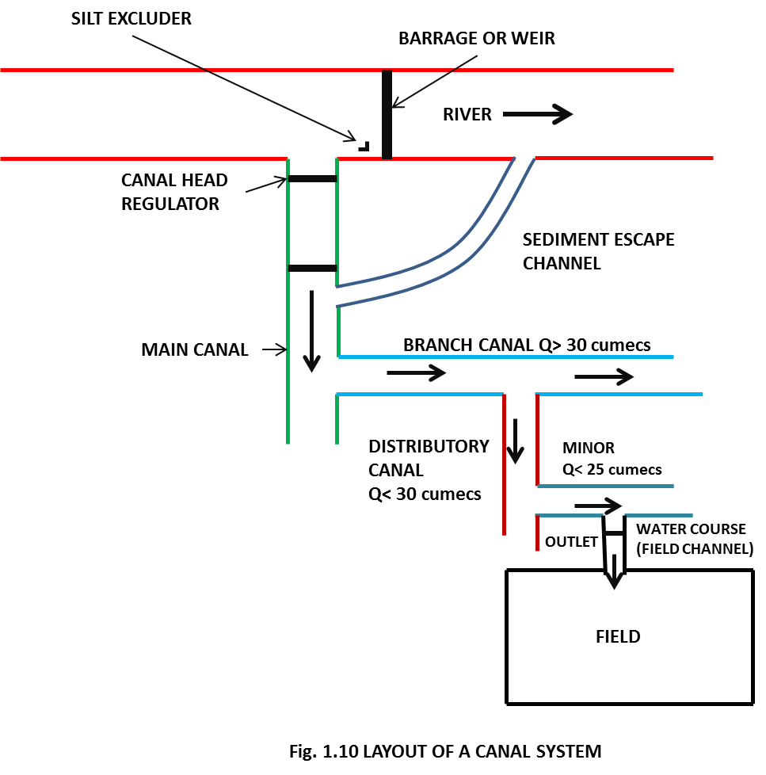

During the passage of water from these irrigation channels, water is lost due to evaporation and percolation. These losses are called Transit losses or Transmission or Conveyance losses in channels.

Duty of water for a crop, is the number of hectares of land, which the unit flow of water for B days can irrigate. There-fore, if the water requirement of a particular crop at a particular location is more; then lesser number of hectares of land it will irrigate. Hence, if water consumed by a crop of a given base period is more, its duty will be less. lt, therefore, becomes clear that the duty of water at the head of the water-course will be less than the duty of water 'on the field' ; because when water flows from the head of the water-course and reaches the field, some water is lost en-route as transit losses. Applying the same reasoning, it can be established that duty of water at the head of a minor will be less than that at the head of the watercourse ; duty at the head of a distributary will be less than that at the head of a minor, duty at the head of a branch canal will be less than that at the head of a distributary, and duty at the head of a main cowl will be less than the duty at the head of a branch canal. Duty of water, therefore, varies from one place to another, and increases as one moves downstream from the head of the main canal towards the head of the branches or water-courses. The duty at the head of water-course (Le. at the outlet point of the minor), is quite important, and is called the outlet discharge factor. This outlet point is generally the end point of Irrigation Department. The control of Irrigation Department finishes at the outlet point, and the water is carried into the fields through water-courses by the beneficiary cultivators themselves.

**Flow duty and Quantity duty**

In direct irrigation, duty is always expressed in hectares/cumec. It is then called as flow-duty or duty. In storage irrigation, duty may, sometimes be expressed in hectares/million cubic metre of water available in the reservoir. It eventually means that every million cubic metre of water available in the reservoir will mature so many hectares of a particular crop. Hence, the irrigation capacity of the reservoir is directly known. When duty is, expressed in this manner, it is called Quantity duty or Storage duty.

**Factors on which duty depends.**

Duty of irrigation water depends upon the following factors :

1. ***Type of crop.*** Different crops require different amount of water, and hence, the duties for them are different. A crop requiring more water will have less flourishing acreage for the same supply of water as compared to that requiring less water. Hence. duty will be less for a crop requiring more water and vice versa.
2. ***Climate and season.*** As stated earlier, duty includes the water lost in evaporation and percolation. These losses will vary with the season. Hence, duty varies from season to season, and also from time to time in the same season. The figures for duties which we generally express are their average values considered over the entire crop period.
3. ***Useful rainfall.*** If some of the rain, falling directly over the irrigated land, is useful for the growth of the crop, then so much less irrigation water will be required to mature the crop. More the useful rainfall, less will be the requirement of irrigation water, and hence, more will be the duty of irrigation water.
4. ***Type of soil.*** If the permeability of the soil under the irrigated crop is high, the water lost due to percolation will be more and hence, the duty will be less. Therefore, for sandy soils, where the permeability is more, the duty of water is less.
5. ***Efficiency of cultivation method.*** If the cultivation method (including tillage and irrigation) is faulty and less efficient, resulting in the wastage of water, the duty of water will naturally be less. If the irrigation water is used economically, then the duty of water will improve, as the same quantity of water would be able to irrigate more area. Cultivators should, therefore, be trained and educated properly to use irrigation water economically.

**Importance of duty.**

It helps us in designing an efficient canal irrigation system. Knowing the total available water at the head of a main canal, and the overall duty for all the crops required to be irrigated in different seasons of the year, the area which can be irrigated can be worked out. Inversely, if we know thecrops area required to be irrigated and their duties, we can work out the discharge required for designing the channel.

**Duty for certain crops.** (Assignment)

**10. MEASURES FOR IMPROVING DUTY OF WATER.**

The duty of canal water can certainly be improved by effecting economy in the use of water by resorting, to the following precautions and practices.

**(1) Precautions in field preparation and sowing :**

(i) Land tope used for cultivation should, as far as possible, be levelled.

(ii) The fields should be properly ploughed to the required depth.

(iii) Improved modern cultivation methods may preferably be adopted.

(iv)Porous soils should be treated before sowing crops to reduce seepage of water.

(v) Alkaline soils should be properly leached before sowing.

(vi) Manure fertilisers should be added to increase water holding capacity of the soil.

(vii)Rotation of crops. should be preferred, as this will ensure increased crop yields with minimum use of water.

**(2) Precautions in handling irrigation supplies :**

(i) The source of irrigation water should be situated within the prescribed limits, and should be capable of delivering sufficient quantity of satisfactary quality of irrigation. water.

(ii) Canals carrying irrigation supplies should be lined to reduce seepage and evaporation , thereby reducing on field requirement of water and consequent-ly improving the duty of water.

(iii) Water courses may preferably be lined ; or R.C.C. pipes may, be used for the same to reduce on field requirement of water, thereby improving duty.

(iv) Free flooding of fields should be avoided and furrew inigition method may preferably be adopted, if surface irrigation is resorted to.

(v) Sub surface irrigation and Drip irrigation may be prefentd to ordinary surface irrigation.

(vi) If canals are not lined, then two canals running side by side may be preferred to a single canal, as this will reduce the FSL, thereby reducing percolation losses.

(vii) Irrigation supplies should be economically used by proper control on its dis-tribution, volumetric assessment, and by imparting proper education to the farmers.

**11. CROP SEASONS AND INDIAN AGRICULTURE**

More than 70% of the Indian population is directly or indirectly connected with agriculture. The chief crops of India are rice, wheat, sugarcane, tea, cotton, groundnut, jute, coffee, rubber, garden crops (like coconuts, orange, etc), etc. Different types of soils are needed for raising different types of crops. For example, heavy retentive soil (40% clay) is favourable for raising crops like sugarcane, rice, etc., requiring more water. Light sandy soil (2 to 8% clay) is suitable for crops like gram, fodder, etc. requiring less water. Medium or normal soil (having about 10-20% of clay) is suitable for crops like wheat, cotton, maize, vegetables, oil seeds, etc. requiring normal amount of water.

From the agricultural point of view, the year can be divided into two principal cropping seasons, i.e. Rabi and Kharif. Normally, Rabi starts from In October and ends on-31-st March ; while **Kharif** starts from **1st April and ends on 30th Septemfrer**. Those dates are not rigid dead lines. The time may vary up to 1-3 months on either side. Sugarcane, which is an important cash crop, extends over both seasons.

The Kharif crops are rice, bajra, jowar, maize, cotton. tobacco, groundnut, etc. The **Rabi crops** are wheat, barley, gram, linseed, mustard, potatoes, etc. Kharif crops are also called 'Summer crops' and Rabi crops as 'Winter crops'. Kharif crops require about two to three times the quantity of water required by the Rabi crops.

The above distinction of seasons is well applicable to North India. But in South India, there is no such marked distinction between the different seasons. In fact, in South India, there is no clear cut winter, spring, summer and autumn seasons, as they are in North India. Except Bombay-Deccan, where there are five crop seasons, there are only three crop seasons in the remaining parts of the country. -These three classifications of seasons are : (i) Hot weather or Kharif season. (ii) Monsoon season. (iii) Winter or Rabi season.

When a crop requires water for its crop season and also for some time in the beginning of the next crop season, allowance has to be made for this overlap. This allowance is known as overlap allowance, Sugarcane is an example of this kind of crop.

**Some important Indian crops, their periods of growth, water requirements, seed requirements, yields, etc.** (Assignment)

**12. CERTAIN IMPORTANT DEFINITIONS**

**Kharif-Rabi ratio or Crop ratio.**

The area to be irrigated for Rabi crop is generally more than that for the Kharif crop. This ratio Of proposed areas, to be irrigated in Kharif season to that in the Rabi season is called, Kharif-Rabi ratio. This ratio is generally 1:2, i.e. Kharif area is one-half of the Rabi area.

**Paleo irrigation.**

Sometimes, in the initial stages before the crop is sown, the land is very dry. This particularly happens at the time of sowing of Rabi crops because of hot September, when the soil may be too dry to be sown easily. In such a case, the soil is moistened with water, so as to help in sowing of the crops. This is known as Paleo irrigation.

**Kor-watering.**

The first watering which is given to a crop, when the crop is a few centimeters-high, is called kor-watering. It is usually the maximum single watering followed by other waterings at usual intervals, as required by drying of leaves. The optimum depth of kor-watering for different crops are different. For example, the optimum depth of kor-watering for Rice is 19 cm., for Wheat (in U.P.) is about 13.5 cm, and for Sugarcane is 16.5 cm. The kor-weltering must be applied within a fixed limited period, called Kor-period. If the plants fail to receive this water in time or in sufficient quantity. then they do suffer a significant loss. The kor-period depends upon the climate. It is less for humid climates and more for dry climates. The kor-period for rice varies from Z to 4 weeks, and that for wheat varies from 3 to 8 weeks.

**Cash crops.**

A cash crop may be defined as a crop which has to be encashed in the market for processing, etc. as it cannot be consumed directly by the cultivators. All non-food crops are thus, included in cash crops. Crops like jute, tea, cotton, tobacco, sugarcane, etc. are. therefore, called cash crops. The food crops like wheat. rice, barley, maize, etc. are excluded front the list of cash crops.

**Crops rotation.**

When the same crop is grown again and again in the same field. the fertility of land gets reduced as the soil becomes deficient in plant foods favourable to that particular crop. In order to enhance the fertility of the land and to make the soil regain its original structure, it is often found necessary and helpful to give some rest to the land. This can be achieved either by allowing the land to lie fallow without any cultivation for some time, or to grow crops which do not mainly require those salts or foods which were mainly required by the earlier grown crop. This method of growing different crops in rotation, one after the other, in the same field. is called Rotation of Crops. A cash crop may be followed by a fodder clop, which, in turn. may be followed by soil-renovating crop like gram, which being a liguminous crop, helps in giving nitrogen to the fields, thereby renovating the soil. The cultivators who are fond of sowing cash crops always, should be educated and made to understand the advantages of sowing crops in rotation.

The rotation of crops will help in extracting different foods from the soil, and thus avoiding the general deficiency of any particular type(s) of element(s). Moreover, if only one type of crop is grown in the same field. numerous insects and pests (of similar nature) will get developed. The crop rotation will also help in checking such growths. Crop rotation will thus help in increasing the fertility of soil, and reducing the diseases and wastage due to insects and hence increasing the overall crop yield.

In general, the following rotations of crops may be adopted depending upon the soil conditions :

1. Wheat—Juar—Gram
2. Rice—Gram.
3. Cotton—Wheat—Gram*— Fallow (up to July)
4. Cotton—Juar—Gram.
5. Sugarcane (18 months) — Thadwa — Wheat or gram — Fallow (upto July).

**13. IRRIGATION EFFICIENCIES**

Efficiency is the ratio of the water output to the water input, and is usually expressed as percentage. Input minus output is nothing but losses. and hence, if losses are more. output is less and, therefore, efficiency is less. Hence, efficiency is inversely propor-tional to the losses. Water is lost in irrigation during various processes and, therefore. there are different kinds of irrigation efficiencies, as given below :

**(i) Efficiency of water conveyance.**

It is the ratio of the water delivered into the fields from the outlet point of the channel, to the water entering into the channel at its starting point. It may be represented by ηc. It takes the conveyance or transit losses into consideration.

**(ii) Efficiency of water application.**

It is the ratio of the quantity of water stored into the root zone of the crops to the quantity of water actually delivered into the field. It may be represented by ηa. It may also be called on farm efficiency, as it takes into consideration the water lost in the farm.

**(iii) Efficiency of water storage.**

It is the ratio of the water stored in the root zone during irrigation to the water needed in the root zone prior to irrigation (i.e. field capacity — existing moisture content). It may be represented by ηs

**(iv) Efficiency of water use.**

It is the ratio of the water beneficially used. including leaching water, to the quantity of water delivered. It may be represented by ηu.

**(v) Uniformity coefficient or Water distribution efficiency**

The effectiveness of irrigation may also be measured by its water distribution efficiency (ηd), which is defined below:

ηd =

where ηd = water distribution efficiency.

D = Mean depth of water stored during irrigation.

d = Average of the absolute values of deviations from the mean.

The water distribution efficiency represents the extent to which the water has penetrated to a uniform depth, throughout the field, the deviation from the mean depth is zero and water distribution efficiency is 1.0.

**14. CONSUMPTIVE USE OR EVAPOTRANSPIRATION (CU)**

Consumptive use for a particular trop may be defined as the total amount of water used by the plant in transpiration (building of plant tissues, etc.) and evaporation from adjacent soils or from plant leaves, in any specified time. The values of consumptive use (**Cu**) may be different for different crops, and may be different for the same crop at different times and places. In fact, the consumptive use for a given crop at a given place may vary throughout the day. throughout the month and throughout the crop period. Values of daily consumptive use or monthly consumptive use, are generally determined or a given crop and at given place. Values of monthly consumptive use over the entire crop period. are then used to determine the irrigation requirement of the crop.

**15. EFFECTIVE RAINFALL (R,)**

Precipitation falling during the growing period of a crop that is available to meet the evapo-transpiration needs of the crop, is called effective rainfall. It does not include precipitation lost through deep percolation below the root zone or the water lost as surface run off.

**16. CONSUMPTIVE IRRIGATION REQUIREMENT (CIR)**

It is the amount of Irrigation water required in order to meet the evapotranspiration needs of the crop during its full growth. It is, therefore nothing but the consumptive use itself, but exclusive of effective precipitation stored soil moisture or ground water. When the last two are ignored, then we can write

CIR = Cu – Re

**17. NET IRRIGATION REQUIREMENT (NIR)**

It is the amount of irrigation water required in order to meet the evapotranspiration need of the crop as well as other needs such as leaching.

Therefore,

N.I.R. = Re+ Water lost as percolation in satisfying other needs such as leaching.

**18. FACTORS AFFECTING CONSUMPTIVE USE**

Consumptive use or evapotranspiration depends upon all those factors on which evaporation and transpiration depend; such as temperature, sunlight. humidity. wind movement. etc. (Explain Assignment)