**MODULE – II**

**CANALS**

**Content:** **Classification of canals – Canal alignment** – **Kennedy’s and Lacey’s theories – Design –** **Balancing depth** – **Effects, causes and prevention of water logging** – **Types of lining** – **Design of lined canals** – **Canal outlets – Falls** – CD works.

Objective:

**INTRODUCTION**

**Canal:**

“**I**t is an artificial channel constructed on the ground to carry water to the field either from a reservoir, tank or river.”

Or

“**C**anal is a channel usually trapezoidal in section. It is constructed to carry water over long distances from the source of water.”

Or

“**A**n artificial waterway used for the navigation or for draining purpose or for irrigating land.”

**Classification of canals:**

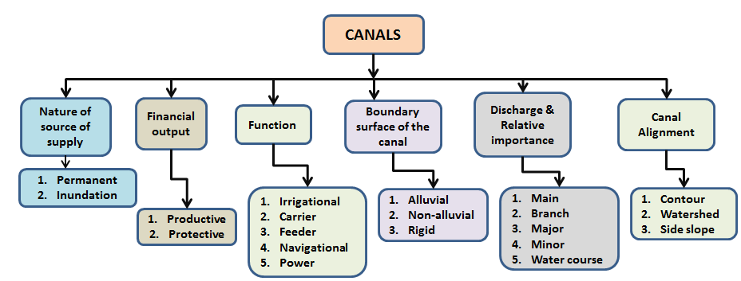

**FIG 2.1 Schematic representation of classification of canals**

**Perennial canal/Permanent canal**

These are the canals which get continuous supplies by permanent source of supply like a river or reservoir. These irrigate the field throughout the year with equitable rate of flow.

**Non-Perennial canals**

These are the canals which irrigate the field for only one part of the year. They irrigate usually during summer season or at the beginning and the end of winter season.

These canals take-off water from the rivers which do not assured supply throughout the year.

**Inundation canal/rainy canal**

These are the earliest form of water conveyance channels. They take off water directly from the river. They are not provided with permanent head works, like a weir or barrage across the river. These canals work only when water in the river rises during high flow season. When water become less, these canals become inoperative. Similarly, if river changes its course, the canal would stop drawing water and ultimately dry up. Therefore, unlike a barrage controlled perennial canal, an inundation canal suffers from the unpredictable behavior of the river.

Most of the inundation canals located in South Asian sub-continent were constructed in the 17th century AD, the Mughal era. Some of the canals are functioning till now. However, most of them cease to function. They have been converted into barrage controlled perennial canals. These canals are generally excavated parallel to the river course. Some of the inundation canals had a very large capacity of 300 cumecs. There were also small inundation canals drawing few hundred cumecs.

**Irrigation canals**

These are the canals which carry water to the fields. The canals having outlets are called irrigation canals.

*For example*

*Distributory canals.*

*Minor canals.*

These canals carry water to the fields. In these canals, the velocity of flow is kept high so that the water may carry silt in suspension.

**Navigation canal**

These are the canals which are used to provide transport and voyage facility from one city to the other or from one country to the other.

Main canal is navigation canal.

**Power canal**

The canals which are constructed to supply water with very high force to the hydro electric power station for the purpose of moving turbine to generate electric power is known as power canal.

Main canal is also used as power canal.

**Link canal**

The canal that is from river to river is known as link canal.

*For example,*

Sidhnai Malsi link canal in Pakistan.

Taunsa Panjand link canal in Pakistan.

These are the canals which are constructed to transfer water to the other conveyance structure which contains in-sufficient quantity of water. These transfer water from river to river system.

**Carrier canal**

Carrier canal is a canal which besides doing irrigation carries water for another canal. It is a canal that is link canal and has outlet.

Upper chenab canal in west Punjab in Pakistan is an example of carrier canal.

These canals not only serve for irrigation but also provide the link between two channels and serve to provide water to other conveyance structure. The total flow through carrier canals is more than the flow required for input to the other conveyance structure. The excessive water is used to serve irrigation purposes.

**Feeder canal**

A feeder canal is constructed with the idea of feeding two or more canals. When main canal is divided into two canals then it is called as feeder canal.

Example,

*Lower chenab canal feeder.*

*Rajistan feeder canal and sidhnai canal.*

These are constructed to provide water to other conveyance structures and is not used for irrigation. These canals feed two or more canals.

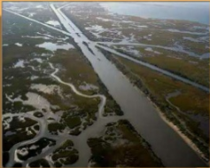**Alluvial and Non-Alluvial Canal**

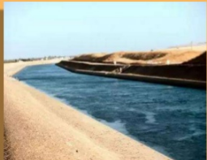The soil which is formed by transportation and deposition of silt through the agency of water, over a course of time, is called the **alluvial soil.** The canals when excavated through such soils are called **alluvial canals.** Canal irrigation (direct irrigation using a weir or a barrage) is generally preferred in such areas, as compared to the storage irrigation (i.e. by using a dam).

The soil which is formed by the disintegration of rock formation is known as **non-alluvial soil.** It has an uneven topography, and hard foundations are generally available. The rivers passing through such areas, have no tendency to shift their courses, and they do not pose much problems for designing irrigation structures on them. Canals, passing through such areas are called **non-alluvial Canals.**

**Main Canal**

Canals having discharge greater than 10 cumecs are called as main canals. A main canal carries discharge directly from river. It carries large amount of water and cannot be used for direct irrigation. Main canal supplies water to the branch canals.

**Branch canal**

Canals having discharge in the range of 5-10 cumecs are called as branch canals. These are the branches of main canal in either direction at regular intervals. Branch canals also do not carry out direct irrigation but sometimes direct outlets are provided. Branch canals are actually the feeders for major and minor distributories.

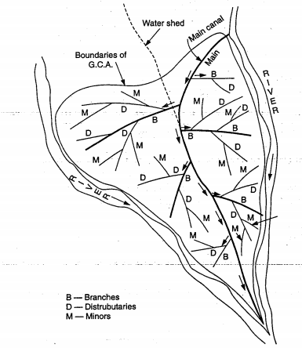

**Distributory canal**

Canals having discharge 0.25-3 cumecs are called Distributory canal. They are further divided into two types:

***Major Distributory.***

***Minor Distributory.***

***Major distributory***

These take off water from branch canals. Sometimes they may get supply from main canal but their discharge is less than branch canal. These are irrigation channels because they supply water to the field directly through outlets.

***Minor distributories***

Canals in which discharge varies from 0.25-3 cumecs are called as minor distributories. These take off from major distributory or sometimes may get supply from branch canal. They also provided water to the courses through outlets provided along with them. The discharge in major distributory is less than in the major distributories.

**Field channels (water courses)**

These are the small channels which ultimately feed water to the irrigation fields.The discharge in water courses is less than 0.25 cumecs. Depending upon the extent of irrigation, a field channel may take off from a major distributory or minor. Sometimes, it may even take off water from the branch canal for the field situated very near to the branch canal.

**Alignment of Canals**

Irrigation canals can be aligned in any of the three ways:

1. As watershed canal

2. As contour canal; and

3. As side –slope canal

**1. Watershed Canal.** The dividing line between the catchment area of two drains (streams) is called the watershed. Thus, between two major stream, there is the main watershed which divides the drainage areas of the two. Similarly, between any tributary and the main stream, and also between any two tributaries there, are subsidiary watersheds, dividing the drainage between the two streams on either side.

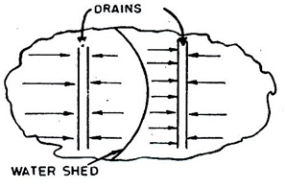For canal system in plain areas, it is often necessary as well as advantageous to align all channels on the watersheds of the areas, they are designed to irrigate. The canal, which is aligned along any natural watershed, is called a watershed canal. From such a canal irrigation, water is taken out by gravity on either side of the canal, directly or through small irrigation channels.

Moreover, cross –drainage works are avoided, as the natural drainage will never cross a watershed, because all the drainage flows away from the watershed. Sometimes, watershed may have to be abandoned in order to bypass localities settled on the watershed.

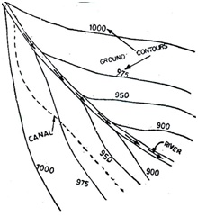

**2. Contour Canal:** The above arrangement of providing the canals along the watershed is not possible in hill areas. In the hills, the river flows in the valley, while the watershed or the ridge line may be hundred of metres above it. It becomes uneconomical to take the canal on top of such a ridge. The channel, in such cases, is generate sufficient flow velocities, are given to it.

The maximum designed slope that can be provided in the canal without generating excessive velocities, is generally less than the available country slope. The difference is accommodated by providing canal falls at suitable places. A contour channel irrigates only on one side, because the areas on the other side are higher.

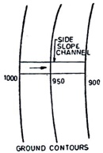 As the drainage flow is always at right angles to the ground contours, such a channel would definitely have to cross drainage lines. Suitable cross drainage works are then provided.

**(iii) Side Slope Canal:** A side slope channel is that which is aligned at right angles to the contours, i.e. along the side slopes, as shown in figure.

Such a channel is parallel to the natural drainage flow and hence, does not intercept cross drainage, and hence no cross drainage works are required.

**Canal Deisgn - Kennedy’s and Lacey’s theories**

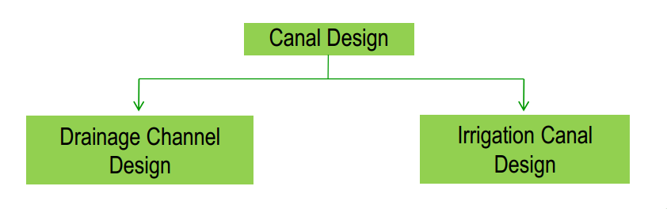

Design Parameters

* The design considerations naturally vary according to the type of soil.
* Velocity of flow in the canal should be critical.
* Design of canals which are known as ‘Kennedy’s theory’ and ‘Lacey’s theory’ are based on the characteristics of sediment load (i.e. silt) in canal water.

Important Terms Related to Canal Design

* Alluvial soil
* Non-alluvial soil
* Silt factor
* Co-efficient of rugosity
* Mean velocity
* Critical velocity
* Critical velocity ratio (c.v.r), m
* Regime channel
* Hydraulic mean depth
* Full supply discharge
* Economical section

Alluvial Soil

The soil which is formed by the continuous deposition of silt is known as alluvial soil. The river carries heavy charge of silt in rainy season. When the river overflows its banks during the flood, the silt particles get deposited on the adjoining areas. This deposition of silt continues year after year. This type of soil is found in deltaic region of a river. This soil is permeable and soft and very fertile. The river passing through this type of soil has a tendency to change its course.

Non-alluvial Soil

The soil which is formed by the disintegration of rock formations is known as non-alluvial soil. It is found in the mountainous region of a river. The soil is hard and impermeable in nature. This is not fertile. The river passing through this type of soil has no tendency to change its course.

Silt Factor

During the investigations works in various canals in alluvial soil, **Gerald Lacey** established the effect of silt on the determination of discharge and the canal section. So, Lacey introduced a factor which is known as ‘silt factor’. It depends on the mean particle size of silt. It is denoted by ‘f’. The silt factor is determined by the expression,



where dmm = mean particle size of silt in mm

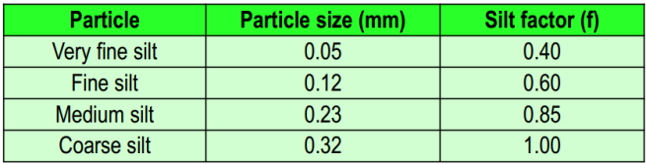

Coefficient of Rugosity (n)

The roughness of the canal bed affects the velocity of flow. The roughness is caused due to the ripples formed on the bed of the canal. So, a coefficient was introduced by R.G Kennedy for calculating the mean velocity of flow. This coefficient is known as coefficient of rugosity and it is denoted by ‘n’. The value of ‘n’ depends on the type of bed materials of the canal.

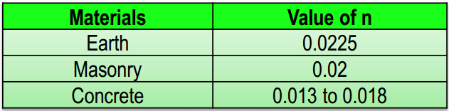

Mean Velocity

It is found by observations that the velocity at a depth 0.6D represents the mean velocity (V), where ‘D’ is the depth of water in the canal or river.

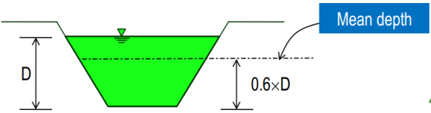

1. Mean Velocity by Chezy’s expression:



1. Mean Velocity by Manning’s expression:

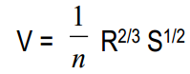

Regime Channel

When the character of the bed and bank materials of the channel are same as that of the transported materials and when the silt charge and silt grade are constant, then the channel is said to be in its regime and the channel is called regime channel. This ideal condition is not practically possible.

Hydraulic Mean Depth/Ratio

The ratio of the cross-sectional area of flow to the wetted perimeter of the channel is known as hydraulic mean depth or radius. It is generally denoted by R.

**R = A/P**

Where,

A = Cross-sectional area

P = Wetted perimeter

Full Supply Discharge

The maximum capacity of the canal for which it is designed, is known as full supply discharge. The water level of the canal corresponding to the full supply discharge is known as full supply level (F.S.L).

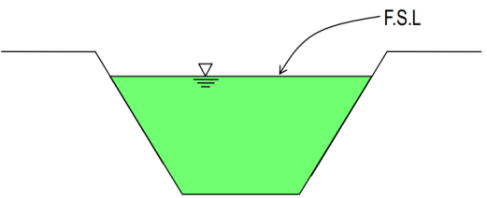

Economical Section

If a canal section is such that the earth obtained from cutting (i.e. excavation) can be fully utilized in forming the banks, then that section is known as economical section. Again, the discharge will be maximum with minimum cross-section area. Here, no extra earth is required from borrow pit and no earth is in excess to form the spoil bank. This condition can only arise in case of partial cutting and partial banking. Sometimes, this condition is designated as balancing of cutting and banking. Here, the depth of cutting is called balancing depth.

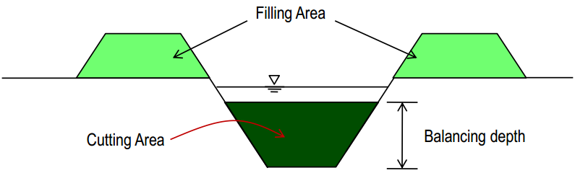

**Unlined Canal Design on Non-alluvial soil**

The non-alluvial soils are stable and nearly impervious. For the design of canal in this type of soil, the coefficient of rugosity plays an important role, but the other factor like silt factor has no role. Here, the velocity of flow is considered very close to critical velocity. So, the mean velocity given by Chezy’s expression or Manning’s expression is considered for the design of canal in this soil. The following formulae are adopted for the design.

1. Mean velocity by Chezy’s formula



Where,

V = mean velocity in m/sec,

C = Chezy’s constant,

R = hydraulic mean depth in m

S = bed slope of canal as 1 in n.

Again, the Chezy’s constant C can be calculated by:

1. Bazin’s Formula:

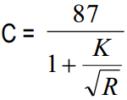

Where,

K = Bazin’s constant,

R = hydraulic mean depth

1. Kutter’s Formula:

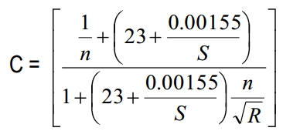

Where,

n = Co-efficient of rugosity,

S = bed slope,

R = hydraulic mean depth

1. Mean velocity by Manning’s formula

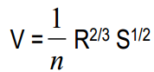

1. Discharge by the following equations:

Q =A *V

Where,

Q = discharge in cumec

A = cross-sectional area of water section in m2

V = mean velocity in m/sec

**Note:**

* If value of K is not given, then it may be assumed as follows,

For unlined channel, K = 1.30 to 1.75.

For line channel, K = 0.45 to 0.85.

* If the value of N is not given, then it may be assumed as follows,

For unlined channel, N = 0.0225.

For lined channel, N = 0.333.

Problem

Design an irrigation channel with the following data:

Discharge of the canal = 24 cumec

Permissible mean velocity = 0.80 m/sec.

Bed slope = 1 in 5000

Side slope = 1:1

Chezy’s constant, C = 44

**Solution:**

We know, A = 24/0.80 = 30 m2

30 = (B + D)D

and P = B + 2.828 D ------ (1)

But, R = 30/(B + 2.828 D) ------ (2)

From Chezy’s formula, V = C $\sqrt{R*S}$

0.80 = 44 $\sqrt{R*0.0002}$

∴ R = 1.65m

Putting the value of R and solving, D = 2.09 m and B = 12.27 m

EXERCISE

**Problem – 1**

Design a most economical trapezoidal section of a canal having the following data:

Discharge of the canal = 20 cumec

Permissible mean velocity = 0.85 m/sec.

Bazin’s constant, K = 1.30

Side slope = 1.5:1

Find also the allowable bed slope of the canal

**Problem – 2**

Find the bed width and bed slope of a canal having the following data:

Discharge of the canal = 40 cumec

Permissible mean velocity = 0.95 m/sec.

Coefficient of rugosity, n = 0.0225

Side slope = 1:1

B/D ratio = 6.5

**Problem – 3**

Find the efficient cross-section of a canal having the discharge 10 cumec. Assume, bed slope 1 in 5000, value of n = 0.0025, C.V.R (m) = 1, full supply depth not to exceed 1.60 m and side slope = 1:1

**Unlined Canal Design on Alluvial Soil by Kennedy’s Theory**

After long investigations, R.G Kennedy arrived at a theory which states that, the silt carried by flowing water in a channel is kept in suspension by the vertical component of eddy current which is formed over the entire bed width of the channel and the suspended silt rises up gently towards the surface.

The following assumptions are made in support of his theory:

* The eddy current is developed due to the roughness of the bed.
* The quality of the suspended silt is proportional to bed width.
* It is applicable to those channels which are flowing through the bed consisting of sandy silt or same grade of silt.
* It is applicable to those channels which are flowing through the bed consisting of sandy silt or same grade of silt.

He established the idea of critical velocity ‘Vo’ which will make a channel free from silting or scouring. From, long observations, he established a relation between the critical velocity and the full supply depth as follows,

Vo = C x Dn

The values of C and n where found out as 0.546 and 0.64 respectively, thus

Vo = 0.546 x D0.64

Again, the realized that the critical velocity was affected by the grade of silt. So, he introduced another factor (m) which is known as critical velocity ratio (C.V.R).

Vo = 0.546 x m x D0.64

**Drawbacks of Kennedy’s Theory**

The theory is limited to average regime channel only.

* The design of channel is based on the trial and error method.
* The value of m was fixed arbitrarily.
* Silt charge and silt grade are not considered.
* There is no equation for determining the bed slope and it depends onKutter’s equation only.
* The ratio of ‘B’ to ‘D’ has no significance in his theory.

**Design Procedure**

* Critical velocity, Vo = 0.546 x m x D0.64
* Mean velocity, V = C (RS)1/2

Where, m = critical velocity ratio, D = full supply depth in m,

R = hydraulic mean depth of radius in m, S = bed slope as 1 in ‘n’.

* The value of ‘C’ is calculated by Kutter’s formula,

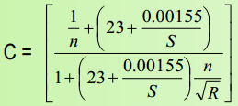

Where, n = rugosity coefficient which is taken as unlined earthen channel.

* B/D ratio is assumed between 3.5 to 12.
* Discharge, Q = A x V.

Where, A = Cross-section area in m2,

V = mean velocity in m/sec

* The full supply depth is fixed by trial to satisfy the value of ‘m’. Generally, the trial depth is assumed between 1 m to 2 m. If the condition is not satisfied within this limit, then it may be assumed accordingly.

**Problem**

Design an irrigation channel with the following data:

Full supply discharge = 6 cumec

Rugosity coefficient (n) = 0.0225

C.V.R (m) = 1

Bed slope = 1 in 5000

Assume other reasonable data for the design

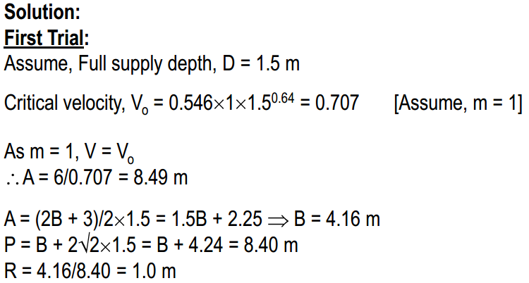

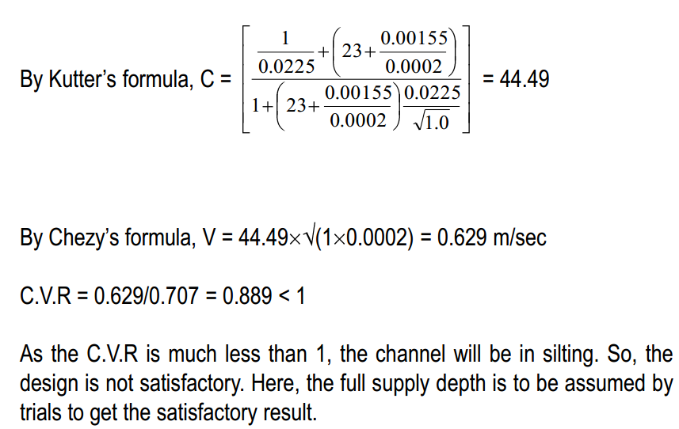

As the C.V.R is much less than 1, the channel will be in silting. So, the design is not satisfactory. Here, the full supply depth is to be assumed by trials to get the satisfactory result.

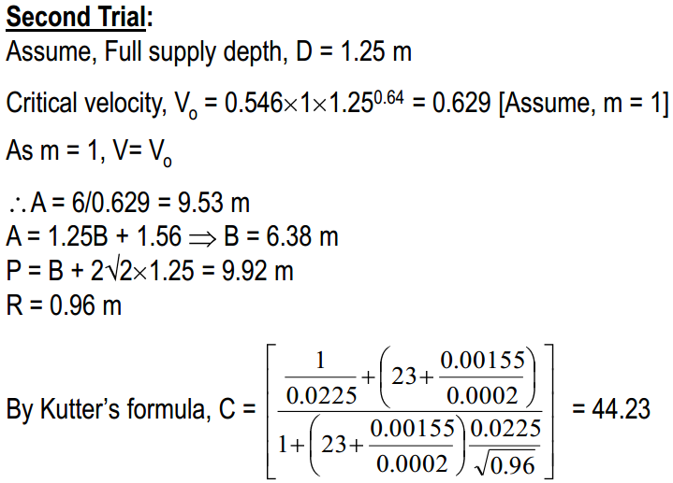

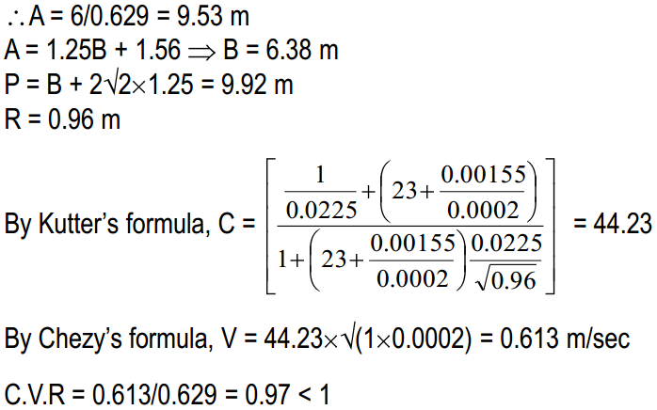

In this case, the CVR is very close to 1. So, the design may be accepted. So, finally,

**D = 1.25 m and B = 6.28 m**

**Exercise Problems**

Problem – 1

Find the maximum discharge through an irrigation channel having the bed width 4 m and fully supply depth is 1.50 m. Given that n = 0.02, S = 0.0002, side slope = 1:1

Assume reasonable data, if necessary. Comment whether the channel will be in scouring or silting.

Problem – 2

Design an irrigation channel with the following data:

Full supply discharge = 10 cumec, Bazin’s constant, K = 1.3, C.V.R (m) = 1, B/D ratio = 4, Side slope = 1:1

Assume other reasonable data for the design

**Unlined Canal Design on Alluvial Soil by Lacey’s Theory**

Lacey’s theory is based on the concept of regime condition of the channel.

The regime condition will be satisfied if,

The channel flows uniformly in unlimited incoherent alluvium of the same character which is transported by the channel.

The silt grade and silt charge remains constant.

The discharge remains constant.

In his theory, he states that the silt carried by the flowing water is kept in suspension by the vertical component of eddies. The eddies are generated at all the points on the wetted perimeter of the channel section. Again, he assumed the hydraulic mean radius R, as the variable factor and he recognized the importance of silt grade for which in introduced a factor which is known as silt factor ‘f’.

Thus, he deduced the velocity as,



Where, V = mean velocity in m/sec, f = silt factor, R = hydraulic mean radius in meter

Then he deduced the relationship between A, V, Q, P, S and f are as follows:

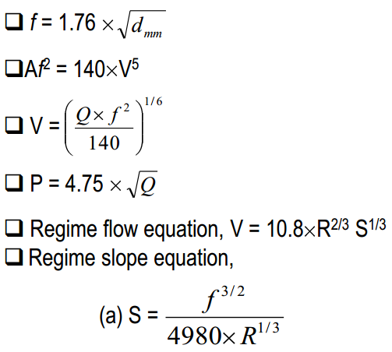

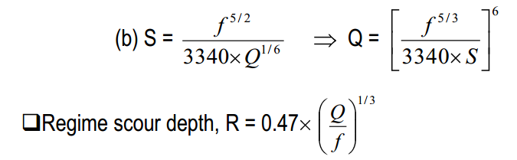

**Problem**

**Design an irrigation channel with the following data:**

**Full supply discharge = 10 cumec**

**Mean diameter of silt particles = 0.33 mm**

**Side slope = ½:1**

**Find also the bed slope of the channel**

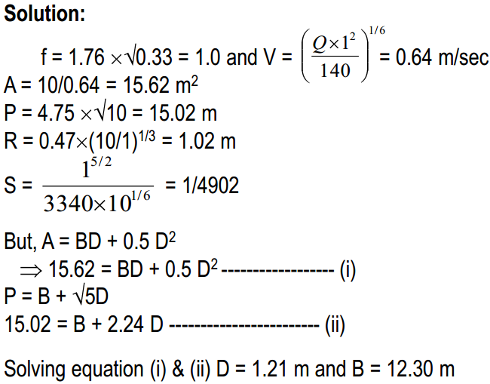

**Exercise Problem**

**Problem – 1**

Find the section and maximum discharge of a channel with the following data:

Bed slope = 1 in 5000

Lacey’s silt factor = 0.95

Side slope = 1:1

**Drawbacks of Lacey’s Theory**

* The concept of true regime is theoretical and con not be achieved practically.
* The various equations are derived by considering the silt factor ‘f’ which is not at all constant.
* The concentration of silt is not taken into account.
* Silt grade and silt charge is not taken into account.
* The equations are empirical and based on the available data from a particular type of channel. So, it may not be true for a different type of channel.
* The characteristics of regime channel may not be same for all cases.

**Comparison between Kennedy’s and Lacey’s Theory**

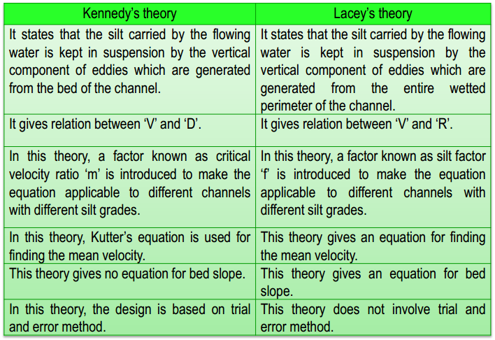

**WATERLOGGING: DEFINITION, CAUSES, EFFECTS (WITH STATISTICS)**

**Definition:**

When the conditions are so created that the crop root-zone gets deprived of proper aeration due to the presence of excessive moisture or water content, the tract is said to be waterlogged. To create such conditions it is not always necessary that under groundwater table should enter the crop root-zone. Sometimes even if water table is below the root-zone depth the capillary water zone may extend in the root-zone depth and makes the air circulation impossible by filling the pores in the soil.

The waterlogging may be defined as rendering the soil unproductive and infertile due to excessive moisture and creation of anaerobic conditions. The phenomenon of waterlogging can be best understood with the help of a hydrologic equation, which states that

Inflow = Outflow -I- Storage

Here inflow represents that amount of water which enters the subsoil in various processes. It includes seepage from the canals, infiltration of rainwater, percolation from irrigated fields and subsoil flow. Thus although it is loss or us, it represents the amount of water flowing into the soil.

The term outflow represents mainly evaporation from soil, transpiration from plants and underground drainage of the tract. The term storage represents the change in the groundwater reservoir.

**Causes of Waterlogging:**

After studying the phenomenon of waterlogging in the light of hydrologic equation main factors which help in raising the water-table may be recognised correctly.

They are:

i. Inadequate drainage of over-land run-off increases the rate of percolation and in turn helps in raising the water table.

ii. The water from rivers may infiltrate into the soil.

iii. Seepage of water from earthen canals also adds significant quantity of water to the underground reservoir continuously.

iv. Sometimes subsoil does not permit free flow of subsoil water which may accentuate the process of raising the water table.

v. Irrigation water is used to flood the fields. If it is used in excess it may help appreciably in raising the water table. Good drainage facility is very essential.

Effects of Waterlogging:

The waterlogging affects the land in various ways. The various after effects are the following:

1. Creation of Anaerobic Condition in the Crop Root-Zone:

When the aeration of the soil is satisfactory bacteriological activities produce the required nitrates from the nitrogenous compounds present in the soil. It helps the crop growth. Excessive moisture content creates anaerobic condition in the soil. The plant roots do not get the required nourishing food or nutrients. As a result crop growth is badly affected.

2. Growth of Water Loving Wild Plants:

When the soil is waterlogged water loving wild plant life grows abundantly. The growth of wild plants totally prevent the growth of useful crops.

3. Impossibility of Tillage Operations:

Waterlogged fields cannot be tilled properly. The reason is that the soil contains excessive moisture content and it does not give proper tilth.

4. Accumulation of Harmful Salts:

The upward water movement brings the toxic salts in the crop root-zone. Excess accumulation of these salts may turn the soil alkaline. It may hamper the crop growth.

5. Lowering of Soil Temperature:

The presence of excessive moisture content lowers the temperature of the soil. In low temperature the bacteriological activities are retarded which affects the crop growth badly.

6. Reduction in Time of Maturity:

Untimely maturity of the crops is the characteristic of waterlogged lands. Due to this shortening of crop period the crop yield is reduced considerably.

Detection of Waterlogging:

From the subject matter discussed above it is clear that the waterlogging is indicated when the ground water reservoir goes on building up continuously. When the storage starts building up in the initial stages the crop growth is actually increased because more water is made available for the crop growth. But after some time the waters table rises very high and the land gets waterlogged. Finally the land is rendered unproductive and infertile.

The problem of waterlogging develops in its full form slowly. Therefore its early detection is possible by keeping a close watch over the yields and also on the variations in the groundwater level. A comparative reduction in crop yields in spite of irrigation and fertilisation and early maturity of crops indicate the symptoms of waterlogging. Also when harmful salts start appearing on the fields as white incrustation or deposit it indicates that waterlogging is likely to follow. In worst cases the water-table rises so high and close to the ground surface that the fields turn into swamps and marshes.

The best way of keeping watch over the problem of waterlogging is by observing variations in the groundwater level. It can be done by measuring the depth of water levels at regular interval in the wells dug in the area. Continuous high water levels indicate that the groundwater storage is building up which may create waterlogging in the area.

Solution to the Problem of Waterlogging:

The problem of waterlogging may be attacked on two fronts. First is preventive measures, which keep the land free from waterlogging. Secondly curative measures may be adopted to reclaim the waterlogged area. But in principle both measures aim at reducing the inflow and augmenting the outflow from the underground reservoir.

Preventive Measures:

Preventive measures include the following:

(a) Controlling the loss of water due to seepage from the canals:

The seepage loss may be reduced by adopting various measures for example

i. By lowering the FSL of the canal:

Loss may be due to percolation or absorption but when FSL is lowered the loss is reduced to sufficient extent. It is course essential to see that while lowering the FSL command is not sacrificed.

ii. By lining the canal section:

When the canal section is made fairly watertight by providing lining the seepage loss is reduced to quite a good extent.

iii. By introducing intercepting drains:

They are generally constructed parallel to the canal. They give exceptionally good results for the reach where the canal runs in high embankments.

(b) Preventing the loss of water due to percolation from field channels and fields:

The percolation loss can be removed by using water more economically. It may also be affected by keeping intensity of irrigation low. Then only small portion of the irrigable tract is flooded and consequently the percolation loss takes place only on the limited area. It keeps the water-table sufficiently low.

(c) Augmentation of outflow and prevention of inflow:

It may be accomplished by introducing artificial open and underground drainage grid. It may also be achieved by improving the flow conditions of existing natural drainages.

(d) Quick disposal of rainwater:

Quick removal of rainwater by surface or open drains is a very effective method of preventing the rise in water table and consequent waterlogging of the tract. It is needless to state that the rainwater removed is net reduction in inflow.

Curative Measures:

Curative measures include the following:

(a) Installation of lift irrigation systems:

When a lift irrigation project in the form of a tube well irrigation system is introduced in the waterlogged area the water table gets lowered sufficiently. It is found to be very successful method of reclaiming waterlogged land. Thus a combination of a canal system and a supplementary tube well irrigation system may be considered to be most successful and efficient irrigation scheme.

Of course it is true that it will create some complications while assessing the charges for irrigation water. (The canal water being cheaper than tube well water). Implementation of drainage schemes: The waterlogged area may be reclaimed by introducing overland and underground drainage schemes.

(b) Implementation of Drainage Schemes:

The waterlogged area may be reclaimed by introducing overland and underground drainage schemes.

Extent or Waterlogged Area:

In our country water-logging is a problem of great concern. It is estimated that total area of waterlogged land is 86.92 lakh hectares. It includes area in irrigation commands as well as other area outside the command.

While the areas in the irrigation command get waterlogged due to rise in water table as a direct consequence of inadequate drainage, other areas get waterlogged due to inundation, as consequence of flooding for long durations. The States mainly affected and the extent of area rendered infertile and unproductive are given in Table.

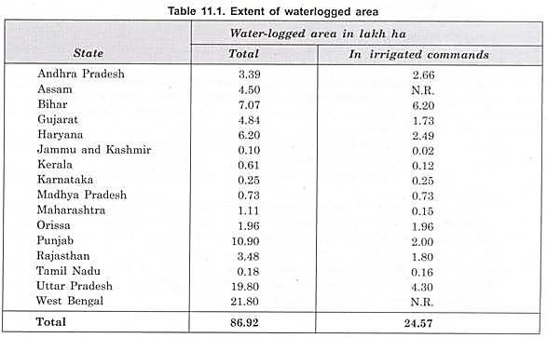

About 48 lakh ha are estimated to be affected by salinity and 25 lakh ha by alkalinity. Saline soils include 10 lakh ha in arid and semi-arid regions of Rajasthan and Gujarat and 14 lakh ha in black cotton soils. The alkali problem is mainly in Punjab, Haryana and Uttar Pradesh.

Steps are being taken to reclaim the waterlogged land in the country. The steps taken to reclaim such areas include implementation of drainage schemes, provision of deep drains, excavation of new channels and improvement of existing ones, construction of sluices with marginal embankment and installation of tube wells.

The spread of conjunctive use of groundwater with that of surface water especially in Punjab, Haryana and parts of Uttar Pradesh has substantially lowered the groundwater table and helped in containing water-logging/salinity.

Summarising the most effective and efficient anti-water-logging measures are:

i. Lining of channels (main canal, branches and field channels).

ii. Provision of surface drains for drainage of rainwater; and

iii. Implementation of tube well projects both extensive and local.

Other methods are of local importance and hence benefit derived from them is limited.

**CANAL LINING**

An impermeable layer is provided at the bed and sides of canal to improve the life and discharge capacity of canal known as canal lining. Generally seepage can result in losses of 30 – 40 % of irrigation water in canals, so we can reduce the effect of seepage by providing lining to the canal.

**Purpose of Canal Lining :**

Implementation of irrigation scheme which includes extensive distribution system is an expensive proposition. Hence it is very necessary to ensure that large losses do not occur in transit due to seepage. In practice, however, considerable loss of water takes place due to seepage in earthen canals. This loss is unavoidable unless the canal is lined. An irrigation canal is said to be lined when the bed and the sides of the canal cross- section are protected with impervious or fairly impervious material of sufficient strength.

Thus main aim of lining the irrigation canals with impermeable material is to stop seepage, thereby saving valuable irrigation water. When canal is lined considerable additional area can be commanded with the help of the saving resulted from lining the canals.

When a canal is to be lined the canal may be built to much smaller cross-section than an unlined one as there is practically no loss in the lined canals due to seepage. Condition of canal is also improved a lot and as a result it requires less maintenance.

Advantages and Disadvantages of canal lining

The lining of an irrigation canal has the **advantages**

1. Reduction in seepage losses from canals reaching water table and raising it resulting in waterlogging and reduction in yield,
2. Reduced seepage losses by as much as 75 per cent means saving of water which otherwise would have required construction of bigger reservoir and dam for the same amount of actual water delivered to the field which implies more capital expenditure without much gain,
3. Reduction in losses and thereby making available more water for extension of irrigation to new areas and improvement of irrigation facilities in the areas afready under irrigation,
4. Flatter slope in lined canal system results in low height of dam and consequent saving in cost of dam construction,
5. Stable channel section,
6. Brings more area under command due to very flat slope possible,
7. Steeper side slopes and bed slope possible as the lined section is immune from erosion,
8. Higher velocity permissible, resulting in proportionate saving in cross sectional area, land width, quantum of earthwork excavation and construction of bridges and cross drainage works which in certain cases may offset completely the extra cost of lining,
9. Possibility of breaches are remote owing to sound structural stability of lined section, hence improvement in operational efficiency,
10. More hydel power generation possible with saving in water from losses and conservation of head losses due to flatter bed slope possible,
11. Low coefficient of rugosity resulting in high velocity with the same slope and hence reduced cross sectional area compared with unlined section,
12. Lined canal water does not pick up harmful salts from the soil through which it passes because canal water does not come in contact with the subsoil,
13. Permits more winding alignment resulting in saving in embankment and cutting costs,
14. Prevents weed growth thereby resulting in saving of expenditure incurred on weed removal in the case of earthen channels,
15. Stable section which in the case of distributaries and minors reduces remodelling and alteration of outlets,
16. Theft of water by cultivators is stopped,
17. High velocity provided in lined section shall carry forward the blown in sand in sandy tracts,
18. Recurring charges on silt clearance inherent in unlined canals are avoided in the case of a silting canal, with the same slope. Existing silting channel when lined at the same slope generates higher velocity to carry forward the sediment,
19. Considerable economy in the acquisition of cultivable land due to relatively narrow section of the canal,
20. Improvement in cropping pattern,
21. Environmental bettennent,
22. Greatly reduced maintenance and operational charges of the canal,
23. Reduction in evaporation and transmission losses due to reduced exposed area,
24. Reduction in erosion which occurs in unlined channels constructed in steep lands.

**Disadvantages of Lining**

The widely publicized lining of channels is not free from disadvantages, some of which are

1. Higher initial investment; a lined canal is 3 to 4 times costlier than an unlined one of the same capacity,
2. Costly repairs,
3. Shifting of outlets is very costly because it involves dismantling and relaying of lining,
4. Longer construction period, and
5. More sophisticated construction equipment and skilled labour are required.

**Selection of Suitable Type of Lining**

**1. Imperviousness:**

To save seepage losses and as an important anti water-logging measure, it should ensure maximum degree of water-tightness. Cement and concrete lining is more impervious than tile lining.

**2. Hydraulic Efficiency:**

The carrying capacity of a channel varies inversely with the value of coefficient of roughness of the lined surface. The coefficient of roughness increases with the deterioration of lined surface with the passage of time. Concrete and tile linings are hydraulically most efficient.

**3. Durability:**

The lining should be strong and durable. It should be resistant to wearing, weathering, chemical action of salts present in soil, thermal and moisture changes.

**4. Structural Stability:**

The lining should be reasonably stable to withstand the differential subsoil water pressure due to subsoil water and backfill getting saturated through seepage or due to sudden drawdown.

**5. Economy:**

The lining is justified in case the benefits occurring from it offset the first cost and subsequent maintenance and give a reasonable return on the capital investment. The lining should be economical in initial cost, repair and maintenance.

**6. High Velocity:**

Lining is intended to withstand maximum velocity of flow so that the section is the minimum possible.

**7. Life:**

The life of lining should be as intended. Cement concrete lining has the longest proved life (over 60 years) with least maintenance.

**8. Weed Growth:**

The lining should be in-penetrable to root of plants, entirely eliminating the possibility of weed growth to keep the flow smooth, clear and perfect.

**9. Availability of construction material:**

The economical lining is the one which makes use of the available construction material at or near the site.

**10. Labor Strength Available:**

The optimum utilization of the kind and strength of labor available for work should be possible with the type of lining selected.

**11. Operation and maintenance charges:**

The lining selected should require least operation and maintenance charges; easy reparability and at economical cost as in case of tile brick and precast concrete lining compared to insitu concrete lining.

**12. Sub-grade:**

Adaptability of the type of lining selected to the given sub-grade is of paramount importance.

**13. Resistance to abrasion:**

Sediment carried by canal water damages the lining by abrasion. Concrete and boulder lining are most resistance to abrasion compared to other linings.

**Types of Canal Lining**

**Reinforced Cement Concrete lining:**

Most concrete linings installed in older irrigation channels were reinforced. During recent years reinforcement has been omitted wherever possible to reduce construction cost.

Unreinforced concrete linings are to some extent susceptible to damage by hydrostatic or other pressure under the lining than reinforced concrete linings. Where unexpected hydrostatic pressures are encountered under the lining, unreinforced concrete ruptures more readily than the reinforced concrete.

The reinforced concrete lining can be justified under unusual conditions, such as high back pressures, high flow velocities in the canal, unstable sub-grade and in reaches where failure would endanger life and property outside the canal.

The main function of reinforcement is to minimize the tendency and severity of cracking and prevent separation of several parts of the concrete slab. Power channel of Ghazi Brotha Hydropower Project is RCC lined canal.

**Plain Cement Concrete Lining:**

Concrete linings probably constitute the best type where benefits justify their high cost. Properly designed, constructed and maintained concrete linings should have an average serviceable life of over 40 years. Some linings still in good condition are 50 to 60 years old.

Concrete linings are suitable for large and small canals, and for both high and low velocities. They fulfill practically every purpose of lining.

They are usually subject to some cracking, but cracks which permit appreciable leakage can be sealed with asphalted compounds. Costly maintenance is seldom necessary.

These are constructed by well-designed premixed cement concrete mixture of selected aggregates, Portland cement and water. The concrete mix should have enough plasticity for thorough consolidation. At the same time, it can be laid manually or by mechanical means. Hand placing is possible only in small canals and distributaries.

Concrete linings usually consist of 2 to 6 inches thick slabs placed on well prepared canal sub-grade.

**Prefabricated Cement Concrete Lining:**

Canal lining with prefabricated cement concrete slabs is more suitable at places where cheap labour, aggregate and transport are easily available. This type of lining is preferred over the insitu concrete lining because of better control over mixing, moulding and curing which can be achieved in a controlled casting yard.

Prefabricated slabs are easy to place on steep side-slopes as compared to laying of cement concrete at site in similar conditions.

This takes lesser time for construction than that of in-situ concrete. Nominal reinforcement is required to avoid breakage during haulage. Operation and maintenance cost is low with an average life of 50 years.

A combination of in-situ concrete in the bed and precast slab on the sides can also be adopted with advantage. Thickness of precast slabs may vary from 2 to 2.75 inches or more.

**Shotcrete Lining:**

Shotcrete is a term adopted for applying cement-sand mortar under pneumatic (air) pressure. If shotcrete is used in thin layers of 1/4" to 1/2" on soil, it often gives trouble. A thick coat of 1.0 to 1.5 inches is durable but it is more costly than a cement concrete layer of equal thickness. Use of shotcrete on rigid but porous or deteriorated surfaces is very useful. Geocomposite liner with a 3-inch shotcrete cover is used for lining option in DRYDEN CANAL, in Wenatchee Valley Washington.

**Brick or Tile Lining:**

This type is commonly used if good quality tiles or bricks and cheap labor are available. The tiles/bricks should be manufactured from the soil having a clay content 10 to 20 percent and salt content of not more than 0.3 percent.

Clay tiles are very porous and are not much effective in preventing seepage losses. Brick/tiles linings have been tried on various canals in the sub-continent. The main advantages of brick/tile lining are that the bricks/tiles can be manufactured in the vicinity of the work.

No contraction and expansion joints are required and these are easy to lay and maintain. The main drawback in the manufacture of bricks/tiles is the problem of non-availability of suitable soil as most of the soils in Pakistan contain salt substantially higher than the prescribed limit. Mohajir Branch (of Thal Canal), BRBD, Lahore Branch etc are brick lined.

**Asphalt Concrete Lining:**

Asphalt mixed with sand and gravel, is used as a lining mixture in the same way as concrete made from portland cement. Asphalt concrete linings when properly constructed are comparable to portland cement concrete linings in many respects.

The thickness of lining varies from 2 to 4 inches. The serviceable life varies from 15 to 20 years

The advantages as compared with portland cement concrete linings include the possibility of placement even during freezing temperatures. It has better adjustment to sub-grade changes and possibility to use slightly poorer quality of aggregate. Initial cost of this type of lining is very low on account of considerable price difference between asphalt and portland cement. Seepage losses can be reduced to as low as in the case of portland cement concrete lining but these will increase considerably after the weed growth over the time with cracks development.

**Stone Lining:**

Lining of stone masonry can be applied in areas where suitable materials, such as stone are available. The construction of this type is relatively slow and the cost of labour is the major expense. Seepage losses may be very high if the stones are not laid in mortar. This type is more suitable for main canals under scouring action or in locations where there is movement of gravel along the bed.

**Soil-Cement Lining:**

Soil-cement linings are constructed with mixture of sandy soil, portland cement and water. This mixture hardens to a concrete like material. The life of this type of lining varies from 10 to 12 years but if properly constructed and maintained then it may serve up to 20 years or so. The thickness of lining varies from 4 to 6 inch. Initial cost of soil cement lining is low as compared to others.

It is suitable for the areas where good sandy soils are available within or in the vicinity of the project area. The seepage losses can be reduced to that of the cement concrete lining, if proper mixing and compaction is done. It however affords less structural stability.

**Compacted / Stabilized Earth Lining:**

Earth lining is composed of compacted earth, mixed with some chemicals which improve the stabilization of the earth. This is comparatively the cheapest type.

Thickness of lining varies from 12 to 24 inches for bed and even more for steep slopes.Seepage losses are more and the structural strength is also poor. It is resistive to weed growth. Deep cracks develop on the surface, if the canal is dry. It requires top-most quality of compaction so that moisture content may not increase or decrease. The average life of this type of lining is about 10 years.

**Exposed Membrane Lining:**

Exposed membranes include thin membranes of asphalt, plastics and synthetic rubber. They possess low permeability, but have no structural strength. Seepage losses mainly depend upon weed growth and other mechanical damages as well as weathering. The life of this type is only a few irrigation seasons.

Due to shorter life the economic use of exposed membrane lining is limited to special cases, such as temporary emergency linings, short sections less vulnerable to damages etc.

**Buried Membrane Lining:**

A buried membrane canal lining consists of a relatively thin and impervious water barrier covered by a protective layer which forms the water-carrying prism. The asphalt spray, plastic film, bentonite and prefabricated asphalt are used as construction material for membranes. Since the protective cover does not get properly attached with the plastic sheet, sloughing and slipping of earth on the sides usually take place. The minimum side slope recommended is 2:1.

The life of the lining depends largely on erosion resistance of cover material. Skilled personnels are required; it can be transported easily along the canal. Suitability of excavated soil as cover material is important for economic reasons.

**Design of Lined Canals**

The lined canals are not designed making use of Lacey or Kennedy Theory because the section is rigid. Generally Manning’s equation is used in design. To carry a certain discharge number of channel sections may be designed with different bed widths and side slopes. But it is clear that each section is not equally good for the purpose.

The section to be adopted should be economical and at the same time it should be functionally efficient. It has been found that the most suitable cross-section of a lined canal is a circular section with sloping sides. That is, the bed is not flat but it is an arc of a circle. This arc is tangential to the sloping sides.

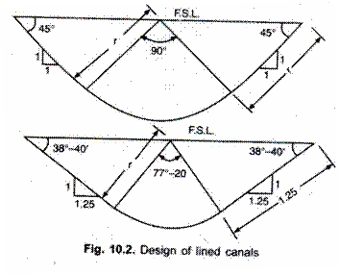

**Side Slopes:**

The side slope is selected in such a way that it nearly equals the angle of repose of the soil in the subgrade. Care is taken to ensure that no earth pressure is exerted on the back of the lining. From the knowledge of hydraulics it is clear that the section is economical when cross- sectional area is maximum for minimum wetted perimeter.

This condition is achieved when the centre of an arc lies at FSL of the canal. This section is also efficient in the sense that as the velocity of flow is higher silt carrying is also higher than a wide and shallow section. Thus the problem of silting is completely eliminated and functioning is efficient.

It may be mentioned here that such section with circular bed may be designed up to a discharge of 85 m3/sec. When the discharge is more than 85 m3/sec the section best suited is one with a flat bed and sloping sides with rounded corners. This section is certainly better than trapezoidal section, because it is more stable and economical to construct. Dimensions of a canal section with circular bed may be obtained from the equations given below. Figure above shows the canal sections of this type with two standard side slopes.

When r = 3.6 m or less, side slopes may be taken 1: 1

When r = 3.6 m side slopes may be taken 1.25: 1

**Velocity of Flow**:

Mean velocity of flow may be calculated using Manning’s formula.

V = 1/N * R2/3 * S1/2

where, N is coefficient of rugosity and may be taken as 0.018

S is the slope of bed and expressed in fall of bed in m in 10,000 m length

For the given value of N formula may be reduced to

V = 0.556 * R2/3 * S1/2

where, V is velocity of flow in m/sec;

R is hydraulic mean radius in m; and

S is bed slope expressed in metres/metre length,

since (10,000)1/2 is merged in the constant 0.556.

**Following Table gives the sectional data for the two side slopes:**

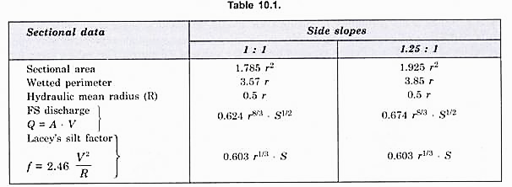

Dimensions of a canal section with flat bottom may be obtained from the equations given below. Figure above shows the cross-sections of this type with two standard side slopes. It may be mentioned here that generally maximum velocity of flow is recommended to be 2 m/sec and Lacey’s ‘f is limited to 1.2. When r exceeds 55 m or when discharge is more than 85 m3/sec, the canal should be designed with a flat bottom with fillets at corners. The Indian Standard 4745 in fact does not suggest lined canal with circular bottom.

**Velocity of Flow:**

Mean velocity of flow may be calculated from Manning’s formula for value of N = 0.018.

Then V = 0.556 R2/3. S1/2

It may be remembered that lined canal could be given steep slope to achieve recommended velocity of 2 m/sec and value of ‘f’ about 1.2. Critical velocity ratio is not applicable to lined canals. But to avoid possibility of sitting CVR should be aimed at more than unity.

Coefficient of Rugosity (N):

In general practice for lined canal average value of N may be taken as 0.018. For different types of linings the value of W varies. The values given for straight channels in Indian Standard 4745 are given in Table 10.3. When the alignment is not straight loss of head increases and a small increase in the value of W may be made to allow for additional loss of energy.

**Freeboard:**

Freeboard is measured from the (FSL) full supply level to the top of lining. For lined canals having less than 10 cumec discharge 0.6 m free board is recommended. For bigger lined canals freeboard not less than 0.75 m is generally provided.

**Bank Widths:**

The Indian Standard recommended following values for bank widths for main and branch canals:

Main canal in cutting and filling = 8.0 m

Branch canal in cutting = 6.5 m

Branch canal in filling, left bank = 6.5 m

Right bank = 5.0 m

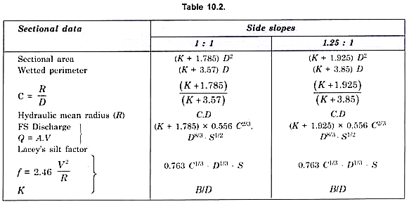

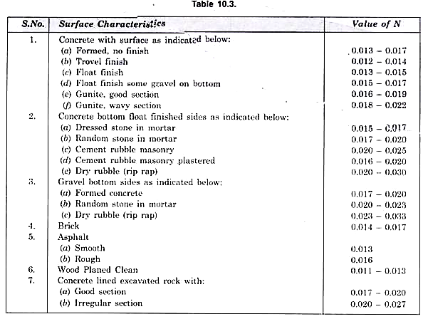

Suitable provision of dowel, roadway, catch water drain, under drainage has to be made for every lined canal. Figure 10.4 shows three typical cross-sections of the lined canal in which provision of various components is illustrated.

The canal sections shown have trapezoidal shape. For circular bottomed canal arrangement will be similar. It may be noted that angle 0 shown in the section varies with the side slopes adopted. 9 for side slope 1: 1 has 45° value and for 1.25: 1 is 38° 40′ as shown in Fig. Maximum height of the spoil bank is limited to 6 m when the excavation is done by machinery. In case work is accomplished manually maximum height is to be restricted to 4 m only. Also when a canal section in filling involves more than 10.5 m filling each section shall be designed and tested for stability.

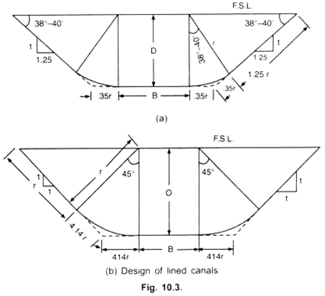

**Problem**

**Design an irrigation lined canal to carry a discharge of 34 m3 / sec. The mean diameter of the average soil particles is 0.464 mm. Assume side slopes 1.25 : 1 and width zero.**

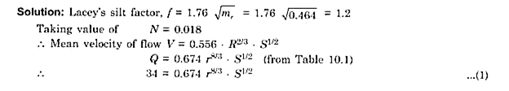

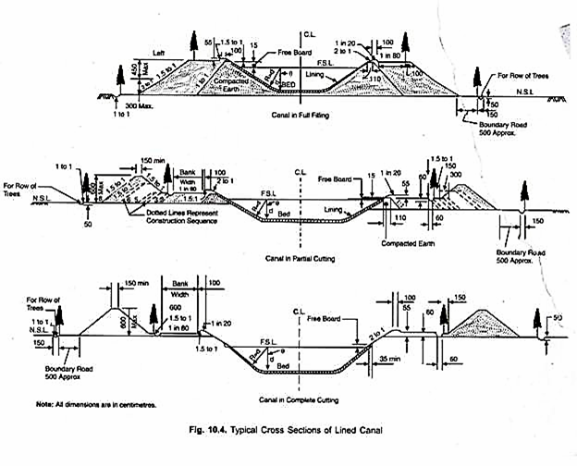

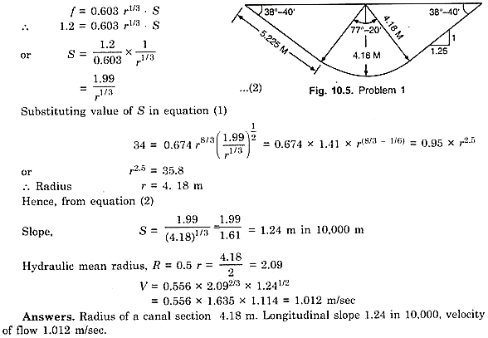

**CANAL OUTLETS**

An outlet is a hydraulic structure conveying irrigation water from a state owned distributary to privately owned water course.

The outlets are large in number as compared to other irrigation structures in an irrigation system and hence their design and type has maximum bearing on the equitable distribution of water.

Therefore proper design of outlet is of utmost importance.

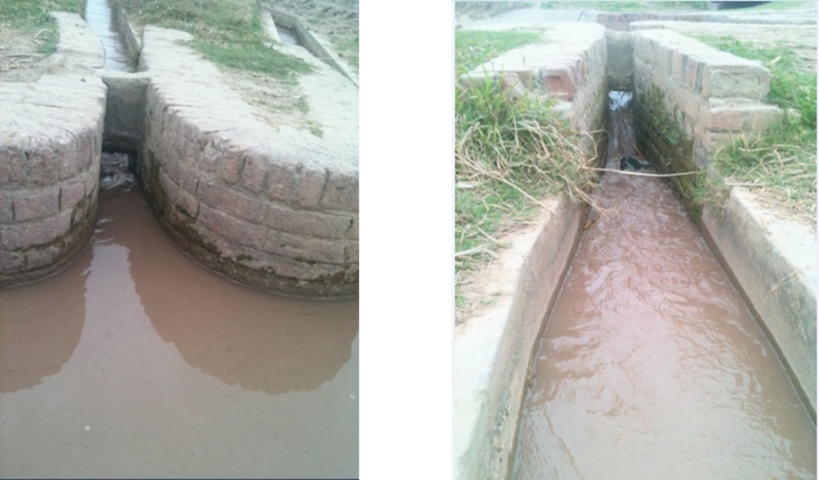

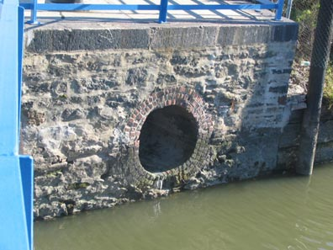

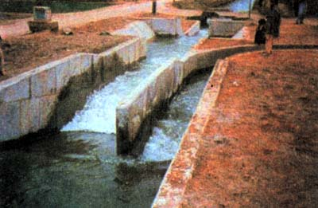

**Essential Requirements of an outlet**

An outlet should be strong and be without movable parts to minimize tempering

Tempering by cultivators should be readily detectable

The outlet must carry its fair share of silt from parent channel

It should be able to work with small working heads

It should be simple so that construction is easy

The total cost of installation and maintenance should be minimum

**Types of Outlets**

**Non-Modular Outlets**

It is one in which the discharge is dependent upon the difference of head in water course and parent channel.

Hence, a variation in either affects the discharge.

**Semi-Modular (Flexible)**

It is one in which the discharge depends upon the water level in distributary only and is independent of water level in water course.

This is achieved by producing hydraulic jump within the flume length.

**Modular (Rigid) Outlets**

It is one in which the discharge is independent of the water level in water course and parent channel.

It can be fixed for any discharge value. This is achieved by creating a free vortex and destroying any extra head more than allowed for in the designed discharge.

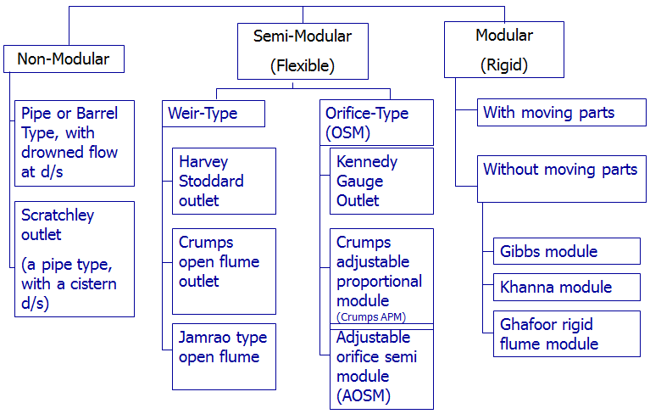

**Characteristic of Outlets**

**Flexibility:** It is defined as the ratio of rate of change of discharge in outlet to the rate of change of discharge in parent channel.

F = (dq/q)/(dQ/Q)

= (m/n)(D/H)

(H/D) is the setting of an outlet

n is exponent of discharge eq (Q=K1Dn) for canal & m is exponent of discharge eq (q=K2Hm) for outlet. For Trap. channel with ½:1 side slope, n is 5/3, and for open flume outlet m is 2/3. Therfore F =0.9 D/H. If we set the crest of outlet at 0.9D depth below water level, the F will be 1 & the outlet will be proportional outlet.

Flexibility is the capacity of an outlet to vary its discharge with the change in the discharge of the distributary.

If F=1 Proportional

If F>1 Hyper-proportional

If F<1 Sub-proportional

**Sensitivity:** It is the ratio of rate of change of discharge of an outlet to the rate of change in the level of distributary water surface, i.e. normal depth of channel

**S = (dq/q)/(dG/D)**

Here, S is the sensitivity and G is the gauge reading of a gauge which is so set that G = 0 corresponds to the condition of no discharge through the outlet (i.e., Q0 = 0).

Sensitivity can also be defined as the ratio of the rate of change of discharge of an outlet to the rate of change of depth of flow in the distributary channel.

**S = nF**

n = 5/3 for wide trapezoidal channel with side slope ½:1

**Efficiency:** It is equal to the ratio of the head recovered (or the residual head after the losses in the outlet) to the input head of the water flowing through the outlet.

**Minimum Modular Head:** it is the minimum head required for the proper functioning of the outlet as per its design.

**Modular Limits:** The extreme values of any parameter at which a module or a semi module ceases to be capable of acting as such.

**Modular Range:** The range of conditions between the modular limits within which a module or semi module works as designed.

**Coefficient of Discharge:** In order to use the outlet as a measuring device the coefficient of discharge should remain constant in the full modular range.

**Silt Drawing Capacity:** It is vital that the outlets should draw their fair share of silt. This avoids silting or scouring and consequently remodeling of distributary.

In a distributary system the absorportion losses are generally taken as 10-15% and therefore the silt conducting power of outlets should be around 110-115% as compared to 100% of distributary to enable them to draw their proportional share.

**Adjustability:** The adjustment of module may range from complete reconstruction to the provision of some mechanical arrangement by which readjustment can be made at little cost. Readjustments are required in view of the revision of areas under command and because of change conditions in the distributary.

**Immunity from Tempering:** There is tendency on the parts of cultivators to draw more than their lawful share of water by tampering with the outlets. Therefore the outlets must be tamper proof.

**SELECTION OF TYPE OF OUTLET**

A rigid module (Modular) or a Flexible module (Semi-modular) with a constant coefficient of discharge is the best selection if the discharge and the water levels are constant in the distributary and necessary working head is available.

But the problem of choice becomes quite complex when both the discharge and levels are likely to change.

The following points may be noted;

For a temporary discharge variation a proportional semi module is desirable to distribute both excess or deficiency in the parent channel.

Seasonal variation in the slope require the use of outlets of low flexibility, i.e., sub-proportional.

For channels running with full supply for a certain period and remaining closed for certain other periods, i.e. rotational running, it is desirable to have hyper-proportional or high flexibility outlets in the head reaches.

The silt drawing capacity of outlet must be 110-115% assuming a 10-15% loss in parent channel.

In general rigid modules are desirable in the following circumstances

Direct outlets on a branch canal subject to variation in supply

In channels which sometimes carry extra discharge for specific reasons like leaching.

**CANAL FALLS**

Irrigation canals are constructed with some permissible bed slopes so that there is no silting or scouring in the canal bed. But it is not always possible to run the canal at the desired bed slope throughout the alignment due to the fluctuating nature of the country slope.

Generally, the slope of the natural ground surface is not uniform throughout the alignment. Sometimes, the ground surface may be steep and sometimes it may be very irregular with abrupt change of grade. In such cases, a vertical drop is provided to step down the canal bed and then it is continued with permissible slope until another step down is necessary. This is done to avoid unnecessary huge earth work in filling. Such vertical drops are known as canal falls or simply falls.

**Necessity / Importance of Canal Falls:**

When the slope of the ground suddenly changes to steeper slope, the permissible bed slope can not be maintained. It requires excessive earthwork in filling to maintain the slope. In such a case falls are provided to avoid excessive earth work in filling When the slope of the ground is more or less uniform and the slope is greater than the permissible bed slope of canal.

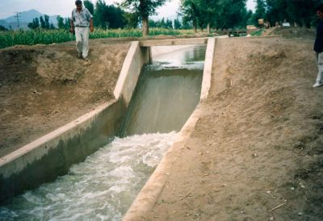

In that case also the canal falls are necessary. In cross-drainage works, when the difference between bed level of canal and that of drainage is small or when the F.S.L of the canal is above the bed level of drainage then the canal fall is necessary to carry the canal water below the stream or drainage.

**Location of Canal Falls**

Location of canal fall depends upon the following factors

* Topography of canal
* Economy of excavation or filling

The above two will decide the location of canal fall across canal. By understanding topographic condition we can provide the required type of fall which will give good results. At the same time, the provided falls is economical and more useful. So, economical calculation is also important. Unbalanced earth work on upstream and downstream result the project more uneconomical.

**Ogee Canal Falls**

Ogee curve is the combination of convex and concave curves. So, Ogee fall consists of both convex and concave curves gradually. This gradual combination helps to provide smooth transition of flow and also reduce the impact. If the canal natural ground surface is suddenly changed to steeper slope, ogee fall is recommended for that canal. Stone pitching is provided in the upstream and downstream of the fall.

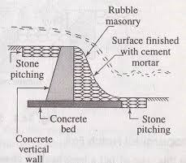

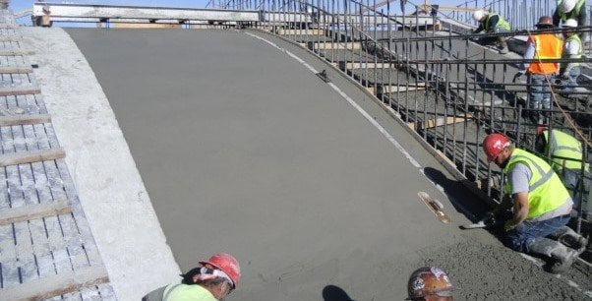

**Rapid Canal Falls**

Rapid fall consists a long sloping glacis. It is constructed if the available natural ground surface is plane and long. For this, a bed of rubble masonry is provided and it is finished with cement mortar of 1:3 ratio. To maintain the slope of bed curtain walls are provided at both upstream and downstream. Rapid falls are high priced constructions.

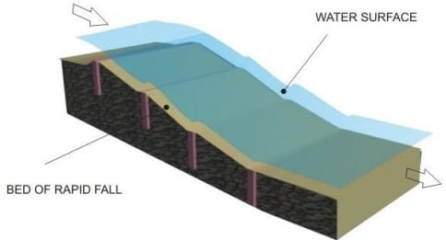 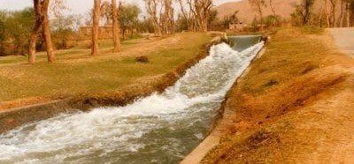

**Stepped Canal Falls**

As in the name itself, stepped fall consist vertical steps at gradual intervals. Stepped fall is the modification of rapid fall. It is suitable for the canal which has it upstream at very high level as compared to downstream. These two levels are connected by providing vertical steps or drops as shown in figure.

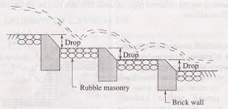 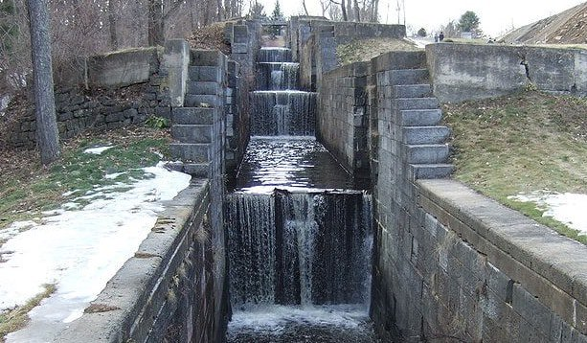

**Trapezoidal Notch Canal Falls**

In case of trapezoidal notch falls, a high crested wall is built across the channel and trapezoidal notches are provided in that wall. Trapezoidal falls are very economical and suitable for low discharges. Now a days this type of falls are using widely because of their simplicity and popularity.

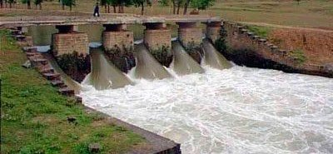

**Well Type Canal Falls**

Well type falls are also called as syphon drop falls. In this case, an inlet well with pipe at its bottom is constructed in upstream. The pipe carries the water to downstream well or reservoir. If the discharge capacity is more than 0.29 cumecs then downstream well is preferred otherwise reservoir is suitable.

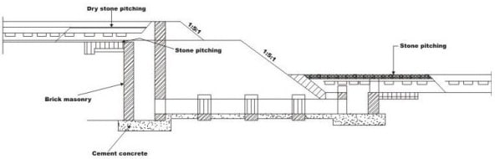

**Simple Vertical Drop Falls (Sarda Type fall)**

Simple vertical drop fall or sarda fall consists, single vertical drop which allows the upstream water to fall with sudden impact on downstream. The downstream acts like cushion for the upstream water and dissipate extra energy. This type of fall is tried in Sarda Canal UP (India) and therefore, it is also called Sarda Fall.

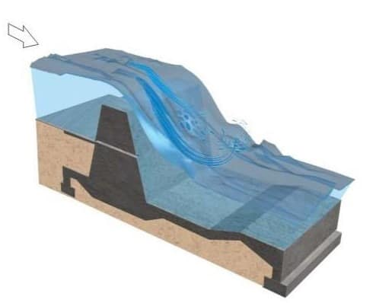

**Straight Glacis Canal Falls**

This is the modern type of construction, in which a raised crest is constructed across the canal and a gentle straight inclined surface is provided from raised crest to the downstream. The water coming from upstream crosses the raised crest and falls on inclined surface with sufficient energy dissipation.

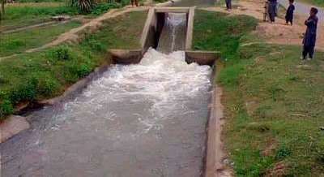

**Montague Type Canal Falls**

Montage fall is similar to straight glacis fall but in this case the glacis is not straight. It is provided in parabolic shape to introduce the vertical component of velocity which improves the energy dissipation to more extent.

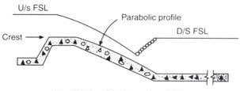

**English or Baffle Canal Falls**

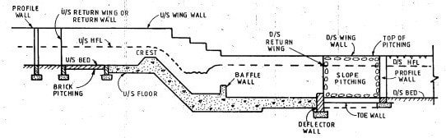

In this case, straight glacis fall is extended as baffle platform with baffle wall. This is suitable for any discharge. The baffle wall is constructed near the toe of the straight glacis at required distance in designed height. The main purpose of the baffle wall is to create hydraulic jump from straight glacis to baffle platform.

**CROSS DRAINAGE WORKS**

When a natural drain crosses or intercepts an irrigation canal it becomes necessary to construct some suitable structure to carry forward the canal safely. As these works are constructed for crossing the drainage, they are termed as cross drainage work. They are also called CD works. It is needles to mention that such additional works on the canal increase the cost of the project. Hence, so far as possible such works should be avoided.

It may be achieved in two ways:

1. The alignment of the irrigation canal should be changed to avoid its crossing with the drain.
2. The drain itself may be diverted to the adjoining stream to avoid the crossing. But in practice it may become impossible to avoid such a crossing. Then there is no other alternative but to construct a structure to carry the canal across the drain.

**Main Types of Cross Drainage Works:**

An irrigation canal may cross a natural drain in three possible ways.

They are:

1. Irrigation canal bed is sufficiently above the bed of a drain.
2. Irrigation canal bed is sufficiently below the bed of a drain.
3. Irrigation canal and the drain cross each other at the same bed level.

**Depending upon the above mentioned possibilities following three cross drainage works may be constructed respectively:**

**Type – 1: Cross drainage work carrying canal over the drain**

The structures falling under this type are

* Aqueduct
* Syphon Aqueduct

**Type – 2: Cross Drainage work carrying Drainage over the canal**

The structures falling under this type are

* Super passage
* Canal Syphon

**Type –3: Cross drainage works admitting canal water into the canal**

The structures falling under this type are

* Level Crossing
* Canal inlets

**Type – 1: Canal over drainage [HFL < FSL]**

**Aqueduct:**

In an aqueduct, the canal bed level is above the drainage bed level so canal is to be constructed above drainage.

A canal trough is to be constructed in which canal water flows from upstream to downstream. This canal trough is to be rested on number of piers. The drained water flows through these piers upstream to downstream.

The canal water level is referred as full supply level (FSL) and drainage water level is referred as high flood level (HFL). The HFL is below the canal bed level.

Aqueduct is similar to a bridge, instead of roadway or railway, canal water are carried in the trough and below that the drainage water flows under gravity and possessing atmospheric pressure.

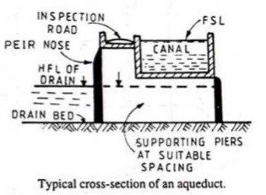

**Syphon Aqueduct:**

In a syphon aqueduct, canal water is carrier above the drainage but the high flood level (HFL) of drainage is above the canal trough. The drainage water flows under syphonic action and there is no presence of atmospheric pressure in the natural drain.

The construction of the syphon aqueduct structure is such that, the flooring of drain is depressed downwards by constructing a vertical drop weir to discharge high flow drain water through the depressed concrete floor.

Syphonic aqueducts are more often constructed and better preferred than simple Aqueduct, though costlier.

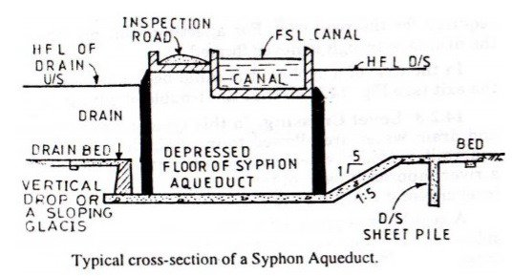

**Type – 2: Drainage over canal (HFL > FSL)**

**Super Passage:**

Super passage structure carries drainage above canal as the canal bed level is below drainage bed level. The drainage trough is to be constructed at road level and drainage water flows through this from upstream to downstream and the canal water flows through the piers which are constructed below this drainage trough as supports.

The full supply level of canal is below the drainage trough in this structure. The water in canal flows under gravity and possess the atmospheric pressure. This is simply a reverse of Aqueduct structure.

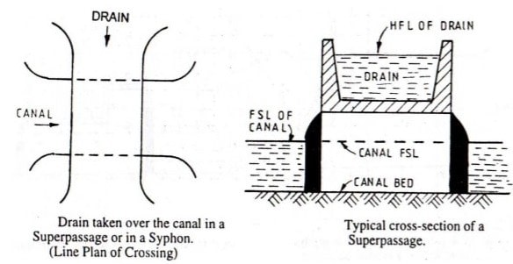

**Canal Syphon:**

In a canal syphon, drainage is carried over canal similar to a super passage but the full supply level of canal is above than the drainage trough.so the canal water flows under syphonic action and there is no presence of atmospheric pressure in canal.

When compared, super passage is more often preferred than canal Syphon because in a canal Syphon, big disadvantage is that the canal water is under drainage trough so any defective minerals or sediment deposited cannot be removed with ease like in the case of a Syphon Aqueduct.

Flooring of canal is depressed and ramp like structure is provided at upstream and downstream to form syphonic action. This structure is a reverse of Syphon aqueduct.

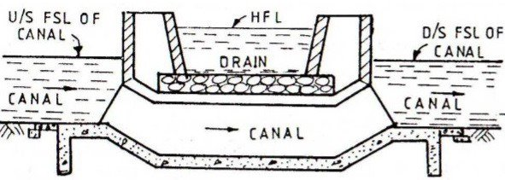

**Type –3: Drainage admitted into canal (HFL = FSL)**

In this case, the drainage water is to be mixed up with canal water, here the cost of construction is less but silt clearance and maintenance of canal water becomes really difficult. So the structures falling under this category are constructed with utmost care.

**Level Crossing:**

When the bed level of canal is equal to the drainage bed level, then level crossing is to be constructed. This consists of following steps:

* Construction of weir to stop drainage water behind it
* Construction of canal regulator across a canal
* Construction of head regulator across a Drainage

**Functioning of a level crossing:**

In peak supply time of canal water parallel to drainage, both the regulators are opened to clear the drainage water from that of canal for certain time interval. Once the drainage is cleared, the head regulator is closed down. Anyhow, cross regulator is always in open condition throughout year to supply canal water continuously.

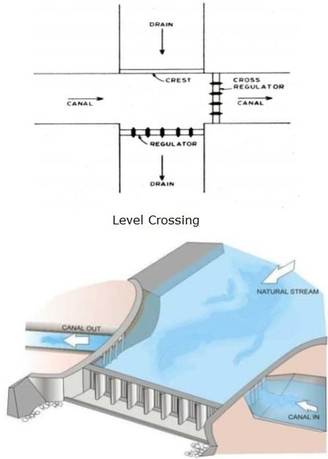

**Canal inlets:**

In a canal inlet structure, the drainage water to be admitted into canal is very less. The drainage is taken through the banks of a canal at inlet. And then this drainage mixed with canal travels certain length of the canal, after which an outlet is provided to create suction pressure and suck all the drainage solids, disposing it to the watershed area nearby.

There are many disadvantages in use of canal inlet structure, because the drainage may pollute canal water and also the bank erosion may take place causing the canal structure deteriorate so that maintenance costs are high. Hence this type of structure is rarely constructed.

