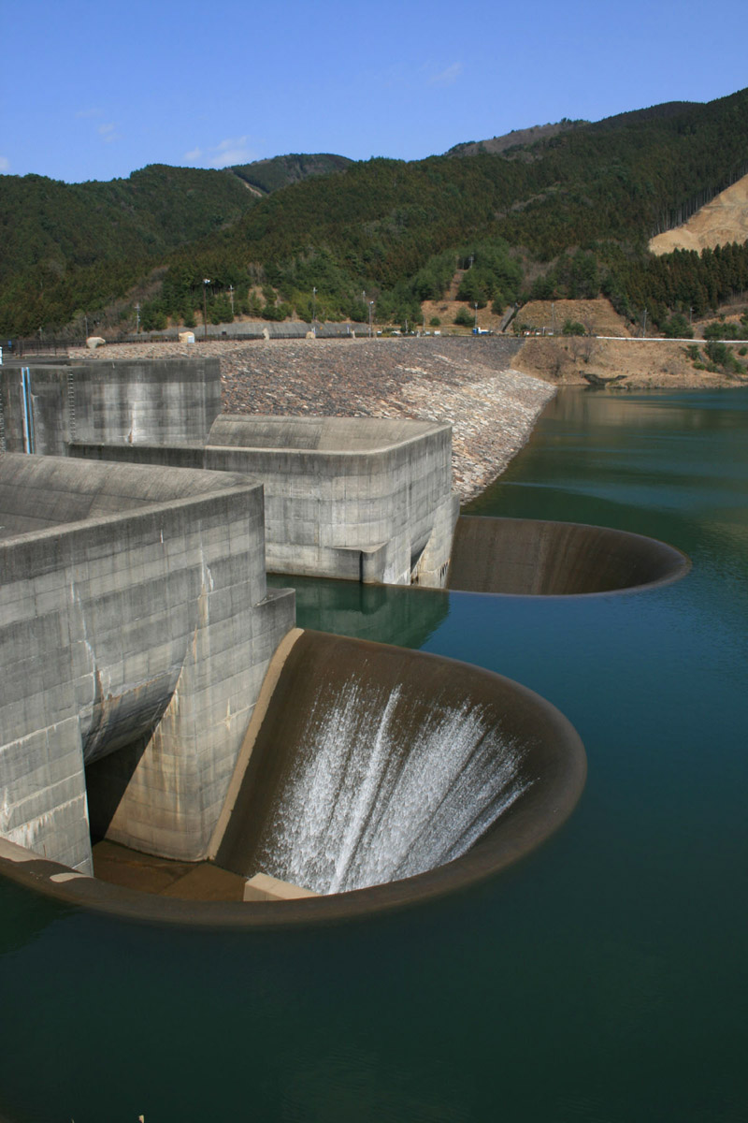
CHAPTER – V
SPILLWAYS

PURPOSE:
- A spillway is a waterway provided to dispose of surplus flood waters from a reservoir after it has been filled to its maximum capacity.
- Spillways are invariably provided for all the dams and these act as safety valves for the dams.
- A spillway may be located either within the body of the dam or at one end of the dam or entirely away from the dam as an independent structure.
- It is essential to provide a spillway of sufficient capacity (or outflow rate through the spillway) so that the surplus flood water is discharged keeping the water level in the reservoir below some predetermined maximum level and no damage is caused to the dam.
- A spillway of insufficient capacity may however lead to over-topping of the dam resulting in serious damage to the dam or in the failure of the dam.
- On the other hand an over-estimation of the spillway capacity would result in an uneconomical design.
ESSENTIAL REQUIREMENTS OF A SPILLWAY
The essential requirements of a spillway are as follows.
- The spillway must have sufficient capacity.
- It must be hydraulically and structurally adequate.
- It must be so located that it provides safe disposal of water i.e., spillway discharges will not erode or undermine the downstream toe of the dam.
- The bounding surfaces of the spillway must be erosion resistant to withstand the high scouring velocities created by the drop from the reservoir surface to tail water.
- Usually some device will be required for dissipation of energy on the downstream side of the spillway.
COMPONENTS OF SPILLWAY
The various components of a spillway are as described below.
- Control Structure. The control structure is a major component of a spillway which regulates and controls the outflows from the reservoir. It prevents outflows below fixed reservoir levels and allows the flow of water when the water surface in the reservoir rises above the level. In most of the cases the control structure consists of the weir which maybe sharp (or narrow) crested, ogee shaped or broad crested. Further in order to regulate the flow of water from the reservoir gates may be provided on the crest of the control structure.
- Discharge Channel. The flow released through the control structure is usually conveyed to the streambed below the dam in a discharge channel or waterway. The main function of this is to convey the water safely from the reservoir downward to the river. The conveyance structure may be the downstream face of the spillway, an open channel excavated along the ground surface, a closed conduit placed through or under a dam, or a tunnel excavated through an abutment.

- Terminal Structures-Energy Dissipators. When the water flows from reservoir pool level to downstream river level. the static energy is converted to kinetic energy. This results in high velocities of flow on the downstream side of the spillway which may cause serious erosion or scour of the streambed and banks. The scouring of the streambed usually retrogrades and may cause serious damage to toe of the spillway and the dam and also to the adjacent structures. The high energy of the flow must therefore be dissipated before the flow is returned to the river. For this usually energy dissipators are provided on the downstream side of the spillway.

- Entrance and Outlet Channels. Entrance channels may be required to be provided to draw water from the reservoir and convey it to the control structure. Similarly outlet channels may be required to be provided to convey the spillway flow from the terminal structure to the river channel below the dam. The entrance and outlet channels are not required where a spillway draws water immediately from the reservoir and delivers it directly back into the river, as in the case of an overflow spillway. However, in the case of spillways placed through abutments or through saddles or ridges, the entrance and outlet channels may be required.

TYPES OF SPILLWAYS
The spillways may be classified according to different considerations as indicated below.
(i) Classification based on the time when the spillways come into operation. On this basis the spillway may be classified as
- Main or service spillway
- Auxiliary spillway
- Emergency spillway.
(a) Main or Service spillway.
- A main or service spillway is the one which is the first to come into operation and is designed to pass the entire spillway design flood. However, in some cases where site conditions are favourable it may be economical to provide an auxiliary spillway in conjunction with a smaller main spillway.
- In such cases the main spillway is designed to pass only small floods which are likely to occur frequently and when these floods are exceeded the main spillway is assisted by the auxiliary spillway in passing the excessive flood waters.

- Auxiliary spillway.
- An auxiliary spillway is the one which is provided as a supplement to the main spillway and its crest is so located that it comes into operation only after the floods for which the main spillway is designed are exceeded.
- Thus an auxiliary spillway is provided in conjunction with the main spillway. The total spillway capacity is then equal to the sum of the capacities of the main and the auxiliary spillways.
- Conditions favourable for the adoption of an auxiliary spillway are the existence of a saddle or depression along the rim of the reservoir which leads into a natural waterway, or a gently sloping abutment where an excavated channel can be carried sufficiently beyond the dam to avoid the possibility of damage to the dam or other structures.
- For auxiliary spillways control gates are seldom provided. However, on the crest of an auxiliary spillway instead of control gates a fuse plug may be provided.
- A fuse plug may be a simple earth embankment (called fuse plug dike) or flash board or other device which allows the water surface in the reservoir to rise above the crest of the spillway and is so designed that when overtopped it automatically washes out thus releasing the excess flood water.

- Emergency spillway.
- An emergency spillway is the one which is provided in addition to the main spillway but it comes into operation only during emergency which may arise at any time and the same might not have been considered in the normal design of the main spillway.
- Thus it is provided for additional safety during emergency. Some of the situations which may lead to emergency are

- an enforced shutdown of the outlet works.
- a malfunctioning of spillway gates,
- the necessity for byepassing the regular spillway because of damage or failure of some part of that structure.

- Classification based on the flow through the spillway being controlled or uncontrolled.
On this basis the spillways may be classified as
- Controlled or Gated spillway
- Uncontrolled or Ungated spillway.
(a) Controlled or Gated spillway A spillway having means to control the outflow from the reservoir is known as controlled or gated spillway.
(b) Uncontrolled or Ungated spillway. A spillway, the crest of which permits water to escape automatically, as the water level in the reservoir rises above the crest is known as uncontrolled or ungated spillway.

(iii) Classification based on the prominent features pertaining to the various components of the spillway. According to the prominent features pertaining to the various components of the spillways such as control structures, discharge channel etc., the spillways may be classified in the following types.
(1) Free overfall or straight drop spillway
(2) Overflow or Ogee spillway
(3) Chute or Open channel or Trough spillway
(4) Side channel spillway
(5) Shaft or Morning glory spillway
(6) Conduit or Tunnel spillway
(7) Siphon spillway.
A detailed description of each of the above noted types of spillways is given in the following sections.
- FREE OVERFALL OR STRAIGHT DROP SPILLWAY
- A free overfall or straight drop spillway is the one for which the control structure is a low height narrow crested weir having its downstream face vertical or nearly vertical
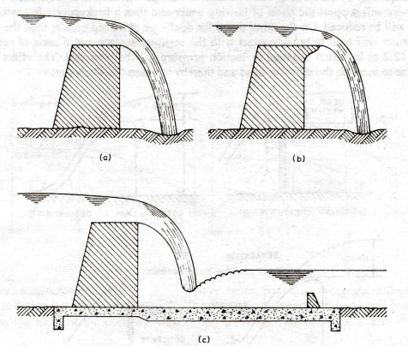
- The overflowing water may be discharged as in the case of a sharp crested weir or it may be supported along the narrow section of the crest.
- However, in either case the water flowing over the crest of this spillway drops as a free jet clearly away from the downstream face of the spillway. As such occasionally the crest of this spillway is extended in the form of an overhanging lip (Fig.b) to direct small discharges away from the downstream face of the overfall section.
- The underside of the nappe is ventilated sufficiently to prevent pulsating or fluctuating jet.
- If no artificial protection is provided on the downstream side of the overfall section, the falling jet will usually cause the scouring of the streambed and will form a deep plunge pool. As such in order to protect the stream bed from scouring, an artificial pool may be created by constructing a low auxiliary darn downstream of the main structure or by excavating a basin which is then provided with a concrete apron.
- However, if tailwater depths are sufficient, a hydraulic jump will form when the jet falls freely from the crest, in which case a sufficiently long flat apron may be provided.
- Moreover in this case floor blocks and an end sill may be provided as shown in Fig.(c) to help in the establishment of the jump and thus reduce the downstream scour.
- The free overfall spillway is most commonly used for low earth dams (or earthen bunds).
- Further this type of spillway is also suitable for thin arch dams and for other dams which have nearly vertical downstream face and would permit free fall of water.
- However, this type of spillway is not suitable for high drops on yielding foundations, because the apron will be subjected to large impact forces at the point of impingement of the jet.
- Moreover the impact forces also cause vibrations which may crack or displace the apron and may result in failure by piping or under-mining.
- Thus ordinarily free overfall spillways are used where the hydraulic drops from head pool to tailwater are not in excess of about 6 m.
2. OVERFLOW OR OGHEE SPILLWAY
- An overflow or ogee spillway is an improvement upon the free overfall spillway and is widely used with gravity, arch and buttress dams.
- Several earth dams are also provided with this type os spillway.
- The essential difference between the free overfall spillway overflow spillway is that in the case of the former the water flowing over the crest of the spillway drops as a free jet clearly away from the downstream face of the spillway, while in the case of the later the overflowing water is guided smoothly over the crest of the spillway and is made to glide over the downstream face of the spillway.
Crest Shape of Overflow Spillway
- For an overflow spillway the control structure is a weir which is ogee or S-shaped (i.e., shaped like an elongated letter S) in profile.
- The shape of the crest or the upper curve of the ogee profile of this spillway is ordinarily made to conform closely to the profile of the lower surface of the nappe or sheet of water flowing over a ventilated sharp-crested weir when discharging at a head equal to the design head of the spillway (Fig. 2).
- The nappe-shaped profile for the crest of an overflow spillway is an ideal profile because for discharge at the design head the water flowing over the crest of the spillway will remain in contact with the surface of the spillway as it glides over it and optimum discharge will occur.
- Moreover in this case no pressure will be exerted on the spillway by the flowing water because there will be atmospheric pressure along the contact surface between the flowing water and the spillway (since along the lower surface of the flow nappe over ventilated sharp-crested weir atmospheric pressure exists).
- Also for discharge at a head less than the design head the water flowing over the crest of the spillway will remain in contact with the surface of the spillway but in this case positive hydrostatic pressure will be exerted on the spillway by the flowing water because the nappe will tend to be depressed.
- However, in this case the spillway will support the sheet of flowing water and thus a backwater effect will be created and the discharge will be reduced.
- On the other thand for discharge at a head greater than the design head the overflowing water will tend to break contact with the spillway surface and a zone of separation will be formed (Fig. c) in which negative or suction pressure will be produced.
- The effect of the negative pressure will be to increase the effective head and thereby increase the discharge.
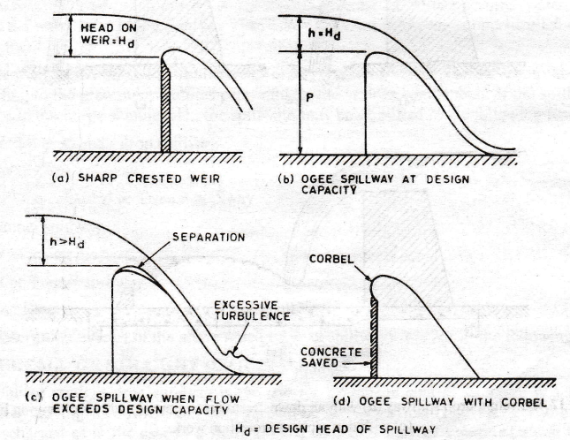
The shape of the nappe-shaped profile depends upon the head, the inclination of the upstream face of the spillway and the height of the spillway above the streambed or the bed of the entrance channel.

Design Principle of Ogee Spillway

- Overflow spillway
Overflow spillways are classified as high and low depending on whether the ratio of the height of the spillway crest measured from the river bed to the design head is greater than and equal to or less than 1.33 respectively. In case of high overflow spillways the velocity of approach head may be considered as negligible.
- Head
The head is the distance measured vertically from the water surface to the crest elevation. It also includes head due to velocity of approach.
- Design Head
The design head is that value of head for which the ogee profile is designed.

- Shape of The Profile
The ogee profile consists of two quadrants, the upstream quadrant and the downstream quadrant. Once the design head H_{d} of the spillway is fixed, the crest geometry may easily be evaluated. The recommended shape is based on detailed observations of the lower nappe profile of a fully ventilated thin-plate weir. Such a profile would generally result in atmospheric pressure along the entire spillway surface at design head H_{d}. For head lower than H_{d}, the pressure would be higher than atmospheric and for higher heads, sub-atmospheric pressure would result.
The ogee profile is divided into three groups as follows:
- Spillways with vertical upstream face
- Spillways with sloping upstream face, and
- Spillways with crest offsets and risers
However, the same general equation for the upstream and downstream quadrants are applicable to all the three cases.
  - Spillway with Vertical Upstream Face
    - Upstream quadrant
The upstream quadrant of the crest may conform to the ellipse:
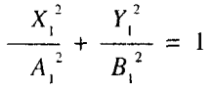
The magnitudes of A, and B, are determined with reference to the. parameter P/H_{d}, from the graphs, given in Fig.
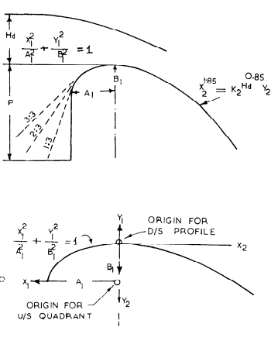

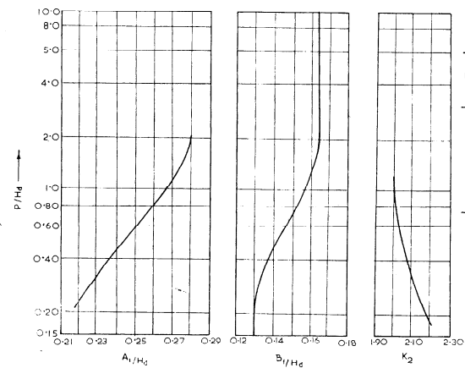
4.1.2 Downstreum profile
The downstream profile of the crest may conform to the equation :
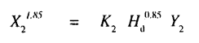
The magnitude of K₂ is determined with reference to the parameter P/H_{d} from the graphs given in Fig. 2
4.2. Spillwuy with Sloping Upstream Face
In the case of sloping upstream face, the desired inclination of the face is fitted tangential to the elliptical profile described in 4.1.1, with the appropriate tangent point worked out from the equation. The profile of the downstream quadrant remains unchanged.
4.3. Discharge Computations
4.3.1. Coefficient of Discharge
The charge over the spillway may be computed from the basic equation:
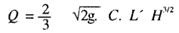
The non-dimensional coefficient of discharge has a theoretical minimum value of = 0.611 and a practical upper limit of about 0.75. the value of parameter 2/3*$\sqrt{2g}$ * C is often called as C_{d}, which, however, is a dimensional quantity. The value of Cd generally varies from 1.80 to 2.21 (SI units).
The value of the coefficient of discharge depends on the following:
a) shape of the crest,
b) depth of overflow in relation to design head,
c) depth of approach,
d) extent of submergence due to tail water, and
e) inclination of the upstream face.
4.4. Effective Length of Overflow Crest
The net length of overflow crest is reduced due to contractions caused by the abutments and crest piers. The effective length L of the crest may be calculated as follows:
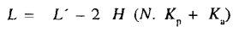
Where The pier contraction coefficient, K_{p} varies between 0 to 0.02 and Average abutment contraction coefficient K_{a} varies between 0 to 0.20
4.5. Determination of Design Head
Designing the crest profile for a particular head H_{d}, results in a profile conforming to the lower nappe of a fully ventilated sharp crested weir and hence the pressures on the profile for the head H_{d},are atmospheric. Operating the spillway for heads lower than H,,wouldgive pressures higher than atmospheric and for heads higher than H_{d}, the pressure would be sub-atmospheric. At the same time the coefficient of discharge would be reduced or increased (relative to that for the design head) for the heads lower or higher than the design head. Generally, designing the profile for a head lower than the highest anticipated head results in a steeper profile provided the sub-atmospheric pressures could be kept within acceptable limits so as not to induce cavitation. The ratio of actual head to design head (H/H_{d}), for ensuring cavitation-free performance of the spillway crest is a function of design head H_{d}.The extent of sub-atmospheric pressure for an under designed spillway profile shall be ascertained from hydraulic model studies for the specific case. Generally design head is kept as 80 to 90 percent of the maximum head.

3. CHUTE OR OPEN CHANNEL OR THROUGH SPILLWAY
In several cases for embankment dams it is not possible to provide overflow spillway. Further for concrete or masonry dams also, the narrowness of the valley, the erodible nature of the streambed, or some other reason may make it impossible or undesirable to provide the overflow spillway. In such cases, some sort of spillway must be provided which may be isolated from the main dam. The chute or open channel or through spillway is one such type of spillway. The chute spillway is provided either in a saddle along the reservoir rim, or along abutment of the dam. It consists of a steep sloped open channel called a chute or trough which carries the surplus water from the reservoir that flows over the crest of the spillway to the river below the dam (Fig. 12.9). Hence this spillway derives its name from the carrier channel. A control structure may or may not be required to be provided for this spillway depending on the natural levels of the saddle. If the saddle has a higher level than the full reservoir level, it is excavated to the later level and left to serve as flat crested weir. On the other hand if the saddle has a lower level than the full reservoir level then a weir has to be built upto that level which is usually made ogee shaped to obtain a high discharge coefficient.
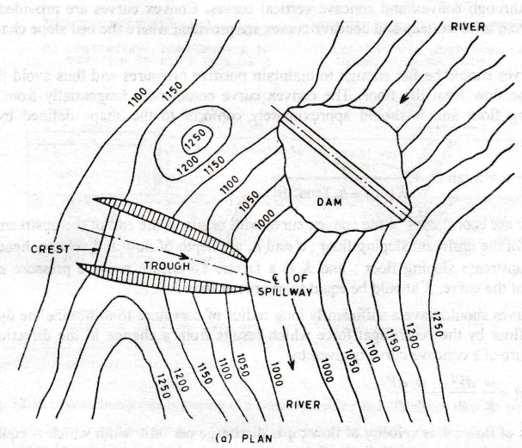
4. SIDE CHANNEL SPILLWAY
A side channel spillway (Fig. 12.11) is one in which water after flowing over the crest is carried in a channel parallel to the crest. Thus the distinctive feature of a side channel spillway which distinguishes it from a chute spillway is that whereas in a chute spillway water flows at right angles to the crest after passing over it, in a side channel spillway water flows parallel to the crest after passing over it. A side channel spillway is suitable for dams in narrow canyons and for other situations where overflow spillway cannot be provided and where space required for a chute spillway of adequate crest length is not available. The control structure for this spillway is also a weir which is usually ogee shaped.
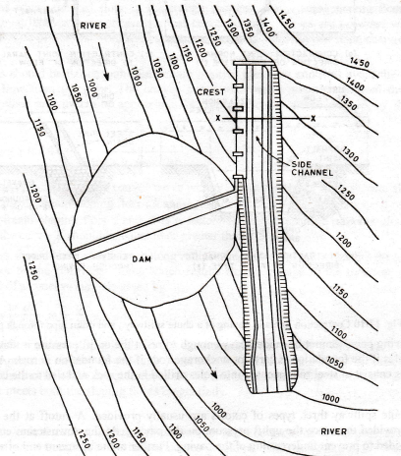
- SHAFT OR MORNING GLORY SPILLWAY
A shaft or morning glory spillway consists of a vertical flaring funnel with its top as the crest of the spillway and its lower end connected to a vertical or inclined shaft which in turn is connected at its lower end to a horizontal or near horizontal conduit or tunnel extending through or around the dam (Fig.). Thus this spillway has a circular crest. The water flowing over the crest of spillway enters the shaft from which it is delivered by the conduit or tunnel to the river below the-dam. There are two types of shaft spillways viz.,

(1) standard crested shaft spillway and
(2) flat crested shaft spillway.

In the case of a standards crested shaft spillway the crest is shaped to conform to the profile of the lower surface of the nappe of water flowing over a circular sharp crested weir of the same diameter discharging at a head equal to the design head of the spillway (Fig. a). On the other hand a flat crested shaft spillway has a wide flat crest similar to that of a broad crested weir (Fig. b). The coefficient of discharge is higher for a standard crested shaft spillway than that for a flat crested shaft spillway and hence the former requires a smaller crest length or diameter of crest than the later. However, the 'crotch' section where the upper nappe from all around the circumference meets is lower in the case of a standard crested shaft spillway than in the case of a flat crested shaft spillway. Thus a standard crested shaft spillway requires a longer funnel than the one for a flat crested shaft spillway (Fig.). Moreover, a standard crested shaft spillway has a larger diameter funnel as compared to a flat crested shaft spillway. As such a standard crested shaft spillway is preferable in locations where the spillway has to be constructed in concrete at its top portion as the quantity of concrete required would be smaller, and a broad crested shaft spillway would be preferable where the entire spillway has to be provided in excavation as due to smaller funnel diameter the rock excavation required would be less. A shaft spillway may be considered as an alternative to side channel spillway if suitable site is available, and if neither the overflow nor the trough spillways are feasible. A suitable location for a shaft spillway would consists of a rock spur projecting into the reservoir a little distance upstream of the dam. If the top of the spur is lower than the full reservoir level, the spillway has to be constructed above the spur level in concrete ; and if the top of the projecting spur is higher than the full reservoir level, it has to be excavated down to the required crest level. Moreover where diversion tunnels are provided to divert the river during construction, it may be possible to utilise them later for shaft spillway. On the crest of a shaft spillway radial piers are provided to guide water radially and prevent spiral flow. The same piers also serve to support a bridge around the spillway. As a shaft spillway is surrounded by water on all sides it has to be connected to the dam or the hill side by a bridge.

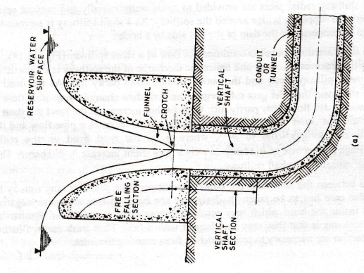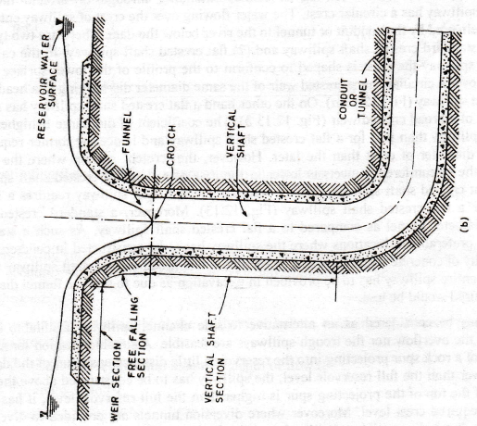
- CONDUIT OR TUNNEL SPILLWAY
A conduit or tunnel spillway is the one in which a closed channel is used to convey the discharge around or under a dam. The closed channel may be in the form of a vertical or inclined shaft and a horizontal tunnel or conduit. The control structure for this spillway may be in the form of an overflow crest, vertical or inclined orifice entrance and side channel crest. The conduit or tunnel is designed to flow partly full and it is not allowed to flow full because siphonic action may develop due to negative pressure being developed in the conduit. Moreover, in order to ensure free flow in the conduit the ratio of the flow area to the total area of the conduit is often limited to about 75%. Also air vents are provided at critical points along the conduit to ensure an adequate air supply which will avoid unsteady flow through the spillway.

- SIPHON SPILLWAY
A siphon spillway operates on the principle of siphonic action. There are two types of siphon spillways as indicated below.
- Saddle siphon spillway
- Volute siphon spillway
Saddle Siphon Spillway
A saddle siphon spillway (or saddle siphon) is shaped like an inverted U tube with unequal legs. The various parts of this spillway are shown in Fig. It consists of an air tight reinforced concrete cover called 'hood' or 'cowl' provided over an ogee shaped body wall to form a siphon duct. Hence this spillway is also known as 'hood siphon spillway or 'hood siphon'. The top of the body wall forms the crest of the siphon spillway and hence it is located at the full reservoir level. The entrance and exit lips of the hood are so shaped that the siphon duct has bell mouth entry and exit. The inlet of the siphon duct is kept submerged well below the full reservoir level so that floating debris etc., does not enter the siphon duct and also the formation of vortices and drawdowns which might break the siphonic action is avoided. The outlet of the siphon duct is kept submerged in a cup-like basin which forms a water seal so that air cannot enter the siphon duct from this end. However, instead of a cup-like basin a cistern may be created by constructing a low weir a little away from the outlet on the downstream of the spillway as shown in Fig.(b). A small deprimer hood is provided above the main hood and both these hoods are interconnected through an air vent. The inlet of the deprimer hood is kept slightly above the Ml reservoir level.
At full reservoir level water stands upto the crest of the spillway and hence there is no flow. When the water level rises above the full reservoir level i.e., above the crest of the spillway, water starts flowing over the crest and the inlet of the deprimer hood gets submerged with the result that entry for air into the deprimer hood and the main hood is sealed. Thus air cannot enter from both the inlet and the outlet of the siphon duct and the air remaining entrapped in the top portion of the siphon duct above the sheet of water flowing over the crest is gradually sucked by the flowing water. As the air is sucked the pressure drops to less than atmospheric in the top portion of the siphon duct which was having atmospheric pressure at the starting of the flow. Thus a difference of pressure develops between the outside atmosphere and the air inside the siphon duct which creates a suction pull and draws in more water over the crest. This is turn takes more air along with it which further increases the suction pull and draws in more and more water. This sucking action which increases progressively and gradually creates the necessary pull for the commencement of the siphonic action and the siphon duct starts running full. The action of the siphon spillway from the moment the water just begins to flow over the crest to the instant when the siphon duct starts running full in known as priming, (or it is said to have 'primed').
It may however be difficult to expel the entrapped air from the siphon duct since it has to be forced through the water in the sealing basin and hence it may not get primed quickly. Moreover relatively large rise in water level above the crest of the spillway may be needed before it gets primed. As such various priming device as described below have been developed to expedite the priming of siphon spillway with relatively less rise in the water level above the crest of the spillway. The depth of water above the crest of a siphon spillway that is required for its priming is known as priming depth. The priming depth varies from about 1/3 to 1/6 of the depth of throat depending on the priming device and the rate of rise of water level in the reservoir. It has been observed that priming takes place quickly when the water level rises gradually rather than when there is sudden rise in the water level.
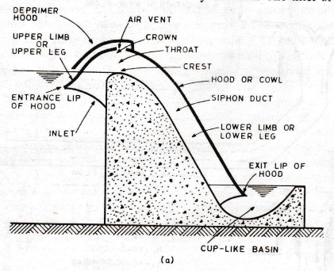
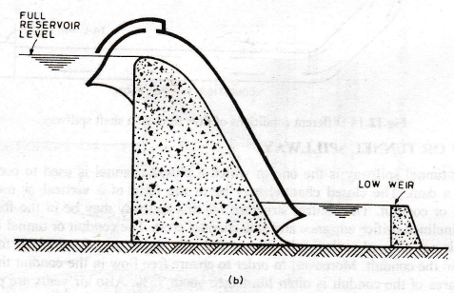

Volute Siphon Spillway
Volute siphon spillway (or volute siphon) is a special type of siphon spillway which was designed by Ganesh lyer in India and hence it is also known as Ganesh lyer siphon. It consists of a vertical pipe or shaft or barrel which opens out in the form of a funnel at the top and at the bottom it is connected to a right angle bend which in turn is connected to a horizontal or nearly horizontal outlet conduit (Fig.) to lead water away from the toe of the dam. The top or lip of the funnel is kept at the kill reservoir level. The inner sloping surface of the funnel is provided with a number of volutes which are the curved vanes or projections (like the blades of a centrifugal pump or turbine) to induce a spiral motion to the water passing along them. A dome supported on a cylindrical drum is provided over the funnel, leaving an annular space around the funnel. The drum is supported on a number of pillars and is open at the bottom. Over the dome small air pipes are provided to serve as deprimers. One end of the air pipe is connected to the interior of the dome at its crown and the other end is open to atmosphere which is kept at the full reservoir level.
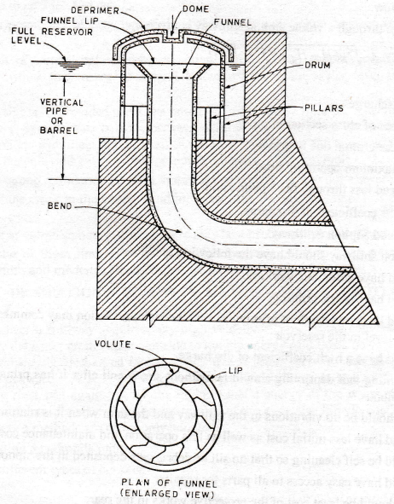
When the water level in the reservoir rises above the full reservoir level it spills over the entire circumference of the lip of the funnel and flows along the volute with a spiral motion a vortex the vertical pipe. The vortex so formed induces a strong suction pull creating a powerful vacuum which sets the siphon in action. When the water level falls to full reservoir level air is let in through the air pipes which stops the siphonic action.
A volute siphon spillway has a lower priming depth and a higher discharge efficiency than a saddle siphon spillway. Further priming of volute siphon spillway takes place on account of vortex flow into the vertical pipe and hence no other priming device is usually necessary. However, sometimes in order to make an effective water seal a baffle or step is provided in the outlet conduit.
A volute siphon spillway has an additional advantage that it can be provided with earth dam also because it is quite independent of the dam section, whereas saddle siphon spillway is possible only with a concrete dam.
QUALITIES OF A GOOD SIPHON SPILLWAY
A good siphon spillway should have the following qualities :
(1) It should have automatic working.
(2) It should have quick priming.
(3) It should have low depth of priming so that the siphonic action may commence even with a small rise in the water level in the reservoir.
(4) It should have a high coefficient of discharge.
(5) The priming and depriming should be without shock and after it has primed the flow should be steady and continuous.
(6) There should be no vibrations in the spillway and the dam when it is running full.
(7) It should have less initial cost as well as less operation and maintenance cost.
(8) It should be self cleaning so that no silt or debris gets deposited in the siphon duct.
(9) It should have easy access to all parts for repairs.
(10) There should be least cost of the protective works in the rear.
(11) It should be simple in design and construction.
(12) There should be repetition of same priming and depriming depths i.e., there should be certainty of priming and depriming actions.
ADVANTAGES OF SIPHON SPILLWAY
The following are the advantages of a siphon spillway over the other types of spillways.
(1) It is automatic in action without involving any mechanical devices or moving parts.
(2) It is able to pass full capacity discharges with narrow limits of rise of water level in the reservoir.
(3) Its discharge per unit length is more because it has a higher operating head.
(4) There is practically no maintenance cost and it is leak proof.
(5) The cost of acquisition of areas which will get submerged between maximum water level and full reservoir level is minimum in this case.
(6) The height of the dam above the crest of the spillway is also reduced correspondingly.
(7) It is also useful in sucking up sediment from the bed of the reservoir when it is in full action during floods.
(8) Its cost of construction compares favourably well with other types of spillways.
LIMITATIONS OF SIPHON SPILLWA
The following are the limitations of a siphon spillway.
(I) It is unable to pass ice and debris.
(2) There is a possibility of clogging of the siphon duct and siphon breaker vents with debris or leaves.
(3) As a result of erratic make-and-break action of the siphon sudden surges and stoppages of outflow may occur which may cause considerable fluctuations in the water level in the river on the downstream side.
(4) If a single siphon is provided there is a possibility of outflows from the reservoir being more than the inflows. However, approximate balance between outflow and inflow can be obtained by providing a series of smaller siphons with their siphon breaker vents set at different elevations so that the siphons get primed at different instants as the water level gradually increase in the reservoir.
(5) It requires strong foundation to resist vibrations which are usually quite severe in this case.
(6) Even a minute crack in the cover would interfere with the functioning of a siphon spillway due to sucking up of air.
(7) In the case of volute siphon spillways there may be a problem of negative pressures at the bend. However, inspite of these limitations siphon spillways may be considered suitable in the case of gorges of limited width and moderate flood discharges in view of their advantages.
ENERGY DISSIPATIONS BELOW SPILLWAY-SCOUR PROTECTION BELOW SPILLWAY
Water flowing over a spillway acquires very high velocity because of the conversion of the potential energy possessed by the water on the upstream side to kinetic energy as it flows down. If the water flowing with such a high velocity is discharged into the river it will scour the river bed and if not checked the scour will extend backwards (or retrograde) and endanger the spillway as well as the dam. As such in order to protect the river bed against scour the higher kinetic energy of the water should be dissipated before it is discharged into the river.
For the dissipation of the excessive kinetic energy possessed by the water the following two methods are commonly adopted.
(1) By developing a hydraulic jump.
(2) By using different types of buckets.
Hydraulic Jump Hydraulic jump is defined as a sudden and turbulent passage of water from supercritical to subcritical state. The flow in a hydraulic jump is accompanied by the formation of extremely turbulent rollers and there is considerable dissipation of energy. As such the hydraulic jump is the most suitable and effective means of energy dissipation. However, the amount of energy dissipated in a jump varies with type of the jump as indicated below.
Types ofJurnp
Different types of hydraulic jumps are developed on a horizontal floor. The jump form and its flow charcaterisitcs mainly depends on the Froude number F1 of the incoming flow which is expressed as $\left(\frac{V_{1}}{\sqrt{gy_{1}}}\right)$, where V1 is the mean velocity of the flow before the jump; g is acceleration due to gravity; and y1 is prejump (or initial) depth of flow. Thus hydraulic jumps may be classified according to the values of F1 as follows.
For F1 = 1, the flow is critical, and hence no jump can form
For F₁ = 1 to 1.7, the water surface shows undulations and the jump is called as undular jump. The energy dissipation in this case is quite low being only about 5%.
For F₁ = 1.7 to 2.5, a series of small rollers develop on the surface of the jump, but the downstream water surface remains smooth. The velocity throughout is uniform. The energy dissipation in this case is also less being only about 20%. This jump is called as weak jump.
For F₁ = 2.5 to 4.5, the entering jet oscillates back and forth form the bottom to the surface and back again without any periodicity. This jump is thus called oscillating jump. The energy dissipation in this case is about 20 to 45%.
For F₁ = 4.5 to 9, a stable and well balanced jump is developed. The action and location of the jump are least sensitive to variation of the tail water depth. This jump has the best performance. The energy dissipation ranges from 45 to 70%. This jump is called a steady jump.
For F₁ = 9.0 and more, the jump action is rough which results in rough water surface with strong surface waves downstream from the jump. The jump action is however effective since the energy dissipation may reach 85%. This jump is called a strong jump.
JUMP HEIGHT AND TAIL WATER RATING CURVE
For a hydraulic jump to be developed in a rectangular channel the following equation must be satisfied,
y₂ = $\frac{y_{1}}{2}\left(\sqrt{1+\left(\frac{8q^{2}}{gy_{1}^{3}}\right)}-1\right)$ ------- (1)
in which y1 = prejump depth; y2 is the post jump depth or sequent depth; g is acceleration due to gravity; q is discharge intensity per unit length; and F1 is Froude number of the incoming flow as defined earlier.
A number of y2 values may thus be obtained for different values of q and a plot if y2 versus q may be made which is known as jump height curve (J.H.C.) or Jump rating Curve (J.R.C.)
The actual tail water depth y2’ corresponding to any discharge intensity q will however depend on the hydraulic condition of the river channel on the d/s side. The values of y2’ corresponding to different values of q may be obtained by actual obersvations and a plot of y2’ verus q may also be made which is also known as tail water rating curve (T.W.R.C.).
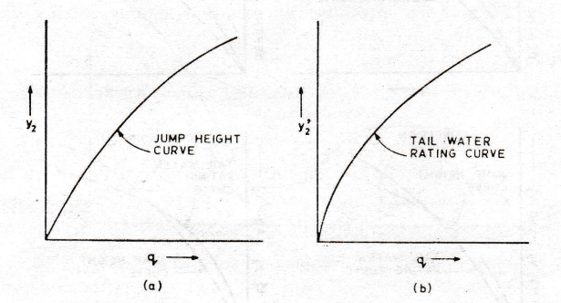
JUMP LOCATION
For a given value of q (and hence of y1) if a jump is developed on the d/s side of a spillway then the location of the jump will depend on the relative magnitude of y2’ and y2, and the following three cases may exist.
CASE-I : The tail water depth y2’ is equal to the depth of y2 sequent to initial depth y1. The jump in this case will be located just at the toe of the spillway. For scour protection purposes, this is an ideal case.
CASE –II: The tail water depth y2’ is less than y2. The jump in this case will be located away from the toe of the spillway on the d/s side. In this case severe erosion may result in the portion of the river between the spillway and the section where jump is located and hence it must be avoided in the design .
CASE-III: The tail water depth y2’ is more than y2. The jump in this case will be located close the toe of the spillway on the d/s side but the jump will be drowned or submerged. However, this case must also be avoided in the design because the dissipation of energy in the case of a drowned jump is much less than that in the case of a clear jump.
The above discussion regarding the location of the jump pertains to a certain value of discharge intensity q corresponding to which there will be a certain value of tailwater depth y2'. However, as q varies y2' also varies and hence for determining the location of the jump for different values of q a comparative study of the jump height curve and the tailwater rating curve will have to be made. For this the jump height curve and the tailwater rating curve are plotted on the same paper. Since there may be difference in the relative positions of both these curves any of the five conditions as shown in Fig. may exist. For each of these conditions the measures to be taken to develop the jump close to the toe of the spillway are
indicated below.
Condition 1. The jump height curve and the tail water rating curve are coinciding with each other for all the discharges. Thus in this case for all the discharges jurnp will develop close to the toe of the spillway. As such a horizontal apron may be provided on the river bed downstream from the toe of the spillway. The length of the apron should be equal to the length of the jump corresponding to the maximum discharge over the spillway. This is however, the most ideal condition which would rarely occur in practice.
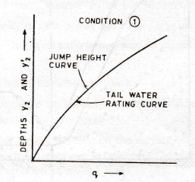
Condition 2. The jump height curve is above the tail water rating curve for all the discharges. In this case as indicted earlier the jump will develop at a certain section far downstream of the toe of the spillway.
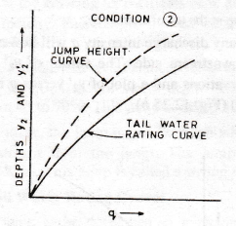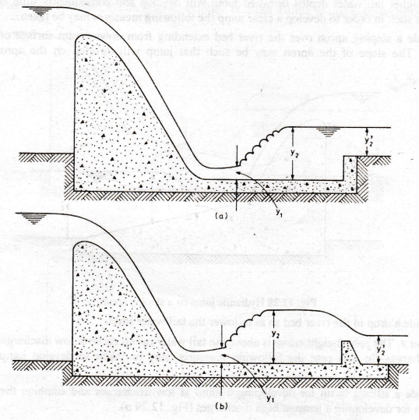
Thus in order to make the jump to develop at a section close to the toe of the spillway the tail water depth must be increased which may be accomplished in any of the following ways.
- Providing a depressed horizontal apron by excavating the river bed on the downstream side from the toe of the spillway (Fig.a). The length and depth of the apron should be such that for all the discharges the jump is confined to the apron. Sometimes the depressed apron may be made sloping instead of horizontal.

- Creating a stilling basin by providing a sill or baffle on the river bed at a section downstream of the toe of the spillway (Fig.b). Again the length and depth of the stilling basin should be such that for all the discharges the jump is confined to the stilling basin.

Condition 3. The jump height curve is below the tail water rating curve for all the discharges. In this case due to higher tail water depths drowned jump will develop and consequently little energy will be dissipated.
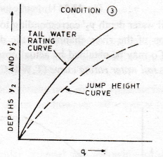
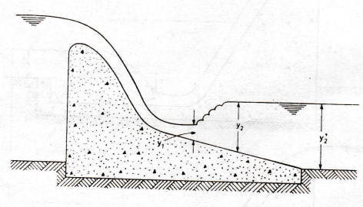

As such in order to develop a clear jump the following measures may be taken.

- Provide a sloping apron over the river bed extending from downstream surface of the spillway (Fig.). The slope of the apron may be such that jump will develop on the apron for all the discharges.
(ii) Provide a drop in the river bed so as to lower the tail water level.
Condition 4. The jump height curve is above the tail water rating curve at low discharges and below it at high discharges. In this case the following measures may be taken to develop jump close to the spillway.
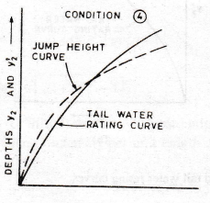
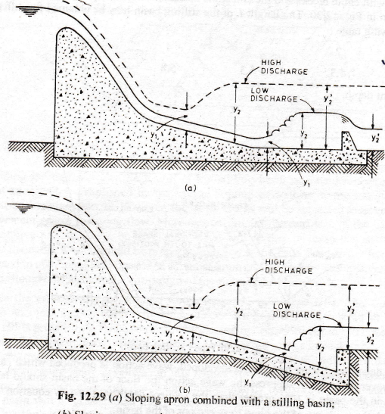

- Provide a stilling basin for developing a jump at low discharges and combine the basin with a sloping apron for developing a jump at high discharges (Fig. a).
- Provide a sloping apron which lies partly above the partly below the river bed so that jump will develop at lower portion of the apron at low discharges and at higher portion of the apron at high discharges (Fig.b).

Condition 5. The jump height curve is below the tail water rating curve at low discharges and above it at high discharges. In this case the following measures may be taken to develop jump close to the spillway.
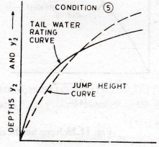
(i) Provide a sloping apron which lies partly above and partly below the river bed so that jump will develop higher up on the apron at low discharges and at lower portion of the apron at high discharges.
(ii) Create a stilling basin by providing a sill or baffle which will increase the tail water depth and thus develop a jump at high discharges. However, at low discharges the already excessive tail water depth will be further increased by the stilling basin and hence drowned jump will develop which will result in less dissipation of energy. If this is not likely to cause scour the device may be used without any modification for low discharges.
The various devices proposed for developing the jump close to toe of the spillway for the five different conditions would be too expensive if these are designed to confine the entire length of the jump. Moreover these devices are not effective in stabilizing the jump and hence the jump tends to shift to the downstream side thus leaving the apron or the basin.
As such certain types of stilling basins have been developed which are relatively more effective in developing stable jumps which would remain confined to the basins. These stilling basins are commonly used with almost all the types of spillways as well as other hydraulic structures such as weirs, barrages, etc.

STILLING BASINS
A stilling basin is defined as a structure in which a hydraulic jump used for energy dissipation is confined either partly or entirely. Certain accessories such as chute blocks, baffle blocks (or floor blocks), and end sills (or baffles) are usually provided in the stilling basins to reduce the length of the jump and thus to reduce the length and the cost of the stilling basin. Moreover these accessories also improve the dissipation action of the basin and stabilize the jump.
The type of stilling basin to be provided depends on the type of jump which in turn, as indicated earlier, depends on the Froude number F1 of the incoming flow. The different types of stilling basins suitable for different ranges of F1 as developed by U.S.B.R. and Indian Standards are described as follows.
U.S.B.R. stilling basins
(i) Stilling basins for Froude number between 1.7 to 2.5. For this case only a horizontal apron needs to be provided. As the flow in this case does not have much turbulence usually no accessories are required to be provided. However, the apron should be sufficiently long to contain the entire jump over it. For this the length of the apron should be equal to the length of the jump which in this case is found to be equal to about 5y2, where y2 is the sequent depth.
(ii) Stilling basins for Froude numbers between 2.5 and 4.5. For this range of Froude number Type I stilling basin shown in Fig. 12.30 has been found to be effective for dissipating the energy of the flow. The basin is provided with chute blocks and the end sill is optional. The size, spacing and location of the chute blocks is as shown in Fig. 12.30. The length L of the stilling basin may be obtained for different values of F1 from the following table :
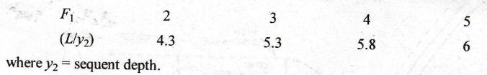
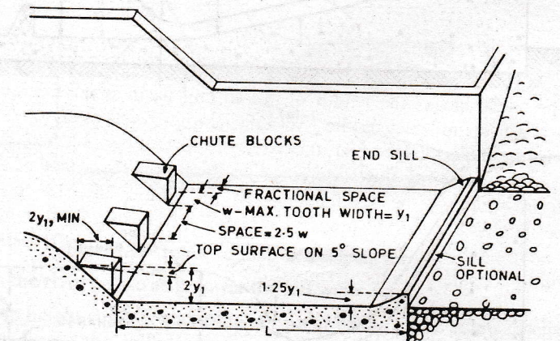
In this case due to oscillating jump being developed, wave action is produced which cannot be entirely dampened. However, in order to suppress the wave action the floor of the basin should be so set that the tail water depth in the basin is 10% greater than the sequent depth y2. This will also help to check the tendency of the jump to sweep out of the basin.
(iii) Stilling basins for Froude numbers higher than 4.5. For this case depending upon the velocity of the incoming flow, two types of stilling basins have been developed as indicated below.
- When the velocity of the incoming flow is less than 15 m/s. Type II stilling basin shown in Fig. may be adopted. This basin utilizes chute blocks baffle blocks and an end sill. The size, spacing and location of the chute and baffle blocks are as shown in Fig. The length L of the stilling basin and the heights h3 and h4 of the baffle blocks and the end sill respectively may be obtained for different values of F1 from the following table:
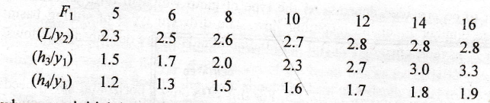
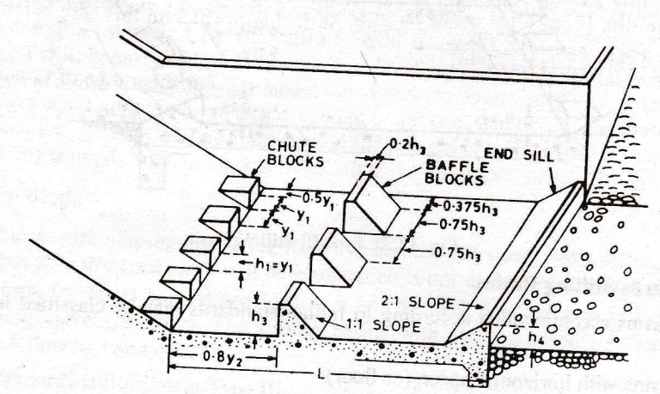
By providing the baffle blocks the length of the stilling basin is considerably reduced because the dissipation of energy is accomplished by the hydraulic jump as well as by the impinging action of the incoming flow against these blocks. However, the baffle blocks will be subjected to large impact forces due to the impingement of the incoming flow. Moreover on the downstream face of the baffle blocks usually suction or negative pressures will be developed which will further increase the force exerted on these blocks. Hence the baffle blocks should be properly anchored at the base. Further the floor of the basin will also be subjected to additional load due to the dynamic force created against the upstream face of the baffle blocks, which should be considered in the design of the floor of the basin.
(b) When the velocity of the incoming flow exceeds 15 m/s. Type III stilling basin shown in Fig. may be adopted. In this basin only chute blocks are provided and instead of a solid end sill a dentated end sill is provided. In this basin baffle blocks are not provided because
(i) due to high velocities of the incoming flows these blocks will be subjected to excessively large impact forces ; and
(ii) there is a possibility of cavitation along the downstream face of these blocks and the adjacent floor of the basin due to large negative pressure being developed in this region.
However, due to baffle blocks being eliminated in this case the dissipation of energy is accomplished primarily by hydraulic jump action and hence the length of the basin will be greater than that indicated for the Type II basin. The length L of the Type III stilling basin may be obtained for different values of F1 from the following table :
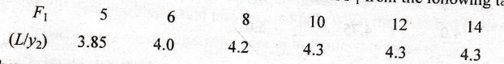
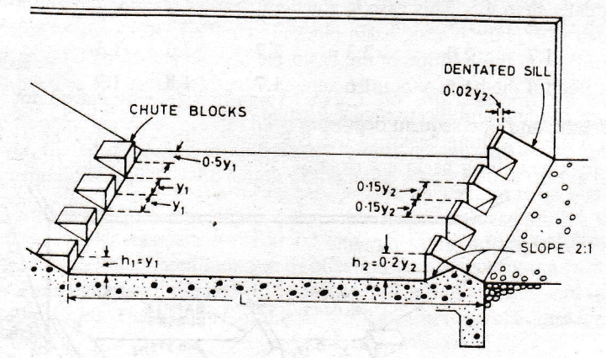
Again in this case also in order to check the tendency of the jump to sweep out the basin the floor of the basin is so set that the tail water depth in the basin is 5% greater than the sequent depth y2.
INDIAN STANDARDS STILLING BASINS
The stilling basins recommended according to Indian standards may be classified into the following two types.
(1) Stilling basins with horizontal apron (or floor).
(2) Stilling basins with sloping apron (or floor).
(1) Stilling basins with horizontal apron (or floor). The stilling basins with horizontal apron (or floor) may be provided when the jump height curve coincides with the tail water rating curve ; or the former is slightly above or below the later. As such in this case the requisite depth for the development of the jump may be obtained on an apron near or at the ground level. The stilling basins with horizontal apron (or floor) may be further classified into the following two types.
(i) Indian standards stilling basin Type 1.
(ii) Indian standards stilling basin Type II.
- Indian standards stilling basin Type I: It may be provided when the Froude number F1 of the incoming flow is less than 4.5. This case is generally encountered on weirs and barrages. This stilling basin is provided with chute blocks, basin blocks (or baffle blocks) and a dentated end sill. The size, spacing and location of the chute blocks for this basin are exactly same as those for Type I stilling basin of U.S.B.R. The height and top thickness of the basin blocks for this stilling basin are same as those for Type II stilling basin of U.S.B.R. However, the width and spacing of the basin blocks for this case is equal to the height of the blocks. Further the size of the dentated end sill for this stilling basin is exactly same as the one for Type III stilling basin of U.S.B.R. The length L of the basin may be obtained for different value of F1 from the following table :
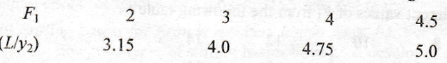
A comparision of the basin lengths of this stilling basin with those of U.S.B.R. Type I stilling basin shows that the former are shorter than the later, which is obviously due to the use of the basin blocks in the former.

- Indian standards stilling basin Type II: It may be provided when the Froude number F1 of the incoming flow is greater than 4.5. This case is a general feature for medium and high dams. This stilling basin is also provided with chute blocks, basin blocks (or baffle blocks) and a dentated end sill. However, when the velocity of flow at the location of the basin blocks exceeds 15 m/s, no basin blocks are provided and in that case the floor of the basin should be kept at a depth equal to the sequent depth y2 below the tail water level. The size, spacing and location of the chute blocks for this stilling basin are exactly same as those for Type II or Type III stilling basins of U.S.B.R.
Further the size, spacing and location of the basin blocks if provided for this stilling basin are exactly same as those for Type II stilling basin of U.S.B.R. Also the dentated end sill provided for this stilling basin is exactly same as Type III stilling basin of U.S.B.R. (or Type I stilling basin of Indian Standards). The length L of this stilling basin may be obtained for different values of F1.

(2) Stilling basin with sloping apron (or floor). When the tail water depth is too large as compared to the sequent depth y2, a drowned jump will develop which is not desirable. In such a case a stilling basin with a sloping apron (or floor) may be provided as it will allow a clear jump to be developed at suitable level on the sloping apron (or floor). The stilling basins with sloping apron (or floor) may be further classified into the following two types.
(i) Indian standards stilling basin Type III.
(ii) Indian standards stilling basin Type IV.
Indian standards stilling basin Type III is recommended for the case where tail water rating curve is above the jump height curve at all discharges. It is usually provided with a sloping apron (or floor) for its entire length.
Indian standards stilling basin Type IV is suitable for the case where the tail water depth at maximum discharge exceeds the sequent y2 considerably but is equal to or slightly greater than y2 at lower discharges. It is provided with a partly sloping and partly horizontal apron (or floor).
For both these stilling basins except a solid or dentated end sill no other accessories are provided. The procedure for the design of all the four types of Indian standards stilling basins is given in I.S. 4997-1968.
BUCKET TYPE ENERGY DISSIPATORS
A bucket type energy dissipater consists of an upturned bucket provided at the toe of the spillway to deflect the water flowing over the spillway. The bucket type energy dissipators may be used only for overflow type spillways. This method of energy dissipation becomes more economical than the method of stilling basins when the Froude number F1 of the incoming flow exceeds 10, because in such cases the difference between the initial and sequent depths being large a long and deep stilling basin would be required. Moreover the bucket type energy dissipators may be used with any tail water condition. However, this method of energy dissipation may be used only when the river bed is composed of stiff rock. The bucket type energy dissipators are of the following three types.
- Solid roller bucket
- Slotted roller bucket
- Ski-jump (or flip or trajectory) bucket.
The solid and slotted roller buckets may be used where the tail water depths are too large as compared to the sequent depths required for the formation of hydraulic jump. Both these buckets remain submerged in the tail water and hence these are also termed as submerged bucket energy dissipators. The solid and slotted roller buckets are described below.
- Solid roller bucket. A solid roller bucket consists of a bucket like apron with a concave circular profile of large radius and a deflector lip as shown in Fig. (a). When water flows over the bucket the entire sheet of water leaving the bucket is deflected upward by the bucket lip and two elliptical rollers are developed as shown in Fig.(b). One of the roller which moves in counter clockwise direction is developed on the surface of the bucket and is contained within the region above the bucket. This is known as bucket roller (or surface roller). The other roller moving in clockwise direction is developed on the ground surface immediately downstream of the bucket, which is known as ground roller. The movement of the rollers, along with the intermingling of the incoming flows causes the dissipation of energy.

The upward deflection of the water by the bucket lip creates a high boil on the water surface and a violent ground roller. This ground roller continuously pulls the loose bed material backwards and deposits the same against the lip of the bucket. Some of this material may move into the bucket, which may get trapped there and damage the surface of the bucket by abrasion. Moreover due to severe surface boil the turbulent flow persists for a considerable distance on downstream side thus resulting in the erosion of the river banks. These drawbacks of the solid roller bucket are remove in the slotted roller bucket.

- Slotted roller bucket. A slotted roller bucket also consists of a bucket like apron with a concave circular profile of large radius but it has a slotted (or dentated) deflector lip as shown in Fig.(a). In general the hydraulic action of a slotted bucket has the same characteristics as those of a solid roller bucket. Thus in the case of a slotted roller bucket also the same two rollers are developed as shown in Fig.(b). However, in this case water leaves the lip of the bucket at a flatter angle and only a part of it is deflected upwards. Thus surface boil is considerably reduced and less violent ground roller occurs which results in a smoother flow on the downstream side. Moreover in this case the bed material is neither deposited nor carried away from the bucket lip. Also any debris which might get into the bucket is immediately washed out through the slots. However, the performance of the slotted bucket is considerably affected by the tail water depth. At low tail water depths the bucket roller will be swept out of the bucket and will produce high
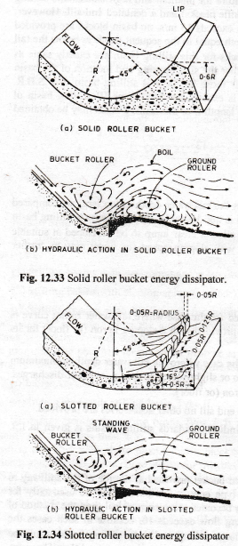

velocity flow on the downstream side which will scour the river bed. On the other hand when the tail water depth becomes excessively large the jet of water leaving the lip of the bucket will get depressed and dive to the river bed which will scour the bed at the point of impingement. Thus the slotted roller buckets are suitable only for a limited range of tail water depths.
Ski-jump bucket
A ski-jump bucket may be used where the tail water depth, is less than the sequent depth required for the formation of hydraulic jump and the river bed is composed of stiff rock. As shown in Fig. the lip of the bucket is so shaped that the entire sheet of water flowing over the bucket is deflected as a free jet which falls back into the river channel at a safe distance away from the spillway. Thus in this case the energy is dissipated by air resistance, breaking up of the jet into bubbles and the impact of the falling jet against the river bed and tail water.
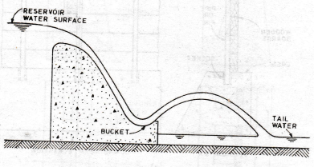
SPILLWAY CREST GATES
For an ungated spillway the useful storage in the reservoir can be maintained only upto the level of the crest of the spillway. By installing gates over the crest of the spillway additional storage can be made available. When the flood occurs these gates are removed so that the full spillway capacity is made available. Gates can be provided on all types of spillways except siphon spillways for which gates are not required because the rise of water level during floods is small as compared to other spillways. Some of the common types of gates used for spillways are described below.
(1) Flasbboards. In general flashboards consist of a series of wooden boards or panels placed on the crest of the spillway. The flashboards may be classified as
(i) temporary flashboards ; and
(ii) permanent flashboards.
Temporary flashboards consist of a series of wooden boards or panels supported by steel pipes or rods (called pins) inserted loosely into sockets set in the masonry or concrete at the crest of the spillway (Fig.a). The steel pipes or rods are designed to bend and release the flashboards when the water surface in the reservoir reaches a certain elevation above the top of the flashboards, thus allowing the excessive floods to pass. Temporary flashboards have been used upto a height of 1.7 m. The operation of the temporary flashboards is automatic, but the disadvantage being that the flashboards are lost each time when the supports fail. Permanent flashboards are similar in principle to the temporary type. except that they are designed to operate without damage to themselves. Permanent flashboards usually consist of wooden boards or panels which can be raised or lowered from an overhead cableway or bridge. Various types of permanent flashboards have been designed. Fig.(b) shows one of the types of permanent flashboards in which the wooden boards are joined to form shutters. These shutters are placed on the crest of the spillway with their lower edge hinged at the crest and are supported in the raised position by struts or by attaching their upper edge to a bridge or cableway at the top. The shutters drop flat on the crest when the struts are tripped or when they are released from the top. These are therefore not suitable for spillways having curved crests. For raising the shutters either a crane travelling on the rest of the spillway or a trolley on a bridge or an overhead cable if there is no bridge may be used.
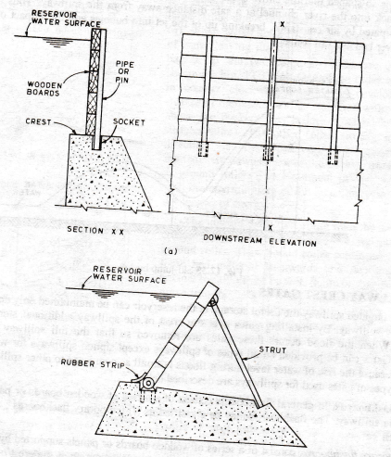
The flashboards are however used only on low spillways or weirs.
(2) Stop logs and Needles. Stop logs consist of horizontal wooden logs or beams spanning the space between grooved piers (Fig.a). The logs are placed one over the other by pushing them down into the grooves. These may be placed or removed by hand or with a hoist. There is usually much leakage between the logs and also there is difficulty of placing and removing them especially if they become jammed in the grooves due to infrequent operation. Stop logs are ordinarily used for small spillways or weirs.
Needles consist of a row of slightly inclined wooden logs with their ends resting in a keyway on the spillway crest and their upper ends supported by a bridge or beam (Fig. 12.37 b). These are invariably placed and removed by hand and hence should not be too large. Needles are somewhat easier to remove than stop logs but are quite difficult to place in flowing water. These are also used only for small spillways or weirs. However. needles are not frequently used.
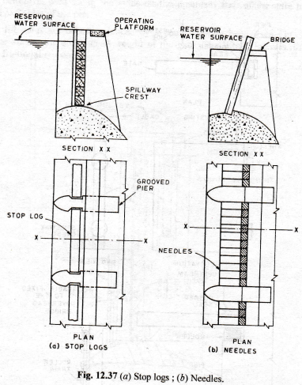
VERTICAL LIFT GATES
A vertical lift gate consists of a framework of steel members to which a skin plate of steel is attached on the upstream side. These gates are rectangular in shape and they move vertically in their own plane in grooves provided in piers at their two ends. The groove is provided with a steel lining in the form of a steel channel section of the required depth in order to provide the necessary bearing strength and also to minimise friction. The gates are raised or lowered by cables attached to them. The different types of vertical lift gates are as follows :
- Sliding gates
- Fixed-wheel gates
- Stoney gates.
- Sliding gates. In this type, the frame of the gate bears directly on the downstream surface of the groove and due to water pressure acting on the gate a water tight seal is formed by the contact between the two. When the gate is raised or lowered it slides over the groove surface. As such in this case heavy frictional resistance will have to be counteracted for lifting the gate against water pressure and hence large hoisting capacity will be required. The size of this type of gates is therefore limited by the available hoisting capacity. Moreover on account of these limitations the sliding gates are seldom used.

- Fixed-wheel gates. In this type, wheels are attached to the gate along each end and it travels on vertical tracks provided on the downstream surface of the gate grooves. Thus as compared to the sliding gates the frictional resistance is considerably reduced in the case of fixed-wheel gates. However in the case of these gates both axle and rolling frictions are developed.

- Stoney gates. In this type a train of rollers is provided in between the gate and the groove on each side. The roller train is neither attached to the gate nor to the groove but rolls between the two as the gate moves. Thus in this case only roller friction is developed and there is no axle friction because the rollers transmit the water load directly from a bearing strip on the gate to the roller path in the groove and hence there being no pressure on the axle there is no friction at the axle.
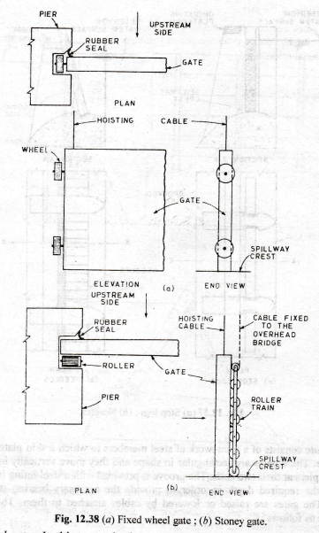

Fig. shows plan and elevation of fixed-wheel and Stoney gates. For both these types of gates rubber sheet or belting is used along the sides on the upstream face of the gate to seal the openings between the gate and sides of the pier.
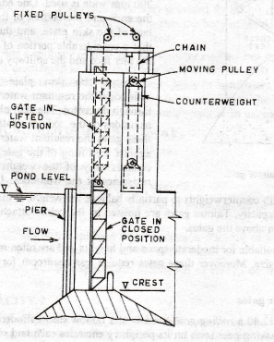

All vertical lift gates are counterbalanced by a counterweight beam. which is loaded to balance almost the entire dead weight of the gate. The lifting force is, therefore, required to balance only the frictional resistance.

Vertical lift gates are operated from an overhead platform by winches which can be worked manually or by power. Vertical lift gates have been used for spans as wide as 15 m or more and for heights upto 15 m. With the increase in the height of the gate the headroom or the height of the operating platform increases because the platform has to be located above the raised position of the gate. Moreover the bottom of the gate in its lifted position must be sufficiently above the high flood level to enable the floating debris to pass. To reduce the height of the operating platform, high gates may be built in two or sometimes three horizontal sections, one above the other. The different section of the gate may be placed either in different grooves with each section overlapping the lower one; or in the same groove with different sections flushing with each other.

When all the sections are placed in the same groove then for raising the gate fully the upper section of the gate may be lifted and removed from the grooves and the lower section may then be lifted and held in raised position within the grooves. The division of the gate into different sections also reduces the load on the hoisting mechanism.

Tainter gates or Radial gates
A Tainter gate consists of a skin plate of steel formed to a segment of a cylinder supported on a steel frame-work which is pivoted on trunnions or pins set in the downstream portion of the piers on the spillway (Fig). Thus when the gate is raised or lowered it rotates about a fixed horizontal axis through the trunnions. Rubber seals are provided between the gate and the piers and spillway crest. For this rubber sheet or belting 150 to 200 mm wide is used. One edge of the sheet is attached to the ends and the bottom of the gate around the upstream face of the skin plate, and the other edge is bent back so that a considerable portion of the width is in contact with the pier face and the spillway crest. Since the skin plate which supports water is cylindrical the resultant water pressure acting on it passes through its centre.
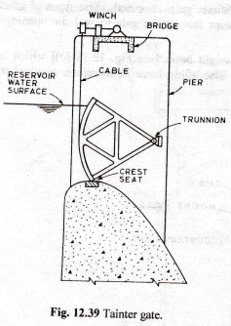
The skin plate is made concentric to the trunnions or the axis of rotation, and hence in the case of these gates the resultant water pressure creates no moment against the lifting of the gate. The hoisting load therefore consists only of the weight of the gate the friction resistance at the trunnions. Larger tainter gates are also sometimes provided with counterweights to partially balance the weight of the gate, which further reduces the required hoisting capacity. Tainter gates are hoisted by the cables attached to them and extending to the winches on platform above the gates. Tainter gates are suitable for moderate spans and heights and are often more economical than vertical lift gates of the same size. Moreover these gates require less headroom for the operating platform than vertical lift gates.

Rolling gates or Roller gates As shown in Fig. a rolling gate consists of a hollow steel cylinder spanning between the piers. A heavy annular rim having gear teeth on its periphery encircles each end of the cylinder. Each pier has an inclined rack which engages the gear teeth encircling the cylinder. The gate is rolled up the inclined rack by exerting a pull on the hoisting cable attached to the cylinder. At the lower portion of the cylinder a cylindrical segment is attached which remains in contact with the spillway crest and increases the gate height. Rolling gates are suitable for long spans and moderate heights.

Drum gates A drum gate consists of a segment of a cylinder formed by skin plates attached to internal bracing (Fig.). It is hinged at the centre of curvature, which may be either upstream or downstream. In the open or lowered position the gate fits in a recesses in the top of spillway. When water is admitted to the • recess, the hollow drum gate is forced upward to the closed position. A type of drum gate developed by U.S. Bureau of Reclamation is shown in Fig. (a) which is a completely enclosed gate, hinged at the upstream edge so that buoyant forces aid in its lifting. When lowered this gate conforms closely to the shape of the ogee crest. This type of gate may be made to operate automatically. The second type of drum gate as shown in Fig.(b) has no bottom plate and is hinged at the downstream edge. In this case the gate is raised only by the water pressure.

The drum gates are also normally used for long spans and moderate heights. However, on account of large cavity required by drum gates in the lowered position these gates are not suited to low dams.

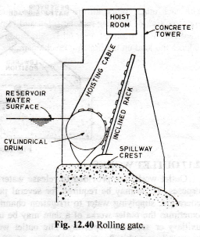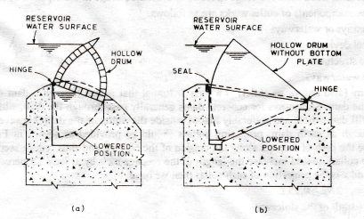

Bear-trap gates A bear-trap gate consists of two leaves of timber or steel hinged and sealed to the spillway crest (Fig.). One of the leaves which is on the upstream side is hinged and sealed along its upstream edge and the other which is on the downstream side is hinged and sealed along its downstream edge. When the gate is lowered, the leaves are in horizontal position with one leaf lying on top of the other and the downstream leaf being housed in a recess in the spillway crest. When water is admitted to the space below the leaves, they are forced upward to the closed position. The downstream leaf is frequently hollow so that its buoyancy aids the lifting operation. The bear-trap gates require a wide base but avoid a deep chamber These gates may also be mark to operate automatically.

