**UNIT I**

**Construction PLANNING AND Management**

**SIGNIFICANCE OF CONSTRUCTION MANAGEMENT**

Right from early ages when man decided to abandon a wandering life style and settle down, the need for shelter has been one of his primary concerns. Building a shelter was perhaps the earliest construction activity undertaken by man. Construction is thus an age-old profession. The art of construction has slowly developed into a science over the centuries. There are several complex old monuments and other intricate construction works in India which bear testimony to the great skills and ingenuity of past craftsmen. During the 19th century, development of the construction industry

In India was relatively slow. Since independence in 1947, industry in India has witnessed large scale mechanisation; rapid changes and advances have taken place in construction practice and in the management of construction jobs. Construction today is an all-embracing term, covering activities from conception to physical realisation of a project; it is not limited only to the physical activities of deploying men, materials and machinery. This enlarged scope of the term became inevitable in view of the increasing variety and magnitude of construction activity.

**Objectives**

The main objectives of construction monogenic-, are:

1. Completing the work within estimated budget and specified time.
2. Evoking a reputation for high quality workmanship.
3. Providing safe and satisfactory working conditions for all personnel and workers.
4. Taking sound decisions at the lowest practical management level through delegation of authority.

0) Motivating people to give of their best within their capacities. (sit Creating an organization that works as a team).

**FUNCTIONS OF CONSTRUCTION MANAGEMENT**

**(ii) Planning:** Planning is best suited from the stand-point of available resources constraints and imposed upon the project. It essentially covers the aspects of 'What to do' and 'How to do it'. Scheduling is the fitting of the final work plan to a time scale. It shows the duration and order of various construction activities. It deals with the aspect of ‘when to do it'.

**(ii) Organising:** Organising is concerned with division of the total construction work into manageable departments/sections and systematically arranging various operations by delegating specific tasks to individuals.

The relationship between various personnel are established and the organisational structure of the project is depicted by a simple flow chart.

**(iii) Staffing:** Organising involves the division of project work into sections and staffing is the provision of people to fill the positions so created. Recruiting the right people, arranging staff training courses and carrying out proper staff assessment arc all part of the staffing function.

**(iv) Directing:** The directing function is concerned with training sub-ordinates to carry out assigned tasks, supervising their work and guiding their efforts. The essence of directing lies in the ability to motivate people individually and as groups to utilise their creative efforts in achieving specified objectives.

**(v) Controlling:** Controlling is necessary for ensuring effective and efficient working. It involves a constant review of the work plan to check on to discover and rectify deviations through appropriate.

**STAGES IN CONSTRUCTION**

1. Directing

2. Designing

3. Tendering

4. Commissioning

5. Constructioning

**(I) Briefing stage::** Also called the `Report Stage', it is the stage where ideas originated by individuals are studied with regard to cost and benefits so as to establish the economic viability or social utility of a project.

**Purpose**:: The purpose of this stage is to enable the client (owner) to specify project functions and permissible costs so that architects, engineers and other members of the construction team can correctly interpret the owner's wishes and provide a likely estimate of costs. It also leads to an objective decision on the scope and feasibility of the project.

**Activities:** A civil engineering project should begin with a thorough investigation of its scope and economic feasibility. This is the preliminary stage and many factors at this stage are not clearly defined but are broadly stated. Various activities involved in the briefing stage are:

(a) To appoint a project steering committee, if necessary.

(h) To appoint a project manager who will have a continuing responsibility to the client throughout the construction process.

(c) To carry out extensive investigations which include both technical and non-technical investigations so that alternative proposals may be given due consideration. Non-technical investigations include economic and social factors which may define the basic requirements or scope of the project. These also include market surveys for resource identification. Technical investigations include land and geological surveys including site investigations such as soil samples and ground water levels from bore-holes.

(d) To study various alternatives and identify the most feasible one.

Construction Planning and Management

(c) To prepare the project report which is the outcome of the first stage (i.e. briefing stage). The project report describes the investigations carried out, possible solutions and their evaluation.

**(ii) Designing or Planning Stage**: It is a very important stage in the field of construction because any modification in the project after this stage would prove expensive. A realistic and detailed cost estimate of the project can be prepared during the design stage.

**Purpose:** The purpose of this stage is to complete the project summary and determine the method of construction and estimate costs so as to obtain necessary approvals from the client(s). Its purpose also includes the preparation of working drawings, Specifications and all arrangements for inviting tenders.

**Activities at this stage are:**

(a) To develop the project summary suitable alternative. y for final adoption of the most

(b) To carry out technical investigations such as soil investigation, graphic investigation, material supply and market surveys etc.

(c) To prepare detailed designs, working drawings, specifications, bill of quantities, final cost estimate and preliminary including time construction programme

(d) To obtain the owner's final approval of the project summary.

FINALISE PROJECT SUMMARY

CARRY OUT TECHNICAL INVESTIGATIONS

PREPARE SCHEME AND DETAILED DESIGNS

PREPARE WORKING DRAWINGS AND SPECIFICATIONS

PREPARE FINAL COST ESTIMATE.

PREPARE CONSTRUCTION PROGRAMME/SCHEDULE

**(iii) Tendering Stage:** It is the stage in which tenders are called and the contract is awarded at the best available terms mutually agreed between the owner's team and the contractors.

Purpose The purpose of this stage is to appoint a contractor or a number of contractors who will undertake the construction work on the most suitable terms and conditions of quality, cost and completion time.

**Activities**

The main activity involved in this stage is to obtain tenders from contractors for the construction work and to award the contract. During this stage, the owner enters into a firm commitment regarding the project expenditure and the procedures of construction are carefully defined. Government tendering procedures are closely controlled to ensure that contracts are awarded in a uniform way. Some works may he done depart-mentally. Orders arc issued by the competent authority authorising expenditure and execution of the work.

**ENGINEERING DRAWINGS**

In the case of small projects, design work at preliminary stage may sufficiently detailed depending upon the expert hence and background of the designer. In such cases, tender drawings. contract drawings, However in the case of large projects, these drawings are prepared at ‘of execution and hence these are prefixed because .eat care and with particular attention to drafting and presentation for proposal. The contractor is concerned with the clarity anci121 expression of engineering derails.

(i)Tender drawings are prepared to various scales using conventions and concepts of engineering drawing for production, manufacture, and construction etc.

(ii) Contract Drawings The engineer can any on with the detailed design only after the completion of tender drawings During the tendering stage, contractors will be busy in interpreting the tender drawings and preparing their bids. Sometimes a contractor may be skilled in a particular method of construction that is different from the one shown in the tender drawings. He may submit a tender based upon his speciality even though it proposes a modification in the original design envisaged in the tender notice. If the contractor's team is competitive and the

(iii) Working Drawings The working drawings fill the constructional details not reflected drawings. As the name itself indicates, working drawings are used for constructing'

**CONSTRUCTION TEAM**

While architects and some sections of the engineering profession carry out the designs of buildings, the execution is the role of Builders, the project manager and the necessary technical supporting personnel. In the light of the above, let us examine the specific roles and conducts of construction professionals in executing building projects.

**Surveyor**

is the custodian of land information. The size, topography, location, features on and beneath the land upon which any development is built, is determined first by surveyors. Without this information, no proper, adequate, effective and accurate planning, design and execution of building projects can be carried out

**THE TOWN PLANER**

Town planner is responsible for the orderliness in the developmental layout to show the various land use. Master plan, layout etc prepared by a Town planner normally take into consideration the population, culture, infrastructural facilities, socio economic, political, health and other human needs. During the execution stage, Town Planners will also ensure that the orderliness in the layout is not distorted and that the approval given is also adhered to strictly. For some building projects, there are needs for environmental impact assessment, which may be carried out by a town planner who has developed knowledge in this specialized area. This exercise must be carried out in collaboration with other relevant professionals. Town planners also carry out Site Analysis Report for building projects. THE ARCHITECT The architect may help the client to formulate his requirements in an understandable form, bearing in mind any statutory conditions that may apply. It will be advantageous to the client at this stage if he could be shown work of a similar nature so that he could obtain a visual impression of shape, type of materials, size etc. if this is not possible, pictorial sketches and/or model can be used, but it is often difficult for the client to visualize the true structure from these very artistic representations. Secondly, under the traditional procurement method, the architect may need to help the client to bring together a team to give specific services such as that of a structural engineer, quantity surveyor, builder, mechanical/electrical engineers, etc. Upon assessing cost limits and time scaled, conceptual design can be produced for client to approve or otherwise, before more detailed drawings are prepared. The cost of the building will have been broken down against elements at this stage with approximate values so that if cost are to be adjusted it can be done within elements, e.g, substructure, superstructure, internal finishes, M/E services, and so on. When general agreement has been reached between the client, and the consultants, the architect can now start detail design and preparation of contract drawings, schedules and specifications to enable tenders to be obtained. It is worthwhile to note that the situation whereby architectural drawings would have been completed before the structural and building services engineer’s designs are commenced and inputs from a builder are obtained is not ideal and should not be encouraged by any member of the building project team. With the completion of the tender documents, the architect and the other consultants will assist the client in selecting the contractors to be invited to tender for the construction of the building

**THE ENGINEERS**

Engineers are very important members of the design team whose responsibilities are to assist in the overall design of the project within the scope of their specialist fields. Engineers such as geotechnical, structural, electrical, mechanical, and will so on, will carry out various analyses and calculations before arriving at the optimal design solution for a specific building. Thereafter, they will produce drawings, specifications, schedules and other relevant data that may be required for the overall design of the project and to assist the quantity surveyor in the preparation of bills of quantities and costing and the client in his assessment of the suitability of the project, regarding statutory requirements. During project execution stage, engineers should visit the site periodically for inspections to ensure that in general, the work being carried out is in compliance with their engineering drawings, schedules and specifications. They must also be available to modify or re-design their individual aspects as may become necessary. Also some projects may require the services of resident engineers on the building project site.

**THE QUANTITY SURVEYOR**

A quantity surveyor should be called upon in the early stages of consultation by the client because of his expertise in construction costs. He should prepare first of all, a cost plan as soon as the brief is settled, an approximate cost from sketch drawings, elemental cost checks during design, so that, should the client’s sum be exceeded, the designers can consider each element of the building project in reasonable isolation, enabling him to pair costs as necessary, within the total cost limit of the project. Upon acceptance by the client of costs and scheme, a quantity Surveyor’s next task after the receipt of designer’s drawings is to prepare a Bill of Quantities (B.O.Q) in accordance with the current Standard Method of Measurement (SMM). This is a very important section of the quantity surveyor’s responsibilities and great care should be taken to ensure accuracy. The bill of quantities can only be as good or accurate as the drawings, schedules and specifications used for its preparation

(1). During the preparation of the bills of quantities, the quantity surveyor has the opportunity to check dimensions and advice on alternative materials. The quantity surveyor could also advice the client on the appropriate form of contact to use. The quantity surveyor will definitely prepare the contract documents in close consultation with other consultants on a project

(2). When tender documents are sent out to contracts, the quantity surveyor must also price the BOQ and his priced bill of quantities must be submitted and opened at the same time as those of the tendering contractors. Once the tenders have been opened and recorded in the presence of the other consultants, the tendering contractors and the project manager client representative, the quantity surveyor must check all the tenders for accuracy and consistency in pricing etc to ensure that the contractors made no serious errors, which could cause complications at a later date. The quantity surveyor should then prepare a tender report on the contractor’s tenders for consideration at the Contractor Selection Meeting. During the construction stage, the quantity surveyor will carry out interim valuations, value variations, ascertain the amount of direct loss and/or expense incurred by the contractor, agree fluctuations with the contractor, prepare the statement of retention’s etc. All these should be done in conjunction with the contractor’s quantity surveyor who should be allowed to be present at such times when physical measurement are being carried out on the site. In carrying out his duties, the quantity surveyor must remain completely impartial and without favour to either side and so produce harmony in his role as a project cost manager. The quantity surveyor has a fiduciary responsibility to ascertain that the client obtains value for his money and the contractor an acceptable profit for work done. On completion of the construction stage, the quantity surveyor should assist the project manager in discussions with the contractor as to extra contractual costs. The quantity surveyor must also prepare, with the aid of the contractor’s invoices and other documents, the final account.

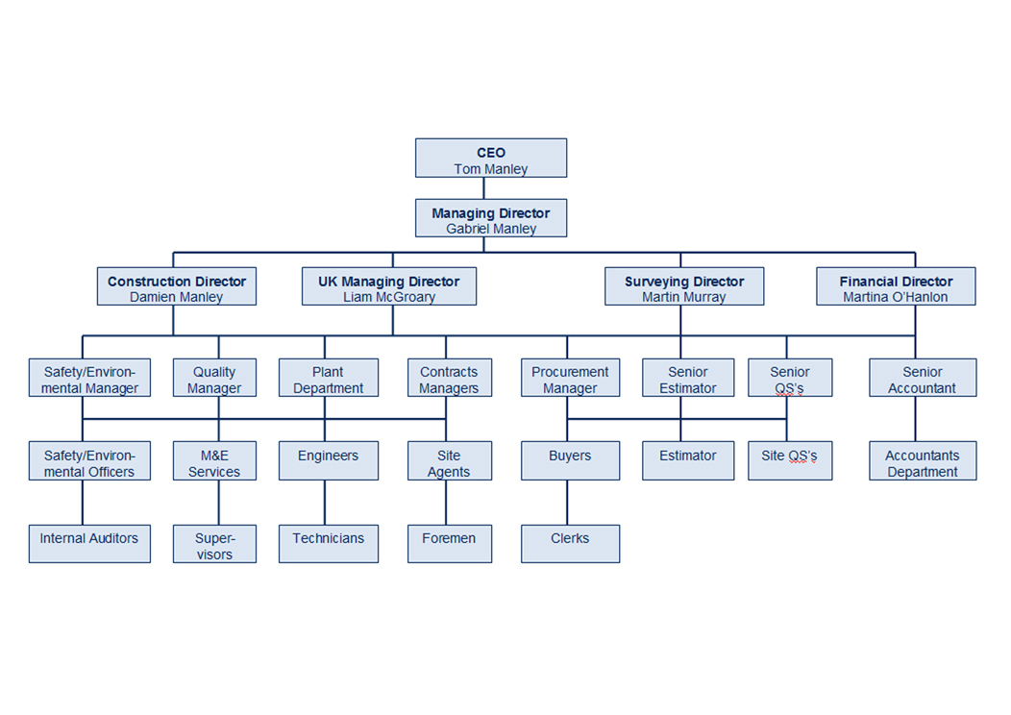

**THE BUILDER**

A Builder is the professional at the centre of the physical construction of buildings. His role in building development process in general, is to construct the building. He does this by taking charge of the activities on a building construction site in translating designs, working drawings, schedules and specifications into a physical structure. He uses his production management expertise, coupled with the necessary resources such as money, manpower, materials, and machineries, in the site execution of building projects. His expertise in Building production management is the main professional input that he renders on building projects. In constructing buildings, a Builder performs the following roles:

**THE PROJECT MANAGER**

While the responsibility for complying with specifications is firmly placed with the contractor, the unspoken assumption is made that unless a client maintains his own representative (the project manager) on the site to watch and inspect the works, the resultant structure or building will not be in conformity with specified quality standard (4). While one may agree with the statement, one will like to believe that it is in recognition of this statement of fact that all the standard form of building contracts always has a condition for the client to have a representative on site. The role of the client representative o site is to inspect quality of materials and the workmanship to ensure that they all comply with drawings and specifications. The person capable of inspecting materials and the workmanship of works must be a professional that is well trained in building construction, and with training in project management. However, the size, type and complexity of a particular building project may make it necessary to have in addition to the project manager, a resident builder, resident engineers and a resident architect(5). When they are all on site representing the interest of the client, their roles are complementary. For example, while the resident architect will inspect those materials, and components specified by the project architect and also check dimensions physically on site, the engineers will equally inspect materials specified by each one of them (structural, electrical and mechanical) and their positioning in the works, the resident builder will have to ensure by way of continuous inspections the implementation of construction methodology and the project manager will ensure that the project quality management plan and stage of work is in conformity with the design. The contractor should usually cooperate with the project manager and treat him as the senior member of the project team whose assistance and advice as to outstanding project execution information, interpretation of designer’s intentions, contract conditions, and so on, cannot be done without. The project manager, as the client’s representative must submit reports periodically to the client.