**Environmental Pollution**

Pollution is derived from Latin word ‘polluere’ which means ‘to contaminate’ any feature of environment. Pollution is the effect of undesirable changes in the surroundings that have harmful effect on plants, animals and human beings. This occurs only when short term economic gains are made at the cost of long term ecological benefits of humanity. *Environmental pollution* is defined as an undesirable change in the physical, chemical and biological characteristics of any component of the environment (water, soil, air) that can cause harmful effect on various forms of life and property. Pollution can be primary (effects immediately on release to the environment) or secondary (product of interaction after release with moisture, sunlight, other pollutants etc.) pollution may be local, regional, trans boundary or global. The agent which cause pollution is called pollutant.

Pollutants can be classified as:

1. Degradable or non persistent pollutants: These can be rapidly broken by natural processes. *Eg.* Domestic sewage, discarded vegetables *etc*.

2. Slowly degradable or persistent pollutants: These remain in the environment for many years in an unchanged condition and take decades or longer to degrade. *Eg*: DDT

3. Non degradable pollutants: These cannot be degraded by natural processes. *Eg:* Toxic elements like lead or mercury and nuclear wastes.

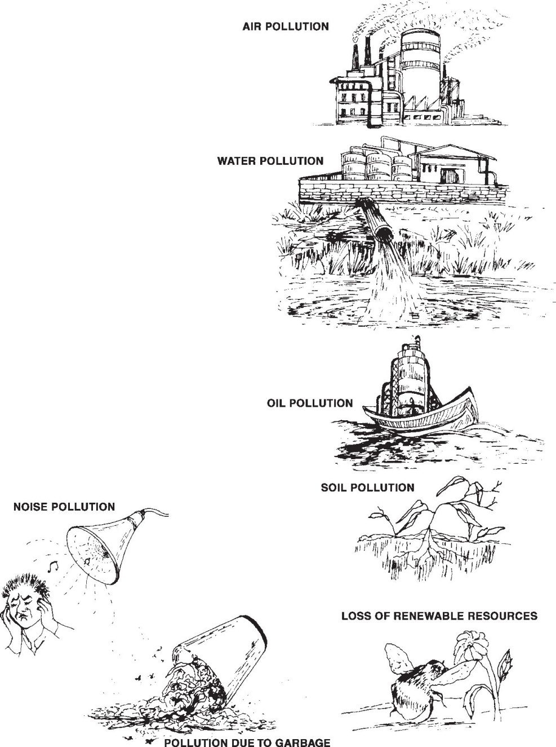Various types of pollutions namely air, water, soil, marine, thermal and noise pollution are presented here under

**AIR POLLUTION**

Air pollution occurs due to the presence of undesirable solid or gaseous particles in the air in quantities that are harmful to human health and environment. It can be defined as presence of foreign matter either gaseous or particulate or combination of both in the air which is detrimental to the health and welfare of human beings.

Pollutants that are emitted directly from identifiable sources are produced by natural events can be in the form of particulate matter or gaseous form. These are called primary pollutants *Ex* : Dust storms and volcanic eruptions and through human activities like emission from vehicles, industries *etc.* There are five primary pollutants that contribute to 90% of global air pollution. These are carbon oxides (CO & CO2), N oxides, sulphur oxides, volatile organic compounds and suspended particulate matter.

The pollutants that are produced in the atmosphere, when certain chemical reactions take place among the primary pollutants and with others in the atmosphere are called secondary air pollutants. Eg: Sulphuric acid nitric acid, carbonic acid and acid rain.

Particulates are small pieces of solid material. Particulate matter can be 1) Natural such as dust, seeds, spores, pollen grains, algae fungi, bacteria and viruses 2) Anthropogenic such as mineral dust, cement, asbestos dust, fibers, metal dust, fly ash smoke particles form fires etc.

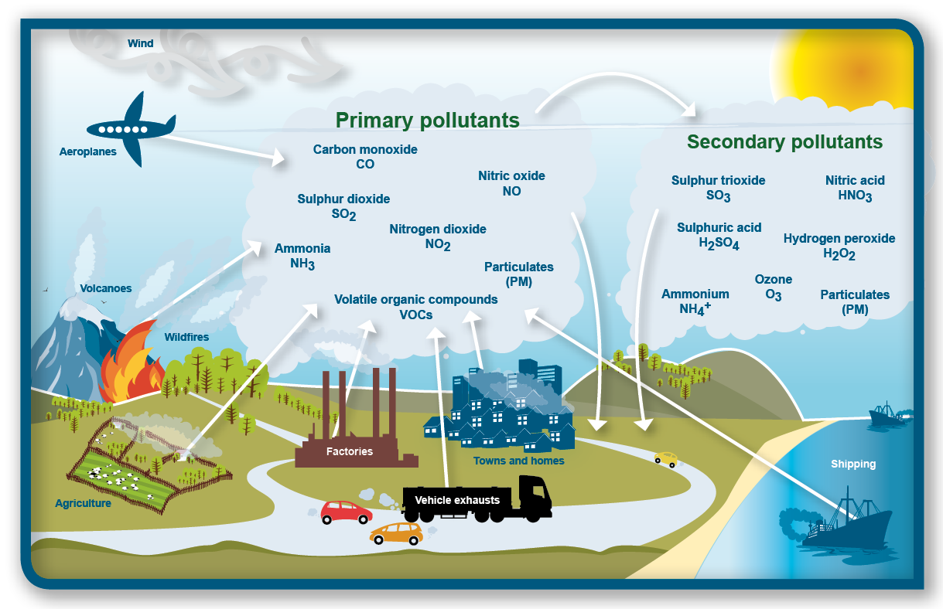

**Causes of Air pollution**

Air pollution may originate from one or more variety of sources. The natural pollution include sources such as oceanic aerosol, volcanic emissions, biogenic sources, windblown terrestrial dust and lightening. The artificial pollution generates from human activities and includes sources such as fuel burning, refuge burning, transportation, construction of buildings, chemical factories, metallurgical factories and, vehicles.

The third category includes solvent usage and sources include spray painting and solvent extraction. Automobiles are the first rate of polluters. Industries occupy second position.

**Effects of Air Pollution:**

1. **Effects on human health:** Particulates cause carcinogenic effects, accumulate inlungs and interfere with ability of lungs to exchange gases. Prolongeal exposure causes lung cancer and asthma. Cigarette smoking is responsible for greatest exposure to carbon monoxide (CO). Exposure to air containing even 0.001% of CO for several hours can cause collapse, coma and even death. As CO remains attached to haemoglobin in the blood for a long time, it accumulates and reduces the oxygen carrying capacity of blood. This impairs thinking, causes headaches, drowsiness and nausea. SO2 irritates the respiratory tissues. NO2 can irritate lungs, aggravate asthma and susceptibility to influenza and common colds. Many volatile organic compounds (benzene and formaldehyde) and toxic particulates can cause mutations and cancer.
2. **Effects on plants** : Gaseous pollutants enter the leaf pores and damage the leaves ofcrop plants, interfere with photosynthesis and plants growth and reduces nutrient uptake and causes the leaves to turn yellow, brown or drop off altogether.
3. **On materials** : Air pollutants break down the exterior paint on cars and houses.
4. **Effect on stratosphere** : The upper stratosphere consists of considerable amounts of ozone, which works as an effective screen for UV light. This region is called ozone layer, which extends up to 60km above the surface of the earth. Ozone is a form of oxygen with 3 atoms instead of 2. It is produced naturally in the atmosphere. Presence of certain pollutants can accelerate the breakdown of ozone. Depletion of ozone effects human health, food productivity and climate as given below.
5. **Effects on human health**: - Sun burn, cataract, aging of skin and skincancer are caused by increased UV radiation. It weakens the immune system by supporting the body’s resistance to certain infections like measles, chickenpox & other viral diseases.
6. **Effect on Food Production**: UV radiation affects the ability of plants tocapture light energy during the process of photosynthesis. This reduces the nutrient content and growth of plants mostly in legumes and cabbage. Plants and animals are damaged by UV radiations**.**
7. **Effects on climate**: Contribute to global warming, a phenomenon which iscaused due to the increase in concentration of certain gases like CO2, NO2methane and chlorofluorocarbons (CFCs).

**Control measures:** Two approaches

1. Preventive technique
2. Effective control

Effective means of controlling air pollution is to have proper equipments in place. This includes devices for removal of pollutants form fuel gases through scrubbers, closed fuel collection recovery systems. The use of dry and wet collectors, filters, electrostatic precipitators etc.

Using unleaded petrol for vehicles is another way of control. The substitution of raw materials that cause more pollution with those that cause less pollution. Building higher smoke –stacks facilitate the discharge of pollutants as far away from the ground as possible. Industries should be carefully located so as to minimize the effect of pollution after considering topography and wind directions.

**Ambient air quality standards in India by the central pollution control board**

|  |  |  |  |  |
| --- | --- | --- | --- | --- |
| **Area Category** | **SPM µg/m3** | **SO2 µg/m3** | **CO µg/m3** | **NOX µg/m3** |
|  |  |  |  |  |
| Industrial & mixed use | 500 | 120 | 5000 | 120 |
|  |  |  |  |  |
| Residential and rural | 200 | 80 | 2000 | 80 |
|  |  |  |  |  |
| Sensitive | 100 | 3 | 1000 | 30 |
|  |  |  |  |  |

***Case study on environmental impact of Iceland volcanic eruption***

*The air traffic disruption caused by the Iceland volcano eruption in 2010 highlighted the environmental impacts of atmospheric dust from volcanic eruption. The volcanic ash, in effect pulverized rock, was spewed between 20,000 to 40,000 feet into the atmosphere right where modern aircraft ply their trade. This atmospheric dust not only hinders visibility but can also damage aircraft engines, forcing them to shut down completely. The fact that this disruption is not only affecting the countries of Europe, but has a knock on effect on all worldwide flights that have a European destination. Volcanoes can spew atmospheric dust and gases tens of kilometres into the earth’s atmosphere where prevailing winds can very quickly transport them thousands of kilometers from the original eruption. Volcanic ash can lower visibility in the upper atmosphere and knock out aircraft engines. Widespread ash from volcanic eruptions increase the Earth’s “Albedo Effect”, cooling the temperature of the lower troposphere while increasing the temperature of the stratosphere.*

*Volcanic activity is estimated to be responsible for the release of 130 million tonnes of carbon dioxide into the atmosphere annually. Sulphur dioxide, a major ingredient of volcanic activity, is the primary cause of environmentally damaging acid rain. It also forms sulphuric acid mists which causes pulmonary damage to both people and animals. Hydrogen sulphide, a colourless gas with an offensive odour, causes irritation of the upper respiratory tract and pulmonary edema. Atmospheric dust from volcanoes can act as a magnet for other pollutants and water vapour, giving rise to atmospheric hazes and heavy fogs.*

**SOIL POLLUTION**

Soil is a natural resource for which there is no substitute. Environmental historian Donald Worster reminds us that fertilizers are not a substitute for fertile soil. Soil cannot be manufactured with a tank of chemicals. Soil is formed from the parent material by physical and chemical weathering of rocks. Climate and time are also important in the development of soils. Extremely dry or cold climates develop soils very slowly while humid and warm climates develop them more rapidly. It is a thin covering over the land consisting of a mixture of minerals, organic material, living organisms, air and water that together support the growth of plant life. The organic portion, which is derived from the decayed remains of plants and animals, is concentrated in the dark uppermost “top soil”.

The inorganic portion, which is made up of rock fragments, is formed over thousands of years by physical and chemical weathering of bedrock. We may enhance the soil by helping its processes along, but we can never recreate what we destroy. Soil pollution is the introduction of substances, biological organisms, or energy into the soil, resulting in a change of the soil quality, which is likely to affect the normal use of the soil or endangering public health and the living environment.

**Causes of Soil Pollution**

1. Erosion**:** Soil erosion can be defined as the movement of surface litter and topsoil from one place to another. It is a natural process often caused by wind and flowing water, accelerated by human activities such as farming, construction, overgrazing by livestock, burning of grass cover and deforestation.
2. Soil contaminants are spilled onto the surface though many different activities. Most of these are the result of accidents involving the vehicles that are transporting waste material from the site at which it originated to the site at which it is to be deposited. Others involve accidents involving vehicles (automobiles, trucks and airplanes) not transporting wastes, but carrying materials, including fuel, that when spilled contaminate the soil. When any liquid pollutant is on or just below the ground the surface for any period of time, one of these could happen to it, if it is not cleaned up first.
3. Pollutant might be washed away by precipitation, causing little or no harm to the ground on which it is found (however, pollutants will simply accumulate somewhere else).The pollutant, if volatile, could evaporate, again causing little harm to the soil (however, not a solution to the bigger pollution problem, as it might become a source of air pollution).
4. Excess use of fertilizers and pesticides: Pollutant could infiltrate through the unsaturated soil, same way has ground water. Agricultural practices including the use of agriculture chemicals is primary sources of pollution on or near the ground surface. Most agricultural chemicals are water soluble, nitrates and phosphates that are applied to fields, lawn and gardens to stimulate the growth of crops, gross and flowers. Farmers are generally use fertilizers to correct soil deficiency. Mixed fertilizers often contain ammonium nitrate, phosphorus and potassium.
5. Excess use of irrigation water

***Effects of Soil Pollution***

1. *Food shortage:* The foremost effect of loosing top soil is causing water pollutionand reduced food production leading to food shortage. With population growth, it becomes more critical.
2. *Desertification:* Continuous exposure of eroded soil to sun for longer periodsmay transform the land into sandy and rocky in nature. These are symptoms of desertification rendering the soil unsuitable for cultivation.
3. Decrease in the extent of agricultural land
4. Top soil which is washed away also contributes water pollution by clogging of lakes, and increasing turbidity of water, ultimately leading to loss of aquatic life.
5. Excess use of irrigation leads to water logging and soil salinisation.
6. Fertilizer run off leads to the eutrophication of waterways.

***Control measures***

1. Proper soil conservation measures to minimize the loss of top soil
2. INM, IPM, using bio pesticides and integrated environment friendly agriculture to reduce pesticides or fertilizers**.**
3. Appropriate water management practices in agriculture
4. Keeping the soil surface covered with crop residues or crop cover
5. Planting trees as a part of afforestation/ shelter belts/wind breakers
6. ***Cleaning up of polluted soil***

Soil pollution information needed to clean up materials added to soil include the following:

1. Kind of material—organic or inorganic—is the material biodegradable, is the material dangerous to animals and humans.
2. C: N ratio of the pollutant material.
   1. Nature of soil
3. Growing conditions for the soil organisms
4. How long as the material been on the site
5. Immediate danger to people and the environment.

***One of the techniques for cleaning polluted soils is bioremediation***

*Bioremediation* can be defined as any process that uses microorganisms, fungi, greenplants or their enzymes to return the natural environment altered by contaminants to its original condition. Bioremediation may be employed to attack specific soil contaminants, such as degradation of chlorinated hydrocarbons by bacteria. Generally requires a mechanism for stimulating and maintaining the activity of the microorganisms, e.g., addition of an electron acceptor (oxygen, nitrate); nutrients (nitrogen, phosphorus); and an energy source (carbon). An example of a more general approach is the cleanup of oil spills by the addition of nitrate and/or sulfate fertilisers to facilitate the decomposition of crude oil by indigenous or exogenous bacteria.

Naturally occurring bioremedia tion and phytoremediation have been used for centuries. For example, desalination of agricultural land by phytoextraction has a long tradition. Bioremediation technologies can be generally classified as *in situ* or *ex situ. In* *situ* bioremediation involves treating the contaminated material at the site. *Ex situ* involves the removal of the contaminated material to be treated elsewhere. Conditions that favour Bioremediation include the following:

* Temperature favorable for organisms
* Availability of water
* Availability of nutrients (N,P, K)
* C:N ratio of the contaminant material
* Availability of oxygen in sufficient quantity in the soil

Some examples of bioremediation technologies are bioventing (injection of air/nutrients into unsaturated zone), land farming, bioreactor, composting, bioaugmentation (inoculation of soil with microbes), rhizofiltration, and biostimulation (stimulation of biological activity) and biosparging (injection of air/nutrients into unsaturated and saturated zone).

Not all contaminants, however, are easily treated by bioremediation using microorganisms. For example, heavy metals such as cadmium and lead are not readily absorbed or captured by organisms. The assimilation of metals such as mercury into the food chain may worsen matters. Phytoremediation is useful in these circumstances, because natural plants or transgenic plants are able to bioaccumulate these toxins in their above ground parts, which are then harvested for removal. The heavy metals in the harvested biomass may be further concentrated by incineration or even recycled for industrial reuse. dsvhbdghdghdfghdsfhfdhdfhdfgdgvdfgdfgdfgdfgfg

**WATER POLLUTION**

When the quality or composition of water changes directly or indirectly as a result of man’s activities such that it becomes unfit for any useful purpose is said to be polluted.

**Two types of pollutions** :

**Point source of pollution**: This source of pollution can be readily identified because it has a definite source and place, where it enters the water. Eg: Municipal industrial discharges pipes.

**Non point source of pollution**: when a source of pollution cannot be readily identifiedsuch as agricultural runoff, acid rain etc, it is called as non point source of pollution.

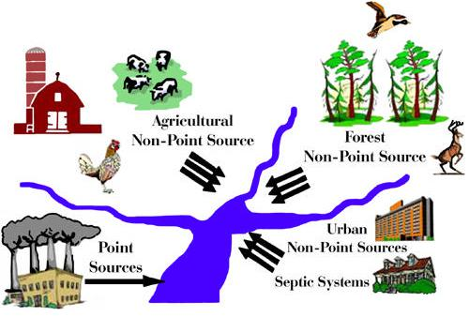

**Causes of water pollution**: (surface water)

* **Disease causing agents** parasitic worms, bacteria, viruses, protozoa that enter waterfrom domestic sewage and untreated human and animal wastes.
* **Oxygen depleting wastes**: These are organic wastes that can be decomposed byaerobic bacteria. The amount of oxygen required to break down a certain amount of organic matter is called BOD. It is an indicator of level of pollution.
* **Inorganic plant nutrients** : These are water soluble nitrates and phosphates**.**
* **Excess pesticides:** For control of pest pesticides are used in discriminately. These fallon ground and leach with rain water to canals and rivers.
* **Water soluble organic chemicals**: These are acids, salts and compounds of toxicmetals such as mercury & lead**.**
* **Variety of organic chemicals** : includes oil, gasoline, plastics, pesticides, detergents& many other chemicals.
* **The sediments of suspended matter**: Occur when soil is eroded.
* **Water soluble radioactive isotopes**: Enter the water courses along with rain water.
* **Hot water** released by power plants & industries that use large volume of water tocool the plant results in a rise in temp of local water bodies.
* Acid drainage into rivers.

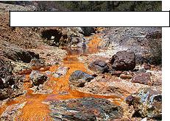

**ACID MINE DRAINAGE INTO THE RIVER**

**ACID MINE DRAINAGE INTO THE RIVER**

**ACID MINE DRAINAGE INTO THE RIVER**

***Ground water pollution***: A greater threat to human life comes from ground water whichis used for drinking and irrigation being polluted.

***Causes of ground water pollution***:

1. Urban runoff of untreated or poorly treated waste water storage and garbage
2. Industrial waste storage located above or near aquifer
3. Agricultural practices such as application of large amounts of fertilizers and pesticides, animal feeding operations etc in rural sector
4. Leaks from underground storage tanks containing gasoline and other hazardous substances
5. Leachate from land fills
6. Poorly designed and inadequately maintained septic tanks
7. Mining waters

***Case study:Cashew in Kasargod, Kerala poisonous nuts***

*Endosulfan, a pesticide banned by many countries in the world including India was extensively sprayed aerially in the cashew plantations of Plantation Corporation of Kerala (PCK) spread over 2209 hectares in various divisions of Kasargod district, Kerala. Endosulfan is slated to be phased out globally under the Stockholm Convention 2001, to which India is a signatory. The pesticide is classified as an organochlorine compound and its breakdown products are persistent in the environment, with an estimated half-life of nine months to six years. It is known to* *potentially bioaccumulate in humans and other animals, in the liver, kidneys and fatty tissue. PCK started using this pesticide in 1979 and unusual health disorders were reported from places like Vaninagar, Adur, Mulleria, Padre etc. The people were unaware that this was a lethal poison. A study conducted by the Centre for Science and Environment (CSE) confirmed the presence of high quantities of endosulfan in the samples of water, soil, fruits, mother’s milk and blood in Kasargode. Further disorders of the central nervous system, cerebral palsy, mental and physical retardation, epilepsy and congenital anomalies like stag horns, liver cancer, blood cancer, infertility, miscarriages, hormonal imbalances, skin diseases and asthma have been reported. All these disorders were traced to endosulfan effects. After mass agitations and several reports by various agencies, the use of endosulfan was banned in Kerala in August 2001. Though, the state government has paid compensations, the rehabilitation of the living victims is really tough and challenging. Reports reveal that approximately, 224 people were critically affected and 226 have a 60 per cent disability. This tragedy was spread over 20 villages in the state. (Ref: Sushmitha Baskar and R.Baskar).*

***Effects of Water pollution***:

1. Large amount of human waste in water increase the number of bacteria such as *Escherichia coli* and *streptococcus* sps which cause gastro intestinal diseases.Water borne diseases diarrhea, typhoid *etc.*

2. If more organic matter is added to water the O2 is used up. This causes fish and other forms of O2 dependent aquatic life dies.

3. Eutrophication due to inorganic pollutants.

4. Excess pesticides cause Biomagnification.

5. High levels of organic chemicals (acids, salts& toxic metals) can make the water unfit to drink, harm fish and other aquatic life, reduce crop yields

6. Variety of organic chemicals / oil gasoline, plastics detergents) are harmful to aquatic life and human life

7. Sediments (erosion) fish, clog the lakes and artificial reservoirs

8. Radioisotopes cause birth defects, cancer and genetic damage. Hot water cause thermal pollution not only decrease the solubility of O2 but also changes the breeding cycles of various aquatic organisms

9. Hot water because of thermal pollution not only decrease the solubility of O2 but also changes the breeding cycles of various aquatic organisms.

10.Accidental oil spills cause environmental damage.

11. Minamata disease is caused due to mercury poisoning of water.

12. Fluorine contamination in drinking water causes Fluorosis, NO3 contamination causes Blue baby disease (Methaemoglobinaceae) and PO4 contamination causes bone marrow disease.

13. Arsenic poisioning is the major effect mostly in West Bengal. Arsenicosis or arsenic toxicity develops after 2-5 years exposure to arsenic contaminated drinking water.

**Eutrophication** The term “eutrophic” means well- nourished; thus, “eutrophication”refers to natural or artificial addition of nutrients to bodies of water and to the effects of the added nutrients. When the effects are undesirable, eutrophication may be considered a form of pollution (National Academy of Sciences, 1969). Nixon (1995) defined it as an increase in the rate of supply of organic matter in an ecosystem. It is the process by which a body of water acquires a high concentration of nutrients, especially phosphates and nitrates. These typically promote excessive growth of algae. As the algae die and decompose, high levels of organic matter and the decomposing organisms deplete the water of available oxygen, causing the death of other organisms, such as fish. Similarities include subsequent negative environmental effects such as anoxia, and severe reductions in water quality, fish and other animal populations may occur. Other species may experience an increase in population that negatively affects other species in the direct ecosystem. In simpler terms it is the bloom of phytoplankton in a water body. It is often the result of anthropogenic pollution with nutrients, particularly the release of sewage effluent and agricultural run-off carrying fertilizers into natural waters. However, it also occurs naturally in situations where nutrients accumulate (e.g. depositional environments) or where they flow into systems on an ephemeral basis. Eutrophication generally promotes excessive plant growth and decay, favours simple algae and plankton over other more complicated plants, and causes a severe reduction in water quality. In aquatic environments, enhanced growth of choking aquatic vegetation or phytoplankton (*eg:* algal blooms) disrupts normal functioning of the ecosystem, causing a variety of problems such as a lack of oxygen in the water, needed for fish and shellfish to survive. The water then becomes cloudy, coloured a shade of green, yellow, brown, or red. Human society is impacted as well: eutrophication decreases the resource value of rivers, lakes, and estuaries such that recreation, fishing, hunting, and aesthetic enjoyment are hindered. Health-related problems can occur where eutrophic conditions interfere with drinking water treatment.

**Biomagnification**, also known as **bioamplification** or **biological magnification**, is theincrease in concentration of a substance, such as the pesticide DDT, that occurs in a food chain as a consequence of:

* Persistence ( can't be broken down by environmental processes)
* Food chain energetics

Low (or nonexistent) rate of internal degradation/excretion of the substance (often due to water-insolubility). Biological Magnification often refers to the process whereby certain substances such as pesticides or heavy metals move up the food chain, work their way into rivers or lakes, and are eaten by aquatic organisms such as fish, which in turn are eaten by large birds, animals or humans. The substances become concentrated in tissues or internal organs as they move up the chain. Bioaccumulants are substances that increase in concentration in living organisms as they take in contaminated air, water, or food because the substances are very slowly metabolized or excreted. For example, though mercury is only present in small amounts in sea water, it is absorbed by algae (generally as methyl mercury. Bioaccumulation and bioconcentration result in buildup in the adipose tissue of successive trophic levels: zooplankton, small nekton, larger fish etc. Anything which eats these fish also consumes the higher level of mercury the fish have accumulated. This process explains why predatory fish such as swordfish and sharks or birds like osprey and eagles have higher concentrations of mercury in their tissue than could be accounted for by direct exposure alone. For example, herring contains mercury at approximately 0.01 ppm and shark contains mercury at greater than 1 ppm (EPA 1997).

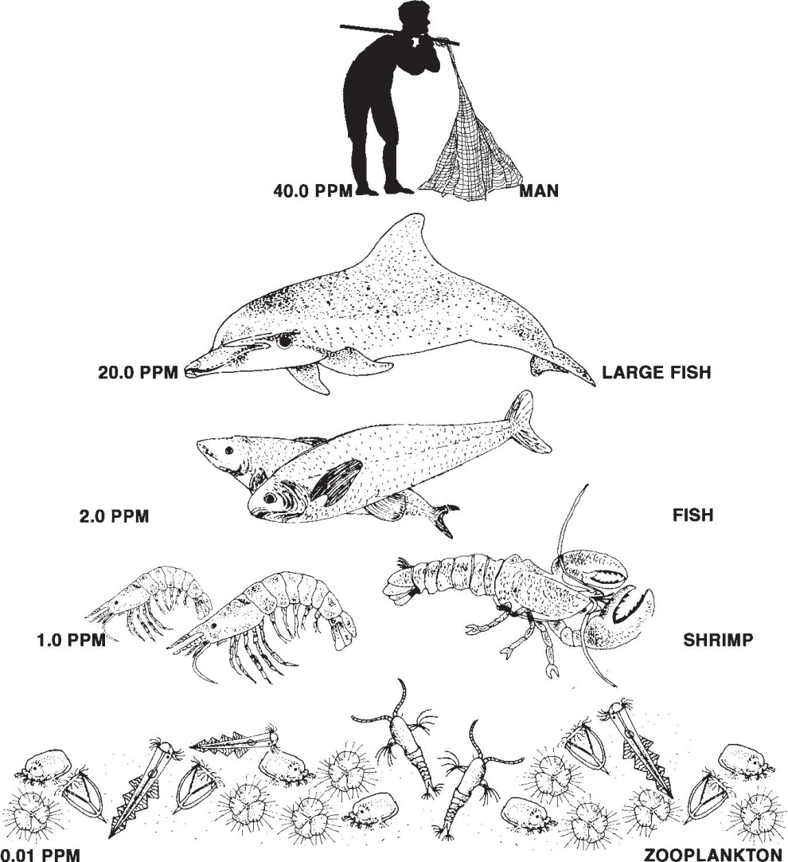

***Case study of groundwater pollution in India***

*An example of groundwater pollution**caused by excessive extraction is that fluoride contamination. It has spread across 19 states and across a variety of ecological regions ranging from the Thar desert, the Gangetic plains and the Deccan plateau. Source: When the bedrock weathers the fluoride leaches into water and the soil. surfaced during the last three decades - extraction of groundwater which has resulted in the tapping of aquifers with high fluoride concentrations was noticed during 1970s and the 1980s when there was massive state investment in rural water development for irrigation as well as for drinking. Encouraged by state subsidies on diesel and electricity, people invested in diesel and submersible pumps in a bid to extract groundwater through borewells. This policy aggravated the fluoride problem. Effects: combines with the bones as it has an affinity for calcium phosphate in the bones. Excess intake of fluoride can lead to dental fluorosis, skeletal fluorosis or non-skeletal fluorosis. Correction: - Deflouridation plants and household water treatment kits are stop-gap solutions. (Ref: Sushmitha Baskar & R.Baskar)*

***Control measures of water pollution****:*

* Setting up of effluent treatment plants to treat waste water can reduce the pollution load in the recipient water. The treated effluent can be reused either for gardening or cooling purposes or wherever possible.
* Root zone process has been developed by Thermax. by running contaminated water through the root zone of specially designed reed beds. These have the capacity to absorb from the surrounding air through their stomata openings. It creates O2 rich conditions where bacteria and fungi oxidize the wastes.
* Providing sanitation and waste water treatment facility.

Integrated nutrient management (INM) and integrated pest management (IPM) practices will reduce the effects caused due to excess pesticides.

***Root zone treatment Technology for sewage***

*The process in a root zone system to treat the sewage is very simple to explain yet complex in nature. Raw effluent (after removing grit or floating material is passed horizontally or vertically through a bed of soil having impervious bottom. The effluent percolates through the bed that has all the roots of the wetland plants spread very thickly . Nearly 2,500 types of bacteria and 10,000 types of Fungi, which harbour around roots get oxygen form the weak membranes of the roots and aerobically oxidize the organic matter of the effluent. The characteristics of plants of absorbing oxygen through their leaves and passing it down to roots through their stems which are hollow, is utilized as a bio-pump. Away from the roots, anaerobic digestion also takes place. The filtering action of the soil bed, the action with fungi etc. and chemical action with certain existing or added inorganic chemicals help in finally obtaining a very clear and clean water. The system of plants regenerates itself as the old plants die and form useful humus. Hence the system becomes maintenance free and can run upto 50 to 60 years without any loss of efficiency as has been described.*

*Reed bed is one of the natural and attractive methods of treating domestic, industrial and agricultural wastes. A reed bed is an engineered method of purifying polluted water as it passes through artificially constructed wetland area, usually containing common reeds. Reed bed is considered as an effective and reliable secondary and tertiary treatment method where land area is not a major constraint. Generally reed bed is made in shallow pits, installed with a drain pipe in a bed of pieces of lime stones and filled up with pebbles, iron filings and graded sand. In this sandy body, reed plants (with hollow root which bring oxygen into the filter bed) are planted.*

*It is advantageous to treat the sewage by root zone system. It achieves the standard for tertiary level treatment standard with no operating cost. There is no chemical used for pH adjustment or for flocculation. Low electricity is consumed for pumping treated water from the collection tank to the reed bed. From the reed bed the treated water is collected and used for irrigation by gradient flow.*

*The root zone system has low maintenance cost since it involves no machinery and its associated maintenance. It requires negligible attendance for operation and monitoring. It has no sludge handling problem such as scraping of slurry from the sludge drying beds and its disposal twice in a week.*

*The sludge gets mineralized in the vertical zone of the reed bed .The sludge mineralizing beds needs to be disposed once in 10 or 15 years.*

* *It enhances the landscape and gives the site a green appeal.*
* *It provides natural habitat for birds and after a few years gives an appearance of a Bird´s sanctuary.*
* *It is though an effluent treatment plant, it does not have odour problem and though it is a green zone, it does not have mosquitoes problem.*
* *The reeds are not grazed by ruminants.*
* *Salinity may not be a problem for a survival or operations of reed beds.*
* *It is recommended to combine vertical flow and then horizontal flow of sewage with a soil having impervious bottom.*
* *In the horizontal flow system, the sewage percolates through bed and that has all roots of the wetland plants spread very thickly nearly with 2500 types of bacteria and 10,000 types of fungi and aerobically oxidized organic matter of the effluent.*
* *Root zone system gives a very good performance of removing 90% BOD and 63% Nitrogen.*
* *Phragmites australis has been found more efficient in nitrogen removal compared to Typha latifolia.*

*However, compared to the conventional treatment processes such as activated sludge, aerated lagoons, waste stabilization pond etc the performance of the root zone treatment system is good with regard to the removal or reduction of BOD, COD, TOC and Total coliforms.*

**THERMAL POLLUTION**

Thermal pollution is the degradation of water quality by any process that increases the ambient water temperature. The increase in temperature (a) decreases the dissolved oxygen/oxygen supply, and (b) affects ecosystem composition.

**Sources of thermal pollution :**

1. *Industries:* A common cause of thermal pollution is the use of water as a coolant bypower plants and industrial manufacturers.
   1. *Hydro-electric power plant*
   2. *Coal fired power plants*
   3. *Nuclear power plants*
   4. *Industrial effluents from power, textiles, paper and pulp industries*

*2)Urban runoff* : storm water discharged to surface waters from roads and parking lotscan also be a source of elevated water temperatures.

3) *Domestic sewage:* municipal sewage normally has a higher temperature.

**Effects of thermal pollution:**

The warmer temperature decreases the solubility of oxygen and increases themetabolism of fish. Tropical marine animals are generally unable to withstand a temperature increase of 2 to 30C and most sponges, mollusks and crustaceans are eliminated at temperatures above 370C. When a power plant first opens or shuts down for repair or other causes, fish and other organisms adapted to particular temperature range can be killed by the abrupt rise in water temperature known as 'thermal shock'.

* Elevated temperature typically decreases the level of dissolved oxygen (DO) in water. The decrease in levels of DO can harm aquatic animals such as fish and amphibians.
* Thermal pollution may also increase the metabolic rate of aquatic animals, as enzyme activity, resulting in these organisms consuming more food in a shorter time than if their environment were not changed. In Australia, where many rivers have warmer temperature regimes, native fish species have been eliminated, and macro invertebrate fauna have been drastically altered and impoverished.
* An increased metabolic rate may result to fewer resources; the more adapted organisms moving in, may have an advantage over organisms that are not used to the warmer temperature. As a result one has the problem of compromising food chains of the old and new environments. As a result Biodiversity can be decreased.
* Releases of unnaturally cold water from reservoirs can dramatically change the fish and macro invertebrate fauna of rivers, and reduce river productivity.
* **Increase in toxicity**: The rising temperature changes the physical and chemicalproperties of water. A100 C rise in temperature doubles the toxic effect of potassium cyanide.
* **Interference with reproduction**: In fishes, several activities like nest building,spawning, hatching, migration and reproduction etc. depend on some optimum

temperature. For instance, the maximum temperature at which lake trout will spawn successfully is 8.90 C. the warm water not only disturbs spawning, but also destroys the laid eggs.

* **Increased vulnerability to disease**: Activities of several pathogenic micro-organisms are accelerated by higher temperature. Hot water causes bacterial disease in salmon fish.
* **Invasion of destructive organisms** : Thermal pollutants may permit the invasion oforganisms that are tolerant to warm water and highly destructive. Invasion of shipworms into New jersey’s Oyster Creek constitute the best example.
* **M**any of the planktons, small fish and insect larvae that re sucked into the condenser along with the cooling water are killed by the thermal shock, increased pressure and water viscosity. cd

**Control measures of thermal pollution**:

* Thermal pollution can be controlled by passing the heated water through a cooling pond or a cooling tower after it leaves the condenser. One method is to construct a large shallow pond. Hot water is pumped into one end of pond and cooler water is removed from the other end. Another method is using a cooling tower.
* During warm weather, urban runoff can have significant thermal impacts on small streams, as storm water passes over hot parking lots, roads and sidewalks. Storm water management facilities that absorb runoff or direct it into groundwater, such as bioretention systems and infiltration basins, can reduce these thermal effects.

ydhfhtbjvhvhchcgdchydchydxrdvhfvhgfvghfghfgfvhjfgfgfghfhcgfcfgfcgcf

**MARINE POLLUTION**

Marine pollution is defined as the introduction of substances to the marine environment directly or indirectly by man resulting in adverse effects such as hazardous to human health, obstruction of marine activities and lowering the quality of sea water.

**Sources of marine pollution:**

1. Municipal waste & sewage from residences and hotels in coastal towns are directly discharged into sea.
2. Pesticides and fertilizers from agriculture which are washed off by rain enter water courses & finally to sea. India is estimated to use 55,000 tons of pesticides annually and about 25 percent of it is carried to ocean.
3. Petroleum & oil washed off from roads normally enter sewage system & finally into seas
4. Ship accidents & accidental spillage at sea can therefore be very damaging to the marine environment.
5. Off shore oil exploration also pollute the sea water to a large extent.
6. Dry docking: All ships periodic dry docking servicing; cleaning the hulls etc. during this period when cargo compartments are emptied, residual oil goes into sea.
7. Pollution due to organic wastes**:** When O2 concentration falls 1.5 mg/l, the rate of aerobic oxidants reduced and replaced by the anaerobic bacteria that can oxidize the organic molecules without the use of oxygen.
8. Pollution due to oil: Crude oil is transported by sea after a tanker has unloaded its cargo of oil; it has to take on sea water ballast for return journey. This ballast water is stored in cargo compartments that previously contained oil. During unloading of cargo certain amount of oil remains clinging to the walls of container & this may amount to 800t in a 200,000t tankers. The ballast water thus contaminated with oil. When fresh crag of oil is to be loaded these compartments are clean with water which discharges the dirty ballast along with oil into sea.
9. Tanker accidents: In the natural process, a large no of oil tanker accidents happen every year. Sometimes this can results in major disasters.
10. Volcanic eruptions in the sea.
11. *Deep sea mining* is a relatively new mineral retrieval process that takes place onthe ocean floor. Ocean mining sites are usually done at about 1,400 - 3,700 meters below the ocean’s surface. The vents create sulphide deposits, which contain precious metals such as silver, gold, copper, manganese, cobalt, and zinc. These raises questions about environment damage to surrounding areas. Removal of parts of the sea floor will result in disturbances to the benthic layer, and habitat of benthic organisms. Beside from direct impact of mining the area, leakage, spills and corrosion would alter the mining area’s chemical makeup.

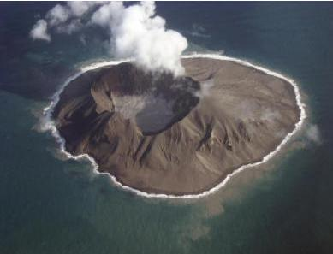

**VOLCANIC ERUPTION IN** **BETWEEN THE SEA**

**BETWEEN THE SEA**

***Case study****:* ***Marine Pollution in Tamil Nadu: Oceans not spared***

*Industrial pollution has threatened the natural habitats of pearls in the pearl banks of Tuticorin coast in the Gulf of Mannar. It has affected fish and other organisms as far as 30 kms south of Tuticorin due to effluents released from chemical industries. Tannery wastes have caused the pollution of coastal waters from Chennai to Vedaranyam. The effect of diversity of phytoplankton ecology of mangrove estuaries of Tuticorin is greatly affected by industrial effluents. The Chennai coastal waters showed high levels of pesticides like DDT, lindane, endosulphan and heptachlor. The bioaccumulation of these pesticides in marine organisms could pose major health hazards.(Ref:.Sushmitha Baskar and R.Baskar.*

**Effects of marine pollution**:

* Apart from causing Eutrophication, a large amount of organic wastes can also result in the development of ‘red tides’. These are phytoplankton blooms because of which the whole area is discolored.
* Commercially important marine species are also killed due to clogging of gills and other structures.
* When oil is spilled on the sea, it spreads over the surface of the water to form a thin film called as oil slick. This damages marine life to a large extent. Commercial damage to fish by tainting which gives unpleasant flavour to fish and sea food reduces market values of sea food and causes death of birds through its effect on feathers. Birds often clean their plumage by pruning and in the process consume oil which can lead to intestinal, renal and liver failure.
* For salt marshy plants oil slick can affect the flowering, fruiting and germination.

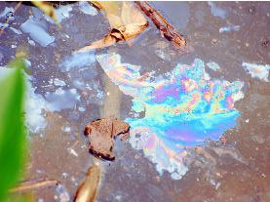 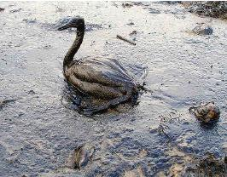

|  |  |  |
| --- | --- | --- |
| Oil on surface of water |  | Bird effected by Oil slick |

* Organic waste addition results in end products such as hydrogen sulphide, ammonia and methane which are toxic to many organisms. This process results in the formation of an anoxic zone which is low in its oxygen content; from which most life disappears except for anaerobic microorganisms and renders the water foul smelling.
* The coral reefs are the productive ecosystems offer many benefits to people. These coral reefs are threatened by

a) the sediments from deforestation carried by the runoffs.

* 1. the agricultural and industrial chemicals reaching through river discharges.

To mention an example, River Ganga is estimated to carry 1.5 billion tons of sediments due to deforestation and intensive farming in India, Bangladesh and Nepal through which it flows to Bay of Bengal.

* Drill cuttings dumped on the seabed result in the production of toxic sulphides in the

bottom sediment thus eliminating the benthic fauna.

**Control measures of marine pollution:**

1. Introduction of *sewage treatment* plants to reduce BOD of final product before discharging into sea.
2. Cleaning oil from surface waters and contaminated beaches can be accelerated through the use of chemical dispersants which can be sprayed on the oil.
3. Load on top system reduce oil pollution cleaned with high pressures jets of water.
4. Crude oil washing: The clingage is removed by jets of crude oil while the cargo is being unloaded.

**NOISE POLLUTION**

Noise may not seem as harmful as the contamination of air or water, but it is a pollution problem that affects human health and can contribute to a general deterioration of environmental quality. Noise is undesirable and unwanted sound. All sound is not noise. It may be considered as music to one person and may be noise to another. Noise is defined as ‘unwanted or offensive sound that unreasonably intrude into our daily activities’. Sound is measured in a unit called the decibel (dB). The permitted noise level is 125 decibels as per the Environment Protection Rules 1999.

**Sources of Noise Pollution:**

There are numerous sources but may be broadly classified into two classes such as indoor and outdoor.

1. Outdoor - Industries/factories, vehicular movements such as car, motor, truck, train, tempo, motor cycle, aircrafts, trains, Construction work, defence equipments, explosions, playing of loudspeakers during various festivals etc. The higher the speed of an air crafts the greater the noise pollution. The invention of supersonic air crafts has added more noise for the persons who live near aerodromes. Another source of noise pollution connected with aeroplanes has been scaring away of birds. Satellites are projected into space with the help of high explosive rockets also contributes to noise pollution.
   1. Indoor - Loudly played radio or music systems, and other electronic gadgets etc.

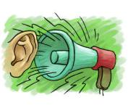

**Effects of noise pollution:**

* Emotional or psychological effects - irritability, anxiety and stress. Lack of concentration and mental fatigue are significant health effects of noise.
* It has been observed that the performance of school children is poor in comprehension tasks when schools are situated in busy areas of a city and suffer from noise pollution - disturbance.
  + - Interferes with normal auditory communication, it may mask auditory warning signals and hence increases the rate of accidents especially in industries.
* The effects can range in severity from being extremely annoying to being extremely painful and hazardous Lowers workers efficiency and productivity and higher accident rates on the job.

**Effects of Noise Pollution on Physical Health:**

* + Physical damage to the ear and the temporary hearing loss often called a temporary threshold shift (TTS). People suffering from this condition will be unable to detect weak sounds. However, hearing ability is usually recovered within a month of exposure. Permanent loss, usually called Noise Induced Permanent Threshold Shift (NIPTS) represents a loss of hearing ability from which there is no recovery. Below a sound level of 80 dB. hearing loss does not occur at all. However temporary effects are noticed at sound levels between 80 and 130 dB. About 50 percent of the people exposed to 95 dB sound levels at work will develop NIPTS and most people exposed to more than 105 dB will experience permanent hearing loss. A sound level of 150 dB or more can physically rupture the human eardrum and greater than 180dB can kill a person. In additions to hearing losses, excessive sound levels can cause harmful effect on the circulatory system by raising blood pressure and altering pulse rates.

**Noise control techniques**:

There are 4 fundamental ways in which noise can becontrolled. 1) Reduce noise at the source 2) block the path of noise 3) increase the path length and 4) protect the recipient.

***Reduce noise at the source***

* 1. Make sure that all openings are acoustically sealed. Noise, lake water rushes out through any cracks or openings. Muffling vehicles and machinery to reduce the noise.

1. In industries, different types of absorptive material can be used to control interior noise. Noise reduction can be done by using rigid sealed enclosures around machinery lined with acoustic absorbing material. Isolating machines and their enclosures from the floor using special spring mounts or absorbent mounts and pads and using flexible couplings for interior pipelines also contribute to reducing noise pollution at the source
2. Regular and thorough maintenance of operating machinery. We should reduce mechanical run out of shafts. By reducing this source of vibration excitation many components like bearing gears and cans may generate less noise and have generate life. We must improve lubrications. We should install bearings correctly. Improper installation sometimes is the reason for bearing noise problems.
3. Traffic volume and speed also have significant effects on the overall sound. Ex: doubling the speed increases the sound levels by about 9 dB and doubling the traffic volume (number of vehicles per hour) increases sound levels by about 3 dB. A smooth flow of traffic causes less noise than a stop-and-go traffic pattern. Thus proper highway planning and design are essential for controlling traffic noise.
4. Establishing lower speed limits for highways that pass through residential areas, limiting traffic volume and providing alternative routes for truck traffic are effective noise control measures.
5. Using efficient flow techniques: for reducing noise associated with high fluid velocities and turbulence.
6. Reducing fluid jet velocities: As jet noise is proportional to the eight power of jet velocity

***Block the path of noise:*** through construction of temporary/permanent barriers

1. Planting of trees around houses can also act as effective noise barriers.
   1. Highly absorptive interior finish material for walls, ceilings and floors can decrease indoor noise levels significantly.

***Increasing the path length*:**Increasing distance from the noise source and the recipientoffers a passive means of control.

1. Municipal land- use ordinances pertaining to the location of airports make use of the attenuating effect of distance on sound levels.

***Protect the recipient:***

1.Use of earplugs and earmuffs. Specially designed earmuffs can reduce the sound level reaching the eardrum by as much as 40 dB.

Besides these in general making Legislation, Educating and bringing awareness in the people is common for control of any pollution Ex: Ban on loud speakers from 10pm to 6pm.

***Case study****:* ***Noise Hits Whales in Hong Kong*** *Studies have shown that shipping**traffic in Hong Kong, which is one of the busiest ports in the world with approximately half a million oceanic vessels traveling through its waters every year (including over 10,000 transits by high speed ferries) has caused changes in the dolphin and whale behavior especially in response to fast moving vessels. A special sanctuary was established by the Hong Kong government in 1995, surrounding the islands of Sha Chau and Lung Kwu Chau, an important place occupied by the humpback dolphins. At any given time approximately 200 vessels surrounds this sanctuary. The sanctuary was a measure to mitigate boat traffic and tremendous noise produced. Adjacent to the sanctuary is an airport, where 700 planes descend and take off everyday, directly over the sanctuary. All the above activities have caused high noise input into the natural whale habitat. Noise, a major anthropogenic stress factor has caused a general decline in the whale populations. (Ref: .Sushmitha Baskar and Baskar).*

**NUCLEAR HAZARDS**

Radionuclides are elements (uranium 235, uranium 283, thorium 232, potassium 40, radium 226, carbon 14 etc) with unstable atomic nuclei and on decomposition release ionizing radiations in the form of alpha, beta and gamma rays. Out of the known 45O radioisotopes only some are of environmental concern like strontium 90, tritium, plutonium 239, argon 41, cobalt 60, cesium 137, iodine 131, krypton 85 *etc*. These can be both beneficial and harmful, depending on the way in which they are used. We routinely use X-rays to examine bones for fractures, treat cancer with radiation and diagnose diseases with the help of radioactive isotopes. About 17% of the electrical energy generated in the world comes from nuclear power plants.

Radioactive substances when released into the environment are either dispersed or become concentrated in living organisms through the food chain. Other than naturally occurring radioisotopes, significant amounts are generated by human activity, including the operation of nuclear power plants, the manufacture of nuclear weapons, and atomic bomb testing.

For example, strontium 90 behaves like calcium and is easily deposited and replaces calcium in the bone tissues. It could be passed to human beings through ingestion of strontium- contaminated milk. Again another example is tritium, which is radioactive hydrogen. The amount of tritium released from nuclear power plants to the atmosphere have reached as high as tens of thousands of curies in one year, and releases to bodies of water have measured as high as tens of millions of picocuries per litre. The U.S. Environmental Protection Agency standard for permissible levels of tritium in drinking water is 20,000 picocuries per litre. Nuclear power plants routinely and accidentally release tritium into the air and water. Tritium has a half- life of 12.3 years and emits radioactive beta particles. Once tritium is inhaled or swallowed, its beta particles can bombard cells causing a mutation.

. A few occupations that involve radioactive exposures are uranium mineworkers, radium watch dial painters, technical staff at nuclear power plants, *etc*. Exposure to radioactive and nuclear hazards has been clinically proven to cause cancer, mutations and teratogenesis (Teratogenesis is a prenatal toxicity characterized by structural or functional defects in the developing embryo or fetus).

Nuclear hazard effects can be either initial or residual. Initial effects occur in the immediate area of explosion and are hazardous immediately after the explosion where as the residual effects can last for days or years and cause death. The principal initial effects are blast and radiation. Blast causes damage to lungs, ruptures eardrums, collapses structures and causes immediate death or injury. Thermal Radiation is the heat and light radiation, which a nuclear explosion’s fireball emits producing extensive fires, skin burns, and flash blindness. Nuclear radiation consists of intense gamma rays and neutrons produced during the first minute after the explosion. This radiation causes extensive damage to cells throughout the body. Radiation damage may cause headaches, nausea, vomiting, diarrhea, and even death, depending on the radiation dose received.

**Sources**

The sources of radioactivity include both natural and manmade.

***Natural sources***

* Cosmic rays from outer space
* Emissions from radioactive materials in the earth’s crust (rocks, marine sediments etc)
* Mining and processing of radioactive ores
* Use of radioactive materials in power plants
* Use of radioactive isotopes in medical technology (x-ray machines, radioisotopes used in medicine)
* Industrial applications include wastes from nuclear reactors
* Research applications: radioactive fallouts during nuclear weapons testing.
* In a nuclear power plant, any leak or accident taking place emit nuclear radiation. In either case it results in nuclear hazard.
* Nuclear tests Conducted under the ground or under oceans which also release radiation.
* Uranium mining and milling, Nuclear reactors and reprocessing of nuclear fuel cause nuclear pollution.

**Effects**

Studies shown that the health effects due to radiation are dependent on the level of dose, kind of radiation, duration of exposure and types of cells irradiated. Radiation effects can be somatic or genetic. ***Somatic affects*** the function of cells and organs. It causes damages to cell membranes, mitochondria and cell nuclei resulting in abnormal cell functions, cell division, growth and death. ***Genetic affects*** the future generations. Radiations can cause mutations, which are changes in genetic makeup of cells. These effects are mainly due to the damages to DNA molecules. People suffer from blood cancer and bone cancer if exposed to doses around 100 to 1000 roentgens. Instantaneous deaths on exposure in the event if disasters are many.

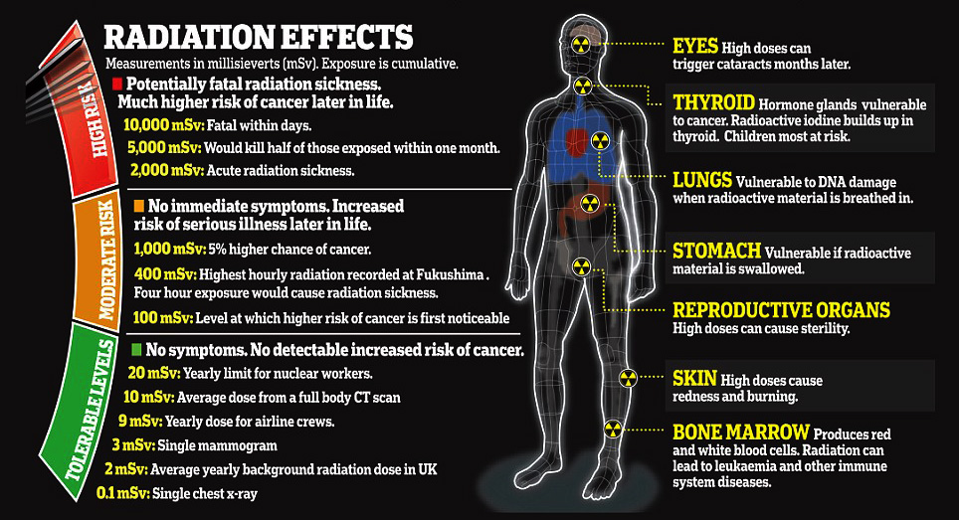

**Control measures**

* Laboratory generated nuclear wastes should be disposed off safely and scientifically.
* Nuclear power plants should be located in areas after careful study of the geology of the area, tectonic activity and meeting other established conditions.
* Appropriate protection against occupational exposure.
* Leakage of radioactive elements from nuclear reactors, careless use of radioactive elements as fuel and careless handling of radioactive isotopes must be prevented.
* Safety measure against accidental release of radioactive elements must be ensured in nuclear plants.
* Unless absolutely necessary, one should not frequently go for diagnosis by x-rays.
* Regular monitoring of the presence of radioactive substance in high risk area should be ensured.

Among the many options for waste disposal, the scientists prefer to bury the waste in hundreds of meters deep in the earth’s crust is considered to be the best safety long term option.

***The Chernobyl nuclear disaster: A lesson in the technological disaster of human*** ***history***

*This disaster that occurred on April*26,*1986 in Ukraine, (i.e. former USSR) at**the Chernobyl power plant reactor, designed to produce 1000 MW of electrical energy. It resulted in the release of Sr-90, Ce-134, Ce-137, 1-131 etc. which polluted the whole region. The explosion occurred due to faulty shutting down of the plant. Combustion of the graphite rods inside the rector resulted in fire and the temperature of the reactor went up to 2000°C. The radioactive debris, gases and plume drifted over the entire northern hemisphere affecting mostly Sweden, Norway, Poland, and Denmark etc. More than 2000 people died in the disaster and many children were affected with congenital abnormalities. The disaster damaged agricultural crops, plants and caused cancer, lung, eye and blood disorders. Many European countries like Denmark and Sweden had banned the import of milk and milk containing products from the former USSR. This was because the milk was contaminated by 1-131, which had entered the cows through grazing on pastures and plants, contaminated with the same.*

**GLOBAL WARMING**

**Global warming**, also referred to as **climate change**, is the observed century-scale rise in the average temperature of the [Earth](https://en.wikipedia.org/wiki/Earth)'s [climate system](https://en.wikipedia.org/wiki/Climate) and its related effects. Many of the observed changes since the 1950s are unprecedented in the [instrumental temperature record](https://en.wikipedia.org/wiki/Instrumental_temperature_record) which extends back to the mid 19th century. The greenhouse effect is the process by which [absorption](https://en.wikipedia.org/wiki/Absorption_%28electromagnetic_radiation%29) and [emission](https://en.wikipedia.org/wiki/Emission_spectrum) of [infrared](https://en.wikipedia.org/wiki/Infrared) radiation by gases in a planet's [atmosphere](https://en.wikipedia.org/wiki/Atmosphere) warm its lower atmosphere and surface. It was proposed by [Joseph Fourier](https://en.wikipedia.org/wiki/Joseph_Fourier) in 1824. It is necessary for the maintenance of Earth's average temperature for species.

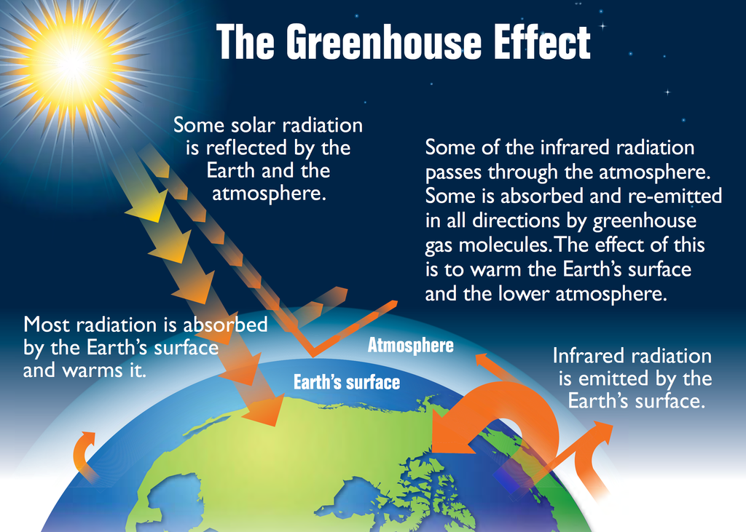

On Earth, an atmosphere containing naturally occurring amounts of greenhouse gases causes air temperature near the surface to be about 33 °C (59 °F) warmer than it would be in their absence. Without the Earth's atmosphere, the Earth's average temperature would be well below the freezing temperature of water. The major greenhouse gases are [water vapour](https://en.wikipedia.org/wiki/Water_vapor), [carbon dioxide](https://en.wikipedia.org/wiki/Carbon_dioxide) (CO2), [methane](https://en.wikipedia.org/wiki/Methane) (CH4), [ozone](https://en.wikipedia.org/wiki/Ozone) (O3).

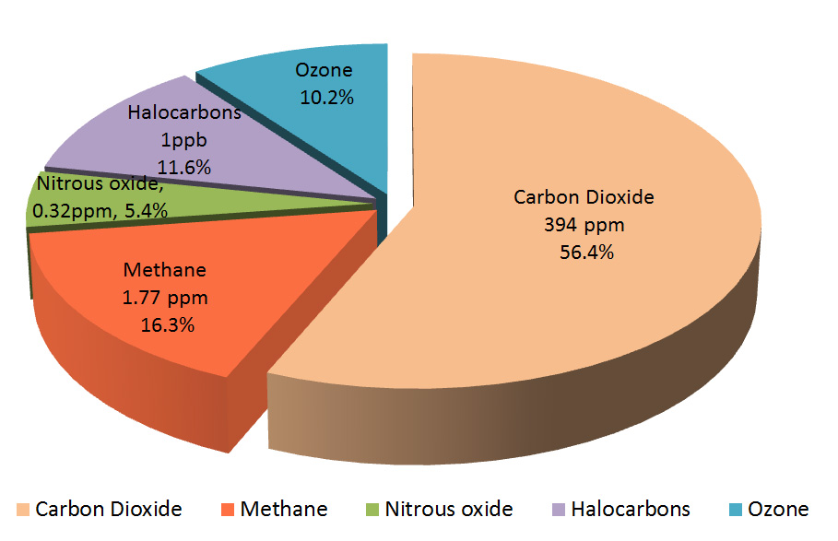

Human activity since the Industrial Revolution has increased the amount of greenhouse gases in the atmosphere, leading (i.e, Enchanced green house gas effect) to increased radioactive forcing from CO2, methane, [troposphere ozone](https://en.wikipedia.org/wiki/Tropospheric_ozone), [CFCs](https://en.wikipedia.org/wiki/Chlorofluorocarbon) and [nitrous oxide](https://en.wikipedia.org/wiki/Nitrous_oxide). According to work published in 2007, the [concentrations](https://en.wikipedia.org/wiki/Greenhouse_gas#Anthropogenic_greenhouse_gases) of CO2 and methane had increased by 36% and 148% respectively since 1750. These levels are much higher than at any time during the last 800,000 years, the period for which reliable data has been extracted from [ice cores](https://en.wikipedia.org/wiki/Ice_core). Less direct geological evidence indicates that CO2 values higher than this were last seen about 20 million years ago.

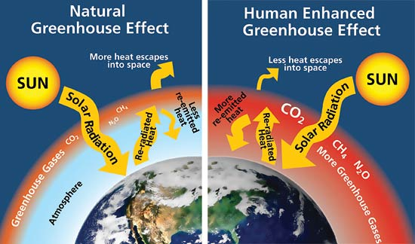

**Anticipated** [**effects**](https://en.wikipedia.org/wiki/Effects_of_global_warming) **of global warming include**

1. Warming global temperature,
2. [Rising sea levels](https://en.wikipedia.org/wiki/Current_sea_level_rise),
3. Changing [precipitation](https://en.wikipedia.org/wiki/Precipitation_%28meteorology%29),
4. Changes include in frequent [extreme weather](https://en.wikipedia.org/wiki/Extreme_weather) events
5. Expansion of [deserts](https://en.wikipedia.org/wiki/Desert) in the [subtropics](https://en.wikipedia.org/wiki/Subtropics) etc.,

Warming is expected to be greater over land than over the oceans and [greatest in the Arctic](https://en.wikipedia.org/wiki/Arctic_shrinkage), with the continuing [retreat of glaciers](https://en.wikipedia.org/wiki/Retreat_of_glaciers_since_1850), [permafrost](https://en.wikipedia.org/wiki/Permafrost) and [sea ice](https://en.wikipedia.org/wiki/Sea_ice). Other likely changes include more frequent [extreme weather](https://en.wikipedia.org/wiki/Extreme_weather) events including [heat waves](https://en.wikipedia.org/wiki/Heat_wave), [droughts](https://en.wikipedia.org/wiki/Drought), heavy [rainfall](https://en.wikipedia.org/wiki/Rain) with [floods](https://en.wikipedia.org/wiki/Inundation) and heavy [snowfall](https://en.wikipedia.org/wiki/Snow), [ocean acidification](https://en.wikipedia.org/wiki/Ocean_acidification); and [species extinctions](https://en.wikipedia.org/wiki/Extinction_risk_from_climate_change) due to shifting temperature regimes. Effects significant to humans include the threat to [food security](https://en.wikipedia.org/wiki/Climate_change_and_agriculture) from decreasing crop yields and the [abandonment of populated areas](https://en.wikipedia.org/wiki/Climate_refugee) due to [rising sea levels](https://en.wikipedia.org/wiki/Sea_level_rise). Because the climate system has a large "[inertia](https://en.wikipedia.org/wiki/Volumetric_heat_capacity#Thermal_inertia)" and greenhouse gases will stay in the atmosphere for a long time, many of these effects will not only exist for decades or centuries, but will persist for tens of thousands of years.

**Control measures of global warming**

Possible societal responses to global warming include [mitigation](https://en.wikipedia.org/wiki/Climate_change_mitigation) by emissions reduction, [adaptation](https://en.wikipedia.org/wiki/Adaptation_to_global_warming) to its effects, building systems [resilient](https://en.wikipedia.org/wiki/Climate_resilience) to its effects, and possible future [climate engineering](https://en.wikipedia.org/wiki/Climate_engineering). Most countries are parties to the [United Nations Framework Convention on Climate Change](https://en.wikipedia.org/wiki/United_Nations_Framework_Convention_on_Climate_Change) (UNFCCC), whose ultimate objective is to [prevent dangerous anthropogenic climate change](https://en.wikipedia.org/wiki/Avoiding_dangerous_climate_change). Parties to the UNFCCC have agreed that deep cuts in emissions are required and that global warming should be limited to well below 2.0 °C relative to pre-industrial levels, with efforts made to limit warming to 1.5 °C.

**ACID RAINS**

Acid rain refers to a mixture of deposited material, both wet and dry, coming from the atmosphere containing more than normal amounts of nitric and sulfuric acids. It is easily defined as rain, fog, sleet or snow that has been made acidic by pollutants in the air as a result of fossil fuel and industrial combustions that mostly emits Nitrogen Oxides (NOx) and Sulfur Dioxide (SO2). Acidity is determined on the basis of the pH level of the water droplets. Normal rain water is slightly acidic with a pH range of 5.3-6.0, because carbon dioxide and water present in the air react together to form carbonic acid, which is a weak acid. When the pH level of [rain water](http://www.conserve-energy-future.com/methods-of-rainwater-harvesting.php) falls below this range, it becomes acid rain.

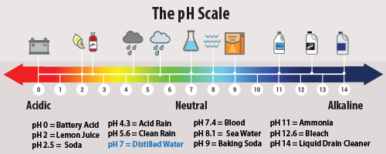

When these gases react with water molecules and oxygen among other chemicals found in the atmosphere, mild acidic chemical compounds such as sulphuric and nitric acid are formed resulting to acid rain. Acid rain generally leads to weathering of buildings, corrosion of metals, and peeling of paints on surfaces. [Erupting volcanoes](http://www.conserve-energy-future.com/HowVolcanoesForm.php) contains some chemicals that can cause acid rain. Apart from this, [burning of fossil fuels](http://www.conserve-energy-future.com/FossilFuels.php), running of  factories and automobiles due to human activities are few other reasons behind this activity.

There are two forms in which acid deposition occurs – wet and dry.

**Wet Deposition:** When the wind blows the acidic chemicals in the air to the areas where the weather is wet, the acids fall to the ground in the form of rain, sleet, fog, snow or mist. It removes acid from the atmosphere and deposit them on the earth’s surface. When this acid flows through the ground, it affects large number of plants, animals and aquatic life. The water from drain flows into rivers and canals which is them mixed up with sea water, thereby affecting marine habitats.

**Dry Deposition:** If the wind blows the acidic chemicals in the air to the areas where the weather is dry, the acidic pollutants slip into dust or smoke and fall to the ground as dry particles. These stick to the ground and other surfaces such as cars, houses, trees and buildings. Almost 50% of the acidic pollutants in the atmosphere fall back through dry deposition. These acidic pollutants can be washed away from earth surface by rainstorms.

**Causes of Acid Rain**

Both natural and man-made sources are known to play a role in the formation of acid rain. But, it is mainly caused by combustion of fossil fuels which results in emissions of sulfur dioxide (SO2) and nitrogen oxides (NOx).

**1. Natural Sources**

The major natural causal agent for acid rain is volcanic emissions. Volcanoes emit acid producing gases to create higher than normal amounts of acid rain or any other form of precipitation such as fog and snow to an extent of affecting vegetation cover and health of residents within the surrounding. Decaying vegetation, wildfires and biological processes within the [environment](http://www.conserve-energy-future.com/environmental-health-and-its-issues.php) also generate the acid rain forming gases. Dimethly sulphide is a typical example of a major biological contributor to sulphur containing elements into the atmosphere. Lighting strikes also naturally produces nitric oxides that react with water molecules via electrical activity to produce nitric acid, thereby forming acid rain.

**2. Man-made sources**

Human activities leading to chemical gas emissions such as sulphur and nitrogen are the primary contributors to acid rain. The activities include [air pollution sources](http://www.conserve-energy-future.com/41-super-easy-ways-to-stop-air-pollution.php) emitting sulphur and nitrogen gases like factories, power generations facilities, and automobiles. In particular, use of coal for electrical power generation is the biggest contributor to gaseous emissions leading to acid rain. Automobiles and factories also release high scores of gaseous emissions on daily basis into the air, especially in highly industrialized areas and urban regions with large numbers of car traffic. These gases react in the atmosphere with water, oxygen, and other chemicals to form various acidic compounds such as sulphuric acid, ammonium nitrate, and nitric acid. As a result, these areas experience exceedingly high amounts of acid rain.

The existing winds blow these acidic compounds over large areas across borders and they fall back to the ground in the form of acid rain or other forms of precipitation. Upon reaching the [earth](http://www.conserve-energy-future.com/What-is-earth-day-and-earth-day-activities.php), it flows across the surface, absorbs into the soil and enters into lakes and rivers and finally gets mixed up with sea water. The gases i.e. i.e. sulphur dioxide (SO2) and nitrogen oxides (NOx) are primarily gases occurring from electric power generation by [burning coal](http://www.conserve-energy-future.com/CoalAsFossilFuel.php) and responsible for acid rain.

## Effects of Acid Rain

Acid rain has significant effects on the world environment and public health.

* **Effect on Aquatic Environment:** Acid rain either falls directly on aquatic bodies or gets run off the forests, roads and fields to flow into streams, rivers and lakes. Over a period of time, acids get accumulated in the water and lower the overall pH of the water body. The aquatic plants and animals need a particular pH level of about 4.8 to survive. If the pH level falls below that the conditions become hostile for the survival of aquatic life. Acid rain tendency of altering pH and aluminium concentrations greatly affects pH concentration levels in surface water, thereby affecting fish as well as other aquatic life-forms.

At pH levels below 5, most fish eggs cannot hatch. Lower pHs can also kill adult fish. Acid rain runoff from catchment areas into rivers and lakes has also reduced [biodiversity](http://www.conserve-energy-future.com/what-is-biodiversity.php) as rivers and lakes become more acidic. Species including fish, plant and insect types in some lakes, rivers and brooks have been reduced and some even completely eliminated owing to excess acid rain flowing into the waters.

* **Effect on Forests:** It makes trees vulnerable to disease, extreme weather, and insects by destroying their leaves, damaging the bark and arresting their growth. [Forest damage](http://www.conserve-energy-future.com/causes-effects-solutions-of-deforestation.php) due to acid rain is most evident in Eastern Europe – especially Germany, Poland and Switzerland.
* **Effect on Soil:** Acid rain highly impacts on soil chemistry and biology. It means, soil microbes and biological activity as well as soil chemical compositions such as soil pH are damaged or reversed due to the effects of acid rain. The soil needs to maintain an optimum pH level for the continuity of biological activity. When acid rains seep into the soil, it means higher soil pH, which damages or reverses soil biological and chemical activities. Hence, sensitive soil microorganisms that cannot adapt to changes in pH are killed. High soil acidity also denatures enzymes for the soil microbes. On the same breadth, hydrogen ions of acid rain leach away vital minerals and nutrients such as calcium and magnesium.
* **Vegetation Cover and Plantations:** The damaging effects of acid rain on soil and high levels of dry depositions have endlessly damaged high altitude forests and vegetation cover since they are mostly encircled by acidic fogs and clouds. Besides, the widespread effects of acid rain on ecological harmony have lead to stunted growth and even death of some forests and vegetation cover.
* **Effect on Architecture and Buildings:** Acid rain on buildings, especially those constructed with limestone, react with the minerals and corrode them away. This leaves the building weak and susceptible to decay. Modern buildings, cars, airplanes, steel bridges and pipes are all affected by acid rain. Irreplaceable damage can be caused to the old heritage buildings.
* **Effect on Public Health:** When in atmosphere, sulphur dioxide and nitrogen oxide gases and their particulate matter derivatives like sulphates and nitrates, degrades visibility and can cause accidents, leading to injuries and deaths. Human health is not directly affected by acid rain because acid rain water is too dilute to cause serious health problems. However, the dry depositions also known as gaseous particulates in the air which in this case are nitrogen oxides and sulphur dioxide can cause serious health problems when inhaled. Intensified levels of acid depositions in dry form in the air can cause lung and heart problems such as bronchitis and asthma.
* **Other Effects:** Acid rain leads to weathering of buildings, corrosion of metals, and peeling of paints on surfaces. Buildings and structures made of marble and limestone are the ones especially damaged by acid rain due to the reactivity of the acids in the rain and the calcium compounds in the structures. The effects are commonly seen on statues, old grave stones, historic monuments, and damaged buildings. Acid rain also corrodes metals like steel, bronze, copper, and iron.

**Preventive measures for Acid Rain**

1. **Cleaning up Exhaust Pipes and Smokestacks**

Most of the electric power supporting the modern-day energy requirements comes from combusting fossil fuels such as oil, natural gas, and coal that generate nitrogen oxides (NOx) and sulfur dioxide (SO2) as the chief contributors to acid rain. Burning coal largely accounts for SO2 emissions while NOx emissions are mostly from fossil fuel combustions.

Washing coal, use of coal comprised of low sulfur, and use of devices known as “scrubbers” can provide technical solution to SO2 emissions. “Scrubbing” also called flue-gas desulfurization (FGD) typically work to chemically eliminate SO2 from the gases leaving smokestacks. It can eliminate up to 95% of SO2 gases. Power generation facilities can also shift to using fuels that emit much less SO2 such as natural gas instead of burning coal. These methods are simply called emission reduction strategies.

Similarly, NOx emissions from automobile fossil fuel combustions are mitigated upon by use of catalytic converters. Catalytic converters are fixed on the exhaust pipe system to reduce NOx emission. Improvement of gasoline that combusts cleaner is also a strategy for reducing emission of NOx gases.

1. **Restoring Damaged Environments**

Use of limestone or lime, a process called liming, is a practice that people can do to repair the damage caused by acid rain to lakes, rivers and brooks. Adding lime into acidic surface waters balances the acidity. It’s a process that has extensively been used, for instance in Sweden, to keep the water pH at optimum. Even though, liming is an expensive method and has to be done repeatedly. Furthermore, it only offers a short-term solution at the expense of solving the broader challenges of SO2 and NOx emissions and risks to human health. Nevertheless, it helps to restore and allow the survival of aquatic life forms by improving chronically acidified surface waters.

1. **Alternative Energy Sources**

Besides fossil fuels, there is a wide range of [alternative energy sources](http://www.conserve-energy-future.com/AlternativeEnergySources.php) that can generate electrical power. These include [wind energy](http://www.conserve-energy-future.com/Wind_Into_Energy.php), geothermal energy, [solar energy](http://www.conserve-energy-future.com/what-is-solar-energy.php), hydropower, and nuclear power. Harnessing these energy sources can offer effective electrical power alternatives instead of using fossil fuels. Fuel cells, natural gas, and batteries can also substitute use of fossil fuel as cleaner energy sources. As of today, all [energy sources](http://www.conserve-energy-future.com/EnergySources.php) have environmental and economic costs as well as benefits. The only solution is using [sustainable energy](http://www.conserve-energy-future.com/what-is-sustainable-development-and-its-goals.php) that can protect the future.

1. **Individual, National/State, and International Actions**

Millions of people directly and indirectly contribute to SO2 and NOx emissions. Mitigation of this challenge requires individuals to be more informed about energy conservation and ways of reducing emissions such as: turning off lights or electrical appliances when not using them; [use public transport](http://www.conserve-energy-future.com/Benefits_of_Public_Transportation.php); use [energy efficient electrical appliances](http://www.conserve-energy-future.com/11-ways-to-make-your-home-more-energy-efficient.php); and use of hybrid vehicles or those with low NOx emissions.

**OZONE LAYER DEPLETION**

Ozone is an unstable blue gas having pungent odour. Chemically, it is an allotrope of Oxygen which is an element in the gaseous form. It has three oxygen atoms in its single molecule and in the language of Chemistry; its molecular formula is 03. It is used as a powerful oxidant, bleach, and water purifier. It is also used to treat industrial wastes.

**Where is ozone found?**

It is found in the troposphere; ozone acts as a powerful pollutant. But, when found in the stratosphere, it acts like a friend of the earth because it shields most of the ultra violet radiations and does not allow them to pass on towards the same. In stratosphere, it is found in the form of a dense layer called as the Ozone Layer or the Ozone Belt. Thus, the Ozone Belt in the stratosphere acts like a Protective Umbrella of the earth. Let us see, how this gas is formed in the atmosphere.

**How is ozone formed?**

Ozone is formed in the stratosphere when oxygen molecules Photo dissociate after absorbing an UV Photon of shorter wavelength(less than 240 nm) to produce two oxygen atoms. Ozone is mainly produced from oxygen containing molecules such as Sulphur dioxide, Nitrogen Oxides, etc. also when these molecules are exposed to ultraviolet radiations. In Chemistry, a molecule is the particle of any substance that can remain in a free state. But, what is an atom? Well, an atom is the smallest particle of a substance that can not usually remain in a free condition. Two or more atoms combine to form a molecule. Through the foregoing lines, we came across another term, allotrope. One of the two or more different forms of molecules of an element is called as an allotrope.

A large number of ozone molecules assemble around the earth to form the Ozone Layer which extends from 13 to 48 km above the earth surface. On an average, it is about 230 Dobson units (DU) in thickness. DU is the unit which measures thickness of the ozone layer. It equals to 0.01 mm.

**Ozone depleting substances**

Chlorofluorocarbons (CFCs or Freons), Methane, Nitrous Oxides (N2O), Carbon Tetrachloride (CCl4), Methyl Bromide (a soil fumigant and insecticide), aircraft emissions, n- propyl bromide and Halon- 1202 are major agents that cause depletion of ozone layer. Hence, these are called as Ozone Depleting Substances (ODS).

**How is the Ozone Layer Depleted?**

Chlorofluorocarbons or Freons get accumulated in greater amounts at high altitudes and gradually reach to the stratosphere. Under the influence of intense short wave ultraviolet radiations they release chlorine atoms. A single chlorine atom can react with more than, 100,000 molecules of ozone and can convert them into oxygen. Other ozone depleting substances like methane, nitrous oxide, methyl bromide etc. too, pass through a series of reactions under the influence of UV-radiations of sunlight and catalysts found in the air and help in the depletion of ozone layer.

• Ozone molecule absorbs UV light between 310 and 200 nm. The ozone molecule absorbs oxygen atom to form two molecules of Oxygen, and the Ozone cycle continues.

• Ozone is destroyed by a number of free radicals catalysts –like Hydroxyl radical, Nitric oxide radical, and Bromine through natural and anthropogenic sources.

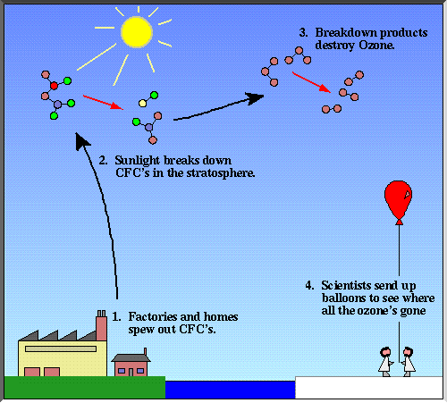

**Effects of the Depletion of Ozone Layer**

**I. General Effects**

Ozone absorbs ultraviolet radiations so that much of it is never allowed to reach to the earth surface. The protective umbrella of ozone layer in the stratosphere protects the earth from harmful ultraviolet radiations. Ozone plays an important role in the biology and climatology on the earth’s environment. It filters out all the radiations that remain below 3000Å. Radiations below this wavelength are biologically harmful. Hence any depletion of ozone layer is sure to exert catastrophic impacts on life in the biosphere. The Ultraviolet radiation is one of the most harmful radiations contained in the sunlight. Ozone layer in the stratosphere absorbs these radiations and does not allow it to reach to the earth.

The depletion of Ozone layer may lead to UV exposures that may cause a number of biological consequences like Skin Cancer, damages to vegetation, and even the reduction of the population of planktons (in the oceanic Photic zone).

Some of the remarkable effects of the UV radiations or the effects of depletion of the Ozone Layer are mentioned below.

(1) UV radiation causes sun- eye- diseases (cataract), skin diseases, skin cancer and damage to immune system in our body.

(2) It damages plants and causes reduction in crop productivity.

(3) It damages embryos of fish, shrimps, crabs and amphibians. The population of salamanders is reducing due to UV-radiations reaching to the earth.

(4) UV- radiations damage fabrics, pipes, paints, and other non-living materials on this earth.

(5) It contributes in the Global Warming. If the ozone depletion continues, the temperature around the world may rise even up to 5.5 Celsius degrees.

**II.Specific Effects**

The specific effects of depletion of Ozone Layer have been observed on Human Society, Agriculture, Plants and Animals etc. These effects have been summarized as below-

**A. Effects of Ozone Depletion on Human Society**

(i).The flux of ultra violet radiation in the biosphere is increased due to ozone depletion. It has seriously harmful effects on human societies like formation of patches on skin and weakening of the human immune system.

(ii). It may cause three types of skin cancer like basal cell carcinoma, squamous cell carcinoma and melanoma. A 10 per cent decrease in stratospheric ozone has been reported to cause 20 to 30 per cent increase in cancer in human society. Each year, about 7000 people die of such diseases each year in USA. About 10 percent increase in skin cancer has been reported in Australia and New Zealand.

(iii).Exposure to UV radiations damages skin of the sun-bathing people by damaging melanocyte-cells or by causing sun-burns due to faster flow of blood in the capillaries of exposed areas.

(iv).Exposure to UV radiations due to ozone depletion may cause leukemia and breast cancer.

(iv).Exposure of UV radiation to human eye damages cornea and lens leading to Photo keratitis, cataract and even blindness.

(v).The Ambient Ozone Exposure may cause Emphysema, bronchitis, asthma and even obstruction of lungs in human beings.

(vi).Exposure to radiations due to ozone depletion has been reported to cause DNA breakage, inhibition and alteration of DNA replication and premature ageing in human beings.

**B. Effect of Ozone Depletion on Agriculture**

(i). Radiations reaching to the earth due to ozone depletion cause severe damage to plants including crops. As per reports, ultra violet radiations reaching to the earth cause losses up to 50 per cent in European countries.

(ii).The radiation reaching to the earth due to the depletion of the ozone layer cause visible damages in plants. They adversely affect the rate of photosynthesis that finally results into decrease in the agricultural production.

(iv).The UV radiation enhances the rate of evaporation through stomata and decreases the moisture content of the soil. This condition adversely affects the growth and development of crop plants and reduces the crop yield.

(v). The ozone reduction adversely affects the weather pattern which in turn affects the crop production by encouraging plant injuries and disease development.

(vi). The UV radiation reaching to the earth surface alters the global balance between radiation and energy. This condition of imbalance causes seasonal variations that further reduce the crop production.

(vii). A number of economically important plant species such as rice, depend on cyanobacteria residing in their roots for the retention of nitrogen. These bacteria are sensitive to UV light and they are hence, are killed instantly.

**C. Effects of Ozone Depletion on other Plants and Animals**

(i).The ozone layer depletion causes climatic alterations that cause physiological changes in plants and animals. The change in the energy balance and radiation may affect the survival and stability of living organisms.

(ii).The depletion of ozone layer may cause changes in thermal conditions of the biosphere. It may affect type, density and stability of vegetation which in turn may affect different bio-geo-chemical cycles operating in nature. Interruption in these cycles damages important process of ecosystem leading to dangerous conditions for plants and animals.

(iii).The depletion of ozone layer causes death of plankton- populations in fresh as well as marine waters .This condition seriously affects the transfer of materials in ecosystems. The recent researches gave analyzed a widespread extinction of planktons 2 million years ago that coincided with the nearby supernova. Planktons are particularly susceptible to effects of UV light and are vitally important to the marine food webs.

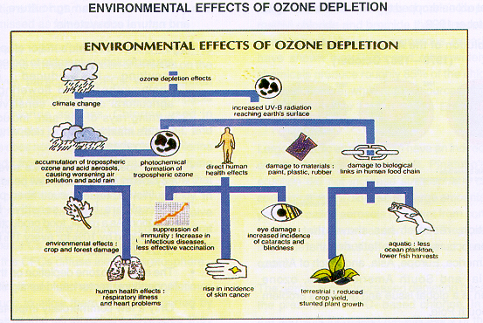

**The Ozone Hole**

The hole in the context of ozone depletion relates to thinning of the ozone layer in a certain area. Here, the word hole is considered as a hole in the ground which in the context of ozone layer is thinning of ozone in a certain area up to certain depth as measured by scientists. In fact, ozone hole is an area where the ozone concentration drops to an average of about 100 Dobson Units. The word ‘Dobson’ has been taken from the name of the famous scientist and climatologist G. M. B. Dobson, who observed the ozone hole for the first time in 1956, over Halley Bay.

The satellite measurements done in September 2000 revealed that the thinning of ozone layer in Antarctic had reached a record 28.3 million sq km which was about one million sq km greater than the record of 1998. Thinning of ozone in such a big area is rightly termed as ozone hole. The ozone hole in the Northern Latitudes has also been recorded. The ozone hole over Antarctica may expose not only the Antarctica but also a large area of the pacific and Atlantic oceans and South America as well.

The ozone hole over Antarctica was first discovered by Farman, Gardiner and Shanklin in 1985. They jointly declared their findings through a paper published in the May issue of Nature (an important International Journal) in 1985. The entire scientific community was shocked to know their findings.

On the basis of observations made through a network of ground based Dobson Spectrophotometer, an International Panel of scientists confirmed that the Ozone Layer was being depleted at all latitudes outside the tropics. Out of a big group of scientists across the world, Crutzen, Molina, and Rowland were awarded the Nobel Prize in Chemistry for their work on Stratospheric Ozone, in 1995.The scientific assessment of ozone depletion is going on across the world since 1981, under the sponsorship of the United Nations Environment Programme (UNEP), and the most recent measurement was done during the year 2006. Here are the comparative pictures showing the Ozone Holes over Antarctica during the spring seasons of two different years.

**Prevention and Control of Depletion of the Ozone Layer**

Banning the production and use of ozone depleting substances is one important way of preventing further depletion of the ozone layer in the stratosphere. On the other hand, alternatives to these chemical compounds should also be searched out so as to replace these chemicals. Scientists of the University of California, U.S.A. devised a possible way of plugging the ozone hole by injecting alkanes or propanes into the atmosphere of Antarctica. The alkanes have the affinity of reacting with ozone destroying chlorine atoms. According to the scientists, about 50,000 tones of alkane or propane would have to be blown to check the ozone loss. These chemicals could be released from an altitude of about 15 km by a group of hundreds of large aircrafts.

**SOLID WASTE**

The combined effects of population explosion and changing modern living standards have had a cumulative effect in the generation of a large amount of various types of wastes.

Solid waste can be classified into different types depending on their source.

* Municipal solid waste (MSW)
* Industrial waste
* Hazardous waste
* Biomedical or hospital waste: as infectious waste.
* Agricultural waste

**SOLID WASTE MANAGEMENT**

**Municipal Solid Waste (MSW):** The term municipal solid waste (MSW) is generallyused to describe most of the non-hazardous solid waste from a city, town or village that requires routine collection and transport to a processing or disposal site. Sources of MSW include private homes, commercial establishments and institutions, as well as industrial facilities. However, MSW does not include wastes from industrial processes, construction and demolition debris, sewage sludge, mining waste or agricultural wastes. MSW is also called as trash or garbage. In general, domestic waste and MSW are used as synonyms. Municipal solid waste contains a wide variety of materials. It can contain food waste (like vegetable and meat material, leftover food, eggshells etc.), which is classified as wet garbage as well as paper, plastic, tetrapack, plastic cans, newspaper, glass bottles, carboard boxes, aluminum foil, metal items, wood pieces, etc., which is classified as dry garbage. The different types of domestic wastes generated and the time taken for them to degenerate is illustrated in the table given below.

**Table: Domestic wastes and their degeneration time**

|  |  |
| --- | --- |
| **Common domestic wastes** | **Approximate time taken for degeneration** |
|  |  |
| Organic kitchen waste vegetables, fruits | 1—2 weeks |
|  |  |
| Paper, cardboard paper | 15 days—1 month |
|  |  |
| Cotton clothes | 2—5 months |
|  |  |
| Woolen clothes | about a year |
|  |  |
| Metal cans, tin, aluminum | 100—500 years |
|  |  |
| Plastics | 1 million years |
|  |  |

India’s urban population slated to increase from the current 330 million to about 600 million by 2030, the challenge of managing municipal solid waste (MSW) in an environmentally and economically sustainable manner is bound to assume gigantic proportions. The country has over 5,000 cities and towns, which generate about 40 million tonnes of MSW per year today. Going by estimates of The Energy Research Institute (TERI), this could well touch 260 million tonnes per year by 2047.

**The functional elements of MSW management**

The municipal solid waste industry has four components: recycling, composting, land filling, and waste-to-energy via incineration.

The primary steps are generation, collection, sorting and separation, transfer and disposal/utilisation. *Waste generation* encompasses activities in which materials are identified as no longer being of value and are either thrown out or gathered together for disposal. The functional element of *Collection* includes not only the gathering of solid waste and recyclable materials, but also the transport of these materials, after collection, to the location where the collection vehicle is emptied. This location may be a materials processing facility, a transfer station or a landfill disposal site.

*Waste handling and* *separation* involves activities associated with waste management until the waste is placedin storage containers for collection. Handling also encompasses the movement of loaded containers to the point of collection. Separating different types of waste components is an important step in the handling and storage of solid waste at the source. The types of means and facilities that are now used for the recovery of waste materials that have been separated at the source include curb side collection, drop off and buy back centres.

*Transfer and transport* involves two main steps. First, the waste is transferred from a smaller collection vehicle to larger transport equipment. The waste is then transported, usually over long distances, to a processing or disposal site. Today the disposal of wastes by land filling or land spreading is the ultimate fate of all solid wastes, whether they are residential wastes collected and transported directly to a landfill site, residual materials from materials recovery facilities (MRFs), residue from the combustion of solid waste, compost or other substances from various solid waste processing facilities. A modern sanitary landfill is not a dump; it is an engineered facility used for disposing of solid wastes on land without creating nuisances or hazards to public health or safety, such as the breeding of insects and the contamination of ground water.

Municipal solid waste can be used to *generate energy*. Several technologies have been developed that make the processing of MSW for energy generation cleaner and more economical than ever before, including landfill gas capture, combustion, pyrolysis, gasification, and plasma arc gasification. While older waste incineration plants emitted high levels of pollutants, recent regulatory changes and new technologies have significantly reduced this concern. In USA, EPA regulations in 1995 and 2000 under the Clean Air Act have succeeded in reducing emissions of dioxins from waste-to-energy facilities by more than 99 percent below 1990 levels, while mercury emissions have been by over 90 percent The EPA noted these improvements in 2003, citing waste-to-energy as a power source “with less environmental impact than almost any other source of electricity”.

Municipal solid waste management is more of an administrative and institutional mechanism failure problem rather than a technological one. Until now, MSW management has been considered to be almost the sole responsibility of urban governments, without the participation of citizens and other stakeholders. The Centre and the Supreme Court, however, have urged that this issue be addressed with multiple stakeholder participation. Cities in India spend approximately 20% of the city budget on solid waste services.

**Hazardous Wastes**

Hazardous wastes are those that can cause harm to human and the environment.

**Characteristics of hazardous us wastes**:

Wastes are classified as hazardous if they exhibit any of four primary characterises based on physical or chemical properties of toxicity, reactivity ignitability and corrosivity.

**Toxic wastes**

Toxic wastes are those that are poisonous in small or trace amounts. Some may have acute or immediate effect on human or animals. Carcinogenic or mutagenic causing biological changes in the children of exposed people and animals. *Eg*: pesticides, heavy metals.

**Reactive wastes**

Reactive wastes are those that have a tendency to react vigorously withair or water are unstable to shock or heat, generate toxic gases or explode during routine management. *Eg*: Gun powder, nitro-glycerine.

**Ignitable waste:** are those that burn at relatively low temperatures (<60oC) and are capable of spontaneous combustion during storage transport or disposal. *Eg:* Gasoline, paint thinners and alcohol.

**Corrosive wastes**: are those that destroy materials and living tissues by chemical reactions. *Eg:* acids and base.

**Infectious wastes**: included human tissue from surgery, used bandages and hypodermneedles hospital wastes.

**Sources**: Chemical manufacturing companies, petroleum refineries, paper mills, smeltersand other industries, Plastic industries.

Thousand of chemicals are used in industries every year. When used incorrectly or inappropriately they can become health hazards. PCBs (Polychlorinated biphenyls) are resistant to fire and do not conduct electricity very well, which makes them excellent materials for several industrial purposes. Rainwater can wash PCBs out of disposal areas in dumps and landfills thus contaminating the water. PCBs do not break open very rapidly in the environment and thus retain their toxic characteristics. They cause long-term exposure problems to both human and wildlife.

Many household chemicals can be quite toxic to humans as well as wildlife. Most of the dangerous substance in our homes are found in various kinds of clearness, solvents and products used in automotive care. When these products are used incorrectly they have the potential to be harmful.

**Effects:** As most of the hazardous wastes are disposed off or in land, the most seriousenvironmental effect is contaminated ground water. Once ground water is polluted with hazardous wastes, it is very often not possible to reverse the damage. Pesticides form residues in the soil that are washed into streams which then carry them forward. The residues may persist in PCBs (poly chlorinated biphenyls) are concentrated in the kidneys and liver and cause damage; they cause reproductive failure in birds and mammals .The soil or in the bottom of lakes and rivers. Exposure can occur through ingestion, inhalation and skin contact, resulting acute or chronic poisoning. Lead, mercury and arsenic are hazardous substances which can often referred to as heavy metals. Most of the lead absorbed by people is stored in the bones. Lead can effect red blood cells by reducing their ability to carry oxygen and shortening their life span. Lead may also damage nervous tissue, resulting in brain disease. Mercury is used in production of chlorine and as a catalyst in the production of some plastics.

Mercury build up in body over long period of time is known to cause brain damage. Minamata disease occur due to mercury poisoning. Vinyl chloride is a chemical that is widely used in plastic manufacture. A long continuous exposure in humans it can cause deafness, vision problem circulation disorders and bone deformities.

**Control**: Common methods for disposing of hazardous wastes are land disposal andincineration Industries need to be encouraged to generate less hazardous waste in the manufacturing process. Although toxic wastes cannot be entirely eliminated, technologies are available for minimizing recycling and treating the wastes. Integrated pest management practices (IPM) reduce the usage of pesticides. Substitute the use of PCBs and vinyl chloride with chemicals that are less toxic. Polyvinyl chloride use can be lowered by reducing the use of plastics.

**Industrial wastes**

These contain more of toxic and require special treatment.

**Source** : Food processing industries, metallurgical chemical and pharmaceutical unit’sbreweries, sugar mills, paper and pulp industries, fertilizer and pesticide industries are major ones which discharges toxic wastes. During processing, scrap materials, tailings, acids etc.

**Effect**: Most common observation is that the health of the people living in theneighborhood of dumping sites is severely affected. The exposure may cause disorders of nervous system, genetic defects, skin diseases and even caner. The liquid effluents discharged by the industries contain inorganic and organic pollutants and they enter into water bodies causing destruction of fish, formation of sediments, pollution of ground water and release of foul odours.

**Control**: Waste minimization technologies have to be developed. Source reductionrecycling and reuse of materials need to be practiced on a large scale.

Hazardous waste should not mix up with general waste. Source reduction involves altering the design, manufacture or use of products & materials to reduce the amount and toxicity of materials that get thrown away. Local communities and voluntary organizations should educate the industrialists as well as the public about dangers of pollution and the need to keep the environment clean. Land filling, incineration & composting technologies to be followed. Biogas is obtained from solid waste treatment of industrial and mining waste is done for the recovery of useful products.

**A classic case study of waste mismanagement: The Love Canal tragedy**

*In 1892, a small area near Niagara Falls, New York, USA was dug up and designed as a route for transportation and for the production of hydroelectric power connecting the lower and upper reaches of the Niagara River, called the love canal (named after William T. love). The process was left incomplete and eventually became a site for waste disposal. A Plastic manufacturing chemical company disposed off its wastes in sealed steel drums during the years 1940 to 50. More than 20,000 tons of 80 different chemicals were dumped in the area. In 1953, the company sold the land to the city of Niagara Falls. Subsequently, many residences and an elementary school were built on the land. The tragic story of the love canal incident started after twenty years due to heavy snow and rains. The sealed plastic wastes had corroded the drums and started leaking into the soil, buildings, water etc. Children in the school were shocked to see their rubber shoe soles disintegrating and they also suffered burns. This caused the officials to look into the matter and it was found that the wastes contained lot of carcinogens and a wide array of toxic organic compounds like benzene, chloroform, trichloroethylene etc. The cleanup of the Love canal totally amounted to about 275 million US dollars. The schools and homes were destroyed, the families relocated, the soil was completely covered with compacted* *clay, the wastes were diverted to a treatment plant, the water pipes were blocked with barriers, etc. This was a classic example of solid waste mismanagement.*

*Toxic materials pose significant health hazards and dwindle our precious bio-reserves. Proper and timely management of waste is very important in the good interest of our environment, and us. The above classic case study proves that management of wastes is a very serious business and if not handled with care, the cleaning up of improperly disposed wastes can cause loss/damage to human life and be extremely costly. It therefore makes sense to plan the disposal of various kinds of wastes in a scientific manner.*

**Agricultural Wastes**

**Sources:** The waste generated by agriculture includes waste from crops and live stock. Indeveloping countries, this waste does not pose a serious problem as most of it is used e.g. dung is used for manure, straw is used as fodder. Some agro-based industries produce waste e.g., rice milling, production of tea, tobacco etc. Agricultural wastes are rice husk, degasses, ground nut shell, maize cobs, straw of cereals etc.

**Effects:** If more C: N ratio wastes like paddy husk or straw may cause immobilization ofnutrients if applied on the fields. It occupies to large land areas if not properly disposed.

**Management**

1. **Waste to energy**
   1. **Gasification**: It is the process in which chemical decomposition of biomasstakes place in the presence of controlled amounts of oxygen, producing a gas. This gas is cleaned and used in an internal combustion engine to produce electric power. Without clean up also, the gas can be used in boilers to produce electric power. This technology is highly suited to generate electric power from agro wastes like rice husks, groundnut shells etc.
   2. **Pyralysis** :It is similar to gasification except that the chemicaldecomposition of biomass wastes take place in the absence or reduced presence of O2 at high temp. Mixtures of gases result from decomposition including H2, NH4 Co, CO2 depending on the organic nature of waste matter. This gas used for power generation.
2. **Biogas production**: Animal wastes, food processing wastes and other organic matter are decomposed anaerobically to produce a gas called biogas. It contains methane and CO2. The methane can provides gas for domestic use. The by-product of this technology is slurry, settled out the bottom of the digester. This can be used as manure.
3. Agricultural waste like corn cobs, paddy husk, bagasse of sugarcane, waste of wheat, rice and other cereals, cotton stalks, coconut wastes, jute waste etc can be used in making of paper and hard board.

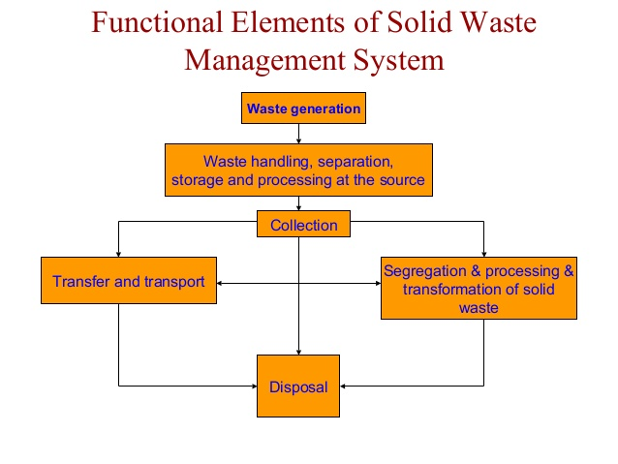

**Waste production can be minimized by adopting the 3 R’s principle: Reduce, Reuse, Recycle**

* Reduce the amount and toxicity of garbage and trash that you discard.
* Reuse containers and try to repair things that are broken.
* Recycle products wherever possible, which includes buying recycled products *i.e*. recycled paper books, paper bags etc.

These are processes that involve integrated waste management practices (IWM). They can reduce the wastes generated by approximately 50 *%.*

**Reduce (Waste prevention):** Waste prevention, or “source reduction,” meansconsuming and discarding less, is a successful method of reducing waste generation. Backyard composting, double sided copying of papers, purchasing durable, long- lasting environmentally friendly goods; products and packaging that are free of toxics, redesigning products to use less raw material production and transport packaging reduction by industries are the normal practices used and have yielded substantial environmental benefits. Source reduction prevents emissions of many greenhouse gases, reduces pollutants the need saves energy, conserves resources, and reduces wastes for new landfills and combustors. It reduces the generation of waste and is generally preferred method of waste management that goes a long way toward saving the environment.

**Re-use:** Re-use is the process, which involves reusing items by repairing them, donatingthem to charity and community groups, or selling them. Reusing products is an alternative to recycling because the item does not need to be reprocessed for its use again. Using durable glassware, steel using cloth napkins or towels, reusing bottles, reusing boxes, purchasing refillable pens and pencils are suggested.

**Recycling:** The process of recycling, including composting, has diverted several milliontons of material away from disposal. Recycled materials include batteries, recycled at a rate of 93%, paper and paperboard at 48%, and yard trimmings at 56%. These materials and others may be recycled through drop off centres, buy-back programs, and deposit systems. Recycling prevents the emission of many greenhouse gases that affect global climate, water pollutants, saves energy, supplies valuable raw materials to industry, creates jobs, stimulates the development of greener technologies, conserves resources for our children’s future, and reduces the need for new landfills and combustors. For example, by recycling of solid waste in 1996, the United States prevented the release of 33 million tons of carbon into the air roughly the amount emitted annually by 25 million cars. Recycling can create valuable resources and it generates a host of environmental, financial, and social benefits. Materials like glass, metal, plastics, and paper are collected, separated and sent to processing centres where they are processed into new products. The advantages of recycling are it conserves resources for future generation, prevents emissions of greenhouse gases and pollutants, saves energy, supplies valuable raw, materials to industries, stimulates the development of greener technologies, reduces the need for new landfills and incinerators.

cfc