**D.C.GENERATORS**

**INTRODUCTION**

The D.C generator converts **Mechanical Energy into Electrical Energy.** The Generator is usually coupled to a **Prime mover.** The prime mover may be a diesel / petrol engine, or a turbine depending upon the rating and application of the Generator. The prime mover converts some sort of energy (diesel / petrol / water / steam / gas etc) into Mechanical Energy. This Mechanical Energy is supplied to the Generator (i.e. generator input).

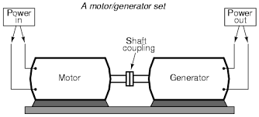

When the Prime mover (motor) output is given to the Generator, the Generator Armature starts rotating. Usually the poles on the yoke are made of Permanent Magnets. Therefore, the armature conductors cuts the weak magnetic field established by Permanent Magnets and small amount of e.m.f is induced in the armature winding according to Faraday Laws of Electromagnetic induction. This induced e.m.f. circulates a small amount of current through the field winding and strengthens the magnetic flux established and hence the induced e.m.f.

**GENERATOR PRINCIPLE**

An electric generator is a machine that converts mechanical energy into electrical energy. An electric generator is based on the principle that whenever flux is cut by a conductor, an e.m.f. is induced which will cause a current to flow if the conductor circuit is closed. The direction of induced e.m.f. (and hence current) is given by Fleming’s right hand rule. Therefore, the essential components of a generator are:

(a) A magnetic field

(b) Conductor or a group of conductors

(c) Motion of conductor w.r.t. magnetic field.

**SIMPLE LOOP GENERATOR**

Consider a single turn loop ABCD rotating clockwise in a uniform magnetic field with a constant speed as shown in Fig.(1.1). As the loop rotates, the flux linking the coil sides AB and CD changes continuously. Hence the e.m.f. induced in these coil sides also changes but the e.m.f. induced in one coil side adds to that induced in the other.

(i) When the loop is in position no. 1 [See Fig. 1.1], the generated e.m.f. is zero because the coil sides (AB and CD) are cutting no flux but are moving parallel to it

(ii) When the loop is in position no. 2, the coil sides are moving at an angle to the flux and, therefore, a low e.m.f. is generated as indicated by point 2 in Fig. (1.2).

(iii) When the loop is in position no. 3, the coil sides (AB and CD) are at right angle to the flux and are, therefore, cutting the flux at a maximum rate. Hence at this instant, the generated e.m.f. is maximum as indicated by point 3 in Fig. (1.2).

(iv) At position 4, the generated e.m.f. is less because the coil sides are cutting the flux at an angle.

(v) At position 5, no magnetic lines are cut and hence induced e.m.f. is zero as indicated by point 5 in Fig. (1.2).

(vi) At position 6, the coil sides move under a pole of opposite polarity and hence the direction of generated e.m.f. is reversed. The maximum e.m.f. in this direction (i.e., reverse direction, See Fig. 1.2) will be when the loop is at position 7 and zero when at position 1. This cycle repeats with each revolution of the coil.

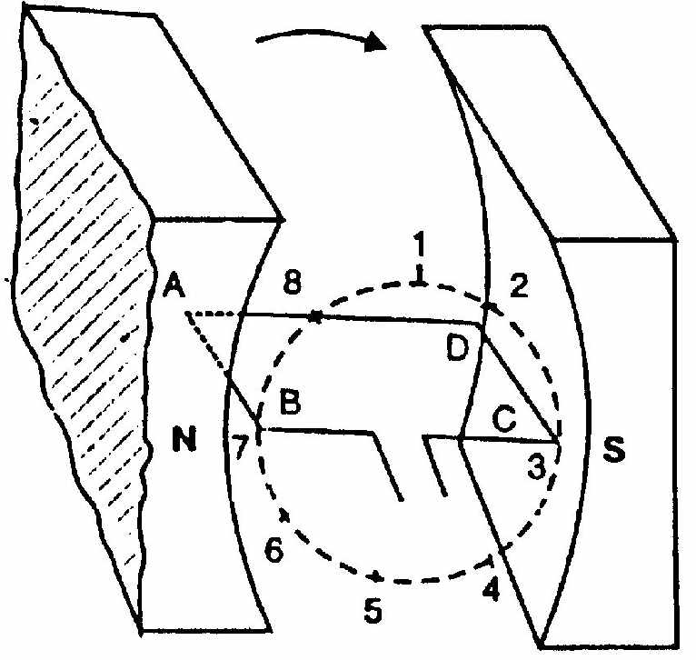

Fig 1.1

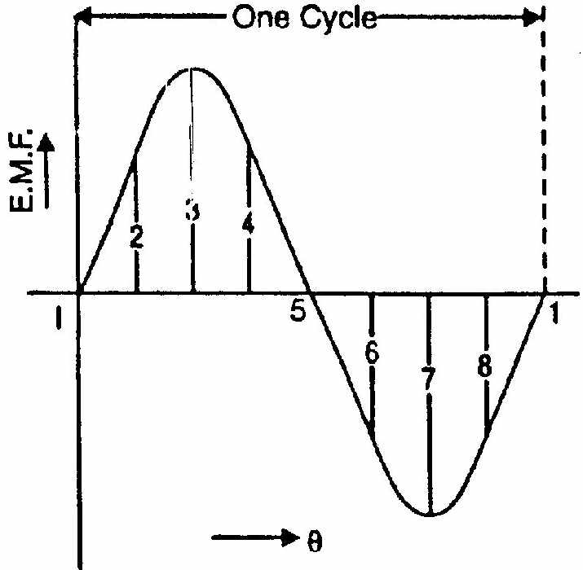

Fig 1.2

Note that e.m.f. generated in the loop is alternating one. It is because any coil side, say AB has e.m.f. in one direction when under the influence of N-pole and in the other direction when under the influence of S-pole. If a load is connected across the ends of the loop, then alternating current will flow through the load. The alternating voltage generated in the loop can be converted into direct voltage by a device called commutator. We then have the d.c. generator. In fact, a commutator is a mechanical rectifier.

**ACTION OF COMMUTATOR**

If, somehow, connection of the coil side to the external load is reversed at the same instant the current in the coil side reverses, the current through the load will be direct current. This is what a commutator does. Fig. (1.3) shows a commutator having two segments C1 and C2. It consists of a cylindrical metal ring cut into two halves or segments C1 and C2 respectively separated by a thin sheet of mica. The commutator is mounted on but insulated from the rotor shaft. The ends of coil sides AB and CD are connected to the segments C1 and C2 respectively as shown in Fig. (1.4). Two stationary carbon brushes rest on the commutator and lead current to the external load. With this arrangement, the commutator at all times connects the coil side under S-pole to the +ve brush and that under N-pole to the -ve brush.

(i) In Fig. (1.4), the coil sides AB and CD are under N-pole and S-pole respectively. Note that segment C1 connects the coil side AB to point P of the load resistance R and the segment C2 connects the coil side CD to point Q of the load. Also note the direction of current through load. It is from Q to P.

(ii) After half a revolution of the loop (i.e., 180° rotation), the coil side AB is under S-pole and the coil side CD under N-pole as shown in Fig. (1.5). The currents in the coil sides now flow in the reverse direction but the segments C1 and C2 have also moved through 180° i.e., segment C1 is now in contact with +ve brush and segment C2 in contact with -ve brush. Note that commutator has reversed the coil connections to the load i.e., coil side AB is now connected to point Q of the load and coil side CD to the point P of the load. Also note the direction of current through the load. It is again from Q to P.

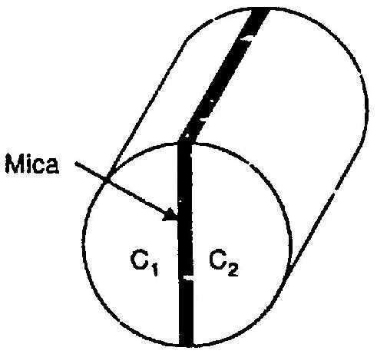

Fig.(1.3)

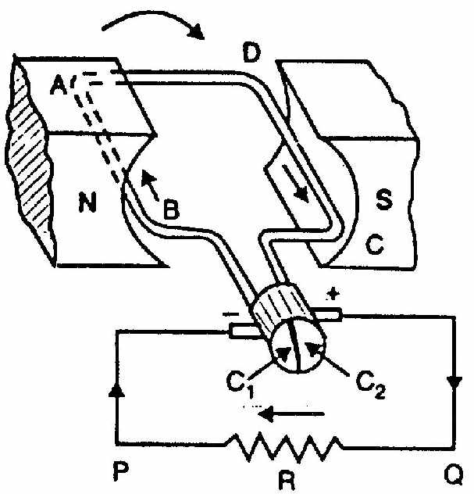

Fig.(1.4)

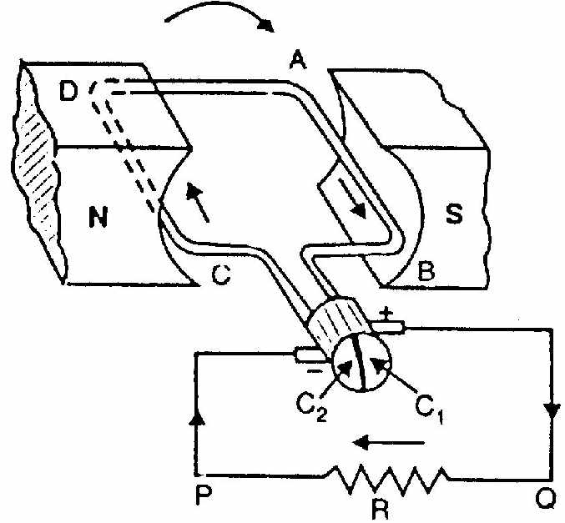

Fig.(1.5)

Thus the alternating voltage generated in the loop will appear as direct voltage across the brushes. The reader may note that e.m.f. generated in the armature winding of a d.c. generator is alternating one. It is by the use of commutator that we convert the generated alternating e.m.f. into direct voltage. The purpose of brushes is simply to lead current from the rotating loop or winding to the external stationary load.

The variation of voltage across the brushes with the angular displacement of the loop will be as shown in Fig. (1.6). This is not a steady direct voltage but has a pulsating character. It is because the voltage appearing across the brushes varies from zero to maximum value and back to zero twice for each revolution of the loop. A pulsating direct voltage such as is produced by a single loop is not suitable for many commercial uses. What we require is the steady direct voltage. This can be achieved by using a large number of coils connected in series. The resulting arrangement is known as armature winding.

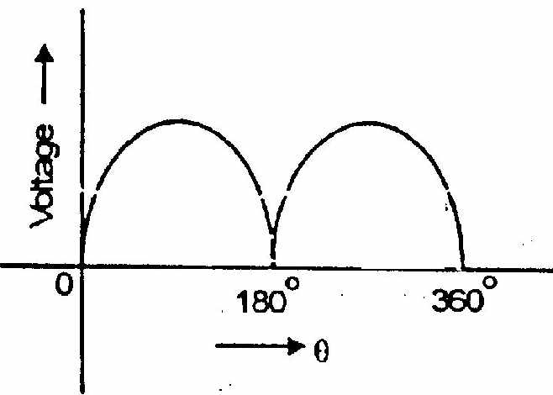

Fig.(1.6)

**CONSTRUCTION OF D.C. GENERATOR**

The d.c. generators and d.c. motors have the same general construction. In fact, when the machine is being assembled, the workmen usually do not know whether it is a d.c. generator or motor. Any d.c. generator can be run as a d.c. motor and vice-versa. All d.c. machines have five principal components viz.

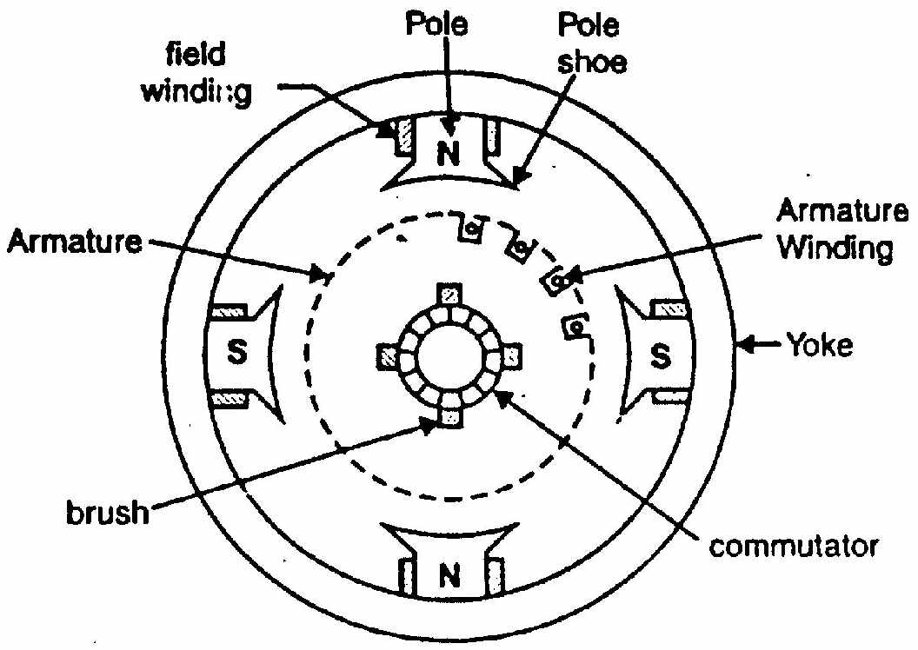

Fig 1.7.

(i) field system

(ii) armature core

(iii) armature winding

(iv) commutator

(v) brushes

**(i) Magnetic Field system**

The function of the field system is to produce uniform magnetic field within which the armature rotates. It consists of a number of salient poles (of course, even number) bolted to the inside of circular frame (generally called yoke).

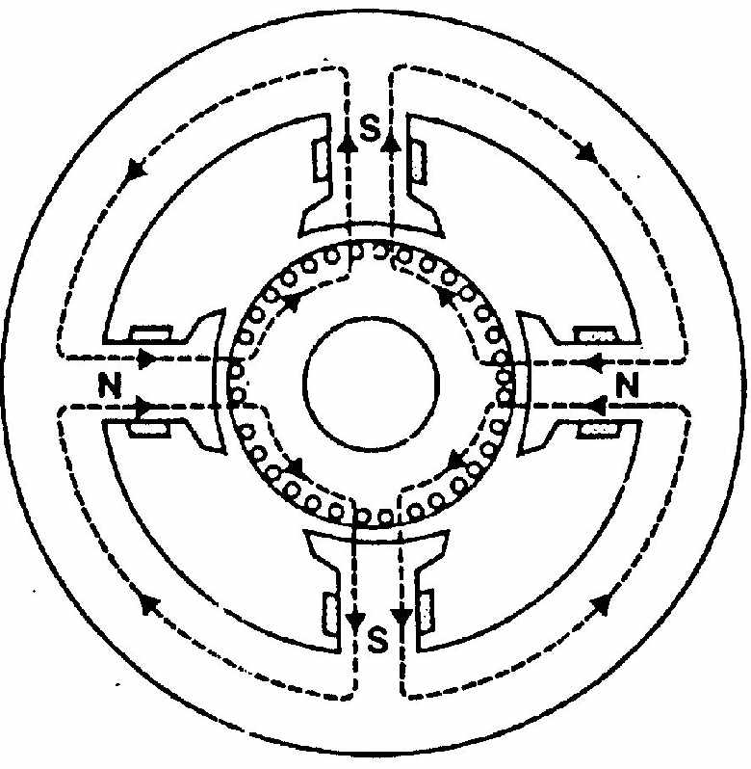

Fig 1.8

The **Fig. (1.7)** yoke is usually made of **solid cast steel** whereas the pole pieces are composed of stacked laminations. Field coils are mounted on the poles and carry the d.c. exciting current. The field coils are connected in such a way that adjacent poles have opposite polarity.

The m.m.f. developed by the field coils produces a magnetic flux that passes through the pole pieces, the air gap, the armature and the frame (See Fig. 1.8). Practical d.c. machines have air gaps ranging from 0.5 mm to 1.5 mm. Since armature and field systems are composed of materials that have high permeability, most of the m.m.f. of field coils is required to set up flux in the air gap. By reducing the length of air gap, we can reduce the size of field coils (i.e. number of turns).

The yoke not only serves as a support for field poles, interpoles (not shown) etc. but it also provides return path for the magnetic flux created by the field windings.

**(ii) Armature core**

The armature core is keyed to the machine shaft and rotates between the field poles. It consists of slotted soft-iron laminations (about 0.4 to 0.6 mm thick) that are stacked to form a cylindrical core as shown in Fig (1.9). The laminations (See Fig. 1.10) are individually coated with a thin insulating film so that they do not come in electrical contact with each other. The purpose of laminating the core is to reduce the eddy current loss. The laminations are slotted to accommodate and provide mechanical security to the armature winding and to give shorter air gap for the flux to cross between the pole face and the armature “teeth”.

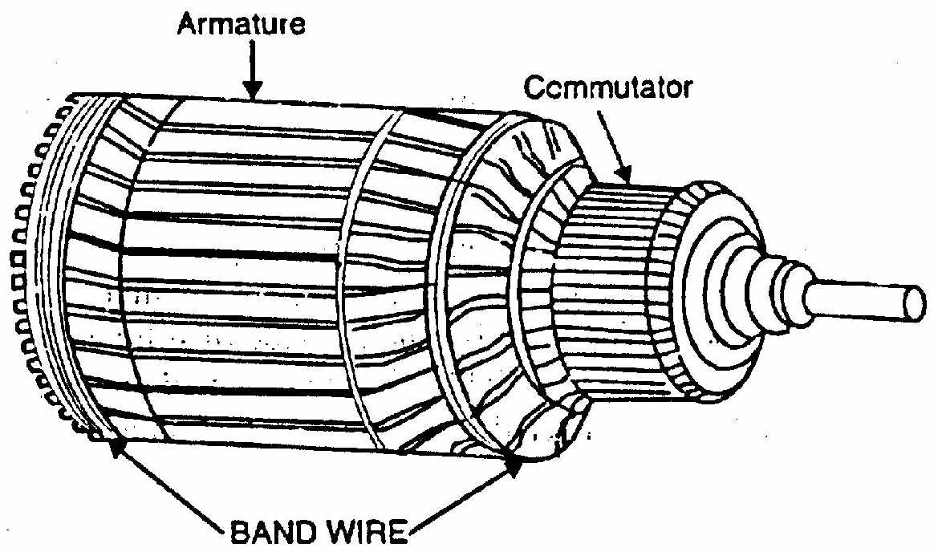

Fig 1.9

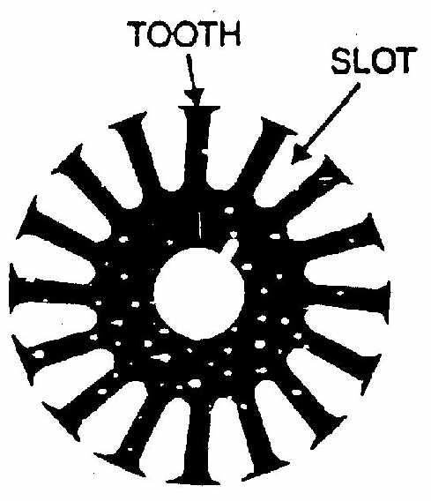

Fig 1.10

**(iii) Armature winding**

The slots of the armature core hold insulated conductors that are connected in a suitable manner. This is known as armature winding. This is the winding in which “working” e.m.f. is induced. The armature conductors are connected in series-parallel; the conductors being connected in series so as to increase the voltage and in parallel paths so as to increase the current. The armature winding of a d.c. machine is a closed-circuit winding; the conductors being connected in a symmetrical manner forming a closed loop or series of closed loops.

**(iv) Commutator**

A commutator is a **mechanical rectifier** which converts the alternating voltage generated in the armature winding into direct voltage across the brushes. The commutator is made of copper segments insulated from each other by mica sheets and mounted on the shaft of the machine (See Fig 1.11). The armature conductors are soldered to the commutator segments, there are two types of armature winding in a.d.c. machine viz., (a) lap winding (b) wave winding. Great care is taken in building the commutator because any eccentricity will cause the brushes to bounce, producing unacceptable sparking. The sparks may burn the brushes and overheat and carbonise the commutator.

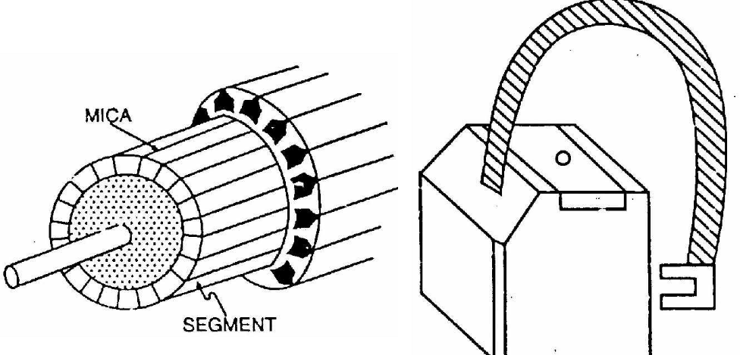

Fig 1.11

Fig 1.12

**v) Brushes**

The purpose of brushes is to ensure electrical connections between the rotating commutator and stationary external load circuit. The brushes are made of carbon and rest on the commutator. The brush pressure is adjusted by means of adjustable springs (See Fig. 1.12). If the brush pressure is very large, the friction produces heating of the commutator and the brushes. On the other hand, if it is too weak, the imperfect contact with the commutator may produce sparking.

Multipole machines have as many brushes as they have poles. For example, a 4- pole machine has 4 brushes. As we go round the commutator, the successive brushes have positive and negative polarities. Brushes having the same polarity are connected together so that we have two terminals viz., the +Ve terminal and the -ve terminal.

**E.M.F. EQUATION OF A D.C. GENERATOR**

We shall now derive an expression for the e.m.f. generated in a d.c. generator.

Let, φ = flux/pole in Wb

Z = total number of armature conductors

P = number of poles

A = number of parallel paths = 2 ... for wave winding

= P ... for lap winding

N = speed of armature in r.p.m.

Eg = e.m.f. of the generator = e.m.f./parallel path

Flux cut by one conductor in one revolution of the armature,

d φ = P φ webers

Time taken to complete one revolution, dt = 60/Nsecond





 ------ (1)

**The following points may be noted:**

(i)Eq. (1) is also valid for a d.c. motor. In case of a d.c. generator, induced e.m.f. in the armature is called generated e.m.f. or generated voltage (Eg). When the d.c. machine operates as a motor, the induced e.m.f.in the armature is called counter e.m.f.or backe.m.f. Eb(=P φZN/60A).

(ii) for a given d.c. machine(generator or motor), Z, P and A are constant so that Eg(or Eb)N. Therefore, for a given d.c. machine, the induced voltage in the armature is directly proportional to flux per pole (φ) and speed of rotation (N).

***Note:*** In deriving eq. (1) above, we have assumed that the poles cover the entire armature periphery. This is virtually impossible. In practical machines, the poles cover 60% to 80% of the armature periphery. This fact must be taken into consideration while computing flux per pole (φ).

**ARMATURE RESISTANCE (RA)**

The resistance offered by the armature circuit is known as armature resistance (Ra) and includes:

(i) resistance of armature winding

(ii) resistance of brushes

The armature resistance depends upon the construction of machine. Except for small machines, its value is generally less than 1 Ω.

**TYPES OF D.C. GENERATORS**

The magnetic field in a d.c. generator is normally produced by electromagnets rather than permanent magnets. Generators are generally classified according to their methods of field excitation. On this basis, d.c. generators are divided into the following two classes:

(i) Separately excited d.c. generators

(ii) Self-excited d.c. generators

The behaviour of a d.c. generator on load depends upon the method of field excitation adopted.

**SEPARATELY EXCITED D.C. GENERATORS**

A d.c. generator whose field magnet winding is supplied from an independent external d.c. source (e.g., a battery etc.) is called a separately excited generator. Fig. (1.13) shows the connections of a separately excited generator. The voltage output depends upon the speed of rotation of armature and the field current (Eg = P φ Z N/60 A). The greater the speed and field current, greater is the generated e.m.f. It may be noted that separately excited d.c. generators are rarely used in practice. The d.c. generators are normally of self-excited type.

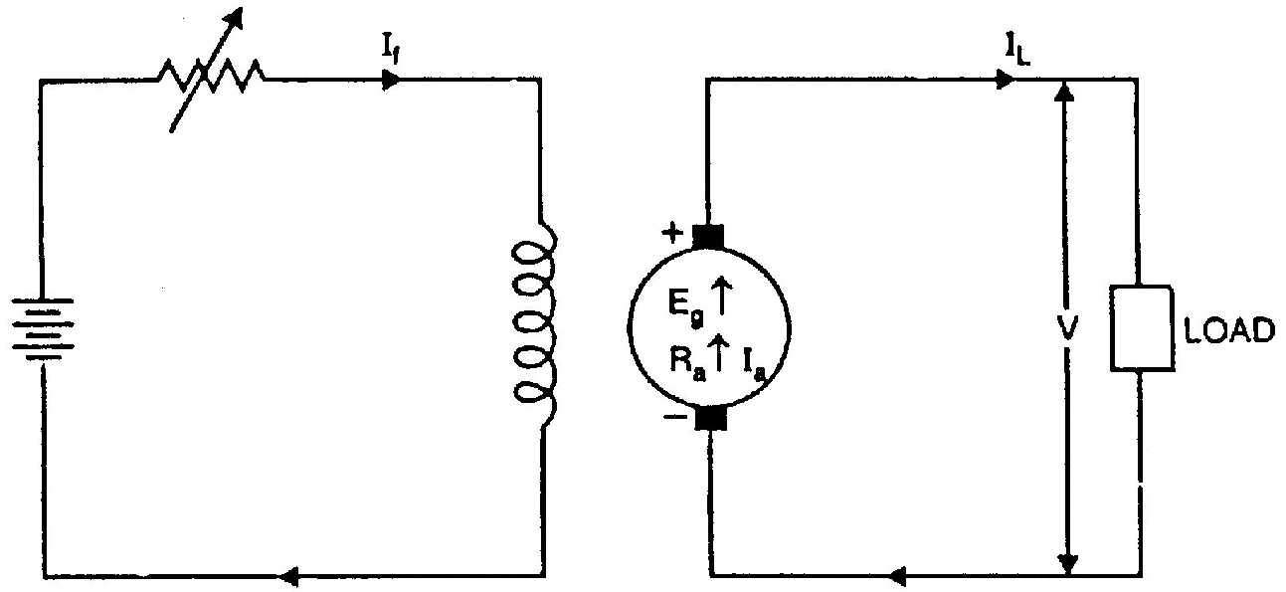

Fig 1.13

Armature current, Ia = IL

Terminal voltage, V= 

Electric power developed = EgIa

Power delivered to load = 

**SELF-EXCITED D.C. GENERATORS**

A d.c. generator whose field magnet winding is supplied current from the output of the generator itself is called a self-excited generator. There are three types of self-excited generators depending upon the manner in which the field winding is connected to the armature, namely;

(i) Series generator; (ii) Shunt generator; (iii) Compound generator

**(i) Series generator**

In a series wound generator, the field winding is connected in series with armature winding so that whole armature current flows through the field winding as well as the load. Fig. (1.14) shows the connections of a series wound generator. Since the field winding carries the whole of load current, it has a few turns of thick wire having low resistance. Series generators are rarely used except for special purposes e.g., as boosters.

Armature current,  (say)

Terminal voltage 

Electric power developed in armature = 

Power delivered to load =

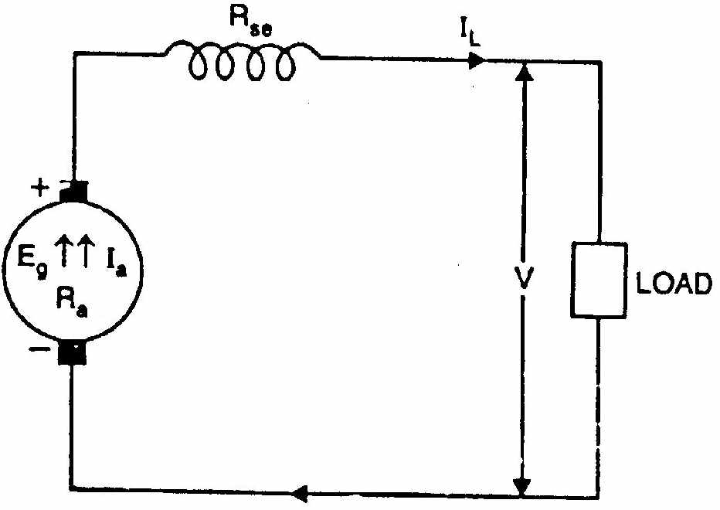

Fig 1.14

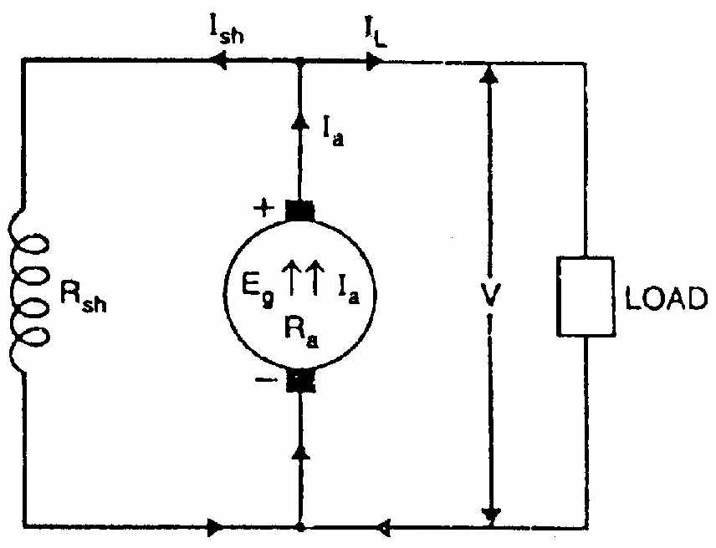

Fig 1.15

**(ii) Shunt generator**

In a shunt generator, the field winding is connected in parallel with the armature winding so that terminal voltage of the generator is applied across it. The shunt field winding has many turns of fine wire having high resistance. Therefore, only a part of armature current flows through shunt field winding and the rest flows through the load. Fig. (1.15) shows the connections of a shunt-wound generator.

Shunt field current, Ish = V/Rsh Armature current, Ia = IL + Ish Terminal voltage, V = 

Power developed in armature = EgIa Power delivered to load = VIL

**(iii) Compound generator**

In a compound-wound generator, there are two sets of field windings on each pole—one is in series and the other in parallel with the armature. A compound wound generator may be:

(a) **Short Shunt** in which only shunt field winding is in parallel with the armature winding [See Fig. 1.16 (i)].

(b) **Long Shunt** in which shunt field winding is in parallel with both series field and armature winding [See Fig. 1.16 (ii)].

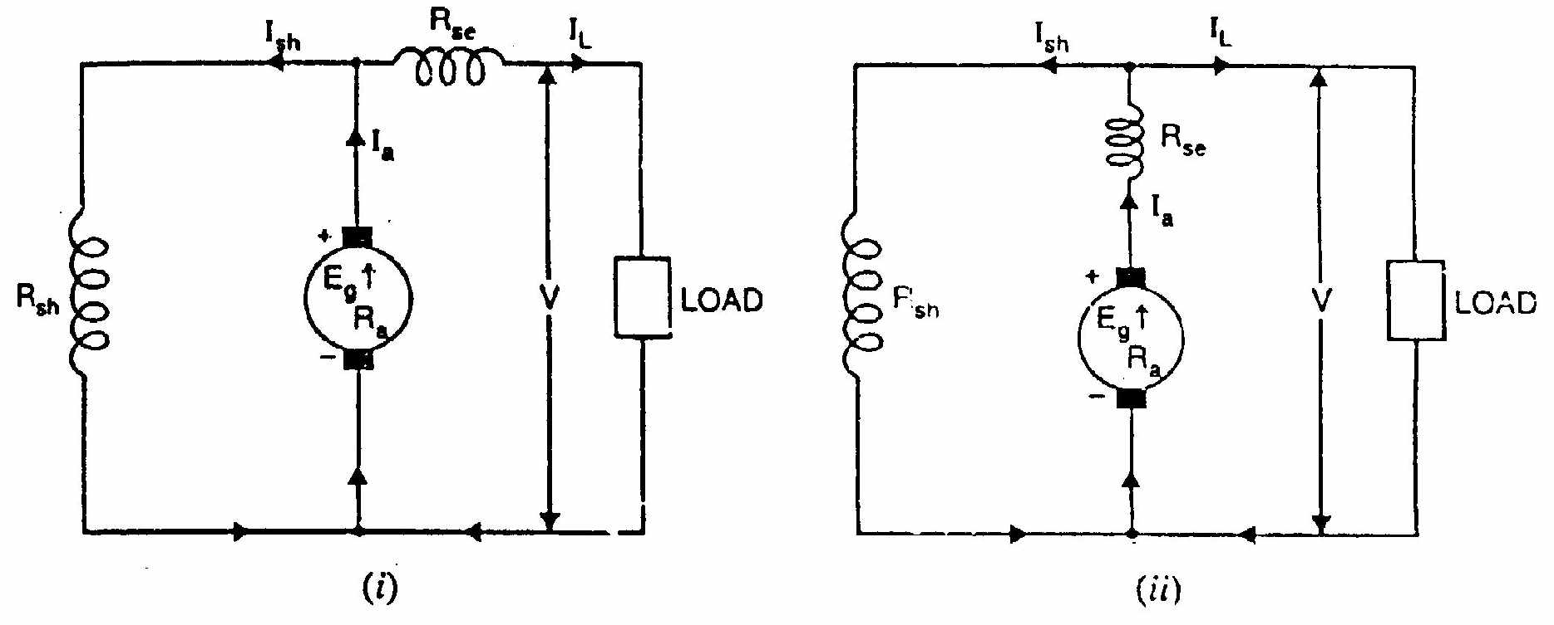

Fig 1.16

**Short shunt**

Series field current. 

Shunt field current,

Terminal voltage,

Power development in armature=

Power delivered to load=

**Long shunt**

Series field current,

Shunt field current,

Terminal voltage,

Power developed in armature=

Power delivered to load=

**BRUSH CONTACT DROP**

It is the voltage drop over the brush contact resistance when current flows. Obviously, its value will depend upon the amount of current flowing and the value of contact resistance. This drop is generally small and may be neglected if not given.

**ELECTROMECHANICAL ENERGY CONVERSION IN A GENERATOR**

A generator converts mechanical energy in to electrical energy. Let us see how it happens. The current always flows in the same direction in those conductors that are momentarily under a N-pole. The same is true for the conductors that are momentarily under a S-pole. However, currents under the N-pole flow opposite to those under the S-pole. Since all the conductors lie in a magnetic field, they all experience a force. By Fleming’s left hand rule, we find that the forces on the conductors all act in the same direction. As can be seen, the conductors produce a torque which acts opposite to the direction in which the generator is driven. To keep the machine going, we must exert a torque on the shaft to overcome this opposing electromagnetic torque, the resulting mechanical energy is converted into electrical energy which is delivered to the generator load. In fig. The generator is driven in anticlockwise direction by the prime mover. The armature conductors under the S-pole carry currents that flow in to the page, away from the reader. On the other hand, the armature currents under the N-pole flow out of the page, towards the reader. Therefore, by Fleming’s left hand rule, the force on every conductor acts towards the right, producing a net clockwise torque. This braking torque acts opposite to the direction of rotation.

**LOSSES IN A D.C. MACHINE**

The losses in a d.c. machine (generator or motor) may be divided into three classes viz (i) copper losses (ii) iron or core losses and (iii) mechanical losses. All these losses appear as heat and thus raise the temperature of the machine. They also lower the efficiency of the machine.

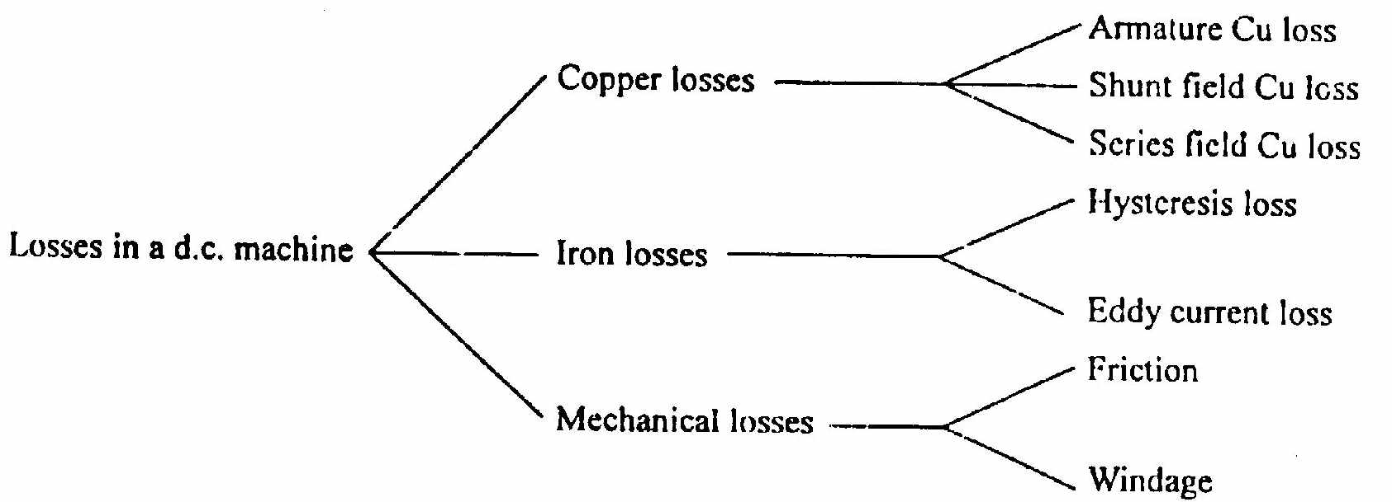

Fig 1.17

**1. Copper losses**

These losses occur due to currents in the various windings of the machine.



**2. Iron or Core losses**

These losses occur in the armature of a d.c. machine and are due to the rotation of armature in the magnetic field of the poles. They are of two types viz., (i) hysteresis loss (ii) eddy current loss.

**(i)** **Hysteresis loss**

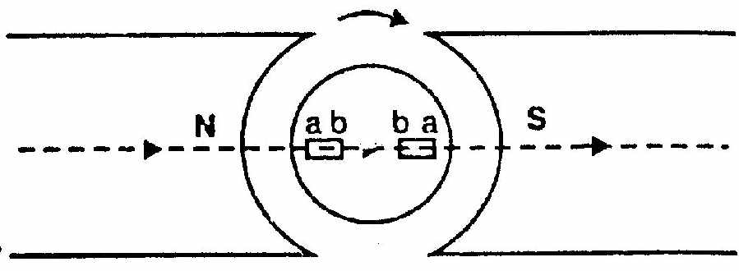

Fig 1.18

Hysteresis loss occurs in the armature of the d.c. machine since any given part of the armature is subjected to magnetic field reversals as it passes under successive poles. Fig. (1.18) shows an armature rotating in two-pole machine. Consider a small piece ab of the armature. When the piece ab is under N-pole, the magnetic lines pass from a to b. Half a revolution later, the same piece of iron is under S-pole and magnetic lines pass from b to a so that magnetism in the iron is reversed. In order to reverse continuously the molecular magnets in the armature core, some amount of power has to be spent which is called hysteresis loss. It is given by Steinmetz formula. This formula is

Hysteresis Loss, 

where Bmax = Maximum flux density in armature

f = Frequency of magnetic reversals

= NP/120 where N is in r.p.m.

V = Volume of armature in m3

ƞ= Steinmetz hysteresis co-efficient

In order to reduce this loss in a d.c. machine, armature core is made of such materials which have a low value of Steinmetz hysteresis co-efficient e.g., silicon steel.

**(ii) Eddy current loss**

In addition to the voltages induced in the armature conductors, there are also voltages induced in the armature core. These voltages produce circulating currents in the armature core as shown in Fig. (1.19). These are called eddy currents and power loss due to their flow is called eddy current loss. The eddy current loss appears as heat which raises the temperature of the machine and lowers its efficiency.

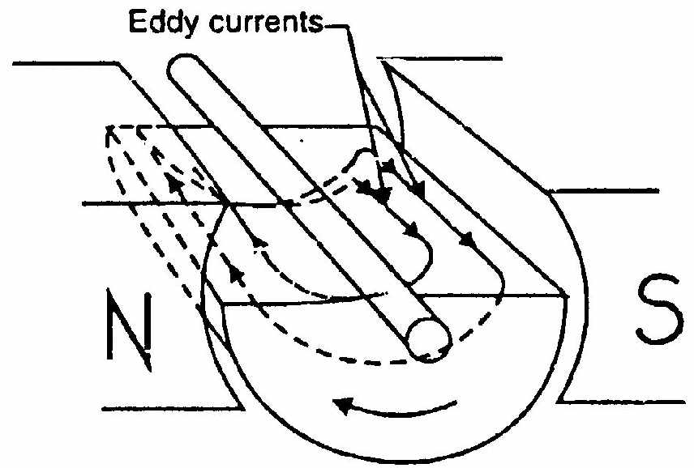

Fig 1.19

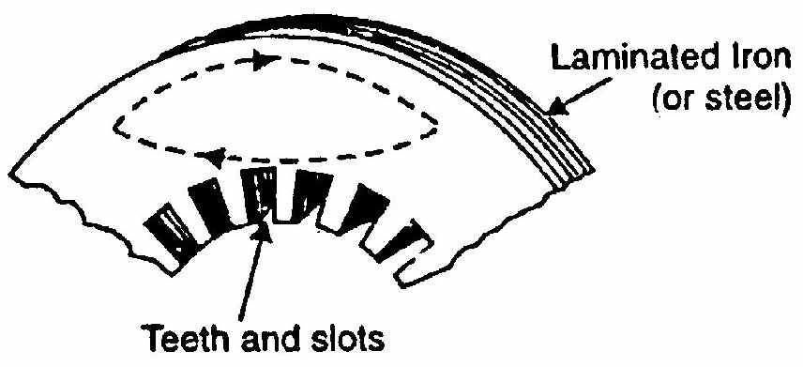

Fig 1.20

If a continuous solid iron core is used, the resistance to eddy current path will be small due to large cross-sectional area of the core. Consequently, the magnitude of eddy current and hence eddy current loss will be large. The magnitude of eddy current can be reduced by making core resistance as high as practical. The core resistance can be greatly increased by constructing the core of thin, round iron sheets called laminations [See Fig. 1.20]. The laminations are insulated from each other with a coating of varnish. The insulating coating has a high resistance, so very little current flows from one lamination to the other. Also, because each lamination is very thin, the resistance to current flowing through the width of a lamination is also quite large. Thus laminating a core increases the core resistance which decreases the eddy current and hence the eddy current loss.

Eddy current loss, 

where Ke = Constant depending upon the electrical resistance of core and system of units used

Bmax = Maximum flux density in Wb/m2

f = Frequency of magnetic reversals in Hz

t = Thickness of lamination in m

V = Volume of core in m3

It may be noted that eddy current loss depends upon the square of lamination thickness. For this reason, lamination thickness should be kept as small as possible.

**3. Mechanical losses**: These losses are due to friction and windage.

(i) friction loss e.g., bearing friction, brush friction etc. (ii) windage loss i.e., air friction of rotating armature.

These losses depend upon the speed of the machine. But for a given speed, they are practically constant.

**Note**. Iron losses and mechanical losses together are called rotational losses.

**Constant and Variable Losses**

The losses in a d.c. generator (or d.c. motor) may be sub-divided into (i) constant losses (ii) variable losses.

(i) **Constant losses**

Those losses in a d.c. generator which remain constant at all loads are known as constant losses. The constant losses in a d.c. generator are:

(a) iron losses (b) mechanical losses (c) shunt field losses

**(ii) Variable losses**

Those losses in a d.c. generator which vary with load are called variable losses.

The variable losses in a d.c. generator are:

(a) Copper loss in armature winding (

(b) Copper loss in series field winding 

Total losses = Constant losses + Variable losses

**Note**. Field Cu loss is constant for shunt and compound generators.

**D.C. GENERATOR CHARACTERISTICS**

**INTRODUCTION**

The speed of a d.c. machine operated as a generator is fixed by the prime mover. For general-purpose operation, the prime mover is equipped with a speed governor so that the speed of the generator is practically constant. Under such condition, the generator performance deals primarily with the relation between excitation, terminal voltage and load. These relations can be best exhibited graphically by means of curves known as generator characteristics. These characteristics show at a glance the behaviour of the generator under different load conditions.

**D.C. GENERATOR CHARACTERISTICS**

The following are the three most important characteristics of a d.c. generator:

**Open Circuit Characteristic (O.C.C.)**

This curve shows the relation between the generated e.m.f. at no-load (E0) and the field current (If) at constant speed. It is also known as magnetic characteristic or no-load saturation curve. Its shape is practically the same for all generators whether separately or self-excited. The data for O.C.C. curve are obtained experimentally by operating the generator at no load and constant speed and recording the change in terminal voltage as the field current is varied.

**Internal or Total characteristic (E/Ia)**

This curve shows the relation between the generated e.m.f. on load (E) and the armature current (Ia). The e.m.f. E is less than E0 due to the demagnetizing effect of armature reaction. Therefore, this curve will lie below the open circuit characteristic (O.C.C.). The internal characteristic is of interest chiefly to the designer. It cannot be

obtained directly by experiment. It is because a voltmeter cannot read the e.m.f. generated on load due to the voltage drop in armature resistance. The internal characteristic can be obtained from external characteristic if winding resistances are known because armature reaction effect is included in both characteristics.

**External characteristic (V/IL)**

This curve shows the relation between the terminal voltage (V) and load current (IL). The terminal voltage V will be less than E due to voltage drop in the armature circuit. Therefore, this curve will lie below the internal characteristic. This characteristic is very important in determining the suitability of a generator for a given purpose. It can be obtained by making simultaneous measurements of terminal voltage and load current (with voltmeter and ammeter) of a loaded generator.

**OPEN CIRCUIT CHARACTERISTIC OF A D.C. GENERATOR**

The O.C.C. for a d.c. generator is determined as follows. The field winding of the d.c. generator (series or shunt) is disconnected from the machine and is separately excited from an external d.c. source as shown in Fig.1.21 (ii). The generator is run at fixed speed (i.e., normal speed). The field current (If) is increased from zero in steps and the corresponding values of generated e.m.f. (E0) read off on a voltmeter connected across the armature terminals. On plotting the relation between E0 and If, we get the open circuit characteristic as shown in Fig. 1.21 (i).

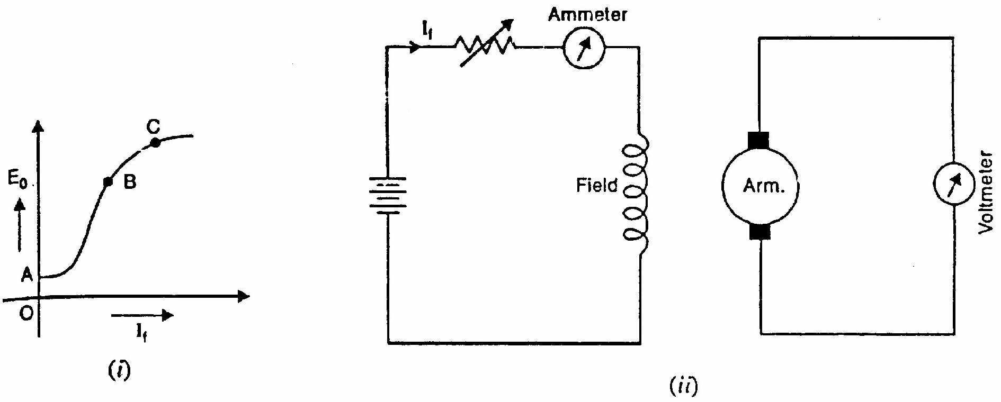

Fig 1.21

The following points may be noted from O.C.C.:

(i) When the field current is zero, there is some generated e.m.f. OA. This is due to the residual magnetism in the field poles.

(ii) Over a fairly wide range of field current (upto point B in the curve), the curve is linear. It is because in this range, reluctance of iron is negligible as compared with that of air gap. The air gap reluctance is constant and hence linear relationship.

(iii) After point B on the curve, the reluctance of iron also comes into picture. It is because at higher flux densities, µr for iron decreases and reluctance of iron is no longer negligible. Consequently, the curve deviates from linear relationship

(iv) After point C on the curve, the magnetic saturation of poles begins and E0 tends to level off.

The reader may note that the O.C.C. of even self-excited generator is obtained by running it as a separately excited generator.

**CHARACTERISTICS OF A SEPARATELY EXCITED D.C.GENERATOR**

The obvious disadvantage of a separately excited d.c. generator is that we require an external d.c. source for excitation. But since the output voltage may be controlled more easily and over a wide range (from zero to a maximum), this type of excitation finds many applications.

**(i) Open circuit characteristic.**

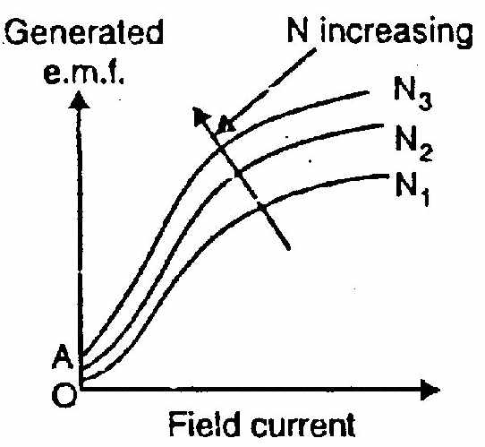

Fig 1.22

The O.C.C. of a separately excited generator is determined in a manner described in Previous Section. Fig. (1.22) shows the variation of generated e.m f. on no load with field current for various fixed speeds. Note that if the value of constant speed is increased, the steepness of the curve also increases. When the field current is zero, the residual magnetism in the poles will give rise to the small initial e.m.f. as shown.

**(ii) Internal and External Characteristics**

The external characteristic of a separately excited generator is the curve between the terminal voltage (V) and the load current IL (which is the same as armature current in this case). In order to determine the external characteristic, the circuit set up is as shown in Fig. (1.23) (i). As the load current increases, the terminal voltage falls due to two reasons: (a)The armature reaction weakens the main flux so that actual e.m.f. generated E on load is less than that generated (E0) on no load.

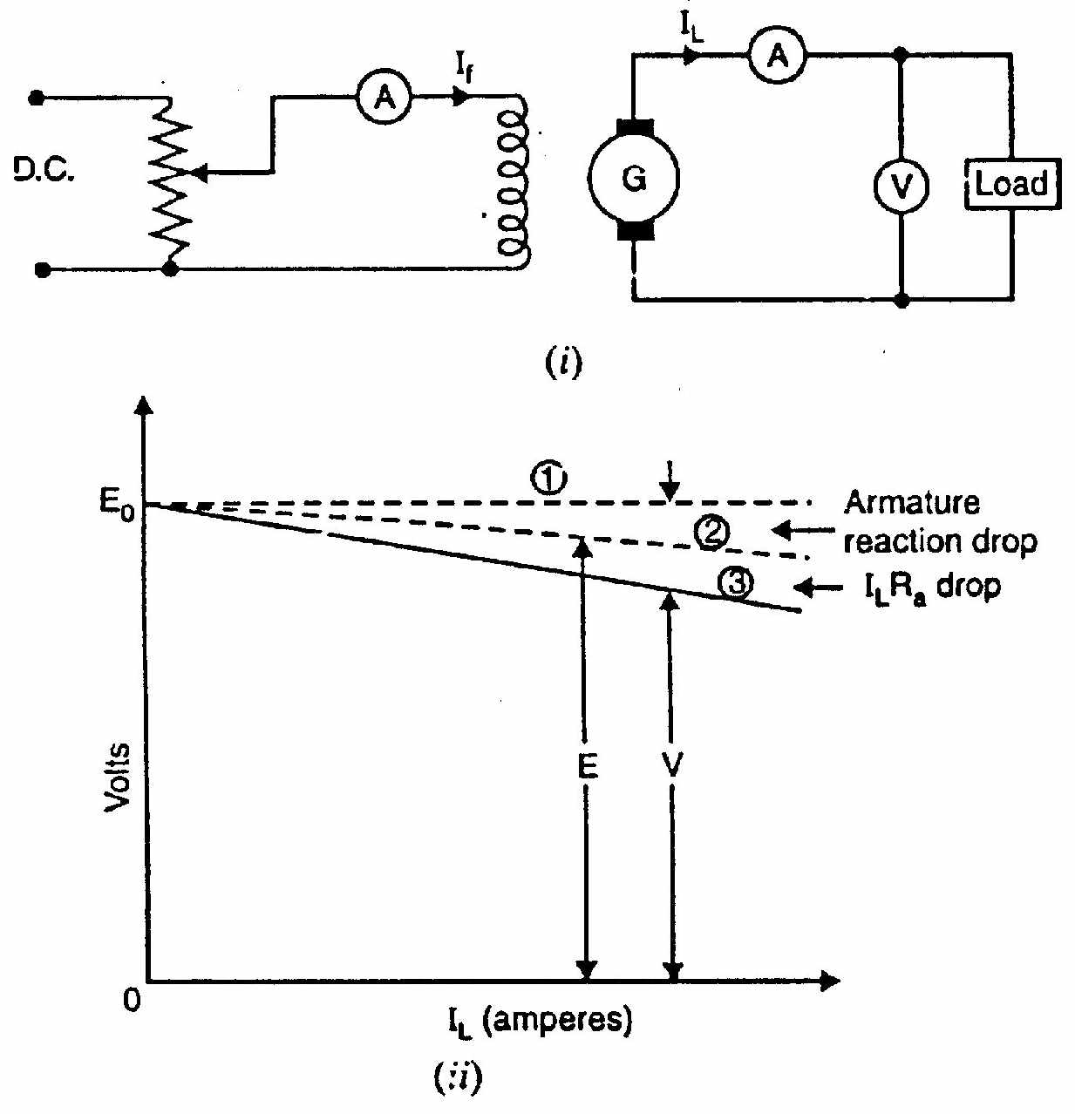

Fig 1.23

(b) There is voltage drop across armature resistance (= ILRa = IaRa).

Due to these reasons, the external characteristic is a drooping curve [curve 3 in Fig. 1.23 (ii)]. Note that in the absence of armature reaction and armature drop, the generated e.m.f. would have been E0 (curve 1).

The internal characteristic can be determined from external characteristic by adding ILRa drop to the external characteristic. It is because armature reaction drop is included in the external characteristic. Curve 2 is the internal characteristic of the generator and should obviously lie above the external characteristic.

**CHARACTERISTICS OF SERIES GENERATOR**

Fig. 1.24 (i) shows the connections of a series wound generator. Since there is only one current (that which flows through the whole machine), the load current is the same as the exciting current.

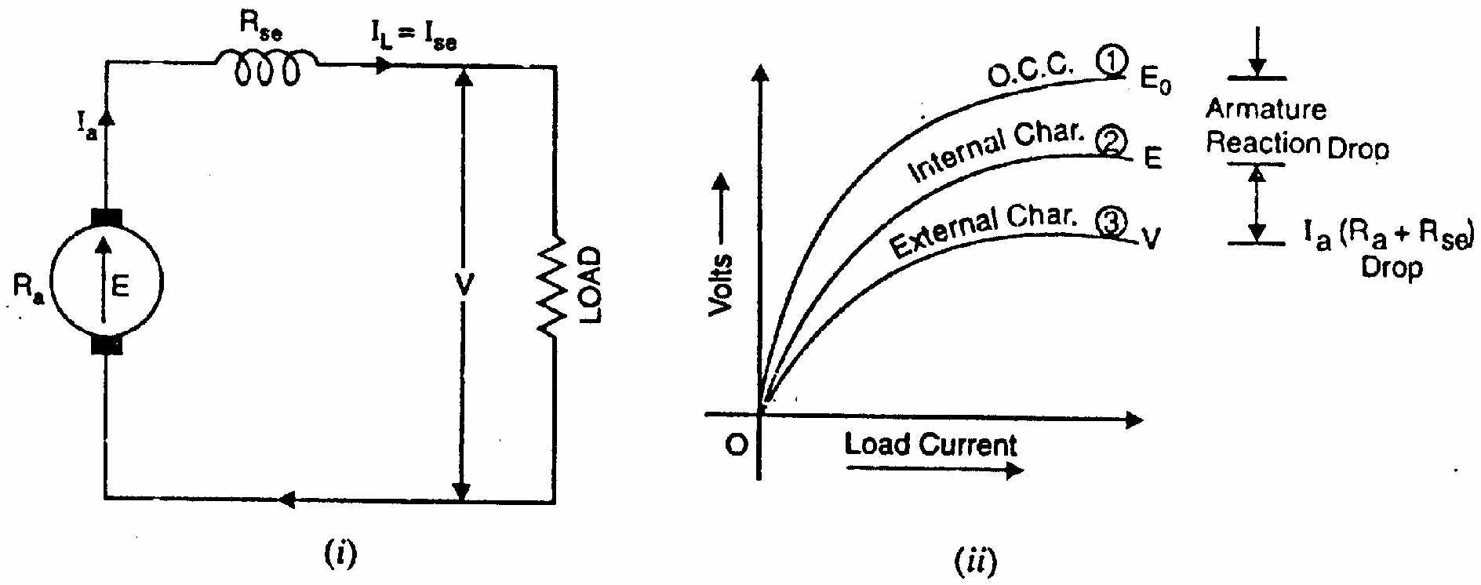

Fig 1.24

**(i) O.C.C.**

Curve 1 shows the open circuit characteristic (O.C.C.) of a series generator. It can be obtained experimentally by disconnecting the field winding from the machine and exciting it from a separate d.c. source as discussed in earlier section.

**(ii) Internal characteristic**

Curve 2 shows the total or internal characteristic of a series generator. It gives the relation between the generated e.m.f. E. on load and armature current. Due to armature reaction, the flux in the machine will be less than the flux at no load. Hence, e.m.f. E generated under load conditions will be less than the e.m.f. E0 generated under no load conditions. Consequently, internal characteristic curve lies below the O.C.C. curve; the difference between them representing the effect of armature reaction [See Fig. 1.30(ii)].

**(iii) External characteristic**

Curve 3 shows the external characteristic of a series generator. It gives the relation between terminal voltage V and load current IL:.



Therefore, external characteristic curve will lie below internal characteristic curve by an amount equal to ohmic drop [i.e., Ia(Ra + Rse)] in the machine as shown in Fig.1.24(ii).

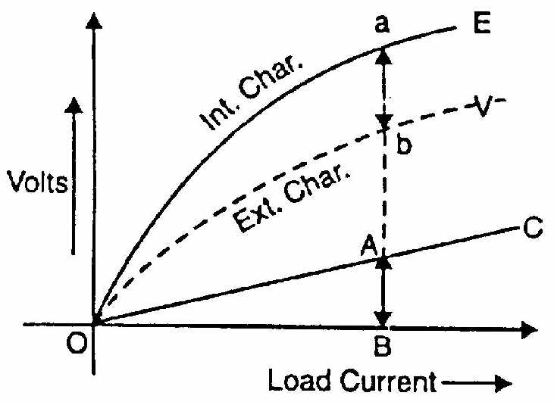

Fig 1.25

The internal and external characteristics of a d.c. series generator can be plotted from one another as shown in Fig. (1.25). Suppose we are given the internal characteristic of the generator. Let the line OC represent the resistance of the whole machine i.e. Ra + Rse. If the load current is OB, drop in the machine is AB i.e.

AB = Ohmic drop in the machine = OB(Ra + Rse)

Now raise a perpendicular from point B and mark a point b on this line such that ab = AB. Then point b will lie on the external characteristic of the generator. Following similar procedure, other points of external characteristic can be located. It is easy to see that we can also plot internal characteristic from the external characteristic.

**CHARACTERISTICS OF A SHUNT GENERATOR**

Fig 1.26(i) shows the connections of a shunt wound generator. The armature current Ia splits up into two parts; a small fraction Ish flowing through shunt field winding while the major part IL goes to the external load.

**(i) O.C.C.**

The O.C.C. of a shunt generator is similar in shape to that of a series generator as shown in Fig. 1.26 (ii). The line OA represents the shunt field circuit resistance. When the generator is run at normal speed, it will build up a voltage OM. At no-load, the terminal voltage of the generator will be constant (= OM) represented by the horizontal dotted line MC

**ii) Internal characteristic**

When the generator is loaded, flux per pole is reduced due to armature reaction. Therefore, e.m.f. E generated on load is less than the e.m.f. generated at no load. As a result, the internal characteristic (E/Ia) drops down slightly as shown in Fig. 1.26 (ii).

**(iii) External characteristic**

Curve 2 shows the external characteristic of a shunt generator. It gives the relation between terminal voltage V and load current IL.





Therefore, external characteristic curve will lie below the internal characteristic curve by an amount equal to drop in the armature circuit [i.e., (IL + Ish)Ra] as shown in Fig. 1.26(ii).

**Note**. It may be seen from the external characteristic that change in terminal voltage from no-load to full load is small. The terminal voltage can always be maintained constant by adjusting the field rheostat R automatically.

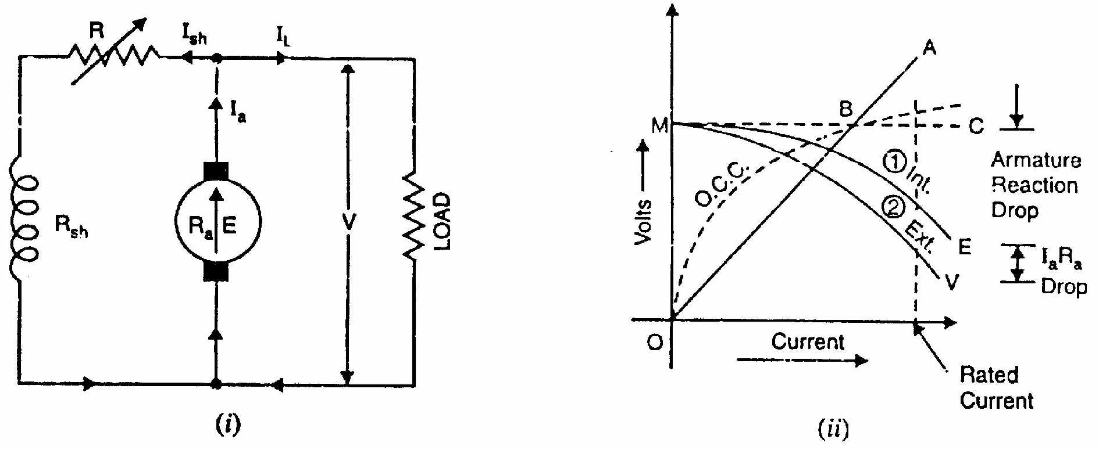

Fig 1.26

**COMPOUND GENERATOR CHARACTERISTICS**

In a compound generator, both series and shunt excitation are combined as shown in Fig. (1.27). The shunt winding can be connected either across the armature only (short-shunt connection S) or across armature plus series field (long-shunt connection G). The compound generator can be cumulatively compounded or differentially compounded generator. The latter is rarely used in practice. Therefore, we shall discuss the characteristics of cumulatively- compounded generator. It may be noted that external characteristics of long and short shunt compound generators are almost identical.

**External characteristic**

Fig. (1.28) shows the external characteristics of a cumulatively compounded generator. The series excitation aids the shunt excitation. The degree of compounding depends upon the increase in series excitation with the increase in load current.

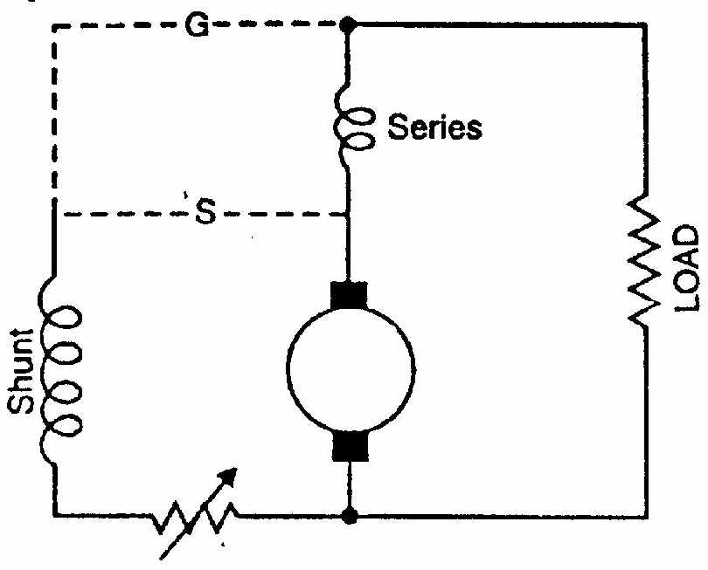

Fig 1.27

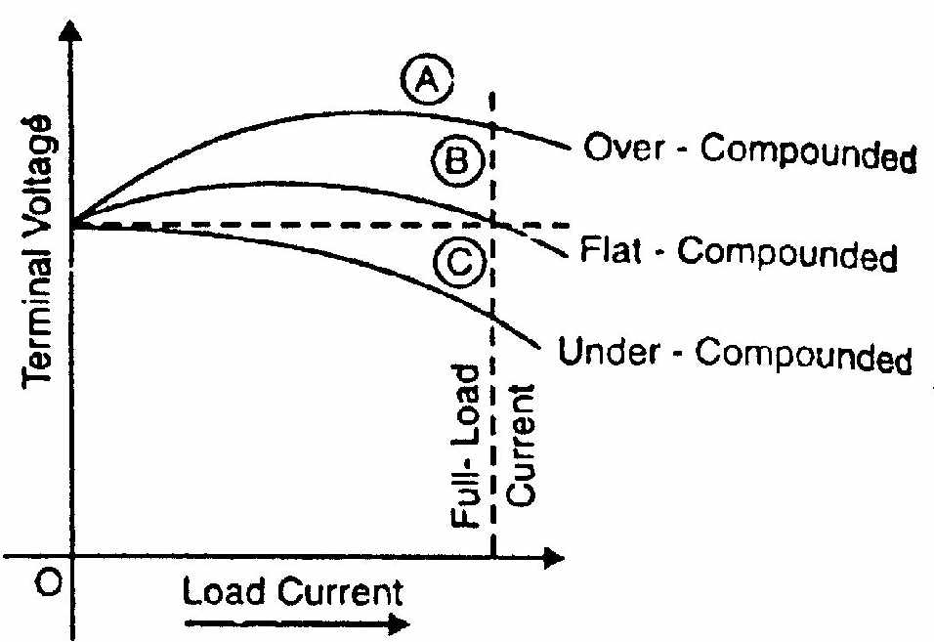

Fig 1.28

(i) If series winding turns are so adjusted that with the increase in load current the terminal voltage increases, it is called over-compounded generator. In such a case, as the load current increases, the series field m.m.f. increases and tends to increase the flux and hence the generated voltage. The increase in generated voltage is greater than the IaRa drop so that instead of decreasing, the terminal voltage increases as shown by curve A in Fig. (1.28).

(ii) If series winding turns are so adjusted that with the increase in load current, the terminal voltage substantially remains constant, it is called flat-compounded generator. The series winding of such a machine has lesser number of turns than the one in over-compounded machine and, therefore, does not increase the flux as much for a given load current. Consequently, the full-load voltage is nearly equal to the no-load voltage as indicated by curve B in Fig (1.28).

(iii) If series field winding has lesser number of turns than for a flat- compounded machine, the terminal voltage falls with increase in load current as indicated by curve C m Fig. (1.28). Such a machine is called under-compounded generator.

**2013**

**UNIT-I**

1.a) Explain the principle of operation of DC generator.

b) An 8-pole wave connected D.C. generator has 1000 armature conductors and

flux/pole 0.035 wb. At what speed must it be driven to generate 500 V?

**2014**

**UNIT-I**

1.a)Derive the expression for EMF equation of DC generator.

b) The open circuit characteristic of a D.C. shunt generator running at 600 r.p.m is as follows:

Field current A: 1.4 2.4 3.6 4.0 4.8

E.M.F., V: 125 188 238 250 270

Calculate:

(i) The voltage that can be developed with a field resistance of 70 ohms.

(ii) The field resistance required to develop 250V

(iii) The cirtical resistance;and

(iv) the critical speed at a field resistance of 62.5 ohms.

**2015**

**UNIT-I**

1.a) Discuss the magnetization and load characteristics of a DC Generator

b) A 4 pole lap connected DC machine has an armature resistance of 0.15

ohm. Find armature resistance of the machine is rewound for wave

connection.

2.a) A Shunt generator has a full load current of 196 A at 220V. The stray loss

is 720W and the shunt field resistance is 55 ohms. If it has a full load

efficiency is 88%, find the armature resistance. Also, find the load current

corresponding to maximum efficiency.

**2016**

**Unit-I**

1.a) A 24KW, 250 V, 1600 rpm separately excited DC generator has armature resistance of 0.1ohm. The machine is first run at rated speed and the field current is adjusted to give an open circuit voltage of 260V. Now, when the generator is loaded to deliver its rated current, the speed of the driving motor is found to be 1500rpm. Compute the terminal voltage of the generator under these conditions. Field flux remains un altered.,

2.a) A shunt generation delivers 195A at terminal voltage of 250V. The armature resistance and shunt field resistance are 0.02. ohms and 50 ohms respectively. The iron losses are 950w. find i) emf. Generated ii) output of prime mover.