**ELECTRICAL TECHNOLOGY**

**UNIT-2**

**D.C. MOTOR**

**INTRODUCTION**

D. C. motors are seldom used in ordinary applications because all electric supply companies furnish alternating current However, for special applications such as in steel mills, mines and electric trains, it is advantageous to convert alternating current into direct current in order to use d.c. motors. The reason is that speed/torque characteristics of d.c. motors are much more superior to that of a.c. motors. Therefore, it is not surprising to note that for industrial drives, d.c. motors are as popular as 3-phase induction motors. Like d.c. generators, d.c. motors are also of three types viz., series-wound, shunt-wound and compound- wound. The use of a particular motor depends upon the mechanical load it has to drive.

**D.C. MOTOR PRINCIPLE**

A machine that converts d.c. power into mechanical power is known as a d.c. motor. Its operation is based on the principle that when a current carrying conductor is placed in a magnetic field, the conductor experiences a mechanical force. The direction of this force is given by Fleming’s left hand rule and magnitude is given by:

F=BIL Newtons

Basically, there is no constructional difference between a d.c. motor and a d.c. generator. The same d.c. machine can be run as a generator or motor.

**WORKING OF D.C. MOTOR**

Consider a part of a multipolar d.c. motor as shown in Fig. (2.1). When the terminals of the motor are connected to an external source of d.c. supply:

(i) the field magnets are excited developing alternate N and S poles;

(ii) the armature conductors carry *currents. All conductors under N-pole carry currents in one direction while all the conductors under S-pole carry currents in the opposite direction.

Suppose the conductors under N-pole carry currents into the plane of the paper and those under S-pole carry currents out of the plane of the paper as shown in Fig (1.36). Since each armature conductor is carrying current and is placed in the magnetic field, mechanical force acts on it. Referring to Fig. (2.1) and applying Fleming’s left hand rule, it is clear that force on each conductor is tending to rotate the armature in anticlockwise direction. All these forces add together to produce a driving torque which sets the armature rotating. When the conductor moves from one side of a brush to the other, the current in that conductor is reversed and at the same time it comes under the influence of next pole which is of opposite polarity. Consequently, the direction of force on the conductor remains the same.

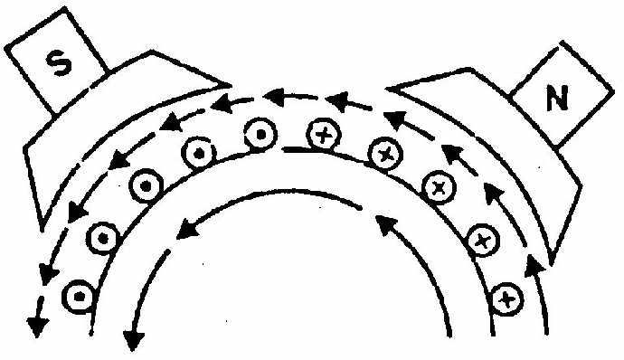

Fig 2.1

**BACK OR COUNTER E.M.F**

When the armature of a d.c. motor rotates under the influence of the driving torque, the armature conductors move through the magnetic field and hence e.m.f. is induced in them as in a generator The induced e.m.f. acts in opposite direction to the applied voltage V(*Lenz’s law) and in known as back or counter e.m.f. Eb. The back e.m.f. Eb(= P φ ZN/60 A) is always less than the applied voltage V, although this difference is small when the motor is running under normal conditions.

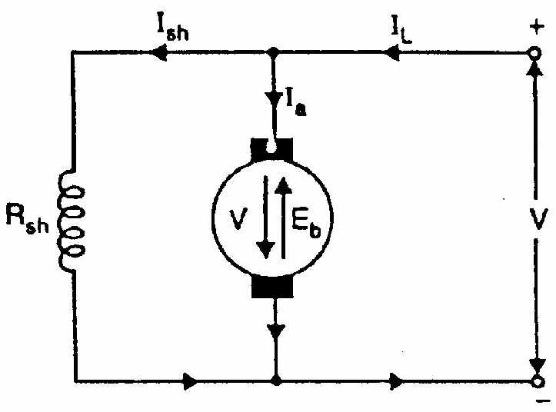

Fig 2.2

Consider a shunt wound motor shown in Fig. (2.2). When d.c. voltage V is applied across the motor terminals, the field magnets are excited and armature conductors are supplied with current. Therefore, driving torque acts on the armature which begins to rotate. As the armature rotates, back e.m.f. Eb is induced which opposes the applied voltage V. The applied voltage V has to force current through the armature against the back e.m.f. Eb. The electric work done in overcoming and causing the current to flow against Eb is converted into mechanical energy developed in the armature. It follows, therefore, that energy conversion in a d.c. motor is only possible due to the production of back e.m.f. Eb.

Net voltage across armature circuit = V - Eb

If Ra is the armature circuit resistance, then,

Since V and Ra are usually fixed, the value of Eb will determine the current drawn by the motor. If the speed of the motor is high, then back e.m.f.

Eb (= P φ ZN/60 A) is large and hence the motor will draw less armature current and vice- versa.

**SIGNIFICANCE OF BACK E.M.F**

The presence of back e.m.f. makes the d.c. motor a self-regulating machine i.e., it makes the motor to draw as much armature current as is just sufficient to develop the torque required by the load.

Armature current, 

(i) When the motor is running on no load, small torque is required to overcome the friction and windage losses. Therefore, the armature current Ia is small and the back e.m.f. is nearly equal to the applied voltage.

(ii) If the motor is suddenly loaded, the first effect is to cause the armature to slow down. Therefore, the speed at which the armature conductors move through the field is reduced and hence the back e.m.f. Eb falls. The decreased back e.m.f. allows a larger current to flow through the armature and larger current means increased driving torque. Thus, the driving torque increases as the motor slows down. The motor will stop slowing down when the armature current is just sufficient to produce the increased torque required by the load.

(iii) If the load on the motor is decreased, the driving torque is momentarily in excess of the requirement so that armature is accelerated. As the armature speed increases, the back e.m.f. Eb also increases and causes the armature current Ia to decrease. The motor will stop accelerating when the armature current is just sufficient to produce the reduced torque required by the load.

It follows, therefore, that back e.m.f. in a d.c. motor regulates the flow of armature current i.e., it automatically changes the armature current to meet the load requirement.

**VOLTAGE EQUATION OF D.C. MOTOR**

Let in a d.c. motor (See Fig. 2.3),

V = applied voltage

Eb = back e.m.f.

Ra = armature resistance

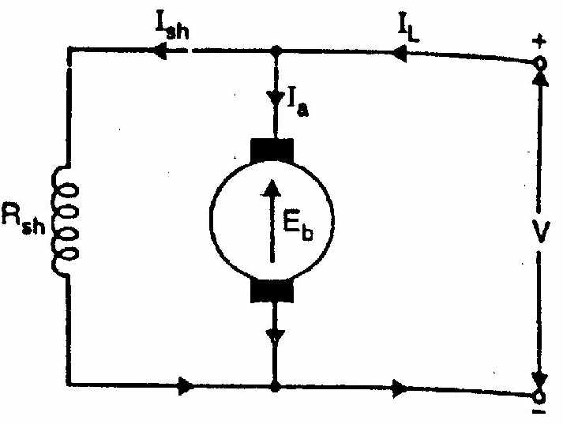

Fig 2.3

Ia = armature current

Since back e.m.f. Eb acts in opposition to the

applied voltage V, the net voltage across the armature circuit is V Eb. The armature current Ia is given by;





or

 --------- (2)

This is known as voltage equation of the d.c. motor.

**Power Equation**

If Eq.(2) above is multiplied by ly throughout, we get,



This is known as power equation of the d.c. motor.

VIa = electric power supplied to armature (armature input)

EbIa = power developed by armature (armature output)

 electric power wasted in armature ( armature Cu loss )

Thus out of the armature input, a small portion (about 5%) is wasted as and the remaining portion EbIa is converted into mechanical power within the armature.

a

**TYPES OF D.C. MOTORS**

Like generators, there are three types of d.c. motors characterized by the connections of field winding in relation to the armature viz.:

**(i)Shunt-wound motor** in which the field winding is connected in parallel with the armature [See Fig. 2.4]. The current through the shunt field winding is not the same as the armature current. Shunt field windings are designed to produce the necessary m.m.f. by means of a relatively large number of turns of wire having high resistance. Therefore, shunt field current is relatively small compared with the armature current.

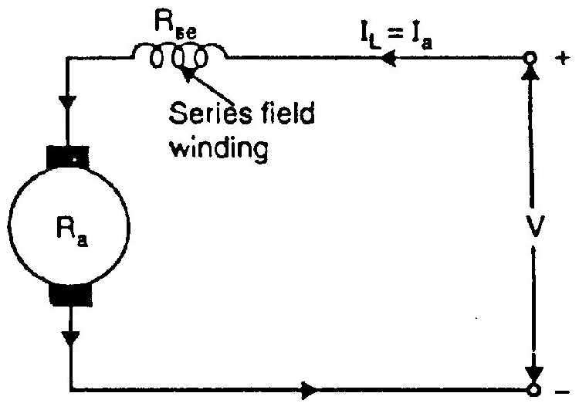

Fig 2.5

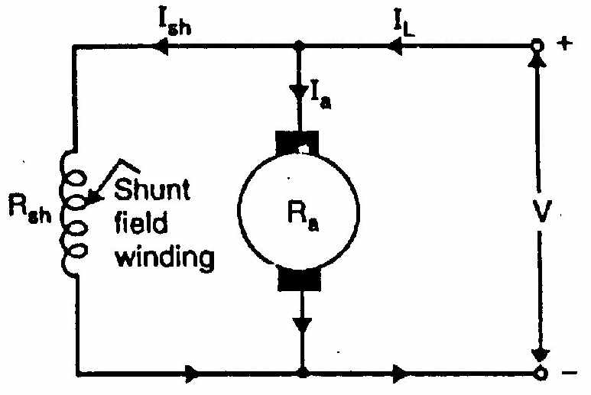

Fig 2.4



But, Ia>>Ish and hence (Ia + Ish) can be written as Ia







Brush Drop is very small and can be neglected,

 and 



Power drawn from supply =

Mechanical Power developed, PM = Power Input – Power loss in Armature and shunt field



**(ii)Series-wound motor** in which the field winding is connected in series with the armature [See Fig. 2.5]. Therefore, series field winding carries the armature current. Since the current passing through a series field winding is the same as the armature current, series field windings must be designed with much fewer turns than shunt field windings for the same m.m.f. Therefore, a series field winding has a relatively small number of turns of thick wire and, therefore, will possess a low resistance.





Brush Drop is very small and can be neglected,



Power drawn from supply =

Mechanical Power developed, PM = Power Input – Power loss in Armature and series field



**(iii) Compound-wound motor** which has two field windings; one connected in parallel with the armature and the other in series with it. There are two types of compound motor connections (like generators). When the shunt field winding is directly connected across the armature terminals [See Fig. 2.6], it is called short-shunt connection. When the shunt winding is so connected that it shunts the series combination of armature and series field [See Fig. 2.7], it is called long-shunt connection.

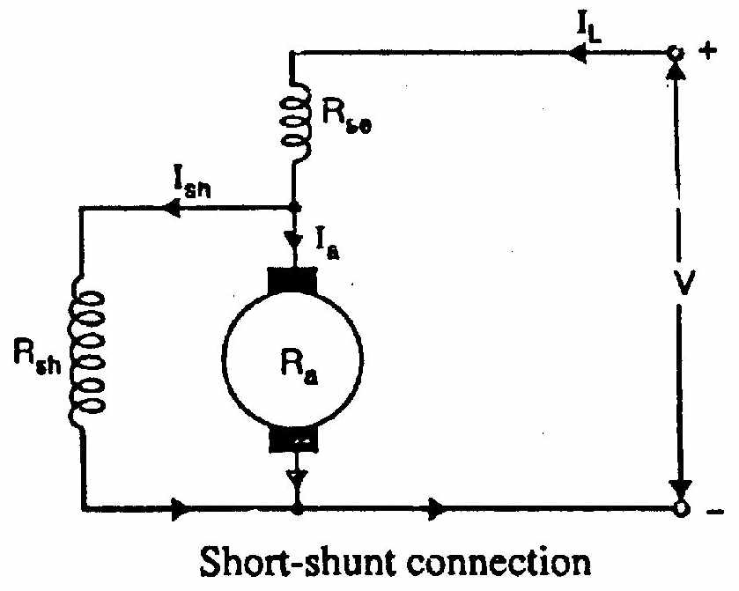

Fig 2.6

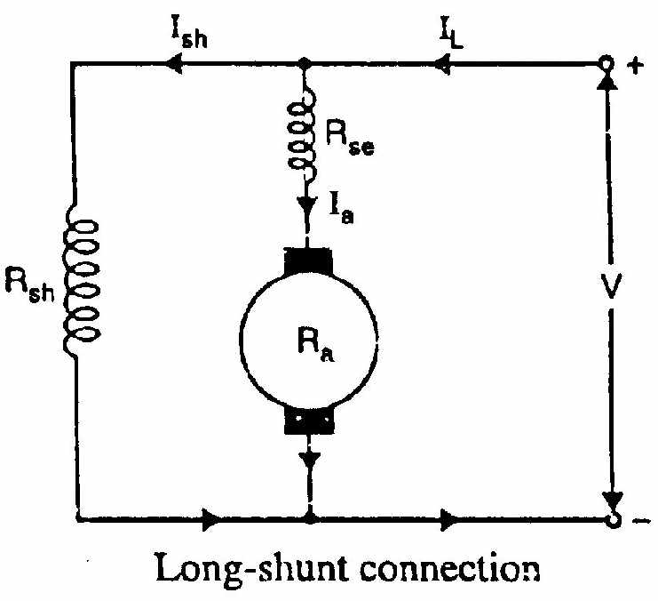

Fig 2.7

The compound machines (generators or motors) are always designed so that the flux produced by shunt field winding is considerably larger than the flux produced by the series field winding. Therefore, shunt field in compound machines is the basic dominant factor in the production of the magnetic field in the machine.

**Short Shunt:**





Brush Drop is very small and can be neglected,



From the Fig 1.41,



**Long Shunt:**

 





**ARMATURE TORQUE OF D.C. MOTOR**

Torque is the turning moment of a force about an axis and is measured by the product of force (F) and radius (r) at right angle to which the force acts i.e.

T = F X r

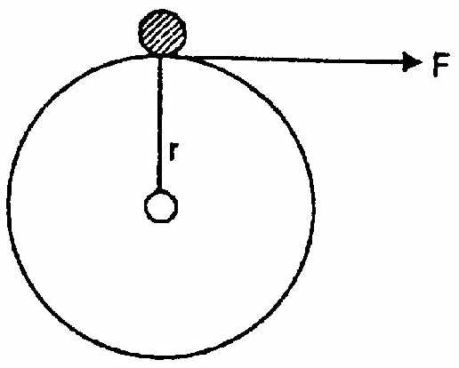

Fig 2.8

In a d.c. motor, each conductor is acted upon by a circumferential force F at a distance r, the radius of the armature (Fig. 2.8). Therefore, each conductor exerts a torque, tending to rotate the armature. The sum of the torques due to all armature conductors is known as gross or armature torque (Ta).

Let in a d.c. motor

r = average radius of armature in m

l = effective length of each conductor in m

Z = total number of armature conductors

A = number of parallel paths

i = current in each conductor = Ia/A

B = average flux density in Wb/m2

φ= flux per pole in Wb

P = number of poles

Force on each conductor, F = B i l newtons

Torque due to one conductor = F * r newton- metre

Total armature torque, Ta = Z F r newton-metre

= Z B i l r

Now i=Ia/A, B=φ/a where a is the x-sectional area of flux path per pole at radius r. Clearly, a=2πrl/P.







 N-m ------(3)

Since, Z, P and A are fixed for a given machine,



Hence, torque in a DC motor is directly proportional to flux per pole and armature current.

(i) For a shunt motor, flux is practically constant,



(ii) For a series motor, flux is directly proportional to armature current Ia provided magnetic saturation does not take place.

Alternate expression for Ta





From eq (3), we get the expression of Ta as:



 N-m

Note that developed torque or gross torque means armature torque Ta.

**SPEED OF A D.C.MOTOR**









 where 

But 





Therefore, in a d.c. motor, speed is directly proportional to back e.m.f Eb and inversely proportional to flux per pole φ

**SPEED CONTROL OF D.C. MOTORS**

**INTRODUCTION**

Although a far greater percentage of electric motors in service are a.c. motors, the d.c. motor is of considerable industrial importance. The principal advantage of a d.c. motor is that its speed can be changed over a wide range by a variety of simple methods. Such a fine speed control is generally not possible with a.c. motors. In fact, fine speed control is one of the reasons for the strong competitive position of d.c. motors in the modem industrial applications. In this chapter, we shall discuss the various methods of-speed control of d.c. motors.

**SPEED CONTROL OF D.C.MOTORS**

The speed of a D.C. motor is given by:



 r.p.m ----(4)

 for shunt motor

 for series motor

From exp. (4), it is clear that there are three main methods of controlling the speed of a d.c. motor, namely:

(i) By varying the flux per pole (φ). This is known as flux control method.

(ii) By varying the resistance in the armature circuit. This is known as armature control method.

(iii) By varying the applied voltage V. This is known as voltage control method.

**SPEED CONTROL OF D.C. SHUNT MOTORS**

The speed of a shunt motor can be changed by (i) flux control method (ii) armature control method (iii) voltage control method. The first method (i.e. flux control method) is frequently used because it is simple and inexpensive.

**1. FLUX CONTROL METHOD**

It is based on the fact that by varying the flux, the motor speed (N 1/φ) can be changed and hence the name flux control method. In this method, a variable resistance (known as shunt field rheostat) is placed in series with shunt field winding as shown in Fig. (2.9).

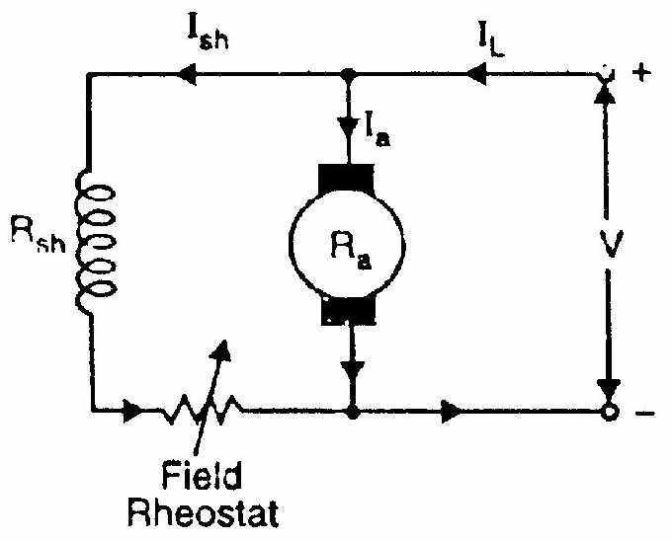

Fig 2.9

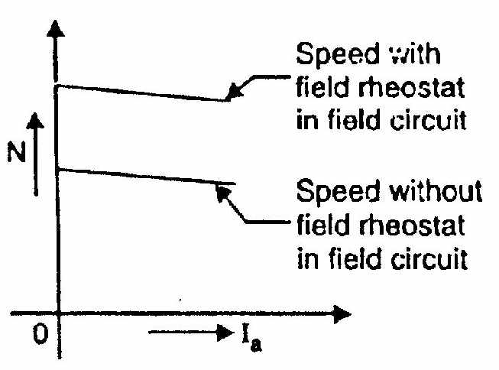

Fig 2.10

The shunt field rheostat reduces the shunt field current Ish and hence the flux φ. Therefore, we can only raise the speed of the motor above the normal speed (See Fig. 2.10). Generally, this method permits to increase the speed in the ratio 3:1. Wider speed ranges tend to produce instability and poor commutation.

**Advantages:**

(i)This is an easy and convenient method.

(ii) It is an inexpensive method since very little power is wasted in the shunt field rheostat due to relatively small value of Ish.

(iii)The speed control exercised by this method is independent of load on the machine.

**Disadvantages:**

(i)Only speeds higher than the normal speed can be obtained since the total field circuit resistance cannot be reduced below Rsh—the shunt field winding resistance.

(ii)There is a limit to the maximum speed obtainable by this method. It is because if the flux is too much weakened, commutation becomes poorer.

**Note**. The field of a shunt motor in operation should never be opened because its speed will increase to an extremely high value.

**2. ARMATURE CONTROL METHOD**

This method is based on the fact that by varying the voltage available across the armature, the back e.m.f and hence the speed of the motor can be changed. This is done by inserting a variable resistance RC (known as controller resistance) in series with the armature as shown in Fig. (2.11).

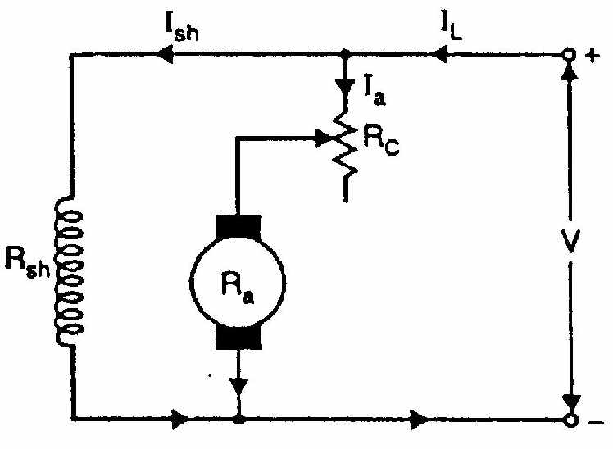

Fig 2.11

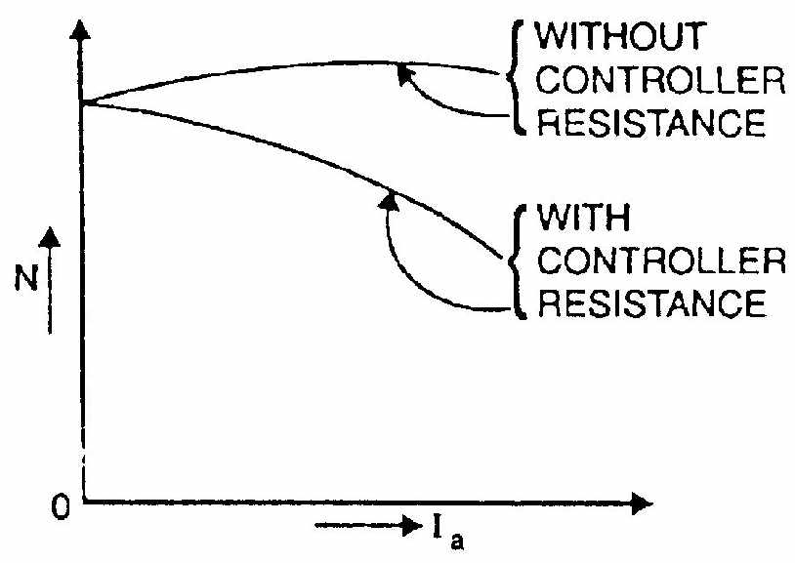

Fig 2.12



Where Rc=controller resistance

Due to voltage drop in the controller resistance, the back e.m.f. (Eb) is decreased. Since N α Eb, the speed of the motor is reduced. The highest speed obtainable is lhat corresponding to RC = 0 i.e., normal speed. Hence, this method can only provide speeds below the normal speed (See Fig. 2.12).

**Disadvantages:**

(i) A large amount of power is wasted in the controller resistance since it carries full armature current Ia.

(ii) The speed varies widely with load since the speed depends upon the voltage drop in the controller resistance and hence on the armature current demanded by the load.

(iii) The output and efficiency of the motor are reduced.

(iv) This method results in poor speed regulation.

Due to above disadvantages, this method is seldom used to control tie speed of shunt motors.

**Note**. The armature control method is a very common method for the speed control of d.c. series motors. The disadvantage of poor speed regulation is not important in a series motor which is used only where varying speed service is required.

**3. VOLTAGE CONTROL METHOD**

In this method, the voltage source supplying the field current is different from that which supplies the armature. This method avoids the disadvantages of poor speed regulation and low efficiency as in armature control method. However, it is quite expensive. Therefore, this method of speed control is employed for large size motors where efficiency is of great importance.

(i) **Multiple voltage control**. In this method, the shunt field of the motor is connected permanently across a-fixed voltage source. The armature can be connected across several different voltages through a suitable switchgear. In this way, voltage applied across the armature can be changed. The speed will be approximately proportional to the voltage applied across the armature. Intermediate speeds can be obtained by means of a shunt field regulator.

(ii) **Ward-Leonard system**. In this method, the adjustable voltage for the armature is obtained from an adjustable-voltage generator while the field circuit is supplied from a separate source. This is illustrated in Fig. (2.13). The armature of the shunt motor M (whose speed is to be controlled) is connected directly to a d.c. generator G driven by a constant-speed a.c. motor A. The field of the shunt motor is supplied from a constant-voltage exciter E. The field of the generator G is also supplied from the exciter E. The voltage of the generator G can be varied by means of its field regulator. By reversing the field current of generator G by controller FC, the voltage applied to the motor may be reversed. Sometimes, a field regulator is included in the field circuit of shunt motor M for additional speed adjustment. With this method, the motor may be operated at any speed up to its maximum speed.

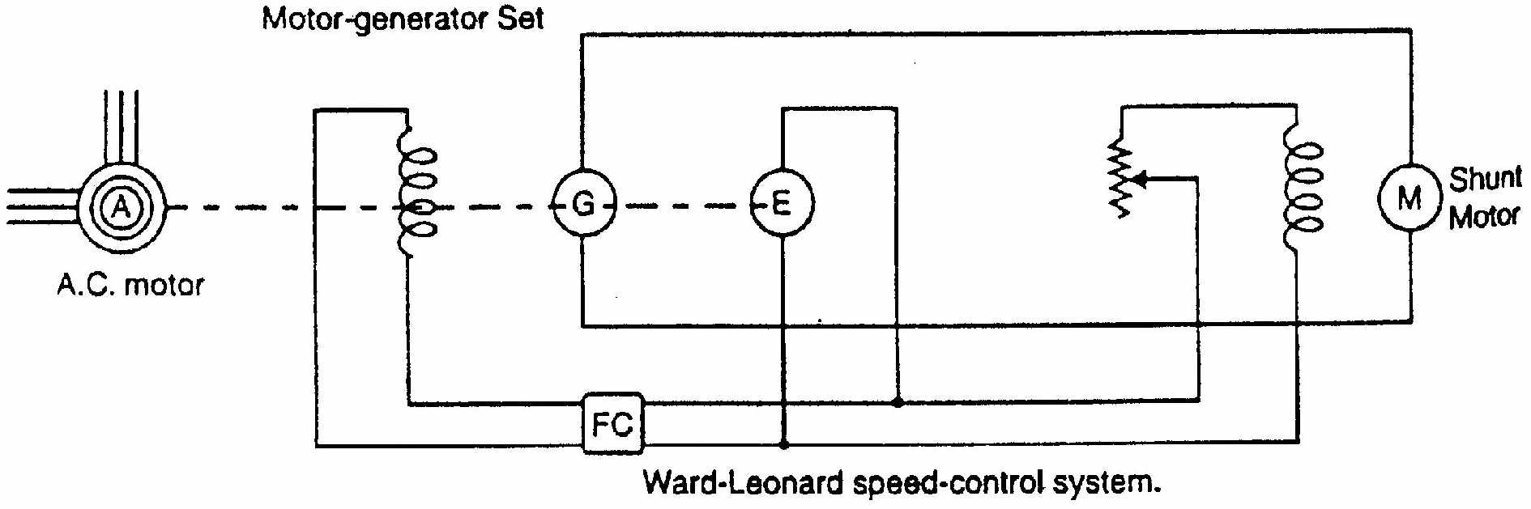

Fig 2.13

**Advantages**

(a) The speed of the motor can be adjusted through a wide range without resistance losses which results in high efficiency.

(b) The motor can be brought to a standstill quickly, simply by rapidly reducing the voltage of generator G. When the generator voltage is reduced below the back e.m.f. of the motor, this back e.m.f. sends current through the generator armature, establishing dynamic braking. While this takes place, the generator G operates as a motor driving motor A which returns power to the line.

(c) This method is used for the speed control of large motors when a d.c. supply is not available.

The disadvantage of the method is that a special motor-generator set is required for each motor and the losses in this set are high if the motor is operating under light loads for long periods.

**Applications**

The ward-Leonard system of speed control is expensive but is used where an unusually wide and very sensitive speed control is desired. This arrangement offers an excellent stepless speed control and is well suited for such applications as passenger elevators, electric excavators etc.

**SPEED CONTROL OF D.C. SERIES MOTORS**

The speed control of d.c. series motors can be obtained by (i) flux control method (ii) armature-resistance control method. The latter method is mostly used.

**1. Flux control method**

In this method, the flux produced by the series motor is varied and hence the speed. The variation of flux can be achieved in the following ways:

(i) **Field diverters**. In this method, a variable resistance (called field diverter) is connected in parallel with series field winding as shown in Fig. (2.14). Its effect is to shunt some portion of the line current from the series field winding, thus weakening the field and increasing the speed (N α 1/φ). The lowest speedobtainable is that corresponding to zero current in the diverter (i.e. diverter is open). Obviously, the lowest speed obtainable is the normal speed of the motor. Consequently, this method can only provide speeds above the normal speed. The series field diverter method is often employed in traction work.

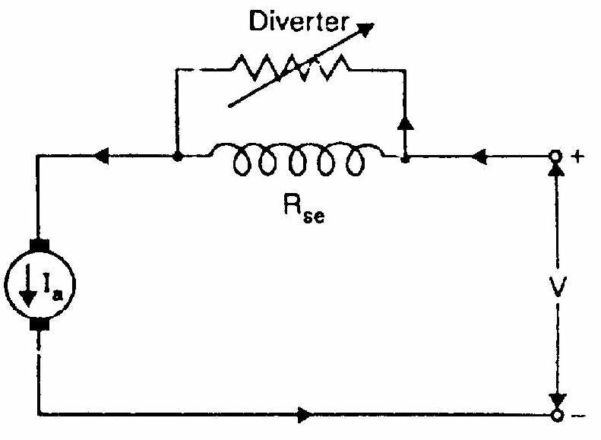

Fig 2.14

(ii)**Armature diverter**. In order to obtain speeds below the normal speed, a variable resistance (called armature diverter) is connected in parallel with the armature as shown in Fig. (2.15). The diverter shunts some of the line current, thus reducing the armature current. Now for a given load, if Ia is decreased, the flux φ must increase (T α φIa). Since Nα (1/φ), the motor speed is decreased. By adjusting the armature diverter, any speed lower than the normal speed can be obtained.

(iii) **Tapped field control**. In this method, the flux is reduced (and hence speed is increased) by decreasing the number of turns of the series field winding as shown in Fig. (2.16). The switch can short circuit any part of the field winding, thus decreasing the flux and raising the speed. With full turns of the field winding, the motor runs at normal speed and as the field turns are cut out, speeds higher than normal speed are achieved.

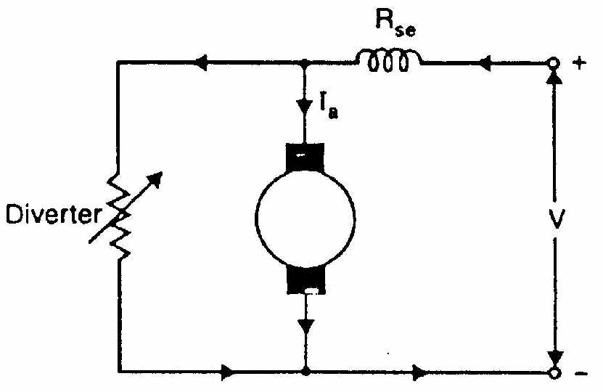

Fig 2.15

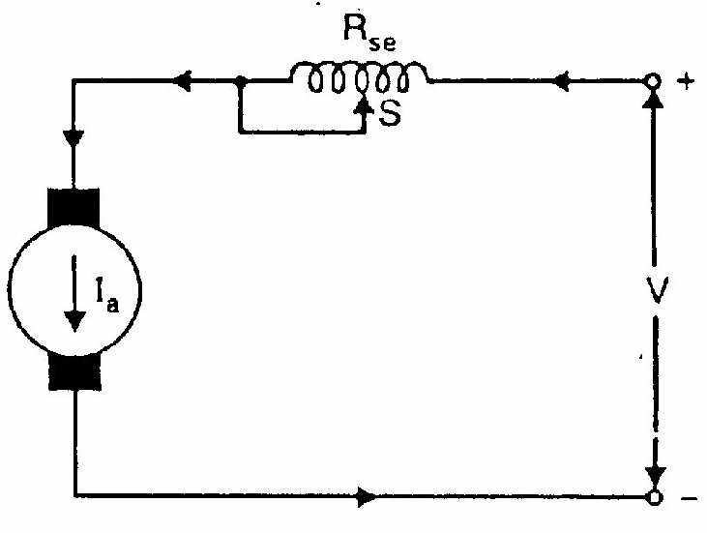

Fig 2.16

(iv) **Paralleling field coils**. This method is usually employed in the case of fan motors. By regrouping the field coils as shown in Fig. (2.17), several fixed speeds can be obtained.

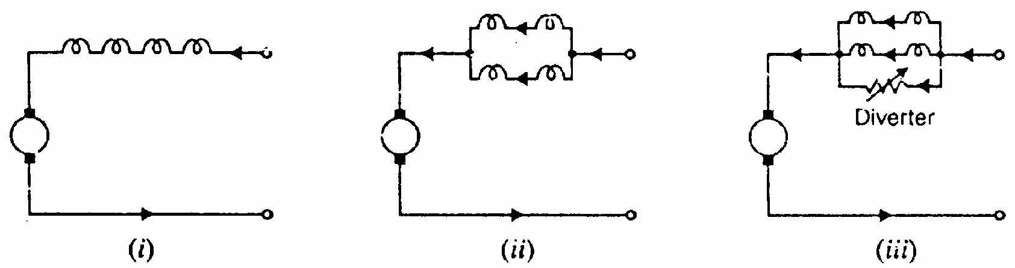

Fig 2.17

**2. Armature-resistance control**

In this method, a variable resistance is directly connected in series with the supply to the complete motor as shown in Fig. (2.18). This reduces the voltage available across the armature and hence the speed falls. By changing the value of variable resistance, any speed below the normal speed can be obtained. This is the most common method employed to control the speed of d.c. series motors. Although this method has poor speed regulation, this has no significance for series motors because they are used in varying speed applications. The loss of power in the series resistance for many applications of series motors is not too serious since in these applications the control is utilized for a large portion of the time for reducing the speed under light-load conditions and is only used intermittently when the motor is carrying full-load.

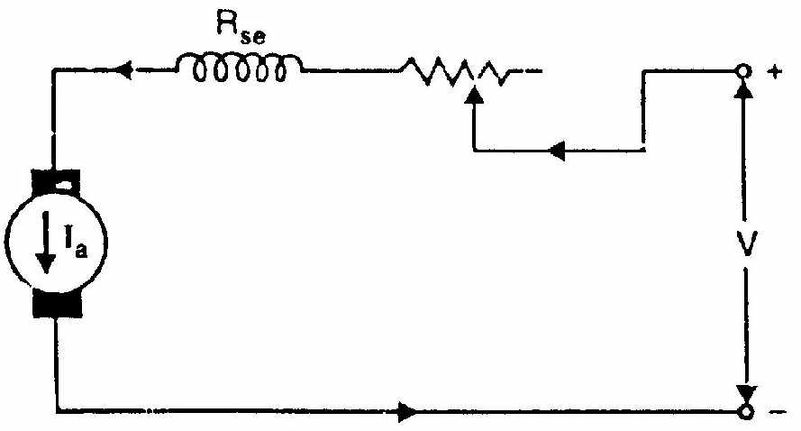

Fig 2.18

**TESTING OF D.C. MACHINES**

**INTRODUCTION**

There are several tests that are conducted upon a d.c. machine (generator or motor) to judge its performance. One important test is performed to measure the efficiency of a d.c. machine. The efficiency of a d.c. machine depends upon its losses. The smaller the losses, the greater is the efficiency of the machine and vice-versa. The consideration of losses in a d.c. machine is important for two principal reasons. First, losses determine the efficiency of the machine and appreciably influence its operating cost. Secondly, losses determine the heating of the machine and hence the power output that may be obtained without undue deterioration of the insulation. In this chapter, we shall focus our attention on the various methods for the determination of the efficiency of a d.c. machine.

**EFFICIENCY OF A D.C. MACHINE**

The power that a d.c. machine receives is called the input and the power it gives out is called the output. Therefore, the efficiency of a d.c. machine, like that of any energy-transferring device, is given by;

Efficiency=output/input

Output=input-Losses and input=output + Losses

Therefore, the efficiency of a.D.C. machine can also be expressed in the following forms:

Efficiency= (input – losses) / input ----- (6)

Efficiency= Output / (output + losses ----- (7)

The most obvious method of determining the efficiency of a d.c. machine is to directly load it and measure the input power and output power. Then we can use Eq.(i) to determine the efficiency of the machine. This method suffers from three main drawbacks. First, this method requires the application of load on the machine. Secondly, for machines of large rating, the loads of the required sizes may not be available. Thirdly, even 'fit is possible to provide such loads, large power will be dissipated, making it an expensive method.

The most common method of measuring the efficiency of a d.c. machine is to determine its losses (instead of measuring the input and output on load). We can then use Eq.(6) or Eq.(7) to determine the efficiency of the machine. This method has the obvious advantage of convenience and economy.

**EFFICIENCY BY DIRECT LOADING**

In this method, the d.c. machine is loaded and output and input are measured to find the efficiency. For this purpose, two simple methods can be used.

**(I) BRAKE TEST**

In this method, a brake is applied to a water-cooled pulley mounted on the motor shaft as shown in Fig. (2.19). One end of the rope is fixed to the floor via a spring balance S and a known mass is suspended at the other end. If the spring balance reading is (W-S) kg-Wt and the suspended mass has a weight of W kg-Wt, then,

Fig 2.19

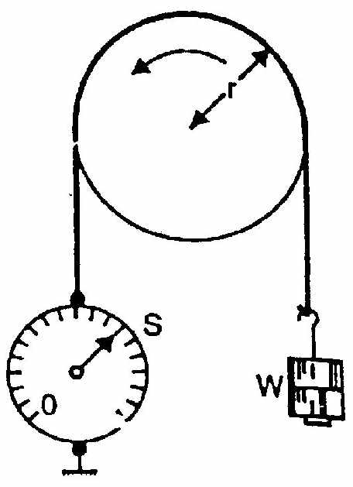

Net pull on the rope = (W-S) kg-Wt = (W-S) x 9.81 newtons

If r is the radius of the pulley in metres, then the shaft torque Tsh developed by the motor is

 N-m

If the speed of the pulley is N r.p.m., then,



Let V=Supply voltage in volts

I=Current taken by the motor in amperes

Therefore, Input to motor=V I Watts



(ii) In another method, the motor drives a calibrated generator i.e. one whose efficiency is known at all loads. The output of the generator is measured with the help of an ammeter and voltmeter.

Therefore, Output of motor = Generator output / Generator efficiency

Let V = Supply voltage is volts

I = Current taken by the motor in amperes

Input to motor=VI

Thus efficiency of the motor can be determined.

Because of several disadvantages, direct loading method is used only for determining the efficiency of small machines.

**SWINBURNE’S METHOD FOR DETERMINING EFFICIENCY**

In this method, the d.c. machine (generator or motor) is run as a motor at no- load and losses of the machine are determined. Once the losses of the machine are known, its efficiency at any desired load can be determined in advance. It may be noted that this method is applicable to those machines in which flux is practically constant at all loads e.g., shunt and compound machines. Let us see how the efficiency of a d.c. shunt machine (generator or motor) is determined by this method. The test insists of two steps:

**(i) Determination of hot resistances of windings**

The armature resistance and shunt field resistance are measured using a battery, voltmeter and ammeter. Since these resistances are measured when the machine is cold, they must be converted to values corresponding to the temperature at which the machine would work on full-load. Generally, these values are measured for a temperature rise of 40°C above the room temperature. Let the hot resistances of armature and shunt field be Ra and Rsh respectively.

**(ii) Determination of constant losses**

The machine is run as a motor on no-load with supply voltage adjusted to the rated voltage i.e. voltage stamped on the nameplate. The speed of the motor is adjusted to the rated speed with the help of field regulator R as shown is Fig. (2.20)

+

+

-

**A1**

# V

**+**

**-**

L

Z

A

A

220V, DC supply

-

200Ω, 1.7A

3A

**+**

A2

**-**

-

(0-250V)

MC

AA

Z

3A

ZZ

Fig 2.20

**CALCULATIONS :**

Let V=Supply Voltage

I0=No load current read by Ammeter A1

Ish= Shunt field current read by Ammeter A2

No-load Armature Current, Ia0=I0-Ish

No-load input power to motor =VI0

No-load input power to Armature =VIa0=V(I0-Ish)

Since output of the motor is zero, the no-load input power to the armature supplies (a) iron losses in the core (b) friction loss (c) windage loss (d) armature Cu loss 

Constant losses, Wc = No load Input- No load armature *cu* losses



Since constant losses are known, the efficiency of the machine at any other load can be determined. Suppose it is desired to determine the efficiency of the machine at load current I. Then,

Armature current, Ia=I-Ish … if the machine is motoring

Ia=I+Ish … if the machine is generating

***Efficiency when running as a motor:***

Input to the motor = V * I

Armature current = I – Ish

Armature *cu* loss = (I– Ish )2 * Ra

Constant losses = Wc

Total losses = Constant losses + Amature *cu* losses

= Wc + (I- Ish )2 * Ra

Output = Input - Losses= (V * I) - (Wc + (I- Ish )2 * Ra )

% Efficiency = 

= 

***Efficiency when running as a generator:***

Output of the generator = V * I

Armature current = I+Ish

Armature *cu* loss = (I+ Ish )2 * Ra

Constant losses = WC

Total losses = Constant losses + Amature *cu* losses

= Wc + (I- Ish )2 * Ra

Input = Output + Losses= (V * I) + (Wc + (I+ Ish )2 * Ra )

% Efficiency = 

= 

**Advantages of Swinburne’s test**

(i) The power required to carry out the test is small because it is a no-load test. Therefore, this method is quite economical.

(ii) The efficiency can be determined at any load because constant losses are known.

(iii) This test is very convenient.

**Disadvantages of Swinburne's test**

(i) It does not take into account the stray load losses that occur when the machine is loaded.

(ii) This test does not enable us to check the performance of the machine on full-load. For example, it does not indicate whether commutation on full load is satisfactory and whether the temperature rise is within the specified limits.

(iii) This test does not give quite accurate efficiency of the machine. It is because iron losses under actual load are greater than those measured. This is mainly due to armature reaction distorting the field.

**2013**

**UNIT-I**

1.a) Derive the expression for Torque developed in DC motor.

b) A six-pole lap-connected 250 V shunt motor has 396 armature conductors. It

takes 30A on full-load. The flux per pole is 0.04 weber. The armature and field

resistances are 0.1 ohm and 200 ohms respectively. Contact drop per brush-1V

Determine the speed on full-load.

**2014**

**UNIT-I**

1.a) Explain swinburne’s test to determine no-load losses of a DC machine. What are the merits and demerits of swinburne’s test.

b) A 10 KW,240 D.C shunt motor draws a line current of 5.2A while running at no-load speed of 1200 r.p.m. from a 240 V.DC supply. It has an armature resistance of 0.25Ω and a field resistance of 160 Ω. Estimate the efficiency of the motor when it delivers rated load.

**2015**

**UNIT-I**

1.a) drive the torque equation of a DC motor.

b) A Shunt generator has a full load current of 196 A at 220V. The stray loss

is 720W and the shunt field resistance is 55 ohms. If it has a full load

efficiency is 88%, find the armature resistance. Also, find the load current

corresponding to maximum efficiency.

**2016**

**Unit-I**

1.a) Explain different methods of speed control in DC shunt motor.

2.a) Predetermine the efficiency of a dc machine at different load conditions.