**ELECTRICAL TECHNOLOGY**

**UNIT-4**

**THREE PHASE INDUCTION MOTORS**

**INTRODUCTION**

The three-phase induction motors are the most widely used electric motors in industry. They run at essentially constant speed from no-load to full-load. However, the speed is frequency dependent and consequently these motors are not easily adapted to speed control. We usually prefer d.c. motors when large speed variations are required. Nevertheless, the 3-phase induction motors are simple, rugged, low-priced, easy to maintain and can be manufactured with characteristics to suit most industrial requirements. In this chapter, we shall focus our attention on the general principles of 3-phase induction motors.

**THREE-PHASE INDUCTION MOTOR**

Like any electric motor, a 3-phase induction motor has a stator and a rotor. The stator carries a 3-phase winding (called stator winding) while the rotor carries a short-circuited winding (called rotor winding). Only the stator winding is fed from 3-phase supply. The rotor winding derives its voltage and power from the externally energized stator winding through electromagnetic induction and hence the name. The induction motor may be considered to be a transformer with a rotating secondary and it can, therefore, be described as a “transformer- type” a.c. machine in which electrical energy is converted into mechanical energy.

**Advantages**

(i) It has simple and rugged construction.

(ii) It is relatively cheap.

(iii) It requires little maintenance.

(iv) It has high efficiency and reasonably good power factor.

(v) It has self starting torque.

**Disadvantages**

(i) It is essentially a constant speed motor and its speed cannot be changed easily.

(ii) Its starting torque is inferior to d.c. shunt motor

**CONSTRUCTION OF THREE PHASE INDUCTION MOTOR**

A 3-phase induction motor has two main parts (i) stator and (ii) rotor. The rotor is separated from the stator by a small air-gap which ranges from 0.4 mm to 4 mm, depending on the power of the motor.

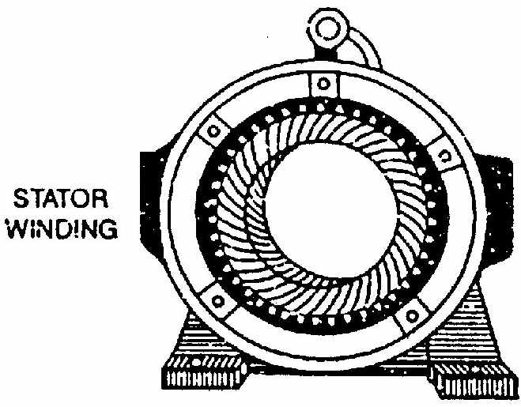

Fig 4.1

**1. Stator**

It consists of a steel frame which encloses a hollow, cylindrical core made up of thin laminations of silicon steel to reduce hysteresis and eddy current losses. A number of evenly spaced slots are provided on the inner periphery of the laminations [See Fig. (4.1)]. The insulated connected to form a balanced 3-phase star or delta connected circuit. The 3-phase stator winding is wound for a definite number of poles as per requirement of speed. Greater the number of poles, lesser is the speed of the motor and vice-versa. When 3-phase supply is given to the stator winding, a rotating magnetic field (See Sec. 3.3) of constant magnitude is produced. This rotating field induces currents in the rotor by electromagnetic induction.

**2. Rotor**

The rotor, mounted on a shaft, is a hollow laminated core having slots on its outer periphery. The winding placed in these slots (called rotor winding) may be one of the following two types:

(i) Squirrel cage type (ii) Wound type

(i) **Squirrel cage rotor**. It consists of a laminated cylindrical core having parallel slots on its outer periphery. One copper or aluminum bar is placed in each slot. All these bars are joined at each end by metal rings called end rings [See Fig. (4.2)]. This forms a permanently short-circuited winding which is indestructible. The entire construction (bars and end rings) resembles a squirrel cage and hence the name. The rotor is not connected electrically to the supply but has current induced in it by transformer action from the stator.

Those induction motors which employ squirrel cage rotor are called squirrel cage induction motors. Most of 3-phase induction motors use squirrel cage rotor as it has a remarkably simple and robust construction enabling it to operate in the most adverse circumstances. However, it suffers from the disadvantage of a low starting torque. It is because the rotor bars are permanently short-circuited and it is not possible to add any external resistance to the rotor circuit to have a large starting torque.

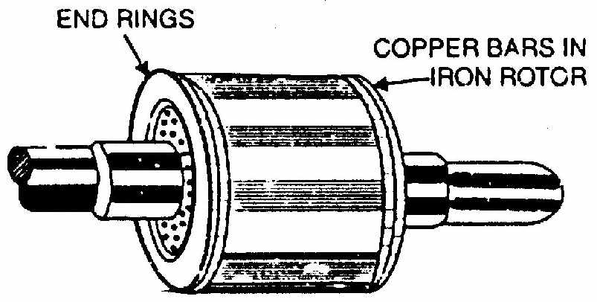

Fig 4.2

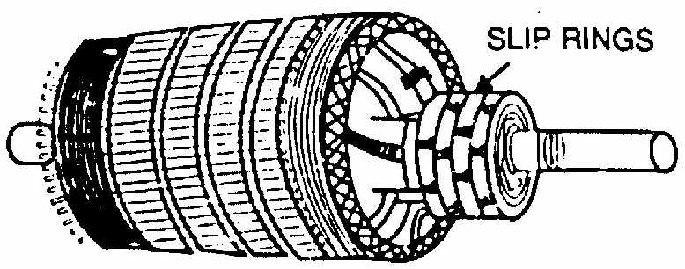

Fig 4.3

i)**Wound rotor**. It consists of a laminated cylindrical core and carries a 3- phase winding, similar to the one on the stator [See Fig. (4.3)]. The rotor winding is uniformly distributed in the slots and is usually star-connected. The open ends of the rotor winding are brought out and joined to three insulated slip rings mounted on the rotor shaft with one brush resting on each slip ring. The three brushes are connected to a 3-phase star-connected rheostat as shown in Fig. (4.4). At starting, the external resistances are included in the rotor circuit to give a large starting torque. These resistances are gradually reduced to zero as the motor runs up to speed.

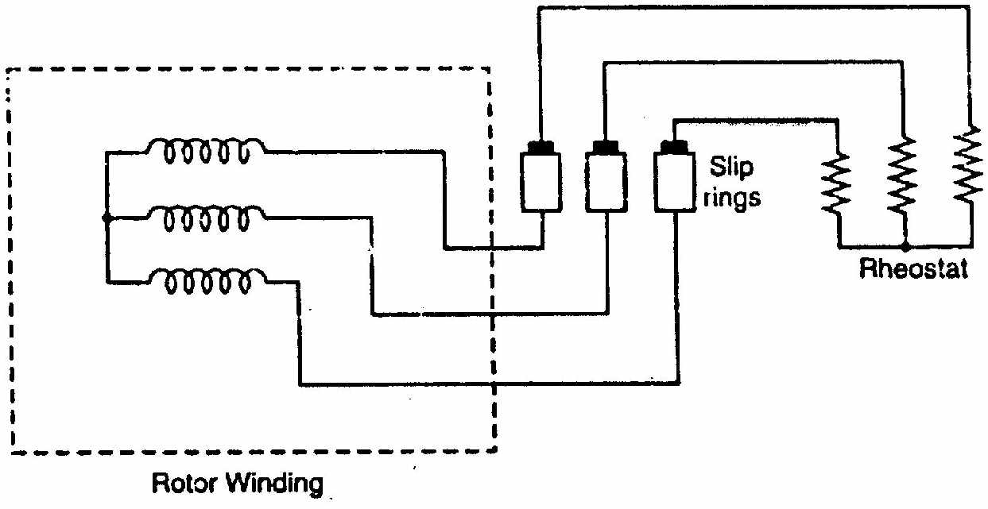

Fig 4.4

The external resistances are used during starting period only. When the motor attains normal speed, the three brushes are short-circuited so that the wound rotor runs like a squirrel cage rotor.

#### DIFFERENCE BETWEEN SLIP RING AND SQUIRREL CAGE INDUCTION MOTOR

|  |  |
| --- | --- |
| **Slip ring or phase wound Induction motor** | **Squirrel cage induction motor** |
| Construction is complicated due to presence of slip ring and brushes | Construction is very simple |
| The rotor winding is similar to the stator winding | The rotor consists of rotor bars which are permanently shorted with the help of end rings |
| We can easily add rotor resistance by using slip ring and brushes | Since the rotor bars are permanently shorted, its not possible to add external resistance |
| Due to presence of external resistance high starting torque can be obtained | Staring torque is low and cannot be improved |
| Slip ring and brushes are present | Slip ring and brushes are absent |
| Frequent maintenance is required due to presence of brushes | Less maintenance is required |
| The construction is complicated and the presence of brushes and slip ring makes the motor more costly | The construction is simple and robust and it is cheap as compared to slip ring induction motor |
| This motor is rarely used only 10 % industry uses slip ring induction motor | Due to its simple construction and low cost. The squirrel cage induction motor is widely used |
| Rotor copper losses are high and hence less efficiency | Less rotor copper losses and hence high efficiency |
| Speed control by rotor resistance method is possible | Speed control by rotor resistance method is not possible |
| Slip ring induction motor are used where high starting torque is required i.e in hoists, cranes, elevator etc | Squirrel cage induction motor is used in lathes, drilling machine, fan, blower printing machines etc |

**ROTATING MAGNETIC FIELD DUE TO 3-PHASE CURRENTS**

When a 3-phase winding is energized from a 3-phase supply, a rotating magnetic field is produced. This field is such that its poles do no remain in a fixed position on the stator but go on shifting their positions around the stator. For this reason, it is called a rotating Held. It can be shown that magnitude of this rotating field is constant and is equal to 1.5 m wherem is the maximum flux due to any phase.

To see how rotating field is produced, consider

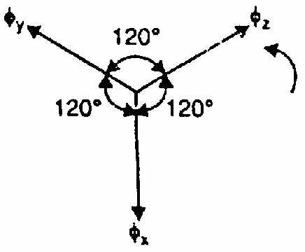

Fig 3.5

a 2-pole,3i-phase winding as shown in Fig. (3.6 (i)).

The three phases X,Y and Z are energized from a 3-phase

Source and currents in these phases are indicated as Ix, Iy

and Iz [See Fig. (3.6 (ii))]. Referring to Fig. (3.6 (ii)), the fluxes

produced by these currents are given by:

x =  m sin

y =  m sin (t -1200 )

z =  m sin (t -2400 )

Herem is the maximum flux due to any phase. Fig. (3.5) shows the phasor diagram of the three fluxes. We shall now prove that this 3-phase supply produces a rotating field of constant magnitude equal to 1.5 m.

(i) At instant 1 [See Fig. (3.6 (ii)) and Fig. (3.6 (iii))], the current in phase X is zero and currents in phases Y and Z are equal

and opposite. The currents are flowing outward in the top conductors and inward in the bottom conductors. This establishes a resultant flux towards right. The magnitude of the resultant flux is constant and is equal to 1.5  m as proved under:

At instant 1,  t = 0°. Therefore, the three fluxes are given by;





The phasor sum of y andz is the resultant flux r [See Fig. (3.7)]. It is clear that:

Resultant flux,



(ii) At instant 2, the current is maximum (negative) in y phase Y and 0.5 maximum (positive) in phases X and Y. The magnitude of resultant flux is 1.5 m as proved under:

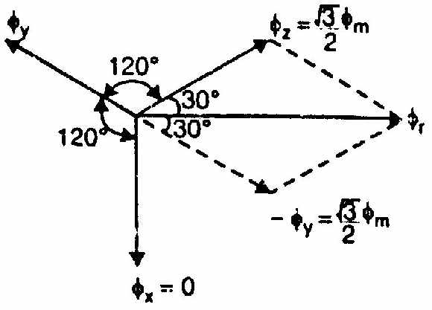

Fig 3.7

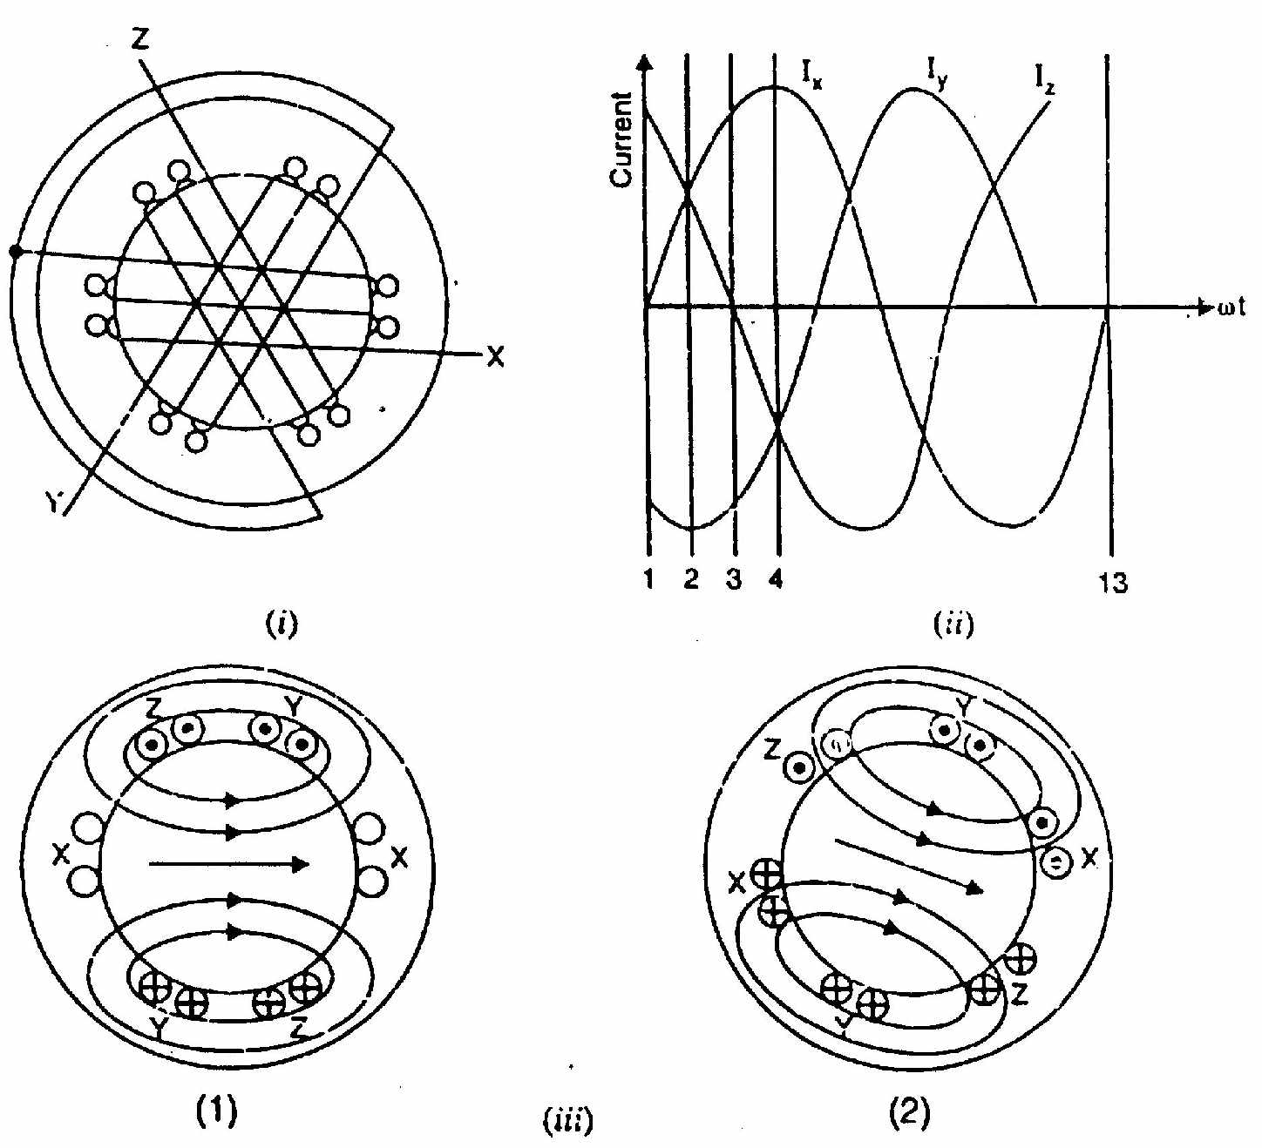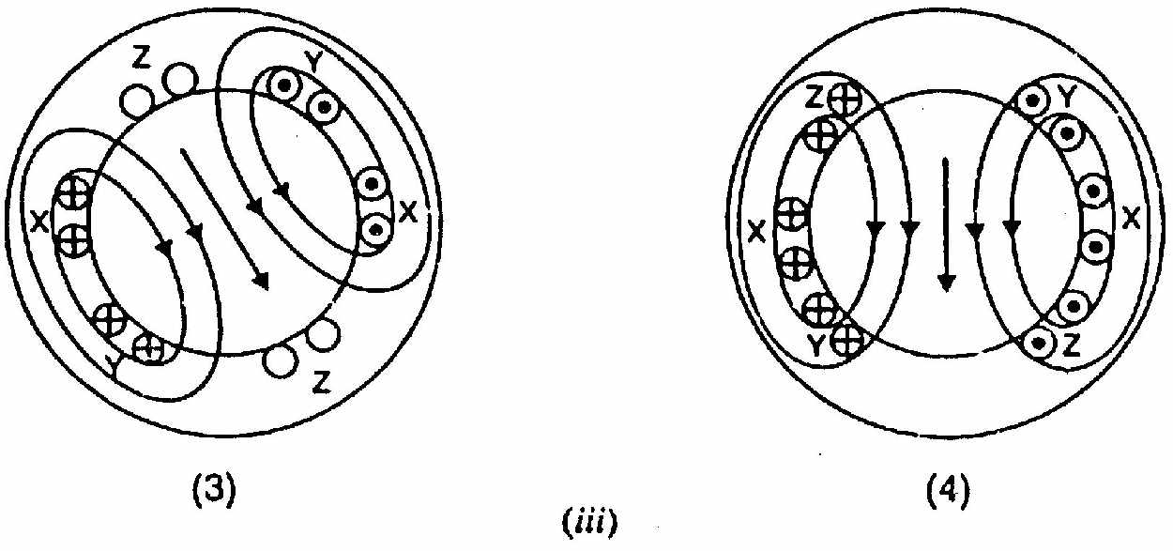

Fig 3.6

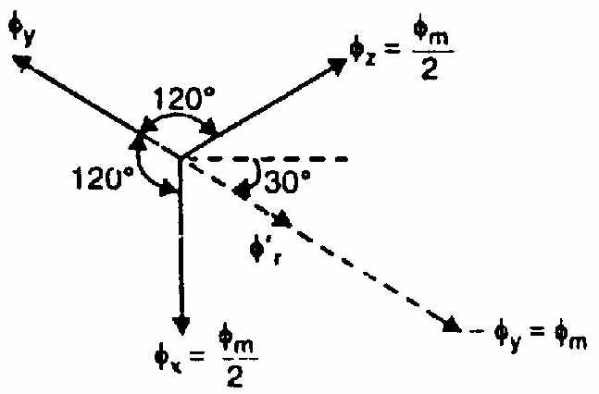

Fig 3.8

At instant 2,  t = 30°. Therefore, the three fluxes are given by;





The phasor sum of - - and is the resultant flux  clear that:

phasor sum of - - and , =

phasor sum of - and-,=

Note that resultant flux is displaced 30° clockwise from position 1.

(iii) At instant 3, current in phase Z is zero and the currents in phases X and Y are equal and opposite (currents in phases X and Y are 0.866 max. value). The magnitude of resultant flux is 1.5 m as proved under:

At instant 3,  t = 60°. Therefore, the three fluxes are given by;



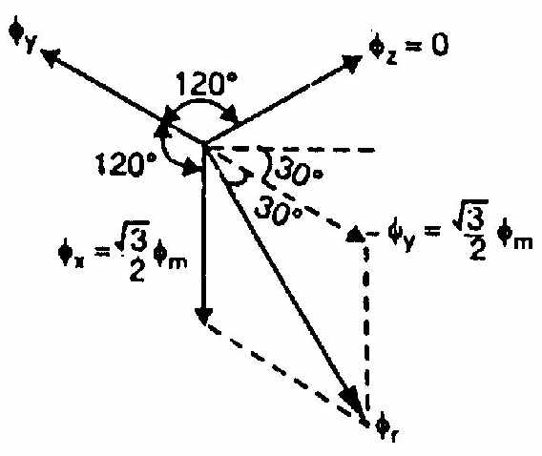

Fig 3.9





The resultant flux is the phasor sum of  and  .



Note that resultant flux is displaced 60° clockwise from position 1.

(iv) At instant 4, the current in phase X is maximum (positive) and the currents in phases V and Z are equal and negative (currents in phases V and Z are 0.5 max. value). This establishes a resultant flux downward as shown under:

At instant 4, t = 90°. Therefore, the three fluxes are given by;





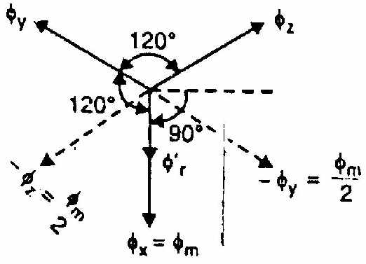

Fig 3.10



The phasor sum of - - and is the resultant flux 

phasor sum of - and, =

phasor sum of - and-,=

Note that the resultant flux is downward i.e., it is displaced 90° clockwise from position 1.

It follows from the above discussion that a 3-phase supply produces a rotating field of constant value (= 1.5 m, where m is the maximum flux due to any phase).

**Speed of rotating magnetic field**

The speed at which the rotating magnetic field revolves is called the synchronous speed (Ns).



**PRINCIPLE OF OPERATION**

Consider a portion of 3-phase induction motor as shown in Fig. (3.13). The operation of the motor can be explained as under:

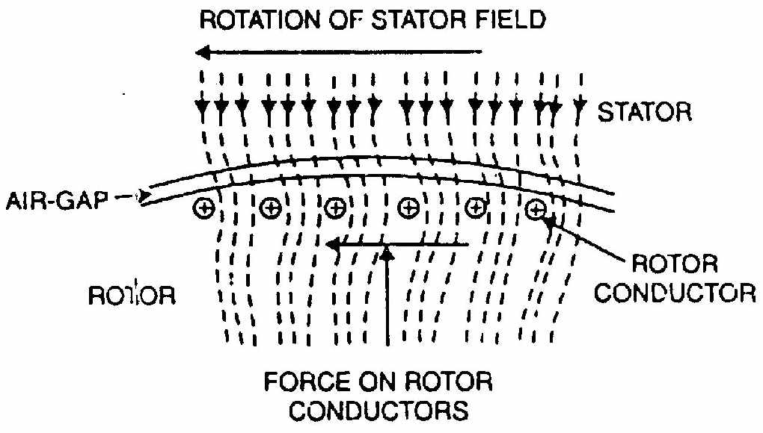

Fig 3.13

(i) When 3-phase stator winding is energized from a 3-phase supply, a rotating magnetic field is set up which rotates round the stator at synchronous speed Ns (= 120 f/P).

(ii) The rotating field passes through the air gap and cuts the rotor conductors,

which as yet, are stationary. Due to the relative speed between the rotating flux and the stationary rotor, e.m.f.s are induced in the rotor conductors. Since the rotor circuit is short-circuited, currents start flowing in the rotor conductors.

(iii) The current-carrying rotor conductors are placed in the magnetic field produced by the stator. Consequently, mechanical force acts on the rotor conductors. The sum of the mechanical forces on all the rotor conductors produces a torque which tends to move the rotor in the same direction as the rotating field.

(iv) The fact that rotor is urged to follow the stator field (i.e., rotor moves in the direction of stator field) can be explained by Lenz’s law. According to this law, the direction of rotor currents will be such that they tend to oppose the cause producing them. Now, the cause producing the rotor currents is the relative speed between the rotating field and the stationary rotor conductors. Hence to reduce this relative speed, the rotor starts running in the same direction as that of stator field and tries to catch it.

**SLIP**

We have seen above that rotor rapidly accelerates in the direction of rotating field. In practice, the rotor can never reach the speed of stator flux. If it did, there would be no relative speed between the stator field and rotor conductors, no induced rotor currents and, therefore, no torque to drive the rotor. The friction and windage would immediately cause the rotor to slow down. Hence, the rotor speed (N) is always less than the suitor field speed (Ns). This difference in speed depends upon load on the motor. The difference between the synchronous speed Ns of the rotating stator field and the actual rotor speed N is called slip. It is usually expressed as a percentage of synchronous speed i.e.,

% age slip, s =

(i) The quantity Ns - N is sometimes called slip speed.

(ii) When the rotor is stationary (i.e., N = 0), slip, s = 1 or 100 %.

(iii) In an induction motor, the change in slip from no-load to full-load is hardly 0.1% to 3% so that it is essentially a constant-speed motor.

**ROTOR CURRENT FREQUENCY**

The frequency of a voltage or current induced due to the relative speed between a vending and a magnetic field is given by the general formula;

Frequency=NP/120

Where N=Relative speed between magnetic field and the winding

P= Number of poles

For a rotor speed N, the relative speed between the rotating flux and the rotor is

Ns - N. Consequently, the rotor current frequency  is given by;







i.e., Rotor current frequency = Fractional slip x Supply frequency

(i) When the rotor is at standstill or stationary (i.e., s = 1), the frequency of rotor current is the same as that of supply frequency (f' = sf = 1 x f = f).

(ii) As the rotor picks up speed, the relative speed between the rotating flux and the rotor decreases. Consequently, the slip s and hence rotor current frequency decreases

**Note:** The relative speed between the rotating field and stator winding is NS-0=NS. Therefore, the frequency of induced current or voltage in the stator winding is f = (Ns* P/120) —the supply frequency.

**EFFECT OF SLIP ON THE ROTOR CIRCUIT**

When the rotor is stationary, s = 1. Under these conditions, the per phase rotor e.m.f. E2 has a frequency equal to that of supply frequency f. At any slip s, the relative speed between stator field and the rotor is decreased. Consequently, the rotor e.m.f. and frequency are reduced proportionally to sEs and sf respectively. At the same time, per phase rotor reactance X2, being frequency dependent, is reduced to sX2.

Consider a 6-pole, 3-phase, 50 Hz induction motor. It has synchronous speed Ns= 120 f/P = 120 x 50/6 = 1000 r.p.m. At standsill, the relative speed between stator flux and rotor is 1000 r.p.m. and rotor e.m.f./phase = E2 (say). If the full- load speed of the motor is 960 r.p.m., then,



(i) The relative speed between stator flux and the rotor is now only 40 r.p.m.

Consequently, rotor e.m.f./phase is reduced to:



(ii) The frequency is also reduced in the same ratio to:



(iii) The per phase rotor reactance X2 is likewise reduced to:



Thus at any slip s,

Rotor e.m.f./phase=sE2

Rotor reactance/phase=sX2

Rotor frequency =sf

Where E2,X2 and f are the corresponding values at standstill.

**ROTOR CURRENT**

Fig. (3.14) shows the circuit of a 3-phase induction motor at any slip s. The rotor is assumed to be of wound type and star connected. Note that rotor e.m.f./phase and rotor reactance/phase are s E2 and sX2 respectively. The rotor resistance/phase is R2 and is independent of frequency and, therefore, does not depend upon slip. Likewise, stator winding values R1 and X1 do not depend upon slip.

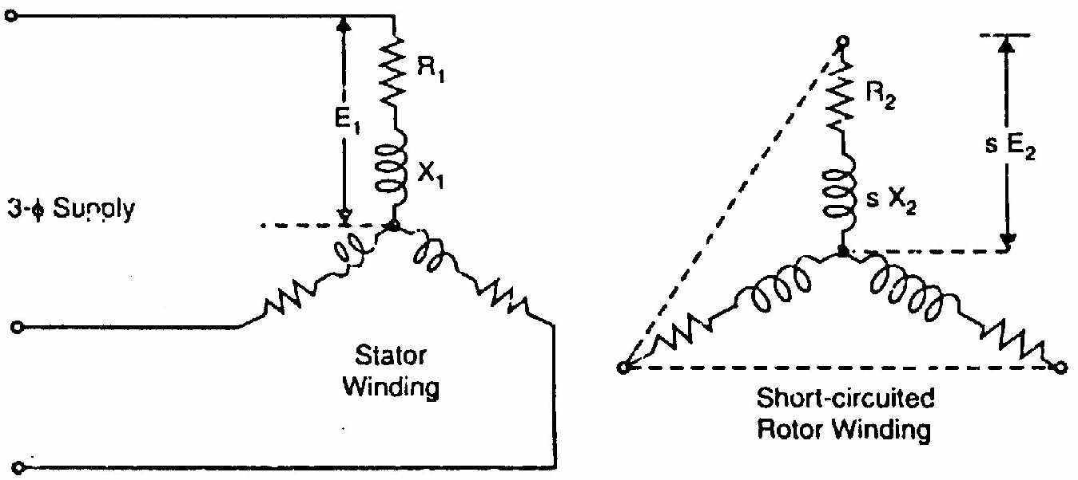

Fig 3.14

Since the motor represents a balanced 3-phase load, we need consider one phase only; the conditions in the other two phases being similar.

**At standstill**. Fig. (3.15 (i)) shows one phase of the rotor circuit at standstill.

Rotor current/phase,



Rotor p.f.,cos

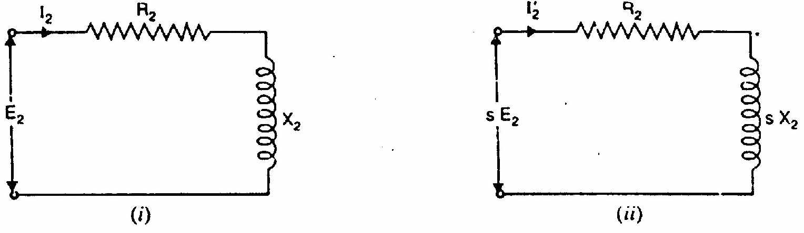

Fig 3.15

**When running at slip s**. Fig. (3.15 (ii)) shows one phase of the rotor circuit when the motor is running at slip s.

Rotor current,

Rotor p.f.,cos

**ROTOR TORQUE**

The torque T developed by the rotor is directly proportional to: (i) rotor current

(ii) rotor e.m.f.

(iii) power factor of the rotor circuit

TE2 I2 cos 2

T = K E2 I2 cos2

where I2 = rotor current at standstill

E2 = rotor e.m.f. at standstill

cos 2= rotor p.f. at standstill

***Note***. The values of rotor e.m.f., rotor current and rotor power factor are taken for the given conditions.

**STARTING TORQUE (TS)**

Let E2 = rotor e.m.f. per phase at standstill

X2 = rotor reactance per phase at standstill

R2 = rotor resistance per phase

Rotor impedance/phase,

Rotor current/phase, 

Rotor p.f.,cos 2 

Starting torque, Ts = K E2 I2 cos2





Generally, the stator supply voltage V is constant so that flux per pole set up by the stator is also fixed. This in turn means that e.m.f. E2 induced in the rotor will be constant.



where K1 is another constant.

It is clear that the magnitude of starting torque would depend upon the relative values of R2 and X2 i.e., rotor resistance/phase and standstill rotor reactance/phase.

It can be shown that



Note that here Ns is in r.p.s.

**CONDITION FOR MAXIMUM STARTING TORQUE**

It can be proved that starting torque will be maximum when rotor resistance/phase is equal to standstill rotor reactance/phase.



Differentiating eq. (i) w.r.t. R2 and equating the result to zero, we get,





Hence starting torque will be maximum when:

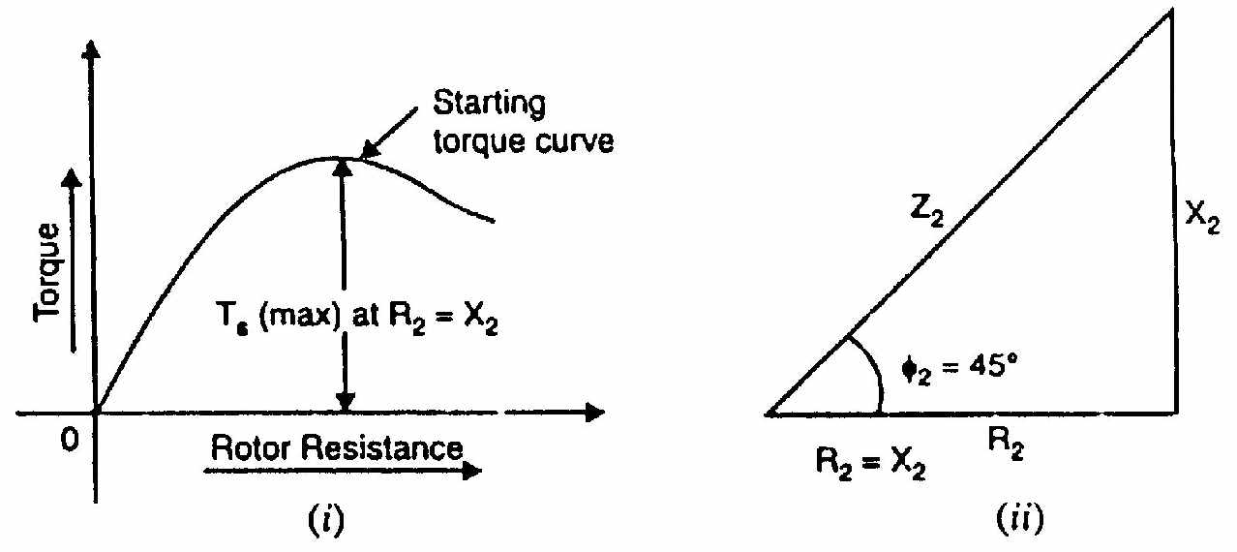

Fig 3.16

Rotor resistance/phase = Standstill rotor reactance/phase

Under the condition of maximum starting torque, 2 = 45° and rotor power factor is 0.707 lagging [See Fig. (3.16 (ii))].

Fig. (3.16 (i)) shows the variation of starting torque with rotor resistance. As the rotor resistance is increased from a relatively low value, the starting torque increases until it becomes maximum when R2 = X2.

**EFFECT OF CHANGE OF SUPPLY VOLTAGE**

Ts = 

Since E2  Supply voltage V

Ts =

where K2 is another constant. Ts V2

Therefore, the starting torque is very sensitive to changes in the value of supply voltage. For example, a drop of 10% in supply voltage will decrease the starting torque by about 20%. This could mean the motor failing to start if it cannot produce a torque greater than the load torque plus friction torque.

**STARTING TORQUE OF 3-PHASE INDUCTION MOTORS**

The rotor circuit of an induction motor has low resistance and high inductance. At starting, the rotor frequency is equal to the stator frequency (i.e., 50 Hz) so that rotor reactance is large compared with rotor resistance. Therefore, rotor current lags the rotor e.m.f. by a large angle, the power factor is low and consequently the starting torque is small. When resistance is added to the rotor circuit, the rotor power factor is improved which results in improved starting torque. This, of course, increases the rotor impedance and, therefore, decreases the value of rotor current but the effect of improved power factor predominates and the starting torque is increased.

(i) **Squirrel-cage motors**. Since the rotor bars are permanently short- circuited, it is not possible to add any external resistance in the rotor circuit at starting. Consequently, the stalling torque of such motors is low. Squirrel cage motors have starting torque of 1.5 to 2 times the full-load value with starting current of 5 to 9 times the full-load current.

(ii) **Wound rotor motors**. The resistance of the rotor circuit of such motors can be increased through the addition of external resistance. By inserting the proper value of external resistance (so that R2 = X2), maximum starting torque can be obtained. As the motor accelerates, the external resistance is gradually cut out until the rotor circuit is short-circuited on itself for running conditions.

**TORQUE UNDER RUNNING CONDITIONS**

Let the rotor at standstill have per phase induced e.m.f. E2, reactance X2 and resistance R2. Then under running conditions at slip s,

Rotor e.m.f./phase, E2’ = s E2

Rotor reactance/phase, 

Rotor impedance/phase, 

Rotor current/phase,

Rotor p.f.,cos

Running torque,



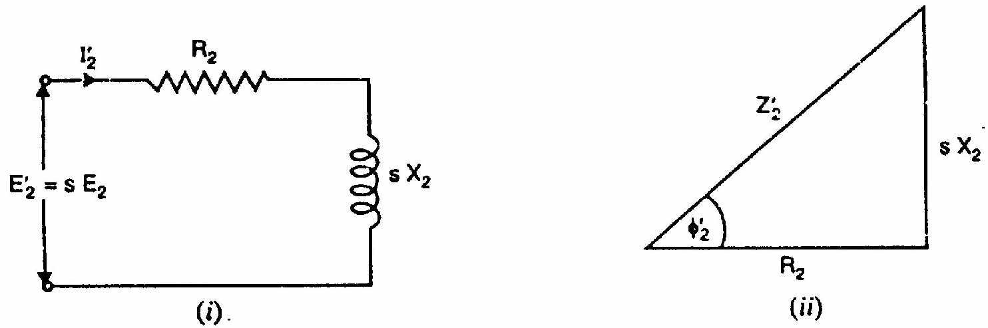

Fig 3.17



If the stator supply voltage V is constant, then stator flux and hence E2 will be constant.



where K2 is another constant.

It may be seen that running torque is:

(i) directly proportional to slip i.e., if slip increases (i.e., motor speed decreases), the torque will increase and vice-versa.

(ii) directly proportional to square of supply voltage.

It can be shown that value of K1 = 3/2  Ns where Ns is in r.p.s.



At starting, s = 1 so that starting torque is



**MAXIMUM TORQUE UNDER RUNNING CONDITIONS**



In order to find the value of rotor resistance that gives maximum torque under running conditions, differentiate exp. (i) w.r.t. s and equate the result to zero i.e.,



- =0

Or 

Or 

Thus for maximum torque (Tm) under running conditions:

Rotor resistance/phase = Fractional slip Standstill rotor reactance/phase

Now 

For maximum torque, R2 = s X2. Putting R2 = s X2 in the above expression, the maximum torque Tm is given by;



Slip corresponding to maximum torque, s = R2/X2.

It can be shown that:



It is evident from the above equations that:

(i) The value of rotor resistance does not alter the value of the maximum torque but Slip corresponding to maximum torque, s = R2/X2.

It can be shown that: only the value of the slip at which it occurs.

(ii) The maximum torque varies inversely as the standstill reactance.

Therefore, it should be kept as small as possible.

(iii) The maximum torque varies directly with the square of the applied voltage.

(iv) To obtain maximum torque at starting (s = 1), the rotor resistance must be made equal to rotor reactance at standstill.

**TORQUE-SLIP CHARACTERISTICS**

As shown in Sec. 3.16, the motor torque under running conditions is given by;



If a curve is drawn between the torque and slip for a particular value of rotor resistance R2, the graph thus obtained is called torque-slip characteristic. Fig. (3.18) shows a family of torque-slip characteristics for a slip-range from s = 0 to s = 1 for various values of rotor resistance.

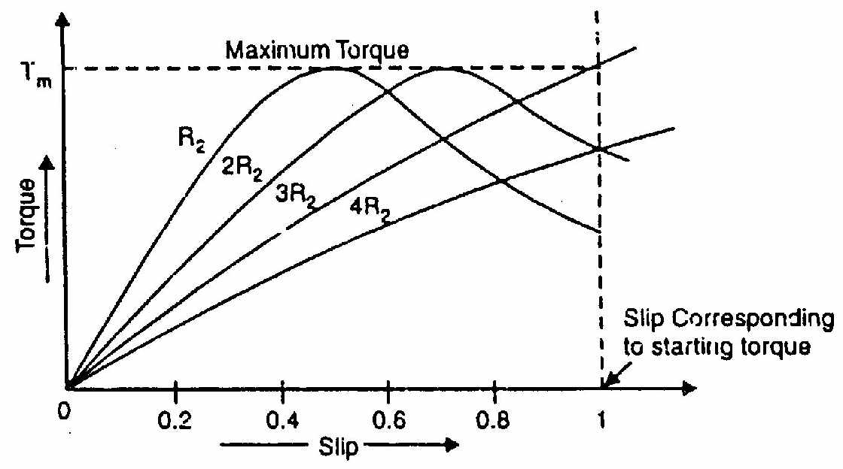

Fig 3.18

The following points may be noted carefully:

(i) At s = 0, T = 0 so that torque-slip curve starts from the origin.

(ii) At normal speed, slip is small so that s X2 is negligible as compared to

R2.



Hence torque slip curve is a straight line from zero slip to a slip that corresponds to full-load.

(iii) As slip increases beyond full-load slip, the torque increases and becomes maximum at s = R2/X2. This maximum torque in an induction motor is called pull-out torque or break-down torque. Its value is at least twice the full-load value when the motor is operated at rated voltage and frequency.

(iv) when slip increases beyond that corresponding to maximum torque, the term  increases very rapidly so that R2 may be neglected as compared to





Thus the torque is now inversely proportional to slip. Hence torque-slip curve is a rectangular hyperbola.

(v) The maximum torque remains the same and is independent of the value of rotor resistance. Therefore, the addition of resistance to the rotor circuit does not change the value of maximum torque but it only changes the value of slip at which maximum torque occurs

**FULL-LOAD, STARTING AND MAXIMUM TORQUES**





Note that s corresponds to full-load slip.

(i) 

Dividing the numerator and denominator on R.H.S. by X 22 , we get



where a=R2/X2 =Rotor resistance/phase

Standstill rotor reactance/phase

(ii) 

Dividing the numerator and denominator on R.H.S. by X22, we get



Where a=R2/X2 = Rotor resistance/phase

Standstill rotor reactance/phase

**POWER STAGES IN AN INDUCTION MOTOR**

The input electric power fed to the stator of the motor is converted into mechanical power at the shaft of the motor. The various losses during the energy conversion are:

**1. Fixed losses**

(i) Stator iron loss

(ii) Friction and windage loss

The rotor iron loss is negligible because the frequency of rotor currents under normal running condition is small.

**2. Variable losses**

(i) Stator copper loss

(ii) Rotor copper loss

Fig. (3.19a) shows how electric power fed to the stator of an induction motor suffers losses and finally converted into mechanical power.

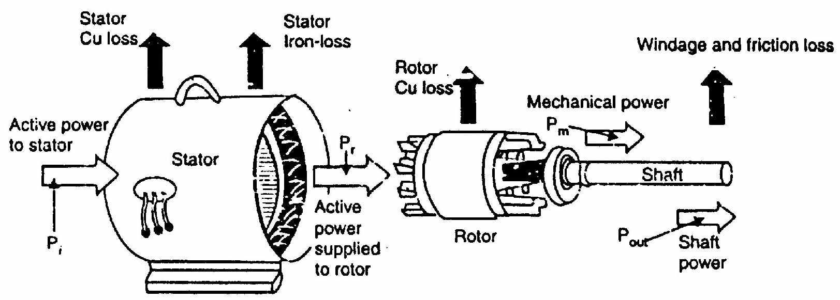

Fig 3.19a

The following points may be noted from the above diagram:

(i) Stator input, Pi = Stator output + Stator losses

= Stator output + Stator Iron loss + Stator Cu loss

(ii) Rotor input, Pr = Stator output

It is because stator output is entirely transferred to the rotor through air gap by electromagnetic induction.

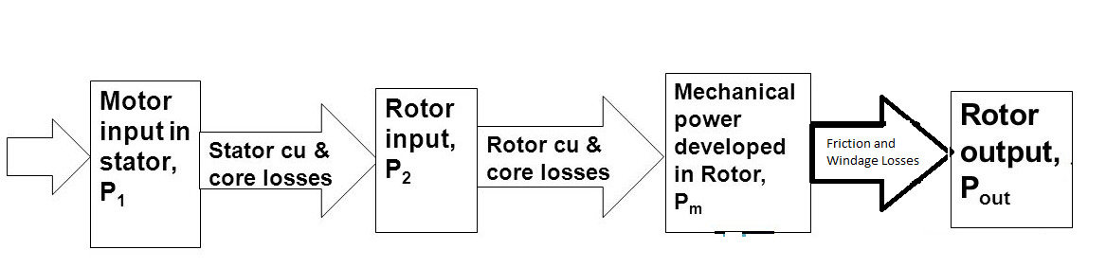

Fig 3.19b

(iii) Mechanical power available, Pm = Pr - Rotor Cu loss

This mechanical power available is the gross rotor output and will produce a gross torque Tg.

(iv) Mechanical power at shaft, Pout = Pm - Friction and windage loss Mechanical power available at the shaft produces a shaft torque Tsh.

Clearly, Pm - Pout = Friction and windage loss

**INDUCTION MOTOR TORQUE**

The mechanical power P available from any electric motor can be expressed as:



Where N=speed of the motor in r.p.m.

T=torque developed in N-m

T=

If the gross output of the rotor of an induction motor is Pm and its speed is N

r.p.m., then* gross torque Tg developed is given by:

similarly 

***Note***. Since windage and friction loss is small, Tg = Tsh,. This assumption hardly leads to any significant error.

**ROTOR OUTPUT**

If Tg newton-metre is the gross torque developed and N r.p.m. is the speed of the rotor, then,

Gross rotor output =  watts

If there were no copper losses in the rotor, the output would equal rotor input and the rotor would run at synchronous speed Ns.

Rotor input = watts

Rotor Cu loss = Rotor input - Rotor output

=

(i)Rotor Cu loss/Rotor input = 

Rotor Cu loss = s x Rotor input

(ii) Gross Rotor output,Pm = Rotor input-Rotor Culoss=Rotor input-s Rotor input

Pm = Rotor input(1-S)

(iii) Gross Rotor output/ Rotor input=1-s=N/Ns

(iv) Rotor Cu loss / Gross Rotor output =s/1-s

It is clear that if the input power to rotor is Pr then s Pr is lost as rotor Cu loss and the remaining (1- s)Pr is converted into mechanical power. Consequently, induction motor operating at high slip has poor efficiency.

***Note.*** Gross Rotor output/ Rotor input=1-s

If the stator losses as well as friction and windage losses arc neglected, then, Gross rotor output = Useful output

Rotor input = Stator input

Useful output / stator input = 1-s =Efficiency

Hence the approximate efficiency of an induction motor is 1-s. Thus if the slip of an induction motor is 0.125, then its approximate efficiency is = 1-0.125 =

0.875 or 87.5%.

# STARTING METHODS FOR 3 PHASE INDUCTION MOTOR

We classify starting methods for squirrel cage induction motor into two types on the basis of voltage. The two types are (i) Full [voltage](https://www.electrical4u.com/voltage-or-electric-potential-difference/) starting method and  
(ii) reduced voltage method for starting squirrel cage induction motor.  
Now let us discuss each of these methods in detail.

### Full Voltage Starting Method for Squirrel Cage Induction Motor

In this type we have only one method of starting.

#### DIRECT ON LINE STARTING METHOD

It is used for small motors below about 5kw.This method is also known as the**DOL method for starting the three phase squirrel cage induction motor**. In this method we directly switch the stator of the three phase squirrel cage induction motor on to the supply mains. The motor at the time of starting draws very high starting current (about 5 to 7 times the full load current) for the very short duration. The amount of current drawn by the motor depends upon its design and size. But such a high value of current does not harm the motor because of rugged construction of the squirrel cage induction motor. Such a high value of current causes sudden undesirable voltage drop in the supply voltage. A live example of this sudden drop of voltage is the dimming of the tube lights and bulbs in our homes at the instant of starting of refrigerator motor.

### REDUCED VOLTAGE METHOD FOR STARTING SQUIRREL CAGE INDUCTION MOTOR

In reduced voltage method we have three different type of starting method and these are written below:

1. Stator resistor starting method
2. Auto transformer staring method
3. Star delta starting method

Now let us discuss each of these methods in detail.

#### STATOR RESISTOR STARTING METHOD

Given below is the figure for the starting [resistor](https://www.electrical4u.com/types-of-resistor-carbon-composition-and-wire-wound-resistor/) method:

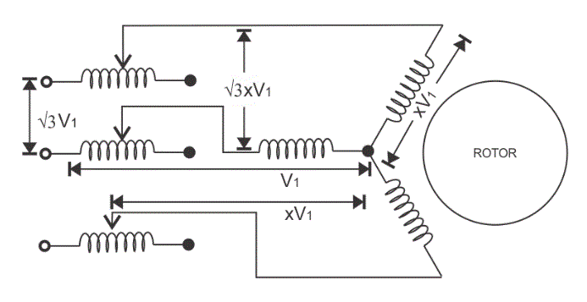

Fig 3.20

In this method we add resistor or a reactor in each phase as shown in the diagram (between the motor terminal and the supply mains).Thus by adding resistor we can control the supply voltage. Only a fraction of the voltage (x) of the supply voltage is applied at the time of starting of the [induction motor](https://www.electrical4u.com/induction-motor-types-of-induction-motor/). The value of x is always less than one. Due to the drop in the voltage the starting torque also decreases. We will derive the expression for the starting torque in terms of the voltage fraction x in order to show the variation of the starting torque with the value of x. As the motor speeds up the reactor or resistor is cut out from the circuit and finally the resistors are short circuited when the motor reaches to its operating speed.

#### AUTO TRANSFORMER STARTING METHOD

As the name suggests in this method we connect [auto transformer](https://www.electrical4u.com/what-is-auto-transformer/) in between the three phase power supply and the [induction motor](https://www.electrical4u.com/induction-motor-types-of-induction-motor/) as shown in the given diagram:

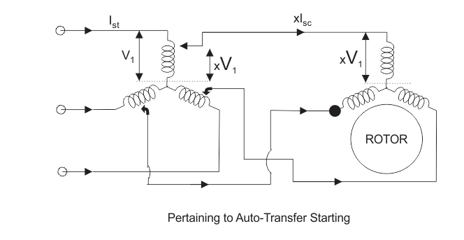

Fig 3.21

The auto transformer is a step down transformer hence it reduces the per phase supply voltage from V1 to xV1.The reduction in voltage reduces current from Is to xIs. After the motor reaches to its normal operating speed, the auto transformer is disconnected and then full line voltage is applied.

#### STAR-DELTA STARTING METHOD

Connection diagram is shown below for star delta method

This method is used for the motors designed to operate in delta connected winding. The terminals are marked for the phases of the stator are shown above. Now let us see this method works. The stator phases are first connected to the star by the help of triple pole double throw switch (TPDT switch) in the diagram the position is marked as 1 then after this when the steady state speed is reached the switch is thrown to position 2 as shown in the above diagram.  
Now let analyse the working of the above circuit. In the first position the terminals of the motor are short circuited and in the second position from the diagram the terminal a, b and c are respectively connected to B, C and A.

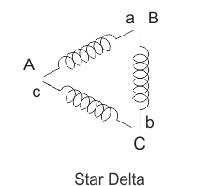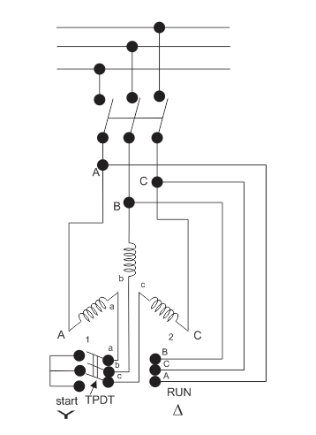

Fig 3.22

**STARTING METHODS OF WOUND ROTOR MOTORS (SLIPRING INDUCTION MOTOR)**

We can employ all the methods that we have discussed for starting of the squirrel cage induction motor in order to start the wound rotor motors. We will discuss the cheapest method of starting the wound rotors motor here

#### Addition of External Resistances in Rotor Circuit

This will decrease the starting current, increases the starting torque and also improves the [power factor](https://www.electrical4u.com/electrical-power-factor/). The circuit diagram is shown below: In the circuit diagram, the three slip rings shown are connected to the rotor terminals of the wound rotor motor. At the time of starting of the motor, the entire external [resistance](https://www.electrical4u.com/electrical-resistance-and-laws-of-resistance/) is added in the rotor circuit. Then the external rotor resistance is decreased in steps as the rotor speeds up, however the motor torque remain maximum during the acceleration period of the motor. Under normal condition when the motor develops load torque the external resistance is removed.

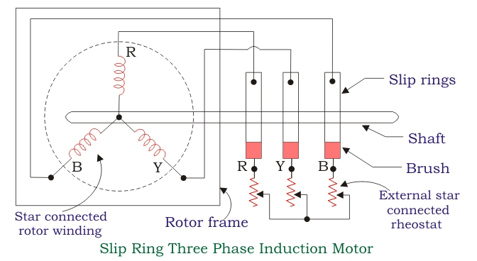

Fig 3.23

**UNIT-III**

**2013**

1.(a) Write the differences between squirre / cage rotor and slipring rotor.

(b) Explain torque-slip characteristics of 3IM.

(or)

2.(a) Drive the Torque equation of a three phase induction motor.

(b) A 3-phase induction motor is wound for 4 poles and is supplied from 50 Hz

system. Calculate:

(i) The synchronous speed

(ii) The speed of the motor when slip is 4% and

(iii) The rotor current frequency when the motor runs at 600r.p.m.

**UNIT-III**

**2014**

1.(a) Explain Torque-slip characteristics of 3IM.

(b) A 50Hz, 8 pole, 3 phase induction has a full load slip of 4%. The rotor resistance 0.001Ω per phase and stand still reactance is 0.005 Ω per phase. Find the ratio maximum torque to full load torque and the speed at which the maximum torque occurs.

(or)

2.(a) Explain any two starting methods of 1 IM.

(b)A 3-phase induction motor is wound for 4 poles and is supplied from 50Hz

System calculate.

(i) The Synchronous speed

(ii) The speed of the motor when slip is 4% and

(iii) The rotor current frequency when the motor runs at 600 r.p.m.

**UNIT-III**

**2015**

1. What are the different types of starting methods of three phase induction motors explain clearly**.**

(or)

2 (a) Explain the Torque-slip characteristics of three phase induction motor.

(b) A three phase induction motor Is wound for 4 poles and is supplied from

50Hz systems calculate:

i) synchronous speed.

ii) The rotor speed when slip is 4% and

iii)Rotor frequency when rotor runs at 600 RPM.

**UNIT-III**

**2016**

1. (a) Derive the expression for torque of three phase induction motor.

(b) The Power input to the rotor of a 400V,50Hz, 6-pole, 3Phase induction motor is 220 W and the slip is 3%. Calculate

i) the frequency of rotor current

ii) rotor speed

iii) rotor copper losses and

iv) rotor resistance per phase if rotor current is 60A.

(or)

2.(a) Discuss the principle of operation of 3 phase induction motor.

(b) A 4-pole, 3phase induction motor operates from a supply whose frequency is 50Hz. Calculate:

i) The speed at which the magnetic field of the stator is rotating

ii) The speed of the rotor when the slip is 0.04

iii) the frequency of rotor currents when the slip is 0.03.

iv) The frequency of the rotor current at stand still.