**ELECTRICAL TECHNOLOGY**

**UNIT-V**

**ALTERNATORS**

**INTRODUCTION**

A.C. system has a number of advantages over d.c. system. These days 3-phase a.c. System is being exclusively used for generation, transmission and distribution of power. The machine, which produces 3-phase power from mechanical power, is called an alternator or synchronous generator. Alternators are the primary source of all the electrical energy we consume. These machines are the largest energy converters found in the world. They convert mechanical energy into a.c. energy. In this chapter, we shall discuss the construction and characteristics of alternators.

**ALTERNATOR**

An alternator operates on the same fundamental principle of electromagnetic induction as a d.c. generator i.e., when the flux linking a conductor changes, an e.m.f. is induced in the conductor. Like a d.c. generator, an alternator also has an armature winding and a field winding. But there is one important difference between the two. In a d.c. generator, the armature winding is placed on the rotor in order to provide a way of converting alternating voltage generated in the winding to a direct voltage at the terminals through the use of a rotating commutator. The field poles are placed on the stationary part of the machine. Since no commutator is required in an alternator, it is usually more convenient and advantageous to place the field winding on the rotating part (i.e., rotor) and armature winding on the stationary part (i.e., stator) as shown in Fig. (5.1).

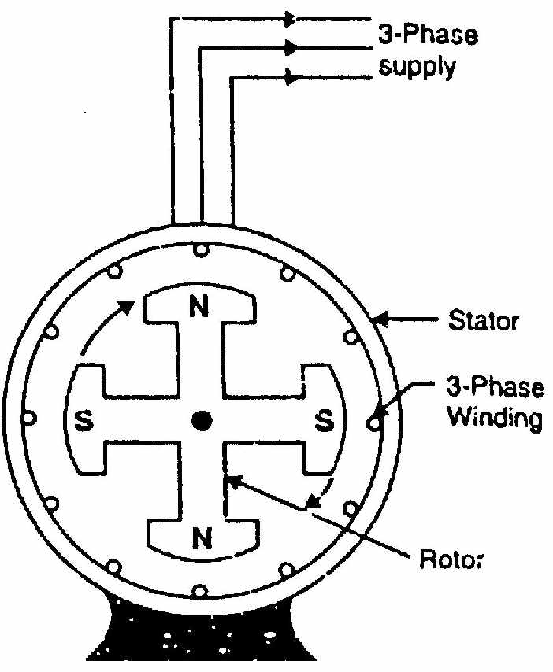

Fig 5.1

**Advantages of stationary armature**

The field winding of an alternator is placed on the rotor and is connected to d.c. supply through two slip rings. The 3-phase armature winding is placed on the stator

(i) It is easier to insulate stationary winding for high voltages for which the alternators are usually designed. It is because they are not subjected to centrifugal forces and also extra space is available due to the stationary arrangement of the armature.

(ii) The stationary 3-phase armature can be directly connected to load without going through large, unreliable slip rings and brushes.

(iii) Only two slip rings are required for d.c. supply to the field winding on the rotor. Since the exciting current is small, the slip rings and brush gear required are of light construction.

(iv) Due to simple and robust construction of the rotor, higher speed of rotating d.c. field is possible. This increases the output obtainable from a machine of given dimensions.

***Note***: All alternators above 5 kVA employ a stationary armature (or stator) and a revolving d.c. field.

**CONSTRUCTION OF ALTERNATOR**

An alternator has 3,-phase winding on the stator and a d.c. field winding on the rotor.

**1. Stator**

It is the stationary part of the machine and is built up of sheet-steel laminations having slots on its inner periphery. A 3-phase winding is placed in these slots and serves as the armature winding of the alternator. The armature winding is always connected in star and the neutral is connected to ground.

**2. Rotor**

The rotor carries a field winding which is supplied with direct current through two slip rings by a separate d.c. source. This d.c. source (called exciter) is generally a small d.c. shunt or compound generator mounted on the shaft of the alternator. Rotor construction is of two types, namely;

(i) Salient (or projecting) pole type

(ii) Non-salient (or cylindrical) pole type

(i) **Salient pole type**

In this type, salient or projecting poles are mounted on a large circular steel frame which is fixed to the shaft of the alternator as shown in Fig. (5.2). The individual field pole windings are connected in series in such a way that when the field winding is energized by the d.c. exciter, adjacent poles have opposite polarities.

Low and medium-speed alternators (120-400 r.p.m.) such as those driven by diesel engines or water turbines have salient pole type rotors due to the following reasons:

(a) The salient field poles would cause .an excessive windage loss if driven at high speed and would tend to produce noise.

(b) Salient-pole construction cannot be made strong enough to withstand the mechanical stresses to which they may be subjected at higher speeds.

(ii) **Non-salient pole type**

In this type, the rotor is made of smooth solid forged-steel radial cylinder having a number of slots along the outer periphery. The field windings are embedded in these slots and are connected in series to the slip rings through which they are energized by the d.c. exciter. The regions forming the poles are usually left un slotted as shown in Fig. (5.3). It is clear that the poles formed are non-salient i.e., they do not project out from the rotor surface.

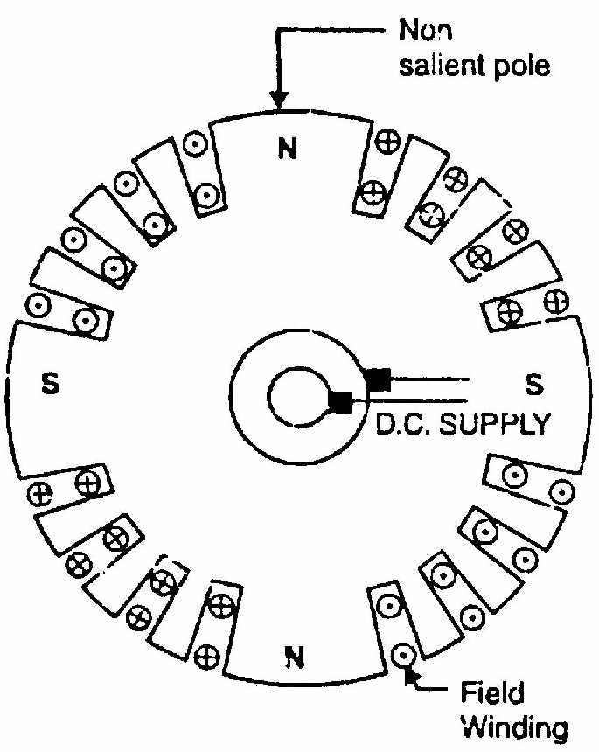

Fig 5.3

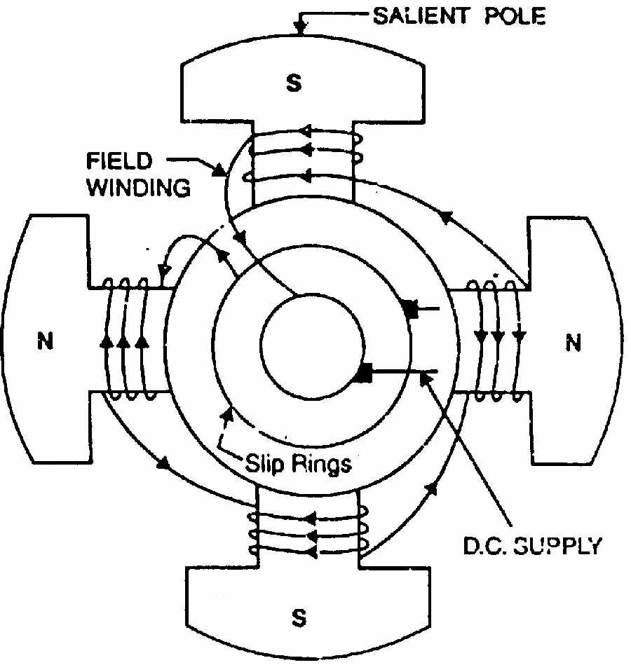

Fig 5.2

High-speed alternators (1500 or 3000 r.p.m.) are driven by steam turbines and use non-salient type rotors due to the following reasons:

(a) This type of construction has mechanical robustness and gives noiseless operation at high speeds.

(b) The flux distribution around the periphery is nearly a sine wave and hence a better e.m.f. waveform is obtained than in the case of salient-pole type.

Since steam turbines run at high speed and a frequency of 50 Hz is required, we need a small number of poles on the rotor of high-speed alternators (also called turbo alternators). We can use not less than 2 poles and this fixes the highest possible speed. For a frequency of 50 Hz, it is 3000 r.p.m. The next lower speed is 1500 r.p.m. for a 4-pole machine. Consequently, turbo alternators possess 2 or 4 poles and have small diameters and very long axial lengths.

**ALTERNATOR OPERATION**

The rotor winding is energized from the d.c. exciter and alternate N and S poles are developed on the rotor. When the rotor is rotated in anti-clockwise direction by a prime mover, the stator or armature conductors are cut by the magnetic flux of rotor poles. Consequently, e.m.f. is induced in the armature conductors due to electromagnetic induction. The induced e.m.f. is alternating since N and S poles of rotor alternately pass the armature conductors. The direction of induced e.m.f. can be found by Fleming’s right hand rule and frequency is given by;

f = N P

120

where N = speed of rotor in r.p.m.

P = number of rotor poles

The magnitude of the voltage induced in each phase depends upon the rotor flux, the number and position of the conductors in the phase and the speed of the rotor.

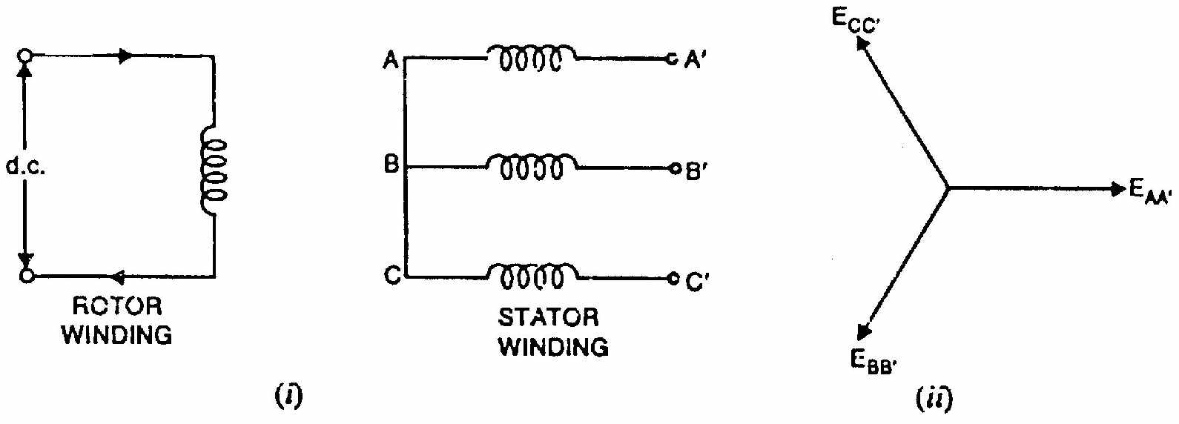

Fig 5.4

Fig. (5.4 (i)) shows star-connected armature winding and d.c. field winding. When the rotor is rotated, a 3-phase voltage is induced in the armature winding. The magnitude of induced e.m.f. depends upon the speed of rotation and the d.c. exciting current. The magnitude of e.m.f. in each phase of the armature winding is the same. However, they differ in phase by 120° electrical as shown in the phasor diagram in Fig. (5.4 (ii)).

**FREQUENCY**

The frequency of induced e.m.f. in the armature conductors depends upon speed and the number of poles.

Let N = rotor speed in r.p.m.

P = number of rotor poles

f = frequency of e.m.f. in Hz

Consider a stator conductor that is successively swept by the N and S poles of the rotor. If a positive voltage is induced when a N-pole sweeps across the conductor, a similar negative voltage is induced when a S-pole sweeps by. This means that one complete cycle of e.m.f. is generated in the conductor as a pair of poles passes it i.e., one N-pole and the adjacent following S-pole. The same is true for every other armature conductor.

No. of cycles/revolution = No. of pairs of poles = P/2

No. of revolutions/second = N/60

No. of cycles/second = (P/2)(N/60) = N P/120

But number of cycles of e.m.f. per second is its frequency.

f = N P

120

It may be noted that N is the synchronous speed and is generally represented by Ns. For a given alternator, the number of rotor poles is fixed and, therefore, the alternator must be run at synchronous speed to give an output of desired frequency. For this reason, an alternator is sometimes called synchronous generator.

**ARMATURE WINDING OF ALTERNATOR**

With very few exceptions, alternators are 3-phase machines because of the advantages of 3-phase service for generation, transmission and distribution. The windings for an alternator are much simpler than that of a d c. machine because no commutator is used. Fig. (5.5) shows a 2-pole, 3-phase double-layer, full- pitch, distributed winding for the stator of an alternator. There are 12 slots and each slot contains two coil sides. The coil sides that are placed in adjacent slots belong to the same phase such as a1, a3 or a2, a4 constitute a phase belt. Note that in a 3-phase machine, phase belt is always 60° electrical. Since the winding has double-layer arrangement, one side of a coil, such as a1, is placed at the bottom of a slot and the other side a1 is placed at the top of another slot spaced one pole pitch apart. Note that each coil has a span of a full pole pitch or 180 electrical degrees. Therefore. the winding is a full-pitch winding.

Note that there are 12 total coils and each phase has four coils. The four coils in each phase are connected in series so that their voltages aid. The three phases then may be connected to form Y or -connection. Fig. (5.6) shows how the coils are connected to form a Y-connection.

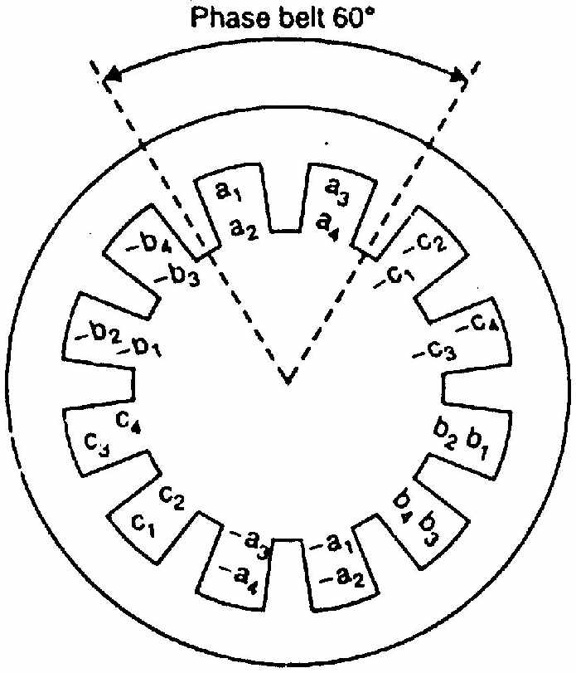

Fig 5.5

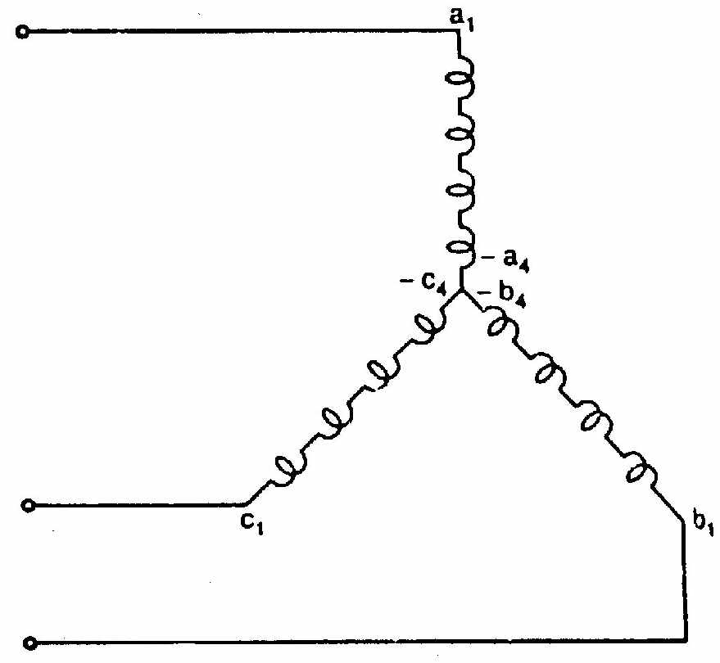

Fig 5.6

**WINDING FACTORS**

The armature winding of an alternator is distributed over the entire armature. The distributed winding produces nearly a sine waveform and the heating is more uniform. Likewise, the coils of armature winding are not full-pitched i.e., the two sides of a coil are not at corresponding points under adjacent poles. The fractional pitched armature winding requires less copper per coil and at the same time waveform of output voltage is unproved. The distribution and pitching of the coils affect the voltages induced in the coils. We shall discuss two winding factors:

(i) Distribution factor (Kd), also called breadth factor

(ii) Pitch factor (Kp), also known as chord factor

**(i) Distribution factor (Kd)**

A winding with only one slot per pole per phase is called a concentrated winding. In this type of winding, the e.m.f. generated/phase is equal to the arithmetic sum of the individual coil e.m.f.s in that phase. However, if the coils/phase are distributed over several slots in space (distributed winding), the e.m.f.s in the coils are not in phase (i.e., phase difference is not zero) but are displaced from each by the slot angle (The angular displacement in electrical degrees between the adjacent slots is called slot angle). The e.m.f./phase will be the phasor sum of coil e.m.f.s. The distribution factor Kd is defined as:

K = e.m.f. with distribute d winding

d e.m.f. with concentrated winding

= phasor sum of coil e.m.f.s/phase

arithmetic sum of coil e.m.f.s/phase

Note that numerator is less than denominator so that Kd < 1. Expression for K

Let α = slot angle= 180 electrical

No. of slots/pole

n = slots per pole per phase

The distribution factor can be determined by constructing a phasor diagram for the coil e.m.f.s. Let n = 3. The three coil e.m.f.s are shown as phasors AB, BC and CD [See Fig. (5.7 (i))] each of which is a chord of circle with centre at O and subtends an angle at O. The phasor sum of the coil e.m.f.s subtends an angle n (Here n = 3) at O. Draw perpendicular bisectors of each chord such as Ox, Oy etc [See Fig. (5.7 (ii))].



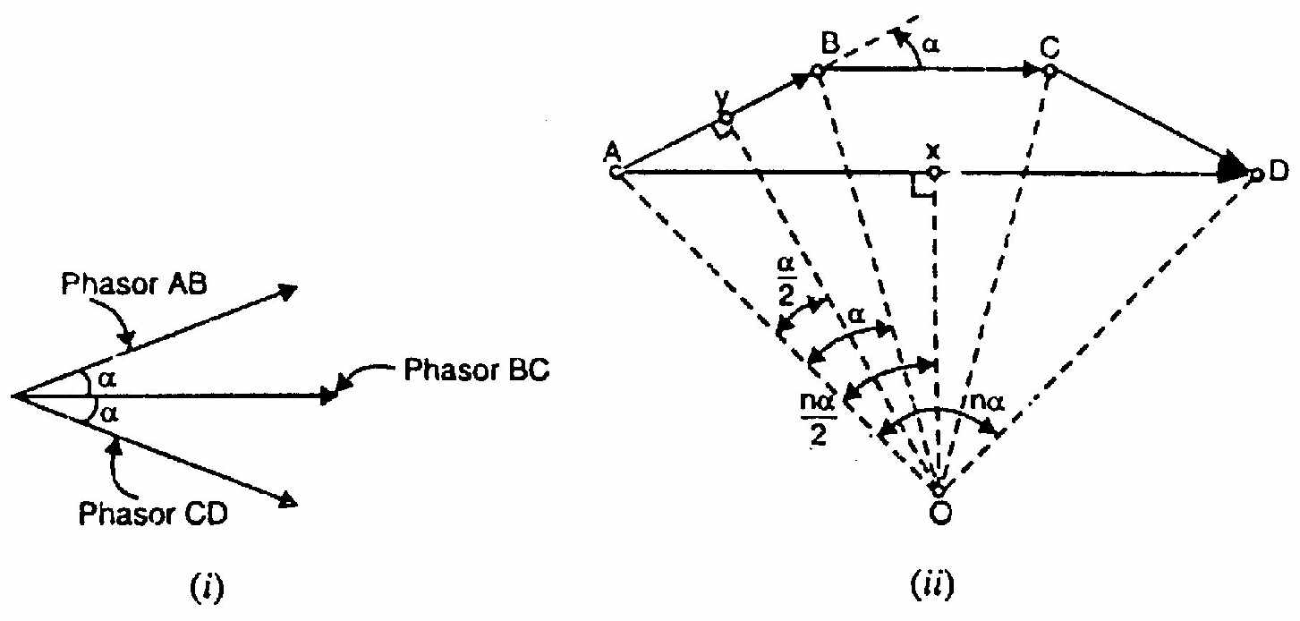

Fig 5.7

Note that n α is the phase spread

**(ii) Pitch factor (Kp)**

A coil whose sides are separated by one pole pitch (i.e., coil span is 180 electrical) is called a full-pitch coil. With a full-pitch coil, the e.m.f.s induced in the two coil sides are in phase with each other and the resultant e.m.f. is the arithmetic sum of individual e.m.fs. However the waveform of the resultant e.m.f. can be improved by making the coil pitch less than a pole pitch. Such a coil is called short-pitch coil. This practice is only possible with double-layer type of winding The e.m.f. induced in a short-pitch coil is less than that of a full- pitch coil. The factor by which e.m.f. per coil is reduced is called pitch factor Kp. It is defined as:

K e.m.f. induced in short - pitch coil

p e.m.f. induced in full - pitch coil

**Expression for Kp**. Consider a coil AB which is short-pitch by an angle electrical degrees as shown in Fig. (5.8). The e.m.f.s generated in the coil sides A and B differ in phase by an angle and can be represented by phasors EA and EB respectively as shown in Fig. (5.9). The diagonal of the parallelogram represents the resultant e.m.f. ER of the coil

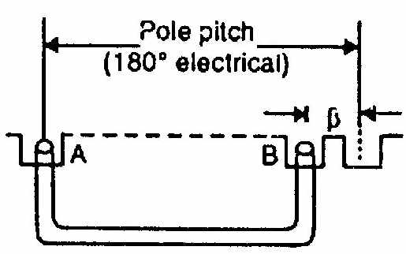

Fig 5.8

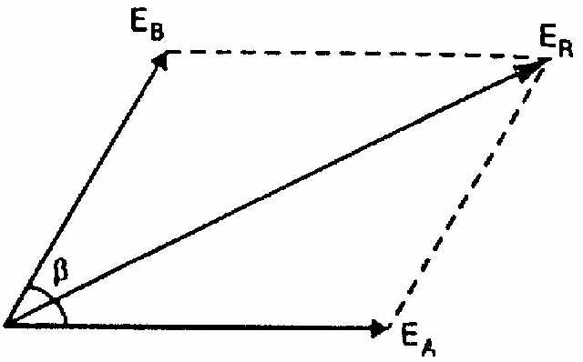

Fig 5.9

Since EA = EB, ER=2EA cos β/2

Pitch factor, Kp = e.m.f. in short - pitch coil

e.m.f. in full - pitch coil

=

For a full-pitch winding, Kp = 1. However, for a short-pitch winding, Kp < 1. Note that β is always an integer multiple of the slot angle α.

**E.M.F. EQUATION OF AN ALTERNATOR**

Let Z = No. of conductors or coil sides in series per phase

= Flux per pole in webers

P = Number of rotor poles

N = Rotor speed in r.p.m.

In one revolution (i.e., 60/N second), each stator conductor is cut by P  webers i.e.,



Average e.m.f. induced in one stator conductor



Since there are Z conductors in serial per phase,

Average e.m.f/phase=

=

=2 Z volts

R.M.S. value of e.m.f./phase = Average value/phase x form factor

=

 Er.m.s/phase=2.22 volts.

If Kp and Kd are the pitch factor and distribution factor of the armature winding, then,

Er.m.s/phase=2.22KpKd volts.

Sometimes the turns (T) per phase rather than conductors per phase are specified, in that case, eq. (ii) becomes:

Er.m.s/phase=4.44KpKd volts.

The line voltage will depend upon whether the winding is star or delta connected.

**ARMATURE REACTION IN ALTERNATOR**

When an alternator is running at no-load, there will be no current flowing through the armature winding. The flux produced in the air-gap will be only due to the rotor ampere-turns. When the alternator is loaded, the three-phase currents will produce a totaling magnetic field in the air-gap. Consequently, the air-gap flux is changed from the no-load condition.

The effect of armature flux on the flux produced by field ampere-turns (i. e., rotor ampere-turns) is called armature reaction.

Two things are worth noting about the armature reaction in an alternator. First, the armature flux and the flux produced by rotor ampere-turns rotate at the same speed (synchronous speed) in the same direction and, therefore, the two fluxes are fixed in space relative to each other. Secondly, the modification of flux in the air-gap due to armature flux depends on the magnitude of stator current and on the power factor of the load. It is the load power factor which determines whether the armature flux distorts, opposes or helps the flux produced by rotor ampere-turns. To illustrate this important point, we shall consider the following three cases:

**ALTERNATOR ON LOAD**

Fig. (4.10) shows Y-connected alternator supplying inductive load (lagging p.f.). When the load on the alternator is increased (i.e., armature current Ia is increased), the field excitation and speed being kept constant, the terminal voltage V (phase value) of the alternator decreases. This is due to

(i) Voltage drop IaRa where Ra is the armature resistance per phase.

(ii) Voltage drop IaXL where XL is the armature leakage reactance per phase.

(iii) Voltage drop because of armature reaction.

**(i) Armature Resistance (Ra)**

Since the armature or stator winding has some resistance, there will be an IaRa drop when current (Ia) flows through it. The armature resistance per phase is generally small so that IaRa drop is negligible for all practical purposes.

**(ii) Armature Leakage Reactance (XL)**

When current flows through the armature winding, flux is set up and a part of it does not cross the air-gap and links the coil sides as shown in Fig. (4.11). This leakage flux alternates with current and gives the winding self-inductance. This is called armature leakage reactance. Therefore, there will be IaXL drop which is also effective in reducing the terminal voltage.

**(iii) Armature reaction**

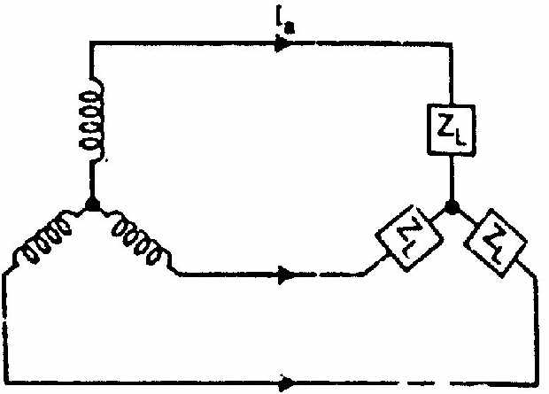

Fig 4.10

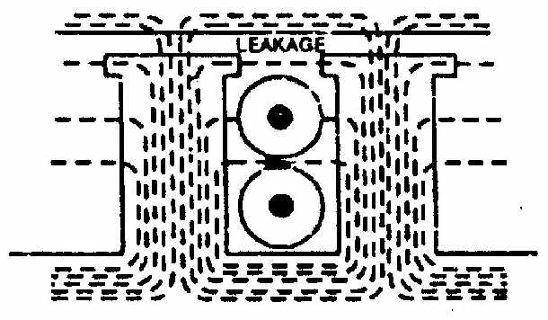

Fig 4.11

The load is generally inductive and the effect of armature reaction is to reduce the generated voltage. Since armature reaction results in a voltage effect in a circuit caused by the change in flux produced by current in the same circuit, its effect is of the nature of an inductive reactance. Therefore, armature reaction effect is accounted for by assuming the presence of a fictitious reactance XAR in the armature winding. The quantity XAR is called reactance of armature reaction. The value of XAR is such that IaXAR represents the voltage drop due to armature reaction.

**Equivalent Circuit**

Fig. (10.16) shows the equivalent circuit of the loaded alternator for one phase. All the quantities are per phase. Here

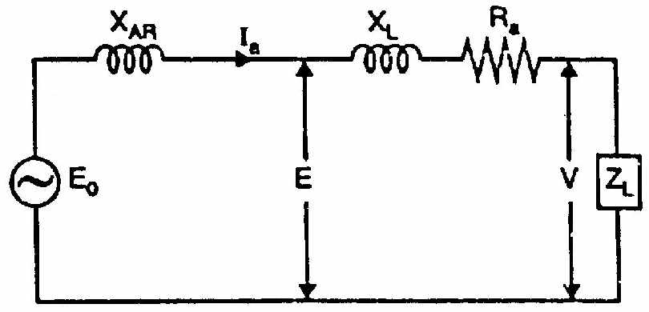

Fig 4.12

E0 = No-load e.m.f.

E = Load induced e.m.f. It is the induced e.m.f. after allowing for armature reaction. It is

equal to phasor difference of E0 and IaXAR.

**F**

V = Terminal voltage. It is less than E by voltage drops in XL and Ra.

 

**SYNCHRONOUS REACTANCE (XS)**

The sum of armature leakage reactance (XL) and reactance of armature reaction (XAR) is called synchronous reactance Xs [See Fig. (5.13 (i))]. Note that all quantities are per phase.

X s = X L + XAR

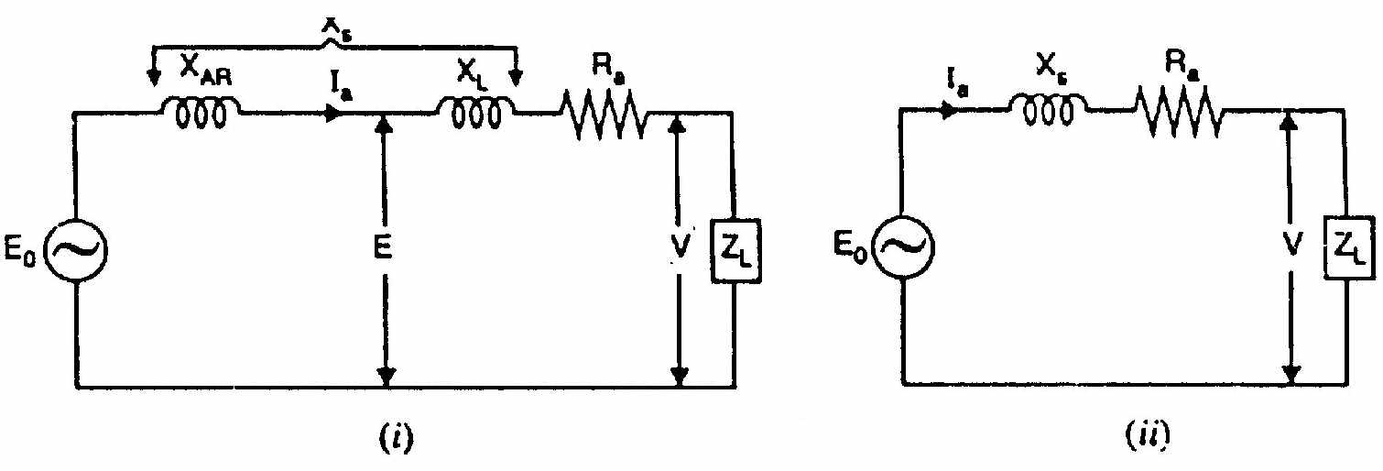

Fig 5.13

The synchronous reactance is a fictitious reactance employed to account for the voltage effects in the armature circuit produced by the actual armature leakage reactance and the change in the air-gap flux caused by armature reaction. The circuit then reduces to the one shown in Fig. (5.13 (ii)).

Synchronous impedance, Zs = Ra + j Xs

The synchronous impedance is the fictitious impedance employed to account for the voltage effects in the armature circuit produced by the actual armature resistance, the actual armature leakage reactance and the change in the air-gap flux produced by armature reaction.



**VOLTAGE REGULATION**

The voltage regulation of an alternator is defined as the change in terminal voltage from no-load to full-load (the speed and field excitation being constant) divided by full-load voltage.

No-load voltage-Full-load voltage

% Voltage regulation=

Full Full- load voltage

X 100

Note that E0-V is the arithmetic difference and not the phasor difference. The factors affecting the voltage regulation of an alternator are:

(i) IaRa drop in armature winding

(ii) IaXL drop in armature winding

(iii) Voltage change due to armature reaction

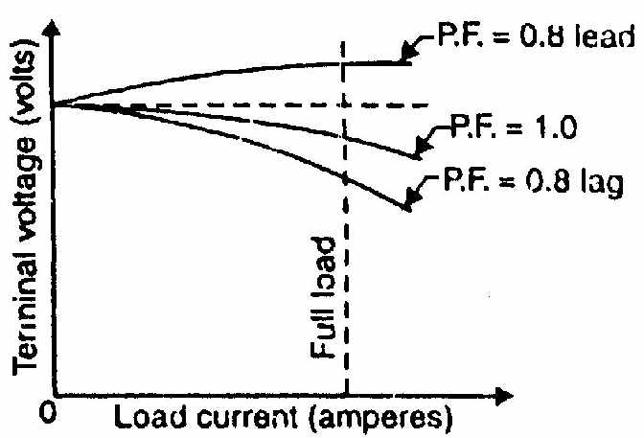

Fig 5.14

We have seen that change in terminal voltage due to armature reaction depends upon the armature current as well as power-factor of the load. For leading load p.f., the no-load voltage is less than the full-load voltage. Hence voltage regulation is negative in this case. The effects of different load power factors on the change in the terminal voltage with changes of load on the alternator are shown in Fig. (5.14). Since the regulation of an alternator depends on the load and the load power factor, it is necessary to mention power factor while expressing regulation.

**DETERMINATION OF VOLTAGE REGULATION**

The kVA ratings of commercial alternators are very high (e.g. 500 MVA). It is neither convenient nor practicable to determine the voltage regulation by direct loading. There are several indirect methods of determining the voltage regulation of an alternator. These methods require only a small amount of power as compared to the power required for direct loading method. Two such methods are:

1. Synchronous impedance or E.M.F. method

2. Ampere-turn or M.M.F. method

For either method, the following data are required:

(i) Armature resistance

(ii) Open-circuit characteristic (O.C.C.)

(iii) Short-Circuit characteristic (S.C.C.)

**(i) Armature resistance**

The armature resistance Ra per phase is determined by using direct current and the voltmeter-ammeter method. This is the d.c. value. The effective armature resistance (a.c. resistance) is greater than this value due to skin effect. It is a usual practice to take the effective resistance 1.5 times the d.c. value (Ra = 1.5 Rdc).

**(ii) Open-circuit characteristic (O.C.C)**

Like the magnetization curve for a d.c. machine, the (Open-circuit characteristic of an alternator is the curve between armature terminal voltage (phase value) on open circuit and the field current when the alternator is running at rated speed.

Fig. (5.15) shows the circuit for determining the O.C.C. of an alternator. The alternator is run on no-load at the rated speed. The field current If is gradually increased from zero (by adjusting field rheostat) until open-circuit voltage E0 (phase value) is about 50% greater than the rated phase voltage. The graph is drawn between open-circuit voltage values and the corresponding values of If as shown in Fig. (4.16).

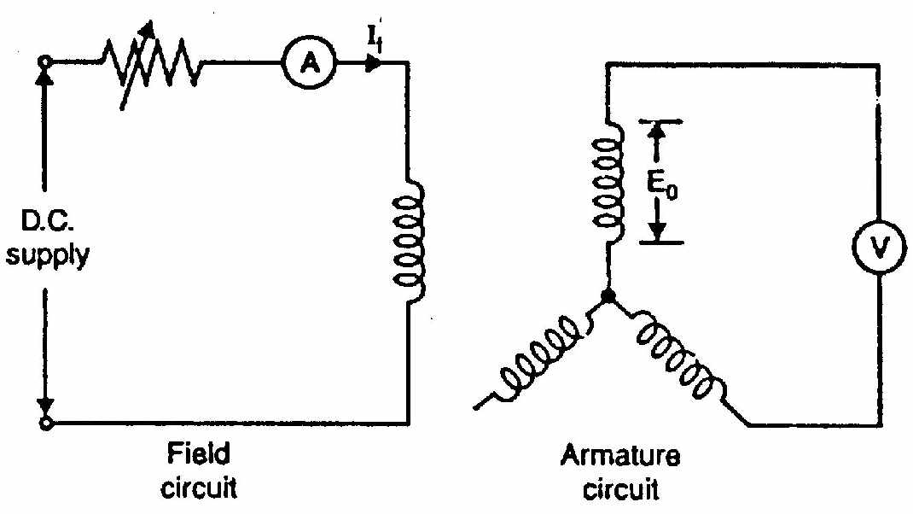

Fig 5.15

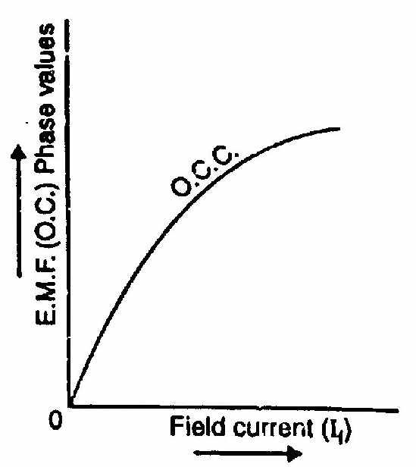

Fig 5.16

**(iii) Short-circuit characteristic (S.C.C.)**

In a short-circuit test, the alternator is run at rated speed and the armature terminals are short-circuited through identical ammeters [See Fig. (5.17)]. Only one ammeter need be read; but three are used for balance. The field current If is gradually increased from zero until the short-circuit armature current ISC is about twice the rated current. The graph between short-circuit armature current and field current gives the short-circuit characteristic (S.C.C.) as shown in Fig. (5.18).

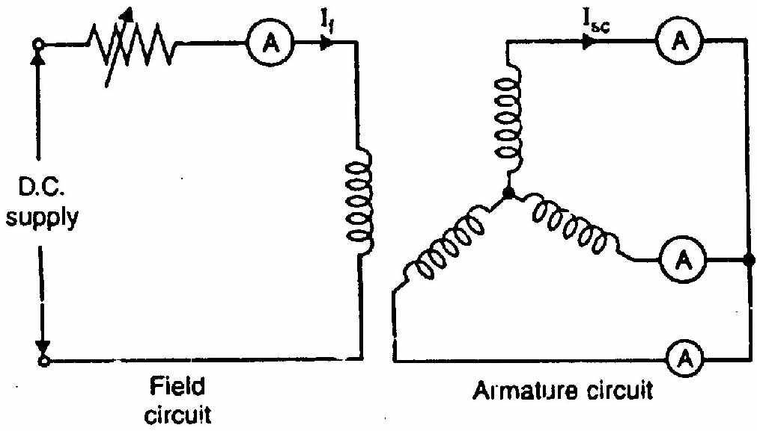

Fig 5.17

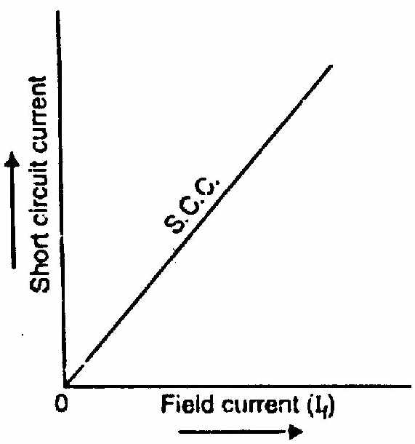

Fig 5.18

There is no need to take more than one reading because S.C.C. is a straight line passing through the origin. The reason is simple. Since armature resistance is much smaller than the synchronous reactance, the short-circuit armature current lags the induced voltage by very nearly 90°. Consequently, the armature flux and field flux are in direct opposition and the resultant flux is small. Since the resultant flux is small, the saturation effects will be negligible and the short- circuit armature current, therefore, is directly proportional to the field current over the range from zero to well above the rated armature current.

**Synchronous Impedance Method**

In this method of finding the voltage regulation of an alternator, we find the synchronous impedance Zs (and hence synchronous reactance Xs) of the alternator from the O.C.C. and S.S.C. For this reason, it is called synchronous impedance method. The method involves the following steps:

(i) Plot the O.C.C. and S.S.C. on the same field current base as shown in Fig. (5.19).

(ii) Consider a field current If. The open-circuit voltage corresponding to this field current is E1. The short-circuit armature current corresponding to field current If is I1. On short-circuit potential difference is zero and voltage E1 is being used to circulate the short-circuit armature current I1 against the synchronous impedance Zs. This is illustrated in Fig. (5.20).



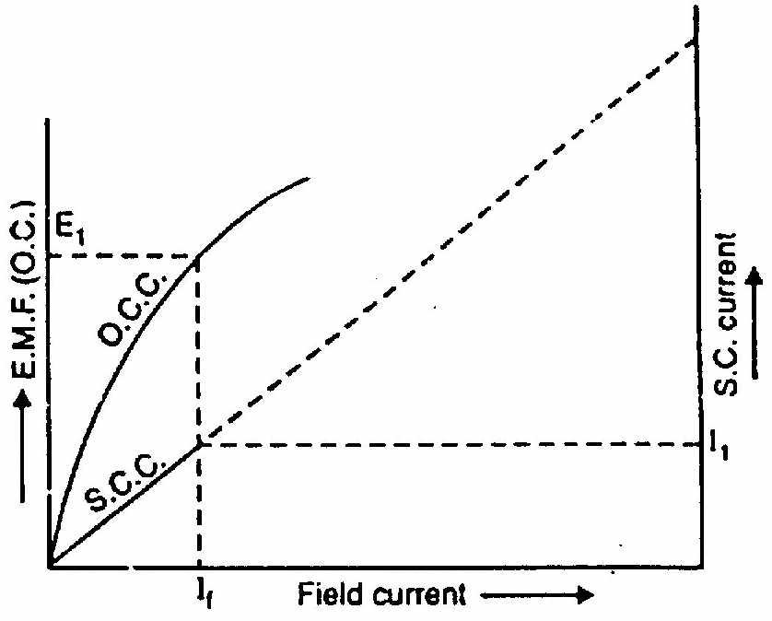

Fig 5.19

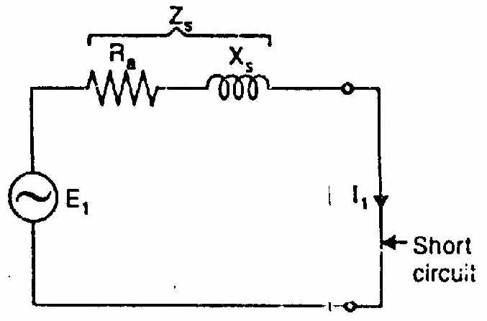

Fig 5.20

Note that E1 is the phase value and so is I1.

(ii) The armature resistance can be found as explained earlier.

Synchronous reactance, 

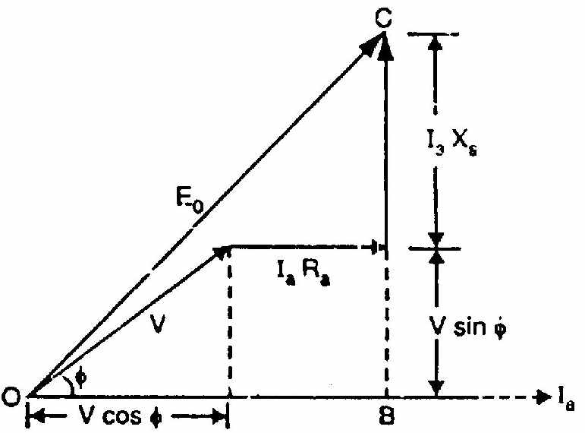

Fig 5.21

(iv) Once we know Ra and Xs, the phasor diagram can be drawn for any load and any p.f.

Note that in drawing the phasor diagram, current Ia has been taken as the reference phasor. The IaRa drop is in phase with Ia while IaXs drop leads Ia by 90°.

The phasor sum of V, IaRa and IaXs gives the no-load e.m.f. E0.



%voltage regulation =

**2013**

1.a) Explain in detail the constructional features of a three phase alternator.

b) Explain the principle of operation of stepper motor.

or

2. a) What is voltage regulation? Derive the voltage regulation for synchronous impedance method.

b) A50 KVA,500V, single-phase a.c. generator gave the following test results:

open circuit test: A field current of 12A produced an e.m.f of 300 volts.

Short-circuit test: Afield current 0f 12A caused a current of 175Ato flow in the short circuited armature.

The effective armature resistance is 0.2Ω

(i) Calculate the synchronous impedance and synchronous reactance

(ii)If the a,c. generator is supplying full-load current of 100A at 0.8 p.f. lagging at what value would the terminal voltage rise if the load were removed? Also find the voltage regulation for this load and p.f.

**2014**

1.a) Explain the principle of operation of Alternator.

b) Explain the principle of operation of stepper motor.

Or

2. a) Drive the generalized expression for an induced emf in three phase alternator.

b) A 3-phase, 50Hz star-connected alternator has 180 conductor per phase and flux pole is 0.0543 wb. Find:

(i) e.m.f generated per phase

(ii)e.m.f. between the line terminals

Assume the winding to be full pitched and distribution factor to be 0.96.

**2015**

1. Explain the synchronous impedance method for calculating the regulation phase alternator.

2. Find the No-load phase and line voltage of a star connected 3 phase, 6 pole alternator which runs at1200 RPM, having flux per pole of 100 mwb, its stator has 54 slots each coil has 8 turns and the coil is chorded by one slot.

**2016**

1.a) Derive the expression for the emf equation for the alternator.

b) A three phase 16 pole alternator has a star connected winding with 144 slots and 10 conductors per slot. The flux per pole is 0.03 Wb, and the speed is 375 rpm. Find the phase & line voltage. Assume full pitched coil.

Or

2.a) Discuss the constructional details of the alternator with near sketch.

b) what are the advantages of rotating filed over the stationary field of the alternator.

**MODEL OBJECTIVE QUESTIONS**

1.Majority of the alternators in use have **revolving field type construction**

2. The field winding of an alternator is **d.c.** excited.

3.An alternator is sometimes called **synchronous** generator.

4.A turboalternator uses **nonsalient-pole field structure**.

5.High-speed alternators are driven by **steam** **turbines**

6.Turbo-alternator have rotors of **small diameter and long axial length**

7. The speed at which a 6-pole alternator should be driven to generate 50 cycles per second is **1000r.p.m.**

8. The frequency of e.m.f.generated in an 8-pole alternator running at 900 r.p.m. is **60Hz**

**9.**A 3-phase alternator generates an open-circuit voltage of 4000V per phase when exciting current is 50A; the short-circuit current for the same excitation being 800A. the synchronous reactance per phase is **5Ω**

10.In the armature winding of an alternator, the coil span falls short of full-pitch by 600(electrical).the pitch factor is **0.866**

11.A 3-phase alternator has 3-slots per pole. The distribution factor of the winding is **1**

12. The stator of a 3-phase induction motor produces **rotating** magnetic field.

13. An induction motor is preferred to a d.c. motor because it **has simple and rugged construction**

14. The air-gap between stator and rotor ofa3-phase induction motor ranges from **0.4mm to 4 mm**

15. The relation among synchronous speed (Ns),rotor speed (N)and slip(s)is

**N=(l-s)Ns**

16. When a 3-phase induction motor is at no load, the slip is **practically zero**

17. The rotor winding of a 3-phase wound rotor is generally **star** connected

18. The starting torque of a 3-phase induction motor is **directly proportional to square of** supply voltage.

19. The conditions of an induction motor on no-load resemble those of a transformer whose secondary is **open-circuited**

20. An 8-pole alternator runs at 750 r.p.m. and supplies power to a 6-pole induction motor which has a full-load slip of 3%. The full-load speed of the motor is **970r.p.m.**

21. A single-phase induction motor employs **squirrel cage**rotor.

22.For the same rating, the size of a single-phase induction motor is about **1.5 times** that of a 3-phase induction motor.

23. For the same rating, the efficiency of a single-phase induction motor is **Less than** that of 3-phase induction motor.

24. The starting winding of a single-phase induction motor has **same number of poles as** that of main winding.

25. A 50 Hz, 4-pole,single-phase induction motor will have a synchronous speed of **1500r.p.m.**

26. The purpose of starting winding in a single-phase induction motor is to **produce rotating flux in conjunction with main winding.**

27. The resistance split-phase induction motor has **moderate** starting torque.

28. A capacitor-start, capacitor-run motor has **high power factor**

29. The capacitor-start, capacitor-run induction motor acts as a true 2-phase motor at **full-load**

30. The single-phase series motor can operate on **both a.c. and d.c.**

31. The least expensive fractional horse power motor is **shaded-pole** motor.

32. The washing machine generally employs **resistance split-phase** motor.

33. A stepper motor is a **multiphase motor.**

34. A variable reluctance stepper motor is constructed of **ferromagnetic** material with salient poles.

35. The most popular types of stepper motor is **Permanent magnet stepper motor.**