I UNIT
RECTIFIERS:
Rectification
An alternating current has the property to change its state continuously. This is understood by observing the sine wave by which an alternating current is indicated. It raises in its positive direction goes to a peak positive value, reduces from there to normal and again goes to negative portion and reaches the negative peak and again gets back to normal and goes on.
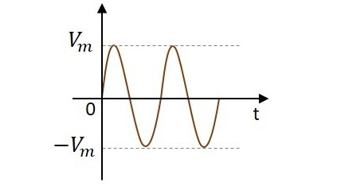

During its journey in the formation of wave, we can observe that the wave goes in positive and negative directions. Actually it alters completely and hence the name alternating current. But during the process of rectification, this alternating current is changed into direct current DC. The wave which flows in both positive and negative direction till then, will get its direction restricted only to positive direction, when converted to DC. Hence the current is allowed to flow only in positive direction and resisted in negative direction, just as in the figure below.
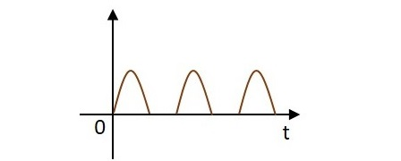
The circuit which does rectification is called as a Rectifier circuit. A diode is used as a rectifier, to construct a rectifier circuit.

Types of Rectifier circuits:There are two main types of rectifier circuits, depending upon their output. They are
- Half-wave Rectifier
- Full-wave Rectifier
A Half-wave rectifier circuit rectifies only positive half cycles of the input supply whereas a Full-wave rectifier circuit rectifies both positive and negative half cycles of the input supply.

Half-Wave Rectifier
The name half-wave rectifier itself states that the rectification is done only for half of the cycle. The AC signal is given through an input transformer which steps up or down according to the usage. Mostly a step down transformer is used in rectifier circuits, so as to reduce the input voltage.
The input signal given to the transformer is passed through a PN junction diode which acts as a rectifier. This diode converts the AC voltage into pulsating dc for only the positive half cycles of the input. A load resistor is connected at the end of the circuit. The figure below shows the circuit of a half wave rectifier.

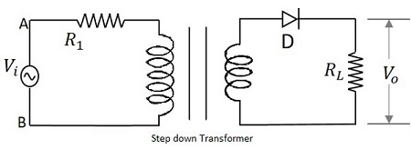

Working of a HWR
The input signal is given to the transformer which reduces the voltage levels. The output from the transformer is given to the diode which acts as a rectifier. This diode gets ON (conducts) for positive half cycles of input signal. Hence a current flows in the circuit and there will be a voltage drop across the load resistor. The diode gets OFF (doesn’t conduct) for negative half cycles and hence the output for negative half cycles will be, i_{D}=0
and Vo=0.
Hence the output is present for positive half cycles of the input voltage only (neglecting the reverse leakage current). This output will be pulsating which is taken across the load resistor.

Waveforms of a HWR
The input and output waveforms are as shown in the following figure.

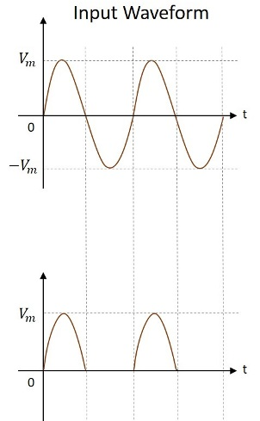

Analysis of Half-Wave Rectifier
To analyze a half-wave rectifier circuit, let us consider the equation of input voltage.
V_{i}=V_{m}SinWt
Vm is the maximum value of supply voltage.

Let us assume that the diode is ideal.
The resistance in the forward direction, i.e., in the ON state is Rf

The resistance in the reverse direction, i.e., in the OFF state is Rr.
The current i in the diode or the load resistor R_{L} is given by
I =I_{m}SinWt for 0<=Wt<=π;
I=0 for π<=Wt<=2π;
Where I_{m} = V_{m}/ (R_{f}+R_{L});

FILTERS:
Full-wave Rectifier with Shunt Capacitor Filter
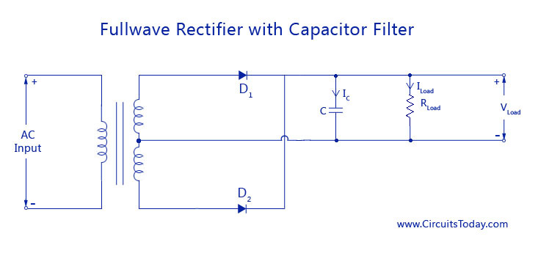
The circuit diagram of a full-wave rectifier wit capacitor filter is shown below
The filter capacitor C is placed across the resistance load R _{Load.} The working is much similar to that of a half-wave rectifier with shunt capacitor. The only difference is that two pulses of current will charge the capacitor during alternate positive (D1) and negative (D2) half cycles. Similarly capacitor C discharges twice through RLoad during one full cycle. This is shown in the waveform below.
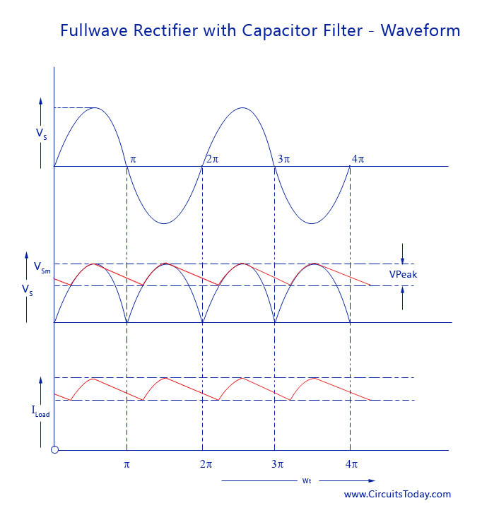

L-C Filters
In the simple shunt capacitor filter circuit explained above, we have concluded that the capacitor will reduce the ripple voltage, but causes the diode current to increase .This large current may damage the diode and will further cause heating problem and decrease the efficiency of the filter. On the other hand, a simple series inductor reduces both the peak and effective values of the output current and output voltage. Then if we combine both the filter (L and C), a new filter called the L-C filter can be designed which will have a good efficiency, with restricted diode current and enough ripple removal factor .The voltage stabilizing action of shunt capacitor and the current smoothing action of series inductor filter can be combined to form a perfect practical filter circuit.
L-C filters can be of two types: Choke Input L-section Filter and L-C Capacitor input filter

Choke Input L-Section Filter
An inductor filter increases the ripple factor with the increase in load current Rload. A capacitor filter has an inversely proportional ripple factor with respect to load resistance. Economically, both inductor filter and capacitor filter are not suitable for high end purpose
L-C inductor input or L-section filter consists of an inductor ‘ L’ connected in series with a half or full wave rectifier and a capacitor ’C’ across the load. This arrangement is also called a choke input filter or L-section filter because it’s shape resembles and inverted L-shape. To increase the smoothing action using the filter circuit, just one L-C circuit will not be enough. Several L-section filters will be arranged to obtain a smooth filtered output. The circuit diagram and smoothened waveform of a Full wave rectifier output is shown below.

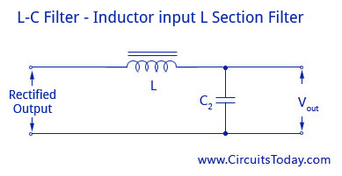
L-C Filter Inductor input L-Section Filter
As shown in the circuit diagram above, the inductor L allows the dc to pass but restricts the flow of ac components as its dc resistance is very small and ac impedance is large. After a signal passes through the choke, if there is any fluctuation remaining the current, it will be fully bypassed before it reaches the load by the shunt capacitor because the value of Xc is much smaller than Rload. The number of ripples can be reduced to a great amount by making the value of XL greater than Xc at ripple frequency.
Ripple Factor
Ripple Factor = Vac rms/Vdc = (√2/3)(Xc/X_{L}) = (√2/3)(1/[2wc])(1/[2wL]) = 1/(6√2w²LC)
Though the L-C filter has all these advantages, it has now become quite obsolete due the huge size of inductors and its cost of manufacturing. Nowadays, IC voltage regulators are more commonly used along with active filters, that reduce the ripples and keeps the output dc voltage constant.
The diagram of L-C Capacitor input filter and waveform is shown below.

Π – Filter or Capacitance Input Filter
The name pi – Filter implies to the resemblance of the circuit to a Π shape with two shunt capacitances (C1 and C2) and an inductance filter ‘L’. As the rectifier output is provided directly into the capacitor it also called a capacitor input filter.
The output from the rectifier is first given to the shunt capacitor C. The rectifier used can be half or full wave and the capacitors are usually electrolytic even though they large in size. In practical applications, the two capacitances are enclosed in a metal container which acts as a common ground for the two capacitors. Circuit diagram and the waveform are given below.
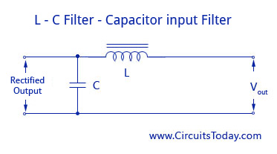
L-C Filter-Capacitor input Filter
When compared to other type of filters, the Π – Filter has some advantages like higher dc voltage and smaller ripple factor. But it also has some disadvantages like poor voltage regulation, high peak diode current, and high peak inverse voltage.
This filter is divided into two – a capacitor filter and a L-section filter. The capacitor C1 does most of the filtering in the circuit and the remaining ripple os removed by the L-section filter (L-C2). C1 is selected to provide very low reactance to the ripple frequency. The voltage regulation is poor for this circuit as the output voltage falls off rapidly with the increase in load current.
Ripple Factor
Ripple Factor = √2/(8w³C₁C₂LR_{load})
REGULATORS
A voltage regulator is used to regulate voltage level. When a steady, reliable voltage is needed, then voltage regulator is the preferred device. It generates a fixed output voltage that remains constant for any changes in an input voltage or load conditions. It acts as a buffer for protecting components from damages. A voltage regulator is a device with a simple feed- forward design and it uses negative feedback control loops. There are mainly two types of voltage regulators: Linear voltage regulators and switching voltage regulators; these are used in wider applications. Linear voltage regulator is the easiest type of voltage regulators. It is available in two types, which are compact and used in low power, low voltage systems. Let us discuss about different types of voltage regulators.
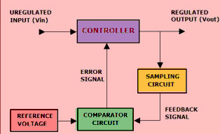
Basically, there are two types of Voltage regulators
There are two types of Linear voltage regulators: Series and Shunt
Series Voltage Regulator
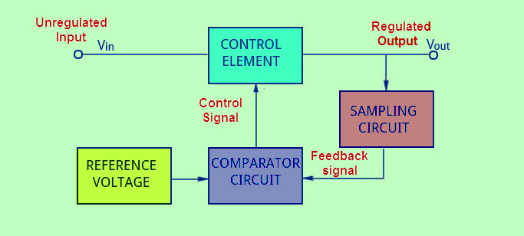
A series voltage regulator uses a variable element placed in series with the load. By changing the resistance of that series element, the voltage dropped across it can be changed. And, the voltage across the load remains constant.
The amount of current drawn is effectively used by the load; this is the main advantage of the series voltage regulator. Even when the load does not require any current, the series regulator does not draw full current. Therefore, a series regulator is considerably more efficient than shunt voltage regulator.
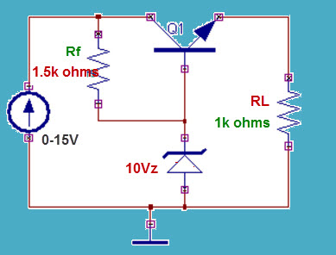
Shunt Voltage Regulator
A shunt voltage regulator works by providing a path from the supply voltage to ground through a variable resistance. The current through the shunt regulator is diverted away from the load and flows uselessly to the ground, making this form usually less efficient than the series regulator. It is, however, simpler, sometimes consisting of just a voltage-reference diode, and is used in very low-powered circuits wherein the wasted current is too small to be of concern. This form is very common for voltage reference circuits. A shunt regulator can usually only sink (absorb) current.
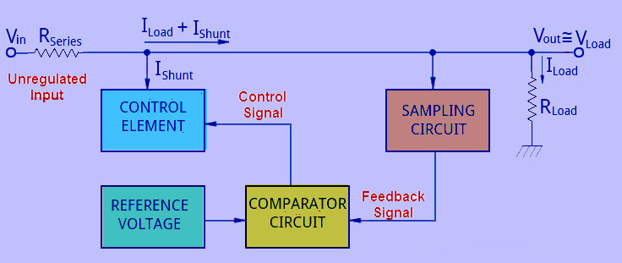
Shunt regulators are used in:
Low Output Voltage Switching Power Supplies
Current Source and Sink Circuits
Error Amplifiers
Adjustable Voltage or Current Linear and Switching Power Supplies
Voltage Monitoring
Analog and Digital Circuits that require precision references
Precision current limiters
Zener Diode Regulator
Zener Diodes can be used to produce a stabilised voltage output with low ripple under varying load current conditions. By passing a small current through the diode from a voltage source, via a suitable current limiting resistor (RS), the zener diode will conduct sufficient current to maintain a voltage drop of Vout.
We remember from the previous tutorials that the DC output voltage from the half or full-wave rectifiers contains ripple superimposed onto the DC voltage and that as the load value changes so to does the average output voltage. By connecting a simple zener stabiliser circuit as shown below across the output of the rectifier, a more stable output voltage can be produced.
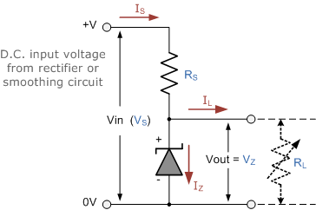
The resistor, RS is connected in series with the zener diode to limit the current flow through the diode with the voltage source, VS being connected across the combination. The stabilised output voltage Vout is taken from across the zener diode. The zener diode is connected with its cathode terminal connected to the positive rail of the DC supply so it is reverse biased and will be operating in its breakdown condition. Resistor RS is selected so to limit the maximum current flowing in the circuit.
With no load connected to the circuit, the load current will be zero, ( IL = 0 ), and all the circuit current passes through the zener diode which in turn dissipates its maximum power. Also a small value of the series resistor RS will result in a greater diode current when the load resistance RL is connected and large as this will increase the power dissipation requirement of the diode so care must be taken when selecting the appropriate value of series resistance so that the zener’s maximum power rating is not exceeded under this no-load or high-impedance condition.
The load is connected in parallel with the zener diode, so the voltage across RL is always the same as the zener voltage, ( VR = VZ ). There is a minimum zener current for which the stabilization of the voltage is effective and the zener current must stay above this value operating under load within its breakdown region at all times. The upper limit of current is of course dependant upon the power rating of the device. The supply voltage VS must be greater than VZ.
One small problem with zener diode stabiliser circuits is that the diode can sometimes generate electrical noise on top of the DC supply as it tries to stabilise the voltage. Normally this is not a problem for most applications but the addition of a large value decoupling capacitor across the zener’s output may be required to give additional smoothing.
Then to summarise a little. A zener diode is always operated in its reverse biased condition. A voltage regulator circuit can be designed using a zener diode to maintain a constant DC output voltage across the load in spite of variations in the input voltage or changes in the load current. The zener voltage regulator consists of a current limiting resistor RS connected in series with the input voltage VS with the zener diode connected in parallel with the load RL in this reverse biased condition. The stabilized output voltage is always selected to be the same as the breakdown voltage VZ of the diode.

UNIT –II
BJT AMPLIFIERS
Operating Point
The point which is obtained from the values of the I_{C} (collector current) or V_{CE} (collector-emitter voltage) when no signal is given to the input is known as the operating point or Q-point in a transistor. It is called operating point because variations of I_{C} (collector current) and VCE (collector-emitter voltage) takes place around this point when no signal is applied to the input.
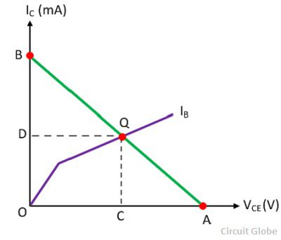
The operating point is also called quiescent (silent) point or simply Q-point because it is a point on I_{C} – V_{CE} characteristic when the transistor is silent or no input signal is applied to the circuit. The operating point can be easily obtained by the DC load line method. The DC load line is explained above.
Let, determines the operating point of particular base circuit current IB. According to the load line condition, the OA = V_{CE} = VCC and OB = I_{C} = V_{CC}/RC is shown on the output characteristic curve above. The point Q is the operating point where the DC load line intersects the base current IB at the output characteristic curves in the absence of input signal.
Where I_{C}= OD mA
V_{CE} = OC volts.
The position of the Q-point depends on the applications of the transistor. If the transistor is used as a switch then for open switch the Q-point is in the cutoff region, and for the close switch, the Q-point is in the saturation region. The Q-point lies in the middle of the line for the transistor which operates as an amplifier.

Biasing of BJT
Biasing refers to the application of D.C. voltages to setup the operating point in such a way that output signal is undistorted throughout the whole operation. Also once selected properly, the Q point should not shift because of change of IC due to
(i) β variation due to replacement of the transistor of same type
(ii) Temperature variation
Stabilization
The process of making operating point independent of temperature changes or variation in transistor parameters is known as stabilization.
Stabilization of operating point is necessary due to
Temperature dependence of I_{C}
Individual variations
Thermal runaway
Temperature dependence of I_{C} & Thermal runaway
I_{C} = βI_{B} + (β + I)I _{CBO}
I_{CBO} is strong function of temperature. A rise of10ºC doubles the I_{CBO} and I_{C}
will increase ( β+1) times of I_{CBO.}
The flow of I_{C} produce heat within the transistor and raises the transistor
temperature further and therefore, further increase in I_{CBO.} This effect is cumulative and in few seconds, the I_{C} may become large enough to burn out the transistor.The self destruction of an un-stabilized transistor is known as thermal runaway.
Stability Factor:
The rate of change collector current I_{C} with respect to the collector leakage
current I_{CBO} is called stability factor, denoted by S = (dI_{c}/dI_{CBO})
Lower the value of S, better is the stability of the transistor.
The rate of change collector current IC with respect to the collector leakage current I_{CBO} at constant β and I_{B} is called stability factor, denoted by S.
I_{C} = βI_{B} + (β + I)I _{CBO} …………….(1)
Differentiating equation (1) w.r.tI_{C}
1= β (dI_{B}/dI_{C})+ β+1(d I _{CBO} /dI_{C}) ……………(2)
1= β (dI_{B}/dI_{C}) + ( β+1 )/ S………………….(3)
S= ( β+1 )/ (1-β( dI_{B}/dI_{C}))……………….(4)

Different biasing schemes:
(i) Fixed bias (base resistor biasing)
(ii) Collector base bias
(iii) Voltage divider bias
Fixed Bias
This form of biasing is also called base bias. The single power source is used for both collector and base of transistor, although separate batteries can also be used.
Using KVL in the base-emitter loop 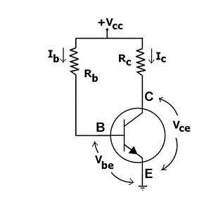
V_{CC} – I_{b}R_{b} –V_{be} = 0 ; I_{b}= (V_{CC}-V_{be})/R_{b} ;
I_{C} = βI_{b}= β(V_{CC}-V_{be})/R_{b} ;
Using KVL in the collector-emitter loop;
V_{CC} – I_{C}R_{C} –Vce = 0; V_{ce} = V_{CC} - I_{C}R_{C} ;
Advantages:
Operating point can be shifted easily anywhere in the active region by merely
changing the base resistor (RB).
A very small number of components are required.
Disadvantages:
Poor stabilization.High stability factor(S=β+1 because I_{B} is constant so (dI_{B}/dI_{C} =0 ), hence
prone to thermal runaway.
Usage:
Due to the above inherent drawbacks, fixed bias is rarely used in linearcircuits (i.e., those circuits which use the transistor as a current source).Instead, it is often used in circuits where transistor is used as a switch.
Collector base bias
This configuration employs negative feedback to prevent thermal runaway and
stabilize the operating point.In this form of biasing, the base resistor RB is connected to the collector instead of connecting it to the DC source Vcc. So any thermal runaway will induce a voltage drop across the RC resistor that will throttle the transistor’s base current.
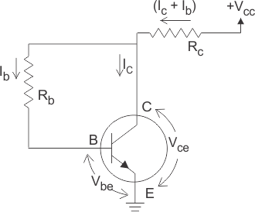
Applying KVL
V_{CC} = (I_{C}+I_{B})R_{C} + V_{CE………….} (1)
V_{CE} = I_{B}R_{B} + V_{BE …………….}2)
Since, I_{C} = βI_{B} so from equation (1) & (2)
I_{B} = V_{CC} - V_{BE} /(R_{b}+(1+ β)R_{c}
Advantages:
Better stabilization compared to fixed bias.
Disadvantages:
This circuit provides negative feedback which reduces the gain of the amplifier.
Usage:
The feedback also decreases the input impedance of the amplifier as seen from
the base, which can be advantageous. Due to the gain reduction from feedback, this
biasing form is used only when the trade-off for stability is warranted.

Voltage divider bias circuit:
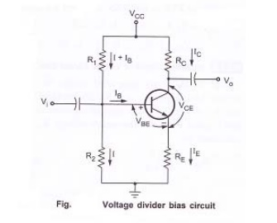
Figure shows the voltage divider bias circuit. In this, biasing is provided by three resistors R₁, R₂ and R_{E.} The resistors R₁& R₂ act as a potential divider giving a fixed voltage to base. If collector current increases due to change in temperature or change in β, emitter current I_{E} also increases and voltage drop across R_{E} increases thus reducing the voltage difference between base and emitter. Due to reduction in base emitter voltage, base current and collector current reduces. So we can say that negative feedback exists in emitter bias circuit. This reduction in collector current compensates for the original change in I_{C}
Circuit analysis:
Fig. Base circuit:
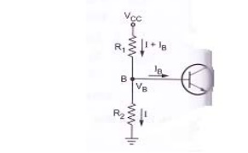
Consider the base circuit as shown in above figure. Voltage across R₂ is base voltage V_{B}. Applying voltage divider rule to find V_{B}

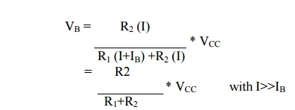
Collector circuit:
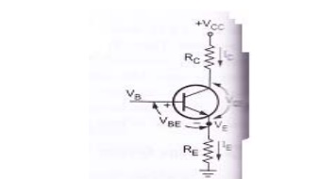
Consider the collector circuit as shown in above figure. Voltage across R_{E} can be obtained as,
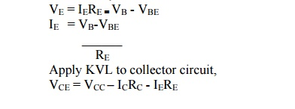
Simplified circuit of voltage divider bias
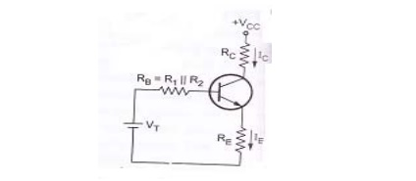
Fig.Thevenin’s equivalent circuit for voltage divider bias.
From above figure, R₁ and R₂ are replaced by R_{B} and V_{T}.
Where R_{B} is the parallel combination of R=1 and R₂
V_{T} is the thevenin’s voltage
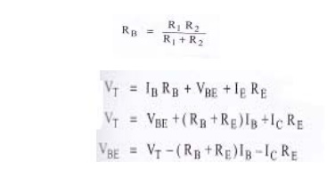
COMPENSATION METHODS
It refers to the use of temperature sensitive devices such as diodes, transistors, thermistors which provide compensating voltage and current to maintain Q point stable.
Diode Compensation Techniques
Compensation for V_{BE}:
Diagram shows the voltage divider bias with bias compensation technique. Here, separate supply VDD is used to keep diode in forward If biased condition. If the diode used in the circuit is of same material and type as the transistor, the voltage across the diode will have the same temperature coefficient as the base to emitter voltage VBE . So when VBE changes by ∂ VBE with change in temperature, VD changes by VD and ∂ VD~=~∂ VBE, the changes tend to cancel each other. Apply*g KVL to the base circuit of Fig. ,we have:
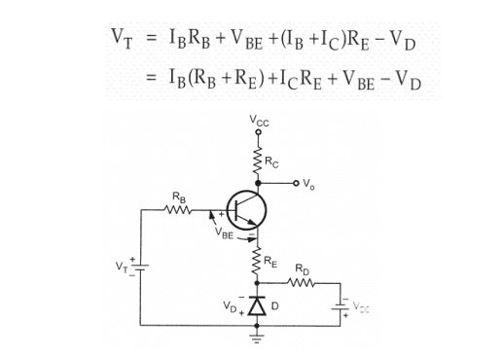
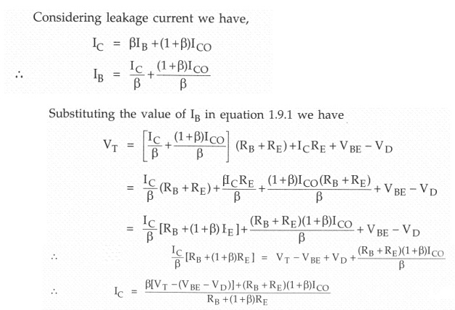
As V_{D} tracks V_{BE} with respect to temperature it is clear that I_{C} will be insensitive to variations in V_{BE} .
Compensation for I_{CO}
In germanium transistor changes in ICO with temperature plays an important role collector current stability. The diode is kept at reverse bias condition ,so only leakage current flows Io increases then I_{CO} also increases
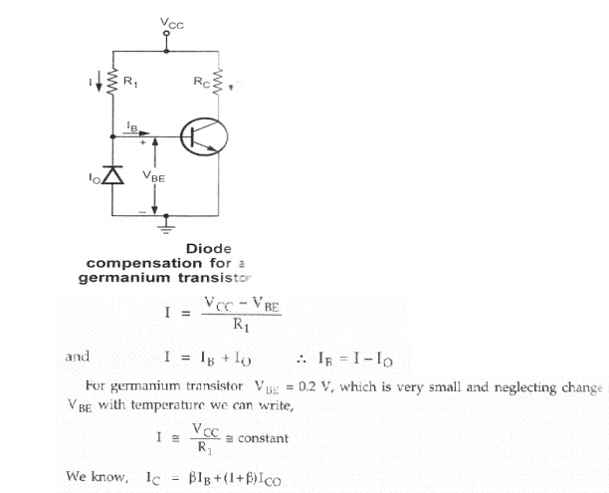
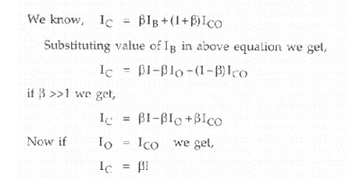
As I is constant , I also remains constant. We can say that changes by I_{CO} with temperature are compensated by diode and collector current remains constant

SINGLE STAGE AMPLIFIERS
BJT – SMALL SIGNAL ANALYSIS:
In order to develop BJT small-signal models, there are two small-signal resistances that we must first determine. These are:
1.r_{π}: the small-signal, active mode input resistance between the base and emitter, as “seen looking into the base.”
2.r_{e} : the small-signal, active mode output resistance between the base and emitter, as “seen looking into the emitter.” These resistances are not the same, because the transistor is not a so-called reciprocal device. Like a diode, the behavior of the BJT in the circuit changes if we interchange the terminals (i.e., a non-reciprocal device).

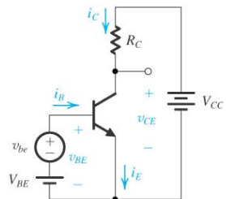

Assuming the transistor is operating in active mode,

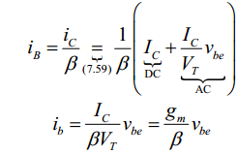
The AC small signal equivalent from the figure is
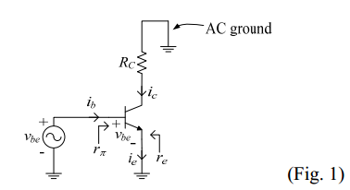
From the small signal equivalent circuit above,
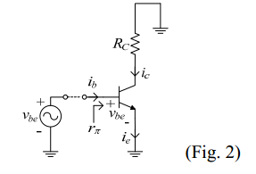
r_{π =} V_{be}/i_{b;&} r_{π =} β/g_{m;}
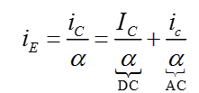

Or with I_{E} = I_{C}/α
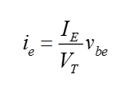
r_{e}is the BJT small signal resistance between emitter and base when looking into the emitter.
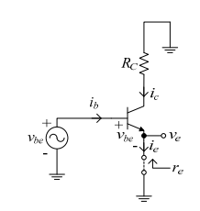
Mathematically this is stated as
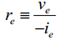
Assuming an ideal signal voltage source, then and
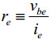
From the above equations ,
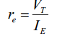 and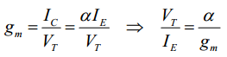
Now r_{e} can be written as
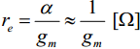 This is the BJT active mode small signal resistance between the base and emitter. And

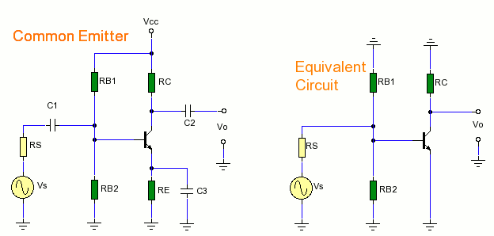
The above figures shows the CE configuration for hybrid analysis and its equivalent circuit.
C1 and C2 are coupling capacitors and c3 is bypass capacitor. Rs is source resistance and Rb1 & RB2 are base resistors in parallel.
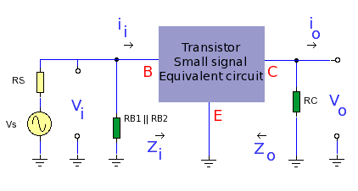
The figure shows hybrid equivalent circuit.
Hybridmodel has 4 parameters, h represents hybrid since it is a combination of impedance, admittance and dimensionless parameters.
- h_{ie}= input impedance in ohms
- hre=reverse voltage ratio.(dimensionless)
- hfe= forward current transfer ratio( dimensionless)
- hoe output admittance in Siemens.
The hybrid model for BJT in common emitter mode is shown below.

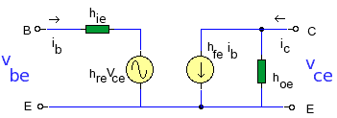

The hybrid model is suitable for small signal at mid band and describes the behavior of transistor. Two equations can be derived from the above diagram , one for input voltage, and the other for output current.

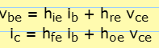
If Ib held constant (Ib=0), then hre and hoe can be observed.
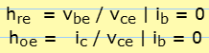
If Vce is held constant, then hie & hfe can be solved.

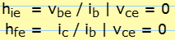

The Figure given below shows the Commom Emitter Vs h-parameter model.
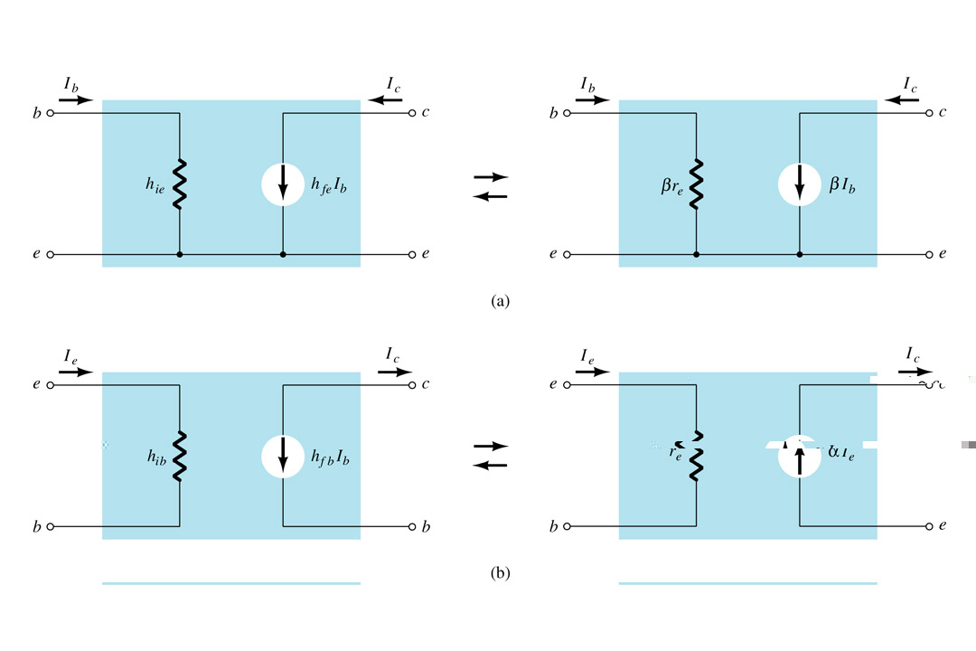

Input Impedance: (Zi):
Input impedance is the parallel combination of base resistors R_{B1} & R_{B2}.
As power supply is considered as short circuit at small signal levels the total resistance at the base is given as R_{BB} = (R_{B1}*R_{B2})/R_{B1}+R_{B2}.
As R_{BB} is parallel with h_{ie} , now input impedance R_{BB}||h_{ie}.

Output Impedance : (Zo):

hfe and ib forms an ideal current generator with infinite ouput impedance, then output impedance Zo is given as
Zo = Rc.

Volatage gain ( Av):
Dueto CE configuration output is 180⁰, now output voltage Vo is

Vo= - Io * Rc;-h_{fe} * Ib * Rc:

Ib= (vi/h_{ie} );

= -h_{fe} * (vi/h_{ie} ) * Rc;

Av = Vo/Vi=-(hfe/hie) * Rc.

Curent Gain (Ai):

It is the ratio of Io/Ii. At the input side, current splits into RBB and hie. By Observing into h parameter model , Ib can be calculatedby using current divider rule,

I_{b} =( R_{BB}/I_{i})/ (R_{BB}+h_{ie});

At the output side, Io = hfe.Ib;

Re- arranging I_{o}/I_{b} = h_{fe} ;

A_{i} =Io/Ii = (Io * I_{b})/ (Ib * Ii).

h_{fe =} R_{BB}/ (R_{BB}+ h_{ie}) :

Ai=Io/Ii = h_{fe}* R_{BB}/ (R_{BB}+ h_{ie}).

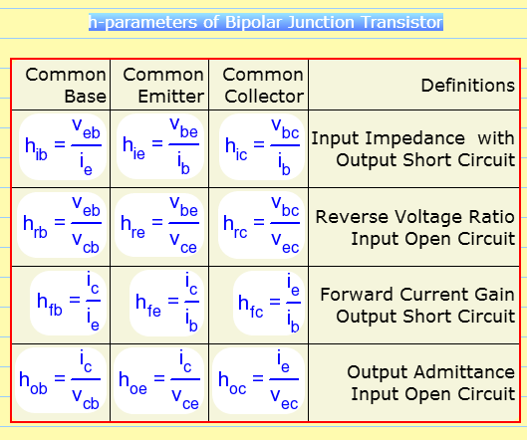

Comparison of CB ,CE and CC Amplifiers:

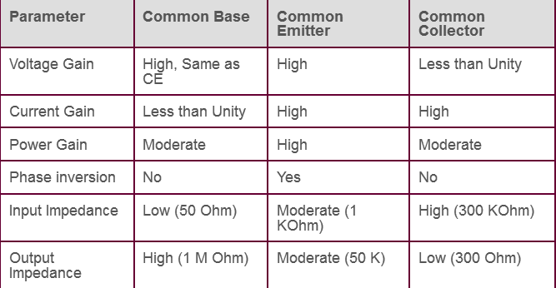

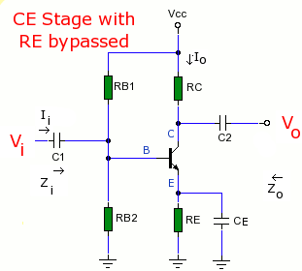
Common emitter amplifier with Emitter resistor Re:
Input resistance:
R_{i} = V_{i} / I_{b};
= [h_{ie} + (1+h_{fe}) * R_{E}]* I_{b} / I_{b};
= [h_{ie}+(1+h_{fe})]*R_{E} .
Input resistance varies much larger than R_{E} . i.e, R_{E} greatly increases the input resistance of the amplifier.

Current gain (Ai)
Ai = -(Ic/I_{b})= - h_{fe} *I_{b} / I_{b} =-h_{fe};
Voltage gain( Av):
Av = Ai * R_{L} / Ri ;
= - (h_{fe} *R_{L}) / h_{ie} + (1+h_{fe}) * R_{E};
This reduction in gain is compensated by stability improvement.
If(1+hfe)R_{E}>>h_{ie} and h_{fe}>> 1;
Now, Av = hfe*R_{E} / (1+h_{fe})* R_{E}=- R_{L}/R_{E}.
Av is completely stable and independent of all transistor parameters.
Output resistance Ro is equal to R_{L} or R_{C} ,which is independent of R_{E}.

Generalized Approximate model :
Hybrid model of CE configuration can be used for approximate analysis.
The signal is connected between input and ground and the load is connected between ground and output.
Current gain (Ai ) :
A_{i}=-h_{fe} /(1+h_{oe}) *R_{C}; if h_{oe} * R_{C} < 0.1 :
Ai = -h_{fe};
Input Impedance Z_{i} ;
Z_{i} = h_{ie} + h_{re}* A_{i} * Rc ;
Z_{i} = h_{ie} { 1- h_{re} * h_{fe} *|A_{i}| * h_{oe} * R_{c} / ( h_{ie} * h_{oe} * h_{fe} ) }
Using the typical values ofh – parameters (h_{re} * h_{fe}) / (h_{ie} * h_{oe}) = 0.5;
And | Ai | = h_{fe};
Now,Zi= h_{ie} {1- ( 0.5 * h_{fe} * h_{oe}* R_{L}) / h_{fe}}; andZ_{i}= h_{ie} = V_{b} / I_{b};
Voltage gain (A_{v}) ;
Voltage gain Av = A_{I}* ( R_{L} / R_{i} ) ;
= -h_{fe} * (R_{L} ) / h_{ie} ;

Output Impedance: Itis the ratio of V_{c} to Ic with Vs =0 and excluding Rc ;
The actual value of output impedance depends on the source resistance Rs , and lies between
40k ohms to 80K ohms.
Effect of coupling and coupling and bypass capacitors on low frequency response.
The equations for current and voltage gain for a small signal amplifier are applicable in low frequency & mid band frequency regions. The main assumption is the reactance of coupling and bypass capacitance are neglible in these regions.
F α 1/Xc;
In the above circuit c1 & c2 are coupling capacitors. At low frequencies C1 and C2 are sufficiently large, so that its reactance is small and does not have any effect on the response. Further it is assumed that RB1 & RB2 are much larger than input resistance, Ri, So that they may be neglected in h parameter equivalent circuit.
At mid frequency Av is given as
Av = -hfe* Rc/(Ri+hie);
Effect of Ce : emitter by pass capacitor at low frequency.
Consider Ce is large enough to cause reduction in gain. At low frequencies, the voltage dropacross Ce, reduces the gain. The frequency at which the gain drops by a factor of 1/sqrt(2). Is the lower 3dB frequency f1 and is given as
F1= 1/(2*π *(Ri+Ri¹).Cc):
Ri¹ = (R1/R2)||Ri;
With bypass capacitor Ce ; Ri is given as h_{ie} + (1+hfe)R *Ce.
Miller’s theorem and its dual:
Millers theorem
The introduction of an impedance that connects amplifier input and output ports adds a great deal of complexity in the analysis process. One technique that often helps reduce the complexity in some circuits is the use of Miller's theorem.
Miller's theorem applies to the process of creating equivalent circuits. This general circuit theorem is particularly useful in the high-frequency analysis of certain transistor amplifiers at high frequencies.
Miller's Theorem generally states:
Given any general linear network having a common terminal and two terminals whose voltage ratio, with respect to the common terminal, is given by:
V₂ = AV₁
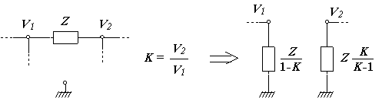
Miller's dual theorem
If there is a branch in a circuit with impedance Z connecting a node, where two currents I1 and I2 converge, to ground, we can replace this branch by two conducting the referred currents, with impedances respectively equal to (1+ a) Z and (1+ a) Z / a, where a = I2 / I1.
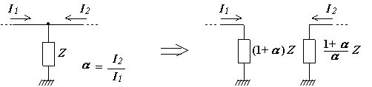

DESIGN OF RC COUPLED AMPLIFIER.
The common emitter RC coupled amplifier is one of the simplest and elementary transistor amplifier that can be made. Don’t expect much boom from this little circuit, the main purpose of this circuit is pre-amplification i.e to make weak signals strong enough for further processing or amplification. If designed properly, this amplifier can provide excellent signal characteristics. The circuit diagram of a single stage common emitter RC coupled amplifier using transistor is shown in Fig
Capacitor Cin is the input DC decoupling capacitor which blocks any DC component if present in the input signal from reaching the Q1 base. If any external DC voltage reaches the base of Q1, it will alter the biasing conditions and affects the performance of the amplifier.
R1 and R2 are the biasing resistors. This network provides the transistor Q1’s base with the necessary bias voltage to drive it into the active region. The region of operation where the transistor is completely switched of is called cut-off region and the region of operation where the transistor is completely switched ON (like a closed switch) is called saturation region. The region in between cut-off and saturation is called active region. Refer Fig 2 for better understanding. For a transistor amplifier to function properly, it should operate in the active region. Let us consider this simple situation where there is no biasing for the transistor. As we all know, a silicon transistor requires 0.7 volts for switch ON and surely this 0.7 V will be taken from the input audio signal by the transistor. So all parts of there input wave form with amplitude ≤ 0.7V will be absent in the output waveform. In the other hand if the transistor is given with a heavy bias at the base ,it will enter into saturation (fully ON) and behaves like a closed switch so that any further change in the base current due to the input audio signal will not cause any change in the output. The voltage across collector and emitter will be 0.2V at this condition (Vce sat = 0.2V). That is why proper biasing is required for the proper operation of a transistor amplifier.
The nominal value of collector current Ic and hfe can be obtained from the datasheet of the transistor.
Design of Re and Ce.
Let voltage across Re; VRe = 10%Vcc ………….(1)
Voltage across Rc; VRc = 40% Vcc. ……………..(2)
The remaining 50% will drop across the collector-emitter .
From (1) and (2) Rc =0.4 (Vcc/Ic) and Re = 01(Vcc/Ic).
Design of R1 and R2.
Base current Ib = Ic/hfe.
Let Ic ≈ Ie .
Let current through R1; IR1 = 10Ib.
Also voltage across R2 ; VR2 must be equal to Vbe + VRe. From this VR2 can be found.
There fore VR1 = Vcc-VR2. Since VR1 ,VR2 and IR1 are found we can find R1 and R2 using the following equations.
R1 = VR1/IR1 and R2 = VR2/IR1.
Finding Ce.
Impedance of emitter by-pass capacitor should be one by tenth of Re.
i.e, XCe = 1/10 (Re) .
Also XCe = 1/2∏FCe.
F can be selected to be 100Hz.
From this Ce can be found.
Finding Cin.
Impedance of the input capacitor(Cin) should be one by tenth of the transistors input impedance (Rin).
i.e, XCin = 1/10 (Rin)
Rin = R1 parallel R2 parallel (1 + (hfe re))
re = 25mV/Ie.
Xcin = 1/2∏FCin.
From this Cin can be found.
Finding Cout.
Impedance of the output capacitor (Cout) must be one by tenth of the circuit’s output resistance (Rout).
i.e, XCout = 1/10 (Rout).
Rout = Rc.
XCout = 1/ 2∏FCout.
From this Cout can be found.
Setting the gain.
Introducing a suitable load resistor RL across the transistor’s collector and ground will set the gain. This is not shown in Fig1.
Expression for the voltage gain (Av) of a common emitter transistor amplifier is as follows.
Av = -(rc/re)
re = 25mV/Ie
and rc = Rc parallel RL
From this RL can be found.

UNIT-IV
MULTISTAGE AMPLIFIERS
The amplification of a signal by a single amplifier may not be enough in most of the practical cases. Hence in these cases, two or more amplifiers are used in series to get sufficient amplified signal. The amplifiers are coupled in such a manner that the output of the first stage becomes the input for the next stage. Connecting the amplifiers in this manner is known as cascading the stages. When a number of amplifiers are connected in cascade, the overall voltage gain is equal to the product of voltage gain of individual stages.
In general the output terminals of one stage cannot be connected directly to the input of the next stage. A suitable coupling network is required to connect two stages. This coupling network should not permit the dc voltage at the output of one stage to pass into the input of the next stage. Otherwise the biasing condition of the second stage will be upset. Further the loss of voltage, when the signal passes from one stage to the next must be minimum. The three coupling devices generally used are
- Resistance - Capacitance (RC) coupling
- (ii) Transformer coupling
- (iii)Direct coupling
RC coupling scheme consist of a series capacitor C and a parallel resistor R. C acts as a short circuit for ac signals while it behaves like an open circuit for dc signals. In transformer coupling scheme, the transformer ensures that the ac signal is transformed from the amplifier to the load, while at the same time, insulating the load from the dc signals. When dc signals have to be amplified, direct coupling is the simplest and the best to use.
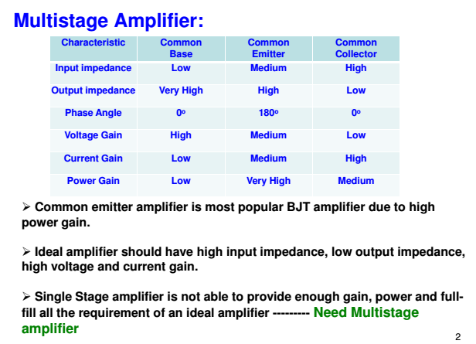
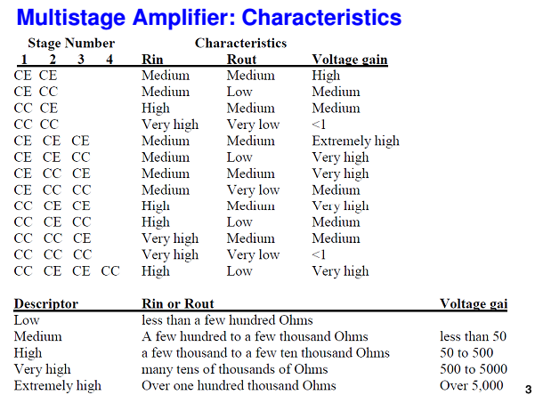
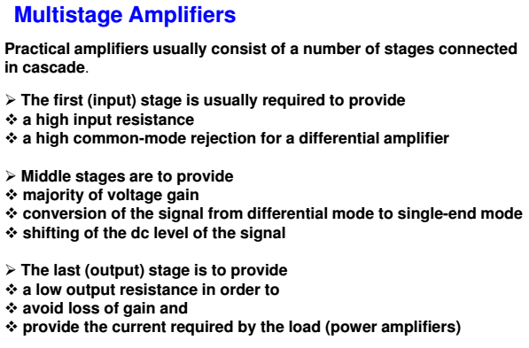
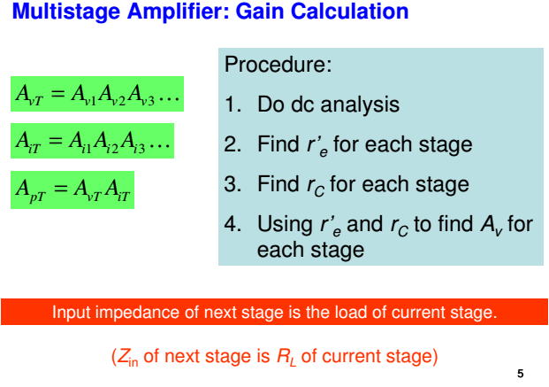
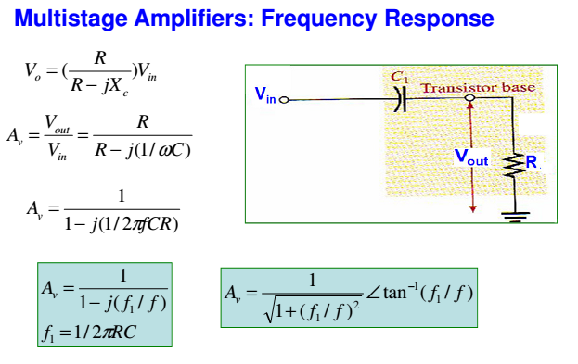
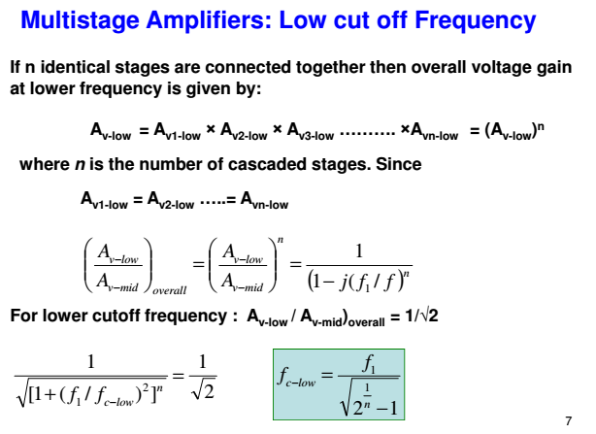
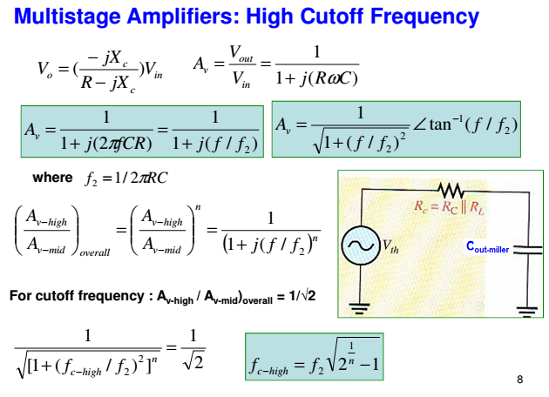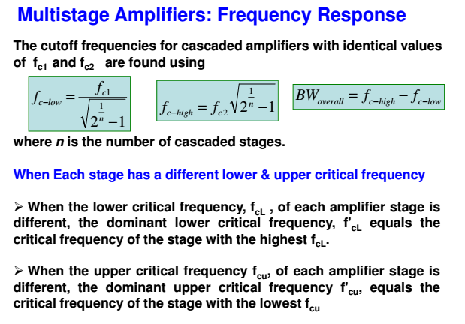
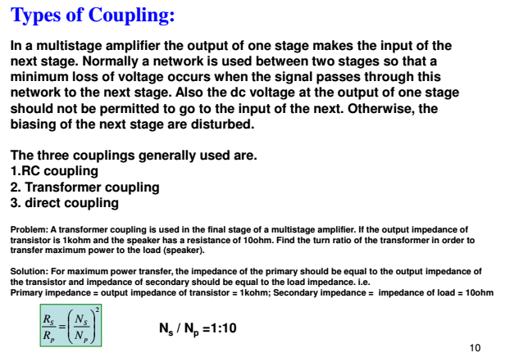
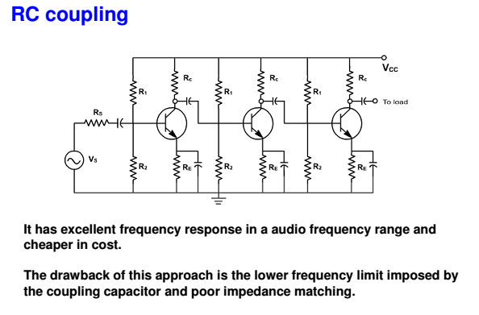
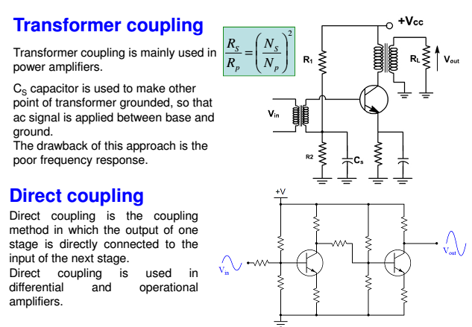
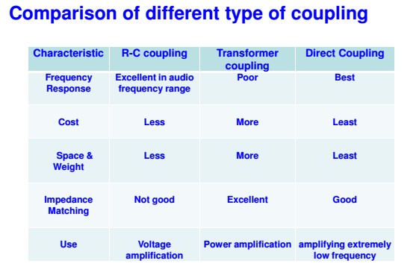

HIGH IMPEDANCE CIRCUITS:
DARLINGTON PAIR AMPLIFIER
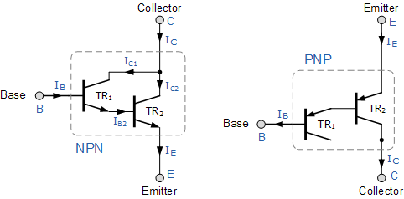
Using the NPN Darlington pair as the example, the collectors of two transistors are connected together, and the emitter of TR1 drives the base of TR2. This configuration achieves β multiplication because for a Base current i_{b}, the collector current is β*ib where the current gain is greater than one, or unity and this is defined as:
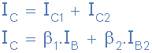
But the base current, IB2 is equal to transistor TR1 emitter current, IE1 as the emitter of TR1 is connected to the base of TR2. Therefore:
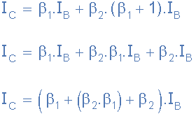
Where β₁ and β₂ are the gains of the individual transistors.
This means that the overall current gain, β is given by the gain of the first transistor multiplied by the gain of the second transistor as the current gains of the two transistors multiply. In other words, a pair of bipolar transistors combined together to make a single Darlington transistor pair can be regarded as a single transistor with a very high value of β and consequently a high input resistance.

CASCODE AMPLIFIER
The cascode is a two-stage amplifier that consists of a common-emitter stage feeding into a common-base stage.
Compared to a single amplifier stage, this combination may have one or more of the following characteristics: higher input–output isolation, higher input impedance, high output impedance, higher bandwidth.
In modern circuits, the cascode is often constructed from two transistors (BJTs or FETs), with one operating as a common emitter or common source and the other as a common base or common gate. The cascode improves input–output isolation (reduces reverse transmission), as there is no direct coupling from the output to input. This eliminates the Miller effect and thus contributes to a much higher bandwidth.
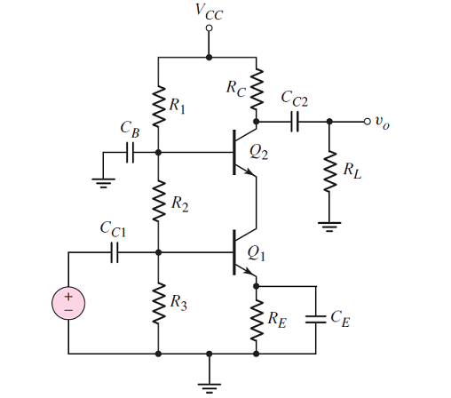

BOOTSTRAP EMITTER FOLLOWER
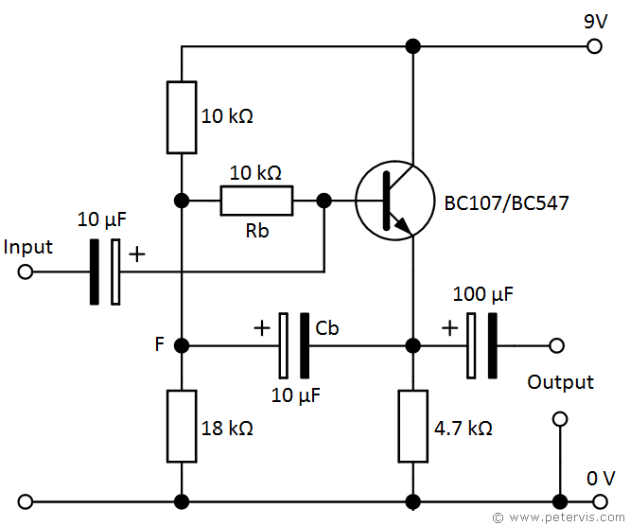

Bootstrapping is a technique used in the design of transistor amplifier circuits to increase the input impedance and thereby reduce the loading effects on the input source. It typically involves the use of a bootstrap capacitor, which provides positive feedback of ac signals to the base junction of a transistor in an emitter follower circuit. Application of this feedback increases the effective value of the base resistance. The amount of increase is a factor determined by the voltage gain of the circuit.
A bipolar junction transistor (BJT) has an inherently low input impedance of typically 1 Ω to 50 kΩ, and this reduces further after the addition of biasing transistors such as a potential divider network connected to the base junction of a transistor. Whilst it improves dc stability, these resistors have the effect of shunting the input thereby reducing the input resistance. These types of circuits usually pose a problem where high input impedance is required, and therefore bootstrapping is a technique that helps increase the input impedance.
A high impedance input is very useful for example in radio circuits where the base junction of a transistor connects to a ferrite coil to amplify the radio signal. Usually the amplifier stage is required to minimise the loading on the coil for better amplification. It is also useful in instrumentation where you need to take accurate measurements using probes such as bio-probes.
A common emitter follower circuit such as the one shown above will achieve a one hundred-fold increase in the effective value of Rb, when the voltage gain is 0.99. For a further increase in impedance, usually a two stage direct-coupled circuit is utilised.

UNIT-V
HIGH FREQUENCY ANALYSIS
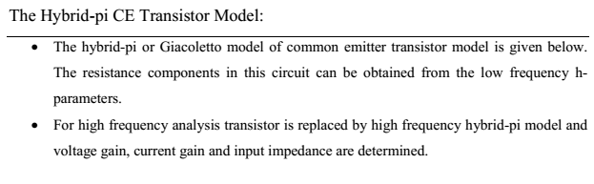
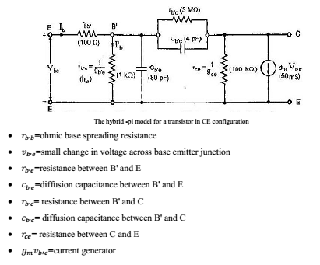
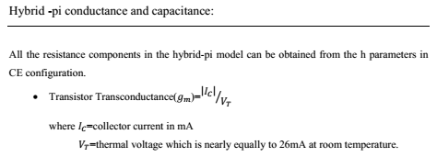
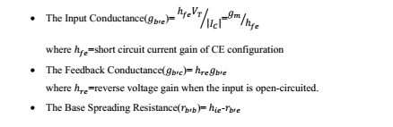
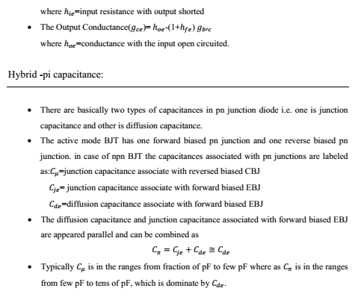

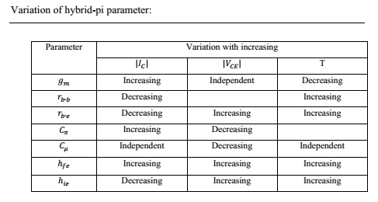
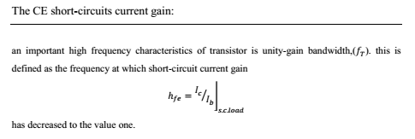
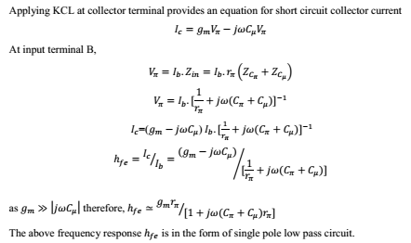
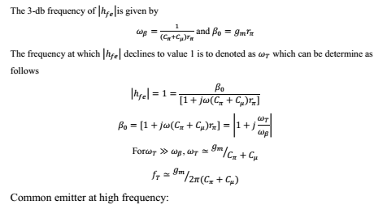

UNIT – VI
FEEDBACK AMPLIFIERS
Feedback Concept In Amplifiers:
Feedback is the process by which a fraction of the output signal, either a voltage or a current, is used as an input. If this feedback fraction is opposite in value or phase (“anti-phase”) to the input signal, then the feedback is said to be Negative Feedback, or degenerative feedback.
Negative feedback opposes or subtracts from the input signals giving it many advantages in the design and stabilisation of control systems. For example, if the systems output changes for any reason, then negative feedback affects the input in such a way as to counteract the change.
Feedback reduces the overall gain of a system with the degree of reduction being related to the systems open-loop gain. Negative feedback also has effects of reducing distortion, noise, sensitivity to external changes as well as improving system bandwidth and input and output impedances.
Feedback in an electronic system, whether negative feedback or positive feedback is unilateral in direction. Meaning that its signals flow one way only from the output to the input of the system. This then makes the loop gain, G of the system independent of the load and source impedances.
As feedback implies a closed-loop system it must therefore have a summing point. In a negative feedback system this summing point or junction at its input subtracts the feedback signal from the input signal to form an error signal, β which drives the system. If the system has a positive gain, the feedback signal must be subtracted from the input signal in order for the feedback to be negative as shown.
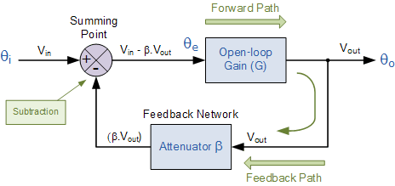
The circuit represents a system with positive gain, G and feedback, β. The summing junction at its input subtracts the feedback signal from the input signal to form the error signal Vin - βG, which drives the system.
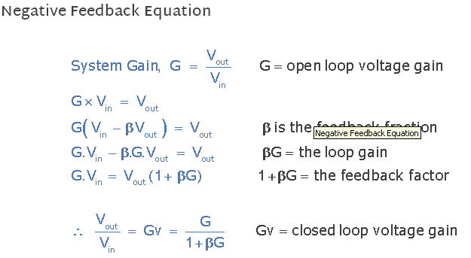

Effects of Negative Feedback
If the open-loop gain, G is very large, then βG will be much greater than 1, so that the overall gain of the system is roughly equal to 1/β. If the open-loop gain decreases due to frequency or the effects of system ageing, providing that βG is still relatively large, the overall system gain does not change very much. So negative feedback tends to reduce the effects of gain change giving what is generally called “gain stability”.
Some of the Advantages of negative feedback:
a)Input resistance increases
b)Output resistance decreases
c)Bandwidth increases
d) Non linear distortion decreases
e)Frequency distortion decreases
f) Sensitivity will be decreased
g)Gain stability
The main disadvantage of negative feedback is decrease in overall gain. The gain and feedback factor in an amplifier are often functions of frequency, so the feedback may lead to positive feedback.

The effect of negative feedback on voltage gain, BW, Noise, nonlinear distortion, Ri, Ro of a voltage amplifier
The voltage gain, bandwidth, noise, nonlinear distortion, input resistance, output resistance are
Voltage gain with feedback = Voltage gain without feedback* desensitivity factor (since desensitivity factor << 1 in negative feedback, hence Voltage gain without feedback < gain without feedback).
Band width with feedback = Band width without feedback/ desensitivity factor (since desensitivity factor << 1 in negative feedback, hence Band width without feedback > Band width without feedback).
Noise with feedback = Noise without feedback* desensitivity factor (since desensitivity factor << 1 in negative feedback, hence Noise without feedback > Noise without feedback).
Non linear distortion with feedback = Non linear distortion without feedback* desensitivity factor (since desensitivity factor << 1 in negative feedback, hence Non linear distortion without feedback > Non linear distortion without feedback).
Non linear distortion with feedback = Non linear distortion without feedback* desensitivity factor (since desensitivity factor << 1 in negative feedback, hence Non linear distortion without feedback > Non linear distortion without feedback).
Input resistance with feedback = Input resistance without feedback/ desensitivity factor (since desensitivity factor << 1 in negative feedback, hence Input resistance without feedback > Input resistance without feedback).
Output resistance with feedback = Output resistance without feedback* desensitivity factor (since desensitivity factor << 1 in negative feedback, hence Output resistance without feedback > Output resistance without feedback),

The different types of feedback topologies:
There are four different types of feedback topologies based on type of output signal and feedback signal (voltage or current signal). Voltage feedback is taken in series with the load and current feedback is taken in shunt with the load. They are
a)Voltage-series: Output signal is voltage signal, feedback signal is voltage signal. Also called as series-series feedback. It is employed in voltage amplifiers.
b)Current series: Output signal is current signal, feedback signal is voltage signal. Also called as shunt-series feedback. It is employed in Transconductance amplifiers.
c)Current shunt: Output signal is current signal, feedback signal is current signal. Also called as shunt-shunt feedback. It is employed in current amplifiers.

d)Voltage shunt: Output signal is voltage signal, feedback signal is current signal. Also called as shunt-shunt feedback. It is employed in current amplifiers.
The first word indicates the type of output signal and the second word indicates the manner in which feedback signal is taken whether it is taken in series or shunt with the load.
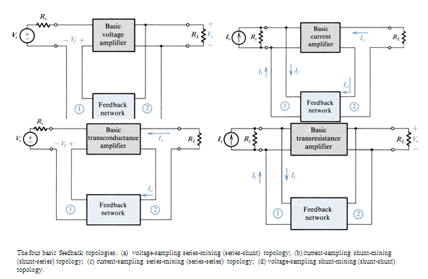

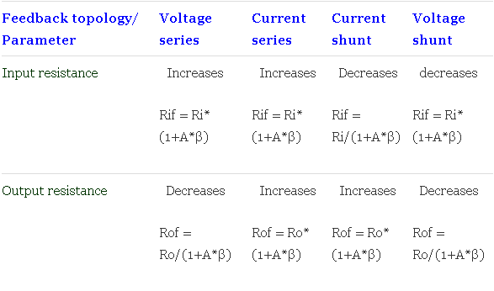

OSCILLATORS
An oscillator generates output without any ac input signal. An electronic oscillator is a circuit which converts dc energy into ac at a very high frequency. An amplifier with a positive feedback can be understood as an oscillator.

Amplifier vs. Oscillator
An amplifier increases the signal strength of the input signal applied, whereas an oscillator generates a signal without that input signal, but it requires dc for its operation. This is the main difference between an amplifier and an oscillator.

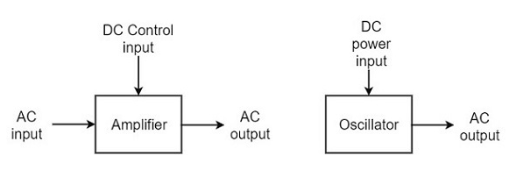

Classification of Oscillators
Electronic oscillators are classified mainly into the following two categories −
- Sinusoidal Oscillators − The oscillators that produce an output having a sine waveform are called sinusoidal or harmonic oscillators. Such oscillators can provide output at frequencies ranging from 20 Hz to 1 GHz.
- Non-sinusoidal Oscillators − The oscillators that produce an output having a square, rectangular or saw-tooth waveform are called non-sinusoidal or relaxation oscillators. Such oscillators can provide output at frequencies ranging from 0 Hz to 20 MHz.
We will discuss only about Sinusoidal Oscillators in this tutorial. You can learn the functions of non-sinusoidal oscillators from our Pulse Circuits tutorial.

Sinusoidal Oscillators
Sinusoidal oscillators can be classified in the following categories −
- Tuned Circuit Oscillators − These oscillators use a tuned-circuit consisting of inductors (L) and capacitors (C) and are used to generate high-frequency signals. Thus they are also known as radio frequency R.F. oscillators. Such oscillators are Hartley, Colpitts, Clapp-oscillators etc.
- RC Oscillators − There oscillators use resistors and capacitors and are used to generate low or audio-frequency signals. Thus they are also known as audio-frequency (A.F.) oscillators. Such oscillators are Phase –shift and Wein-bridge oscillators.
- Crystal Oscillators − These oscillators use quartz crystals and are used to generate highly stabilized output signal with frequencies up to 10 MHz. The Piezo oscillator is an example of a crystal oscillator.
- Negative-resistance Oscillator − These oscillators use negative-resistance characteristic of the devices such as tunnel devices. A tuned diode oscillator is an example of a negative-resistance oscillator.

Nature of Sinusoidal Oscillations
The nature of oscillations in a sinusoidal wave are generally of two types. They are damped and undamped oscillations.

Damped Oscillations
The electrical oscillations whose amplitude goes on decreasing with time are called as Damped Oscillations. The frequency of the damped oscillations may remain constant depending upon the circuit parameters.
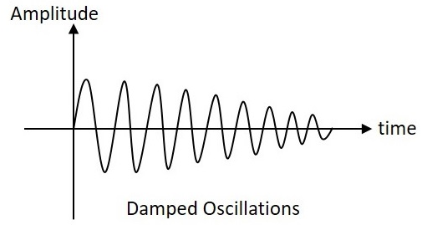
Damped oscillations are generally produced by the oscillatory circuits that produce power losses and doesn’t compensate if required.

Undamped Oscillations
The electrical oscillations whose amplitude remains constant with time are called as Undamped Oscillations. The frequency of the Undamped oscillations remains constant.
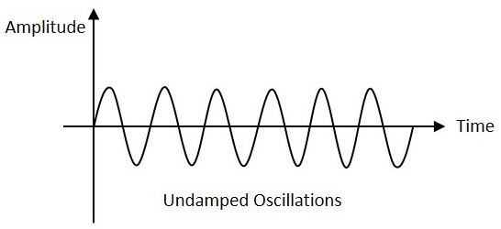
Undamped oscillations are generally produced by the oscillatory circuits that produce no power losses and follow compensation techniques if any power losses occur.

An amplifier with positive feedback produces its output to be in phase with the input and increases the strength of the signal. Positive feedback is also called asdegenerative feedback or direct feedback. This kind of feedback makes a feedback amplifier, an oscillator.
The use of positive feedback results in a feedback amplifier having closed-loop gain greater than the open-loop gain. It results in instability and operates as an oscillatory circuit. An oscillatory circuit provides a constantly varying amplified output signal of any desired frequency.

The Oscillatory Circuit
An oscillatory circuit produces electrical oscillations of a desired frequency. They are also known as tank circuits.
A simple tank circuit comprises of an inductor L and a capacitor C both of which together determine the oscillatory frequency of the circuit.
To understand the concept of oscillatory circuit, let us consider the following circuit. The capacitor in this circuit is already charged using a dc source. In this situation, the upper plate of the capacitor has excess of electrons whereas the lower plate has deficit of electrons. The capacitor holds some electrostatic energy and there is a voltage across the capacitor.
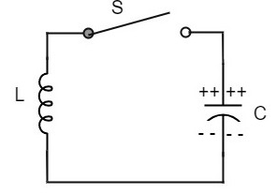
when the switch S is closed, the capacitor discharges and the current flows through the inductor. Due to the inductive effect, the current builds up slowly towards a maximum value. Once the capacitor discharges completely, the magnetic field around the coil is maximum.
This continuation of charging and discharging results in alternating motion of electrons or an oscillatory current. The interchange of energy between L and C produce continuous oscillations.
In an ideal circuit, where there are no losses, the oscillations would continue indefinitely. In a practical tank circuit, there occur losses such as resistive andradiation losses in the coil and dielectric losses in the capacitor. These losses result in damped oscillations.

Frequency of Oscillations
The frequency of the oscillations produced by the tank circuit are determined by the components of the tank circuit, the L and the C. The actual frequency of oscillations is the resonant frequency (or natural frequency) of the tank circuit which is given by
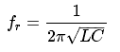

The parts of the practical oscillator circuit.
- Tank Circuit − The tank circuit consists of an inductance L connected in parallel with capacitor C. The values of these two components determine the frequency of the oscillator circuit and hence this is called as Frequency determining circuit.
- Transistor Amplifier − The output of the tank circuit is connected to the amplifier circuit so that the oscillations produced by the tank circuit are amplified here. Hence the output of these oscillations are increased by the amplifier.
- Feedback Circuit − The function of feedback circuit is to transfer a part of the output energy to LC circuit in proper phase. This feedback is positive in oscillators while negative in amplifiers.

Frequency Stability of an Oscillator
The frequency stability of an oscillator is a measure of its ability to maintain a constant frequency, over a long time interval. When operated over a longer period of time, the oscillator frequency may have a drift from the previously set value either by increasing or by decreasing.
The change in oscillator frequency may arise due to the following factors −
- Operating point of the active device such as BJT or FET used should lie in the linear region of the amplifier. Its deviation will affect the oscillator frequency.
- The temperature dependency of the performance of circuit components affect the oscillator frequency.
- The changes in d.c. supply voltage applied to the active device, shift the oscillator frequency. This can be avoided if a regulated power supply is used.
- A change in output load may cause a change in the Q-factor of the tank circuit, thereby causing a change in oscillator output frequency.
- The presence of inter element capacitances and stray capacitances affect the oscillator output frequency and thus frequency stability.

Principle of Feedback Amplifier & Barkhausan Criteria:
A feedback amplifier generally consists of two parts. They are the amplifier and the feedback circuit. The feedback circuit usually consists of resistors. The concept of feedback amplifier can be understood from the following figure below.

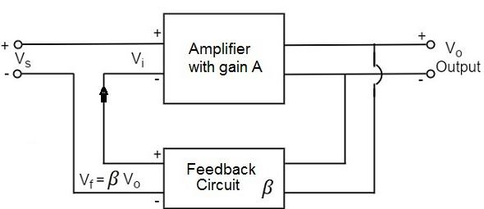

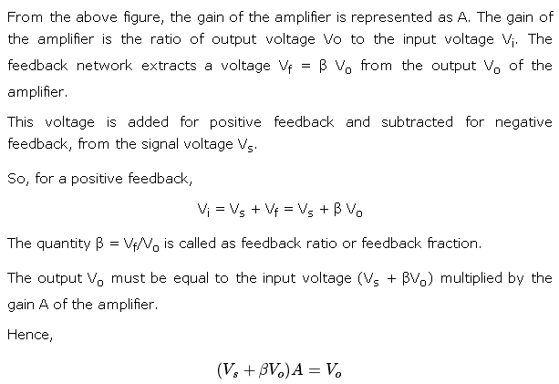
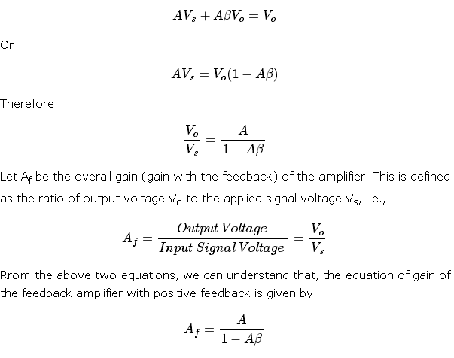
Where Aβ is the feedback factor or the loop gain.
If Aβ = 1, A_{f} = ∞. Thus the gain becomes infinity, i.e., there is output without any input. In another words, the amplifier works as an Oscillator.
The condition Aβ = 1 is called as Barkhausen Criterion of oscillations.
Tuned circuit oscillators are the circuits that produce oscillations with the help of tuning circuits. The tuning circuits consists of an inductance L and a capacitor C. These are also known as LC oscillators, resonant circuit oscillators or tank circuit oscillators.
The tuned circuit oscillators are used to produce an output with frequencies ranging from 1 MHz to 500 MHz Hence these are also known as R.F. Oscillators. A BJT or a FET is used as an amplifier with tuned circuit oscillators. With an amplifier and an LC tank circuit, we can feedback a signal with right amplitude and phase to maintain oscillations.

Types of Tuned Circuit Oscillators
Most of the oscillators used in radio transmitters and receivers are of LC oscillators type. Depending upon the way the feedback is used in the circuit, the LC oscillators are divided as the following types.
- Tuned-collector or Armstrong Oscillator − It uses inductive feedback from the collector of a transistor to the base. The LC circuit is in the collector circuit of the transistor.
- Tuned base Oscillator − It uses inductive feedback. But the LC circuit is in the base circuit.
- Hartley Oscillator − It uses inductive feedback.
- Colpitts Oscillator − It uses capacitive feedback.
- Clapp Oscillator − It uses capacitive feedback.

Tuned Collector Oscillator
Tuned collector oscillators are called so, because the tuned circuit is placed in the collector of the transistor amplifier. The combination of L and C form the tuned circuit or frequency determining circuit.
Construction
The resistors R₁, R₂ and R_{E} are used to provide d.c. bias to the transistor. The capacitors C_{E} and C are the by-pass capacitors. The secondary of the transformer provides a.c. feedback voltage that appears across the base-emitter junction of R₁ and R₂ is at a.c. ground due to by-pass capacitor C. In case, the capacitor was absent, a part of the voltage induced in the secondary of the transformer would drop across R₂ instead of completely going to the input of transistor.
As the CE configured transistor provides 180º phase shift, another 180º phase shift is provided by the transformer, which makes 360º phase shift between the input and output voltages. The following circuit diagram shows the arrangement of a tuned collector circuit.
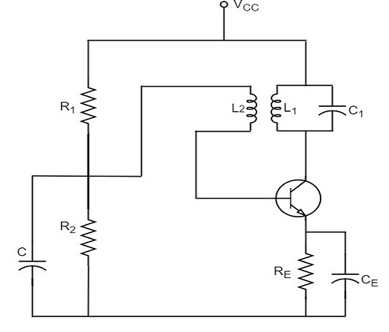

Operation
Once the supply is given, the collector current starts increasing and charging of capacitor C takes place. When the capacitor is fully charged, it discharges through the inductance L₁. Now oscillations are produced. These oscillations induce some voltage in the secondary winding L₂. The frequency of voltage induced in the secondary winding is same as that of the tank circuit and its magnitude depends upon the number of turns in secondary winding and coupling between both the windings.
The voltage across L₂ is applied between base and emitter and appears in the amplified form in the collector circuit, thus overcoming the losses in the tank circuit. The number of turns of L₂ and coupling between L₁ and L₂ are so adjusted that oscillations across L₂ are amplified to a level just sufficient to supply losses to the tank circuit.
Tuned collector oscillators are widely used as the local oscillator in radio receivers.
HartelyOscillator:
A very popular local oscillator circuit that is mostly used in radio receivers is the Hartley Oscillator circuit. The constructional details and operation of a Hartley oscillator are as discussed below.

Construction
In the circuit diagram of a Hartley oscillator shown below, the resistors R₁, R₂and R_{e} provide necessary bias condition for the circuit. The capacitor C_{e}provides a.c. ground thereby providing any signal degeneration. This also provides temperature stabilization.
The capacitors C_{c} and C_{b} are employed to block d.c. and to provide an a.c. path. The radio frequency choke (R.F.C) offers very high impedance to high frequency currents which means it shorts for d.c. and opens for a.c. Hence it provides d.c. load for collector and keeps a.c. currents out of d.c. supply source

Tank Circuit
The frequency determining network is a parallel resonant circuit which consists of the inductors L₁ and L₂ along with a variable capacitor C. The junction of L₁and L₂ are earthed. The coil L₁ has its one end connected to base via C_{c} and the other to emitter via C_{e}. So, L₂ is in the output circuit. Both the coils L₁ and L₂are inductively coupled and together form an Auto-transformer.The following circuit diagram shows the arrangement of a Hartley oscillator. The tank circuit is shunt fed in this circuit. It can also be a series-fed.
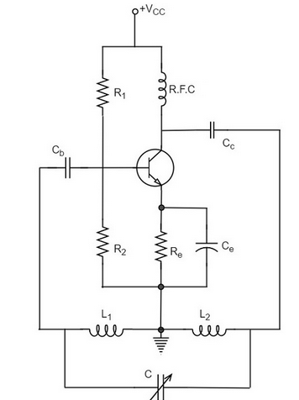

Operation
When the collector supply is given, a transient current is produced in the oscillatory or tank circuit. The oscillatory current in the tank circuit produces a.c. voltage across L₁.
The auto-transformer made by the inductive coupling of L₁ and L₂ helps in determining the frequency and establishes the feedback. As the CE configured transistor provides 180º phase shift, another 180º phase shift is provided by the transformer, which makes 360º phase shift between the input and output voltages.
This makes the feedback positive which is essential for the condition of oscillations. When the loop gain |βA| of the amplifier is greater than one, oscillations are sustained in the circuit.

Frequency
The equation for frequency of Hartley oscillator is given as

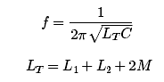
Here, L_{T} is the total cumulatively coupled inductance; L₁ and L₂ represent inductances of 1st and 2nd coils; and M represents mutual inductance. Mutual inductance is calculated when two windings are considered.

Advantages
- Instead of using a large transformer, a single coil can be used as an auto-transformer.
- Frequency can be varied by employing either a variable capacitor or a variable inductor.
- Less number of components are sufficient.
- The amplitude of the output remains constant over a fixed frequency range.

Disadvantages
- It cannot be a low frequency oscillator.
- Harmonic distortions are present.

Applications
- It is used to produce a sine-wave of desired frequency.
- Mostly used as a local oscillator in radio receivers.
- It is also used as R.F. Oscillator.
Colpitts oscillator:
A Colpitts oscillator looks just like the Hartley oscillator but the inductors and capacitors are replaced with each other in the tank circuit. The constructional details and operation of a colpitts oscillator are as discussed below.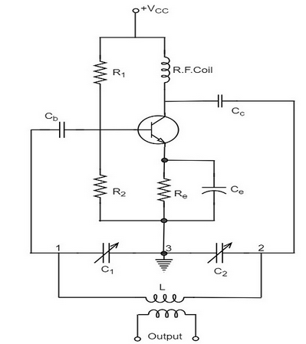
The resistors R₁, R₂ and R_{e} provide necessary bias condition for the circuit. The capacitor C_{e} provides a.c. ground thereby providing any signal degeneration. This also provides temperature stabilization.
The capacitors C_{c} and C_{b} are employed to block d.c. and to provide an a.c. path. The radio frequency choke (R.F.C) offers very high impedance to high frequency currents which means it shorts for d.c. and opens for a.c. Hence it provides d.c. load for collector and keeps a.c. currents out of d.c. supply source.

Tank Circuit
The frequency determining network is a parallel resonant circuit which consists of variable capacitors C₁ and C₂ along with an inductor L. The junction of C₁ and C₂ are earthed. The capacitor C₁ has its one end connected to base via C_{c} and the other to emitter via C_{e}. the voltage developed across C₁ provides the regenerative feedback required for the sustained oscillations.

Operation
When the collector supply is given, a transient current is produced in the oscillatory or tank circuit. The oscillatory current in the tank circuit produces a.c. voltage across C₁ which are applied to the base emitter junction and appear in the amplified form in the collector circuit and supply losses to the tank circuit.
If terminal 1 is at positive potential with respect to terminal 3 at any instant, then terminal 2 will be at negative potential with respect to 3 at that instant because terminal 3 is grounded. Therefore, points 1 and 2 are out of phase by 180º.
As the CE configuration provides 180º phase shift, it makes 360º phase shift between the input and output voltages. Hence, feedback is properly phased to produce continuous Undamped oscillations. When the loop gain |βA| of the amplifier is greater than one, oscillations are sustained in the circuit.
The equation for frequency of Colpitts oscillator is given as

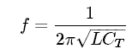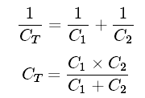

Advantages
- Colpitts oscillator can generate sinusoidal signals of very high frequencies.
- It can withstand high and low temperatures.
- The frequency stability is high.
- Frequency can be varied by using both the variable capacitors.
- Less number of components are sufficient.
- The amplitude of the output remains constant over a fixed frequency range.
The Colpitts oscillator is designed to eliminate the disadvantages of Hartley oscillator and is known to have no specific disadvantages. Hence there are many applications of a colpitts oscillator.

Applications
The applications of Colpitts oscillator are as follows −
- Colpitts oscillator can be used as High frequency sine-wave generator.
- This can be used as a temperature sensor with some associated circuitry.
- Mostly used as a local oscillator in radio receivers.
- It is also used as R.F. Oscillator.
- It is also used in Mobile applications.
- It has got many other commercial applications.
Phase Shift Oscillators:
One of the important features of an oscillator is that the feedback energy applied should be in correct phase to the tank circuit. The oscillator circuits discussed so far has employed inductor (L) and capacitor (C) combination, in the tank circuit or frequency determining circuit.
We have observed that the LC combination in oscillators provide 180º phase shift and transistor in CE configuration provide 180° phase shift to make a total of 360º phase shift so that it would make a zero difference in phase.

Drawbacks of LC circuits
- Frequency instability
- Waveform is poor
- Cannot be used for low frequencies
- Inductors are bulky and expensive
There is an another type of oscillator circuits, which are made by replacing the inductors with resistors. By doing so, the frequency stability is improved and a good quality waveform is obtained. These oscillators can also produce lower frequencies. As well, the circuit becomes neither bulky nor expensive.
All the drawbacks of LC oscillator circuits are thus eliminated in RC oscillator circuits. Hence the need for RC oscillator circuits arise. These are also called as Phase–shift Oscillators.

Principle of Phase-shift oscillators
The output voltage of an RC circuit for a sinewave input leads the input voltage. The phase angle by which it leads is determined by the value of RC components used in the circuit. The following circuit diagram shows a single section of an RC network.
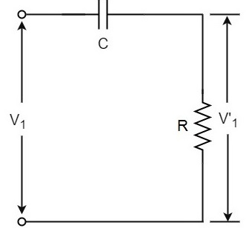
the output voltage V₁’ across the resistor R leads the input voltage applied input V₁ by some phase angle ɸº. If R were reduced to zero, V₁’ will lead the V₁ by 90º i.e., ɸº = 90º.
However, adjusting R to zero would be impracticable, because it would lead to no voltage across R. Therefore, in practice, R is varied to such a value that makes V₁’ to lead V₁ by 60º. The following circuit diagram shows the three sections of the RC network.

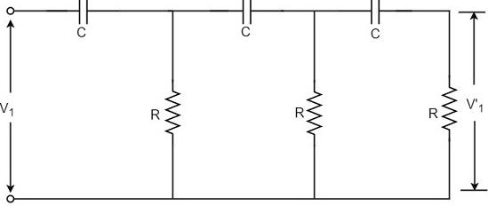
Each section produces a phase shift of 60º. Consequently, a total phase shift of 180º is produced, i.e., voltage V₂ leads the voltage V₁ by 180º.

Phase-shift Oscillator Circuit
The oscillator circuit that produces a sine wave using a phase-shift network is called as a Phase-shift oscillator circuit. The constructional details and operation of a phase-shift oscillator circuit are as given below.

Construction
The phase-shift oscillator circuit consists of a single transistor amplifier section and a RC phase-shift network. The phase shift network in this circuit, consists of three RC sections. At the resonant frequency f_{o}, the phase shift in each RC section is 60º so that the total phase shift produced by RC network is 180º.
The following circuit diagram shows the arrangement of an RC phase-shift oscillator.
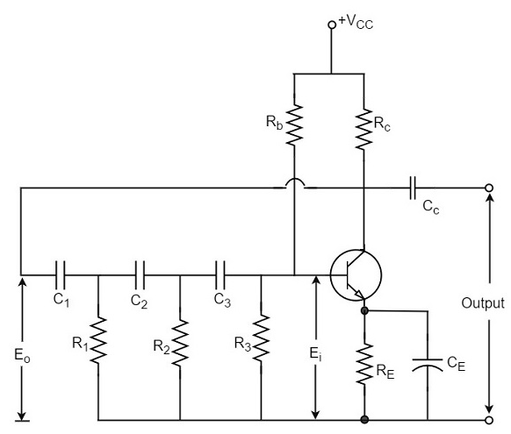

The frequency of oscillations is given by
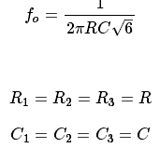

Operation
The circuit when switched ON oscillates at the resonant frequency f_{o}. The output E_{o} of the amplifier is fed back to RC feedback network. This network produces a phase shift of 180º and a voltage E_{i} appears at its output. This voltage is applied to the transistor amplifier.
The feedback applied will be
m=Ei/Eom=Ei/Eo
The feedback is in correct phase, whereas the transistor amplifier, which is in CE configuration, produces a 180º phase shift. The phase shift produced by network and the transistor add to form a phase shift around the entire loop which is 360º.

Advantages
The advantages of RC phase shift oscillator are as follows −
- It does not require transformers or inductors.
- It can be used to produce very low frequencies.
- The circuit provides good frequency stability.

Disadvantages
The disadvantages of RC phase shift oscillator are as follows −
- Starting the oscillations is difficult as the feedback is small.
- The output produced is small.
Wein-BridgeOscillator:
Another type of popular audio frequency oscillator is the Wien bridge oscillator circuit. This is mostly used because of its important features. This circuit is free from the circuit fluctuations and the ambient temperature.
The main advantage of this oscillator is that the frequency can be varied in the range of 10Hz to about 1MHz whereas in RC oscillators, the frequency is not varied.

Construction
The circuit construction of Wien bridge oscillator can be explained as below. It is a two-stage amplifier with RC bridge circuit. The bridge circuit has the arms R₁C₁, R₃, R₂C₂ and the tungsten lamp L_{p}. Resistance R₃ and the lamp L_{p} are used to stabilize the amplitude of the output.
The following circuit diagram shows the arrangement of a Wien bridge oscillator.
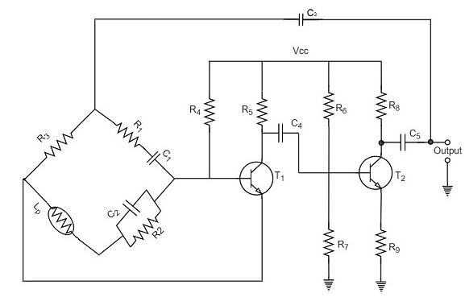

The transistor T₁ serves as an oscillator and an amplifier while the other transistor T₂ serves as an inverter. The inverter operation provides a phase shift of 180º. This circuit provides positive feedback through R₁C₁, C₂R₂ to the transistor T₁ and negative feedback through the voltage divider to the input of transistor T₂.
The frequency of oscillations is determined by the series element R₁C₁ and parallel element R₂C₂ of the bridge.
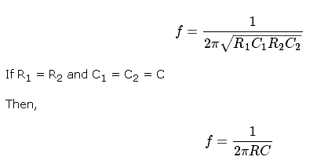

The oscillator consists of two stages of RC coupled amplifier and a feedback network. The voltage across the parallel combination of R and C is fed to the input of amplifier 1. The net phase shift through the two amplifiers is zero.
The usual idea of connecting the output of amplifier 2 to amplifier 1 to provide signal regeneration for oscillator is not applicable here as the amplifier 1 will amplify signals over a wide range of frequencies and hence direct coupling would result in poor frequency stability. By adding Wien bridge feedback network, the oscillator becomes sensitive to a particular frequency and hence frequency stability is achieved.

Operation
When the circuit is switched ON, the bridge circuit produces oscillations of the frequency stated above. The two transistors produce a total phase shift of 360ºso that proper positive feedback is ensured. The negative feedback in the circuit ensures constant output. This is achieved by temperature sensitive tungsten lamp L_{p}. Its resistance increases with current.
If the amplitude of the output increases, more current is produced and more negative feedback is achieved. Due to this, the output would return to the original value. Whereas, if the output tends to decrease, reverse action would take place.

Advantages:

The circuit provides good frequency stability.
- It provides constant output.
- The operation of circuit is quite easy.
- The overall gain is high because of two transistors.
- The frequency of oscillations can be changed easily.
- The amplitude stability of the output voltage can be maintained more accurately, by replacing R₂ with a thermistor.

Disadvantages
- The circuit cannot generate very high frequencies.
- Two transistors and number of components are required for the circuit construction.

Crystal Oscillators:
Whenever an oscillator is under continuous operation, its frequency stabilitygets affected. There occur changes in its frequency. The main factors that affect the frequency of an oscillator are
- Power supply variations
- Changes in temperature
- Changes in load or output resistance
In RC and LC oscillators the values of resistance, capacitance and inductance vary with temperature and hence the frequency gets affected. In order to avoid this problem, the piezo electric crystals are being used in oscillators.
The use of piezo electric crystals in parallel resonant circuits provide high frequency stability in oscillators. Such oscillators are called as Crystal Oscillators.
The principle of crystal oscillators depends upon the Piezo electric effect. The natural shape of a crystal is hexagonal. When a crystal wafer is cur perpendicular to X-axis, it is called as X-cut and when it is cut along Y-axis, it is called as Y-cut.
The crystal used in crystal oscillator exhibits a property called as Piezo electric property. So, let us have an idea on piezo electric effect.

Piezo Electric Effect
The crystal exhibits the property that when a mechanical stress is applied across one of the faces of the crystal, a potential difference is developed across the opposite faces of the crystal. Conversely, when a potential difference is applied across one of the faces, a mechanical stress is produced along the other faces. This is known as Piezo electric effect.
Certain crystalline materials like Rochelle salt, quartz and tourmaline exhibit piezo electric effect and such materials are called as Piezo electric crystals. Quartz is the most commonly used piezo electric crystal because it is inexpensive and readily available in nature.
When a piezo electric crystal is subjected to a proper alternating potential, it vibrates mechanically. The amplitude of mechanical vibrations becomes maximum when the frequency of alternating voltage is equal to the natural frequency of the crystal.

Working of a Quartz Crystal
In order to make a crystal work in an electronic circuit, the crystal is placed between two metal plates in the form of a capacitor. Quartz is the mostly used type of crystal because of its availability and strong nature while being inexpensive. The ac voltage is applied in parallel to the crystal.

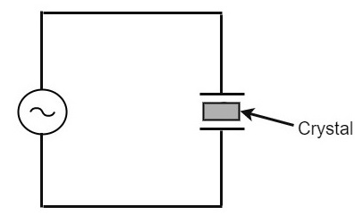
If an AC voltage is applied, the crystal starts vibrating at the frequency of the applied voltage. However, if the frequency of the applied voltage is made equal to the natural frequency of the crystal, resonance takes place and crystal vibrations reach a maximum value. This natural frequency is almost constant.

Equivalent circuit of a Crystal
To represent the crystal with an equivalent electric circuit, we have to consider two cases, i.e., when it vibrates and when it doesn’t. The figures below represent the symbol and electrical equivalent circuit of a crystal respectively.

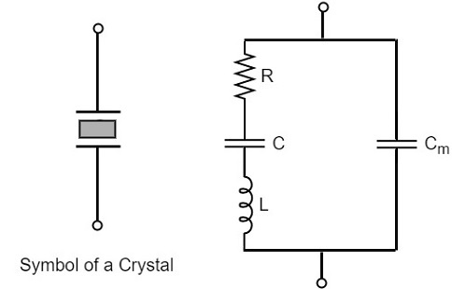
The above equivalent circuit consists of a series R-L-C circuit in parallel with a capacitance C_{m}. When the crystal mounted across the AC source is not vibrating, it is equivalent to the capacitance C_{m}. When the crystal vibrates, it acts like a tuned R-L-C circuit.

Frequency response
The frequency response of a crystal is as shown below. The graph shows the reactance (X_{L} or X_{C}) versus frequency (f). It is evident that the crystal has two closely spaced resonant frequencies
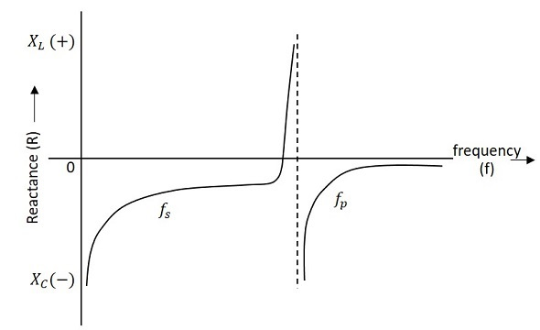

the first one is the series resonant frequency (f_{s}), which occurs when reactance of the inductance (L) is equal to the reactance of the capacitance C. In that case, the impedance of the equivalent circuit is equal to the resistance R and the frequency of oscillation is given by the relation,
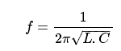
The second one is the parallel resonant frequency (f_{p}), which occurs when the reactance of R-L-C branch is equal to the reactance of capacitor C_{m}. At this frequency, the crystal offers a very high impedance to the external circuit and the frequency of oscillation is given by the relation.
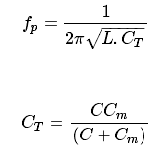
The value of C_{m} is usually very large as compared to C. Therefore, the value of C_{T} is approximately equal to C and hence the series resonant frequency is approximately equal to the parallel resonant frequency (i.e., f_{s} = f_{p}).

Crystal Oscillator Circuit
A crystal oscillator circuit can be constructed in a number of ways like a Crystal controlled tuned collector oscillator, a Colpitts crystal oscillator, a Clap crystal oscillator etc. But the transistor pierce crystal oscillator is the most commonly used one. This is the circuit which is normally referred as a crystal oscillator circuit.

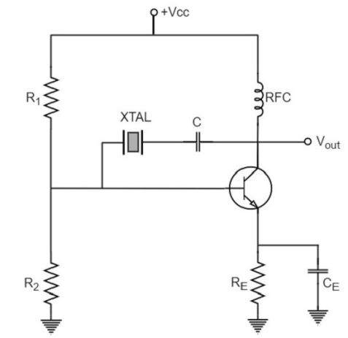
In this circuit, the crystal is connected as a series element in the feedback path from collector to the base. The resistors R₁, R₂ and R_{E} provide a voltage-divider stabilized d.c. bias circuit. The capacitor C_{E} provides a.c. bypass of the emitter resistor and RFC (radio frequency choke) coil provides for d.c. bias while decoupling any a.c. signal on the power lines from affecting the output signal. The coupling capacitor C has negligible impedance at the circuit operating frequency. But it blocks any d.c. between collector and base.
The circuit frequency of oscillation is set by the series resonant frequency of the crystal and its value is given by the relation,

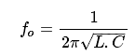
It may be noted that the changes in supply voltage, transistor device parameters etc. have no effect on the circuit operating frequency, which is held stabilized by the crystal.

Advantages
- They have a high order of frequency stability.
- The quality factor (Q) of the crystal is very high.

Disadvantages
- They are fragile and can be used in low power circuits.
- The frequency of oscillations cannot be changed appreciably.

Frequency Stability of an Oscillator
An Oscillator is expected to maintain its frequency for a longer duration without any variations, so as to have a smoother clear sinewave output for the circuit operation. Hence the term frequency stability really matters a lot, when it comes to oscillators, whether sinusoidal or non-sinusoidal.
The frequency stability of an oscillator is defined as the ability of the oscillator to maintain the required frequency constant over a long time interval as possible. Let us try to discuss the factors that affect this frequency stability.

Change in operating point
We have already come across the transistor parameters and learnt how important an operating point is. The stability of this operating point for the transistor being used in the circuit for amplification (BJT or FET), is of higher consideration.
The operating of the active device used is adjusted to be in the linear portion of its characteristics. This point is shifted due to temperature variations and hence the stability is affected.

Variation in temperature
The tank circuit in the oscillator circuit, contains various frequency determining components such as resistors, capacitors and inductors. All of their parameters are temperature dependent. Due to the change in temperature, their values get affected. This brings the change in frequency of the oscillator circuit.

Due to power supply
The variations in the supplied power will also affect the frequency. The power supply variations lead to the variations in V_{cc}. This will affect the frequency of the oscillations produced.
In order to avoid this, the regulated power supply system is implemented.

Change in output load
The variations in output resistance or output load also affects the frequency of the oscillator. When a load is connected, the effective resistance of the tank circuit is changed. As a result, the Q-factor of LC tuned circuit is changed. This results a change in output frequency of oscillator.

Changes in inter-element capacitances
Inter-element capacitances are the capacitances that develop in PN junction materials such as diodes and transistors. These are developed due to the charge present in them during their operation.
The inter element capacitors undergo change due to various reasons as temperature, voltage etc. This problem can be solved by connecting swamping capacitor across offending inter-element capacitor.

Value of Q
The value of Q (Quality factor) must be high in oscillators. The value of Q in tuned oscillators determine the selectivity. As this Q is directly proportional to the frequency stability of a tuned circuit, the value of Q should be maintained high.
Frequency stability can be mathematically represented as,
Sw=dθ/dwSw=dθ/dw
Where dθ is the phase shift introduced for a small frequency change in nominal frequency f_{r}. The circuit giving the larger value of (dθ/dw) has more stable oscillatory frequency.

