**Unit 4**

**Network Functions**

* **Network function**:

In the frequency domain, **network functions** are defined as the quotient obtained by dividing the phasor corresponding to the circuit output by the phasor corresponding to the circuit input.

In simple words, **network functions** are the ratio of output phasor to the input phasor when phasors exists in frequency domain. The general form of network functions are given below:

https://www.electrical4u.com/equations/tns-07-05-14-01.gif

Now with the help of the above general network function we are in position to describe the necessary conditions of the stability of all the network functions. There are three mains necessary conditions for the stability of these network functions and they are written below:

1. The degree of the numerator of F(s) should not exceed the degree of denominator by more than unity. In other words (m - n) should be less than or equal to one.
2. F(s) should not have multiple poles on the jω-axis or the y-axis of the pole-zero plot.
3. F(s) should not have poles on the right half of the s-plane.

* **Port:**

In electrical [circuit theory](https://en.wikipedia.org/wiki/Circuit_theory), a **port** is a pair of terminals connecting an [electrical network](https://en.wikipedia.org/wiki/Electrical_network) or circuit to an external circuit, a point of entry or exit for electrical energy. A port consists of two [nodes](https://en.wikipedia.org/wiki/Node_(circuits)) ([terminals](https://en.wikipedia.org/wiki/Terminal_(electronics))) connected to an outside circuit

* **Single port:**

A port is combination of two terminals on the same side of network. Thus a terminal pair is nothing but a port as shown in fig .A network having only one terminal pair or port is called one port network.One port network can be represented as below



Fig 4.1: schematic diagram of one port network

Any two-pole circuit is guaranteed to meet the port condition by virtue of [Kirchhoff's current law](https://en.wikipedia.org/wiki/Kirchhoff%27s_current_law) and they are therefore one-ports unconditionally. All of the basic [electrical elements](https://en.wikipedia.org/wiki/Electrical_element) ([inductance](https://en.wikipedia.org/wiki/Inductance), [resistance](https://en.wikipedia.org/wiki/Electrical_resistance), [capacitance](https://en.wikipedia.org/wiki/Capacitance), [voltage source](https://en.wikipedia.org/wiki/Voltage_source), [current source](https://en.wikipedia.org/wiki/Current_source)) are one-ports, as is a general [impedance](https://en.wikipedia.org/wiki/Electrical_impedance).

Study of one-ports is an important part of the foundation of [network synthesis](https://en.wikipedia.org/wiki/Network_synthesis), most especially in [filter design](https://en.wikipedia.org/wiki/Filter_design). Two-element one-ports (that is [RC](https://en.wikipedia.org/wiki/RC_circuit), [RL](https://en.wikipedia.org/wiki/RL_circuit) and [LC circuits](https://en.wikipedia.org/wiki/LC_circuit)) are easier to synthesise than the general case. For a two-element one-port [Foster's canonical form](https://en.wikipedia.org/wiki/Foster%27s_reactance_theorem) or [Cauer's canonical form](https://en.wikipedia.org/w/index.php?title=Cauer%27s_canonical_form&action=edit&redlink=1) can be used. In particular, [LC circuits](https://en.wikipedia.org/wiki/LC_circuit) are studied since these are lossless and are commonly used in [filter design](https://en.wikipedia.org/wiki/Filter_design).

* **Network Function For One Port Network**

Voltage and current for the one port linear network as shown in fig.4.1.As there is one port , voltage and current measured at same port. Thus for one port network only driving function can be defined as below.

* **Driving Point Impedance Function**

The ratio of Laplace transform of voltage and current measured at port under zero initial condition is called driving point impedance function .It is denoted by Z(s)

**Z(s)=V(s)/I(s)**

* **Driving Point Admittance Function**

It is the ratio of Laplace transform of current and voltage measured at port under zero initial condition is called driving point admittance function. It denoted by Y(s)

**Y(s)=I(s)/V(s)**

* **Two-port:**

A two-port network (a kind of four-terminal network or quadripole) is an [electrical network](https://en.wikipedia.org/wiki/Electrical_network) ([circuit](https://en.wikipedia.org/wiki/Electrical_circuit)) or device with two *pairs* of terminals to connect to external circuits. Two terminals constitute a [port](https://en.wikipedia.org/wiki/Port_(circuit_theory)) if the currents applied to them satisfy the essential requirement known as the port condition: the [electric current](https://en.wikipedia.org/wiki/Electric_current) entering one terminal must equal the current emerging from the other terminal on the same port.

A two-port network requires two terminal pairs (total 4 terminals). Amongst the two voltages and two currents shown,generally two can be independently specified (externally).

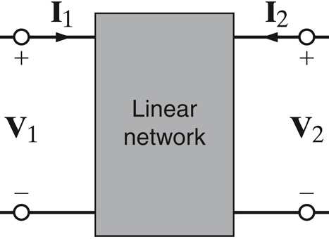

Fig 4.2: schematic diagram of two-port network

* **Network functions for Two-Port Network**

Consider a two port network with voltages and currents at ports 1-1’ and 2-2’ as V1(t), I1(t) and V2(t), I2(t) respectively as shown in figure .

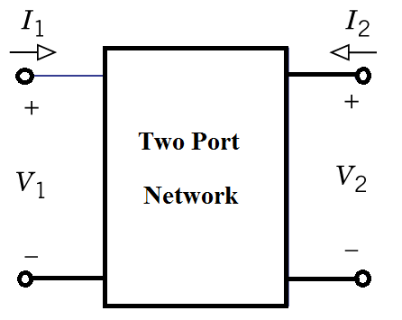

1. Driving point functions:
   * + Driving point impedance functions
     + Driving point admittance functions
2. Transfer Functions:
   * + Voltage transfer functions
     + Current transfer functions
     + Transfer impedance functions
     + Transfer admittance functions

* **Driving point functions:**
* Driving point impedance functions

The ratio of Laplace transform of voltage and current at port 1-1’ or 2-2’ is defined as driving point impedance function. Thus there are two driving point impedance functions.

* + - At port 1-1’ denoted as Z11(s) = V1(s) **/** I1(s)
    - At port 2-2’ denoted as Z22(s) = V2(s) **/** I2(s)
* Driving point admittance functions

The ratio of Laplace transform of current and voltage at port 1-1’ or 2-2’ is defined as driving point admittance function.Thus there are two driving point admittance functions.

* + - At port 1-1’ denoted as Y11(s) = I1(s) **/** V1(s)
    - At port 2-2’ denoted as Y22(s) = I2(s) / V2(s)
* **Transfer Functions:**
* **Voltage Transfer Function:**

It is defined as the ratio of Laplace transform of voltage at one port and voltage at another port.It is denoted as G(s).

G12(s) = V1(s) **/** V2(s) and G21(s) = V2(s) **/** V1(s)

* **Current Transfer Function:**

It is defined as the ratio of Laplace transform of current at one port and current at another port.It is denoted as A(s).

A12(s) = I1(s) **/** I2(s)and A21(s) = I2(s) **/** I1(s)

* **Transfer Impedance Function:**

It is defined as the ratio of Laplace transform of voltage at one port and current at another port.

Z12(s) = V1(s) **/** I2(s) and Z21(s) = V2(s) **/** I1(s)

* **Transfer Admittance Function:**

It is defined as the ratio of Laplace transform of current at one port and voltage at another port.

Y12(s) = I1(s) / V2(s) and Y21(s) = I2(s) / V1(s)

* **Immittance functions of two port networks:**

Immittance is a concept combining the [impedance](https://en.wikipedia.org/wiki/Electrical_impedance) and [admittance](https://en.wikipedia.org/wiki/Admittance) of a system or circuit. it is sometimes convenient to use *immittance* to refer to a [complex number](https://en.wikipedia.org/wiki/Complex_number) which may be either the impedance (ratio of [voltage](https://en.wikipedia.org/wiki/Volt) to [current](https://en.wikipedia.org/wiki/Electric_current) in electrical circuits) or the admittance (ratio of current to voltage) of a system.

* **Poles** and **Zeros** of Transfer Function

**Poles** and **Zeros** of a transfer function are the frequencies for which the value of the denominator and numerator of transfer function becomes zero respectively. The values of the poles and the zeros of a system determine whether the system is stable, and how well the system performs.

Zeros are defined as the roots of the polynomial of the numerator of a transfer function and poles are defined as the roots of the denominator of a transfer function. For the generalized transfer function.

Generally a function can be represented to its polynomial form. For example,



Now similarly transfer function of a control system can also be represented as



Where, K is known as gain factor of the transfer function.  
Now in the above function if s = z1, or s = z2, or s = z3,....s = zn,the value of transfer function becomes zero. These z1, z2, z3,....zn, are roots of the numerator polynomial. As for these roots the numerator polynomial, the transfer function becomes zero, these roots are called zeros of the transfer function.

Now, if s = p1, or s = p2, or s = p3,....s = pm, the value of transfer function becomes infinite. Thus the roots of denominator are called the poles of the function.  
Now let us rewrite the transfer function in its polynomial form.



Now, let us consider s approaches to infinity as the roots are all finite number, they can be ignored compared to the infinite s.

Therefore

Hence, when s → ∞ and n > m, the function will have also value of infinity, that means the transfer function has poles at infinite s, and the multiplicity or order of such pole is n - m.  
Again, when s → ∞ and n < m, the transfer function will have value of zero that means the transfer function has zeros at infinite s, and the multiplicity or order of such zeros is m - n.

* **Restrictions on pole and zero locations for driving point functions** (or) **necessary conditions for driving point functions**:

1. The coefficients in the polynomials in numerator and denominator must be real and positive.
2. The poles and zeros, if complex or imaginary, must occur in conjugate pairs.
3. The real part of all poles and zeros must be negative or zero, i.e., the poles and zeros must lie in left half of s plane.
4. If the real part of pole or zero is zero, then that pole or zero must be simple.
5. The polynomials of numerator and denominator may not have missing terms between those of highest and lowest degree, unless all even or all odd terms are missing.
6. The degree of numerator and denominator may differ by either zero or one only. This condition prevents multiple poles and zeros at s = ∞.
7. The terms of lowest degree in numerator and denominator may differ in degree by one at most. This condition prevents multiple poles and zeros at s = ∞.

* **Restrictions on pole and zero locations for transfer functions**(or) **necessary conditions for transfer functions:**

1. The coefficients in the polynomials in numerator and denominator must be real and positive.
2. The poles and zeros, if complex or imaginary, must occur in conjugate pairs.
3. The real part of all poles must be negative or zero, if the real part is zero, then that pole must be simple.
4. The polynomials of denominator may not have missing terms between that of highest and lowest degree, unless all odd terms are missing.
5. The polynomials of numerator may have missing terms of highest and lowest degree, and some of the coefficients may be negative.
6. The degree of numerator may be small as zero, independent of the degree of denominator.
7. For voltage and current transfer functions, the maximum degree of numerator is the degree of denominator.
8. The transfer impedance and admittance functions, the maximum degree of numerator is the degree of denominator plus one.

* **Complex frequency:**

A type of frequency that depends on two parameters one is the ” σ” which controls the magnitude of the signal and the other is “ω”, which controls the rotation of the signal ; is known as “complex frequency”.



Sigma σ is the real part in S and is called neper frequency and is expressed in Np/s. “ω”is the radian frequency and is expressed in rad/sec. “S” is called complex frequency and is expressed in complex neper/sec.

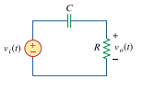1.





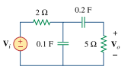2.

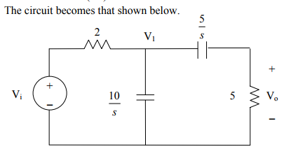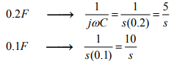

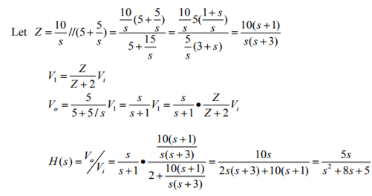



3.

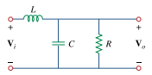

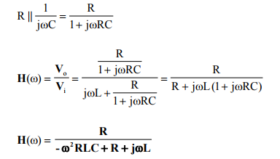



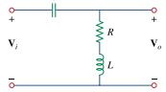4.

