**UNIT-III**

**BJT HIGH FREQUENCY ANALYSIS**

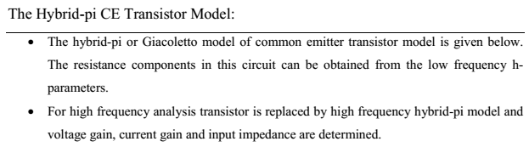

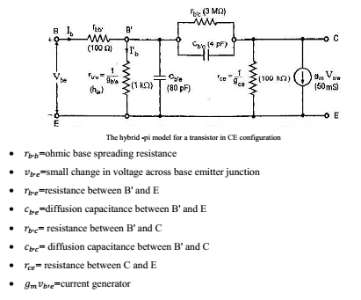

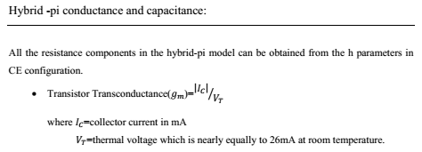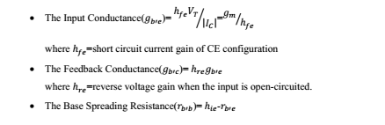

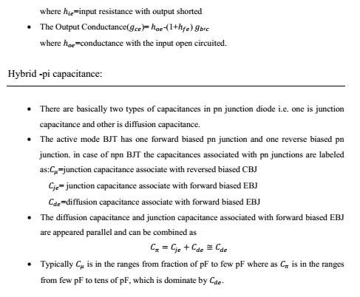

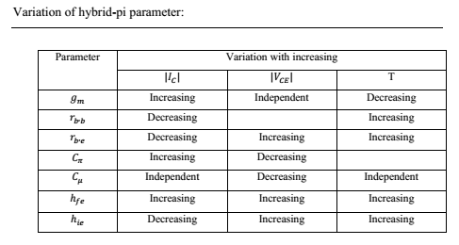

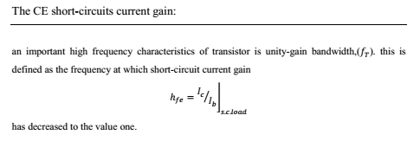

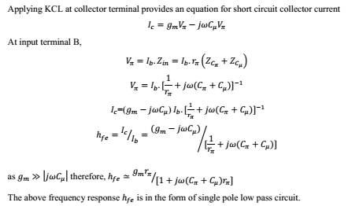

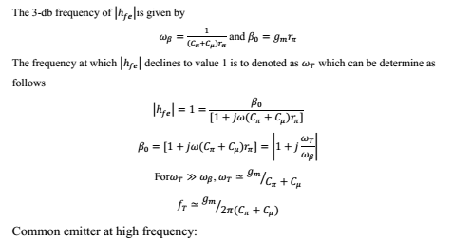

**MULTISTAGE AMPLIFIERS**

The amplification of a signal by a single amplifier may not be enough in most of the practical cases. Hence in these cases, two or more amplifiers are used in series to get sufficient amplified signal. The amplifiers are coupled in such a manner that the output of the first stage becomes the input for the next stage. Connecting the amplifiers in this manner is known as cascading the stages. When a number of amplifiers are connected in cascade, the overall voltage gain is equal to the product of voltage gain of individual stages.

In general the output terminals of one stage cannot be connected directly to the input of the next stage. A suitable coupling network is required to connect two stages. This coupling network should not permit the dc voltage at the output of one stage to pass into the input of the next stage. Otherwise the biasing condition of the second stage will be upset. Further the loss of voltage, when the signal passes from one stage to the next must be minimum. The three coupling devices generally used are

1. Resistance - Capacitance (RC) coupling
2. (ii) Transformer coupling
3. (iii)Direct coupling

RC coupling scheme consist of a series capacitor C and a parallel resistor R. C acts as a short circuit for ac signals while it behaves like an open circuit for dc signals. In transformer coupling scheme, the transformer ensures that the ac signal is transformed from the amplifier to the load, while at the same time, insulating the load from the dc signals. When dc signals have to be amplified, direct coupling is the simplest and the best to use.

