UNIT-III
NON-CONVENTIONAL SOURCES OF ENERGY AND PLANTS:

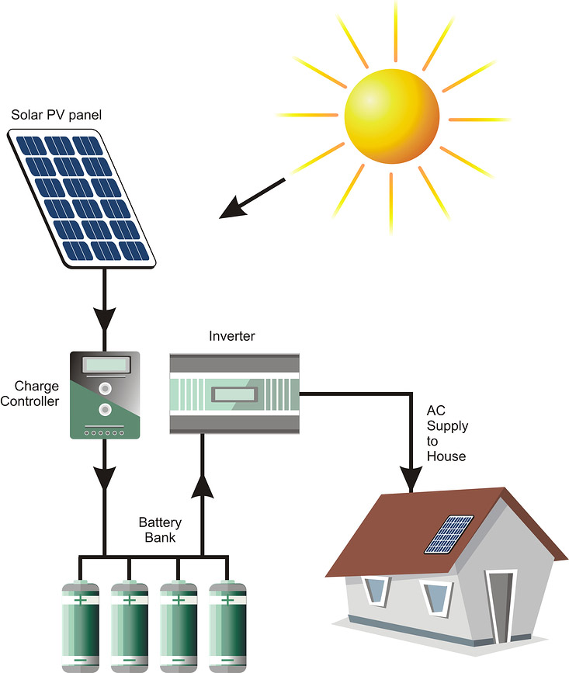

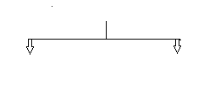
Power generation

Conventional energy sources Non- Conventional energy sources
(Non-renewable energy sources) (Renewable energy sources)
Coal, oil, nuclear, Hydel Solar, wind, Tidal, Geothermal, Biomass

SOLAR ENERGY:
The Energy from the Sun that reaches the Earth is called “Solar Energy”.
Advantages:
1. Solar energy is very large inexhaustible energyand is freely available.
2. It is clean and free from environmental pollution.
3. It can be utilized without highly specialized skills.
Dis advantages:
1. It is not available during cloudy (or) rainy days.
2. The availability of solar energy depends on the weather conditions.
3. Large areais required to collect the energy at the useful rate.
4. It requires large capital investmentfor conversions of solar energies.

IMPORTANCE OF RENEWABLE ENERGY SOURCES:
The availability of fossil fuelsare limited and they are reducing with their use. In order to preserve the fossil fuels for future generation to meet the increasing future demand we must less dependent on fossil fuels and more dependent on renewable energy sources.
Further, the main reason to generate the power with the use of renewable energy sources is to minimize the global warmingas because with the use of fossil fuels we are releasing more carbon dioxideinto the atmosphere.
Hence, from the above, the main importance of renewable energy sources is to reduce the pollution problems as well as improving the living style of human beings.

 | Renewable energy Sources | Non-Renewable energy Sources
1. | Sources which can be renewed or reproduced known as Renewable energy Sources. | Sources which gets exhausted when put to use.
2. | E.g. Solar & Wind energy, Water, Biomass, MHT, Geo thermal, Ocean tides and waves | e.g. Fossil fuels like, coal, petroleum, natural gas, Nuclear.
3. | Renewable Sources are inexhaustible. | Non-Renewable Sources are exhaustible.
4. | Renewable sources are not affected by the human activities. | Non-Renewable sources are affected by the human activities.
5. | These do not cause any pollutionto the environment. | These cause pollutionto the environment.
6. | These are the free gifts of nature. | These are not the free gifts of nature.
7. | Small capacitypower generation over a shorter interval of time. | Bulk capacitypower generation over a longer period .
8. | Most of the plants are located nearer to consumer premises i.e. there is no constraint in setting of these plants. | Most of the plants are located at remote places i.e. these plants are based on Geographical Constraints.
9. | Continuity of supply is not possible. | Continuity of supply is possible.
10. | It is suitable to meet peak load demands | It is suitable to meet Base load demands.
RENEWABLE AND NON-RENEWABLE ENERGY SOURCES

ROLE AND POTENTIAL OF SOLAR ENERGY
Sun is around triple three thousand (3,33,000) times bigger than earth. The surface and core temperature of the sun as calculated are 5,600°C and 15,000,000°C respectively.
Nuclear reactions are continuously going on in the sun. It is a huge mass of constant nuclearactivity. The only sun is the source of all kind of energy available on this planet even it provides the energy needed to survive all life forms on this planet. Sun controls the climates and weatherson this planet.
Solar energy is the light and radiant heat from the Sun that control Earth's climate and weather and protect life. It is a renewable source of energy and originates with the thermonuclear process that transfers about 650,000,000 tons of hydrogen to helium per second. This action produces lots of heat and electromagnetic radiation.
The produced heat remains in the sun and is helpful in upholding the thermonuclear reaction and electromagnetic radiation together with visible, infrared and ultra-violet radiation flow out into space in all directions. Solar energy is in reality nuclear energy.
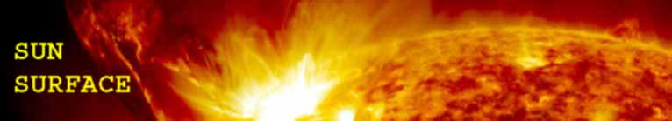

Now a day’s solar energy system play an important role in the field of producing electricity or other domestic uses like water heating, cooking etc. As we know that major part of generated electricity or electricity depends upon coal which is used in thermal power plant (in In India 69% of total power is generated by the thermal power plant).
But the main problem is here that the fuel used in thermal power plant is coal which is in limited amount and may be not available in future to produce or generate electricity. That is the main reason to solar energy systemcomes to the picture.
Solar energy system is the pollution free source of energy and always available because, sun is the single source of solar energy (also known as renewable energy or non-conventional energy).

The sun energy reach to earth is sufficient to produce or generate electricity which is polluted free. Due to this consideration somewhat we reduce the use of Thermal Power Plant, Gas Power Plant etc and reserve the non-renewable energy sources like coal, petroleum etc for future.
In recent years solar energy system is rise as a primary source of energy that converted into electricity and almost all country in the world utilize maximum solar energy to produce electricity and this is very less costly.
The main benefit of solar energy system is that the sun light is present everywhere free of cost. To produce electricity or convert solar energy to other form of energy first we invest heavy amount for solar panel that convert solar energy to electricity but the main advantage is after that installation no any type of maintenance is required for 40 to 50 years.

SOLAR RADIATION
Human life (and all other forms of life) on this planet is completely dependent on the daily flow of solar energy. The food production and all the life-support systems of the natural environment are dependent on the sun.
The sun’s great energy release is the result of an elaborate chemical process in the sun’s core-a process of thermonuclear fusion like the reaction in a hydrogen bomb. At the tremendous heat of more than 45x10⁶ F in the interior of sun, the hydrogen atoms fuse with helium atoms to produce the energy that powers our planet. Solar energy travels in small particles called photons.
The amount of solar energy is expressed in solar constant. The solar constant is the total energy that falls on a unit area exposed normally to the rays of the sun at the average sun-earth distance. The most accepted value of solar constant is 1.353KW per m².
A number of scattering and absorption processes in the atmosphere reduce the maximum heat flux reaching the earth’s surface to around 1kW per m². The heat flux reaches the earth’s surface by two modes: direct and diffuse.
It is only the direct heat energy which can be collected through a collector.The ratio of direct to total heat energy varies from place to place and depends on atmospheric conditions like dust, smoke, water vapour and other suspended matter. Different investigators have suggested values between 0.64 to 0.88for this ratio.
Since the altitude of sun and length of day vary with the season, the solar energy received on a summer day is many times the energy received on a winter day. As a result the total energy for most of the areas in plaints in India is around 6000 MJ per m² per year.

SOLAR POWER PLANT
PHOTO VOLTAIC SYSTEM
Conversion of light energy in to electrical energy is based on a phenomenon called photovoltaic effect.
Solar energy would be directly converted into electrical energy using direct conversion devices known as photovoltaic cells.
Photovoltaic cells are made of semiconducting elements as they could produce electricity when light strikes their surface (process of absorption). Energy in the form of photon is absorbed and energy in the form of free electrons is generated.
Since these cells create low voltage and current, they are combined as modules and panels and by arraying them specific power requirements, can be met. These Photovoltaic cells operate at room temperatures.
The efficiency of Photovoltaic cells theoretically is 25%if temperature is raised by few degree centigrade, the efficiency falls hyperbolically.
When photon strikes the cell it will free an electron by transforming certain energy to that electron known as gap energy.
Material used for Photovoltaic cells are Silicon, Cadmium Sulphide (Cd₂S) and Gallium Arsenide etc.

WORKING PRINCIPLE OF PHOTO VOLTAIC CELL (SOLAR CELL)

The solar cell has two layers called N-type and P-type. N-type material is obtained doping silicon crystal with N-type impurity and P-type metal is obtained by doping silicon crystal with P-type impurity.
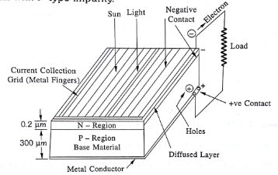

The N-type layer is thin and transparent. The P-type layer is thick. When sun light strikes the N-type thin layer, the light waves penetrates up to P-type layer.
The energy from photons in the light waves is important to the molecules and atoms in the N-P junction resulting in liberation of electron-hole pairs. Electrons are released from N-type material and holes are created in P-type material. Electrons are negative charges and holes are positive charges.
When external electric circuit is completed by connecting electrodes to the load, the electrons flow in the closed external circuit from N-type terminal (-) to P-type terminal (+). The direction of current is from +veterminal (P-type) to -veterminal (N-type) in the external circuit.

SOLAR PANELS
The normal output voltage of a solar cell is approximately 0.5 Vhence if 6 such cells are connected in series then the output voltage of the cell would be 0.5 × 6 = 3 Volt.
Solar panelsare connected together to create a solar array. Multiple panels are connected together both in parallel and seriesto achieve higher current andhigher voltage respectively.

Materials Used in Solar Cell
The materials which are used for this purpose must have band gap close to 1.5ev. Commonly used materials are-
- Silicon 2.GaAs 3.CdTe

USES
- It may be used to charge batteries.
- Used in light meters.
- It is used to power calculators and wrist watches.
- It can be used in spacecraft to provide electrical energy.
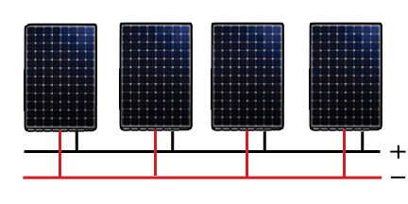
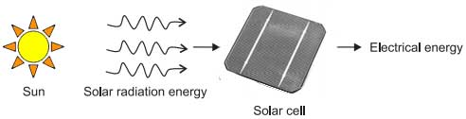

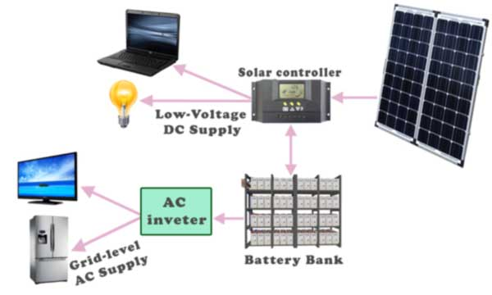
SOLAR COLLECTORS
A solar collector is a device which collects the solar radiations and transfers this solar energy to the fluid passing in contact with it. These are made of Copper, Aluminium (or) steel and coated with black coke powder to have high absorption and low emission.

These are classified into two types, namely:
1.Flat plate collectors .
2.Focusing (or) Concentrating collectors.

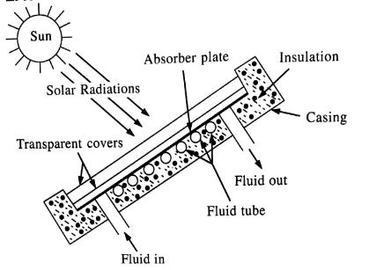
FLAT PLATE COLLECTORS

Flat plate collectors mainly consists of following parts, namely
1. Transparent cover plates 2. Absorber plate
3. Fluid tube 4. Insulation
5. Casing

The main function of Transparent cover plates is to allow the sun radiation which falls on it.
The absorber plates (collectors) which absorbs the maximum solar beam and diffused and gets heated up. These plates are made in rectangular shape with Copper, Aluminium (or) Steel and Coated with black coke powder for obtaining high absorption and low emissivity.

The fluid tubes which are so designed as a integrated part of the flat plate collector causes the fluids which are passing through the tubes gets heated up. The total flat plates and fluid tubes are enclosed in a casing which is thermally insulated to prevent the loss of heat from the absorber and fluid.

Working:
When the sun radiations falls on the transparent covers causes they allow to reach the absorber plates. The solar plates absorb these radiations and gets heated up which inturn heats the fluid flowing through the tubes.

Advantages:
1. The design of flat plate collectors is simple
2. Its maintenance cost is low
3. It has no moving parts

Applications: Widely used in variety of applications in which temperatures ranging from
40° C to 100° C.
1.Water heating.
2. Space heating.
3. Drying.

FOCUSING (OR) CONCENTRATING COLLECTORS
Concentrating collectors use optical system can be used to heat the fluids up to about500 C. These collectors are so designed to work on direct sun radiation. These collectors are mainly classified in to two categories, namely:

1. Line Focusing 2. Point Focusing

1. Line Focusing Collectors:
The solar radiation coming from a particular direction are collected over the area of the reflecting surface and is concentrated at the Focus, F of Parabola.
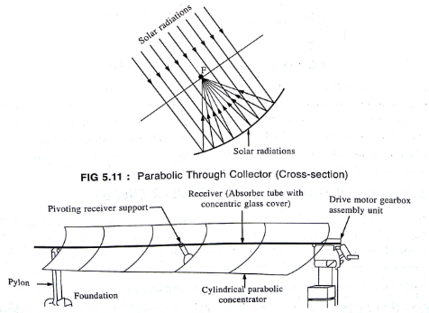

Figure shows the cylindrical parabolic concentrating collector. It consists of a movable parabolic cylindrical mirror (reflector) that focuses the direct radiation on a receiver tube (Absorber tube).The receiver tube is located along the axis of the collector.
The mirror rotates about its longitudinal axis, tracking the sun throughout the day. The solar energy focused on the receiver tube heats a fluid about 400ºC.
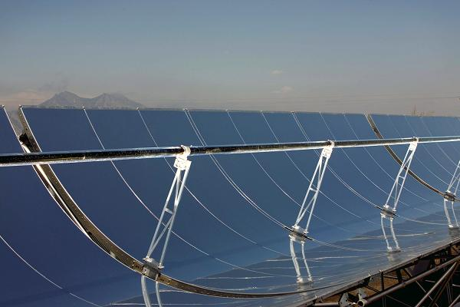

Parabolic trough collector

- Point Focusing Collectors:
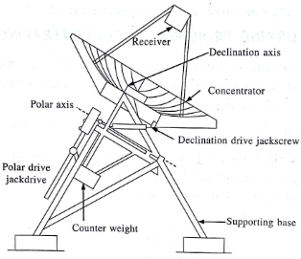
Fig shows the point focusing type parabolic dish collector. It consists of a reflecting parabolic dish of about 6.6 metre diameter which tracks the sun, redirecting and concentrating the solar radiation on a receiver (Absorber) at the dish's focal point.
The absorber located at the focus is a cavity made of Zirconium-Copper alloy with blackchrome selective coating. In the receiver (or) absorber heat is absorbed by a working fluid. The fluid is supplied to a power generating unit.

SOLAR THERMAL SYSTEM
(Concentrated Solar power plant)
The solar thermal power system collects the thermal energy in solar radiationand uses it at high or low temperatures. Low-temperature applications include water and room heating for commercial and residential buildings.
High-temperature applications concentrate the sun's heat energy to produce steamfor driving electrical generators. Concentrating solar power (CSP) technology has the ability to store thermal energy from sunlight and deliver electric power during dark or peak –demandperiods.
Figure shows a schematic of a large-scale solar thermal power station. In such a plant, solar energy is collected by thousands of sun-tracking mirrors, called heliostats,which reflect the sun's energy to a single receiver at top a centrally located tower. This enormous amount of energy that is focused on the receiver tower is used to melt a salt at high temperature.
The hot molten salt is stored in a storage tank and used when needed to generate steam and drive a turbine generator. After generating steam, the used molten salt, now at low temperature, is returned to the cold salt storage tank.
From here, the salt is pumped to the receiver tower to be heated again for the next thermal cycle. The usable energy extracted during such a thermal cycle depends on the working temperatures. The maximum thermodynamic conversion efficiencythat can be theoretically achieved with the hot-side temperature T_{hot}and the cold-side temperature T_{cold} is given by the Carnot cycle efficiency, which is as follows:
Η_{carnot}=(T_{hot}-T_{cold})/T_{hot}
where the temperatures are in degrees Kelvin.
A major benefit of this scheme is that it incorporates thermal energy storage for several hours with no degradation in performance or for longer with some degradation. Moreover, compared with the solar photovoltaic (PV) system, the solar thermal system is economical and more efficient because it eliminates use of costly PV cells and alternating current (AC) inverters. It is, however, limited to large-scale applications.

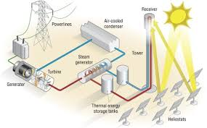
Solar thermal power plant schematic for generating electricity

ENERGY COLLECTION
Concentrated solar power(CSP) research and development focuses on three types of concentrators, which use different kinds of concentrating mirrors to convert the sun's energy into high temperature heat energy.

PARABOLIC TROUGH:
The parabolic trough system focuses sunlight on a glass-encapsulated tube running along the focal line of a collector. The tube carries a heat-absorbing liquid, usually oil that heats water to generate steam. More than 350 MW of parabolic trough capacity has been in operation in the California Mojave Desert.

CENTRAL RECEIVER:
In the central receiver system, an array of field mirrors focus sunlight on a central receivermounted on a tower. To focus sunlight on the central receiver at all times, each heliostat is mounted on a dual-axis sun tracker to seek a position in the sky that is midway between the receiver and the sun. Compared with the parabolic trough, this technology produces a much higher concentration and hence a higher temperature of the working medium, usually a salt.
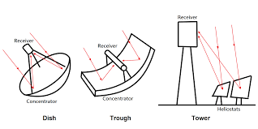
PARABOLIC DISH
A parabolic dish tracks the sun to focus heat, which drives a Stirling heat engine that is connected to an electrical generator. This technology has applications in relatively small capacity (tens of kilowatts) due to available engine size and wind load on the collector dishes. Because of their small size, they are more modular than other solar thermal power systems and call-be assembled in capacities ranging from a few hundred kilowatts to a few megawatts. This technology is particularly attractive for small stand-alone remote applications.
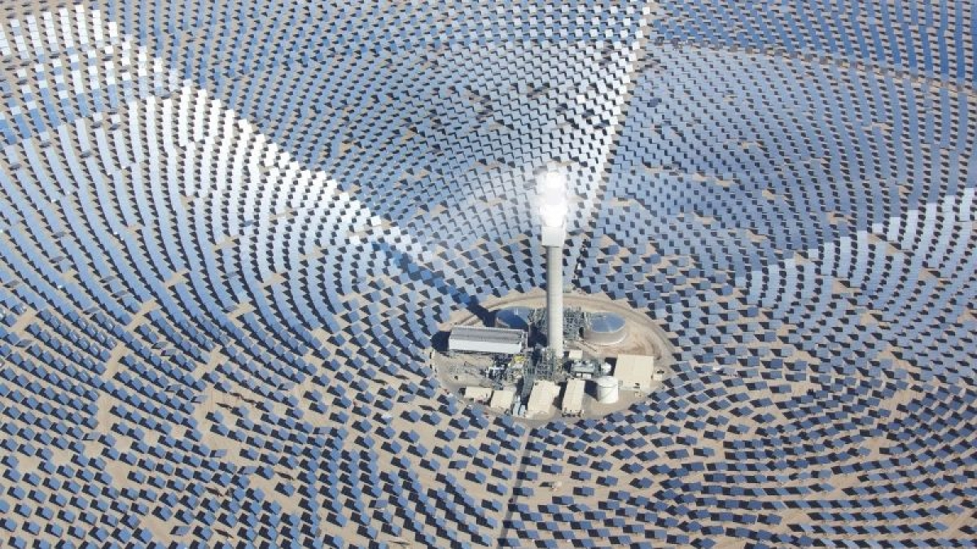

SOLAR ENERGY STORAGE
- Some form of energy storage is necessary to maintain plant output at a constant level despite solar insolation variation. One characteristic of storage system is the duration for which energy can be stored without much losses.
- The storage is referred to as short term if the duration is up to 24 hours and long term if the duration is more than a week or more. For duration of 24 hours to one week it is known as medium term.
- Another characteristic of storage system is its volume per unit energy storage. A good storage system should have long duration and a small volume per unit of energy stored.
- Solar energy has to be converted into another form before it can be stored. Assuming that the end product would finally be electricity, solar energy can be stored after it is converted into electricity or before.
- Solar energy can be stored in the form of heat by heating a fluid. Storage in the form of heat lasts for very short time because of losses by conduction, convection or radiation. However, these losses can be minimized if thermal insulation is good.
- Batteries are an obvious choice for storing electrical energy. However batteries do not meet the projected specifications of performance, cycle life and cost. Their use is limited to kilowatt level only.
- Pumped hydro power plant is presently the best method of storage and is the only one used for large scale use. Electrical energy, obtained from solar energy, pumps water from a tail-water pond to a head water pond. Whenever energy is needed, water is drawn from the head-water pond through thepenstock and generates power for supplying the load.
- Compressed air combustion turbine storage systems and coupling of motor generator set to a flywheel for storage of energy in the form of kinetic energy have also been suggested.

SOLAR APPLICATIONS
  - solar water heater
  - solar space heater
  - solar cooker
  - solar street lighting
  - solar water pumping
  - solar vehicles(car, bicycle)
  - remote sensor
  - road side emergency telephone
  - solar power satellite
  - solar battery charging

