MAGNETO HYDRO DYNAMIC POWER GENERATION
UNIT - IV

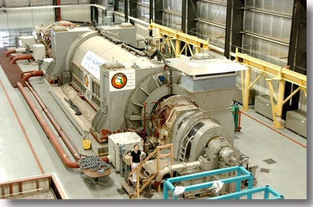

INTRODUCTION

The electricity requirements of the world including India are increasing at alarming rate and the power demand has been running ahead of supply.

It is also now widely recognized that the fossil fuels (i.e. coal, petroleum and natural gas) and other conventional resources, presently being used for generation of electrical energy, may not be either sufficient or suitable to keep pace with ever increasing demand of the electrical energy of the world.

Also generation of electrical power by coal based steam power plants or nuclear power plants causes pollution, which is likely to be more acute in future due to large generating capacity on one side and greater awareness of the people in this respect.
The recent severe energy crisis has forced the world to develop new and alternative methods of power generation, which could not be adopted so far due to various reasons.
The magneto-hydro-dynamic (MHD) power generation is one of the example of a new unique method of power generation. The other non-conventional methods of power generation may be such as solar cells, fuel cells, thermo-electric generator, thermionic converter, solar power generation, wind power generation, geo-thermal energy generation, tidal power generation etc.

MAGNETO-HYDRO-DYNAMIC (MHD) POWER GENERATION:

The basic principle of MHD generation is the same as that of a conventional electrical generation i.e. the motion of a conductor (working fluid) through a magnetic field induces an emf in it- called the Faraday’s law of electro-magnetic induction.

Thus two stages of energy conversion are involved in which the heat to mechanical energy conversion has inherently very low efficiency. Also, the rotating machine has its associated losses and maintenance problems.

In MHD generation, electrical energy is directly generated from hot combustion gases produced by the combustion of the fuel without moving parts.

When a fluid is used for the energy conversion technique, it is called MAGNETO HYDRO DYNAMIC (MHD), energy conversion.

The flow direction is right angles to the magnetic fields direction.

An electromotive force (or electric voltage) is induced in the direction at right angles to both flow and field directions.
The MHD power generation technology is the production of electric power utilizing a high temperature conducting plasma moving through an intense magnetic field.
Suppose we have a charged particle (having charge q) moving at a velocity v towards right and a perpendicular magnetic field (pointing into the paper) is applied. A magnetic force F acts on the charged particle . This force is given by:
F = q (v x B)
Force F, velocity v and magnetic flux density B are vectors.

In an MHD generator, electrically conducting gas (argon ,helium) at a very high temperature is passed at high velocity through a strong magnetic field at right angles to the direction of flow, there by generating electrical energy.

The electrical energy is then collected from stationary electrodes placed on the opposite sides of the channel .The current so obtained is direct current which can be converted into ac by an Inverter.

Ionized gas can be produced by heating it to a high temperature. On heating of a gas, the outer electrons escape out from its atoms or molecules. The particles acquire an electric charge and the gases passes into the state of plasma.

However, to achieve thermal ionization products of combustion of fossil fuels
or inert gases, extremely high temperatures are necessary. Air becomes highly
ionized at temperature of 5,000° to 6,000° C.

To have a reasonable value of electrical conductivity of gases at temperatures around 2,000^{O} to 3,000° c by reasonable ionization, the gases are seeded with additives of easily ionizing materials (alkali metals) such as
cesium or potassium.

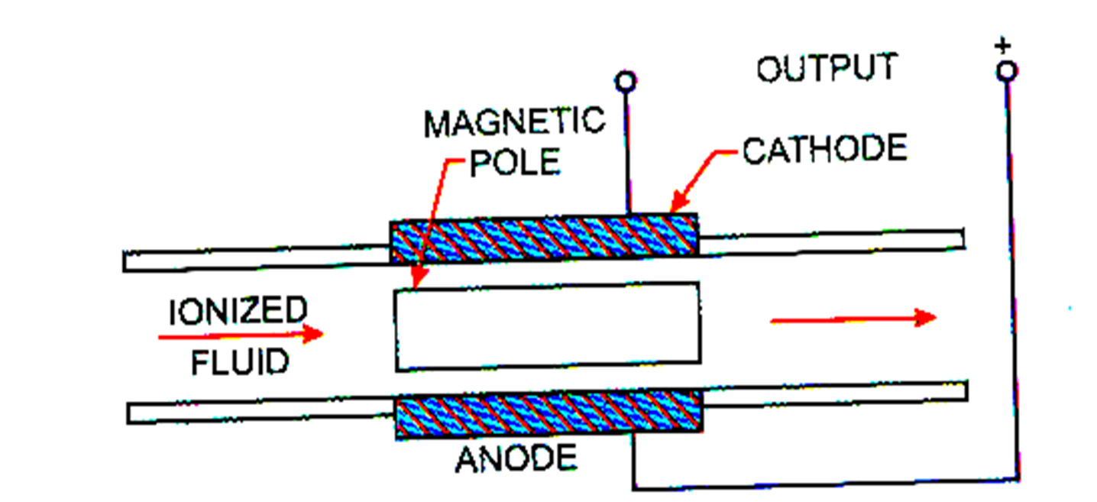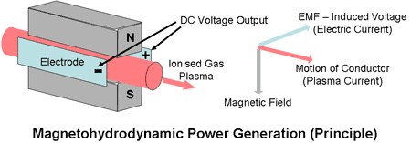

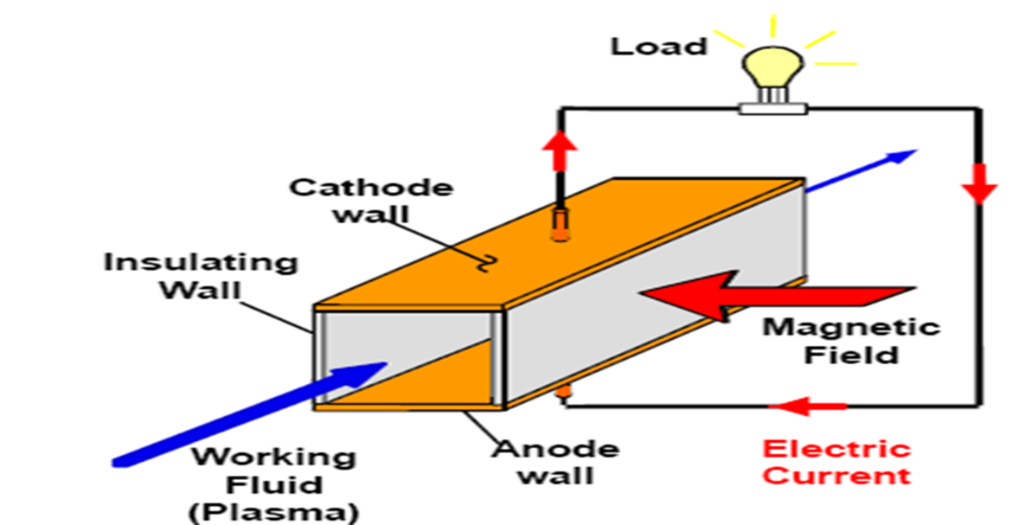

TYPES OF MHD SYSTEM
MHD system may be an open cycle system or a closed cycle system. In an open cycle system, the working fluid after doing useful work (generating electrical energy) is discharged to the atmosphere through a stack .
While in a closed cycle system the working fluid is recycled to the heat source and thus used again and again.
The operation of MHD, generators directly on combustion products is an open cycle system using air as working fluid.
In closed cycle systems gases used on the working fluid are helium or argon.
OPEN CYCLE MHD SYSTEM
1) Open Cycle MHD System:

Fig shows an elementary open cycle MHD system in which a high pressure high temperature combustion gas is forced through a strong magnetic field.
- Coal is processed and burnt in the combustor at a high temperature of
about 2,600°C and pressure of about 12 atmosphere with preheated air to form the plasma.
- Then a seeding material, such as potassium carbonate, is injected to the plasma in order to increase the electrical conductivity.
- The resulting mixture having an electrical conductivity of about 10 siemens/m, is expanded through a nozzle, so as to have high velocity, and then passed through the strong magnetic field (5-7 T) of the MHD generator.
- During the expansion of gas at high temperature, the positive and negative ions move to the electrodes and so constitute an electric current. This current is dc and an inverter is employed for its conversion into ac.
- The gas leaving the MHD generator is still very hot. The heat from the exhaust gases of the MHD generator is utilized in preheating the air supplied to the combustor.

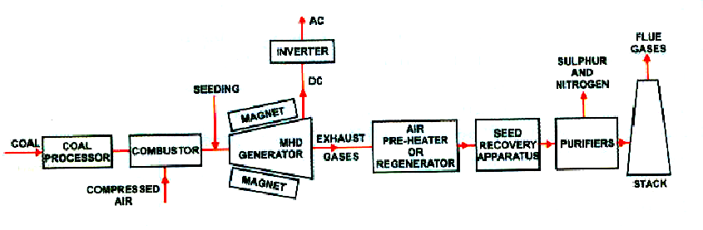
- The seed material is recovered from the gas for successive use and harmful emissions (such as nitrogen and sulphur) are removed from the gas, for pollution control, and the gas is finally discharged to the atmosphere through a stack.

The open-cycle MHD system explained above is not suitable for commercial use. For making this process efficient, it is necessary to combine the MHD unit with steam-turbine alternator unit.
In this system the heat from the exhaust gases of the MHD generator is used to raise steam which generates additional energy in a steam turbine-alternator unit.
A part of this steam is also used in a steam turbine driving a compressor for compressing air for the MHD cycle. Such a cycle is called the hybrid, binary or topping MHD steam plant cycle.

The electrodes are usually made of graphite and the duct of boron nitride.

For efficient practical realization an MHD system must have following features:
(1) Air superheating arrangement to heat the gas to around 2500°C so that the electrical conductivity of the gas is increased.

(2) The combustion chamber must have low heat losses.

(3) Arrangement to add a low ionization potential seed material to the gas to increase its conductivity.

(4) A water cooled but electrically insulating expanding duct with long life electrodes.
(5) A magnet capable of producing high magnetic flux density (5 to 7 teslas).
(6) Seed recovery apparatus-necessary for both environmental and economic reasons.

Power generated by the MHD system is given as

P = σ B² v² K (1- K) W/m³ ... (1)

where σ is the specific electrical conductivity of gas in siemen/metre, B is magnetic field strength in Tesla (Wb/m²), v is the velocity of gas in m/s and K is the ratio of external load voltage to open-circuit voltage.

CLOSED CYCLE MHD SYSTEM

2. Closed Cycle MHD System.
As the name suggests, the working fluid, in a closed cycle, is circulated in a closed loop.
The closed cycle MHD system may be either a plasma converter or a liquid metal converter.

The plasma converter uses an ionized gas (helium or argon seeded with cesium) and the liquid metal converter uses the vapour of the metal or the metal in a liquid form (the metal may be an alkali or some other metal).

The closed cycle inert gas MHD system was thought that all the advantages of the open cycle system would be retained and the main disadvantages of the open cycle system (viz. very high temperature requirements and a very chemically active flow) could be removed.

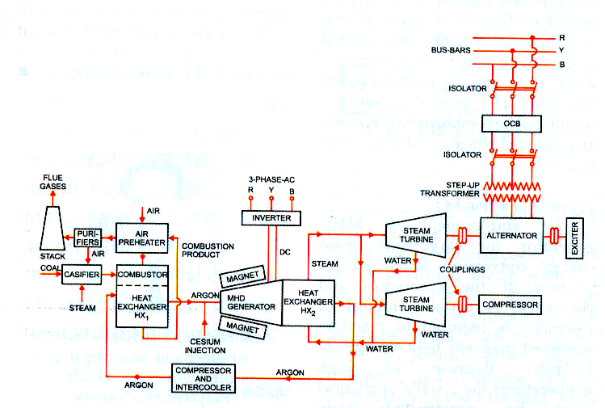

As the name suggests, the working fluid, in a closed cycle, is circulated in a closed loop. The working fluid is helium or argon with cesium seeding.

Since electron density tends to be governed by electron temperature rather than gas temperature we can get substantially higher electron density and electrical conductivity than would exist at the same temperature in combustion gas flow.

The possibility of using a nuclear heat source with a closed cycle MHD system has also been investigated. However its feasibility has yet not been
Established.

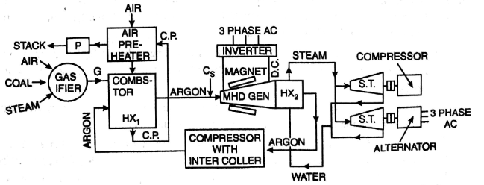
Fig shows a closed cycle MHD system. The complete system has three distinct but interlocking loops. On the left is the external heating loop.
Closed cycle MHD Steam

Coal is gasified and the gas so produced has heat value of about 5.35 MJ/kg and a temperature of about 520°C.
This gas is burnt in a combustor to generate heat. This heat transferred to the working fluid (argon) of the MHD cycle in a heat exchanger (HX₁).
The Combustion products are passed through the air preheater (for recovery of a part of heat of Combustion products) and purifiers and then discharged to the atmosphere. This is loop I and may be called an external heating loop.

The loop in the center is the MHD loop. The hot argon gas is seeded with cesium and passed through MHD generator. The d.c. power output of MHD generator is converted to a.c. by the inverter and is then fed into the grid.

The loop shown on the right hand side in Fig is the steam loop for further recovering the heat of the working fluid and converting this heat into electrical energy.
In the diffuser (not shown) the working fluid is slowed down to a low subsonic speed. Then this fluid passes through the heat exchanger HX2 where it imparts its heat to water which gets converted to steam.
This steam is used partly for driving a turbine which runs the compressor and partly expanded in a turbine which drives an alternator.
The output of the alternator is also fed to the grid. The working fluid goes back to the heat exchanger HX1 after passing through compressor and intercooler.
A closed cycle system can provide more useful power conversion at
lower temperatures (around 1900 K as compared to 2500 K for
open cycle system).

The difficulties with such a system are the design of heat exchanger (the heat exchanger operates upto the highest temperature of the gas), requirement of absolute purity of the working fluid, the problems posed by electrical stability of the flow in the generator (the gas is subject to electric fields approaching breakdown conditions) etc.

ADVANTAGES OF MHD POWER GENERATION.

MHD power generation offers several advantages over other conventional methods of power generation. Some of these are given below,

- The conversion efficiency of a MHD system can be around 50% much higher compared to the most efficient steam plants. Still higher efficiencies are expected in future, around 60 – 65 %, with the improvements in experience and technology.

- Large amount of power is generated.
- No moving part, so more reliable. Here only working fluid is circulated, and there are no moving mechanical parts. This reduces the mechanical losses to nil and makes the operation more dependable.
- It has closed cycle system produces power, free of pollution.
- It has ability to reach the full power level as soon as started.
- The size of the plant is considerably smaller than conventional fossil fuel plants.

- Although the cost cannot be predicted very accurately, yet it has been reported that capital costs of MHD plants will be competitive to conventional steam plants.
- It has been estimated that the overall operational costs in a plant would be about 20% less than conventional steam plants.

- Direct conversion of heat into electricity permits to eliminate the turbine (compared with a gas turbine power plant) or both the boiler and the turbine (compared with a steam power plant) elimination reduces losses of energy.
- These systems permit better fuel utilization. The reduced fuel consumption would offer additional economic and special benefits and would also lead to conservation of energy resources.
- It is possible to use MHD for peak power generations and emergency service. It has been estimated that MHD equipment for such duties is simpler, has capability of generating in large units and has the ability to make rapid start to full load.

VOLTAGE AND POWER OUTPUT OF MHD GENERATOR

Previous equation F = q (v x B) gives the force on the charged particle moving in the magnetic field. If an electric field E is also present in the region, the total force is
=q (+ * ---(2)
The velocity to be used in Eq. (2) is the vector sum of gas velocity v and the particle drift velocity u. Thus force is given by
=q (+ * + * ) ---(3)
Eq. (3) can be written as =q (+ * )
where
=+ * --- (4)
Referring to Fig the motion of gas is in x direction, magnetic field B is in y direction and the force on the particle is in z direction. A resistance R is connected between the two plates and a current I flows, developing a voltage V across the load.
The electric field intensity = - ----(5)
The total electric field is
= + B = (B v d - V) ---(6)
The electromagnetic fields E_{z} and B acting on the moving gas produce the same force on the ions as the electromagnetic field Ez' and B produce on a gas with zero average velocity. Evidently the term B v d gives the internal e.m.f. (or open circuit voltage) of the MHD generator.
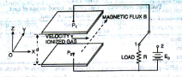
E₀=B v d ---(7)
Fig. 15.6 Direction of magnetic flux. Gas velocity and force in MHD system
The internal resistance of generator is R_{g} and equals to (d/σA) where σ is the conductivity of gas and A is the plate area.
Let k = 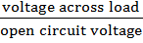 =
Or V=kE₀ ₋₋₋₋₋₍₈₎
Voltage drop in duct=E₀ – V = E₀ (1-k)-----(9)
If I is the current in the duct and R_{g} is the internal resistance of duct, the
I R_{g} is the voltage drop in the duct. Therefore,
E₀ (1-k)
Since R_{g}=
Where d is the distance between the plates (or dimension of the duct in the direction of current flow) σ is the conductivity of gas and A is the area of cross-section of duct. Therefore,
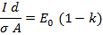
Current density 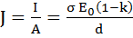
Or 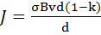 A/m²
Or A/m² ⁻⁻⁻⁻⁽¹⁰⁾
Total Power produced in the duct = P=E₀I
I=JA
Therefore P=E₀JA= (B v d) [σ B v (1-k)] A watts
P=σB²v²dA (1-k) watts –(11)
Power density =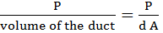 watts/m³

Or Power density= σB²v² (1-k) watts/m³ ⁻⁻⁻⁻⁻⁽¹²⁾
The electrical power is generated is due to the pressure difference of the gas between the inlet and outlet. The force f due to this pressure difference is the ratio of power density and gas velocity. Hence
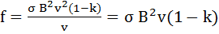 N/m ---(13)
If V=0 (i.e. short circuit condition), the current is the short circuit current I_{sc}.
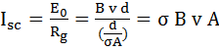 amperes-----(14)
Short circuit current density J_{sc} is
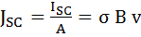 A/m²---- (15)
The power delivered to the load is maximum when load resistance= R=R_{g}
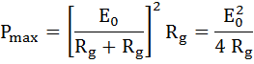 ----(16)

2013

1. Discus in detail about the working of open cycle MHD system.

2. Explain about MHD cycles and working fluids.

3. Discuss about the renewable energy and its applications.

2014

4.Explain about open cycle MHD system.

5. Explain about voltage and power output of MHD Generator.

2015

6. Give the principle of MHD Generation of Electrical

7. What are the advantages of MHD Generation?

8.what are the parameters governing the MHD generator power output?

2016

9.Explain the advantages of MHD power Generation?

10.Explain about any one closed cycle MHD Generation system?

11. Explain in detail about operating principle of MHD power Generation.

