UNIT-I

AC and DC Distribution
Now-a-days electrical energy is generated, transmitted and distributed in the form of alternating current.
Components of power system
Components of power system are shown in Fig 1.1

➢ Generators - Convert mechanical energy in to electrical energy
➢ Transformers - Transfer Power or energy from one circuit to another circuit with out change in frequency
➢ Transmission Lines - Transfer power from one place another place
➢ Control Equipment: Used for protection purpose
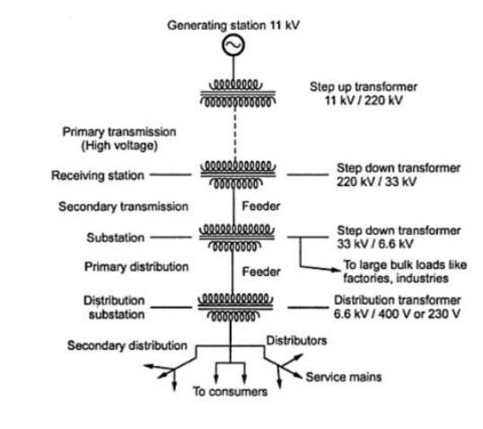
Fig 1.1Components of power system

AC DISTRIBUTION
Now-a-days electrical energy is generated, transmitted and distributed in the form of alternating current. One important reason for the widespread use of alternating current in preference to direct current is the fact that alternating voltage can be conveniently changed in magnitude by means of a transformer. Transformer has made it possible to transmit A.C. power at high voltage and utilize it at a safe potential. High transmission and distribution voltages have greatly reduced the current in the conductors and the resulting line losses.
There is no definite line between transmission and distribution according to voltage or bulk capacity. However, in general, the A.C. distribution system is the electrical system between the step- down substation fed by the transmission system and the consumers’ meters. The A.C distribution system is classified into
i. primary distribution system and
ii. Secondary distribution system.
i) Primary distribution system.
It is that part of A.C. distribution system which operates at voltages somewhat higher than general utilization and handles large blocks of electrical energy than the average low-voltage consumer uses. The voltage used for primary distribution depends upon the amount of power to be conveyed and the distance of the substation required to be fed. The most commonly used primary distribution voltages are 11 kV, 6·6 kV and 3·3 kV. The Primary distribution system is shown in Fig1.2
Due to economic considerations, primary distribution is carried out by 3- phase, 3-wire system Fig. shows a typical primary distribution system Electric power from the generating station is transmitted at high voltage to the substation located in or near the city.
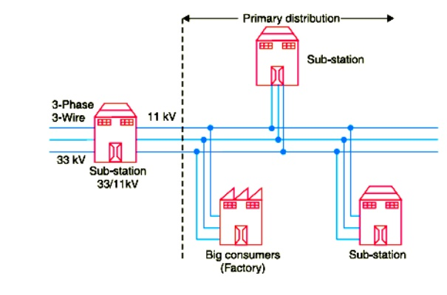
Fig1.2 Primary distribution system

ii) Secondary distribution system
It is that part of A.C distribution system. The secondary distribution employs 400/230V,3-phase,4wire system. Fig1.3 shows a typical secondary distribution system. The primary distribution circuit delivers power to various substations, called distribution sub-stations. The substations are situated near the consumers’ localities and contain step-down transformers. At each distribution substation, the voltage is stepped down to 400Vandpowerisdeliveredby 3-phase,4-wire A.C system. The voltage between any two phases is 400V and between any phase and neutralize 230V.The single phase domestic loads are connected between any one phase and the neutral, where as 3-phase 400V motor loads are connected across 3- phase lines directly. The secondary distribution system is shown in Fig1.3.
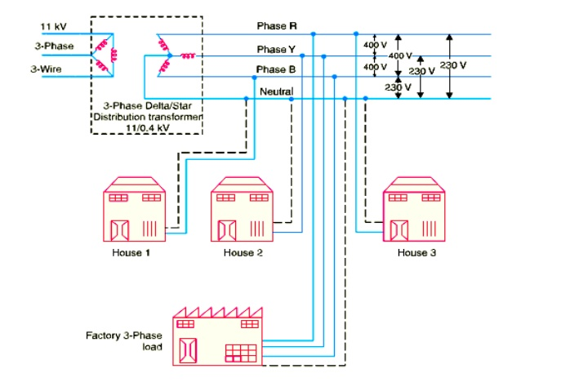
Fig1.3 Secondary distribution system
D.C. DISTRIBUTION
It is a common knowledge that electric power is almost exclusively generated, transmitted and distributed as A.C. However, for certain applications, D.C. supply is absolutely necessary. For instance, D.C. supply is required for the operation of variable speed machinery (D.C. motors), for electro-chemical work and for congested areas where storage battery reserves are necessary. For this purpose, A.C. power is converted into D.C. power at the substation by using converting machinery e.g., mercury arc rectifiers, rotary converters and motor-generator sets. The D.C. supply from the substation may be obtained in the form of
( i) 2-wire
( ii) 3-wire for distribution.

( i) 2-wire D.C. system.
As the name implies, this system of distribution consists of two wires. One is the outgoing or positive wire and the other is the return or negative wire. The loads such as lamps, motors etc. are connected in parallel between the two wires as shown in Fig. 1.4. This system is never used for transmission purposes due to low efficiency but may be employed for distribution of D.C. power.
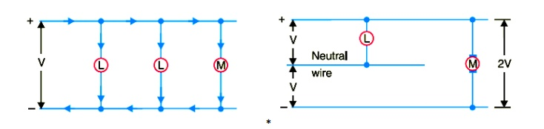
Fig1.4 Two wire DC distribution system Fig1.5 Three wire DC distribution
system

( ii) 3-wire D.C. system.
It consists of two outers and a middle or neutral wire which is earthed at the substation. The voltage between the outers is twice the voltage between either outer and neutral wire as shown in Fig. 1.5. The principal advantage of this system is that it makes available two voltages at the consumer terminals viz., V between any outer and the neutral and 2V between the outers. Loads requiring high voltage ( e.g., motors) are connected across the outers, whereas lamps and heating circuits requiring less voltage are connected between either outer and the neutral. The methods of obtaining 3-wire system are discussed in the following article.

OVERHEAD VERSUS UNDERGROUND SYSTEM
The distribution system can be overhead or underground. Overhead lines are generally mounted on wooden, concrete or steel poles which are arranged to carry distribution transformers in addition to the conductors. The underground system uses conduits, cables and manholes under the surface of streets and sidewalks. The choice between overhead and underground system depends upon a number of widely differing factors. Therefore, it is desirable to make a comparison between the two.
( i) Public safety.
The underground system is more safe than overhead system because all distribution wiring is placed underground and there are little chances of any hazard.
( ii) Initial cost.
The underground system is more expensive due to the high cost of trenching, conduits, cables, manholes and other special equipment. The initial cost of an underground system may be five to ten times than that of an overhead system.
( iii) Flexibility.
The overhead system is much more flexible than the underground system. In the latter case, manholes, duct lines etc., are permanently placed once installed and the load expansion can only be met by laying new lines. However, on an overhead system, poles, wires, transformers etc., can be easily shifted to meet the changes in load conditions.
( iv) Faults.
The chances of faults in underground system are very rare as the cables are laid underground and are generally provided with better insulation.
( v) Appearance.
The general appearance of an underground system is better as all the distribution lines are invisible. This factor is exerting considerable public pressure on electric supply companies to switch over to underground system.
( vi) Fault location and repairs.
In general, there are little chances of faults in an underground system. However, if a fault does occur, it is difficult to locate and repair on this system. On an overhead system, the conductors are visible and easily accessible so that fault locations and repairs can be easily made.
( vii) Current carrying capacity and voltage drop.
An overhead distribution conductor has a considerably higher current carrying capacity than an underground cable conductor of the same material and cross-section. On the other hand, underground cable conductor has much lower inductive reactance than that of an overhead conductor because of closer spacing of conductors.
( viii) Useful life.
The useful life of underground system is much longer than that of an overhead system. An overhead system may have a useful life of 25 years, whereas an underground system may have a useful life of more than 50 years.
( ix) Maintenance cost.
The maintenance cost of underground system is very low as compared with that of overhead system because of fewer chances of faults and service interruptions from wind, ice, lightning as well as from traffic hazards.

( x) Interference with communication circuits.
An overhead system causes electromagnetic interference with the telephone lines. The power line currents are superimposed on speech currents, resulting in the potential of the communication channel being raised to an undesirable level. However, there is no such interference with the underground system.
It is clear from the above comparison that each system has its own advantages and disadvantages. However, comparative economics ( i.e., annual cost of operation) is the most powerful factor influencing the choice between underground and overhead system. The greater capital cost of underground system prohibits its use for distribution. But sometimes non-economic factors ( e.g., general appearance, public safety etc.) exert considerable influence on choosing underground system. In general, overhead system is adopted for distribution and the use of underground system is made only where overhead construction is impracticable or prohibited by local laws.
CONNECTION SCHEMES OF DISTRIBUTION SYSTEM
All distribution of electrical energy is done by constant voltage system. In practice, the following distribution circuits are generally used :
( i) Radial System.
In this system, separate feeders radiate from a single substation and feed the distributors at one end only. Fig1.6. shows a single line diagram of a radial system for D.C. distribution where a feeder OC supplies a distributor A B at point A . Obviously, the distributor is fed at one end only i.e., point A is this case. The radial system is employed only when power is generated at low voltage and the substation is located at the centre of the load.
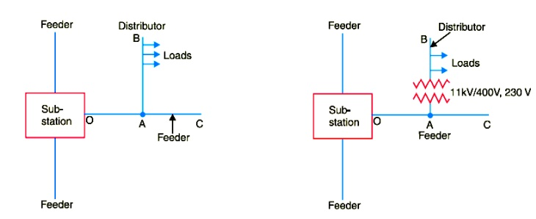
Fig1.6 single line diagram of a radial system
This is the simplest distribution circuit and has the lowest initial cost. However, it suffers from the following drawbacks :
( a) The end of the distributor nearest to the feeding point will be heavily loaded.
( b) The consumers are dependent on a single feeder and single distributor. Therefore, any fault on the feeder or distributor cuts off supply to the consumers who are on the side of the fault away from the substation.
( c) The consumers at the distant end of the distributor would be subjected to serious voltage fluctuations when the load on the distributor changes.
Due to these limitations, this system is used for short distances only.
( ii) Ring main system.
In this system, the primaries of distribution transformers form a loop. The loop circuit starts from the substation bus-bars, makes a loop through the area to be served, and returns to the substation. Fig. 1.7 shows the single line diagram of ring main system for A.C. distribution where substation supplies to the closed feeder LMNOPQRS.
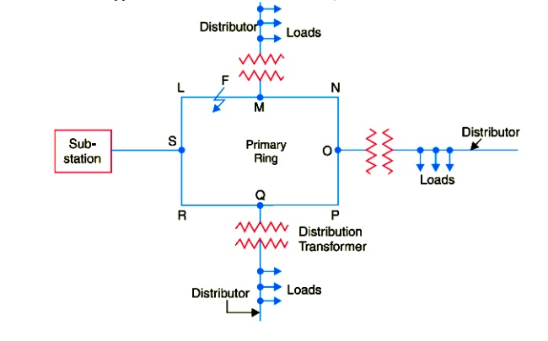
Fig. 1.7 single line diagram of ring main system for A.C. distribution

The distributors are tapped from different points M, O and Q of the feeder through distribution transformers. The ring main system has the following advantages :
( a) There are less voltage fluctuations at consumer’s terminals.
( b) The system is very reliable as each distributor is fed via *two feeders. In the event of fault on any section of the feeder, the continuity of supply is maintained. For example, suppose that fault occurs at any point F of section SLM of the feeder. Then section SLM of the feeder can be isolated for repairs and at the same time continuity of supply is maintained to all the consumers via the feeder SRQPONM.
( iii) Interconnected system.
When the feeder ring is energized by two or more than two generating stations or substations, it is called inter-connected system. Fig.1.8 shows the single line diagram of interconnected system where the closed feeder ring ABCD is supplied by two substations S and S at points D and C respectively.

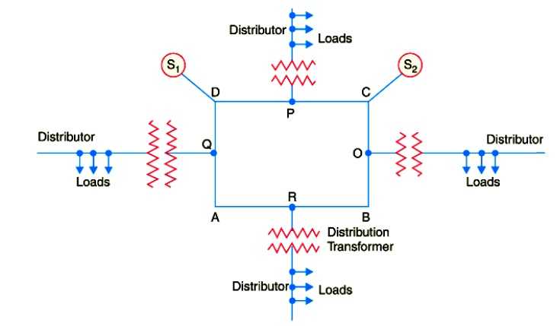
Fig. 1.8 single line diagram of interconnected system
Distributors are connected to points O, P, Q and R of the feeder ring through distribution transformers. The interconnected system has the following advantages
( a) It increases the service reliability.
( b) Any area fed from one generating station during peak load hours can be fed from the other generating station. This reduces reserve power capacity and increases efficiency of the system.
REQUIREMENTS OF A DISTRIBUTION SYSTEM
A considerable amount of effort is necessary to maintain an electric power supply within the requirements of various types of consumers. Some of the requirements of a good distribution system are : proper voltage, availability of power on demand and reliability.
( i) Proper voltage.
One important requirement of a distribution system is that voltage variations at consumer’s terminals should be as low as possible. The changes in voltage are generally caused due to the variation of load on the system. Low voltage causes loss of revenue, inefficient lighting and possible burning out of motors. High voltage causes lamps to burn out permanently and may cause failure of other appliances. Therefore, a good distribution system should ensure that the voltage variations at consumers terminals are within permissible limits. The statutory limit of voltage variations is ± 6% of the rated value at the consumer’s terminals. Thus, if the declared voltage is 230 V, then the highest voltage of the consumer should not exceed 244 V while the lowest voltage of the consumer should not be less than 216 V.
( ii) Availability of power on demand.
Power must be available to the consumers in any amount that they may require from time to time. For example, motors may be started or shut down, lights may be turned on or off, without advance warning to the electric supply company. As electrical energy cannot be stored, therefore, the distribution system must be capable of supplying load demands of the consumers. This necessitates that operating staff must continuously study load patterns to predict in advance those major load changes that follow the known schedules.
( iii) Reliability.
Modern industry is almost dependent on electric power for its operation. Homes and office buildings are lighted, heated, cooled and ventilated by electric power. This calls for reliable service. Unfortunately, electric power, like everything else that is man-made, can never be absolutely reliable. However, the reliability can be improved to a considerable extent by ( a) interconnected system ( b) reliable automatic control system ( c) providing additional reserve facilities.
DESIGN CONSIDERATIONS IN DISTRIBUTION SYSTEM
Good voltage regulation of a distribution network is probably the most important factor responsible for delivering good service to the consumers. For this purpose, design of feeders and distributors requires careful consideration.
( i) Feeders.
A feeder is designed from the point of view of its current carrying capacity while the voltage drop consideration is relatively unimportant. It is because voltage drop in a feeder can be compensated by means of voltage regulating equipment at the substation.
( ii) Distributors.
A distributor is designed from the point of view of the voltage drop in it. It is because a distributor supplies power to the consumers and there is a statutory limit of voltage variations at the consumer’s terminals (± 6% of rated value). The size and length of the distributor should be such that voltage at the consumer’s terminals is within the permissible limits.

Comparison of Volume of Copper in Overhead System
The selection of a particular type of A.C. or D.C. system for the transmission and distribution is based on comparison of amount of material i.e. copper necessary for the various systems. As mentioned earlier, the maximum stress in the overhead system exists between the conductor and earth. Hence comparison of material required is done assuming the maximum voltage between any conductor and earth being the same. The assumptions made for the comparison are :
1. The power (P) transmitted by all the systems is same.
2. The distance ( l ) over which the power is transmitted is same.
3. The power loss (W) in all the systems are same.
4. The maximum voltage (V_{m}) exists between any conductor and the earth, in all the systems.
Based on these assumptions, let us compare the various types of systems for the volume of copper required.
Two Wire D.C. System With One Line Earthed
The system is represented in the Fig. 1.9
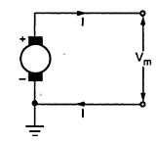
Fig. 1.9 Two wire D.C. System with One Line Earthed

The maximum voltage between the conductors is V_{m}, as one material is earthed.
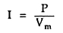
Where P = Power transmitted
Let R = resistance of each conductor
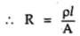
Total copper losses in both the lines are,
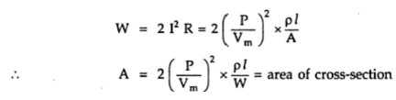
Volume of copper required is
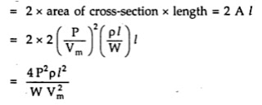
The volume of copper required for other systems is compared by taking volume of copper required for this system as base. Let it be constant K and volume of copper required for other systems can be expressed interms of K.
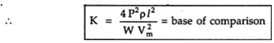

Two Wire D.C. System With Midpoint Earthed
The system is represented in the Fig. 1.10.
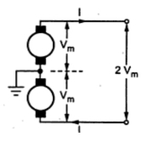
Fig. 1.10 Two wire D.C. System with midpoint Earthed

As power transmitted is same as P, the current in each conductor is,
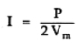
The total copper loss in both the lines is,
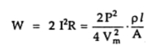
where A = area of cross-section of each line.
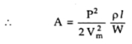
The total volume of copper required is,
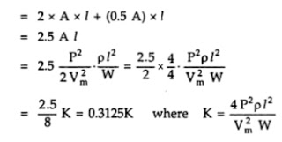
Thus the volume of copper required in this system is one fourth the volume of copper required for two wire D.C. system with one line earthed.
Three Wire D.C. System
The system is represented as shown in the Fig. 1.11
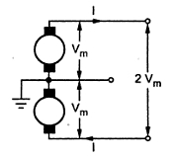
Fig. 1.11 Three wire D.C. System

When the load is balanced, current through the third neutral wire is zero.
Let A = Cross-section of outer conductors
The total copper loss is,
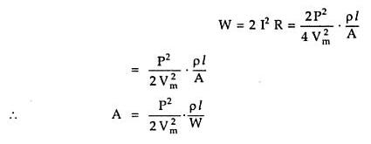
Let area of cross-section of the middle neutral wire is half of the area of cross-section of the outer conductor.
Hence the total volume of copper
= Volume of copper for outer wires + volume of copper for neutral wire
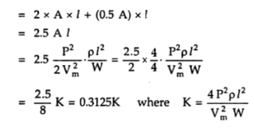
Thus the volume of copper required in this system is 0.3125 times the volume of copper required for two wire D.C. system with one line earthed.
Three Phase Three Wire A.C. System
This is most commonly used system for the transmission. The three phase three wire star connected system with neutral earthed is shown in the Fig. 1.12
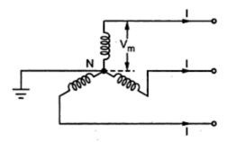
Fig. 1.12 Three Phase Three Wire A.C. System

The maximum voltage between each line conductor and the neutral is V_{m} as shown in the Fig. 1.12.
The R.M.S. value of the voltage per phase given by,
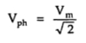
Then total power transmitted is P watts hence per phase power transmission is,
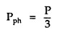
Let cosΦ be the load power factor
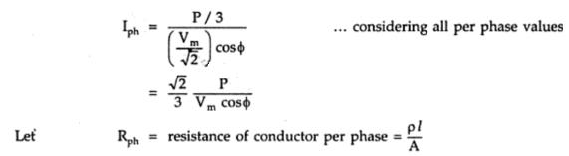
Hence the total copper loss is,
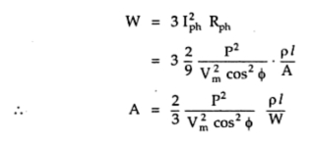
The volume of the copper required is
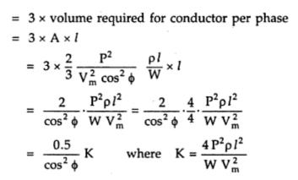
Thus the volume of copper required depends on power factor of the load and it is 0.5/cos²Φ times the volume of copper required by twp wire D.C. system with one line earthed. This system may be delta connected but irrespective of the method of connection star or delta, the result derived remains same.
Three Phase Four Wire A.C. System
This system is popularly used for secondary distribution. The neutral is also made available for the connection of the load. The system is shown in the Fig. 1.13
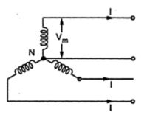
Fig. 1.13 Three Phase four wire A.C. System

Assuming the load balanced, there is no current flowing through the neutral.
The cross-section area of neutral is half the cross-section of each conductor i.e. 0.5 A where A is cross-section of each conductor.
The maximum voltage between any conductor and the neutral is V_{m} hence R.M.S. voltage per phase is,

The power transmitted per phase is,
Hence all the calculations up to the copper losses and expression of A remain same as derived for three phase three wire system.
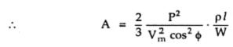

The total volume of copper requires is,
= Volume of copper for 3 lines + copper required for neutral
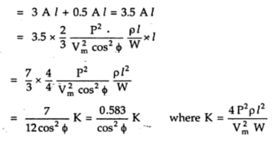
Thus the volume of copper required is 0.583/cos²Φ times the volume of copper required by two wire D.C. system with one line earthed.

A.C. DISTRIBUTION
In the beginning of electrical age, electricity was generated, transmitted and distributed as direct current. The principal disadvantage of D.C. system was that voltage level could not readily be changed, except by the use of rotating machinery, which in most cases was too expensive. With the development of transformer by George Westinghouse, A.C. system has become so predominant as to make D.C. system practically extinct in most parts of the world. The present day large power system has been possible only due to the adoption of A.C. system Now-a-days, electrical energy is generated, transmitted and distributed in the form of alternating current as an economical proposition. The electrical energy produced at the power station is transmitted at very high voltages by 3-phase, 3-wire system to step-down sub-stations for distribution. The distribution system consists of two parts viz. primary distribution and secondary distribution. The primary distribution circuit is 3-phase, 3-wire and operates at voltages (3·3 or 6·6 or 11kV) somewhat higher than general utilization levels. It delivers power to the secondary distribution circuit through distribution transformers situated near consumers’ localities. Each distribution transformer steps down the voltage to 400 V and power is distributed to ultimate consumers by 400/230 V, 3-phase, 4-wire system.
1. A.C. DISTRIBUTION CALCULATIONS
A.C. distribution calculations differ from those of D.C. distribution in the following respects :
( i) In case of D.C. system, the voltage drop is due to resistance alone. However, in A.C. system, the voltage drops are due to the combined effects of resistance, inductance and capacitance.
( ii) In a D.C. system, additions and subtractions of currents or voltages are done arithmetically but in case of A.C. system, these operations are done vectorially.
( iii) In an A.C. system, power factor (p.f.) has to be taken into account. Loads tapped off form the distributor are generally at different power factors. There are two ways of referring power factor viz
( a) It may be referred to supply or receiving end voltage which is regarded as the reference vector.
( b) It may be referred to the voltage at the load point itself.
There are several ways of solving A.C. distribution problems. However, symbolic notation method has been found to be most convenient for this purpose. In this method, voltages, currents and impedances are expressed in complex notation and the calculations are made exactly as in D.C. distribution.
2. METHODS OF SOLVING A.C. DISTRIBUTION PROBLEMS
In A.C. distribution calculations, power factors of various load currents have to be considered since currents in different sections of the distributor will be the vector sum of load currents and not the arithmetic sum. The power factors of load currents may be given ( i) w.r.t. receiving or sending end voltage or ( ii) w.r.t. to load voltage itself. Each case shall be discussed separately.
( i) Power factors referred to receiving end voltage.
Consider an A.C. distributor A B with concentrated loads of I₁ and I₂ tapped off at points C and B as shown in following Figure. Taking the receiving end voltage V _{B} as the reference vector, let lagging power factors at C and B be cos φ₁ and cos φ ₂ w.r.t. V_{B} . Let R₁ , X₁ and R₂ , X₂ be the resistance and reactance of sections A C and CB of the distributor.
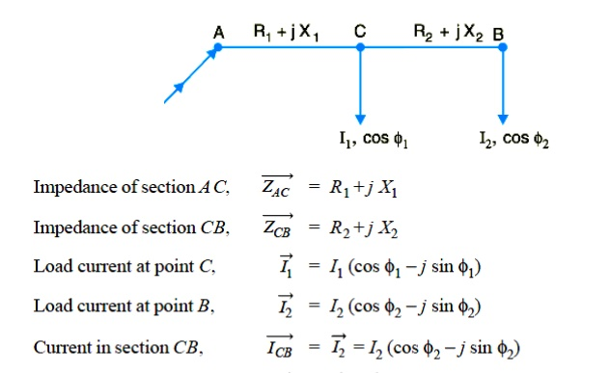
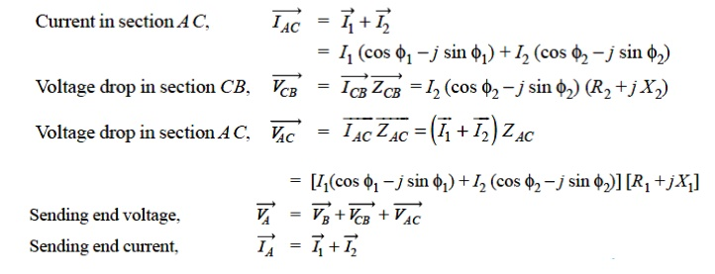
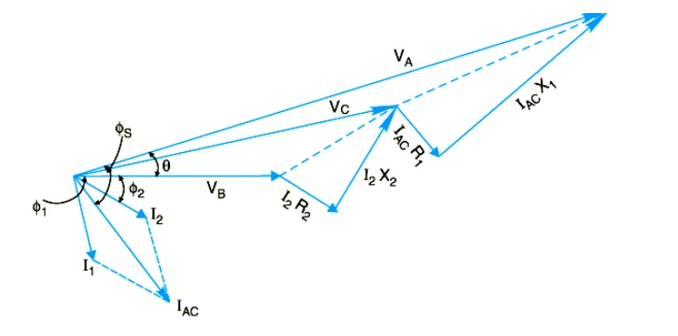
Fig.1.14 The vector diagram of the AC distributor
The vector diagram of the AC distributor under these conditions is shown in Fig.1.14. Here, the receiving end voltage V_{B} is taken as the reference vector. As power factors of loads are given w.r.t. V_{B} , therefore, I₁ and I₂ lag behind V_{B} by φ₁ and φ₂ respectively.
( ii) Power factors referred to respective load voltages.
The vector diagram of the AC distributor under these conditions is shown in Fig.1.15. Suppose the power factors of loads are referred to their respective load voltages. Then φ1 is the phase angle between VC and I₁ and φ₂ is the phase angle between VB and I2 .
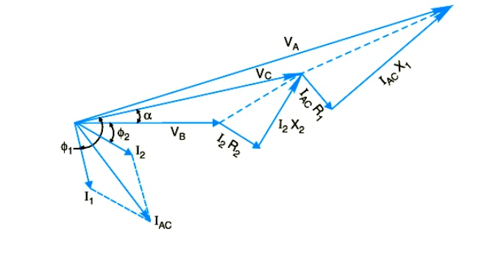
Fig.1.15 The vector diagram of the AC distributor

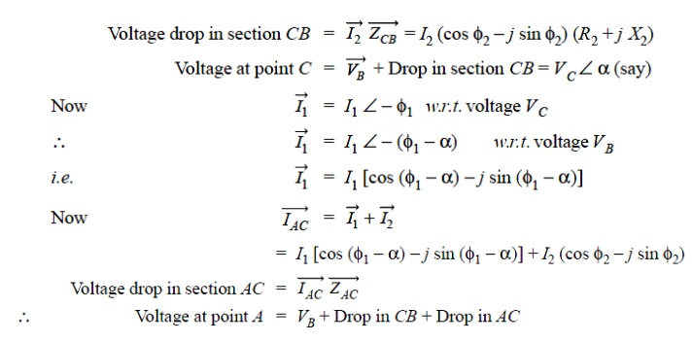
TYPES OF D.C. DISTRIBUTORS
The most general method of classifying D.C. distributors is the way they are fed by the feeders. On this basis, D.C. distributors are classified as:
( i) Distributor fed at one end
( ii) Distributor fed at both ends
( iii) Distributor fed at the centre
( iv) Ring distributor.
( i) Distributor fed at one end.
In this type of feeding, the distributor is connected to the supply at one end and loads are taken at different point along the length of the distributor.
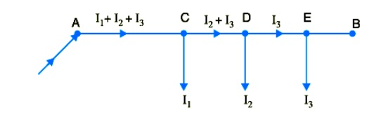
Fig1.16 Single line diagram of distributor fed at one end
Fig.1.16 shows the single line diagram of a D.C. distributor AB fed at the end A (also known as singly fed distributor) and loads I₁ , I₂ and I₃ tapped off at points C, D and E respectively.

The following points are worth noting in a singly fed distributor:
( a) The current in the various sections of the distributor away from feeding point goes on decreasing. Thus current in section AC is more than the current in section CD and current in section CD is more than the current in section DE.
( b) The voltage across the loads away from the feeding point goes on decreasing. Thus in Fig. the minimum voltage occurs at the load point E.
( c) In case a fault occurs on any section of the distributor, the whole distributor will have to be disconnected from the supply mains. Therefore, continuity of supply is interrupted.
( ii) Distributor fed at both ends.
In this type of feeding, the distributor is connected to the supply mains at both ends and loads are tapped off at different points along the length of the distributor. Single line diagram of distributor fed at both ends is shown in Fig1.17
The voltage at the feeding points may or may not be equal. Fig. shows a distributor A B fed at the ends A and B and loads of I₁ , I₂ and I₃ tapped off at points C, D and E respectively.
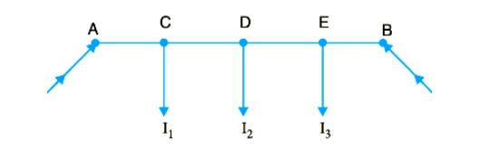
Fig1.17 Single line diagram of distributor fed at both ends

Here, the load voltage goes on decreasing as we move away from one feeding point say A , reaches minimum value and then again starts rising and reaches maximum value when we reach the other feeding point B. The minimum voltage occurs at some load point and is never fixed. It is shifted with the variation of load on different sections of the distributor.
Advantages
( a) If a fault occurs on any feeding point of the distributor, the continuity of supply is maintained from the other feeding point.
( b) In case of fault on any section of the distributor, the continuity of supply is maintained from the other feeding point.
( c) The area of X-section required for a doubly fed distributor is much less than that of a singly fed distributor.
( iii) Distributor fed at the centre.
In this type of feeding, the centre of the distributor is connected to the supply mains as shown in Fig1.18. It is equivalent to two singly fed distributors, each distributor having a common feeding point and length equal to half of the total length.

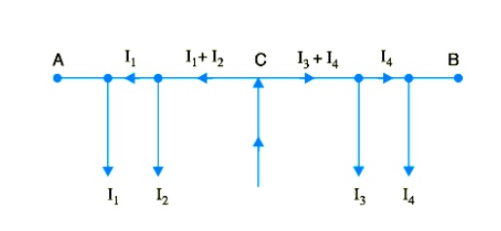
Fig1.18 Single line diagram of distributor fed at centre
( iv)Ring mains.
In this type, the distributor is in the form of a closed ring as shown in Fig.1.19. It is equivalent to a straight distributor fed at both ends with equal voltages, the two ends being brought together to form a closed ring. The distributor ring may be fed at one or more than one point.
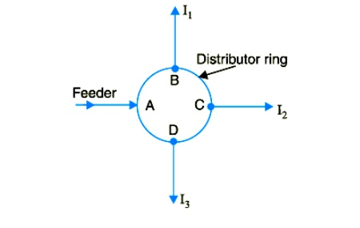
Fig1.19 Single line diagram of ring main distributor
1. D.C. DISTRIBUTOR FED AT ONE END — CONCENTRATED LOADING
Fig.1.20 shows the single line diagram of a 2-wire D.C. distributor AB fed at one end A and having concentrated loads I₁ , I₂ , I₃ and I₄ tapped off at points C, D, E and F respectively.
Let r₁ , r₂ , r₃ and r₄ be the resistances of both wires (go and return) of the sections A C, CD, DE and EF of the distributor respectively

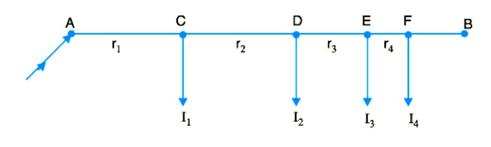
Fig.1.20 single line diagram of a 2-wire DC distributor
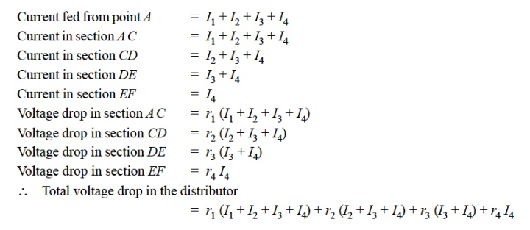
It is easy to see that the minimum potential will occur at point F which is farthest from the feeding point A .
2. UNIFORMLY LOADED DISTRIBUTOR FED AT ONE END
Fig 1.21 shows the single line diagram of a 2-wire d.c. distributor A B fed at one end A and loaded uniformly with i amperes per metre length. It means that at every 1 m length of the distributor, the load tapped is i amperes. Let l metres be the length of the distributor and r ohm be the resistance per metre run.
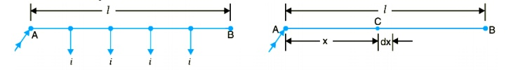
Fig.1.21 single line diagram of a 2-wire DC distributor fed at one with uniform loading

Consider a point C on the distributor at a distance x metres from the feeding point A as shown in Fig. Then current at point C is

= i l − i x amperes = i ( l − x) amperes
Now, consider a small length dx near point C. Its resistance is r dx and the voltage drop over length dx is d v = i ( l − x) r dx = i r ( l − x) dx Total voltage drop in the distributor upto point C is
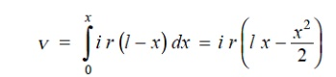
The voltage drop up to point B ( i.e. over the whole distributor) can be obtained by putting x = l in the above expression.
∴ Voltage drop over the distributor AB
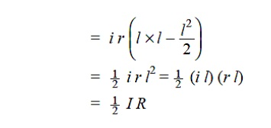

where
i l = I, the total current entering at point A r l = R, the total resistance of the distributor
Thus, in a uniformly loaded distributor fed at one end, the total voltage drop is equal to that produced by the whole of the load assumed to be concentrated at the middle point.
3. DISTRIBUTOR FED AT BOTH ENDS — CONCENTRATED LOADING
Whenever possible, it is desirable that a long distributor should be fed at both ends instead of at one end only, since total voltage drop can be considerably reduced without increasing the cross-section of the conductor. The two ends of the distributor may be supplied with ( i) equal voltages ( ii) unequal voltages.
( i) Two ends fed with equal voltages. Consider a distributor A B fed at both ends with equal voltages V volts and having concentrated loads I₁ , I₂ , I₃ , I₄ and I₅ at points C, D, E, F and G respectively as shown in Fig.1.22. As we move away from one of the feeding points, say A , p.d. goes on decreasing till it reaches the minimum value at some load point, say E, and then again starts rising and becomes V volts as we reach the other feeding point B.
All the currents tapped off between points A and E (minimum p.d. point) will be supplied from the feeding point A while those tapped off between B and E will be supplied from the feeding point B.
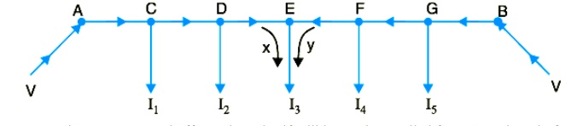
Fig.1.22 single line diagram of a 2-wire DC distributor fed at both ends with equal voltages
The current tapped off at point E itself will be partly supplied from A and partly from B. If these currents are x and y respectively, then,
I ₃= x + y
Therefore, we arrive at a very important conclusion that at the point of minimum potential, current comes from both ends of the distributor.
Point of minimum potential.
It is generally desired to locate the point of minimum potential. There is a simple method for it. Consider a distributor A B having three concentrated loads I₁ , I₂ and I₃ at points C, D and E respectively. Suppose that current supplied by feeding end A is Ia . Then current distribution in the various sections of the distributor can be worked out as shown in Fig.1.23
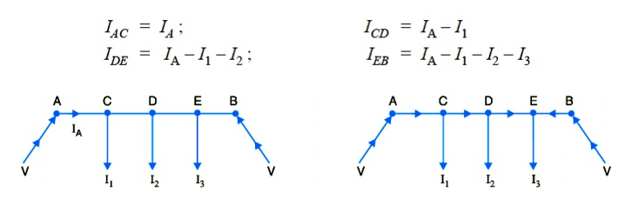
Fig1.23 current distribution of a 2-wire DC distributor fed at both ends with equal voltages
Voltage drop between A and B = Voltage drop over A B
From this equation, the unknown I_{A} can be calculated as the values of other quantities are generally given. Suppose actual directions of currents in the various sections of the distributor are indicated as shown in Fig. The load point where the currents are coming from both sides of the distributor is the point of minimum potential i.e. point E in this case
( ii) Two ends fed with unequal voltages.
Fig1.24 shows the distributor A B fed with unequal voltages end A being fed at V₁ volts and end B at V₂ volts. The point of minimum potential can be found by following the same procedure as discussed above. Thus in this case, Voltage drop between A and B = Voltage drop over A B
V₁ − V₂ = Voltage drop over A B
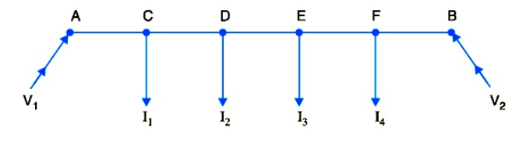
Fig1.24 single line diagram of a 2-wire DC distributor fed at both ends with un-equal voltages
4. UNIFORMLY LOADED DISTRIBUTOR FED AT BOTH ENDS
We shall now determine the voltage drop in a uniformly loaded distributor fed at both ends. There can be two cases viz. the distributor fed at both ends with ( i) equal voltages ( ii) unequal voltages. The two cases shall be discussed separately.
( i) Distributor fed at both ends with equal voltages.
Consider a distributor A B of length l metres, having resistance r ohms per metre run and with uniform loading of i amperes per metre run as shown in Fig. 1.25. Let the distributor be fed at the feeding points A and B at equal voltages, say V volts. The total current supplied to the distributor is i l. As the two end voltages are equal, therefore, current supplied from each feeding point is i l/2 i.e.
Current supplied from each feeding point
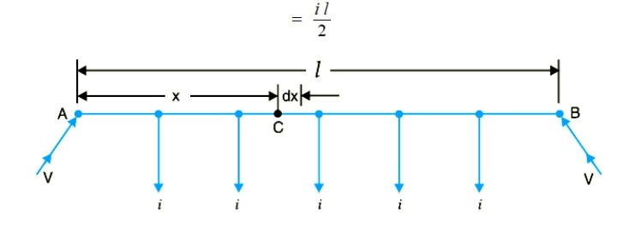
Fig 1.25 Single line diagram of uniformly loaded distributor fed at both ends with equal voltages
Consider a point C at a distance x metres from the feeding point A. Then current at point C is i l

Now, consider a small length dx near point C. Its resistance is r dx and the voltage drop over length dx is
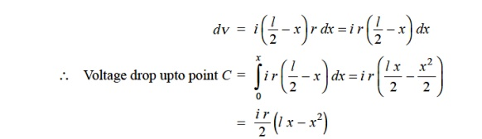
Obviously, the point of minimum potential will be the mid-point. Therefore, maximum voltage drop will occur at mid-point i.e. where x = l/2.
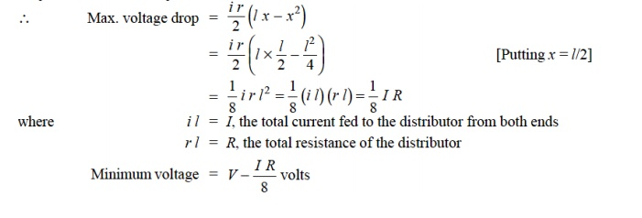
( ii) Distributor fed at both ends with unequal voltages.
Consider a distributor AB of length l metres having resistance r ohms per metre run and with a uniform loading of i amperes per metre run as shown in Fig.1.26. Let the distributor be fed from feeding points A and B at voltages V_{A} and V_{B} respectively. Suppose that the point of minimum potential C is situated at a distance x metres from the feeding point A. Then current supplied by the feeding point A will be * i x.
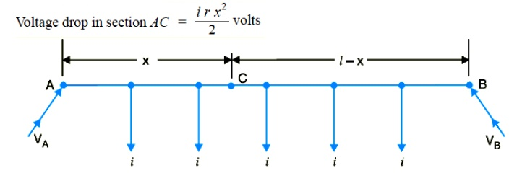
Fig 1.26 Single line diagram of uniformly loaded distributor fed at both ends with equal voltages

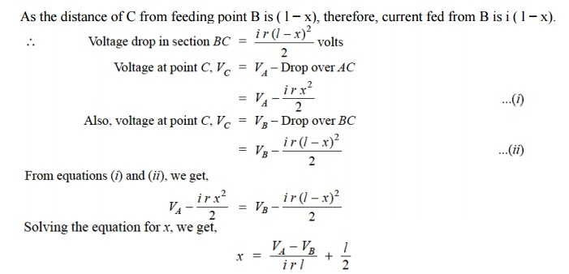
As all the quantities on the right hand side of the equation are known, therefore, the point on the distributor where minimum potential occurs can be calculated.

Long distance power transmission:
Power transmission over long distances using alternating current is complicated by the inductance and capacitance of the line. For satisfactory operation of such lines it is necessary to balance the lagging inductive volt amperes of the line ( I² ωL) against the leading capacitance volt amperes ( V² ω C ). Equating the two we get V/I the impedance of the load. √L/C which is also known as characteristic impedance of the line, Z₀. The corresponding load is thus V²/Z₀ watts per phase or (kV) ²/Z, M W for three phase line where kV is the line voltage in kilo volts. This load is termed as "natural load " on the transmission line. Long distance high power high voltage transmission lines are designed for rated load equal to its natural load.

Natural Loads of transmission lines:

Voltage kV | 132 | 220 | 400
Z₀ (Ω) | 350 | 320 | 290
Natural load, MW | 50 | 150 | 500
Current (A) | 220 | 385 | 752

Conductor Materials of transmission lines:
A material for conducting electric power should have the following properties :
1. High electrical conductivity.
2. Low cost.
3. Low specific gravity.
4. High tensile strength.
Commonly used materials for conductors are:
1. Copper.
2. Aluminium.
3. Aluminium conductor steel Reinforced (ACSR).
4. Galvanized steel.
5. Cadmium copper.

Kelvin's Law:
The most economical area of conductor is that for which the total annual cost of transmission line is minimum.
This is called as Kelvin’s law after Lord Kelvin who first stated in 1881.

Economic Size of conductor:
The most economical size of conductor is that for which the variable part of the annual charges is equal to the cost of energy losses per year.

Limitations of Kelvin's Law:
1. The law assumes a linear relation between the cost on account of interest and depreciation on the capital outlay which is not necessarily always valid. Moreover, it is difficult to calculate these values.
2. Actual energy loss on a transmission line cannot be estimated without actual load curves. Load curves are not available at the planning stages.
3. The conductor size estimated according to this law may not be the optimum as various aspects of safety etc. have not been taken into account.
4. The law does not take into account some of the aspects like safe current destiny, mechanical strength, corona loss etc.
The transmission line cost forms major part in the annual charges of a power system.
The cost is due to
- Depreciation
- Repair and maintenance
- Loss of energy in the line due to its resistance
- The cost towards the production of the lost energy is considered
- If we decreases the area of the conductor in order to reduce the capital cost, the line losses increase.
- Similarly, if we increase the conductor cross-section to save the cost towards copper loss in the line, the weight of copper increases and hence the capital cost will be more.
Because of the above reasons, it is difficult to find the economical size of the conductor. But it becomes easy with the help of Kelvin’s law.
In this post we will understand about the Kelvin’s law and limitations of the kelvin's law. The graphical representation of Kelvin's law is shown in the Fig.1.27
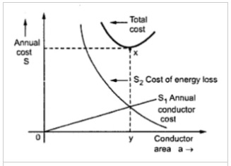
Fig 1.27 The graphical representation of Kelvin’s law
Assume
A = Cross section of conductor
C = total initial cost towards conductor
C is directly proportional to A
C ∝ A
C = PA
where P is a constant.
Let r be the annual rate of interest and depreciation.
The annual fixed cost C₁ = C_{r} = PA_{r}
Since line losses are inversely proportional to the area of the conductor
The annual cost on lost energy,
C₂ = Q/A where Q is a constant.
Total annual cost C = C₁ + C₂
= PA_{r} + Q/A
For C to be minimum,
C/dA = 0
Pr - Q/A² =0
Pr = Q/A²
Pr.A² = Q
A² = Q/Pr
A = √ (Q/Pr)
The equation shows that
"The economical cross-section of the conductor is that for which the annual charge on the conductor equals the annual charge for the loss of energy in the conductor".
This is known as Kelvin's law.
Note: Kelvin's law should not be applied to underground cables and high voltage overhead lines. Kelvin's law may be successfully used for overhead lines of voltage below 30KV.

