Unit-III
SIGNAL ANALYZERS
Rectifier type instruments:

Half Wave Rectifier Circuits of Rectifier Type Instruments:
Let us consider a circuit given below in which the rectifying element is connected in series with sinusoidal voltage source, permanent magnet moving coil instrument and the multiplier resistor.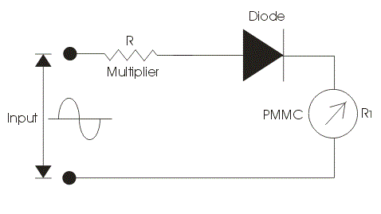
Fig.1. Half Wave Rectifier
The function of this multiplier electrical resistance is to limit the current drawn by the permanent magnet moving coil type of instrument. It is very essential to limit the current drawn by the permanent magnet moving coil instrument because if the current exceeds the current rating of PMMC then it destructs the instrument. Now here we divide our operation in two parts. In first part we apply constant DC voltage to the above circuit. In the circuit diagram we are assuming the rectifying element as ideal one. Let us mark the resistance of multiplier be R, and that of permanent magnet moving coil instrument be R₁.The DC voltage produces a full scale deflection of magnitude I=V/(R+R1) where V is root mean square value of voltage. Now let us consider second case, in this case we will apply AC sinusoidal AC voltage to the circuit V =V_{m} × sin(wt) and we will get the output waveform as shown. In the positive half cycle the rectifying element will conduct and in the negative half cycle it does not conduct. So we will get a pulse of voltage at moving coil instrument which produces pulsating current thus pulsating current will produce pulsating torque. The deflection produced will corresponds to the average value of voltage. So let us calculate the average value of electric current, in order to calculate the average value of voltage we have integrate the instantaneous expression of the voltage from 0 to 2π. So the calculated average value of voltage comes out to be 0.45V.Again we have V is root mean square value of current. Thus we conclude that the sensitivity of the ac input is 0.45 times the sensitivity of DC input in case of half wave rectifier.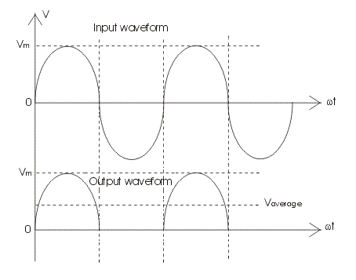
Fig.2. Half Wave Rectifier waveforms

Full Wave Rectifier Circuits of Rectifier Type Instruments:
Let us consider a circuit given below.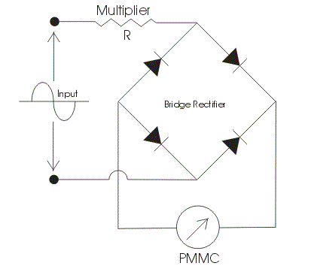
Fig.3. Full Wave Rectifier

We have used here a bridge rectifier circuit as shown. Again we divide our operation into two parts. In the first we analyze the output by applying the DC voltage and in another we apply AC voltage to the circuit. A series multiplier resistance is connected in series with the voltage source which has the same function as described above. Let us consider first case here we apply DC voltage to the circuit. Now the value of full scale deflection current in this case is again V/(R+R₁), where V is the root mean square value of the applied voltage, R is the resistance of the resistance multiplier and R₁ which is the electrical resistance of the instrument. The R and R₁ are marked in the circuit diagram. Now let us consider second case, in this case we will apply ac sinusoidal voltage to the circuit which is given V=V_{m}sin(wt) where V_{m} is the peak value of the applied voltage again if we calculate the value of full scale deflection current in this case by applying the similar procedure then we will get an expression of full scale current as 0 .9V/(R+R1). Remember in order to obtain the average value of voltage we should integrate the instantaneous expression of voltage from zero to π. Thus comparing it DC output we conclude that the sensitivity with ac input voltage source is 0.9 times the as in the case of DC input voltage source.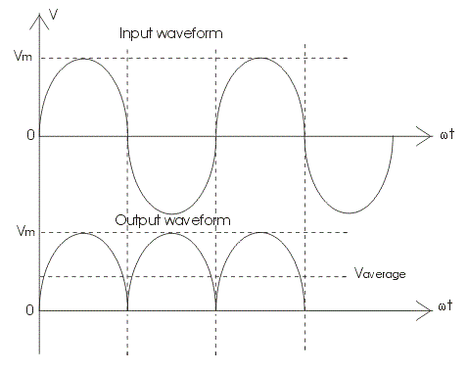
Fig.4. Full Wave Rectifier waveforms

The output wave is shown below. Now we are going to discuss the factors which affect the performance of Rectifier type instruments:
- Rectifier type of instruments is calibrated in terms of root mean square values of sinusoidal wave of voltages and current. The problem is that the input waveform may or may not have same form factor on which the scale of these meter is calibrated.
- There may be some error due to the rectifier circuit as we have not included the resistance of the rectifier bridge circuits in both the cases. The non linear characteristics of bridge may distort the current and voltage waveform.
- There may be variation in the temperature due to which the electrical resistance of the bridge changes hence in order to compensate this kind of errors we should apply multiplier resistor with high temperature coefficient .
- Effect of capacitance of the bridge rectifier: Bridge rectifier has imperfect capacitance thus due to this it bypasses the high frequency currents. Hence there is decrement in the reading.
- The sensitivity of Rectifier type instruments is low in case of ac input voltage.

Advantages of Rectifier Type Instruments
Following are the advantages of the rectifier type of instruments:
The accuracy of rectifier type instrument is about 5 percent under normal operating condition.
The frequency range of operation can be extended to high value.
They have uniform scale on the meter.
They have low operating value of current and voltages.
The loading effect of an ac rectifier voltmeter in both the cases (i.e. half wave diode rectifier and full wave diode rectifier) is high as compared to the loading effects of DC voltmeters as the sensitivity of the voltmeter either using in half wave or full wave rectification is less than the sensitivity of DC voltmeters.
Factors effecting the performance of rectifier type instruments:
- Effect of waveform:
It is clear that these instruments are subjected to waveform errors.
- Effect of temperature changes:
Variation in temperature causes errors.
- Decrease in sensitivity:
Sensitivity of the instrument decreases with an operation of AC
- Effect of rectifier resistance:
As the diode have internal resistance , the output value is not exactly calibrated to the input quantity under measurement.
Advantages of these meters over MI:
- Frequency range can be extended from 20 Hz to as high as Audio frequency range
- Uniform scale can be calibrated
- They have high accuracy
- Power consumption is low.
True RMS Voltmeter :
Complex waveforms voltage magnitude is measured with true RMS voltmeters
AC voltage is applied to any known resistor the heat generated in the resistor is proportional to the square of the R.M.S. voltage.
By amplifying the input voltage under measurement is fed to the thermocouple whose output is proportional to the R.M.S. value of the input voltage.
Using thermocouple arrangement:
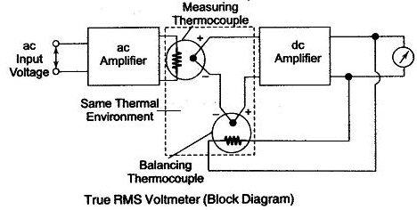
Fig.5. True RMS voltmeter
AC voltage applied to the resistor
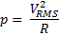
Allows a band of frequencies and rejects all others.
Driver amplifier:
It feeds the attenuated waveform to a high Q active filter.
High Q active filter:
It consists of cascaded arrangement of RC sections and filter amplifiers
The purpose of capacitor ‘C’ is to allow different ranges of pass band frequencies.
The purpose of resistor is to adjust desired frequency in the given pass band frequency.
Finally active filter selects the pass band frequency in which the desired frequency is present.
Meter range attenuator:
It selects the desired frequency signal from pass band frequency and sends them to the output amplifier.
Output amplifer :
It supplies the selected signal of desired frequency to the meter amplifier and output buffer amplifier.
Output buffer amplifier :
It is used to drive the recorder (or) an electronic counter.
The desired frequency signals amplitude coming from meter amplifier is displayed by the voltmeter.
Signal Analyzers:
It is desired to analyse the signal in terms of its amplitude, phase etc., and it is performed by signal analyzer.
It is often desired to measure the amplitude of each harmonic or fundamental individually. This can be performed by instruments called wave analyzers. Different types of signal analyzers are
- wave analyzers
- spectrum analyzers
- distortion analyzers
- audio analyzers
- power analyzers

Wave Analyzer:
These are voltmeters which are tuned to measure the amplitude of the single frequency signal.
Range: 10 Hz to 40 MHz
Spectrum Analyzer:
They display the plot of amplitude vs frequency of a given signal.
Range: 0.02 Hz to 250 GHz

Distortion Analyzer:
They measure the energy present in the signal outside a specified freq. band.
Audio analyzer:
These are like distortion analyzers used for measuring the noise content in the signals
Power analyzer:
These are power associated with a selected frequency of a given signal.
Wave analyzer (Frequency selective wave analyzer):

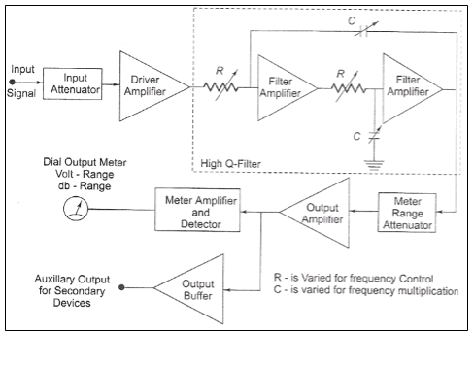
Fig.6. Frequency selective wave analyzer
They calculate the amplitude of a single frequency signal. Components used are attenuators and amplifiers.
Attenuators allow pass band frequency .
Amplifers are of unit gain.
Filters select a particular f requency in the pass band and displays its magnitude.
Wave analyzers are frequency selective voltmeters. Depending on the frequency range of input signal they are classified as AF & HF.
AF are used for frequency range of 20 Hz to 20KHz. Wave analyzers allow narrow band of freq. and provide a high degree of attenuation to all other frequencies.
From the above fig, the input signal is first processed through attenuator. It is a freq range selector which selects single freq. and attenuates remaining frequencies from the signal.

Spectrum analyzer:
It is an instrument representing the plot of amplitudes vs differential frequencies.
- Parallel bank filter analyser
- Swept frequency technique analyser

Signal consists of even and odd harmonics
-Parallel bank filter analyser has many filters connected in parallel, each allowing different frequency. Filters are connected to a meter which displays the amplitudes. Spectrum analyser is a frequency Domain instrument . Amplitude can be linear and are represented as straight line at corresponding freq. each line represents the absolute amplitude of sine wave.

-Swept frequency technique analyser Sweep generator is used.
Spectrum analyzers displays the amplitude of a signal in frequency domain. It provides the frequency on horizontal axis and amplitude on vertical axis .From the graph spectrum analyser gives the absolute amplitude of various frequency components of a signal .
Parallel bank filter analyser:
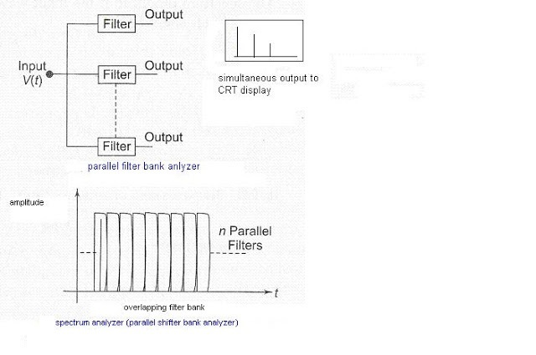
Fig.7. Parallel bank filter analyser
In this various filters are connected parallel to the input system . Each filter is tuned to allow particular frequency only and attenuates all other frequencies.

Swept frequency technique analyser:
Saw tooth voltage is the frequency controlled element of the voltage tuned oscillator . different amplitudes of voltage waveforms generates different pass band freq oscillator whenever component of input signal and oscillator frequency beat together produces a different frequency.
IF AMP:
IF amp allows the different frequency component of the signal in which the input frequency component is present.
Detector:
It is a filter which detects the input frequency signal and applied to the vertical plates of spectrum LRD.
Saw tooth voltage applying to the horizontal plates of CRO provides frequency domain.
Harmonic Distortion Analyser:
Fundamental harmonic suppression type:
A distortion analyser suppresses the fundamental component by means of a high pass filter whose out of frequency is little above the fundamental frequency.
This analyser measures the total harmonic power present in the test wave rather than distortion caused by each component.
This high pass filter allows only harmonic to pass and total harmonic distortion can be measured the other type of distortion analyser based on the fundamental suppression types are as follows:
- Employing a resonance bridge:

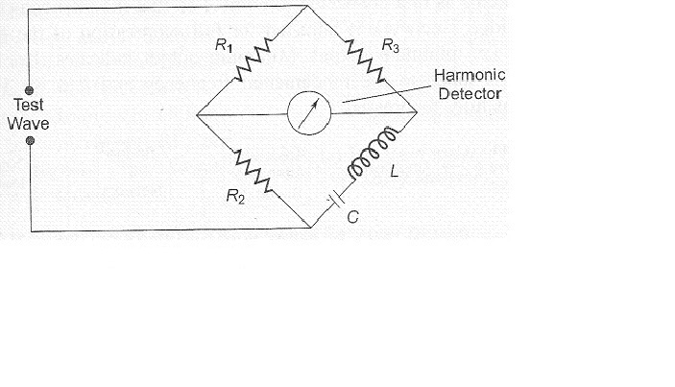
Fig.8. Resonance bridge
For all other harmonics , the detector measures the RMS voltage. RMS detector uses a thermocouple.
- Wien’s bridge method :
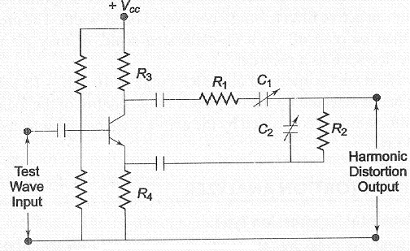
Fig.9 Resonance bridge.
Bridge is balanced for fundamental frequency the energy associated with fundamental frequency dissipates in the elements of circuit only.
For balanced conditions
C₁ = C₂ = C , R₁=R₂=R₃
Harmonic components only can reach the output terminals. The RMS value of all harmonic components can be measured by a metal.
- Bridge T- network method:
R is adjusted from f-f. The energy oscillated with f-f is calculated in the tank circuit. The other frequency components reach at output terminals can be measured.
- Harmonic distortion analyser using bridge T- network:
Bridge T network attenuates are adjusted for fundamental frequency all other frequency components are allowed to pass reach the output metal.
Heterodyne wave analyzers:
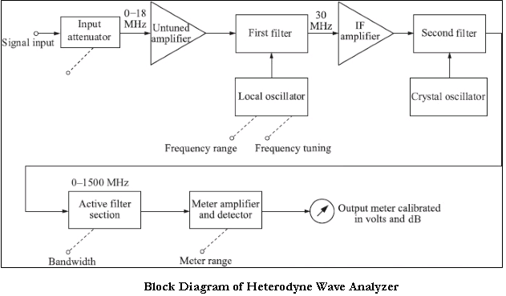
Fig.10. Heterodyne wave analyzers
Two frequencies one known and other unknown are mixed .This is known as heterodyne.
HF wave analyser is used in MHz rane .Heterodying principle is mixing the unknown frequency with the known frequency. From the above block bias input signal is applied to the attenuator. Let F₁ be the freq. of the input signal.
This input signal is mixed with a known frequency of the other signal from the oscillator in mixer 1 ckt. The output of the mixer is sum of two frequencies or different of 2 freq i.e., f₂-f₁is pass band freq. This pass band freq is allowed through (Intermediate freq) IF amplifier. The output of the IF amplifier again compares with the other frequency i.e., f₃ coming from fixed oscillator. Now mixer 2 circuit creates a new pass band frequency range in our desired frequency signal component is present.
Active filter:
Active filter selects the single desired freq of a signal from the pass band freq. range of a signal. The single freq coming out of the active filter is processed through amplifier before displaying in the voltmeter.
These voltmeters display the amplitude of desired single frequency only. For other freq the amplitude showed a zero or null.

Power analyser:
In modern industrial applications a number of electronic appliance are connected to the AC line due to this , it is observed that the input connected to every device may not be clean steady sinusoidal waveform with constant amplitude.
Hence when any device does not work properly ,it is necessary to check the quality of input power. If the power line and appliance are perfect, no power problems could be observed but practically load connected to AC line and power distribution both contribute to power problems power analyser evaluate on power problems and provide complete documents of the test.
Currents in each line and line voltage are sensed using dedicated sensors Cr, Cu, Cv and V_{RY,} V_{YB,} V_{BR} respectively.
These sensed currents and voltages are selected sequentially by a multiplexer. The multiplexer combines all the above signals into a single channel, the output of the mux is connected for an A/D converter these analog signals get converted to digital signals which are given to the micro controller.
According to the program stored in the microcontroller , computations and calculations are done, finally the calculated quantities are displayed using a display unit.
Parameters measured by power analysers:
- Line currents and line voltages
- Power relatives and quantities
- Harmonic analysers of voltage and currents
Oscillators:
Oscillators are the signal resources which provides an output waveform as a output signal .
Classification: oscillators are classified based on
- Frequency range over which they are used.
- Design principles.

- Frequency range:
- Audio frequency oscillator (20 Hz to 20 KHz)
- Radio frequency oscillator (20 KHz to 30 KHz)
- Video frequency oscillator (-dc- 5 MHz)
- High frequency oscillator (1.5 MHz – 30 MHz)
- Very high frequency oscillator (30 – 300 MHz)

Potentiometric recorders:
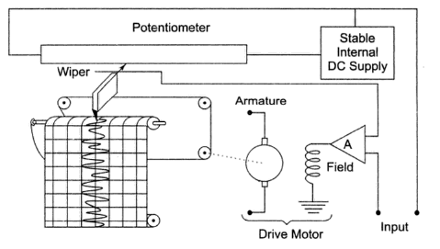
Fig.11. Potentiometric recorders
The difference between the input signal and potentiometer voltage is the error signal. This error signal is amplified and is used to energise the field coil of the dc motor.This error serves as the input to the electronic detector and the amplified error is then fed to the balancing motor.This motor is so connected that it turns in a direction that rotates voltage divider arm to it in the direction that reduces the error.This is achieved by mechanically connecting the wiper arm to the armature of dc motor.The pen is mechanically connected to the wiper.Hence as the wiper moves in a particular direction the pen also moves in synchronism in the same direction there by recording the input waveform.This technique results in graphical recorders having a very high input impedence. A sensitivity of 4V/mm is attained with an error of less than ±0.25% with a bandwidth of 0.8Hz.The above block diagram represents a single point recorder.
Q-Meter
The Q meter is an instrument designed to measure some of the electrical properties of coils and capacitors. The operation of this useful laboratory instrument is based on the characteristics of a series-resonant circuit, i.e., that the voltage across the coil or the capacitor is equal to the applied voltage times the Q of the circuit. If a fixed voltage is applied to the circuit, a voltmeter across the
capacitor can be calibrated to read Q directly.
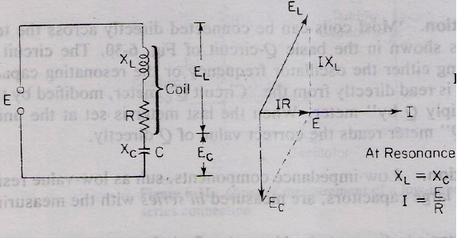
If E is maintained at a constant and known level, a voltmeter connected across the
capacitor can be calibrated directly in terms of the circuit Q as 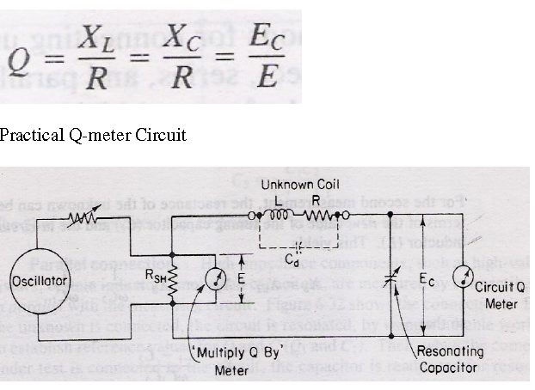
Fig.12. Q- meter circuit.
The wide-range oscillator with a frequency range from 50 kHz to 50 MHz delivers current to a low-value shunt resistance R_{sh}. The value of this shunt is very low, typically on the order of 0.02. It introduces almost no resistance into the oscillatory circuit and it therefore represents a voltage source of magnitude E. With a very small (in most cases negligible) internal resistance. The voltage E across the shunt, corresponding to E in the Fig is measured with a thermocouple meter, marked “Multiply Q by”. The voltage across the variable capacitor, corresponding to EC in the Fig , is measured with an electronic voltmeter whose scale is calibrated directly in Q values. To make a measurement, the unknown coil is connected to the test terminals of the instrument, and the circuit is tuned to resonance either by setting the oscillator to a given frequency and varying the internal resonating capacitor or by
presetting the capacitor to a desired value and adjusting the frequency of the oscillator. The Q reading on the output meter must be multiplied by the index setting of the "Multiply Q by" meter to obtain the actual Q value. The indicated Q (which is the resonant reading on the “Circuit Q" meter) is called the circuit Q, because the losses of the resonating capacitor, voltmeter, and insertion resistor are all included in the measuring circuit. The effective Q of the measured coil will be somewhat greater than the indicated Q. This difference can generally be neglected except in certain cases where the resistance of the coil is relatively small in comparison with the value of the insertion resistor
The inductance of the coil can be calculated from the known values of freq f and capacitance C.

