Transducers:
- A Transducer is a device which converts one form of energy into another form.
- Alternatively, a Transducer is defined as a device which provides usable output response to a specific input measured which may be a physical quantity.
- A Transducer can also be defined as a device when actuated by energy in one system supplies energy in the same form or in another form to a second system.

Classification of Transducers:
- Transducers may be classified according to their application, method of energy conversion, nature of the output signal, and so on.
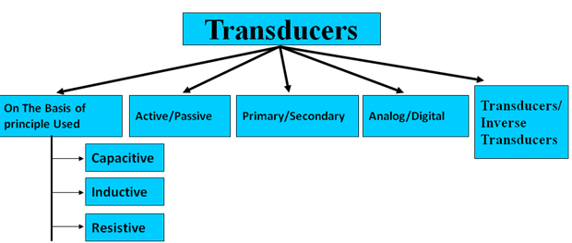
Fig.4.1 Classification of transducers

1. Active and Passive Transducers:
- Active transducers :
These transducers do not need any external source of power for their operation. Therefore they are also called as self generating type transducers.
- The active transducers are self generating devices which operate under the energy conversion principle.
- As the output of active transducers we get an equivalent electrical output signal e.g. temperature or strain to electric potential, without any external source of energy being used.

Classification of Active Transducers:
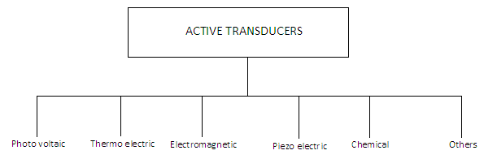
Fig.4.2Active transducers

Example of active transducers:

- Piezoelectric Transducer- When an external force is applied on to a quartz crystal, there will be a change in the voltage generated across the surface. This change is measured by its corresponding value of sound or vibration.
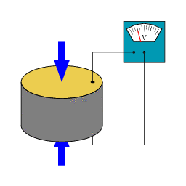
Fig.4.3 simple piezoelectric transducer

Passive Transducers:
- These transducers need external source of power for their operation. So they are not self generating type transducers.
- A DC power supply or an audio frequency generator is used as an external power source.
- These transducers produce the output signal in the form of variation in electrical parameter like resistance, capacitance or inductance.
- Examples – Thermistor, Potentiometer type transducer

2. Primary and Secondary Transducers:

- Some transducers contain the mechanical as well as electrical device. The mechanical device converts the physical quantity to be measured into a mechanical signal. Such mechanical device are called as the primary transducers, because they deal with the physical quantity to be measured. The electrical device then convert this mechanical signal into a corresponding electrical signal. Such electrical device are known as secondary transducers.

Example of Primary and secondary transducer:
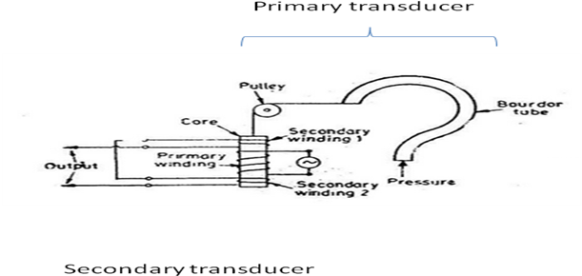
Fig.4.4Bourdan tube
3.According to Transduction principle used:

Capacitive Transduction:

- Here, the measurand is converted into a change in capacitance.
- A change in capacitance occurs either by changing the distance between the two plates or by changing the dielectric.
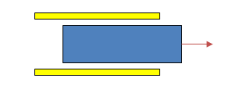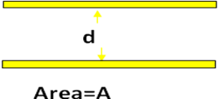
Fig4.5Capacitive transduction

Electromagnetic transduction:
- In electromagnetic transduction, the measurand is converted to voltage induced in conductor by change in the magnetic flux, in absence of excitation.
- The electromagnetic transducer are self generating active transducers
- The motion between a piece of magnet and an electromagnet is responsible for the change in flux

Inductance Transduction:
- In inductive transduction, the measurand is converted into a change in the self inductance of a single coil. It is achieved by displacing the core of the coil that is attached to a mechanical sensing element
Piezoelectric Transduction:
- In piezoelectric transduction the measurand is converted into a change in electrostatic charge q or voltage V generated by crystals when it is mechanically stressed.
Photovoltaic Transduction:
- In photovoltaic transduction the measurand is converted to voltage generated when the junction between dissimilar material is illuminated.
Photovoltaic Transduction:
- In photovoltaic transduction the measurand is converted to voltage generated when the junction between dissimilar material is illuminated.

4.Analog and Digital Transducers:

Analog transducers:
- These transducers convert the input quantity into an analog output which is a continuous function of time.
- Thus a strain gauge, an L.V.D.T., a thermocouple or a thermistor may be called as Analog Transducers as they give an output which is a continuous function of time.
Digital Transducers:
- These transducers convert the input quantity into an electrical output which is in the form of pulses and its output is represented by 0 and 1.

5.Transducer and Inverse Transducer:

Transducer:
- Transducers convert non electrical quantity to electrical quantity.
Inverse Transducer:
- Inverse transducers convert electrical quantity to a non electrical quantity. A piezoelectric crystal acts as an inverse transducer because when a voltage is applied across its surfaces, it changes its dimensions causing a mechanical displacement.

Selection of Transducer:
Selection of a transducer is one of the most important factors which help in obtaining accurate results. Some of the main parameters are given below.
- Selection depends on the physical quantity to be measured.
- Depends on the best transducer principle for the given physical input.
- Depends on the order of accuracy to be obtained.

strain gauge:
A strain gauge is a register used to measure strain on an object. When an external force is applied on an object, due to which there is a deformation occur in the shape of the object. This deformation in the shape either compressive or tensile is called strain, and it is measured by the strain gauge. When an object deforms within the limit of elasticity, either it becomes narrower and longer or it become shorter and broadens. As a result of it, there is a change in resistance end-to-end. The strain gauge is sensitive to that small changes occur in the geometry of an object. By measuring the change in resistance of an object, the amount of induced stress can be calculated. The change in resistance normally has very small value, and to sense that small change, strain gauge has a long thin metallic strip arrange in a zig-zag pattern on a non-conducting material called the carrier, as shown below, so that it can enlarge the small amount of stress in the group of parallel lines and could be measured with high accuracy. The gauge is literally glued onto the device by an adhesive.
Gauge factor
Gauge factor is defined as the ratio of per unit change in resistance to per unit change
in length
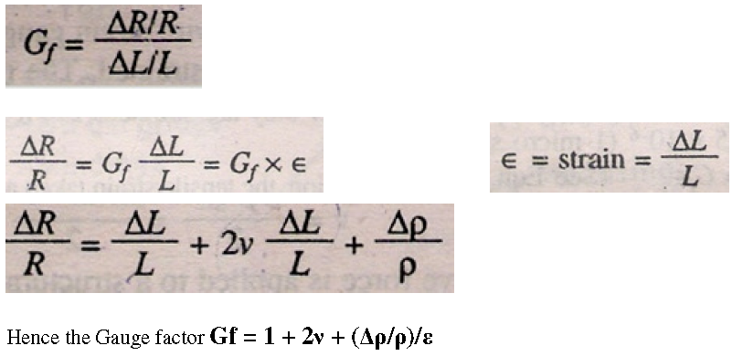
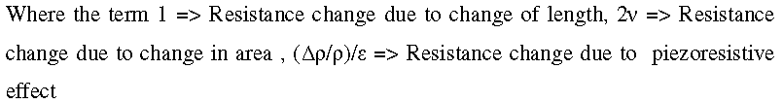
The strain is usually expressed in terms of microstrain. 1 microstrain = 1 μm/m.
If the change in the value of resistivity of a material when strained is neglected, the
gauge factor is :
Gf = 1 + 2v
The common value for Poisson's ratio for wires is 0.3.This gives a gauge factor of 1.6
for wire wound strain gauges. Poisson's ratio for all metals is between 0 & 0.5.This
gives a value of 2.
This class of strain gauges is only an extension of the bonded metal wire strain gauges. The
bonded metal wire strain gauges (Fig. 5) have been completely superseded by bonded metal
foil strain gauges
Bonded Metal Strain Gauge:
The spreading of wire permits a uniform distribution of stress over the grid. The carrier is
bonded with an adhesive material to file specimen under study. This permits a good transfer
of strain from carrier to grid of wires. The wires cannot buckle as they are embedded in a
matrix of cement and hence faithfully follow both the tensile and compressive strains of the
specimen.
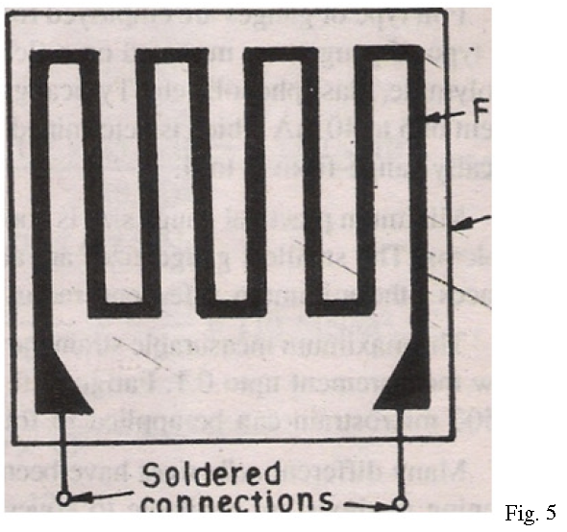
Fig.4.6.Bonded Metal Strain Gauge
Foil type gauges have a much greater heat dissipation capacity as compared with wire
wound strain gauges on account of their greater surface area for the same volume. For this
reason, they can be used for higher operating temperature range. Also the large surface area
leads to better bonding. The sensing elements of foil gauges are formed from sheets less
than 0.005 mm thick by photocopying process, which allow greater flexibility with regard to
shape.

Unbounded Metal Strain Gauge
An unbounded metal strain gauge is shown in Fig.2. This gauge consists of a wire stretched
between two points in an insulating medium such as air. The wires are of copper nickel,
chrome nickel or nickel iron alloys. The flexure element is connected via a rod to a
diaphragm which is used for sensing of pressure. The wires are tensioned to avoid buckling
when they experience a compressive force
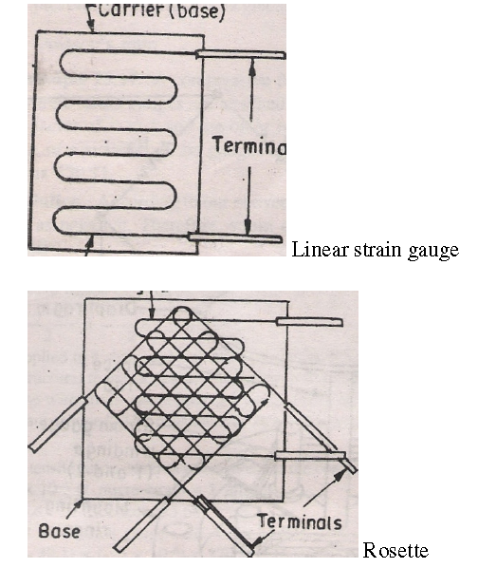

Fig.4.7.Unbonded Metal Strain Gauge

Use of Strain Gauge
- In the field of mechanical engineering development.
- To measure the stress generated by machinery.
- In the field of component testing of aircraft like; linkages, structural damage etc

Displacement Transducers:
Displacement is a basic variable whose value is measured and involved in many other physical parameters such as velocity, force, acceleration, torque and so on. The transducer used for the measurement of displacement can be classified in many ways. One of the most common classifications is given below.
- Mechanical
- Pneumatic
- Electrical
- Optical
In order to obtain an electrical output, a mixture of two or more methods is also used. For example, optical methods using photo-detectors present the output as an electrical quantity like voltage, current and so on. Thus, the combined mechanical and optical method is desired.
Measurements can be made in the direct and indirect way. In direct method, the displacement is measured directly. But indirect methods are mostly used as the associated variables like force, acceleration, torque; velocity and so on can be obtained.
In electrical conversion method, the displacement is converted to an electrical quantity like voltage or current. This value is then recorded or displayed on a screen.
A basic displacement scheme is shown in the figure below.
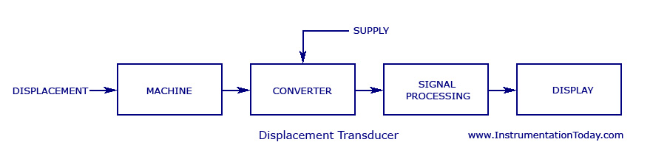
Fig.4.8 Displacement Transducer
Some of the most commonly used methods are listed and explained below. Though some of these methods can be used for the measurement of other physical quantities, the electrical signals derived from such transducers always depend on a displacement parameter.
Thermistor:
Thermistor is a resistance thermometer, similar to a Resistance Temperature Detector (RTD) and is used fortemperature measurement. It consists of a non-metallic resistor that is used as the temperature sensing element.
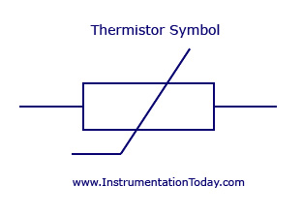
Fig.4.9 Thermistor Symbol
Thermistor is the short form for ‘Thermal Resistor’. The device consists of a bulk semiconductor device that acts as a resistor with a high and negative temperature co-efficient of resistance, sometimes as high as -6% per degree Celsius rise in temperature. Due to this property of high sensitivity (that is, huge resistance change for a small change in temperature), the thermistor is mainly applicable in precision temperature measurement, temperature control, and temperature compensation, especially in a lower temperature range of -100 degree Celsius to +300 degree Celsius.

Difference between Thermistor and Resistance Temperature Detectors (RTD)
Both devices work on the same principle that a constant current flowing through the resistor, and its changing resistance due to change in temperature, is measured as a voltage drop across it. The main difference is that the electrical resistance of the resistor used in a thermistor varies in a non-linear manner with respect to temperature. The sensing element used in the thermistor is made up of either a ceramic or polymer, while RTD uses pure metals as its sensing element. Another major difference is in its operating range. Due to its high sensitivity, thermistors are used in narrow span measurements and low temperature ranges from -20 degree Celsius to +120 degree Celsius. But RTD’s are used over wide and larger temperature ranges.
Construction
The device is manufactured from materials like sintered mixtures of oxides of metals such as manganese, nickel, cobalt, and iron. Their resistances range from 0.4 ohms to 75 mega-ohms and they may be fabricated in wide variety of shapes and sizes. Smaller thermistors are in the form of beads of diameter from 0.15 millimeters to 1.5 millimeters. Such a bead may be sealed in the tip of solid glass rod to form probe which is easier to mount than bead. Alternatively thermistor may be in the form of disks and washers made by pressing thermistor material under high pressure into flat cylindrical shapes with diameter from 3 millimeters to 25 millimeters. Washers may be stacked and placed in series or parallel to increase power disciplining capability.
Characteristic Curve
The resistance versus temperature curve is one of the main characteristics that is used in measurement, control and compensation applications using a thermistor. The characteristics graph is shown below.
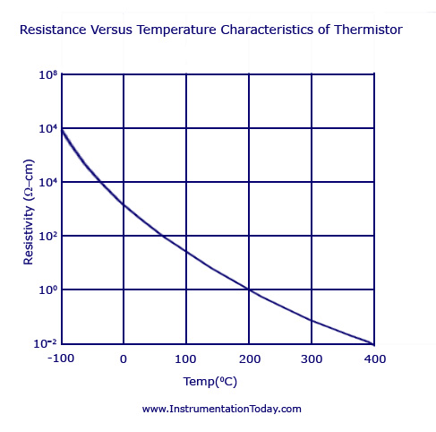
Fig.4.10.Resistance Versus Temperature Characteristics of Thermistor
From the characteristics graph of a typical thermistor, we can see that the resistivity changes from 107 to 1 ohm-cm as the temperature changes from -100 degree Celsius to +400 degree Celsius. This high negative temperature coefficient of resistance makes thermistor an ideal temperature transducer.
Thermistor as Temperature Sensor
A thermistor used for the measurement of temperature is shown in the figure below. The thermistor is designed to have a resistance of 2 kilo-ohms at 25 degree Celsius and temperature coefficient of -4% per degree Celsius will bring a reduction of 80 ohms per degree Celsius change in temperature.
The device is connected in series to a battery and a micrometer. A change in temperature causes a change in the resistance if the thermistor and the corresponding micrometer current reading is noted. Usually, the meter is calibrated in terms of temperature with 0.1 degree Celsius resolution. As shown in the figure, a bridge circuit is also used so as to increase the thermistors sensitivity.
Thermistor Types
For studying about the different types of thermistors, it is important to understand the formula which shows the linear relationship between resistance and temperature.
As a 1st order approximation, the change in resistance is equal to the 1st order temperature co-efficient of resistance times the change in temperature.
dR = k.dT
where, dR – Change in Resistance
k – 1st Order Temperature Coefficient of Resistance
dT – Change in Temperature
If the value of temperature coefficient of resistance (k) is positive, an increase in temperature increases the resistance. Such a device can be called a Posistor or Positive Temperature Coefficient Thermistor (PTC). If the value of k is negative, an increase in temperature will decrease the resistance value. Such a device is called a Negative Temperature Coefficient Thermistor (NTC).
Negative Temperature Coefficient (NTC) Thermistors
NTC Thermistors that are used in industries are broadly classified into two. Thus classification is based on the method by which the electrodes are placed on the ceramic body. This main category could be further divided depending on the different types of geometries, shapes and processing methods. One of the main categories that is most commonly used in the industries is the bead type thermistors. According to the shape and manufacturing methods, bead thermistors can be again classified into Bare Beads, Glass Coated Beads, Ruggedized Beads, and Bead in glass Enclosures and many more.
Another group of NTC Thermistors is the ones with metalized surface contacts. These thermistors can be mounted using spring contacts or by surface mounting.
Applications
- NTC thermistors are used for temperature measurements (usually in a narrow span and low temperature ranges).
- The device can be used to limit the sudden over current that flows in supply circuits. The device is known to have a very high value of resistance in the beginning. The resistance gradually decreases by the heating up of the device. As the resistance decreases, the usual operation of the circuit is restored and the high current flows through it without damaging other parts of the circuit.
- This device is used to measure the temperature of incubators.
- NTC thermistors are used to measure and monitor batteries while they are kept for charging.
- They are used to know the temperature of oil and coolant used inside automotive engines. This information is sent back to the driver through indirect ways.
Thermocouple:
A thermocouple is a temperature sensor that has a pair of dissimilar metals joined together at one end and terminated at the other end. The joined end is called the sensing junction or hot junction and the terminated end is called the reference junction or cold junction. The temperature at the reference junction is called reference temperature and is always maintained constant. When the sensing junction and the reference junction are at different temperatures, a potential difference is obtained and this causes a flow of current in the circuit. The thermoelectric voltage produced is due to the different binding energies of the electrons to the metal ions. This voltage depends on the metals themselves, and in addition on the temperature. The thermal voltage is produced only because of the closed circuit between the two metals. This phenomenon is called “Seebeck Effect”.
The wires must be electrically separated beyond the measuring junction. If the reference junction is kept at a standard temperature, usually 32°F, then a given pair of metals will have a unique variation of EMF as the measuring-junction temperature is changed (note that at 32º F there is no EMF generated). This variation can also be called thermocouple calibration, and is shown in the figure below for its different types.
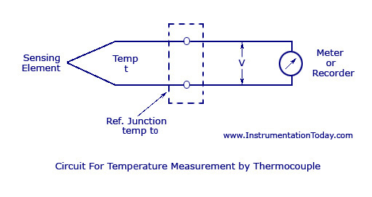
Fig.4.11. Circuit for Temperature Measurement by Thermocouple
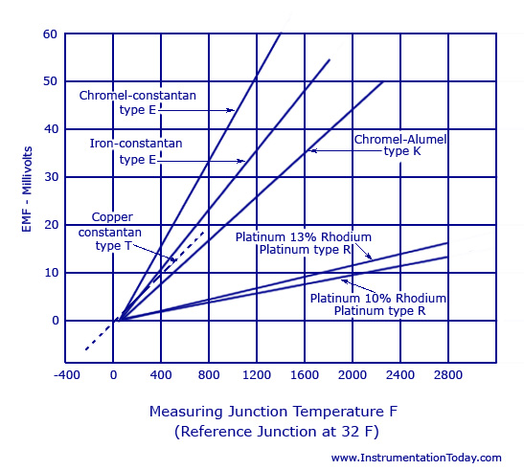
Fig.4.12.Thermocouple Temperature-EMF Graph

Thermocouple Measurement
Thermocouple measurement is explained along with a figure shown below. The figure shows a thermocouple circuit with T2 at 32°F (0° C). This temperature is maintained with the help of an ice-bath reference junction. The thermocouple circuit ends in the ice-bath, the generated EMF flow through standard copper wire until it reaches its final destination, – a millivolt meter type instrument. The millivolt value sensed by this instrument is then converted into a temperature T1. Tables are available for every commercially used thermocouple material combination and they are based on the reference junction temperature of 0°C/32°F.
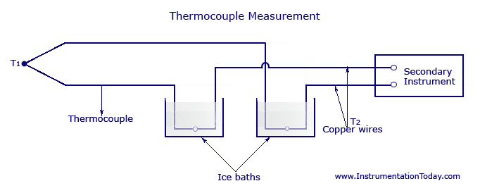
Fig4.13.Thermocouple Measurement
Thermocouple Types
There are a lot of thermocouple material types and these combinations are approved and standardized by the American National Standard ISA MC 96.1: “Temperature Measurement Thermocouples” in USA. The standards must be followed for the different device designations as well as its color coding.
According to ISA MC96.1 standards, the thermocouple can be designated with the different combinations of letters like “E”, “J”, “K”, “T”, ”S”, ”R”. Four of the most popular thermocouple wire combinations are almost always identified by their trade names:
- Thermocouple Type E is a combination of Chromel (Nickel-Chromium) and Constantan (Copper-Nickel).
- Thermocouple Type J is a combination of Iron and Constantan.
- Thermocouple Type K is a combination of Chromel (Nickel-Chromium) and Alumel (Nickel Aluminium).
- Thermocouple Type T is a combination of Copper and Constantan.
- Thermocouple Type S is a combination of Platinum 10% rhodium and Platinum.
- Thermocouple Type R is a combination of Platinum 13% rhodium and Platinum.
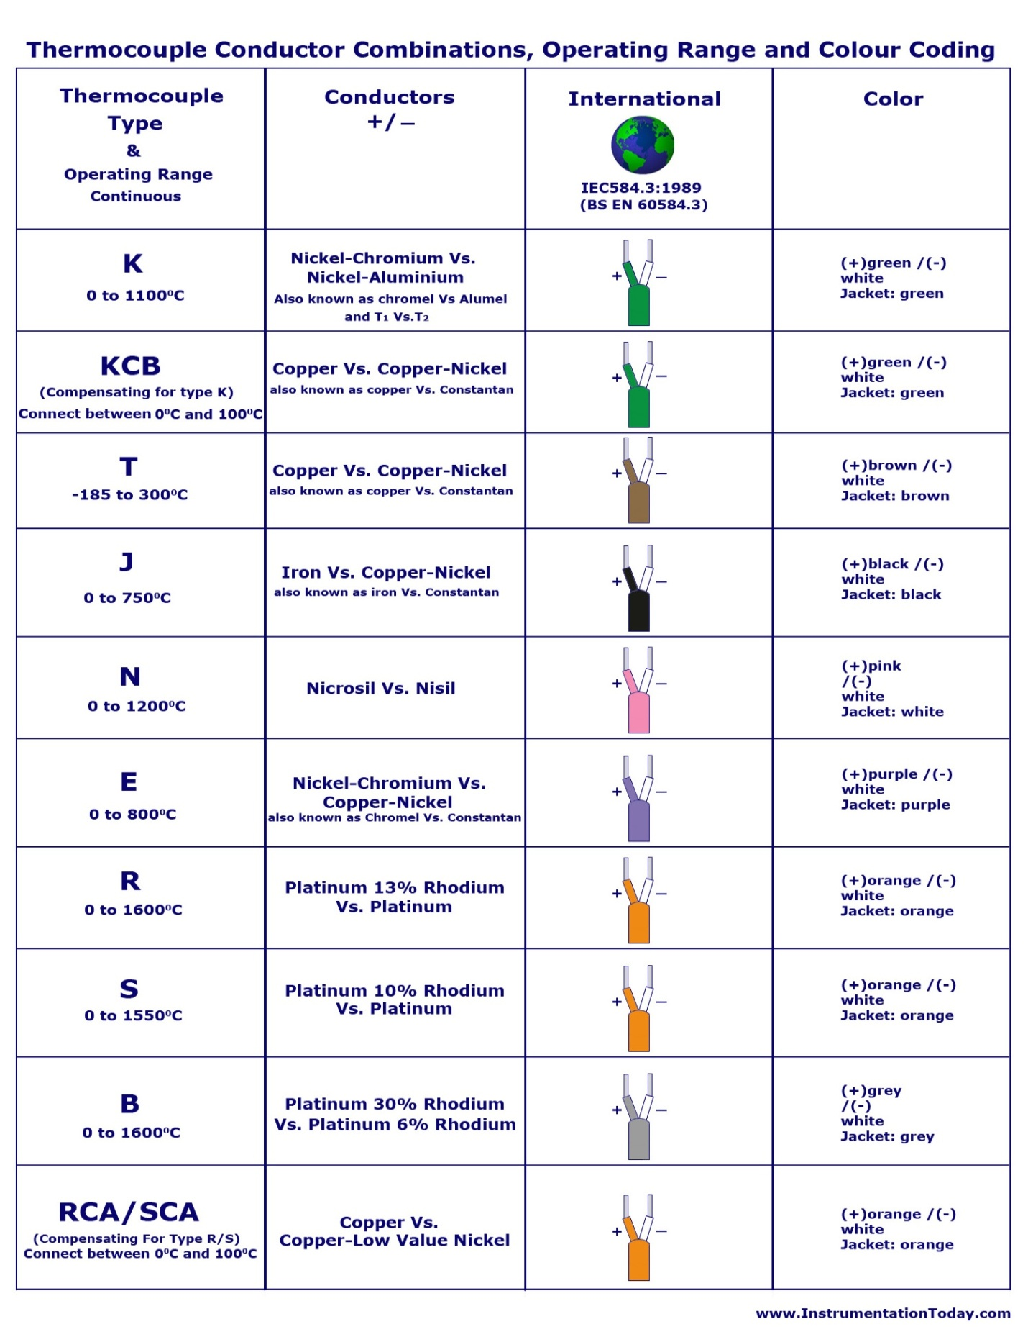
Table 4.1 Different types of Thermocouples
RTD - resistance temperature detector
All metals produce a positive change in resistance with temperature. The requirements of a conductor material to be used in RTDs are :
(i) The change in resistance of material per unit change in temperature should be as large as possible. This implies a metal with a high value of resistivity should be used for RTDs.
ii) The material should have a high value of so that minimum volume of material is used
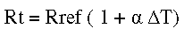
A high value of is desirable in a temperature-sensing element so that a substantial change in resistance occurs for a relatively small change in temperature. This change in resistance (can be measured with a Wheatstone bridge which may be calibrated to indicate the temperature that caused the resistance change rather than the
resistance itself.
Fig. 15 shows the variation of resistance with temperature for several commonly used materials. The graph indicates that the resistance of platinum and copper increases almost linearly with increasing temperature, while the characteristic for nickel is decidedly nonlinear.
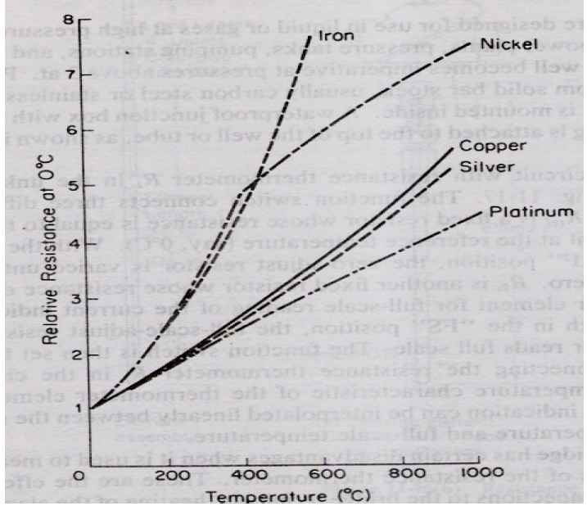
Fig4.14 Resistance vs temperature for RTD
The sensing element of a resistance thermometer is selected according to the intended application. The Table below summarizes the characteristics of the three most commonly used resistance materials. Platinum wire is used for most laboratory work and for industrial measurements of high accuracy. Nickel wire and copper wire are less expensive and easier to manufacture than platinum wire elements, and they are often used in low-range industrial applications.
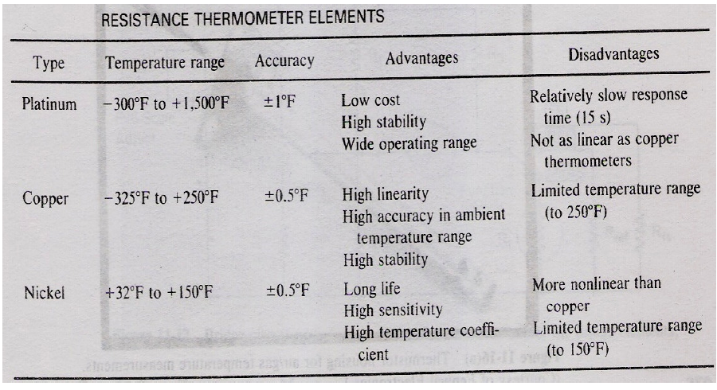
Table 4.1 Resistance temperature elements
To this day platinum is used as the primary element in all high accuracy resistance thermometers. In fact, the platinum resistance temperature detector (PRTD) (see Fig. 17) is used as an interpolation standard from oxygen point (-182.96) to antimony point (630.74 oC). Platinum is especially suited for this purpose, as it can withstand high temperatures while maintaining excellent stability. As a nobel metal, it shows limited susceptibility to
contamination.
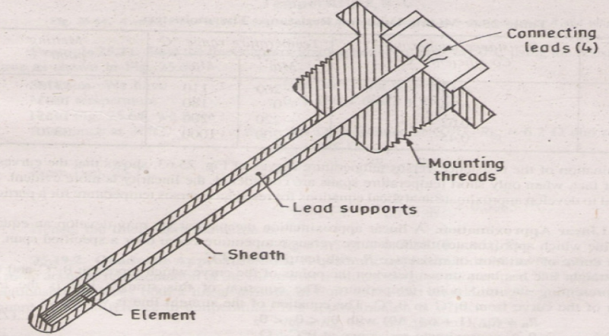
Fig. 4.15. Industrial Platinum Resistance Thermometer

Linear Variable Displacement Transducer (LVDT):
A very basic transducer which is always useful in the field of instrumentation, I have studied about this in my college days. Now let me explain about the LVDT with its Principle of Operation and I will explain how it is constructed for its well known operation and you can understand the working of LVDT.
Principle of LVDT:
LVDT works under the principle of mutual induction, and the displacement which is a non-electrical energy is converted into an electrical energy. And the way how the energy is getting converted is described in working of LVDT in a detailed manner.
Construction of LVDT:
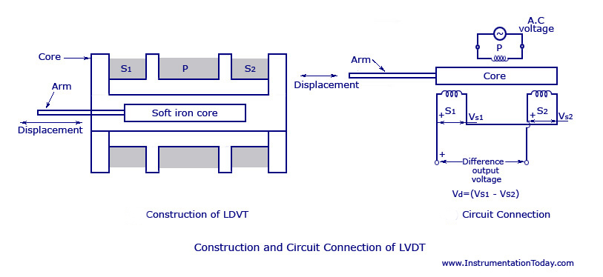
Fig.4.16 construction and circuit connection of LVDT
LVDT consists of a cylindrical former where it is surrounded by one primary winding in the centre of the former and the two secondary windings at the sides. The number of turns in both the secondary windings are equal, but they are opposite to each other, i.e., if the left secondary windings is in the clockwise direction, the right secondary windings will be in the anti-clockwise direction, hence the net output voltages will be the difference in voltages between the two secondary coil. The two secondary coil is represented as S1 and S2. Esteem iron core is placed in the centre of the cylindrical former which can move in to and fro motion as shown in the figure. The AC excitation voltage is 5 to 12V and the operating frequency is given by 50 to 400 HZ.
Working of LVDT:
Let's study the working of LVDT by splitting the cases into 3 based on the iron core position inside the insulated former.
Case 1:
On applying an external force which is the displacement, if the core reminds in the null position itself without providing any movement then the voltage induced in both the secondary windings are equal which results in net output is equal to zero.
i.e., Esec1-Esec2=0
Case 2:
When an external force is applied and if the steel iron core tends to move in the left hand side direction then the emf voltage induced in the secondary coil is greater when compared to the emf induced in the secondary coil 2. Therefore the net output will be Esec1-Esec2
Case 3:
When an external force is applied and if the steel iron core moves in the right hand side direction then the emf induced in the secondary coil 2 is greater when compared to the emf voltage induced in the secondary coil 1. therefore the net output voltage will be Esec2-Esec1
Advantages of LVDT:
* Infinite resolution is present in LVDT
* High output
* LVDT gives High sensitivity
* Very good linearity
* Ruggedness
* LVDT Provides Less friction
* Low hysteresis
* LVDT gives Low power consumption.
Disadvantages of LVDT:
* Very high displacement is required for generating high voltages.
* Shielding is required since it is sensitive to magnetic field.
* The performance of the transducer gets affected by vibrations
* It is greatly affected by temperature changes.
Applications of LVDT:
1.LVDT is used to measure displacement ranging from fraction millimeter to centimeter.
2.Acting as a secondary transducer, LVDT can be used as a device to measure force, weight and pressure, etc..

Piezoelectric Transducer:

A piezoelectric crystal transducer/sensor is an active sensor and it does not need the help of an external power as it is self-generating. It is important to know the basics of a piezoelectric quartz crystal and piezoelectric effect before going into details about the transducer.

Piezoelectric Quartz Crystal
A quartz crystal is a piezoelectric material that can generate a voltage proportional to the stress applied upon it. For the application, a natural quartz crystal has to be cut in the shape of a thin plate of rectangular or oval shape of uniform thickness. Each crystal has three sets of axes – Optical axes, three electrical axes OX1, OX2, and OX3 with 120 degree with each other, and three mechanical axes OY1,OY2 and OY3 also at 120 degree with each other. The mechanical axes will be at right angles to the electrical axes. Some of the parameters that decide the nature of the crystal for the application are
- Angle at which the wafer is cut from natural quartz crystal
- Plate thickness
- Dimension of the plate
- Means of mounting

Piezoelectric Transducer
The main principle of a piezoelectric transducer is that a force, when applied on the quartz crystal, produces electric charges on the crystal surface. The charge thus produced can be called as piezoelectricity. Piezo electricity can be defined as the electrical polarization produced by mechanical strain on certain class of crystals. The rate of charge produced will be proportional to the rate of change of force applied as input. As the charge produced is very small, a charge amplifier is needed so as to produce an output voltage big enough to be measured. The device is also known to be mechanically stiff. For example, if a force of 15 kiloN is given to the transducer, it may only deflect to a maximum of 0.002mm. But the output response may be as high as 100KiloHz.This proves that the device is best applicable for dynamic measurement.
The figure shows a conventional piezoelectric transducer with a piezoelectric crystal inserted between a solid base and the force summing member. If a force is applied on the pressure port, the same force will fall on the force summing member. Thus a potential difference will be generated on the crystal due to its property. The voltage produced will be proportional to the magnitude of the applied force.
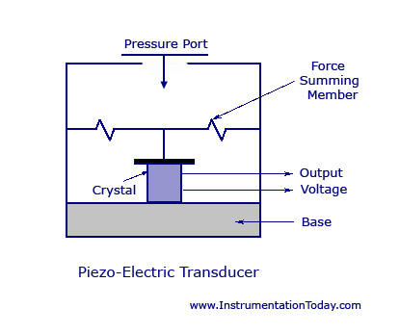
Fig.4.17.Piezoelectric Transducer

Piezoelectric Transducer can measure pressure in the same way a force or an acceleration can be measured. For low pressure measurement, possible vibration of the amount should be compensated for. The pressure measuring quartz disc stack faces the pressure through a diaphragm and on the other side of this stack, the compensating mass followed by a compensating quartz.

Applications
- Due to its excellent frequency response, it is normally used as an accelerometer, where the output is in the order of (1-30) mV per gravity of acceleration.
- The device is usually designed for use as a pre-tensional bolt so that both tensional and compression force measurements can be made.
- Can be used for measuring force, pressure and displacement in terms of voltage.

Advantages
- Very high frequency response.
- Self generating, so no need of external source.
- Simple to use as they have small dimensions and large measuring range.
- Barium titanate and quartz can be made in any desired shape and form. It also has a large dielectric constant. The crystal axis is selectable by orienting the direction of orientation.

Disadvantages
- It is not suitable for measurement in static condition.
- Since the device operates with the small electric charge, they need high impedance cable for electrical interface.
- The output may vary according to the temperature variation of the crystal.
- The relative humidity rises above 85% or falls below 35%, its output will be affected. If so, it has to be coated with wax or polymer material.

Capacitive Transducers
To learn about a capacitive transducer, it is important to know the basics of a parallel plate capacitor. Being the simplest form of a capacitor, it has two parallel conducting plates that are separated to each other by a dielectric or insulator with a permittivity of Ε (for air). Other than paper, vacuum, and semi-conductor depletion region, the most commonly used dielectric is air.
Due to a potential difference across the conductors, an electric field develops across the insulator. This causes the positive charges to accumulate on one plate and the negative charges to accumulate on the other. The capacitor value is usually denoted by its capacitance, which is measured in Farads. It can be defined as the ratio of the electric charge on each conductor to the voltage difference between them.
The capacitance is denoted by C. In a parallel plate capacitor, C = [A*Er*9.85*10¹² F/M]/d
A – Area of each plate (m)
d – Distance between both the plates (m)
Er – Relative Dielectric Constant
The value 9.85*10¹² F/M is a constant denoted by Eo and is called the dielectric constant of free space.
From the equation it is clear that the value of capacitance C and the distance between the parallel plates,d are inversely proportional to each other. An increase of distance between the parallel plates will decrease the capacitance value correspondingly. The same theory is used in a capacitive transducer. This transducer is used to convert the value of displacement or change in pressure in terms of frequency.
As shown in the figure below, a capacitive transducer has a static plate and a deflected flexible diaphragm with a dielectric in between. When a force is exerted to the outer side of the diaphragm the distance between the diaphragm and the static plate changes. This produces a capacitance which is measured using an alternating current bridge or a tank circuit.
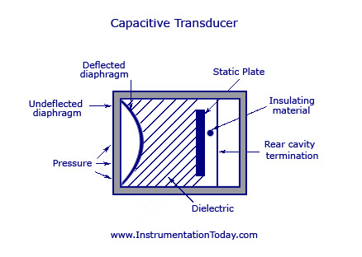
Fig4.18.Capacitive Transducer
A tank circuit is more preferred because it produces a change in frequency according to the change in capacitance. This value of frequency will be corresponding to the displacement or force given to the input.

Advantages
- It produces an accurate frequency response to both static and dynamic measurements.

Disadvantages
- An increase or decrease in temperature to a high level will change the accuracy of the device.
- As the lead is lengthy it can cause errors or distortion in signals.

Magnetostrictive Transducer
Magnetostriction
Magnetostriction can be explained as the corresponding change in length per unit length produced as a result of magnetization. The material should be magnetostrictive in nature. This phenomenon is known as Magnetostrictive Effect. The same effect can be reversed in the sense that, if an external force is applied on a magnetostrictive material, there will be a proportional change in the magnetic state of the material. This property was first discovered by James Prescott Joule by noticing the change in length of the material according to the change in magnetization. He called the phenomenon as Joule effect. The reverse process is called Villari Effect or Magnetostrictive effect. This effect explains the change in magnetization of a material due to the force applied. Joule effect is commonly applied in magnetostrictive actuators and Villari effect is applied in magnetostrictive sensors.
This process is highly applicable as a transducer as the magnetostriction property of a material does not degrade with time.
Magnetostriction Transducers
A magnetostriction transducer is a device that is used to convert mechanical energy into magnetic energy and vice versa. Such a device can be used as a sensor and also for actuation as the transducer characteristics is very high due to the bi-directional coupling between mechanical and magnetic states of the material.
This device can also be called as an electro-magneto mechanical device as the electrical conversion to its appropriate mechanical energy is done by the device itself. In other devices, this operation is carried out by passing a current into a wire conductor so as to produce a magnetic field or measuring current induced by a magnetic field to sense the magnetic field strength.
Working
The figure below describes the exact working of a magnetostrictive transducer. The different figures explain the amount of strain produced from null magnetization to full magnetization. The device is divided into discrete mechanical and magnetic attributes that are coupled in their effect on the magnetostrictive core strain and magnetic induction.
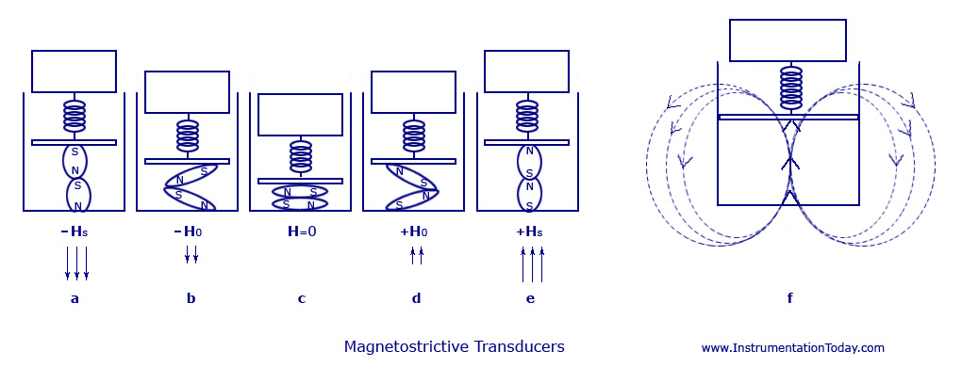
Fig4.19.Magnetostrictive Transducers
First, considering the case where no magnetic field is applied to the material. This is shown in fig.c. Thus, the change in length will also be null along with the magnetic induction produced. The amount of the magnetic field (H) is increased to its saturation limits (±Hsat). This causes an increase in the axial strain to “esat”. Also, there will be an increase in the value of the magnetization to the value +Bsat (fig.e) or decreases to –Bsat (fig.a). The maximum strain saturation and magnetic induction is obtained at the point when the value of Hs is at its maximum. At this point, even if we try to increase the value of field, it will not bring any change in the value of magnetization or field to the device. Thus, when the field value hits saturation, the values of strain and magnetic induction will increase moving from the center figure outward.
Let us consider another instance, where the value of Hs is kept fixed. At the same time, if we increase the amount of force on the magnetostrictive material, the compressive stress in the material will increase on to the opposite side along with a reduction in the values of axial strain and axial magnetization.
In fig.c, there are no flux lines present due to null magnetization. Fig.b and fig.d has magnetic flux lines in a much lesser magnitude, but according to the alignment of the magnetic domains in the magnetostrictive driver. Fig.a also has flux lines in the same design, but its flow will be in the opposite direction. Fig.f shows the flux lines according to the applied field Hs and the placing of the magnetic domains. These flux fields produced are measured using the principle of Hall Effect or by calculating the voltage produced in a conductor kept in right angle to the flux produced. This value will be proportional to the input strain or force.
Applications
The applications of this device can be divided into two modes. That is, one implying Joule Effect and the other are Villari Effect.
- In the case where magnetic energy is converted to mechanical energy it can be used for producing force in the case of actuators and can be used for detecting magnetic field in the case of sensors.
- If mechanical energy is converted to magnetic energy it can be used for detecting force or motion.

