Flow meter:

Electromagnetic Flow meter:
It is difficult to measure and meter flowing fluids with accuracy. A category of flowmeter such as induction flowmeter or magnetic flowmeter can be used to measure the flow of the liquid, if the liquid has a conducting property to a certain extent. An electromagnetic flowmeter can be used to measure the flow of fluids like corrosive acids, acid slurries, paper pulp, detergents, beer, and so on.
The parameter used for the measurement of flow is the speed of flow, and is measured in terms of the potential difference induced when the moves in a tubing/pipe with a transverse magnetic field impressed. The working of an electromagnetic flowmeter can be understood from the figure below.
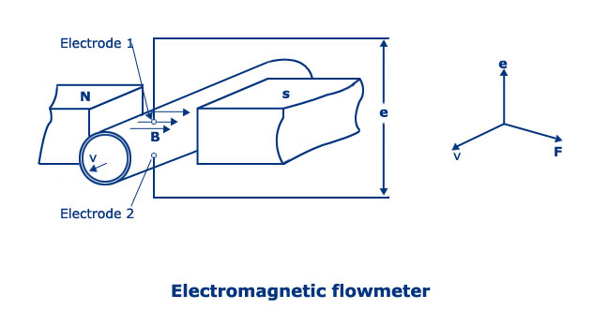
Fig.5.1.Electromagnetic Flowmeter
Suppose the flow of liquid whose conductivity is atleast about 10⁻⁵ S/cm and is flowing through an insulating tube of diameter‘d’ and is placed in a magnetic field of flux density ‘B’, then to a pair of electrodes mounted perpendicular both to the magnetic field and fluid, as shown in the figure above, a voltage ‘e’ is induced which is dependent on the flux density and liquid flowing velocity v, according to Faraday’s law.
Thus,
E = -B.d.v * 10⁻⁸ V
The equation written above can also be obtained in a generalized way through Lorentz force which deflects the charge carriers in the fluid as the conductor in the magnetic field. The force F is given as
F = c. (v*B)
An insulating pipe is usually chosen to avoid short-circuiting and a non-magnetic pipe is selected for allowing the magnetic field to penetrate through the liquid. A plastic tube or a metal tube lined with neoprene is well suited. Some other materials that are used for lining are Teflon (PTFE), polyurethane, ceramic (99.5% Al₂O₃) base, and polysulphate. These are chosen also on the basis of process fluids, their corrosivity, temperature, and so on. The electrodes are usually of stainless steel mounted flush with the inside face of the tube. Titanium, tantalum, hastelloy have also been used.
The plane of the measuring electrodes is generally chosen to be vertical such that the formation of air bubbles or deposition of non-conducting solids does not break the electrical circuit.
As the measured quantity is in volts and since its magnitude is small, parasitic effects are to be carefully considered. Suitable amplifiers are necessary to amplify the signal. The input impedance of the amplifiers are to be properly selected since the liquid resistance between the electrodes for small conductivity liquids are larger than usual.

Ultrasonic Flowmeter:
When pressure waves are released into the flowing fluid, their velocity and amplitude are affected by the fluid velocity. Ultrasonic flowmeters help in measuring these pressure wave changes, especially in the ones having frequencies greater than 20KiloHertz using specialized techniques. There are two types of ultrasonic flowmeters. One of them is based on the measurement of phase shift between the waves directed downstream and upstream alternately. The other one is based on the measurement of separation of frequency of oscillation directed downstream and upstream simultaneously.
The working of Ultrasonic flow measurement system by measuring phase difference is shown in the figure below. The two peizo-crystals p1 and p2 working both as transmitter and receiver of signals alternatively are mounted conveniently, so that the ultrasonic signals are transmitted between them as well as through the liquid. Switch ‘sw’ is utilized to supply p1 and p2 alternately from an oscillator simultaneously connecting the detector to p2 and p1 respectively. The detector is designed to measure the transit time from upstream to downstream and vice versa via phase shift measurement. If C is the velocity of the ultrasonic wave and v is the fluid velocity, then for a distance b between the crystals pa and p2, the phase shifts between the two cases are
Pd1 = wb/(C + v) and
Pd2 = wb/(C – v)
Phase shift difference is proportional to the liquid flow rate.
Pd2 – Pd1 = 2wvb/ {(C-v)(C+v)} = 2wvb/C²
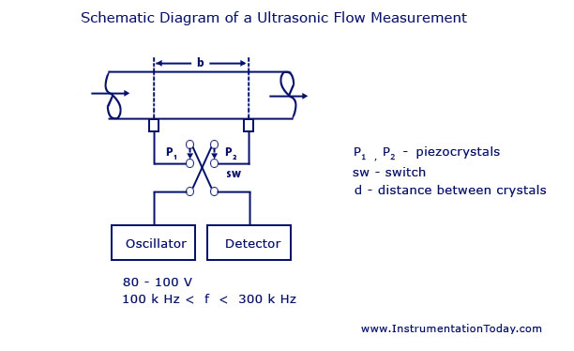
Fig.5.2.Ultrasonic Flow Measurement using Phase Difference
The measurement through this method using the phase shift method provides the instrument good linearity. The dynamic response is limited by the switching frequency. Material of the flow channel should be chosen not to allow acoustic transmission. Plastic is often chosen for the purpose.
The phase measurement flow system has also been used with inter digital transducers. Acoustic wave is transmitted and received across the flow line by two output transducers, one upstream and anther downstream equidistant from the transmitter. The transmitter has uniformly spaced metallic fingers for radiating the sound wave into the liquid from a solid-liquid boundary without focusing on either direction. Some transducers can act as receivers as well.

Displacement Transducers:
Displacement is a basic variable whose value is measured and involved in many other physical parameters such as velocity, force, acceleration, torque and so on. The transducer used for the measurement of displacement can be classified in many ways. One of the most common classification is given below.
- Mechanical
- Pneumatic
- Electrical
- Optical
In order to obtain an electrical output, a mixture of two or more methods is also used. For example, optical methods using photo-detectors present the output as an electrical quantity like voltage, current and so on. Thus, the combined mechanical and optical method is desired.
Measurements can be made in the direct and indirect way. In direct method, the displacement is measured directly. But indirect methods are mostly used as the associated variables like force, acceleration, torque, velocity and so on can be obtained.
In electrical conversion method, the displacement is converted to an electrical quantity like voltage or current. This value is then recorded or displayed on a screen.
A basic displacement scheme is shown in the figure below.
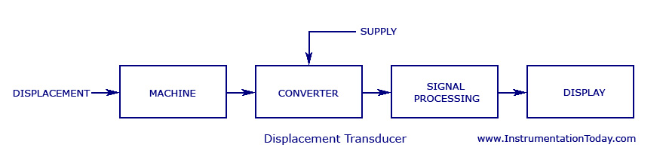
Fig5.3. Displacement Transducer
Some of the most commonly used methods are listed and explained below. Though some of these methods can be used for the measurement of other physical quantities, the electrical signals derived from such transducers always depend on a displacement parameter.
  - Linear Potentiometer Transducer
  - Linear Motion Variable Inductance Transducer
  - Proximity Inductance Transducer
  - Capacitive Transducer
  - Linear Voltage Differential Transformer (LVDT)
  - Piezoelectric Transducer
  - Photo-ElectricTransducers

Photo-Electric Transducers
Before explaining about the different photo-electric transducers, it is important to know the basics of photo-electric effect.
Photo-Electric Effect – It can be explained as the electric current produced when a light of certain intensity strikes on a piece of metal. The energy contained in the light is transferred to the surface of the metal and thus produce a movement of electrons. This movement produces a current. This effect cannot be produced by all colors in the spectrum. A
bright red colored light will not produce a current flow in the metal. But, a dim blue light can cause current flow. Thus, the only way to decide the colors producing the photo-electric effect is through the concept of photons. The idea was brought forward by Albert Einstein, and according to him, light is made up of small packets of energy that had the behavior of particles. These packets of energy were named photons. A red light does not move the electrons, as their individual photons does not have much energy. But a blue light can move electrons as their individual photons have more energy than that of red light. The electrons thus emitted in this manner are called photo electrons.
Some of the most commonly used displacement transducers through the application of photo-electric effect are explained below.
1. Vacuum Photo-Tube as Transducer
A schematic of the vacuum photo-tube transducer is shown in the figure below.
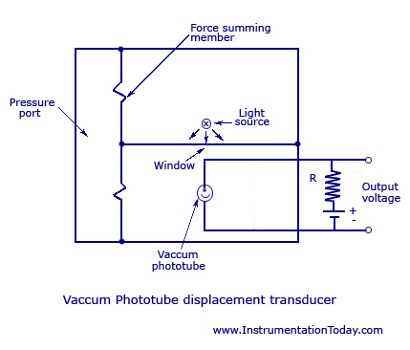
Fig.5.4.Vaccum Photo-Tube Transducer
A displacement produced will modulate or change the intensity of the light intensity of the light incident on the photo-cathode. This changes the amount of voltage and thus, the proportional anode current is given to the resistor R. This changes the output voltage. The output voltage produced will be proportional to the amount of displacement given as input. This transducer is appropriate when there is an availability of a stable light source or an ac modulated light.
Advantages
- Efficiency is fairly high.
- Can take both static and dynamic measurements.
Disadvantages
- Stability is achieved only for a short period.
- If the light variations are subjected to high temperatures, there will be very little response.
- Only suitable for applications having large displacements.
2. Photo-Diode as Transducer
The circuit for a photo-diode transducer is shown below.
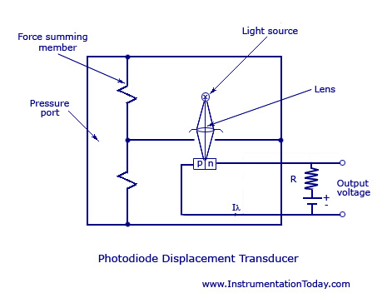
Fig5.5.Photo-Diode Transducer
The arrangement is almost same as a photo-tube transducer except that the photo-tube has been replaced by a photo-diode and the lens has been replaced to make the light strike on the junction of the photo-diode. When a displacement is produced, it provides a force on the summing member and thus changes the quantum of light intensity incident on the photo-diode junction. The proportional change in anode voltage produces a current in the resistor R. Thus, an output voltage is produced which will be proportional to the displacement given as input.
3. Photo-Conductor as Transducer
The circuit is the same as a vacuum photo-tube arrangement except that the photo-conductor is placed instead of a photo-tube. The displacement causes a unique light intensity incident on the photo-conductor and causes a variation in current through resistor R. Hence the output voltage produced will be a linear function of the displacement produced. This device is not used much as the sensitivity produced remains stable only at the beginning and becomes poor at high frequencies.
4. Photo-Voltage Cell as Transducer
This device has great applications in electronic instrumentation and control circuits as it is an active transducer and needs no associated energy source. According to the light intensity striking on the photo-voltage cell, it illuminates and produces a small proportional voltage. The circuit diagram is the same as that given above except that the photo-tube is replaced by photo-voltaic cell and the source for voltage is taken away. The working is also the same as that explained above and it can be calibrated according to the amount of displacement produced.
Measurement of Liquid Level:-
Liquid level refers to the position or height of a liquid surface above a datum line. Level measurements are made to a certain quantity of the liquid held within a container. Level offers both the pressure and rate of flow in and out of the container and as such its measurement and control is an important function in a variety of processes. The task of liquid level measurement may be accomplished by direct methods and indirect methods.
(i) CAPACITIVE LIQUID LEVEL SENSOR:
Fig.5.6.CAPACITIVE LIQUID LEVEL SENSOR
The principle of operation of capacitance level indicator is based upon the familiar capacitance equation of a parallel plate capacitor given by:
C= K (A/D)
where, C = Capacitance, in farad K = Dielectric constant A = area of plate, in 2 D= Distance between two plates in m.
Therefore, it is seen from the above elation that if A and D are constant, then the capacitance of a capacitor is directly proportional to the dielectric constant, and this principle is utilized in the capacitance level indicator. Figure shows a capacitance type Liquid level indicator. It consists of an insulated capacitance probe (which is a metal electrode) firmly fixed near and parallel to the maul wall of the tank If liquid in the tank is non-inductive, the capacitance probe and the tank wall form the plates of a parallel plate capacitor and liquid in between them acts as the dielectric. If liquid is conductive, the capacitance probe and liquid form the plates of the capacitor and the insulation of the probe acts as the dielectric. A capacitance measuring device is connected with the probe and the tank wall, which is calibrated in terms of the level of liquid in the tank.
Ultrasonic method:
Fig.5.7.Ultrasonic level detector
Ultrasonic liquid level works on the principle of reflection of the sound wave from the surface of the liquid. The schematic arrangement of liquid level measurement by ultrasonic liquid level gauge is illustrated above. The transmitter ‘T’ sends the ultrasonic wave towards the free surface of the liquid. The wave gets reflected from the surface. The reflected waves received by the receiver ‘R’. The time taken by the transmitted wave to travel to the surface of the liquid and then back to the receives gives the level of the liquid. As the level of the liquid reaches the time taken to reach the surface of the liquid and then back to receiver also changes. Thus the change in the level of the liquid are determined accurately.
Advantages:- 1. 2. Operating principle is very simple. It can be used for various types of liquids and solid substances. Disadvantages:- 1. 2. Very expensive. Very experienced and skilled operator is required for measurement.

MAGNETIC TYPE LEVEL INDICATORS:
Fig.5.8MAGNETIC TYPE LEVEL INDICATOR
These are used for measuring the toxic and corrosive liquids. It is used to measure the level of liquids which contain corrosive and toxic materials.
It contains a float in which a magnet is arranged and is placed in the chamber, whose liquid level is to be determined. The float moves up and down with the increase and decrease in the level of liquid respectively. A magnetic shielding device and an indicator containing small wafers arranged in series and attached to the sealed chamber. These wafers are coated with luminous paint and rotate 180*. As the level changes the float moves (along with the magnet) up and down. Due to this movement of magnet, wafers rotate and present a black coloured surface for the movement of float in opposite direction.

Humidity:
The amount of water vapour contained in air or gas is called as humidity. It is usually measured as absolute humidity, relative humidity or due point temperature.

Dry air:
When there is no water vapour contained in the atmosphere, it is called dry air.

Moist air
When there is water vapour present in the atmosphere, it is called moist air.

Saturated air
Saturated air is the moist air where the partial pressure of water-vapour equals the saturation pressure of steam corresponding to the temperature of air.

Absolute humidity:
It is the mass of water vapour present per unit volume. In other words, it is the quantity of the water vapour present in air and its unit is grams per cubic meter of air.

Relative humidity RH:
Relative humidity = (water vapour pressure actually present)/(water vapour pressure required of saturation)at a given.
Here a comparison is made between the humidity of air and humidity of saturated air at the same temperature and pressure. It should be noted that if relative humidity is 100%, it is saturated air. That is, the air contains all the moisture it can hold. It should also be noted that the degree of saturation (percentage of relative humidity) of air keeps on changing with temperature.
HYGROMETER:

A hygrometer an instrument used for measuring the moisture content in the atmosphere. Humidity measurement instruments usually rely on measurements of some other quantity such as temperature, pressure, mass or a mechanical or electrical change in a substance as moisture is absorbed. By calibration and calculation, these measured quantities can lead to a measurement of humidity. Modern electronic devices use temperature of condensation, or changes in electrical capacitance or resistance to measure humidity differences.

Resistive Hygrometer:
Variations in ambient relative humidity produce variations in resistance. This occurs in certain moisture-sensitive materials such as hygroscopic salts and carbon powder. In resistive hygrometer sensors, these materials are applied as a film over an insulating substrate and are terminated by metal contacts. The components of a resistive hygrometer sensor are represented below. As air passes over the film, changes in resistance vary with changes in relative humidity. Pictured below on the left are two resistive hygrometer sensors. Notice their small size.

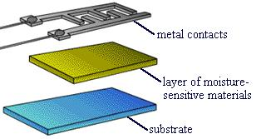

Fig.5.9.Resistive Hygrometer

Capacitive Hygrometer
Capacitive hygrometer sensors use a capacitor that is sensitive to the amount of water vapor in the air to measure humidity.
A capacitor is composed of two adjacent metal plates insulated from each other by a dielectric. The capacitance depends on the area of the plates and the distance between them. In capacitive hygrometer sensors, changes in the amount of water vapor in the air alter the capacitance. This change in capacitance is proportional to a change in relative humidity. There are two types of capacitance hygrometer sensors: thin-film polymer sensors, such as the one in the picture below, and aluminum-oxide sensors.

Equipment Design
Thin-film polymer sensors generally have four layers, shown in the schematic. The bottom layer is a glass or silicon substrate that acts as the support for the capacitor. A metal electrode is placed on the substrate and covered with a thin film of polymer. The thin-film polymer is then coated with a porous metal layer, which is the top electrode. The water vapor travels through the porous metal layer and is absorbed by the polymer, changing its capacitance. The change in capacitance is proportional to the change in the relative humidity.
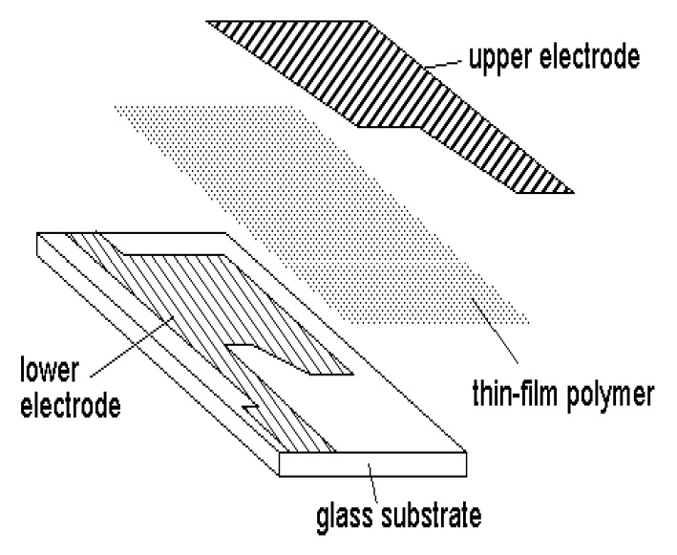
Fig.5.10Capacitive hygrometer
Aluminum-oxide sensors are formed by depositing a layer of porous aluminum oxide on a conductive substrate and then coating the aluminum oxide with a thin film of gold, as shown below. The conductive substrate and gold film are the sensor's electrodes. The aluminum oxide acts as the sensor's dielectric.
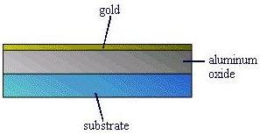
Fig5.11..Aluminum-oxide capacitive hygrometer
Water vapor penetrates the gold film and is absorbed by the aluminum oxide. This absorption changes the capacitance, reflecting a change in relative humidity.

Velocity Transducer:

Basic Principle of Moving coil Type Velocity Transducer:
- A coil moves in a magnetic field according to the velocity applied.
- The voltage in the coil becomes a measure of the velocity when calibrated.

Description of Moving coil Type Velocity Transducer
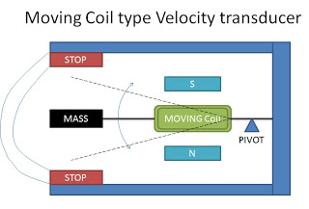
Fig.5.12.Moving coil Type Velocity Transducer
- The instrument has permanent pole pieces which generate the magnetic field.
- There is a pivoted arm on which a coil is mounted.
- There is a mass attached to the end of the coil.
- The whole device is contained in an antimagnetic case.

Operation of Moving coil Type Velocity Transducer:
- The velocity to be measured is applied to the arm.
- Due to this coil moves in the magnetic field.
- A voltage is generated on account of motion of the coil in the magnetic field.
- The output voltage is proportional to the velocity.

Advantages of Moving coil Type Velocity Transducer
- The antimagnetic case reduces the effects of stray magnetic field.
- Damping is obtained electrically.
- There is high stability under varying temperature conditions.

Moving magnet type velocity Transducer :
Basic principle of Moving magnet type velocity Transducer When a permanent magnet moves inside a coil, the change in the length of the air gap varies the reluctance. Hence the output voltage is directly proportional to the rate of change of the length of the air gap (change in length produced by velocity). Thus the output voltage becomes a measure of the velocity when calibrated.
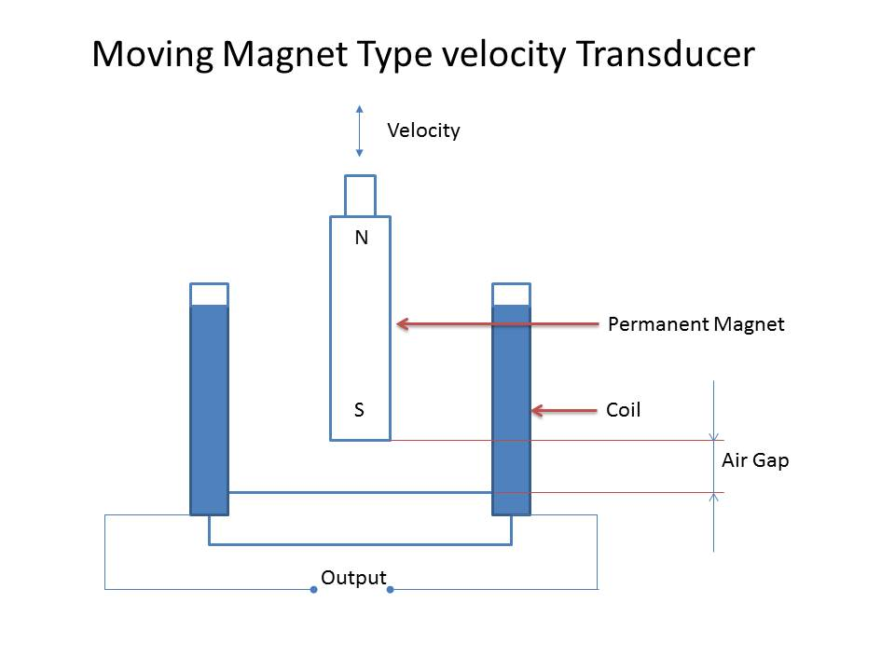
Fig.5.13.Moving magnet type velocity Transducer
Description of Moving magnet type velocity Transducer
1. The sensing element which is a rod is a permanent magnet.
2. The rod is rigidly coupled to the device whose velocity is being measured.
3. There is a coil surrounding the permanent magnet.
4. The permanent magnet is movable, that is, it can move in and out of the coil.
Operation of Moving magnet type velocity Transducer
1. The instrument is fixed to the device whose velocity is to measured.
2. Due to the application of the velocity, the permanent magnet moves in or out of the coil. Due to its motion, the length of the air gap varies.
3. The output voltage also varies due to the motion of the magnet and the amplitude of the voltage is directly proportional to velocity.
4. The polarity of the output voltages determines the direction of the velocity.
Advantages of Moving magnet type velocity Transducer
1. Its maintenance is negligible. 2. The output voltage is linearly proportional to velocity. 3. Cost of manufacture is less.
Disadvantages of Moving magnet type velocity Transducer
1. Performance is affected by stray magnetic fields and hence noise is caused. 2. Frequency response is poor. Application Used as a velocity transducer to convert velocity to measureable voltage

Force Transducer

The basic principle behind the measurement of force is – when a force is applied on an object, the object gets displaced. The amount of displacement occurred can be calculated using the various displacement transducers, and thus force measurement can be done. This is an indirect method for calculating force. Some of the direct methods for measuring force are given below.
- Strain Gauge Transducer
- Piezo-Electric Transducer
- Magnetostrictive Transducer
- Force Measurement using Pressure
- Other Force Measuring Systems

Force Measurement Using Pressure:
Force measurement through pressure can be done with two types of load cells. They are explained below.
1. Hydraulic Load Cell
As shown in the figure given below, the inside chamber of the device is filled with oil which has a pre-load pressure. The force is applied on the upper portion and this increases the pressure of the fluid inside the chamber. This pressure change is measured using a pressure transducer or is displayed on a pressure gauge dial using a Bourdon Tube.
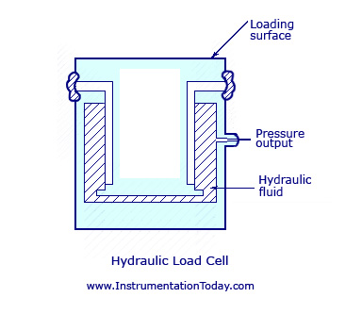
Fig.5.14. Hydraulic Load Cell
When a pressure transducer is used for measuring the value, the load cell is known to be very stiff. Even at a fully forced condition, it will only deflect up to 0.05mm. Thus, this device is usually used for calculating forces whose value lies between 500N and 200KiloN. The force monitoring device can be placed at a distance far away from the device with the help of a fluid-filled hose. Sometimes there will be need of multiple load cells. If so, a totaliser unit has to be designed for the purpose.
The biggest advantage of such a device is that it is completely mechanical. There is no need of any electrical assistance for the device. They can also be used for calculating both tensile and compressive forces. The error percentage does not exceed more than 0.25% if the device is designed correctly.
The device will have to be calibrated according to the temperature in which it is used as it is temperature sensitive.
2. Pneumatic Load Cell
The working of a pneumatic load cell is almost same to that of a hydraulic load cell. The force, whose value is to be measured, is applied on one side of a piston and this is balanced by pneumatic pressure on the other side. The pressure thus obtained will be equal to the input force applied. The value is measured using a bourdon tube.
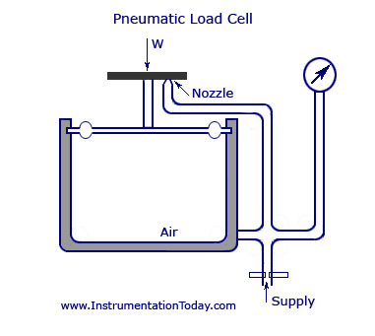
Fig.5.15.Pneumatic Load Cell
The pneumatic load cell has an inside chamber which is closed with a cap. An air pressure is built up inside the chamber until its value equals the force on the cap. If the pressure is increased further, the air inside the chamber will forcefully open the cap and the process will continue until both the pressures are equal. At this point, the reading of the pressure in the chamber is taken using a pressure transducer and it will be equal to the input force.

Electrical Pressure Transducers
There are mainly three types of electrical pressure transducers – inductive, resistive, and capacitive. The inductive type consists of a Linear Voltage Differential Transformer (LVDT) where core is positioned by the pressure through a diaphragm or a bellows element as shown in the figure below.
The same method can be extended to develop a null-balance type instrument as shown in the figure below. Feedback through the force coil produces the wanted balance while the output is taken across resistor R and is of value K*(p1-p2), K being a constant.
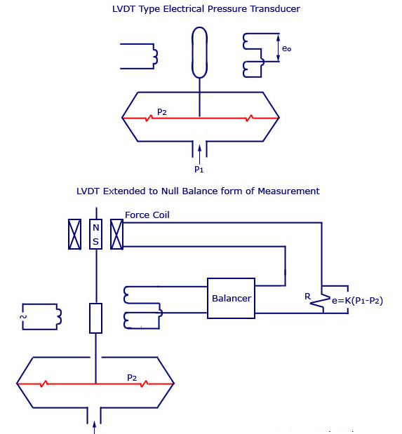

Fig.5.16 LVDT Type Electrical Pressure Transducer
A high accuracy stable pressure transducer often recommended as calibration standard for gas pressure and density, is obtained by making a thin walled cylinder oscillate continuously in one of its vibration modes – specifically circumferential mode using limit cycle feedback system. Any change in the pressure causes change in the oscillation frequency and the reluctance type pick-up cum drive system produces an output signal which is processed and displayed by electronic means. Provision for temperature compensation is also made where a solid state temperature sensor picks up temperature change and a microprocessor system makes the relevant compensation.
In resistive pressure transducers, the pressure operates the primary sensors as in a bourdon tube, a diaphragm or a bellows element or even the liquid column in a manometer. The mechanical movement of this primary sensor is then converted into electrical signals by resistance variations as shown in the figures below. Figure (4) shows a liquid contact type resistance pressure gauge where with increasing pressure more and more resistances are shortened and the resistance R is decreased. A current meter will directly indicate the pressure.

Electrical Pressure Transducers – Working, Construction
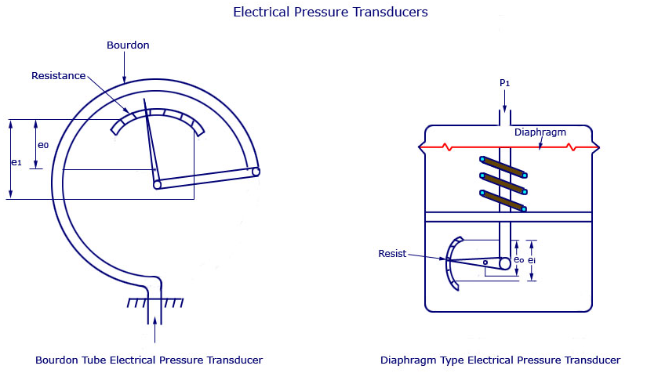
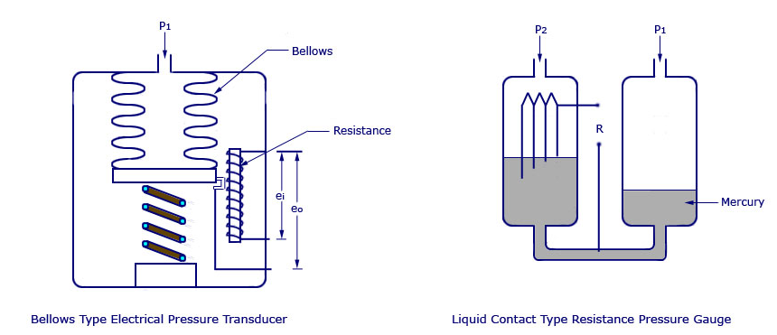
Fig.5.17. Electrical Pressure Transducers
The modified system is shown in the figure below where a resistance ratio element is used. Long resistance wires are introduced into two manometer legs containing a conducting fluid. The unbalance current in galvanometer directly indicates the pressure difference (p1-p2).
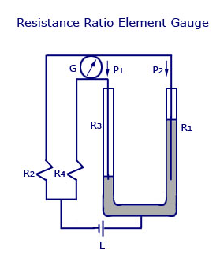

Fig. 5.18.Resistance Ratio Element Gauge

Data acquisition system:

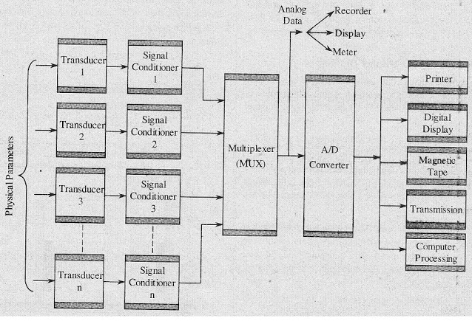
Fig.5.19. data acquisition system
Data acquisition is the process of sampling signals that measure real world physical conditions and converting the resulting samples into digital numeric values that can be manipulated by a computer. Data acquisition systems, abbreviated by the acronyms DAS or DAQ, typically convert analog waveforms into digital values for processing. The components of data acquisition systems include:
- Sensors, to convert physical parameters to electrical signals.
- Signal conditioning circuitry, to convert sensor signals into a form that can be converted to digital values.
- Analog-to-digital converters, to convert conditioned sensor signals to digital values.

