UNIT-IV

Synchronous vs. Asynchronous
- Synchronous data transfer:
  - sender and receiver use the same clock signal
  - supports high data transfer rate
  - needs clock signal between the sender and the receiver
  - requires master/slave configuration
- Asynchronous data transfer:
  - Sender provides a synchronization signal to the receiver before starting the transfer of each message
  - does not need clock signal between the sender and the receiver
  - slower data transfer rate

Notes:
There are many serial data transfer protocols. The protocols for serial data transfer can be grouped into two types: synchronous and asynchronous. For synchronous data transfer, both the sender and receiver access the data according to the same clock. Therefore, a special line for the clock signal is required. A master (or one of the senders) should provide the clock signal to all the receivers in the synchronous data transfer.
For asynchronous data transfer, there is no common clock signal between the sender and receivers. Therefore, the sender and the receiver first need to agree on a data transfer speed. This speed usually does not change after the data transfer starts. Both the sender and receiver set up their own internal circuits to make sure that the data accessing is follows that agreement. However, just like some watches run faster than others, computer clocks also differ in accuracy. Although the difference is very small, it can accumulate fast and eventually cause errors in data transfer. This problem is solved by adding synchronization bits at the front, middle or end of the data. Since the synchronization is done periodically, the receiver can correct the clock accumulation error. The synchronization information may be added to every byte of data or to every frame of data. Sending these extra synchronization bits may account for up to 50% data transfer overhead and hence slows down the actual data transfer rate.
The Intel 8253 and 8254 are Programmable Interval Timers (PTIs) designed for microprocessors to perform timing and counting functions using three 16-bit registers. Each counter has 2 input pins, i.e. Clock & Gate, and 1 pin for “OUT” output. To operate a counter, a 16-bit count is loaded in its register. On command, it begins to decrement the count until it reaches 0, then it generates a pulse that can be used to interrupt the CPU.

Difference between 8253 and 8254
The following table differentiates the features of 8253 and 8254

8253 | 8254
Its operating frequency is 0 - 2.6 MHz | Its operating frequency is 0 - 10 MHz
It uses N-MOS technology | It uses H-MOS technology
Read-Back command is not available | Read-Back command is available
Reads and writes of the same counter cannot be interleaved. | Reads and writes of the same counter can be interleaved.

Features of 8253 / 54
The most prominent features of 8253/54 are as follows −
- It has three independent 16-bit down counters.
- It can handle inputs from DC to 10 MHz.
- These three counters can be programmed for either binary or BCD count.
- It is compatible with almost all microprocessors.
- 8254 has a powerful command called READ BACK command, which allows the user to check the count value, the programmed mode, the current mode, and the current status of the counter.

8254 Architecture
The architecture of 8254 looks as follows –
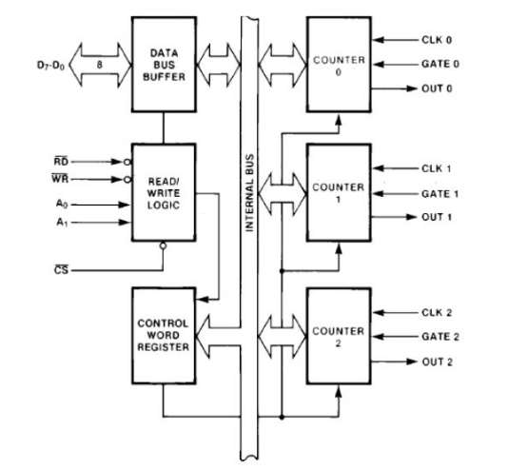

8254 Pin Description
Here is the pin diagram of 8254
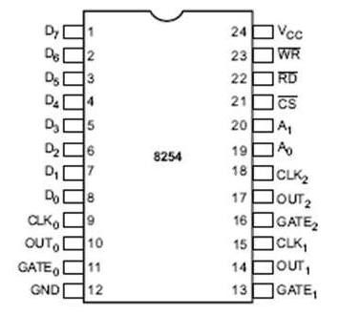

In the above figure, there are three counters, a data bus buffer, Read/Write control logic, and a control register. Each counter has two input signals - CLOCK & GATE, and one output signal - OUT.

Data Bus Buffer
It is a tri-state, bi-directional, 8-bit buffer, which is used to interface the 8253/54 to the system data bus. It has three basic functions −
- Programming the modes of 8253/54.
- Loading the count registers.
- Reading the count values.

Read/Write Logic

It includes 5 signals, i.e. RD, WR, CS, and the address lines A₀ & A₁. In the peripheral I/O mode, the RD and WR signals are connected to IOR and IOW, respectively. In the memorymapped I/O mode, these are connected to MEMR and MEMW.
Address lines A₀ & A₁ of the CPU are connected to lines A₀ and A₁ of the 8253/54, and CS is tied to a decoded address. The control word register and counters are selected according to the signals on lines A₀ & A₁.

A₁ | A₀ | Result
0 | 0 | Counter 0
0 | 1 | Counter 1
1 | 0 | Counter 2
1 | 1 | Control Word Register
X | X | No Selection

Control Word Register
This register is accessed when lines A₀ & A₁ are at logic 1. It is used to write a command word, which specifies the counter to be used, its mode, and either a read or write operation. Following table shows the result for various control inputs.
A₁ | A₀ | RD | WR | CS | Result
0 | 0 | 1 | 0 | 0 | Write Counter 0
0 | 1 | 1 | 0 | 0 | Write Counter 1
1 | 0 | 1 | 0 | 0 | Write Counter 2
1 | 1 | 1 | 0 | 0 | Write Control Word
0 | 0 | 0 | 1 | 0 | Read Counter 0
0 | 1 | 0 | 1 | 0 | Read Counter 1
1 | 0 | 0 | 1 | 0 | Read Counter 2
1 | 1 | 0 | 1 | 0 | No operation
X | X | 1 | 1 | 0 | No operation
X | X | X | X | 1 | No operation

WRITE Operation :
1. Write a control word into control register.
2. Load the low-order byte of a count in the counter register.

3. Load the high-order byte of count in the counter register.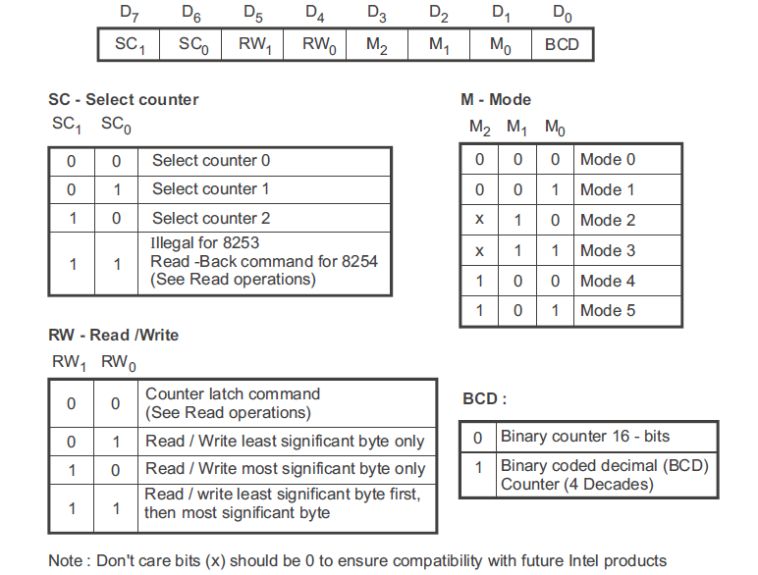
Fig. Control word format

READ Operation : In some applications, especially in event counters, it is necessary to read the value of the count in process. This can be done by three possible methods:
1. Simple Read : It involves reading a count after inhibiting the counter by controlling the gate input or the clock input of the selected counter, and two I/O read operations are performed by the CPU. The first I/O operation reads the low-order byte, and the second I/O operation reads the high order byte.
2. Counter Latch Command : In the second method, an appropriate control word is written into the control register to latch a count in the output latch, and two I/O read operations are performed by the CPU. The first I/O operation reads the low-order byte, and the second I/O operation reads the high order byte.
3. Read-Back Command (Available only for 8254) : The third method uses the Read-Back command. This command allows the user to check the count value, programmed Mode, and current status of the OUT pin and Null count flag of the selected counter(s). Fig. 9.4 shows the format of the control word register for Read-Back command.

Counters
Each counter consists of a single, 16 bit-down counter, which can be operated in either binary or BCD. Its input and output is configured by the selection of modes stored in the control word register. The programmer can read the contents of any of the three counters without disturbing the actual count in process.
8253/54 can be operated in 6 different modes. In this chapter, we will discuss these operational modes.

Mode 0 ─ Interrupt on Terminal Count
- It is used to generate an interrupt to the microprocessor after a certain interval.
- Initially the output is low after the mode is set. The output remains LOW after the count value is loaded into the counter.
- The process of decrementing the counter continues till the terminal count is reached, i.e., the count become zero and the output goes HIGH and will remain high until it reloads a new count.
- The GATE signal is high for normal counting. When GATE goes low, counting is terminated and the current count is latched till the GATE goes high again.

Mode 1 – Programmable One Shot
- It can be used as a mono stable multi-vibrator.
- The gate input is used as a trigger input in this mode.
- The output remains high until the count is loaded and a trigger is applied.

Mode 2 – Rate Generator
- The output is normally high after initialization.
- Whenever the count becomes zero, another low pulse is generated at the output and the counter will be reloaded.

Mode 3 – Square Wave Generator
- This mode is similar to Mode 2 except the output remains low for half of the timer period and high for the other half of the period.

Mode 4 − Software Triggered Mode
- In this mode, the output will remain high until the timer has counted to zero, at which point the output will pulse low and then go high again.
- The count is latched when the GATE signal goes LOW.
- On the terminal count, the output goes low for one clock cycle then goes HIGH. This low pulse can be used as a strobe.

Mode 5 – Hardware Triggered Mode
- This mode generates a strobe in response to an externally generated signal.
- This mode is similar to mode 4 except that the counting is initiated by a signal at the gate input, which means it is hardware triggered instead of software triggered.
- After it is initialized, the output goes high.
- When the terminal count is reached, the output goes low for one clock cycle.
8257 DMA :
DMA stands for Direct Memory Access. It is designed by Intel to transfer data at the fastest rate. It allows the device to transfer the data directly to/from memory without any interference of the CPU.
Using a DMA controller, the device requests the CPU to hold its data, address and control bus, so the device is free to transfer data directly to/from the memory. The DMA data transfer is initiated only after receiving HLDA signal from the CPU.

How DMA Operations are Performed?
Following is the sequence of operations performed by a DMA −
- Initially, when any device has to send data between the device and the memory, the device has to send DMA request (DRQ) to DMA controller.
- The DMA controller sends Hold request (HRQ) to the CPU and waits for the CPU to assert the HLDA.
- Then the microprocessor tri-states all the data bus, address bus, and control bus. The CPU leaves the control over bus and acknowledges the HOLD request through HLDA signal.
- Now the CPU is in HOLD state and the DMA controller has to manage the operations over buses between the CPU, memory, and I/O devices.

Features of 8257
Here is a list of some of the prominent features of 8257 −
- It has four channels which can be used over four I/O devices.
- Each channel has 16-bit address and 14-bit counter.
- Each channel can transfer data up to 64kb.
- Each channel can be programmed independently.
- Each channel can perform read transfer, write transfer and verify transfer operations.
- It generates MARK signal to the peripheral device that 128 bytes have been transferred.
- It requires a single phase clock.
- Its frequency ranges from 250Hz to 3MHz.
- It operates in 2 modes, i.e., Master mode and Slave mode.

8257 Architecture
The following image shows the architecture of 8257
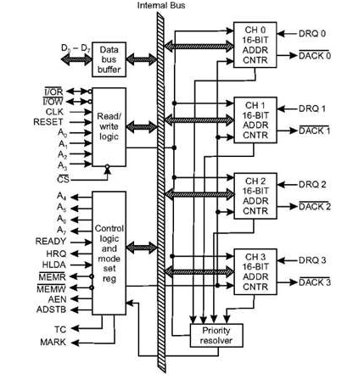

8257 Pin Description
The following image shows the pin diagram of a 8257 DMA controller −
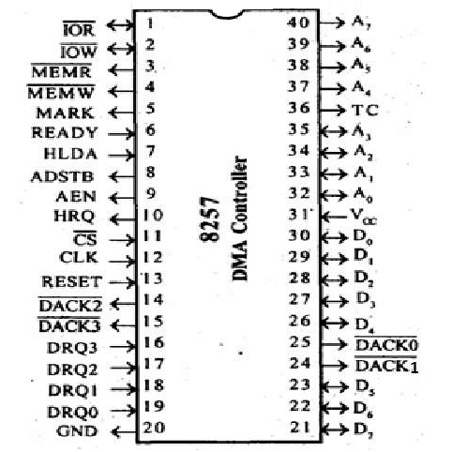

DRQ₀−DRQ3
These are the four individual channel DMA request inputs, which are used by the peripheral devices for using DMA services. When the fixed priority mode is selected, then DRQ₀ has the highest priority and DRQ₃ has the lowest priority among them.

DACK_{o} − DACK₃
These are the active-low DMA acknowledge lines, which updates the requesting peripheral about the status of their request by the CPU. These lines can also act as strobe lines for the requesting devices.

D_{o} − D₇
These are bidirectional, data lines which are used to interface the system bus with the internal data bus of DMA controller. In the Slave mode, it carries command words to 8257 and status word from 8257. In the master mode, these lines are used to send higher byte of the generated address to the latch. This address is further latched using ADSTB signal.

IOR
It is an active-low bidirectional tri-state input line, which is used by the CPU to read internal registers of 8257 in the Slave mode. In the master mode, it is used to read data from the peripheral devices during a memory write cycle.

IOW
It is an active low bi-direction tri-state line, which is used to load the contents of the data bus to the 8-bit mode register or upper/lower byte of a 16-bit DMA address register or terminal count register. In the master mode, it is used to load the data to the peripheral devices during DMA memory read cycle.

CLK
It is a clock frequency signal which is required for the internal operation of 8257.

RESET
This signal is used to RESET the DMA controller by disabling all the DMA channels.

A_{o} - A₃
These are the four least significant address lines. In the slave mode, they act as an input, which selects one of the registers to be read or written. In the master mode, they are the four least significant memory address output lines generated by 8257.

CS
It is an active-low chip select line. In the Slave mode, it enables the read/write operations to/from 8257. In the master mode, it disables the read/write operations to/from 8257.

A₄ - A₇
These are the higher nibble of the lower byte address generated by DMA in the master mode.

READY It is an active-high asynchronous input signal, which makes DMA ready by inserting wait states.

HRQ
This signal is used to receive the hold request signal from the output device. In the slave mode, it is connected with a DRQ input line 8257. In Master mode, it is connected with HOLD input of the CPU.

HLDA
It is the hold acknowledgement signal which indicates the DMA controller that the bus has been granted to the requesting peripheral by the CPU when it is set to 1.

MEMR
It is the low memory read signal, which is used to read the data from the addressed memory locations during DMA read cycles.

MEMW
It is the active-low three state signal which is used to write the data to the addressed memory location during DMA write operation.

ADST
This signal is used to convert the higher byte of the memory address generated by the DMA controller into the latches.

AEN
This signal is used to disable the address bus/data bus.

TC
It stands for ‘Terminal Count’, which indicates the present DMA cycle to the present peripheral devices.

MARK
The mark will be activated after each 128 cycles or integral multiples of it from the beginning. It indicates the current DMA cycle is the 128th cycle since the previous MARK output to the selected peripheral device.

V_{cc}
It is the power signal which is required for the operation of the circuit.

Mode Set Register:
When set, the various bits in the Mode Set register enable each of the four DMA channels, and allow four different options for the 8257:
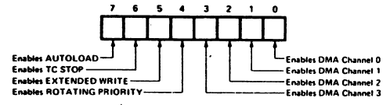
The Mode Set register is normally programmed by the CPU after the DMA address register(s) and terminal count register(s) are initialized. The Mode Set Register is cleared by the RESET input, thus disabling all options, inhibiting all channels, and preventing bus conflicts on power-up. A channel should not be left enabled unless its DMA address and terminal count registers contain valid values; otherwise, an inadvertent DMA request (DROn) from a peripheral could initiate a DMA cycle that would destroy memory data. The various options which can be enabled by bits in the Mode Set register are explained below:
Rotating Priority Bit 4
In the Rotating Priority Mode, the priority of the channels has a circular sequence. After each DMA cycle, the priority of each channel changes. The channel which had just been serviced will have the lowest priority.
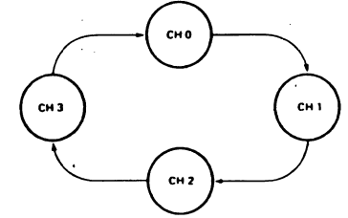
If the ROTATING PRIORITY bit is not set (set to a zero). each DMA channel has a fixed priority. In the fixed priority mode. Channel 0 has the highest priority and Channel 3 has the lowest priority. If the ROTATING PRIORITY bit is set to a one. the priority of each channel changes after each DMA cycle (not each DMA request). Each channel moves up to the next highest priority assignment, while the channel which has just been serviced moves to the lowest priority assignment:

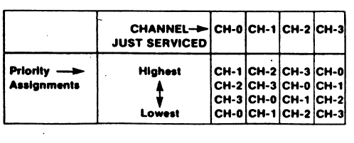
Note that rotating priority will prevent any one channel from monopolizing the PMA mode; consecutive DMA cycles will service different channels if more,than one channel is enabled and requesting service. There is no overhead penalty associated with this mode of operation. All DMA operations began with Channel 0 initially assigned to the highest priority for the first DMA cycle.

Extended Write Bit
If the EXTENDED WRITE bit is set. the duration of both the MEMW and I/OW signals is extended by activating them earlier in the DMA cycle. Data transfers within micro computer systems proceed asynchronously to allow use of various types of memory and I/O devices with
different access times. If a device cannot be accessed within a specific amount of time it returns a "not ready" indication to the 8257 that causes the 8257 to insert one or more wait states in its internal sequencing. Some devices are fast enough to be accessed without the use of wait states, but if they generate their READY response with the leading edge of the f/SW or MEMW signal (which generally occurs late in the transfer sequence), they would normally cause the 8257 to enter a wait state because it does not receive READY in time. For systems with these types of devices, the Extended Write option provides alternative timing for the I/O and memory write signals which allows the devices to return an early READY and prevents the unnecessary occurrence of wait states in the 8257. thus increasing system throughput.
TC Stop Bit

If the TC STOP bit is set. a channel is disabled (i.e.. its enable bit is reset) after the Terminal Count (TC) output goes true, thus automatically preventing further DMA operation on that channel. The enable bit for that channel must be re-programmed to continue or begin another DMA operation. If the TC STOP bit is not set. The occurrence of the TC output has no effect on the channel enable bits. In this case, it is generally the responsibility of the peripheral to cease DMA requests in order to terminate a DMA operation.

Auto Load Bit
The Auto Load mode permits Channel 2 to be used for repeat block or block chaining operations, without immediate software intervention between blocks. Channel 2 registers are initialized as usual for the first data block; Channel 3 registers, however, are used to store the block re-initialization parameters (DMA starting address, terminal count and DMA transfer mode). After the first block of DMA cycles is executed by Channel 2 (i.e.. after the TC output goes true), the parameters stored in the Channel 3 registers are transferred to Channel 2 during an "update" cycle. Note that the TC STOP feature, described above, has no effect on Channel 2 when the Auto Load bit is set.
If the Auto Load bit is set. the initial parameters for Channel 2 are automatically duplicated in the Channel 3 registers when Channel 2 is programmed. This permits repeat block operations to be set up with the programming of a single channel. Repeat block operations can be used in applications such as CRT refreshing. Channels 2 and 3 can still be loaded with separate values if Channel 2 is loaded before loading Channel 3. Note that in the Auto Load mode, Channel 3 is still available to the user if the Channel 3 enable bit is set. but use of this channel will change the values to be auto loaded into Channel 2 at update time. All that is necessary to use the Auto Load feature for chaining operations is to reload Channel 3 registers at the conclusion of each update cycle with the new parameters for the next data block transfer. Each time that the 8257 enters an update cycle, the update flag in the status register is set and parameters in Channel 3 are transferred to Channel 2. non-destructively for Channel 3. The actual re-initialization of Channel 2 occurs at the beginning of the next channel 2 DMA cycle after the TC cycle. This will be the first DMA cycle of the new data block for Channel 2. The update flag is cleared at the conclusion of this DMA cycle. For chaining operations, the update flag in the status register can be monitored by the CPU to determine when the re-initialization process has been completed so that the next block parameters can be safely loaded into Channel

Status Register
The eight-bit status register indicates which channels have reached a terminal count condition and includes the update flag described previously.
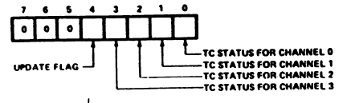
The TC status bits are set when the Terminal Count (TC) output is activated for that channel. These bits remain set until the status register is read or the 8257 is reset. The UPDATE FLAG, however, is not affected by a status register read operation. The UPDATE FLAG can be cleared by resetting the 8257. by changing to the non-auto load mode (i.e.. by resetting the AUTO LOAD bit in the Mode Set register) or it can be left to clear itself at the completion of the update cycle. The purpose of the UPDATE FLAG is to prevent the CPU from inadvertently skipping a data block by overwriting a starting address or terminal count in the Channel 3 registers before those parameters are properly auto-loaded into Channel 2.
8255A:
The 8255A is a general purpose programmable I/O device designed to transfer the data from I/O to interrupt I/O under certain conditions as required. It can be used with almost any microprocessor.
It consists of three 8-bit bidirectional I/O ports (24I/O lines) which can be configured as per the requirement.

Ports of 8255A
8255A has three ports, i.e., PORT A, PORT B, and PORT C.
- Port A contains one 8-bit output latch/buffer and one 8-bit input buffer.
- Port B is similar to PORT A.
- Port C can be split into two parts, i.e. PORT C lower (PC0-PC3) and PORT C upper (PC7-PC4) by the control word.
These three ports are further divided into two groups, i.e. Group A includes PORT A and upper PORT C. Group B includes PORT B and lower PORT C. These two groups can be programmed in three different modes, i.e. the first mode is named as mode 0, the second mode is named as Mode 1 and the third mode is named as Mode 2.

Operating Modes
8255A has three different operating modes −
- Mode 0 − In this mode, Port A and B is used as two 8-bit ports and Port C as two 4-bit ports. Each port can be programmed in either input mode or output mode where outputs are latched and inputs are not latched. Ports do not have interrupt capability.
- Mode 1 − In this mode, Port A and B is used as 8-bit I/O ports. They can be configured as either input or output ports. Each port uses three lines from port C as handshake signals. Inputs and outputs are latched.
- Mode 2 − In this mode, Port A can be configured as the bidirectional port and Port B either in Mode 0 or Mode 1. Port A uses five signals from Port C as handshake signals for data transfer. The remaining three signals from Port C can be used either as simple I/O or as handshake for port B.

Features of 8255A
The prominent features of 8255A are as follows −
- It consists of 3 8-bit IO ports i.e. PA, PB, and PC.
- Address/data bus must be externally demux'd.
- It is TTL compatible.
- It has improved DC driving capability.

8255 Architecture
The following figure shows the architecture of 8255A −
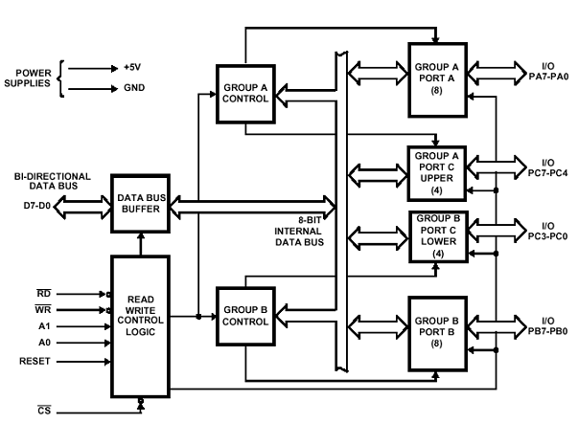
Let us first take a look at the pin diagram of Intel 8255A −
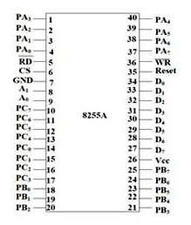
Now let us discuss the functional description of the pins in 8255A.

Data Bus Buffer
It is a tri-state 8-bit buffer, which is used to interface the microprocessor to the system data bus. Data is transmitted or received by the buffer as per the instructions by the CPU. Control words and status information is also transferred using this bus.

Read/Write Control Logic
This block is responsible for controlling the internal/external transfer of data/control/status word. It accepts the input from the CPU address and control buses, and in turn issues command to both the control groups.

CS
It stands for Chip Select. A LOW on this input selects the chip and enables the communication between the 8255A and the CPU. It is connected to the decoded address, and A₀ & A₁ are connected to the microprocessor address lines.

Their result depends on the following conditions
CS | A₁ | A₀ | Result
0 | 0 | 0 | PORT A
0 | 0 | 1 | PORT B
0 | 1 | 0 | PORT C
0 | 1 | 1 | Control Register
1 | X | X | No Selection

Data Bus Buffer
This three-state bi-directional 8-bit buffer is used to interface the 8255 to the system data bus. Data is transmitted or received by the buffer upon execution of input or output instructions by the CPU. Control words and status informa-tion are also transferred through the data bus buffer.
Read/Write and Control Logic
The function of this block is to manage all of the internal and external transfers of both Data and Control or Status words. It accepts inputs from the CPU Address and Control busses and in turn, issues commands to both of the Control Groups.
(CS) Chip Select. A "low" on this input pin enables the communcation between the 8255 and the CPU.
(RD) Read. A "low" on this input pin enables 8255 to send the data or status information to the CPU on the data bus. In essence, it allows the CPU to "read from" the 8255.
(WR) Write. A "low" on this input pin enables the CPU to write data or control words into the 8255.
(A0 and A1) Port Select 0 and Port Select 1. These input signals, in conjunction with the RD and WR inputs, control the selection of one of the three ports or the control word register. They are normally connected to the least significant bits of the address bus (A0 and A1).
(RESET) Reset. A "high" on this input initializes the control register to 9Bh and all ports (A, B, C) are set to the input mode.

A1 | A0 | SELECTION
0 | 0 | PORT A
0 | 1 | PORT B
1 | 0 | PORT C
1 | 1 | CONTROL
Group A and Group B Controls
The functional configuration of each port is programmed by the systems software. In essence, the CPU "outputs" a control word to the 8255. The control word contains information such as "mode", "bit set", "bit reset", etc., that initializes the functional configuration of the 8255. Each of the Control blocks (Group A and Group B) accepts "commands" from the Read/Write Control logic, receives "control words" from the internal data bus and issues the proper commands to its associated ports.
Ports A, B, and C
The 8255 contains three 8-bit ports (A, B, and C). All can be configured to a wide variety of functional characteristics by the system software but each has its own special features or "personality" to further enhance the power and flexibility of the 8255.
Port A One 8-bit data output latch/buffer and one 8-bit data input latch. Both "pull-up" and "pull-down" bus-hold devices are present on Port A.
Port B One 8-bit data input/output latch/buffer and one 8-bit data input buffer.
Port C One 8-bit data output latch/buffer and one 8-bit data input buffer (no latch for input). This port can be divided into two 4-bit ports under the mode control. Each 4-bit port contains a 4-bit latch and it can be used for the control signal output and status signal inputs in conjunction with ports A and B.

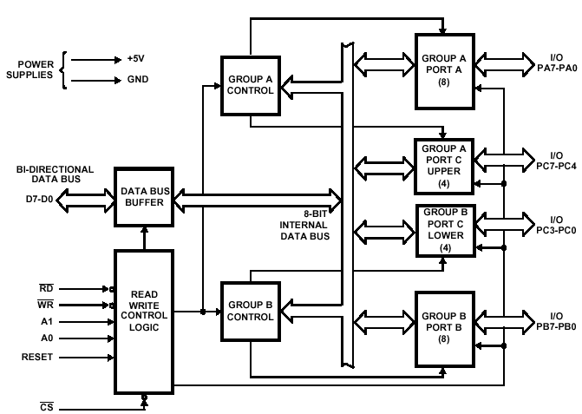
Block Diagram of the 8255 Programmable Peripheral Interface (PPI)

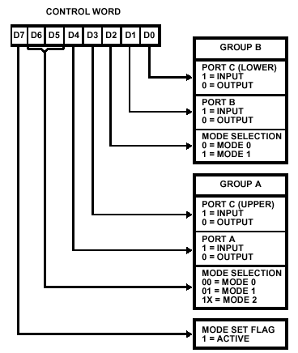
Mode Definition Format

8251 UNIVERSAL SYNCHRONOUS ASYNCHRONOUS RECEIVER TRANSMITTER (USART)
The 8251 is a USART (Universal Synchronous Asynchronous Receiver Transmitter) for serial data communication. As a peripheral device of a microcomputer system, the 8251 receives parallel data from the CPU and transmits serial data after conversion. This device also receives serial data from the outside and transmits parallel data to the CPU after conversion.

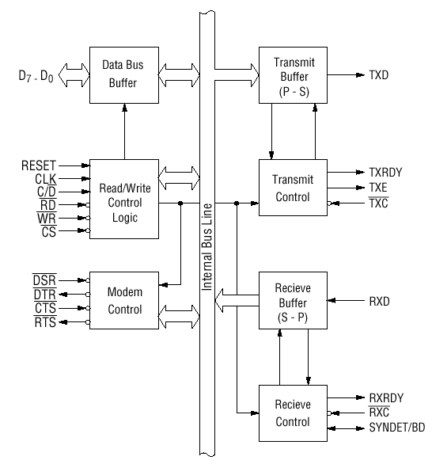
Block diagram of the 8251 USART (Universal Synchronous Asynchronous Receiver Transmitter)
The 8251 functional configuration is programed by software. Operation between the 8251 and a CPU is executed by program control. Table 1 shows the operation between a CPU and the device.
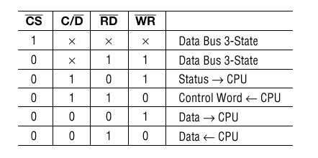
Table 1 Operation between a CPU and 8251

Control Words
There are two types of control word.
1. Mode instruction (setting of function)
2. Command (setting of operation)

1) Mode Instruction
Mode instruction is used for setting the function of the 8251. Mode instruction will be in "wait for write" at either internal reset or external reset. That is, the writing of a control word after resetting will be recognized as a "mode instruction."
Items set by mode instruction are as follows:
• Synchronous/asynchronous mode
• Stop bit length (asynchronous mode)
• Character length
• Parity bit
• Baud rate factor (asynchronous mode)
• Internal/external synchronization (synchronous mode)
• Number of synchronous characters (Synchronous mode)
The bit configuration of mode instruction is shown in Figures 2 and 3. In the case of synchronous mode, it is necessary to write one-or two byte sync characters. If sync characters were written, a function will be set because the writing of sync characters constitutes part of mode instruction.
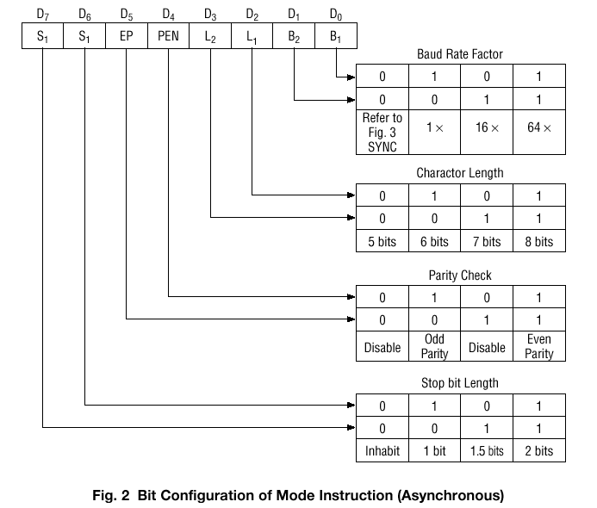

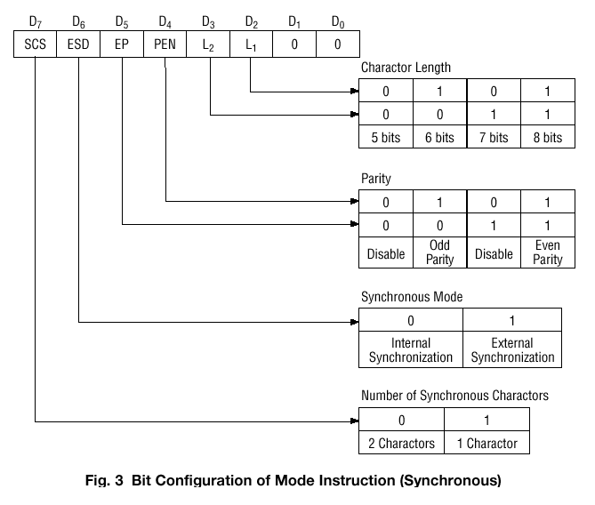

2) Command
Command is used for setting the operation of the 8251. It is possible to write a command whenever necessary after writing a mode instruction and sync characters.
Items to be set by command are as follows:
• Transmit Enable/Disable
• Receive Enable/Disable
• DTR, RTS Output of data.
• Resetting of error flag.
• Sending to break characters
• Internal resetting
• Hunt mode (synchronous mode)

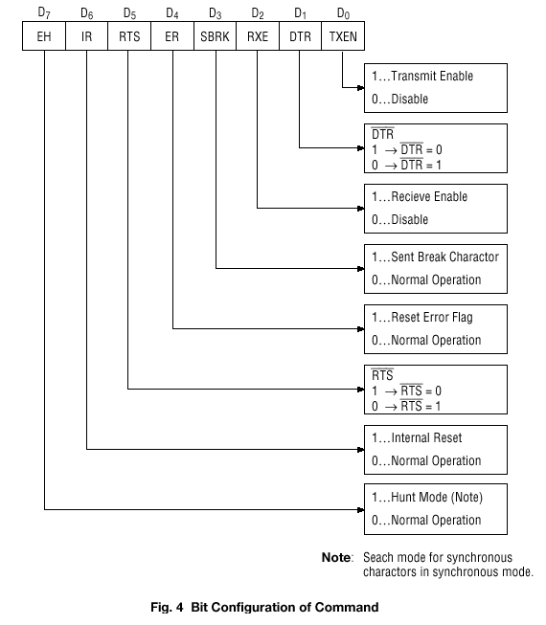

Status Word
It is possible to see the internal status of the 8251 by reading a status word. The bit configuration of status word is shown in Fig. 5.
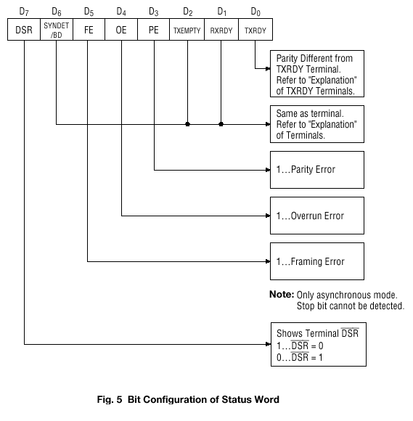

Pin Description
D 0 to D 7 (l/O terminal)
This is bidirectional data bus which receive control words and transmits data from the CPU and sends status words and received data to CPU.
RESET (Input terminal)
A "High" on this input forces the 8251 into "reset status." The device waits for the writing of "mode instruction." The min. reset width is six clock inputs during the operating status of CLK.
CLK (Input terminal)
CLK signal is used to generate internal device timing. CLK signal is independent of RXC or TXC. However, the frequency of CLK must be greater than 30 times the RXC and TXC at Synchronous mode and Asynchronous "x1" mode, and must be greater than 5 times at Asynchronous "x16" and "x64" mode.
WR (Input terminal)
This is the "active low" input terminal which receives a signal for writing transmit data and control words from the CPU into the 8251.
RD (Input terminal)
This is the "active low" input terminal which receives a signal for reading receive data and status words from the 8251.
C/D (Input terminal)
This is an input terminal which receives a signal for selecting data or command words and status words when the 8251 is accessed by the CPU. If C/D = low, data will be accessed. If C/D = high, command word or status word will be accessed.
CS (Input terminal)
This is the "active low" input terminal which selects the 8251 at low level when the CPU accesses. Note: The device won’t be in "standby status"; only setting CS = High.
TXD (output terminal)
This is an output terminal for transmitting data from which serial-converted data is sent out. The device is in "mark status" (high level) after resetting or during a status when transmit is disabled. It is also possible to set the device in "break status" (low level) by a command.
TXRDY (output terminal)
This is an output terminal which indicates that the 8251is ready to accept a transmitted data character. But the terminal is always at low level if CTS = high or the device was set in "TX disable status" by a command. Note: TXRDY status word indicates that transmit data character is receivable, regardless of CTS or command. If the CPU writes a data character, TXRDY will be reset by the leading edge or WR signal.
TXEMPTY (Output terminal)
This is an output terminal which indicates that the 8251 has transmitted all the characters and had no data character. In "synchronous mode," the terminal is at high level, if transmit data characters are no longer remaining and sync characters are automatically transmitted. If the CPU writes a data character, TXEMPTY will be reset by the leading edge of WR signal. Note : As the transmitter is disabled by setting CTS "High" or command, data written before disable will be sent out. Then TXD and TXEMPTY will be "High". Even if a data is written after disable, that data is not sent out and TXE will be "High".After the transmitter is enabled, it sent out. (Refer to Timing Chart of Transmitter Control and Flag Timing)
TXC (Input terminal)
This is a clock input signal which determines the transfer speed of transmitted data. In "synchronous mode," the baud rate will be the same as the frequency of TXC. In "asynchronous mode", it is possible to select the baud rate factor by mode instruction. It can be 1, 1/16 or 1/64 the TXC. The falling edge of TXC sifts the serial data out of the 8251.
RXD (input terminal)
This is a terminal which receives serial data.
RXRDY (Output terminal)
This is a terminal which indicates that the 8251 contains a character that is ready to READ. If the CPU reads a data character, RXRDY will be reset by the leading edge of RD signal. Unless the CPU reads a data character before the next one is received completely, the preceding data will be lost. In such a case, an overrun error flag status word will be set.
RXC (Input terminal)
This is a clock input signal which determines the transfer speed of received data. In "synchronous mode," the baud rate is the same as the frequency of RXC. In "asynchronous mode," it is possible to select the baud rate factor by mode instruction. It can be 1, 1/16, 1/64 the RXC.
SYNDET/BD (Input or output terminal)
This is a terminal whose function changes according to mode. In "internal synchronous mode." this terminal is at high level, if sync characters are received and synchronized. If a status word is read, the terminal will be reset. In "external synchronous mode, "this is an input terminal. A "High" on this input forces the 8251 to start receiving data characters.
In "asynchronous mode," this is an output terminal which generates "high level"output upon the detection of a "break" character if receiver data contains a "low-level" space between the stop bits of two continuous characters. The terminal will be reset, if RXD is at high level. After Reset is active, the terminal will be output at low level.
DSR (Input terminal)
This is an input port for MODEM interface. The input status of the terminal can be recognized by the CPU reading status words.
DTR (Output terminal)
This is an output port for MODEM interface. It is possible to set the status of DTR by a command.
CTS (Input terminal)
This is an input terminal for MODEM interface which is used for controlling a transmit circuit. The terminal controls data transmission if the device is set in "TX Enable" status by a command. Data is transmitable if the terminal is at low level.
RTS (Output terminal)
This is an output port for MODEM interface. It is possible to set the status RTS by a command.

INTEL 8259A Programmable Interrupt Controller
The 8259A is a programmable interrupt controller designed to work with Intel microprocessor 8080 A, 8085, 8086, 8088. The 8259 A interrupt controller can
1) Handle eight interrupt inputs. This is equivalent to providing eight interrupt pins on the processor in place of one INTR/INT pin.
2) Vector an interrupt request anywhere in the memory map. However, all the eight interrupt are spaced at the interval of either four or eight location. This eliminates the major drawback, 8085 interrupt, in which all interrupts are vectored to memory location on page 00H.
3) Resolve eight levels of interrupt priorities in a variety of modes.
4) Mask each interrupt request individually.
5) Read the status of pending interrupts, in service interrupts, and masked interrupts.
6) Be set up to accept either the level triggered or edge triggered interrupt request.
7) Mine 8259 as can be cascade in a master slave configuration to handle 64 interrupt inputs.
The 8259 A is contained in a 28-element in line package that requires only a compatible with 8259. The main difference between the two is that the 8259 A can be used with Intel 8086/8088 processor. It also induces additional features such as level triggered mode, buffered mode and automatic end of interrupt mode. The pin diagram and interval block diagram is shown below:
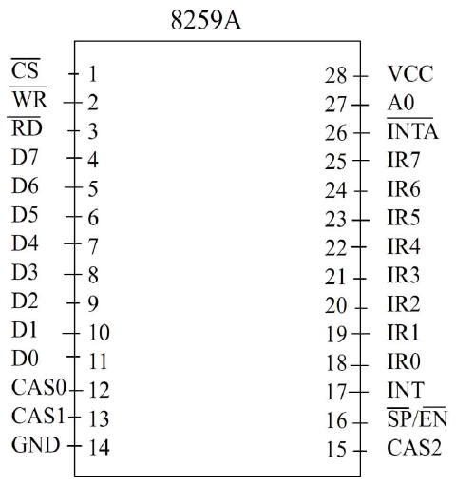
The pins are defined as follows:
: Chip select
To access this chip, is made low. A LOW on this pin enables & communication between the CPU and the 8259A. This pin is connected to address bus through the decoder logic circuits. INTA functions are independent of .
:
A low on this pin. When is low enables the 8259 A to accept command words from CPU.
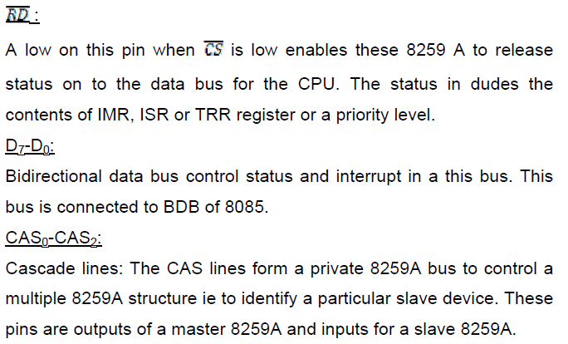
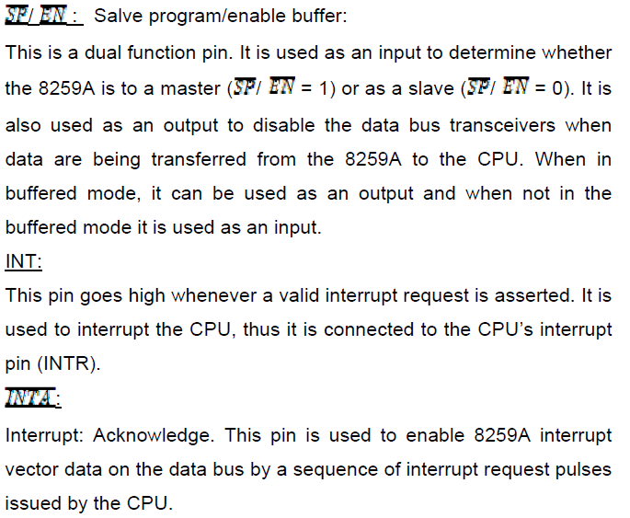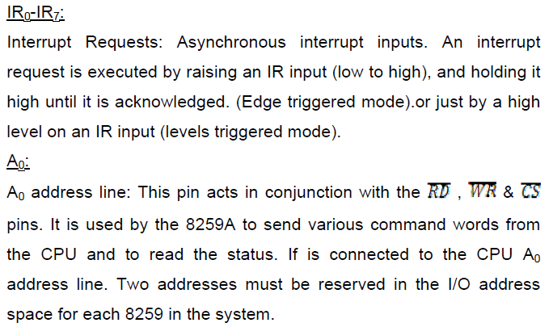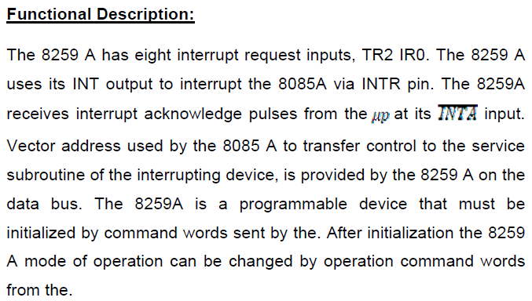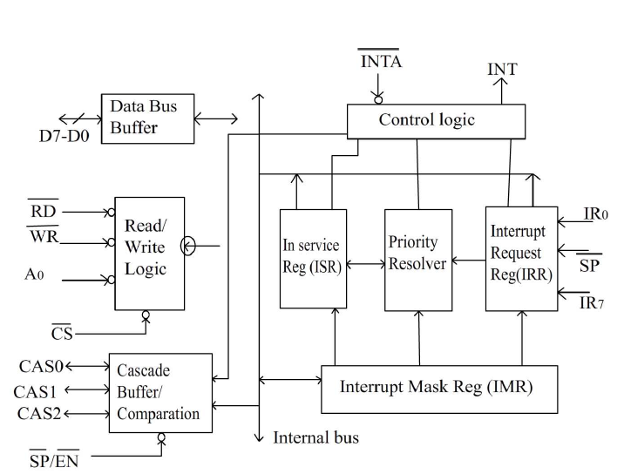
The descriptions of various blocks are,
Data bus buffer:
This 3- state, bidirectional 8-bit buffer is used to interface the 8259A to the system data bus. Control words and status information are transferred through the data bus buffer.
Read/Write & control logic:
The function of this block is to accept OUTPUT commands from the CPU. It contains the initialization command word (ICW) register and operation command word (OCW) register which store the various control formats for device operation. This function block also allows the status of 8159A to be transferred to the data bus.
Interrupt request register (IRR):
IRR stores all the interrupt inputs that are requesting service. Basically, it keeps track of which interrupt inputs are asking for service. If an interrupt input is unmasked, and has an interrupt signal on it, then the corresponding bit in the IRR will be set.

Interrupt mask register (IMR):
The IMR is used to disable (Mask) or enable (Unmask) individual interrupt inputs. Each bit in this register corresponds to the interrupt input with the same number. The IMR operation on the IRR. Masking of higher priority input will not affect the interrupt request lines of lower priority. To unmask any interrupt the corresponding bit is set ‘0’.
In service register (ISR):
The in service registers keeps tracks of which interrupt inputs are currently being serviced. For each input that is currently being serviced the corresponding bit will be set in the in service register. Each of these 3-reg can be read as status reg.
Priority Resolver:
This logic block determines the priorities of the set in the IRR. The highest priority is selected and strobed into the corresponding bit of the ISR during pulse.
Cascade buffer/comparator:
This function blocks stores and compare the IDS of all 8259A’s in the reg. The associated 3-I/O pins (CAS0-CAS2) are outputs when 8259A is used a master. Master and are inputs when 8259A is used as a slave. As a master, the 8259A sends the ID of the interrupting slave device onto the cas2-cas0. The slave thus selected will send its pre-programmed subroutine address on to the data bus during the next one or two successive pulses.

