NBKRIST

POWER ELECTRONICS LECTURE NOTES
UNIT-5
I.PRABHAKAR REDDY & G.VIJAYKRISHNA
DEPARTMENT OF ELECTRICAL AND ELECTRONICS ENGINEERING

CYCLO-CONVERTERS
5.2 Introduction
- Traditionally, ac-ac conversion using power semiconductor switches is done in two different ways: 1- in two stages (ac-dc and then dc-ac) as in dc link converters or 2- in one stage (ac-ac) cycloconverters as shown in figure 5.21. Cycloconverters are used in high power applications driving induction and synchronous motors. They are usually phase-controlled and they traditionally use thyristors due to their ease of phase commutation.
Fig 5.21 block diagram of cyclo converter
- There are other newer forms of cyclo-conversion such as ac-ac matrix converters and high frequency ac-ac converters and these use self-controlled switches. These converters, however, are not popular yet.

Applications of cycloconverter are:
- Cement mill drives
- Ship propulsion drives
- Rolling mill drives
- Scherbius drives
- Ore grinding mills
- Mine winders

5.21 Advantages and Disadvantages of Cyclo-converter:
5.21(a) Advantages:
- In a cyclo-converter, ac power at one frequency is converted directly to a lower frequency in a single conversion stage.
- Cyclo-converter functions by means of phase commutation, without auxiliary forced commutation circuits. The power circuit is more compact, eliminating circuit losses associated with forced commutation.
- Cyclo-converter is inherently capable of power transfer in either direction between source and load. It can supply power to loads at any power factor, and is also capable of regeneration over the complete speed range, down to standstill. This feature makes it preferable for large reversing drives requiring rapid acceleration and deceleration, thus suited for metal rolling application.
- Commutation failure causes a short circuit of ac supply. But, if an individual fuse blows off, a complete shutdown is not necessary, and cyclo-converter continues to function with somewhat distorted waveforms. A balanced load is presented to the ac supply with unbalanced output conditions.
- Cyclo-converter delivers a high quality sinusoidal waveform at low output frequencies, since it is fabricated from a large number of segments of the supply waveform. This is often preferable for very low speed applications.
5.21(b) Disadvantages:
- Large number of thyristors is required in a cyclo-converter, and its control circuitry becomes more complex. It is not justified to use it for small installations, but is economical for units above 20 kVA.
- For reasonable power output and efficiency, the output frequency is limited to one-third of the input frequency.
- The power factor is low particularly at reduced output voltages, as phase control is used with high firing delay angle.

5.22 Principle of Operation of Single Phase Cyclo-converter:
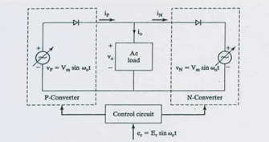
Fig 5.22 equivalent circuit of cyclo converter
A cyclo-converter is a direct frequency changer that converts ac power at one frequency at one frequency to ac power at another frequency to ac to ac conversion without any intermediate dc link.
They are again classified as:
- Step Up Cyclo-Converter
- Step Down Cyclo-Converter

5.23 Step Up Cyclo-Converter
a) Mid-point step-up cyclo-converter
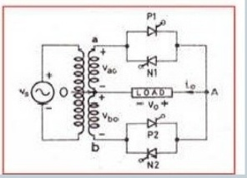
Fig_5.23: Step Up Cyclo-Converter midpoint connection
P1,P2 -> Positive Group Thyristor
N1,N2 -> Negative Group Thyristor
In Single Phase Step Up Cyclo Converter, during a positive half cycle of supply voltage terminal A is positive with respect to terminal B so that SCRs P₁ and N₂ are forward biased from wt = 0 to wt = π. SCR P₁ is turned on at wt = 0, so that load voltage is positive. At certain instant wt₁, P₁ is forced commutated and N₂ is turned on by providing a gate signal to it and it remains in a conduction state and load voltage is negative.

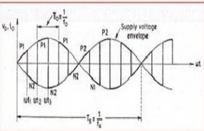
Fig5.24 step up cyclo converter waveforms (fo=6fs)

Similarly, at wt₂, N₂ is forced commutated and P₁ is turned on and load voltage is positive. So, we can repeat this process by turning on and turning off the Positive Group Thyristor in the appropriate time interval. When wt = π, terminal B is positive with respect to terminal A; both SCR P₂ and N₁ are therefore forward biased from wt = π to 2π. In the same way, P2 and N1 are turned on and off in a certain sequence.
Thus, by switching the positive group thyristor and Negative group thyristor in a certain appropriate sequence as mentioned above, the frequency of the output voltage is increased certain times than frequency of input voltage.
Similarly for Bridge type Cycloconverter, circuit diagram as shown in fig. 5.25 and related wave forms are shown in fig. 5.26.

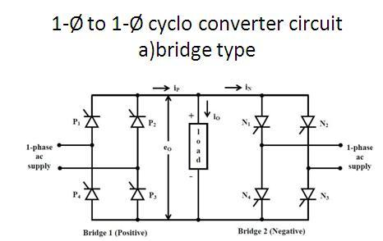
Fig_5.25: Step Up Bridge type Cyclo-Converter connection

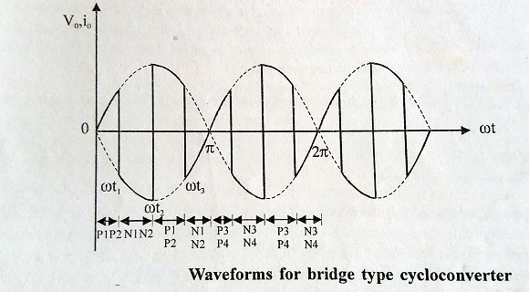
Fig5.26 step up cyclo converter waveforms for Bride type cyclo conveter (fo=4fs)

Step Down Cyclo-Converter
- Bridge type Step Down Cyclo-Converter

Fig 5.27: Bridge type Step Down Cyclo-Converter circuit diagram
In this converter, two single phase controlled converters are operated as a bridge rectifier and they are named as P-Converter and N-Converter where P and N mean positive and negative. Thus P-Converter gives positive output voltage while N-Converter gives negative output voltage. However, their delay angles are such that the output voltage of P-Converter is equal to the output voltage of N-Converter.
Gating Sequence
During the first period of output frequency T_{o} /2, P-Converter operates at a delay angle α_{p} = α i.e by gating T₁ and T₂ at α and T₃ and T₄ at (π + α). During the negative half cycle, T_{o}/2, N-Converter operating at delay angle of α_{n} = α i.e by gating T₁’ and T₂’ at 3π + α and T₃’ and T₄’ at 4π + α as shown in figure 5.28 for f_{o} = ½ f_{s}.
Similarly the related wave forms are shown for RL load to discontinues and continuous current
conduction as shown in figs. 5.29 and 5.30 respectively.
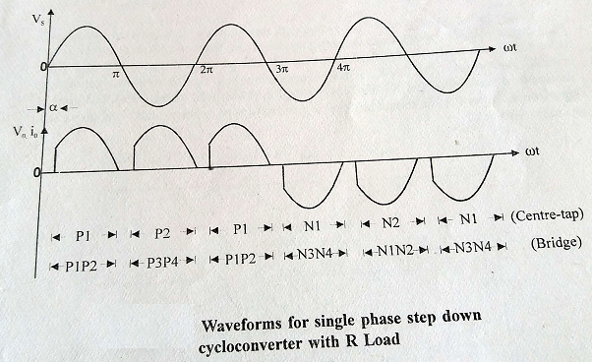
Fig 5.28 Related wave forms for step down cyclo-converter with Resistive load.

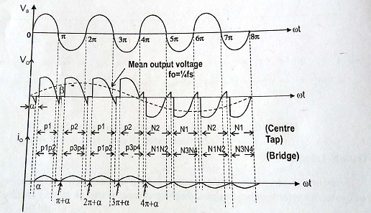
Fig 5.29 Voltage and current wave forms for step down cyclo - converter with discontinuous load current mode of operation

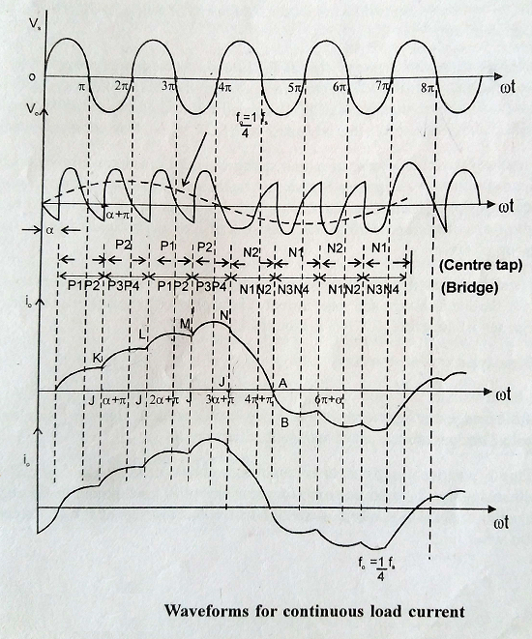
Fig 5.30 Voltage and current wave forms for step down cyclo - converter with continuous load current mode of operation

Similarly the fig. 5.31 shows Mid-point step-down cyclo-converter and operates the P1, P2 switches to generate positive pulse in output voltage and operates the N1, N2 switches to generate negative pulse in output voltage. The voltage and current wave forms for R and RL loads are as shown in Figs. 5.28, 5.29 and 5.30.
Fig. 5.13 Mid-point step-down cyclo-converter circuit diagram

