UNIT-III
Power system earthing
The objective of earthing are:
1. To ensure that no part of equipments, other than live parts should assume a potential which is dangerously different from surroundings.
2. To allow sufficient current to flow safely for proper operation of protective devices.
3. To limit over voltages between neutral and ground and between line and ground.
4. To suppress dangerous high potential gradients. The earth potential gradients, if not suppressed, may cause incorrect operation of control and protective devices and may also cause shock or injury to personnel.
Earthing can be divided into neutral earthing and equipment earthing. Neutral earthing deals with earthing of system neutral to ensure safety of personnel and protection against lighting. Equipment earthing deals with earthing of non-current carrying parts of the equipment to ensure safety of personnel and protection against lighting.
DEFINITIONS:
- EARTH ELECTRODE: A rod , pipe, plate or an array of conductors, embedded in earth horizontally or vertically. In distribution system the earth electrode consists of a rod about 1m long, driven vertically into ground. For substations an elaborate earthing system known as earth grid or earth mat is used.
- EARTH CURRENT: The current dissipated by earth electrode into the ground.
- RESISTANCE OF EARTH ELECTRODE: The resistance offered by the earth electrode to the flow of current into the ground. The resistance is not the ohmic resistance of the electrode but represents the resistance of the mass of earth surrounding the earth electrode. Numerically it is equal to the ratio of Potential of earth electrode with respect to remote point, to the current dissipated by it.
- STEP POTENTIAL: The potential difference shunted by a human body between two accessible points on the ground separated by the distance of one pace assumed to be equal to 1m.
- TOUCH POTENTIAL: The potential difference between a point on the ground and a point on an object likely to carry fault current (e.g Frame of equipment) and which can be touched by a person.
- MESH POTENTIAL: The maximum potential within a mesh of the grid.
- TRANSFERRED POTENTIAL: A special case of touch potential where a potential is transferred into or out of the substation.

Step Potential: Voltage between the feet of a person
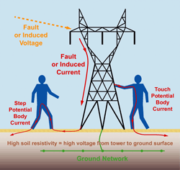
Fig 3.1 Step and touch potential
When current is flowing from the tower to the earth ground, the ground potential rises at the tower and a voltage gradient will occur based on the resistivity of the soil, resulting in a potential difference between two points on the ground. This is called a Step Potential as it can cause voltage between a person’s feet as shown in Fig3.1.

Touch Potential: Voltage between energized object and feet of a person
If the ground connection between the tower and the soil is high resistance (common with some soil conditions), the tower itself (and any conductive item touching the tower) can be energized. Touch potential is the voltage between the energized object and the feet of a person in contact with the object as shown in Fig3.1
TOLERABLE LIMITS OF BODY CURRENTS:
- The effect of electric current passing through vital organs of the body depends on magnitude, duration and frequency of current. The most dangerous consequences is a heart condition known as ventricular fibrillation which results in stoppage of blood circulation.
(a)Effect of magnitude of current :
The threshold of perception is a current of 1mA. Current in the range of 1-6 mA are known as “Let to go current” because these currents, though unpleasant, do not impair the ability of a person, holding an energised object, to release it. Currents in the range 9-25 mA may be painful and impair the ability to release energised object. Still higher current makes breathing difficult. However, if the current is less than about 6 mA, the effect are not permanent and disappear when current is interrupted. Currents higher than 60 mA , may lead to ventricular fibrillation, injury and death.

(b)Effect of duration of current :
- The magnitude of 50Hz tolerable current is related to duration. According to tests reported by Dalziel, 99.5% of persons of 50Kg weight can safety withstand the current given by equation.
- I_{B} = 0.116/√t ------- 1 where I_{B} is RMS value of body current in amperes and t is the time in seconds. If the weight of body is 70Kgs.
- I_{B} = 0.157 /√t ------- 2 are valid for 0.03<t<3 sec.
(c)Effect of frequency:
- The tolerable currents mentioned above for 50-60 Hz. It has been found that human body can tolerance about 5times higher direct current. At high frequencies (3000-10Hz) still higher currents can be tolerated.
SOIL RESISTIVITY: It is measure of how much the soil resists the flow of electricity.

The resistivity of soil depends on the following factors
SOIL TYPE: The type of soil governs the resistivity to large extent. Some typical values are Sea water 2.5 Ω -m, Tap water 20 Ω -m, Clay 50 Ω -m, Sand 2000 Ω -m, dry concrete 10000 Ω -m, rock 10000 Ω -m.
MOISTURE CONTENT: Electrical conduction in soil is electrolytic. Soil resistivity decreases with increase in moisture content. However when the moisture is more than 20% the change in resistivity is negligible. The amount of water which a soil can absorb depends on soil type, grain size and compactness.
TEMPERATURE: When temperature is more than zero degrees, its effect on soil resistivity is negligible. At zero degrees, water in the soil starts freezing and resistivity increases.
SALT CONTENT: The composition and amount of soluble salts also affect resistivity considerably.
MAGNITUDE OF CURRENT: If the value of current being dissipated by the soil is high, it may cause significant drying of soil and increase in its resistivity.
The soil resistivity at a particular location also changes with depth. Generally the lower layers of soil have greater moisture content and lower resistivity. However, if the lower layer contains hard, rocky soil resistivity may increase with depth.

Neutral Earthing or Grounding

The process of connecting neutral of 3-phase system to earth either directly or through some circuit element (e.g resistance, reactance) is called neutral earthing. Neutral earthing does not have any influence on the operation of a 3-phase system under balanced steady state conditions. However, the voltage and current during ground fault conditions are greatly affected.

Neutral earthing provides protection to personnel and equipment. It is because during earth fault condition the current path is completed through the earthed neutral and the protective devices (e.g fuses) operate to isolate the faulty conductor from the rest of the system.
To connect the metallic (conductive) Parts of an Electric appliance or installations to the earth (ground) is called Earthing or Grounding.
In other words, to connect the metallic parts of electric machinery and devices to the earth plate or earth electrode (which is buried in the moisture earth) through a thick conductor wire (which has very low resistance) for safety purpose is known as Earthing or grounding.
To earth or earthing rather, means to connect the part of electrical apparatus such as metallic covering of metals, earth terminal of socket cables, stay wires that do not carry current to the earth. Earthing can be said as the connection of the neutral point of a power supply system to the earth so as to avoid or minimize danger during discharge of electrical energy. Earthing or grounding shown in Fig3.2
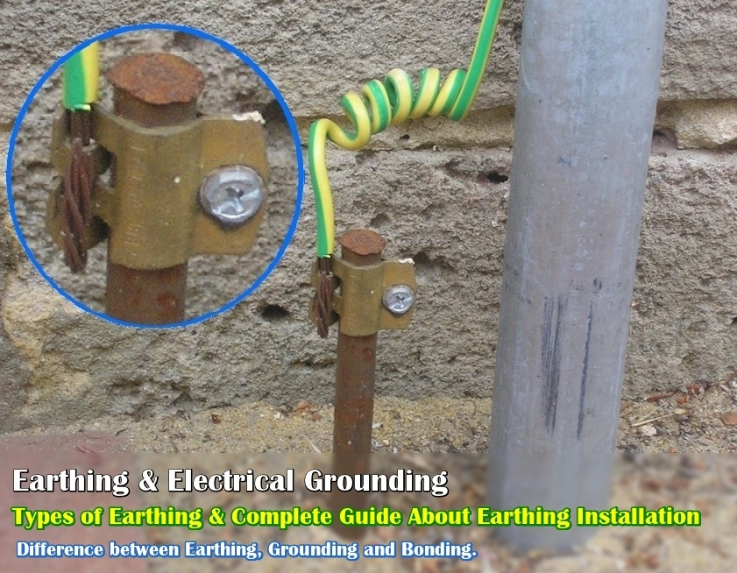

Fig 3.2 Earthing or grounding

Earthing System Design Considerations
Conductors - a substation earthing grid will consist of a earthing system of bonded cross conductors.
The earthing conductors, composing the grid and connections to all equipment and structures, must possess sufficient thermal capacity to pass the highest fault current for the required time.
Also, the earthing conductors must have sufficient mechanical strength and corrosion resistance. It is normal practice to bury horizontal earthing conductors at a depth of between 0.5m and 1m - this ensures that the earth conductor has the following properties :
- Adequate mechanical protection
- It is situated below the frost line
- The surrounding earth will not dry out
Vertically Driven Earth Rods
Where there are low resistivity strands beneath the surface layer then it would be advantageous to drive vertical earth rods down into this layer - to be effective the earth rods should be on the periphery of the site. The length of the earth rod is chosen so as to reach the more stable layers of ground below. The earth rods would stabilise the earth grid resistance over seasonal resistivity changes at the grid burial depth.
Substation Fences
The earthing of metallic fences around a substation is of vital importance because dangerous touch potentials can be involved and the fence is often accessible to the general public.
Fence earthing can be accomplished in two different ways :
- Electrically connecting the fence to the earth grid, locating it within the grid area or alternatively just outside
- Independently earthing the fence and locating it outside the earth grid area at a convenient place where the potential gradient from the grid edge is acceptably low.

Tower footing resistance
Tower footing resistance is the resistance offered by tower footing to the dissipation of current. The effective wire depends to a large extended on the tower footing resistance. The tower top potential depends on the resistance.
Significance: A low value of tower footing resistance results in less voltage stresses across line insulation. A tower footing resistance of 20Ω for EHV lines and 10 Ω for HV lines provides sufficient lightning protection.

METHODS OF NEUTRAL GROUNDING
The methods commonly used for grounding the system neutral are
- 1.Solid grounding (or effective grounding)
- 2.Resistance Grounding
- 3.Reactance Grounding
- 4.Peterson-coil grounding (or resonant grounding)
  - Solid grounding or effective grounding
- The selection of the type of grounding depends on the size of the unit, system voltage and protection scheme to be used.
- A power system is said to be effectively grounded or solidly grounded when the neutral of a generator, power transformer or grounding transformer are directly connected to the ground through a conductor of negligible resistance and reactance.
- A part of a system or system is said to be solidly grounded when the positive-sequence impedance of the system is greater or equal to the zero sequence resistance, and positive sequence reactance is three times greater than or equal to the zero sequence reactance. Effective grounding system is shown in Fig3.3
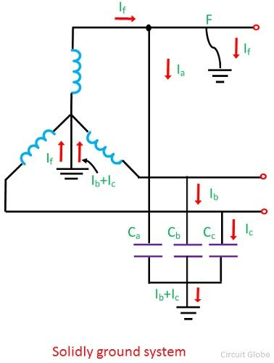
Fig 3.3.Solidly grounding system
- For the solidly neutral grounded system, it is necessary that the ground fault current should not exceed 80% of the three-phase fault. It is usually used for keeping the fault current within safe limits.
The main features of effectively grounded neutral system are
1. Ground fault currents is high, its maximum value may sometimes exceed even 3-phase short circuit current.
2. In the event of SLG fault, the maximum voltage of healthy phases doesn’t exceed 80% of line to line voltage.
3. Arcing grounds cannot occurs because the short circuit current eliminates the influence of capacitive current.
4. Since the ground fault current is high, danger to personnel
5. Ground fault relaying is simple and satisfactory.
6. Because of high fault currents, the interference due to electromagnetic induction with neighboring communication circuits may be high.

2. Resistance grounding
- In this type of neutral grounding, the neutral of the system is connected to ground through one or more resistance. Resistance grounding limits the fault currents. It protects the system from transient over voltages. Resistance grounding decreases the arcing grounding risk and permits ground-fault protection.
- The value of resistance used in the neutral grounding system should neither be very high nor be very low shown in the Fig3.4.
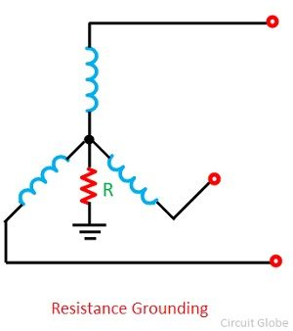
Fig 3.4.Resistance grounding system

- A very low resistance makes the system to the solidity grounded, whereas a very high resistance makes the system ungrounded. The value of resistance is chosen such that the ground-fault current is limited, but still sufficient ground current flows permit the operation of ground faults protections. In general, the ground fault may be limited up to 5% to 20% of that which occur with a three-phase line.
The main features of resistance grounded neutral system are
1. The ground fault current is low but higher than the capacitive ground fault current.
2. Ground fault relaying is simple and satisfactory.
3. The power dissipation in the grounding resistance may improve system stability because this power dissipation reduces the accelerating power.
3. Reactance Grounding
- As per IEEE definition reactance grounding means grounding through impedance, the principle element of which is reactance. This grounding is used when the zero sequence reactance of system is so low as to cause excessive ground fault current.
- In reactance grounded system, a reactance is inserted between the neutral and ground to limit the fault current as shown in the Fig3.5.
- Let X1,X2,X0 be the +ve,-ve and zero sequence reactance of a system and V be the voltage per phase.
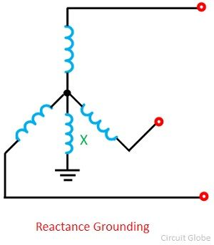
Fig 3.5 Reactance grounding system

- If X0 is negligible as compared to X1
- X1=X2
- Ground fault current = 3V/(X1+X2+X0) [X0 is negligible, X1=X2]
= 3V/2X1
=1.5 times 3phase s.c current
If X0=X1, X1=X2
Ground fault current = 3V/(X1+X2+X0) = 3V/3X1 =V/X1
If X1=X2=X0 and a reactance Xe is connected b/n neutral and earth
Ground fault current =3V/(X1+X2+X3+3Xe) = V/X1+Xe
If Xe is increased , the ground fault current decreases. If Xe is very small , the system behaves as an effectively grounded system.
Xe is very high , the system behaves as an isolated grounded system.

The main features of reactance grounded neutral system are:
1. The ground fault current is reduced but is much higher than capacitive ground fault current.
2. Voltages across healthy phases are b/n 0.8 t0 1 per unit of line voltage.
3. Arcing grounds are avoided
4. Transient ground fault are converted to controlled current faults.
5. Ground fault relaying is simple and satisfactory.

4. Peterson-coil grounding (or resonant grounding)
PETERSON COIL GROUNDING
Peterson coils are used in ungrounded three phase grounding systes to limit the arcing currents during ground faults.
The coils are first developed by W.Peterson in 1916.
However the use of modern power electronics has revolutionised the performance of these classical solutions.
Theory of Arcing Ground-Ungrounded System:
Ungrounded System is one where the neutral is not connected to earth. Thus, neutral of ungrounded system is isolated.
Arcing Ground is an electrical phenomenon in which the voltage of faulty phase fluctuates due to capacitive charging current. This arcing ground phenomenon is prevalent in three phase ungrounded neutral system.
A transmission line has shunt capacitance, due to this shunt capacitance, a charging current flows from line to ground under normal operating condition. Let us consider a three phase ungrounded neutral system as shown in figure below.
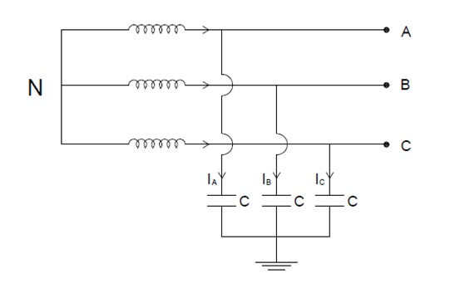
Fig 3.6 Ungrounded 3-phase system

As shown in Fig3.6, shunt capacitance for each line is C. I_{A}, I_{B} and I_{C} are the charging current corresponding to three phases A, B and C. Under normal operating condition, these charging currents will lead their corresponding phase voltage by 90°. Thus if we draw the phasor for this, then it will look like below.
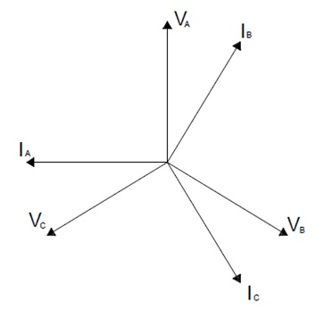
Fig 3.7 Ungrounded 3-phase system Phasor diagram

Carefully observe that I_{A}, I_{B} and I_{C} are leading phase voltage V_{A}, V_{B} and V_{C} by an angle 90°. But the angles between the three charging currents are maintained 120°. Thus we can say that, the charging currents are balanced and therefore,
I_{A}+I_{B}+I_{C} = 0
Ungrounded 3-phase system Phasor diagram is shown in Fig3.7.
Thus there will be no flow of current through the neutral. Hence the potential of neutral will be maintained at the ground potential.
Let us now consider a fault condition. Suppose a single line to ground fault takes place in C phase as shown in Fig3.8.
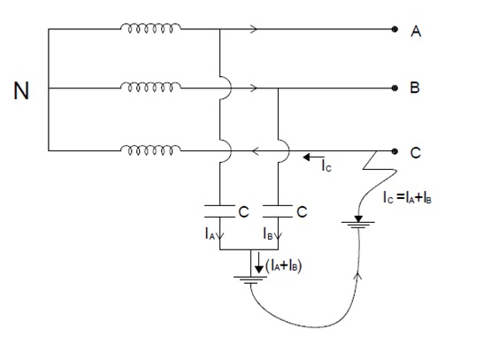
Fig 3.8 Ungrounded 3-phase system during fault

The fault current this case will complete its circuit as shown in figure above. Fault current I_{C} will be equal to the vector some of I_{A} and I_{B}. Therefore,
I_{C} = I_{A} + I_{B}
I_{C} in C phase will flow toward the neutral. Therefore we can say that, phase voltage of C phase has reversed its direction. This in turn means that, the voltage of neutral point has shifted from ground potential to phase voltage.
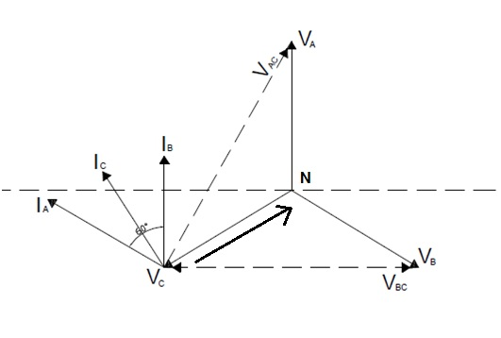
Fig 3.8 Ungrounded 3-phase system Phasor diagram during fault

Because of this shifting of neutral voltage, the voltage of healthy phase will become equal to the line voltage. This can be well understood by applying Kirchhof’s voltage law in the current loop of phase A.
(V_{C} – V_{N}) + (V_{N}-V_{A}) + (V_{A}-V_{C}) = 0
So,
(V_{A}-V_{N}) = (V_{C} – V_{N}) + (V_{A} – V_{C})
= -V_{C} + (V_{A} – 0)
= -V_{C} + V_{A}
= V_{A} – V_{C} = Line Voltage = V_{AC}
But V_{A} – V_{N} = Phase Voltage of A phase. Thus we observe that, the voltage of healthy phase rises to line voltage i.e. √3Vph. Due to this raised voltage of healthy phases, charging currents will increase.
I_{A} = √3V_{ph} / X_{C}
and I_{B} = √3V_{ph} / X_{C}
where X_{C} is capacitive reactance.
These charging currents will now lead with their respective voltages by 90° as shown in phasor diagram above. But notice that, this time the voltage is line voltage.
Therefore the fault current will be,
I_{C} = I_{A} + I_{B} (vector sum, please correlate with phasor diagram)
= 3V_{ph}/X_{C}
From the above expression of fault current, it is clear that charging current in faulted phase is three times that of the normal charging current. Due to this heavy arcing will take place in the faulted phase. This phenomenon of arcing is known as Arcing Ground. Peterson coil is used for the elimination of arcing ground.

Protection Against Arcing Ground:
The surge voltage due to arcing ground can remove by using the arc suppression coil or Peterson coil. The arc suppression coil has an iron cored tapped reactor connected in neutral to ground connection.
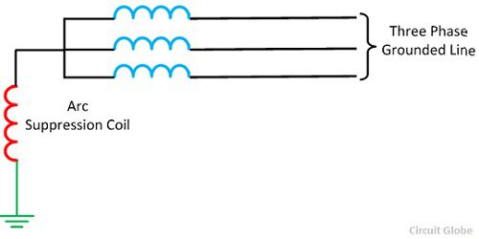
Fig 3.9 Peterson coil grounding
The reactor of the arc suppression coil extinguishes the arcing ground by neutralising the capacitive current. The Peterson coil isolates the system, in which the healthy phases continue supplies power and avoid the complete shut down on the system till the fault was located and isolated. peterson coil grounding is shown in Fig3.9.
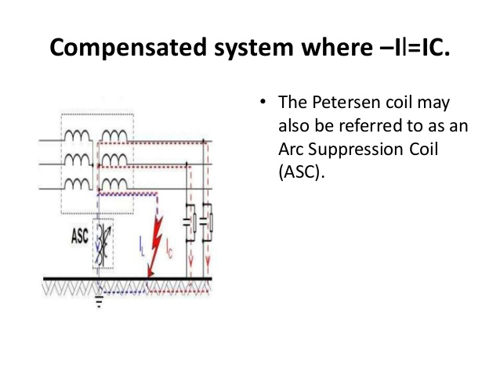

Neutral earthing transformer
The neutral earthing transformer is used to create a neutral for the delta side (which does not have a neutral point on its own). The reason is, put a transformer in there instead of directly creating a neutral point and grounding it, is that you get some impedance in between due to the transformer, which would limit various imbalanced currents and fault currents to a particular value. Note that this is usually a three-phase transformer.
If they are used on the star side, they are usually single-phase, and connected between the neutral and ground. No need to connect a three phase device here as the neutral point already exists.
Neutral earthing transformers are very common on large generators. They are used to limit bolted fault currents for these machines. They essentially allow you to insert a very small resistance (1-2 ohms) with an ampere rating of around 200A to restrict line-to-ground fault currents for the generators to around 1 - 2 A. They are indispensable for this purpose.

