UNIT-IV

Substations

Electrical Substation
Now days the electrical power demand is increasing very rapidly. For fulfilling these huge power demands the modern time requires creation of bigger and bigger power generating stations. These power generating stations may be hydro-electric, thermal or atomic. Depending upon the availability of resources these stations are constructed different places. These places may not be nearer to load centres where the actual consumption of power takes place. So it is necessary to transmit these huge power blocks from generating station to their load centres. Long and high voltage transmission networks are needed for this purpose. Power is generated comparatively in low voltage level. It is economical to transmit power at high voltage level. Distribution of electrical power is done at lower voltage levels as specified by consumers. For maintaining these voltage levels and for providing greater stability a number of transformation and switching stations have to be created in between generating station and consumer ends. These transformation and switching stations are generally known as electrical substations.

Location and Installation of SS
Selection of the location of a substation must consider many factors.
- Sufficient land area is required for installation of equipment with necessary clearances for electrical safety, and for access to maintain large apparatus such as transformers.
- Where land is costly, such as in urban areas, gas insulated switchgear may save money overall. Substations located in coastal areas affected by flooding and tropical storms may often require an elevated structure to keep equipment sensitive to surges hardened against these elements.
- The site must have room for expansion due to load growth or planned transmission additions. Environmental effects of the substation must be considered, such as drainage, noise and road traffic effects.
- The substation site must be reasonably central to the distribution area to be served.
- The site must be secure from intrusion by passers-by, both to protect people from injury by electric shock or arcs, and to protect the electrical system from misoperation due to vandalism.
Depending upon the purposes, the substations may be classified as-

Step Up Substation
Step up substations are associated with generating stations. Generation of power is limited to low voltage levels due to limitations of the rotating alternators. These generating voltages must be stepped up for economical transmission of power over long distance. So there must be a step up substation associated with generating station.

Step Down Substation
The stepped up voltages must be stepped down at load centres, to different voltage levels for different purposes. Depending upon these purposes the step down substation are further categorized in different sub categories.

Primary Step Down Substation
The primary step down sub stations are created nearer to load centre along the primary transmission lines. Here primary transmission voltages are stepped down to different suitable voltages for secondary transmission purpose. Primary step down Substation is shown in Fig4.1.

Secondary Step Down Substation
Along the secondary transmission lines, at load centre, the secondary transmission voltages are further stepped down for primary distribution purpose. The stepping down of secondary transmission voltages to primary distribution levels are done at secondary step down substation.

Distribution Substation
Distribution substations are situated where the primary distribution voltages are stepped down to supply voltages for feeding the actual consumers through a distribution network.

Bulk Supply or Industrial Substation
Bulk supply or industrial substations are generally a distribution substation but they are dedicated for one consumer only. An industrial consumer of large or medium supply group may be designated as bulk supply consumer. Individual step down substation is dedicated to these consumers.

Mining Substation
The mining substations are very special type of substation and they need special design construction because of extra precautions for safety needed in the operation of electric supply.

Mobile Substation
The mobile substations are also very special purpose substation temporarily required for construction purpose. For big construction purpose this substation fulfils the temporary power requirement during construction work.
Depending upon the constructional feature categories of substation may be divided into following manner-
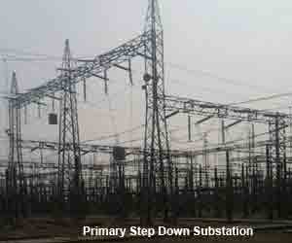

Fig4.1 Primary step down Substation
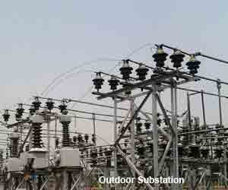

Fig4.2 Outdoor Type Substation

Outdoor type substations are constructed in open air. Nearly all 132KV, 220KV, 400KV substation are outdoor type substation. Although now days special GIS (Gas insulated substation) are constructed for extra high voltage system which are generally situated under roof. Outdoor Type Substation is shown in Fig4.2.

Indoor Substation
The substations are constructed under roof is called indoor type substation. Generally 11 KV and sometime 33 KV substation are of this type.

Underground Substation
The substation are situated at underground is called underground substation. In congested places where place for constructing distribution substation is difficult to find out, one can go for underground substation scheme.

Pole Mounted Substation
Pole mounted substation are mainly distribution substation constructed on two pole, four pole and sometime six or more poles structures. In these type of substation fuse protected distribution transformer are mounted on poles along with electrical isolator switches.
Main Components in Electrical Substations and their Workings
The power system is a constituent of power generation, transmission and distribution systems. For all the power system operations, substations are required for their course of action. Substations are congregation of electrical equipment through which consumers get supply of electrical power from generating stations. By varying the voltage levels or frequency or any other aspects, the required electrical quantity can be altered in substations to provide quality power to consumers
Based on the application of substations, they are classified into different types: Generation substation, Indoor substation, Outdoor substation, Pole mounted substation, Switching substation, Transmission substation, Converter substation and Distribution substation. In rare cases like wind farm power generation system, multiple hydroelectric and thermal power plants one can observe the collector substation which is used for transferring power from multiple turbines into one transmission unit.

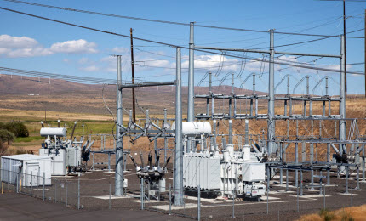

Fig4.3 Substation

The substation is an assembly of the following major electrical equipments
- Electrical Power transformers
- Instrument transformers
- Conductors& Insulators
- Isolators
- Bus bars
- Lightning arresters
- Circuit breakers
- Relays
- Capacitor banks and miscellaneous equipment
Electrical Power Transformer
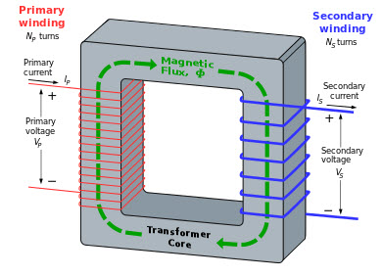

Fig4.4 Electrical power Transformer

Electrical Power transformer
A static electrical machine used for transforming power from one circuit to another circuit without changing frequency is termed as Power transformer. The transformers are generally used to step down or step up the voltage levels of a system for transmission and generation purpose. These transformers are classified into different types based on their design, utilization purpose, installation methods, and so on. Electrical power Transformer is shown in Fig4.4.
Instrument Transformers:
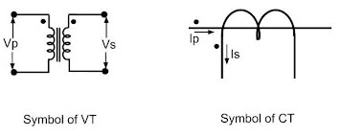
The current and voltage transformers are together called as the Instrument transformers.

Current Transformer
Current transformer is used for the measurement of the alternating current by taking samples of the higher currents of the system. These reduced samples are in accurate proportions with the actual high currents of the system. These are used for installation and maintenance of the current relays in substations for protection purpose which are normally have low-current ratings for their operation

Potential Transformer
Potential transformer is quite similar to the current transformer, but it is used for taking samples of high voltages of a system for providing low-voltage to the relays of protection system and also to the low-rating meters for voltage measurement. From this low-voltage measurement, the actual system’s high voltage can be calculated without measuring high voltages directly to avoid the cost of the measurement system

Conductors
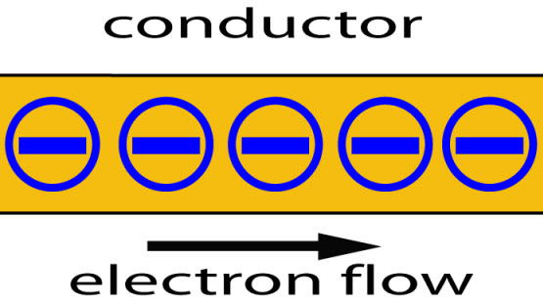
The material or object that obeys the electrical property conductance (mostly made of metals such as aluminium and copper) and that allows the flow of electric charge is called conductor. Conductors permit free movement of the flow of electrons through them. These are used for the transmission of power or electrical energy from one place (generating station) to another place (consumer point where power is consumed by the loads) through substations. Conductors are of different types and mostly aluminium conductors are preferred in practical power systems

Insulators
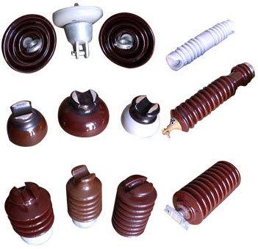
The metal which does not allow free movement of electrons or electric charge is called as an insulator. Hence, insulators resist electricity with their high resisting property. There are different types of insulators such as suspension type, strain type, stray type, shackle, pin type and so on. A few types of insulators are shown in the above figure. Insulators are used for insulation purpose while erecting electric poles with conductors to avoid short circuit and for other insulation requirements.

Isolators
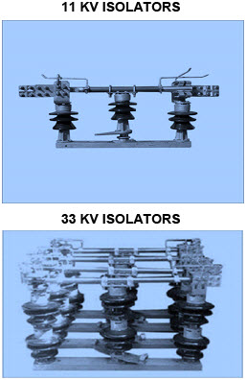

Isolator is a manually operated mechanical switch that isolates the faulty section or the section of a conductor or a part of a circuit of substation meant for repair from a healthy section in order to avoid occurrence of more severe faults. Hence, it is also called as a disconnector or disconnecting switch. There are different types of isolators used for different applications such as single-break isolator, double-break isolator, bus isolator, line isolator, etc.
Bus Bars
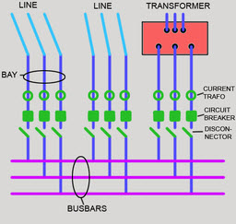
The conductor carrying current and having multiple numbers of incoming and outgoing line connections can be called as bus bar, which is commonly used in substations. These are classified into different types like single bus, double bus and ring bus

Lightening Arresters
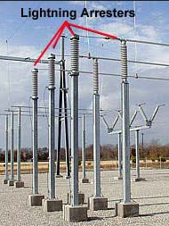

The substation equipments such as conductors, transformers, etc., are always erected outdoor. Whenever light surges occur then, a high-voltage pass through these electrical components causing damage to them (either temporary or permanent damage based on the amount of voltage surge). Therefore, to avoid this difficulty, lightening arresters are placed to pass the entire lightening surges to earth. There are other arresters which are used to ground the switching surges called as surge arresters.

Circuit Breakers
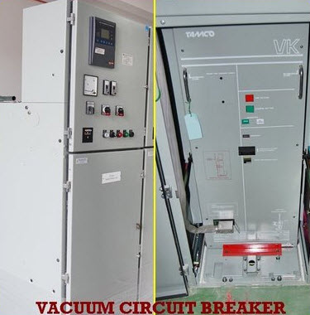

For the protection of substation and its components from the over currents or over load due to short circuit or any other fault the faulty section is disconnected from the healthy section either manually or automatically. If once the fault is rectified, then again the original circuit can be rebuilt by manually or automatically. Different types of circuit breakers are designed based on different criteria and usage. But in general mostly used circuit breakers are Oil circuit breaker, Air circuit breaker, SF6 circuit breaker, Vacuum Circuit Breaker, and so on
Relays:
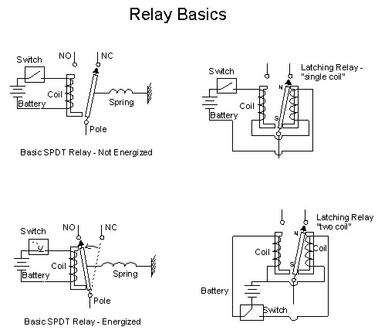

Relays are used for disconnecting the circuits by manual or automatic operation. Relay consists of the coil which is excited or energized and such that making the contacts of relay closed activates the relay to break or make the circuit connection. There are different types of relays such as over current relays, definite time over current relays, voltage relays, auxiliary relays, reclosing relays, solid state relays, directional relays, inverse time over current relays, microcontroller relays, etc. The above figure shows some basic relays and their operation
Capacitor banks
Capacitor bank is a set of many identical capacitors connected in series or parallel within a enclosure and is used for the power factor correction and basic protection of substation. These capacitor banks are acts as a source of reactive power, and thus, the phase difference between voltage and current can be reduced by the capacitor banks. They will increase the ripple current capacity of the supply. It avoids undesirable characteristics in the power system. It is the most economical method for maintaining power factor and of correction of the power lag problems

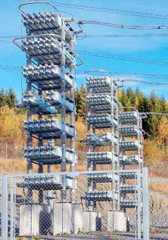
Emerging trends in technological development have created advancement in the substation installation and maintenance. For example, SCADA, supervisory control and data acquisition technique made it possible to control a substation automatically from a remote location. For more data regarding miscellaneous components and technologies in substations, post your queries in the comments section below.

BUS BAR ARRANGEMENTS:
Bus-bars are the important components in a sub-station. There are several bus-bar arrangements that can be used in a sub-station. The choice of a particular arrangement depends upon various factors such as system voltage, position of sub-station, degree of reliability, cost etc. The following are the important bus-bar arrangements used in sub-stations
- Single bus bar system
- Single bus bar system with sectionalisation
- Duplicate bus bar or double bus bar system

- SINGLE BUS-BAR ARRANGEMENT

As the name suggests, it consists of a single bus-bar and all the incoming and outgoing lines are connected to it. The chief advantages of this type of arrangement are low initial cost, less maintenance and simple operation. However, the principal disadvantage of single bus-bar system is that if repair is to be done on the bus-bar or a fault occurs on the bus, there is a complete interruption of the supply. This arrangement is not used for voltages exceeding 33kV. The indoor 11kV sub-stations often use single bus-bar arrangement. single bus-bar arrangement is shown in Fig4.5

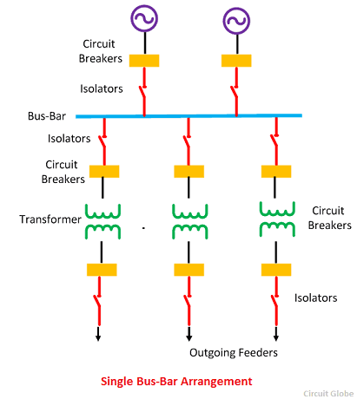

Fig4.5 SINGLE BUS-BAR ARRANGEMENT

2.SINGLE BUS-BAR WITH SECTIONALISER ARRANGEMENT

In this arrangement, the single bus-bar is divided into sections and load is equally distributed on all the sections. Any two sections of the busbar are connected by a circuit breaker and isolators. Two principal advantages are claimed for this arrangement. Firstly, if a fault occurs on any section of the bus, that section can be isolated without affecting the supply from other sections. Secondly, repairs and maintenance of any section of the busbar can be carried out by de-energising that section only, eliminating the possibility of complete shutdown. This arrangement is used for voltages upto 33 kV. single bus-bar with sectionaliser arrangement is shown in Fig4.6.

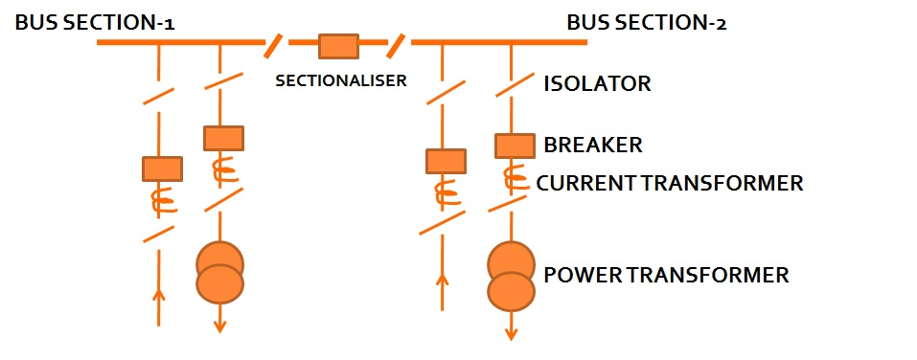
Fig4.6 SINGLE BUS-BAR WITH SECTIONALISER ARRANGEMENT

3.DOUBLE BUS BAR ARRANGEMENT
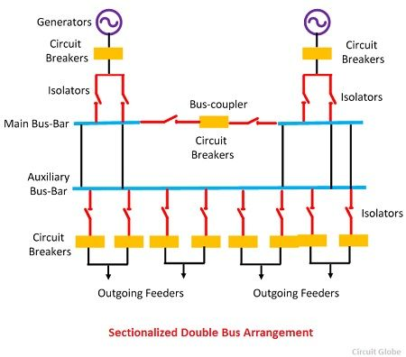
Fig4.7 SECTIONALISED DOUBLE BUS ARRANGEMENT

This system consists of two bus-bars, a “main” bus-bar and a “spare” bus-bar. Each bus-bar has the capacity to take up the entire sub-station load. The incoming and outgoing lines can be connected to either bus-bar with the help of a bus-bar coupler which consists of a circuit breaker and isolators. Ordinarily, the incoming and outgoing lines remain connected to the main bus-bar. However, in case of repair of main bus-bar or fault occuring on it, the continuity of supply to the circuit can be maintained by transferring it to the spare bus-bar. For voltages exceeding 33kV, duplicate bus-bar system is frequently used. Double bus-bar with sectionaliser arrangement is shown in Fig4.7.
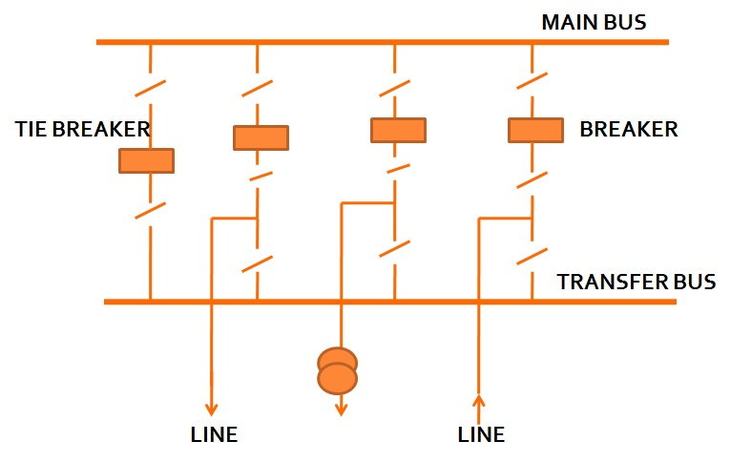
Tie-line bus bar arrangement
Fig4.8 TIE-LINE BUS BAR ARRANGEMENT

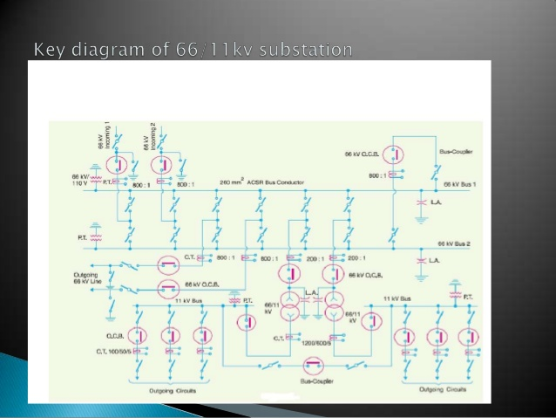
Fig4.9 Key diagram of 66/11 KV SUBSTATION

EHV TRANSMISSION
Two factors considered in the classification of a "high voltage" are the possibility of causing a spark in air, and the danger of electric shock by contact or proximity.
In electric power transmission engineering, high voltage is usually considered any voltage over approximately 35,000 volts.
In digital electronics, a high voltage is the one that represents a logic 1; this may be only several hundred millivolts for some logic families.
In electric power transmission engineering this refers to equipment designed for more than 345,000 volts between conductors. In electronics systems, a power supply that provides greater than 275,000 volts is known as an "EHV Power Supply". It is often used in experiments in physics
EHV POWER LINES
Electrical transmission and distribution lines for electric power always use voltages significantly higher than 50 volts, so contact with or close approach to the line conductors presents a danger of electrocution.
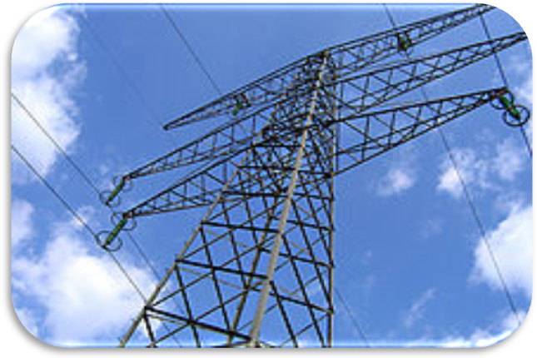
For high voltage and extra-high voltage transmission lines, specially trained personnel use so-called "live line" techniques to allow hands-on contact with energized equipment.

NECESSITY FOR EHV TRANSMISSION
With the increase in transmission voltage, for same amount of power to be transmitted current in the line decreases which reduces I²R losses. This will lead to increase in transmission efficiency.
With decrease in transmission current, size of conductor required reduces which decreases the volume of conductor

The transmission capacity is proportional to square of operating voltages. Thus the transmission capacity of line increases with increase in voltage
With increase in level of transmission voltage, the installation cost of the transmission line per km decreases.
It is economical with EHV transmission to interconnect the power systems on a large scale. The no. of circuits and the land requirement for transmission decreases with the use of higher transmission voltages.
ADVANTAGES OF EHV TRANSMISSION
The major advantages are:
- Reduction in the current.
- Reduction in the losses.
- Reduction in volume of conductor material required.
- Decrease in voltage drop & improvement of voltage regulation.
- Increase in Transmission Efficiency.
- Increased power handling capacity.
- The no. of circuits & the land requirement reduces as transmission voltage increases.
- The total line cost per MW per km decreases considerably with the increase in line voltage
DISADVANTAGES OF EHV TRANSMISSION
The major disadvantages are:
- Corona loss & radio interference
- Line supports
- Erection difficulties
- Insulation needs
- The cost of transformers, switchgear equipments & protective equipments increases with increase in transmission line voltage

- The EHV lines generates electrostatic effects which are harmful to human beings & animals.

APPLICATIONS OF EHV AC TRANSMISSION
High voltage is used in
- In electrical power distribution,
- In cathode ray tubes, to generate X-rays and particle beams, to demonstrate arcing, for ignition
- In photomultiplier tubes, and high power amplifier vacuum tubes and other industrial and scientific applications

HVDC TRANSMISSION:
The electric power is produced, transmitted and distributed as an AC power. From the generating stations, power is transmitted to the end user via transmission and distribution lines. Transmission lines are long and operate at high or extra high voltages.
- But, the amount of AC power transmission through the line is restricted by its inductance. To overcome this, a High Voltage DC (HVDC) transmission system is generally employed for high power transmission.
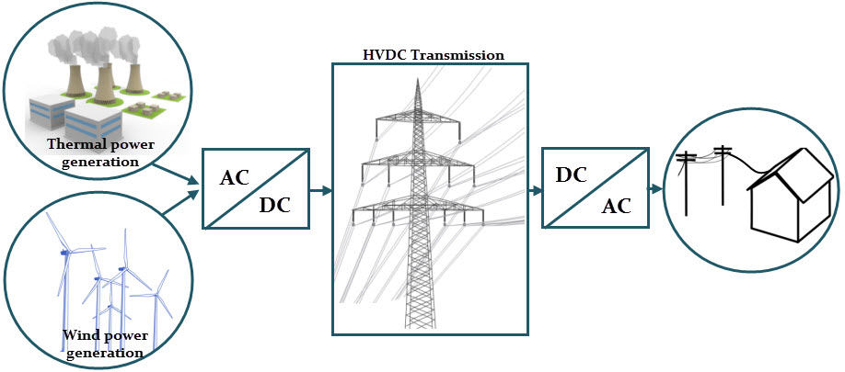
At the end of the DC power system, DC power is inverted to the AC power and synchronizes with succeeding AC network. So the entire HVDC consists of three sections, namely converter station, transmission portion and an inverter station.
The sending end or converter station consists of 6, 12, or 24-pulse thyristor bridge rectifier while the receiving end or inverter station consists of a similarly configured thyristor bridge but which operates in inverter mode.

Advantages of HVDC over HVAC Transmission Systems
- In DC transmission, only two conductors are needed for a single line. Only one conductor is enough using earth return and by using two conductors and earth return, the capacity of the line is doubled. But, in case of AC transmission, at least three conductors are needed and six conductors would be needed for double circuit line.
- It can transport power economically and efficiently over long distances with reduced transmission lines compared with losses in AC transmission.
- The DC link connected between two AC systems eliminates the need for maintaining the synchronization between them. The supply frequencies may or may not be equal on the two sides. HVDC systems always maintain the power flow as long as the voltage of the systems linked by HVDC is maintained at certain limits. But in case of HVAC system, synchronization of the supply frequency is must.
- The power flow in HVDC system can easily be controlled at high speed. The automatic controllers in the converter station determine the power flow through the link.
- No stability problems due to the transmission line length because no reactive power is needed to be transmitted.
- Fault isolation between the sending end and receiving end can be dynamically achieved due to fast efficient control of the HVDC link.
- In case of HVAC transmission for voltages greater than 400KV, it is necessary to limit the possible switching transients due to economic reasons. With the use of HVDC, such problems do not occur.

Components of an HVDC Transmission System

The essential components in a HVDC transmission system are 6/12/24 pulse converters, converter transformer with suitable ratio and tap changing, filters at both DC and AC side, smoothening reactor in DC side, shunt capacitors and DC transmission lines. Components of an HVDC Transmission System are shown in Fig4.10.

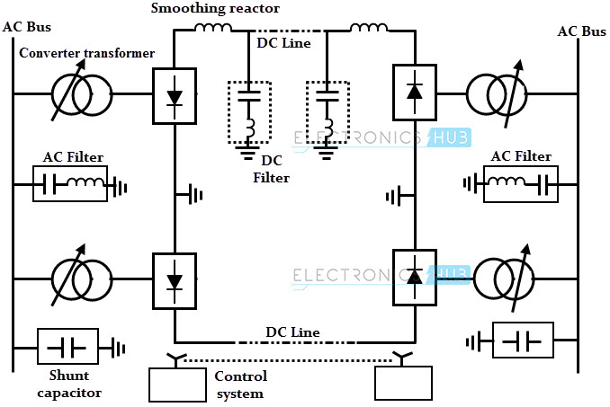
Fig 4.10 HVDC Transmission system

Converter Unit
HVDC transmission requires a converter at each end of the line. The sending end converter acts as a rectifier which converts AC power to DC power and the receiving end converter acts as an inverter which converts DC power to AC power.
This unit usually consists of two three phase converter which are connected in series to form a 12 pulse converter. The converter consists of 12 thyristor valves and these valves can be packaged as single valve or double valve or quadrivalve arrangements.
Due to the evaluation of power electronic devices, the thyristor valves have been replaced by high power handling devices such as gate turn-off thyristors (GTOs), IGBTs and light triggered thyristors.
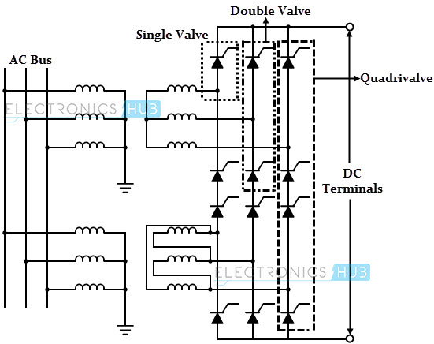
Fig 4.11 Converter unit

The valves are cooled by air, water or oil and these are designed based on modular concept where each module consists of a series connected thyristor levels.
Firing signals for the valves are generated in the converter controller and are transmitted to each thyristor in the valve through a fiber optic light guide system. The light signals further converted into electrical signals using gate drive amplifiers with pulse transformers.
The valves are protected using snubber circuits, gapless surge arrestors, and protective firing circuits.

Converter Transformers
The transformers used before the rectification of AC in HVDC system are called as converter transformers. The different configurations of the converter transformer include three phase- two winding, single phase- three winding and single phase- two winding transformers.
The valve side windings of transformers are connected in star and delta with ungrounded neutral and the AC supply side windings are connected in parallel with grounded neutral.
The design of the control transformer is somewhat different from the one used in AC systems . These are designed to withstand DC voltage stresses and increased eddy current losses due to harmonic currents.
The content of harmonics in a converter transformer is much higher compared to conventional transformer which causes additional leakage flux and it results to the formation of local hotspots in windings. To avoid these hotspots, suitable magnetic shunts and effective cooling arrangements are required.

Filters
Due to the repetitive firing of thyristors, harmonics are generated in the HVDC system. These harmonics are transmitted to the AC network and led to the overheating of the equipment and also interference with the communication system. In order to reduce the harmonics, filters and filtering techniques are used. Types of filters include

AC filters
These are made with passive components and they provide low impedance and shunt paths for AC harmonic currents. Tuned as well as damped filter arrangements are generally used in HVDC system.

DC filters
Similar to AC filters, these are also used for filtering the harmonics. Filters used at DC end, usually smaller and less expensive than filters used in AC side. The modern DC filters are of active type in which passive part is reduced to a minimum. Specially designed DC filters are used in HVDC transmission lines in order to reduce the disturbances caused in telecommunication systems due to harmonics.

High frequency filters
These are provided to suppress the high frequency currents and are connected between converter transformer and the station AC bus. Sometimes these are connected between DC filter and DC line and also on the neutral side.

Shunt capacitors or Reactive Compensation
Due to the delay in the firing angle of the converter station, reactive volt-amperes are generated in the process of conversion. Since the DC system does not require or generate any reactive power, this must be suitably compensated by using shunt capacitors connecting at both ends of the system.

Smoothening reactor
It is a large series reactor, which is used on DC side to smooth the DC current as well as for protection purpose. It regulates the DC current to a fixed value by opposing sudden change of the input current from the converter. It can be connected on the line side, neutral side or at an intermediate location.

Transmission medium lines or cables
Overhead lines act as a most frequent transmission medium for bulk power transmission over land. Two conductors with different polarity are used in HVDC systems to transfer the power from sending end to receiving end.
The size of the conductors required in DC transmission is small for the same power handling capacity to that of AC transmission. Due to the absence of frequency, there is no skin effect in the conductors.
High voltage DC cables are used in case of submarine transmission. Most of such cables are of an oil filled type. Its insulation consists of paper tapes impregnated with high viscosity oil.

Different types of HVDC links
The HVDC transmission, which is economical for long distance power transmission, and for the interconnection of two or more networks that has different frequencies or voltages. For connecting two networks or system, various types of HVDC links are use. HVDC links are classified into three type. These links are explained below;
Monopolar link – It has a single conductor of negative polarity and uses earth or sea for the return path of current. Sometimes the metallic return is also used. In the Monopolar link, two converters are placed at the end of each pole. Earthing of poles is done by earth electrodes placed about 15 to 55 km away from the respective terminal stations. But this link has several disadvantages because it uses earth as a return path. The monopolar link is not much in use nowadays. Monopolar link is shown in Fig4.12
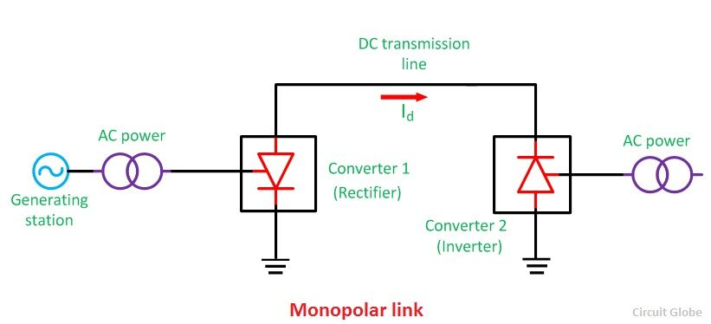 Fig 4.12 Monopolar link
Bipolar link – A bipolar link has two conductors, one positive and the other negative on earth. The midpoints of converters at each terminal station are earthed via electrode lines. The voltage between the conductors is equal to two times the voltages between either of the two conductors and ground.
Since one conductor is at the positive polarity on earth and other is at negative polarity on earth. In bipolar link when one pole goes out of operation, the system may be changed to the monopolar mode with the ground return. Thus, the system continues to supply the half rated power .Bipolar links are most commonly used in all high power HVDC systems. Bipolar link is shown in Fig4.13
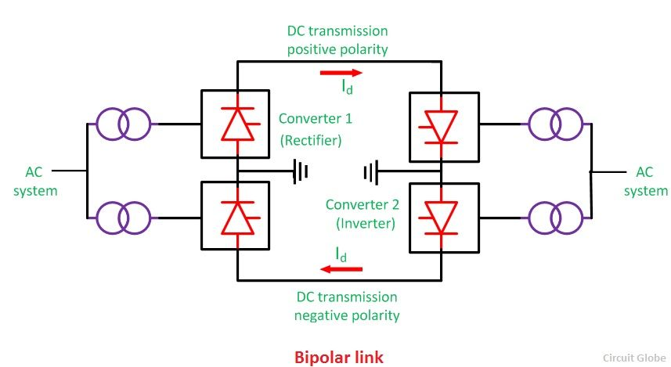 Fig 4.13 Bipolar link
Homopolar link– It has two conductors of the same polarity usually negative polarity, and always operates with earth or metallic return. In the homopolar link, poles are operated in parallel, which reduces the insulation cost. Homopolar link is shown in Fig4.14
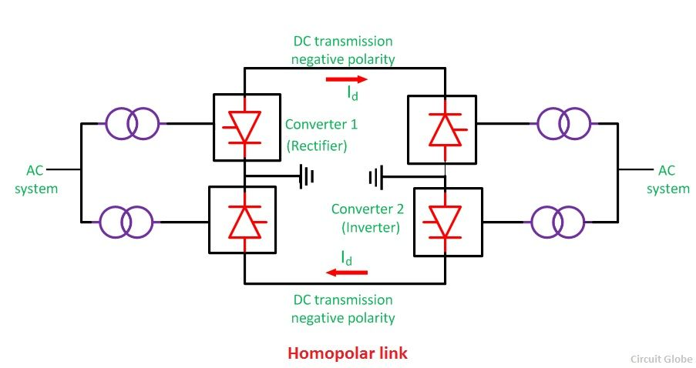
Fig 4.14 Homopolar link
The homopolar system is not used presently.

