**Chapter 1**

**Fundamentals of Illumination**

**1.1 INTRODUCTION**

Study of illumination engineering is necessary not only to understand the principles of light control as applied to interior lighting design such as domestic and factory lighting but also to understand outdoor applications such as highway lighting and flood lighting. Nowaday, the electrically produced light is preferred to the other source of illumination because of an account of its cleanliness, ease of control, steady light output, low cost, and reliability. The best illumination is that it produces no strain on the eyes. Apart from its esthetic and decorative aspects, good lighting has a strictly utilitarian value in reducing the fatigue of the workers, protecting their health, increasing production, etc. The science of illumination engineering is therefore becoming of major importance.

**1.1.1 Nature of light**

Light is a form of electromagnetic energy radiated from a body and human eye is capable of receiving it. Light is a prime factor in the human life as all activities of human being ultimately depend upon the light.

Various forms of incandescent bodies are the sources of light and the light emitted by such bodies depends upon their temperature. A hot body about 500–800°C becomes a red hot and about 2,500–3,000°C the body becomes white hot. While the body is red-hot, the wavelength of the radiated energy will be sufficiently large and the energy available in the form of heat. Further, the temperature increases, the body changes from red-hot to white-hot state, the wavelength of the radiated energy becomes smaller and enters into the range of the wavelength of light. The wavelength of the light waves varying from 0.0004 to 0.00075 mm, i.e. 4,000-7,500 Å (1 Angstrom unit = 10–10 mm).

The eye discriminates between different wavelengths in this range by the sensation of color. The whole of the energy radiated out is not useful for illumination purpose. Radiations of very short wavelength varying from 0.0000156 × 10–6m to 0.001 × 10–6 m are not in the visible range are called as rontgen or x-rays, which are having the property of penetrating through opaque bodies.

**1.2 TERMS USED IN ILLUMINATION**

The following terms are generally used in illumination.

**Colour:** The energy radiation of the heated body is monochromatic, i.e. the radiation of only one wavelength emits specific color. The wavelength of visible light lies between 4,000 and 7,500 Å. The color of the radiation corresponding to the wavelength is shown in [Fig. 1.1](https://www.safaribooksonline.com/library/view/generation-and-utilization/9789332515673/xhtml/chapter006.xhtml#Fig-6-1).

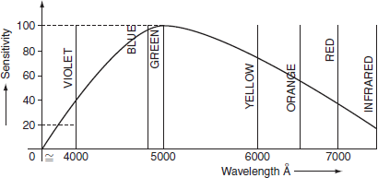

**Fig. 1.1** Wavelength

**Relative sensitivity:** The reacting power of the human eye to the light waves of different wavelengths varies from person to person, and also varies with age. The average relative sensitivity is shown in [Fig. 1.2](https://www.safaribooksonline.com/library/view/generation-and-utilization/9789332515673/xhtml/chapter006.xhtml#Fig-6-2).

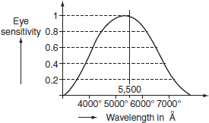

**Fig. 1.2** The average relative sensitivity

The eye is most sensitive for a wavelength of 5,500 Å. So that, the relative sensitivity according to this wavelength is taken as unity.

Referred from [Fig. 6.1](https://www.safaribooksonline.com/library/view/generation-and-utilization/9789332515673/xhtml/chapter006.xhtml#Fig-6-1), blue and violet corresponding to the short wavelengths and red to the long wavelengths, orange, yellow, and green being in the middle of the visible region of wavelength. The color corresponding to 5,500 Å is not suitable for most of the applications since yellowish green. The relative sensitivity at any particular wavelength (*λ*) is known as relative luminous factor (*K*λ)*.*

**Light:** It is defined as the radiant energy from a hot body that produces the visual sensation upon the human eye. It is expressed in lumen-hours and it analogous to watt-hours, which denoted by the symbol ‘*Q*’.

**Luminous flux:** It is defined as the energy in the form of light waves radiated per second from a luminous body. It is represented by the symbol ‘*φ*’ and measured in lumens.

***Ex:*** Suppose the luminous body is an incandescent lamp.

The total electrical power input to the lamp is not converted to luminous flux, some of the power lost through conduction, convection, and radiation, etc. Afraction of the remaining radiant flux is in the form of light waves lies in between the visual range of wavelength, i.e. between 4,000 and 7,000 Å, as shown in [Fig. 1.3](https://www.safaribooksonline.com/library/view/generation-and-utilization/9789332515673/xhtml/chapter006.xhtml#Fig-6-3).

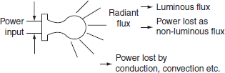

**Fig. 1.3** Flux diagram

**1.2.1 Radiant efficiency**

When an electric current is passed through a conductor, some heat is produced to *I*2*R* loss, which increases its temperature of the conductor. At low temperature, conductor radiates energy in the form of heat waves, but at very high temperatures, radiated energy will be in the form of light as well as heat waves.

‘Radiant efficiency is defined as the ratio of energy radiated in the form of light, produces sensation of vision to the total energy radiated out by the luminous body’.

Image

**1.2.2 Plane angle**

A plane angle is the angle subtended at a point in a plane by two converging lines ([Fig. 1.4](https://www.safaribooksonline.com/library/view/generation-and-utilization/9789332515673/xhtml/chapter006.xhtml#Fig-6-4)). It is denoted by the Greek letter ‘*θ*’ (theta) and is usually measured in degrees or radians.

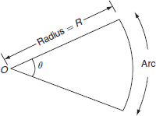

**Fig. 1.4** Plane angle

Image

One radian is defined as the angle subtended by an arc of a circle whose length by an arc of a circle whose length is equals to the radius of the circle.

**1.2.3 Solid angle**

Solid angle is the angle subtended at a point in space by an area, i.e., the angle enclosed in the volume formed by numerous lines lying on the surface and meeting at the point ([Fig. 1.5](https://www.safaribooksonline.com/library/view/generation-and-utilization/9789332515673/xhtml/chapter006.xhtml#Fig-6-5)). It is usually denoted by symbol ‘*ω*’ and is measured in steradian.

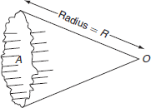

**Fig. 1.5** Solid angle

Image

The largest solid angle subtended at the center of a sphere:

Image

***Relationship between plane angle and solid angle***

Let us consider a curved surface of a spherical segment ABC of height ‘*h*’ and radius of the sphere ‘*r*’ as shown in [Fig. 1.6](https://www.safaribooksonline.com/library/view/generation-and-utilization/9789332515673/xhtml/chapter006.xhtml#Fig-6-6). The surface area of the curved surface of the spherical segment *ABC =* 2*πrh.*From the [Fig. 1.6](https://www.safaribooksonline.com/library/view/generation-and-utilization/9789332515673/xhtml/chapter006.xhtml#Fig-6-6):

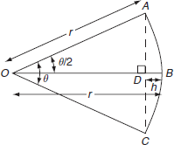

**Fig. 1.6** Sectional view for solid angle

*BD = OB – OD*

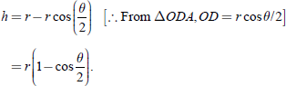

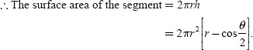

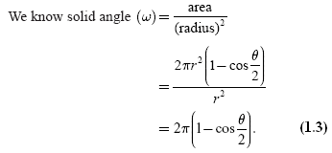

From the [Equation (1.3)](https://www.safaribooksonline.com/library/view/generation-and-utilization/9789332515673/xhtml/chapter006.xhtml#eq-6-3), the curve shows the variation of solid angle with plane angle is shown in[Fig. 1.7](https://www.safaribooksonline.com/library/view/generation-and-utilization/9789332515673/xhtml/chapter006.xhtml#Fig-6-7).

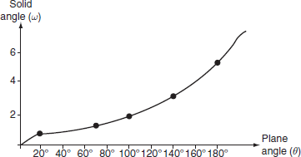

**Fig. 1.7** Relation between solid angle and plane angle

***Luminous intensity***

Luminous intensity in a given direction is defined as the luminous flux emitted by the source per unit solid angle ([Fig. 1.8](https://www.safaribooksonline.com/library/view/generation-and-utilization/9789332515673/xhtml/chapter006.xhtml#Fig-6-8)).

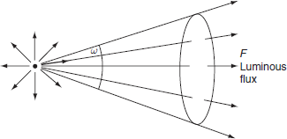

**Fig. 1.8** Luminous flux emitting from the source

It is denoted by the symbol ‘*I*’ and is usually measured in ‘candela’.

Let ‘*F*’ be the luminous flux crossing a spherical segment of solid angle ‘*ω*’. Then luminous intensity Image lumen/steradian or candela.

**Lumen:** It is the unit of luminous flux.

It is defined as the luminous flux emitted by a source of one candle power per unit solid angle in all directions.

Lumen = candle power of source × solid angle.

Lumen = CP × *ω*

Total flux emitted by a source of one candle power is 4*π* lumens.

***Candle power (CP)***

The CP of a source is defined as the total luminous flux lines emitted by that source in a unit solid angle.

Image

***Illumination***

Illumination is defined as the luminous flux received by the surface per unit area.

It is usually denoted by the symbol ‘*E*’ and is measured in lux or lumen/m2 or meter candle or foot candle.

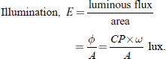

***Lux or meter candle***

It is defined as the illumination of the inside of a sphere of radius 1 m and a source of 1 CP is fitted at the center of sphere.

***Foot candle***

It is the unit of illumination and is defined as the illumination of the inside of a sphere of radius 1 foot, and a source of 1 CP is fitted at the center of it.

We know that 1 lux = 1 foot candle = 1 lumen/(ft)2

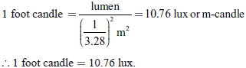

***Brightness***

Brightness of any surface is defined as the luminous intensity pen unit surface area of the projected surface in the given direction. It is usually denoted by symbol ‘*L*’.

If the luminous intensity of source be ‘*I*’ candela on an *area A,* then the projected area is *A* cos *θ.*

Image

The unit of brightness is candela/m2 or candela/cm2 or candela/(ft)2.

***Relation between I, E, and L***

Let us consider a uniform diffuse sphere with radius *r* meters, at the center a source of 1 CP, and luminous intensity *I* candela.

Image

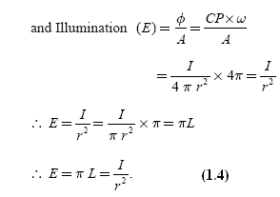

***Mean horizontal candle power (MHCP)***

MHCP is defined as the mean of the candle power of source in all directions in horizontal plane.

***Mean spherical candle power (MSCP)***

MSCP is defined as the mean of the candle power of source in all directions in all planes.

***Mean hemispherical candle power (MHSCP)***

MHSCP is defined as the mean of the candle power of source in all directions above or below the horizontal plane.

***Reduction factor***

Reduction factor of the source of light is defined as the ratio of its mean spherical candle power to its mean horizontal candle power.

Image

***Lamp efficiency***

It is defined as the ratio of the total luminous flux emitting from the source to its electrical power input in watts.

Image

It is expressed in lumen/W.

***Specific consumption***

It is defined as the ratio of electric power input to its average candle power.

***Space to height ratio***

It is defined as ratio of horizontal distance between adjacent lamps to the height of their mountings.

Image

***Coefficient of utilization or utilization factor***

It is defined as the ratio of total number of lumens reaching the working plane to the total number of lumens emitting from source.

Image

***Maintenance factor***

It is defined as the ratio of illumination under normal working conditions to the illumination when everything is clean.

Image

Its value is always less than 1, and it will be around 0.8. This is due to the accumulation of dust, dirt, and smoke on the lamps that emit less light than that they emit when they are so clean. Frequent cleaning of lamp will improve the maintenance factor.

***Depreciation factor***

It is defined as the ratio of initial illumination to the ultimate maintained illumination on the working plane.

Image

Its values is always more than 1.

***Waste light factor***

When a surface is illuminated by several numbers of the sources of light, there is certain amount of wastage due to overlapping of light waves; the wastage of light is taken into account depending upon the type of area to be illuminated. Its value for rectangular area is 1.2 and for irregular area is 1.5 and objects such as statues, monuments, etc.

***Absorption factor***

Normally, when the atmosphere is full of smoke and fumes, there is a possibility of absorption of light. Hence, the total lumens available after absorption to the total lumens emitted by the lamp are known as absorption factor.

Image

***Reflection factor or coefficient of reflection***

When light rays impinge on a surface, it is reflected from the surface at an angle of incidence shown in [Fig. 1.9](https://www.safaribooksonline.com/library/view/generation-and-utilization/9789332515673/xhtml/chapter006.xhtml#Fig-6-9). A portion of incident light is absorbed by the surface.

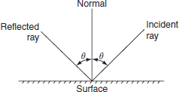

**Fig. 1.9** Reflected ray

The ratio of luminous flux leaving the surface to the luminous flux incident on it is known as reflection factor.

Image

Its value will be always less than 1.

***Beam factor***

It is defined as the ratio of ‘lumens in the beam of a projector to the lumens given out by lamps’. Its value is usually varies from 0.3 to 0.6. This factor is taken into account for the absorption of light by reflector and front glass of the projector lamp.

**Example 1.1:   A 200-V lamp takes a current of 1.2 A, it produces a total flux of 2,860 lumens. Calculate:**

**1. the MSCPofthe lamp**

**Solution:**

Given V = 200 V

*I* = 1.2 A, flux = 2,860 lumens.

Image

**Example 1.2:   A room with an area of 6 × 9 m is illustrated by ten 80-W lamps. The luminous efficiency of the lamp is 80 lumens/W and the coefficient of utilization is 0.65. Find the average illumination.**

**Solution:**

Room area = 6 × 9 = 54 m2.

Total wattage = 80 × 10 = 800 W.

Total flux emitted by ten lamps = 80 × 800 = 64,000 lumens.

Flux reaching the working plane = 64,000 × 0.65 = 41,600 lumens.

Image

**Example 1.3:   The luminous intensity of a lamp is 600 CP. Find the flux given out. Also find the flux in the hemisphere containing the source of light and zero above the horizontal.**

**Solution:**

Flux emitted by source (lumen)

= Intensity (*I*) × solid angle (*ω*)

*=* 600 × 2 π = 3,769.911 lumens

∴ Flux emitted in the lower hemisphere = 3,769.911 lumens.

**Example 1.4:   The flux emitted by 100-W lamp is 1,400 lumens placed in a frosted globe of 40 cm diameter and gives uniform brightness of 250 milli-lumens/m2 in all directions. Calculate the candel power of the globe and the percentage of light absorbed by the globe.**

**Solution:**

Flux emitted by the globe

= brightness × globe area

Image

= 1,256.63 lumens

Flux absorbed by the globe

= flux emitted by source – flux emitted by globe

= 1,400 – 1,256.63

= 143.36 lumens.

Image

**Example 1.5:   A surface inclined at an angle 40° to the rays is kept 6 m away from 150 candle power lamp. Find the average intensity of illumination on the surface.**

**Solution:**

From the [Fig. P.1.1](https://www.safaribooksonline.com/library/view/generation-and-utilization/9789332515673/xhtml/chapter006.xhtml#Fig-P-6-1):

*θ* = (90° – 40°) = 50°.

∴ Average illumination:

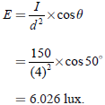

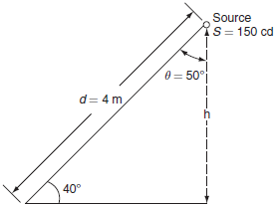

**Fig. P.1.1**

**1.3 LAWS OF ILLUMINATION**

Mainly there are two laws of illumination.

1. Inverse square law.
2. Lambert's cosine law.

**1.3.1 Inverse square law**

This law states that ‘the illumination of a surface is inversely proportional to the square of distance between the surface and a point source’.

***Proof:***

Let, ‘*S*’ be a point source of luminous intensity ‘*I*’ candela, the luminous flux emitting from source crossing the three parallel plates having areas *A*1*A*2*,* and *A*3 square meters, which are separated by a distances of *d,* 2*d,* and 3*d* from the point source respectively as shown in [Fig. 1.10](https://www.safaribooksonline.com/library/view/generation-and-utilization/9789332515673/xhtml/chapter006.xhtml#Fig-6-10).

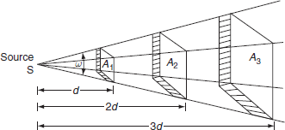

**Fig. 1.10** Inverse square law

Image

Luminous flux reaching the area A1 = luminous intensity × solid angle

Image

∴ Illumination *'E*1*'* on the surface area *'A*1*'* is:

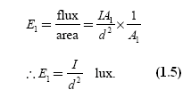

Similarly, illumination *'E*2*'* on the surface *area A*2 is:

Image

and illumination ‘*E*3’ on the surface area *A*3 is:

Image

From [Equations (1.5)](https://www.safaribooksonline.com/library/view/generation-and-utilization/9789332515673/xhtml/chapter006.xhtml#eq-6-5), [(1.6)](https://www.safaribooksonline.com/library/view/generation-and-utilization/9789332515673/xhtml/chapter006.xhtml#eq-6-6), and [(1.7)](https://www.safaribooksonline.com/library/view/generation-and-utilization/9789332515673/xhtml/chapter006.xhtml#eq-6-7)

Image

Hence, from [Equation (1.8)](https://www.safaribooksonline.com/library/view/generation-and-utilization/9789332515673/xhtml/chapter006.xhtml#eq-6-8), illumination on any surface is inversely proportional to the square of distance between the surface and the source.

**1.3.2 Lambert's cosine law**

This law states that ‘illumination, *E* at any point on a surface is directly proportional to the cosine of the angle between the normal at that point and the line of flux’.

***Proof:***

While discussing, the Lambert's cosine law, let us assume that the surface is inclined at an angle ‘*θ*’ to the lines of flux as shown in [Fig. 1.11](https://www.safaribooksonline.com/library/view/generation-and-utilization/9789332515673/xhtml/chapter006.xhtml#Fig-6-11).

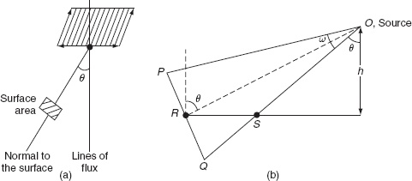

**Fig. 1.11** Lambert's cosine law

Let

|  |  |
| --- | --- |
| *PQ*= | The surface area normal to the source and inclined at ‘*θ*’ to the vertical axis. |
| *RS*= | The surface area normal to the vertical axis and inclined at an angle *θ* to the source ‘*O*’. |

Therefore, from [Fig. 1.11](https://www.safaribooksonline.com/library/view/generation-and-utilization/9789332515673/xhtml/chapter006.xhtml#Fig-6-11):

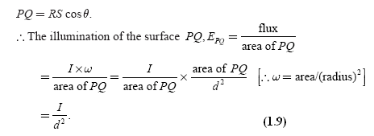

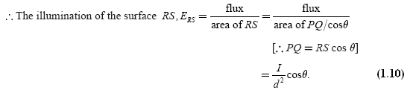

From [Fig. 1.11](https://www.safaribooksonline.com/library/view/generation-and-utilization/9789332515673/xhtml/chapter006.xhtml#Fig-6-11)(b):

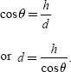

Substituting ‘d' from the above equation in [Equation (1.10)](https://www.safaribooksonline.com/library/view/generation-and-utilization/9789332515673/xhtml/chapter006.xhtml#eq-6-10):

Image

Image

where *d* is the distance between the source and the surface in m, *h* is the height of source from the surface in m, and *I* is the luminous intensity in candela.

Hence, [Equation (1.11)](https://www.safaribooksonline.com/library/view/generation-and-utilization/9789332515673/xhtml/chapter006.xhtml#eq-6-11) is also known as ‘cosine cube’ law. This law states that the ‘illumination at any point on a surface is dependent on the cube of cosine of the angle between line of flux and normal at that point’.

***Note:***

*From the above laws of illumination, it is to be noted that inverse square law is only applicable for the surfaces if the surface is normal to the line of flux. And Lambert's cosine law is applicable for the surfaces if the surface is inclined an angle ‘*θ*’ to the line of flux.

**1.4 POLAR CURVES**

The luminous flux emitted by a source can be determined using the intensity distribution curve. Till now we assumed that the luminous intensity or the candle power from a source is distributed uniformly over the surrounding surface. But due to its s not uniform in all directions. The luminous intensity or the distribution of the light can be represented with the help of the polar curves.

The polar curves are drawn by taking luminous intensities in various directions at an equal angular displacement in the sphere. A radial ordinate pointing in any particular direction on a polar curve represents the luminous intensity of the source when it is viewed from that direction. Accordingly, there are two different types of polar curves and they are:

1. A curve is plotted between the candle power and the angular position, if the luminous intensity, i.e., candle power is measured in the horizontal plane about the vertical axis, called ***'horizontal polar curve’****.*

2. curve is plotted between the candle power, if it is measured in the vertical plane and the angular position is known as ***'verticalpolar curve’****.*

[Figure 1.12](https://www.safaribooksonline.com/library/view/generation-and-utilization/9789332515673/xhtml/chapter006.xhtml#Fig-6-12) shows the typical polar curves for an ordinary lamp.

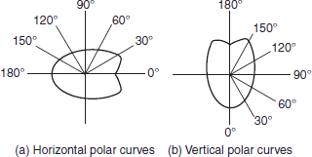

**Fig. 1.12** Polar curves

Depression at 180° in the vertical polar curve is due to the lamp holder. Slight depression at 0° in horizontal polar curve is because of coiled coil filament.

Polar curves are used to determine the actual illumination of a surface by employing the candle power in that particular direction as read from the vertical polar curve. These are also used to determine mean horizontal candle power (MHCP) and mean spherical candle power (MSCP).

The mean horizontal candle power of a lamp can be determined from the horizontal polar curve by considering the mean value of all the candle powers in a horizontal direction.

The mean spherical candle power of a symmetrical source of a light can be found out from the polar curve by means of a Rousseau's construction.

**Top of Form**

**Bottom of Form**

**1.5 TYPES OF SOURCES OF ILLUMINATION**

Usually in a broad sense, based upon the way of producing the light by electricity, the sources of light are classified into following four types.

**1.5.1 Electric arc lamps**

The ionization of air present between the two electrodes produces an arc and provides intense light.

**1.5.2 Incandescent lamps**

When the filaments of these lamps are heated to high temperature, they emit light that falls in the visible region of wavelength. Tungsten-filament lamps are operating on this principle.

**1.5.3 Gaseous discharge lamps**

When an electric current is made to pass through a gas or metal vapor, it produces visible radiation by discharge takes place in the gas vapor. Sodium and mercury vapor lamps operate on this principle.

**1.5.4 Fluorescent lamps**

Certain materials like phosphor powders exposed to ultraviolet rays emits the absorbed energy into visible radiations fall in the visible range of wavelength. This principle is employed in fluorescent lamps.

**1.6 ARC LAMPS**

In arc lamps, the electrodes are in contact with each other and are separated by some distance apart; the electric current is made to flow through these two electrodes. The discharge is allowed to take place in the atmosphere where there are the production of a very intense light and a considerable amount of UV radiation, when an arc is struck between two electrodes.

The arcs maintain current and is very efficient source of light. They are used in search lights, projection lamps, and other special purpose lamps such as those in flash cameras.

Generally, used arc lamps are:

1. carbon arc lamp,
2. flame arc lamp, and
3. magnetic arc lamp.

**1.6.1 Carbon arc lamp**

Carbon arc lamp consists of two hard rod-type electrodes made up of carbon. Two electrodes are placed end to end and are connected to the DC supply. The positive electrode is of a large size than that of the negative electrode. The carbon electrodes used with AC supply are of the same size as that of the DC supply. The DC supply across the two electrodes must not be less than 45 V. When electric current passes through the electrodes are in contact and then withdrawn apart about 2–3 mm an arc is established between the two rods.

The two edges of the rods becomes incandescence due to the high resistance offered by rods as shown in [Fig. 1.13](https://www.safaribooksonline.com/library/view/generation-and-utilization/9789332515673/xhtml/chapter007.xhtml#Fig-7-1) by transfer of carbon particles from one rod to the other. It is observed that carbon particles transfer from the positive rod to the negative one. So that the positive electrode gets consumed earlier than the negative electrode. Hence, the positive electrode is of twice the diameter than that of the negative electrode.

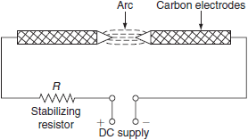

**Fig. 1.13** Carbon arc lamp

In case of AC supply, the rate of consumption of the two electrodes is same; therefore, the cross-section of the two electrodes is same. *A* resistance ‘*R*’ is connected in series with the electrode for stabilizing the arc. As current increases, the vaporizing rate of carbon increases, which decreases the resistance so much, then voltage drop across the arc decreases. So, to maintain the arc between the two electrodes, series resistance should be necessarily connected.

For maintaining the arc, the necessary voltage required is:

*V* = (39 + 2.8 *l* ) V,

where *l* is the length of the arc. The voltage drop across the arc is 60 V, the temperature of the positive electrode is 3,500 – 4,200°C, and the temperature of the negative electrode is 2,500°C. The luminous efficiency of such lamps is 9–12 lumens/W. This low luminous efficiency is due to the service resistance provided in DC supply while in case of AC supply, an inductor is used in place of a resistor. In carbon arc lamps, 85% of the light is given out by the positive electrode, 10% of the light is given out by the negative electrodes, and 5% of the light is given out by the air.

**1.6.2 Flame arc lamp**

The electrodes used in flame arc lamp are made up of 85% of carbon and 15% of fluoride. This fluoride is also known as flame material; it has the efficient property that radiates light energy from high heated arc stream. Generally, the core type electrodes are used and the cavities are filled with fluoride. The principle of operation of the flame arc lamp is similar to the carbon arc lamp. When the arc is established between the electrodes, both fluoride and carbon get vaporized and give out very high luminous intensities. The color output of the flame arc lamps depends upon the flame materials. The luminous efficiency of such lamp is 8 lumens/W. A simple flame arc lamp is shown in [Fig. 1.14](https://www.safaribooksonline.com/library/view/generation-and-utilization/9789332515673/xhtml/chapter007.xhtml#Fig-7-2). Resistance is connected in service with the electrodes to stabilize the arc.

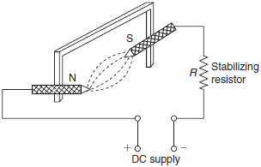

**Fig. 1.14** Flame arc lamp

**1.6.3 Magnetic arc lamp**

The principle of the operation of the magnetic arc lamp is similar to the carbon arc lamp. This lamp consists of positive electrode that is made up of copper and negative electrode that is made up of magnetic oxide of iron. Light energy radiated out when the arc is struck between the two electrodes. These are rarely used lamps.

**1.7 INCANDESCENT LAMP**

These lamps are temperature-dependent sources. When electric current is made to flow through a fine metallic wire, which is known as *filament*, its temperature increases. At low temperatures, it emits only heat energy, but at very high temperature, the metallic wire emits both heat and light energy. These incandescent lamps are also known as *temperature radiators.*

**1.7.1 Choice of material for filament**

The materials commonly used as filament for incandescent lamps are carbon, tantalum, tungsten, and osmium.

The materials used for the filament of the incandescent lamp have the following properties.

* The melting point of the filament material should be high.
* The temperature coefficient of the material should be low.
* It should be high resistive material.
* The material should possess good mechanical strength to withstand vibrations.
* The material should be ductile.

**1.7.2 Comparisons of carbon, osmium, tantalum, and tungsten used for making the filament**

***Carbon***

* Carbon has high melting point of 3,500°C; even though, its melting point is high, carbon starts disintegration at very fast rate beyond its working temperature of 1,800°C.
* Its resistance decreases with increase in temperature, i.e., its temperature coefficient of resistivity is negative, so that it draws more current from the supply. The temperature coefficient (*α*) is –0.0002 to –0.0008.
* The efficiency of carbon filament lamp is low; because of its low operating tem perature, large electrical input is required. The commercial efficiency of carbon lamp is 3 – 4.5 lumens/W approximately.
* Carbon has high resistivity (*ρ*), which is about 1,000–7,000 μΩ-cm and its density is 1.7–3.5.

***Osmium***

* The melting point of osmium is 2,600°C.
* It is very rare and expensive metal.
* The average efficiency of osmium lamp is 5 lumens/W.

***Tantalum***

* The melting point of tantalum is 3,000°C.
* Resistivity (*ρ*) is 12.5 μΩ-cm.
* The main drawback of the negative temperature coefficient of carbon is overcome in tantalum. It has positive temperature coefficient (*α*) and its value is 0.0036.
* The density of tantalum is 16.6.
* The efficiency of tantalum lamp is 2 lumens/W.

***Tungsten***

* The working temperature of tungsten is 2,500–3,000°C.
* Its resistance at working temperature is about 12–15 times the cold resistance.
* It has positive temperature coefficient of resistance of 0.0045.
* Its resistivity is 5.6 12.5 μΩ-cm.
* The density of tungsten is 19.3.
* The efficiency of tantalum when working at 2,000°C is 18 lumens/W.
* Its vapor pressure is low when compared to carbon.

In fact, the carbon lamp is the first lamp introduced by Thomas Alva Edison in 1879, owing to two drawbacks, tungsten radiates more energy in visible spectrum and somewhat less in infrared spectrum so that there was a switch over in infrared spectrum so that there was a switch over from carbon filament to tungsten filament. Nowadays, tungsten filament lamps are widely used incandescent lamps.

The chemically pure tungsten is very strong and fragile. In order to make it into ductile, tungsten oxide is first reduced in the form of gray power in the atmosphere of hydrogen and this powder is pressed in steel mold for small bars; the mechanical strength of these bars can be improved by heating them to their melting point and then hammered at red-hot position and re-rolled into wires.

***Construction***

[Figure 1.15](https://www.safaribooksonline.com/library/view/generation-and-utilization/9789332515673/xhtml/chapter007.xhtml#Fig-7-3) shows the construction of the pure tungsten filament incandescent lamp. It consists of an evacuated glass bulb and an aluminum or brass cap is provided with two pins to insert the bulb into the socket. The inner side of the bulb consists of a tungsten filament and the support wires are made of molybdenum to hold the filament in proper position. A glass button is provided in which the support wires are inserted. A stem tube forms an air-tight seal around the filament whenever the glass is melted.

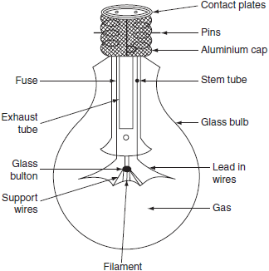

**Fig. 1.15** Incandescent lamp

***Operation***

When electric current is made to flow through the fine metallic tungsten filament, its temperature increases. At very high temperature, the filament emits both heat and light radiations, which fall in the visible region. The maximum temperature at which the filament can be worked without oxidization is 2,000°C, i.e., beyond this temperature, the tungsten filament blackens the inside of the bulb. The tungsten filament lamps can be operated efficiently beyond 2,000°C, it can be attained by inserting a small quantity of inert gas nitrogen with small quantity of organ. But if gas is inserted instead of vacuum in the inner side of the bulb, the heat of the lamp is conducted away and it reduces the efficiency of the lamp. To reduce this loss of heat by conduction and convection, as far as possible, the filament should be so wound that it takes very little space. This is achieved by using a single-coil filament instead of a straight wire filament as shown in [Fig. 1.16(a)](https://www.safaribooksonline.com/library/view/generation-and-utilization/9789332515673/xhtml/chapter007.xhtml#Fig-7-4). This single-coil filament is used in vacuum bulbs up to 25 W and gas filled bulbs from 300 to 1,000 W.

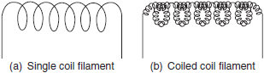

**Fig. 1.16** Various filaments used in incandescent lamps

***The advantages of the incandescent lamps***

* These lamps are available in various shapes and sizes.
* These are operating at unity power factor.
* These lamps are not affected by surrounding air temperature.
* Different colored light output can be obtained by using different colored glasses.

***Limitations***

The incandescent lamp suffers from the following drawbacks:

* Low efficiency.
* Colored light can be obtained by using different colored glass enclosures only.

**1.8 DISCHARGE LAMPS**

Discharge lamps have been developed to overcome the drawbacks of the incandescent lamp. The main principle of the operation of light in a gaseous discharge lamp is illustrated as below.

In all discharge lamps, an electric current is made to pass through a gas or vapor, which produces its illuminance. Normally, at high pressures and atmospheric conditions, all the gases are poor conductors of electricity. But on application of sufficient voltage across the two electrodes, these ionized gases produce electromagnetic radiation. In the process of producing light by gaseous conduction, the most commonly used elements are neon, sodium, and mercury. The wavelength of the electromagnetic radiation depends upon the nature of gas and the gaseous pressure used inside the lamp. A simple discharge lamp is shown in [Fig. 1.17](https://www.safaribooksonline.com/library/view/generation-and-utilization/9789332515673/xhtml/chapter007.xhtml#Fig-7-6).

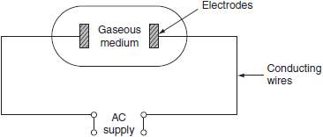

**Fig. 1.17** Discharge lamps

The production of light in the gaseous discharge lamps is based on the phenomenon of excitation and ionization of gas or metal vapor present between the two electrodes of a discharge tube.

When the potential between the two electrodes is equals to ionizing potential, gas or metal vapor starts ionizing and an arc is established between the two electrodes. Volt–ampere characteristics of the arc is negative, i.e., gaseous discharge lamp possess a negative resistance characteristics. A choke or ballast is provided to limit high currents to a safe value. Here, the choke serves two functions.

* It provides ignition voltage initially.
* Limits high currents.

The use of choke will reduce the power factor (0.3–0.4) of all the gaseous lamps so that all the discharge lamps should be provided with a condenser to improve the power factor. The nature of the gas and vapor used in the lamp will affect the color affected of light.

**1.8.1 Types of discharge lamps**

Generally used discharge lamps are of two types. They are:

1. The lamps that emit light of the color produced by discharge takes place through the gas or vapor present in the discharge tube such as neon gas, sodium vapor, mercury vapor, etc.

***Ex:*** Neon gas, sodium vapor lamp, and mercury vapor lamp.

2. The lamp that emits light of color depends upon the type of phosphor material coated inside the walls of the discharge tube. Initially, the discharge takes place through the vapor produces UV radiation, then the invisible UV rays absorbed by the phosphors and radiates light energy falls in the visible region. This UV light causes fluorescence in certain phosphor materials, such lamps are known as fluorescent lamps.

***Ex:*** Fluorescent mercury vapor tube.

In general, the gaseous discharge lamps are superior to the tungsten filament lamps.

**1.8.2 Drawbacks**

The discharge lamps suffer from the following drawbacks.

1. The starting of the discharge lamps requires starters and transformers; therefore, the lamp circuitry is complex.
2. High initial cost.
3. Poor power factor; therefore, the lamps make use of the capacitor.
4. Time required to give its full output brilliancy is more.
5. These lamps must be placed in particular position.
6. These lamps require stabilizing choke to limit current since the lamps have negative resistance characteristics.

If the helium gas is used instead of neon, pinkish white light is obtained. These lamps are used as night lamps and as indicator lamps and used for the determination of the polarity of DC mains and for advertising purpose.

**1.9 SODIUM VAPOR LAMP**

A sodium vapor lamp is a cold cathode and low-pressure lamp. A sodium vapor discharge lamp consists of a *U*-shaped tube enclosed in a double-walled vacuum flask, to keep the temperature of the tube within the working region. The inner *U*-tube consists of two oxide-coated electrodes, which are sealed with the ends. These electrodes are connected to a pin type base construction of sodium vapor lamp is shown in [Fig. 1.18](https://www.safaribooksonline.com/library/view/generation-and-utilization/9789332515673/xhtml/chapter007.xhtml#Fig-7-8).

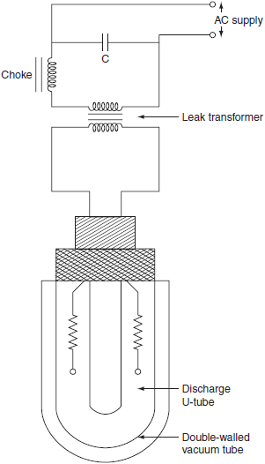

**Fig. 1.18** Sodium vapor lamp

This sodium vapor lamp is low luminosity lamp, so that the length of the lamp should be more. In order to get the desired length, it is made in the form of a *U*-shaped tube. This long *U*-tube consists of a small amount of neon gas and metallic sodium. At the time of start, the neon gas vaporizes and develops sufficient heat to vaporize metallic sodium in the *U*-shaped tube.

**1.9.1 Working**

Initially, the sodium is in the form of a solid, deposited on the walls of inner tube. When sufficient voltage is impressed across the electrodes, the discharge starts in the inert gas, i.e., neon; it operates as a low-pressure neon lamp with pink color. The temperature of the lamp increases gradually and the metallic sodium vaporizes and then ionizes thereby producing the monochromatic yellow light. This lamp takes 10–15 min to give its full light output. The yellowish output of the lamp makes the object appears gray.

In order to start the lamp, 380 – 450 V of striking voltage required for 40- and 100-W lamps. These voltages can be obtained from a high reactance transformer or an auto transformer. The operating power factor of the lamp is very poor, so that a capacitor is placed to improve the power factor to above 0.8. More care should be taken while replacing the inner tube, if it is broken, then sodium comes in contact with the moisture; therefore, fire will result. The lamp must be operated horizontally or nearly so, to spread out the sodium well along the tube.

The efficiency of sodium vapor lamp is lies between 40 and 50 lumens/W. Normally, these lamps are manufactured in 45-, 60-, 85- and 140-W ratings. The normal operating temperatures of these lamps are 300°C. In general, the average life of the sodium vapor lamp is 3,000 hr and such bulbs are not affected by voltage variations.

Following are the causes of failure to operate the lamp, when:

* The cathode fails to emit the electrons.
* The filament breaks or burns out.
* All the particles of sodium are concentrated on one side of the inner tube.
* The life of the lamp increases due to aging.

The average light output of the lamp is reduced by 15% due to aging. These lamps are mainly used for highway and street lighting, parks, railway yards, general outdoor lighting, etc.

**1.10 HIGH-PRESSURE MERCURY VAPOR LAMP**

The working of the mercury vapor discharge lamp mainly depends upon the pressure, voltage, temperature, and other characteristics that influence the spectral quality and the efficiency of the lamp.

Generally used high-pressure mercury vapor lamps are of three types. They are:

1. MA type: Preferred for 250- and 400-W rating bulbs on 200–250-V AC supply.
2. MAT type: Preferred for 300- and 500-W rating bulbs on 200–250-V AC supply.
3. MB type: Preferred for 80- and 125-W rating bulbs and they are working at very high pressures.

**1.10.1 MA type lamp**

It is a high-pressure mercury vapor discharge lamp that is similar to the construction of sodium vapor lamp. The construction of MA type lamp is shown in [Fig. 1.19](https://www.safaribooksonline.com/library/view/generation-and-utilization/9789332515673/xhtml/chapter007.xhtml#Fig-7-9)

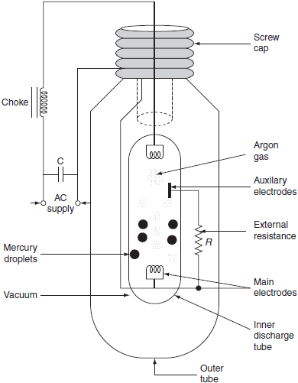

**Fig. 1.19** MA type lamp

MA type lamp consists of a long discharge tube in ‘*U*’ shape and is made up of hard glass or quartz. This discharge tube is enclosed in an outer tube of ordinary glass. To prevent the heat loss from the inner bulb, by convection, the gap between the two tubes is completely evacuated. The inner tube contains two main electrodes and an auxiliary starting electrode, which is connected through a high resistance of about 50 kΩ. It also contains a small quantity of argon gas and mercury. The two main electrodes are tungsten coils coated with electron emitting material (such as thorium metal).

***Working***

Initially, the tube is cold and hence the mercury is in condensed form. Initially, when supply is given to the lamp, argon gas present between the main and the auxiliary electrodes gets ionized, and an arc is established, and then discharge takes place through argon for few minutes between the main and the auxiliary electrodes. As a result, discharge takes place through argon for few minutes in between the main and the auxiliary electrodes. The discharge can be controlled by using high resistance that is inserted in-series with the auxiliary electrode. After few minutes, the argon gas, as a whole, gets ionized between the two main electrodes. Hence, the discharge shifts from the auxiliary electrode to the two main electrodes. During the discharge process, heat is produced and this heat is sufficient to vaporize the mercury. As a result, the pressure inside the discharge tube becomes high and the voltage drop across the two main electrodes will increases from 20 to 150 V. After 5–7 min, the lamp starts and gives its full output.

Initially, the discharge through the argon is pale blue glow and the discharge through the mercury vapors is greenish blue light; here, choke is provided to limit high currents and capacitor is to improve the power factor of the lamp.

If the supply is interrupted, the lamp must cool down and the vapor pressure be reduced before it will start. It takes approximately 3 – 4 min. The operating temperature of the inner discharge tube is about 600°C. The efficiency of this type of lamp is 30–40 lumens/W. These lamps are manufactured in 250 and 400 W ratings for use on 200–250 V on AC supply.

Generally, the MA type lamps are used for general industrial lighting, ports, shopping centers, railway yards, etc.

***Stroboscopic effect***

We all know that because of ‘the alternating nature of supply, it crosses zero two times in a cycle’. For 50-Hz frequency supply of the alternating current, a discharge lamp will be extinguished twice in a cycle and 100 times per second (for 50-Hz supply). A human eye cannot identify this extinguish phenomenon, because of the persistence of vision. If this light falls upon a moving object, the object appearing like slow moving or fast moving or moving in reverse direction, sometimes stationary. This effect is due to the extinguishing nature of the light of the lamp. This effect is called as ‘*stroboscopic effect*’.

**1.11 COMPARISON BETWEEN TUNGSTEN FILAMENT LAMPS AND FLUORESCENT LAMPS**

[Table 1.2](https://www.safaribooksonline.com/library/view/generation-and-utilization/9789332515673/xhtml/chapter007.xhtml#Tab-7-2) gives the comparison between tungsten filament lamps and fluorescent lamps.

**Table 1.2** Comparison between tungsten filament and fluorescent lamps

|  |  |
| --- | --- |
| ***Incandescent lamp*** | ***Fluorescent lamp*** |
| 1. Initial cost is less. | 1. Initial cost is more. |
| 2. Fluctuation in supply voltage has less effect on light output, as the variations in voltage are absorbed in choke. | 2. Fluctuations in supply voltage has comparatively more effect on the light output. |
| 3. It radiates the light; the color of which resembles the natural light. | 3. It does not give light close to the natural light. |
| 4. It works on AC as well as DC. | 4. Change of supply needs additional equipment. |
| 5. The luminous efficiency of the lamp is high that is about 8 – 40 lumens/W. | 5. The luminous efficiency is poor, which is about 8–10 lumen/W. |
| 6. Different color lights can be obtained by using different colored glasses. | 6. Different color lights can be obtained by using different composition of fluorescent powder. |
| 7. Brightness of the lamp is more. | 7. Brightness of the lamp is less. |
| 8. The reduction in light output of the lamp is comparatively high, with the time. | 8. The reduction in light output of the lamp is comparatively low, with the lamp. |
| 9. The working temperature is about 2,000°C. | 9. The working temperature is about 50°C. |
| 10. The normal working life is 1,000 hr. | 10. The normal working life is 5,000–7,500 hr. |
| 11. No stroboscopic effect. | 11. Stroboscopic effect is present. |
| 12. These lamps are widely used for domestic, industrial, and street lighting. | 12. They find wide application in domestic, industrial, and floodlighting. |
| 13. The luminous efficiency increases with the increase in the voltage of the lamp. | 13. The luminous efficiency increase with the increase in voltage and the increase in the length of tube. |

**1.12 BASIC PRINCIPLES OF LIGHT CONTROL**

When light strikes the surface of an object, based on the properties of that surface, some portion of the light is reflected, some portion is transmitted through the medium of the surface, and the remaining is absorbed.

The method of light control is used to change the direction of light through large angle. There are four light control methods. They are:

1. reflection,
2. refraction,
3. riffusion, and
4. absorption.

**1.12.1 Reflection**

The light falling on the surface, whole of the light will not absorbed or transmitted through the surface, but some of the light is reflected back, at an angle equals to the angle of incidence. The ratio of reflected light energy to the incident light energy is known as reflection factor. The two basic types of reflection are:

1. mirror or specular reflection and

2. diffuse reflection.

***Specular reflection***

When whole of the light falling on a smooth surfaces will be reflected back at an angle equal to the angle of incidence. Such a reflection is known as *specular reflection.* With such reflection, observer will be able to see the light source but not the illuminated surface. Most of the surfaces causing the specular reflection are silvered mirrors, highly polished metal surfaces. Specular reflection is shown in [Fig. 1.20](https://www.safaribooksonline.com/library/view/generation-and-utilization/9789332515673/xhtml/chapter007.xhtml#Fig-7-17).

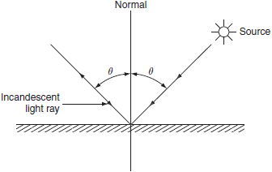

**Fig. 1.20** Specular reflection

A surface that is almost free from reflection is called a matt surface.

***Diffuse reflection***

When the light ray falling on any surface, it is scattered in all directions irrespective of the angle of incidence. Such type of reflector is known as *diffuse reflection* and is shown in [Fig. 1.21](https://www.safaribooksonline.com/library/view/generation-and-utilization/9789332515673/xhtml/chapter007.xhtml#Fig-7-18). Most of the surfaces causing the diffuse reflection are rough or matt surfaces such as blotting paper, frosted glass, plaster, etc.

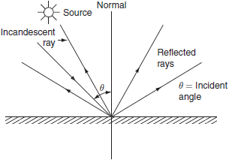

**Fig. 1.21** Diffuse reflection

In this reflection, observer will be able to see the illuminated surface but not the light source.

**1.12.2 Refraction**

When a beam of light passes through two different mediums having different densities, the light ray will be reflected. This phenomenon is known as *refraction.*

[Figure 1.22](https://www.safaribooksonline.com/library/view/generation-and-utilization/9789332515673/xhtml/chapter007.xhtml#Fig-7-19) shows the refraction of light ray from dense medium to rare medium where *μ*1 and *μ*2 are the refractive indices of two medium, *θ* is the angle of incidence, and *α* is the angle of reflection.

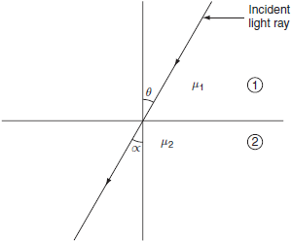

**Fig. 1.22** Refraction

The angle of light ray with normal is comparatively less in dense medium than in rare medium.

**1.12.3 Diffusion**

When a ray of light falling on a surface is reflected in all possible directions, so that such surface appears luminous from all possible directions. This can be achieved with a diffusing glass screen introduced between the observer and the light source. The normally employed diffusing glasses are opal glass and frosted glass. Both are ordinary glasses, but frosted glass is an ordinary glass coated with crystalline substance.

Although frosted glass is cheaper than opal glass, the disadvantage of frosted glass is, it collects more dust particles and it is difficult to clean.

**1.12.4 Absorption**

In some of the cases, whole of the light emitted by tungsten filament lamp will be excessive, so that it is necessary to avoid that the amount of unwanted wavelengths without interference. This can be achieved by using a special bluish colored glass for the filament lamp to absorb the unwanted radiation.

**1.13 TYPES OF LIGHTING SCHEMES**

Usually, with the reflector and some special diffusing screens, it is possible to control the distribution of light emitted from lamps up to some extent. A good lighting scheme results in an attractive and commanding presence of objects and enhances the architectural style of the interior of a building. Depending upon the requirements and the way of light reaching the surface, lighting schemes are classified as follows:

1. direct lighting,

2. semidirect lighting,

3. indirect lighting,

4. semi-indirect lighting, and

5. general lighting.

**1.13.1 Direct lighting schemes**

Direct lighting scheme is most widely used for interior lighting scheme. In this scheme, by using deep reflectors, it is possible to make 90% of light falls just below the lamp. This scheme is more efficient but it suffers from hard shadows and glare. Hence, while designing such schemes, all the possibilities that will cause glare on the eye have to be eliminated. It is mainly used for industrial and general outdoor lighting.

**1.13.2 Semidirect lighting schemes**

In semidirect lighting scheme, about 60–90% of lamps luminous flux is made to fall downward directly by using some reflectors and the rest of the light is used to illuminate the walls and ceiling. This type of light scheme is employed in rooms with high ceiling. Glare can be avoided by employing diffusing globes. This scheme will improve not only the brightness but also the efficiency.

**1.13.3 Indirect lighting schemes**

In this lighting scheme, 90% of total light is thrown upwards to the ceiling. In such scheme, the ceiling acts as the lighting source and glare is reduced to minimum.

This system provides shadowless illumination, which is very useful for drawing offices and in workshops where large machines and other difficulties would cause trouble some shadows if direct lighting schemes were used.

**1.13.4 Semi-indirect lighting schemes**

In semi-indirect lighting scheme, about 60–90% of light from the lamp is thrown upwards to the ceiling and the remaining luminous flux reaches the working surface. Glare will be completely eliminated with such type of lighting scheme. This scheme is widely preferred for indoor lighting decoration purpose.

**1.13.5 General lighting scheme**

This scheme of lighting use diffusing glasses to produce the equal illumination in all directions. Mounting height of the source should be much above eye level to avoid glare. Lamp fittings of various lighting schemes are shown in [Fig. 1.23](https://www.safaribooksonline.com/library/view/generation-and-utilization/9789332515673/xhtml/chapter007.xhtml#Fig-7-20).

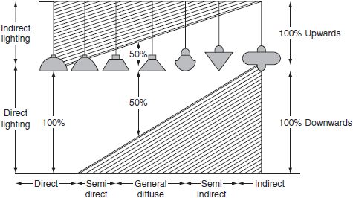

**Fig. 1.23** Lighting schemes

**1.14 DESIGN OF LIGHTING SCHEMES**

The lighting scheme should be such that:

* It should be able to provide sufficient illumination.
* It should be able to provide the uniform distribution of light throughout the working plane.
* It should be able to produce the light of suitable color.
* It should be able to avoid glare and hard shadows as much as possible.

While designing a lighting scheme, the following factors should be taken into consideration.

1. Illumination level.

2. The size of the room.

3. The mounting height and the space of fitting.

**1.14.1 Illumination level**

The intensity of illumination required on the surface is depending on the type of work being done. For each type of work, there is a range of brightness that causes minimum fatigue and gives maximum output in terms of quality and quantity. Moving objects and the objects that are seen for longer duration require more illumination than those for stationary object and casual work.

The recommended levels of illumination for different aspects are given below

|  |  |
| --- | --- |
| ***Occupancy*** | ***Illumination (lux)*** |
| 1. Covered areas: |  |
| (i) Proofreading | 95–185 |
| (ii) Drawing an exhibition | 55–95 |
| (iii) Museums | 35–55 |
| (iv) Bedrooms and waiting room | 8–32 |
| (v) Hospital, railway yards, and platforms | 5–10 |
| 2. Hotels and restaurants |  |
| (i) Reception, dining room, and bedroom | 50–200 |
| (ii) Accounts and writing desks | 300–400 |
| 3. Power station |  |
| (i) Boiler house, turbine stage, transformer, and switch gear chamber | 100–150 |
| (ii) Control room | 200–300 |
| 4. Canteens | 100–200 |
| 5. Outdoor areas |  |
| (i) Boxing rings | 1,750–2,750 |
| (ii) Race tracks | 185–280 |
| (iii) Railway shunting yards | 110–200 |
| 6. Spot ground's |  |
| (i) Football ground | 100–200 |
| (ii) Tennis court | 300–400 |
| (iii) Stadium | 200–300 |
| 7. Industrial purpose |  |
| (i) Precision machine room | 240–500 |
| (ii) Lathe and sewing machine | 140–185 |
| (iii) General lighting factory | 18–35 |
| 8. Schools and colleges |  |
| (i) Laboratories, library, lecture hall, and workshop | 200–300 |
| (ii) Drawing rooms | 400–500 |
| (iii) Waiting rooms and stair | 100–150 |

**1.14.2 Size of the room**

The luminous flux emitted from the source will not be completely utilized at the workplace. A portion of flux will be lost in the lamp fitting, some other will be absorbed, and the rest of it is reflected. This absorption and reflection are depending upon the size and color of the walls and ceiling. Illumination in any room depends upon the reflected light from the walls and ceiling. White color walls and ceiling reflect more light as compared to colored ones.

**1.14.3 Mounting height and space of fittings**

In general lighting, the illumination at any point should not vary throughout the room. So that, the lamp fittings for general lighting should be in such a way that the illumination received from each fitting overlaps with the other. In order to provide adequate illumination over the working plane, the distance of a light source from the wall should be half of the distance between the two adjacent lamps and also the distance between the source fitting or the spacing should not exceed more than 1.5 times the mounting height.

Image

**1.15 STREET LIGHTING**

Street lighting not only requires for shopping centers, promenades, etc. but also necessary for the following.

* In order to make the street more attractive, so that obstructions on the road clearly visible to the drivers of vehicles.
* To increase the community value of the street.
* To clear the traffic easily in order to promote safety and convenience.

The basic principles employed for the street lighting are given below.

1. Diffusion principle.

2. The specular reflection principle.

**1.15.1 Diffusion principle**

In this method, light is directed downwards from the lamp by the suitably designed reflectors. The design of these reflectors are in such a way that they may reflect total light over the road surface uniformly as much as possible. The reflectors are made to have a cutoff between 30° and 45°, so that the filament of the lamp is not visible expect just below the source, which results in eliminating glare. Illumination at any point on the road surface is calculated by applying inverse square low or point-by-point method.

**1.15.2 Specular reflection principle**

The specular reflection principle enables a motorist to see an object about 30 m ahead. In this case, the reflectors are curved upwards, so that the light is thrown on the road at a very large angle of incidence. This can be explained with the help of [Fig. 7.21](https://www.safaribooksonline.com/library/view/generation-and-utilization/9789332515673/xhtml/chapter007.xhtml#Fig-7-21). An object resides over the road at ‘P’ in between the lamps *S*1, *S*2, and *S*3 and the observer at ‘*Q*’.

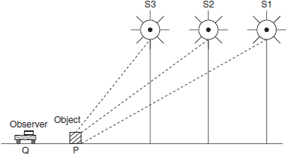

**Fig. 1.21** Specular reflection for street lighting

Thus, the object will appear immediately against the bright road surface due to the lamps at a longer distance. This method of lighting is only suitable for straight sections along the road. In this method, it is observed that the objects on the roadway can be seen by a smaller expenditure of power than by the diffusion method of lighting.

**1.15.3 Illumination level, mounting height, and the types of lamps for street lighting**

Normally, illumination required depends upon the class of street lighting installation. The illumination required for different areas of street lighting are given in [Table 1.3](https://www.safaribooksonline.com/library/view/generation-and-utilization/9789332515673/xhtml/chapter007.xhtml#Tab-7-3).

**Table 1.3** Illumination required for different areas of street lighting

|  |  |  |
| --- | --- | --- |
|  | ***Area*** | ***Illumination (lumen/m2)*** |
| 1. | Road junctions and important shopping centers. | 30 |
| 2. | Poorly lighted sub-urban streets. | 4 |
| 3. | Average well-lighted street. | 8–15 |

Mercury vapor and sodium vapor discharge lamps are preferable for street lighting since the overall cost of the installation of discharge lamps are less than the filament lamps and also the less power consumption for a given amount of power output. Normal spacing for the standard lamps is 50 m with a mounting height of 8 m. Lamp posts should be fixed at the junctions of roads.

**1.16 FACTORY LIGHTING**

Industry or factory lighting must satisfy the following aspects.

1. The quality of work is to be improved.
2. Accidents must be reduced.
3. The productivity of labor should be increased.

The above requirements can be met by the factory lighting only when the lighting scheme provides:

1. Adequate illumination on the working plane.

2. Minimum glare.

3. Clean and effective source fitting.

4. Uniform distribution of light over the working plane.

The lamps used for factory lighting are fitted with specially designed reflectors and they can be easily cleaned. The requirements of most of the installations of industrialized area can be met by the following lamp fitting.

* Industrial lighting fittings.
* Standard reflectors.
* Diffusing fittings.
* Concentrating reflectors.
* Enclosed diffusing fittings.
* Angle reflectors.

**1.17 FLOODLIGHTING**

Floodlighting means flooding of large surface areas with light from powerful projectors. A special reflector and housing is employed in floodlighting in order to concentrate the light emitted from the lamp into a relatively narrow beam, which is known as floodlight projector. This projector consists of a reflecting surface that may be a silvered glass or chromium plate or stainless steel. The efficiency of silvered glass and polished metal are 85–90% and 70%, respectively. Usually metal reflectors are robust; therefore, they can be preferred. An important application of illumination engineering is the floodlighting of large and open areas. It is necessary to employ floodlighting to serve one or more of the following purposes.

**1.17.1 Esthetic floodlighting**

They are used for enhancing the beauty of monuments, ancient buildings, and churches by floodlighting.

**1.17.2 Industrial and commercial floodlighting**

They are used for illuminating sports arenas, railway yards, quarries, car parks, etc.

**1.17.3 Advertising**

They are used for illuminating showcases and advertisement boards and for the decoration of houses, etc.

The projectors of floodlighting schemes are classified according to the light beam spread are discussed below.

***Narrow beam projectors***

Light beam with such a projectors spreads between 12° and 25°. They can be employed for a distance of 70 m.

***Medium angle projectors***

Projectors with beam spread between 25° and 40°. These are employed for a distance of 30–70 m.

***Wide angle projectors***

Projectors with beam spread between 40° and 90°. They can be employed for a distance of 30 m or below.

Economically, the wide angle projectors with high wattage lamps and narrow beam projectors with low wattage lamps are used.

**1.17.4 Floodlighting calculations**

While calculating the number of projectors required for floodlightings, it is necessary to know the level of illumination required; it is depending on the type of building and the purpose of floodlighting. And also the type of projector and the selection of projector depend upon the beam size as well as the light output.

∴ The total number of projectors required:

Image

where *N* is the number of projectors, *A* is the area of surface to be illuminated in square meter, and *E*is the illumination level required in lumen.

**1.18 METHODS OF LIGHTING CALCULATIONS**

There are so many methods have been employed for lighting calculation, some of those methods are as follows.

1. Watts-per-square-meter method.

2. Lumen or light flux method

3. Point-to-point method

**1.18.1 Watts-per-square-meter method**

This method is more adoptive for rough calculation and checking also. According to the illumination required, this method makes an allowance of watt per square meter of area to be illuminated.

**1.18.2 Lumen or light flux method**

Lumen method is applicable for the cases in which all the sources produce uniform illumination over the working plane or an average value is required.

Total lumens received on working plane = No. of lamps × wattage of each lamp × efficiency of each lamp × coefficient of utilization.

**1.18.3 Point-to-point or inverse square law method**

This method is used to calculate the illumination at any particular point due to several number of sources whose candle powers are known values.

In general, illumination can be calculated by using the empirical formula:

Image

where *N* is the number of fitting required, *E* is the illumination required in lux, *A* is the working area in square meter, *φ* is the luminous flux produced per lamp in lumen, UF is the utilization factor, and MF is the maintenance factor.