**Chapter 2**

**Electric Heating**

**2.1 INTRODUCTION**

Heat plays a major role in everyday life. All heating requirements in domestic purposes such as cooking, room heater, immersion water heaters, and electric toasters and also in industrial purposes such as welding, melting of metals, tempering, hardening, and drying can be met easily by electric heating, over the other forms of conventional heating. Heat and electricity are interchangeable. Heat also can be produced by passing the current through material to be heated. This is called electric heating; there are various methods of heating a material but electric heating is considered far superior compared to the heat produced by coal, oil, and natural gas.

**2.2 ADVANTAGES OF ELECTRIC HEATING**

The various advantages of electric heating over other the types of heating are:

***(i) Economical***

Electric heating equipment is cheaper; they do not require much skilled persons; therefore, maintenance cost is less.

***(ii) Cleanliness***

Since dust and ash are completely eliminated in the electric heating, it keeps surroundings cleanly.

***(iii) Pollution free***

As there are no flue gases in the electric heating, atmosphere around is pollution free; no need of providing space for their exit.

***(iv) Ease of control***

In this heating, temperature can be controlled and regulated accurately either manually or automatically.

***(v) Uniform heating***

With electric heating, the substance can be heated uniformly, throughout whether it may be conducting or non-conducting material.

***(vi) High efficiency***

In non-electric heating, only 40–60% of heat is utilized but in electric heating 75–100% of heat can be successfully utilized. So, overall efficiency of electric heating is very high.

***(vii) Automatic protection***

Protection against over current and over heating can be provided by using fast control devices.

***(viii) Heating of non-conducting materials***

The heat developed in the non-conducting materials such as wood and porcelain is possible only through the electric heating.

***(ix) Better working conditions***

No irritating noise is produced with electric heating and also radiating losses are low.

***(x) Less floor area***

Due to the compactness of electric furnace, floor area required is less.

***(xi) High temperature***

High temperature can be obtained by the electric heating except the ability of the material to withstand the heat.

***(xii) Safety***

The electric heating is quite safe.

**2.3 MODES OF TRANSFER OF HEAT**

The transmission of the heat energy from one body to another because of the temperature gradient takes place by any of the following methods:

1. conduction,
2. convection, or
3. radiation.

**2.3.1 Conduction**

In this mode, the heat transfers from one part of substance to another part without the movement in the molecules of substance. The rate of the conduction of heat along the substance depends upon the temperature gradient.

The amount of heat passed through a cubic body with two parallel faces with thickness ‘*t*’ meters, having the cross-sectional area of ‘*A*’ square meters and the temperature of its two faces *T*1°C and*T*2°C, during ‘*T*’ hours is given by:

Image

where *k* is the coefficient of the thermal conductivity for the material and it is measured in MJ/m3/°C/hr.

**Ex:** Refractory heating, the heating of insulating materials, etc.

**2.3.2 Convection**

In this mode, the heat transfer takes place from one part to another part of substance or fluid due to the actual motion of the molecules. The rate of conduction of heat depends mainly on the difference in the fluid density at different temperatures.

**Ex:** Immersion water heater.

The mount of heat absorbed by the water from heater through convection depends mainly upon the temperature of heating element and also depends partly on the position of the heater.

Heat dissipation is given by the following expression.

*H* = a (*T*1 – *T*2)b W/m2,

where ‘a’ and ‘b’ are the constants whose values are depend upon the heating surface and *T*1 and *T*2are the temperatures of heating element and fluid in °C, respectively.

**2.3.3 Radiation**

In this mode, the heat transfers from source to the substance to be heated without heating the medium in between. It is dependent on surface.

**Ex:** Solar heaters.

The rate of heat dissipation through radiation is given by Stefan's Law.

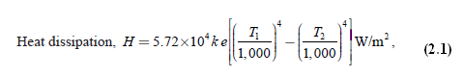

where *T*1 is the temperature of the source in kelvin, *T*2 is the temperature of the substance to be heated in kelvin, and *k* is the radiant efficiency:

= 1, for single element

= 0.5–0.8, for several elements

*e* = emissivity = 1, for black body

= 0.9, for resistance heating element.

From [Equation (4.1)](https://www.safaribooksonline.com/library/view/generation-and-utilization/9789332515673/xhtml/chapter004.xhtml#eq-4-1), the radiant heat is proportional to the difference of fourth power of the temperature, so it is very efficient heating at high temperature.

**2.4 ESSENTIAL REQUIREMENTS OF GOOD HEATING ELEMENT**

The materials used for heating element should have the following properties:

* **High-specific resistance**

Material should have high-specific resistance so that small length of wire may be required to provide given amount of heat.

* **High-melting point**

It should have high-melting point so that it can withstand for high temperature, a small increase in temperature will not destroy the element.

* **Low temperature coefficient of resistance**

From [Equation (4.1)](https://www.safaribooksonline.com/library/view/generation-and-utilization/9789332515673/xhtml/chapter004.xhtml#eq-4-1), the radiant heat is proportional to fourth powers of the temperatures, it is very efficient heating at high temperature.

For accurate temperature control, the variation of resistance with the operating temperature should be very low. This can be obtained only if the material has low temperature coefficient of resistance

* **Free from oxidation**

The element material should not be oxidized when it is subjected to high temperatures; otherwise the formation of oxidized layers will shorten its life.

* **High-mechanical strength**

The material should have high-mechanical strength and should withstand for mechanical vibrations.

* **Non-corrosive**

The element should not corrode when exposed to atmosphere or any other chemical fumes.

* **Economical**

The cost of material should not be so high.

**2.5 MATERIAL FOR HEATING ELEMENTS**

The selection of a material for heating element is depending upon the service conditions such as maximum operating temperature and the amount of charge to be heated, but no single element will not satisfy all the requirements of the heating elements. The materials normally used as heating elements are either alloys of nickel–chromium, nickel–chromium–iron, nickel–chromium–aluminum, or nickel–copper.

Nickel–chromium–iron alloy is cheaper when compared to simple nickel–chromium alloy. The use of iron in the alloy reduces the cost of final product but, reduces the life of the alloy, as it gets oxidized soon. We have different types of alloys for heating elements. [Table 2.1](https://www.safaribooksonline.com/library/view/generation-and-utilization/9789332515673/xhtml/chapter004.xhtml#Tab-4-1) gives the relevant properties of some of the commercial heating elements.

**Table 2.1** Properties of some heating elements

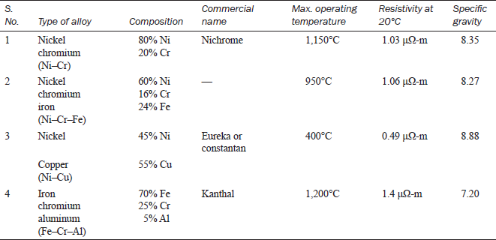

The properties of some commercial heating element materials commonly employed for low and medium temperatures up to 1,200°C are Ni–Cr and an alloy of Ni–Cr–Fe composition of these alloys are given in [Table 4.1](https://www.safaribooksonline.com/library/view/generation-and-utilization/9789332515673/xhtml/chapter004.xhtml#Tab-4-1). For operating temperatures above 1,200°C, the heating elements are made up of silicon carbide, molebdenum, tungsten, and graphite. (Ni–Cu alloy is frequently used for heating elements operating at low temperatures. Its most important property is that it has virtually zero resistance and temperature coefficient.)

**2.6 CAUSES OF FAILURE OF HEATING ELEMENTS**

Heating element may fail due to any one of the following reasons.

1. Formation of hot spots.
2. Oxidation of the element and intermittency of operation.
3. Embrittlement caused by gain growth.
4. Contamination and corrosion.

**2.6.1 Formation of hotspots**

Hotspots are the points on the heating element generally at a higher temperature than the main body. The main reasons of the formation of hotspot in the heating element are the high rate of the local oxidation causing reduction in the area of cross-section of the element leading to the increase in the resistance at that spot. It gives rise to the damage of heating element due to the generation of more heat at spot. Another reason is the shielding of element by supports, etc., which reduces the local heat loss by radiation and hence the temperature of the shielded portion of the element will increase. So that the minimum number of supports should be used without producing the distortion of the element. The sagging and wrapping of the material arise due to the insufficient support for the element (or) selection of wrong fuse material may lead to the uneven spacing of sections thereby developing the hotspots on the element.

**2.6.2 Oxidation and intermittency of operation**

A continuous oxide layer is formed on the surface of the element at very high temperatures such layer is so strong that it prevents further oxidation of the inner metal of the element. If the element is used quite often, the oxide layer is subjected to thermal stresses; thus, the layer cracks and flakes off, thereby exposing fresh metal to oxidation. Thus, the local oxidation of the metal increases producing the hotspots.

**2.6.3 Embrittlement causing grain growth**

In general, most of the alloys containing iron tend to form large brittle grains at high temperatures. When cold, the elements are very brittle and liable to rupture easily on the slightest handling and jerks.

**2.6.4 contamination and corrosion**

The heating elements may be subjected to dry corrosion produced by their contamination with the gases of the controlled atmosphere prevailing in annealing furnaces.

**2.7 DESIGN OF HEATING ELEMENTS**

By knowing the voltage and electrical energy input, the design of the heating element for an electric furnace is required to determine the size and length of the heating element. The wire employed may be circular or rectangular like a ribbon. The ribbon-type heating element permits the use of higher wattage per unit area compared to the circular-type element.

***Circular-type heating element***

Initially when the heating element is connected to the supply, the temperature goes on increasing and finally reaches high temperature.

Let *V* be the supply voltage of the system and *R* be the resistance of the element, then electric power input, Image.

If *ρ* is the resistivity of the element, *l* is the length, ‘*a*’ is the area, and *d* is the diameter of the element, then:

Image

Therefore, power input,

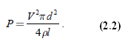

By rearranging the above equation, we get:

Image

where *P* is the electrical power input per phase (watt), *V* is the operating voltage per phase (volts), *R*is the resistance of the element (Ω), *l* is the length of the element (*m*), *a* is the area of cross-section (m2), *d* is the diameter of the element (*m*), and *ρ* is the specific resistance (Ω-m)

According to Stefan's law, heat dissipated per unit area is

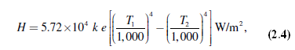

where *T*1 is the absolute temperature of the element (K), *T*2 is the absolute temperature of the charge (K), *e* is the emissivity, and *k* is the radiant efficiency.

The surface area of the circular heating element:

*S* = *πdl.*

∴ Total heat dissipated = surface area × *H*

                           = *Hπdl*.

Under thermal equilibrium,

Power input = heat dissipated

*P* = *H* × *πdl*.

Substituting *P* from [Equation (4.2)](https://www.safaribooksonline.com/library/view/generation-and-utilization/9789332515673/xhtml/chapter004.xhtml#eq-4-2) in above equation:

Image

Image

By solving [Equations (4.3)](https://www.safaribooksonline.com/library/view/generation-and-utilization/9789332515673/xhtml/chapter004.xhtml#eq-4-3) and [(4.4)](https://www.safaribooksonline.com/library/view/generation-and-utilization/9789332515673/xhtml/chapter004.xhtml#eq-4-4), the length and diameter of the wire can be determined.

***Ribbon-type element***

Let ‘*w*’ be the width and ‘*t*’ be the thickness of the ribbon-type heating element.

Image

We know that, Image (for ribbon or rectangular element, *a* = *w* × *t*)

Image

Image

The surface area of the rectangular element (*S*) = 2 *l* ×*w*.

∴ Total heat dissipated = *H* × *S*

= *H* × 2 *lw.*

∴ Under the thermal equilibrium,

Electrical power input = heat dissipated

*P* = *H* × 2 *lw*

Image

By solving [Equations (2.7)](https://www.safaribooksonline.com/library/view/generation-and-utilization/9789332515673/xhtml/chapter004.xhtml#eq-4-7) and [(2.8)](https://www.safaribooksonline.com/library/view/generation-and-utilization/9789332515673/xhtml/chapter004.xhtml#eq-4-8), the length and width of the heating element can be determined.

**Example 4.1:   A 4.5-kW, 200-V, and 1*-φ* resistance oven is to have nichrome wire heating elements. If the wire temperature is to be 1,000°C and that of the charge 500°C. Estimate the diameter and length of the wire. The resistivy of the nichrome alloy is 42.5 μΩ*-*m*.* Assume the radiating efficiency and the emissivity of the element as 1.0 and 0.9, respectively.**

**Solution:**

Given data

Power input (*P*) = 4.5 kW

Supply voltage (*V*) = 200 V

Temperature of the source (*T*1) = 1,000 + 273

                            = 1,273 K.

Temperature of the charge *T*2= 500 + 273

                            = 773 K.

According to the Stefan's law,

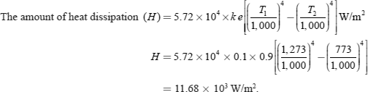

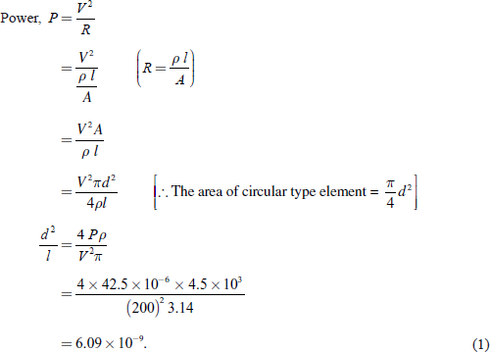

The heat dissipation is given by:

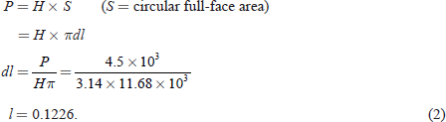

By solving [Equations (1)](https://www.safaribooksonline.com/library/view/generation-and-utilization/9789332515673/xhtml/chapter004.xhtml#eq-1a) and [(2)](https://www.safaribooksonline.com/library/view/generation-and-utilization/9789332515673/xhtml/chapter004.xhtml#eq-2a):

*d3 =* 0.7466

*d =* 0.907 mm.

Substitute the value of ‘*d*’ in [Equation (2)](https://www.safaribooksonline.com/library/view/generation-and-utilization/9789332515673/xhtml/chapter004.xhtml#eq-2):

*l* = 135.14 m.

**Example 4.2:   A20-kW, 230-V, and single-phase resistance oven employs nickel—chrome strip 25-mm thick is used, for its heating elements. If the wire temperature is not to exceed 1,200°C and the temperature of the charge is to be 700°C. Calculate the width and length of the wire. Assume the radiating efficiency as 0.6 and emissivity as 0.9. Determine also the temperature of the wire when the charge is cold.**

**Solution:**

Power supplied, *P* = 20 × 103 W.

Let ‘*w*’ be the width in meters, *t* be the thickness in meters, and ‘*l*’ be the length also in meters. Then:

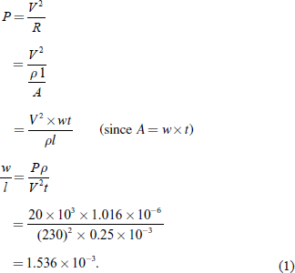

According to the Stefan's law of heat radiation:

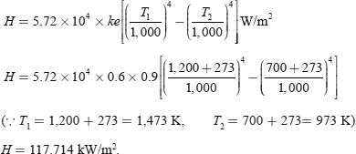

The total amount of the heat dissipation × the surface area of strip = power supplied

*P* = *H* × *S*

*= H* × 2 *lw*(*S* = surface area of strip = 2*lw*)

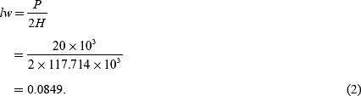

From [Equations (1)](https://www.safaribooksonline.com/library/view/generation-and-utilization/9789332515673/xhtml/chapter004.xhtml#eq-1b) and [(2)](https://www.safaribooksonline.com/library/view/generation-and-utilization/9789332515673/xhtml/chapter004.xhtml#eq-2b):

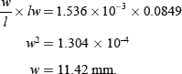

Substitute the value of ‘*w*’ in [Equation (2)](https://www.safaribooksonline.com/library/view/generation-and-utilization/9789332515673/xhtml/chapter004.xhtml#eq-2b) then:

*l =* 7.435 m.

When the charge is cold, it would be at normal temperature, say 25°C.

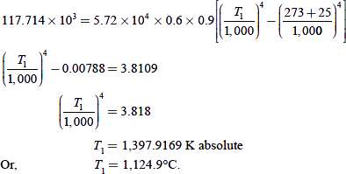

**Example 4.3   Determine the diameter and length of the wire, if a 17-kW, 220-V, and 1*-φ* resistance oven employs nickel-chrome wire for its heating elements. The temperature is not exceeding to 1,100°C and the temperature of the charge is to be 500°C. Assume the radiating efficiency as 0.5 and the emissivity as 0.9, respectively.**

**Solution:**

For a circular element:

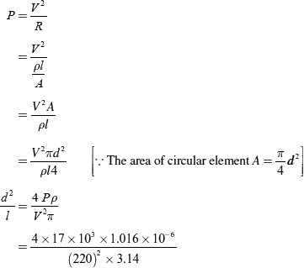

Image

According to Stefan's law of heat dissipation:

Image

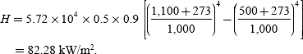

At steady temperature, crucial power input = heat output:

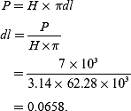

Solving [Equations (1)](https://www.safaribooksonline.com/library/view/generation-and-utilization/9789332515673/xhtml/chapter004.xhtml#eq-1) and [(2)](https://www.safaribooksonline.com/library/view/generation-and-utilization/9789332515673/xhtml/chapter004.xhtml#eq-2), we get:

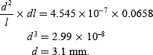

Substitute the value of ‘*d'* in [Equation (2)](https://www.safaribooksonline.com/library/view/generation-and-utilization/9789332515673/xhtml/chapter004.xhtml#eq-2) gives:

*l* = 21.198 m.

**Example 4.4:   A 40-kW, 3-phase, and 400-V resistance oven is to employ Ni-Cr strip of 0.3 mm thickness. The heating elements are star commuted. If the temperature of the wire is to be 1,200°C and that of the charge is 700°C. Determine the length and width of the wire. Take the radiation efficiency 0.5 and the emissivity as 0.9. Take the specific resistance of Ni-Cr = 1.03 × 10-6 Ω-m.**

**Solution:**

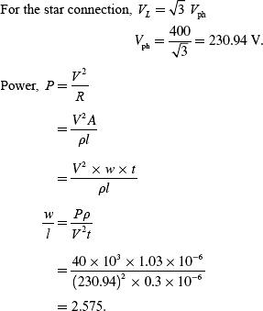

According to the Stefan's law of heat dissipation:

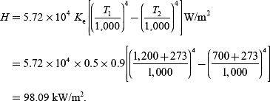

At steady state:

Electrical power input = heat output

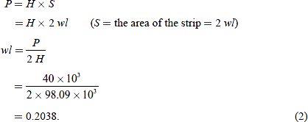

Solving [Equations (1)](https://www.safaribooksonline.com/library/view/generation-and-utilization/9789332515673/xhtml/chapter004.xhtml#eq-1) and [(2)](https://www.safaribooksonline.com/library/view/generation-and-utilization/9789332515673/xhtml/chapter004.xhtml#eq-2):

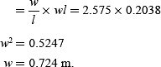

Substitute the value of ‘*w*’ in [Equation (2)](https://www.safaribooksonline.com/library/view/generation-and-utilization/9789332515673/xhtml/chapter004.xhtml#eq-2):

*l* = 0.2812 m.

**2.8 METHODS OF ELECTRIC HEATING**

Heat can be generated by passing the current through a resistance or induced currents. The initiation of an arc between two electrodes also develops heat. The bombardment by some heat energy particles such as *α,* *γ,* *β*, and x-rays or accelerating ion can produce heat on a surface.

Electric heating can be broadly classified as follows.

***(i) Direct resistance heating***

In this method, the electric current is made to pass through the charge (or) substance to be heated. This principle of heating is employed in electrode boiler.

***(ii) Indirect resistance heating***

In this method, the electric current is made to pass through a wire or high-resistance heating element, the heat so developed is transferred to charge from the heating element by convection or radiation. This method of heating is employed in immersion water heaters.

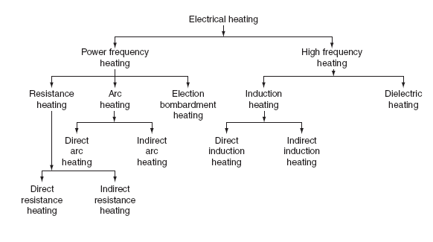

**Fig. 2.1** Classification of electrical heating

**Direct arc heating**

In this method, by striking the arc between the charge and the electrode or electrodes, the heat so developed is directly conducted and taken by the charge. The furnace operating on this principle is known as direct arc furnaces. The main application of this type of heating is production of steel.

**Indirect arc heating**

In this method, arc is established between the two electrodes, the heat so developed is transferred to the charge (or) substance by radiation. The furnaces operating on this principle are known as indirect arc furnaces. This method is generally used in the melting of non-ferrous metals.

**Direct induction heating**

In this method of heating, the currents are induced by electromagnetic action in the charge to be heated. These induced currents are used to melt the charge in induction furnace.

**Indirect induction heating**

In this method, eddy currents are induced in the heating element by electromagnetic action. Thus, the developed heat in the heating element is transferred to the body (or) charge to be heated by radiation (or) convection. This principle of heating is employed in induction furnaces used for the heat treatment of metals.

**Dielectric heating**

In this method of electric heating, the heat developed in a non-metallic material due to inter-atomic friction, known as dielectric loss. This principle of heating usually employed for preheating of plastic performs, baking foundry cores, etc.

**2.9 RESISTANCE HEATING**

When the electric current is made to pass through a high-resistive body (or) substance, a power loss takes place in it, which results in the form of heat energy, i.e., resistance heating is passed upon the*I*2*R* effect. This method of heating has wide applications such as drying, baking of potteries, commercial and domestic cooking, and the heat treatment of metals such as annealing and hardening. In oven where wire resistances are employed for heating, temperature up to about 1,000°C can be obtained.

The resistance heating is further classified as:

1. direct resistance heating,
2. indirect resistance heating, and
3. infrared (or) radiant heating.

**2.9.1 Direct resistance heating**

In this method, electrodes are immersed in a material or charge to be heated. The charge may be in the form of powder, pieces, or liquid. The electrodes are connected to AC or DC supply as shown in[Fig. 2.1(a)](https://www.safaribooksonline.com/library/view/generation-and-utilization/9789332515673/xhtml/chapter004.xhtml#Fig-4-1). In case of DC or 1*-φ* AC, two electrodes are immersed and three electrodes are immersed in the charge and connected to supply in case of availability of 3-*φ* supply. When metal pieces are to be heated, the powder of lightly resistive is sprinkled over the surface of the charge (or) pieces to avoid direct short circuit. The current flows through the charge and heat is produced in the charge itself. So, this method has high efficiency. As the current in this case is not variable, so that automatic temperature control is not possible. This method of heating is employed in salt bath furnace and electrode boiler for heating water.

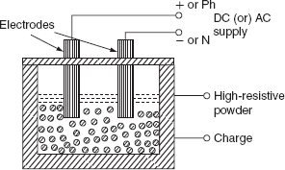

**Fig. 2.1(a)** Direct resistance heating

***(i) Salt bath furnace***

This type of furnace consists of a bath and containing some salt such as molten sodium chloride and two electrodes immersed in it.

Such salt have a fusing point of about 1,000–1,500°C depending upon the type of salt used. When the current is passed between the electrodes immersed in the salt, heat is developed and the temperature of the salt bath may be increased. Such an arrangement is known as a salt bath furnace.

In this bath, the material or job to be heated is dipped. The electrodes should be carefully immersed in the bath in such a way that the current flows through the salt and not through the job being heated. As DC will cause electrolysis so, low-voltage AC up to 20 V and current up to 3,000 A is adopted depending upon the type of furnaces.

The resistance of the salt decreases with increase in the temperature of the salt, therefore, in order to maintain the constant power input, the voltage can be controlled by providing a tap changing transformer. The control of power input is also affected by varying the depth of immersion and the distance between the electrodes.

***(ii) Electrode boiler***

It is used to heat the water by immersing three electrodes in a tank as shown in [Fig. 2.2](https://www.safaribooksonline.com/library/view/generation-and-utilization/9789332515673/xhtml/chapter004.xhtml#Fig-4-2). This is based on the principle that when the electric current passed through the water produces heat due to the resistance offered by it. For DC supply, it results in a lot of evolution of H2 at negative electrode and O2 at positive electrode. Whereas AC supply hardly results in any evolution of gas, but heats the water. Electrode boiler tank is earthed solidly and connected to the ground. A circuit breaker is usually incorporated to make and break all poles simultaneously and an over current protective device is provided in each conductor feeding an electrode.

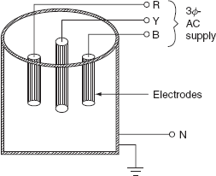

**Fig. 2.2** Electrode boiler

**2.9.2 Indirect resistance heating**

In the indirect resistance heating method, high current is passed through the heating element. In case of industrial heating, some times the heating element is placed in a cylinder which is surrounded by the charge placed in a jacket is known as heating chamber is shown in [Fig. 2.3](https://www.safaribooksonline.com/library/view/generation-and-utilization/9789332515673/xhtml/chapter004.xhtml#Fig-4-3). The heat is proportional to power loss produced in the heating element is delivered to the charge by one or more of the modes of the transfer of heat viz. conduction, convection, and radiation. This arrangement provides uniform temperature and automatic temperature control. Generally, this method of heating is used in immersion water heaters, room heaters, and the resistance ovens used in domestic and commercial cooling and salt bath furnace.

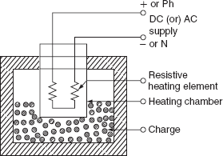

**Fig. 2.3** Indirect resistance heating

***Resistance ovens***

According to the operating temperatures, the resistance furnaces may be classified into various types. Low-temperature heating chamber with the provision for ventilation is called as oven. For drying varnish coating, the hardening of synthetic materials, and commercial and domestic heating, etc., the resistance ovens are employed. The operating temperature of medium temperature furnaces is between 300°C and 1,050°C. These are employed for the melting of non-ferrous metals, stove (annealing), etc. Furnaces operating at temperature between 1,050°C and 1,350°C are known as high-temperature furnaces. These furnaces are employed for hardening applications. A simple resistance oven is shown in [Fig. 2.4](https://www.safaribooksonline.com/library/view/generation-and-utilization/9789332515673/xhtml/chapter004.xhtml#Fig-4-4).

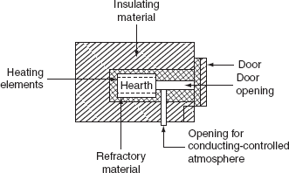

**Fig. 2.4** Resistance oven

Resistance oven consists of a heating chamber in which heating elements are placed as shown in the[Fig. 2.4](https://www.safaribooksonline.com/library/view/generation-and-utilization/9789332515673/xhtml/chapter004.xhtml#Fig-4-4). The inner surface of the heating chamber is made to suit the character of the charge and the type of furnace or oven. The type of insulation used for heating chamber is determined by the maximum temperature of the heating chamber.

***Efficiency and losses of resistance ovens***

The heat produced in the heating elements, not only raises the temperature of the charge to desired value, but also used to overcome the losses occurring due to:

1. Heat used in raising the temperature of oven (or) furnace.

2. Heat used in raising the temperature of containers (or) carriers,

3. Heat conducted through the walls.

4. Heat loss due to the opening of oven door.

1. The heat required to raise the temperature of oven to desired value can be calculated by knowing the mass of refractory material (*M*), its specific heat (*S*)*,* and raise of temperature (∆*T*) and is given by:

*H*oven =*MS*∆*T*J*.*

In case the oven is continuously used, this loss becomes negligible.

2. Heat used in rising the temperature of containers (or) carriers can be calculated exactly the same way as for oven (or) furnaces.

3. Heat loss conducted through the walls of the container can be calculated by knowing the area of the container (*A*) in square meters, the thickness of the walls (*t*) in meters, the inside and out side temperatures of the container *T*1 and *T*2 in °C, respectively, and the thermal conductivity of the container walls ‘*k*’ in m3/°C/hr and is given by: Heat loss by conduction Image

Actually, there is no specific formula for the determination of loss occurring due to the opening of door for the periodic inspection of the charge so that this loss may be approximately taken as 0.58–1.15 MJ/m2 of the door area, if the door is opened for a period of 20–30 sec.

The *efficiency of the oven* is defined as the ratio of the heat required to raise the temperature of the charge to the desired value to the heat required to raise the charge and losses.

The efficiency of the oven:

Image

The efficiency of the resistance oven lies in between 60% and 80%.

**2.10 ARC HEATING**

If the high voltage is applied across an air gap, the air in the gap gets ionized under the influence of electrostatic forces and becomes conducting medium, current flows in the form of a continuous spark, known as *arc.* A very high voltage is required to establish an arc but very small voltage is sufficient to maintain it, across the air gap. The high voltage required for striking an arc can be obtained by using a step-up transformer fed from a variable AC supply.

Another method of striking the arc by using low voltage is by short circuiting the two electrodes momentarily and with drawing them back. Electrodes made up of carbon or graphite and are used in the arc furnaces when the temperature obtained is in the range of 3,000–3,500°C.

**2.10.1 Types of arc furnaces**

There are two types of arc furnaces and they are:

1. direct arc furnace and

2. indirect arc furnace.

**(i) Direct arc furnace**

When supply is given to the electrodes, two arcs are established and current passes through the charge, as shown in [Fig. 2.5](https://www.safaribooksonline.com/library/view/generation-and-utilization/9789332515673/xhtml/chapter004.xhtml#Fig-4-5). As the arc is in direct contact with the charge and heat is also produced by current flowing through the charge itself, it is known as *direct arc furnace.*

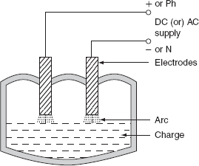

**Fig. 2.5** Direct arc furnace

If the available supply is DC or 1-*φ,* AC, two electrodes are sufficient, if the supply is 3-*φ*, AC, three electrodes are placed at three vertices of an equilateral triangle. The most important feature of the direct arc furnace is that the current flows through the charge, the stirring action is inherent due to the electromagnetic force setup by the current, such furnace is used for manufacturing alloy steel and gives purer product.

It is very simple and easy to control the composition of the final product during refining process operating the power factor of arc furnace is 0.8 lagging. For 1-ton furnace, the power required is about 200 kW and the energy consumed is 1.0 MWh/ton.

**(ii) Indirect arc furnace**

In indirect arc furnace, the arc strikes between two electrodes by bringing momentarily in contact and then with drawing them heat so developed, due to the striking of arc across air gap is transferred to charge is purely by radiation. A simple indirect arc furnace is shown in [Fig. 2.6](https://www.safaribooksonline.com/library/view/generation-and-utilization/9789332515673/xhtml/chapter004.xhtml#Fig-4-6).

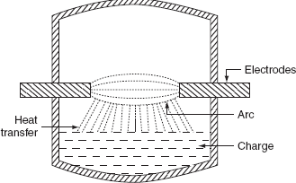

**Fig. 2.6** Indirect arc furnace

These furnaces are usually l*-φ* and hence their size is limited by the amount of one-phase load which can be taken from one point. There is no inherent stirring action provided in this furnace, as current does not flow through the charge and the furnace must be rocked mechanically. The electrodes are projected through this chamber at each end along the horizontal axis. This furnace is also sometimes called as *rocking arc furnace.* The charge in this furnace is heated not only by radiation from the arc between electrode tips but also by conduction from the heated refractory during rocking action; so, the efficiency of such furnace is high. The arc is produced by bringing electrodes into solid contact and then withdrawing them; power input to the furnace is regulated by adjusting the arc length by moving the electrodes.

Even though it can be used in iron foundries where small quantities of iron are required frequently, the main application of this furnace is the melting of non-ferrous metals.

**2.11 INDUCTION HEATING**

The induction heating process makes use of the currents induced by the electromagnetic action in the material to be heated. To develop sufficient amount of heat, the resistance of the material must be low Image, which is possible only with the metals, and the voltage must be higher, which can be obtained by employing higher flux and higher frequency. Therefore, the magnetic materials can be heated than non-magnetic materials due to their high permeability.

In order to analyze the factors affecting induction heating, let us consider a circular disc to be heated carrying a current of ‘*I*’ amps at a frequency ‘*f*’ Hz. As shown in [Fig. 2.9](https://www.safaribooksonline.com/library/view/generation-and-utilization/9789332515673/xhtml/chapter004.xhtml#Fig-4-9).

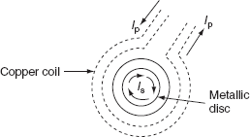

**Fig. 2.9** Induction heating

Heat developed in the disc is depending upon the following factors.

* Primary coil current.
* The number of the turns of the coil.
* Supply frequency.
* The magnetic coupling between the coil and the disc.
* The high electrical resistivity of the disc.

If the charge to be heated is non-magnetic, then the heat developed is due to eddy current loss, whereas if it is magnetic material, there will be hysteresis loss in addition to eddy current loss. Both hysteresis and eddy current loss are depended upon frequency, but at high-frequency hysteresis, loss is very small as compared to eddy currents.

The depth of penetration of induced currents into the disc is given by:

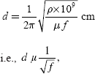

where *ρ* is the specific resistance in Ω*-*cm, *f* is the frequency in Hz, and *μ* is the permeability of the charge.

There are basically two types of induction furnaces and they are:

1. Core type or low-frequency induction furnace.
2. Coreless type or high-frequency induction furnace.

**2.11.1 Core type furnace**

The operating principle of the core type furnace is the electromagnetic induction. This furnace is operating just like a transformer. It is further classified as:

1. Direct core type.

2. Vertical core type.

3. Indirect core type.

**(i) Direct core type induction furnace**

The core type furnace is essentially a transformer in which the charge to be heated forms single-turn secondary circuit and is magnetically coupled to the primary by an iron core as shown in [Fig. 2.10](https://www.safaribooksonline.com/library/view/generation-and-utilization/9789332515673/xhtml/chapter004.xhtml#Fig-4-10).

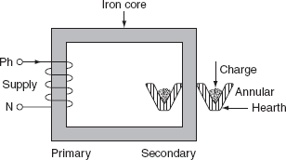

**Fig. 2.10** Direct core type furnace

The furnace consists of a circular hearth in the form of a trough, which contains the charge to be melted in the form of an annular ring. This type of furnace has the following characteristics:

* This metal ring is quite large in diameter and is magnetically interlinked with primary winding, which is energized from an AC source. The magnetic coupling between primary and secondary is very weak; it results in high leakage reactance and low pf. To overcome the increase in leakage reactance, the furnace should be operated at low frequency of the order of 10 Hz.
* When there is no molten metal in the hearth, the secondary becomes open circuited thereby cutting of secondary current. Hence, to start the furnace, the molten metal has to be taken in the hearth to keep the secondary as short circuit.
* Furnace is operating at normal frequency, which causes turbulence and severe stirring action in the molten metal to avoid this difficulty, it is also necessary to operate the furnace at low frequency.
* In order to obtain low-frequency supply, separate motor-generator set (or) frequency changer is to be provided, which involves the extra cost.
* The crucible used for the charge is of odd shape and inconvenient from the metallurgical viewpoint.
* If current density exceeds about 500 A/cm2, it will produce high-electromagnetic forces in the molten metal and hence adjacent molecules repel each other, as they are in the same direction. The repulsion may cause the interruption of secondary circuit (formation of bubbles and voids); this effect is known as *pinch effect.*

The pinch effect is also dependent on frequency; at low frequency, this effect is negligible, and so it is necessary to operate the furnace at low frequency.

**(ii) Vertical core type induction furnace**

It is an improvement over the direct core type furnace, to overcome some of the disadvantages mentioned above. This type of furnace consists of a vertical core instead of horizontal core as shown in [Fig. 2.11](https://www.safaribooksonline.com/library/view/generation-and-utilization/9789332515673/xhtml/chapter004.xhtml#Fig-4-11). It is also known as *Ajax*–*Wyatt induction furnace.*

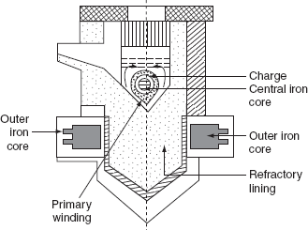

**Fig. 2.11** Vertical core type furnace (Ajax–Wyatt induction furnace)

Vertical core avoids the pinch effect due to the weight of the charge in the main body of the crucible. The leakage reactance is comparatively low and the power factor is high as the magnetic coupling is high compared to direct core type.

There is a tendency of molten metal to accumulate at the bottom that keeps the secondary completed for a vertical core type furnace as it consists of narrow V-shaped channel.

The inside layer of furnace is lined depending upon the type charge used. Clay lining is used for yellow brass and an alloy of magnesia and alumina is used for red brass.

The top surface of the furnace is covered with insulating material, which can be removed for admitting the charge. Necessary hydraulic arrangements are usually made for tilting the furnace to take out the molten metal. Even though it is having complicated construction, it is operating at power factor of the order of 0.8–0.83. This furnace is normally used for the melting and refining of brass and non-ferrous metals.

***Advantages***

* Accurate temperature control and reduced metal losses.
* Absence of crucibles.
* Consistent performance and simple control.
* It is operating at high power factor.
* Pinch effect can be avoided.

**(iii) Indirect core type furnace**

This type of furnace is used for providing heat treatment to metal. A simple induction furnace with the absence of core is shown in [Fig. 2.12](https://www.safaribooksonline.com/library/view/generation-and-utilization/9789332515673/xhtml/chapter004.xhtml#Fig-4-12).

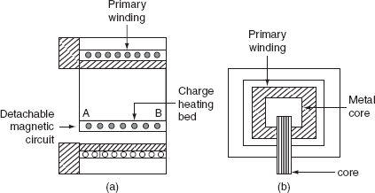

**Fig. 2.12** Indirect core type furnace

The secondary winding itself forms the walls of the container or furnace and an iron core links both primary and secondary windings.

The heat produced in the secondary winding is transmitted to the charge by radiation. An oven of this type is in direct competition with ordinary resistance oven.

It consists of a magnetic circuit AB is made up of a special alloy and is kept inside the chamber of the furnace. This magnetic circuit loses its magnetic properties at certain temperature and regains them again when it is cooled to the same temperature.

When the oven reaches to critical temperature, the reluctance of the magnetic circuit increases many times and the inductive effect decreases thereby cutting off the supply heat. Thus, the temperature of the furnace can be effectively controlled. The magnetic circuit ‘AB’ is detachable type that can be replaced by the other magnetic circuits having critical temperatures ranging between 400°C and 1,000°C. The furnace operates at a pf of around 0.8.

The main advantage of such furnace is wide variation of temperature control is possible.

**2.11.2 Coreless type induction furnace**

It is a simple furnace with the absence core is shown in [Fig. 2.13](https://www.safaribooksonline.com/library/view/generation-and-utilization/9789332515673/xhtml/chapter004.xhtml#Fig-4-13). In this furnace, heat developed in the charge due to eddy currents flowing through it.

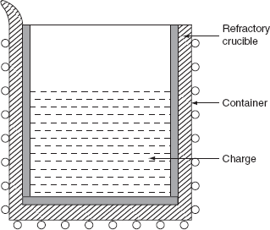

**Fig. 2.13** Coreless induction furnace

The furnace consists of a refractory or ceramic crucible cylindrical in shape enclosed within a coil that forms primary of the transformer. The furnace also contains a conducting or non-conducting container that acts as secondary.

If the container is made up of conducting material, charge can be conducting or non-conducting; whereas, if the container is made up of non-conducting material, charge taken should have conducting properties.

When primary coils are excited by an alternating source, the flux set up by these coils induce the eddy currents in the charge. The direction of the resultant eddy current is in a direction opposite to the current in the primary coil. These currents heat the charge to melting point and they also set up electromagnetic forces that produce a stirring action to the charge.

∴ The eddy currents developed in any magnetic circuit are given as:

*W*e ∝ *B*m2*f*2,

where *B*m is the maximum flux density (tesla), *f* is the frequency in (Hz), and *W*e is the eddy current loss (watts).

In coreless furnace, the flux density will be low as there is no core. Hence, the primary supply should have high frequency for compensating the low flux density.

If it is operating at high frequency, due to the skin effect, it results copper loss, thereby increasing the temperature of the primary winding. This necessitates in artificial cooling. The coil, therefore, is made of hollow copper tube through which cold water is circulated.

Minimum stray magnetic field is maintained when designing coreless furnace, otherwise there will be considerable eddy current loss.

The selection of a suitable frequency of the primary current can be given by penetration formula. According to this:

Image

where ‘*t*’ is the thickness up to which current in the metal has penetrated, ‘*ρ*’ is the resistivity in Ω-cm,'*μ*’ is the permeability of the material, and ‘*f*’ is the frequency in Hz.

For the efficient operation, the ratio of the diameter of the charge (*d*) to the depth of the penetration of currents (*t*) should be more than ‘6’, therefore let us take:

Image

Substitute above in [Equation (2.11)](https://www.safaribooksonline.com/library/view/generation-and-utilization/9789332515673/xhtml/chapter004.xhtml#eq-4-11).

Image

Following are the advantages of coreless furnace over the other furnaces:

* Ease of control.
* Oxidation is reduced, as the time taken to reach the melting temperature is less.
* The eddy currents in the charge itself results in automatic stirring.
* The cost is less for the erection and operation.
* It can be used for heating and melting.
* Any shape of crucible can be used.
* It is suitable for intermittent operation.

**4.12 DIELECTRIC HEATING**

When non-metallic materials i.e., insulators such as wood, plastics, and china glass are subjected to high-voltage alternating electric field, the atoms get stresses, and due to interatomic friction caused by the repeated deformation and the rotation of atomic structure (polarization), heat is produced. This is known as dielectric loss. This dielectric loss in insulators corresponds to hysteresis loss in ferro-magnetic materials. This loss is due to the reversal of magnetism or magneto molecular friction. These losses developed in a material that has to be heated.

An atom of any material is neutral, since the central positive charge is equals to the negative charge. So that, the centers of positive and negative charges coincide as long as there is no external field is applied, as shown in [Fig. 2.14(a)](https://www.safaribooksonline.com/library/view/generation-and-utilization/9789332515673/xhtml/chapter004.xhtml#Fig-4-14). When this atom is subjected to the influence of the electric field, the positive charge of the nucleus is acted upon by some force in the direction of negative charges in the opposite direction. Therefore, the effective centers of both positive and negative charges no longer coincident as shown in [Fig. 2.14(b)](https://www.safaribooksonline.com/library/view/generation-and-utilization/9789332515673/xhtml/chapter004.xhtml#Fig-4-14). The electric charge of an atom equivalent to [Fig. 2.14(b)](https://www.safaribooksonline.com/library/view/generation-and-utilization/9789332515673/xhtml/chapter004.xhtml#Fig-4-14) is shown in [Fig. 2.14(c)](https://www.safaribooksonline.com/library/view/generation-and-utilization/9789332515673/xhtml/chapter004.xhtml#Fig-4-14).

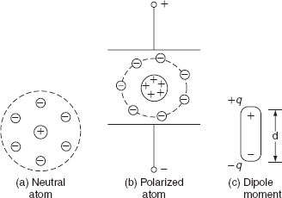

**Fig. 2.14** Polarization

This gives raise to an electric dipole moment equal to *P* = *q d,* where *d* is the distance between the two centers and *q* is the charge on the nucleus.

Now, the atom is said to be polarized atom. If we apply alternating voltage across the capacitor plate, we will get alternating electric field.

Electric dipoles will also try to change their orientation according to the direction of the impressed electric field. In doing so, some energy will be wasted as inter-atomic friction, which is called dielectric loss.

As there is no perfect conductor, so there is no perfect insulator. All the dielectric materials can be represented by a parallel combination of a leakage resistor ‘*R*’ and a capacitor ‘*C*’ as shown in [Fig. 2.15 (a)](https://www.safaribooksonline.com/library/view/generation-and-utilization/9789332515673/xhtml/chapter004.xhtml#Fig-4-15) and [(b)](https://www.safaribooksonline.com/library/view/generation-and-utilization/9789332515673/xhtml/chapter004.xhtml#Fig-4-15).

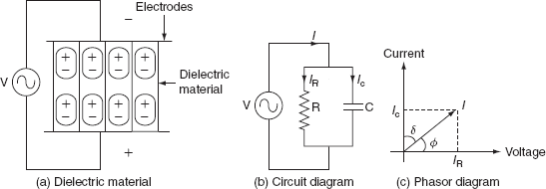

**Fig. 2.15** Dielectric heating

If an AC voltage is applied across a piece of insulator, an electric current flows; total current ‘*I*’ supposed to be made up of two components *I*C and *IR,* where *I*C is the capacitive current leading the applied voltage by 90° and *I*R is in phase with applied voltage as shown in [Fig. 2.15(c)](https://www.safaribooksonline.com/library/view/generation-and-utilization/9789332515673/xhtml/chapter004.xhtml#Fig-4-15).

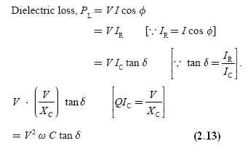

Image

where ‘*V'* is the applied voltage in volts, ‘*f*’ is the supply frequency in Hz, *ɛ*0 is the absolute permittivity of the medium = 8.854 × 10-12 F/m, *ɛ*r is the relative permittivity of the medium = 1 for free space, *A*is the area of the plate or electrode (m2), *d* is the thickness of the dielectric medium, and *δ* is the loss angle in radian.

From [Equation (2.14)](https://www.safaribooksonline.com/library/view/generation-and-utilization/9789332515673/xhtml/chapter004.xhtml#eq-4-14):

Image

Normally frequency used for dielectric heating is in the range of 1–40 MHz. The use of high voltage is also limited due to the breakdown voltage of thin dielectric that is to be heated, under normal conditions; the voltage gradient used is limited to 18 kV/cm.

***The advantages of the dielectric heating***

* The heating of the non-conducting materials is very rapid.
* The uniform heating of material is possible.
* Heat is produced in the whole mass of the material.

***The applications of the dielectric heating***

* The drying of paper, wood, etc.
* The gluing of wood.
* The heat-sealing of plastic sheets.
* The heating for the general processing such as coffee roasting and chocolate industry.
* The heating for the dehydration such as milk, cream, and vegetables.
* The preparation of thermoplastic resins.
* The heating of bones and tissues.
* Diathermy, i.e., the heat treatment for certain body pains and diseases, etc.
* The sterilization of absorbent cotton, bandages, etc.
* The processing of rubber, synthetic materials, chemicals, etc.

**Electric Welding**

**INTRODUCTION**

Welding is the process of joining two pieces of metal or non-metal together by heating them to their melting point. Filler metal may or may not be used to join two pieces. The physical and mechanical properties of a material to be welded such as melting temperature, density, thermal conductivity, and tensile strength take an important role in welding. Depending upon how the heat applied is created; we get different types of welding such as thermal welding, gas welding, and electric welding. Here in this chapter, we will discuss only about the electric welding and some introduction to other modern welding techniques. Welding is nowadays extensively used in automobile industry, pipe-line fabrication in thermal power plants, machine repair work, machine frames, etc.

**ADVANTAGES AND DISADVANTAGES OF WELDING**

Some of the advantages of welding are:

* Welding is the most economical method to permanently join two metal parts.
* It provides design flexibility.
* Welding equipment is not so costly.
* It joins all the commercial metals.
* Both similar and dissimilar metals can be joined by welding.
* Portable welding equipment are available.

Some of the disadvantages of welding are:

* Welding gives out harmful radiations and fumes.
* Welding needs internal inspection.
* If welding is not done carefully, it may result in the distortion of work piece.
* Skilled welding is necessary to produce good welding.

**ELECTRIC WELDING**

It is defined as the process of joining two metal pieces, in which the electrical energy is used to generate heat at the point of welding in order to melt the joint.

The classification of electric welding process is shown in [Fig. 2.1](https://www.safaribooksonline.com/library/view/generation-and-utilization/9789332515673/xhtml/chapter005.xhtml#Fig-5-1).

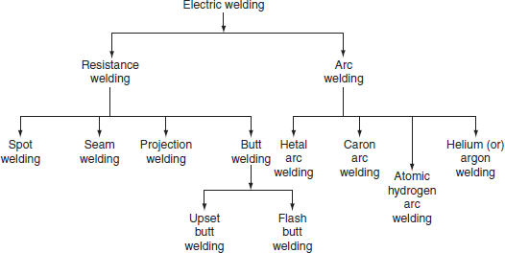

**Fig. 5.1** Classification of electric welding

The selection of proper welding process depends on the following factors.

* The type of metal to be joined.
* The techniques of welding adopted.
* The cost of equipment used.
* The nature of products to be fabricated.

**RESISTANCE WELDING**

Resistance welding is the process of joining two metals together by the heat produced due to the resistance offered to the flow of electric current at the junctions of two metals. The heat produced by the resistance to the flow of current is given by:

*H = I*2*Rt*,

where *I* is the current through the electrodes, *R* is the contact resistance of the interface, and *t* is the time for which current flows.

Here, the total resistance offered to the flow of current is made up of:

1. The resistance of current path in the work.

2. The resistance between the contact surfaces of the parts being welded.

3. The resistance between electrodes and the surface of parts being welded.

In this process of welding, the heat developed at the contact area between the pieces to be welded reduces the metal to plastic state or liquid state, then the pieces are pressed under high mechanical pressure to complete the weld. The electrical voltage input to the welding varies in between 4 and 12 V depending upon area, thickness, composition, etc. and usually power ranges from about 60 to 180 W for each sq. mm of area.

Any desired combination of voltage and current can be obtained by means of a suitable transformer in AC; hence, AC is found to be most suitable for the resistance welding. The magnitude of current is controlled by changing the primary voltage of the welding transformer, which can be done by using an auto-transformer or a tap-changing transformer. Automatic arrangements are provided to switch off the supply after a pre-determined time from applying the pressure, why because the duration of the current flow through the work is very important in the resistance welding.

The electrical circuit diagram for the resistance welding is shown in [Fig. 2.2](https://www.safaribooksonline.com/library/view/generation-and-utilization/9789332515673/xhtml/chapter005.xhtml#Fig-5-2). This method of welding consists of a tap-changing transformer, a clamping device for holding the metal pieces, and some sort of mechanical arrangement for forcing the pieces to form a complete weld.

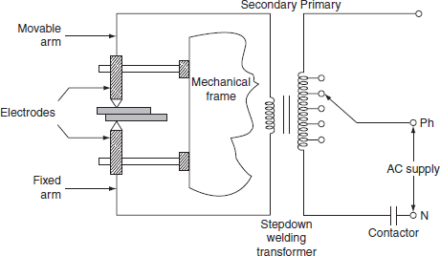

**Fig. 2.2** Electric circuit for resistance welding

***Advantages***

* Welding process is rapid and simple.
* Localized heating is possible, if required.
* No need of using filler metal.
* Both similar and dissimilar metals can be welded.
* Comparatively lesser skill is required.
* Maintenance cost is less.
* It can be employed for mass production.

*However, the resistance welding has got some drawbacks and they are:*

* Initial cost is very high.
* High maintenance cost.
* The workpiece with heavier thickness cannot be welded, since it requires high input current.

***Applications***

* It is used by many industries manufacturing products made up of thinner gauge metals.
* It is used for the manufacturing of tubes and smaller structural sections.

**Types of resistance welding**

Depending upon the method of weld obtained and the type of electrodes used, the resistance welding is classified as:

1. Spot welding.
2. Seam welding.
3. Projection welding.
4. Butt welding.

***(i) Spot welding***

Spot welding means the joining of two metal sheets and fusing them together between copper electrode tips at suitably spaced intervals by means of heavy electric current passed through the electrodes as shown in [Fig. 2.3](https://www.safaribooksonline.com/library/view/generation-and-utilization/9789332515673/xhtml/chapter005.xhtml#Fig-5-3).

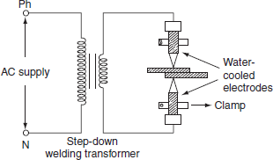

**Fig. 2.3** Spot welding

This type of joint formed by the spot welding provides mechanical strength and not air or water tight, for such welding it is necessary to localize the welding current and to apply sufficient pressure on the sheet to be welded. The electrodes are made up of copper or copper alloy and are water cooled. The welding current varies widely depending upon the thickness and composition of the plates. It varies from 1,000 to 10,000 A, and voltage between the electrodes is usually less than 2 V. The period of the flow of current varies widely depending upon the thickness of sheets to be joined. A step-down transformer is used to reduce a high-voltage and low-current supply to low-voltage and high-current supply required. Since the heat developed being proportional to the product of welding time and square of the current. Good weld can be obtained by low currents for longer duration and high currents for shorter duration; longer welding time usually produces stronger weld but it involves high energy expenditure, electrode maintenance, and lot of distortion of workpiece.

When voltage applied across the electrode, the flow of current will generate heat at the three junctions, i.e., heat developed, between the two electrode tips and workpiece, between the two workpieces to be joined as shown in [Fig. 2.3](https://www.safaribooksonline.com/library/view/generation-and-utilization/9789332515673/xhtml/chapter003.xhtml#Fig-3-3). The generation of heat at junctions 1 and 3 will effect electrode sticking and melt through holes, the prevention of electrode striking is achieved by:

1. Using water-cooled electrodes shown in [Fig. 2.4](https://www.safaribooksonline.com/library/view/generation-and-utilization/9789332515673/xhtml/chapter005.xhtml#Fig-5-4). By avoiding the heating of junctions 1 and 3 electrodes in which cold water circulated continuously as shown in [Fig. 2.3](https://www.safaribooksonline.com/library/view/generation-and-utilization/9789332515673/xhtml/chapter005.xhtml#Fig-5-3).

2. The material used for electrode should have high electrical and thermal conductivity. Spot welding is widely used for automatic welding process, for joining automobile parts, joining and fabricating sheet metal structure, etc.

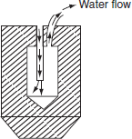

**Fig. 2.4** Water cooled electrode

***(ii) Seam welding***

Seam welding is nothing but the series of continuous spot welding. If number spots obtained by spot welding are placed very closely that they can overlap, it gives rise to seam welding.

In this welding, continuous spot welds can be formed by using wheel type or roller electrodes instead of tipped electrodes as shown in [Fig. 2.5](https://www.safaribooksonline.com/library/view/generation-and-utilization/9789332515673/xhtml/chapter005.xhtml#Fig-5-5).

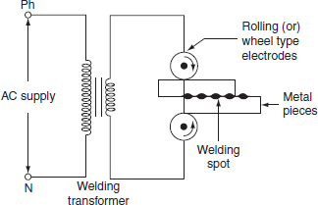

**Fig. 2.5** Seam welding

Seam welding is obtained by keeping the job under electrodes. When these wheel type electrodes travel over the metal pieces which are under pressure, the current passing between them heats the two metal pieces to the plastic state and results into continuous spot welds.

In this welding, the contact area of electrodes should be small, which will localize the current pressure to the welding point. After forming weld at one point, the weld so obtained can be cooled by splashing water over the job by using cooling jets.

In general, it is not satisfactory to make a continuous weld, for which the flow of continuous current build up high heat that causes burning and wrapping of the metal piece. To avoid this difficulty, an interrupter is provided on the circuit which turns on supply for a period sufficient to heat the welding point. The series of weld spots depends upon the number of welding current pulses.

The two forms of welding currents are shown in [Fig. 2.6(a)](https://www.safaribooksonline.com/library/view/generation-and-utilization/9789332515673/xhtml/chapter005.xhtml#Fig-5-6) and [(b)](https://www.safaribooksonline.com/library/view/generation-and-utilization/9789332515673/xhtml/chapter005.xhtml#Fig-5-6).

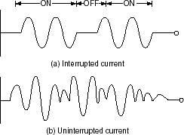

**Fig. 2.6** Welding current

Welding cannot be made satisfactorily by using uninterrupted or un-modulated current, which builds up high heat as the welding progress; this will over heat the workpiece and cause distortion.

Seam welding is very important, as it provides leak proof joints. It is usually employed in welding of pressure tanks, transformers, condensers, evaporators, air craft tanks, refrigerators, varnish containers, etc.

***(iii) Projection welding***

It is a modified form of the spot welding. In the projection welding, both current and pressure are localized to the welding points as in the spot welding. But the only difference in the projection welding is the high mechanical pressure applied on the metal pieces to be welded, after the formation of weld. The electrodes used for such welding are flat metal plates known as *platens*. The two pieces of base metal to be weld are held together in between the two platens, one is movable and the other is fixed, as shown in [Fig. 2.7](https://www.safaribooksonline.com/library/view/generation-and-utilization/9789332515673/xhtml/chapter005.xhtml#Fig-5-7).

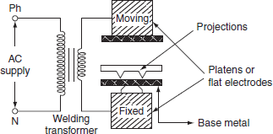

**Fig. 2.7** Projection welding

One of the two pieces of metal is run through a machine that makes the bumps or projections of required shape and size in the metal. As current flows through the two metal parts to be welded, which heat up and melt. These weld points soon reach the plastic state, and the projection touches the metal then force applied by the two flat electrodes forms the complete weld.

The projection welding needs no protective atmosphere as in the spot welding to produce successful results. This welding process reduces the amount of current and pressure in order to join two metal surfaces, so that there is less chance of distortion of the surrounding areas of the weld zone. Due to this reason, it has been incorporated into many manufacturing process.

The projection welding has the following advantages over the spot welding.

* Simplicity in welding process.
* It is easy to weld some of the parts where the spot welding is not possible.
* It is possible to join several welding points.
* Welds are located automatically by the position of projection.
* As the electrodes used in the projection welding are flat type, the contact area over the projection is sufficient.

This type of welding is usually employed on punched, formed, or stamped parts where the projection automatically exists. The projection welding is particularly employed for mass production work, i.e., welding of refrigerators, condensers, crossed wire welding, refrigerator racks, grills, etc.

***(iv) Butt welding***

Butt welding is similar to the spot welding; however, the only difference is, in butt welding, instead of electrodes the metal parts that are to be joined or butted together are connected to the supply.

The three basic types of the butt welding process are:

1. Upset butt welding.

2. Flash butt welding.

3. Percussion butt welding.

***(a) Upset butt welding***

In upset welding, the two metal parts to be welded are joined end to end and are connected across the secondary of a welding transformer as shown in [Fig. 2.8](https://www.safaribooksonline.com/library/view/generation-and-utilization/9789332515673/xhtml/chapter005.xhtml#Fig-5-8).

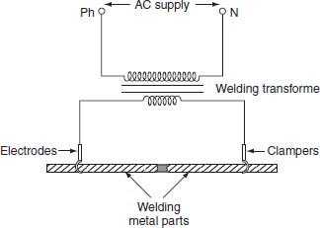

**Fig. 2.8** Upset butt welding

Due to the contact resistance of the metals to be welded, heating effect is generated in this welding. When current is made to flow through the two electrodes, heat will develop due to the contact resistance of the two pieces and then melts. By applying high mechanical pressure either manually or by toggle mechanism, the two metal pieces are pressed. When jaw-type electrodes are used that introduce the high currents without treating any hot spot on the job.

This type of welding is usually employed for welding of rods, pipes, and wires and for joining metal parts end to end.

***(b) Flash butt welding***

Flash butt welding is a combination of resistance, arc, and pressure welding. This method of welding is mainly used in the production welding. A simple flash butt welding arrangement is shown in [Fig. 2.9](https://www.safaribooksonline.com/library/view/generation-and-utilization/9789332515673/xhtml/chapter005.xhtml#Fig-5-9).

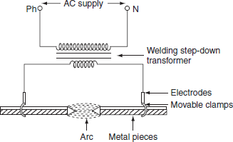

**Fig. 2.9** Flash butt welding

In this method of welding, the two pieces to be welded are brought very nearer to each other under light mechanical pressure. These two pieces are placed in a conducting movable clamps. When high current is passed through the two metal pieces and they are separated by some distance, then arc established between them. This arc or flashing is allowed till the ends of the workpieces reach melting temperature, the supply will be switched off and the pieces are rapidly brought together under light pressure. As the pieces are moved together, the fused metal and slag come out of the joint making a good solid joint.

Following are the advantages of the flash butt welding over the upset welding.

* Less requirement of power.
* When the surfaces being joined, it requires only less attention.
* Weld obtained is so clean and pure; due to the foreign metals appearing on the surfaces will burn due to flash or arc.

**ELECTRIC ARC WELDING**

Electric arc welding is the process of joining two metallic pieces or melting of metal is obtained due to the heat developed by an arc struck between an electrode and the metal to be welded or between the two electrodes as shown in Fig. 2.13.

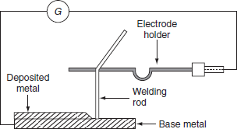

**Fig. 2.13** Arrangement of electric welding equipment

In this process, an electric arc is produced by bringing two conductors (electrode and metal piece) connected to a suitable source of electric current, momentarily in contact and then separated by a small gap, arc blows due to the ionization and give intense heat.

The heat so developed is utilized to melt the part of workpiece and filler metal and thus forms the weld.

In this method of welding, no mechanical pressure is employed; therefore, this type of welding is also known as *'non-pressure welding’.*

The length of the arc required for welding depends upon the following factors:

* The surface coating and the type of electrodes used.
* The position of welding.
* The amount of current used.

When the supply is given across the conductors separated by some distance apart, the air gap present between the two conductors gets ionized, as the arc welding is in progress, the ionization of the arc path and its surrounding area increases. This increase in ionization decreases the resistance of the path. Thus, current increases with the decrease in voltage of arc. This *V-I* characteristic of an arc is shown in Fig. 5.13, it also known as *negative resistance characteristics of an arc.* Thus, it will be seen that this decrease in resistance with increase in current does not remain the arc steadily. This difficulty cab be avoided, with the supply, it should fall rapidly with the increase in the current so that any further increase in the current is restricted.

For the arc welding, the temperature of the arc should be 3,500°C. At this temperature, mechanical pressure for melting is not required. Both AC and DC can be used in the arc welding. Usually 70–100 V on AC supply and 50–60 V on DC supply system is sufficient to struck the arc in the air gap between the electrodes. Once the arc is struck, 20–30 V is only required to maintain it.

However, in certain cases, there is any danger of electric shock to the operator, low voltage should be used for the welding purpose. Thus, DC arc welding of low voltage is generally preferred.

Electric arc welding is extensively used for the joining of metal parts, the repair of fractured casting, and the fillings by the deposition of new metal on base metal, etc.

Various types of electric arc welding are:

1. Carbon arc welding.
2. Metal arc welding.
3. Atomic hydrogen arc welding.
4. Inert gas metal arc welding.
5. Submerged arc welding.

**Carbon arc welding**

It is one of the processes of arc welding in which arc is struck between two carbon electrodes or the carbon electrode and the base metal. The simple arrangement of the carbon arc welding is shown in [Fig. 2.14](https://www.safaribooksonline.com/library/view/generation-and-utilization/9789332515673/xhtml/chapter005.xhtml#Fig-5-14).

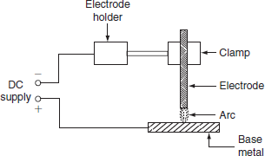

**Fig. 2.14** Carbon arc welding

In this process of welding, the electrodes are placed in an electrode holder used as negative electrode and the base metal being welded as positive. Unless, the electrode is negative relative to the work, due to high temperature, there is a tendency of the particles of carbon will fuse and mix up with the base metal, which causes brittleness; DC is preferred for carbon arc welding since there is no fixed polarity maintained in case of AC.

In the carbon arc welding, carbon or graphite rods are used as electrode. Due to longer life and low resistance, graphite electrodes are used, and thus capable of conducting more current. The arc produced between electrode and base metal; heat the metal to the melting temperature, on the negative electrode is 3,200°C and on the positive electrode is 3,900°C.

This process of welding is normally employed where addition of filler metal is not required. The carbon arc is easy to maintain, and also the length of the arc can be easily varied. One major problem with carbon arc is its instability which can be overcome by using an inductor in the electrode of 2.5-cm diameter and with the current of about of 500–800 A employed to deposit large amount of filler metal on the base metal.

Filler metal and flux may not be used depending upon the type of joint and material to be welded.

***Advantages***

* The heat developed during the welding can be easily controlled by adjusting the length of the arc.
* It is quite clean, simple, and less expensive when compared to other welding process.
* Easily adoptable for automation.
* Both the ferrous and the non-ferrous metals can be welded.

***Disadvantages***

* Input current required in this welding, for the workpiece to rise its temperature to melting/welding temperature, is approximately double the metal arc welding.
* In case of the ferrous metal, there is a chance of disintegrating the carbon at high temperature and transfer to the weld, which causes harder weld deposit and brittlement.
* A separate filler rod has to be used if any filler metal is required.

***Applications***

* It can be employed for the welding of stainless steel with thinner gauges.
* Useful for the welding of thin high-grade nickel alloys and for galvanized sheets using copper silicon manganese alloy filler metal.

**Metal arc welding**

In metal arc welding, the electrodes used must be of the same metal as that of the work-piece to be welded. The electrode itself forms the filler metal. An electric arc is stuck by bringing the electrode connected to a suitable source of electric current, momentarily in contract with the workpieces to be welded and withdrawn apart. The circuit diagram for the metal arc welding is shown in [Fig. 2.15](https://www.safaribooksonline.com/library/view/generation-and-utilization/9789332515673/xhtml/chapter005.xhtml#Fig-5-15).

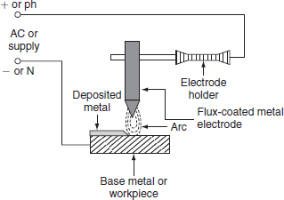

**Fig. 2.15** Metal arc welding

The arc produced between the workpiece and the electrode results high temperature of the order of about 2,400°C at negative metal electrode and 2,600°C at positive base metal or workpiece.

This high temperature of the arc melts the metal as well as the tip of the electrode, then the electrode melts and deposited over the surface of the workpiece, forms complete weld.

Both AC and DC can be used for the metal arc welding. The voltage required for the DC metal arc welding is about 50–60 V and for the AC metal arc welding is about 80–90 V

In order to maintain the voltage drop across the arc less than 13 V, the arc length should be kept as small as possible, otherwise the weld will be brittle. The current required for the welding varies from 10 to 500 A depending upon the type of work to be welded.

The main disadvantage in the DC metal arc welding is the presence of arc blow, i.e., distortion of arc stream from the intended path due to the magnetic forces of the non-uniform magnetic field with AC arc blow is considerably reduced. For obtaining good weld, the flux-coated electrodes must be used, so the metal which is melted is covered with slag produces a non-oxidizing gas or a molten slag to cover the weld, and also stabilizes the arc.

**Atomic hydrogen arc welding**

In atomic hydrogen arc welding, shown in [Fig. 2.16](https://www.safaribooksonline.com/library/view/generation-and-utilization/9789332515673/xhtml/chapter005.xhtml#Fig-5-16), the heat for the welding process is produced from an electric arc struck between two tungsten electrodes in an atmosphere of hydrogen. Here, hydrogen serves mainly two functions; one acts as a protective screen for the arc and the other acts as a cooling agent for the glowing tungsten electrode tips. As the hydrogen gas passes through the arc, the hydrogen molecules are broken up into atoms, absorbs heat from the glowing tungsten electrodes so that these are cooled.

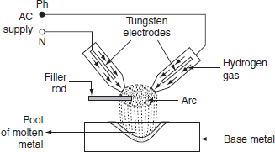

**Fig. 5216** Atomic hydrogen arc welding

But, when the atoms of hydrogen recombine into molecules outside the arc, a large amount of heat is liberated. This extraheat is added to the intense heat of arc, which produces a temperature of about 4,000°C that is sufficient to melt the surfaces to be welded, together with the filler rod if used. Moreover hydrogen includes oxygen and some other gases that might combine with the molten metal and forms oxides and other impurities. Hydrogen also removes oxides from the surface of workpiece. Thus, this process is capable of producing strong, uniform, smooth, and ductile welds.

In the atomic hydrogen arc welding, the arc is maintained between the two non-consumable tungsten electrodes under a pressure of about 0.5 kg/cm2. In order to obtain equal consumption of electrodes, AC supply is used. Arc currents up to 150 A can be used. High voltage about 300 V is applied for this welding through a transformer. For striking the arc between the electrodes the open circuit voltage required varies from 80 to 100 V.

As the atomic hydrogen welding is too expensive, it is usually employed for welding alloy steel, carbon steel, stainless steel, aluminum, etc.

**Inert gas metal arc welding**

It is a gas-shielded metal arc welding, in which an electric arc is stuck between tungsten electrode and workpiece to be welded. Filler metal may be introduced separately into the arc if required. A welding gun, which carries a nozzle, through this nozzle, inert gas such as beryllium or argon is blown around the arc and onto the weld, as shown in [Fig. 2.17](https://www.safaribooksonline.com/library/view/generation-and-utilization/9789332515673/xhtml/chapter005.xhtml#Fig-5-17). As both beryllium and argon are chemically inert, so the molten metal is protected from the action of the atmosphere by an envelope of chemically reducing or inert gas.

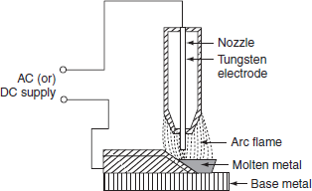

**Fig. 2.17** Inert gas metal are welding

As molten metal has an affinity for oxygen and nitrogen, if exposed to the atmosphere, thereby forming their oxides and nitrides, which makes weld leaky and brittle.

Thus, several methods of shielding have been employed. With the use of flux coating electrodes or by pumping, the inert gases around the arc produces a slag that floats on the top of molten metal and produces an envelope of inert gas around the arc and the weld.

***Advantages***

* Flux is not required since inert gas envelope protects the molten metal without forming oxides and nitrates so the weld is smooth, uniform, and ductile.
* Distortion of the work is minimum because the concentration of heat is possible.

***Applications***

* The welding is employed for light alloys, stainless steel, etc.
* The welding of non-ferrous metal such as copper, aluminum, etc.

**COMPARISON BETWEEN RESISTANCE AND ARC WELDING**

|  |  |
| --- | --- |
| *Resistance welding* | *Arc welding* |
| 1 The source of supply is AC only. | The source of supply is either AC (1-*φ* or 3-*φ*) or DC. |
| 2 The head developed is mainly due to the flow of contact resistance. | The heat developed is mainly due to the striking of arc between electrodes or an electrode and the workpiece. |
| 3 The temperature attained by the workpiece is not so high. | The temperature of the arc is so high, so proper care should be taken during the welding. |
| 4 External pressure is required. | No external pressure is required hence the welding equipment is more simple and easy to control. |
| 5 Filler metal is not required to join two metal pieces. | Suitable filler electrodes are necessary to get proper welding strength. |
| 6 It cannot be used for repair work; it is suitable for mass production. | It is not suitable for mass production. It is most suitable for repair works and where more metal is to be deposited. |
| 7 The power consumption is low. | The power consumption is high. |
| 8 The operating power factor is low. | The operating power factor is high. |
| 9 Bar, roller, or flat type electrodes are used (not consumable). | Bare or coated electrodes are used (consumable or non-consumable). |

**COMPARISON BETWEEN AC AND DC WELDING**

|  |  |
| --- | --- |
| *AC welding* | *DC welding* |
| 1 Motor generator set or rectifier is required in case of the availability of AC supply. | Only transformer is required. |
| 2 The cost of the equipment is high. | The cost of the equipment is cheap. |
| 3 Arc stability is more. | Arc stability is less. |
| 4 The heat produced is uniform. | The heat produced is not uniform. |
| 5 Both bare and coated electrodes can be used. | Only coated electrodes should be used. |
| 6 The operating power factor is high. | The power factor is low. So, the capacitors are necessary to improve the power factor. |
| 7 It is safer since no load voltage is low. | It is dangerous since no load voltage is high. |
| 8 The electric energy consumption is 5–10 kWh/kg of deposited metal. | The electrical energy consumption is 3–4 kWh/kg of deposited metal |
| 9 Arc blow occurs due to the presence of non-uniform magnetic field. | Arc blow will not occur due to the uniform magnetic field. |
| 10 The efficiency is low due to the rotating parts. | The efficiency is high due to the absence of rotating parts. |