UNIT-III
Electric Drives
3.1 INTRODUCTION:
Motor control is required in large number of industrial and domestic applications such as transportation systems, rolling mills, paper machines, textile mills, machine tools, fans, pumps, robots, and washing machines. Systems employed for motion control are called drives and may employ any of the prime movers. Drives employing electric motors are known as electric drives.
Nowadays, in electric power stations generating large amounts of electric energy for agriculture, industry, domestic needs, and electrified traction facilities and in driving all kinds of working machines, electric motor is essential, which is the predominant type of drive so the term electric drive being applied to it.
Electric drive becomes more popular because of its simplicity, reliability, cleanliness, easiness, and smooth control. Both AC and DC motors are used as electric drives
3.2 BLOCK DIAGRAM OF ELECTRIC DRIVE

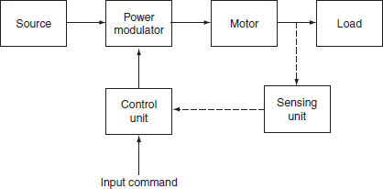
Fig. 3.1 Block diagram of electric drive
3.2.1 Source:
1-φ and 3-φ, 50-Hz AC supplies are readily available in most locations. Very low power drives are generally fed from 1-φ source; however, the high power drives are powered from 3-φ source; some of the drives are powered from a battery (Fig. 3.1).
Ex: Fork lifts trucks and milk vans.
3.2.2 Power modulator:
Power modulator performs the following functions:
It modulates flow of power from the source to the motor is impart speed−torque characteristics required by the load.
It regulates source and motor currents within permissible values, such as starting, braking, and speed reversal conditions.
Selects the mode of operation of motor, i.e., motoring or braking.
Converts source energy in the form suitable to the motor.
3.2.3 Electrical motors:
Motors commonly used in electric drives are DC motors, induction motors, synchronous motors, blushless DC motors, stepper motors, and switched reluctance motors, etc. In olden days, induction and synchronous motors were employed mainly for constant speed drives but not for variable speed drives, because of poor efficiency and are too expensive. But in nowadays, AC motors employed in variable speed drives due to the development of semiconductors employing SCRs, power transistors, IGBTs, and GTOs.
3.2.4 Load:
It is usually a machinery, such as fans, pumps, robots, and washing machines, designed to perform a given task, usually load requirements, can be specified in terms of speed and torque demands.
3.2.5 Control unit:
Control unit controls the function of power modulator. The nature of control unit for a particular drive depends on the type of power modulator used. When semiconductor converters are used, the control unit will consists of firing circuits. Microprocessors also used when sophisticated control is required.
3.2.6 Sensing unit:
Sensing unit consists of speed sensor or current sensor. The sensing of speed is required for the implementation of closed loop speed control schemes. Speed is usually sensed using tachometers coupled to the motor shaft. Current sensing is required for the implementation of current limit control.

Advantages of electric drives:
There are a number of inherent advantages that the electric drive possesses over the other forms of conventional drives are:
- They have comparatively long life than the mechanical drive.
- It is cleaner, as there are no flue gases, etc.
- It is more economical.
- They have flexible control characteristics.
- There is no need to store fuel or transportation.
- It requires less maintenance.
- Do not pollute environment.

Disadvantages of electric drives:
The two inherit disadvantages of the electric drive system are:
- The non-availability of drive on the failure of electrical power supply.
- It cannot be employed in distant places where electric power supply is not available.
3.3 TYPES OF ELECTRIC DRIVES
Depending on the type of equipment used to ran the electric motors in industrial purpose, they may be classified into three types. They are:
Group drives.
Individual drives.
Multi-motor drives.
3.3.1 Group drives
Electric drive that is used to drive one or more than two machines from line shaft through belts and pulleys is known as group drive. It is also sometimes called the line shaft drive. This drive is economical in the consideration of the cost of motor and control gear. A single motor of large capacity cost is less than the total cost of a number of small motors of the same total capacity. In switch over from non-electric drive to electric drive, the simplest way is to replace the engine by means of motor and retaining the rest of power transmission system.

Advantages:
The cost of installation is less. For example, if the power requirement of each machine is 10 HP and there are five machines in the group, then the cost of five motors will be more than one 50-HP motor.
Disadvantages:
Even though group drive has above advantages, it suffers from the following disadvantages.
1.If there is any fault in the main motor, all the machines connected to the motor will fail to operate; thereby, paralyzing a part of industry until the fault is removed.
2.It is not possible to install any machine at a distant place.
3.The possibility of the installation of additional machines in an existing industry is limited.
4.The level of noise produced at the work site is quite large.
5.The speed control of different machines using belts and pulleys is difficult.
6.The flexibility of layout is lost due to line shaft, belts, and pulleys.

3.3.2 Individual drive
In individual drive, a single electric motor is used to drive one individual machine. Such a drive is very common in most of the industries.
Advantages:
It is more clean and safety.
Machines can be located at convenient places.
If there is a fault in one motor, the output and operation of the other motors will not be effected.
The continuity in the production of the industry is ensured to a higher degree.
Individual drive is preferred for new factories, as it causes some saving in the cost.
Disadvantages:
Initial cost will be high.
Power loss is high.

3.3.3 Multi-motor drive:
In multi-motor drives, several separate motors are provided for operating different parts of the same machine.
Ex: In traveling cranes, three motors are used for hoisting, long travel, and cross-travel motions. Multi-motor drive is used in complicated metal cutting machine tools, rolling mills, paper making machines, etc.
3.4 CHOICE OF MOTORS
The selection of the driving motor for a given service depends upon the conditions under which it has to operate. Due to the universal adoption of electric drive, it has become necessary for the manufacturer to manufacture motors of various designs according to the suitability and the use in various designs according to the suitability and the use in various classes of industry. This has resulted into numerous types of motors. For this reason, the selection of motor itself has become an important and tedious process. The conditions under which an electric motor has to operate and the type of load it has to handle, determine its selection.

While selecting a motor, the following factors must be taken into consideration:
1.Nature of Supply: Whether ac or dc or rectified ac supply is to be utilized for motor
2.Cost:
i.Capital Cost
ii.Running Cost
3.Size and Rating of motors:Requirements for continuous, Intermittent, or variable load cycle and overload capacity
4.Type of drive: The drive is for one or more machines and the type of transmission through gears, belts, etc.
5.Nature of Load: Whether it is for continuous, Intermittent or variable loads
6.Electrical Characteristics:
i.Starting characteristics
ii.Running characteristics
iii.Braking characteristics
iv.Speed control

7.Mechanical Considerations:
i.Type of enclosures
ii.Type of Bearings
iii.Noise level
iv.Heating and cooling time constants

3.5 CHARACTERISTICS OF DC MOTOR

The performance and, therefore, suitability of a DC motor are determined from its characteristics. The important characteristics of DC motor are:
Torque vs. armature current characteristics (T vs. I_{a}):
This characteristic curve gives relation between torque developed in the armature (T) and armature current (I_{a}). This is also known as electrical characteristic.
Speed vs. armature current characteristics (N vs. I_{a}):
This characteristic curve gives relation between speed (N) and armature current (I_{a}). This is also known as speed characteristics.
Output (HP) vs. armature current characteristics (HP vs. I_{a}):
The horse power of the motor is dependent on the shaft torque, so its characteristics followsshaft torque characteristic.
Speed vs. characteristics (N vs. T):
This characteristic gives relation between speed (N) and torque (T) developed in the armature. This curve may be derived from the two characteristics mentioned in characteristics (i) and (ii) above.
Characteristics (i), (ii), and (iii) are called starting characteristics, and (iv) is known asrunning characteristics.
While discussing motor characteristics, the following relations should always be kept in mind.

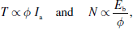

where T_{a} is the torque developed in the armature in N-m, I_{a} is the armature current in ampere, E_{b} is the back emf in volts, and φ is the flux in weber.

3.5.1 Characteristics of shunt motor:
The field winding connected across the armature terminals called as shunt motor as shown in Fig. 3.2. Rated voltage is applied across the field and armature terminals.

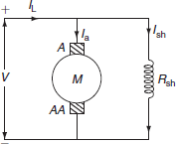

Fig. 3.2 DC shunt motor

Starting characteristics:
The study of starting characteristics of a motor is essential to know the starting torque necessary to accelerate the motor from standstill position is also to require to overcome the static friction and the standstill load or, to provide load torque.
Torque vs. armature current (T Vs I_{a}):
In the expression for the torque of a DC motor, torque is directly proportional to the product of flux per pole (φ) and armature current (I_{a}):

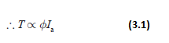

Since, in case of a DC shunt motor, the flux per pole (φ) is considered to be constant.

∴ T ∝ I_{a}.

So, the torque is proportional to armature current and is practically a straight line passing through the origin as shown if Fig. 3.3.

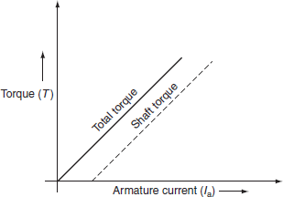

Fig. 3.3 Torque vs. armature current characteristics

To generate high starting torque, this type of motor requires a large value of armature current at starting. This may damage the motor, hence DC shunt motors can develop moderate starting torque and hence suitable for such applications where starting torque requirement is moderate.
Speed vs. armature current (N Vs I_{a}):
In shunt motor, the applied voltage ‘ V' is kept constant, the field current will remain constant, and hence the flux will have maximum value on no load due to the armature reaction; if load on the motor increases, the flux will be slightly decrease. By neglecting the armature reaction, the flux is almost constant.
From the speed equation of DC shunt motor:

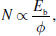

where E_{b} = V − I_{a}R_{a}

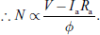

Since, for DC shunt motor, the flux per pole is considered to be constant.

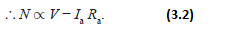

So, as the load on the motor increases, the armature current increases and hence I_{a}R_{a} drop also increases. For constant supply, the voltage (V-I_{a}R_{a}) decreases and hence the speed reduces. Hence, as armature current increases, the speed of the DC motor decreases. The variation of speed with armature current is shown in Fig. 3.4.

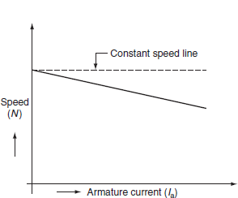

Fig. 3.4 Speed vs. armature current characteristics

Output vs. armature current:

The output of the motor is dependent on the shaft torque. If the armature current increases, the output of the motor gradually increases. The variation of output with the armature current is shown in Fig. 3.5.

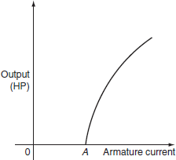

Fig. 3.5 Armature current and HP characteristics

Running characteristics:

Speed-torque characteristics (N vs. T):

These characteristics can be derived from its staring characteristics of (i) and (ii). During the steady-state operation of the motor, the voltage equation of the armature circuit is given by:

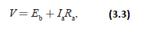

where V is the applied voltage, E_{b} is the back emf of motor, I_{a} is the armature current, and R_{a} is the armature resistance.
The back emf of motor can be expressed as:

E_{b} ∝φ N

∴E_{b} = K φ N,
where K is the constant, 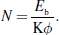
Substituting E_{b} from Equation (3.3) in above equation:
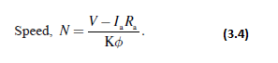

The torque of the motor is directly proportional to product of flux and armature current.

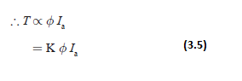

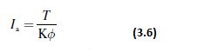

Substitute Equation (3.6) in Equation (3.4), we get:

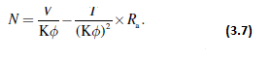

Since, the shunt motor flux is constant, the speed of the motor is:

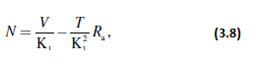

where K₁ = Kφ.

When V and R_{a} are kept constant, the speed torque characteristic is a straight line.
If the load on the motor increases, thus the torque increases and hence the speed of the motor decreases. The characteristic curve can be drawn from the Equation (3.8) and is shown in Fig. 3.6.

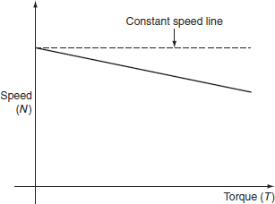

Fig. 3.6 Speed and torque characteristics

3.5.2 Characteristics of DC series motor:

In case of series motor, the field windings are connected in series with armature terminals as shown in Fig. 3.7. Since, the field winding is connected in series with the armature winding, the load current (I_{L}) is equals to the armature current (I_{a}) or the series field current (I_{se}).

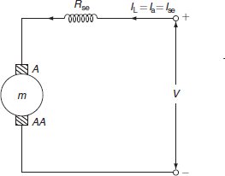

Fig. 3.7 DC series motor

∴ I_{L} = I_{a} = I_{se}.

Starting characteristics:

Torque vs. armature current (T Vs I_{a}):

In case of DC motors, torque is directly proportional to the product of flux per pole (φ) and armature current (I_{a}).

∴ T ∝ φ I_{a}.

Up to the saturation point, the flux is proportional to the field current and hence the armature current:

i.e., φ ∝ I_{se} ∝ I_{a}.

Therefore, the torque is proportional to the square of the armature current.

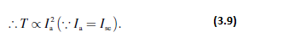

Hence, the curve drawn in Fig. 3.8; the torque and the armature currents are parabolas, up to saturation point. After saturation, the flux (φ) is almost independent of the excitation current and so the torque is proportional to the armature current, i.e., T ∝ I_{a}. Hence the characteristics become a straight line. The variation of torque with the armature current is shown in Fig. 3.8.

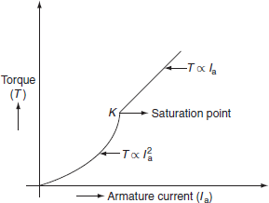

Fig. 3.8 Torque and armature current
Speed vs. armature current:

From the speed equation of DC series motor, the speed is directly proportional to the back emf and is inversely proportional to flux:
i.e., 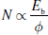
where E_{b} = V − I_{a}R_{se}.

When the armature current increases, the voltage drop in the armature resistance and the field resistance increases, but under the normal conditions, the voltage drop is small and it is negligible. Hence, V = E_{b} and it is constant:

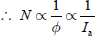

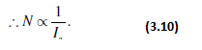

This relation shows the variation of speed with the armature current and it will be a rectangular hyperbola, which is shown in Fig. 3.9.

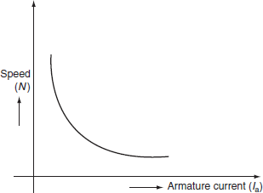

Fig. 3.9 Speed and armature current
Running characteristics:

Speed-torque characteristics:

These characteristics can be derived its starting characteristics. It is also known as mechanical characteristic.
In case of series motors:
T ∝ ϕI_{a} ∝I_{a}²

and 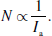
As the torque of a DC machine is directly proportional to armature current and flux, the speed will be inversely proportional to the square root of the torque, i.e., from the above two relations:

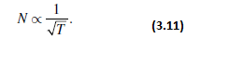

But at higher loads, the flux becomes saturated and the torque will be proportional to armature current, so the speed can be represented as:

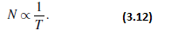

The speed–torque characteristics of a DC series motor is shown in Fig. 3.10.

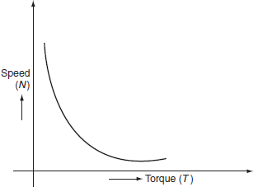
Fig. 3.10 Speed–torque characteristics

Hence, the series motors are best suited for services where the motor is directly coupled to the load such as whose speed falls with the increase in load torque.

3.5.3 Characteristics of DC compound wound motors:
Compound motors have both series. If the series field excitation aids with the shunt excitation, then the motor is said to be cumulatively compounded. If the series field opposes the shunt field excitation, it is known as differential compound motor. The characteristics of such motors lie in between shunt and series motors.
Cumulative-compound motor
Since, the series field aids with the shunt field winding, the flux is increased, as load is applied to the motor, and due to this reason, the motor speed slightly decreases. Such machines are used where series characteristics are required. Due to the shunt field, the winding speed will not become excessively high, but due to the series field winding, it will be able to take heavy loads.
Compound wound motors have the greatest application with loads that require high starting torques or pulsating load.
Differential-compound motors
In this motor, the series field opposes the shunt field and the flux is decreased, as load is applied to the motor. This results in the motor speed that is almost constant or even increasing with increase in load.
The speed-armature current and the torque–armature current characteristics of both the cumulative and the differential compound motors are shown in Figs. 3.11 and 3.12.

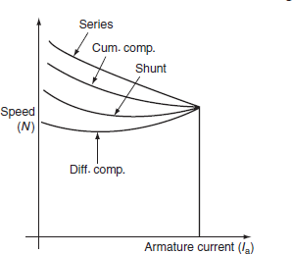

Fig. 3.11 Speed and armature current characteristics

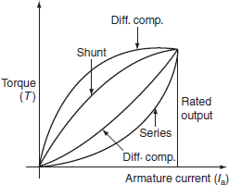

Fig. 3.12 Torque and armature current characteristics

3.6 THREE-PHASE INDUCTION MOTOR
Three-phase induction motors are simple in design, rugged in construction with the absence of commentator, and reliable in service. Besides this, they have low initial cost, simple maintenance, easy operation, and simple control gear for starting and speed control.
The speed–torque characteristics of the induction motor are quite important in the selection of the induction motor drive. These characteristics can be effectively determined by means of the equivalent circuit of the induction motor. The simplified equivalent circuit of induction motor is shown in Fig. 3.13.

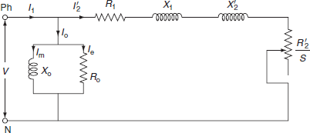

Fig. 3.13 Equivalent circuit of induction motor

In Fig. 3.13, V is the applied voltage per phase, R₁ and X₁ are the stator resistance and leakage reactance per phase, are the rotor resistance and leakage reactance per phase, R₀ and X₀ are the resistance and reactance per phase of the magnetizing branch, and is the rotor current per phase.

3.6.1 Torque equation:
The torque produced in the induction motor is mainly depends on the magnitude of rotor current, the power factor of the rotor circuit, and the part of rotating magnetic field that interacts with the rotor.
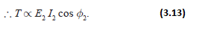

Substituting the values of I₂ and cos φ₂ in Equation (3.13):

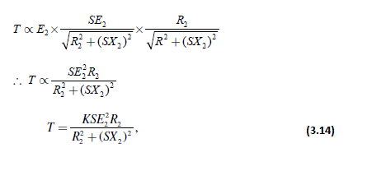

where ‘K’ is proportionality constant and is proved to be 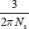 for the three-phase induction motor.

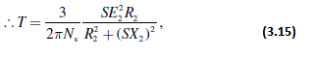

where N_{s} is synchronous speed in rps at standstill slip S = 1; therefore, the expression for starting torque may be obtained by putting S= 1 in Equation (3.14).

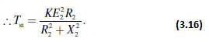

Ratio of full-load torque to maximum torque:
Let,
S_{f} = full-load slip of the motor
S_{m} = slip corresponding to maximum torque 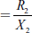.
According to the torque, the equation of motor is:

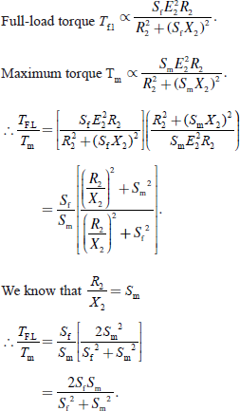
Ratio of starting torque to maximum torque:
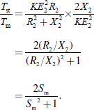

Torque–speed and torque–slip characteristics:
The torque–speed and torque–slip characteristics are shown in Fig. 3.14 (a) and (b). According to the torque equation of motor:

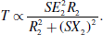

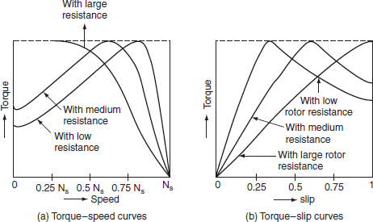

Fig. 3.14 (a) Torque-speed characteristics and (b) torque–slip characteristics

But for constant supply voltage, E₂ is also constant:

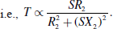

From the above expression, it is evident that, when torque is zero, slip S = 0 in low-slip region, slip is very very small, so that (SX₂) is so small compared to R₂; hence, it can be neglected.

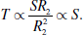

Therefore, torque T is proportional to slip ‘S’ if rotor resistance R₂ is constant. That is speeds nearer to synchronous speeds, the torque–speed, and torque–slip curves are approximately straight lines.
In high-slip region, the slip value approaches to unity. Here, it can be assumed that is very very small as compared to (SX₂)²; hence, it can be neglected.

3.7 SPEED CONTROL OF DC MOTORS
In practical applications, a motor may be required to perform a number of desirable jobs conforming different load conditions and speed requirements. The availability of DC motors to adjustment of their operating speed over wide ranges and by a variety of methods is one of the important reasons for the strong competitive position of DC machinery in the industrial applications.
The natures of speed control required by different industrial drives are:
Some drives require a continuously variable speed over the range from zero to full speed, such drives are known as variable-speed drives.
Some drives require only two to three fixed speeds over a region, such drives are known as multi-speed drives.
In some cases, speed is needed for adjusting or setting up the work on driven machine only for a few revolutions per minute. Such a speed is known as creeping speed.
3.8 TYPES OF LOADS
While selecting a motor, in addition to the information of load−speed−torque characteristics, the variation of load torque, losses, and temperature raise with time is also needed. In case the load and torque verses time variation is periodic and repetitive, such one cycle of variation of load with time is known as load or duty cycle. The various types of loads that occur in industrial practice can be classified depending upon their variation with time and duty cycle, which can be specified by the load diagram.
Figure 3.15 shows the typical duty cycle or load cycle which will give the variation of load with time and also the type of load.

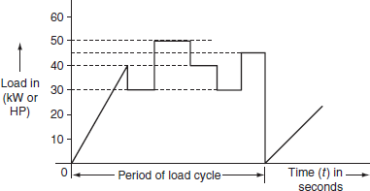
Fig. 3.15 Duty cycle or load cycle

3.8.1 Classification of loads with respect to time
The loads are classified with respect to time as follows.
Continuous and constant loads:
The loads on the motor operate for a long time under the same conditions.
Ex: fan, compressors, conveyors, centrifugal pumps, etc.
Continuous and variable loads:
The load on the motor operates repetitively for a longer duration but varies continuously over a period.
Ex: metal cutting lathes, hoist winches, conveyors, etc.
Pulsating loads:
The load on the motor which can be viewed as constant torque superimposed by pulsations.
Ex: tile looms, reciprocating pumps, certain type of loads with crankshaft, frame saws, etc.
Impact loads:
The load on the motor having regular and repetitive load peaks or pulses, i.e., load increases to a maximum level suddenly.

3.8.2 Classification of loads with respect to duty cycle
There are three basic classifications of duties of an electric motor. They are:
Continuous duty cycle.
Short-time duty cycle.
Intermittent duty cycle.
Continuous duty cycle:
Continuous duty is the duty when the on-period is so long that the motor attains a steady-state temperature raise. The motor so selected should be able to withstand momentary overload capacity. This type of motors will have high efficiency because they will be operating almost at its full load and also have good power factor.
There are mainly two types of continuous duty cycle. They are:
i.Continuous duty at constant load cycle.
ii.Continuous duty at variable load cycle.
In continuous duty with constant load cycle, the load torque remains constant for a sufficiently longer period. The variation of torque against time for continuous duty is shown in Fig. 3.16.

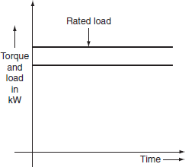
Fig. 3.16 Continuous duty with constant load

Ex: Conveyors, compressors, fan, etc. in which continuous duty at constant load occurs.
In continuous duty with variable load cycle, the load on the motor is not constant, but it has several phases in one cycle. The variation of load against time for variable load cycle is shown in Fig. 3.17. The selection of motor for this type of duty involves thermal calculation, which is a difficult task. The motors operating for such type of duties will have poor efficiency and also poor power factor.

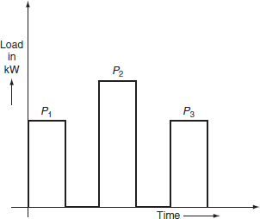
Fig. 3.17 Continuous duty with variable load

The selection of motor for this type of duty may be based on average power or average current method.
Short-time duty:
In this type of duty, the load occurs on the motor during a small interval and the remains idle for long time to re-establish the equality of temperature with the cooling medium. The variation of the load against time for short-time duty is shown in Fig. 3.18.

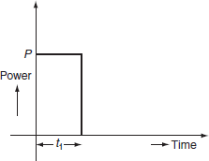

Fig. 3.18 Load cycle for short time duty

Usually, such type of short-time duty occurs in bridges, lock gates, and some other household appliances such as mixies.
Intermittent duty:
The duty in which load on the motor varies periodically in a sequence of identical cycles shown in Fig. 3.19, in which motor is loaded for sometimes ‘t_{on}’ and shut off for a period of ‘t_{off}’.

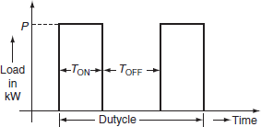

Fig. 3.19 Load cycle for intermittent duty

Motor heats during ‘on’ period ‘t_{on}’ and cools down during ‘off’ period ‘t_{off}’. The ratio of ‘t_{on}’ to (t_{on} + t_{off}) is known as duty ratio.

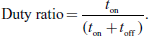

Maximum temperature attained with intermittent loading can be obtained by using the temperature raise and cooling equations of motor, and is given as follows.
Let θ_{h}, θ_{n}¹, θ_{h}², …θ_{h}^{n–1} be the temperature raise and be the fall in temperature for ‘n’ times intermittency.
Let t₁ be the duration of heating in second, t₂ be the duration of cooling in second, τ_{n} be the heating time constant in second, τ_{C} be the cooling time constant in second, and θ_{f} be the maximum permissible temperature raise of motor.

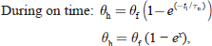

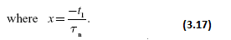

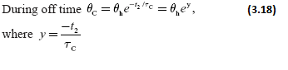

Substituting Equation (3.17) in Equation (3.18):

We get θ_{C} = θ_{f} (1 − e^{x})e_{y}.

Similarly, for the next intermittent loading:

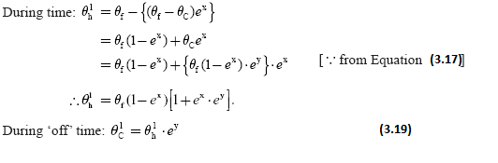

Similarly, for the next ‘on’ and ‘off’ periods:

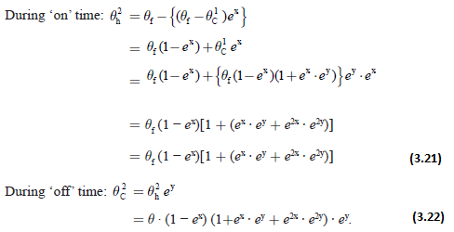

Similarly, for ‘n’ times intermittency:

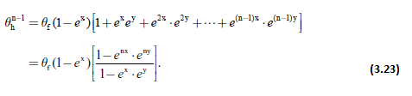

As n → ∞ both e_{nx} and e_{ny} will be zero, as x and y are negative. If ‘θ_{m}’ be the maximum temperature with intermittent loading then:

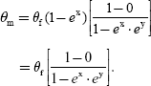

By substituting x and y values in the above equations:

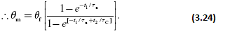
3.9 LOAD EQUALIZATION
The load fluctuations take place in many of the industrial drives such as rolling mills, planning machines presses, and reciprocating pumps, where the load on the motor varies widely within a span of few seconds. The sudden and peak load requires very large current from the supply results high voltage drop in the system or alternately would require very large size of cables. It is very essential to smooth out fluctuating load is known as ‘load equalization’. The load equalization involves the storage of energy during the off-peak period and gives out during the peak load period.
Load equalization process is commonly achieved by means of a flywheel. A flywheel is nothing but a big wheel that is mounted on the same shaft of motor, if the speed of the motor is not to be reversed or a heavy rotating body that acts as a reservoir for absorbing and redistributing stored energy is also known as flywheel.
3.9.1 Function of flywheel
To operate the flywheel efficiently, the driving motor should have drooping speed characteristics. The various models of flywheel are shown in Fig. 3.20 (a) and (b). During the lightload, the acceleration of the flywheel is increased and it stores the kinetic energy and at the time of peak load, the flywheel slows down and the stored kinetic energy is given out to the load; so that, the demand of the load from the motor or supply is reduced.

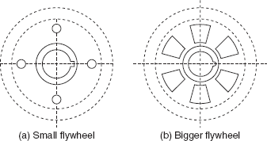

Fig. 3.20 Flywheel

It is necessary that the motor used for load equalization should have drooping characteristics. The flywheel is not used with motors having constant speed for example synchronous motor. The torque developed by the motor and the load torque required as well as the speed variations with time are shown in Fig. 3.21.
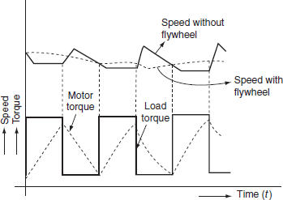

Fig. 3.21 Motor torque, load torque, and speed variations against time
Flywheel calculations:
Let us consider a flywheel is attached to a variable speed motor to achieve load equalization.
Let T_{L} be the load torque (assumed constant during particular interval) in N-m. T_{M} is the motor torque in N-m, T_{F} is the flywheel torque in N-m, T₀ is the no-load torque in N-m, ω₀ is the motor speed on no-load in rad/sec, ω is the motor speed at any instant in rad/sec, and J is the moment of inertia of flywheel in kg-m².

S = (ω₀ − ω) = motor slip.
Case (i): Let us consider that the load on the motor is increasing; during this period, the flywheel will decelerate and impart its stored kinetic energy to the load. The torque required to be supplied by the motor:

T_{M} = T_{L} − T_{F}.

The kinetic energy given by the flywheel when its speed reduced from ω₀ to ω is:

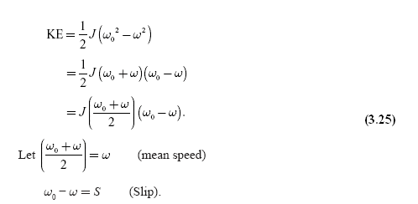

Then, Equation (3.25) becomes:

KE = JωS. (3.26)

The power given out by the flywheel = the rate of change of the energy given up by the flywheel.

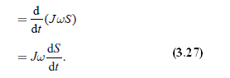

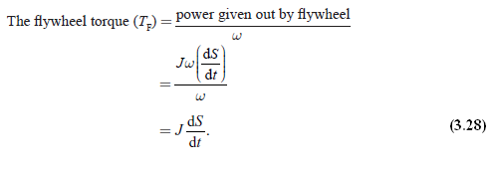

By substituting Equation (3.28) in Equation T_{M} = T_{L} − T_{F} , we get:

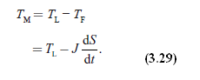

If the slip, i.e., drop in speed limited to 10%, then the slip is proportional to the motor torque:

i.e., S ∝ T_{M}

S = KT_{M}.

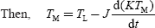

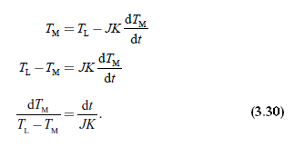

Integrating the Equation (3.30):

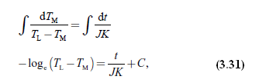

where C is proportionality constant.
At time t = 0, the motor torque will be equals to the no-load torque:

i.e., at t = 0, T_{M} = T₀. (3.32)

The value of ‘C’ can be determined by using the initial conditions. Substituting Equation (3.32) inEquation (3.31):

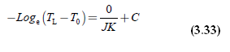

∴ C = −log_{e} (T_{L} − T₀).
Substituting ‘C’ value in Equation (3.33):

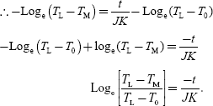

Applying exponentials on both sides:

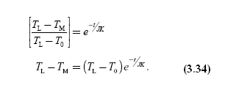

Case (ii): Now consider that the load is totally removed or decreasing, the motor starts accelerating and so the KE is stored by the flywheel.
Hence, the flywheel regains its normal speed; therefore, the slip decreases, i.e., is negative.
Now, motor torque will be:

But,
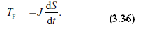
Substitute Equation (3.36) in Equation (3.35):

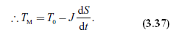
We know that S ∝ T_{M}:

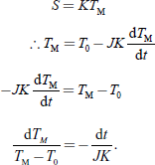

Integrating on both sides:

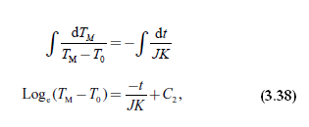

where ‘C₂’ is integration constant.
The value of constant can be obtained by substituting the initial conditions in Equation (3.38).

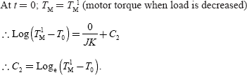

By substituting ‘C₂’ in Equation (3.38), we get:

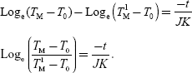

Applying exponentials on both sides:

