**Chapter 4**

**Electric Traction**

**4.1 INTRODUCTION**

The system that causes the propulsion of a vehicle in which that driving force or tractive force is obtained from various devices such as electric motors, steam engine drives, diesel engine dives, etc. is known as traction system.

Traction system may be broadly classified into two types. They are electric-traction systems, which use electrical energy, and non-electric traction system, which does not use electrical energy for the propulsion of vehicle.

**4.1.1Requirements of ideal traction system**

Normally, no single traction system fulfills the requirements of ideal traction system, why because each traction system has its merits and suffers from its own demerits, in the fields of applications.

The requirements of ideal traction systems are:

* Ideal traction system should have the capability of developing high tractive effort in order to have rapid acceleration.
* The speed control of the traction motors should be easy.
* Vehicles should be able to run on any route, without interruption.
* Equipment required for traction system should be minimum with high efficiency.
* It must be free from smoke, ash, durt, etc.
* Regenerative braking should be possible and braking should be in such a way to cause minimum wear on the break shoe.
* Locomotive should be self-contained and it must be capable of withstanding overloads.
* Interference to the communication lines should be eliminated while the locomotive running along the track.

**4.1.2 Advantages and Disadvantages of Electric Traction**

Electric traction system has many advantages compared to non-electric traction systems. The following are the advantages of electric traction:

* Electric traction system is more clean and easy to handle.
* No need of storage of coal and water that in turn reduces the maintenance cost as well as the saving of high-grade coal.
* Electric energy drawn from the supply distribution system is sufficient to maintain the common necessities of locomotives such as fans and lights; therefore, there is no need of providing additional generators.
* The maintenance and running costs are comparatively low.
* The speed control of the electric motor is easy.
* Regenerative braking is possible so that the energy can be fed back to the supply system during the braking period.
* In electric traction system, in addition to the mechanical braking, electrical braking can also be used that reduces the wear on the brake shoes, wheels, etc.
* Electrically operated vehicles can withstand for overloads, as the system is capable of drawing more energy from the system.

In addition to the above advantages, the electric traction system suffers from the following drawbacks:

* Electric traction system involves high erection cost of power system.
* Interference causes to the communication lines due to the overhead distribution networks.
* The failure of power supply brings whole traction system to stand still.
* In an electric traction system, the electrically operated vehicles have to move only on the electrified routes.
* Additional equipment should be needed for the provision of regenerative braking, it will increase the overall cost of installation.

**4.2 REVIEW OF EXISTING ELECTRIC TRACTION SYSTEM IN INDIA**

In olden days, first traction system was introduced by Britain in 1890 (600-V DC track). Electrification system was employed for the first traction vehicle. This traction system was introduced in India in the year 1925 and the first traction system employed in India was from Bombay VT to Igatpuri and Pune, with 1,500-V DC supply. This DC supply can be obtained for traction from substations equipped with rotary converters. Development in the rectifiers leads to the replacement of rotary converters by mercury arc rectifiers. But nowadays further development in the technology of semiconductors, these mercury arc valves are replaced by solid-state semiconductors devices due to fast traction system was introduced on 3,000-V DC. Further development in research on traction system by French international railways was suggested that, based on relative merits and demerits, it is advantageous to prefer to AC rather than DC both financially and operationally.

Thus, Indian railways was introduced on 52-kV, 50-Hz single-phase AC system in 1957; this system of track electrification leads to the reduction of the cost of overhead, locomotive equipment, etc. Various systems employed for track electrification are shown in [Table 4.1](https://www.safaribooksonline.com/library/view/generation-and-utilization/9789332515673/xhtml/chapter009.xhtml#Tab-9-1).

**Table 4.1** Track electrification systems

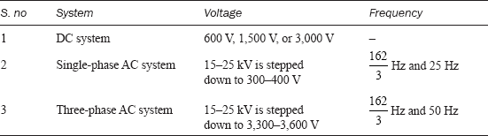

**4.3 SYSTEM OF TRACTION**

Traction system is normally classified into two types based on the type of energy given as input to drive the system and they are:

1. **Non-electric traction system**

Traction system develops the necessary propelling torque, which do not involve the use of electrical energy at any stage to drive the traction vehicle known as electric traction system.

*Ex:* Direct steam engine drive and direct internal combustion engine drive.

1. **Electric traction system**

Traction system develops the necessary propelling torque, which involves the use of electrical energy at any stage to drive the traction vehicle, known as electric traction system.

Based upon the type of sources used to feed electric supply for traction system, electric traction may be classified into two groups:

* 1. Self-contained locomotives.
  2. Electric vehicle fed from the distribution networks.

**4.3.1 Self-contained locomotives**

In this type, the locomotives or vehicles themselves having a capability of generating electrical energy for traction purpose. Examples for such type of locomotives are:

1. **Steam electric drive**

In steam electric locomotives, the steam turbine is employed for driving a generator used to feed the electric motors. Such types of locomotives are not generally used for traction because of some mechanical difficulties and maintenance problems.

1. **Diesel electric trains**

A few locomotives employing diesel engine coupled to DC generator used to feed the electric motors producing necessary propelling torque. Diesel engine is a variable high-speed type that feeds the self- or separately excited DC generator. The excitation for generator can be supplied from any auxiliary devices and battery.

Generally, this type of traction system is suggested in the areas where coal and steam tractions are not available. The advantages and disadvantages of the diesel engine drive are given below:

**Advantages**

* As these are no overhead distribution system, initial cost is low.
* Easy speed control is possible.
* Power loss in speed control is very low
* Time taken to bring the locomotive into service is less.
* In this system, high acceleration and braking retardation can be obtained compared to steam locomotives.
* The overall efficiency is high compared to steam locomotives.

**Disadvantages**

* The overloading capability of the diesel engine is less.
* The running and maintenance costs are high.
* The regenerative braking cannot be employed for the diesel engine drives.

**4.3.2 Petrol electric traction**

This system of traction is used in road vehicles such as heavy lorries and buses. These vehicles are capable of handling overloads. At the same time, this system provides fine and smooth control so that they can run along roads without any jerking.

**4.3.3 Battery drives**

In this drive, the locomotive consists of batteries used to supply power to DC motors employed for driving the vehicle. This type of drives can be preferred for frequently operated services such as local delivery goods traction in industrial works and mines, etc. This is due to the unreliability of supply source to feed the electric motors.

**4.3.4 Electric vehicles fed from distribution network**

Vehicles in electrical traction system that receives power from over head distribution network fed or substations with suitable spacing. Based on the available supply, these groups of vehicles are further subdivided into:

1.System operating with DC supply. Ex: tramways, trolley buses, and railways.

2.System operating with AC supply. Ex: railways.

**Systems operating with DC supply**

In case if the available supply is DC, then the necessary propelling power can be obtained for the vehicles from DC system such as tram ways, trolley buses, and railways.

**Tramways:** Tramways are similar to the ordinary buses and cars but only the difference is they are able to run only along the track. Operating power supply for the tramways is 500-V DC tramways are fed from single overhead conductor acts as positive polarity that is fed at suitable points from either power station or substations and the track rail acts as return conductor.

The equipment used in tramways is similar to that used in railways but with small output not more than 40–50 kW. Usually, the tramways are provided with two driving axels to control the speed of the vehicles from either ends. The main drawback of tramways is they have to run along the guided routes only. Rehostatic and mechanical brakings can be applied to tramways. Mechanical brakes can be applied at low speeds for providing better saturation where electric braking is ineffective, during the normal service. The erection and maintenance costs of tramways are high since the cost ofoverhead distribution structure is costlier and sometimes, it may cause a source of danger to other road users.

**Trolley buses:** The main drawback of tramways is, running along the track is avoided in case of trolley buses. These are electrically operated vehicles, and are fed usually 600-V DC from two overhead conductors, by means of two collectors. Even though overhead distribution structure is costlier, the trolley buses are advantageous because, they eliminate the necessity of track in the roadways.

In case of trolley buses, rheostatic braking is employed, due to high adhesion between roads and rubber types. A DC compound motor is employed in trolley buses.

**4.4 SYSTEM OF TRACK ELECTRIFICATION**

Nowadays, based on the available supply, the track electrification systems are categorized into.

1. DC system.

2. Single-phase AC system.

3. Three-phase AC system.

4. Composite system.

**4.4.1 DC system**

In this system of traction, the electric motors employed for getting necessary propelling torque should be selected in such a way that they should be able to operate on DC supply. Examples for such vehicles operating based on DC system are tramways and trolley buses. Usually, DC series motors are preferred for tramways and trolley buses even though DC compound motors are available where regenerative braking is desired. The operating voltages of vehicles for DC track electrification system are 600, 750, 1,500, and 3,000 V. Direct current at 600–750 V is universally employed for tramways in the urban areas and for many suburban and main line railways, 1,500–3,000 V is used. In some cases, DC supply for traction motor can be obtained from substations equipped with rotary converters to convert AC power to DC. These substations receive AC power from 3-*φ* high-voltage line or single-phase overhead distribution network. The operating voltage for traction purpose can be justified by the spacing between stations and the type of traction motors available. Theses substations are usually automatic and remote controlled and they are so costlier since they involve rotary converting equipment. The DC system is preferred for suburban services and road transport where stops are frequent and distance between the stops is small.

**4.4.2 Single-phase AC system**

In this system of track electrification, usually AC series motors are used for getting the necessary propelling power. The distribution network employed for such traction systems is normally 15–25 kV at reduced frequency of 163⅔ Hz or 25 Hz. The main reason of operating at reduced frequencies is AC series motors that are more efficient and show better performance at low frequency. These high voltages are stepped down to suitable low voltage of 300–400 V by means of step-down transformer. Low frequency can be obtained from normal supply frequency with the help of frequency converter. Low-frequency operation of overhead transmission line reduces the line reactance and hence the voltage drops directly and single-phase AC system is mainly preferred for main line services where the cost of overhead structure is not much importance moreover rapid acceleration and retardation is not required for suburban services.

**4.4.3 Three- phase AC system**

In this system of track electrification, 3-*φ* induction motors are employed for getting the necessary propelling power. The operating voltage of induction motors is normally 3,000–3,600-V AC at either normal supply frequency or 16⅔-Hz frequency.

Usually 3-*φ* induction motors are preferable because they have simple and robust construction, high operating efficiency, provision of regenerative braking without placing any additional equipment, and better performance at both normal and seduced frequencies. In addition to the above advantages, the induction motors suffer from some drawbacks; they are low-starting torque, high-starting current, and the absence of speed control. The main disadvantage of such track electrification system is high cost of overhead distribution structure. This distribution system consists of two overhead wires and track rail for the third phase and receives power either directly from the generating station or through transformer substation.

Three-phase AC system is mainly adopted for the services where the output power required is high and regeneration of electrical energy is possible.

**4.4.4 Composite system**

As the above track electrification system have their own merits and demerits, 1-*φ* AC system is preferable in the view of distribution cost and distribution voltage can be stepped up to high voltage with the use of transformers, which reduces the transmission losses. Whereas in DC system, DC series motors have most desirable features and for 3-*φ* system, 3-*φ* induction motor has the advantage of automatic regenerative braking. So, it is necessary to combine the advantages of the DC/AC and 3-*φ*/1-*φ* systems. The above cause leads to the evolution of composite system.

**Composite systems are of two types.**

1. Single-phase to DC system.

2. Single-phase to three-phase system or kando system.

**Single-phase to DC system**

In this system, the advantages of both 1-*φ* and DC systems are combined to get high voltage for distribution in order to reduce the losses that can be achieved with 1-*φ* distribution networks, and DC series motor is employed for producing the necessary propelling torque. Finally, 1-*φ* AC distribution network results minimum cost with high transmission efficiency and DC series motor is ideally suited for traction purpose. Normal operating voltage employed of distribution is 25 kV at normal frequency of 50 Hz. This track electrification is employed in India.

**Single-phase to 3-φ system (or) kando system**

In this system, 1-*φ* AC system is preferred for distribution network. Since single-phase overhead distribution system is cheap and 3-*φ* induction motors are employed as traction motor because of their simple, robust construction, and the provision of automatic regenerative braking.

The voltage used for the distribution network is about 15–25 kV at 50 Hz. This 1-*φ* supply is converted to 3-*φ* supply through the help of the phase converters and high voltage is stepped down transformers to feed the 3-*φ* induction motors. Frequency converters are also employed to get high-starting torque and to achieve better speed control with the variable supply frequency.

**4.5 COMPARISON OF DC AND AC TRACTIONS**

[Table 4.2](https://www.safaribooksonline.com/library/view/generation-and-utilization/9789332515673/xhtml/chapter009.xhtml#Tab-9-2) gives a comparison between DC traction and AC traction.

**Table 4.2** Comparison between DC and AC tractions

| ***Factor*** | ***DC traction*** | ***AC traction*** |
| --- | --- | --- |
| 1. Cost | DC series motors are cheaper. | AC series motors are expensive. |
| 2. Efficiency | It is more efficient. | Less efficient. |
| 3. Maintenance | It requires less maintenance. | It requires more maintenance. |
| 4. Acceleration | It is capable of giving high acceleration. | It is capable of giving less acceleration. |
| 5. Speed control | The speed control of DC series motor is limited. | Wide range of speed control is possible. |
| 6. Interference | DC system causes less interference with communication lines. | It will produce more interference with communication lines. |
| 7. Regenerative braking | Regenerative braking is more efficient in DC series motor. | Regenerative braking is less efficient in AC series motor. |
| 8. Overhead distribution | Overhead distribution. | Overhead distribution. |
| 9. System | System is less costly in DC system. | System is costlier in AC system. |
| 10. Torque | The torque developed by the DC series motor is less. | The starting and running torque developed by the AC series motor is more. |
| 11. Substations | The number of substations required for a given track distance on DC traction is more. | The number of substations required in AC traction is less. |

**4.6 SPECIAL FEATURES OF TRACTION MOTORS**

The general features of the electric motors used for traction purpose are:

1. Mechanical features.
2. Electrical features.

**4.6.1 Mechanical features**

1. A traction motor must be mechanically strong and robust and it should be capable of withstanding severe mechanical vibrations.
2. The traction motor should be completely enclosed type when placed beneath the locomotive to protect against dirt, dust, mud, etc.
3. In overall dimensions, the traction motor must have small diameter, to arrange easily beneath the motor coach.
4. A traction motor must have minimum weight so the weight of locomotive will decrease. Hence, the load carrying capability of the motor will increase.

**4.6.2 Electrical features**

**High-starting torque**

A traction motor must have high-starting torque, which is required to start the motor on load during the starting conditions in urban and suburban services.

**Speed control**

The speed control of the traction motor must be simple and easy. This is necessary for the frequent starting and stopping of the motor in traction purpose.

**Dynamic and regenerative braking**

Traction motors should be able to provide easy simple rehostatic and regenerative braking subjected to higher voltages so that system must have the capability of withstanding voltage fluctuations.

**Temperature**

The traction motor should have the capability of withstanding high temperatures during transient conditions.

**Overload capacity**

The traction motor should have the capability of handling excessecive overloads.

**Parallel running**

In traction work, more number of motors need to run in parallel to carry more load. Therefore, the traction motor should have such speed–torque and current–torque characteristics and those motors may share the total load almost equally.

**Commutation**

Traction motor should have the feature of better commutation, to avoid the sparking at the brushes and commutator segments.

**4.7 BRAKING**

If at any time, it is required to stop an electric motor, then the electric supply must be disconnected from its terminals to bring the motor to rest. In this method, even though supply is cut off, the motor continue to rotate for long time due to inertia. In some cases, there is delay in bringing the other equipment. So that, it is necessary to bring the motor to rest quickly. The process of bringing the motor to rest within the pre-determined time is known as braking.

**A good braking system must have the following features:**

* Braking should be fast and reliable.
* The equipment to stop the motor should be in such a way that the kinetic energy of the rotating parts of the motor should be dissipated as soon as the brakes are applied.

**4.8 TYPES OF ELECTRIC BRAKING**

Electric braking can be applied to the traction vehicle, by any one of the following methods, namely:

1. Plugging.

2. Rheostatic braking.

3. Regenerative braking.

**4.8.1 Plugging**

In this method of braking, the electric motor is reconnected to the supply in such a way that it has to develop a torque in opposite direction to the movement of the rotor. Now, the motor will decelerates until zero speed is zero and then accelerates in opposite direction. Immediately, it is necessary to disconnect the motor from the supply as soon as system comes to rest.

The main disadvantage of this method is that the kinetic energy of the rotating parts of the motor is wasted and an additional amount of energy from the supply is required to develop the torque in reverse direction, i.e., in this method, the motor should be connected to the supply during braking. This method can be applied to both DC and AC motors.

**Plugging applied to DC motors**

Pulling is nothing but reverse current braking. This method of braking can be applied to both DC shunt and DC series motors by reversing either the current through armature or the field winding in order to produce the torque in apposite direction, but not both. The connection diagrams for both DC shunt and DC series motors during normal and braking periods are given as follows.

The connection diagram for normal running conditions of both DC shunt and DC series motors are shown in [Figs. 9.4 (a)](https://www.safaribooksonline.com/library/view/generation-and-utilization/9789332515673/xhtml/chapter009.xhtml#Fig-9-4) and [9.5 (a)](https://www.safaribooksonline.com/library/view/generation-and-utilization/9789332515673/xhtml/chapter009.xhtml#Fig-9-5). The back emf developed by the motor is equal in magnitude and same as to the direction of terminal or supply voltage. During the braking, the armatures of both shunt and series motors are reversed as shown in [Fig. 9.4 (b)](https://www.safaribooksonline.com/library/view/generation-and-utilization/9789332515673/xhtml/chapter009.xhtml#Fig-9-4) and [Fig. 9.5 (b)](https://www.safaribooksonline.com/library/view/generation-and-utilization/9789332515673/xhtml/chapter009.xhtml#Fig-9-5). Now, the back emf developed by the motor direction of terminal voltage. A high resistance ‘*R*’ is connected in series with the armature to limit high-starting current during the braking period.

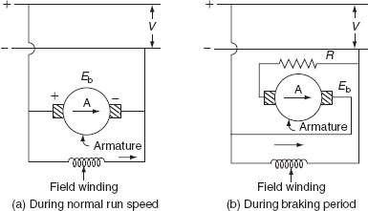

**Fig. 9.4 Plugging of DC shunt motor**

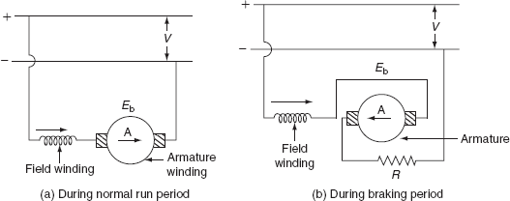

**Fig. 9.5 Plugging of DC series motor**

Current flowing through the armature during normal run condition:

image

where *V* is the supply voltage, *E*b is the back emf, and *R*a is the armature resistance.

Current flowing through the armature during braking period:

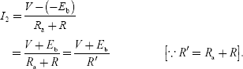

∴ Electric braking torque, *T*B ∝ *φ* *I*2.

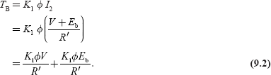

But we know that:

image

Substitute [Equation (9.3)](https://www.safaribooksonline.com/library/view/generation-and-utilization/9789332515673/xhtml/chapter009.xhtml#eq-9-3) in [Equation (9.2)](https://www.safaribooksonline.com/library/view/generation-and-utilization/9789332515673/xhtml/chapter009.xhtml#eq-9-2):

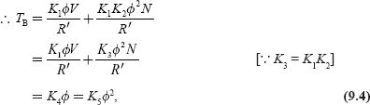

where image and image.

We know that, in case of series motor flux (*φ*) developed by the winding is depending the current flowing through it.

image

In case of shunt motor, the flux remains constant.

image

**Plugging applied to induction motor**

During the normal operating condition, the rotating magnetic field developed by the stator and the rotation of rotor are in the same direction. But during the braking period, plugging is applied to an induction motor by reversing any two phases of the three phases of stator winding in order to change the direction of the rotating magnetic field as shown in [Fig. 9.6](https://www.safaribooksonline.com/library/view/generation-and-utilization/9789332515673/xhtml/chapter009.xhtml#Fig-9-6). So that, the rotating magnetic filed and the rotor will be rotating in opposite direction. So that, the relative speed between emf and rotor is nearly twice the synchronous speed *N*s –(–*N*s) = 2*N*s.

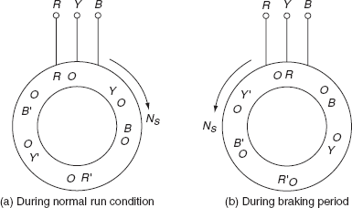

**Fig. 9.6 Plugging applied to induction motor**

∴ Slip during the braking period:

image

But the voltage induced in the rotor (E2) is proportional to the slip (*S* ) × stator voltage (*V*):

∴ *E*2 ∝ *SV*.

So, the rotor voltage during the braking period is twice the normal voltage. To avoid the damage of the rotor winding, it should be provided with additional insulation, to withstand the high induced voltage.

The rotation of the magnetic field in the reverse direction produce torque in reverse direction; thereby applying the brakes to the motor. The braking of induction motor can be analyzed by the torque–slip characteristics shown in [Fig. 9.7](https://www.safaribooksonline.com/library/view/generation-and-utilization/9789332515673/xhtml/chapter009.xhtml#Fig-9-7).

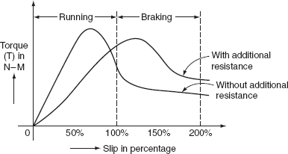

**Fig. 9.7** Torque–slip characteristics

Rotor current during the braking period, image.

The characteristic curve for the rotor current and the rotor voltage with the variation of the slip is shown in [Fig. 9.8](https://www.safaribooksonline.com/library/view/generation-and-utilization/9789332515673/xhtml/chapter009.xhtml#Fig-9-8).

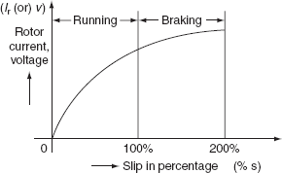

**Fig. 9.8** Rotor current–slip characteristics

**Plugging applied to synchronous motor**

Normally, the stator winding of the synchronous motor is fed with 3-*φ* AC supply to produce the rotating magnetic field that induces stator poles. And, the field winding is excited by giving the DC supply thereby inducing the rotor poles. At any instant, the stator poles gets locked with the rotor poles and the synchronous motor rotating at the synchronous speed. In this method of plugging applied to synchronous motor, simply it is not possible to produce the counter torque during the braking period by interchanging any two of three phases. This is due to the magnetic locking of stator and rotor poles ([Fig. 9.9](https://www.safaribooksonline.com/library/view/generation-and-utilization/9789332515673/xhtml/chapter009.xhtml#Fig-9-9)).

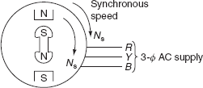

**Fig. 9.9** Synchronous motor

In order to develop the counter torque, the rotor of synchronous motor should be provided with damper winding. The EMF induced in the damper winding whenever there is any change, i.e., the reversal of the direction of the stator field. Now, according to Lenz's law, the emf induced in the damper winding opposes the change which producing it. This emf induced in the damper winding produces the circulating current to produce the torque in the reverse direction. This torque is known as braking torque. This braking torque helps to bring the motor to rest.

**4.8.2 Rheostatic or dynamic braking**

In this method of braking, the electric motor is disconnected from the supply during the braking period and is reconnected across same electrical resistance. But field winding is continuously excited from the supply in the same direction. Thus, during the starts working as generator during the braking period and all the kinetic energy of the rotating parts is converted into electric energy and is dissipated across the external resistance.

One of the main advantages of the rehostatic braking is electrical energy is not drawn by the motor during braking period compared to plugging. The rehostatic braking can be applied to various DC and AC motors.

**Rehostatic braking applied to DC motors**

The rheostatic braking can be applied to both DC shunt and DC series motors, by disconnecting the armature from the supply and reconnecting it across and external resistance. This is required to dissipate the kinetic energy of all rotating parts thereby brining the motor to rest.

**DC shunts motor**

[Figure 9.10](https://www.safaribooksonline.com/library/view/generation-and-utilization/9789332515673/xhtml/chapter009.xhtml#Fig-9-10) shows the connection diagram of the DC shunt motor during both normal and braking conditions. In case of DC shunt motor, both armature and field windings are connected across the DC supply, as shown in [Fig. 9.10 (a.)](https://www.safaribooksonline.com/library/view/generation-and-utilization/9789332515673/xhtml/chapter009.xhtml#Fig-9-10)

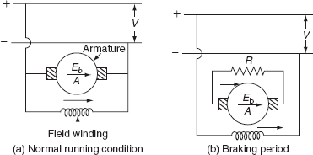

**Fig. 9.10 Rheostatic braking of DC shunt motor**

During the braking period, the armature is disconnected from the supply and field winding is continuously excited by the supply in the same direction, as shown in [Fig. 9.10 (b)](https://www.safaribooksonline.com/library/view/generation-and-utilization/9789332515673/xhtml/chapter009.xhtml#Fig-9-10). The kinetic energy of all rotating parts is dissipated in the resistor ‘*R*’ now the machine starts working as generator. Now, braking developed is proportional to the product of the field and the armature currents. But the shunt motor flux remains constant, so the braking torque is proportional to armature current at low-speeds braking torque is less and in order to maintain constant braking torque, the armature is gradually disconnected. Hence, the armature current remains same thereby maintaining the uniform braking torque.

**DC series motor**

In this braking, which is applied to DC series motor, the armature is disconnected from the supply and is reconnected across an external resistance ‘*R*’ shown in [Fig. 9.11 (a)](https://www.safaribooksonline.com/library/view/generation-and-utilization/9789332515673/xhtml/chapter009.xhtml#Fig-9-11) and [(b)](https://www.safaribooksonline.com/library/view/generation-and-utilization/9789332515673/xhtml/chapter009.xhtml#Fig-9-11). But, simply, it is not possible to develop the retarding torque by the DC series motor after connecting armature across the resistance as DC shunt motor.

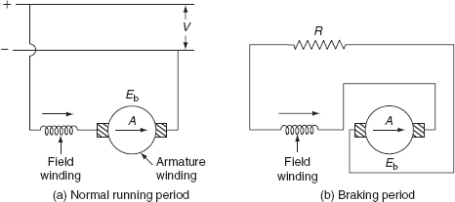

**Fig. 9.11 Rheostatic braking of DC series motor**

In case of DC series motor, both the field and armature windings are connected across the resistance after disconnecting the same from the supply; current directions of both the field and armatures are reversed. This results in the production of torque in same direction as before. So, in order to produce the braking torque only the direction of current in the armature has to be reversed. The connection diagram of DC series is shown in [Fig. 9.11](https://www.safaribooksonline.com/library/view/generation-and-utilization/9789332515673/xhtml/chapter009.xhtml#Fig-9-11).

If more than one motor has to be used as in electric traction. All motors can be connected in equalizer connection as shown in [Fig. 9.12](https://www.safaribooksonline.com/library/view/generation-and-utilization/9789332515673/xhtml/chapter009.xhtml#Fig-9-12). In this connection, one machine is excited by the armature current of another machine.

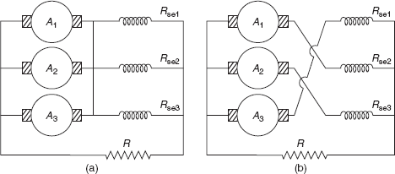

**Fig. 9.12** Equalizer connection

*Braking torque*

The current flowing through the armature during braking period:

image

where *E*b is the back emf developed, *R* is the external resistance, and *R*a is the armature resistance.

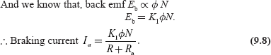

Braking torque, *T*B ∝ *φ* *I*a.

image

Now, substitute [Equation (9.8)](https://www.safaribooksonline.com/library/view/generation-and-utilization/9789332515673/xhtml/chapter009.xhtml#eq-9-8) in [Equation (9.9)](https://www.safaribooksonline.com/library/view/generation-and-utilization/9789332515673/xhtml/chapter009.xhtml#eq-9-9):

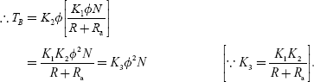

For shunt motor flux is practically constant:

image

**Rheostatic braking applied to induction motor**

In case of an induction motor, normally, under running condition, the stator is fed from AC supply. If rehostatic braking applied to an induction motor, stator must be disconnected from supply; therefore, there is no rmf, no rotor short-circuit current, and no retarding torque produced. To avoid the above difficulty, the stator must be excited by giving DC supply, to produce the constant air gap flux that is cut by the rotor conductors, which will induce currents in the short-circuited rotor. This rotor current will produce the required braking torque. This braking torque can be controlled either by controlling DC excitation or by varying rotor resistance. The various connections for giving to the stator winding are shown in [Fig. 9.13](https://www.safaribooksonline.com/library/view/generation-and-utilization/9789332515673/xhtml/chapter009.xhtml#Fig-9-13).

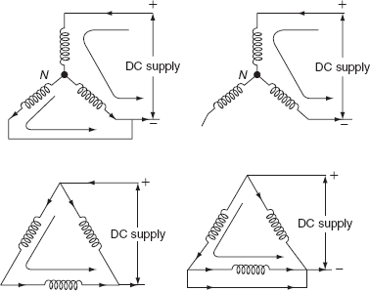

**Fig. 9.13** DC excitation to three-phase winding

**4.8.3 Regenerative braking**

Regenerative braking is the most efficient method of braking to stop the motor. In previous method of rehostatic braking, the kinetic energy of all rotating parts is wasted in external braking resistor and in case of plugging extra energy is drawn from the supply during braking period. But in this method of braking, no energy is drawn from the supply during the braking period and some of the energy is fed back to the supply system.

Regenerative braking can be applied to both DC and AC motors.

**Regenerative braking applied to DC shunt motor**

In case of DC shunt motor, energy can be fed back to the supply system whenever rotational emf is more than the supply voltage. During the braking period, the excitation and speed of DC shunt motor are suitably adjusted such that the rotational emf is more than the supply voltage (*E*b > *V*f). Since, back emf or rotational emf is directly proportional to the field flux and the speed of the rotation of the shaft of the machine.

Now, a motor acts as generator and the direction of current through armature is reversed imageso that, the torque developed by the armature is reversed.

This retarding torque helps to bring motor to rest. Connection diagram of DC shunt motor for regenerative braking is shown in [Fig. 9.14](https://www.safaribooksonline.com/library/view/generation-and-utilization/9789332515673/xhtml/chapter009.xhtml#Fig-9-14).

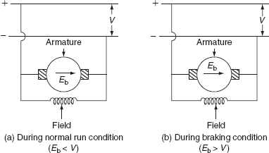

**Fig. 9.14 Regenerative braking of DC shunt motor**

**DC series motor**

In case of DC series motor, it is not easy to apply regenerative braking as of DC shunt motor. The main reasons of the difficulty of applying regenerative braking to DC series motor are:

1. During the braking period, the motor acts as generator by reversing the direction of current flowing through the armature, but at condition will set up both back emf and supply voltage will be added together. So that, during the braking period, it is necessary to reverse the terminals of field winding.
2. Some sort of compensating equipment must be incorporated to take care of large change in supply voltage.

On doing some modifications during the braking period, the regenerative braking can be applied to DC series motor. Any one of the following methods is used.

**Method-I (French method)**

If one or more series motors are running in parallel, during the braking period, the field windings, of all series motors, are connected across the supply in series with suitable resistance. Thereby converting all series machines in shunt machines as shown in [Fig. 9.15](https://www.safaribooksonline.com/library/view/generation-and-utilization/9789332515673/xhtml/chapter009.xhtml#Fig-9-15).

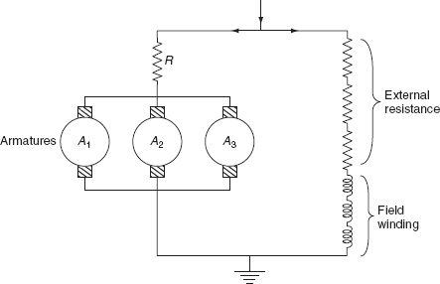

**Fig. 9.15 Regenerative braking of DC series motor**

The main advantage of this method is, all armatures are connected in parallel and current supplied to one machine is sufficient to excite the field windings of all the machines, and the energy supplied by remaining all the machines is fed back to the supply system, during the braking period.

**Method-II**

In this method, the exciter is provided to excite the field windings of the series machine during the regenerative braking period. This is necessary to avoid the dissipation of energy or the loss of power in the external resistance.

Whenever the excitation of field winding is adjusted to increase the rotational emf more than the supply voltage, then the energy is supplied to the supply system. At that time, the field winding of the series machine is connected across an excited being driven by motor operated from an auxiliary supply. Now, during the braking period, the series machine acts as separately excited DC generator which supplies energy to the main lines. A stabilizing resistance is used to control the braking torque ([Figs. 9.16](https://www.safaribooksonline.com/library/view/generation-and-utilization/9789332515673/xhtml/chapter009.xhtml#Fig-9-16) and [9.17](https://www.safaribooksonline.com/library/view/generation-and-utilization/9789332515673/xhtml/chapter009.xhtml#Fig-9-17)).

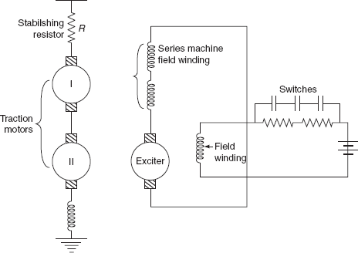

**Fig. 9.16** Regenerative braking

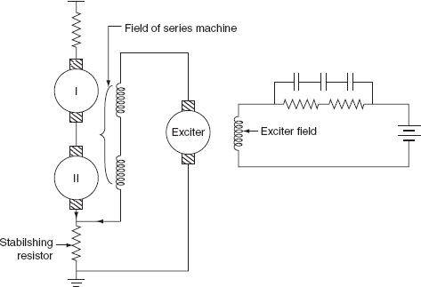

**Fig. 9.17** Regenerative braking

**Method-III**

In this method, the armature of exciter is connected in series. With the field winding of series machine, this combination is connected across the stabilizing resistance.

Here, the current flowing through stabilizing resistance is the sum of exciter current and regenerated current by the series machines.

During the braking period, the regenerated current increases the voltage drop across the stabilizing resistance, which will reduce the voltage across the armature circuit and cause the reduction of the exciter current of the series machine field winding. Hence, the traction motors operating as series generators*.*