**Chapter 5**

**Mechanism of Train Movement**

**5.1 INTRODUCTION**

The movement of trains and their energy consumption can be most conveniently studied by means of the speed–distance and the speed–time curves. The motion of any vehicle may be at constant speed or it may consist of periodic acceleration and retardation. The speed–time curves have significant importance in traction. If the frictional resistance to the motion is known value, the energy required for motion of the vehicle can be determined from it. Moreover, this curve gives the speed at various time instants after the start of run directly.

**5.2 TYPES OF SERVICES**

There are mainly three types of passenger services, by which the type of traction system has to be selected, namely:

1. Main line service.
2. Urban or city service.
3. Suburban service.

**5.2.1 Main line services**

In the main line service, the distance between two stops is usually more than 10 km. High balancing speeds should be required. Acceleration and retardation are not so important.

**5.2.2 Urban service**

In the urban service, the distance between two stops is very less and it is less than 1 km. It requires high average speed for frequent starting and stopping.

**5.2.3 Suburban service**

In the suburban service, the distance between two stations is between 1 and 8 km. This service requires rapid acceleration and retardation as frequent starting and stopping is required.

**5.3 SPEED–TIME AND SPEED–DISTANCE CURVES FOR DIFFERENT SERVICES**

The curve that shows the instantaneous speed of train in kmph along the ordinate and time in seconds along the abscissa is known as ‘*speed–time*’ curve.

The curve that shows the distance between two stations in km along the ordinate and time in seconds along the abscissa is known as ‘*speed–distance*’ curve.

The area under the speed–time curve gives the distance travelled during, given time internal and slope at any point on the curve toward abscissa gives the acceleration and retardation at the instance, out of the two speed–time curve is more important.

**5.3.1 Speed–time curve for main line service**

Typical speed–time curve of a train running on main line service is shown in [Fig. 5.1](https://www.safaribooksonline.com/library/view/generation-and-utilization/9789332515673/xhtml/chapter010.xhtml#Fig-10-1). It mainly consists of the following time periods:

1. Constant accelerating period.
2. Acceleration on speed curve.
3. Free-running period.
4. Coasting period.
5. Braking period.

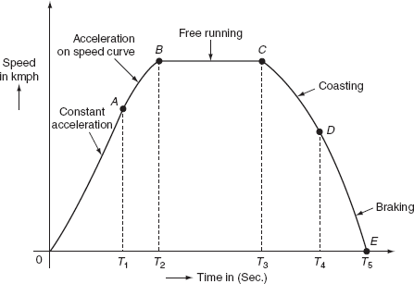

  Fig. 5.1 Speed–time curve for mainline service

***Constant acceleration***

During this period, the traction motor accelerate from rest. The curve ‘OA’ represents the constant accelerating period. During the instant 0 to *T*1, the current is maintained approximately constant and the voltage across the motor is gradually increased by cutting out the starting resistance slowly moving from one notch to the other. Thus, current taken by the motor and the tractive efforts are practically constant and therefore acceleration remains constant during this period. Hence, this period is also called as notch up accelerating period or rehostatic accelerating period. Typical value of acceleration lies between 0.5 and 1 kmph. Acceleration is denoted with the symbol ‘*α*’.

***Acceleration on speed-curve***

During the running period from *T*1 to *T*2, the voltage across the motor remains constant and the current starts decreasing, this is because cut out at the instant ‘*T*1’.

According to the characteristics of motor, its speed increases with the decrease in the current and finally the current taken by the motor remains constant. But, at the same time, even though train accelerates, the acceleration decreases with the increase in speed. Finally, the acceleration reaches to zero for certain speed, at which the tractive effort excreted by the motor is exactly equals to the train resistance. This is also known as decreasing accelerating period. This period is shown by the curve ‘*AB*’.

***Free-running or constant-speed period***

The train runs freely during the period *T*2 to *T*3 at the speed attained by the train at the instant ‘*T*2’. During this speed, the motor draws constant power from the supply lines. This period is shown by the curve *BC*.

***Coasting period***

This period is from *T*3 to *T*4, i.e., from C to D. At the instant ‘*T*3’ power supply to the traction, the motor will be cut off and the speed falls on account of friction, windage resistance, etc. During this period, the train runs due to the momentum attained at that particular instant. The rate of the decrease of the speed during coasting period is known as coasting retardation. Usually, it is denoted with the symbol ‘*β*c’.

***Braking period***

Braking period is from *T*4 to *T*5, i.e., from *D* to *E*. At the end of the coasting period, i.e., at ‘*T*4’ brakes are applied to bring the train to rest. During this period, the speed of the train decreases rapidly and finally reduces to zero.

In main line service, the free-running period will be more, the starting and braking periods are very negligible, since the distance between the stops for the main line service is more than 10 km.

**5.3.2 Speed–time curve for suburban service**

In suburban service, the distance between two adjacent stops for electric train is lying between 1 and 8 km. In this service, the distance between stops is more than the urban service and smaller than the main line service. The typical speed–time curve for suburban service is shown in [Fig. 5.2](https://www.safaribooksonline.com/library/view/generation-and-utilization/9789332515673/xhtml/chapter010.xhtml#Fig-10-2).

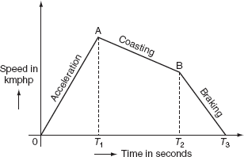

**Fig. 5.2** Typical speed–time curve for suburban service

The speed–time curve for urban service consists of three distinct periods. They are:

1. Acceleration.
2. Coasting.
3. Retardation.

For this service, there is no free-running period. The coasting period is comparatively longer since the distance between two stops is more. Braking or retardation period is comparatively small. It requires relatively high values of acceleration and retardation. Typical acceleration and retardation values are lying between 1.5 and 4 kmphp and 3 and 4 kmphp, respectively.

**5.3.3 Speed–time curve for urban or city service**

The speed–time curve urban or city service is almost similar to suburban service and is shown in [Fig. 5.3](https://www.safaribooksonline.com/library/view/generation-and-utilization/9789332515673/xhtml/chapter010.xhtml#Fig-10-3).

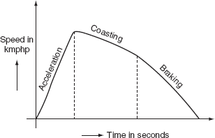

**Fig. 5.3** Typical speed–time curve for urban service

In this service also, there is no free-running period. The distance between two stop is less about 1 km. Hence, relatively short coasting and longer braking period is required. The relative values of acceleration and retardation are high to achieve moderately high average between the stops. Here, the small coasting period is included to save the energy consumption. The acceleration for the urban service lies between 1.6 and 4 kmphp. The coasting retardation is about 0.15 kmphp and the braking retardation is lying between 3 and 5 kmphp. Some typical values of various services are shown in[Table. 5.1](https://www.safaribooksonline.com/library/view/generation-and-utilization/9789332515673/xhtml/chapter010.xhtml#Tab-10-1).

**Table 5.1** Types of services

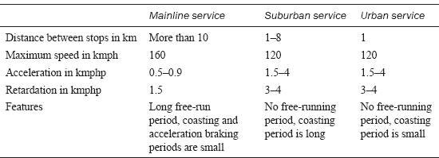

**5.4 SOME DEFINITIONS**

**5.4.1 Crest speed**

The maximum speed attained by the train during run is known as crest speed. It is denoted with ‘*V*m’.

**5.4.2 Average speed**

It is the mean of the speeds attained by the train from start to stop, i.e., it is defined as the ratio of the distance covered by the train between two stops to the total time of rum. It is denoted with ‘*V*a’.

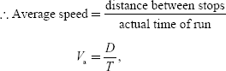

where *V*a is the average speed of train in kmph, *D* is the distance between stops in km, and *T* is the actual time of run in hours.

**5.4.3 Schedule speed**

The ratio of the distance covered between two stops to the total time of the run including the time for stop is known as schedule speed. It is denoted with the symbol ‘*V*s’.

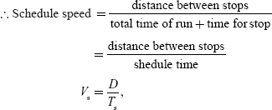

where *T*s is the schedule time in hours.

**5.4.4 Schedule time**

It is defined as the sum of time required for actual run and the time required for stop.

i.e., *T*s = *T*run + *T*stop.

**5.5 FACTORS AFFECTING THE SCHEDULE SPEED OF A TRAIN**

The factors that affect the schedule speed of a train are:

1. Crest speed.
2. The duration of stops.
3. The distance between the stops.
4. Acceleration.
5. Braking retardation.

**5.5.1 Crest speed**

It is the maximum speed of train, which affects the schedule speed as for fixed acceleration, retardation, and constant distance between the stops. If the crest speed increases, the actual running time of train decreases. For the low crest speed of train it running so, the high crest speed of train will increases its schedule speed.

**5.5.2 Duration of stops**

If the duration of stops is more, then the running time of train will be less; so that, this leads to the low schedule speed.

Thus, for high schedule speed, its duration of stops must be low.

**5.5.3 Distance between the stops**

If the distance between the stops is more, then the running time of the train is less; hence, the schedule speed of train will be more.

**5.5.4 Acceleration**

If the acceleration of train increases, then the running time of the train decreases provided the distance between stops and crest speed is maintained as constant. Thus, the increase in acceleration will increase the schedule speed.

**5.5.5 Breaking retardation**

High breaking retardation leads to the reduction of running time of train. These will cause high schedule speed provided the distance between the stops is small.

**5.6 SIMPLIFIED TRAPEZOIDAL AND QUADRILATERAL SPEED TIME CURVES**

Simplified speed–time curves gives the relationship between acceleration, retardation average speed, and the distance between the stop, which are needed to estimate the performance of a service at different schedule speeds. So that, the actual speed–time curves for the main line, urban, and suburban services are approximated to some from of the simplified curves. These curves may be of either trapezoidal or quadrilateral shape.

**5.6.1 Analysis of trapezoidal speed–time curve**

Trapezoidal speed–time curve can be approximated from the actual speed–time curves of different services by assuming that:

* The acceleration and retardation periods of the simplified curve is kept same as to that of the actual curve.
* The running and coasting periods of the actual speed–time curve are replaced by the constant periods.

This known as trapezoidal approximation, a simplified trapezoidal speed–time curve is shown in [Fig. 5.4](https://www.safaribooksonline.com/library/view/generation-and-utilization/9789332515673/xhtml/chapter010.xhtml#Fig-10-4).

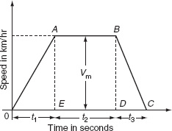

**Fig. 5.4** Trapezoidal speed–time curve

***Calculations from the trapezoidal speed–time curve***

Let *D* be the distance between the stops in km, *T* be the actual running time of train in second, *α* be the acceleration in km/h/sec, *β* be the retardation in km/h/sec, *V*m be the maximum or the crest speed of train in km/h, and *V*a be the average speed of train in km/h. From the [Fig. 5.4](https://www.safaribooksonline.com/library/view/generation-and-utilization/9789332515673/xhtml/chapter010.xhtml#Fig-10-4):

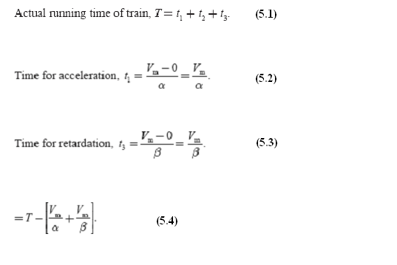

Area under the trapezoidal speed–time curve gives the total distance between the two stops (*D*).

∴ The distance between the stops (*D*) = area under triangle *OAE* + area of rectangle *ABDE* + area of triangle *DBC*

= The distance travelled during acceleration + distance travelled during free-running period + distance travelled during retardation.

Now:

The distance travelled during acceleration = average speed during accelerating period × time for acceleration

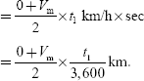

The distance travelled during free-running period = average speed × time of free running

image

The distance travelled during retardation period = average speed × time for retardation

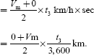

The distance between the two stops is:

image

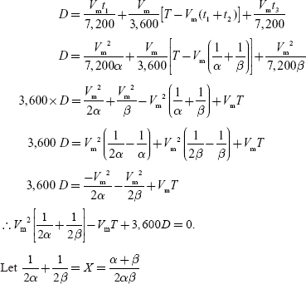



Solving quadratic [Equation (5.5)](https://www.safaribooksonline.com/library/view/generation-and-utilization/9789332515673/xhtml/chapter010.xhtml#eq-10-5), we get:

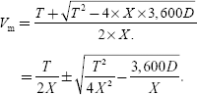

By considering positive sign, we will get high values of crest speed, which is practically not possible, so negative sign should be considered:

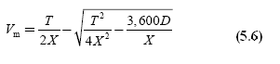

image

**5.6.2 Analysis of quadrilateral speed–time curve**

Quadrilateral speed–time curve for urban and suburban services for which the distance between two stops is less. The assumption for simplified quadrilateral speed–time curve is the initial acceleration and coasting retardation periods are extended, and there is no free-running period. Simplified quadrilateral speed–time curve is shown in [Fig. 5.5](https://www.safaribooksonline.com/library/view/generation-and-utilization/9789332515673/xhtml/chapter010.xhtml#Fig-10-5).

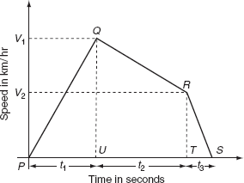

**Fig. 5.5** Quadrilateral speed–time curve

Let *V*1 be the speed at the end of accelerating period in km/h, *V*2 be the speed at the end of coasting retardation period in km/h, and *β*c be the coasting retardation in km/h/sec.

Time for acceleration, image

Time for coasting period, image

Time period for braking retardation period, image

Total distance travelled during the running period *D*:

= the area of triangle *PQU* + the area of rectangle *UQRS* + the area of triangle *TRS*.

= the distance travelled during acceleration + the distance travelled during coastingretardation + the distance travelled during breaking retardation.

But, the distance travelled during acceleration = average speed × time for acceleration

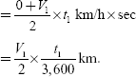

The distance travelled during coasting retardation = image

image

The distance travelled during breaking retardation = average speed × time for breaking retardation

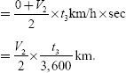

∴ Total distance travelled:

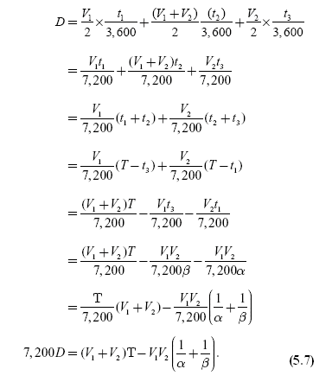

**Example 5.1:   The distance between two stops is 1.2 km. A schedule speed of 40 kmph is required to cover that distance. The stop is of 18-s duration. The values of the acceleration and retardation are 2 kmphp and 3 kmphp, respectively. Then, determine the maximum speed over the run. Assume a simplified trapezoidal speed–time curve.**

**Solution:**

Acceleration *α* = 2.0 kmphp.

Retardation β = 3 kmphp.

Schedule speed *V*s = 40 kmph.

Distance of run, D = 1.2 km.

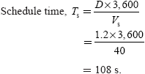

Actual run time, *T* = *T*s– stop duration

                            = 108 – 18

                            = 90 s.

image

where

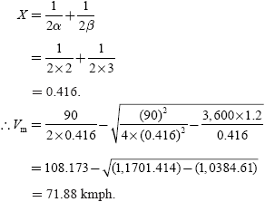

**Example 5.2:   The speed–time curve of train carries of the following parameters:**

1. **Free running for 12 min.**
2. **Uniform acceleration of 6.5 kmphp for 20 s.**
3. **Uniform deceleration of 6.5 kmphp to stop the train.**
4. **A stop of 7 min.**

**Then, determine the distance between two stations, the average, and the schedule speeds.**

**Solution:**

Acceleration (*α*) = 6.5 kmphps.

Acceleration period *t*1= 20 s.

Maximum speed *V*m= *α*t1

                               = 6.5 × 20 = 130 kmph.

Free-running time (*t*2) = 12 × 60

                                  = 720 s.

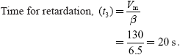

The distance travelled during the acceleration period:

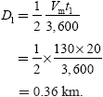

The distance travelled during the free-running period:

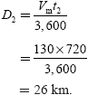

The distance travelled during the braking period image

image

The distance between the two stations:

*D* = *D*1 + *D*2 + *D*3

    = 0.36 + 26 + 0.362

    = 26.724 km.

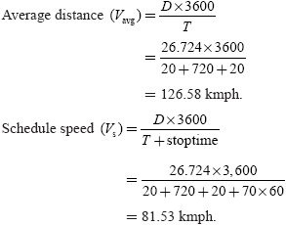

**Example 5.3:   The distance between two stops is 5 km. A train has schedule speed of 50 kmph. The train accelerates at 2.5 kmphps and retards 3.5 kmphps and the duration of stop is 55 s. Determine the crest speed over the run assuming trapezoidal speed–time curve.**

**Solution:**

Acceleration (*α*) = 2.5 kmphps.

Retardation (*β*) = 3.5 kmphps.

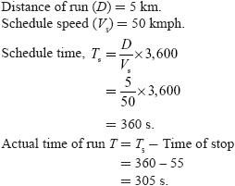

By using the equation:

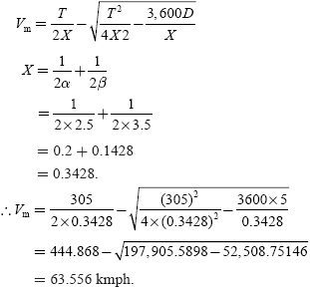

**Example 5.4:   A train is required to run between two stations 1.5 km apart at an average speed of 42 kmph. The run is to be made to a simplified quadrilateral speed–time curve. If the maximum speed is limited to 65 kmph, the acceleration to 2.5, kmphps, and the casting and braking retardation to 0.15 kmphs and 3 kmphs, respectively. Determine the duration of acceleration, costing, and braking periods.**

**Solution:**

Distance between two stations *D* = 1.5 km.

Average speed *V*a = 42 kmph.

Maximum speed *V*m = 65 kmph.

Acceleration (*α*) = 2.5 kmphps.

Coasting retardation *β*c = 0.15 kmphps.

Barking retardation *β* = 3 kmphps.

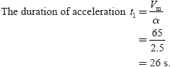

image

Before applying brakes; let the speed be *V*2.

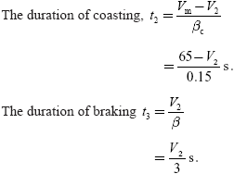

The actual time of run, *T* = *t*1 + *t*2 + *t*3

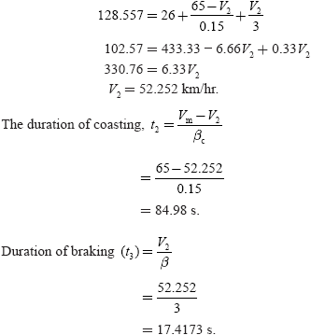

**Example 5.5:   A train has schedule speed of 32 kmph over a level track distance between two stations being 2 km. The duration of stop is 25 s. Assuming the braking retardation of 3.2 kmphps and the maximum speed is 20% grater than the average speed. Determine the acceleration required to run the service.**

**Solution:**

Schedule speed *V*s = 32 kmph.

Distance *D* = 2 km.

Duration of stop = 25 s.

Braking retardation = 3.2 kmphps.

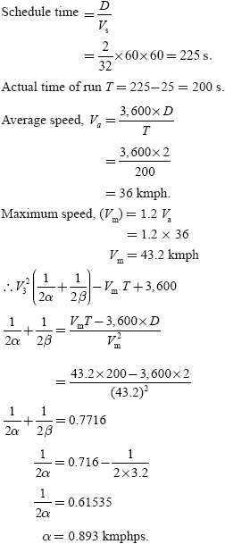

**Example 5.6:   A suburban electric train has a maximum speed of 75 kmph. The schedule speed including a station stop of 25 s is 48 kmph. If the acceleration is 2 kmphps, the average distance between two stops is 4 km. Determine the value of retardation.**

**Solution:**

Maximum speed *V*m = 75 kmph.

The distance of run (*D*) = 4 km.

Schedule speed (*V*s) = 48 kmph.

Acceleration (*α*) = 2 kmphps.

The duration of stop = 25 s.

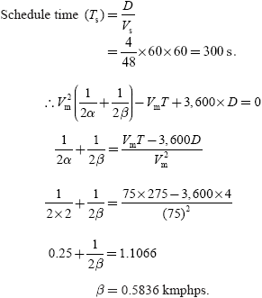

**Example 5.7:   An electric train is accelerated at 2 kmphps and is braked at 3 kmphps. The train has an average speed of 50 kmph on a level track of 2,000 min between the two stations. Determine the following:**

1. **Actual time of run.**
2. **Maximum speed.**
3. **The distance travelled before applying brakes**
4. **Schedule speed.**

**Assume time for stop as 12 s. And, run according to trapezoidal.**

**Solution:**

Acceleration (*α*) = 2 kmphps.

Retardation (*β*) = 3 kmphps.

Average speed (*V*a) = 50 kmph.

Distance D = 2,000 min = 2 km.

The duration of stop = 12 s.

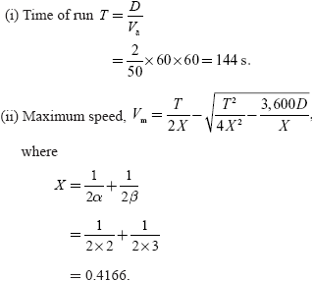

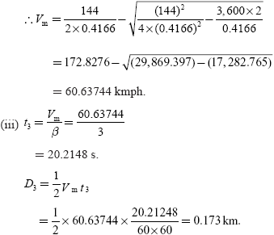

The distance travelled before applying brakes

*D*1 + *D*2 = *D* - *D*3

              = 2 – 0.17 = 1.83 km.

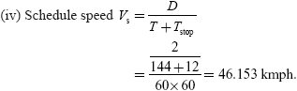

**Example 5.8:   An electric train has an average speed of 40 kmph on a level track between stops 1,500 m apart. It is accelerated at 2 kmphps and is braked at 3 kmphps. Draw the speed–time curve for the run.**

**Solution:**

Average speed *V*a = 40 kmph.

The distance of run (*D*) = 1,500 m = 1.5 km.

Acceleration (*α*) = 2 kmphps.

Retroaction (*β*) = 3 kmphps.

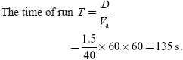

Using the equation ([Fig. P.5.1](https://www.safaribooksonline.com/library/view/generation-and-utilization/9789332515673/xhtml/chapter010.xhtml#Fig-P-10-1)):

image

where

image

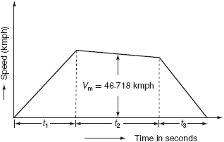

**Fig. P.5.1**

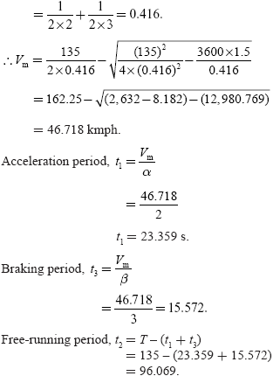

**5.7 TRACTIVE EFFORT (FT)**

It is the effective force acting on the wheel of locomotive, necessary to propel the train is known as ‘***tractive effort*’**. It is denoted with the symbol *F*t. The tractive effort is a vector quantity always acting tangential to the wheel of a locomotive. It is measured in newton.

The net effective force or the total tractive effort (*F*t) on the wheel of a locomotive or a train to run on the track is equals to the sum of tractive effort:

1. Required for linear and angular acceleration (*F*a).
2. To overcome the effect of gravity (*F*g).
3. To overcome the frictional resistance to the motion of the train (*F*r).



**5.7.1 Mechanics of train movement**

The essential driving mechanism of an electric locomotive is shown in [Fig. 5.6](https://www.safaribooksonline.com/library/view/generation-and-utilization/9789332515673/xhtml/chapter010.xhtml#Fig-10-6). The electric locomotive consists of pinion and gear wheel meshed with the traction motor and the wheel of the locomotive. Here, the gear wheel transfers the tractive effort at the edge of the pinion to the driving wheel.

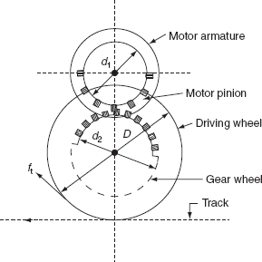

**Fig. 5.6** Driving mechanism of electric locomotives

Let *T* is the torque exerted by the motor in N-m, *F*p is tractive effort at the edge of the pinion in Newton, *F*t is the tractive effort at the wheel, *D* is the diameter of the driving wheel, *d*1 and *d*2 are the diameter of pinion and gear wheel, respectively, and *η* is the efficiency of the power transmission for the motor to the driving axle.

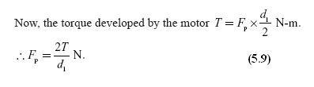

The tractive effort at the edge of the pinion transferred to the wheel of locomotive is:



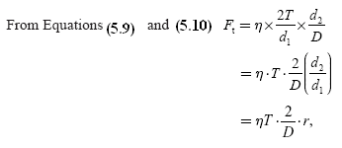

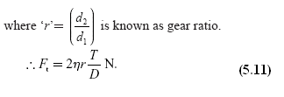

**5.7.2 Tractive effort required for propulsion of train**

From [Equation (10.8)](https://www.safaribooksonline.com/library/view/generation-and-utilization/9789332515673/xhtml/chapter010.xhtml#eq-10-8), the tractive effort required for train propulsion is:

*F*t = *F*a + *F*g + *F*r,

where *F*a is the force required for linear and angular acceleration, *F*g is the force required to overcome the gravity, and *F*r is the force required to overcome the resistance to the motion.

**Force required for linear and angular acceleration (Fa)**

According to the fundamental law of acceleration, the force required to accelerate the motion of the body is given by:

Force = Mass × acceleration

*F* = *ma.*

Let the weight of train be ‘*W* ’ tons being accelerated at ‘*α*’ kmphps:

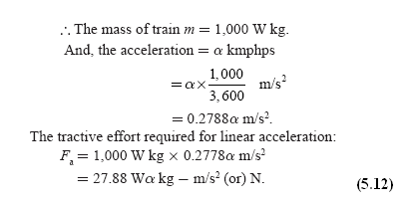

[Equation (5.12)](https://www.safaribooksonline.com/library/view/generation-and-utilization/9789332515673/xhtml/chapter010.xhtml#eq-10-12) holds good only if the accelerating body has no rotating parts. Owing to the fact that the train has rotating parts such as motor armature, wheels, axels, and gear system. The weight of the body being accelerated including the rotating parts is known as *effective weight* or *accelerating weight*. It is denoted with ‘*W*e’. The accelerating weight ‘(*W*e)’ is much higher (about 8–15%) than the dead weight (*W*) of the train. Hence, these parts need to be given angular acceleration at the same time as the whole train is accelerated in linear direction.

∴ The tractive effort required-for linear and angular acceleration is:



**Tractive effort required to overcome the train resistance (Fr)**

When the train is running at uniform speed on a level track, it has to overcome the opposing force due to the surface friction, i.e., the friction at various parts of the rolling stock, the fraction at the track, and also due to the wind resistance. The magnitude of the frictional resistance depends upon the shape, size, and condition of the track and the velocity of the train, etc.

Let ‘*r*’ is the specific train resistance in N/ton of the dead weight and ‘*W*’ is the dead weight in ton.



**Tractive effort required to overcome the effect of gravity (Fg)**

When the train is moving on up gradient as shown in [Fig. 5.7](https://www.safaribooksonline.com/library/view/generation-and-utilization/9789332515673/xhtml/chapter010.xhtml#Fig-10-7), the gravity component of the dead weight opposes the motion of the train in upward direction. In order to prevent this opposition, the tractive effort should be acting in upward direction.

**∴** The tractive effort required to overcome the effect of gravity:



Now, from the [Fig. 5.7](https://www.safaribooksonline.com/library/view/generation-and-utilization/9789332515673/xhtml/chapter010.xhtml#Fig-10-7):

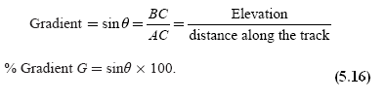

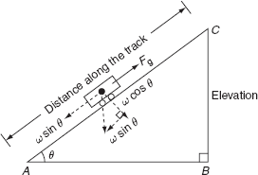

**Fig. 5.7** Train moving on up gradient

From [Equations (5.15)](https://www.safaribooksonline.com/library/view/generation-and-utilization/9789332515673/xhtml/chapter010.xhtml#eq-10-15) and [(5.16)](https://www.safaribooksonline.com/library/view/generation-and-utilization/9789332515673/xhtml/chapter010.xhtml#eq-10-16):

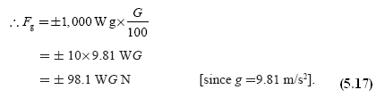

+ve sign for the train is moving on up gradient.

–ve sign for the train is moving on down gradient.

This is due to when the train is moving on up a gradient, the tractive effort showing [Equation (10.17)](https://www.safaribooksonline.com/library/view/generation-and-utilization/9789332515673/xhtml/chapter010.xhtml#eq-10-17)will be required to oppose the force due to gravitational force, but while going down the gradient, the same force will be added to the total tractive effort.

∴ The total tractive effort required for the propulsion of train *F*t = *F*a + *F*r ± *F*g:



**5.7.3 Power output from the driving axle**

Let *F*t is the tractive effort in N and *ν* is the speed of train in kmph.

∴ The power output (*P*) = rate of work done

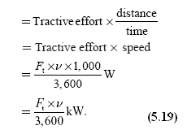

If ‘*ν*’ is in m/s, then *P* = *F*t × *ν* W*.*

If ‘*η*’ is the efficiency of the gear transmission, then the power output of motors, image:



**5.8 SPECIFIC ENERGY CONSUMPTION**

The energy input to the motors is called the *energy consumption*. This is the energy consumed by various parts of the train for its propulsion. The energy drawn from the distribution system should be equals to the energy consumed by the various parts of the train and the quantity of the energy required for lighting, heating, control, and braking. This quantity of energy consumed by the various parts of train per ton per kilometer is known as specific energy consumption. It is expressed in watt hours per ton per km.

image

**5.8.1 Determination of specific energy output from simplified speed–time curve**

Energy output is the energy required for the propulsion of a train or vehicle is mainly for accelerating the rest to velocity ‘*V*m’, which is the energy required to overcome the gradient and track resistance to motion.

***Energy required for accelerating the train from rest to its crest speed ‘Vm'***

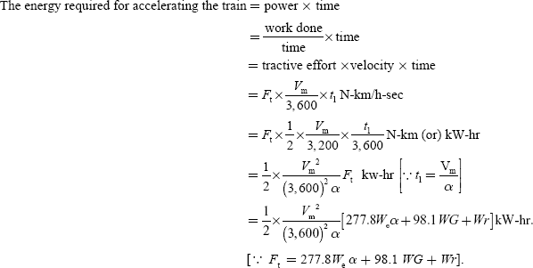

***Energy required for overcoming the gradient and tracking resistance to motion***

Energy required for overcoming the gradient and tracking resistance:

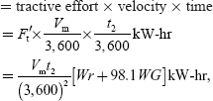

where *F*t′ is the tractive effort required to overcome the gradient and track resistance, *W* is the dead weight of train, *r* is the track resistance, and *G* is the percentage gradient.

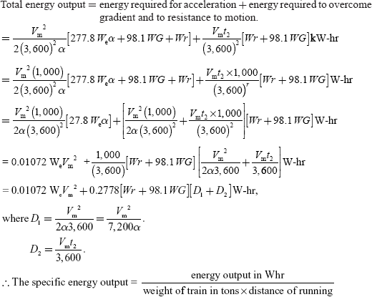

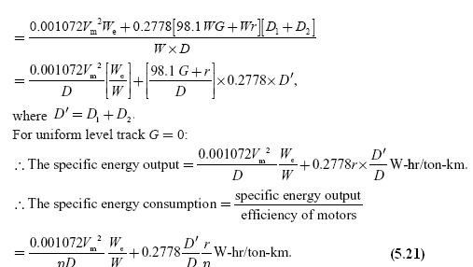

**5.8.2 Factors affecting the specific energy consumption**

Factors that affect the specific energy consumption are given as follows.

**Distance between stations**

From equation specific energy consumption is inversely proportional to the distance between stations. Greater the distance between stops is, the lesser will be the specific energy consumption. The typical values of the specific energy consumption is less for the main line service of 20–30 W-hr/ton-km and high for the urban and suburban services of 50–60 W-hr/ton-km.

**Acceleration and retardation**

For a given schedule speed, the specific energy consumption will accordingly be less for more acceleration and retardation.

**Maximum speed**

For a given distance between the stops, the specific energy consumption increases with the increase in the speed of train.

**Gradient and train resistance**

From the specific energy consumption, it is clear that both gradient and train resistance are proportional to the specific energy consumption. Normally, the coefficient of adhesion will be affected by the running of train, parentage gradient, condition of track, etc. for the wet and greasy track conditions. The value of the coefficient of adhesion is much higher compared to dry and sandy conditions.

**5.9 IMPORTANT DEFINITIONS**

**5.9.1 Dead weight**

It is the total weight of train to be propelled by the locomotive. It is denoted by ‘*W*’.

**5.9.2 Accelerating weight**

It is the effective weight of train that has angular acceleration due to the rotational inertia including the dead weight of the train. It is denoted by ‘*W*e’.

This effective train is also known as accelerating weight. The effective weight of the train will be more than the dead weight. Normally, it is taken as 5–10% of more than the dead weight.

**5.9.3 Adhesive weight**

The total weight to be carried out on the drive in wheels of a locomotive is known as adhesive weight.

**5.9.4 Coefficient of adhesion**

It is defined as the ratio of the tractive effort required to propel the wheel of a locomotive to its adhesive weight.

*Ft* ∝ *W*

= *μW*,

where *F*t is the tractive effort and *W* is the adhesive weight.



**Example 5.9:   A 250-ton motor coach having four motors each developing 6,000 N-m torque during acceleration, starts from rest. If the gradient is 40 in 1,000, gear ration is 4, gear transmission efficiency is 87%, wheel radius is 40 cm, train resistance is 50 N/ton, the addition of rotational inertia is 12%. Calculate the time taken to attain a speed of 50 kmph. If the line voltage is 3,000-V DC and the efficiency of motors is 85%. Find the current during notching period.**

**Solution:**

The weight of train *W* = 250 ton.

image

Gear ratio *r* = 4.

Wheel diameter *D* = 2 × 40 = 80 cm.

Or, *D* = 0.8 m.

Train resistance *r* = 50 N/ton.

Rotational inertia = 12%.

Accelerating weight of the train *W*e= 1.10 × 250 = 275 ton.

Total torque developed *T* = 4 × 6,000 = 24,000 Nm.

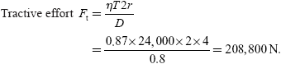

But,

*F*t = 277.8 *W*e*α* + 98.1 *WG* + *Wr*

208,800 = 277.8 × 275 *α* + 98.1 × 250 × 4 + 250 × 50

∴ *α* = 1.285 kmphps.

The time taken for the train to attain the speed of 50 kmph:

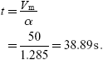

Power output from the driving axles:

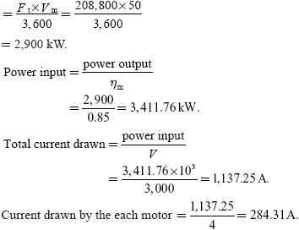

**Example 5.10:   An electric train of weight 250 ton has eight motors geared to driving wheels, each is 85 cm diameter. The tractive resistance is of 50/ton. The effect of rotational inertia is 8% of the train weight, the gear ratio is 4–1, and the gearing efficiency is 85% determine. The torque developed by each motor to accelerate the train to a speed of 50 kmph in 30 s up a gradient of 1 in 200.**

**Solution:**

The weight of train *W* = 250 ton.

The diameter of driving wheel *D* =0.85 m.

Tractive resistance, *r* = 50N/ton.

Gear ratio *r* = 4.

Gearing efficiency *η* = 0.85.

Accelerating weight of the train:

*W*e= 1.10 × *W*

     = 1.10 × 250 =275 ton.

Maximum speed *V*m= 50 kmph.

image

Tractive effort *F*t = 277.8 *W*e*α* + 98.1 *WG* + *Wr*

                             = 126,815.7+12,262.5+12,500

                             = 151,578.2 N.

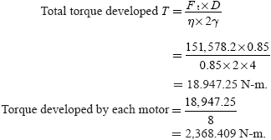

**Example 5.11:   A tram car is equipped with two motors that are operating in parallel, the resistance in parallel. The resistance of each motor is 0.5 Ω. Calculate the current drawn from the supply mains at 450 V when the car is running at a steady-state speed of 45 kmph and each motor is developing a tractive effort of 1,600 N. The friction, windage, and other losses may be assumed as 3,000 W per motor.**

**Solution:**

The resistance of each motor = 0.5 Ω.

Voltage across each motor *V* = 450 V.

Tractive effort *F*t= 1,600 N.

Maximum speed *V*m= 45 kmph.

Losses per motor = 3,000 W.

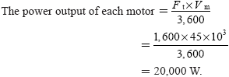

Copper losses = *I*2*R*m= *I*2× 0.5

Motor input = motor output + constant loss + copper losses

      450 × *I* = 20,000 + 3,000 + 0.5*I*2

      0.5 *I*2– 450*I* + 23,000 = 0.

After solving, we get *I* = 54.39 A.

Total current drawn from supply mains = 2 × 54.39

                                                           = 108.78 A.

**Example 5.12:   A locomotive exerts a tractive effort of 35,000 N in halting a train at 50 kmph on the level track. If the motor is to haul the same train on a gradient of 1 in 50 and the tractive effort required is 55,000 N, determine the power delivered by the locomotive if it is driven by (i) DC series motors and (ii) induction motors.**

**Solution:**

Tractive effort *Ft*= 35,000 N.

Maximum speed *Vm* = 50 kmph.

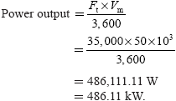

The power delivered by the locomotive on up gradient track with the DC series motors:

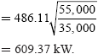

Since the power output image the power delivered by the locomotive on up gradient with the induction motors is:

image

**Example 5.13:   A train weighting 450 ton has speed reduced by the regenerative braking from 50 to 30 kmph over a distance of 2 km on down gradient of 1.5%. Calculate the electrical energy and the overage power returned to the line tractive resistance is 50 N/ton. And, allow the rotational inertia of 10% and the efficiency conversion 80%.**

**Solution:**

The accelerating weight of the train *W*e = 1.1 W

                                                          = 1.1 × 450 = 495 ton.

The distance travelled *D* = 2 km.

Gradient *G* = 1.5%

Track resistance *r* = 50 N/ton.

Efficiency *η* = 0.8.

The energy available due to the reduction in the speed is:

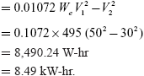

The tractive effort required while going down the gradient:

*F*t = *Wr* – 98.1 *WG*

    = 450 × 50 – 98.1 × 450 × 1.5

    = -43,717.5 N.

The energy available while moving down the gradient a distance of 2 km is:

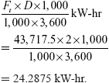

The total energy available = 8.49 + 24.2875

                                       = 32.7775 kW-hr.

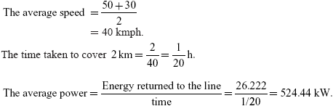

**Example 5.14:   A train weighing 450 ton is going down a gradient of 20 in 1,000, it is desired to maintain train speed at 50 kmph by regenerative braking. Calculate the power fed into the line and allow rotational inertia of 12% and the efficiency of conversion is 80%. Traction resistance is 50 N/ton.**

**Solution:**

The dead weight of train *W* = 450 ton.

The maximum speed *V*m = 50 kmph.

image

Tractive resistance *r* = 50 N/ton.

Rotational inertia = 12%.

The efficiency of conversion = 0.8

The tractive effort required while going down the gradient:

Tractive resistance *r* = 50 N/ton.

Rotational inertia = 12%.

The efficiency of conversion = 0.8

The tractive effort required while going down the gradient:

   = *Wr* – 98.1 *WG*

   = 450 × 50 – 98.1 × 450 × 2

   = –65,790 N.

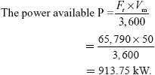

The power fed into the line = power available × efficiency of conversion

   = 913.75 × 0.8

   = 731 kW.

**Example 5.15:   The speed–time curve of an electric train on a uniform raising gradient of 10 in 1,000 comprise of:**

1. **Uniform acceleration from rest at 2.2 kmphps for 30 s.**
2. **Wasting with power off for 30 s.**
3. **Braking at 3.2 kmphps to standstill the weight of the train is 200 ton. The tractive resistance of level track being 4 kg/ton and the allowance for rotary inertia 10%. Calculate the maximum power developed by traction motors and the total distance travelled by the train. Assume the transmission efficiency as 85%.**

**Solution:**

image

Acceleration (*α*) = 2.2 kmphps.

Braking (*β*) = 3.2 kmph.

The dead weight of train *W* = 200 ton.

Track resistance *r* = 4 kg/ton = 4 × 9.81 = 39.24 N/ton.

Maximum velocity *V*m = *αt*1 = 2.2 × 30 = 66 kmph.

Tractive effort required:

*F*t= 277.8 *W*e *α* + 98.1 *WG* + *Wr*

    = 277.8 × 8 × 1.1 × 200 × 2.2 + 98.1 × 200 × 1 + 200 × 39.24

    = 161,923.2 N.

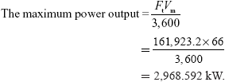

The maximum power developed by the traction motor = image = 3492.46kW.

Let, the coasting retardation be *β*c:

*Ft* = 277.8 *W*e(-*β*c) + 98.1 *WG* + *Wr*

0 = -277.8 × (1.1 × 200) × *β*c + 98.1 × 200 × 1 + 200 × 39.24

*β*c = 0.449 kmphps

*V*2 = *V*m – *β*c *V*2

= 66 – 0.449 × 65

= 36.815 kmph.

image

The total distance travelled by the train:

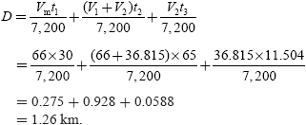

**Example 5.16:   A 2,300-ton train proceeds down a gradient of 1 in 100 for 5 min, during which period, its speed gets reduced from 40 to 20 kmph by the application of the regenerative braking. Find the energy returned to the lines if the tractive resistance is 5 kg/ton, the rotational inertia 10%, and the overall efficiency of the motors during regeneration is 80%.**

**Solution:**

The dead weight of the train *W* = 2,300 ton.

The accelerating weight of the train *W*e = 1.1 × 2,300 s

                                                          = 2,530 ton.

image

Tractive resistance *r* = 5×9.81= 49.05 N/ton.

Regenerative period *t* = 5 × 60

                                 = 300 s.

Overall efficiency *η* = 0.8.

The energy available due to the reduction in speed:

= 0.01072 *W*e image

= 0.01072 × 2,530 × (402-202)

= 32,545.92

= 32.54 kW-hr.

The tractive effort required while going down the gradient:

= *Wr* – 98.1 *WG*

= 2,300 × 49.05–98.1 × 2,300 × 1

= –112,815.

The distance moved during regeneration:

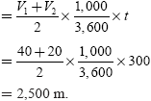

The energy available on the account of moving down the gradient over a distance of 2,500 m:

image

The total energy available = 32.54 + 78.34

                                       = 88.707 kW-hr.

The energy returned to the line = 0.8×11.08

                                               = 88.707 kW-hr.