DIGITAL FILTER STRUCTURES

Realization of Digital Filters

Chapter Intended Learning Outcomes:

- Ability to implement finite impulse response (FIR) and infinite impulse response (IIR) filters using different structures in terms of block diagram and signal flow graph

- Ability to determine the system transfer function and difference equation given the corresponding block diagram or signal flow graph representation.

Filter Implementation

When causality is assumed, a LTI filter can be uniquely

characterized by its transfer function 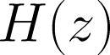:
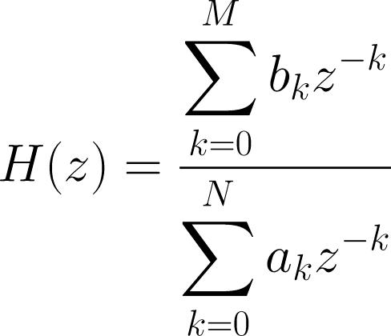

(3.1)

or the corresponding difference equation:
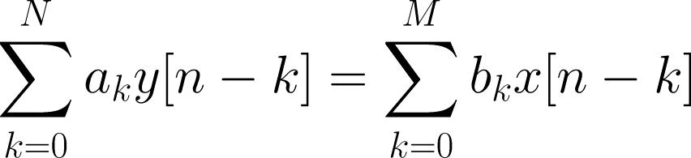

(3.2)

where 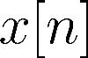 and 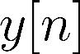 are the system input and output

Assuming 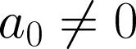, the output is:
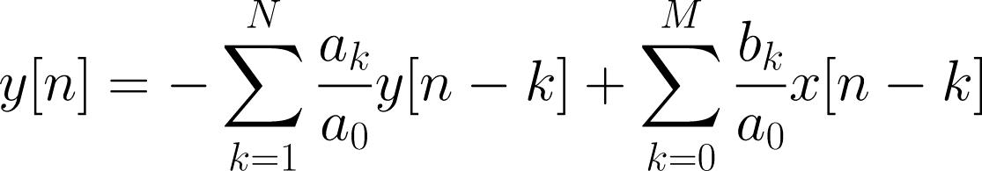

(3.3)

Assigning 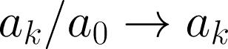 and 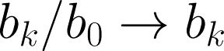 yields
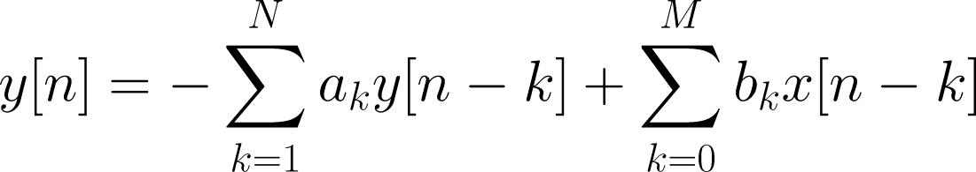

(3.4)

Computing involves and

. That is, we need

- Delay elements or storage

- Multipliers

- Adders (subtraction is considered as addition)

How many storage elements are needed?
How many multipliers are needed?
How many adders are needed?

Computations of y[n] can be arranged in different ways to

give the same difference equation, which leads to different structures for realization of discrete-time LTI systems

4 basic forms of implementations, namely, direct form, canonic form, cascade form and parallel form will be described

An implementation can be represented using either a block diagram or a signal flow graph

Block Diagram Representation
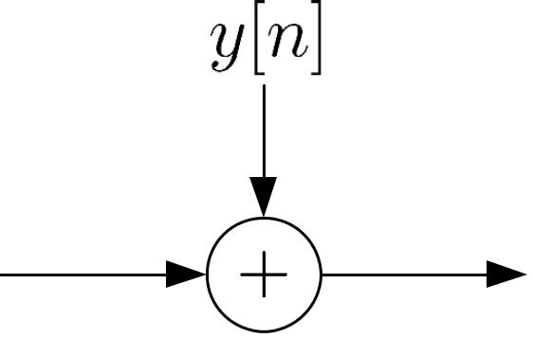

adder
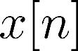
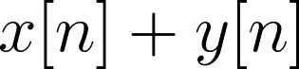
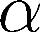

multiplier
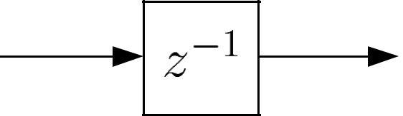

unit delay
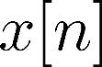
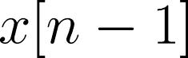

Fig.3.1: Basic operations in block diagram

Although an adder can generally deal with more than two sequences, here we consider two signals in order to align with practical implementation in microprocessors.

When 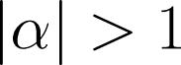, it corresponds to signal amplification while the

signal is attenuated for 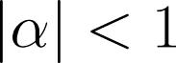. Note that a multiplier usually

has the highest implementation or computational cost and thus it is desired to reduce the number of multipliers in different systems, if possible.

The transfer function 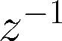 corresponds to a unit delay. It can be implemented by providing a storage register for each unit delay in digital implementation. If the required number
of samples of delay is 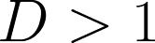, then the corresponding system function is 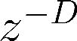.

Signal Flow Graph Representation
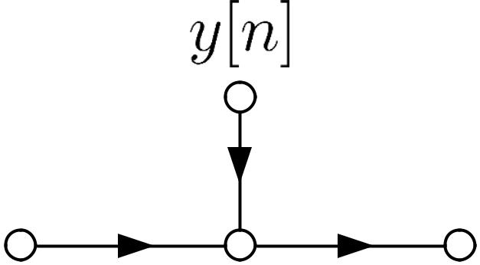

adder

multiplier
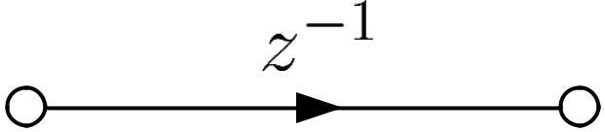

unit delay
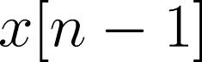

Figure 3.2: Basic operations in signal flow graph

Its basic elements are branches with directions, and nodes. That is, a signal flow graph is a set of directed branches that connect at nodes.

Signal at a node of a flow graph is equal to the sum of the signals from all branches connecting to the node.

Signal out of a branch is equal to the branch gain times the signal into the branch.

Branch gain can refer to a scalar or a transfer function of corresponding to multiplication or unit delay operation, respectively.

When the branch gain is unity, it is left unlabeled.

A signal flow graph provides an alternative but equivalent graphical representation to a block diagram structure

Example 3.1
Draw the block diagram and signal flow graph

representations of a LTI system whose input and output 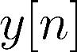 satisfy the following difference equation:
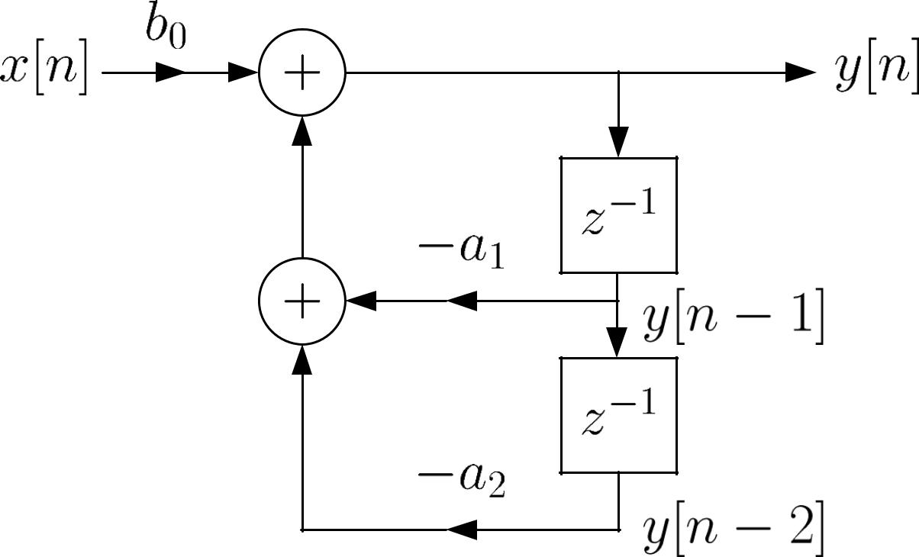

Fig.3.3: Illustration of block diagram

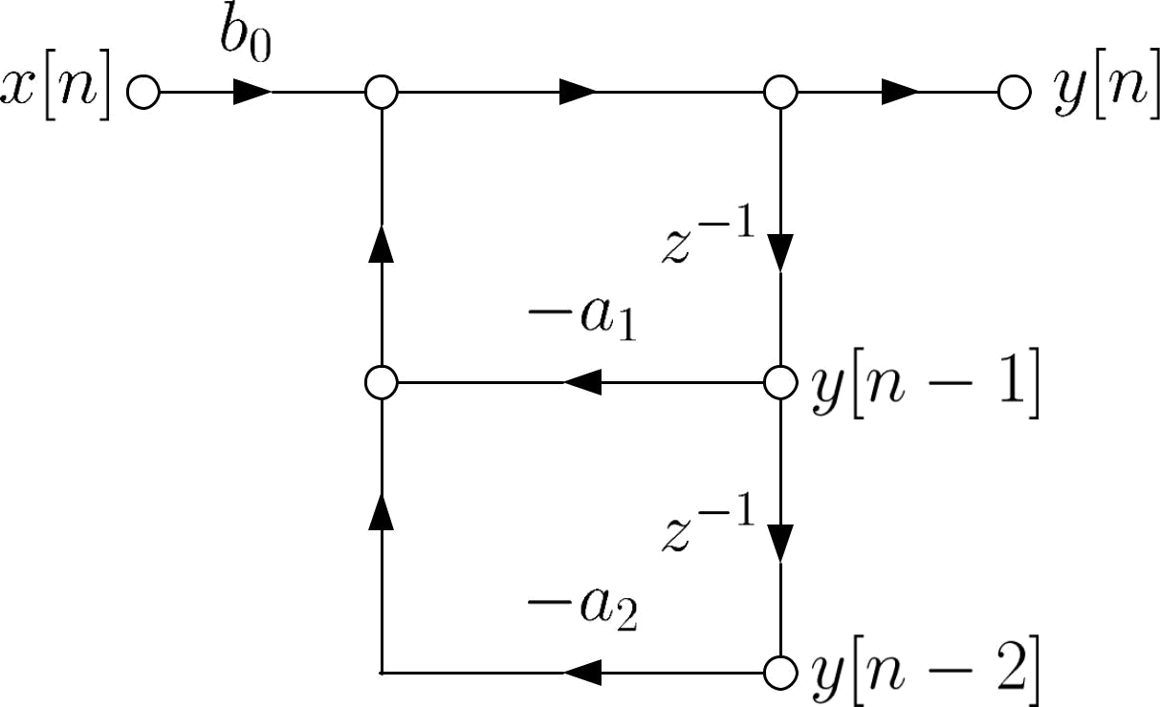

Fig.3.4: Illustration of signal flow graph

2 adders, 3 multipliers and 2 delay elements are required to implement the system.

Structures for FIR Filter

For FIR filter, its transfer function does not contain pole.
That is, setting 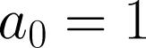 and in (9.1) yields a FIR system:
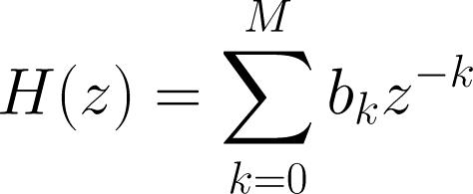

(3.5)

while the corresponding difference equation is:
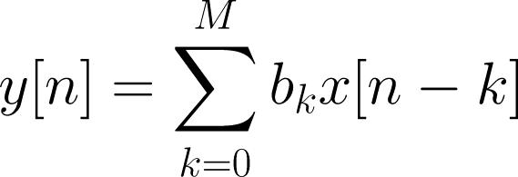

(3.6)

- Direct Form

Comparing (3.6) with the convolution formula of (3.18), 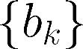 correspond to the system impulse response 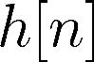:
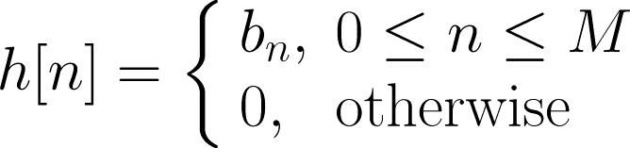

(3.7)

(3.6) can also be written as:
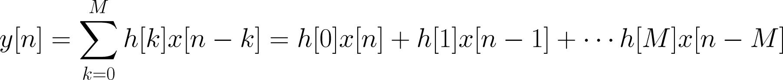

(3.8)

The direct form follows straightforwardly from the difference equation.

The implementation needs 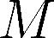 memory locations for storing
previous inputs of 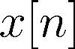 , 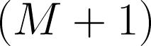 multiplications and
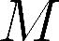

additions for computing each output value of .
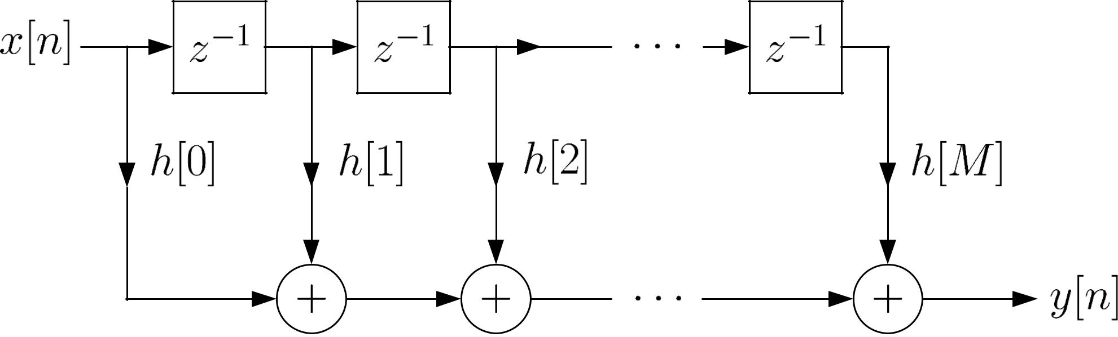

Fig.3.5: Direct form of FIR filter

- Cascade Form

Expressing (3.5) as products of second-order polynomial system functions via factorization:
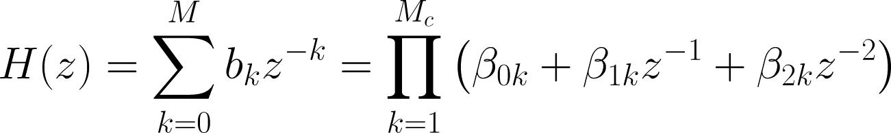

(3.9)

where 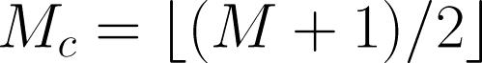 is the largest integer contained in

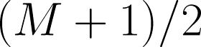. Note that when is odd, one of the 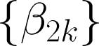 will be

zero. Assuming that is even, this implementation needs
storage elements, 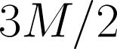 multiplications and additions,

for computing each output value of .

Why second -order polynomial instead of first-order polynomial?

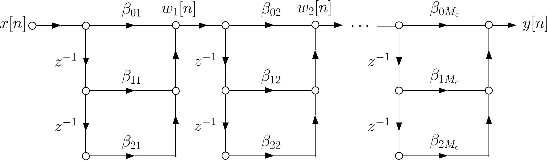

Fig.3.6: Cascade form of FIR filter

(3.10)

and
(3.11)

Taking transform on (3.10) and (3.11):
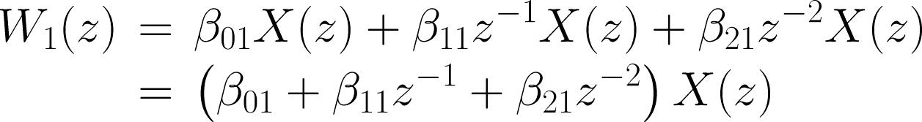

(3.12)

and

(3.13)

Substituting (3.13) into (3.12) yields:

(3.14)

Extending (3.14) to , we finally get:
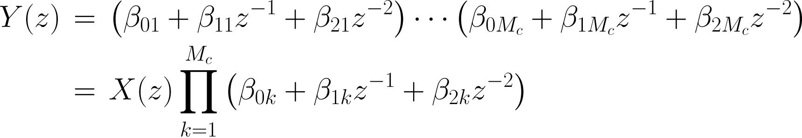

(3.15)

To save the computational complexity, we express (3.9) as:
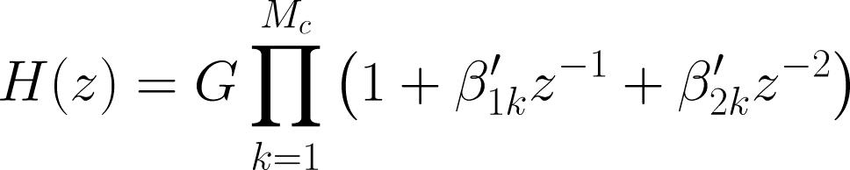

(3.16)

where 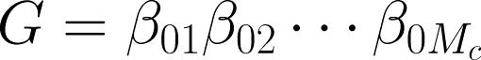 , 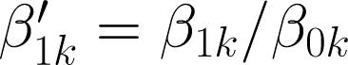 and 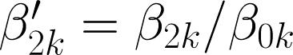 ,

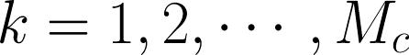. That is, all 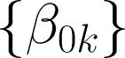 are normalized to 1.

Assuming that is even, (3.16) needs delay elements,
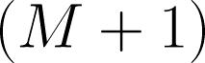 multiplications and additions, for computing each

output value of

Why (M+1) multiplications are needed?

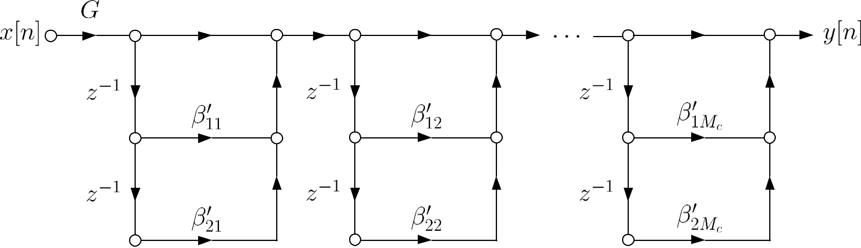

Fig.3.7: Cascade form of FIR filter with smaller complexity Example 3.2
Draw the signal flow graph using the cascade form for the
LTI system whose transfer function is:
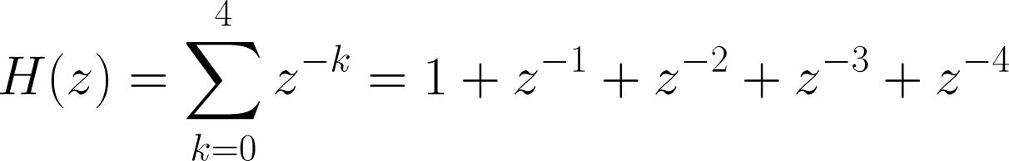

To factorize , we use the MATLAB command roots([1 1

- 1 1]) to solve for the roots:

0.3090 + 0.9511i
0.3090 - 0.9511i
-0.8090 + 0.5878i
-0.8090 - 0.5878i

Hence can be factorized as

Although it can be realized with first -order sections, complex coefficients are needed, which implies higher computational cost. To guarantee real-valued coefficients, we group the sections of complex conjugates together:

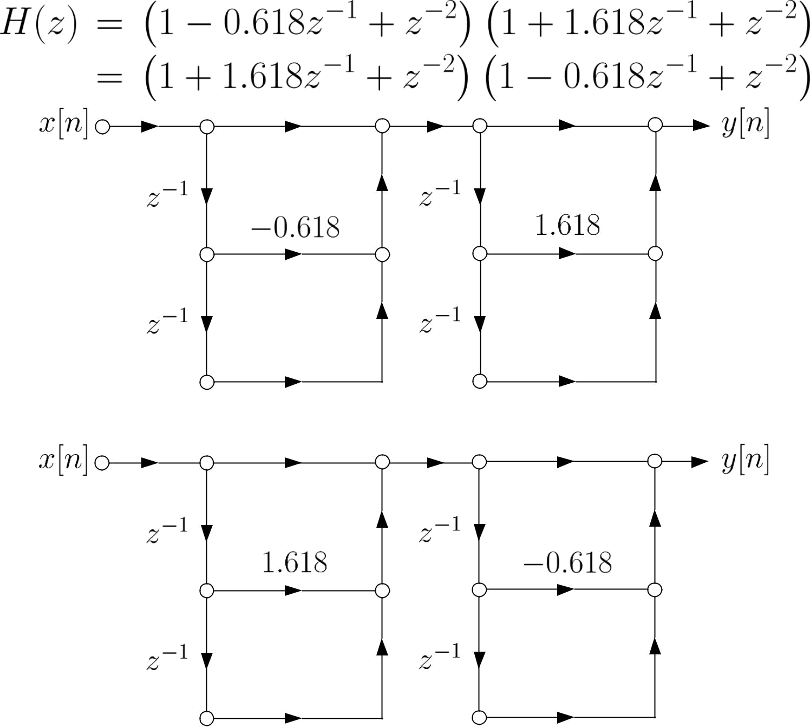

Fig.3.8: Two possible cascade forms for FIR filter

Structures for IIR Filter

When there is at least one pole in , it corresponds to an

IIR filter. The corresponding transfer function is thus:
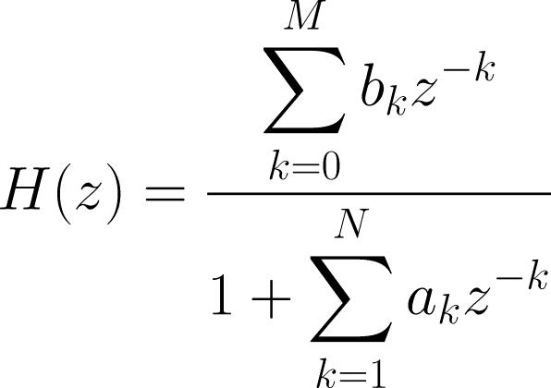

(3.17)

That is, IIR filter is the general form of any discrete-time LTI system.

- Direct Form-I

It realizes (3.4) in an explicit manner via decomposing it into a pair of difference equations:
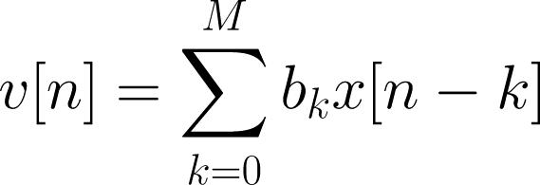

(3.18)

and
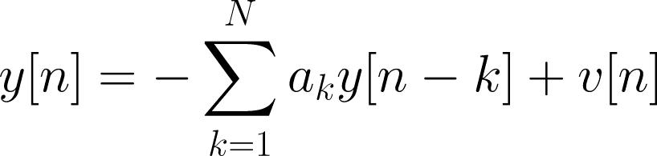

(3.19)

The direct form can also be obtained by decomposing 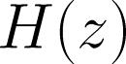 into two transfer functions as:

(3.20)
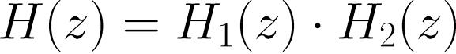

where

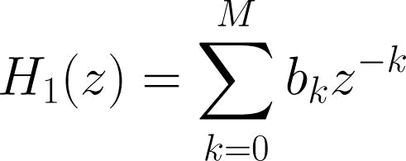
(3.21)

and
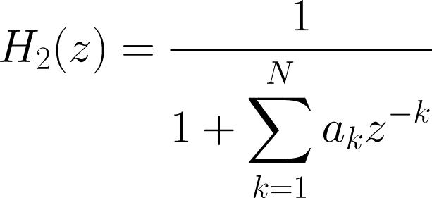

(3.22)

In the transform domain, we have:
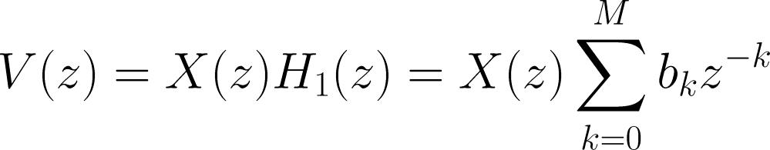

(3.23)

and
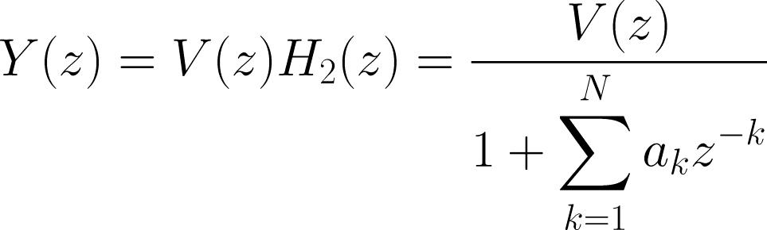

(3.24)

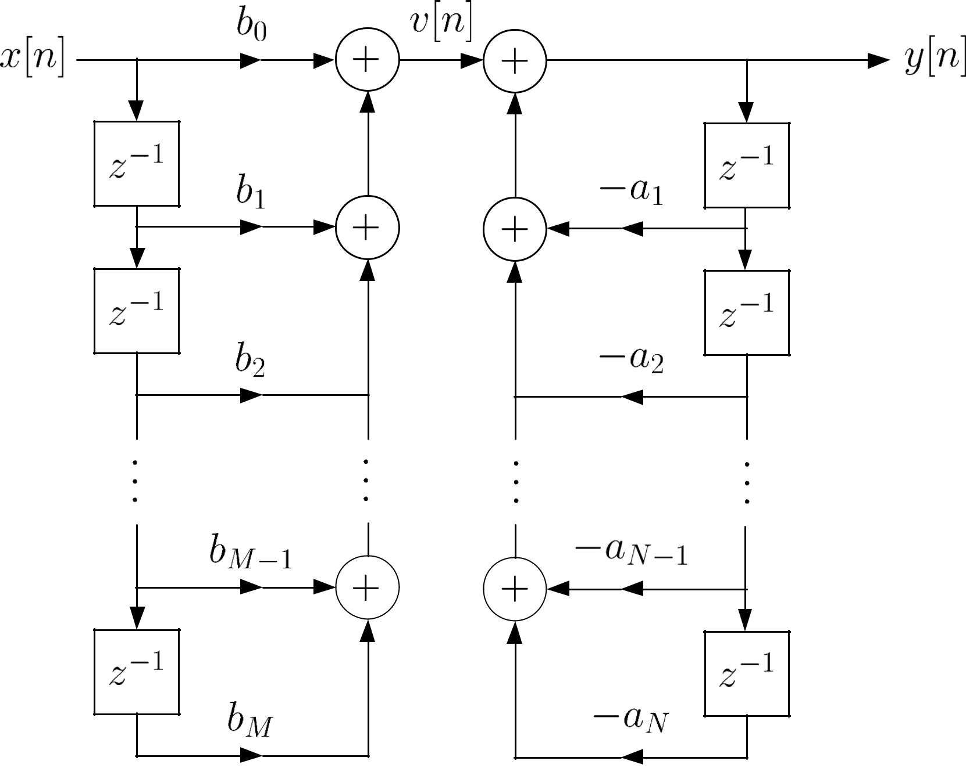

Fig.9.9: Direct form of IIR filter

The direct form implementation needs 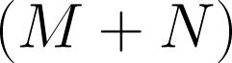 memory

locations, 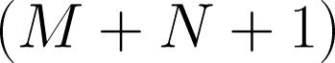 multiplications and additions, for computing each output value of .

- Direct Form-II

On the other hand, we can first pass 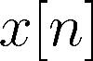 through the filter

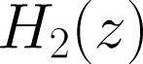 to produce an intermediate signal 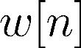. The is then

passed through the system 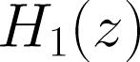 to give :
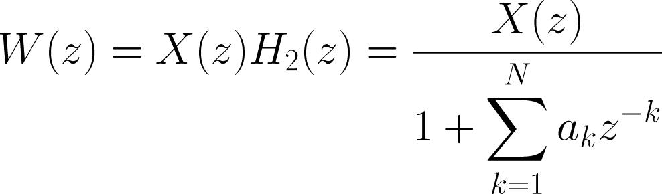

(3.25)

and
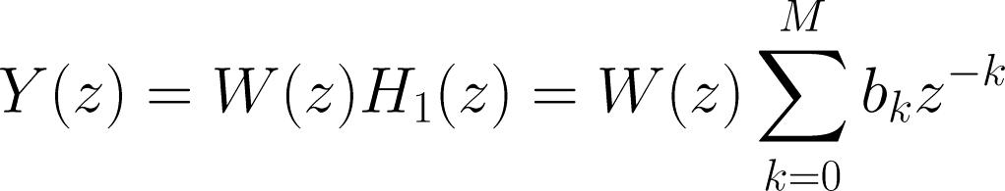

(3.26)

Applying inverse transform, we get:
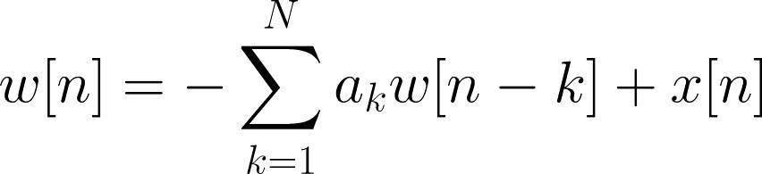

(3.27)

and
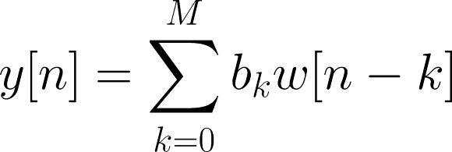

(3.28)

which can be considered as an alternative direct form.

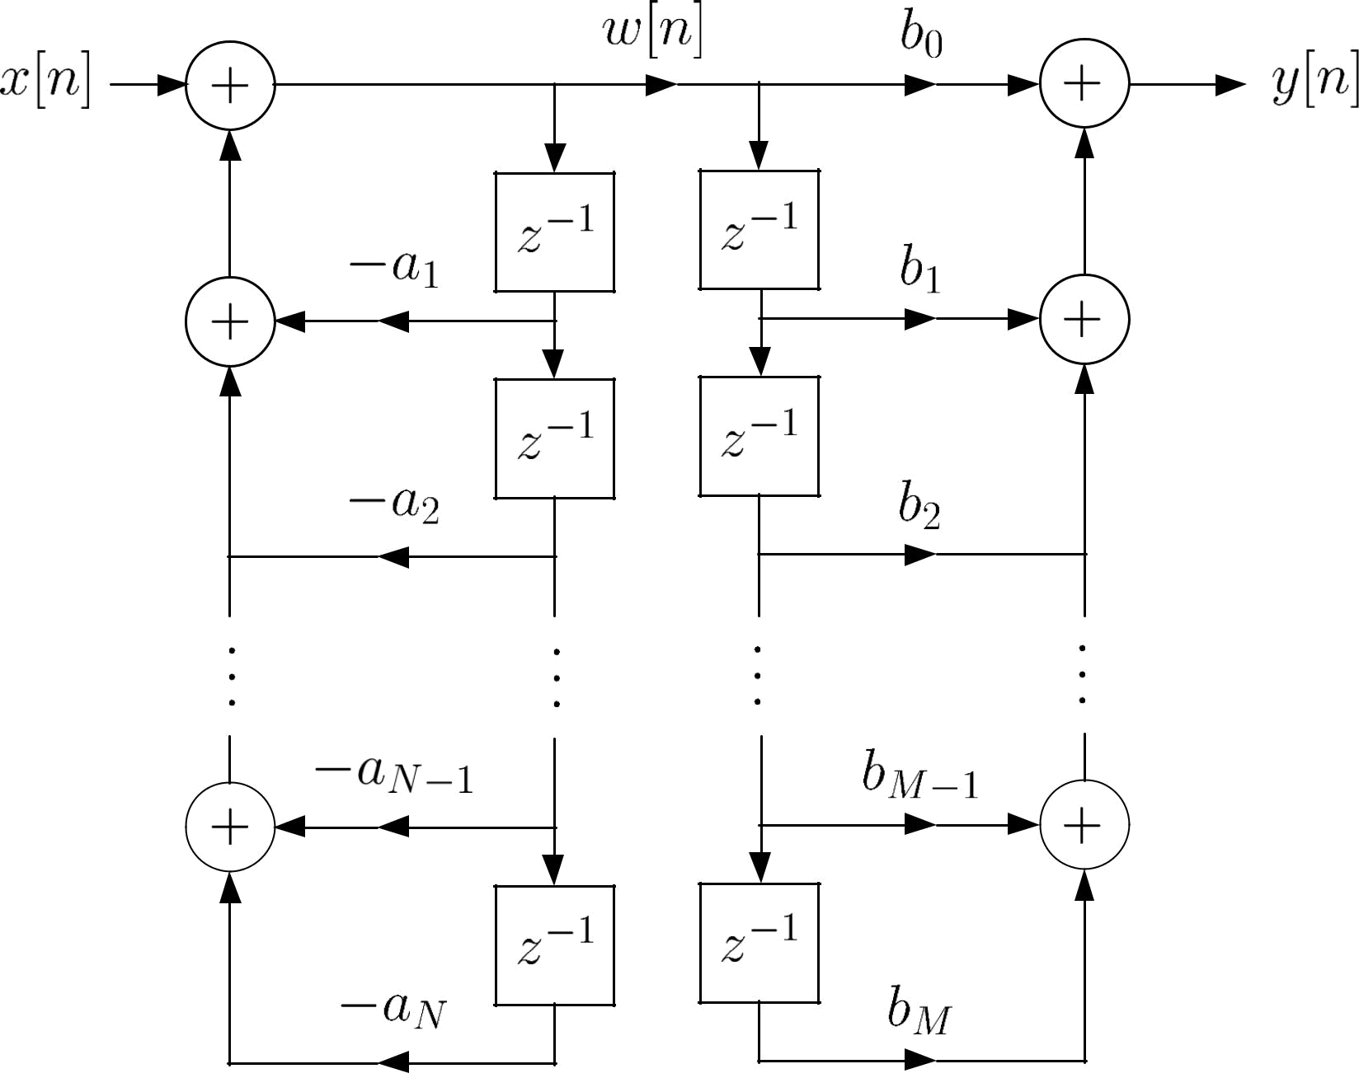

Fig.3.10: Alternative direct form of IIR filter
Assume 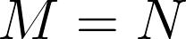 . Since the same signals , are stored in the two chains of storage elements, they can be combined to reduce the

memory requirement.

In general, the minimum number of delay elements
required is 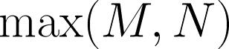.

It is called canonic form because this implementation involves the minimum number of storages.

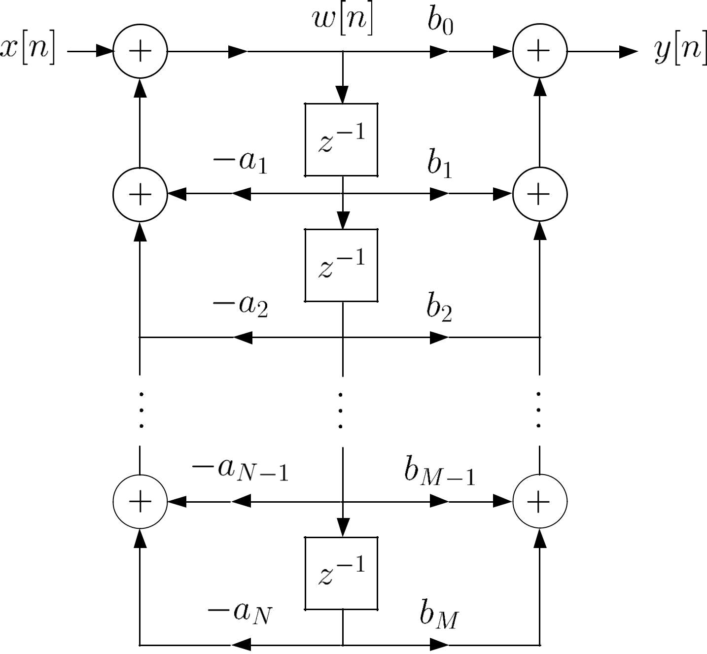

Fig.3.11: Canonic form of IIR filter

Example 3.3
Draw the block diagrams using the direct and canonic forms for the LTI system whose transfer function is:
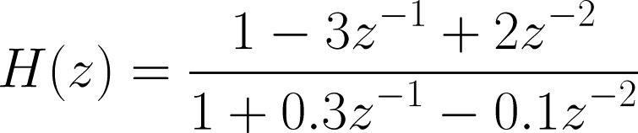

According to (3.18)-(3.19):
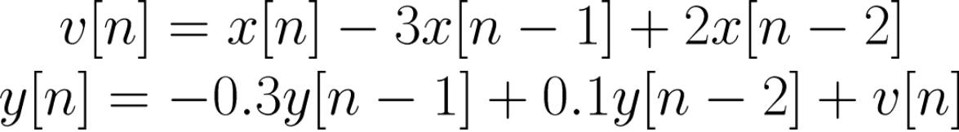

Based on (3.27)-(3.28):
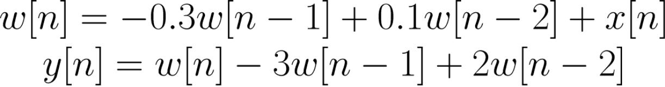

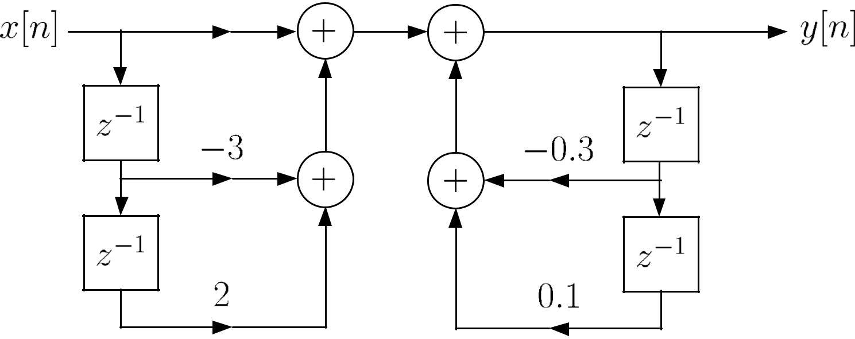

Fig.3.12: Direct form of second-order IIR filter
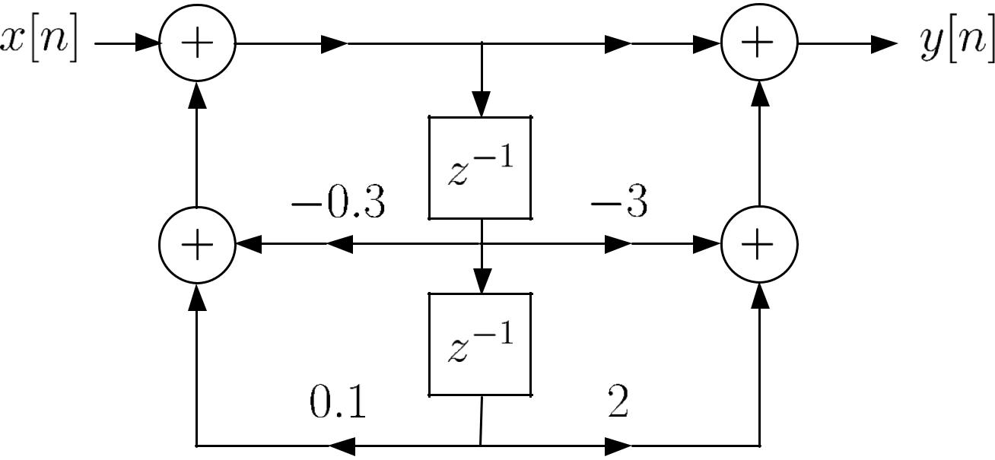

Fig.3.13: Canonic form of second-order IIR filter

- Cascade Form

We factorize the numerator and denominator polynomials in terms of second-order polynomial system functions as:
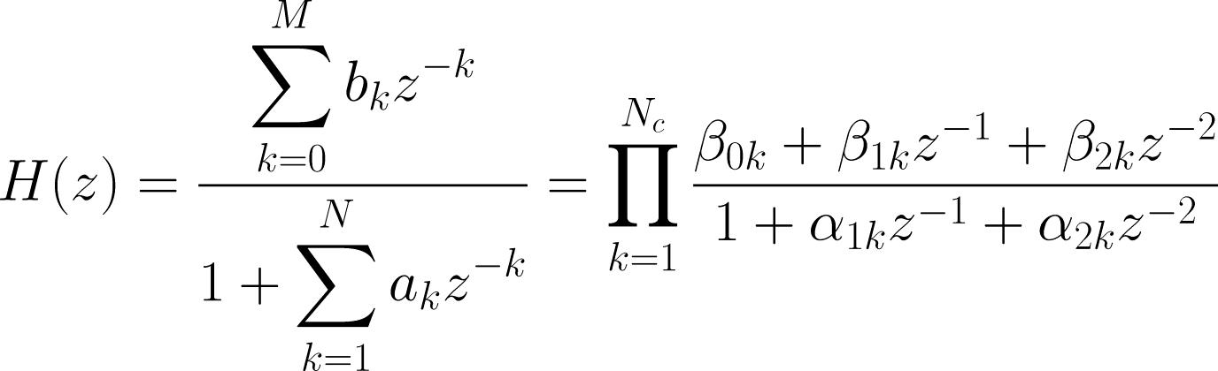

(3.29)

Without loss of generality, it is assumed that 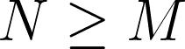 so that
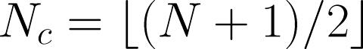. Note that when or 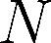 is odd, one of the

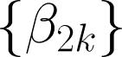 or 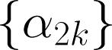 will be zero.

Each second-order subsystem
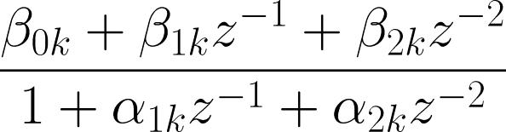

(3.30)

can be realized in either the direct or canonic form. Nevertheless, the canonic form is preferred because it requires the minimum number of delay elements.

In IIR filter implementation, we can group the numerator and denominator of (3.30) in different ways, leading to different pole and zero combinations in each of the second-order sections.

For example, there are four possible cascade realizations for
a fourth-order IIR filter with 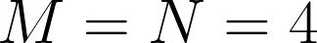.

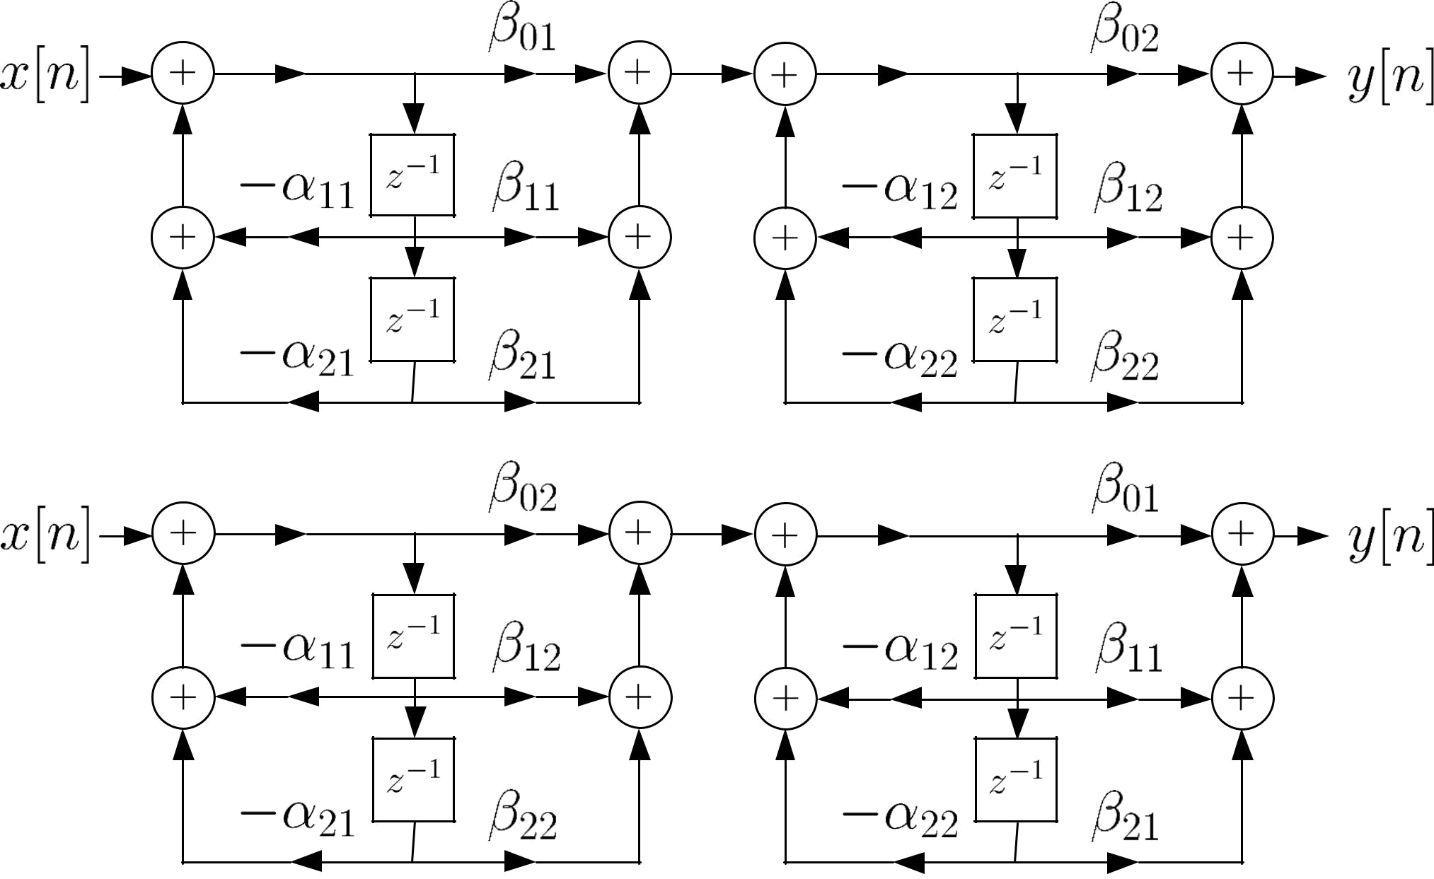

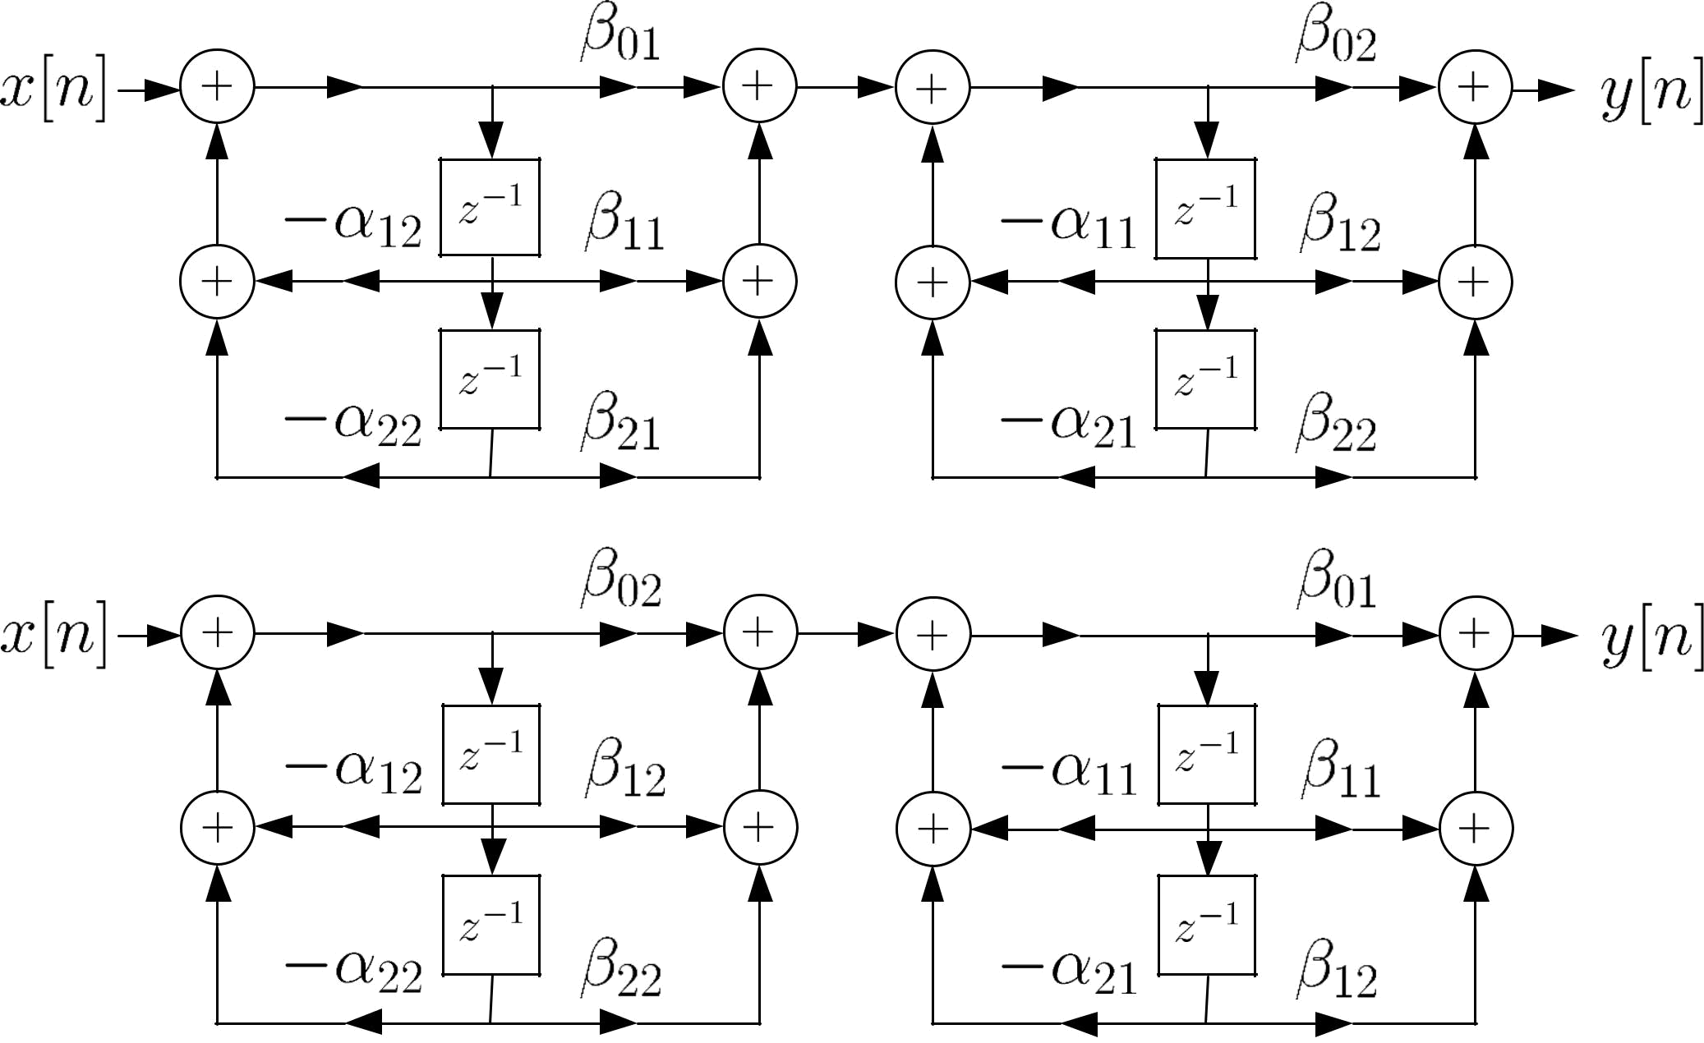

Fig.3.14: 4 possible cascade realizations for 4th-order IIR filter

To save the computational complexity, we express (3.29) as
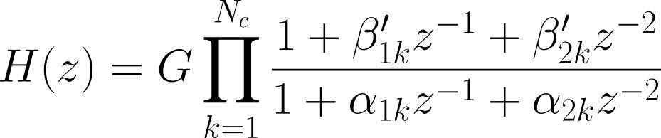

(3.31)

where 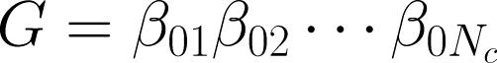 , 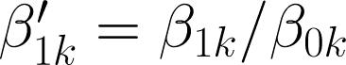 and ,

.
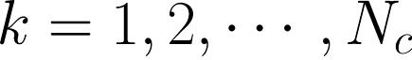

Assuming that is even with 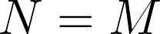 , the cascade

implementation of (3.31) needs or 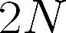 delay elements,
multiplications and 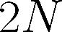 additions, for computing
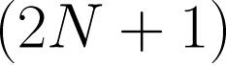

each . That is, its memory and computational

requirements are equal to those of the direct form.

Example 3.4
Draw the signal flow graph using the cascade form with first-order sections for the LTI system whose transfer function is:
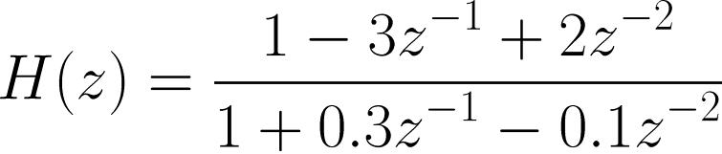

For each first-order section, canonic form is assumed. Solving the quadratic equations of the numerator and

denominator polynomials, we can factorize 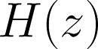 as:
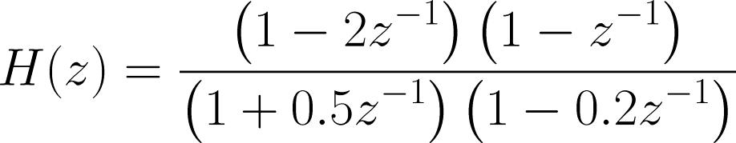

There are four possible cascade forms for :

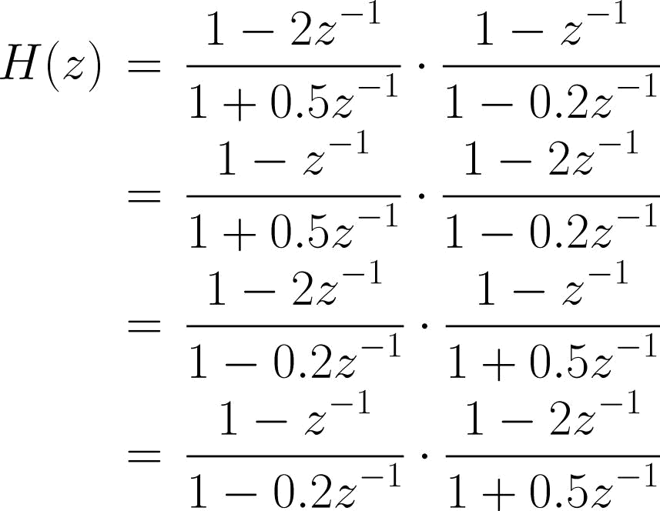

Note that although all four realizations are equivalent for infinite precision, they may differ in actual implementation when finite-precision numbers are employed.

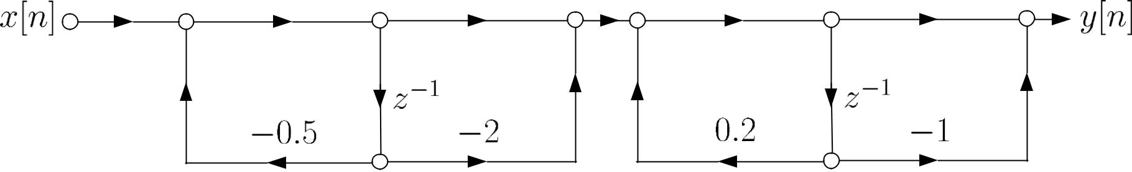
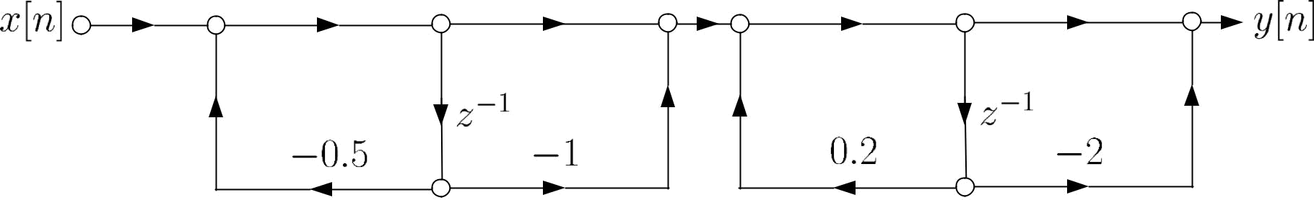
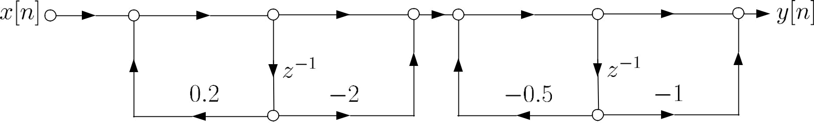
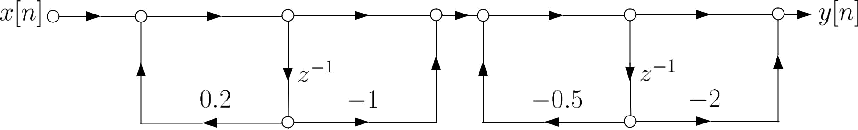

Fig.3.15: 4 possible cascade realizations with 1st-order sections

Example 3.5
Consider a LTI system whose transfer function is:
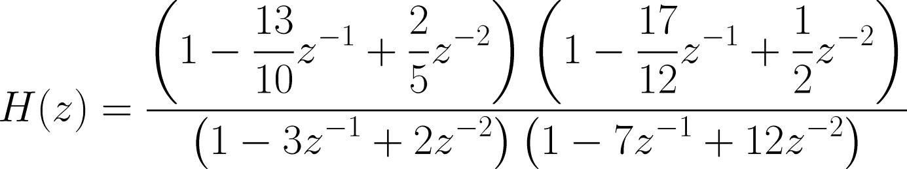

Find the number of possible combinations of cascade form with second- order sections. Determine if the system is stable or not.

Further factorizing yields:
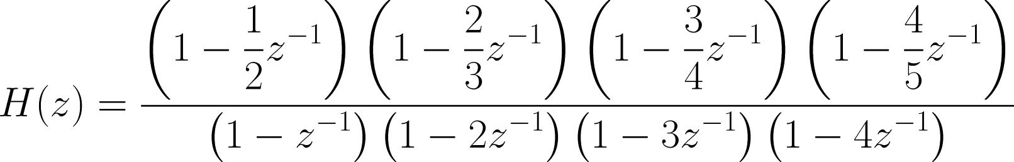

For the numerator polynomials, there are 3 grouping possibilities in terms of second-order sections as follows:
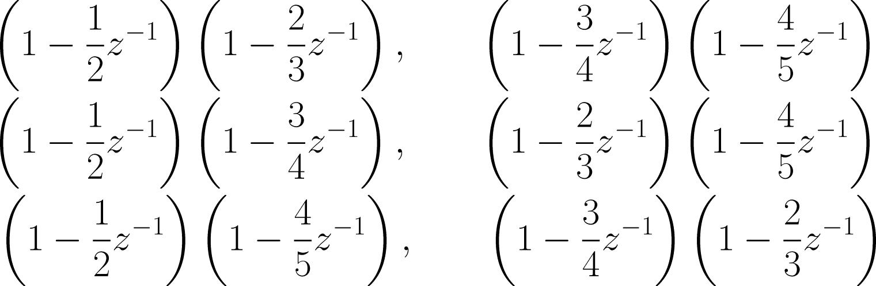

There are also 3 grouping possibilities for the denominator:
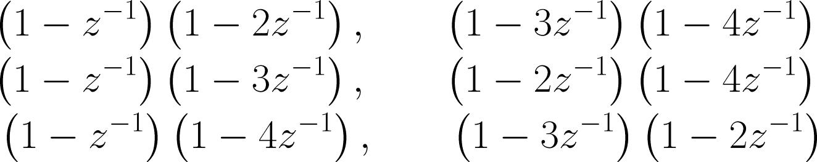

Each fourth-order IIR filter can be realized in four possible cascade forms.

As a result, the number of possible cascade form
combinations with second-order sections for 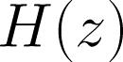 is

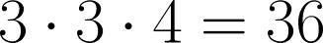.

When implementing a filter, causality is always assumed because it is impossible to realize a non-causal system where the output depends on future input. It is clear that
the region of convergence (ROC) for causal is 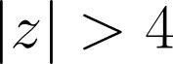 .

Since the ROC does not include the unit circle, the system is not stable.

In summary, a causal system is stable when all poles are inside the unit circle.

- Parallel Form

The idea of the parallel form is similar to the partial fraction expansion of transform:
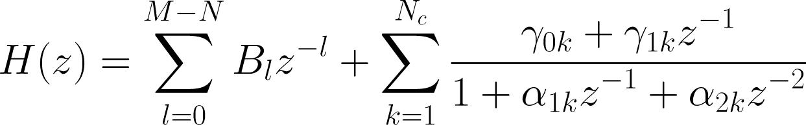

(3.32)

where . But now we use second-order

sections in order to ensure all 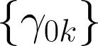, 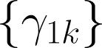, 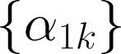 and are real.

Note that when 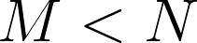, the first summation term in (3.32) will not be included.

Example 3.6
Draw the block diagram using parallel form for a LTI system whose transfer function is:

Following the long division as in Example 3.9, we obtain:
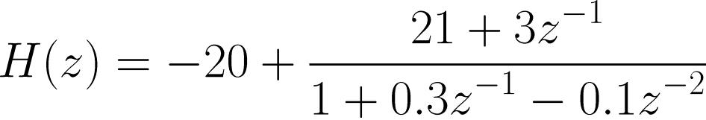

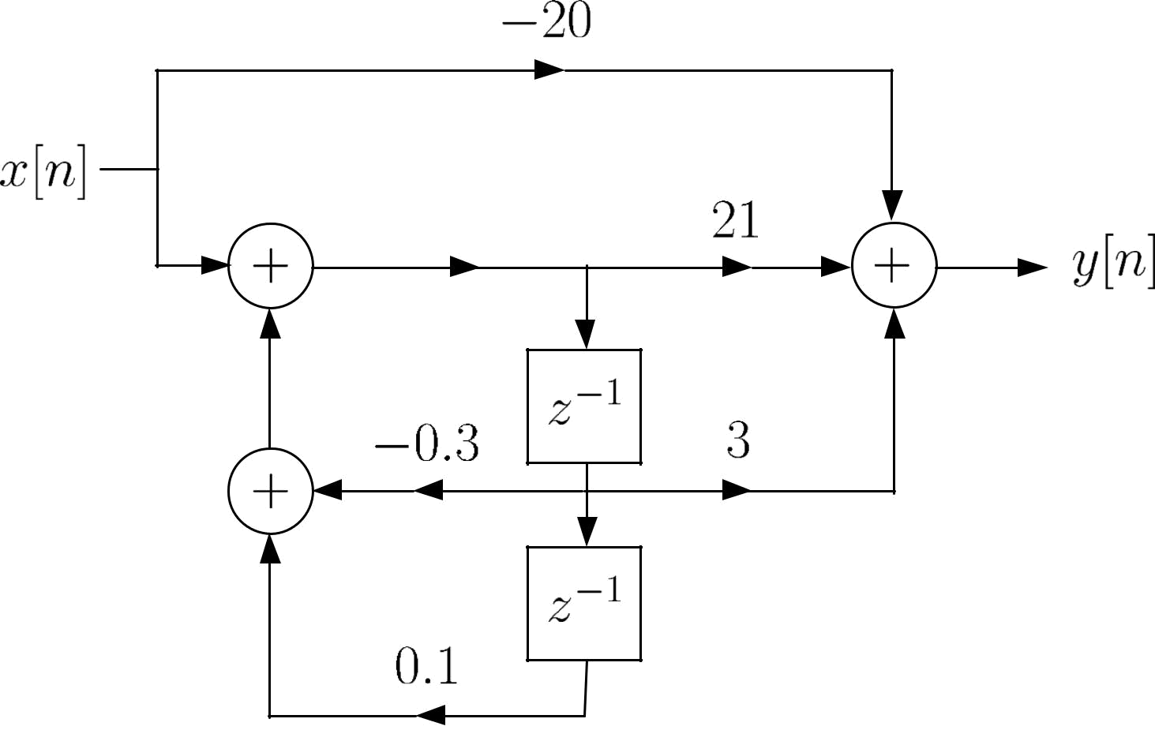

Fig.3.16: Parallel form with second-order section

As the poles of are real, we can also express in terms of first-order sections as:

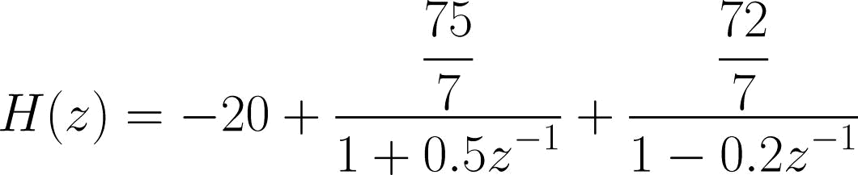
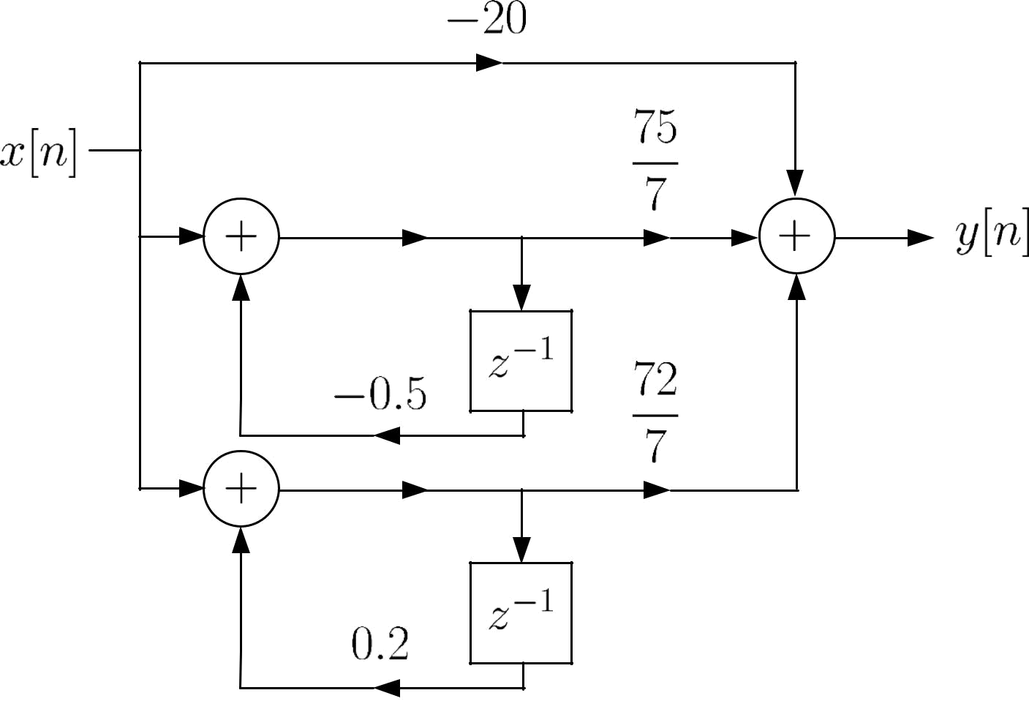

Fig.3.17: Parallel form with first-order sections

Example 3.7
Determine the transfer |  |  |  |  |  | function |  |  |  |  |  |  | and the difference
equation which relates |  |  |  |  |  | and |  |  |  | for
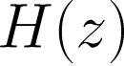
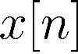
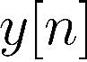
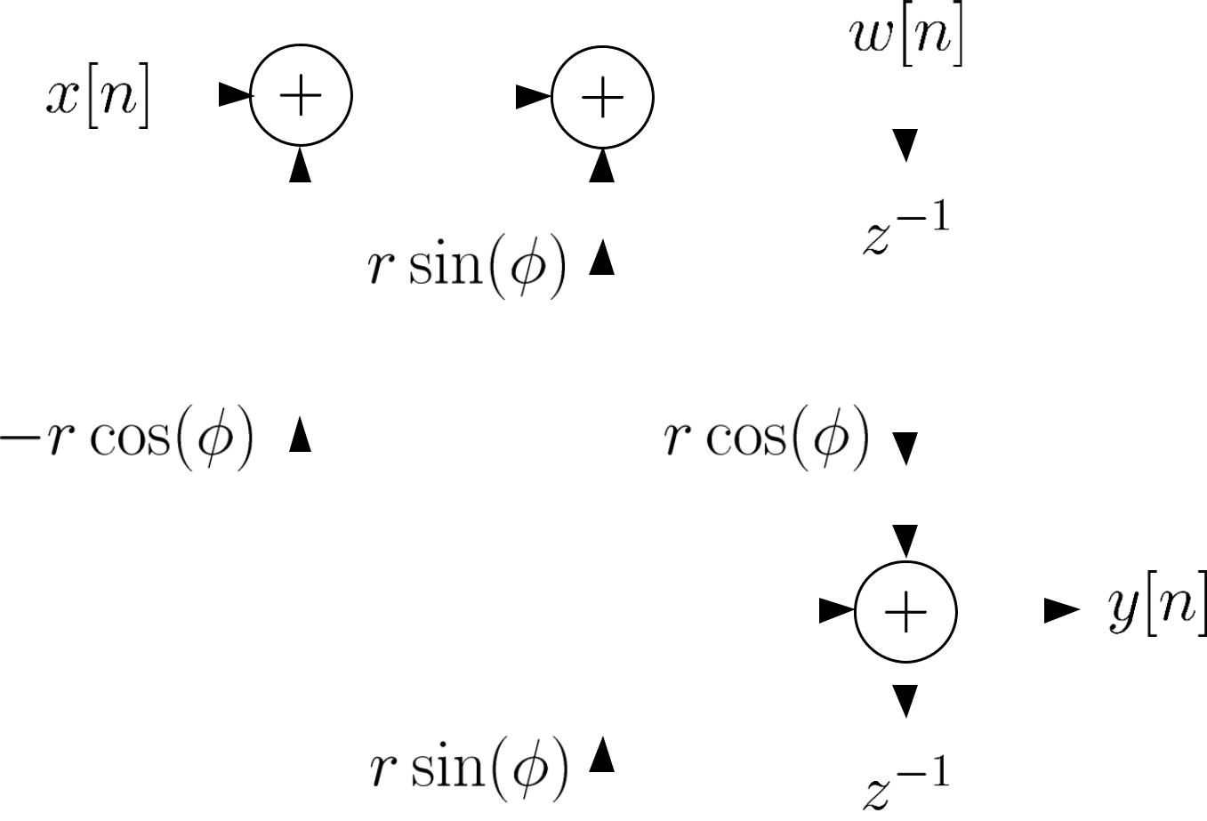

Fig.3.18: LTI system parameterized by and 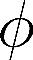

We first introduce an intermediate sequence to relate

and . Then we can establish:

and

Applying transform yields:

and

From the second equation, we have:
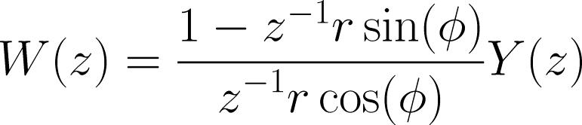

Substituting it into the first equation, we finally have:
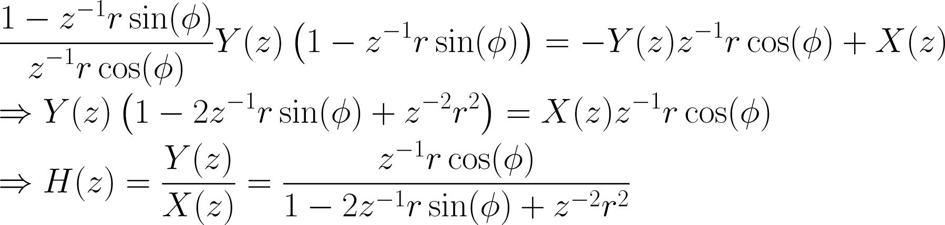

Taking the inverse transform gives:

Comparison of Different Structures

The major factors that affect our choice of a specific realization are computational complexity, memory requirement, and finite word-length effects. Assuming that 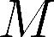 is even with 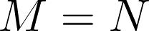:

Structure |  | Multiplication |  | Addition |  | Register
Direct form
Cascade form
Table 9.1: FIR filter structure comparison
Structure | Multiplication |  | Addition |  | Register
Direct form
Canonic form
Cascade form
Parallel form
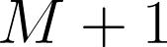
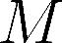
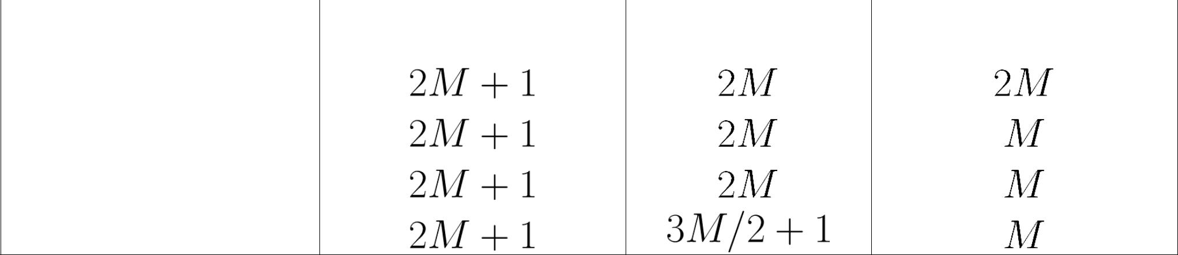
Table 3.2: IIR filter structure comparison

Computations of the direct form can be reduced if the FIR filter coefficients are symmetric or anti-symmetric.

When the filter coefficients are expressed using infinite precision numbers, all realizations are same. However, in practice, they are processed in registers which have finite word-lengths. In the presence of quantization errors, the cascade and parallel realizations are more robust than the direct and canonic forms, that is, they have frequency responses closer to the desired responses.

FIR filters are less sensitive than IIR filters to finite word-length effects.

For a feasible system, it should be causal and stable.

In cascade and parallel realizations of IIR filters, system stability can be easily monitored by checking pole locations.

