# Unit-I Electric Drives

# What is Electrical Drive?

# Whenever the term [electric motor](https://www.electrical4u.com/electrical-motor-types-classification-and-history-of-motor/) or electrical generator is used, we tend to think that the speed of rotation of these machines is totally controlled only by the applied [voltage](https://www.electrical4u.com/voltage-or-electric-potential-difference/) and frequency of the source current. But the speed of rotation of an electrical machine can be controlled precisely also by implementing the concept of drive. The main advantage of this concept is, the motion control is easily optimized with the help of drive. In very simple words, the systems which control the motion of the electrical machines, are known as electrical drives. A typical drive system is assembled with a [electric motor](https://www.electrical4u.com/electrical-motor-types-classification-and-history-of-motor/) (may be several) and a sophisticated control system that controls the rotation of the motor shaft. Now days, this control can be done easily with the help of software. So, the controlling becomes more and more accurate and this concept of drive also provides the ease of use.

This drive system is widely used in large number of industrial and domestic applications like factories, transportation systems, textile mills, fans, pumps, motors, robots etc. Drives are employed as prime movers for diesel or petrol engines, gas or [steam](https://www.electrical4u.com/steam/) turbines, hydraulic motors and [electric motors](https://www.electrical4u.com/electrical-motor-types-classification-and-history-of-motor/).

Now coming to the history of **electrical drives**, this was first designed in Russia in the year 1838 by B.S. Iakobi, when he tested a [DC electric motor](https://www.electrical4u.com/dc-motor-or-direct-current-motor/) supplied from a storage [battery](https://www.electrical4u.com/battery-history-and-working-principle-of-batteries/) and propelled a boat. Even though the industrial adaptation occurred after many years as around 1870. Today almost everywhere the application of **electric drives** is seen.  
The very basic block diagram an electric drives is shown below. The load in the figure represents various types of equipments which consist of [electric motor](https://www.electrical4u.com/electrical-motor-types-classification-and-history-of-motor/), like fans, pumps, washing machines etc.

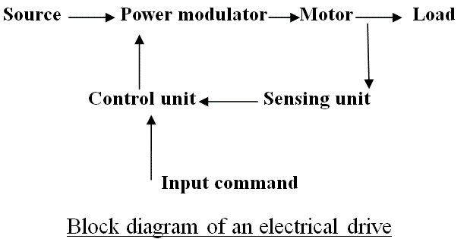

**Classification of Electrical Drives or Types of Electrical Drives**

The **classification of electrical drives** can be done depending upon the various components of the drive system. Now according to the design, the drives can be classified into three types such as single-motor drive, group motor drive and multi motor drive. The single motor types are the very basic type of drive which are mainly used in simple metal working, house hold appliances etc. Group electric drives are used in modern industries because of various complexities. Multi motor drives are used in heavy industries or where multiple motoring units are required such as railway transport. If we divide from another point of view, these drives are of two types:

1. Reversible types drives
2. Non reversible types drives.

This depends mainly on the capability of the drive system to alter the direction of the flux generated. So, several classification of drive is discussed above.

### Parts of Electrical Drives

The diagram which shows the basic circuit design and components of a drive, also shows that, drives have some fixed parts such as, load, motor, power modulator, control unit and source. These equipments are termed as **parts of drive system**. Now, loads can be of various types i.e they can have specific requirements and multiple conditions, which are discussed later, first of all we will discuss about the other four **parts of electrical drives** i.e motor, power modulator, source and control unit. Electric motors are of various types. The DC motors can be divided in four types – shunt wound DC motor, series wound DC motor, compound wound DC motor and permanent magnet DC motor. AC motors are of two types – induction motors and synchronous motors. Now synchronous motors are of two types – round field and permanent magnet. Induction motors are also of two types – squirrel cage and wound motor. Besides all of these, stepper motors and switched reluctance motors are also considered as the parts of drive system.

So, there are various types of electric motors, and they are used according to their specifications and uses. When the electrical drives were not so popular, induction and synchronous motors were usually implemented only where fixed or constant speed was the only requirement. For variable speed drive applications, DC motors were used. But as we know that, induction motors of same rating as a DC motors have various advantages like they have lighter weight, lower cost, lower volume and there is less restriction on maximum voltage, speed and power ratings. For these reasons, the induction motors are rapidly replaced the DC motors. Moreover induction motors are mechanically stronger and require less maintenance. When synchronous motors are considered, wound field and permanent magnet synchronous motors have higher full load efficiency and power factor than induction motors, but the size and cost of synchronous motors are higher than induction motors for the same rating. Brush less DC motors are similar to permanent magnet synchronous motors. They are used for servo applications and now a day’s used as an efficient alternative to DC servo motors because they don’t have the disadvantages like commendation problem. Beside of these, stepper motors are used for position control and switched reluctance motors are used for speed control.  
Power Modulators - are the devices which alter the nature or frequency as well as changes the intensity of power to control electrical drives. Roughly, power modulators can be classified into three types,

1. Converters,
2. Variable impedance circuits,
3. Switching circuits.

As the name suggests, converters are used to convert currents from one type to other type. Depending on the type of function, converters can be divided into 5 types

1. AC to DC converters
2. AC regulators
3. Choppers or DC - DC converters
4. Inverters
5. Cycloconverters

AC to DC converters are used to obtain fixed DC supply from the AC supply of fixed voltage. The very basic diagram of AC to DC converters is like.

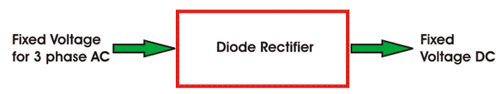

AC Regulators are used to obtain the regulated AC voltage, mainly auto transformers or tap changer transformers are used in these regulators.

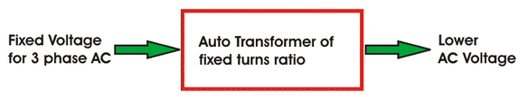             Choppers or DC - DC converters are used to get a variable DC voltage. Power transistors, [IGBT's](https://www.electrical4u.com/insulated-gate-bipolar-transistor-igbt/), GPO's, [power MOSFET's](https://www.electrical4u.com/power-mosfet/) are mainly used for this purpose.

              Inverters are used to get AC from DC, the operation is just opposite to that of AC to DC converters. PWM [semiconductors](https://www.electrical4u.com/theory-of-semiconductor/) are used to invert the current.

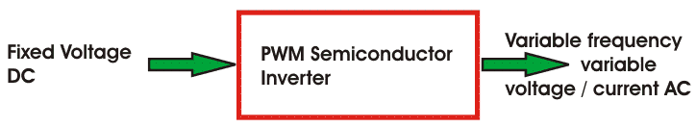Cycloconverters are used to convert the fixed frequency and fixed [voltage](https://www.electrical4u.com/voltage-or-electric-potential-difference/) AC into variable frequency and variable voltage AC. [Thyristor](https://www.electrical4u.com/silicon-controlled-rectifier-scr-two-transistor-model-operating-principle/#What-is-Thyristor-or-SCR?)s are used in these converters to control the firing signals.

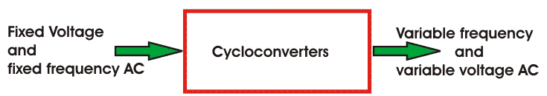

**Variable Impedance circuits** are used to controlling speed by varying the resistance or impedance of the circuit. But these controlling methods are used in low cost DC and ac drives. There can be two or more steps which can be controlled manually or automatically with the help of contactors. To limit the starting current inductors are used in AC motors.  
**Switching circuits** in motors and electrical drives are used for running the motor smoothly and they also protect the machine during faults. These circuits are used for changing the quadrant of operations during the running condition of a motor. And these circuits are implemented to operate the motor and drives according to predetermined sequence, to provide interlocking, to disconnect the motor from the main circuit during any abnormal condition or faults.  
**Sources** may be of 1 phase and 3 phase. 50 Hz AC supply is the most common type of electricity supplied in India, both for domestic and commercial purpose. Synchronous motors which are fed 50 Hz supply have maximum speed up to 3000 rpm, and for getting higher speeds higher frequency supply is needed. Motors of low and medium powers are fed from 400 V supply, and higher ratings like 3.3 kv, 6.6 kv, 11 kv etc are provided also.  
**Control Unit -** Choice of control unit depends upon the type of power modulator that is used. These are of many types, like when semiconductor converters are used, then the control unit consists of firing circuits, which employ linear devices and microprocessors.  
So, the above discussion provides us a simple concept about the several parts of electrical drive.

#### Advantages of Electrical Drives

Electrical drives are readily used these days for controlling purpose but this is not the only the **advantage of Electrical drives**. There are several other advantages which are listed below -

1. These drives are available in wide range torque, speed and power.
2. The control characteristics of these drives are flexible. According to load requirements these can be shaped to steady state and dynamic characteristics. As well as speed control, electric braking, gearing, starting many things can be accomplished.
3. They are adaptable to any type of operating conditions, no matter how much vigorous or rough it is.
4. They can operate in all the four quadrants of speed torque plane, which is not applicable for other prime movers.
5. They do not pollute the environment.
6. They do not need refueling or preheating, they can be started instantly and can be loaded immediately.
7. They are powered by electrical energy which is atmosphere friendly and cheap source of power.

Because of the above mentioned **advantages of electrical drives**, they are getting more and more popular and are used in a wider range of applications.

**Classification of Electric Drives**

*According to Mode of Operation*

1.Continuous duty drives 2. Short time duty drives 3. Intermittent duty drives

*According to Means of Control*

1. Manual 2. Semi automatic 3. Automatic

*According to Number of machines*

1. Individual drive 2. Group drive 3. Multi-motor drive

*According to Dynamics and Transients*

1. Uncontrolled transient period 2. Controlled transient period

*According to Methods of Speed Control*

1. Reversible and non-reversible uncontrolled constant speed
2. Reversible and non-reversible step speed control
3. Variable position control.
4. Reversible and non-reversible smooth speed control

**Advantages of Electrical Drive**

1. They have flexible control characteristics. The steady state and dynamic characteristics of      electric drives can be shaped to satisfy the load requirements.

2. Drives can be provided with automatic fault detection systems. Programmable logic controller

    and computers can be employed to automatically control the drive operations in a desired     sequence.

3. They are available in wide range of torque, speed and power.

4. They are adaptable to almost any operating conditions such as explosive and radioactive      environments

5. It can operate in all the four quadrants of speed-torque plane

6. They can be started instantly and can immediately be fully loaded

7. Control gear requirement for speed control, starting and braking is usually simple and easy to      operate.

**Choice (or) Selection of Electrical Drives**

Choice of an electric drive depends on a number of factors. Some of the important factors are.

1. Steady State Operating conditions requirements --- Nature of speed torque characteristics,     speed regulation, speed range, efficiency, duty cycle, quadrants of operation, speed     fluctuations if any, ratings etc

2. Transient operation requirements --- Values of acceleration and deceleration, starting, braking      and reversing performance.

3. Requirements related to the source --- Types of source and its capacity, magnitude of voltage,     voltage fluctuations, power factor, harmonics and their effect on other loads, ability to accept     regenerative power

4. Capital and running cost, maintenance needs life.

5. Space and weight restriction if any.

6. Environment and location.

7. Reliability.

### Classification of Electric Drive with Advantage and Disadvantage

### Classification of Electric Drive

##### Generally classified into 3 categories:

I. Group drive

II. Individual Drive

III. Multimotor Drive

**Group Drive**

If several group of mechanisms or machines are organized on one shaft and driven or actuated by one motor, the system is called a group drive or shaft drive.

**Advantage :**

Most Economical

**Disadvantage:**

1. Any Fault that occurs in the driving motor renders all the driving equipment idle.

2. Efficiency low because of losses occurring in the energy transmitting mechanisms (Power     loss)

3. Not safe to operate.

4. Noise level at the working spot is high.

5. Flexibility.

**Individual Drive**

1. If a single motor is used to drive or actuate a given mechanism and it does all the jobs connected with this load , the drive is called individual drive.

2. All the operations connected with operating a lathe may be performed by a single motor.

3. Each motor is driven by its own separated motor with the help of gears , pulleys etc.

**Disadvantage:**

Power loss occurs.

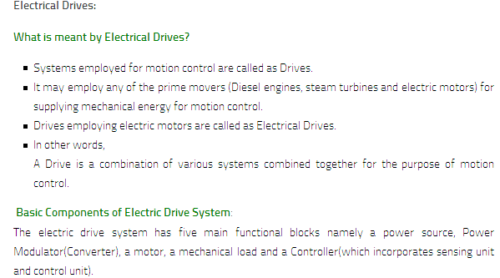

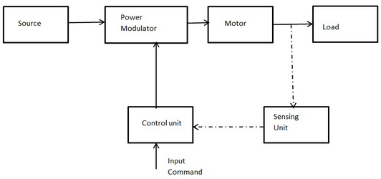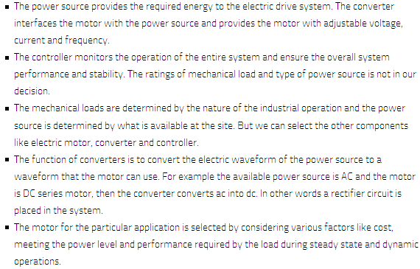

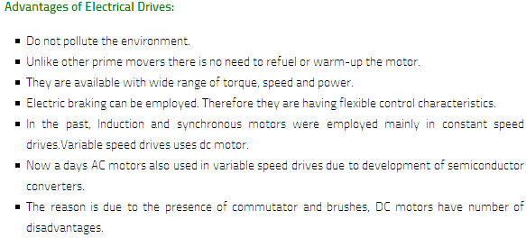

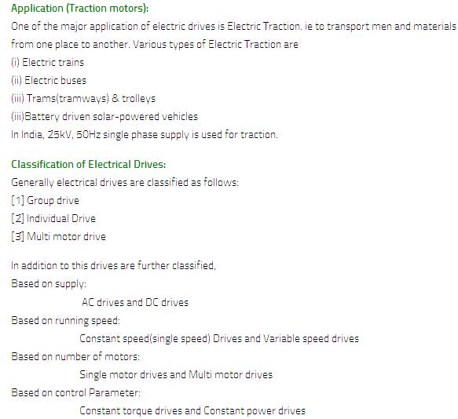

**DC Shunt Motor**

The **shunt wound DC motor** falls under the category of self excited DC motors, where the field windings are shunted to, or are connected in parallel to the armature winding of the motor, as its name is suggestive of. And for this reason both the armature winding and the field winding are exposed to the same supply voltage, though there are separate branches for the flow of armature current and the field current as shown in the figure of **DC shunt motor** below.

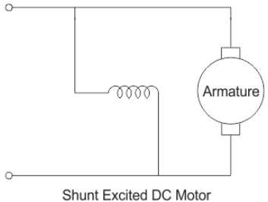

## Voltage and Current Equation of a Shunt Wound DC Motor

Let us now consider the voltage and current being supplied from the electrical terminal to the motor be given by E and Itotal respectively.

This supply current in case of the **shunt wound DC motor** is split up into 2 parts. Ia, flowing through the armature winding of resistance Ra and Ish flowing through the field winding of resistance Rsh. The voltage across both windings remains the same.  
From there we can write

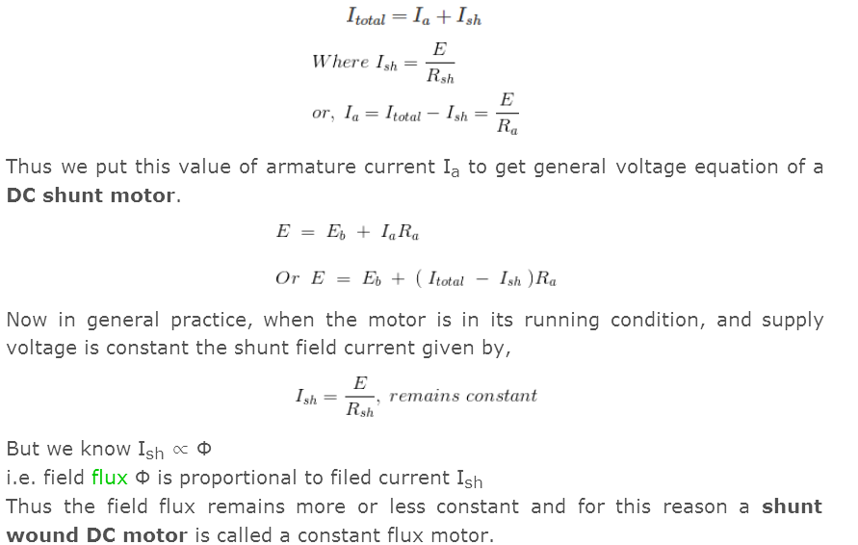

## Construction of a Shunt Wound DC Motor

The construction of a dc shunt motor is pretty similar to other types of DC motor, as shown in the figure below.

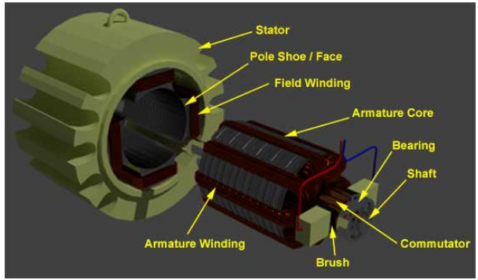

Just that there is one distinguishable feature in its designing which can be explained by taking into consideration, the torque generated by the motor. To produce a high torque,

1. The armature winding must be exposed to an amount of current that’s much higher than the field windings current, as the torque is proportional to the armature current.
2. The field winding must be wound with many turns to increase the flux linkage, as flux linkage between the field and armature winding is also proportional to the torque. Keeping these two above mentioned criterion in mind a dc shunt motor has been designed in a way, that the field winding possess much higher number of turns to increase net flux linkage and are lesser in diameter of conductor to increase resistance (reduce current flow) compared to the armature winding of the DC motor. And this is how a shunt wound DC motor is visibly distinguishable in static condition from the DC series motor (having thicker field coils) of the self excited type motor’s category.

## Self-Speed Regulation of a Shunt Wound DC Motor

A very important and interesting fact about the DC shunt motor, is in its ability to self regulate its speed on application of load to the shaft of the rotor terminals. This essentially means that on switching the motor running condition from no load to loaded, surprisingly there is no considerable change in speed of running, as would be expected in the absence of any speed regulating modifications from outside. Let us see how?  
Let us do a step-wise analysis to understand it better.

1. Initially considering the motor to be running under no load or lightly loaded condition at a speed of N rpm.
2. On adding a load to the shaft, the motor does slow down initially, but this is where the concept of self regulation comes into the picture.
3. At the very onset of load introduction to a shunt wound DC motor, the speed definitely reduces, and along with speed also reduces the **back emf**, Eb. Since Eb ∝ N, given by,

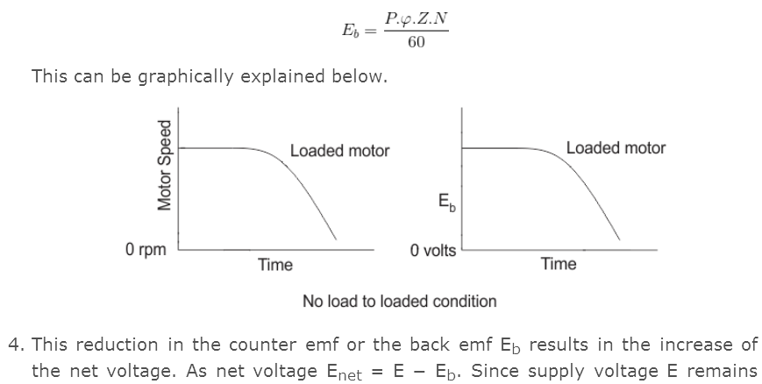

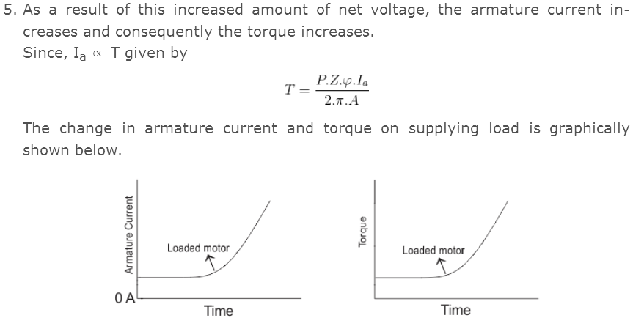

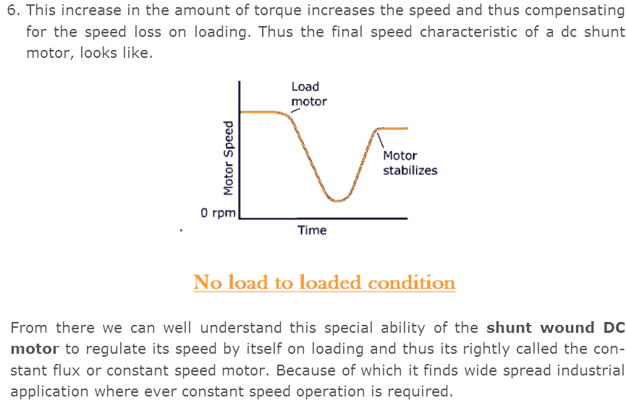

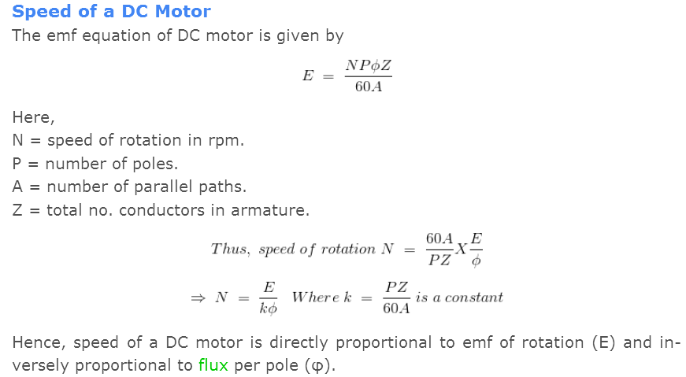

**Series Wound DC Motor or DC Series Motor**

A **series wound DC motor** like in the case of shunt wound DC motor or compound wound DC motor falls under the category of self-excited DC motors, and it gets its name from the fact that the field winding in this case is connected internally in series to the armature winding. Thus the field windings are exposed to the entire armature current unlike in the case of a shunt motor.

## Construction of Series DC Motor

Construction wise a this motor is similar to any other types of DC motors in almost all aspects. It consists of all the fundamental components like the stator housing the field winding or the rotor carrying the armature conductors, and the other vital parts like the commutator or the brush segments all attached in the proper sequence as in the case of a generic DC motor.

Yet if we are to take a close look into the wiring of the field and armature coils of this DC motor, its clearly distinguishable from the other members of this type.  
 To understand that let us revert back into the above mentioned basic fact, that the this motor has field coil connected in series to the armature winding. For this reason relatively higher current flows through the field coils, and its designed accordingly as mentioned below.

1. The field coils of **DC series motor** are wound with relatively fewer turns as the current through the field is its armature current and hence for required mmf less numbers of turns are required.

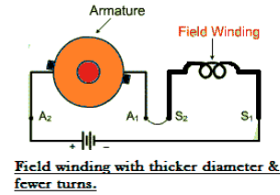

1. The wire is heavier, as the diameter is considerable increased to provide minimum electrical resistance to the flow of full armature current.
2. In spite of the above mentioned differences, about having fewer coil turns the running of this DC motor remains unaffected, as the current through the field is reasonably high to produce a field strong enough for generating the required amount of torque. To understand that better lets look into the voltage and current equation of DC series motor.

## Voltage and Current Equation of Series DC Motor

The electrical layout of a typical series wound DC motor is shown in the diagram below.

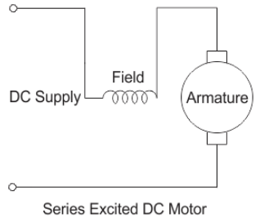

Let the supply voltage and current given to the electrical port of the motor be given by E and Itotal respectively. Since the entire supply current flows through both the armature and field conductor.



Where, Ise is the series current in the field coil and Ia is the armature current. Now form the basic voltage equation of the DC motor.



Where, Eb is the back emf.  
Rse is the series coil resistance and Ra is the armature resistance.  
Since Ise = Ia, we can write,



This is the basic voltage equation of a series wound DC motor.  
Another interesting fact about the DC series motor worth noting is that, the field flux like in the case of any other DC motor is proportional to field current.



But since here

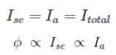

i.e. the field flux is proportional to the entire armature current or the total supply current. And for this reason, the [flux](https://www.electrical4u.com/what-is-flux-types-of-flux/) produced in this motor is strong enough to produce sufficient torque, even with the bare minimum number of turns it has in the field coil.

## Speed & Torque of Series DC Motor

A series wound motors has linear relationship existing between the field current and the amount of torque produced. i.e. torque is directly proportional to current over the entire range of the graph. As in this case relatively higher current flows through the heavy series field winding with thicker diameter, the electromagnetic torque produced here is much higher than normal. This high electromagnetic torque produces motor speed, strong enough to lift heavy load overcoming its initial inertial of rest. And for this particular reason the motor becomes extremely essential as starter motors for most industrial applications dealing in heavy mechanical load like huge cranes or large metal chunks etc. Series motors are generally operated for a very small duration, about only a few seconds, just for the purpose of starting. Because if its run for too long, the high series current might burn out the series field coils thus leaving the motor useless.

## Speed Regulation of Series Wound DC Motor

Unlike in the case of a [DC shunt motor](https://www.electrical4u.com/shunt-wound-dc-motor-dc-shunt-motor/), the DC series motor has very poor speed regulation. i.e. the series motor is unable to maintain its speed on addition of external load to the shaft. Let us see why?  
When mechanical load is added to the shaft at any instance, the speed automatically reduces whatever be the type of motor. But the term speed regulation refers to the ability of the motor to bring back the reduced speed to its original previous value within reasonable amount of time. But this motor is highly incapable of doing that as with reduction in speed N on addition of load, the back emf given by,



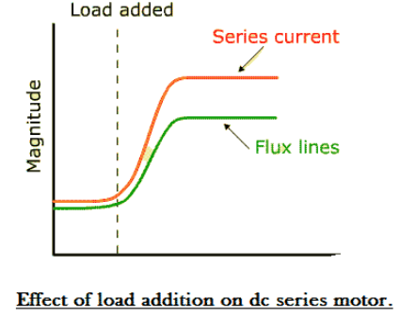

This decrease in back Emf Eb, increases the net voltage E - Eb, and consequently the series field current increases,

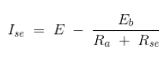

The value of series current through the field coil becomes so high that it tends to saturate of the magnetic core of the field. As a result the magnetic flux linking the coils increases at a much slower rate compared to the increase in current beyond the saturation region as shown in the figure below.  
 The weak magnetic field produced as a consequence is unable to provide for the necessary amount of force to bring back the speed at its previous value before application of load. So keeping all the above mentioned facts in mind, a **series wound DC motor** is most applicable as a starting motor for industrial applications.

**Characteristics of DC motors**

Generally, three characteristic curves are considered important for DC motors which are, (i) Torque vs. armature current, (ii) Speed vs. armature current and (iii) Speed vs. torque. These are explained below for each type of DC motor. These characteristics are determined by keeping the following two relations in mind.

**Ta ∝ ɸ.Ia** and **N ∝ Eb/ɸ**

These above equations can be studied at - emf and torque equation of dc machine. For a DC motor, magnitude of the back emf is given by the same emf equation of a dc generator i.e. Eb = PɸNZ / 60A. For a machine, P, Z and A are constant, therefore, N ∝ Eb/ɸ

### Characteristics of DC series motors

#### Torque vs. armature current (Ta-Ia)

This characteristic is also known as **electrical characteristic**. We know that torque is directly proportional to the product of armature current and field flux, Ta ∝ ɸ.Ia. In DC series motors, field winding is connected in series with the armature, i.e. Ia = If. Therefore, before magnetic saturation of the field, flux ɸ is directly proportional to Ia. Hence, before magnetic saturation Ta α Ia2. Therefore, the Ta-Ia curve is parabola for smaller values of Ia.

After magnetic saturation of the field poles, flux ɸ is independent of armature current Ia. Therefore, the torque varies proportionally to Ia only, T ∝ Ia. Therefore, after magnetic saturation, Ta-Ia curve becomes a straight line.  
The shaft torque (Tsh) is less than armature torque (Ta) due to stray losses. Hence, the curve Tsh vs Ia lies slightly lower. In DC series motors, (prior to magnetic saturation) torque increases as the square of armature current, these motors are used where high starting torque is required.

#### Speed vs. armature current (N-Ia)

We know the relation, N ∝ Eb/ɸ

For small load current (and hence for small armature current) change in back emf Eb is small and it may be neglected. Hence, for small currents speed is inversely proportional to ɸ. As we know, flux is directly proportional to Ia, speed is inversely proportional to Ia. Therefore, when armature current is very small the speed becomes dangerously high. That is **why a series motor should never be started without some mechanical load**.

But, at heavy loads, armature current Ia is large. And hence, speed is low which results in decreased back emf Eb. Due to decreased Eb, more armature current is allowed.

#### Speed vs. torque (N-Ta)

This characteristic is also called as **mechanical characteristic**. From the above two **characteristics of DC series motor**, it can be found that when speed is high, torque is low and vice versa.

[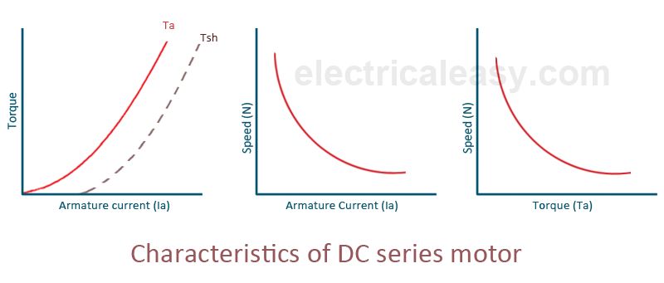](http://3.bp.blogspot.com/-cUu8u-bZm0o/U7qEkWngbRI/AAAAAAAAA58/-7F6w5isurc/s1600/Characteristics+of+DC+series+motor.png)

### Characteristics of DC shunt motors

#### Torque vs. armature current (Ta-Ia)

In case of DC shunt motors, we can assume the field flux ɸ to be constant. Though at heavy loads, ɸ decreases in a small amount due to increased armature reaction. As we are neglecting the change in the flux ɸ, we can say that torque is proportional to armature current. Hence, the Ta-Ia characteristic for a dc shunt motor will be a straight line through the origin.  
Since heavy starting load needs heavy starting current, **shunt motor should never be started on a heavy load**.

#### Speed vs. armature current (N-Ia)

As flux ɸ is assumed to be constant, we can say N ∝ Eb. But, as back emf is also almost constant, the speed should remain constant. But practically, ɸ as well as Eb decreases with increase in load. Back emf Eb decreases slightly more than ɸ, therefore, the speed decreases slightly. Generally, the speed decreases only by 5 to 15% of full load speed. Therefore, **a shunt motor can be assumed as a constant speed motor**. In speed vs. armature current characteristic in the following figure, the straight horizontal line represents the ideal characteristic and the actual characteristic is shown by the dotted line.

[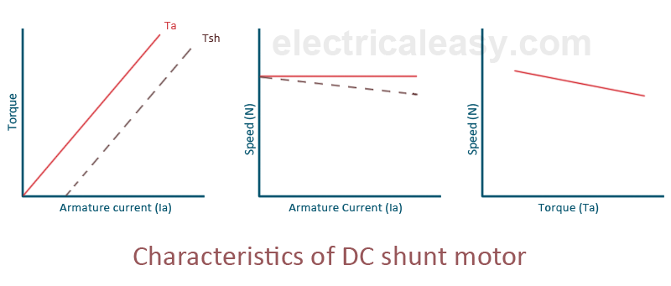](http://1.bp.blogspot.com/-C_FMlkL4L94/U7qF335Ne3I/AAAAAAAAA6E/PkKtiuwDtaI/s1600/Characteristics+of+DC+shunt+motor.png)

### Characteristics of DC compound motor

DC compound motors have both series as well as shunt winding. In a compound motor, if series and shunt windings are connected such that series flux is in direction as that of the shunt flux then the motor is said to be cumulatively compounded. And if the series flux is opposite to the direction of the shunt flux, then the motor is said to be differentially compounded. Characteristics of both these compound motors are explained below.  
**(a) Cumulative compound motor**  
Cumulative compound motors are used where series characteristics are required but the load is likely to be removed completely. Series winding takes care of the heavy load, whereas the shunt winding prevents the motor from running at dangerously high speed when the load is suddenly removed. These motors have generally employed a flywheel, where sudden and temporary loads are applied like in rolling mills.  
**(b) Differential compound motor**  
Since in differential field motors, series flux opposes shunt flux, the total flux decreases with increase in load. Due to this, the speed remains almost constant or even it may increase slightly with increase in load (N ∝ Eb/ɸ). Differential compound motors are not commonly used, but they find limited applications in experimental and research work.

[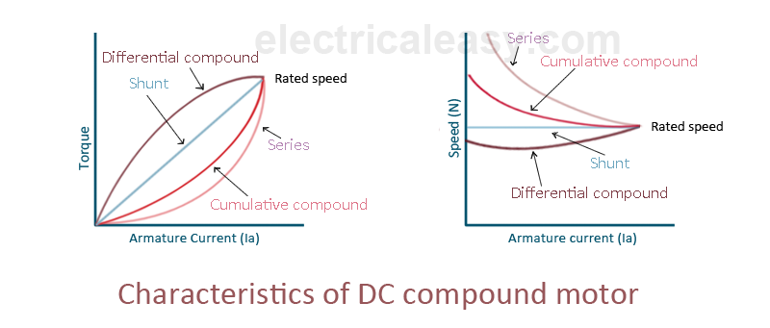](http://4.bp.blogspot.com/-cs_O6WoxO20/U7qGoSQmGnI/AAAAAAAAA6M/Q-TgOKMeQbU/s1600/Characteristics+of+DC+compound+motor.png)