Slip power recovery schemes

Static Kramer Drive

**Definition:** The static Kramer-drive is the method of controlling the speed of an induction motor by injecting the opposite-phase voltage in the rotor circuit. The injected voltage increases the resistance of the rotor, thus controlled the speed of the motor. By changing the injected voltage, the resistance and speed of an induction motor are controlled.

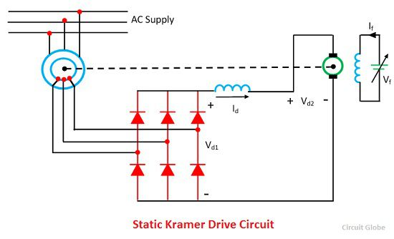

The static Kramer-drive converts the slip power of an induction motor into AC power and supply back to the line. The slip power is the air gap power between the stator and the rotor of an induction motor which is not converted into mechanical power. Thus, the power is getting wasted. The static Kramer drives fed back the wasted power into the main supply. This method is only applicable when the speed of the drive is less than the synchronous speed.

## Static Kramer Drive Working

The rotor slip power is converted into DC by a diode bridge. This DC power is now fed into DC motor which is mechanically coupled to an induction motor. The torque supplied to the load is the total sum of the torque produced by the induction and DC motor drive.

[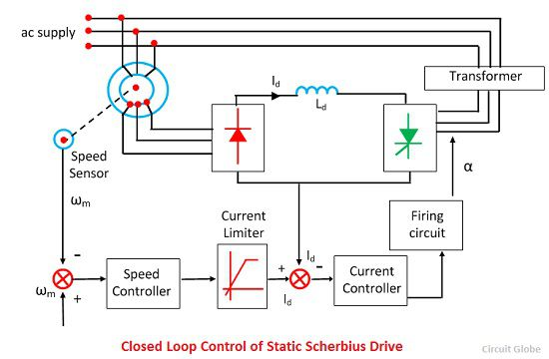](https://circuitglobe.com/wp-content/uploads/2016/11/closed-loop-control-of-static-scherbius-drive.jpg)

The figure shown below represents the variation of Vd1 and Vd2 with a speed of two values of DC motor field current. When the value of Vd1 is equal to the value of Vd2 then the steady state operation of the drive is obtained, i.e., at A and B for field current of If1 and If2.

The speed control is possible only when speed is less or half of the synchronous speed. When the large range speed is required, the diode bridge is replaced by the thyristor bridge. The relationship between the Vd1 and the speed can be altered by controlling the firing angle of thyristor amplifier. Speed can now be controlled up to stand still.

# Static Scherbius Drive

The Static Scherbius Drive provides the speed control of a wound rotor motor below synchronous speed. The portion of rotor AC power is converted into DC by a diode bridge. The controlled rectifier works as an inverter and converts the DC power back into AC and feeds it back to the AC source. This drive has the ability of flow the power both in the positive as well as the negative direction of the injected voltage. This increases the operating condition of the drive.

The feedback power is controlled by controlling the inverter counter emf Vd2, which is controlled by controlling the inverter firing angle.The DC link inverter reduced the ripple in DC link current Id. The slip power of the drive is fed back to the source due to which the efficiency of the drive increases.

[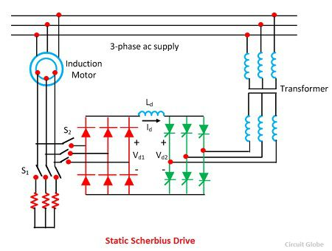](https://circuitglobe.com/wp-content/uploads/2016/11/static-scherbius-drive.jpg)

The drive input power is the difference of the DC input power and the power fed back. Reactive input power is the sum of the motor and input reactive power.Thus, the drive has poor power factor throughout the range of its operation.

[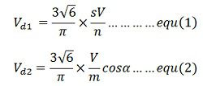](https://circuitglobe.com/wp-content/uploads/2016/11/static-scherbius-drive-equation-1.jpg)Where α is the inverter firing angle and n, and m are respectively the stator to the rotor turn ratio of motor and source side to convert side turns ratio of the transformer. The neglecting drop across the inductor.

[static-scherbius-drive-equation-2](https://circuitglobe.com/wp-content/uploads/2016/11/static-scherbius-drive-equation-2.jpg)

Substituting the equation (1) and (2) in the above equation we get

[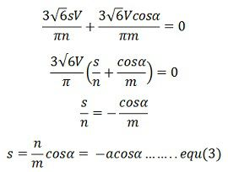](https://circuitglobe.com/wp-content/uploads/2016/11/static-scherbius-drive-equation-3.jpg)

where a = n/m

The maximum value of alpha is restricted to 165º for safe commutation of inverter thyristor. The slip can be controlled from 0 to 0.966α when α is changed from 90º to 165º.The appropriate speed range can be obtained by choosing the appropriate value of α.

The transformer is used to match the voltage from Vd1 and Vd2. At the lowest speed required from the drive, Vd1 will have the maximum value Vd1m, and it is given by

[static-scherbius-drive-equation-4](https://circuitglobe.com/wp-content/uploads/2016/11/static-scherbius-drive-equation-4.jpg)

Where Sm is the value of slip at the lowest speed. If α is restricted to 165, m is chosen such that the inverter voltage has a value Vd1m when α is 165º, i.e.,

[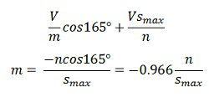](https://circuitglobe.com/wp-content/uploads/2016/11/static-scherbius-drive-equation-5.jpg)

The value of m determines the highest firing angle at the lower motor speed. It also gives the highest firing angle and the lowest reactive power at the lowest speed.

Considered the circuit of the motor, which is neglecting the magnetising branch. When referred to DC link, resistance (sRs + Rr) will be 2(sR’s + Rr). This gives the equivalent circuit of the drive, where Vd1 and Vd2 are given. Rdis the resistance of the DC link inductor.

[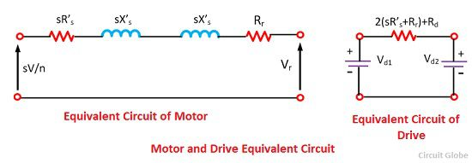](https://circuitglobe.com/wp-content/uploads/2016/11/motor-and-drive-equivalent-circuit.jpg)

[](https://circuitglobe.com/wp-content/uploads/2016/11/static-scherbius-drive-equation-5-1.jpg)

If rotor copper loss is neglected

[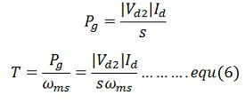](https://circuitglobe.com/wp-content/uploads/2016/11/static-scherbius-drive-equation-8.jpg)

The nature of the speed torque curve is shown in the figure below.

[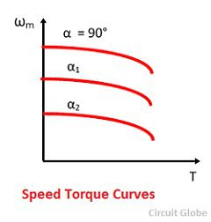](https://circuitglobe.com/wp-content/uploads/2016/11/speed-torque-curves.jpg)

The drive has application in pump drive which requires the speed control in the narrow range only. The drive is widely used in medium and high power fan and pump drives, because of high efficiency and low cost.

### Operating Modes of Static Scherbius Drives

The following are the operating modes of Static Scherbius Drives.

**Sub-synchronous Motoring –**In this mode of operation the slip and torque both are positive and hence the injected voltage is in phase with rotor current. The power flows into the stator and feedback into the rotor circuit.

**Super-synchronous Motoring –**When the speed of the motor is above the synchronous speed, then the slip is negative. Thus, the voltage and current are out of phase with each other.The power feeds into the rotor from the drive circuit along with input power flowing into the stator.

**Sub-synchronous Generating** – For sub-synchronous speed, the torque is required to be positive, although the slip is positive. The power is fed into the rotor through the slip ring.

**Super-synchronous Generating** – When the speed of the motor above the synchronous speed, then the slip and torque becomes negative. Thus, the injecting voltage is in phase with the rotor. The mechanical power is injected by the shaft and the output power is obtained from the stator and rotor circuit.

**SYNCHRONOUS MOTOR DRIVES**

Introduction

Synchronous motor drives are close competitors to induction motor drives in many industrial applications. They are generally more expensive than induction motor drives,but the advantages is that the efficiency is higher,which is tends to lower the life cycle cost. The development of semiconductor variable frequency sources,such as inverters and cycloconverters has allowed their use in variable speed applications such as high power and high speed compressors,blowers ,induced and forced draft fans,main line traction,servo drives etc… Synchronous motor variable speed Drives

Variable frequency control Synchronous speed is directly proportinal to frequency,similar ti induction motors constant flux operation below base speed is achiecved by operating the synchronous motor with constant (V / f) ratio. The synchronous motor either run at synchronous speed (or) it will not run at all. Hence variable frequency control may employ any of the following two modes

1.True synchronous mode

2.Separate controlled mode

3.Self controlled mode

SEPARATE CONTROLLED MODE

This method can also be used for smooth starting and regenerative braking.An example for true synchronous mode is the open loop (V/f) speed control shown in fig

 Separate Controlled Mode

Here all the machines are connected in parallel to the same inverter and they move in response to the command frequency f* at the input.The frequency command f* after passing through the delay circuit is applied to the voltage source inverters (or) a voltage fed PWM inverter.This is done so that the rotor source is able to track the change in frequency.

A flux control black is used which changes the stator voltage with frequency so as to maintain constant flux for speed below base speed and constant terminal voltage for speed above base speed.

The front end of the voltage fed PWM inverter is supplied from utility line through a diode rectifier and LC filter.the machine can be built with damper winding to prevent oscillations.

SELF CONTROLLED MODE

In self controlled mode, the supply frequency is changed so that the synchronous speed is same as that of the rotor speed.Hence, rotor cannot pull-out of slip and hunting eliminations are eliminated. For such a mode of operation the motor does not require a damper winding.



Self Controlled Mode

Fig shows a synchronous permanent magnet machine with self control.The stator winding of the machine is fed by an inverter that generates a variable frequency voltage sinusoidal supply.

Here the frequency and phase of the output wave are controlled by an absolute position sensor mounted on machine shaft, giving it self-control characteristics. Here the pulse train from position sensor may be delayed by the external command as shown in fig.

In this kind of control the machine behavior is decided by the torque angle and voltage/ current. Such a machine can be looked upon as a dc motor having its commutator replaced by a converter connected to stator. The self controlled motor run 4 has properties of a dc motor both under steady state and dynamic conditions and therefore, is called commutator less motor (CLM).These machines have better stability behavior.

Alternatively, the firing pulses for the inverters can also be obtained from the phase position of stator voltages in which case the rotor position sensor can be dispensed with. When synchronous motor is over excited they can supply the reactive power required for commutation thyristors. In such a case the synchronous machine can supply with inverter works similar to the line commutated inverter where the firing signals are synchronized with line voltages.

Here, the firing signals are synchronized with the machine voltages then these voltages can be used both for control as well as for commutation.Hence,the frequency of the inverter will be same as that of the machine voltages. This type of inverters are called load commutated inverter (LCI).Hence the commutation has simple configurations due to the absence of diodes, capacitors and auxiliary thyristors.

But then this natural commutation its not possible at low speeds upto 10% of base speed as the machine voltage are insufficient to provide satisfactory commutation. At that line some forced commutations circuit must be employed.

Self controlled synchronous motor Drive empolying load commuated Thyristor Inverter

In fig wound field synchronous motor is used for large power drives.Permanent magnet synchronous motor is used for medium power drives.This drive consists of two converters.i.e source side converter and load side converter.

The source side converter is a 3 phase 6 pulse line commutated fully controlled rectifier .When the firing angle range 0≤ǂs≤90º,it acts as a commutated fully contrlled rectifier.



During this mode ,output volatge Vds and output current Ids is positive.When the firing angle range is 90º≤ǂs≤180º,it acts as an line commutated inverter.

During this mode,output voltage Vds is negative and output current Ids is positive. When synchronous motor operates at a leading power factor ,thyristors of the load side 3φ converter can be commutated (turn off) by the motor induced voltages in the same way,as thyristors of a 3φ line commutated converter are commutated by supply voltage .Load commutation is defined as commutation of thyristors by induced voltages of load (here load is synchronous motor).



Triggering angle is measured by comparison of induced voltage in the same way as by the comparison of supply voltages in a line commutated converter.Loas side converter operates as a rectifier when the firing angle range is 0≤ǂl≤90º.It gives positive Vdl and Id.

When the firing angle range is 90º≤ǂl≤180º,it gives negative Vdl and positive Id. For 0≤ǂs≤90º, 90º≤ǂl≤180º and with Vds >Vdl,the source side converter works as a line commutated rectifier and load side converter,causing power flow from ac source to the motor,thus giving motoring operation. When firing angles are changed such that 90º≤ǂs≤180º and 0º≤ǂl≤90º,the load side converter operates as a rectifier and source side converter operates as an inverter.

In this condition ,the power flow reverses and machine operates in regerative braking.The magnitude of torque value depends on (Vds – Vdl).Synchronous motor speed can be changed by control of line side converter firing angles.

When working as an inverter ,the firing angle has to be less than 180º to take care of commutation overlap and turn off of thyristors.The commutation lead angle for load side converter is βl =180º -αl

if commutation overlap is neglected ,the input ac current of the converter will lag behind input ac voltage by angle ǂl.Here synchronous motor input current has an opposite phase to converter input current,the motor current will lead its terminal voltage by a commutation lead angle ǃl. Therefore the synchronous motor operates at a leading power factor. The commutation lead angle is low value, due ti this higher the motor power factor and lower the inverter rating.