**Unit-2**

**Generator Principle :**

An electric generator is a machine that converts mechanical energy into electrical energy. An electric generator is based on the principle that whenever flux is cut by a conductor, an e.m.f. is induced which will cause a current to flow if the conductor circuit is closed. The direction of induced e.m.f. (and hence current) is given by Fleming’s right hand rule. Therefore, the essential components of a generator are:

(a) A magnetic field

(b) Conductor or a group of conductors

(c) Motion of conductor w.r.t. magnetic field.

**Simple Loop Generator :**

Consider a single turn loop ABCD rotating clockwise in a uniform magnetic field with a constant speed as shown in Fig.(1.1). As the loop rotates the flux linking the coil sides AB and CD changes continuously. Hence the e.m.f. induced in these coil sides also changes but the e.m.f. induced in one coil side adds to that induced in the other.

(i) When the loop is in position no. 1 [See Fig. 1.1], the generated e.m.f. is zero because the coil sides (AB and CD) are cutting no flux but are moving parallel to it

(ii) When the loop is in position no. 2, the coil sides are moving at an angle to the flux and, therefore, a low e.m.f. is generated as indicated by point 2 in Fig. (1.2).

(iii) When the loop is in position no. 3, the coil sides (AB and CD) are at right angle to the flux and are, therefore, cutting the flux at a maximum rate. Hence at this instant, the generated e.m.f. is maximum as indicated by point 3 in Fig. (1.2).

(iv) At position 4, the generated e.m.f. is less because the coil sides are cutting the flux at an

angle.

(v) At position 5, no magnetic lines are cut and hence induced e.m.f. is zero as indicated by point 5 in Fig. (1.2).

(vi) At position 6, the coil sides move under a pole of opposite polarity and hence the direction of generated e.m.f. is reversed. The maximum e.m.f. in this direction (i.e., reverse direction, See Fig. 1.2) will be when the loop is at position 7 and zero when at position 1. This cycle repeats with each revolution of the coil.

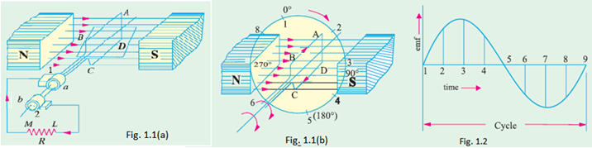

Note that e.m.f. generated in the loop is alternating one. It is because any coil side says AB has e.m.f. in one direction when under the influence of N-pole and in the other direction when under the influence of S-pole. If a load is connected across the ends of the loop, then alternating current will flow through the load. The alternating voltage generated in the loop can be converted into direct voltage by a device called commutator. We then have the d.c. generator. In fact, a commutator is a mechanical rectifier.

**Action of Commutator:**

Commutator consists of a cylindrical metal ring cut into two halves or segments C1 and C2 respectively separated by a thin sheet of mica. The commutator is mounted on but insulated from the rotor shaft. The ends of coil sides AB and CD are connected to the segments C1 and C2 respectively as shown in Fig. (1.4). Two stationary carbon brushes rest on the commutator and lead current to the external load. With this arrangement, the commutator at all times connects the coil side under S-pole to the +ve brush and that under N-pole to the -ve brush.

(i) In Fig. (1.4), the coil sides AB and CD are under N-pole and S-pole respectively. Note that segment C1 connects the coil side AB to point M of the load resistance R and the segment C2 connects the coil side CD to point L of the load. Also note the direction of current through load. It is from L to M.

(ii) After half a revolution of the loop (i.e., 180° rotation), the coil side AB is under S-pole and the coil side CD under N-pole as shown in Fig. (1.5).The currents in the coil sides now flow in the reverse direction but the segments C1 and C2 have also moved through 180° i.e., segment C1 is now in contact with +ve brush and segment C2 in contact with -ve brush.

Note that commutator has reversed the coil connections to the load i.e., coil side AB is now connected to point L of the load and coil side CD to the point M of the load. Also note the direction of current through the load. It is again from L to M.

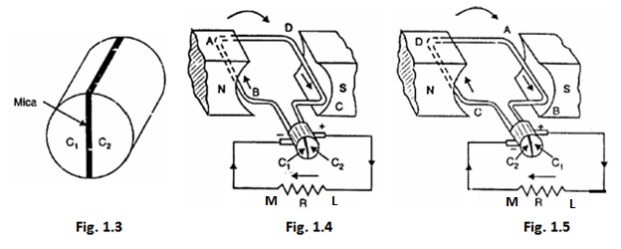

Thus the alternating voltage generated in the loop will appear as direct voltage across the brushes.

The variation of voltage across the brushes with the angular displacement of the loop will be as shown in Fig. 1.6. This is not a steady direct voltage but has a pulsating character. It is because the voltage appearing across the brushes varies from zero to maximum value and back to zero twice for each revolution of the loop. A pulsating direct voltage such as is produced by a single loop is not suitable for many commercial uses. What we require is the steady direct voltage. This can be achieved by using a large number of coils connected in series. The resulting arrangement is known as armature winding.

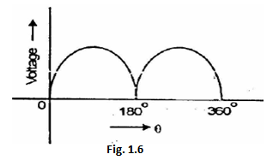

**Construction of a Practical D.C. Machine**

 As stated earlier, whether a machine is d.c. generator or a motor the construction basically remains the same as shown in the Fig. 1.

|  |
| --- |
|  |
| **Fig.1 A cross section of typical d.c. machine** |

It consists of the following parts:

**1. Yoke**

a) Functions:

1. It serves the purpose of outermost cover of the d.c. machine. So that the insulating materials get protected from harmful atmospheric elements like moisture, dust and various gases like SO2, acidic fumes etc.
2. It provides mechanical support to the poles.
3. It forms a part of the magnetic circuit. It provides a path of low reluctance for magnetic flux. The low reluctance path is important to avoid wastage of power to provide same flux. Large current and hence the power is necessary if the path has high reluctance, to produce the same flux.

b) Choice of Material: To provide low reluctance path, it must be made up of some magnetic material. It is prepared by using cast iron because it is cheapest. For large machines rolled steel, cast steel is used which provides high permeability i.e. low reluctance and gives good mechanical strength.

**2. Poles**

       Each pole is divided into two parts namely, I) Pole core and II) Pole shoe.

       This is shown in the Fig. 2.

|  |
| --- |
| <http://2.bp.blogspot.com/-Y9bLit_X8r0/UDbA4eVEC2I/AAAAAAAAGHY/Gf7zKPxOLU4/s1600/ccc137.jpeg> |
| **Fig. 2 Pole Structure** |

**a**) Functions of pole core and pole shoe:

Pole core basically carries a field winding which is necessary to produce the flux.

It directs the flux produced through air gap to armature core, to the next pole. Pole shoe enlarges the area of armature core to come across the flux, which is necessary to produce larger induced e.m.f. To achieve this, pole shoe has been given a particular shape.

b) Choice of Material: It is made up of magnetic material like cast iron or cast steel. As it requires a definite shape and size, laminated construction is used. The laminations of required size and shape are stamped together to get a pole which is then bolted to the yoke.

**3. Field Winding (F1-F2)**

       The field winding is wound on the pole core with a definite direction.

a) Functions: To carry current due to which pole core, on which the field winding is placed, behaves as an electromagnet, producing necessary flux.

       As it helps in producing the magnetic field i.e. exciting the pole as an electromagnet it is called Field winding or Exciting winding.

b) Choice of material: It has to carry current hence obviously made up of some conducting material. So aluminum or copper is the choice. But field coils are required to take any type of shape and bend about pole core and copper has good flexibility i.e. it can bend easily. So copper is the proper choice.

**4. Armature**

       It is further divided into two parts namely,

I) Armature core and II) Armature winding

I) Armature core: Armature core is cylindrical in shape mounted on the shaft. It consists of slots on its periphery and the air ducts to permit the air flow through armature which serves cooling purpose.

a) Functions:

Armature core provides house for armature winding i.e. armature conductors.

To provide a path of low reluctance to the magnetic flux produced by the field winding.

b) Choice of Material: As it has to provide a low reluctance path to the flux, it is made up of magnetic material like cast iron or cast steel.

       It is made up of laminated construction to keep eddy current loss as low as possible. A single circular lamination used for the construction of the armature core is shown in the Fig. 4

|  |
| --- |
| <http://2.bp.blogspot.com/-CkZsj1iFNv4/UDbBpIqA2lI/AAAAAAAAGHg/y1NMKMLOamY/s1600/ccc138.jpeg> |
| **Fig. 4 Single Circular lamination of Armature core** |

II) Armature winding: Armature winding is nothing but the interconnection of the armature conductors, placed in the slots provided on the armature core periphery. When the armature is rotated, in case of generator, magnetic flux gets cut by armature conductors and e.m.f. gets induced in them.

a) Functions:

Generation of e.m.f takes place in the armature winding in case of generators.

To carry the current supplied in case of d.c. motors.

To do the useful work in the external circuit.

b) Choice of material: As armature winding carries entire current which depends on external load, it has to be made up of conducting material, which is copper.

       Armature winding is generally former wound. The conductors are placed in the armature slots which are lined with tough insulating material.

**5. Commutator**

We have seen earlier that the basic nature of e.m.f. induced in the armature conductors is alternating. This needs rectification in case of d.c. generator, which is possible by a device called commutator.

a) Functions:

To facilitate the collection of current from the armature conductors.

To convert internally developed alternating e.m.f. to unidirectional (d.c.) e.m.f.

To produce unidirectional torque in case of motors.

b) Choice of material: As it collects current from armature, it is also made up of copper segments.

       It is cylindrical in shape and is made up of wedge shaped segments of the hard drawn, high conductivity copper. These segments are insulated from each other by thin layer of mica. Each commutator segment is connected to the armature conductor by means of copper lug or strip. This connection is shown in the Fig. 5.

|  |
| --- |
| <http://3.bp.blogspot.com/-FW7wfttb1Eo/UDbCNQTBcZI/AAAAAAAAGHo/Jc1fMEVLRyg/s1600/ccc139.jpeg> |
| **Fig. 5 Commutator** |

**6. Brushes and Brush Gear**

       Brushes are stationary and resting on the surface of the commutator.

a) Function: To collect current from commutator and make it available to the stationary external circuit.

b) Choice of material: Brushes are normally made up of soft material like carbon.

       Brushes are rectangular in shape. They are housed in brush holders, which are usually of box type. The brushes are made to press on the commutator surface by means of a spring, whose tension can be adjusted with the help of lever. A flexible copper conductor called pig tail is used to connect the brush to the external circuit. To avoid wear and tear of commutator, the brushes are made up of soft material like carbon, Graphite and copper.

**7. Bearings**

       Ball-bearings are usually used as they are more reliable. For heavy duty machines, roller bearings are preferred.

## Armature Winding

Armature winding is an arrangement of conductors to develop desired emfs by relative motion in a magnetic field. In winding, conductor or group of conductors are distributed in different ways in slots all over the periphery of the armature. The conductors may be connected in series and parallel combinations depending upon the current and voltage rating of the machine.

### Terminology

It is necessary to understand some of the important terms before discussing winding. The most commonly used term in describing a winding are given below.

**Conductor**

Each individual length of wire lying within the magnetic field is called the conductor. Symbol Z will be used for the total number of conductors in the armature winding.

**Turn**

The two conductors lying in a magnetic field are connected in series is called a turn.So that the resultant induced emf becomes double (assuming full pitch coil) of that due to one conductor.

**Coil**

When one or more turns are connected in series and the two ends of it are connected to adjacent commutator segments (in lap winding) it is termed as a coil. Signal turn and multi-turn coils are shown in Fig. 1 (a) and 1 (b) respectively. Multi-turn coils are used when total number of armature conductors is excessive and it is not feasible to use single turn coils, because it will required large number of commutator segments and if used it will not give sparkless commutation and it will not be economical due of more copper in end connections. Symbol C will be used for the total number of coils symbol C will winding.

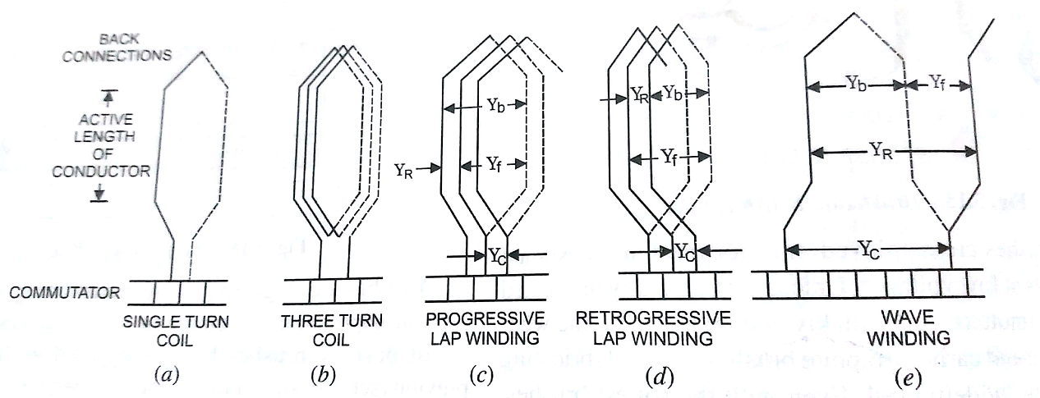

Fig. 1

**Coil side**

Each coil, signal-turn or multi-turn, has two sides called the coil sides, embedded in two different slots nearly a pole pitch apart.

**Coil Group**

A coil group may have one or more single coils.

**Front End Connector**

A wire that connects the end of a coil to commutators segments is called the front end connector.

**Back End Connector**

A wire that connects one side of coil to the other side of the coil is called the back end connector. It is on the end opposite to that of commutator.

**Pole Pitch**

It is defined as the number of conductors per pole. If there are 54 conductors for 6 poles then pole pitch will be equal to 54/6 i.e. 9 conductors per pole.

**Front Pitch**

It is defined as the distance in terms of number of armature conductors between the second conductor of one coil and the first conductor of next coil which are connected to the same commutator segment on the front or commutator end. It is represented by Y_f‘ as shown in Figs. 1 (c), (d) and (e).

**Back Pitch**

It is defined as the distance in terms of number of armature conductors between the last and the first conductors of the coil. It is also called the coil span or coil spread. It is denoted by Y_b as illustrated in Figs. 1 (c), (d), and (e).

**Resultant Pitch**

It is defined as the distance in terms of number of conductors between the start of one coil and start of next coil to which it is connected. It is denoted by Y_R, as illustrated i figs. 1 (c), (d), and (e).

**Commutator Pitch**

It is defined as the distance measured in terms of commutator segments between the segments to which the two ends of a coil are connected. It is denoted by Y_c as shown in Figs. 1 (c), (d) and (e).

Coil Span or Coil pitch. When the coil span of the winding is equal to pole pitch, the coils are called the full pitched coils. Full pitched coils have the advantage of giving maximum emf induced in the coil. Coils 1, 2 and 3 shown in Fig. 2 are short-pitched, full-pitched and over-pitched coils respectively.

Since coil No. 1 has span less than the pole pitch, during the revolution of armature there will be an instant during which both sides of such coils will be under the influence of one and the same pole so emf induced in these two sides of the coil will be in opposition. Similarly, there will be an instant during which both sides of an over-pitched coil will be under the influence of two similar poles and emf induced in the two sides of such a coil will be in opposition.

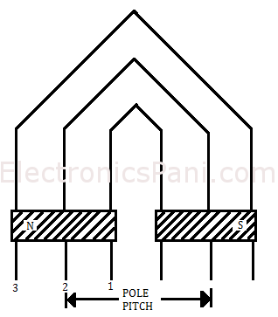

Figure 2: Pole Pitch (short-pitched, full-pitched and over-pitched)

**Types of Armature Winding**

The armature conductors are connected in specific manner as per the requirements, which is called armature winding. According to the way of connecting the conductors, armature winding has basically two types namely,

a) Lap winding          b) Wave winding

1. **Lap winding:**

Lap winding is the winding in which successive coils overlap each other. It is named "Lap" winding because it doubles or laps back with its succeeding coils.

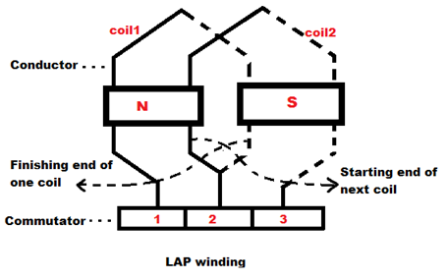

In this winding the finishing end of one coil is connected to one commutator segment and the starting end of the next coil situated under the same pole and connected with same commutator segment. Here we can see in picture, the finishing end of coil - 1 and starting end of coil - 2 are both connected to the commutator segment - 2 and both coils are under the same magnetic pole that is N pole here.

**Lap winding** are of two types –

## Simplex Lap Winding

A winding in which the number of parallel path between the brushes is equal to the number of poles is called **simplex lap winding**.

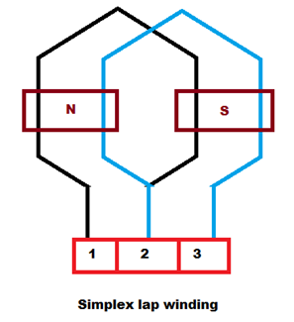 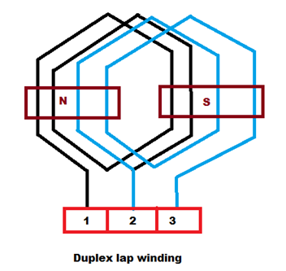

## Duplex Lap Winding

A winding in which the number of parallel path between the brushes is twice the number of poles is called **duplex lap winding**.

Some important points to remember while designing the Lap winding:

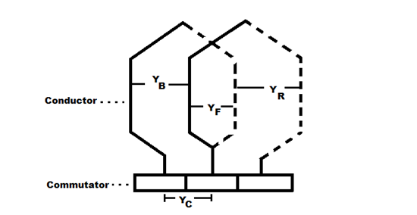

If, Z = the number conductors

P = number of poles

YB = Back pitch

YF = Front pitch

YC = Commutator pitch

YA = Average pole pitch

YP = Pole pitch

YR = Resultant pitch

Then, the back and front pitches are of opposite sign and they cannot be equal.

* YB = YF ± 2m m = multiplicity of the winding.
* m = 1 for Simplex Lap winding
* m = 2 for Duplex Lap winding
* When, YB > YF, it is called progressive winding.
* YB < YF, it is called retrogressive winding.
* Back pitch and front pitch must be odd.
* Resultant pitch (YR) = YB - YF = 2m
* YR is even because it is the difference between two odd numbers.

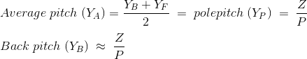

* Commutator pitch (YC) = ±m
* Number of parallel path in the Lap winding = mP

### Construction of Lap Winding

Let us develop a simplex and progressive Lap winding diagram of a machine having 16 conductor in 16 slots and 4 poles.

YA = 16/4 = 4

YB+YF = 8 ------1

YB-YF = 2 ------2

Therefore YB = 5 and YF = 3

Let us start from 1st conductor,

|  |  |
| --- | --- |
| **Back connections** | **Front connections** |
| 1 to (1+YB) = (1+5) = 6 | 6 to (6-YF) = (6 - 3) = 3 |
| 3 to (3+5) = 8 | 8 to (8-3) = 5 |
| 5 to (5+5) = 10 | 10 to (10-3) = 7 |
| 7 to (7+5) = 12 | 12 to (12-3) = 9 |
| 9 to (9+5) = 14 | 14 to (14-3) = 11 |
| 11 to (11+5) = 16 | 16 to (16-3) =13 |
| 13 to (13+5) = 18 = (18-16) = 2 | 2 to (18-3) = 15 |
| 15 to (15+5) = 20 = (20-16) = 4 | 1. to (20-3) = 17 = (17-16) = 1 |

### simplex lap winding

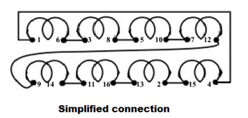

### Advantages of Lap Winding

1. This winding is necessarily required for large current application because it has more parallel paths.
2. It is suitable for low [voltage](https://www.electrical4u.com/voltage-or-electric-potential-difference/) and high current generators.

### Disadvantages of Lap Winding

1. It gives less emf compared to wave winding. This winding requires more no. of conductors for giving the same emf, it results high winding cost.
2. It has less efficient utilization of space in the armature slots.

**2. Wave Winding**

**Wave winding** is one type of armature winding. In this winding, we connect the end of one coil to the starting of another coil of the same polarity as that of the first coil. In this type of winding the coil side (A - B) progresses forward around the armature to another coil side and goes on successively passing through N and S pole till it returns to a conductor (A1-B1) lying under the starting pole.

This winding forms a wave with its coil, that’s why we call it as **wave winding**. Since we connect the coils in series here, we also call it series winding.

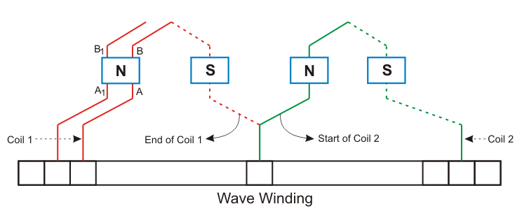

## Progressive Wave Winding

If after one round of the armature the coil falls in a slot right to its starting slot the winging is called Progressive wave winding.

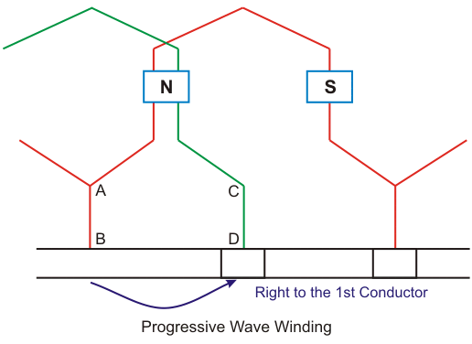

## Retrogressive Wave Winding

If after one round of the armature the coil falls in a slot left to its starting slot the winging is called **Retrogressive wave winding**.

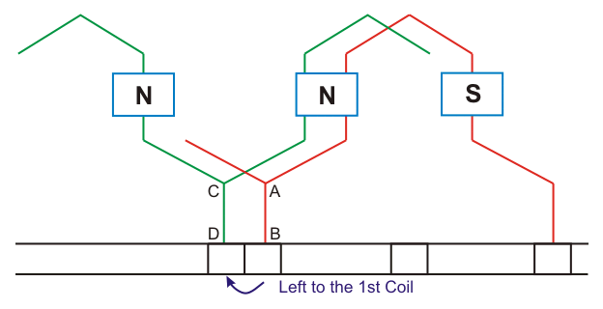

Here in the picture above we can see that 2nd conductor CD is in the left of the 1st [conductor](https://www.electrical4u.com/electrical-conductor/).

#### Important Points about Wave Winding

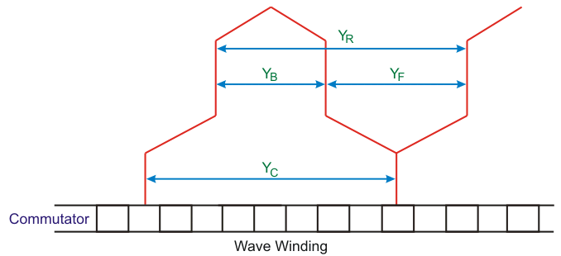

In simplex wave winding Back pitch (YB) and front pitch (YF) are both odd and are of same sign.

Back-pitch and front-pitch are nearly equal to the pole pitch and may be equal or differ by ±2.

+ for progressive winding, - for retrogressive winding.

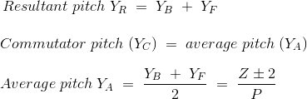

Here, Z is the no of conductors in the winding.

P is the no of poles.

Average pitch (YA) must be an integer number, because it may close itself. We take ± 2 (two) because after one round of the armature the winding falls sort of two conductors. If we take an average pitch Z/P then after one round the winding will close itself without including all coil sides. Since average pitch must be an integer, this winding is not possible with any no. of conductors.

Let us take 8 conductors in a 4 pole machine. https://www.electrical4u.com/electrical/machine-equation/motor-equation/wave-winding-2.gif

Being fractional number the wave winding is not possible but if there was 6 conductors then the winding can be done. Since, https://www.electrical4u.com/electrical/machine-equation/motor-equation/wave-winding-7.gif

For this problem the DUMMY COILS are introduced.

### Dummy Coil

The wave winding is possible only with particular number of [conductors](https://www.electrical4u.com/electrical-conductor/) and slots combinations. It is not always possible to have the standard stampings in the winding shop consist of the number of slots according to the design requirements. In such cases dummy coils are employed. These coils are placed in the slots to give the machine the mechanical balance but they are not electrically connected to the rest of the winding.

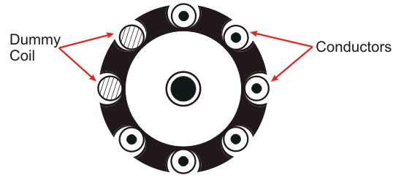

In multiplex wave winding … https://www.electrical4u.com/electrical/machine-equation/motor-equation/wave-winding-3.gifm is the multiplicity of the

winding. m = 1 for simplex winding m = 2 for duplex winding.

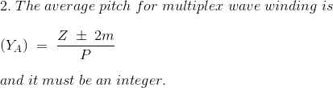

### Construction of Wave Winding

Let us develop a simplex and progressive wave winding diagram of a machine having 34 conductor in 17 slots and 4 poles.

**Average pitch:**

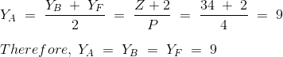

Now we have to construct a table for the connection diagram:

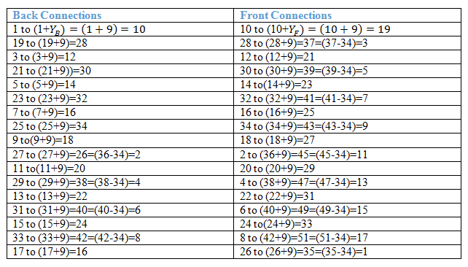

### Winding Diagram

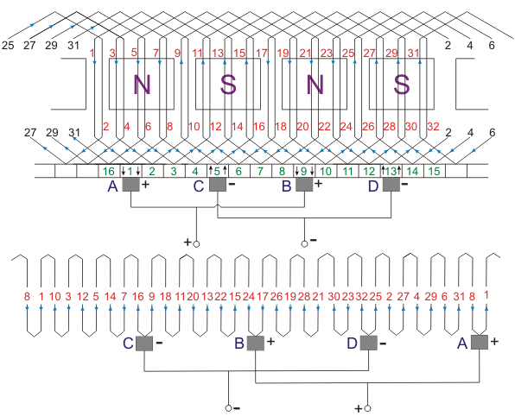



### Characteristics and Advantage of Simplex Wave Winding

1. In this winding only two brushes are required but more parallel brushes can be added to make it equal to the no. of poles. If one or more brushes set poor contacts with the commutator, satisfactory operation is still possible.
2. This winding gives sparkles commutation. The reason behind that it has two parallel paths irrespective of no of poles of the machine. The conductors in each of the two parallel path distributed around the armature in the entire circumference.
3. No. of conductors in each path = Z/2, Z is the total no. of conductors.
4. Generated emf = average emf induced in each path X Z/2
5. For a given no of poles and armature conductors it gives more emf than that of lap winding. Hence **wave winding** is used in high voltage and low current machines. This winding is suitable for small generators circuit with voltage rating 500-600V.
6. Current flowing through each conductor.

https://www.electrical4u.com/electrical/machine-equation/motor-equation/wave-winding-6.gif

1. Ia is the armature current. Current per path for this kind of winding must not be exceeded 250A.
2. Resultant emf around the entire circuit is zero.

#### Disadvantage of simplex wave winding

* 1. **Wave winding** cannot be used in the machines having higher current rating because it has only two parallel paths.

**3. Comparison of Lap and Wave Type Winding:**

|  |  |
| --- | --- |
| **Lap Winding** | **Wave Winding** |
| 1. In this winding all the pole groups of the coils generating e.m.f in the same direction at any instant of time are connected in parallel by the brushes | 1. In this winding all the coils carrying current in the same direction are connected in series i.e., coils carrying current in one direction are connected in one series circuit and coils carrying current in opposite direction are connected in other series circuit. |
| 2. Lap winding is also known as parallel windings. | 2. Wave winding is also known as series winding. |
| 3. The number of parallel path is equal to the number of poles i.e., A = P. | 3. The number of parallel paths is always equal to 2 i.e., A = 2. |
| 4. The number of brush required by this winding is always equal to the number of poles. | 4. The number of brushes required by this winding is always equal to 2. |
| 5. The machine using lap winding requires equalizer rings for obtaining better commutation. | 5. The machine using wave winding does require dummy coils to provide the mechanical balance for the armature. |
| 6. Lap windings are used for low voltage and high current machines. | 6. Wave windings are used for high voltage and low  current machines. |

### Closed and Open Windings

     Armature windings are classified into two different types namely i) Closed type winding ii) Open type winding.

**1. Closed Type Winding**

       In this type of winding, a closed path is formed around the armature. The starting point of the winding is reached again after passing through all the turns. The current passing through closed type of winding is through brushes placed on commutator. The commutator segments are connected to various armature coils.

              The closed type of winding is normally used in d.c. machines.

**2.Open Type Winding**

       In case of a.c. machines, commutator is not used and hence closed winding is not required to be used. The armature is left open at one or more points.

       The ends of each section of the winding can be brought at the terminals to do the required type of interconnection externally. The open type of winding is preferred over closed type as it gives better flexibility in design and freedom of connections.

       These types of windings are either single layer type or double layer type and are mainly used in induction machines and synchronous machines.

**E.M.F. Equation of D.C. Generator**

Let       P = Number of poles of the generator

            Φ = Flux produced by each pole in webers (Wb)

            N = Speed of armature in r.p.m.

             Z = Total Number of Armature Conductors

             A = Number of parallel paths in which the 'Z' number of conductors are divided

       So        A = P for lap type of winding

                   A = 2 for wave type of winding

       Now, according to Faraday's law of electromagnetic induction, the average value of e.m.f. induced in a conductor.

       e = Rate of cutting the flux = dΦ/dt

       In one revolution, conductor will cut total flux produced by all the poles i.e. Φ x P.

While time required to completing one revolution is 60/N seconds as speed is N r.p.m.

[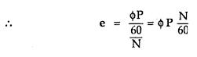](http://4.bp.blogspot.com/-O06KLo6mi5w/UDblLNi98JI/AAAAAAAAGJo/hEp0pPQs9is/s1600/ccc144.jpeg)

       This is the e.m.f. induced in one conductor. There are Z conductors with ‘A’ parallel paths, hence conductors in each parallel path are Z/A.

Total e.m.f. can be expressed as,

[http://3.bp.blogspot.com/-_efcHle8bUc/UDbm1dBKyTI/AAAAAAAAGKY/XLRntU_OaUY/s1600/ccc150.jpeg](http://3.bp.blogspot.com/-_efcHle8bUc/UDbm1dBKyTI/AAAAAAAAGKY/XLRntU_OaUY/s1600/ccc150.jpeg)

This is nothing but the e.m.f. equation of a d.c. generator.

[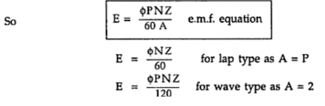](http://4.bp.blogspot.com/-kN25l7A7QsQ/UDblZYECjDI/AAAAAAAAGJw/WJ0iGo4sxKk/s1600/ccc145.jpeg)

**Armature Reaction:**

The effect of armature flux (Flux due to current flows through armature conductors) on the main flux is known as armature reaction.

**Explanation of Armature Reaction:**

With no current in armature conductors, the M.N.A (Magnetic neutral axis) coincides with G.N.A (Geometric neutral axis). However, when current flows in armature conductors, the combined action of main flux and armature flux shifts the M.N.A. from G.N.A. In case of a generator, the M.N.A. is shifted in the direction of rotation of the machine. In order to achieve spark less commutation, the brushes have to be moved along the new M.N.A. Under such a condition, the armature reaction produces the following two effects:

1. It demagnetizes or weakens the main flux.

2. It cross-magnetizes or distorts the main flux.

Let us discuss these effects of armature reaction by considering a 2-pole generator (though the following remarks also hold good for a multi polar generator).

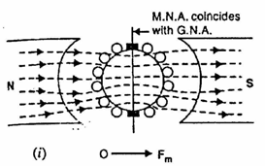

Fig. (i) Shows the flux due to main

poles (main flux) when the armature conductors carry no current.

The flux across the air gap is uniform.

The m.m.f. producing the main flux is represented in magnitude and direction by the vector OFm.

Note that OFm is perpendicular to G.N.A.

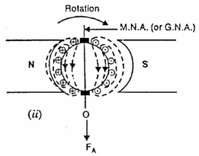Fig. (ii) Shows the flux due to

current flowing in armature conductors alone (main poles unexcited). The armature conductors to the left of G.N.A. carry current “in” (+) and those to the right carry current “out” (•).

The direction of magnetic lines of

force can be found by cork screw rule. It is clear that armature flux is directed downward parallel to the brush axis.

The m.m.f. producing the armature

flux is represented in magnitude and direction by the vector OFA.

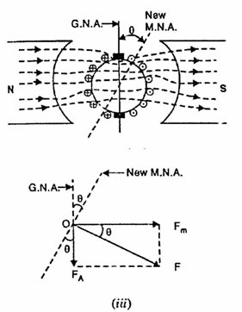

Fig. (iii) Shows the flux due to the main poles and that due to current in armature conductors acting together.

The resultant m.m.f. OF is the

vector sum of OFm and OFA as shown in Fig. (iii). since M.N.A. is always perpendicular to the resultant m.m.f., the M.N.A. is shifted through an angle ϴ.

Note that M.N.A. is shifted in the direction of rotation of the generator.

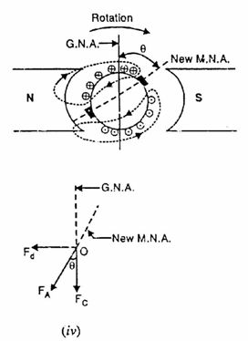

In order to achieve sparkles

commutation, the brushes must lie along the M.N.A. Consequently, the brushes are shifted through an angle ϴ so as to lie along the new M.N.A. as shown in Fig.(iv).

Due to brush shift, the m.m.f. FA of the armature is also rotated through the same angle ϴ. It is because some of the conductors which were earlier under N-pole now come under S-pole and vice-versa.

The result is that armature m.m.f. FA will no longer be vertically downward but will be rotated in the direction of rotation through an angle ϴ as shown in Fig. (iv). Now FA can be resolved into rectangular components Fc and Fd.

(a) The component Fd is in direct opposition to the mmf OFm due to main poles. It has a demagnetizing effect on the flux due to main poles. For this reason, it is called the demagnetizing or weakening component of armature reaction.

(b) The component Fc is at right angles to the mmf OFm due to main poles. It distorts the main field. For this reason, it is called the cross magnetizing or distorting component of armature reaction.

### Demagnetizing and Cross Magnetizing Conductors

  The conductors which are responsible for producing demagnetizing and distortion effects are shown in the Fig.1.

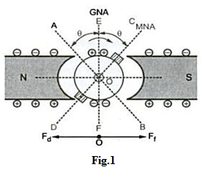

       The brushes are lying along the new position of MNA which is at angle θ from GNA. The conductors in the region AOC = BOD = 2θ  at the top and bottom of the armature are carrying current in such a direction as to send the flux in armature from right to left. Thus these conductors are in direct opposition to main field and called demagnetizing armature conductors.

        The remaining armature conductors which are lying in the region AOD and BOC carry current in such a direction as to send the flux pointing vertically downwards i.e. at right angles to the main field flux. Hence these conductors are called cross magnetizing armature conductors which will cause distortion in main field flux.

       These conductors are shown in the Fig. 2

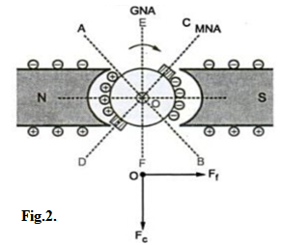

Calculation of Demagnetizing and Cross Magnetizing Amp-Turns

       Let us the number of demagnetizing and cross magnetizing amp-turns.

       Let      Z    = Total number of armature conductors

                   P = Number of poles

                   I = Armature conductor current in Amperes

                     = Ia/2 for simplex wave winding

                     = Ia/P for simplex lap winding

                θm = Forward lead of brush in mechanical degrees.

       The conductors which are responsible for demagnetizing ampere-turns are lying in the region spanning 4θm degrees. The region is between angles AOC and BOD, as shown in the Fig. 2. Total number of armature conductors lying in angles AOC and BOD.

[http://4.bp.blogspot.com/-1fW748_H8_c/UDrcqtCQU_I/AAAAAAAAGRU/oYQmpRdTgTQ/s1600/ccc164.jpeg](http://4.bp.blogspot.com/-1fW748_H8_c/UDrcqtCQU_I/AAAAAAAAGRU/oYQmpRdTgTQ/s1600/ccc164.jpeg)

   Since two conductors form one turn,

[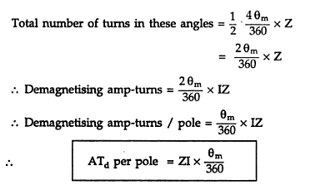](http://3.bp.blogspot.com/-NoZz-40lC1I/UDrcx9wqSdI/AAAAAAAAGRc/oNSmExbT84w/s1600/ccc165.jpeg)

       The conductor which are responsible for cross magnetizing ampere turns are lying between the angles AOD and BOC, as shown in the Fig.2.

       Total armature-conductors / pole = Z/P

       From above we have found an expression for demagnetizing conductors per pole.

[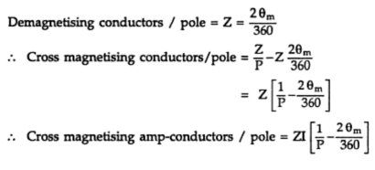](http://4.bp.blogspot.com/-5V1JXSOVIg0/UDrdAO0SwuI/AAAAAAAAGRk/DiqE69epiU8/s1600/ccc166.jpeg)

[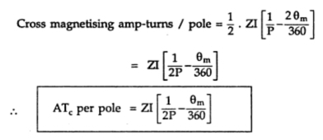](http://4.bp.blogspot.com/-goYI7xZt0Qw/UDrdI2SAfpI/AAAAAAAAGRs/DYceKir5b-w/s1600/ccc167.jpeg)

       If the brush shift angle is given in electrical degrees then it should be converted into mechanical degrees by using the relation,

[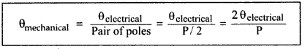](http://1.bp.blogspot.com/-pYug7SAvY1g/UDrdPti_zxI/AAAAAAAAGR0/Cz0vj0mqMZg/s1600/22.png)

### Compensation of Armature Reaction

 In order to reduce the effect of armature reaction following methods are used.

1) The armature reaction causes the distortion in main field flux. This can be reduced if the reluctance of the path of the cross-magnetizing field is increased. The armature teeth and air gap at pole tips offer reluctance to armature flux. Thus by increasing length of air gap, the armature reaction effect is reduced.

2) The effect of armature reaction can be neutralized by use of compensating winding. It is always placed in series with armature winding. The armature ampere conductors under pole shoe must be equal to compensating winding ampere conductors which will compensate armature m.m.f. perfectly.

3) The armature reaction causes shifting the magnetic neutral axis. Therefore there will be some flux density at brush axis which produces e.m.f. in the coil undergoing commutation. This will lead to delayed commutation. Thus the armature reaction at brush axis must be neutralized. This requires another equal and opposite m.m.f. to that of armature m.m.f. This can be applied by inter poles which are placed at geometric neutral axis at midway between the main poles.

       Out of the different methods mentioned above, compensating winding method is very popularly used in actual practice for d.c. machines.

**Compensating winding:**

       The compensating windings are basically used to neutralize the armature flux in the pole arc region which will otherwise cause severe distortion of main field flux. These windings are of concentric type and are placed in axial slots in the pole faces as sown in the Fig. 1.

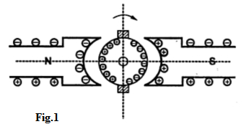

       The symbolic representation of compensating winding is shown in the Fig. 2.

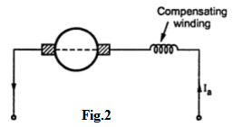

      These windings are connected in series with the armature. The current in this windings flow in opposite direction to that in armature conductors below the pole shoes. This will counterbalance the cross magnetizing effect of armature reaction.

Note: To have perfect neutralization of armature m.m.f. under the pole shoe, the ampere conductors of compensating winding must be equal to total armature ampere conductors under the pole shoe.

       Ampere turns per pole for compensating winding

[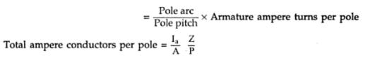](http://4.bp.blogspot.com/-gi7hw2_0v44/UDt4R4c_TVI/AAAAAAAAGTE/fQrXPrb9nJs/s1600/ccc170.jpeg)

[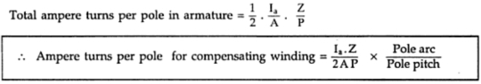](http://3.bp.blogspot.com/-Oj-TBlxA5DY/UDt4Xx7NEGI/AAAAAAAAGTM/FnhLJkLhda4/s1600/ccc171.jpeg)

       Since the distortion of armature m.m.f. and compensating winding m.m.f. is not identical the complete neutralization of armature m.m.f. cannot be achieved by using compensating winding. The armature m.m.f. under the pole shoe is neutralized whereas there is incomplete neutralization in the interpolar region. There will be small flux density remaining unneutralized in GNA. This can be neutralized by using interpole windings.

       Thus by using interpole as well as compensating windings, the armature reaction effect is completely neutralized over the entire armature periphery. The only flux present in the machine will be main field flux which will be an ideal situation.

Though compensating windings are very expensive they are provided in machines which carry heavy overloads or there is rapid change in the load. So that there will not by any possibility of flashover.

### Commutation

The e.m.f. induced in each coil of armature is alternating in nature. If load is connected, the current flowing will also be alternating. But the flow of current in a d.c. generator must be unidirectional. This can be achieved by the use of commutator. When the armature conductors are under the influence of one pole they carry current in one direction whereas the current is reversed when the conductors are under the influence of other pole. This reversal of current takes place along with MNA.

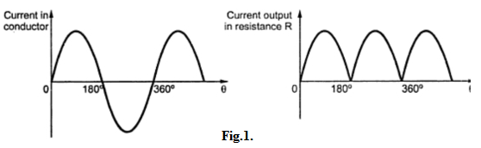Commutation:

*A process by which current in the short circuited coil is reversed while it crosses the MNA is called commutation.*

The time during which the coil remains short circuited is known as commutation period. This period is generally of the order of 0.0005 to 0.002 sec.

       The commutation is said to be ideal when current changes from +I to zero and zero to -I within the commutation period. The sparking is produced between the commutator and brush if current is not reversed by that time. This will lead to damage of commutator as well as brush. Hence for satisfactory operation of d.c. machine proper commutation is required i.e. transfer of current must be without sparking and losses.

Now we will see the process of commutation in detail with the help of the figures. Let us assume that the armature winding is ring type and the width of brush is equal to the width of one commutator segment and one-mica insulation. In this case only one coil is short circuited at a time at each of these brushes whereas in actual practice width of brush is more than that of commutator so that more than two coils are simultaneously short circuited at each brush.

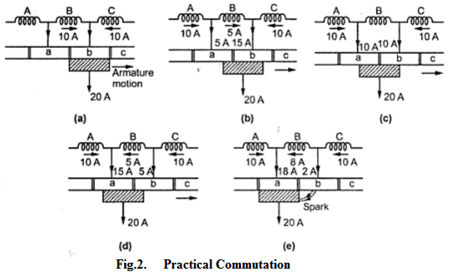

       As shown in the Fig. 2(a), coil B is about to be short circuited. The brush is about to come in contact with commutator segment 'a'. Suppose that each coil is carrying current of 10A so that total brush current is 20 A as every coil meeting at the brush supplies half the brush current independently of lap or wave wound armature.

       Before coil B is short circuited, it is belonging to the group of coils lying left of the brush. It is carrying current 10 A from left to right.

       As seen from the Fig. 2(b), coil B is entering short circuit period. The current in coil B has reduced from 10 A to 5 A as the other 5 A flows via segment 'a'. The total current is remaining same at 20 A. But area of contact of the brush is more with segment 'b' than with segment 'a'. Hence current of 15 A is from segment 'b' whereas 5 A from segment 'a'.

       The coil B is in the middle of its short circuit period as shown in the Fig. 2(c). The current in coil B is reduced to zero. The current 10 A and 10 A pass to the brush directly from coils A and C. The total current is again20 A and the contact area of brush with the segments 'a' and 'b' are equal.

       As shown in the Fig. 2(d), the coil B is now under group of coils to the right of brush. The contact area of brush with segment 'b' is decreasing whereas with segment 'a' is increasing. Coil B is now carrying 5 A in other direction. Thus current of 15 A is passed via segment 'a' to the brush while the other 5 A is supplied by coil C and passes from segment 'b' to brush. Again the total current is 20 A.

       In case of ideal commutation current through coil B will reverse at the end of commutation or short circuit period. But as shown in Fig. 2(e) current flowing through coil B is only 8 A instead of 10 A. So the difference in coil currents i.e. 10 - 8 = 2 A jumps directly from segment 'b' to the brush through air and produces spark.

       The variation in current during the process of commutation can be plotted with respect to time as shown in the Fig. 3.

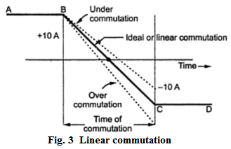

       The current in the coil B is 10 A till commutation begins represented by horizontal line AB. After finishing commutation the current is again 10 A but in reverse direction represented by horizontal line CD.

If current varies uniformly represented by straight line BC the commutation is said to be linear commutation. But it is observed that the self induced e.m.f. in the coil will try to maintain the current in the same direction and will cause delay for commutation. The commutation in this case is said to be retarded or under commutation. This is shown by the dotted part in the Fig. 3.

If reversal of current in the coil is faster than ideal or linear commutation then also sparking may occur. The commutation in this case is said to be over commutation or accelerated commutation.

       Thus it can be seen that if reversal of current is retarded or accelerated then value of current in the short circuited coil after the commutation period is over is different than that when linear commutation occurs. This will cause sparking at the brushes. This will lead to excessive wear and tear of commutator and ultimately lead to burning of commutator. Hence it is desired that the commutation must be as sparkless as possible.

       Now let us see that why there is delayed or accelerated commutation. The main reason for non-linear commutation is the production of self induced e.m.f. in the coil undergoing commutation as the coil has significant amount of self inductance because it is embedded in the armature which is made up of high permeability material. This self induced e.m.f. though small in magnitude produces a large current through the coil whose resistance is small due to short circuit.

Expression for Reactance Voltage:

       The e.m.f. induced in the coil undergoing commutation can be calculated as follows.  
       Let           Wb = Brush width  
                       Wm = Width of mica insulation  
                        v = Periphery velocity of commutator segment

       The period of commutation is nothing but the time required by commutator to move a distance equal to circumferential thickness of the brush minus the thickness of one insulation plate.

       If Tc is the time required for commutation then,

[http://3.bp.blogspot.com/-MS5ucqqRXFs/UDwALXMdniI/AAAAAAAAGV8/Cqf6K1VbF6w/s1600/ccc181.jpeg](http://3.bp.blogspot.com/-MS5ucqqRXFs/UDwALXMdniI/AAAAAAAAGV8/Cqf6K1VbF6w/s1600/ccc181.jpeg)

       The total change in current during the process of commutation is 2I. Therefore self induced or reactance voltage is given by,

       Self induced voltage = Coefficient of self inductance x Rate of change of current

[http://1.bp.blogspot.com/-1ktExrCWCYI/UDwAj9nU4hI/AAAAAAAAGWE/hmkxmrDRjmA/s1600/ccc182.jpeg](http://1.bp.blogspot.com/-1ktExrCWCYI/UDwAj9nU4hI/AAAAAAAAGWE/hmkxmrDRjmA/s1600/ccc182.jpeg)

       This self induced e.m.f. will oppose the change of direction of current. As stated earlier this will cause sparking at the brushes since current in the short circuited coil does not reach to its full value in the reversed direction by the end of commutation.

This is sinusoidal commutation. Hence the self induced voltage or reactance voltage for sinusoidal commutation is given by,

[http://2.bp.blogspot.com/-zLUQrZZRL3k/UDwAw0OXDJI/AAAAAAAAGWM/UG1GeZbUIbE/s1600/ccc183.jpeg](http://2.bp.blogspot.com/-zLUQrZZRL3k/UDwAw0OXDJI/AAAAAAAAGWM/UG1GeZbUIbE/s1600/ccc183.jpeg)

       L = Coefficient of self inductance  
       Tc  = Time of commutation

### Methods of Improving Commutation

There are two practical ways by which commutation may be improved. These methods are,

1. Resistance commutation and 2. E.M.F. commutation.

**Resistance Commutation**

       In this method of improving commutation, the low resistance copper brushes are replaced by high resistance carbon brushes.

       From the Fig. 1 it can be seen that the current I from coil C when passing through commutator segment 'b' has two parallel paths. One is straight from 'b' to brush while the other is through short circuited coil B to segment 'a' and then to the brush. By using low resistance copper brush the current will not prefer second path as it will prefer first low resistance path.

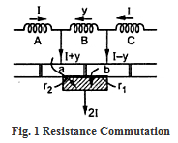

       When carbon brushes having comparatively high resistance are used then current I through coil C will select the second path as resistance of first path will be increasing due to decrease in contact area of 'b' with brush and resistance r2  of second path will be decreasing due to increase in contact area of 'a' with brush.

       Thus by increasing contact resistance between commutator segment and brushes, will limit short circuit current and reduce time constant (L/P) of the circuit which will help in quick reversal of current in the desired direction.

Advantages of Resistance Commutation  
       The advantages of resistance commutation are,  
1) Upto some degree they are self lubricating and polish the commutator.  
2) If sparking occurs, damage to commutator will be less as compared to when copper brushes are used.

Disadvantages of Resistance Commutation  
       The disadvantages of resistance commutation are,

1) There is a loss of approximately 2 volts due to high contact resistance. Hence this is not used in small machines.

2) If carbon brushes are used the commutator is required to be made somewhat larger for heat dissipation without rise in temperature which is not necessary for copper brushes.

3) Larger brush holders are required due to lower current density (about 7-8 A/cm).

**E.M.F. Commutation**

       The method in which reactance voltage produced is neutralized by the reversing e.m.f. in short circuited coil is called e.m.f. commutation. If the value of this reversing e.m.f. is made equal to reactance voltage, the effect of reactance voltage will be completely nullified so that there will be fast reversal of current which will give sparkless commutation. There are two ways of proving e.m.f. commutation.

* 1. By giving a forward lead to the brushes
  2. By using interpoles

Giving Brush Shift

       If the brushes are shifted forward or backward depending on generator or motor, a little beyond to magnetic neutral axis, the short circuited coil will come under the influence of main pole of opposite polarity. This will partly neutralized the reactance voltage which will help in quick current reversal. This method is rarely used in practice as it will lead to many practical difficulties.

Interpoles

       This method is more suitable and actually used in practice. In this method reversing e.m.f. required to neutralize reactance voltage is induced in the coil undergoing commutation by using small poles fixed to the yoke and placed in between the main poles i.e. along geometrical neutral axis. These poles are called interpoles. Practically interpoles are placed in between the main poles, as shown in the Fig. 2.

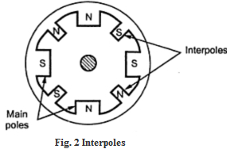

      On these interpoles few heavy gauge copper wire turns are wound and these are connected in series with the armature. The polarity of interpoles is same as the next main pole ahead in the direction of rotation and in case of motor it is same as main pole behind as shown in the Fig. 3. The brushes are kept along the GNA so that coil sides lie directly under the interpoles.