Parallel Operation of D.C. Generators

In this tutorial we going to discuss about parallel operation of [DC generators](http://www.electricaledition.com/2015/09/dc-machine-construction-motor-generator.html).We mostly do not go for  parallel operation for DC series generators ,but in some cases like electrical braking we go for it.Before going to deep discussion on **why? parallel operation of DC generators is needed.**

*In latest power generating system, power is usually supplied by many generators connected in parallel because due to lots of advantages.*

[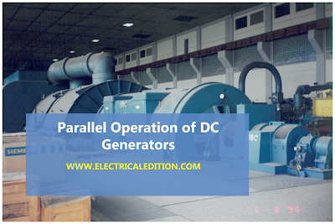](https://2.bp.blogspot.com/-uf_W8PZ3JW4/VsmfR16zOMI/AAAAAAAAA3Y/TwATBFoo2aE/s1600/DC-GENERATOR-PARALLEL-OPEARTION.png)

Advantages of Parallel Operation of DC Generators

The reasons for paralleling D.C. generators, (especially when it is recognized that this usage of the word parallel means duplicator or multiple) are enumerated below

**1. Reliability.**The sources of power such as generators are frequently primary safety items and are therefore duplicated or paralleled for reliability.

**2. Continuity of power supply.** If you are running only single generator,in case of breakdown the supply of power will get disrupted.So to avoid this problem we operate dc generators in parallel.

**3. To improve efficiency of dc generators.**Electrical machines run most efficiently when loaded on their rated capacity. DC generators also runs most efficiently at rated capacity and moreover power costs less per kWh when the generator producing it is efficiently loaded.In parallel operation of dc generators we have one more advantage that we can shutdown/start generator units as per power requirements.

**4. Easy to maintain and repair of DC generators.**Generators requires regular-maintenance and repair as like every machine. In case of parallel operation of dc generators the routine or emergency operations can be performed by isolating the only affected dc generator while load is being supplied by other units. This leads to both safety and economy.

**5. Non-availability of single required large generator.**It is hard to get single rated generator if concern efficiency and cost.So it is better to operate small generators in parallel in order to get desired power.

**6. To increasing plant capacity.** In the modern world of increasing population, the use of electricity is continuously increasing. To increase power capacity as it changes,we have flexibility in parallel operation that is,we can add a new unit   in parallel with the old units.

We have 3 [types of DC generators](http://www.electricaledition.com/2016/01/types-of-dc-machines-dc-generators-dc-motors.html).They are shunt,series,compound dc generators.So let us discuss about,

1.Parallel operation of shunt dc generators

2.Parallel operation of series dc generators

3.Parallel operation of compound dc generators

Conditions:Parallel Operation Of Shunt Generators

Below figure shows a circuit diagram for the parallel operation of two shunt generators. It is assumed that generator A is already operating and supplying a

particular load as per its capacity; that is why the switch SI and the circuit breaker CB, are shown closed in figure.

[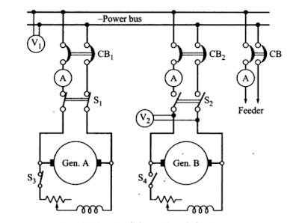](https://3.bp.blogspot.com/-C-0Mau9uvsg/VsmS-DbVziI/AAAAAAAAA2w/Bd4K-MfSN9Y/s1600/dc-shunt-generators-parallel-operation.PNG)

When the load on the station increases beyond the capacity of generator A. it is essential to connect the generator B to operate in parallel with A. in order to share the total load on the station. The procedure for paralleling generator B with generator A comprises following steps.

(i) The prime mover of the generator B is brought up to the rated speed.

(ii) Switch S4 provided in the generator field circuit is closed, as a result the generator will build up its voltage.

(iii) The circuit breaker CB2 is closed.

(iv) The excitation of the generator B is adjusted. so that it generates a voltage equal to the bus bar voltage, that is the reading of voltmeter V2 should be equal to V1

(v) Polarities of the generator B should be the same as those of the bus bars.

(vi) Now the main switch S2 is closed. thus putting generator B in parallel with generator A. However generator B is still running idle or floating (not supplying any load).

(vii) Adjust the field rheostats of generators A and B simultaneously. The field current of generators A should be reduced slowly. while that of generator B be increased. By this process. any amount of load can be shifted on to generator B. However. care should be taken that the incoming machine is not overload.

(viii) In case generator A is to be shut down. the whole load can be shifted onto generator B, provided it has a capacity to supply that load without over- loading. In that case reduce the current in the generator A to zero and then open switch S1.

Next the load sharing by the two generators running in parallel is discussed. Let us assume the following for the derivation of the equations showing the load sharing.

Load Sharing of DC Shunt Generators

Ea emf generated by generator A

Eb emf generated by generator B

V Terminal voltage at the load terminals

Ia Current supplied to the load by generator A

Ib Current supplied to the load by generator B

I Total load current

ra Armature resistance of generator A

rb Armature resistance of generator B

The external characteristic of the two generators can now be expressed as.

V=Ea-Iara ..........(1)

and V =Eb-Ibrb ..........(2)

Total load current, I = Ia + Ib..........(3)

Solving above equations for Ia,Ib

[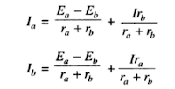](https://1.bp.blogspot.com/-PKpKJR75giY/VsmXdHeBmaI/AAAAAAAAA28/Ca_YjzFT7Q4/s1600/Capture.PNG)

Above equations  clearly indicate that the current supplied by each [generator](http://www.electricaledition.com/2016/02/construction-of-alternator-or-synchronous-generator.html)consists of two components (i) independent of load current (ii) dependent upon load current. First component exists when the generated emfs of two generators running in parallel are different, which certainly causes the circulating current to flow producing heat loss. This component would exist even at no load and can be avoided only when the [emfs generated](http://www.electricaledition.com/2016/01/emf-equation-of-dc-generator.html) by the two generators are equal. Second component shows clearly that the load current divides itself inversely as the [armature resistance of the generators](http://www.electricaledition.com/2016/01/armature-reaction-in-dc-machines.html).

If the load on the generators is a fixed resistance R. Equations ( 1 and 2) can be rewritten as,

Ea=Iara+(Ia + Ib)R  ..........(5)

Eb=Ibrb+(Ia + Ib)R   ..........(6)

Sovling equations (5) & (6)

[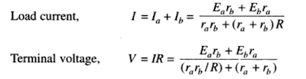](https://4.bp.blogspot.com/-BrdEAgJW3vI/VsmaOMI6AiI/AAAAAAAAA3I/9GDypJ0hq90/s1600/Capture.PNG)

Based on above equations which are obtained by parallel operation of shunt generators we get load shared by each generator operating In parallel can be ascertained depending upon the parameters of the generators.

D.C. Compound Generators in Parallel

Above we discussed why parallel operation of dc generators is necessary ?.Here we are going to discuss about  parallel operation of D.C. compound generators.

Let us have two compound dc generators,say generator 1 and generator 2 running in parallel as shown in the below figure.Assume each generator is taking proper share of load.

[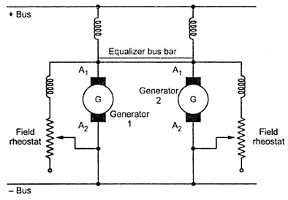](https://1.bp.blogspot.com/-PQL3ZNtpxEc/VsnWd2awFsI/AAAAAAAAA3o/uHfe2OWLuqA/s1600/ccc1126.jpeg)

Due to some reason,say the generator 1 taking more load slightly then the current passing through its series field winding increases strengthening its field to increase the generated e.m.f. This causes generator 1 to take still more load. If system load is assumed to be constant then the load on generator 2 will decrease weakening its series field due to less current passing through its field winding which results in further decrease in its load. This effect is cumulative which leads generator 1 to take the entire load and generator 2 will be driven as motor. The circuit breakers of at least one of the two generators will open to stop the parallel operation. The under compound generators show stable operation like shunt generators.

For stable parallel operation of over and level compound generators, equalizer bus bars are used. It is connected to the armature ends of the series coils of the generators. The equalizer bus bar is also a conductor which is not required is case of under compound generator as their characteristics are not rising.

Now consider that the same two compound generators are operating in parallel with equalizer bar between them. If for any reason, generator 1 starts taking more load than its proper share the its series field current is increased. But now this increased field current will partly pass through series field winding of generator 1 and partly through series field winding of generator 2 via equalizer bar. Thus the two generators are affected in similar way preventing generator 1 from taking extra load. To have proper division of load from no load to full load it is required that the regulation of each generator must be same. The series field resistances should be inversely proportional to the generator ratings.