Unit-II
Hydro-Electric Plants
Introduction
Installed Capacity as on 30-11-2014

Source | Subtype | Capacity (MW)
Thermal | Coal | 153571
Thermal | Gas | 22971
Thermal | Diesel | 1199
Thermal | Total | 177742
Nuclear |  | 4780
Hydro |  | 40798
Renewable Energy Sources | Wind | 21136
Renewable Energy Sources | Solar | 2632
Renewable Energy Sources | Biopower | 4119

List of Hydroelectric power stations
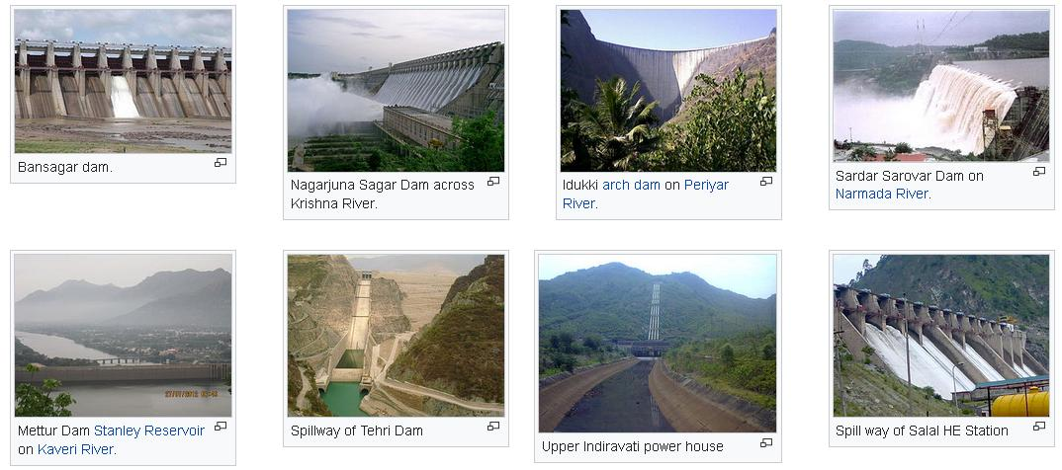
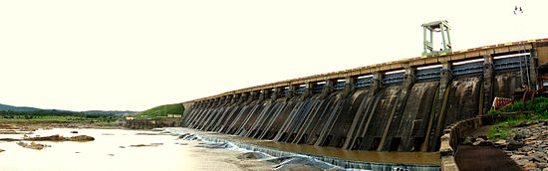
Panoramic View of Hirakud Dam at Sambalpur
India is the 7th largest producer of hydroelectric power in the world, and ranked 3rd in the total number of dams. The Tehri Dam, a 260.5 meters (855 ft) high rock and earth-fill embankment dam and is currently the highest dam out of India's approximately 4710 finished dams.
On March 31, 2016, the installed utility-scale capacity was 42,783 MW, which was 14.35% of India's total utility electricity generation capacity. In addition, small hydroelectric power units with a cumulative capacity of 4,274 MW have been installed. Between 2014 and 2015, the total amount of hydroelectric energy India generated was 129 TWh. The hydroelectric power potential of India is estimated at 84,000 MW at 60% load factor, one of the largest in the world.
India also imports surplus hydroelectric power from Bhutan. The hydro-electric power plants at Darjeeling and Shivanasamudra were established in 1898 and 1902 respectively, and were among the first in Asia. India has been a dominant player in global hydroelectric power development.

India has gone from an electricity deficit to an electricity surplus, and pumped storage schemes to store the surplus electricity have the potential to meet peak load demand. They also produce secondary/seasonal power at no additional cost when rivers are flooding with excess water. India has already established nearly 6,800 MW pumped storage capacities due to the installation of hydro power plants.

Pumped storage units can also be used as pumping stations to supply river water for upland irrigation, industrial needs, and drinking water. In a tropical country like India, abundant water is needed for agriculture due to a very high annual evaporation rate. The necessary amount of water to meet this demand can be harnessed from India's rivers via pumped storage units. Food security in India is possible with water security, which in turn is possible with energy security to supply the needed electricity for the water pumping.

More and more solar power generation is made available due to its advantage in terms of cost and environmental impact. Solar power has the capacity to meet daytime energy demands, while pumped storage units could meet night-time demands.[14] Many of the existing hydropower stations on west-flowing rivers located in Western Ghats of Kerala and Karnataka are already expanding to include pumped storage units in an effort to solve the water deficit of east-flowing rivers like Kaveri, Krishna, etc.
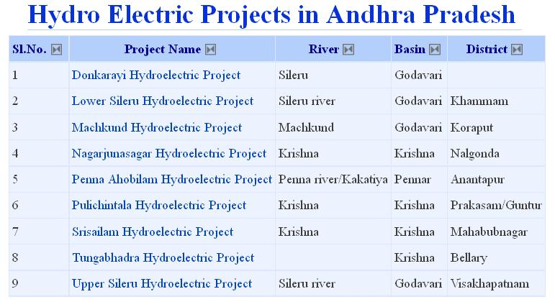
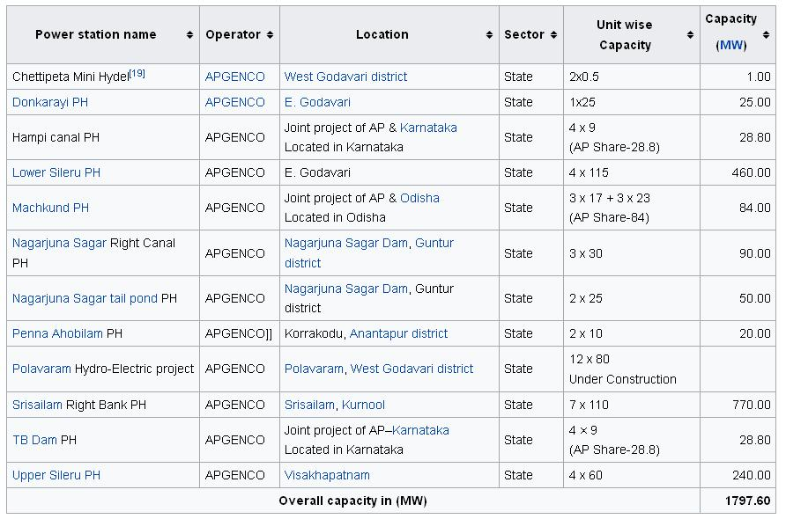
Hydro Power Potential
- = g*ρ*Q*H Where;
- = Power available in water
g = 9.81 m/s²
- = flow or discharge (m³/s)
H = Height of fall of water or head (m)
P = 9.81*1000*Q*H*10⁻³ kW = 9.81 QH kW
P= 9.81 QHη kW where η = efficiency of the turbine-generator assembly

Rain falling on earth’s surface has potential energy relative to oceans. This energy is converted to shaft work when the water falls through a vertical distance. This shaft work is used to drive water turbines to generate electricity.
Hydrology
- First requirement – Q (discharge)
- Hydrology deals with occurrence and distribution of water over and under earth’s surface.
– Surface Water Hydrology
– Ground Water Hydrology
- Watershed, catchment area or drainage area: length of the river, size and shape of the area it affects, tributaries, lakes, reservoirs etc.
- Investigation of run-off for past few years is required for power potential studies of a HPP.
Objectives of Hydrology
- To obtain data regarding the stream flow of water that would be available,
- To predict the yearly possible flow
- To calculate the mean annual rainfall in the area under consideration from a record of the annual rainfall for a number of years, say 25 to 30
- To note the frequency of dry years
- To find maximum rainfall and flood frequency
Various terms related to Hydrology
- Rainfall is also known as precipitation and can be measured by rain gauges.
- Some part of precipitation is lost due to evaporation, interception and transpiration.

- Transpiration: Plants absorbing moisture and giving it off to the atmosphere
- Stream flow = precipitation – losses
- Stream flow = surface flow + percolation to ground
- Surface flow is also known as run-off.
Hydrograph
– shows the variation of stream flow in m³/s with time for a particular river site. The time may be hour, week, month or a year.
– The area under hydrograph gives the total volume of flow.
- Flow duration curve:
– shows the percentage of time during the period when the flow was equal to greater than the given flow.
– The area under FDC gives the total quantity of run-off during a period
- Mass curve
– indicates the total volume of run-off in cubic meters up to a certain time.
– the slope of the curve at any point shows the rate of flow at that time
– Used for estimating the capacity of storage reservoir
- Storage:
– to ensure water availability during deficient flow and thus increasing the firm capacity
– Storage also results in more energy production
- Pondage:
– Storing water in small ponds near the power plant as the storage reservoir is away from plant
– To meet the power demand fluctuations over a short period of time e.g. 24 hours
- Primary Power: power that will be available 90 % of the time
- Secondary Power: power that will be available 75 % of the time
- Dump Power: power that will be available 50 % of the time.
- Maximum flow estimation: gives estimation of floods and helps in design of dam and spillway.
Site Selection for Hydropower Plants
- Availability of Water: Run-off data for many years available
- Water Storage: for water availability throughout the year
- Head of Water: most economic head, possibility of constructing a dam to get required head
- Geological Investigations: strong foundation, earthquake frequency is less
- Water Pollution: excessive corrosion and damage to metallic structures
- Sedimentation: capacity reduces due to gradual deposition of silt
- Social and Environmental Effects: submergence of areas, effect on biodiversity (e.g. western ghat), cultural and historic aspects
- Access to Site: for transportation of construction material and heavy machinery new railway lines or roads may be needed
- Multipurpose: power generation, irrigation, flood control, navigation, recreation; because initial cost of power plant is high because of civil engineering construction work
Types of Dams
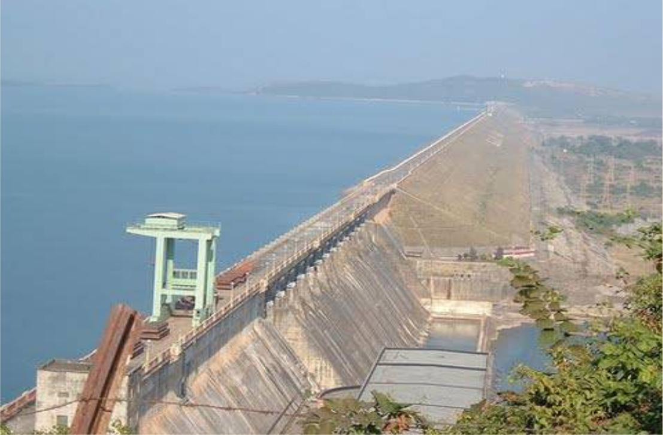

Earth and Rock fill Dam
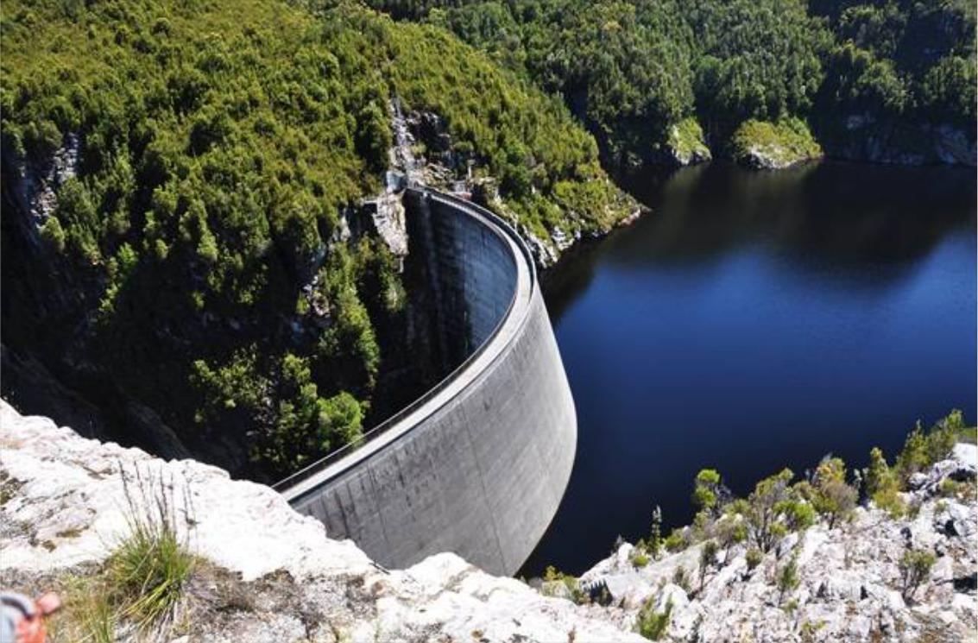

Arc Dam
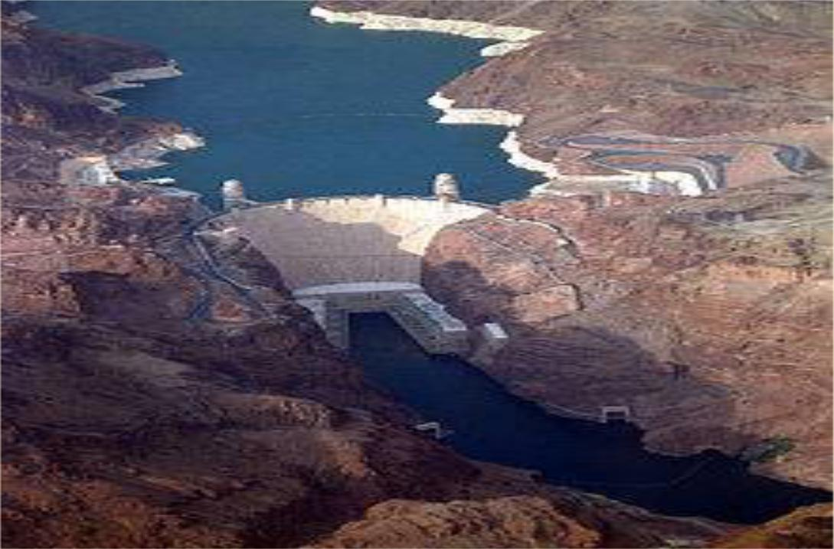

Arc Gravity Dam
Classification of Hydropower Plants
According to water flow regulation:
- Runoff river plants without pondage
- Runoff river plants with pondage
- Hydroelectric plants with storage reservoir
According to Load:
- Base load plants
- Peak load plants
- Pumped storage plants
According to head:
- High head plants (>100m)
- Medium head plants (30-100 m)
Low head plants (<30 m)
Generation of electricity by hydropower (potential energy in stored water) is one of the cleanest methods of producing electric power. In 2012, hydroelectric power plants contributed about 16% of total electricity generation of the world. Hydroelectricity is the most widely used form of renewable energy. It is a flexible source of electricity and also the cost of electricity generation is relatively low. This article talks about the layout, basic components and working of a hydroelectric power station.

Layout and Working of Hydroelectric Power Plant
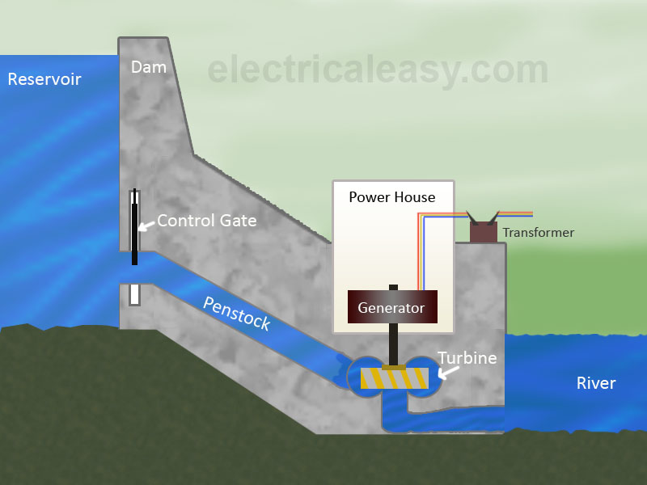

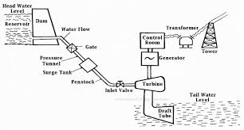
The above image shows the typical layout of a hydroelectric power plant and its basic components.

Dam and Reservoir: The dam is constructed on a large river in hilly areas to ensure sufficient water storage at height. The dam forms a large reservoir behind it. The height of water level (called as water head) in the reservoir determines how much of potential energy is stored in it.

Control Gate: Water from the reservoir is allowed to flow through the penstock to the turbine. The amount of water which is to be released in the penstock can be controlled by a control gate. When the control gate is fully opened, maximum amount of water is released through the penstock.

Penstock: A penstock is a huge steel pipe which carries water from the reservoir to the turbine. Potential energy of the water is converted into kinetic energy as it flows down through the penstock due to gravity.

Water Turbine: Water from the penstock is taken into the water turbine. The turbine is mechanically coupled to an electric generator. Kinetic energy of the water drives the turbine and consequently the generator gets driven. There are two main types of water turbine; (i) Impulse turbine and (ii) Reaction turbine. Impulse turbines are used for large heads and reaction turbines are used for low and medium heads.

Generator: A generator is mounted in the power house and it is mechanically coupled to the turbine shaft. When the turbine blades are rotated, it drives the generator and electricity is generated which is then stepped up with the help of a transformer for the transmission purpose.

Surge Tank:
Surge tanks are usually provided in high or medium head power plants when considerably long penstock is required. A surge tank is a small reservoir or tank which is open at the top. It is fitted between the reservoir and the power house. The water level in the surge tank rises or falls to reduce the pressure swings in the penstock. When there is sudden reduction in load on the turbine, the governor closes the gates of the turbine to reduce the water flow. This causes pressure to increase abnormally in the penstock. This is prevented by using a surge tank, in which the water level rises to reduce the pressure. On the other hand, the surge tank provides excess water needed when the gates are suddenly opened to meet the increased load demand.
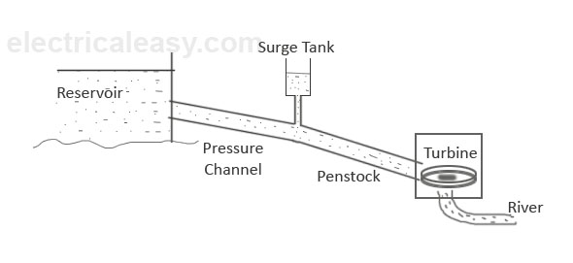

Types of Hydro-Power Plants

Conventional Plants:
Conventional plants use potential energy from dammed water. The energy extracted depends on the volume and head of the water. The difference between height of water level in the reservoir and the water outflow level is called as water head.

Pumped Storage Plant:
In pumped storage plant, a second reservoir is constructed near the water outflow from the turbine. When the demand of electricity is low, the water from lower reservoir is pumped into the upper (main) reservoir. This is to ensure sufficient amount of water available in the main reservoir to fulfil the peak loads.

Run-Of-River Plant:
In this type of facility, no dam is constructed and, hence, reservoir is absent. A portion of river is diverted through a penstock or canal to the turbine. Thus, only the water flowing from the river is available for the generation. And due to absence of reservoir, any oversupply of water is passed unused.

Advantages of Hydroelectric Power Plant
- No fuel is required as potential energy is stored water is used for electricity generation
- Neat and clean source of energy
- Very small running charges - as water is available free of cost
- Comparatively less maintenance is required and has longer life
- Serves other purposes too, such as irrigation

Disadvantages
- Very high capital cost due to construction of dam
- High cost of transmission – as hydro plants are located in hilly areas which are quite away from the consumers

