**UNIT - V**

**INTRODUCTION TO WIND POWER :**

Wind energy is a source of renewable power which comes from air current flowing across the earth's surface. Wind turbines harvest this kinetic energy and convert it into usable power which can provide electricity for home, farm, school or business applications on small (residential), medium (community), or large (utility) scales.

Wind energy is one of the fastest growing sources of new electricity generation in the world today. These growth trends can be linked to the multi-dimensional benefits associated with wind energy.

* **Green Power:** The electricity produced from wind power is said to be "clean" because its generation produces no pollution or greenhouse gases. As both health and environmental concerns are on the rise, clean energy sources are a growing demand.
* **Sustainable:** Wind is a renewable energy resource, it is inexhaustible and requires no "fuel" besides the wind that blows across the earth. This infinite energy supply is a security that many users view as a stable investment in our energy economy as well as in our children's' future.
* **Affordable:** Wind power is a cost-competitive source of electricity, largely due to technological advancements, as well as economies of scale as more of these machines are manufactured and put online around the world.
* **Economic Development:** As well as being affordable, wind power is a locally-produced source of electricity that enables communities to keep energy dollars in their economy. Job creation (manufacturing, service, construction, and operation) and tax base increase are other economic development benefits for communities utilizing wind energy.

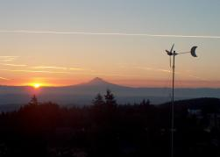

# How to calculate power output of wind :

The following formula illustrates factors that are important to the performance of a wind turbine. Notice that the wind speed, V, has an exponent of 3 applied to it. This means that even a small increase in wind speed results in a large increase in power. Read How high should your small wind turbine be for more information. That is why a taller tower will increase the productivity of any wind turbine by giving it access to higher wind speeds as shown in the Wind Speeds Increase with Height graph. The formula for how to calculate power is:

Wind-Power-calculation

Where:  
P = Power output, kilowatts  
Cp = Maximum power coefficient, ranging from 0.25 to 0.45, dimension less (theoretical maximum = 0.59)  
ρ = Air density, lb/ft3  
A = Rotor swept area, ft2 or π D2/4 (D is the rotor diameter in ft, π = 3.1416)  
V = Wind speed, mph  
k = 0.000133  A constant to yield power in kilowatts. (Multiplying the above kilowatt answer by 1.340 converts it to horse- power [i.e., 1 kW = 1.340 horsepower]).

The rotor swept area, A, is important because the rotor is the part of the turbine that captures the wind energy. So, the larger the rotor, the more energy it can capture.

The air density, ρ, changes slightly with air temperature and with elevation. The ratings for wind turbines are based on standard conditions of 59° F (15° C) at sea level. A density correction should be made for higher elevations as shown in the Air Density Change with Elevation graph. A correction for temperature is typically not needed for predicting the long-term performance of a wind turbine.

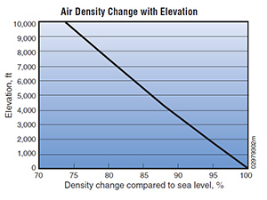

Although the calculation of wind power illustrates important features about wind turbines, the best measure of wind turbine performance is annual energy output. The difference between power and energy is that power (kilowatts [kW]) is the rate at which electricity is consumed, while energy (kilowatt-hours [kWh]) is the quantity consumed. An estimate of the annual energy output from your wind turbine, kWh/year, is the best way to determine whether a particular wind turbine and tower will produce enough electricity to meet your needs.

A wind turbine manufacturer can help you estimate the energy production you can expect. They will use a calculation based on the particular wind turbine power curve, the average annual wind speed at your site, the height of the tower that you plan to use, and the frequency distribution of the wind–an estimate of the number of hours that the wind will blow at each speed during an average year. They should also adjust this calculation for the elevation of your site. Contact a wind turbine manufacturer or dealer for assistance with this calculation.

To get a preliminary estimate of the performance of a particular wind turbine, use the formula below.

Annual-Energy-Output-Formula

Where:  
AEO = Annual energy output, kWh/year  
D = Rotor diameter, feet  
V = Annual average wind speed, mph

The Wind Energy Payback Period Workbook from the [National Renewable Energy Labs](http://www.nrel.gov/wind/docs/spread_sheet_Final.xls) is a spreadsheet tool that can help you analyze the economics of a small wind electric system and decide whether wind energy will work for you. It asks you to provide information about how you’re going to finance the system, the characteristics of your site, and the properties of the system you’re considering. It then provides you with a simple payback estimation in years. If it takes too long to regain your capital investment—the number of years comes too close or is greater than the life of the system—wind energy will not be practical for you. Read here for more on the [physics and economics of wind turbines](https://www.windpowerengineering.com/policy/the-physics-and-economics-of-wind-turbines/).

**SITE SELECTION**

                        Although wind power is a never ending green resource, assessment of environmental risks and impacts- which comprise the backbone of environmental policy- in the context of specific projects or sites often are necessary to explicate and weigh the environmental trade-offs that are involved. [11] In the case of wind farms, a number of turbines (ranging from about 250 kW to 750 kW) are connected together to generate large amounts of power. Apart from the constraints resulting from the number of turbines, any site selection should think over the technical, economic, social, environmental and political aspects. [7]

**Technical Considerations :**

                        Many technical factors affect the decision making on site selection including wind speed, land topography and geology, grid structure and distance and turbine size. These technical factors must be understood in order to give pair-wise scores to sub-factors.

***Wind Speed***

                        The viability of wind power in a given site depends on having sufficient wind speed available at the height at which the turbine is to be installed. Any choice of wind turbine design must be based on the average wind velocity at the selected wind turbine construction site.

***Land topography and geology***

                        Wind farms typically need large lands. [10] Topography and prevailing wind conditions determine turbine placement and spacing within a wind farm. In flat areas where there is nothing to interfere with wind flow, at least 2600-6000 m2/MW may be required. Wind turbines are usually sited on farms that have slope smaller than 10-20%.

***Grid structure and distance:***

                        The connection of wind turbines to an electricity grid can potentially affect reliability of supply and power quality, due to the unpredictable fluctuations in wind power output.

***Turbine size :***

                        Required height for the installation of turbine above ground is one of the important factors that affect the annual energy generation. [10] Turbine size is related with the energy output, because the bigger the turbine size is, the more wind it is exposed to. [7]

**Economic Considerations :**

                        The economic sub factors that affect the site selection include capital cost, land cost and operational and management costs. It is important to make economical evaluations by considering time value of money due to long periods of service life of wind farm projects.

***Capital cost :***

                        Construction, electrical connection, grid connection, planning, wind turbines, approvals, utilities and management are the main components of capital cost for wind farm projects.

***Land cost :***

                        For the site selection, main economic factor is the cost of the land where the wind farm is constructed; because, the cost of land primarily depends on the region, soil condition and the distance from the residential area.

***Operational and management cost :***

                        There will be control functions such as supervisory control and data acquisition (SCADA) which will provide control of each wind turbine in O&M facilities. Business rates, maintenance expenses, rents, staff payments are main components of O&M costs.

***Electricity market***

Existing of an electricity market for the energy generated is an important factor affecting the economic benefits of the project. There should be energy demand in regions close to wind farms.

**Environmental Considerations**

                        The environmental sub factors that affect the site selection of a wind farm include visual impact, electromagnetic interference, wild life and endangered species and noise impact.

***Visual impact***

                        Wind turbines are located in windy places, and most of the time, those places are highly visible. To many people, those big towers with 2 or 3 blades create visual pollution. To minimize the impacts of visual pollution, many investors implement the actions.

# Basic Construction of Wind Turbine :

Tower is very crucial part of [wind turbine](https://www.electrical4u.com/theory-of-wind-turbine/) that supports all the other parts. It not only supports the turbine but raises the turbine to sufficient height so that its blades tips would be at safe height during rotation. Not only that, we have to maintain the height of the tower, so that it can get sufficiently strong wind. The height of tower ultimately depends on the power capacity of wind turbines. The tower of the turbines in commercial wind power plants usually ranges from 40 meters to 100 meters. These towers may be either tubular steel towers, lattice towers, or concrete towers. We use tubular steel tower for a large wind turbine. These are normally manufactured in section of 30 to 40 meters length.

Each section has flanges with holes. Such sections are fitted together by nut bolts at the site to form a complete tower. The complete tower is slight conical shape to provide better mechanical stability. We assemble a lattice tower by different members of steel or GI angles or tubes. All members are bolted or welded together to form a complete tower of desired height. The cost of these towers are much less than that of steel tubular tower, but it aesthetically looks not as good as steel tubular tower. Although, transportation, assembling, and maintenance are quite easy but still use of lattice tower is avoided in modern wind turbine plant due to its aesthetic look. There is another type of tower used for small wind turbines, and this is guyed pole tower. Guyed pole tower is a single vertical pole supported by guy wired from different sides. Because of numbers of guy wires, it is difficult to access the footing area of the tower. Because of that, we avoid this type of tower in the agricultural field.

There is another type of wind turbine tower used for small plant, and this is hybrid type tower. Hybrid type tower is also a guyed type tower, but the only difference is that instead of using a single pole in the middle it uses a thin and tall lattice type tower. Hybrid type tower is hybrid of both lattice type and guyed type tower. 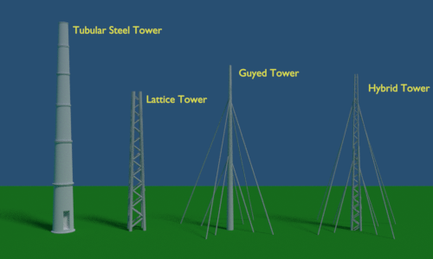

### Nacelle of Wind Turbine :

The nacelle is a big box or kiosk that sits on the tower and houses all the **components of a wind turbine**. It houses electrical generator, power converter, gearbox, turbine controller, cables, yaw drive.

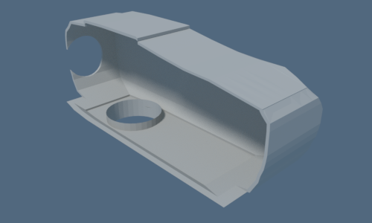

### Rotor Blades of Wind Turbine

Blades are the main mechanical parts of a wind turbine. The blades convert wind energy into usable mechanical energy. When the wind strikes on the blades, the blades rotate. This rotation transfers its mechanical energy to the shaft. We design the blades like airplane wings. The wind turbine blades can be 40 metres to 90 meters long. The blades should be mechanically strong enough to withstand strong wind even during the storm. At the same time, the wind turbine blades should be made as light as possible to facilitate smooth rotation of the blades. For that, we make the blades with fiberglass and carbon fiber layers on synthetic reinforce.

In a modern turbine, normally three identical blades are fitted to a central hub using nut bolts. Each identical blades are aligned at 120o to each other. The process makes a better distribution of mass and gives the system more smooth rotation. 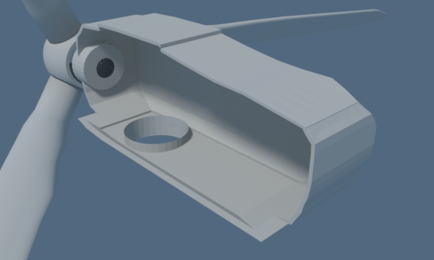

### Shaft of Wind Turbine

The shaft directly connected to the hub is a low-speed shaft. When the blades rotate, this shaft spins with the same rpm as the rotating hub. We couple this shaft directly to the electrical generator in case of a low-speed generator. But in most cases, the low-speed main shaft is geared with a high-speed shaft through a gearbox. In this way, the rotor blades transfer its mechanical energy to the shaft which ultimately enters into an electrical generator. 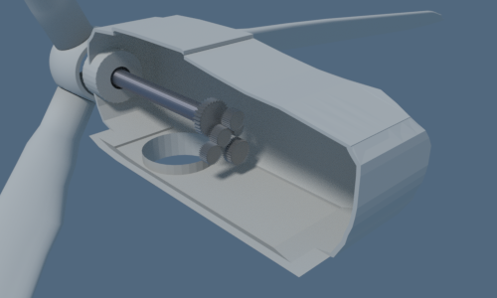

### Gearbox :

The wind turbine does not rotate at high speed rather it rotates gently at low speed. But most of the electrical generators require high-speed rotation, to generate electricity at a desired voltage level. So there must be some speed multiplication arrangement to achieve the high speed of the generator shaft. The gearbox of the wind turbine does this. Gearbox increases the speed to much higher value. For example, if gearbox ratio is 1:80 and if the rpm of a low speed main shaft is 15, the gearbox will increase the speed of generator shaft to 15 × 80 = 1200 rpm.

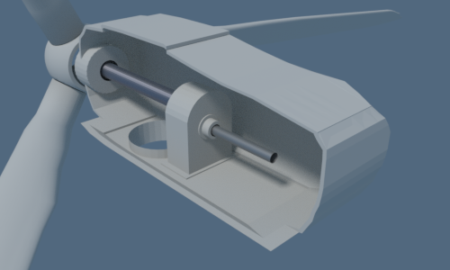

### Generator :

The generator is an electrical device that converts mechanical energy received from the shaft into electrical energy. Normally, we use induction generators in modern wind turbines. Previously, synchronous generators were popular for this purpose. Permanent Magnet DC generator also used in some wind turbines. The speed of the shaft can be made high by using gearbox assembly, but we can not make the shaft speed constant. There may be a fluctuation in shaft speed since it depends on wind speed. So, speed of the rotor also varies. This variation affects the frequency, voltage of the generated electric power. To, overcome these issues, we normally use induction generator for the purpose.

Because induction generator always produces electric power synchronized to the connected grid irrespective of the speed of the rotor. If we use the three-phase synchronous generator, then we first rectify the output power to DC and then convert it to AC of desired voltage and frequency using inverter circuit. Because the alternating power generated by the synchronous generator is not constant in voltage and frequency, rather it varies with speed of the rotor. Because, for the same reason, in some cases, we use DC generator for the purpose. In these cases, the output DC power from generator inverted to AC of desired voltage and frequency, before feeding it to the grid. 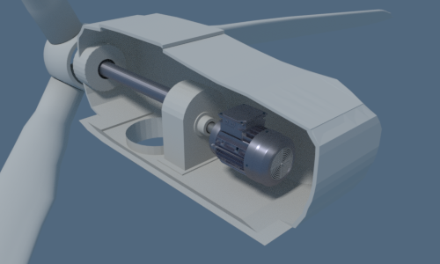

### Power Converter

Because wind is not always constant, so electrical potential generated from a generator is not constant, but we need a very stable voltage to feed the grid. A power converter is an electrical device that stabilizes the alternating output voltage transferred to the grid. 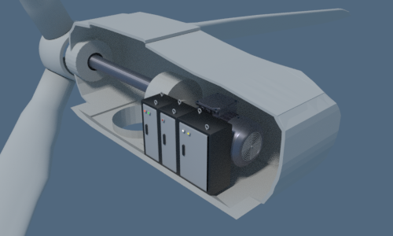

#### Turbine Controller

Turbine controller is a computer (PLC) that controls the entire turbine. It starts and stops the turbine and runs self diagnostic in case of any [error](https://www.electrical4u.com/errors-in-measurement-classification-of-errors/) in the turbine.

### Anemometer

It measures the wind speed and passes the speed information to PLC to control the turbine power.

### Wind Vane

It senses the direction of the wind and passes the direction to PLC then PLC faces the blades in such a way that it cuts the maximum wind. 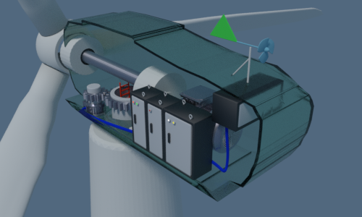

### Pitch Drive

Pitch drive motors control the angle of blades whenever the wind changes it rotates the angle of blades to cut the maximum wind, which is called pitching of blades.

### Yaw Drive

Blades and other components in wind turbine are housed in a nacelle, whenever any change in wind direction is there, the nacelle has to face in the direction of the wind to extract the maximum energy from wind. For this purpose yaw drive, a motor is used to rotate the nacelle. It is controlled by PLC that uses the wind vane information to sense the wind direction.

# Wind Turbine Introduction

The wind has its kinetic energy as it nothing but the flow of atmospheric air. A [wind turbine](https://www.electrical4u.com/wind-turbine-working-types-and-history-of-wind-turbine/) is a machine which utilises the kinetic energy of wind to produce rotational mechanical energy in its shaft. The rotational motion of the shaft turns an electrical generator to generate [electricity](https://www.electrical4u.com/electric-current-and-theory-of-electricity/).  
There are mainly two types of wind turbine available one is horizontal axis type another is vertical axis type. The turbines are also available in different sizes depending upon their mode of applications. In many places of the modern world, people use small-sized wind turbines to charge batteries for auxiliary power supply to boats, caravans etc. Many electric utility companies use medium-sized wind turbines to supply a portion of the domestic load when sufficient wind is available so that they can sale back the surplus demanded power to the electrical grid.

The stock of fossil fuels on that planet is becoming nil day by day, so there is a significant need for renewable sources of energy to produce electricity to meet up the on-growing demand for electricity. The [wind power generating station](https://www.electrical4u.com/basic-wind-energy/) is one of the solutions for that. The wind power generating stations, use many giant wind turbines to produce required [electricity](https://www.electrical4u.com/electric-current-and-theory-of-electricity/). The wind turbines can have either horizon shaft or vertical shaft depending on their design criteria. The horizontal design is more common as it produces more power compared to vertical one.

## Horizontal Axis Wind Turbine

We call the [wind turbines](https://www.electrical4u.com/wind-turbine-working-types-and-history-of-wind-turbine/) that have horizontal shaft as horizontal axis wind turbines or in short HAWT. In HAWT the turbine rotor couples the electrical generator and this turbine generator set is placed on the top of the turbine tower. A wind sensor with servomotor keeps the axis of the turbine along the path of the wind. Although in small turbine a wind vane does the purpose. The turbines commonly have a gearbox in between the turbine shaft and the generator shaft. The functions of this gearbox are to provide mechanical coupling between these two shafts and to step up the slow rotating speed of the turbine blades to a high rotating speed of the generator.



A [wind electric power generating station](https://www.electrical4u.com/basic-wind-energy/) uses three blades horizontal axis wind turbines (HAWT). Three blades design is more mechanically stable and can have less torque ripple. The blade-length may be from 20 m to 80 m and usually of bright white coloured so that any aircraft can view comfortably. A turbine with the blade length of 80 m may have rating up to 8 MW. The height of the large commercial turbine may be up to 70 m to 120 m and may be up to 160 metres in the extreme. The modern [wind turbine systems](https://www.electrical4u.com/wind-turbine-working-types-and-history-of-wind-turbine/) use steel tubular supporting poles. The RPM of a large wind turbine may be from 10 to 22. Such large turbine blades, cannot achieve rotational speed more than that. As we told earlier, we use a gearing arrangement (gearbox) to step up this slow speed to required high speed of the generator.

Although, there are some designs in which the turbine rotor shaft directly couples the generator. As the rotational speed of a wind turbine varies with the variation of wind pressure, the modern wind turbines use solid-state converters to convert the generated electrical energy to a required [voltage](https://www.electrical4u.com/voltage-or-electric-potential-difference/) level and frequency to feed the electrical grids.

No one can control the wind pressure on the blades by any means it entirely depends on nature. The designers provide a protective system to all large wind turbine which aligns the blade-edge faces depending on the speed of the wind so that we can avoid breakage of the blades during high wind pressure. We call this technique as the feathering.

## Vertical Axis Wind Turbine

There is another type of wind turbine which uses vertically aligned rotating shaft. We call this turbine as Vertical Axis Wind Turbines or VAWTs. As it has the vertical axis, it does not have to align itself with the wind and hence using of these turbines are more suitable where the direction of wind significantly varies. We can install this turbine even on the rooftop since the height of this turbine is much lesser than that of HAWT. Another significant advantage is that as the shaft is vertical, we can extend it to the bottom level where we can couple a generator with the vertical shaft with the help of ground-based gearbox which facilitates easier maintenance. In spite of so many advantages over HAWT, we do not use VAWT for bulk power generation as the power output is quite less in VAWT compared to HAWT.

# Wind Turbine | Working and Types of Wind Turbine

## How Does Wind Turbine Work?

There is a lightweight turbine of large diameter attached to the top of a supporting tower of sufficient height. When wind strikes on the turbine blades, the turbine rotates due to their typical design and alignment. The shaft of the turbine is coupled with an [electrical generator](https://www.electrical4u.com/alternator-or-synchronous-generator/). The output of the generator is collected through electric power cable.

## Working of Wind Turbine

When the wind strikes the rotor blades, blades start rotating. The rotor is directly connected to a high-speed gearbox. Gearbox converts the rotor rotation into high speed which rotates the electrical generator. An exciter is needed to give the required excitation to the coil so that it can generate required [voltage](https://www.electrical4u.com/voltage-or-electric-potential-difference/). The exciter current is controlled by a turbine controller which senses the wind speed based on that it calculates the power what we can achieve at that particular wind speed. Then output voltage of [electrical generator](https://www.electrical4u.com/alternator-or-synchronous-generator/) is given to a rectifier and rectifier output is given to line converter unit to stabilize the output AC that is feed to the grid by a high [voltage transformer](https://www.electrical4u.com/voltage-transformer-or-potential-transformer-theory/). An extra units is used to give the power to internal auxiliaries of **wind turbine** (like motor, [battery](https://www.electrical4u.com/battery-working-principle-of-batteries/) etc.), this is called Internal Supply unit. ISU can take power from the grid as well as from wind. [Chopper](https://www.electrical4u.com/chopper-dc-to-dc-converter/) is used to dissipate extra energy from the RU for safety purpose. An internal Block diagram of a wind turbine 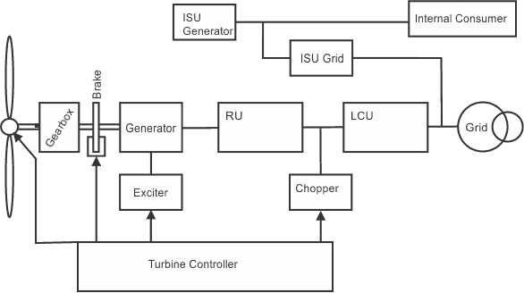

## Types of Wind Turbine

There are generally two types of wind turbines. The horizontal axis and vertical axis. The horizontal axis is divided as upwind and downwind whereas vertical axis is divided as a drag based and lift based as shown in below.

Horizontal Axis Wind Turbine or HAWT - Up wind

Horizontal Axis Wind Turbine or HAWT - Down wind

Vertical Axis Wind Turbine or VAWT - Drag based

Vertical Axis Wind Turbine or VAWT - Lift based

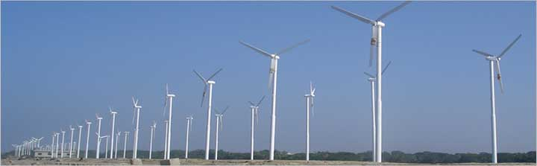In Horizontal Axis Up Wind turbine, the shaft of turbine and [alternator](https://www.electrical4u.com/alternator-or-synchronous-generator/) both are aligned horizontally, and the turbine blades are placed at the front of the turbine that means air strikes the turbine blades before the tower. In the case of Vertical Axis, Down Wind turbine the shafts of the rotor and generator are also placed horizontally, but turbine blades are placed after the turbine that means the wind strikes the tower before the blades. 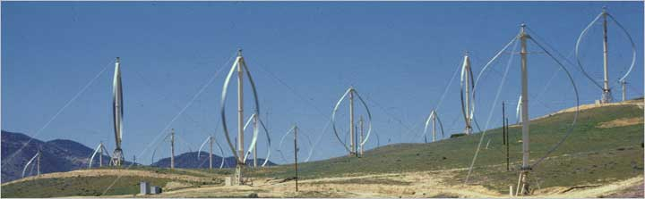If we observe VAWT drag based turbine, the generator shaft is located vertically with the blades positioning up, and the turbines are normally mounted on the ground or a tiny tower. This type is also called the Savonius turbine, after its inventor, S.I. Savonius. In the case of VAWT lift based turbine, the generator shaft is placed vertically with the blade's position is up. Nowadays Horizontal axis wind turbines are most popular because of high efficiency. Since the blades always move perpendicularly to the wind and receive power through the whole rotation.

#### Application of Wind Energy:

1. The wind energy is used to propel the sailboats in river and seas to transport men and materials from one place to another.

2. Wind energy is used to run pumps to draw water from the grounds through wind mills.

3. Wind energy has also been used to run flourmills to grind the grains like wheat and corn into flour.

4. Now-a-days wind energy is being used to generate electricity.

Wind energy may be considered as the world’s fastest growing energy source.

By the development of technology, wind power may become most economical and environmental friendly source of electricity in many countries in the coming 10 to 20 years.

**Betz criteria:**

According to **Betz's** law, no turbine can capture more than 16/27 (59.3%) of the kinetic energy in wind. The factor 16/27 (0.593) is known as **Betz's** coefficient. Practical utility-scale wind turbines achieve at peak 75% to 80% of the **Betz limit**. The **Betz limit** is based on an open disk actuator.

