What is a transformer?
Transformer is a static electrical machine which transforms electrical power from one circuit to another circuit, without changing the frequency. Transformer can increase or decrease the voltage with corresponding decrease or increase in current.

Working Principle of Transformer
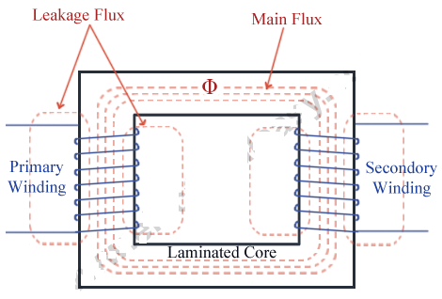
Fig. 1.1
The basic principle behind working of a transformer is the phenomenon of mutual induction between two windings linked by common magnetic flux. The fig. 1.1 shows the simplest form of a transformer. Basically a transformer consists of two inductive coils; primary winding and secondary winding. The coils are electrically separated but magnetically linked to each other. When, primary winding is connected to a source of alternating voltage, alternating magnetic flux is produced around the winding. The core provides magnetic path for the flux, to get linked with the secondary winding. Most of the flux gets linked with the secondary winding which is called as 'useful flux' or main 'flux', and the flux which does not get linked with secondary winding is called as 'leakage flux'. As the flux produced is alternating (the direction of it is continuously changing), EMF gets induced in the secondary winding according to Faraday's law of electromagnetic induction. This emf is called 'mutually induced emf', and the frequency of mutually induced emf is same as that of supplied emf. If the secondary winding is closed circuit, then mutually induced current flows through it, and hence the electrical energy is transferred from one circuit (primary) to another circuit (secondary).
In short, a transformer carries the operations shown below:
- Transfer of electric power from one circuit to another.
- Transfer of electric power without any change in frequency.
- Transfer with the principle of electromagnetic induction.
- The two electrical circuits are linked by mutual induction.

Basic Construction of Transformer
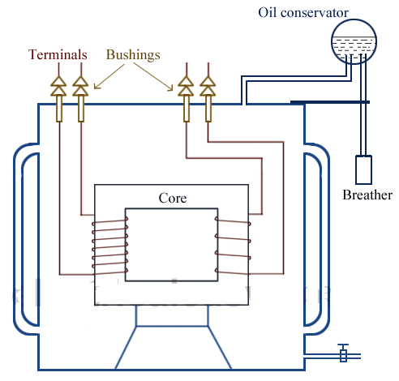
Fig. 1.2

Basically a transformer consists of two inductive windings and a laminated steel core. The coils are insulated from each other as well as from the steel core. A transformer may also consist of a container for winding and core assembly (called as tank), suitable bushings to take the terminals; conservator is taking care of oil expansion and contraction in the transformer tank during operation of transformer. Breather avoids moisture entry into transformer tank during oil contraction. The fig. 1.2 illustrates the basic construction of a transformer.
In all types of transformers, core is constructed by assembling (stacking) laminated sheets of steel, with minimum air-gap between them (to achieve continuous magnetic path). The steel used is having high silicon content and sometimes heat treated, to provide high permeability and low hysteresis loss. Laminated sheets of steel are used to reduce eddy current loss (the thickness of the lamination varies from 0.35mm to 0.5mm). The sheets are cut in the shape as E, I and L as shown in Fig. 1.3. To avoid high reluctance at joints, laminations are stacked by alternating the sides of joint. That is, if joints of first sheet assembly are at front face, the joints of following assemble are kept at back face.

Fig. 1.3

Types of Transformers
Transformers can be classified on different basis, like types of construction, types of cooling etc.
(A) On the basis of construction,
Transformers can be classified into two types as; (i) Core type transformer and (ii) Shell type transformer, which are described below.
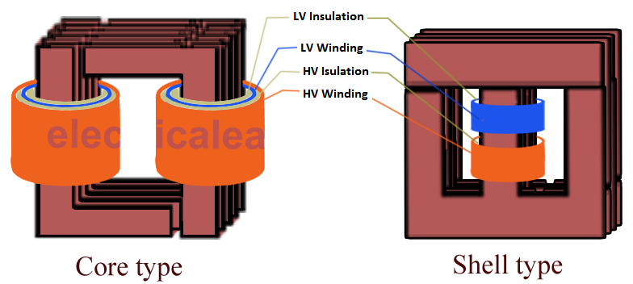
Fig. 1.4

(i) Core Type Transformer
In core type transformer, windings are cylindrical former wound, mounted on the core limbs as shown in the fig. 1.4. The cylindrical coils have different layers and each layer is insulated from each other. Materials like paper, cloth or mica can be used for insulation. Low voltage windings are placed nearer to the core, as they are easier to insulate.

(ii) Shell Type Transformer
The coils are former wound and mounted in layers stacked with insulation between them. A shell type transformer may have simple rectangular form (as shown in Fig. 1.4), or it may have a distributed form.

(B) On the basis of their purpose
- Step up transformer:
Voltage increases (with subsequent decrease in current) at secondary.
- Step down transformer:
Voltage decreases (with subsequent increase in current) at secondary.

(C) On the basis of type of supply
- Single phase transformer
- Three phase transformer

(D) On the basis of their use
- Power transformer:
Used in transmission network, high rating
- Distribution transformer:
Used in distribution network, comparatively lower rating than that of power transformers.
- Instrument transformer:
Used in relay and protection purpose in different instruments in industries
  - Current transformer (CT)
  - Potential transformer (PT)

(E) On the basis of cooling employed
- Oil-filled self cooled type
- Oil-filled water cooled type
- Air blast type (air cooled)

E.M.F Equation of a Transformer
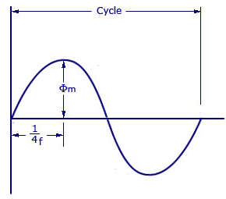
Fig. 1.5

The alternating flux produced by the primary winding is sinusoidal as shown in Fig. 1.5.
Let,
- N_{A} = Number of turns in primary
- N_{B} = Number of turns in secondary
- Ø_{max} = Maximum flux in the core in webers = B_{max} X A
- f = Frequency of alternating current input in hertz (H_{Z})
- As shown in figure above, the core flux increases from its zero value to maximum value Ø_{max} in one quarter of the cycle , that is in 1/(4f) second.
- Therefore, average rate of change of flux = Ø_{max}/ 1/ (4f) = 4f Ø_{max}Wb/s
- Now, rate of change of flux per turn means induced electro motive force in volts.
- Therefore, average electro-motive force induced/turn = 4f Ø_{max}volt
- If flux Ø varies sinusoidally, then r.m.s value of induced e.m.f is obtained by multiplying the average value with form factor.
- Form Factor = r.m.s. value/average value = 1.11
- Therefore, r.m.s value of e.m.f/turn = 1.11 X 4f Ø_{max} = 4.44f Ø_{max}
- Now, r.m.s value of induced e.m.f in the whole of primary winding
= (induced e.m.f./turn) X Number of primary turns
Therefore,
- E_{A} = 4.44f N_{A}Ø_{max} = 4.44fN_{A}B_{m}A
Similarly, r.m.s value of induced e.m.f in secondary is
- E_{B} = 4.44f N_{B} Ø_{max} = 4.44fN_{B}B_{m}A
In an ideal transformer on no load,
- V_{A} = E_{A} and V_{B} = E_{B,} where V_{B} is the terminal voltage

Voltage Transformation Ratio (K)
From the above equations we get
- E_{B}/ E_{A} = V_{B}/ V_{A} = N_{B}/N_{A} = K
This constant K is known as voltage transformation ratio.
- If N_{B}>N_{A}, that is K>1, then transformer is called step-up transformer.
- If N_{B}<1, that is K<1, then transformer is known as step-down transformer.
Again for an ideal transformer,
- Input VA = output VA
- V_{A}I_{A} = V_{B}I_{B}
- Or, I_{B}/I_{A} = V_{A}/V_{B} = 1/K
Hence, currents are in the inverse ratio of the (voltage) transformation ratio.

Applications of a transformer
Transformers are used in
    - Transmission of electric power.
    - Distribution of electric power
    - Electronic circuits
Ideal Transformer
An ideal transformer is an imaginary transformer which has
- No copper losses (no winding resistance)
- No iron loss in core
- No leakage flux

In other words, an ideal transformer gives output power exactly equal to the input power. The efficiency of an idea transformer is 100%. Actually, it is impossible to have such a transformer in practice, but ideal transformer model makes problems easier.

Characteristics of Ideal Transformer
- Zero winding resistance: It is assumed that, resistance of primary as well as secondary winding of an ideal transformer is zero. That is, both the coils are purely inductive in nature.
- Infinite permeability of the core: Higher the permeability, lesser the mmf required for flux establishment. That means, if permeability is high, less magnetizing current is required to magnetize the transformer core.
- No leakage flux: Leakage flux is a part of magnetic flux which does not get linked with secondary winding. In an ideal transformer, it is assumed that entire amount of flux get linked with secondary winding (that is, no leakage flux).
- 100% efficiency: An ideal transformer does not have any losses like hysteresis loss, eddy current loss etc. So, the output power of an ideal transformer is exactly equal to the input power. Hence, 100% efficiency.
- The above mention properties are not possible in the practical transformer. In an ideal transformer, there is no power loss. Therefore, the output power is equal to the input power.
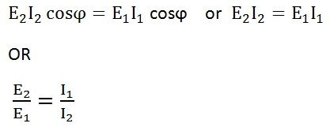
Since E_{l} ∞ N₂ and E₁ ∞ N₁, also E₁ is similar to V₁ and E₂ is similar to V₂
Therefore, transformation ratio will be given by the equation shown below
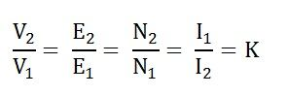
The primary and the secondary currents are inversely proportional to their respective turns.

Behavior of Ideal Transformer
Consider the ideal transformer shown in the fig. 1.6. The voltage source V₁ is applied across the primary winding of the transformer. Their secondary winding is kept open. The N₁ and N₂ are the numbers of turns of their primary and secondary winding.
The current I_{m} is the magnetizing current flows through the primary winding of the transformer. The magnetizing current produces the flux φ_{m} in the core of the transformer. As the permeability of the core is infinite, the flux of the core link with both the primary and secondary winding of the transformer.
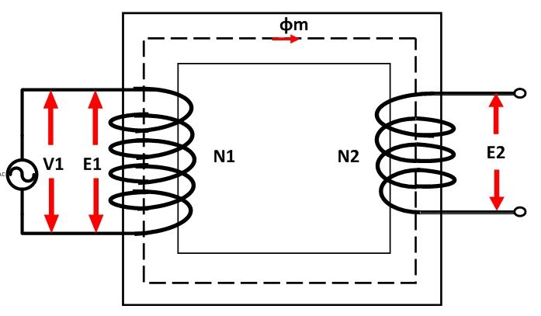
Fig. 1.6
The flux link with the primary winding induces the emf E₁ because of self-induction. The direction of the induced emf is inversely proportional to the applied voltage V₁. The emf E₂ induces in the secondary winding of the transformer because of mutual induction.

Phasor Diagram of Ideal Transformer
The phasor diagram of the ideal transformer is shown in the fig. 1.7. As the coil of the primary transformer is purely inductive the magnetizing current induces in the transformer lag 90º by the input voltage V₁. The E₁ and E₂ are the emf induced in the primary and secondary winding of the transformer. The direction of the induces emf inversely proportional to the applied voltage
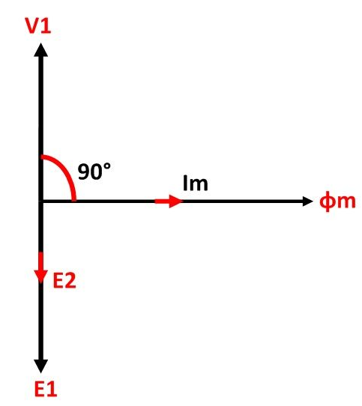
Fig. 1.7 Phasor Diagram of an Ideal Transformer

Transformer on No Load Condition
When the transformer is operating at no load, the secondary winding is open circuited, which means there is no load on the secondary side of the transformer and, therefore, current in the secondary will be zero, while primary winding carries a small current I₀ called no load current which is 2 to 10% of the rated current. This current is responsible for supplying the iron losses (hysteresis and eddy current losses) in the core and a very small amount of copper losses in the primary winding. The angle of lag depends upon the losses in the transformer. The power factor is very low and varies from 0.1 to 0.15.
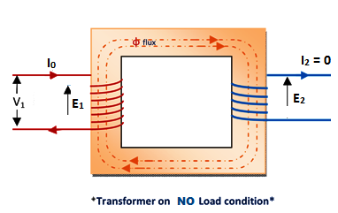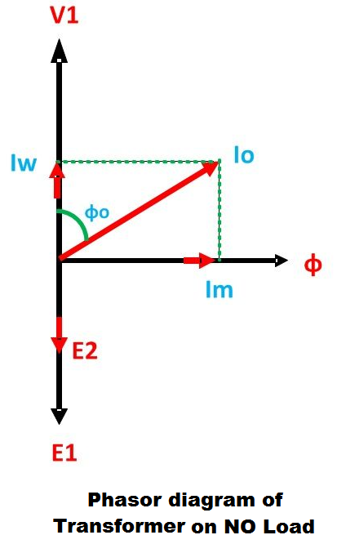
Fig. 1.8 Fig. 1.9

The no load current consists of two components
- Reactive or magnetizing component I_{m} (It is in quadrature with the applied voltage V₁. It produces flux in the core and does not consume any power)
- Active or power component I_{w}, also known as working component (It is in phase with the applied voltage V₁. It supplies the iron losses and a small amount of primary copper loss)
The following steps are given below to draw the phasor diagram
- The function of the magnetizing component is to produce the magnetizing flux, and thus, it will be in phase with the flux.
- Induced emf in the primary and the secondary winding lags the flux ϕ by 90 degrees.
- The primary copper loss is neglected, and secondary current losses are zero as I₂ = 0. Therefore, the current I₀ lags behind the voltage vector V₁ by an angle ϕ₀ called no-load power factor angle shown in the phasor diagram above.
- The applied voltage V₁ is drawn equal and opposite to the induced emf E₁because the difference between the two, at no load, is negligible.
- Active component I_{w} is drawn in phase with the applied voltage V₁.
- The phasor sum of magnetizing current I_{m} and the working current I_{w} gives the no load current I₀.
From the phasor diagram drawn above, the following conclusions are made
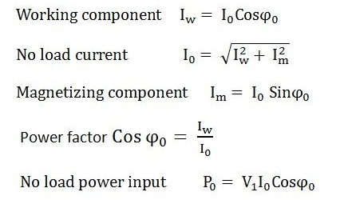

Transformer on On load Condition
When load is connected to the secondary winding of a transformer, I₂ (secondary current) is flow in the secondary winding. The magnitude and phase of I₂ with respect to V₂ (secondary voltage) depends upon the characteristics of the load. Secondary current I₂ is in phase with V₂, if load is pure resistive, lags if load is inductive and it leads if load is capacitive.
This secondary current sets up m.m.f( =N₂I₂ ) and hence it produce magnetic flux Φ ₂ which is in opposition to the main primary flux Φ . The secondary ampere-turns N₂I₂ are known as demagnetizing amp-turns. The opposing secondary flux Φ ₂ weakens the primary flux Φ momentarily; hence the primary winding back e.m.f E₁ tends to be reduced. For a moment V₁ > E₁ more current flow in the primary winding. Let the additional primary current be I₂¹ which is known as load component of primary current. This current (I₂¹) is anti-phase with I₂.This load component of primary current(I₂¹) sets up its own flux Φ ₂¹ which is in opposition to secondary flux Φ ₂ , but is in the same direction as primary flux Φ and flux Φ ₂¹ is equal to Φ ₂. Hence, the two fluxes cancel out each other.
So, we can say that whatever the load conditions, the net flux passing through the core is approximately the same as at no-load. Due to the constancy of core flux at all loads; the core loss is also practically the same under all load conditions. As Φ ₂= Φ ₂¹.
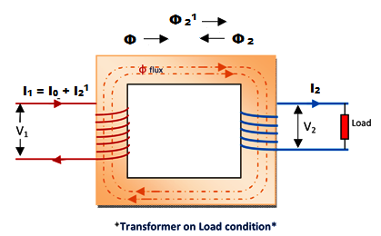
Fig. 1.10
Hence, when transformer is on load, the primary winding has two currents in it; one is I₀ and the other is I₂¹ which is anti-phase with I₂ and K times in magnitude. The total primary current is the vector sum of I₀and I₂¹.
In Fig. below shown the vector diagram of a transformer when the load is Resistive and when the load is inductive. If we assume voltage transformation ratio is unity, (i.e. K= 1)
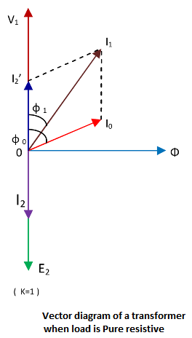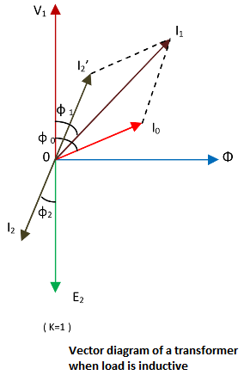
Fig. 1.11 Fig. 1.12
In the fig.1.11, shown the vector diagram of a transformer when load is Pure resistive
I₂= secondary current in phase with E₂= V₂
I₂¹= load component of primary current which is anti-phase with I₂ and also equal to it in magnitude (as K=1)
I₁= Primary current which is vector sum of I₀ and I₂¹ and lags behind V₁ by angle φ₁.

In the fig.1.12, shown the vector diagram of a transformer when load is inductive,
I₂= secondary current lags E₂ by φ₂.
I₂’= load component of primary current which is anti-phase with I₂ and also equal to it in magnitude (as K=1)
I₁= Primary current which is vector sum of I₀ and I₂’ and lags behind V₁ by angle φ₁.
It is seen from the fig.-2 that the angle φ₁is slightly greater than φ₂.

Transformer with winding Resistance and Magnetic Leakage
Let us discuss in this topic what will be effect in a transformer due to the presence of resistance & leakage reactance. The resistance of Transformer means the resistance of primary and secondary winding of the transformer. And leakage reactance of Transformer means there is some magnetic leaking in the both of the windings that should be equal to inductive coils connected in both primary & secondary winding which is shown in fig. below
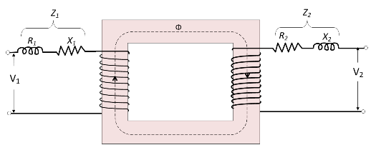
Fig. 1.13

Where, the R₁= Resistance of primary winding,
R₂ = Resistance of Secondary winding,
X₁= Reactance of primary winding,
X₂= Reactance of secondary winding,
Therefore, Primary impedance of transformer is
Z₁= √ (R₁² + X₁²)
Therefore, Secondary impedance of transformer is
Z₂= √ (R₂² + X₂²),

Due to the presence of resistance and leakage reactance, some voltage drop will occur in the primary winding.
If, V₁ =Applied primary voltage,
E₁= Primary induced voltage,
Then, we can write, that
V₁ = E₁ + I₁( R₁+jX₁)
V₁ = E₁ + I₁Z₁,
Similarly, the voltage drop will occur in secondary winding,
If V₂ = secondary terminal voltage,
and E₂= Secondary induced voltage,
Then, we can write, that
E₂=V₂ + I₂( R₂+jX₂)
E₂ =V₂ +I₂Z₂
Now, we draw the vector diagram below for different kinds of the load is shown in figs.
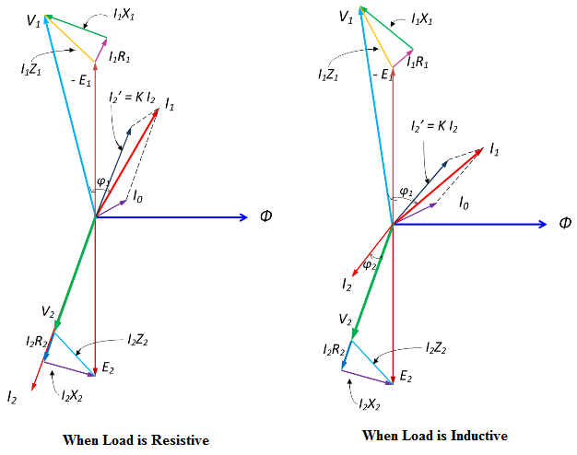
Fig. 1.14 (a)
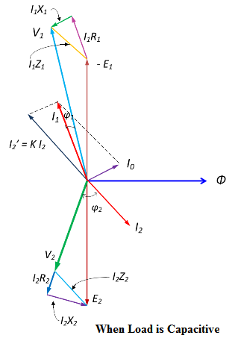
Fig. 1.14 (b)

Equivalent Circuit diagram of single phase Transformer
Equivalent circuit diagram of a transformer is basically a diagram which can be resolved into an equivalent circuit in which the resistance and leakage reactance of the transformer are imagined to be external to the winding.
The equivalent circuit diagram of transformer is given in below Fig. 1.15:-
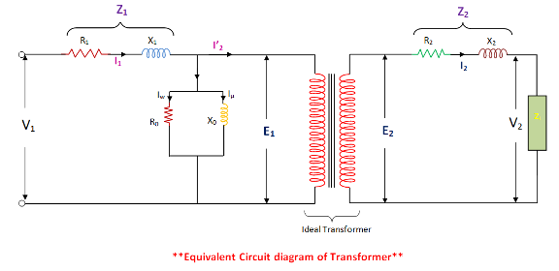
Fig. 1.15
Where,
Where
V₁ = Primary voltage in volts
V₂ = Secondary voltage in volts
I₁ = Primary Current in amps
I₂¹ = Equivalent Secondary current referred to primary in amps
I₀ = No- load current in amps
I_{µ} = Magnetizing Component,
I_{w} = Working Component,
R₀ = Excitation resistance in ohms
X₀ = Excitation reactance or magnetizing reactance in ohms
R₁ = Primary winding resistance in ohms
X₁ = Primary winding reactance in ohms
R₂ = Secondary winding resistance in ohms
X₂ = Secondary winding reactance in ohms
This I_{µ} & I_{w} are connected in parallel across the primary circuit.
The value of E₁ (Primary e.m.f) is obtained by subtracting vectorially I₁ Z₁ from V₁.
The value of X₀ = E₁ / I₀ and R₀ = E₁ /I_{w}.
We know that the relation of E₁ and E₂ is E₂ /E₁ = N₂ /N₁ = K, (transformation Ratio)
From the equivalent circuit, we can easily calculate the voltage, current, and impedance either referred to the primary or the secondary.
The below fig. 1.16 showed the secondary circuit and its equivalent referred primary side.
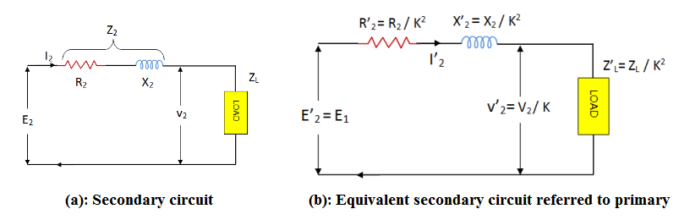
Fig. 1.16
Where
R₂¹ = Secondary winding resistance referred to primary in ohms = R₂/K²
X₂¹ = Secondary winding reactance referred to primary in ohms = X₂/K²
K = Transformation ratio = N₂/N₁ = V₂/V₁
The total equivalent circuit of the transformer referred to primary is obtained as shown in below Fig. 1.17.
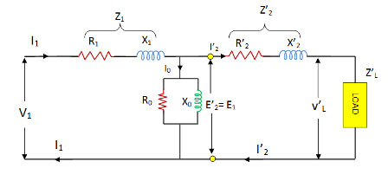
Fig. 1.17

And it can be simplified as in following figures 1.18 and 1.19 because I₀ << I₁
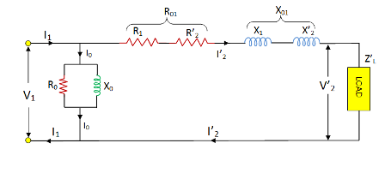
Fig. 1.18
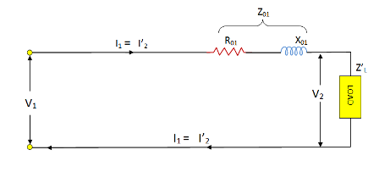
Fig. 1.19
Where
R₀₁ = R₁ + R₂¹ = Total equivalent resistance referred to primary in ohms
X₀₁ = X₁ + X₂¹ = Total equivalent reactance referred to primary in ohms

Transformer Voltage Regulation
Definition:
The voltage regulation is the percentage of secondary voltage difference between no load and full load voltages of a transformer with respect to its rated secondary voltage (No-Load secondary voltage).
Mathematically, the voltage regulation is represented as
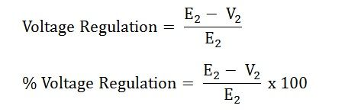
Where,
E₂ – secondary terminal voltage at no load
V₂ – secondary terminal voltage at full load
The approximate expression for the no-load secondary voltage for the different types of load is
  - For inductive Load
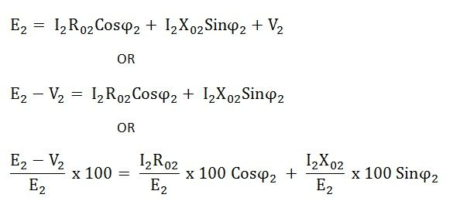
Where,
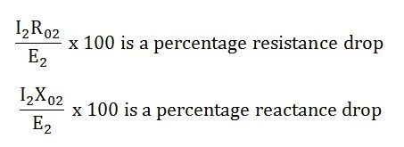
  - For Capacitive load
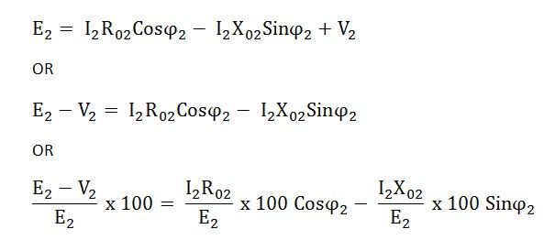

Auto Transformer
An Auto Transformer is a transformer with only one winding wound on a laminated core. An auto transformer is similar to a two winding transformer but differ in the way the primary and secondary winding are interrelated. A part of the winding is common to both primary and secondary sides. On load condition, a part of the load current is obtained directly from the supply and the remaining part is obtained by transformer action. An Auto transformer works as a voltage regulator.
In an ordinary transformer, the primary and the secondary windings are electrically insulated from each other but connected magnetically as shown in the fig. 1.20 below and in auto transformer the primary and the secondary windings are connected magnetically as well as electrically. In fact, a part of the single continuous winding is common to both primary and secondary.
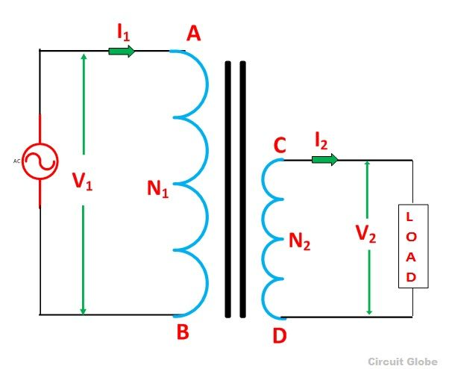
Fig. 1.20: Ordinary Two Winding Transformer
There are two types of auto transformer based on the construction. In one type of transformer, here is continuous winding with the taps brought out at convenient points determined by desired secondary voltage and in another type of auto transformer, there are two or more distinct coils which are electrically connected to form a continuous winding. The construction of Auto transformer is shown in the fig. 1.21 below.
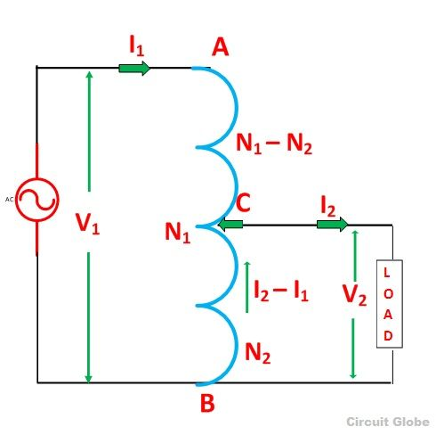
Fig. 1.21: Auto – Transformer
The primary winding AB from which a tapping at C is taken, such that CB acts as a secondary winding. The supply voltage is applied across AB, and the load is connected across CB. The tapping may be fixed or variable. When an AC voltage V₁ is applied across AB, an alternating flux is set up in the core, as a result, an emf E₁ is induced in the winding AB. A part of this induced emf is taken in the secondary circuit.
Let,
V₁ – primary applied voltage
V₂ – secondary voltage across the load
I₁ – primary current
I₂ – load current
N₁ – number of turns between A and B
N₂ – number of turns between C and B
Neglecting no load current, leakage reactance and losses,
V₁ = E₁ and V₂ = E₂
Therefore the transformation ratio K= $\frac{V_{2}}{V_{1}}=\frac{N_{2}}{N_{1}}=\frac{I_{1}}{I_{2}}$
As the secondary ampere-turns are opposite to primary ampere turns, so the current I₂ is in phase opposition to I₁. The secondary voltage is less than the primary. Therefore current I₂ is more than the current I₁. Therefore, the resulting current flowing through section BC is (I₂ – I₁) the ampere-turns due to section BC = current turns
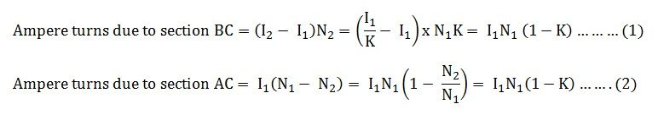
Equation (1) and (2) shows that the ampere turns due to section BC and AC balance each other which is characteristic of the transformer action.

Saving of Copper in Auto Transformer as Compared to Ordinary Two Winding Transformer
The weight of the copper is proportional to the length and area of a cross section of the conductor. The length of the conductor is proportional to the number of turns, and the cross section is proportional to the product of current and number of turns. Now, from the above figure (B) shown of the auto transformer, the weight of copper required in an auto transformer is Wa = weight of copper in section AC + weight of copper in section CB.
Therefore
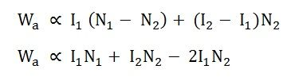
If the same duty is performed with an ordinary two winding transformer shown above in the figure (A) the total weight of the copper required in the ordinary transformerW₀ = weight of copper on its primary winding + weight of copper on its secondary winding. Therefore,
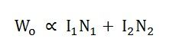

Now, the ratio of the weight of the copper in an auto transformer to the weight of copper in an ordinary transformer is given as
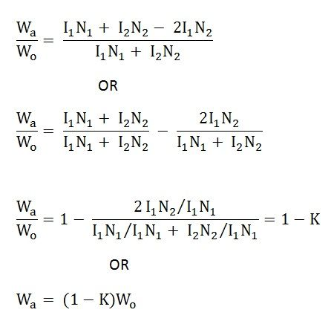
Saving of copper affected by using an auto transformer = weight of copper required in an ordinary transformer – weight of copper required in an auto transformer
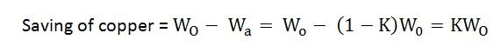
Therefore, saving of copper = K x weight of copper required for two windings of the transformer. Hence, saving in copper increases as the transformation ratio approaches to unity. Hence the auto transformer is used when the value of K is nearly equal to unity.
Advantages of Auto transformer
- Less costly
- Better regulation
- Low losses as compared to ordinary two winding transformer of the same rating.

Disadvantages of Auto transformer
There are various advantages of the auto transformer, but then also one major disadvantage, why auto transformer is not widely used, is that
- The secondary winding is not insulated from the primary winding.
If an auto transformer is used to supply low voltage from a high voltage and there is a break in the secondary winding, the full primary voltage comes across the secondary terminal which is dangerous to the operator and the equipment. So the auto transformer should not be used to for interconnecting high voltage and low voltage system.
- Used only in the limited places where a slight variation of the output voltage from input voltage is required.

Applications of Auto transformer
- It is used as a starter to give up to 50 to 60% of full voltage to the stator of a squirrel cage induction motor during starting.
- It is used to give a small boost to a distribution cable, to correct the voltage drop.
- It is also used as a voltage regulator
- Used in power transmission and distribution system and also in the audio system and railways.
Conversion of 2-Winding Transformer into Auto- transformer:
Any two-winding transformer can be converted into an autotransformer either step-down or step-up as the following example.
Suppose we have a single phase 200V/100V, 50Hz, 10kVA two winding transformer with polarity markings. Then the coils can be connected in various ways as shown in figure below.
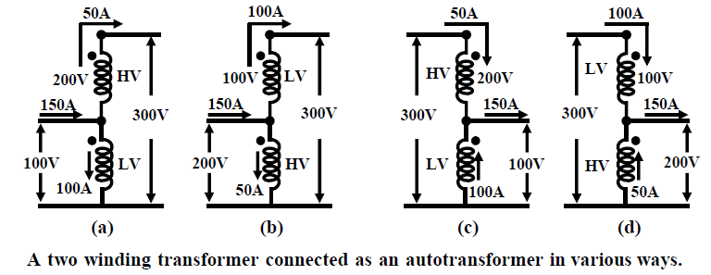
Fig. 1.22
Let us explain the one of the connections in fig. 1.22 (a) in detail. Here the LV and the HV sides are connected in additive series. For rated applied voltage (100V) across the LV winding, 200V must be induced across the HV winding. So across the whole combination we shall get a voltage of 300V. Thus the input voltage is stepped up by a factor of 3 (300 V/100 V).
Now how much current can be supplied to a load at 300 V? From the given rating of the transformer we know, I_{HV rated} = 50 A and I_{LV rated} = 100 A. Therefore for safe operation of the transformer, these rated currents should not be exceeded in HV and LV coils. Since the load is in series with the HV coil, 50A current can be safely supplied. But a current of 50A in the HV demands that the LV winding current must be 100A and in a direction as shown, in order to keep the flux in the core constant. Therefore by applying KCL at the junction, the current drawn from the supply will be 150A.
Obviously the kVA handled by the transformer is 15 kVA and without overloading either of the windings. It may look a bit surprising because as a two winding transformer its rating is only 10 kVA. The explanation is not far to seek. Unlike a two winding transformer, the coils here are connected electrically. So the kVA transferred from supply to the load side takes place both inductively as well as conductively – 10kVA being transferred inductively and remaining 20kVA transferred conductively.
The other connections shown in fig. 1.22 (b), (c) and (d) of figure can similarly explained.

