UNIT 2 TRANSMISSION LINE PARAMETERS

Parameters of single and three phase transmission lines with single and double circuits - Resistance, inductance and capacitance of solid, stranded and bundled conductors, Symmetrical and unsymmetrical spacing and transposition - application of self and mutual GMD; skin and proximity effects

PARAMETERS OF SINGLE AND THREE PHASE TRANSMISSION LINES WITH SINGLE AND DOUBLE CIRCUITS

    - CONSTANTS OF A TRANSMISSION LINE
A transmission line has resistance, inductance and capacitance uniformly distributed along the whole length of the line. Before pass on to the methods of finding these constants for a transmission line, it is profitable to understand them thoroughly.
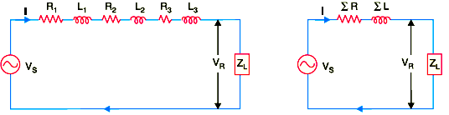
Fig2.1 Transmission line
( i) Resistance. It is the opposition of line conductors to current flow. The resistance is distributed uniformly along the whole length of the line as shown in Fig2.1. However, the performance of a transmission line can be analysed conveniently if distributed resistance is considered as lumped as shown in Fig.2.1
( ii) Inductance. When an alternating current flows through a conductor, a changing flux is set up which links the conductor. Due to these flux linkages, the conductor possesses inductance. Mathematically, inductance is defined as the flux linkages per amperei.e.,
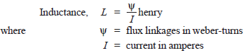
The inductance is also uniformly distributed along the length of the line as show in Fig2.1. Again for the convenience of analysis, it can be taken to be lumped as shown in Fig2.1

( iii) Capacitance. Any two conductors separated by an insulating material constitute a capacitor. As any two conductors of an overhead transmission line are separated by air which acts as an insulation, therefore, capacitance exists between any two overhead line conductors. The capacitance between the conductors is the charge per unit potential difference i.e.,

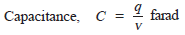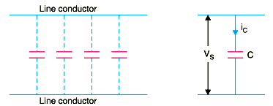

Fig. 2.2 (i) Capacitance distribution along the transmission line (ii) charging current

where

q = charge on the line in coulomb
v = p.d. between the conductors in volts
The capacitance is uniformly distributed along the whole length of the line and may be

regarded as a uniform series of capacitors connected between the conductors as shown in Fig. 2.2(i). When an alternating voltage is impressed on a transmission line, the charge on the conductors at any point increases and decreases with the increase and decrease of the instantaneous value of the voltage between conductors at that point. The result is that a current (known as charging current) flows between the conductors [See Fig. 2.2( ii)]. This charging current flows in the line even when it is open-circuited i.e., supplying no load. It affects the voltage drop along the line as well as the efficiency and power factor of the line.

Resistance of a Transmission Line
The resistance of transmission line conductors is the most important cause of power loss in a transmission line. The resistance R of a line conductor having resistivity ρ, length l and area of cross-section a is given by ;
R = ρ l/a
The variation of resistance of metallic conductors with temperature is practically linear over the normal range of operation. Suppose R1 and R2 are the resistances of a conductor at t1 ºC and t2 ºC
( t2>t1 ) respectively. If α 1is the temperature coefficient at t1 °C,then,
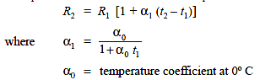

  - INDUCTANCE OF A SINGLE PHASE TWO-WIRE LINE
A single phase line consists of two parallel conductors which form a rectangular loop of one turn shown in Fig2.3.
When an alternating current flows through such a loop, a changing magnetic flux is set up. The changing flux links the loop and hence the loop (or single phase line) possesses inductance. It may appear that inductance of a single phase line is negligible because it consists of a loop of one turn and the flux path is through air of high reluctance. But as the X-sectional

area of the loop is very large, even for a small flux density, the total flux linking the loop is quite large and hence the line has appreciable inductance.
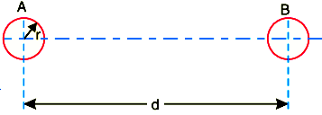
Fig. 2.3 Single phase over head line

Consider a single phase overhead line consisting of two parallel conductors A and B spaced d metres apart as shown in Fig. 2.3. Conductors A and B carry the same amount of current ( i.e. IA
= IB ), but in the opposite direction because one forms the return circuit of the other.
IA+IB = 0
In order to find the inductance of conductor A (or conductor B), Consider the flux linkages with it. There will be flux linkages with conductor A due to its own current IA and also A due to the mutual inductance effect of current IB in the conductor B Flux linkages with conductor A due to its own current
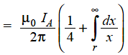
Flux linkages with conductor A due to current IB
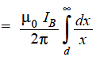
Total flux linkages with conductor A is
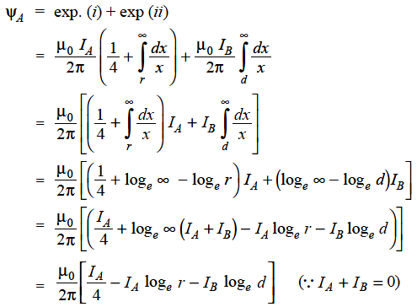

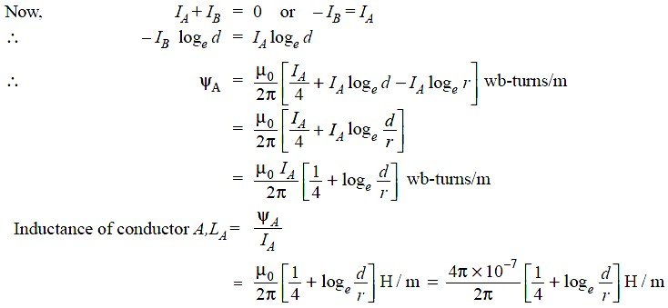
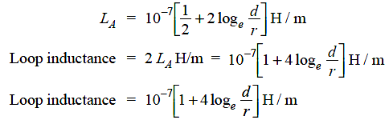

Note that eq. ( ii) is the inductance of the two-wire line and is sometimes called loop inductance. However, inductance given by eq. ( i) is the inductance per conductor and is equal to half the loopinductance.

    - INDUCTANCE OF A 3-PHASE OVERHEAD LINE

Fig.2.4 shows the three conductors A, B and C of a 3-phase line carrying currents IA , IB and IC respectively. Let d1 , d2 and d3 be the spacing between the conductors as shown in Fig2.4. Let us further assume that the loads are balanced i.e. IA + IB + IC = 0. Consider the flux linkages with conductor . There will be flux linkages with conductor A due to its own current and also due to the mutual inductance effects of IB and IC
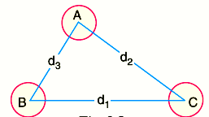
Fig.2.4 Three phase line

Flux linkages with conductor A due to its own current
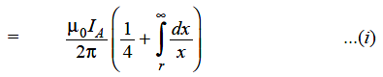
Flux linkages with conductor A due to current IB
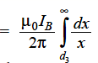
Flux linkages with conductor A due to current IC
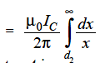
Total flux linkages with conductor Ais

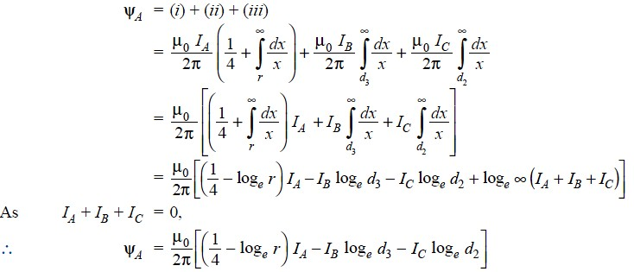

    - SYMMETRICAL SPACING
If the three conductors A, B and C are placed symmetrically at the corners of an equilateral triangle of side d, then, d1 = d2 = d3 = d. Under such conditions, the flux derived in a similar way, the expressions for inductance are the same for conductors B and C.

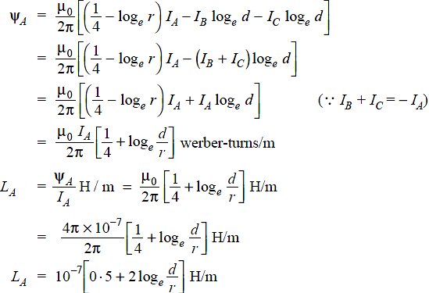

    - UNSYMMETRICAL SPACING

When 3-phase line conductors are not equidistant from each other, the conductor spacing is said to be unsymmetrical. Under such conditions, the flux linkages and inductance of each phase are not the same. A different inductance in each phase results in unequal voltage drops in the three phases even if the currents in the conductors are balanced. Therefore, the voltage at the receiving end will not be the same for all phases. In order that voltage drops are equal in all conductors, we generally interchange the positions of the conductors at regular intervals along the line so that each conductor occupies the original position of every other conductor over an equal distance. Such an exchange of positions is known as transposition. Fig.2.5 shows the transposed line. The phase conductors are designated as A, B and C and the positions occupied are numbered 1, 2 and 3. The effect of transposition is that each conductor has the same average inductance.
Fig.2.5 shows a 3-phase transposed line having unsymmetrical spacing. Let us assume that each of the three sections is 1 m in length. Let us further assume balanced conditions i.e.,
IA + IB +IC =0
Let the line currents be :
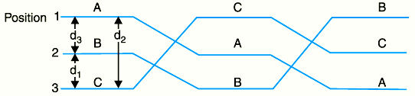

Fig.2.5 shows the transposed line.
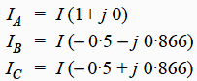

As proved above, the total flux linkages per metre length of conductor A is
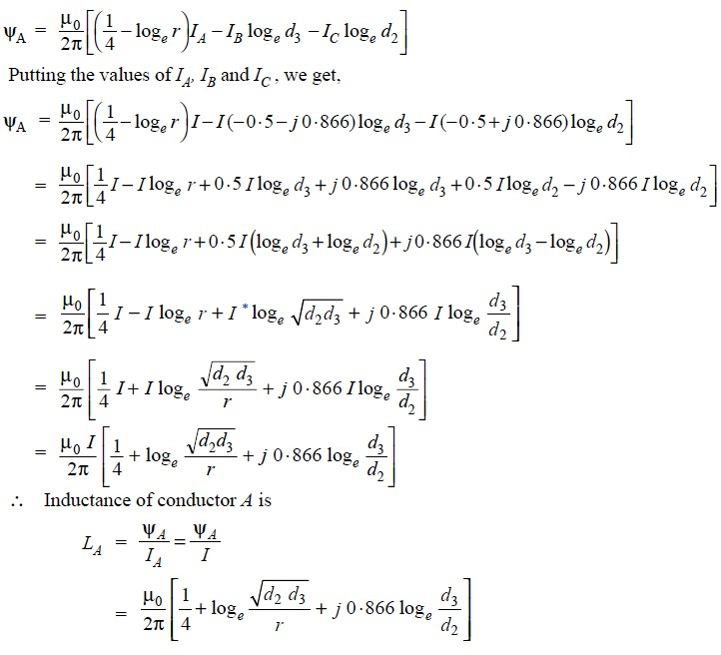
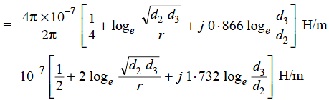

Similarly inductance of conductors B and C will be :
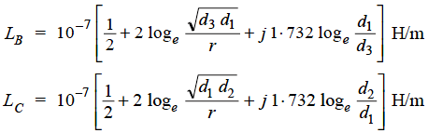

Inductance of each line conductor
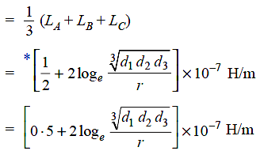

Compare the formula of inductance of an un symmetrically spaced transposed line with that of symmetrically spaced line, we find that inductance of each line conductor in the two cases will be equal if 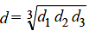The distance d is known as equivalent equilateral spacing for un symmetrically transposed line

  - BUNDLED CONDUCTOR
There are two types of transmission line conductors: overhead and underground. Overhead conductors, made of naked metal and suspended on insulators, are preferred over underground conductors because of the lower cost and easy maintenance. Also, overhead transmission lines use aluminum conductors, because of the lower cost and lighter weight compared to copper conductors, although more cross-section area is needed to conduct the same amount of current. There are different types of commercially available aluminum conductors: aluminum-conductor-steel-reinforced (ACSR), aluminum-conductor-alloy-reinforced (ACAR), all-aluminum-conductor (AAC), and all-aluminum alloy- conductor (AAAC).
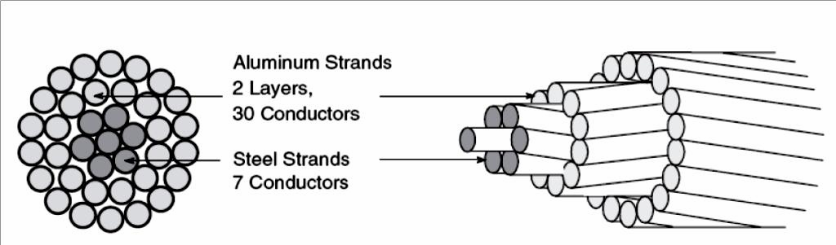
ACSR is one of the most used conductors in transmission lines. It consists of alternate layers of stranded conductors, spiraled in opposite directions to hold the strands together, surrounding a core of steel strands. Above figure shows an example of aluminum and steel strands combination. The purpose of introducing a steel core inside the stranded aluminum conductors is to obtain a high strength-to-weight ratio. A stranded conductor offers more flexibility and easier to manufacture than a solid large conductor. However, the total resistance is increased because the outside strands are larger than the inside strands on account of the spiraling. The resistance of each wound conductor at any layer, per unit length, is based on its total length as follows:

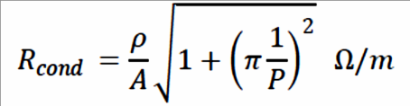

  - CONCEPT OF SELF-GMD ANDMUTUAL-GMD
The use of self geometrical mean distance (abbreviated as self-GMD) and mutual geometrical mean distance (mutual-GMD) simplifies the inductance calculations, particularly relating to multi conductor arrangements. The symbols used for these are respectively Ds and Dm. We shall briefly discuss these terms.

( i) Self-GMD (Ds)
In order to have concept of self-GMD (also sometimes called Geometrical mean radius; GMR), consider the expression for inductance per conductor per metre already derived in Art. Inductance/conductor/m
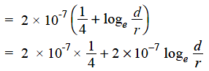

In this expression, the term 2 × 10-7 × (1/4) is the inductance due to flux within the solid conductor. For many purposes, it is desirable to eliminate this term by the introduction of a concept called self-GMD or GMR. If we replace the original solid conductor by an equivalent hollow cylinder with extremely thin walls, the current is confined to the conductor surface and internal conductor flux linkage would be almost zero. Consequently, inductance due to internal
flux would be zero and the term 2 × 10-7 × (1/4) shall be eliminated. The radius of this equivalent hollow cylinder must be sufficiently smaller than the physical radius of the conductor to allow room for enough additional flux to compensate for the absence of internal flux linkage. It can be proved mathematically that for a solid round conductor of radius r, the self-GMD or GMR = 0·7788 r. Using self-GMD, the eq. ( i) becomes:
Inductance/conductor/m = 2 × 10-7loge d/ Ds *
Where
Ds = GMR or self-GMD = 0·7788 r
It may be noted that self-GMD of a conductor depends upon the size and shape of the conductor and is independent of the spacing between the conductors.
- Mutual-GMD
The mutual-GMD is the geometrical mean of the distances form one conductor to the other and, therefore, must be between the largest and smallest such distance. In fact, mutual- GMD simply represents the equivalent geometrical spacing.
  - The mutual-GMD between two conductors (assuming that spacing between conductors is large compared to the diameter of each conductor) is equal to the distance between their centres i.e. Dm = spacing between conductors =d
  - For a single circuit 3-φ line, the mutual-GMD is equal to the equivalent equilateral spacing i.e., ( d1d2 d3)1/3.

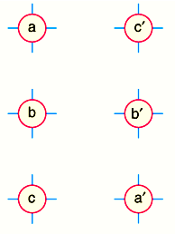
Fig2.6 3-Phase double circuit line
  - The principle of geometrical mean distances can be most profitably employed to 3-φ
double circuit lines. Consider the conductor arrangement of the double circuit shown in Fig.2.6 Suppose the radius of each conductor is r.
Self-GMD of conductor = 0·7788 r Self-GMD of combination aa’ is
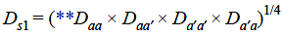
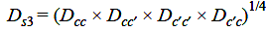
Self-GMD of combination bb’ is Self-GMD of combination cc’ is Equivalent self-GMD of one phase
The value of Ds is the same for all the phases as each conductor has the same radius. Mutual-GMD between phases A and B is
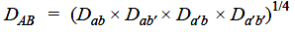
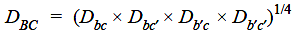
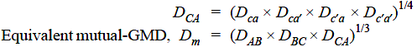
Mutual-GMD between phases B and C is Mutual-GMD between phases C and A is

It is worthwhile to note that mutual GMD depends only upon the spacing and is substantially independent of the exact size, shape and orientation of the conductor.

Inductance Formulas in Terms of GMD
The inductance formulas developed in the previous articles can be conveniently expressed in terms of geometrical meandistances.
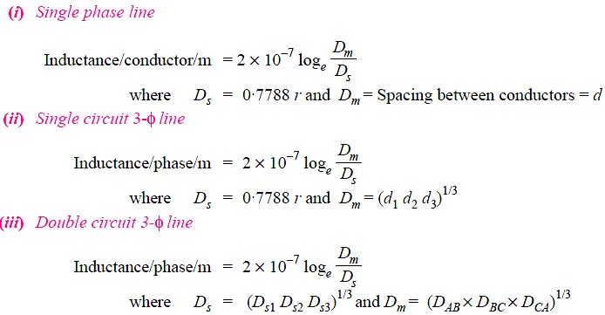

  - CAPACITANCE OF A SINGLE PHASE TWO-WIRELINE
Consider a single phase overhead transmission line consisting of two parallel conductors A and B spaced d metres apart in air as shown in Fig2.7. Suppose that radius of each conductor is r metres. Let their respective charge be + Q and − Q coulombs per metre length. The total p.d. between conductor A and neutral “infinite” plane is
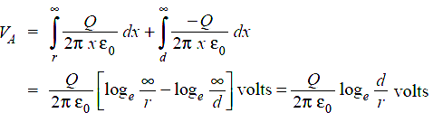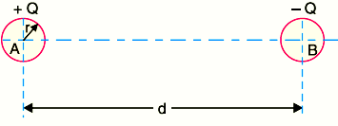
Fig2.7 single phase overhead transmission line

Similarly, p.d. between conductor B and neutral “infinite” plane is
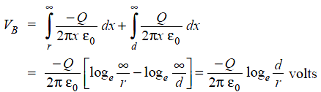

Both these potentials are w.r.t. the same neutral plane. Since the unlike charges attract each other, the potential difference between the conductorsis
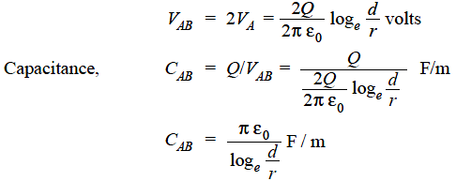

Capacitance to neutral
Equation ( i) gives the capacitance between the conductors of a two-wire line Often it is desired to know the capacitance between one of the conductors and a neutral point between them. Since potential of the mid-point between the conductors is zero, the potential difference
between each conductor and the ground or neutral is half the potential difference between the conductors. Thus the capacitance to ground or capacitance to neutral for the two-wire line is twice the line-to-line capacitance
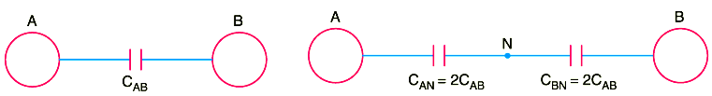
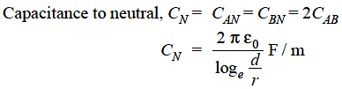

The reader may compare eq. ( ii) to the one for inductance. One difference between the equations for capacitance and inductance should be noted carefully. The radius in the equation for capacitance is the actual outside radius of the conductor and not the GMR of the conductor as in the inductance formula. Note that eq. ( ii) applies only to a solid round conductor.
    - CAPACITANCE OF A 3-PHASE OVERHEAD LINE
In a 3-phase transmission line, the capacitance of each conductor is considered instead of capacitance from conductor to conductor. Here, again two cases arise viz., symmetrical spacing and unsymmetrical spacing.

( i) Symmetrical Spacing
Fig2.8 shows the three conductors A, B and C of the 3-phase overhead transmission line having charges QA , QB and QC per meter length respectively. Let the conductors be equidistant (d meters) from each other. We shall find the capacitance from line conductor to neutral in this symmetrically spaced line. Referring toFig2.8.
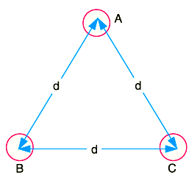
Fig 2.8 Three phase overhead transmission line with symmetrical spacing
Overall potential difference between conductor A and infinite neutral plane is given by
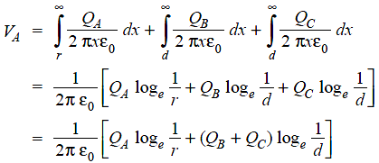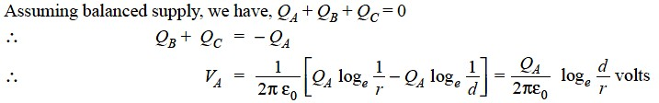
∴ Capacitance of conductor A w.r.t neutral,
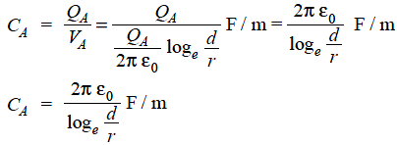
Note that this equation is identical to capacitance to neutral for two-wire line. Derived in a similar manner, the expressions for capacitance are the same for conductors B andC.

(ii) Unsymmetrical spacing.
Fig.2.9 shows a 3-phase transposed line having unsymmetrical spacing. Let us assume balanced conditions i.e. QA + QB + QC = 0.

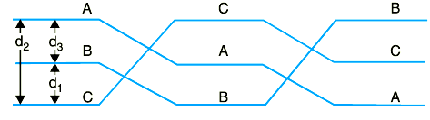

Fig.2.9 3-phase transposed line having unsymmetrical spacing

Considering all the three sections of the transposed line for phase A,
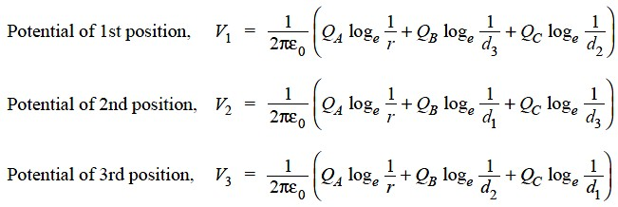

Average voltage on conductor Ais
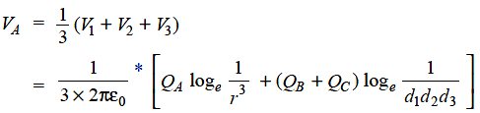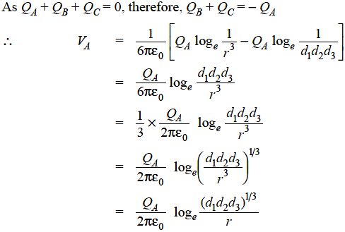
Capacitance from conductor to neutral is
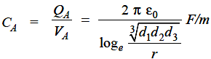

  - INDUCTIVE INTERFERENCE WITH NEIGHBOURING COMMUNICATION CIRCUITS

It is usual practice to run telephone lines along the same route as the power lines. The transmission lines transmit bulk power at relatively high voltages and, therefore, these lines give rise to electro-magnetic and electrostatic fields of sufficient magnitude which induce are superposed on the true speech currents in the neighboring telephone wires and set up distortion while the voltage so induced raise the potential of the communication circuit as a whole. In extreme cases the effect of these may make it impossible to transmit any message faithfully and may raise the potential of the telephone receiver above the ground to such an extent to render the handling of the telephone receiver extremely dangerous and in such cases elaborate precautions are required to be observed to avoid this danger.

In practice it is observed that the power lines and the communication lines run along the same path. Sometimes it can also be seen that both these lines run on same supports along the same route. The transmission lines transmit bulk power with relatively high voltage. Electromagnetic and electrostatic fields are produced by these lines having sufficient magnitude. Because of these fields, voltages and currents are induced in the neighboring communication lines. Thus it gives rise to interference of power line with communication circuit.

Due to electromagnetic effect, currents are induced which is superimposed on speech current of the neighboring communication line which results into distortion. The potential of the communication circuit as a whole is raised because of electrostatic effect and the communication apparatus and the equipment’s may get damaged due to extraneous voltages. In the worst situation, the faithful transmission of message becomes impossible due to effect of these fields. Also the potential of the apparatus is raised above the ground to such an extent that the handling of telephone receiver becomes extremely dangerous.
The electromagnetic and the electrostatic effects mainly depend on what is the distance between power and communication circuits and the length of the route over which they are parallel. Thus it can be noted that if the distortion effect and potential rise effect are within permissible limits then the communication will be proper. The unacceptable disturbance which is produced in the telephone communication because of power lines is called Telephone Interference.
There are various factors influencing the telephone interference. These factors are as follows
- Because of harmonics in power circuit, their frequency range andmagnitudes.
- Electromagnetic coupling between power and telephoneconductor.
The electric coupling is in the form of capacitive coupling between power and telephone conductor whereas the magnetic coupling is through space and is generally expressed in terms of mutual inductance at harmonic frequencies.
- Due to unbalance in power circuits and in telephonecircuits.
- Type of return telephone circuit i.e. either metallic or groundreturn.
- Screeningeffects.

Steps for Reducing Telephone Interference
There are various ways that can reduce the telephone interference. Some of them are as listedbelow
  - The harmonics at the source can be reduced with the use of A.C. harmonic filters, D.C. harmonic filters and smoothingrectors.
  - Use greater spacing between power and telephonelines.
  - The parallel run between telephone line and power line isavoided.
  - Instead of using overhead telephone wires, underground telephone cables may beused.
  - If the telephone circuit is ground return then replace it with metallicreturn.
  - Use microwave or carrier communication instead of telephonecommunication.
  - The balance of AC power line is improved by using transposition. Transposition of lines reduces the induced voltages to a considerable extent. The capacitance of the lines is balanced by transposition leading to balance in electrostatically induced voltages. Using transposition the fluxes due to positive and negative phase sequence currents cancel out so the electromagnetically induced e.m.f.s are diminished. For zero sequence currents the telephone lines are also transposed which is shown in the Fig.2.10.

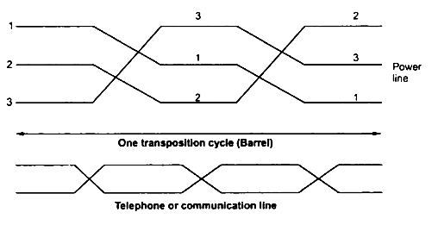
Fig 2.10 Transposed line

  - CONDUCTORS
Commonly used conductor materials:
The most commonly used conductor materials for over head lines are copper, aluminium, steel cored aluminium, galvanised steel and cadmium copper. The choice of a particular material will depend upon the cost, the required electrical and mechanical properties and the local conditions. All conductors used for overhead lines are preferably stranded in order to increase the flexibility. In stranded conductors, there is generally one central wire and round this, successive layers of wires containing 6, 12, 18, 24 ...... wires. Thus, if there are n layers, the total number of individual wires is 3n(n + 1) + 1. In the manufacture of stranded conductors, the consecutive layers of wires are twisted or spiralled in opposite directions so that layers are bound together.
    - TYPES OFCONDUCTOR 1.Copper
Copper is an ideal material for overhead lines owing to its high electrical conductivity and greater tensile strength. It is always used in the hard drawn form as stranded conductor. Although hard drawing decreases the electrical conductivity slightly yet it increases the tensile strength considerably. Copper has high current density i.e., the current carrying capacity of copper per unit of Xsectional area is quite large. This leads to two advantages. Firstly, smaller X- sectional area of conductor is required and secondly, the area offered by the conductor to wind loads is reduced. Moreover, this metal is quite homogeneous, durable and has high scrap value. There is hardly any doubt that copper is an ideal material for transmission and distribution of electric power. However, due to its higher cost and non-availability, it is rarely used for these purposes. Now a days the trend is to use aluminium in place ofcopper.

- Aluminium
Aluminium is cheap and light as compared to copper but it has much smaller conductivity and tensile strength. The relative comparison of the two materials is briefed below:
- The conductivity of aluminium is 60% that of copper. The smaller conductivity of aluminium means that for any particular transmission efficiency, the X-sectional area of conductor must be
larger in aluminium than in copper. For the same resistance, the diameter of aluminium conductor is about 1·26 times the diameter of copper conductor. The increased X-section of aluminium exposes a greater surface to wind pressure and, therefore, supporting towers must be designed for greater transverse strength. This often requires the use of higher towers with consequence of greatersag.
- The specific gravity of aluminium (2·71 gm/cc) is lower than that of copper (8·9 gm/cc).Therefore, an aluminium conductor has almost one-half the weight of equivalent copper conductor. For this reason, the supporting structures for aluminium need not be made so strong as that of copperconductor.
- Aluminium conductor being light, is liable to greater swings and hence larger cross-arms are required.
- Due to lower tensile strength and higher co-efficient of linear expansion of aluminium, the sag is greater in aluminium conductors. Considering the combined properties of cost, conductivity, tensile strength, weight etc., aluminium has an edge over copper. Therefore, it is being widely used as a conductor material. It is particularly profitable to use aluminium for heavy-current transmission where the conductor size is large and its cost forms a major proportion of the total cost of completeinstallation.

- Steel coredaluminium
Due to low tensile strength, aluminium conductors produce greater sag. This prohibits their use for larger spans and makes them unsuitable for long distance transmission. In order to increase the tensile strength, the aluminium conductor is reinforced with a core of galvanised steel wires. The composite conductor thus obtained is known as steel cored aluminium and is abbreviated as A.C.S.R. (aluminium conductor steel reinforced).
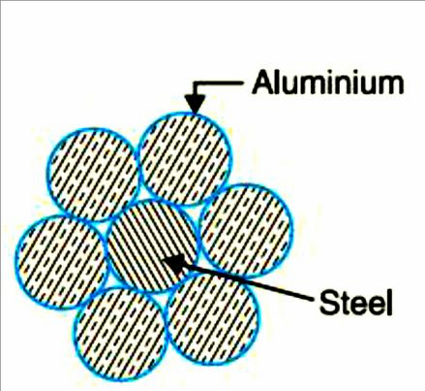
Steel-cored aluminium conductor consists of central core of galvanized steel wires surrounded by a number of aluminium strands. Usually, diameter of both steel and aluminium wires is the same. The X-section of the two metals are generally in the ratio of 1 : 6 but can be modified to 1 : 4 in order to get more tensile strength for the conductor. Fig. shows steel coredaluminium conductor having one steel wire surrounded by six wires of aluminium. The result of this composite conductor is that steel core takes greater percentage of mechanical strength while aluminium strands carry the bulk of current. The steel coredaluminium conductors have the following

Advantages:
- The reinforcement with steel increases the tensile strength but at the same time keeps the composite conductor light. Therefore, steel coredaluminium conductors will produce smaller sag and hence longer spans can beused.

- Due to smaller sag with steel coredaluminium conductors, towers of smaller heights can be used.

- Galvanisedsteel
Steel has very high tensile strength. Therefore, galvanised steel conductors can be used for extremely long spans or for short line sections exposed to abnormally high stresses due to climatic conditions. They have been found very suitable in rural areas where cheapness is the main consideration. Due to poor conductivity and high resistance of steel, such conductors are not suitable for transmitting large power over a long distance. However, they can be used to advantage for transmitting a small power over a small distance where the size of the copper conductor desirable from economic considerations would be too small and thus unsuitable for use because of poor mechanicalstrength.

- Cadmiumcopper
The conductor material now being employed in certain cases is copper alloyed with cadmium. An addition of 1% or 2% cadmium to copper increases the tensile strength by about 50% and the conductivity is only reduced by 15% below that of pure copper. Therefore, cadmium copper conductor can be useful for exceptionally long spans. However, due to high cost of cadmium, such conductors will be economical only for lines of small X-section i.e., where the cost of conductor material is comparatively small compared with the cost ofsupports.

