UNIT 3

VARIOUS FACTORS GOVERNING

PERFORMANCE OF TRANSMISSION LINE

  - SKINEFFECT
The phenomena arising due to unequal distribution of electric current over the entire cross section of the conductor being used for long distance power transmission is referred as the skin effect in transmission lines. Such a phenomena does not have much role to play in case of a very short line, but with increase in the effective length of the conductors, skin effect increases considerably. So the modifications in line calculation needs to be done accordingly. The distribution of electric current over the entire cross section of the conductor is quite uniform in case of a DC system. But what we are using in the present era of power system engineering is predominantly an alternating electric current system, where the electric current tends to flow with higher density through the surface of the conductors (i.e skin of the conductor), leaving the core deprived of necessary number of electrons.
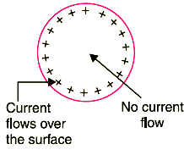
In fact there even arises a condition when absolutely no electric current flows through the core, and concentrating the entire amount on the surface region, thus resulting in an increase in the effective electrical resistance of the conductor. This particular trend of an AC transmission system to take the surface path for the flow of electric current depriving the core is referred to as the skin effect in transmission lines.
Factors Affecting Skin Effect
The skin effect in an ac system depends on a number of factors like:-
1) Shape of conductor.
2) Type of material.
3) Diameter of the conductors.
4) Operational frequency

  - PROXIMITY EFFECT
The alternating magnetic flux in a conductor caused by current flowing in neighboring conductor gives rise to the circulating currents which causes an increase in the resistance of a conductor. This phenomenon is called “proximity effect”.
- When two or more conductors carrying AC current are close to each other, then distribution of current in each conductor is affected due to the varying magnetic field of each other. The varying magnetic field produced by AC induces eddy currents in the adjacent conductors. Due to this, when the nearby conductors carrying current in the same direction, the current is concentrated at the farthest side of the conductors. The magnetic field of the halves of the conductors which are close to each other is cancelling each other and hence no current flow through that halves portion of the conductor.

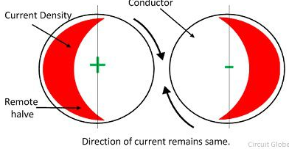
- If conductors are carrying current in opposite direction, the magnetic fields setup will tend to cause an increase in current density adjacent portions of the conductors. The result in any case Effective resistance of the conductor is increased due to the proximity effect.
- This effect is called as Proximity effect. The proximity effect also increases with increase in the frequency.
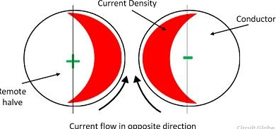

- Both skin and proximity effects depends on the conductor size, resistivity and permeability of the material. Thus at power frequencies and small conductors these effect negligible, but these effects may be quite important for large conductors and high frequency.
- The proximity effect can be reduced by using the ACSR (Aluminum Core Steel Reinforced) conductor. In ACSR conductor the steel is placed at the centre of the conductor and the aluminium conductor is positioned around steel wire.
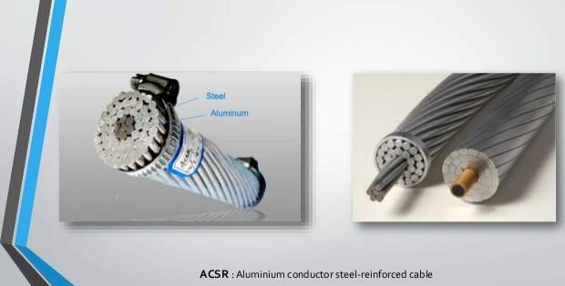

3.3 FERRANTI EFFECT

A long transmission line draws a substantial quantity of charging current. If such a line is open circuited or very lightly loaded at the receiving end, the voltage at receiving end may become greater than voltage at sending end. This is known as Ferranti Effect and is due to the voltage drop across the line inductance (due to charging current) being in phase with the sending end voltages. Therefore both capacitance and inductance is responsible to produce this phenomenon The capacitance (and charging current) is negligible in short line but significant in medium line and appreciable in long line. Therefore this phenomenon occurs in medium and long lines.

Represent the line by equivalent π model.
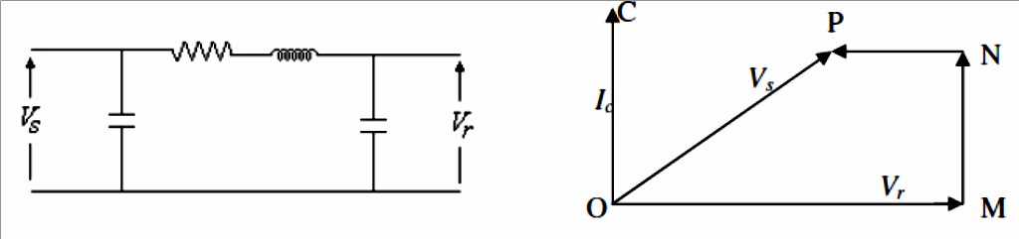
Line capacitance is assumed to be concentrated at the receiving end.
OM = receiving end voltage Vr
OC = Current drawn by capacitance = Ic MN = Resistance drop
NP = Inductive reactance drop Therefore;
OP = Sending end voltage at no load and is less than receiving end voltage (Vr)
Since, resistance is small compared to reactance; resistance can be neglected in calculating Ferranti effect.
From π model,
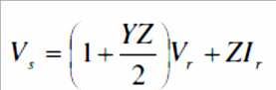
For open circuit line; Ir = 0
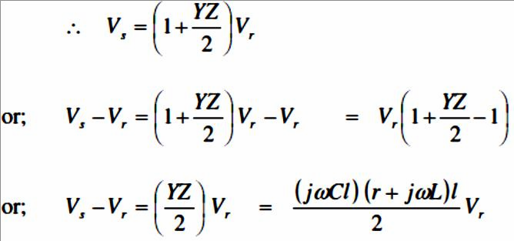
Neglecting resistance;

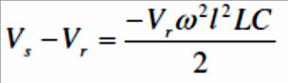
Substituting the value in above equation;
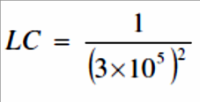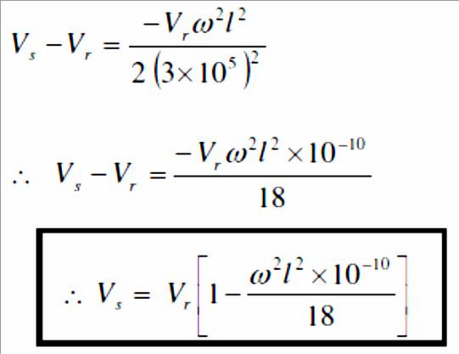
Now, from above expression;
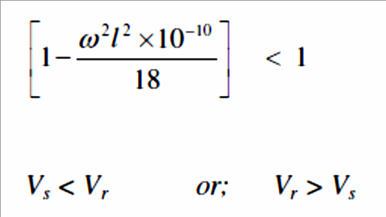
i.e. receiving end voltage is greater than sending end voltage and this effect is called Ferranti Effect. It is valid for open circuit condition of long line.

3.4 CORONA
When an alternating potential difference is applied across two conductors whose spacing is large as compared to their diameters, there is no apparent change in the condition of atmospheric air surrounding the wires if the applied voltage is low. However, when the applied voltage exceeds a certain value, called critical disruptive voltage, the conductors are surrounded by a faint violet glow called corona.
The phenomenon of corona is accompanied by a hissing sound, production of ozone, power loss and radio interference. The higher the voltage is raised, the larger and higher the luminous envelope becomes, and greater are the sound, the power loss and the radio noise. If the applied voltage is increased to breakdown value, a flash-over will occur between the conductors due to the breakdown of air insulation If the conductors are polished and smooth, the corona glow will be uniform throughout the length of the conductor, otherwise the rough points will appear brighter. With d.c. voltage, there is difference in the appearance of the two wires. The positive wire has uniform glow about it, while the negative conductor has spotty glow.

Theory of corona formation
Some ionisation is always present in air due to cosmic rays, ultraviolet radiations and radioactivity. Therefore, under normal conditions, the air around the conductors contains some ionised particles and neutral molecules. When p.d. is applied between the conductors, potential gradient is set up in the air which will have maximum value at the conductor surfaces. Under the influence of potential gradient, the existing free electrons acquire greater velocities. The greater the applied voltage, the greater the potential gradient and more is the velocity of free electrons. When the potential gradient at the conductor surface reaches about 30 kV per cm (max. value), the velocity acquired by the free electrons is sufficient to strike a neutral molecule with enough
force to dislodge one or more electrons from it. This produces another ion and one or more free electrons, which is turn are accelerated until they collide with other neutral molecules, thus producing other ions. Thus, the process of ionisation is cummulative. The result of this ionisation is that either corona is formed or spark takes place between the conductors.

Factors Affecting Corona
The phenomenon of corona is affected by the physical state of the atmosphere as well as by the conditions of the line. The following are the factors upon which corona depends: (i)Atmosphere
As corona is formed due to ionsiation of air surrounding the conductors, therefore, it is affected by the physical state of atmosphere. In the stormy weather, the number of ions is more than normal and as such corona occurs at much less voltage as compared with fair weather.
- Conductor size.
The corona effect depends upon the shape and conditions of the conductors. The rough and irregular surface will give rise to more corona because unevenness of the surface decreases the value of breakdown voltage. Thus a stranded conductor has irregular surface and hence gives rise to more corona that a solid conductor.
- Spacing between conductors.
If the spacing between the conductors is made very large as compared to their diameters, there may not be any corona effect. It is because larger distance between conductors reduces the electro-static stresses at the conductor surface, thus avoiding corona formation.
- Line voltage.
The line voltage greatly affects corona. If it is low, there is no change in the condition of air surrounding the conductors and hence no corona is formed. However, if the line voltage has such a value that electrostatic stresses developed at the conductor surface make the air around the conductor conducting, then corona is formed.

Important Terms
The phenomenon of corona plays an important role in the design of an overhead transmission line. Therefore, it is profitable to consider the following terms much used in the analysis of corona effects:
- Critical Disruptive Voltage
It is the minimum phase-neutral voltage at which corona occurs. Consider two conductors of radii r cm and spaced d cm apart. If V is the phase-neutral potential, then potential gradient at the conductor surface is given by:
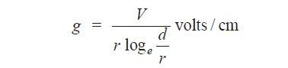
In order that corona is formed, the value of g must be made equal to the breakdown strength of air. The breakdown strength of air at 76 cm pressure and temperature of 25ºC is 30 kV/cm (max) or 21·2 kV/cm (r.m.s.) and is denoted by go. If Vc is the phase-neutral potential required under these conditions, then,
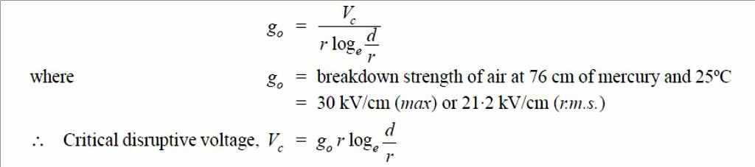

The above expression for disruptive voltage is under standard conditions i.e., at 76 cm of Hg and 25ºC. However, if these conditions vary, the air density also changes, thus altering the value of go. The value of go is directly proportional to air density. Thus the breakdown strength of air at a barometric pressure of b cm of mercury and temperature of tºC becomes δ go where
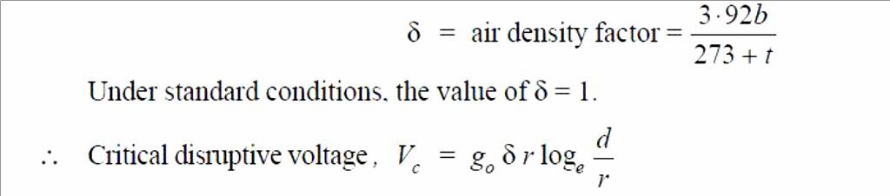
Correction must also be made for the surface condition of the conductor. This is accounted for by multiplying the above expression by irregularity factor mo.
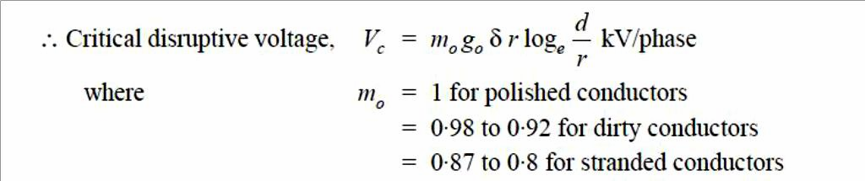
- Visual critical voltage
It is the minimum phase-neutral voltage at which corona glow appears all along the line conductors. It has been seen that in case of parallel conductors, the corona glow does not begin at the disruptive voltage Vc but at a higher voltage Vv, called visual critical voltage. The phase- neutral effective value of visual critical voltage is given by the following empirical formula : where mV is another irregularity factor having a value of 1·0 for polished conductors and 0·72 to 0·82 for rough conductors.
- Power loss due to corona
Formation of corona is always accompanied by energy loss which is dissipated in the form of light, heat, sound and chemical action. When disruptive voltage is exceeded, the power loss due to corona is given by:
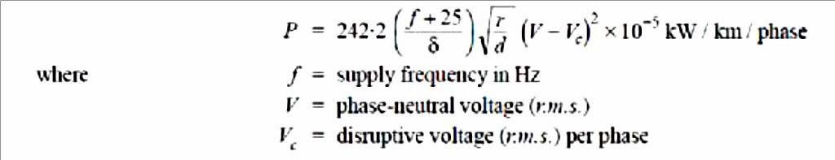

Advantages and Disadvantages of Corona
Corona has many advantages and disadvantages. In the correct design of a high voltage overhead line, a balance should be struck between the advantages and disadvantages.

Advantages
  - Due to corona formation, the air surrounding the conductor becomes conducting and hence virtual diameter of the conductor is increased. The increased diameter reduces the electrostatic stresses between the conductors.
  - Corona reduces the effects of transients produced by surges.

Disadvantages
- Corona is accompanied by a loss of energy. This affects the transmission efficiency of the line.
- Ozone is produced by corona and may cause corrosion of the conductor due to chemical action.
- The current drawn by the line due to corona is non-sinusoidal and hence no sinusoidal voltage drop occurs in the line. This may cause inductive interference with neighboring communication lines.

Methods of Reducing Corona Effect
It has been seen that intense corona effects are observed at a working voltage of 33 kV or above. Therefore, careful design should be made to avoid corona on the sub-stations or bus-bars rated for 33 kV and higher voltages otherwise highly ionized air may cause flash-over in the insulators or between the phases, causing considerable damage to the equipment. The corona effects can be reduced by the following methods
- By increasing conductor size.
By increasing conductor size, the voltage at which corona occurs is raised and hence corona effects are considerably reduced. This is one of the reasons that ACSR conductors which have a larger cross-sectional area are used in transmission lines.
- By increasing conductor spacing
By increasing the spacing between conductors, the voltage at which corona occurs is raised and hence corona effects can be eliminated. However, spacing cannot be increased too much otherwise the cost of supporting structure (e.g., bigger cross arms and supports) may increase to a considerable extent.

Radio Interference or Radio Frequency Interference (RFI):
Radio frequency interference is the conduction or radiation of radio frequency energy that causes an electronic or electrical device to produce noise that typically interferes with the function of an adjacent device. It also refers to the disruption of the normal functionality of a satellite due to the interference of radio astronomy. Radio frequency interference can disrupt and disturb the normal functioning of electronic and electrical devices, and thus it is important to limit it when possible.
Electrical interference, or noise, is an unwanted electrical signal that can cause intolerable error in, or complete disablement of an electronic control or measurement systems. Interference or electrical noise is broken down into two somewhat overlapping categories: Radio Frequency Interference (RFI) and Electromagnetic Interference (EMI). Some of the more commonly encountered sources of interference are:
❑ Mobile and stationary radio, television and hand-held transmitters (walkie-talkies)
❑ Cellular telephones
❑ Fluorescent lights
❑ Radar
❑ Weather related electrical discharges such as lightning and corona
❑ Static discharges
❑ Induction heating systems
❑ High speed power switching elements such as SCRs and thyristors
❑ High AC current conductors
❑ Large solenoids or relays
❑ Transformers
❑ AC or DC motors
❑ Ultrasonic cleaning or welding equipment
❑ Welding equipment
❑ Engine ignition systems
The effects of Radio Frequency Interference (RFI) and Electromagnetic Interference (EMI) can cause unpredictable and non-repeatable degradation of instrument performance and accuracy, and even complete instrument failure. This can result in reduced process efficiency and production, plant shutdowns, and sometimes dangerous safety hazards.
There are two basic approaches to protecting and electronic system from the harmful effects of radio frequency and electromagnetic interference. The first is to keep the interference from entering the system or instrument using special shielding, designs and terminal filters. The second is to design the system or instruments circuitry so that it is inherently immune to RFI/EMI.

