**UNIT-II**

**Fuses:** Definitions, characteristics, selection of fuses, types of fuses and applications.

**Circuit breakers:** Arc phenomena, initiation & maintenance of arc, methods of arc interruption, restriking voltage and recovery voltages, restriking phenomenon, average and max. RRRV, expression for RRRV, resistance switching, single frequency transients, double frequency transients, current chopping, interruption of capacitive currents.

**Fuses**

## FUSE- Definitions

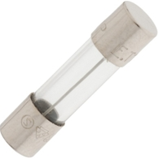

The fuse is an electronic device, which is used to protect circuits from over current, overload and make sure the protection of the circuit. There are many types of fuses available in the market, but function of all these fuses is same.

Fuse consists of a low resistance metallic wire enclosed in a non combustible material. Whenever a short circuit, over current or mismatched load connection occurs, then the thin wire inside the fuse melts because of the heat generated by the heavy current flowing through it. Therefore, it disconnects the power supply from the connected system. In normal operation of the circuit, fuse wire is just a very low resistance component and does not affect the normal operation of the system connected to the power supply.

The basic purpose of the fuse is to protect and is composed of an alloy which has a low melting point. A strip of this fuse is placed in series with the circuit. The working principle is that if the current is in excess then the strip would melt and break the circuit. There are different variants of fuse boxes available with different types of circuit breaking. For instance, in the case of slow blow fuses, a small overload is carried for some period without the circuit been broken.

Other fuse boxes are designed to break the circuit rapidly. The selection is based upon the kind of device and also the fluctuation level of the current.

#### Types of fuses

[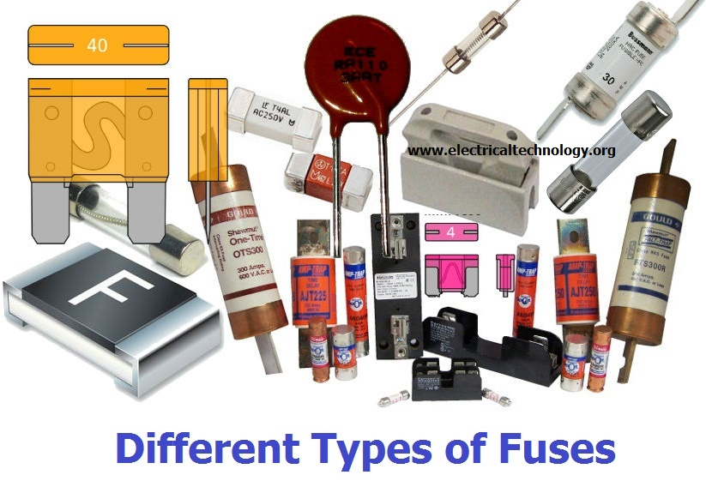](http://electricaltechnology.org/wp-content/uploads/2014/11/Different-Types-of-Fuses.jpg)

The main components of a standard fuse unit consist of the following items:

* Metal fuse element
* Set of contacts
* Support body

The major two categories of fuses include:

* Low Voltage Fuses
* High Voltage Fuses

In order to understand Low voltage fuses better, we can further classify it further into:

* Semi Enclosed or Rewireable Type
* Totally enclosed or Cartridge Type

#### Rewirable Fuses

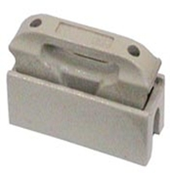

This kind of fuse is most commonly used in the case of domestic wiring and small scale usage. Another name for this type is the KIT-KAT type fuse. The main composition is of a porcelain base which holds the wires.

The fuse element is located inside a carrier that is also made out of porcelain. It is possible for you to remove the fuse carrier without any risk of electrical shock. Normally what happens is that when the fuse blows, you can replace it without having to change the complete thing.

The main metals or alloys used in making fuse wire include lead, tinned copper, aluminum or tin lead alloy.

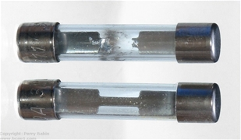

When there is an over surge that causes the fuse element to blow off, you can replace it. A new fuse carrier is inserted in the base.

The main advantage of this type of fuse is that it is easy to install and also replace without risking any electrical injury. But there are certain shortcomings associated with it too. For instance, with this fuse you would have an element of unreliability. There is a level of lack of discrimination and a small time lag, which may hinder its functionality.

With a slow speed of operation, you also get a low rupturing capacity.

Other types have current limiting features, and this one does not.

All this being said it is still a valuable fuse device for small scale usage.

#### Totally Enclosed or Cartridge Type

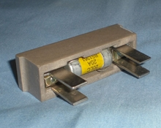

In this type of fuse, we have a completely closed container and there are contacts (metal) on either side. The level of sub division in this case includes:

* D type
* Link Type

In Link type, we further have a knife blade type and a bolted type.

D Type Cartridge Fuses: This cannot be interchanged and comes with the following main components: fuse base and cap, adapter ring and the cartridge.

The fuse base has the cap screwed to it and the cartridge is pushed into it. The circuit becomes complete when the tip of the cartridge is in contact with the conductor. In this case, the main advantage that we get is that of reliability.

Link Type Cartridge/ High Rapturing Capacity Fuses: When it comes to current distribution, there is need for a specified break capacity of high nature. This is where the alternate name of this fuse High Rapturing Capacity comes from. The fusing factor in such cases is up to 1.45.

1. Knife Blade Type HRC Fuse: This kind is easily replaceable in the circuit without any load. For this purpose, special insulated fuse pullers are used.
2. Bolted Type HRC Link Fuse: In this type, the conducting plates are bolted to the base of the fuse. There is also a presence of a switch through which the fuse can be removed without getting an electrical shock.

#### ANL/ANE fuses

ANL kind of fuses is mostly used in cars for the audio systems. They are available in various sizes. As opposed to others, this one has no wire terminal block.

#### How to check the fuses?

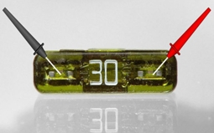

In order to check the fuse, a probe is used with readings from the terminals. The correct functioning would be when the value is 0V DC. The fuse should be checked with the voltage being supplied.

In cases, the value you are getting is higher than 0V DC, this means than there is a need to remove it.

#### Usage

The main usage of fuse is for the protection of the circuit. In a real term scenario, the current flowing through the wires may not be uniform at times. In such cases, your device could get overheated. There is also the chance of a fire if the fuse is not installed.

While the technology has advanced with the usage of circuit breaker, fuses are still used in a number of places like cars and basic electrical components.

**Fuse-Characteristics**

Fuses have different characteristics of operating time compared to current. A standard fuse may require twice its rated current to open in one second, a fast-blow fuse may require twice its rated current to blow in 0.1 seconds and a slow-blow fuse may require twice its rated current for tens of seconds to blow.

### Temperature Rises in Fuses

Fuses have a specific electric resistance value. When exposed to current, their temperature will rise depending on the load. (Figure) Test results for temperature rises can vary significantly based on the type of jig or fuse connection used, and fuse performance is therefore measured using a standard jig (i.e. specified by a relevant industry standard). Because measurements of temperature rises in the lab will be different from data obtained during actual driving, the general approach is to conduct a second evaluation based on reliability tests for each vehicle model. Fuses with connection terminals made out of heat-resistant copper alloy are able to withstand a temperature of up to 140°C. If we assume a temperature of 80°C inside the engine compartment, this means the fuses can support a temperature increase of 60°C.

### Time-current Characteristics of Fuses

Time-current characteristics are the most important specifications of fuses.

Fuses are designed to only withstand continuous current that is equivalent to their rated current. When the current flowing through a fuse exceeds the rated current, the fuse must cut off the current within a predetermined time interval, thus ensuring the current flow is interrupted.

For this reason, the melting time of a fuse when exposed to overcurrent is specified by international and national standards for each type of fuse. In the case of BFMN fuses, which are the most common type in use today, the applicable standards are ISO 8820-3 (international), JASO D612 (Japan) and SAE J2077 (US). These standards specify uniform time-current characteristics, which are regarded as the international standard.

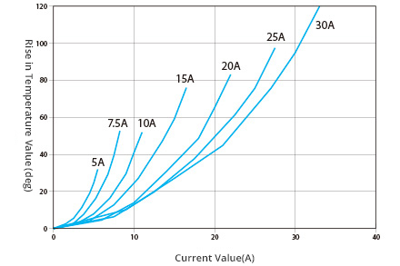

Figure: Fuse-Characteristics

### Durability of Fuses

The durability (i.e., service life) of a fuse depends on the load, current waveforms, ambient temperatures and other factors. If exposed to a consistent current frequency, the service life of a fuse (total usage count) can be easily determined from the I2t characteristics diagram organized by capacity.

Fuses need to have a capacity that exceeds the service life (total usage count) demanded by automakers. In the case of continuous current flow, they are recommended to be used with a rate load of 70% or below.

**Selection Factors of fuses**

1. Normal operating current

2. Application voltage (AC or DC)

3. Ambient temperature

4. Overload current and length of time in which the fuse must open

5. Maximum available fault current

6. Pulses, Surge Currents, Inrush Currents, Start-up Currents, and Circuit Transients

7. Physical size limitations, such as length, diameter, or height

8. Agency Approvals required, such as UL, CSA, VDE, METI, MITI or Military

9. Fuse features (mounting type/form factor, ease of removal, axial leads, visual indication, etc.)

10. Fuse holder features, if applicable and associated rerating (clips, mounting block, panel mount, PC board mount, R.F.I. shielded, etc.)

11. Application testing and verification prior to production

### Typical Uses and Applications of fuses

Electronic Fuses can be used in all types of electrical and electronic applications including:

* Motors
* Air-conditions
* Home distribution boards
* General electrical appliances and devices
* Laptops
* Cell phones
* Game systems
* Printers
* Digital cameras
* DVD players
* Portable Electronics
* LCD monitors
* Scanners
* Battery packs
* Hard disk drives
* Power converter

**Circuit Breakers**

A circuit breaker is an automatically-operated electrical circuit designed to protect an electrical circuit from damage caused by overload or short circuit. A circuit breaker is a switch device which is used for making and breaking and electrical circuit, once or repeatedly, several times, during normal as well as abnormal operating conditions.

**Functions**

* Circuit breakers are used to protect an electrical circuit from overloading or short- circuiting. This prevents damage to equipment and wiring, as well as reducing the risk of fire.
* Closing, opening and carrying full load rated current of the circuit for a prolonged period without any excessive temperature rise.
* To carry the full load current at all times.
* Breaking the heavy currents in case of short circuits.
* Carrying current of short circuit magnitude until the fault is cleared by a circuit breaker nearest to the fault if it is used as back up protection.
* Withstanding the effect of arcing at its contact terminal and thermal and electromagnetic stresses due to flow of heavy current during fault. To open and close the circuit on no loads.

**Basic Principle of Circuit Breaker**

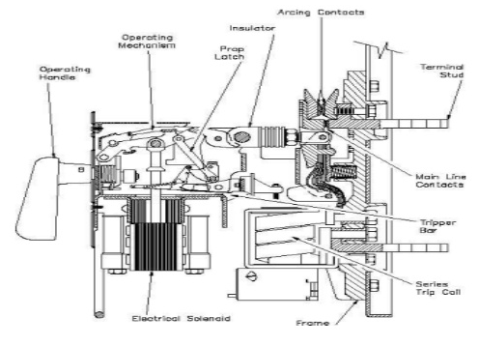

All circuit breakers have common features in their operation, although details vary substantially depending on the voltage class, current rating and type of the circuit breaker. The circuit breaker must detect a fault condition; in low-voltage circuit breakers this is usually done within the breaker enclosure. Circuit breakers for large currents or high voltages are usually arranged with pilot devices to sense a fault current and to operate the trip opening mechanism. The trip solenoid that releases the latch is usually energized by a separate battery, although some high-voltage circuit breakers are self-contained with current transformers, protection relays, and an internal control power source. Once a fault is detected, contacts within the circuit breaker must open to interrupt the circuit; some mechanically-stored energy (using something such as springs or compressed air)contained within the breaker is used to separate the contacts, although some of the energy required may be obtained from the fault current itself. Small circuit breakers may be manually operated; larger units have solenoids to trip the mechanism, and electric motors to restore energy to the springs. The circuit breaker contacts must carry the load current without excessive heating, and must also withstand the heat of the arc produced when interrupting the circuit. Contacts are made of copper or copper alloys, silver alloys, and other materials. Service life of the contacts is limited by the erosion due to interrupting the arc. Miniature and molded case circuit breakers are usually discarded when the contacts are worn, but power circuit breakers and high-voltage circuit breakers have replaceable contacts. When a current is interrupted, an arc is generated. This arc must be contained, cooled, and extinguished in a controlled way, so that the gap between the contacts can again withstand the voltage in the circuit.

Different circuit breakers use vacuum, air, insulating gas, or oil as the medium in which the arc forms.

**Different techniques are used to extinguish the arc including:**

• Lengthening of the arc

• Intensive cooling

• Division into partial arcs

• Zero point quenching

• Connecting capacitors in parallel with contacts in DC circuits

Finally, once the fault condition has been cleared, the contacts must again be closed to restore power to the interrupted circuit.

**Arc Phenomenon Iin Circuit Breaker**

When a loose connection (a gap) is made in the faulted circuit so loose that the current flow is non-continuous, it is called an arcing or arc fault. An electric arc is an electrical breakdown of a gas which produces an ongoing plasma discharge, resulting from a current flowing through normally nonconductive media such as air. The arc consists of a column of ionized gas having molecules which have lost one more electrons. The electrons being negatively charged are attracted towards the positive contact with high velocity and on the way they detach more electrons by impact. The positive ions are attracted towards the negative contact but they comp rise almost the entire weight of the atom, they move relatively slow.

**Initiation of arc**

To initiate the arc, when the fault current occurs and the electrodes separate, the electron from the cathode must be emitted.

**The emission of the arc takes place due to the following reasons:**

1. When the contacts are separated than the area and pressure between the contacts is decreased and the resistances will increases but the fault current is same. So due to the high current the high potential gradient is formed which can dislodge the electrons from the contacts.

2. When the contact separates the contact area is also decreases. Due to the high current flowing, the current density will increase. Due to the high current densities the temperature will increase resulting in the thermionic emission.

**Maintenance of arc**

When the electron are emitted from the cathode, they collide with other neutral electron and other particles with great velocities and make them also the negatively charge and swifts them along with itself toward the cathode. The process is known as ionizations. The ionized ions further ionize other particle and create the avalanche of the electron to reach to the anode. The process of ionization is furthered achieved by the following reasons:

The high temperature caused by the high current densities when the contact separates. The high voltage gradient formed when the contact separates. Due to increase in the mean free path when the contact separates.

**Methods of arc interruption**

The phenomenon of the arc formation is inevitable when the contacts separated during the faults.

**The main reasons to form the arc are:**

1. The high voltage gradient between the contacts. The arc formed by the high gradient can be reduces by making the high separation between the contacts but this is not possible for the high voltage system because the separation need very large.

2. The ionization of neutral particles. Also the formation of ions is proportional to number of electron per cubic centimeters, so to avoid this need to have the high diameter which is again not practical.

**Following methods are used for the arc extinguishing:**

1. **High Resistance Method**

The high resistance method uses the process to increase the effective resistance of the arc with the time so that the current is reduced to such a value that heat produce by it is not sufficient to produce the arc. During this the heat is dissipated inside the circuit breaker the circuit breaker should be designed to withstand such large quantities of energy.

**The resistance of the arc can be increased by the following ways:**

**Cooling of Arc**: The arc resistance can be increased by adding the neutral or cold air between the contacts.

**Increasing the length of arc:** The resistance of the arc can be increased by increasing the mean length between the contacts. This decreases the voltage gradient of the contact and the arc phenomenon can be reduces. But this process is not practical because this increases the length of the contacts for the high voltage system.

**Reducing the cross section area**: The cross section of the arc can be reduced by having the small contact surface area or letting the arc pass through the small hole to reduce the arc. This process can help to reduce the voltage necessary to maintain the arc.

**Splitting the arc**: This is the best method of increasing the resistance of the arc. The arcs so formed are spitted into the small channels to reduce the effect of it. The provision of splitter is designed in the circuit breaker and the formed arc is passed through it to form the series of arc into the splitter. This increases the mean length of the arc and the cooling is better.

1. **Low Current or The Current Zero Interruption**

This method is applicable for only the ac supply because in this we get have the zero current in each half cycle. In this process when the current reaches the zero value it has the minimum effect and the fresh air is supplied to turn down the arc. This method is widely used in the modern circuit breaker.

**This phenomenon is explained by the given theories:**

1. Energy Balance or Cassie theory:

This theory states that if the rate of heat dissipation between the contacts is greater than the rate at which heat is generated, the arc will be extinguish, otherwise it will restrike. During the faults the high heat is produced due to the higher voltage gradient or the high current densities between the contacts. Thus if the heat generated could be removed by cooling, lengthening or by arc splitter at a higher rate than the generation of the arc, then the arc will be extinguish.

1. Recovery Rate or Slepian’s Theory:

This theory states that is the rate at which the ions and the electrons combine to form or are replaced by the neutral molecules i.e. the rate at which the gap recovers its dielectrics strength is faster then the rate at which voltage stress rises, the arc will be extinguished: if otherwise the arc may be interrupted for a brief period but it again restrike. So in this process when the current is at zero value, the fresh air is entered to neutral the electrons.

**For this the following process are applied:**

a) **Lengthening the gap**: The dielectrics strength and the length between the contacts are proportional to each other. Lengthening the contact gap can be the obvious process. The permissible arc length is limited; however, by other considerations e.g. arc energy and possibility of transient voltages due to the current chopping.

b) **Increasing the pressure in the vicinity of the arc**: By increasing the pressure the density of the particle constituting the discharge also increases. The increased density of particle causes higher rate of deionization and thus the dielectric strength of the medium between the contacts is increased.

c) **Cooling** :If the particle is allowed to cool the natural combination of ionized particles will take place more rapidly resulting increase in dielectric strength of the medium. Cooling by conduction to adjacent parts e.g. baffles or by the use of gas such as hydrogen that has as high diffusion and great absorption rate is, therefore, effective.

d) **Blast effect:** By blowing a stream of air through the arc ionized particles between the contacts are swept away and replaced by unionized particles. These unionized particles increased the dielectrics strength of the, medium considerably.

**Restriking Voltage and Recovery Voltages**

In ac circuit breakers, the current interruption takes place invariably at the natural zeroes of current wave. At current zero, a high frequency transient voltage appears across the breaker contacts and is caused by the rapid distribution of energy between the magnetic and

electric fields associated with the plant and transmission line of the power system.

**Restriking Voltage**

It is the transient voltage that exists during the arcing time. (Natural frequency kHz ).

**Recovery Voltage**

It is the rms voltage after final arc extinction (Normal frequency 50 or 60 Hz). Both voltages appear between circuit breaker poles.

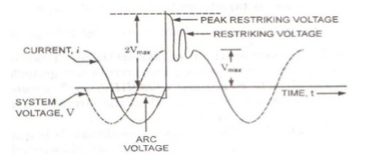 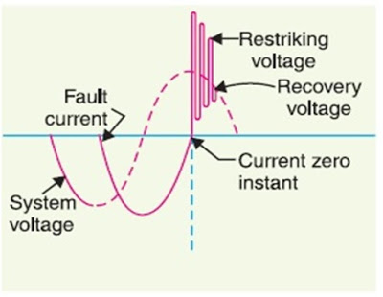

Figure: Operating circuit of circuit breaker

**Expression for Restriking Voltage:**

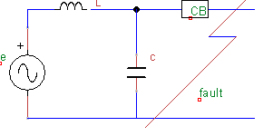

Figure: Fault and its equivalent circuit

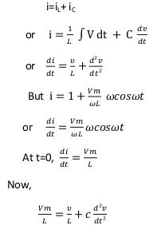

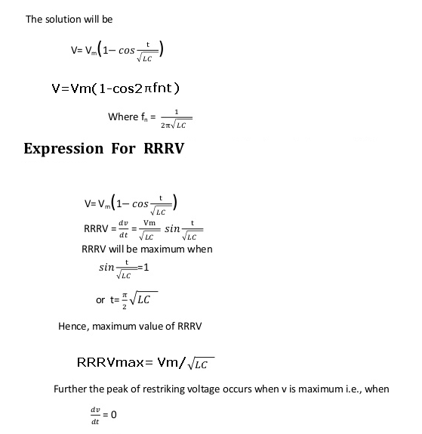

The average RRRV = (Peak value of restriking voltage)/(Time taken in attaining peak value)=(2Vm)/(μ√LC)

**RRRVMAX = VM/√LC**

**Arc phenomenon**

When a fault occurs in a power system, an abnormal value of current flows through the contacts of the circuit breakers before they are opened the protective system. This **arc** provides a low resistance path to the flow of fault current.

# Resistance Switching

A fixed connection of resistance in parallel with the contact space or arc is called the resistance switching. Resistance switching is employed in circuit breakers having a high post zero resistance of contact space. The resistance switching is mainly used for reducing the restriking voltage and the transient voltage surge.

Severe voltage occurs in the system because of two reasons, firstly because of the breaking of low voltage current, and secondly because of the breaking of capacitive current. The severe voltage may endanger the operation of the system. It can be avoided by using resistance switching (by connecting the resistor across the contacts of the circuit breaker).

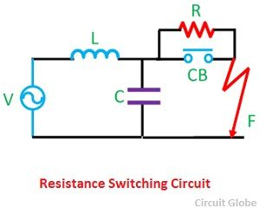

When the fault occurs, the contacts of the circuit breaker are open, and an arc is struck between the contacts. With the arc shunted by the resistance **R**, a part of arc current is diverted through the resistance. This results in the decreases of arc current and an increase in the rate of deionization of the arc path.

Thus, the arc resistance is increased, leading to the further increase in current through the shunt resistance **R**. This builds up process continue until the current becomes so small that it fails to maintain the arc shown in the figure below. Now the arc is extinguished, and the circuit breaker gets interrupted.

[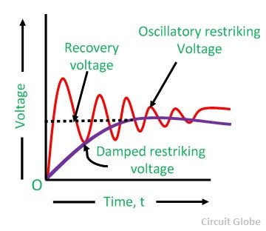](http://circuitglobe.com/wp-content/uploads/2016/06/resistance-switching-wave-compressor.jpg)

Alternatively, the resistance may be automatically switched in by transference of the arc from the main contacts to the probe contact as in the case of an axial blast circuit breaker,  the time required for this action is very small. Having the arc path substituted by a metallic path, the current flowing through the resistance is limited and then easily broken.

The shunt resistor also helps in limiting the oscillatory growth of restriking voltage transients. It can be proved mathematically that the natural frequency (fn) of oscillations of the circuit shown is given as

[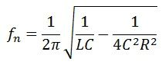](http://circuitglobe.com/wp-content/uploads/2016/06/resistance-swiching-equation-compressor.jpg)

To sum up, resistor across the circuit breaker contacts may be used to perform any one or more of the following functions.

* It reduces the RRRV (Rate of Rising of Restriking Voltage) burden on the circuit breaker.
* It reduces the high-frequency restriking voltage transients during switching out inductive or capacitive loads.
* In a multi-break circuit breaker, it helps in distributing the transient recovery voltage more uniformly across the contact gaps.

The resistance switching is not required in the plan circuit breaker because their contact space is low.

**Current Chopping**

Current Chopping in circuit breaker is defined as a phenomena in which current is forcibly interrupted before the natural current zero. Current Chopping is mainly observed in Vacuum Circuit Breaker and Air Blast Circuit Breaker. There is no such phenomena in Oil Circuit Breaker. Current chopping is predominant while switching Shunt Reactor or unloaded Transformer.

Generally the arc extinction in a circuit breaker take place at natural current zero. But this is true if the capacity of the breaker to extinguish the arc is varies with the level of fault current.This means that, the arc extinction capability of breaker will always ensure that arc extinction is taking place at natural current zero.

Now, let us assume Air Blast Circuit Breaker. In Air Blast Circuit Breaker or Vacuum Circuit Breaker, the fault clearing capacity is fixed and independent of the fault current level. In this case, when breaker is used to break the circuit of unloaded transformer or shunt reactor, the current will be brought to zero well before the natural current zero. This is because, the breaker is interrupting only the magnetizing current which is very less compared to full load current or fault current.  As the capability of breaker arc extinction is high enough, therefore the low magnetizing current will be brought to zero before the natural current zero position. This phenomenon is known as Current Chopping. Let us understand current chopping in detail.

Consider a shunt reactor as shown in figure below:

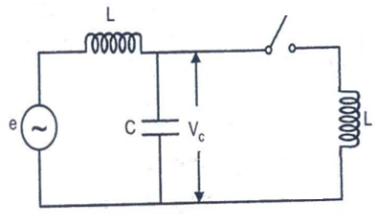

Breaker in the figure above is Air Blast Circuit Breaker. We know that shunt reactor always takes magnetizing current. This magnetizing current is, of course, low. Under normal condition, the current flowing through the reactor is I (say) and hence the stored magnetic energy in it is (LI2 / 2). But as soon as the breaker is open, current chopping will take place and the current through the reactor becomes zero. Due to this sudden drop of current through the inductor, a high voltage will be developed across it according to Faraday’s Law. Therefore, the voltage across the capacitor will also rise. The stored energy in the inductance of reactor is basically transferred to the capacitor. Therefore mathematically we can write as

LI2 / 2 = CV2 / 2

Here V = Voltage across the capacitor

Thus, ***V = I √(L/C)***

This is the prospective voltage across the capacitor during current chopping. Notice that this prospective voltage is above the natural voltage of the system.  This means that there will be a high voltage stress on the shunt reactor during current chopping. Note that the prospective voltage V is directly proportional to the value of current chopped and the surge impedance of the reactor.

Thus we see that, the magnitude of V is quite high. Again, if this voltage V is high enough, then it may lead to the restrike of arc in the breaker and thus current again start to flow through the circuit. Again, there will be chopping of current and but this time the level of current chopped will reduce and therefore the voltage stress on the reactor is less. Thus a number of current chopping will take place till the prospective voltage become low enough to restrike the arc.

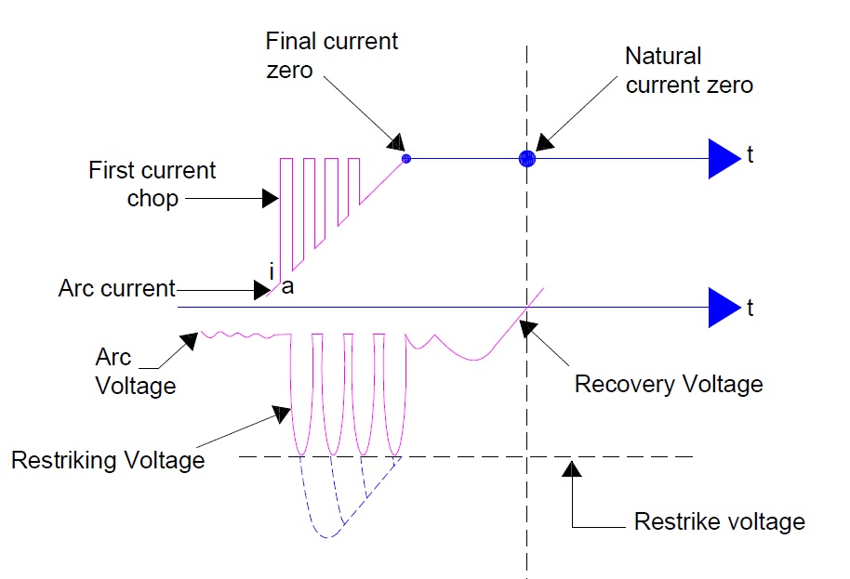

Carefully observe the figure above. In the figure you can see, 4 current chopping. In each current chopping the magnitude of current reduces. This is because of dampening effect of losses in the equipment like eddy current loss and hysteresis loss.

Basically, in oil circuit breaker the arc control is proportional to the fault current or current to be interrupted. Thus in such breaker the extinguishing power is proportional to the current to be interrupted. Therefore current cannot be made zero before the natural current zero. Therefore no current chopping is observed in Oil Circuit Breaker.

**Interruption of capacitive currents**

While opening of unloaded long transmission lines and unloaded underground cables &disconnecting of capacitor banks employed in the network to provide reactive power at leading power factor.

Consider simple circuit shown:

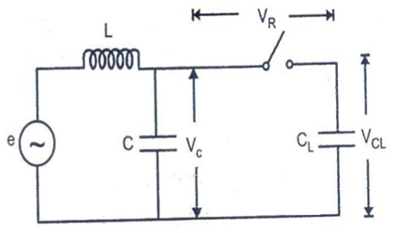

Such a line although unloaded in normal sense will actually carry a capacitive current i on account of capacitance CL between line and earth.

C=Stray capacitance

CL=Line Capacitance

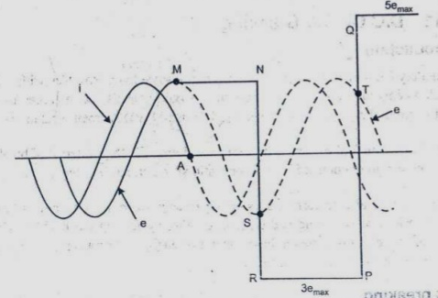

The value of CL is more than C. The voltage across the capacitor will not change instantaneously. The current supplied to the capacitor is generally of small order and that can interrupt such currents invariably at first current zero. Due to 90o phase angle difference the voltage across the capacitor is at maximum value (Vc) at this instant t1 when arc is interrupted and capacitor remains charged at this voltage Vc.

After half cycle (t2) the recovery voltage of approximate magnitude of VBmax appears across the C. Bs and the total voltage across the C.B is the sum of the two voltages i.e

VTmax=VBmax + Vc

VTmax=max. voltage across C.B

VBmax=max. value of power frequency recovery voltage

Vc=Voltage across capacitor

Now since recovery voltage is such a large value therefore restrike is possible. If restrike occurs LC circuit will oscillate at frequency given by

Fn=1/2√L/C

This current tries to maintain the arc. The voltage across the interrupter rises up to 4p.u due to one restrike and up to 6 p.u with second restrike.

The ½ CV2 energy to be dissipated during current chopping. Such arcs is quite large and interrupters may get damaged in the process after a restrike.

Hence, the circuit breakers used for capacitors duty should be restrike free, It should have adequate rating for capacitive current switching.

### ****Single frequency transients & double frequency transients****

### ****Classification of Restriking Transients:****

Restriking voltage transients, and consequently their respective circuits can generally be placed under two main headings.

**(1) Single Frequency Oscillatory Transients:** Conditions are as shown in Figure a. The voltage wave form is shown in Figure b. When the switch contacts part an arc is formed which normally extinguishes at a current zero, the circuit voltage then being at its peak. This voltage tries to appear across the circuit breaker but is delayed in doing so due to presence of capacitance C, which gets charged and then establishes the voltage across the circuit breaker. However a. transient (restriking) voltage at the natural frequency of the simple L-C series circuit is superimposed on that already existing in the circuit (recovery voltage) as shown in Figure b. The natural frequencies are of the order of 1000 to 10,000 Hz.

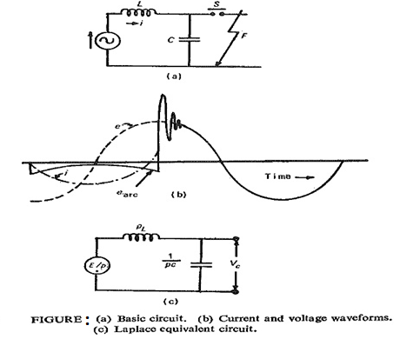

**(2) Double Frequency Transients:** It is quite possible that the circuit breaker S may have L and C parameters on its two sides, as shown in Figure. Before clearance the points a and b are at the same potential. After the fault is cleared, i.e. the arc has been extinguished; both the circuits oscillate at their own natural frequencies a composite double frequency transient appears across the circuit breaker S (Figure b).



