**UNIT-IV**

**Protective relays & Classification of relays**

**Protective relays:** Fundamental requirement of protective relays, primary and backup protection, principle of operation of protective schemes.

**Classification of relays:** Types of Electromagnetic relays, over current relays, directional relays and non-directional relays, earth fault relays.

## ****Protective Relay****

***A Protective Relay is a device that detects the fault and initiates the operation of the circuit breaker to isolate the defective element from the rest of the system.***

The Protective Relay detects the abnormal conditions in the electrical circuits by constantly measuring the electrical quantities which are different under normal and fault conditions. The electrical quantities which may change under fault conditions are voltage, current, frequency and phase angle. Through the changes in one or more of these quantities, the faults signal their presence, type and location to the protective relay. Having detected the fault, the relay operates to close the trip circuit of the breaker. This results in the opening of the breaker and disconnection of the faulty circuit.

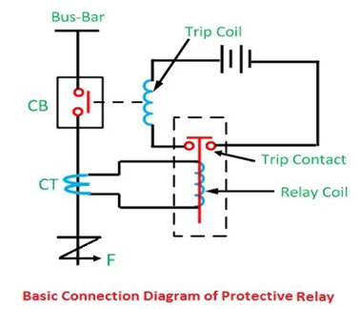

## Figure: **Protective Relay**

A typical relay circuit is shown in Figure. This diagram shows one phase of 3-phase system for simplicity. The relay circuit connections can be divided into three parts viz.

* First part is the primary winding of a current transformer (CT.) which is connected in series with the line to be protected.
* Second part consists of secondary winding of C.T. and Cu. the relay operating coil.
* Third part is the tripping circuit which may be either a.c. or d.c. It consists of a source of supply, the trip coil of the circuit breaker and the relay stationary contacts.

When a short circuit occurs at point F on the transmission line, the current flowing in the line increases to an enormous value. This results in a heavy current flow through the relay coil, causing the relay to operate by closing its contacts. This in turn closes the trip circuit of the breaker, making the circuit breaker open and isolating the faulty section from the rest of the system. In this way, the relay ensures the safety of the circuit equipment from damage and normal working of the healthy portion of the system.

### Fundamental Requirements of Protective Relay

The principal function of Protective Relay is to cause the prompt removal from service of any element of the [power system](https://www.eeeguide.com/category/power-system/) when it starts to operate in an abnormal manner or interfere with the effective operation of the rest of the system. In order that protective relay system may perform this function satisfactorily, it should have the following qualities:

1. Selectivity
2. Speed
3. Sensitivity
4. Reliability
5. Simplicity
6. Economy

**1. Selectivity:**It is the ability of the protective system to select correctly that part of the system in trouble and disconnect the faulty part without disturbing the rest of the system.

A well designed and efficient relay system should be selective i.e. it should be able to detect the point at which the fault occurs and cause the opening of the circuit breakers closest to the fault with minimum or no damage to the system. This can be illustrated by referring to the single line diagram of a portion of a typical [power system](https://www.eeeguide.com/category/power-system/) shown in Figure. It may be seen that circuit breakers are located in the connections to each [power system](https://www.eeeguide.com/category/power-system/) element in order to make it possible to disconnect only the faulty section. Thus, if a fault occurs at bus-bars on the last zone, then only breakers nearest to the fault viz. 10, 11, 12 and 13 should open. In fact, opening of any other breaker to clear the fault will lead to a greater part of the system being disconnected.

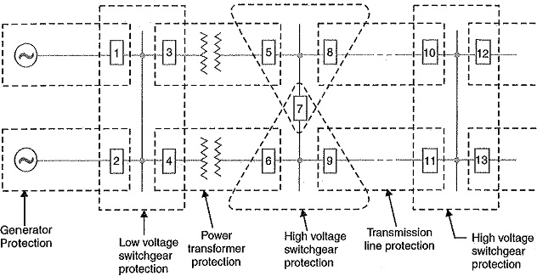

Figure: Single line diagram of a portion of a typical [power system](https://www.eeeguide.com/category/power-system/)

In order to provide selectivity to the system, it is a usual practice to divide the entire system into several protection zones. When a fault occurs in a given zone, then only the circuit breakers within that zone will be opened. This will isolate only the faulty circuit or apparatus, leaving the healthy [circuits](https://www.eeeguide.com/category/circuits/) intact.

The system can be divided into the following protection zones :

* **Generators**
* **Low-tension switchgear**
* [**Transformers**](https://www.eeeguide.com/category/electrical-machines/transformers/)
* **High-tension switchgear**
* [**Transmission lines**](https://www.eeeguide.com/transmission-lines/)

It may be seen in Figure that there is certain amount of overlap between the adjacent protection zones. For a failure within the region where two adjacent zones overlap, more breakers will be opened than the minimum necessary to disconnect the faulty section. But if there were no overlap, a failure in the region between zones would not lie in either region and, therefore, no breaker would be opened. For this reason, a certain amount of overlap is provided between the adjacent zones.

**2. Speed:** The relay system should disconnect the faulty section as fast as possible for the following reasons

* Electrical apparatus may be damaged if they are made to carry the fault currents for a long time.
* A failure on the system leads to a great reduction in the system voltage. If the faulty section is not disconnected quickly, then the low voltage created by the fault may shut down consumers motors and the generators on the system may become unstable.
* The high speed relay system decreases the possibility of development of one type of fault into the other more severe type.

**3. Sensitivity:** It is the ability of the relay system to operate with low value of actuating quantity.

Sensitivity of a relay is a function of the volt-amperes input to the coil of the relay necessary to cause its operation. The smaller the volt-ampere input required to cause relay operation, the more sensitive is the relay. Thus, a 1 VA relay is more sensitive than a 3 VA relay. It is desirable that relay system should be sensitive so that it operates with low values of volt-ampere input.

**4. Reliability:**It is the ability of the Protective Relay system to operate under the pre-determined conditions. Without reliability, the protection would be rendered largely ineffective and could even become a [liability](http://www.allaboutcircuits.com/).

**5. Simplicity:**The relaying system should be simple so that it can be easily maintained. Reli­ability is closely related to simplicity. The simpler the protection scheme, the greater will be its reliability.

**6. Economy:** The most important factor in the choice of a particular protection scheme is the economic aspect. Sometimes it is economically unjustified to use an ideal scheme of protection and a compromise method has to be adopted. As a rule, the protective gear should not cost more than 5% of total costa However, when the apparatus to be protected is of utmost importance (e.g. generator, main transmission line etc.), economic considerations are often subordinated to reliability.

# Primary & Backup Protection

## Primary Protection

The main protection or primary protection is the first line protection which provides quick-acting and selective clearing of a fault within the boundary of the circuit section or element it protects. The main protection is provided in each section of an electrical installation.

## Backup Protection

The backup protection provides the back up to the main protection whenever it fails in operation or its cut out for repairs. The backup protection is essential for the proper working of the electrical system. The backup protection is the second line of defence which isolates the faulty section of the system in case the main protection fails to function properly. The failure of the primary protection occurs because of the failure of the DC supply circuit, current or voltage supply to relay circuit, relay protective circuit or because of the circuit breaker.

The backup protection may be provided either on the same circuit breaker which would be normally opened by the main protection or in the different circuit breaker. The backup protection is mainly used where the main protection of the adjacent circuit is unable to back up the main protection of the given circuit. Sometimes for simplification, the backup protection has a low sensitivity and operated over a limited backup zone.

**Example:**Consider the remote backup protection is provided by a small time graded relay, as shown in the figure below. Let F be the fault occur on relay R4. The relay R4 operates the circuit breaker at D and isolate the faulty section. Now if the circuit breaker D fails to operate, the faulty section would be isolated by the operation of the relay R3 at C.

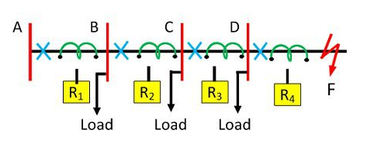

Figure: Backup protection

The use of the backup protection depends on the economics and technical consideration. The backup protection usually for the economic reason not so fast as the main protection.

**Operating Principle of Protective Relay schemes**

The working of the relay is either depends on the electromagnetic attraction or electromagnetic induction. The electromagnetic attraction type relay has a solenoid which is attracted towards the poles of the electromagnet. This relays works on both the AC and DC supply.

The electromagnetic induction type relay uses the induction motor inside which the torque is generated by the process of electromagnetic induction. Such type of relays works only on ac quantities.

## Principle of operation of protective schemes

Protective relay work as a sensing device, it senses the fault, then known its position and finally, it gives the tripping command to the circuit breaker. The circuit breaker after taking the command from the protective relay, disconnect the faulted element.

By clearing the fault fast with the help of fast-acting protective relay and associated circuit breaker, the damage to the apparatus is reduced, and the resultant hazards like fire, the risk of the life are reduced, by removing the particularly faulted section.

But the continuity of supply is maintained, though remaining healthy section, by clearing the fault fast, fault arising time is reduced, and therefore the system can be restored to the normal state sooner. Hence the transient state stability limit of the system is greatly improved, permanent damage to the equipment is avoided and the possibility of developing most simple fault such as single phase-to-ground into most severe fault such as double phase-to-ground fault is reduced.



Figure: Protective Relay

The fault can only be reduced if the protective relay is reliable, maintainable and sensitive enough to distinguish between normal and abnormal condition. The relay must come into action whenever there is a fault and must not operate if there is no fault.  Some relays are used for the protection of the power system.  Some of them are primary relay meaning that they are the first line of defence. Such relays sense the fault and send a signal to the proper circuit breaker to trip and clear the fault.

The fault may not be cleared if the circuit breaker fails to open or relay mal operates. The relay failure is because of three reasons such as wrong setting, bad contacts and open circuit in the relay coil. In such cases, the second line of defence is provided by the backup relays. The backup relay has longer operating time, even though they sense the fault along with the primary relays.

To attain the desired reliability, the power system network is divided into two different protection zones. The overall system protection is divided into different protection zones. They are generator protection, transformer protection, bus protection, transmission line protection and feeder protection. The relay employed for protection of the apparatus and transmission lines are as follows

* Overcurrent  Relays
* Under-frequency Relays
* Directional Relays
* Thermal Relays
* Phase Sequence Relays
  + Negative phase sequence Relays
  + Positive sequence Relays
* Distance or impedance Relays
  + Phase Impedance Relay
  + Angle Impedance  Relay
  + Ohm (or reactance ) Relay
  + Angle Impedance Relay
  + Mho’s  Relay offset or Restricted Relay
* Pilot Relays
  + Carrier channel pilot or Microwave pilot Relays

The protective relays do not eliminate the possibility of fault occurrence on the power system rather their circuit actions start only after the fault has occurred on the system. The main features of a good protective relaying are its reliability, sensitivity, simplicity, speed, and economy. For the sake of familiarity of protective relay, we have to understand some important terms.

**Energizing Quantity** – It is an electrical quantity which is a merger of voltage or current or either voltage or current alone, required for the operation of the relay.

**Trip Circuit** – It is the circuit that controls the circuit breaker for opening operation and comprises of trip coil, relay contacts, auxiliary switch battery supply, etc.

**Operating Force or Torque** – It is a force which tends to close the relay contacts.

**Restraining Force or Torque** – It is a force or torque, which opposes the torque and tends to interrupt the closure of the relay contacts.

**Setting** – It is an actual value of the energizing quantity at which the relay is made to operate under given conditions.

**Pick Up** – A relay is said to pick up when it moves from the off position to the on position or the operation of the relay is called the relay pick-up.

**Operating or Pickup Relay** – It is the value of the actuating quantity (current or voltage) which is on the threshold above which the relay operates and closes its contacts. If the current in the relay is less than the pickup value, the relay does not operate, and the breaker operates by it remain in the closed position.

**Drop Out or Reset Level** – This is the value of the current or voltage, etc. below which a relay opens its contacts and comes back to its original position. The ratio of the drop-out voltage or reset value to the pick or operating value is called the drop-out or reset ratio.

**Reset time** – It is given by the time which passes away between the instant when the current or voltage (actuating quantity) becomes less than the reset value at the time when the relay contacts are closed.

**Fault Clearing Time-** It is the time between the existence of a fault and at the time of final arc quenching in a circuit breaker is called the fault clearing time.

**Breaker Time** – It is the time between termination of fault and final arc quenching in a circuit breaker is called the breaker time.

**Relay Time** – The interval between the existence of fault and closure of relay contacts is called the relay time.

**Reach** – It is defined as the limiting distance covered by the protection, the fault beyond which are not within reach of the protection and should be covered by the other relay.

# Zones of Protection in Power System

**Definition:** Protection zone is defined as the part of the power system which is protected by a certain protective scheme. It is established around each power system equipment. When the fault occurs on any of the protection zones then only the circuit breakers within that zone will be opened. Thus, only the faulty element will be isolated without disturbing the rest of the system.

The protection zone covers the entire power system, and no part of the equipment is left unprotected. It usually consists one or more element of the power system. The protection zone of the power system mainly depends upon the rating of the machine, its location, the probability of faults and abnormal condition of the equipment.

## Overlapping Zone of Power System

If there were no overlapping in the protective zone, then the failure occurs in the equipment will not lie in any one of the zones and hence no circuit breaker would be tripped. The fault occurs in the un protective system will damage the equipment and hence disturb the continuity of the supply.

The figure below shows a certain amount of overlapping between the protective zones.

[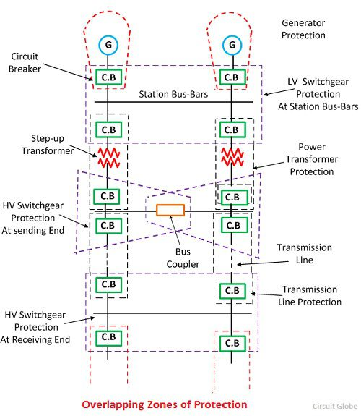](http://circuitglobe.com/wp-content/uploads/2016/12/protection-zones.jpg)

## Figure: Overlapping Zone of Power System

The probability of failure in the overlap region is very small. But the overlap region will cause the tripping of the more circuit breaker than the minimum necessary for the disconnection of the faults region. Because when the fault occurs in any one of the two overlapping regions than the breaker of both the region will be opened, and the systems are isolated.

Consider the two protective zone A and B which will overlap each other. The X is the fault occurs in the zone B, and due to this fault, the circuit breakers of zone B tripped along with the C (circuit breaker). The relay of the zone B will also trip the circuit breaker of zone A for other faults in the zone B which occurs to the right of the C (circuit breaker). Hence the unnecessary tripping of the breaker can be tolerated only in the particular region.

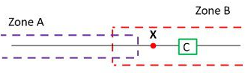

Figure: overlapping zone

The scheme which senses the fault of any of the certain unit will have a high degree of sensitivity and it also has the adaptability of the fast speed of operation.

**Classification of relays**

**Types of Electromagnetic relays**

# Electromagnetic Relay

**Definition:** Electromagnetic relays are those relay which operates on the principle of electromagnetic attraction. It is a type of a magnetic switch which uses the magnet for creating a magnetic field. The magnetic field then uses for opening and closing the switch and for performing the mechanical operation.

## Types of an Electromagnetic Relay

By their working principle, the electromagnetic relay is mainly classified into two types. These are

1. Electromagnetic Attraction Relay
2. Electromagnetic Induction Relay

### 1. Electromagnetic Attraction Relay

In this relay, the armature is attracted to the pole of a magnet. The electromagnetic force exerted on the moving element is proportional to the square of the current flow through the coil. This relay responds to both the alternating and direct current.

For AC quantity the electromagnetic force developed is given as

[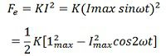](https://circuitglobe.com/wp-content/uploads/2017/01/equation-1.jpg)

The above equation shows that the electromagnetic relay consists two components, one constant independent of time and another dependent upon time and pulsating at double supply frequency. This double supply frequency produces noise and hence damage the relay contacts.

The difficulty of a double frequency supply is overcome by splitting the flux developing in the electromagnetic relay. These fluxes were acting simultaneously but differ in time phase. Thus the resulting deflecting force is always positive and constant. The splitting of fluxes is achieved by using the electromagnet having a phase shifting networks or by putting shading rings on the poles of an electromagnet.

The electromagnetic attraction relay is the simplest type of relay which includes a plunger (or solenoid), hinged armature, rotating armature (or balanced) and moving iron polarised relay.

**a. Balanced Beam Relay –**In such type of relay two quantities are compared because the electromagnetic force developed varies as the square of the ampere-turn. The ratio of an operating current for such relay is low. If the relay is set for fast operation, then it will tend to overreach on a fast operation.

[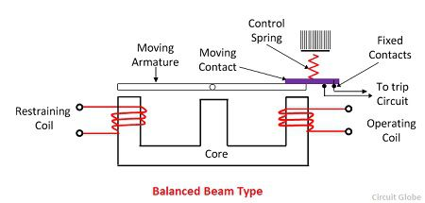](https://circuitglobe.com/wp-content/uploads/2017/01/Balanced-beam-type.jpg)

Figure: Balanced Beam Relay

**b. Hinged armature relay –** The sensitivity of the relay can be increased for DC operation by adding the permanent magnet. This relay is also known as the polarized moving relay.

### [hinged-armature-type-relay](https://circuitglobe.com/wp-content/uploads/2017/01/hinged-armature-type-relay.jpg)

Figure: Hinged armature Relay

### 2. Electromagnetic Induction Relay

The electromagnetic relay operates on the principle of a split-phase induction motor. The initial force is developed on the moving element that may be disc or another form of the rotor of the non-magnetic moving element. The force is developed by the interaction of electromagnetic fluxes with eddy current that is induced in the rotor by these fluxes.

The different type of structure has been used for obtaining the phase difference in the fluxes. These structures are

a. Shaded pole structure  
 b. Watt-hour meter or double winding structure  
 c. Induction cup structure.

### a. Shaded pole structure

### This coil is usually energized by current flowing in the single coil wound on a magnetic structure containing an air gap. The air-gap fluxes produce by the initializing current is split into two flux displace in time-space and by a shaded ring. The shaded ring is made up of the copper ring that encircles the part of the pole face of each pole.

[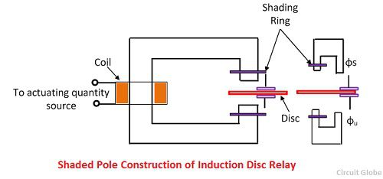](https://circuitglobe.com/wp-content/uploads/2017/01/shaded-pole-construction-of-induction-disc-relay.jpg)

The disc is made up of aluminium. The inertia of the aluminium disc is very less.. Hence they need less deflecting torque for its movement. The two rings have the current induced in them by the alternating flux of the electromagnetic. The magnetic field develops from the current produces the flux in the portion of the iron ring surrounded by the ring to lag in phase by 40° to 50° behind the flux in the unshaded portion of the pole.

### b. Watt-hour Meter Structure

This structure consists E shape electromagnet and a U shape electromagnet with a disc-free to rotate in between them. The phase displacement between the fluxes produced by the electromagnet is obtained by the flux generated by the two magnets having different resistance and inductance for the two circuits.

[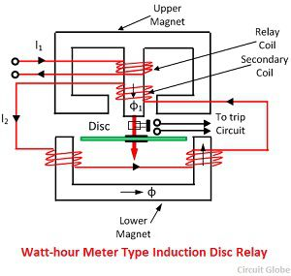](https://circuitglobe.com/wp-content/uploads/2017/01/watt-hour-meter-type-induction-motor.jpg)

The E-shaped electromagnet carries the two windings the primary and the secondary. The primary current was carrying the relay current I1 while the secondary winding is connected to the windings of the U-shaped electromagnet.

The primary winding carries relay current I1 while the secondary current induces the emf in the secondary and so circulate the current I2 in it. The flux φ1 induces in the E shed magnet, and the flux φ induces in the U-shaped magnet. These fluxes induced in the upper and lower magnetic differs in phase by angle θ which will develop a driving torque on the disc proportional to φ1φ sinθ.

The most important feature of the relay is that opening can control their operation or close the secondary winding circuit. If the secondary winding is opened, then no torque will be developed, and thus relay can be made inoperative.

### c. Induction Cup Relay

The relay which works on the principle of electromagnetic induction is known as the induction cup relay. The relay has two or more electromagnet which is energized by the relay coil. The static iron core is placed between the electromagnet as shown in the figure below.

[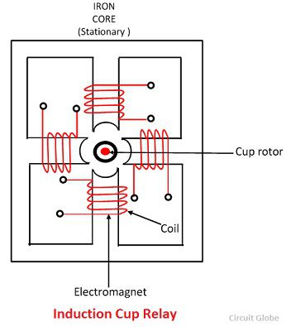](https://circuitglobe.com/wp-content/uploads/2017/01/induction-cup-relay.jpg)

The coil which is wound on the electromagnet generates the rotating magnetic field. Because of the rotating magnetic field, the current induces inside the cup. Thus, the cup starts rotating. The direction of rotation of the cup is same as that of the current.

The more torque is produced in the induction cup relay as compared to the shaded and watt meter type relay. The relay is fast in operation and their operating time is very less approximately 0.01 sec.

## Types of Over Current Relay

Depending upon time of operation, there are various **types of Over Current relays**, such as,

1. **Instantaneous over current relay**.
2. **Definite time over current relay**.
3. **Inverse time over current relay**.

**Inverse time over current relay** or simply **inverse OC relay** is again subdivided as **inverse definite minimum time** (IDMT), **very inverse time**, **extremely inverse time over current relay** or **OC relay**.

### Instantaneous Over Current Relay

Construction and working principle of **instantaneous over current relay** quite simple.

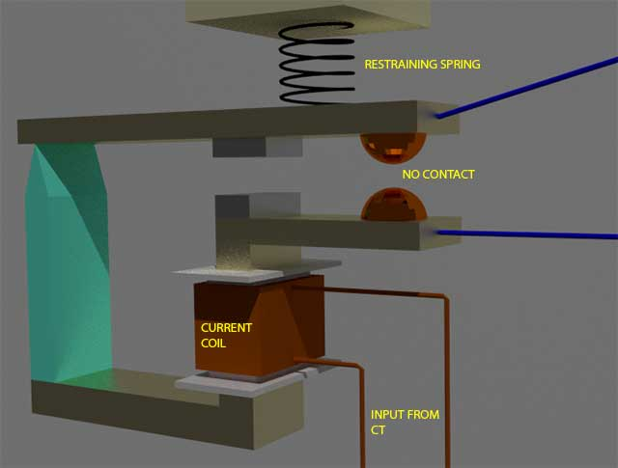

Here generally a magnetic core is wound by current coil. A piece of iron is so fitted by hinge support and restraining spring in the relay, that when there is not sufficient current in the coil, the NO contacts remain open. When current in the coil crosses a present value, the attractive force becomes sufficient to pull the iron piece towards the magnetic core and consequently the no contacts are closed.

The preset value of current in the relay coil is referred as pick up setting current. This relay is referred as instantaneous **over current relay**, as ideally, the relay operates as soon as the current in the coil gets higher than pick up setting current. There is no intentional time delay applied. But there is always an inherent time delay which cannot be avoided practically. In practice the operating time of an instantaneous relay is of the order of a few milliseconds.

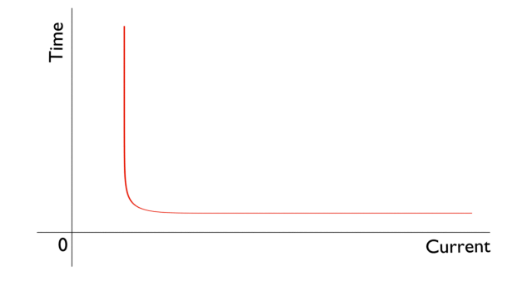

### Definite Time over Current Relay

This relay is created by applying intentional time delay after crossing pick up value of the current. A **definite time over current relay** can be adjusted to issue a trip output at definite amount of time after it picks up. Thus, it has a time setting adjustment and pick up adjustment.

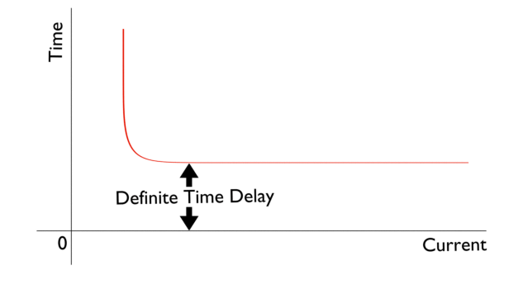

### Inverse Time over Current Relay

Inverse time is a natural character of any induction type rotating device. This means the speed of rotation of rotating art of the device is faster if input current is increased. In other words, time of operation inversely varies with input current. This natural characteristic of electromechanical induction disc relay in very suitable for over current protection. This is because, in this relay, if fault is more severe, it would be cleared more faster. Although time inverse characteristic is inherent to electromechanical induction disc relay, but the same characteristic can be achieved in microprocessor based relay also by proper programming.

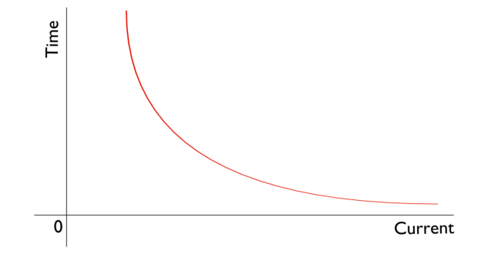

### Inverse Definite Minimum Time over Current Relay or IDMT O/C Relay

Ideal inverse time characteristics cannot be achieved, in an over current relay. As the current in the system increases, the secondary current of the current transformer is increased proportionally. The secondary current is fed to the relay current coil. But when the CT becomes saturated, there would not be further proportional increase of CT secondary current with increased system current. From this phenomenon it is clear that from trick value to certain range of faulty level, an inverse time relay shows exact inverse characteristic. But after this level of fault, the [CT](https://www.electrical4u.com/current-transformer-ct-class-ratio-error-phase-angle-error-in-current-transformer/) becomes saturated and relay current does not increase further with increasing faulty level of the system. As the relay current is not increased further, there would not be any further reduction in time of operation in the relay. This time is referred as minimum time of operation. Hence, the characteristic is inverse in the initial part, which tends to a definite minimum operating time as the current becomes very high. That is why the relay is referred as **inverse definite minimum time over current relay** or simply **IDMT relay**.

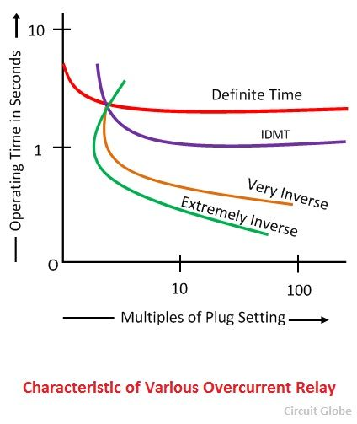

**Directional relays and non-directional relays**

Directional and non-directional relays are over voltage protection devices. They are used to protect the power system under faulty condition. The directional relays are the one which operates under the direction of flow of fault current. Directional relays: Directional relay operates when the fault is driving power to flow in particular direction. It senses the direction of current flowing. For example, consider a three phase synchronous motor. Assume fault on the system. Power supply to motor is not available. But 3-phase armature is rotating in magnetic field due to inertia. So motor starts generating power which feeds fault. To avoid this, Directional Relay is used.

Directional relays sense the direction of fault and operate if the fault is in the assigned direction. These relays assigned to operate in either forward or reverse directions. This direction is assigned in the settings of the relay along with other parameters that help to identify zone of fault (Means the entire range of particular direction).

Zone of fault is identified with the help of [Relay Characteristic and Maximum Torque Angle Settings](https://electengmaterials.com/directional-over-current-relay-67/)of Directional Relay.

The simple application of this relay can find in parallel feeders as shown below. The objective of this scheme is to isolate only faulty feeder in case of fault and the load will get continuous supply from another feeder.

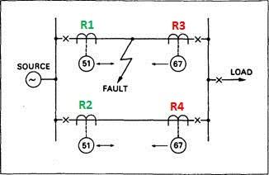

Here

R1, R2 = Non directional Relays

R3, R4 = Directional Relays

Consider all relays are simple over current relays. Actual Scheme involves impedance relays also. As shown in above figure Relays R3 and R4 at Load side are directional relays. Means these two operate if fault current flows from load to source direction (Reverse Zone) through these relays according to scheme. Consider an example fault came between Two relays in the first feeder as shown in figure. Now fault current starting from source divide into two paths one is from Source—> R1 and other is Source—> R2 →R4→R3.

Now the tripping of relays as follows.

The current through R1 is high as it is near to fault (line impedance seen by relay is less so current is high) so it will operate. Current through R2 is less (line impedance seen by relay is high so current is low) so it won’t operate. R4 looks the fault current in reverse direction so it won’t operate. R3 looks the fault current in same direction so it will operate. Thus only relays R1 and R3 operate and hence Feeder-1 is isolated. The load gets continuous supply via Feeder-2.

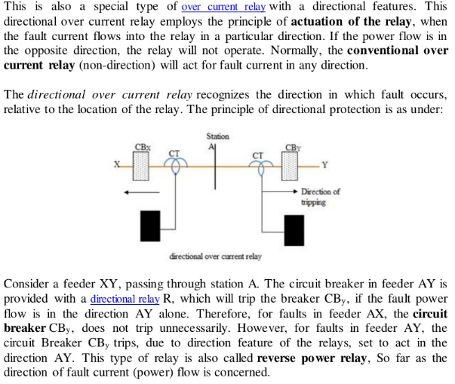

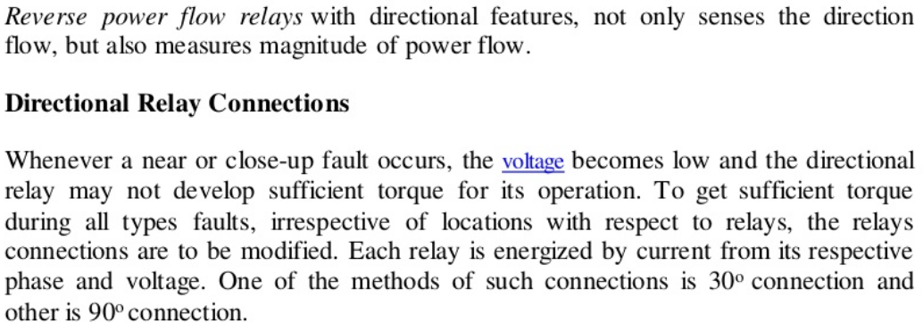

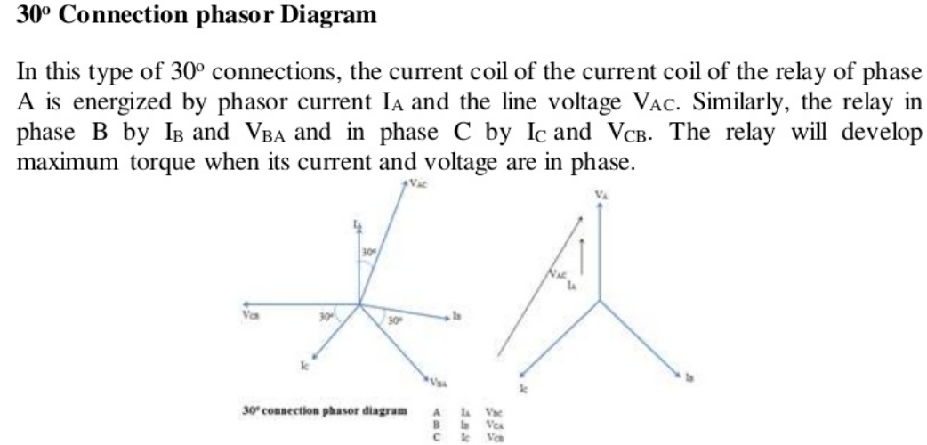

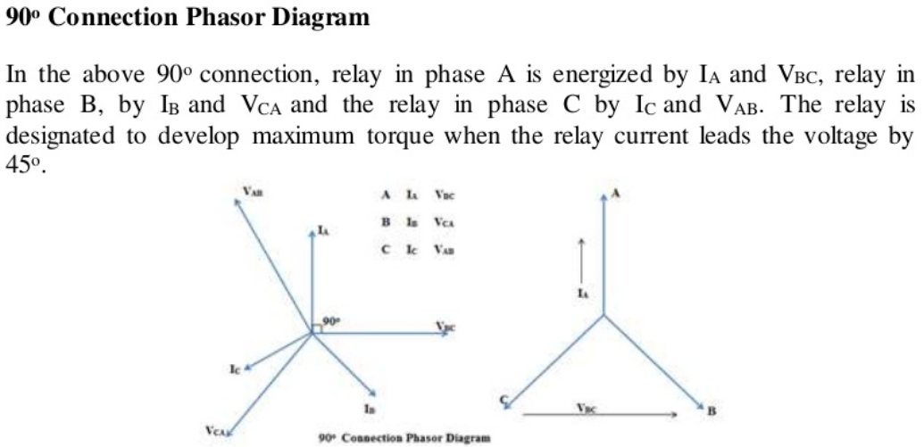

**Non-directional relays:** When there is fault in power system, power flows through fault. Non directional relays operate irrespective of direction of flow of current.

* 1. For example, breaker at generator end. If there is fault on generator secondary relay has to operate to open GT breaker.
  2. If there is fault in windings of generator and it's drawing power from grid then also GT breaker has to operate. So we use a non-directional relay. It has to operate in fault conditions irrespective of direction of power flow.



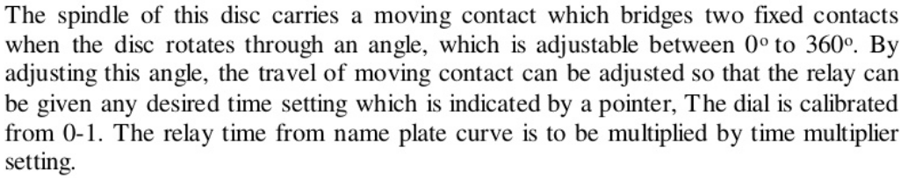

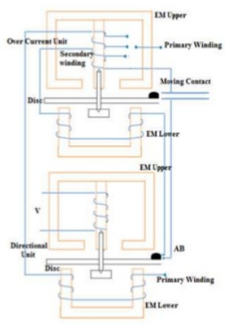

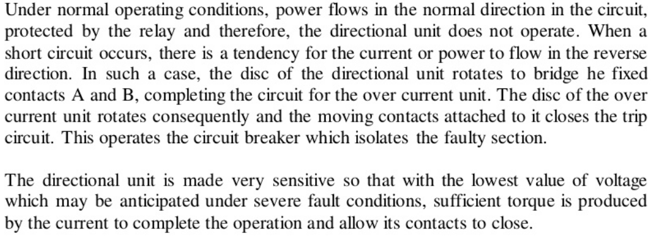

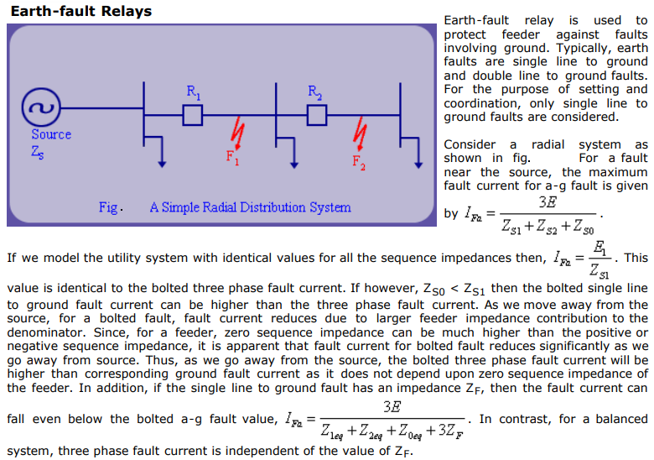

## Earth Fault Relay (EFR)

It is a safety device used in electrical installations with high earth impedance. It detects small stray voltages on the metal enclosures of electrical equipment. The result is to interrupt the circuit if a dangerous voltage is detected. The EFR is protected against tripping from transients and prevents shock.

The following figure shows the Earth Fault Relay –

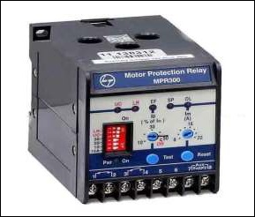

## Restricted Earth Fault Protection Scheme

Let us consider a star winding transformer, which is protected by a Restricted Earth Fault Protection with EFR protecting device as shown in the figure below.

The following image shows the Earth Fault Protection with EFR −

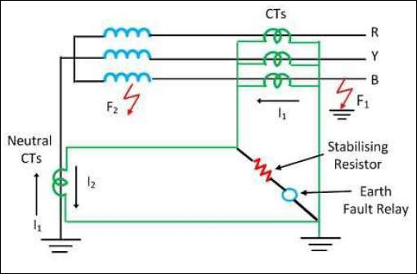

When an external fault F1 occurs in the network, I1 and I2 flow through the secondary side of the CTs. The resultant of I1 and I2 will be zero. However, if an internal fault F2 occurs inside the protective zone, only I2 flows and I1 is neglected. The resultant current I2 passes through the earth fault relay, which senses the fault current and protects the restricted portion of winding. The fault current is approximately 15% more than the rated winding current. To avoid the magnetizing inrush current, the stabilizing current must be in series with the relay.

**\*\*\*\*\*\*\*\*\***