UNIT-5

SLIP POWER RECOVERY SCHEMES

During speed control of an Induction motor (SRIM) using rotor resistance control, rotor power is wasted in the external rotor resistance. The same can be utilized to increase the efficiency of the drive. Basically there are two schemes for recovering the wasted power.

1. Scherbius drive

Here the variable frequency (sf) rotor power is converted to dc by a diode bridge rectifier and then an inverter converts it back to ac (50/60 Hz) and is fed back to the supply mains. Thus the slip power is fed back to the source instead of wasting it in the rotor resistance thereby increasing the efficiency of the drive .

2. Kramer Drive

Here the variable frequency (sf) rotor power is converted to dc by a diode bridge rectifier. The dc power is fed to a dc motor which is mechanically coupled to the induction motor. Thus the torque supplied to the load is the sum of the torque produced by induction and dc motor. In this scheme, the slip power is utilized mechanically.

**Slip Power** : A part of the air-gap power which is not converted into mechanical power is called slip power. it is represented by spg. Where s=slip, pg= air-gap power

slip recovery: the air gap power which is getting wasted in rotor is fed back to the supply mains this is called slip recovery

**How is slip power recovered?**

The slip energy recovery method provides the speed control of a slip ring induction motor below its synchronous speed. A portion of rotor AC power (slip power) is converted into DC by a diode bridge. ...

The inverter inverts the DC power to the AC power and feeds it back to the AC source. This system is mainly used for Induction motor speed control. The speed control in induction motor has poor efficiency due to wasting of slip power in the rotor circuit.

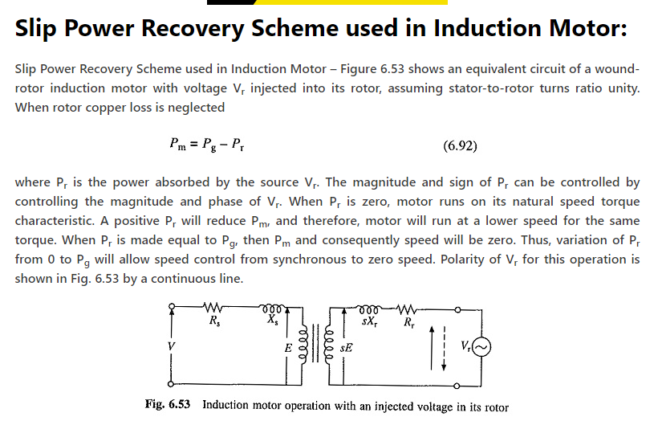

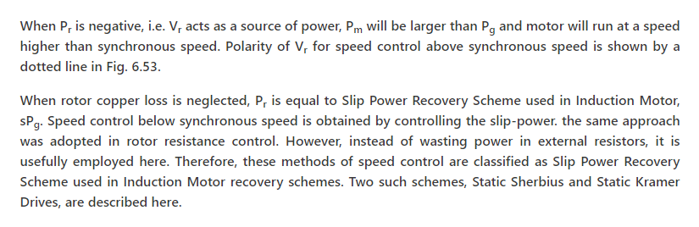

By using recovery schemes the induction motor speed is controlled to avoidslip power loss.The slip power is classified into two types

1. Static Scherbius system

2. Static Karmer system

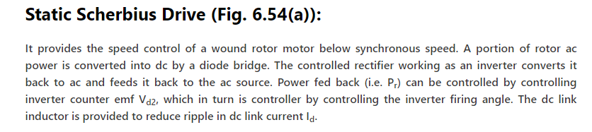

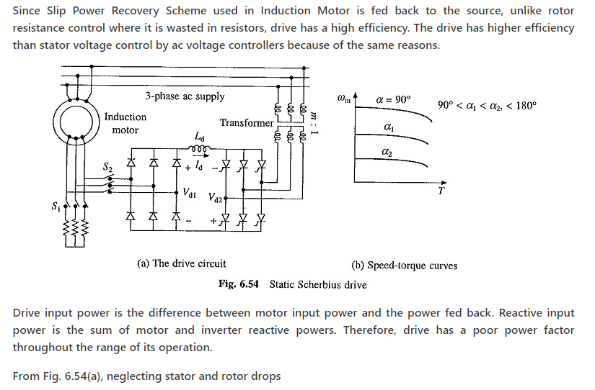

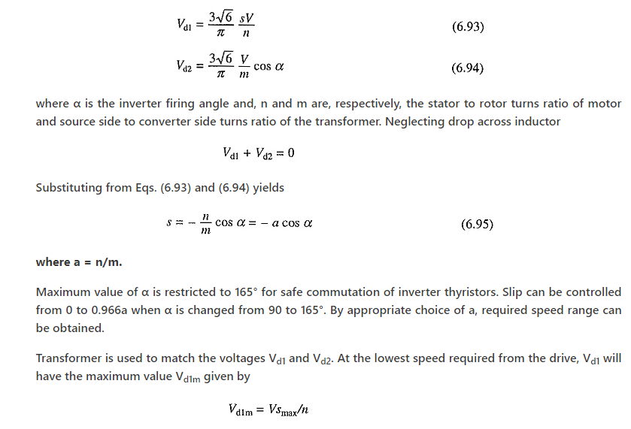

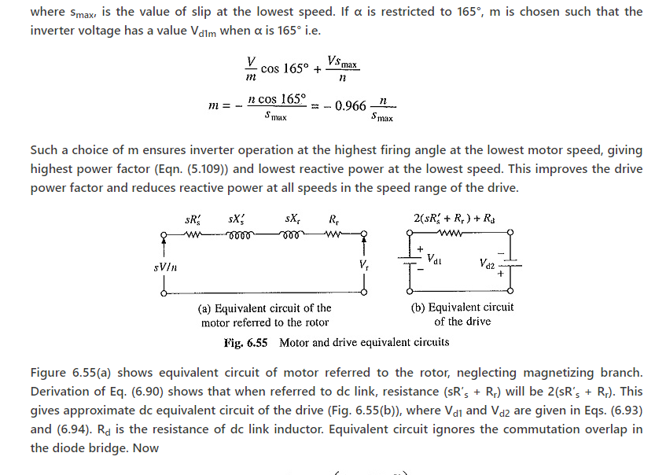

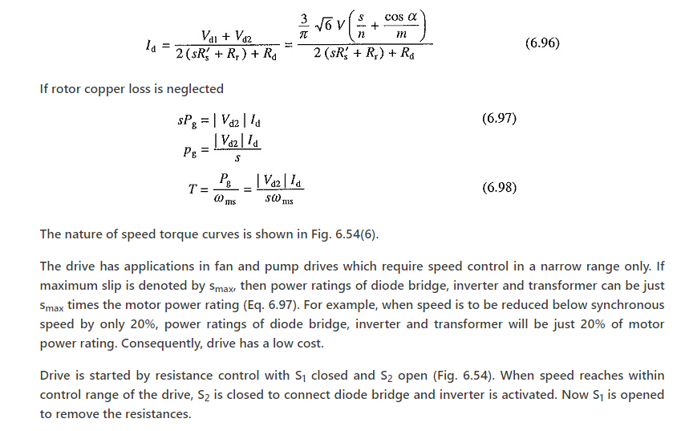

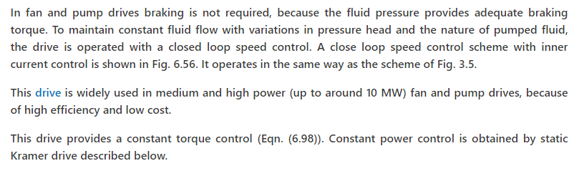

[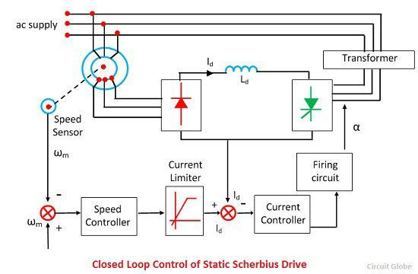](https://circuitglobe.com/wp-content/uploads/2016/11/closed-loop-control-of-static-scherbius-drive.jpg)

Static Kramer Drive

**Definition:** The static Kramer-drive is the method of controlling the speed of an induction motor by injecting the opposite-phase voltage in the rotor circuit. The injected voltage increases the resistance of the rotor, thus controlled the speed of the motor. By changing the injected voltage, the resistance and speed of an induction motor are controlled.

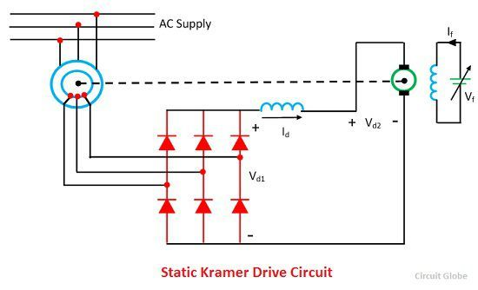

The static Kramer-drive converts the slip power of an induction motor into AC power and supply back to the line. The slip power is the air gap power between the stator and the rotor of an induction motor which is not converted into mechanical power. Thus, the power is getting wasted. The static Kramer drives fed back the wasted power into the main supply. This method is only applicable when the speed of the drive is less than the synchronous speed.

## Static Kramer Drive Working

The rotor slip power is converted into DC by a diode bridge. This DC power is now fed into DC motor which is mechanically coupled to an induction motor. The torque supplied to the load is the total sum of the torque produced by the induction and DC motor drive.

The figure shown below represents the variation of Vd1 and Vd2 with a speed of two values of DC motor field current. When the value of Vd1 is equal to the value of Vd2 then the steady state operation of the drive is obtained, i.e., at A and B for field current of If1 and If2.

The speed control is possible only when speed is less or half of the synchronous speed. When the large range speed is required, the diode bridge is replaced by the thyristor bridge. The relationship between the Vd1 and the speed can be altered by controlling the firing angle of thyristor amplifier. Speed can now be controlled up to stand still.

Speed Torque characteristics of Static kramers drive

