# Torque Speed Characteristic of an Induction Motor

**Torque Speed Characteristic** is the curve plotted between the torque and the speed of the induction motor. As we have already discussed the torque of the induction motor in the topic [Torque Equation of an Induction motor.](https://circuitglobe.com/torque-equation-of-an-induction-motor.html) The equation of the torque is given as shown below.

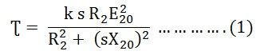

At the maximum torque, the speed of the rotor is expressed by the equation shown below.

https://circuitglobe.com/wp-content/uploads/2016/01/Torque-speed-characteristic-of-an-induction-motor-eq-2-compressor.jpg

The curve below shows the Torque Speed Characteristic.

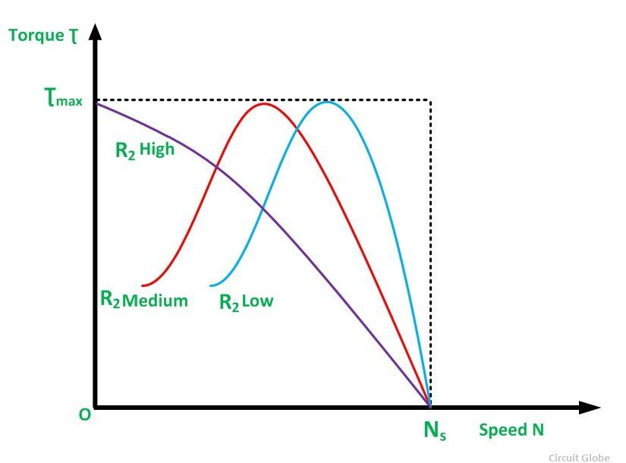

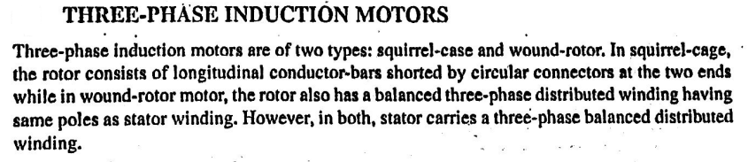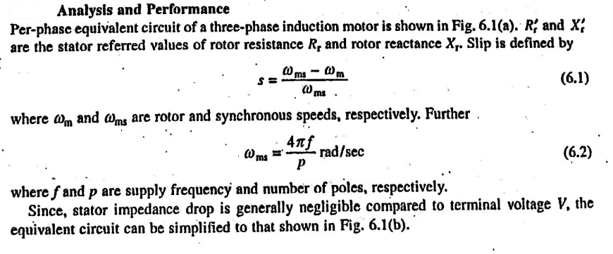

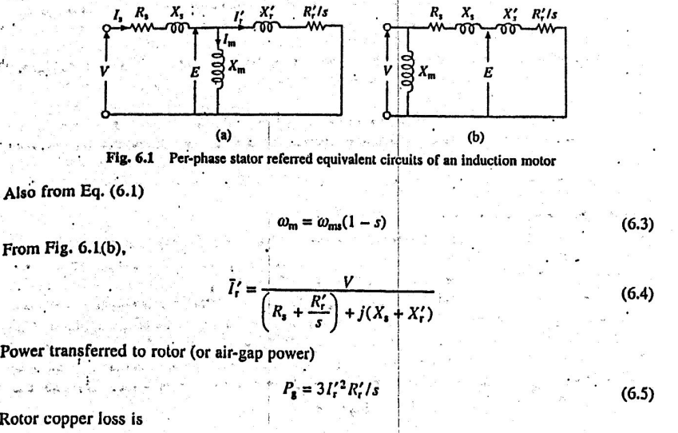

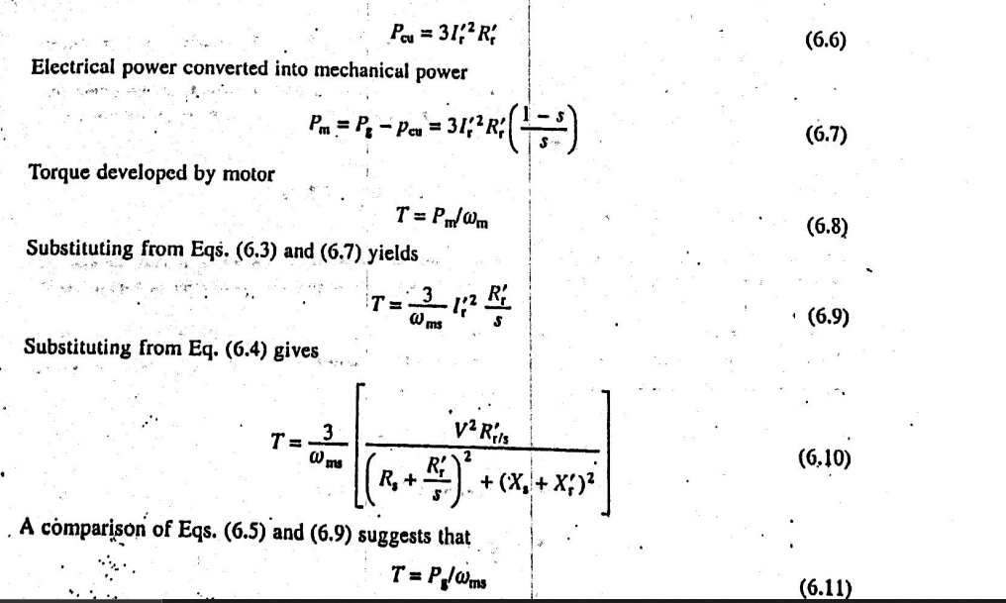

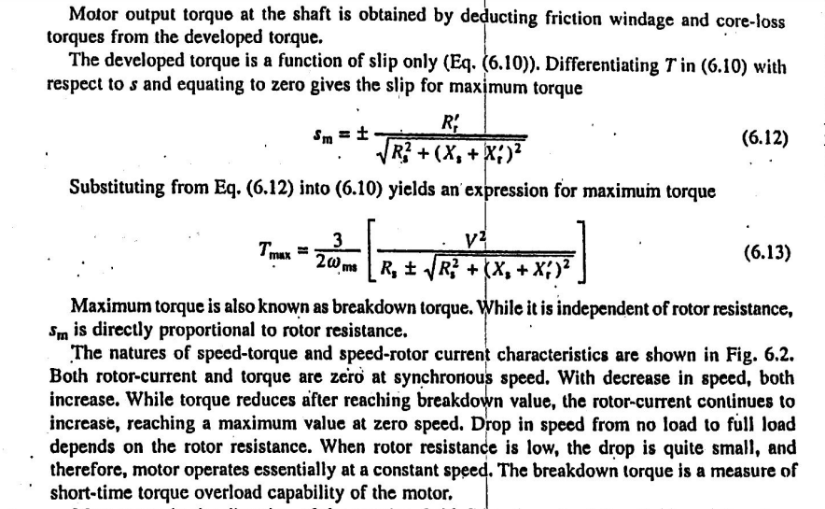

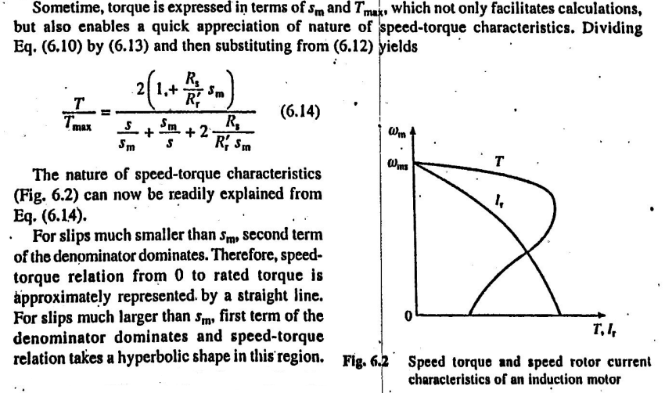

# Stator Voltage Control of an Induction Motor

**Stator Voltage Control** is a method used to control the speed of an **Induction Motor.** The speed of a three phase induction motor can be varied by varying the supply voltage. As we already know that the torque developed is proportional to the square of the supply voltage and the slip at the maximum torque is independent of the supply voltage. The variation in the supply voltage does not alter the synchronous speed of the motor.

The **Torque-Speed Characteristics** of the three phase Induction motors for varying supply voltage and also for the fan load are shown below.

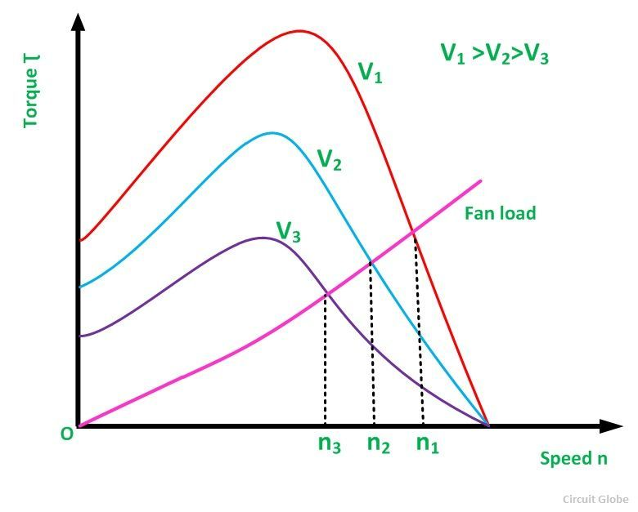

By varying the **supplying voltage**, the speed can be controlled. The voltage is varied until the torque required by the load is developed, at the desired speed. The torque developed is proportional to the square of the supply voltage and the current is proportional to the voltage.

Hence, to reduce the speed for the same value of the same current, the value of the voltage is reduced and as a result, the torque developed by the motor is reduced. This stator voltage control method is suitable for the applications where the load torque decreases with the speed. **For example-** In the fan load.

This method gives a**speed control** only below the normal rated speed as the operation of the voltages if higher than the rated voltage is not admissible. This method is suitable where the intermittent operation of the drive is required and also for the fan and pump drives. As in fan and pump the load torque varies as the square of the speed. These types of drives required low torque at lower speeds. This condition can be obtained by applying lower voltage without exceeding the motor current.

The variable voltage for speed control of small size motors mainly for single phase can be obtained by the following methods given below.

* By connecting an external resistance in the stator circuit of the motor.
* By using an Auto transformer.
* By using a Thyristor voltage controller
* By using a Triac Controller

Nowadays the **Thyristor voltage controller** method is preferred for varying the voltage. For a single phase supply, two Thyristors are connected back to back as shown in the figure below.

[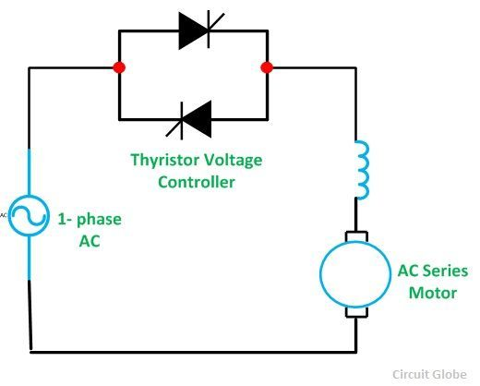](https://circuitglobe.com/wp-content/uploads/2016/02/stator-voltage-control-of-an-induction-motor-fig-2.jpg)The domestic fan motors, which are single phase are controlled by a single phase **Triac Voltage Controller** as shown in the figure below.

[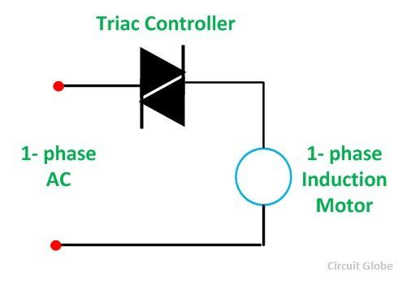](https://circuitglobe.com/wp-content/uploads/2016/02/stator-voltage-control-of-an-induction-motor-fig-3.jpg)

**Speed control** is obtained by varying the firing angle of the **Triac**. These controllers are known as **Solid State fan regulators**. As the solid state regulators are more compact and efficient as compared to the conventional variable regulator. Thus, they are preferred over the normal regulator.

In case of a three phase induction, motor three pairs of Thyristor are required which are connected back to back. Each pair consists of two Thyristor. The diagram below shows the**Stator Voltage Control** of the three phase induction motors by **Thyristor Voltage Controller.**

[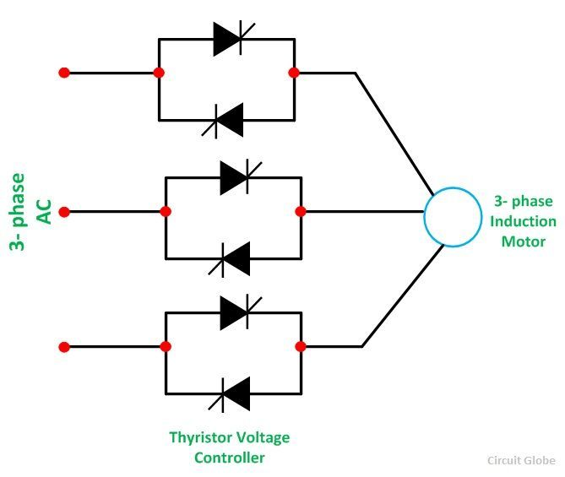](https://circuitglobe.com/wp-content/uploads/2016/02/stator-voltage-control-of-an-induction-motor-fig-4.jpg)

Each pair of the Thyristor controls the voltage of the phase to which it is connected. Speed control is obtained by varying the conduction period of the Thyristor. For lower power ratings, the back to back Thyristor pairs connected in each phase is replaced by Traic.

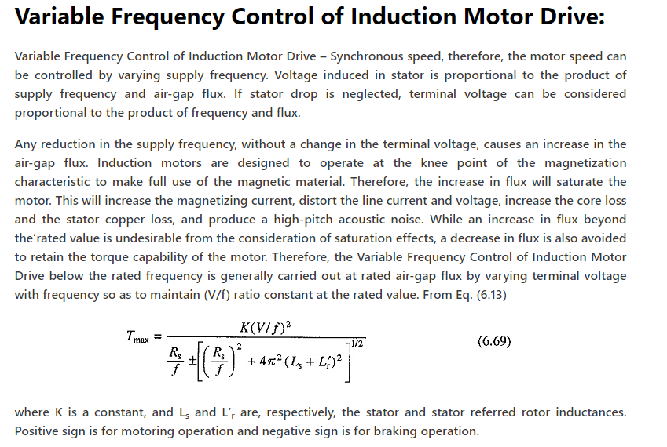

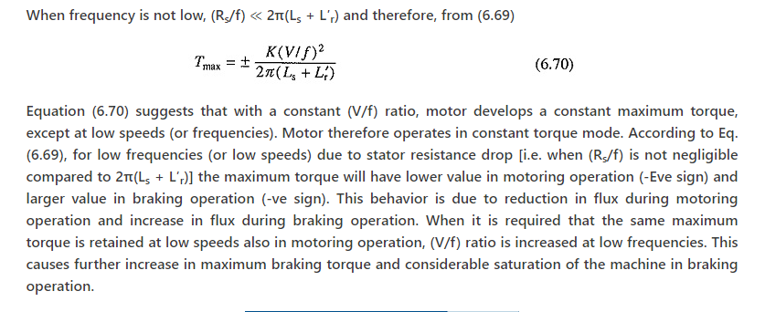

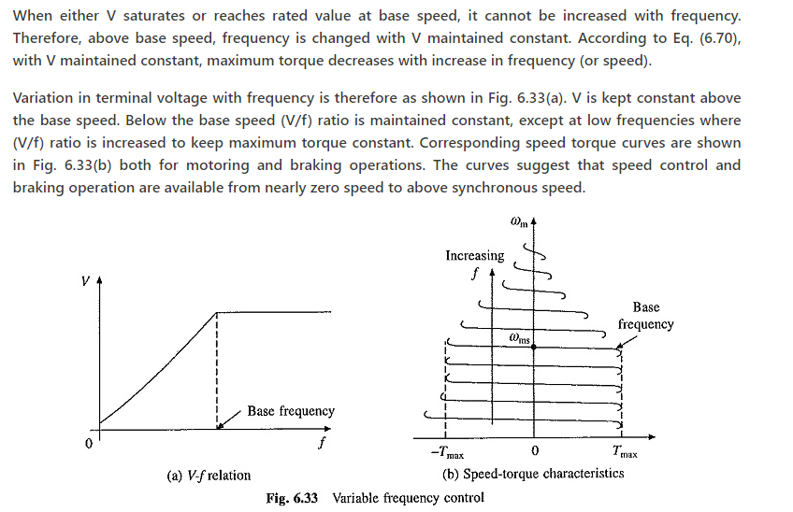

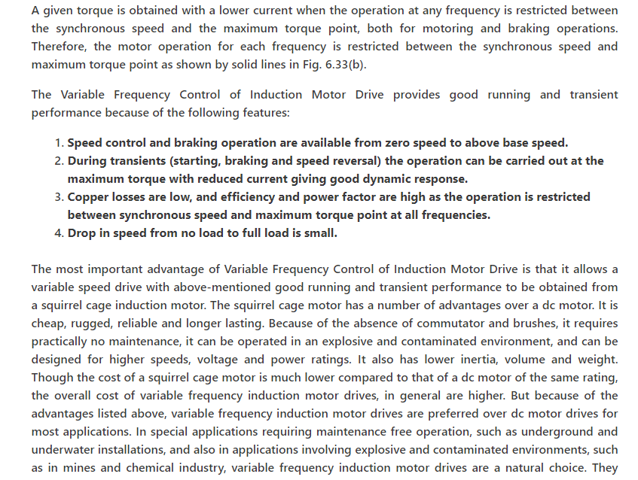

have several other applications such as traction, mill run out tables, steel mills, pumps, fans, blowers, compressors, spindle drives, conveyers, machine tools, and so on.

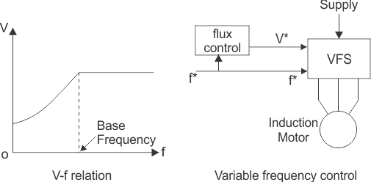

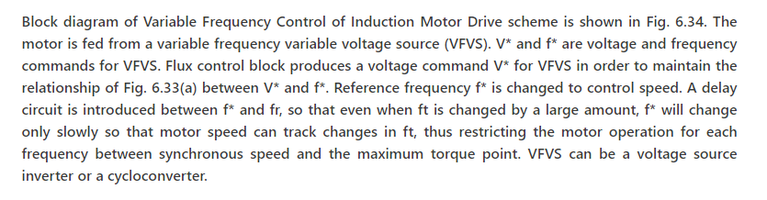

# VSI Fed Induction Motor Drives

**Definition:** The voltage source inverter is defined as the inverter which takes a variable frequency from a DC supply. The input voltage of the voltage source inverter remains constant, and their output voltage is independent of the load.The magnitude of the load current depends on the nature of the load impedance.

The figure below shows a voltage source inverter employing transistor.

[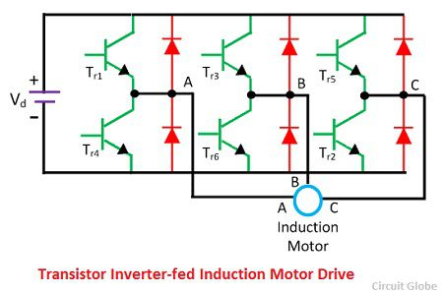](https://circuitglobe.com/wp-content/uploads/2016/11/transistor-inverter-fed-niduction-motor-drive.jpg)

The voltage source inverter use self-commutated device like MOSFET, IGBT, GTO, etc. It is operated as a stepped-wave inverter or a pulse width modulation. When the voltage source inverter is operated as a stepped-wave inverter, then the transistor is switched in the sequence of their number with a time difference of T/6.

The each of the transistors is kept on for the duration of T/2, where T is the period for one cycle. The waveform of the line voltage is shown in the figure below. The frequency of the inverter is varied by varying T, and the output voltage of the inverter is varied by varying DC input voltage.

[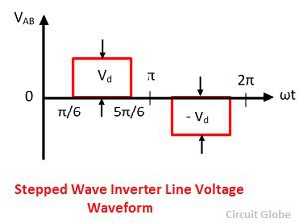](https://circuitglobe.com/wp-content/uploads/2016/11/stepped-wave-inverter-line-voltage-waveform.jpg)

[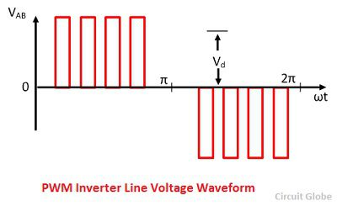](https://circuitglobe.com/wp-content/uploads/2016/11/pwm-inverter-line-votlage-waveform.jpg)

When the supply is DC, then the variable DC input is obtained by connecting a chopper between DC supply and inverter.

[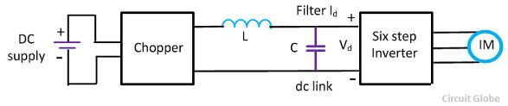](https://circuitglobe.com/wp-content/uploads/2016/11/vsi-conrolled-inductionmotor-drive-1.jpg)

When the supply is AC, then the DC input voltage is obtained by connecting the controlled rectifier between the AC supply and inverter shown in the figure below.The capacitor C filter out the harmonics in DC link voltage.

[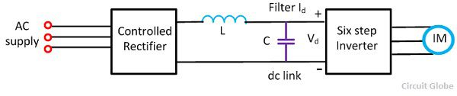](https://circuitglobe.com/wp-content/uploads/2016/11/voltage-source-inverter-controlled-induction-motor-drive.jpg)

The main drawback of the VSI induction motor drive is the large harmonics of the low frequency in the output voltage. The harmonics increases the loss in the motor and cause the jerky motion of the rotor at low speed.

CSI (Current Source Inverter)

CSI is used in many applications due to its flexibility, reliability and commutation. CSI operates on closed loop and capable of generation, by using CSI variable frequency is obtained.

[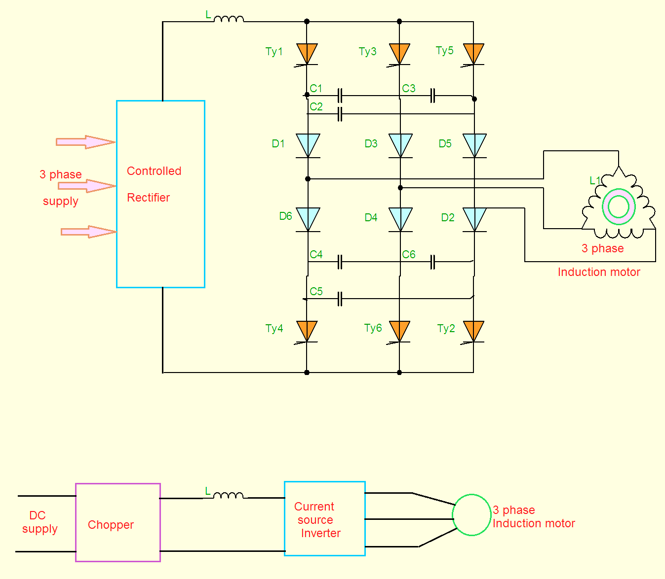](https://3.bp.blogspot.com/-DtUizD3ThX8/Vxdog3t1RiI/AAAAAAAADoA/_HE_CP8mqhIZFVEu1pEYjZ2ZGRqQOC4TQCLcB/s1600/CSI.png)

The variable  frequency control  of an induction motor can also  be obtained using CSI. The inductor is connected in series with the input.

* By varying the thyristors conduction periods and Inverter, the DC current is converted into a three phase current source.

* The stator current is a function of rotor frequency, by keeping flux constant the magnitude of stator is controlled by the rotor frequency.

* When supply is AC the controlled rectifier converts it into variable DC, if the supply is DC  the chopper manages the circuit.

* From the circuit diagram for commutation of  six thyristors the circuit is provided with six diodes and six capacitors.

* The six thyristors are triggered with a phase difference of 180°. The diodes are used for preventing discharge of capacitors through load.

Characteristics:

*For below rated speed, motor operates at constant flux mode.

*For above rated speed, motor operates at field weakening mode.

*For speed equal to rated speed, the voltage reach its rated value and no further increase of speed.

The characteristics are shown below on taking percentage slip on x-axis and percentage torque on y-axis.

[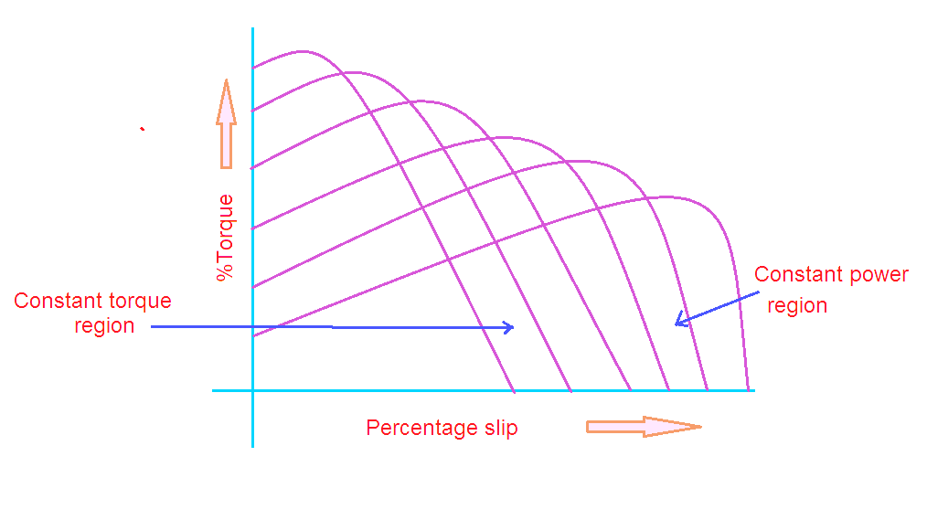](https://3.bp.blogspot.com/-tDMDwBZxlhQ/VxdonccfXfI/AAAAAAAADoE/LuWkGVgRJIIC7KqG5qLiMCxxScQBDGM8ACLcB/s1600/CSI+characteristics.png)

Advantages:

1. CSI is robust and simple

2. Four quadrant operation is possible

3. Controlling the speed in simple way

4. Better controlled performance.

Disadvantages:

1. Cost is expensive with PWM technique

2. Unsupported for multi-motor operation

3. CSI not used in open loop control drives

4. Undesirable dynamic performance

5. At no-load condition it is difficult to operate.

Comparison of VSI and CSi

|  |  |
| --- | --- |
| **VSI** | **CSI** |
| VSI is fed from a DC voltage source having small or negligible impedance. | CSI is fed with adjustable current from a DC voltage source of high impedance. |
| Input voltage is maintained constant | The input current is constant but adjustable. |
| Output voltage does not dependent on the load | The amplitude of output current is independent of the load. |
| The waveform of the load current as well as its magnitude depends upon the nature of load impedance. | The magnitude of output voltage and its waveform depends upon the nature of the load impedance. |
| VSI requires feedback diodes | The CSI does not require any feedback diodes. |
| The commutation circuit is complicated | Commutation circuit is simple as it contains only capacitors. |
| Power BJT, Power MOSFET, IGBT, GTO with self commutation can be used in the circuit. | They cannot be used as these devices have to withstand reverse voltage. |

Cycloconverter fed to Induction motor

Cyclo converter is a single stage frequency conversion device which converts fixed AC frequency to variable AC frequency. A three phase, three pulse cyclo converter feeding a three phase induction motor is shown below

[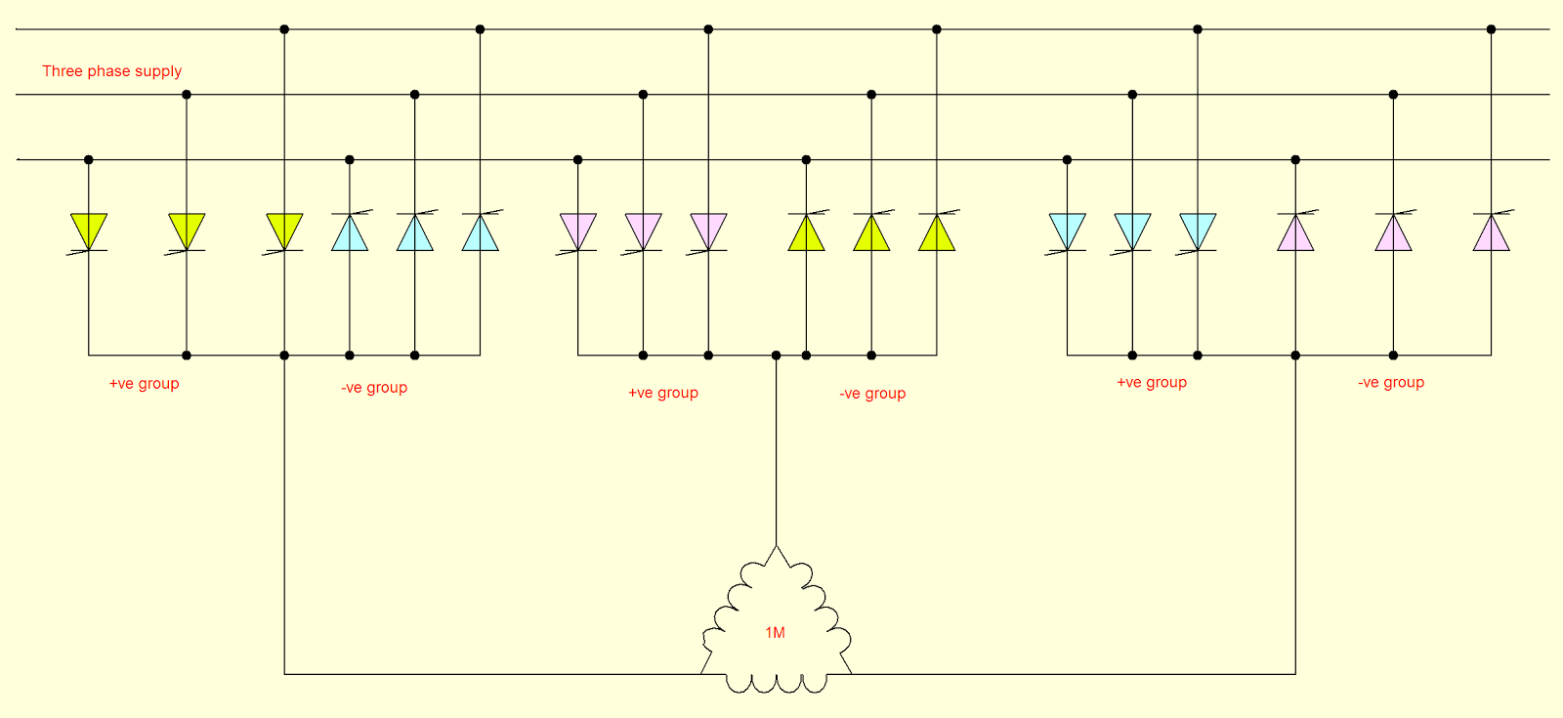](https://2.bp.blogspot.com/-ajNJNQYzDss/Vv8inWcCYHI/AAAAAAAACcw/WkdQzteClm49FTEp1-gRlmZT93tSjUOeg/s1600/cycloconverter%2Bfed%2Bto%2Binduction%2Bmotor.png)

A cyclo converter fed induction motor drive has following features:

1.The machine operates at its rated flux conditions due to voltage control is made in the converter itself.

2.A cyclo converter operates on line commutation, the losses occurred by forced commutation is eliminated. The converter operates at lag power factor and very poor line power factor for light loads.

3.By modulating thyristors firing angle the high quality sinusoidal waveform is obtained at all frequencies.

4.A cyclo converter is capable of power transfer between AC source to motor load and vice versa.

5.The operation is smooth and efficient due to less significance of torque pulsation and harmonic losses of the machine.

6.At any power factor it can feed power to load with four quadrant operation which is simple and straight forward.

7. The output frequency of cyclo converter is limited to one-third of input frequency. A speed control range of 0-33% of base speed is possible.

8.It requires many thyristors for line commutation, if a thyristor fails no shut down is required and output can be made available without any interruption.

9.Regeneration is inherent in the complete speed range.

Advantages:

1.It has reversibility and four quadrant operation

2.It is justified for large horse power applications

3.Very smooth low speed operation with the least torque ripple

4.Output voltage is replica of reference voltage

5.By using controlled rectifiers and firing angles the output voltage may be controlled

Disadvantages:

1.It requires large number of thyristors

2.At higher ratings the power factor is poor and harmonics are   
present in output

3.Converter operates at lagging power factor.

Applications:

1.Gearless cement mills or ball mill drives

2.Low speed, large power and reversible drive applications.

## Closed-Loop Speed Control

The block diagram of the closed loop speed control system is shown in the figure below. This system used an inner control loop within an outer speed loop. The inner control loop controls the motor current and motor torque below a safe limit.

[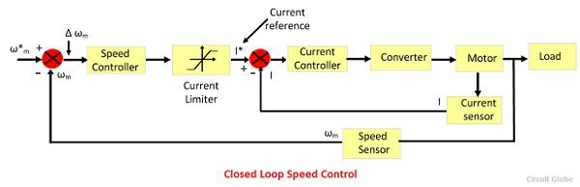](https://circuitglobe.com/wp-content/uploads/2016/10/closed-loop-speed-control.jpg)Consider a reference speed ω*m which produces a positive error Δ ω*m. The speed error is operated through a speed controller and applied to a current limiter which is overloaded even for a small speed error. The current limiter set current for the inner current control loop. Then, the drive accelerates, and when the speed of the drive is equal to the desired speed, then the motor torque is equal to the load torque. This, decrease the reference speed and produces a negative speed error.

When the current limiter saturates, then the drive becomes de-accelerate in a braking mode. When the current limiter becomes desaturated, then the drive is transferred from braking to motoring.