SYNCHRONOUS MOTOR DRIVES

**Characteristics of Synchronous Motor:**

Characteristics of Synchronous Motor are constant speed motors. The speed of the motor is decided by the number of poles and frequency. Compared to an induction motor, it is very sensitive to sudden changes of load. This causes a hunting of the rotor and finally leads to stability problems. It has no starting torque and requires starting equipment to bring it to its rated speed. When it is running at its rated speed the field is excited. The [damper windings](https://www.eeeguide.com/sequence-impedances-and-networks-of-synchronous-machine/) on the field poles help in damping the hunting and providing the starting torque. The motor can be operated at different power factors by changing the excitation. Overexcited synchronous motors operate at leading power factors whereas underexcited ones operate at lagging power factors. They are reasonably efficient. Their efficiency and ability to correct the power factor by varying the excitation make synchronous motors attractive in large power applications. They are preferred as constant speed drives in the industry.

The phasor diagram of a Characteristics of Synchronous Motor is shown in Fig. 1.32. The theory of these motors has been developed on the basis of synchronous reac­tance, which takes care of leakage reactance and [armature reaction](https://www.eeeguide.com/nature-of-armature-reaction/). A salient pole machine, which has a non-uniform air gap, is described by direct and quadrature axis reactances. Variation of the armature current of the motor when its excitation is varied is described by V-curves when the motor develops a given power.

The variation of excitation brings about the following:

1. **change in armature current**
2. **change in line power factor**
3. **slight change in the load angle.**

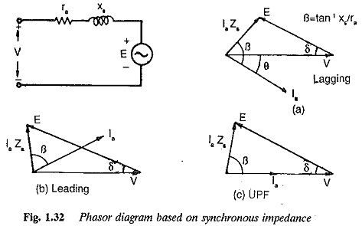

However, there are minimum and maximum excitations for a given power developed.

An increase in the mechanical load at constant excitation would tend to retard the rotor. The angle by which the rotor tends to fall behind the no-load position is called the load angle. In the process of attaining a final position the rotor undergoes oscillations which are damped by damper windings.

### ****Power developed by Characteristics of Synchronous Motor:****

The phasor diagram of a cylindrical rotor synchronous motor at a lagging power factor is shown in Fig. 1.32. The power developed by the motor is given by[Characteristics of Synchronous Motor](https://www.eeeguide.com/wp-content/uploads/2017/10/Characteristics-of-Synchronous-Motor-1.jpg)**where**

**δ is the load angle**

**V is the terminal voltage**

**Et is the induced voltage**

[Characteristics of Synchronous Motor](https://www.eeeguide.com/wp-content/uploads/2017/10/Characteristics-of-Synchronous-Motor-2.jpg)

The torque developed by the motor isThe power developed depends on the excitation. An increase in the excitation results in an increase of Pd. Consequently, the load angle decreases for a given power developed. The overload capacity of the motor increases with an increase in excitation and the machine becomes more stable. If the resistance of the armature is negligible, the power developed is given by

[Characteristics of Synchronous Motor](https://www.eeeguide.com/wp-content/uploads/2017/10/Characteristics-of-Synchronous-Motor-3.jpg)

For a [salient pole rotor](https://www.eeeguide.com/salient-pole-synchronous-generator/) the use of a single synchronous reactance gives unreliable results. The performance of the motor is determined by the use of two reactances, namely direct axis and quadrature axis reactances (Xd, Xq), The former being greater than the latter.

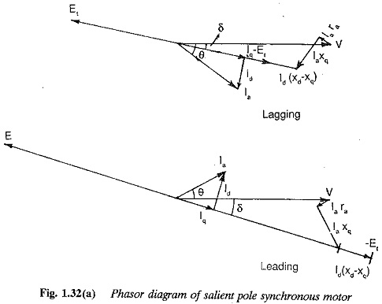

The phasor diagram of an overexcited salient pole synchronous motor is shown in Fig. 1.32(b). Neglecting armature resistance the power developed is given by

[https://www.eeeguide.com/wp-content/uploads/2017/10/Characteristics-of-Synchronous-Motor-5.jpg](https://www.eeeguide.com/wp-content/uploads/2017/10/Characteristics-of-Synchronous-Motor-5.jpg)

and the torque developed[https://www.eeeguide.com/wp-content/uploads/2017/10/Characteristics-of-Synchronous-Motor-6.jpg](https://www.eeeguide.com/wp-content/uploads/2017/10/Characteristics-of-Synchronous-Motor-6.jpg)

When compared with round rotor machines, the following differences are clear:

1. **The power (torque) developed by a salient pole rotor has an additional component due to saliency, which depends upon the difference of the two axes reactances. This is called**[**reluctance power**](https://www.eeeguide.com/electrical-drives/)**(torque). A salient pole rotor develops more power for a given load angle. This means the power per degree of load angle is greater in a salient pole rotor than that in a round rotor when excitation is the same in both the cases (the two motors are otherwise identical).**
2. **The maximum torque in a salient pole rotor occurs at a torque angle which is less than the corresponding one of a round rotor motor.**
3. **Torque is available in a salient pole rotor even at zero excitation.**

### ****Power Angle diagram of Synchronous Motor:****

The power angle characteristics of both types of rotor are shown in Fig. 1.33, for different excitations. The torque developed in a synchronous motor is directly proportional to the applied voltage unlike in an induction motors where it is proportional to the square of voltage. Hence it is less sensitive to voltage variations.

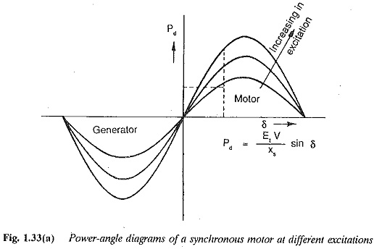

The Torque Speed Characteristics of Synchronous Motor is shown in Fig. 1.34. The characteristic is parallel to the torque axis since the motor is of constant speed type.

The damper windings provided on the pole faces to suppress hunting may also be used to start the motor using the induction motor principle. The

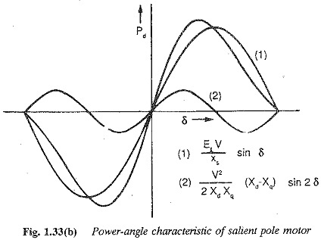

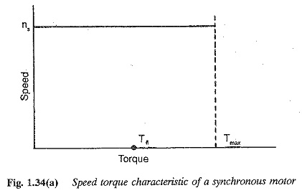

The torque speed characteristics of synchronous motor during starting is similar to that of an [induction motor](https://www.eeeguide.com/speed-torque-characteristics-of-induction-motor/), and is depicted in Fig. 1.34 for different damper resis­tances. To get a better starting torque the damper winding must have a high resistance. However, this inhibits their primary function of damping the oscillations, since a low resistance damper is more effective for this task. A judicious choice of resistance is required, depending upon the application of the motor.

### ****Speed Control of Synchronous Motor:****

With the availability of thyristor power converters, synchronous motors are becoming increasingly popular as variable speed drives. Two types of control are possible for synchronous motor, when fed from thyristor power converters.

1. **Separate control**
2. **Self control**

The type of control employed affects both the dynamic and the steady-state performance of the motor. In the former (Fig. 1.38), the motor is fed from a variable frequency supply, the frequency being controlled externally from a crystal oscillator. The motor has the normal synchronous motor operation with all its stability and hunting problems. In self control (Fig. 1.39), the frequency of the input is decided by the rotor speed or stator voltages. A rotor position sensor is used to control the inverter firing pulses. By the time the rotor moves by two pole pitches, all the thyristors in the inverter are fired once in the sequence. Thus the input frequency and rotor speed are related . The firing pluses may be derived by sensing the stator volt­ages also. With self control the motor has good stability as well as good dynamic performance. The motor acquires dc motor characteristics. The in­verter with rotor position sensing or induced voltage sensing is equivalent to a six-segment commutator. A self controlled synchronous motor can re­place a dc motor, which has limitations due to its mechanical commutator. In this mode of operation it is also called a commutator-less motor (CLM). The motor may be fed from a VSI or CSI or [cycloconverter](https://www.eeeguide.com/ac-dc-converters/). When fed from a CSI the motor may be overexcited to make use of the machine voltages for commutation.

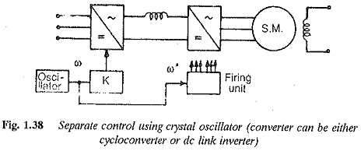

The input voltage waveform and current to the Characteristics of Synchronous Motor are non-sinusoidal. The time harmonics of the waveform result in torque pulsations and armature heating. These effects are minimal with a cycloconverter. In the case of CSI feeding, voltage spikes are present. These affect the motor insulation and voltage rating of the [inverter](http://www.allaboutcircuits.com/).

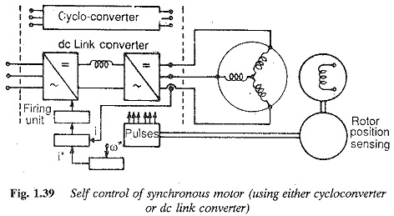

Variable frequency control of Synchronous Motor Drive

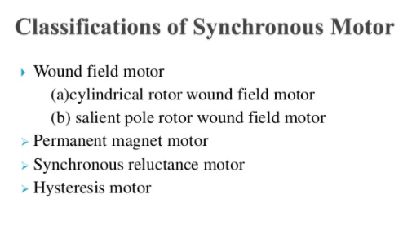

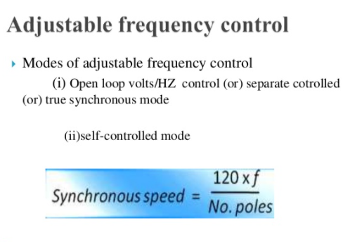

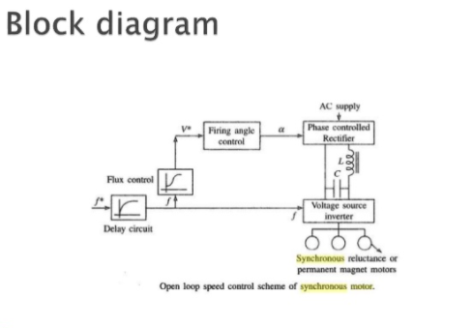

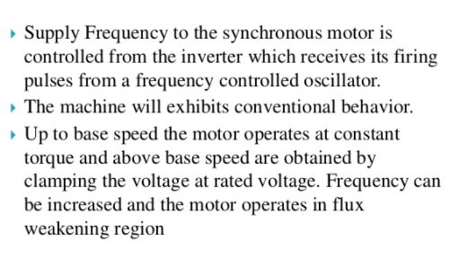

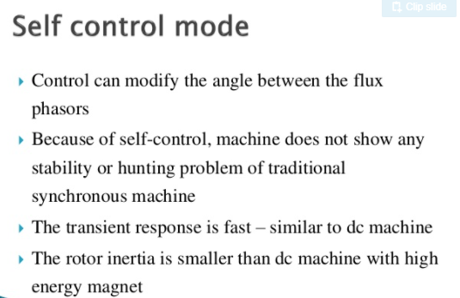

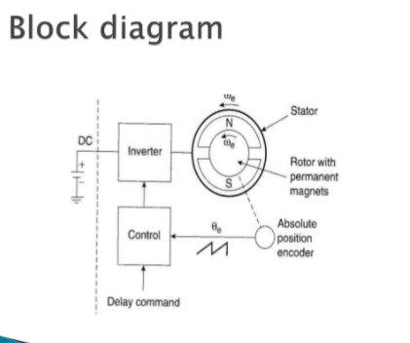

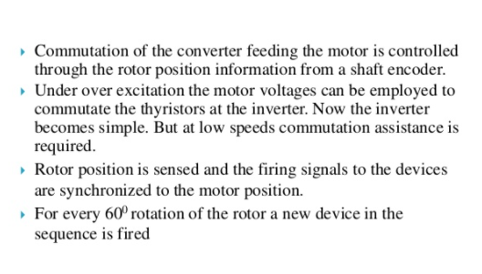

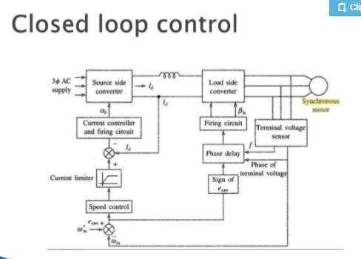

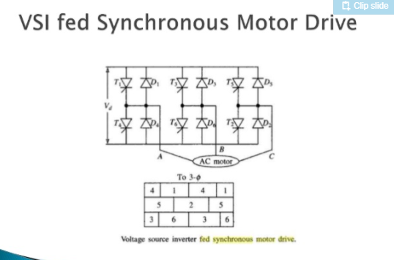

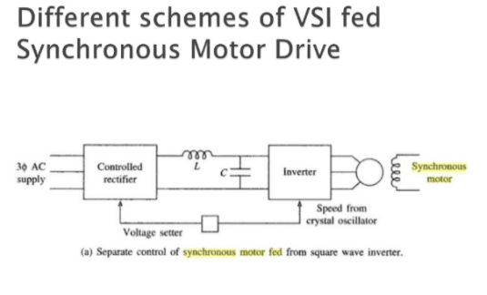

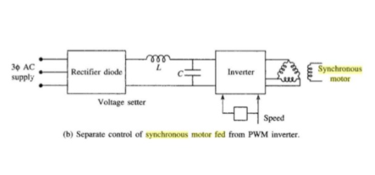

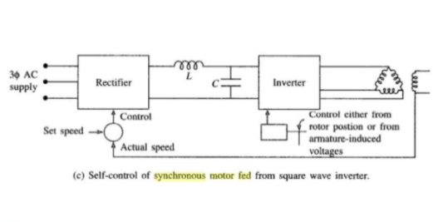

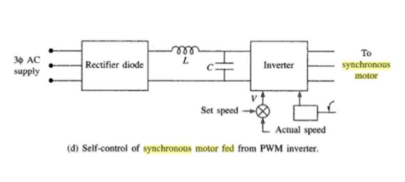

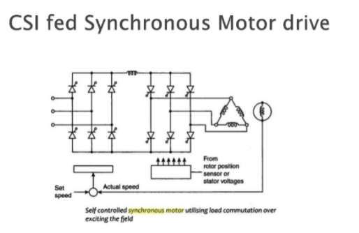

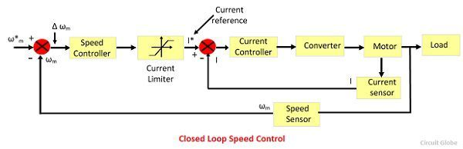

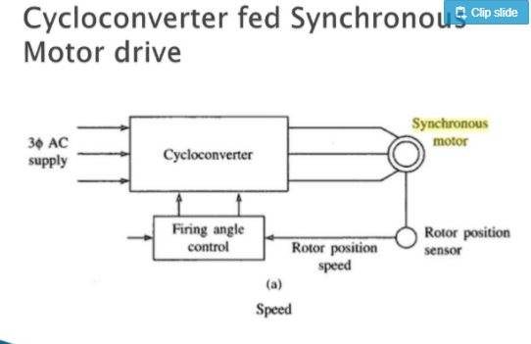

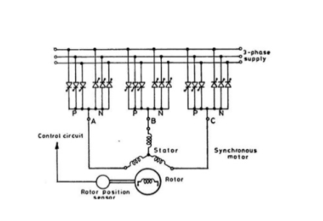

## ****Voltage Source Inverter Fed Synchronous Motor Drive:****

An inverter fed synchronous motor has been very popular as a converter motor in which the synchronous motor is fed from a CSI having load commutation. Of late more attention is being paid towards understanding the behavior of synchronous motors fed from a Voltage Source Inverter. These drives can also be developed to have self control, using a rotor position sensor or [phase control methods](https://www.eeeguide.com/3-phase-induction-motor-construction/). It has been reported in the literature that these drives might impose fewer prob­lems both on machine as well as on the system design. A normal VS1 with 180° conduction of thyristors requires forced commutation and load commutation is not possible.

[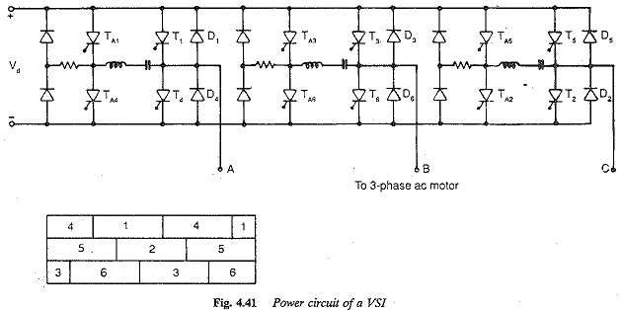](https://www.eeeguide.com/wp-content/uploads/2018/05/Voltage-Source-Inverter-Fed-Synchronous-Motor-Drive.jpg)

A typical power circuit of a voltage source inverter is shown in Fig. 4.41. Three combinations are possible, to provide a variable voltage variable fre­quency supply to a synchronous motor (Fig. 4.42). The voltage control can be obtained external to the inverter using a phase controlled rectifier. The [link voltage](https://www.eeeguide.com/inverter-control-for-variable-link-voltage/) is variable. This  has the disadvantage that commutation is difficult at very low speeds. As the output voltage is a square wave the inverter is called variable voltage inverter or [square wave inverter](https://www.eeeguide.com/square-wave-voltage-source-inverter-fed-induction-motor-drive/). The second alternative is to have voltage control in the inverter itself, using principles of PWM or PSM. The inverter is fed from a [constant link voltage](https://www.eeeguide.com/current-source-inverter-for-feeding-three-phase-motors/). A diode rectifier would be sufficient on the line side. This does not have difficulties of commutation at low speeds. Very low speeds up to zero can be obtained. The third alternative is to interpose a dc chopper in between the rectifier and the inverter. The system may appear cumbersome at first sight, but it has advantages. Three simple converters are used to give the desired result. It is possible to reduce the size of [link inductance](https://www.eeeguide.com/inductance-of-three-phase-lines/) by having a synchronous control of the chopper.

**[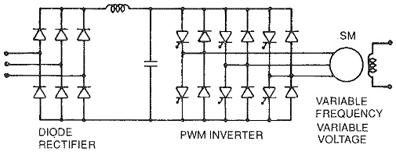](https://www.eeeguide.com/wp-content/uploads/2018/05/Voltage-Source-Inverter-Fed-Synchronous-Motor-Drive-1.jpg)**

**[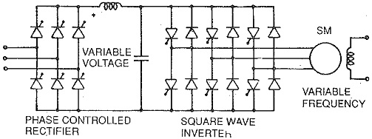](https://www.eeeguide.com/wp-content/uploads/2018/05/Voltage-Source-Inverter-Fed-Synchronous-Motor-Drive-2.jpg)**

**[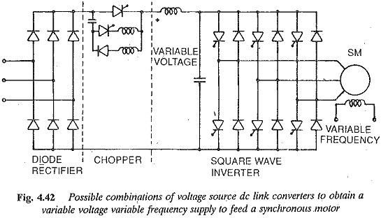](https://www.eeeguide.com/wp-content/uploads/2018/05/Voltage-Source-Inverter-Fed-Synchronous-Motor-Drive-3.jpg)**

**A voltage source inverter feeding a synchronous motor can have either separate control or self control. In the former the speed of the motor is determined by external frequency from a [crystal oscillator](https://www.eeeguide.com/synchronous-speed-on-variable-frequency-supply/). Open loop control is possible. The motor has instability problems and hunting, similar to a [conventional motor](https://www.eeeguide.com/speed-torque-characteristics-of-series-motor/). In the latter the inverter is controlled by means of firing pulses obtained from a rotor position sensor or induced voltage sensor. The motor is in the CLM mode and has better stability characteristic (Fig. 4.43).**

**[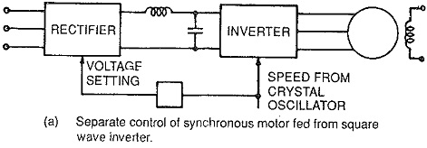](https://www.eeeguide.com/wp-content/uploads/2018/05/Voltage-Source-Inverter-Fed-Synchronous-Motor-Drive-4.jpg)**

**[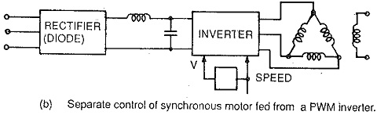](https://www.eeeguide.com/wp-content/uploads/2018/05/Voltage-Source-Inverter-Fed-Synchronous-Motor-Drive-5.jpg)**

**[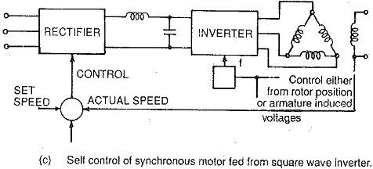](https://www.eeeguide.com/wp-content/uploads/2018/05/Voltage-Source-Inverter-Fed-Synchronous-Motor-Drive-6.jpg)**

**[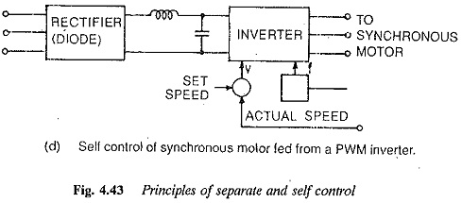](https://www.eeeguide.com/wp-content/uploads/2018/05/Voltage-Source-Inverter-Fed-Synchronous-Motor-Drive-7.jpg)**

**The output voltage of the inverter is non-sinusoidal. The behaviour of the motor supplied from the inverter is entirely different from the behaviour of the motor operating on a conventional sinusoidal supply. A knowledge of the behavior is essential. The steady-state performance enables one to have a proper choice of the thyristors, and also to determine the effects of non-sinusoidal waveforms on torque developed and [machine losses](https://www.eeeguide.com/rotating-machines-losses-classification/)**

**The stator current drawn by the motor when fed from the square wave inverter has sharp peaks and is rich in harmonic content. These harmonics can cause additional losses and heating of the motor. They also cause pulsating torques which are objectionable at low speeds. Thus the performance with respect to additional heating due to harmonics, and pulsating torques is similar to that of an induction motor.**

**When a PWM inverter is used, these harmonic effects are reduced. The stator currents are less peaky and have reduced harmonic content. Accordingly additional losses due to harmonics, consequent motor heating and [torque pulsations](https://www.eeeguide.com/pulse-width-modulated-inverter-fed-induction-motor-drive/) are decreased. These effects become minimal.**

**The discussion on regeneration given for induction motors holds good for these cases also. With the square wave inverter another [phase controlled rectifier](https://www.eeeguide.com/silicon-controlled-rectifier-construction-and-working/) is required on the line side. Dynamic braking can be employed. When a PWM inverter is used, two cases may arise. The inverter may be fed from a constant dc source in which case regeneration is straight forward. The dc supply to the inverter may be obtained from a diode rectifier. In this case an additional phase controlled converter is required on the line side.**

**A square wave inverter drive must have a phase controlled converter on the line side. Due to phase control the line power factor is very poor. A diode rectifier is sufficient in the case of PWM inverter. The line pf improves to unity. In either case the machine p.f. can be improved by field control. With a view to minimizing the inverter size as well as losses in the inverter and motor, it is advantageous to operate the motor at UPF.**

**A VSI drive provides reasonably good efficiency. Converter cost is high. Open loop (separate) control may pose stability problems at low speeds. CLM mode is very stable. PWM drive has a better dynamic response than a square wave drive. This finds application as a general purpose industrial drive for low and medium [powers](http://www.circuitstoday.com/).**

**Load Commutated Inverter Fed Synchronous Motor Drive:**

Load Commutated Inverter Fed Synchronous Motor Drive is shown in Fig. 10.22. The inverter is a current source inverter employing thyristors T1 – T6. The commutation of inverter thyristor is done by the voltages induced in armature of the synchronous motor. A chopper is used to obtain a variable dc voltage Vds from the fixed source voltage V. The Vds is varied with Vdl so that a required current is supplied to the dc link, and therefore, to the motor.

During motoring, the power flows from the dc mains through the chopper, dc link and inverter to the motor. When the inverter firing angle is changed from close to 180° to 0°, the voltage Vdl reverses. If chopper operation is also changed to make Vds negative but less than Vdl in magnitude, the power flows from the load, through the machine, inverter and chopper to the dc mains, giving regenerative braking operation. Here arrangement for dynamic braking is not shown, but it can be incorporated in the same way as shown already.

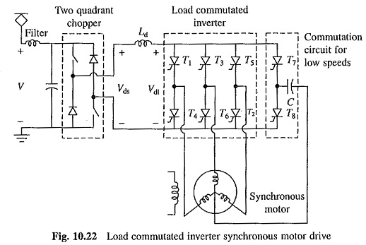

Armature induced voltages are too small to commutate inverter thyristors at low speeds, including standstill. Thyristors T7 and T8 and capacitor C are used to commutate inverter thyristors at low speeds. Around 10% of the base speed gate pulses are withdrawn from T7 and T8, and the load commutation is employed.

Due to the presence of Ld, inverter is essentially current source inverter. Therefore, each traction motor is fed by its own inverter. If there are four traction motors, four such inverters will be required.

Further, because of current source characteristics, the inverters can be connected in series but not in parallel. Thus, when four traction motors are used one alternative will be to connect all four inverters in series fed by a common chopper. Such a series connection will have adverse effect on adhesion. Alternatively, one can connect two inverters in series, and each such series pair is then fed by its own [chopper](http://www.allaboutcircuits.com/).

### ****This Load Commutated Inverter Fed Synchronous Motor Drive has following features in comparison to PWM VSI induction motor drive:****

#### **Because of an additional power stage (i.e. chopper), the converter efficiency is lower, but the motor efficiency is higher**

#### **Due to the presence of large inductance Ld, the drive has slow dynamic response giving inferior adhesion.**

#### **Larger weight and volume.**

#### **Each motor should have its own inverter and these inverters can be connected in series but not in parallel. When large traction motors are involved the drive becomes expensive and Series connection also has adverse effect on adhesion.**

#### **Inverter is more reliable due to absence of shoot through fault.**

#### **Because of torque pulsations produced by harmonics, the acceleration is not smooth. This also has adverse effect on adhesion**.****