LECTURE NOTES

ON

**POWER SYSTEMS-II**

**(R19)**

**II B.TECH II Semester**

**Dr N.Usha Professor**

**NBKR INSTITUTE OF SCIENCE & TECHNOLOGY:: VIDYANAGAR (AUTONOMOUS)**

**(AFFILIATED TO JNTUA :: ANANTAPUR)**

**(Autonomous)**

**VIDYANAGAR, SPSR NELLORE(Dt) -524413**

**Department of Electrical and Electronics Engineering**

**19EE2205-POWER SYSTEMS-II**

|  |  |  |  |
| --- | --- | --- | --- |
| **Course Category:** | Professional core | **Credits:** | 4 |
| **Course Type:** | Theory | **Lecture-Tutorial-Practical:** | 3-1-0 |
| **Pre-requisite:** | Generation of electric power, Circuits and Networks | **Sessional Evaluation:**  **External Exam Evaluation:**  **Total Marks:** | 40  60  100 |

|  |  |  |
| --- | --- | --- |
| **Course Objectives:** | Students undergoing this course are expected to learn : | |
| 1. The classification of transmission lines and performance calculation of  transmission lines.  2. The different types of insulators , methods of equalising the potential across  the string of insulators.  3.The various types of underground cables and the methods of grading of  underground cables.  4. The transients and travelling wave phenomenon on transmission lines.  5. The objective of power system earthing and methods of earthing.  6. The fundamental concepts of electrical power distribution, both AC & DC. | |
| **Course Outcomes:** | After completing the course the student will be able to | |
| CO1 | Understand the classification of transmission lines and performance calculation of over head transmission lines. |
| CO2 | Gain knowledge about the different types of insulators, methods of equalizing the potential across the string of insulators. |
| CO3 | Acquire the knowledge on underground cables and methods grading of underground cables. |
| CO4 | The transients and travelling wave phenomenon on transmission lines. |
| CO5 | Understand the objective of power system earthing and methods of earthing. |
| CO6 | Design and evaluate the performance of D.C distribution and A.C distribution. |
| **Course Content:** | **UNIT- I**  **Performance of transmission lines**: Representation of lines, Short transmission lines, Medium transmission lines, Nominal pie and T representation of long lines by distributed parameters, Equivalent T and Pie representation of long transmission lines, Evaluation of ABCD parameters of long lines, Ferranti effect.  **UNIT –II**  **Overhead Line Insulators:** Introduction, Types of Insulators, potential distribution over a string of insulators, Methods of equalizing the potential, string efficiency.  **UNIT-III**  **Underground Cables**: Types of Cables, Construction, insulation types, insulating materials for EHV voltage cables, classification of cables, parameters of single core cable, Grading of cables, Capacitance grading, Inter-sheath grading, Capacitance of three core belted cable.  **UNIT-IV**  **Power system transients:** Introduction, Circuit closing transients, Recovery transient due to removal of a short circuit, Travelling waves on transmission line, Surge impedance and wave velocity, Specification of travelling waves, Reflections and refractions of waves, Different types of terminations, Forked line, Successive reflections, Bewley’s Lattice diagram, Attenuation and distortion.  **UNIT-V**  **Power system earthing:** Objectives, definitions, Tolerable limits of body currents, Soil resistivity, Earth resistance, Tolerable Step and touch voltages, Neutral earthing, Ungrounded and effectively earthed system, Resistance, Reactance, Arc suppression coil earthing and grounding transformers. Arcing grounds, protection against arcing grounds.  **UNIT –VI**  **DC & AC Distribution :** Comparison of single Phase , 3-phase three wire and 3- phase four wire system, Types of primary distribution systems, Types of Secondary distribution systems, DC distribution fed at one end and at both ends(Concentrated loads), AC distribution fed at one end and at both ends(Concentrated loads ), Kelvin’s law - limitation of Kelvin’s law - Numerical problems. | |
| **Text Books**  **&**  **Reference Books:** | **TEXT BOOKS:**  1. “Electrical power systems”, by C.L.Wadhwa, New Age International (P) Limited, 6th Edition, Reprint 2014.  2. “Power system analysis and Design”, by B.R.Gupta S.chand company Pvt. Ltd New Delhi, Reprint-2015.  **REFERENCE BOOKS:**  1.“Power System Engineering”, by I.J Nagarath and D.P Kothari, TMH Publications.  2.“A course in power systems”, by J.B.Gupta, S.K.Kataria & sons, Reprint-2016. | |
| **e-Resources:** | <http://nptel.ac.in/courses>  http://iete-elan.ac.in  <http://freevideolectures.com/university/iitm> | |

# UNIT – I

**PERFORMANCE OF TRANSMISSION LINES**

##### BASIS OF CLASSIFICATION OF TRANSMISSION LINE:

Over head transmission lines are classified based on the manner in which the capacitance is considered:

##### Short Transmission Lines:

Transmission lines whose length less than 80kms and operating voltage less than 20kV comes under short transmission line. Due to the smaller distance and lower voltage levels capacitance (shunt) effect is extremely low and hence capacitance effect is neglected. The performance of the short transmission lines depend on the resistance and inductance value of the line.

Thought the resistance and inductance are distributed over the length of the line it is assumed that resistance and inductance values are taken as lumped at one place. The effect of transformers and generators are taken in to account by considering equivalent impedance to the impedance of the line

##### Medium Transmission Line:

Transmission lines having length between 80kms and 200kms and line voltages between 20kV and 100kV falls in the second category. As the length of the line and voltage levels are moderate or not as low as small transmission lines, charging currents (transmission lines draw charging currents when the transmission line conductor and ground forms a capacitor with air in between as dielectric medium due to increase in the potential between the conductor and ground) comes in to picture in the case of medium transmission lines. Hence capacitance value is considered in the case of medium transmission line. Though the capacitance is distributed throughout the length of the line, capacitance value is assumed to be concentrated at one or more points

##### Long Transmission Line:

Transmission Lines having length above 200kms and line voltage above 100kV comes under Long Transmission Lines. In Long lines impedance (Resistance and inductance in series) and admittance (shunt capacitance and shunt conductance in parallel) values are distributed uniformly throughout the length of the line

Every [transmission line](https://www.electrical4u.com/electrical-power-transmission-system-and-network/) will have three basic electrical parameters. The [conductors](https://www.electrical4u.com/electrical-conductor/) of the line will have [electrical resistance,](https://www.electrical4u.com/electrical-resistance-and-laws-of-resistance/) [inductance,](https://www.electrical4u.com/what-is-inductor-and-inductance-theory-of-inductor/) and [capacitance.](https://www.electrical4u.com/what-is-capacitor/) As the transmission line is a set of conductors being run from one place to another supported by [transmission towers](https://www.electrical4u.com/electrical-transmission-tower-types-and-design/), the parameters are distributed uniformly along the line.

The [electrical power](https://www.electrical4u.com/electric-power-single-and-three-phase/) is transmitted over a transmission line with a speed of light that is 3 × 108 m ⁄ sec. Frequency of the power is 50 Hz. The wave length of the voltage and [current](https://www.electrical4u.com/electric-current-and-theory-of-electricity/) of the power can be determined by the equation given below, f.λ = v where, f is power frequency, λ is wave length and υ is the speed of light.

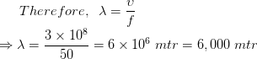

Hence, the wave length of the transmitting power is quite long compared to the generally used line length of

[transmission line](https://www.electrical4u.com/electrical-power-transmission-system-and-network/).

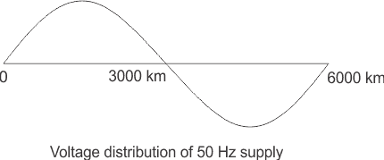

For this reason, the transmission line, with length less than 160 km, the parameters are assumed to be lumped and not distributed. Such lines are known as electrically [short transmission line](https://www.electrical4u.com/short-transmission-line/). This electrically short transmission lines are again categorized as short transmission line (length up to 60 km) and medium transmission line (length between 60 and 160 km). The capacitive parameter of short transmission line is ignored whereas in case of medium length line the, capacitance is assumed to be lumped at the middle of the line or half of the capacitance may be considered to be lumped at each ends of the transmission line. Lines with length more than 160 km, the parameters are considered to be distributed over the line. This is called [long transmission line.](https://www.electrical4u.com/long-transmission-line/)

##### ABCD PARAMETERS OF TRANSMISSION LINE:

A major section of power system engineering deals in the [transmission of electrical power](https://www.electrical4u.com/electrical-power-transmission-system-and-network/) from one particular place (eg. generating station) to another like [substations](https://www.electrical4u.com/electrical-power-substation-engineering-and-layout/) or distribution units with maximum efficiency. So it's of substantial importance for power system engineers to be thorough with its mathematical modeling. Thus the entire transmission system can be simplified to a **two port network** for the sake of easier calculations. The circuit of a 2 port network is shown in the diagram below. As the name suggests, a 2 port network consists of an input port PQ and an output port RS. In any 4 terminal network, (i.e. linear, passive, bilateral network) the input [voltage](https://www.electrical4u.com/voltage-or-electric-potential-difference/) and input current can be expressed in terms of output voltage and output current. Each port has 2 terminals to connect itself to the external circuit. Thus it is essentially a 2 port or a 4 terminal circuit, having

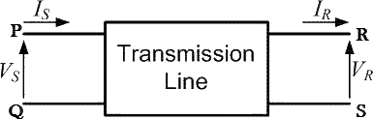

abcd-parameters-of-transmission-line-1

abcd-parameters-of-transmission-line-2Given to the input port PQ.

Given to the output port RS. As shown in the diagram below. Now the **ABCD parameters** or the transmission line parameters provide the link between the supply and receiving end voltages and currents, considering the circuit elements to be linear in nature.

Thus the relation between the sending and receiving end specifications are given using **ABCD parameters**

by the equations below.

abcd-parameters-of-transmission-line-3

Now in order to determine the ABCD parameters of transmission line let us impose the required circuit conditions in different cases.

ABCD Parameters, When Receiving End is Open Circuited

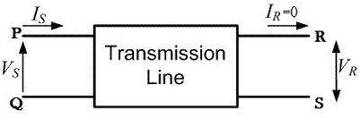

The receiving end is open circuited meaning receiving end [current](https://www.electrical4u.com/electric-current-and-theory-of-electricity/) IR = 0. Applying this condition to equation (1) we get,

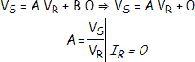

Thus its implies that on applying open circuit condition to ABCD parameters, we get parameter A as the ratio of sending end [voltage](https://www.electrical4u.com/voltage-or-electric-potential-difference/) to the open circuit receiving end voltage. Since dimension wise A is a ratio of voltage to voltage, A is a dimension less parameter. Applying the same open circuit condition i.e IR = 0 to equation (2)

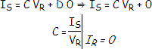

Thus its implies that on applying open circuit condition to ABCD parameters of transmission line, we get parameter C as the ratio of sending end current to the open circuit receiving end voltage. Since dimension wise C is a ratio of current to voltage, its unit is mho. Thus C is the open circuit [conductance](https://www.electrical4u.com/electrical-conductivity-of-metal-semiconductor-and-insulator/) and is given by

C = IS ⁄ VR mho.

ABCD Parameters, When Receiving End is Short Circuited

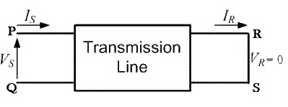

Receiving end is short circuited meaning receiving end voltage VR = 0 Applying this condition to equation

(1) we get,

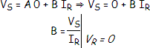

Thus its implies that on applying short circuit condition to ABCD parameters, we get parameter B as the ratio of sending end voltage to the short circuit receiving end current. Since dimension wise B is a ratio of voltage to current, its unit is Ω. Thus B is the short circuit [resistance](https://www.electrical4u.com/electrical-resistance-and-laws-of-resistance/) and is given by B = VS ⁄ IR Ω. Applying the same short circuit condition i.e VR = 0 to equation (2) we get

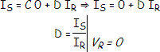

Thus its implies that on applying short circuit condition to ABCD parameters, we get parameter D as the ratio of sending end current to the short circuit receiving end current. Since dimension wise D is a ratio of current to current, it‘s a dimension less parameter. ∴

The ABCD parameters of transmission line can be tabulated as:

|  |  |  |
| --- | --- | --- |
| Parameter | Specification | Unit |
| A = VS / VR | Voltage ratio | Unit less |
| B = VS / IR | Short circuit resistance | Ω |
| C = IS / VR | Open circuit conductance | mho |
| D = IS / IR | Current ratio | Unit less |

##### SHORT TRANSMISSION LINE:

The transmission lines which have length less than 80 km are generally referred as short transmission lines.

For short length, the shunt capacitance of this type of line is neglected and other parameters like resistance and inductance of these short lines are lumped, hence the equivalent circuit is represented as given below,

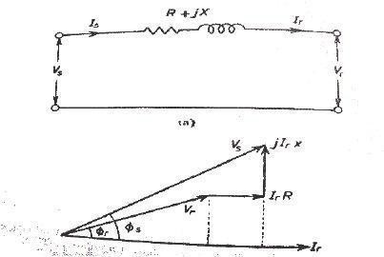Let‘s draw the vector diagram for this equivalent circuit, taking receiving end current Ir as reference. The sending end and receiving end voltages make angle with that reference receiving end current, of φs and φr, respectively.

As the shunt capacitance of the line is neglected, hence sending end current and receiving end current is same, i.e.

Is = Ir.

Now if we observe the vector diagram carefully, we will get, Vs is approximately equal to

Vr + Ir.R.cosφr + Ir.X.sinφr

That means,

Vs ≈ Vr + Ir.R.cosφr + Ir.X.sinφr

as the it is assumed that φs ≈ φr

As there is no capacitance, during no load condition the current through the line is considered as zero, hence at no load condition, receiving end voltage is the same as sending end voltage

As per dentition of voltage regulation,

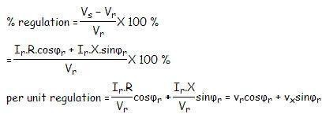

Here, vr and vx are the per unit resistance and reactance of the short transmission line. Any electrical network generally has two input terminals and two output terminals. If we consider any complex electrical network in a black box, it will have two input terminals and output terminals. This network is called two – port network. Two port model of a network simplifies the network solving technique. Mathematically a two port network can be solved

by 2 by 2 matrixes.

A transmission as it is also an electrical network; line can be represented as two port network. Hence two port network of transmission line can be represented as 2 by 2 matrixes. Here the concept of ABCD parameters comes. Voltage and currents of the network can represented as ,

Vs= AVr + BIr (1)

Is= CVr + DIr (2)

Where A, B, C and D are different constant of the network.

If we put Ir = 0 at equation (1), we get

Hence, A is the voltage impressed at the sending end per volt at the receiving end when receiving end is open. It is dimension less. If we put Vr = 0 at equation (1), we get

That indicates it is impedance of the transmission line when the receiving terminals are short circuited. This parameter is referred as transfer impedance.



C is the current in amperes into the sending end per volt on open circuited receiving end. It has the dimension of admittance.



D is the current in amperes into the sending end per amp on short circuited receiving end. It is dimensionless.

Now from equivalent circuit, it is found that,

Vs = Vr + IrZ and Is = Ir Comparing these equations with equation 1 and 2 we get,

A = 1, B = Z, C = 0 and D = 1. As we know that the constant A, B, C and D are related

for passive network as

AD − BC = 1.

Here, A = 1, B = Z, C = 0 and D = 1

⇒ 1.1 − Z.0 = 1

So the values calculated are correct for short transmission line. From above equation (1),

Vs = AVr + BIr

When Ir = 0 that means receiving end terminals is open circuited and then from the equation 1, we get receiving end voltage at no load

and as per definition of voltage regulation,



##### Efficiency of Short Transmission Line:

The efficiency of short line as simple as efficiency equation of any other electrical equipment, that means

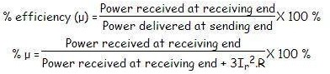

##### MEDIUM TRANSMISSION LINE:

The transmission line having its effective length more than 80 km but less than 250 km, is generally referred to as a medium transmission line. Due to the line length being considerably high, admittance Y of the network does play a role in calculating the effective circuit parameters, unlike in the case of short transmission lines. For this reason the modelling of a medium length transmission line is done using lumped shunt admittance along with the lumped impedance in series to the circuit.

These lumped parameters of a medium length transmission line can be represented using two different models, namely.

1. Nominal Π representation.
2. Nominal T representation.

Let‘s now go into the detailed discussion of these above mentioned models. Nominal Π representation of a medium transmission line In case of a nominal Π representation, the lumped series impedance is placed at the middle of the circuit where as the shunt admittances are at the ends. As we can see from the diagram of the Π network below, the total lumped shunt admittance is divided into 2 equal halves, and each half with value Y ⁄ 2 is placed at both the sending and the receiving end while the entire circuit impedance is between the two. The shape of the circuit so formed resembles that of a symbol Π, and for this reason it is known as the nominal Π representation of a medium transmission line. It is mainly used for determining the general circuit parameters and performing load flow analysis.

##### NOMINAL Π REPRESENTATION OF A MEDIUM TRANSMISSION LINE:

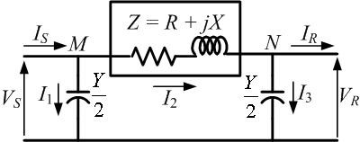

Nominal-π representation

In case of a nominal Π representation, the lumped series impedance is placed at the middle of the circuit where as the shunt admittances are at the ends. As we can see from the diagram of the Π network below, the total lumped shunt admittance is divided into 2 equal halves, and each half with value Y ⁄ 2 is placed at both the sending and the receiving end while the entire circuit impedance is between the two. The shape of the circuit so formed resembles that of a symbol Π, and for this reason it is known as the nominal Π representation of a medium transmission line. It is mainly used for determining the general circuit parameters and performing load flow analysis.

As we can see here, VS and VR is the supply and receiving end voltages respectively, and Is is the current flowing through the supply end. IR is the current flowing through the receiving end of the circuit. I1 and I3 are the values of currents flowing through the admittances.

And I2 is the current through the impedance Z.

Now applying KCL, at node P, we get. IS = I1 + I2 —————(1) Similarly applying KCL, to node

Q. I2 = I3 + IR —————(2)

Now substituting equation (2) to equation

IS = I1 + I3 + IR



Now by applying KVL to the circuit,

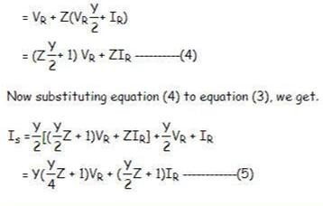VS = VR + Z I2

Comparing equation (4) and (5) with the standard ABCD parameter equations

VS = A VR + B IR IS = C VR + D IR

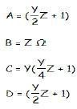We derive the parameters of a medium transmission line as:

##### NOMINAL T REPRESENTATION OF A MEDIUM TRANSMISSION LINE:

In the **nominal T** model of a medium transmission line the lumped shunt admittance is placed in the middle, while the net series impedance is divided into two equal halves and and placed on either side of the shunt admittance. The circuit so formed resembles the symbol of a capital **T**, and hence is known as the nominal T network of a medium length transmission line and is shown in the diagram below.

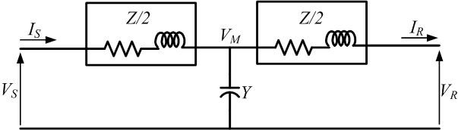

Nominal-T representation.

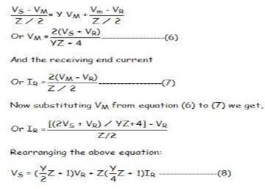Here also Vs and Vr is the supply and receiving end voltages respectively, and Is is the current flowing through the supply end. Ir is the current flowing through the receiving end of the circuit. Let M be a node at the midpoint of the circuit, and the drop at M, be given by Vm. Applying KVL to the above network we get

Now the sending end current is

Is = Y VM + IR ——————(9)

Substituting the value of VM to equation (9) we get,



Again comparing Comparing equation (8) and (10) with the standard ABCD parameter Equations

VS = A VR + B IR IS = C VR + D IR

The parameters of the **T** network of a medium transmission line are

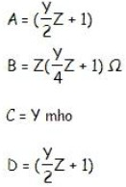

##### PERFORMANCE OF LONG TRANSMISSION LINE:

A power transmission line with its effective length of around 250 Kms or above is referred to as a long transmission line. Calculations related to circuit parameters (ABCD parameters) of such a power transmission is not that simple, as was the case for a short or medium transmission line. The reason being that, the effective circuit length in this case is much higher than what it was for the former models(long and medium line) and, thus ruling out the approximations considered there like.

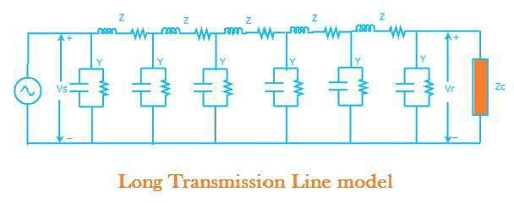

For accurate modeling of the transmission line we must not assume that the parameters are lumped but are distributed throughout line. The single-line diagram of a long transmission line is shown in Fig. 2.5. The length of the line is l. Let us consider a small strip Δx that is at a distance x from the receiving end. The voltage and current at the end of the strip are V and I respectively and the beginning of the strip are V + ΔV and I + ΔI respectively. The voltage drop across the strip is then ΔV. Since the length of the strip is Δx, the series impedance and shunt admittance are z Δx and y Δx. It is to be noted here that the total impedance and admittance of the line are Z = z ×l and Y = y ×l

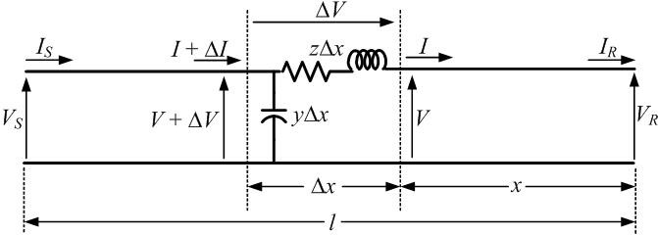

From the circuit of Fig. we see that

Here a line of length l > 250km is supplied with a sending end voltage and current of VS and IS respectively, where as the VR and IR are the values of voltage and current obtained from the receiving end. Lets us now consider an element of infinitely small length Δx at a distance x from the receiving end as shown in the figure where.

V = value of voltage just before entering the element Δx. I = value of current just before entering the element Δx. V+ΔV = voltage leaving the element Δx.

I+ΔI = current leaving the element Δx.

ΔV = voltage drop across element Δx. zΔx = series impedence of element Δx yΔx = shunt admittance of element Δx

Where Z = z l and Y = y l are the values of total impedance and admittance of the long transmission line.

∴ the voltage drop across the infinitely small element Δx is given by ΔV = I z Δx

Or I z = ΔV ⁄ Δx

Or I z = dV ⁄ dx —————————(1)

Now to determine the current ΔI, we apply KCL to node A. ΔI = (V+ΔV)yΔx = V yΔx + ΔV yΔx

Since the term ΔV yΔx is the product of 2 infinitely small values, we can ignore it for the sake of easier calculation.

∴ we can write dI ⁄ dx = V y —————–(2) Now derevating both sides of eq (1) w.r.t x,

d2 V ⁄ d x2 = z dI ⁄ dx

Now substituting dI ⁄ dx = V y from equation (2) d2 V ⁄ d x2 = zyV

or d2 V ⁄ d x2 − zyV = 0 ————(3)

The solution of the above second order differential equation is given by.

V = A1 ex√yz + A2 e−x√yz ————–(4) Derivating equation (4) w.r.to x.

dV/dx = √(yz) A1 ex√yz − √(yz)A2 e−x√yz ————

(5) Now comparing equation (1) with equation (5)



Now to go further let us define the characteristic impedance Zc and propagation constant δ of a long transmission line as

Zc = √(z/y) Ω δ = √(yz)

Then the voltage and current equation can be expressed in terms of characteristic impedance and propagation constant as

V = A1 eδx + A2 e−δx ———–(7)

I = A1/ Zc eδx + A2 / Zc e−δx —————(8)

Now at x=0, V= VR and I= Ir. Substituting these conditions to equation (7) and (8) respectively. VR = A1

+ A—(9)

IR = A1/ Zc + A2 / Zc —————(10)

Solving equation (9) and (10), We get values of A1 and A2 as, A1 = (VR + ZCIR) ⁄ 2

And A1 = (VR − ZCIR)

Now applying another extreme condition at x=l, we have V = VS and I = IS.

Now to determine VS and IS we substitute x by l and put the values of A1 and A2 in equation (7) and (8) we get

VS = (VR + ZC IR)eδl ⁄ 2 + (VR − ZC IR)e−δl/2 ————–(11)

IS = (VR ⁄ ZC + IR)eδl/2 − (VR / ZC − IR)e−δl/2————— (12

By trigonometric and exponential operators we know sinh δl = (eδl − e−δl) ⁄ 2 And cosh δl = (eδl + e−δl) ⁄2

∴ equation(11) and (12) can be re-written as

VS = VRcosh δl + ZC IR sinh δl IS = (VR sinh δl)/ZC + IRcosh δl

Thus comparing with the general circuit parameters equation, we get the ABCD parameters\ of a long transmission line as,

C = sinh δl ⁄ ZC A = cosh δl D = cosh δl B = ZC sinh δl

##### FERRANTI EFFECT:

In general practice we know, that for all electrical systems current flows from the region of higher potential to the region of lower potential, to compensate for the potential difference that exists in the system. In all practical cases the sending end voltage is higher than the receiving end, so current flows from the source or the supply end to the load. But Sir S.Z. Ferranti, in the year 1890, came up with an astonishing theory about medium or long distance transmission lines suggesting that in case of light loading or no load operation of transmission system, the receiving end voltage often increases beyond the sending end voltage, leading to a phenomena known as Ferranti effect in power system.

##### Why Ferranti effect occurs in a transmission line?

A long transmission line can be considered to composed a considerably high amount of capacitance and inductance distributed across the entire length of the line. Ferranti Effect occurs when current drawn by the distributed capacitance of the line itself is greater than the current associated with the load at the receiving end of the line( during light or no load). This capacitor charging current leads to voltage drop across the line inductance of the transmission system which is in phase with the sending end voltages. This voltage drop keeps on increasing additively as we move towards the load end of the line and subsequently the receiving end voltage tends to get larger than applied voltage leading to the phenomena called Ferranti effect in power system. It is illustrated with the help of a phasor diagram below.

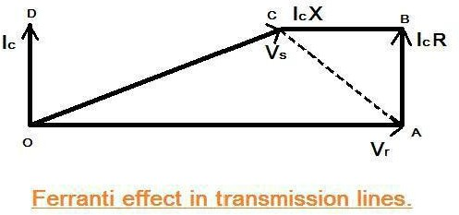

Thus both the capacitance and inductance effect of transmission line are equally responsible for this particular phenomena to occur, and hence Ferranti effect is negligible in case of a short transmission lines as the inductance of such a line is practically considered to be nearing zero. In general for a 300 Km line operating at a frequency of 50

Hz, the no load receiving end voltage has been found to be 5% higher than the sending end voltage. Now for analysis of Ferranti effect let us consider the phasor diagrame shown above.

Here Vr is considered to be the reference phasor, represented by OA.

Thus Vr = Vr (1 + j0) Capacitance current, Ic = jωCVr

Now sending end voltage Vs = Vr + resistive drop + reactive drop.

= Vr + IcR + jIcX

= Vr+ Ic (R + jX)

= Vr+jωcVr (R + jω L) [since X= ωL] Now Vs = Vr -ω2cLVr + j ωcRVr

This is represented by the phasor OC.

Now in case of a long transmission line, it has been practically observed that the line resistance is negligibly small compared to the line reactance, hence we can assume the length of the phasor Ic R = 0, we can consider the rise in the voltage is only due to OA –

OC = reactive drop in the line.

Now if we consider c0 and L0 are the values of capacitance and inductance per km of the transmission line, where l is the length of the line. Thus capacitive reactance Xc = 1/(ω l c0)

Since, in case of a long transmission line the capacitance is distributed throughout its length, the average current flowing is,

Ic = 1/2 Vr/Xc = 1/2 Vrω l c0 Now the inductive reactance of the line = ω L0 l

Thus the rise in voltage due to line inductance is given by, IcX = 1/2Vrω l c0 X ω L0 l

Voltage rise = 1/2 Vrω2 l 2 c0L0

From the above equation it is absolutely evident, that the rise in voltage at the receiving end is directly proportional to the square of the line length, and hence in case of a long transmission line it keeps increasing with length and even goes beyond the applied sending end voltage at times, leading to the phenomena called Ferranti effect in power system.

# UNIT – II

**OVERHEAD INSULATORS**

##### ELECTRICAL INSULATORS:

Electrical Insulator must be used in electrical system to prevent unwanted flow of current to the earth from its supporting points. The insulator plays a vital role in electrical system. Electrical Insulator is a very high resistive path through which practically no current can flow. In transmission and distribution system, the overhead conductors are generally supported by supporting towers or poles. The towers and poles both are properly grounded. So there must

be insulator between tower or pole body and current carrying conductors to prevent the flow of current from conductor to earth through the grounded supporting towers or poles.

##### Insulating Material

The main cause of failure of overhead line insulator, is flash over, occurs in between line and earth during abnormal over voltage in the system. During this flash over, the huge heat produced by arcing, causes puncher in insulator body. Viewing this phenomenon the materials used for electrical insulator, has to posses some specific properties.

##### Properties of Insulating Material

The materials generally used for insulating purpose is called insulating material. For successful utilization, this material should have some specific properties as listed below.

* + - 1. It must be mechanically strong enough to carry tension and weight of conductors.
      2. It must have very high dielectric strength to withstand the voltage stresses in High Voltage system.
      3. It must possesses high Insulation Resistance to prevent leakage current to the earth.
      4. The insulating material must be free from unwanted impurities.
      5. It should not be porous.
      6. There must not be any entrance on the surface of electrical insulator so that the moisture or gases can enter in it.
      7. There physical as well as electrical properties must be less affected by changing temperature. There are mainly three types of insulator used as overhead insulator likewise

1. Pin Insulator
2. Suspension Insulator
3. Strain Insulator

In addition to that there are other two types of electrical insulator available mainly for low voltage application i.e. Stray Insulator and Shackle Insulator.

##### PIN INSULATOR:

Pin Insulator is earliest developed overhead insulator, but still popularly used in power network up to 33KV system. Pin type insulator can be one part, two parts or three parts type, depending upon application voltage. In 11KV system we generally use one part type insulator where whole pin insulator is one piece of properly shaped porcelain or glass. As the leakage path of insulator is through its surface, it is desirable to increase the vertical length of the insulator surface area for lengthening leakage path. In order to obtain lengthy leakage path, one, tower or more rain sheds or petticoats are provided on the insulator

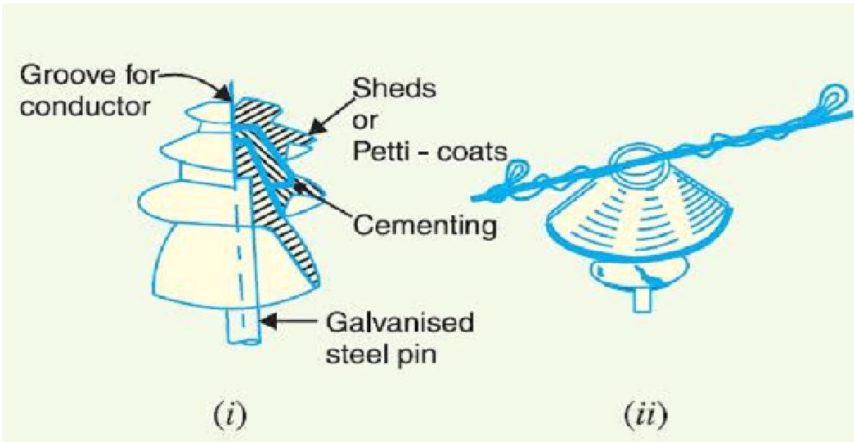body. In addition to that rain shed or petticoats on an insulator serve another purpose. These rain sheds or petticoats are so designed, that during raining the outer surface of the rain shed becomes wet but the inner surface remains dry and non-conductive. So there will be discontinuations of conducting path through the wet pin insulator surface.

##### Pin Insulator:

In higher voltage like 33KV and 66KV manufacturing of one part porcelain pin insulator becomes difficult. Because in higher voltage, the thickness of the insulator become more and a quite thick single piece porcelain insulator cannot manufactured practically. In this case we use multiple part pin insulator, where a number of properly designed porcelain shells are fixed together by Portland cement to form one complete insulator unit. For 33KV tow parts and for 66KV three parts pin insulator are generally used.

##### Designing Consideration of Electrical Insulator:

The live conductor attached to the top of the pin insulator is at a potential and bottom of the insulator fixed to supporting structure of earth potential. The insulator has to withstand the potential stresses between conductor and earth. The shortest distance between conductor and earth, surrounding the insulator body, along which electrical discharge may take place through air, is known as flash over distance.

1. When insulator is wet, its outer surface becomes almost conducting. Hence the flash over distance of insulator is decreased. The design of an electrical insulator should be such that the decrease of flash over distance is minimum when the insulator is wet. That is why the upper most petticoat of a pin insulator has umbrella type designed so that it can protect, the rest lower part of the insulator from rain. The upper surface of top most petticoat is inclined as less as possible to maintain maximum flash over voltage during raining.
2. To keep the inner side of the insulator dry, the rain sheds are made in order that these rain sheds should not disturb the voltage distribution they are so designed that their subsurface at right angle to the electromagnetic lines of force.

##### POST INSULATOR:

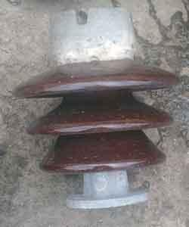

Post insulator is more or less similar to Pin insulator, but former is suitable for higher voltage application. Post insulator has higher numbers of petticoats and has greater height. We can mount this type of insulator on supporting structure horizontally as well as vertically. The insulator is made of one piece of porcelain and it has clamp arrangement are in both top and bottom end for fixing. The main differences between pin insulator and post insulator are,

##### SUSPENSION INSULATOR:

|  |  |  |
| --- | --- | --- |
| SL | Pin Insulator | Post Insulator |
| 1 | It is generally used up to 33KV system | It is suitable for lower voltage and also for  higher voltage |
| 2 | It is single stag | It can be single stag as well as multiple stags |
| 3 | Conductor is fixed on the top of the insulator  by binding | Conductor is fixed on the top of the insulator  with help of connector clamp |
| 4 | Two insulators cannot be fixed together for higher voltage application | Two or more insulators can be fixed together  one above other for higher voltage application |
| 4 | Metallic fixing arrangement provided only  on bottom end of the insulator | Metallic fixing arrangement provided on  both top and bottom ends of the insulator |

In higher voltage, beyond 33KV, it becomes uneconomical to use pin insulator because size, weight of the insulator become more. Handling and replacing bigger size single unit insulator are quite difficult task. For overcoming these difficulties, **suspension insulator** was developed. In **suspension insulator** numbers of insulators are connected in series to form a string and the line conductor is carried by the bottom most insulator. Each insulator of a suspension string is called disc insulator because of their disc like shape.

##### Advantages of Suspension Insulator:

1. Suspension type insulators are cheaper than pin type insulators for voltages beyond 33 kV.
2. Each unit or disc of suspension type insulator is designed for low voltage, usually 11 kV. Depending upon the working voltage, the desired number of discs can be connected in series.
3. If anyone disc is damaged, the whole string does not become useless because the damaged disc can be replaced by the sound one.
4. The suspension arrangement provides greater flexibility to the line. The connection at the cross arm is such that insulator string is free to swing in any direction and can take up the position where mechanical stresses are minimum.
5. In case of increased demand on the transmission line, it is found more satisfactory to supply. the greater demand by raising the line voltage than to provide another set of conductors. The additional insulation required for the raised voltage can be easily obtained in the suspension arrangement by adding the desired number of discs.
6. The suspension type insulators are generally used with steel towers. As the conductors run below the earthed cross-arm of the tower, therefore, this arrangement provides partial protection from lightning.

##### Disadvantages of Suspension Insulator:

1. Suspension insulator string costlier than pin and post type insulator.
2. Suspension string requires more height of supporting structure than that for pin or post insulator to maintain same ground clearance of current conductor.
3. The amplitude of free swing of conductors is larger in suspension insulator system, hence, more spacing between conductors should be provided.

##### STRAIN INSULATOR:

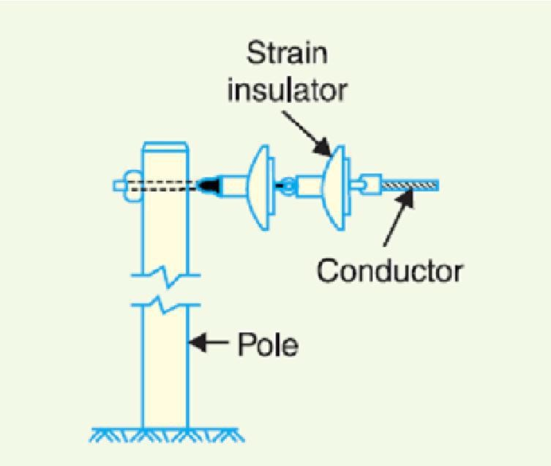When suspension string is used to sustain extraordinary tensile load of conductor it is referred as string insulator. When there is a dead end or there is a sharp corner in transmission line, the line has to sustain a great tensile load of conductor or strain. A strain insulator must have considerable mechanical strength as well as the necessary electrical insulating properties.

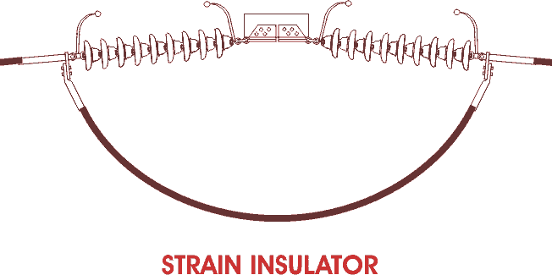

|  |  |  |
| --- | --- | --- |
| **Rated System**  **Voltage** | **Number of disc insulator used in strain**  **type tension insulator string** | **Number of disc insulator used in**  **suspension insulator string** |
| 33KV | 3 | 3 |
| 66KV | 5 | 4 |
| 132KV | 9 | 8 |
| 220KV | 15 | 14 |

##### stay insulatorSTAY INSULATOR:

For low voltage lines, the stays are to be insulated from ground at a height. The insulator used in the stay wire is called as the **stay insulator** and is usually of porcelain and is so designed that in case of breakage of the insulator the guy-wire will not fall to the ground.



##### SHACKLE INSULATOR OR SPOOL INSULATOR:

The **shackle insulator** or **spool insulator** is usually used in low voltage distribution network. It can be used both in horizontal and vertical position. The use of such insulator has decreased recently after increasing the using of underground cable for distribution purpose. The tapered hole of the **spool insulator** distributes the load more evenly and minimizes the possibility of breakage when heavily loaded. The conductor in the groove of **shackle insulator** is fixed with the help of soft binding wire.

##### POTENTIAL DISTRIBUTION OVERA STRING OF SUSPENSION INSULATORS:

A string of suspension insulators consists of a number of porcelain discs connected in series through metallic links. Fig. 2.3(i) shows 3-disc string of suspension insulators. The porcelain portion of each disc is in between two metal links. Therefore, each disc forms a capacitor C as shown in Fig.2.3(ii). This is known as mutual capacitance or self-capacitance.

If there were mutual capacitance alone, then charging current would have been the same through all the discs and consequently voltage across each unit would have been the same i.e., V/3 as shown in Fig. 2.3(ii). However, in actual practice, capacitance also exists between metal fitting of each disc and tower or earth. This is known as shunt capacitance C1. Due to shunt capacitance, charging current is not the same through all the discs of the string [See Fig2.3(iii)]. Therefore, voltage across each disc will be different.

Obviously, the disc nearest to the line conductor will have the maximum voltage. Thus referring to Fig 2.3(iii), V3 will be much more than V2 or V1.

The following points may be noted regarding the potential distribution over a string of suspension insulators:

1. The voltage impressed on a string of suspension insulators does not distribute itself uniformly across the individual discs due to the presence of shunt capacitance.
2. The disc nearest to the conductor has maximum voltage across it. As we move towards the cross- arm, the voltage across each disc goes on decreasing.
3. The unit nearest to the conductor is under maximum electrical stress and is likely to be punctured. Therefore, means must be provided to equalize the potential across each unit.
4. 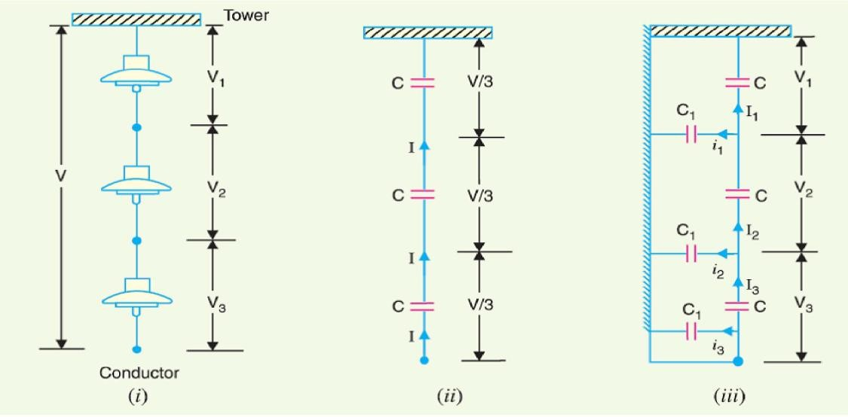The presence of stray capacitance causes unequal potential distribution over the string. The end unit of the string (which is the closest to the line) takes maximum potential difference and the upper units have a gradually decreased potential difference until the uppermost unit which\ has the lowest potential difference. The next proof illustrates this concept.

##### Suspension Insulator string

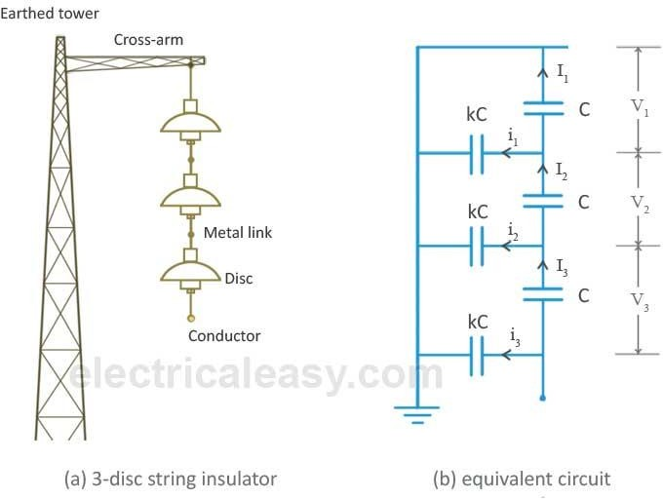

If there were only mutual capacitances, then the charging current would have been the same through all the discs. In this case, the voltage would have been uniformly distributed across the string, i.e. voltage across

each disc would have been the same. But, due to the shut capacitances, charging current is not the same through all the discs. From the above equivalent circuit, applying Kirchoff's current law to node A,

I2 = I1 + i1

V2ωC = V1ωC + V1ωkC V2 = V1 + V1k

V2 = (1 + k)V1 eq.(i)

applying Kirchoff's current law to node B, I3 = I2 + i2

V3ωC = V2ωC + (V2 + V1)ωkC V3 = V2 + (V1 + V2)k

V3 = kV1 + (1 + k) V2

V3 = kV1 + (1 + k)2 V1 from eq.(i)

V3 = V1 [k + (1 + k)2]

V3 = V1 [k + 1 + 2k + k2]

V3 = V1 (1 + 3k + k2) eq.(ii)

Now, voltage between the conductor and the earther tower is, V = V1 + V2 + V3

V = V1 + (1 + k)V1 + V1 (1 + 3k + k2)

V = V1 (3 + 4k + k2) eq.(iii)

from the above equations (i), (ii) & (iii), it is clear that the voltage across the top disc is minimum while voltage across the disc nearest to the conductor is maximum, i.e. V3 = V1 (1 + 3k + k2). As we move towards the cross arm, voltage across the disc goes on decreasing. Due to this non-uniform voltage distribution across the string, the unit nearest to the conductor is under maximum electrical stress and is likely to be punctured.

##### STRING EFFICIENCY:

As explained above, voltage is not uniformly distributed over a suspension insulator string. The disc nearest to the conductor has maximum voltage across it and, hence, it will be under maximum electrical stress. Due to this, the disc nearest to the conductor is likely to be punctured and subsequently, other discs may puncture successively. Therefore, this unequal voltage distribution is undesirable and usually expressed in terms of string efficiency. The ratio of voltage across the whole string to the product of number of discs and the voltage across the disc nearest to the conductor is called as **string efficiency**

String efficiency = Voltage across the string / (number of discs X voltage across the disc nearest to the conductor).

Greater the string efficiency, more uniform is the voltage distribution. String efficiency becomes 100% if the voltage across each disc is exactly the same, but this is an ideal case and impossible in practical scenario. However, for DC voltages, insulator capacitances are ineffective and voltage across each unit would be the same. This is why string efficiency for DC system is 100%**.**

Inequality in voltage distribution increases with the increase in the number of discs in a string. Therefore, shorter strings are more efficient than longer string insulators.

##### METHODS OF IMPROVING STRING EFFICIENCY:

* + 1. **Using Longer Cross Arms:**

It is clear from the above mathematical expression of string efficiency that the value of string efficiency depends upon the value of *k*. Lesser the value of *k*, the greater is the string efficiency. As the value of *k* approaches to zero, the string efficiency approaches to 100%. The value of *k* can be decreased by reducing the shunt capacitance. In order to decrease the shunt capacitance, the distance between the insulator string and the tower should be increased, i.e. longer cross-arms should be used. However, there is a limit in increasing the length of cross-arms due to economic considerations.

##### Grading Of Insulator Discs:

In this method, voltage across each disc can be equailized by using discs with different capacitances. For equalizing the voltage distribution, the top unit of the string must have minimum capacitance, while the disc nearest to the conductor must have maximum capacitance. The insulator discs of different dimensions are so chosen that the each disc has a different capacitance. They are arranged in such a way that the capacitance increases progressively towards the bottom. As voltage is inversely proportional to capacitance, this method tends to equalize the voltage distribution across each disc.

##### By Using A Guard Or Grading Ring:

A guard ring or grading ring is basically a metal ring which is electrically connected to the conductor surrounding the bottom unit of the string insulator. The guard ring introduces capacitance between metal links and the line conductor which tends to cancel out the shunt capacitances. As a result, nearly same charging current flows through each disc and, hence, improving the string efficiecy. Grading rings are sometimes similar to [corona rings,](http://www.electricaleasy.com/2016/07/corona-discharge.html) but they encircle insulators rather than conductors.

##### UNDERGROUND CABLES:

Electric power can be transmitted or dis tributed either by overhead system or by underground cables. The underground cables have serveral advantages such as less liable to damage through storms or lightning, low maintenance cost, less chances of faults, smaller voltage drop and better general appearance. However, their major drawback is that they have greater installation cost and introduce insulation problems at high voltages compared with the equivalent overhead system. For this reason, underground cables are employed where it is impracticable to use overhead lines. Such locations may be thickly populated areas where municipal authorities prohibit overhead lines for reasons of safety, or around plants and substations or where maintenance conditions do not permit the use of overhead construction.

The chief use of underground cables for many years has been for distribution of electric power in congested urban areas at comparatively low or moderate voltages. However, recent improve- ments in the design and manufacture have led to the development of cables suitable for use at high voltages. This has made it possible to employ underground cables for transmission of electric power for short or moderate distances. In this chapter, we shall focus our attention on the various aspects of underground cables and their increasing use in power system.

##### UNIT-III

##### UNDERGROUND CABLES:

An underground cable essentially consists of one or more conductors covered with suitable insula- tion and surrounded by a protecting cover.

Although several types of cables are available, the type of cable to be used will depend upon the working voltage and service requirements. In general, a cable must fulfil the following necessary requirements :

* + - 1. The conductor used in cables should be tinned stranded copper or aluminium of high con- ductivity. Stranding is done so that conductor may become flexible and carry more current.
      2. The conductor size should be such that the cable carries the desired load current without overheating and causes voltage drop within permissible limits.
      3. The cable must have proper thickness of insulation in order to give high degree of safety and reliability at the voltage for which it is designed.
      4. The cable must be provided with suitable mechanical protection so that it may withstand the rough use in laying it.
      5. The materials used in the manufacture of cables should be such that there is complete chemical and physical stability throughout.

##### CONSTRUCTION OF CABLES

Fig. 11.1 shows the general construction of a 3-conductor cable. The various parts are :

1. **Cores or Conductors**. A cable may have one or more than one core (conductor) depending upon the type of service for which it is intended. For instance, the 3-conductor cable shown in Fig. 11.1 is used for 3-phase service. The conductors are made of tinned copper or aluminium and are usually stranded in order to provide flexibility to the cable.
2. **Insulation.** Each core or conductor is provided with a suitable thickness of insulation, the thickness of layer depending upon the voltage to be withstood by the cable. The commonly used materials for insulation are impregnated paper, varnished cambric or rubber mineral compound.

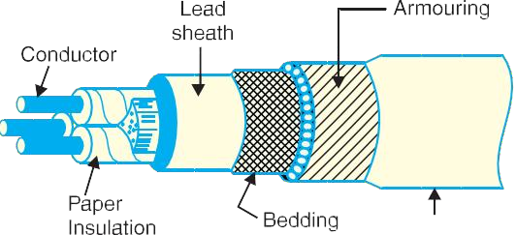

1. **Metallic sheath**. In order to protect the cable from moisture, gases or other damaging liquids (acids or alkalis) in the soil and atmosphere, a metallic sheath of lead or aluminium is provided over the insulation as shown in Fig. 11.1
2. **Bedding.** Over the metallic sheath is applied a layer of bedding which consists of a fibrous material like jute or hessian tape. The purpose of bedding is to protect the metallic sheath against corrosion and from mechanical injury due to armouring.
3. **Armouring.** Over the bedding, armouring is provided which consists of one or two layers of

galvanized steel wire or steel tape. Its purpose is to protect the cable from mechanical injury while laying it and during the course of handling. Armouring may not be done in the case of some cables.

1. **Serving.** In order to protect armouring from atmospheric conditions, a layer of fibrous material (like jute) similar to bedding is provided over the armouring. This is known as serving.

It may not be out of place to mention here that bedding, armouring and serving are only applied to the cables for the protection of conductor insulation and to protect the metallic sheath from mechanical injury.

##### INSULATING MATERIALS FOR CABLES:

The satisfactory operation of a cable depends to a great extent upon the characteristics of insulation used. Therefore, the proper choice of insulating material for cables is of considerable importance. In general, the insulating materials used in cables should have the following properties:

1. High insulation resistance to avoid leakage current.
2. High dielectric strength to avoid electrical breakdown of the cable.
3. High mechanical strength to withstand the mechanical handling of cables.
4. Non-hygroscopic *i.e.,* it should not absorb moisture from air or soil. The moisture tends to decrease the insulation resistance and hastens the breakdown of the cable. In case the insulating material is hygroscopic, it must be enclosed in a waterproof covering like lead sheath.
5. Non-inflammable.
6. Low cost so as to make the underground system a viable proposition.
7. Unaffected by acids and alkalis to avoid any chemical action.

No one insulating material possesses all the above mentioned properties. Therefore, the type of insulating material to be used depends upon the purpose for which the cable is required and the quality of insulation to be aimed at. The principal insulating materials used in cables are rubber, vulcanized India rubber, impregnated paper, varnished cambric and polyvinylchloride.

1. **Rubber.** Rubber may be obtained from milky sap of tropical trees or it may be produced from oil products. It has relative permittivity varying between 2 and 3, dielectric strength is about 30 kV/mm and resistivity of insulation is 1017 cm. Although pure rubber has reasonably high insulating properties, it suffers from some major drawbacks *viz.,* readily absorbs moisture, maximum safe temperature is low (about 38ºC), soft and liable to damage due to rough handling and ages when exposed to light. Therefore, pure rubber cannot be used as an insulating material.
2. **Vulcanized India Rubber (*V.I.R.*).** It is prepared by mixing pure rubber with mineral mat- ter such as zine oxide, red lead etc., and 3 to 5% of sulphur. The compound so formed is rolled into thin sheets and cut into strips. The rubber compound is then applied to the conductor and is heated to a temperature of about 150ºC. The whole process is called vulcanization and the product obtained is known as vulcanized India rubber.

Vulcanized India rubber has greater mechanical strength, durability and wear resistant property than pure rubber. Its main drawback is that sulphur reacts very quickly with copper and for this reason, cables using VIR insulation have tinned copper conductor. The VIR insulation is generally used for low and moderate voltage cables.

1. **Impregnated paper.** It consists of chemically pulped paper made from wood chippings and impregnated with some compound such as paraffinic or naphthenic material. This type of insulation has almost superseded the rubber insulation. It is because it has the advantages of low cost, low capacitance, high dielectric strength and high insulation resistance. The only disadvantage is that paper is hygroscopic and even if it is impregnated with suitable compound, it absorbs moisture and thus lowers the insulation resistance of the cable. For this reason, paper insulated cables are always provided with some protective covering and are never left unsealed. If it is required to be left unused on the site during laying, its ends are temporarily covered with wax or tar.

Since the paper insulated cables have the tendency to absorb moisture, they are used where the cable route has a *few joints. For instance, they can be profitably used for distribution at low voltages in congested areas where the joints are generally provided only at the terminal apparatus. However, for smaller installations, where the lengths are small and joints are required at a number of places, VIR cables will be cheaper and durable than paper insulated cables.

1. **Varnished cambric.** It is a cotton cloth impregnated and coated with varnish. This type of insulation is also known as *empire tape.* The cambric is lapped on to the conductor in the form of a tape and its surfaces are coated with petroleum jelly compound to allow for the sliding of one turn over another as the cable is bent. As the varnished cambric is hygroscopic, therefore, such cables are always provided with metallic sheath. Its dielectric strength is about 4 kV/mm and permittivity is 2.5 to 3.8.
2. **Polyvinyl chloride (*PVC*).** This insulating material is a synthetic compound. It is obtained from the polymerization of acetylene and is in the form of white powder. For obtaining this material as a cable insulation, it is compounded with certain materials known as plasticizers which are liquids with high boiling point. The plasticizer forms a gel and renders the material plastic over the desired range of temperature.

Polyvinyl chloride has high insulation resistance, good dielectric strength and mechanical tough- ness over a wide range of temperatures. It is inert to oxygen and almost inert to many alkalis and acids. Therefore, this type of insulation is preferred over VIR in extreme environmental conditions such as in cement factory or chemical factory. As the mechanical properties (i.e., elasticity etc.) of PVC are not so good as those of rubber, therefore, PVC insulated cables are generally used for low and medium domestic lights and power installations.

##### CLASSIFICATION OF CABLES:

Cables for underground service may be classified in two ways according to (i) the type of insulating material used in their manufacture (ii) the voltage for which they are manufactured. However, the latter method of classification is generally preferred, according to which cables can be divided into the following groups:

1. Low-tension (L.T.) cables — up to 1000 V
2. High-tension (H.T*.*) cables — up to 11,000 V
3. Super-tension (S.T.) cables — from 22 kV to 33 kV
4. Extra high-tension (E.H.T.) cables — from 33 kV to 66 kV
5. Extra super voltage cables — beyond 132 kV

A cable may have one or more than one core depending upon the type of service for which it is intended. It may be (i) single-core (ii) two-core (iii) three-core (iv) four-core etc. For a 3-phase service, either

3-single-corecablesorthree-core cable can be used depending upon the operating voltage and load demand. Fig. 11.2 shows the constructional details of a single-core low tension cable. The cable has ordinary construction be- cause the stresses developed in the cable for low voltages (up to 6600 V) are generally small.

It consists of one circular core of tinned stranded copper (or aluminium) insulated by layers of impregnated

paper. The insulation is surrounded by a lead sheath which prevents the entry of moisture into the inner parts. In order to protect the lead sheath from corrosion, an overall serving of compounded fibrous material (jute etc.) is provided. Single-core cables are not usually armoured in order to avoid excessive sheath losses. The principal advantages of single-core cables are simple construction and availability of larger copper section.

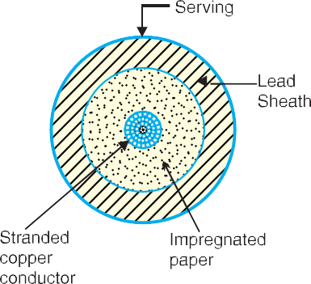

##### CABLES FOR 3-PHASE SERVICE:

In practice, underground cables are generally required to deliver 3-phase power. For the purpose, either three-core cable or *three single core cables may be used. For voltages up to 66 kV, 3-core cable (*i*.*e.,* multi-core construction) is preferred due to economic reasons. However, for voltages beyond 66 kV, 3-core- cables become too large and unwieldy and, therefore, single-core cables are used. The following types of cables are generally used for 3-phase service:

1. Belted cables — up to 11 kV
2. Screened cables — from 22 kV to 66 kV
3. Pressure cables — beyond 66 kV.

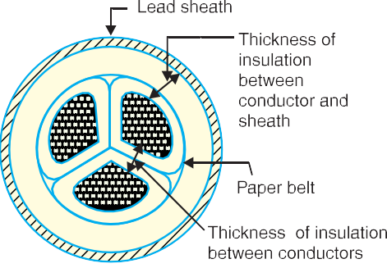

1. **Belted cables.** These cables are used for voltages upto 11kV but in extraordinary cases, their use may be extended upto 22kV. Fig. 11.3 shows the constructional details of a 3-core belted cable. The cores are insulated from each other by layers of impregnated paper. Another layer of impreg- nated paper tape, called *paper belt* is wound round the grouped insulated cores. The gap between the insu- lated cores is filled with fibrous insulating material (jute etc.) so as to give circular cross-section to the cable. The cores are generally stranded and may be of non- circular shape to make better use of

available space. The belt is covered with lead sheath to protect the cable against ingress of moisture and mechanical injury. The lead sheath is covered with one or more layers of armouring with an outer serving (not shown in the fig- ure).

The belted type construction is suitable only for low and medium voltages as the electrostatic stresses developed in the cables for these voltages are more or less radial *i.e.,* across the insulation. However, for high voltages (beyond 22 kV), the tangential stresses also become important. These stresses act along the layers of paper insulation. As the insulation resistance of paper is quite small along the layers, therefore, tangential stresses set up **leakage current along the layers of paper insulation. The leakage current causes local heating, resulting in the risk of breakdown of insulation at any moment. In order to overcome this difficulty, *screened cables* are used where leakage currents are conducted to earth through metallic screens.

1. **Screened cables.** These cables are meant for use up to 33 kV, but in particular cases their use may be extended to operating voltages up to 66 kV. Two principal types of screened cables are H- type cables and S.L. type cables.
   1. **H-type cables:-**This type of cable was first designed by H. Hochstadter and hence the name. Fig. 11.4 shows the constructional details of a typical 3-core, H-type cable. Each core is insulated by layers of impregnated paper. The insulation on each core is covered with a metallic screen which usually consists of a perforated aluminium foil. The cores are laid in such a way that metallic screens make contact with one another. An additional conducting belt (copper woven fabric tape) is wrapped round the three cores. The cable has no insulating belt but lead sheath, bedding, armouring and serving follow as usual. It is easy to see that each core screen is in electrical con- tact with the conducting belt and the lead sheath. As all the four screens (3 core screens and one conducting belt) and the lead sheath are at †earth potential, therefore, the electrical stresses are purely radial and consequently dielectric losses are reduced.

Two principal advantages are claimed for H-type cables. Firstly, the perforations in the metallic screens assist in the complete impregnation of the cable with the compound and thus the possibility of air pockets or voids (vacuous spaces) in the dielectric is eliminated. The voids if present tend to reduce the breakdown strength of the cable and may cause considerable damage to the paper insulation. Secondly, the metallic screens increase the heat dissipating power of the cable.

* 1. **S.L. type cables:** Fig. 11.5 shows the constructional details of a 3-core *S.L. (separate lead) type cable. It is basically H-type cable but the screen round each core insulation is covered by its own lead sheath. There is no overall lead sheath but only armouring and serving are provided. The S.L. type cables have two main advantages over H-type cables. Firstly, the separate sheaths minimize the possibility of core-to-core breakdown. Secondly, bending of cables becomes easy due to the elimination of overall lead sheath. However, the disadvantage is that the three lead sheaths of S.L. cable are much thinner than the single sheath of H-cable and, therefore, call for greater care in manufacture.

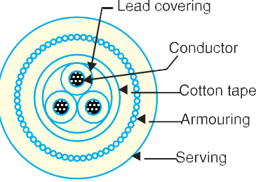

##### Limitations of solid type cables:

All the cables of above construction are referred to as solid type cables because solid insulation is used and no gas or oil circulates in the cable sheath. The voltage limit for solid type cables is 66 kV due to the following reasons:

1. As a solid cable carries the load, its conductor temperature increases and the cable compound (i.e., insulating compound over paper) expands. This action stretches the lead sheath which may be damaged.
2. When the load on the cable decreases, the conductor cools and a partial vacuum is formed within the cable sheath. If the pinholes are present in the lead sheath, moist air may be drawn into the cable. The moisture reduces the dielectric strength of insulation and may eventually cause the break- down of the cable.
3. In practice, †voids are always present in the insulation of a cable. Modern techniques of manufacturing have resulted in void free cables. However, under operating conditions, the voids are formed as a result of the differential expansion and contraction of the sheath and impregnated com- pound. The breakdown strength of voids is considerably less than that of the insulation. If the void is small enough, the electrostatic stress across it may cause its breakdown. The voids nearest to the conductor are the first to break down, the chemical and thermal effects of ionization causing permanent damage to the paper insulation.
4. **Pressure cables** For voltages beyond 66 kV, solid type cables are unreliable because there is a danger of breakdown of insulation due to the presence of voids. When the operating voltages are greater than 66 kV, pressure cables are used. In such cables, voids are eliminated by increasing the pressure of compound and for this reason they are called pressure cables. Two types of pressure cables viz oil-filled cables and gas pressure cables are commonly used.

Oil-filled cables. In such types of cables, channels or ducts are provided in the cable for oil circulation. The oil under pressure (it is the same oil used for impregnation) is kept constantly supplied to the channel by means of external reservoirs placed at suitable distances (say 500 m) along the route of the cable. Oil under pressure compresses the layers of paper insulation and is forced into any voids that may have formed between the layers. Due to the elimination of voids, oil-filled cables can be used for higher voltages, the range being from 66 kV up to 230 kV. Oil-filled cables are of three types viz., single-core conductor channel, single-core sheath channel and three-core filler-space channels. Fig.

11.6 shows the constructional details of a single-core conductor channel, oil filled cable. The oil channel is formed at the centre by stranding the conductor wire around a hollow cylindrical steel spiral

tape. The oil under pressure is supplied to the channel by means of external reservoir. As the channel is made of spiral steel tape, it allows the oil to percolate between copper strands to the wrapped insulation. The oil pressure compresses the layers of paper insulation and prevents the possibility of void formation. The system is so designed that when the oil gets expanded due to increase in cable temperature, the extra oil collects in the reservoir. How- ever, when the cable temperature falls during light load conditions, the oil from the reservoir flows to the channel. The disadvantage of this type of cable is that the channel is at the middle of the cable and is at full voltage w.r.t. earth, so that a very complicated system of joints is necessary.

Fig. 11.7 shows the constructional details of a single- core sheath channel oil-filled cable. In this type of cable, the conductor is solid similar to that of solid cable and is paper insulated. However, oil ducts are provided in the metallic sheath as shown. In the 3-core oil-filler cable shown

##### DIELECTRIC STRESS IN CABLE:

Under operating conditions, the insulation of a cable is subjected to electrostatic forces. This is known as dielectric stress. The dielectric stress at any point in a cable is in fact the potential gradient (or electric intensity) at that point. Consider a single core cable with core diameter d and internal sheath diameter D. The electric intensity at a point x meters from the centre of the cable is



By definition, electric intensity is equal to potential gradient. Therefore, potential gradient g at a point x meters from the Centre of cable is

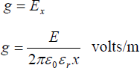

Potential difference V between conductor and sheath is

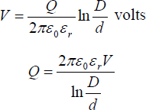

Substituting the value of Q, we get

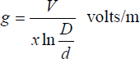

It is clear from the above equation that potential gradient varies inversely as the distance x. Therefore, potential gradient will be maximum when x is minimum i.e., when x = d/2 or at the surface of the conductor. On the other hand, potential gradient will be minimum at x = D/2 or at sheath surface. Maximum potential gradient is

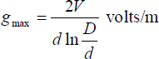

Minimum potential gradient is

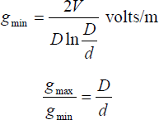

The variation of stress in the dielectric is shown in Fig.14. It is clear that dielectric stress is maximum at the conductor surface and its value goes on decreasing as we move away from the conductor. It may be noted that maximum stress is an important consideration in the design of a cable. For instance, if a cable is to be operated at such a voltage that maximum stress is 5 kV/mm, then the insulation used must have a dielectric strength of at least 5 kV/mm, otherwise breakdown of the cable will become inevitable.

##### MOST ECONOMICAL SIZE OF CONDUCTOR:

It has already been shown that maximum stress in a cable occurs at the surface of the conductor. For safe working of the cable, dielectric strength of the insulation should be more than the maximums tress. Rewriting the expression for maximum stress, we get,

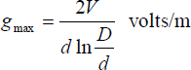

The values of working voltage V and internal sheath diameter D have to be kept fixed at certain values due to design considerations. This leaves conductor diameter d to be the only variable.

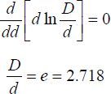For given values of V and D, the most economical conductor diameter will be one for which gmax has a minimum value. The value of gmax will be minimum when *d*ln *D/d* is maximum i.e.

Most economical conductor diameter is



And the value of gmax under this condition is



##### GRADING OF CABLES:

The process of achieving uniform electrostatic stress in the dielectric of cables is known as grading of cables. It has already been shown that electrostatic stress in a single core cable has a maximum value (gmax) at the conductor surface and goes on decreasing as we move towards the sheath. The maximum voltage that can be safely applied to a cable depends upon gmax i.e., electrostatic stress at the conductor surface. For safe working of a cable having homogeneous dielectric, the strength of dielectric must be more than gmax. If a dielectric of high strength is used for a cable, it is useful only near the conductor where stress is maximum. But as we move away from the conductor, the electrostatic stress decreases, so the dielectric will be unnecessarily over strong. The unequal stress distribution in a cable is undesirable for two reasons. Firstly, insulation of greater thickness is required which increases the cable size.

Secondly, it may lead to the breakdown of insulation. In order to overcome above disadvantages, it is necessary to have a uniform stress distribution in cables. This can be achieved by distributing the stress in such a way that its value is increased in the outer layers of dielectric. This is known as grading of cables. The following are the two main methods of grading of cables:

1. Capacitance grading
2. Intersheath grading

##### Capacitance Grading:

The process of achieving uniformity in the dielectric stress by using layers of different dielectrics is known as capacitance grading. In capacitance grading, the homogeneous dielectric is replaced by a composite dielectric. The composite dielectric consists of various layers of different dielectrics in such a manner that relative permittivity > r of any layer is inversely proportional to its distance from the center. Under such conditions, the value of potential gradient any point in the dielectric is constant and is independent of its distance from the center. In other words, the dielectric stress in the cable is same everywhere and the grading is ideal one. However, ideal grading requires the use of an infinite number of dielectrics which is an impossible task. In practice, two or three dielectrics are used in the decreasing order of permittivity, the dielectric of highest permittivity being used near the core. The capacitance grading can be explained beautifully by referring to the above Figure. There are three dielectrics of outer diameter d1, d2 and D and of relative permittivity >1, >2 and >3 respectively. If the permittivity are such that >1 > 2 > 3 and the three dielectrics are worked at the same maximum stress, then

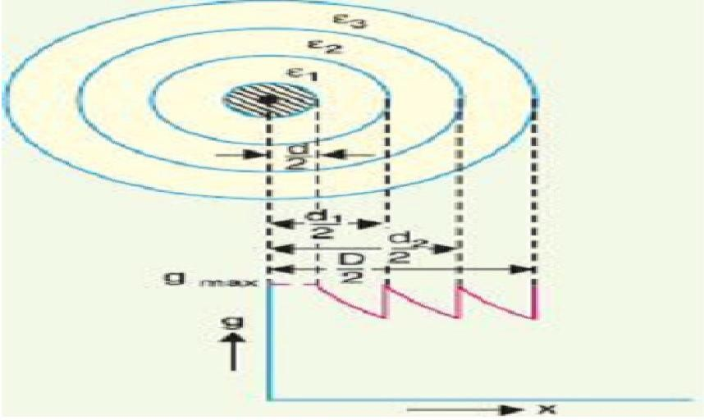

##### Capacitance grading

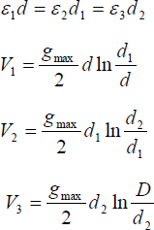

Total p.d. between core and earthed sheath is

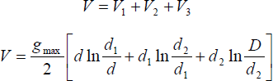

* + 1. 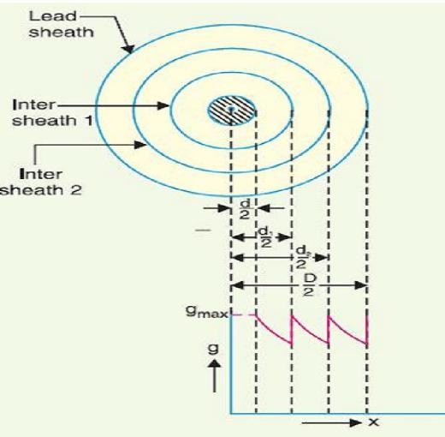**Intersheath Grading**: In this method of cable grading, a homogeneous dielectric is used, but it is divided into various layers by placing metallic inters heaths between the core and lead sheath. The inter sheaths are held at suitable potentials which are in between the core potential and earth potential. This arrangement improves voltage distribution in the dielectric of the cable and consequently more uniform potential gradient is obtained.

Intersheath grading

Consider a cable of core diameter d and outer lead sheath of diameter D. Suppose that two intersheaths of diameters d1 and d2 are inserted into the homogeneous dielectric and maintained at some fixed potentials. Let V1, V2 and V3 respectively be the voltage between core and Intersheath 1, between inter sheath 1 and 2 and between inter sheath 2 and outer lead sheath.

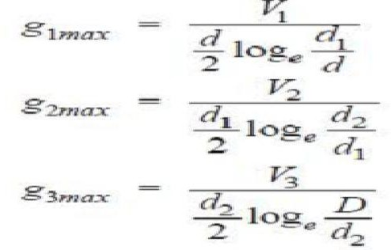As there is a definite potential difference between the inner and outer layers of each inter sheath, therefore, each sheath can be treated like a homogeneous single core cable Maximum stress between core and inter sheath 1 is

Since the dielectric is homogeneous, the maximum stress in each layer is the same i.e.,

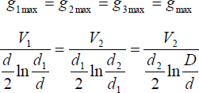

As the cable behaves like three capacitors in series, therefore, all the potentials are in phase i.e. Voltage between conductor and earthed lead sheath is



Inter sheath grading has three principal disadvantages. Firstly, there are complications in fixing the sheath potentials. Secondly, the inter sheaths are likely to be damaged during transportation and installation which might result in local concentrations of potential gradient. Thirdly, there are considerable losses in the inter sheaths due to charging currents. For these reasons, inter sheath grading is rarely used.

##### MEASUREMENT OF CAPACITANCE OF 3-CORE CABLES:

In three-core cables, capacitance does not have a single value, but can be lumped as shown in below figure.

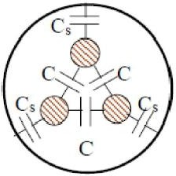Capacitance between each core and sheath = CS Capacitance between cores = C

##### Cable Capacitance

These can be separated from measurements as described in the following section.

1. Strap the 3 cores together and measure the capacitance between this bundle and the sheath as shown in figure.

Measured value = Cm1 = 3 Cs

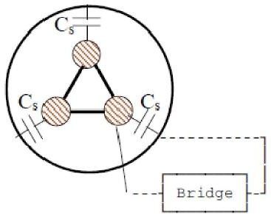This gives the capacitance to the sheath as Cs =CMI/3

##### Capacitance Measurement

1. Connect 2 of the cores to the sheath and measure between the remaining core and the sheath.

Measured value Cm2= 2 C + Cs

i.e. C = (Cm2 – Cs)/2 = (3 Cm2 – Cm1)/6

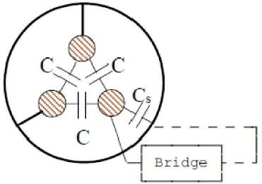Which gives the capacitance between the conductors.

##### Capacitance Measurement

The effective capacitance to neutral Co of any of the cores may be obtained by considering the star equivalent. This gives

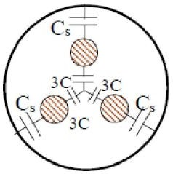

##### Calculation of C0

In the breakdown of actual 3-core belted cables, it is generally observed that charring occurs at those places where the stress is tangential to the layers of paper. Thus for the insulation to be effective, the tangential stresses in paper insulation should be preferably avoided. This can usually be accomplished only screening each core separately (or by having individual lead sheaths for each of the cores), so that the cable in effect becomes 3 individual cables laid within the same protective covering.

# UNIT – VI DISTRIBUTION SYSTEMS

##### DISTRIBUTION SYSTEM:

That part of power system which distributes electric power for local use is known as distribution system**.**

In general, the distribution system is the electrical system between the sub-station fed by the distribution system and the consumer‘s meters. It generally consists of feeders, distributors and the service mains.

1. **Feeders:** A feeder is a conductor which connects the sub-station (or localized generating station) to the area where power is to be distributed. Generally, no tapping‘s are taken from the feeder so that current in it remains the same throughout. The main consideration in the design of a feeder is the current carrying capacity.

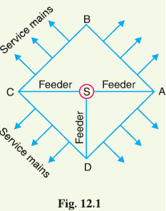

1. **Distributor.** A distributor is a conductor from which tappings are taken for supply to the consumers. In Fig. 12.1, *AB*, *BC*, *CD* and *DA* are the distributors. The current through a distributor is not constant because tappings are taken at various places along its length. While designing a distributor, voltage drop along its length is the main consideration since the statutory limit of voltage variations is ± 6% of rated value at the consumers‘ terminals.
   1. **Service mains***.* A service mains is generally a small cable which connects the distributor to the consumers‘ terminals.

##### Classification of Distribution Systems

A distribution system may be classified according to ;

* + 1. *Nature of current.* According to nature of current, distribution system may be classified as (*a*)

d.c. distribution system (*b*) a.c. distribution system.

Now-a-days, a.c. system is universally adopted for distribution of electric power as it is simpler and more economical than direct current method.

* 1. Type of construction. According to type of construction, distribution system may be classified as

(a) overhead system (b) underground system. The overhead system is generally employed for distribution as it is 5 to 10 times cheaper than the equivalent underground system. In general, the

underground system is used at places where overhead construction is impracticable or prohibited by the local laws.

* 1. Scheme of connection. According to scheme of connection, the distribution system may be classified as (a) radial system (b) ring main system (c) inter-connected system. Each scheme has its own advantages and disadvantages

##### A.C. DISTRIBUTION

* + 1. Now-a-days electrical energy is generated, transmitted and distributed in the form of alternating current.
    2. Alternating current in preferred to direct current is the fact that alternating voltage can be conveniently changed by means of a transformer.
    3. High distribution and distribution voltages have greatly reduced the current in the conductors and the resulting line losses.
    4. The A.C. distribution system is the electrical system between the step-down substation fed by the distribution system and the consumers‘ meters.

The A.C. distribution system is classified into

1. Primary distribution system and
2. Secondary distribution system.

##### PRIMARY DISTRIBUTION SYSTEM:

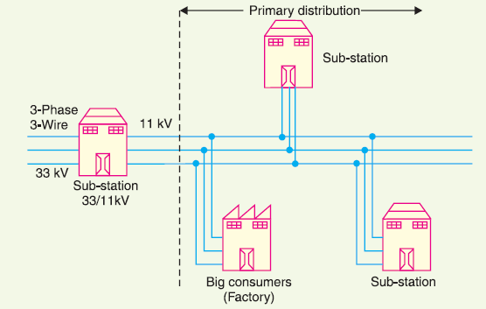

It is that part of A.C. distribution system which operates at voltages somewhat higher than general utilization than the average low-voltage consumer uses.

The most commonly used primary distribution voltages are 11 kV, 6·6kV and 3·3 kV

Primary distribution is carried out by 3-phase, 3-wire system. Fig. shows a typical primary distribution system. Electric power from the generating station is transmitted at high voltage to the substation located

in or near the city. At this substation, voltage is stepped down to 11 kV with the help of step-down transformer. Power is supplied to various substations for distribution or to big consumers at this voltage. This forms the high voltage distribution or primary distribution.

##### SECONDARY DISTRIBUTION SYSTEM:

It is that part of a.c. distribution system employs 400/230 V, 3-phase, 4-wire system. shows a typical secondary distribution system.

The primary distribution circuit delivers power to various substations, called distribution substations. The substations are situated near the consumers‘ localities and contain step down transformers.

At each distribution substation, the voltage is stepped down to 400 V and power is delivered by 3-phase,4- wire a.c. system.

The voltage between any two phases is 400 V and between any phase and neutral is 230 V.

The single phase domestic loads are connected between any one phase and the neutral, Motor loads are connected across 3-phase lines directly.

##### D.C. DISTRIBUTION:

For certain applications, d.c. supply is absolutely necessary. d.c. supply is required for the operation of variable speed machinery (*i.e*., d.c. motors storage battery.

For this purpose, A.C. power is converted into D.C. power at the substation by using converting machinery

*e.g.,* mercury arc rectifiers, rotary converters and motor-generator sets.

The D.C. supply obtained in the form of (*i*) 2-wire or (*ii*) 3-wire for distribution.

##### 2-Wire D.C. System

* + - As the name implies, this system of distribution consists of two wires.
    - One is the outgoing or positive wire and the other is the return or negative wire.
    - The loads such as lamps, motors etc. are connected in parallel between the two wires as shown in Fig.

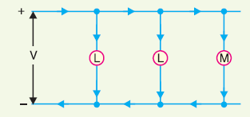This system is never used for distrubution purposes due to low efficiency but may be employed for distribution of d.c. power.

##### 3-wire D.C. system*.*

* + - It consists of two outers and a middle or neutral wire which is earthed at the substation.
    - The voltage between the outers is twice the voltage between either outer or neutral.
    - The principal advantage of this system is that it makes available two voltages at the consumer terminals,
    - *V* between any outer and the neutral and 2V between the outers.

##### COMPARISON OF D.C. AND A.C. DISTRIBUTION:

The electric power can be distributed either by means of D.C. or A.C. Each system has its own merits and demerits.

##### D.C DISTRIBUTION:

* + - * **Advantages.**

1. It requires only two conductors as compared to three for A.C. distribution.
2. There is no inductance, capacitance, phase displacement and surge problems in D.C. distribution.
3. Due to the absence of inductance, the voltage drop in a D.C. distribution line is less than the

A.C. line for the same load and sending end voltage. For this reason, a D.C. distribution line has better voltage regulation.

1. There is no skin effect in a D.C. system. Therefore, entire cross-section of the line conductor is utilized.
2. For the same working voltage, the potential stress on the insulation is less in case of D.C. system than that in A.C. system. Therefore, a D.C. line requires less insulation.
3. A D.C. line has less corona loss and reduced interference with communication circuits.
4. The high voltage D.C. distribution is free from the dielectric losses, particularly in **(*viii*)** In D.C. distribution; there are no stability problems and synchronizing difficulties.

##### Disadvantages

(1). Electric power cannot be generated at high D.C. voltage due to commutation problems. (2). The D.C. voltage cannot be stepped up for distribution of power at high voltages.

(3). The D.C. switches and circuit breakers have their own limitations.

##### A.C. DISTRIBUTION:

* + - * **Advantages**

1. The power can be generated at high voltages.
2. The maintenance of A.C. sub-stations is easy and cheaper.
3. The A.C. voltage can be stepped up or stepped down by transformers with ease and efficiency.

This permits to transmit power at high voltages and distribute it at safe potentials.

##### Disadvantages

1. An A.C. line requires more copper than a D.C. line.
2. The construction of A.C. distribution line is more complicated than a D.C. distribution line. (3). Due to skin effect in the A.C. system, the effective resistance of the line is increased.

(4). An A.C. line has capacitance. Therefore, there is a continuous loss of power due to charging current even when the line is open.

##### OVERHEAD VERSUS UNDERGROUND SYSTEM:

The distribution system can be overhead or underground.

Overhead lines are generally mounted on wooden, concrete or steel poles which are arranged to carry distribution transformers in addition to the conductors.

The underground system uses conduits, cables and manholes under the surface of streets and sidewalks.

The choice between overhead and underground system depends upon a number of widely differing factors.

1. **Public Safety:** The underground system is more safe than overhead system because all distribution wiring is placed underground and there are little chances of any hazard.
2. **Initial Cost**: The underground system is more expensive due to the high cost of trenching, conduits, cables, manholes and other special equipment. The initial cost of an underground system may be five to ten times than that of an overhead system.
3. **Flexibility:** The overhead system is much more flexible than the underground system. In the latter case, manholes, duct lines etc., are permanently placed once installed and the load expansion can only be met by laying new lines. However, on an overhead system, poles, wires, transformers etc., can be easily shifted to meet the changes in load conditions.
4. **Faults:** The chances of faults in underground system are very rare as the cables are laid underground and are generally provided with better insulation.
5. **Appearance:** The general appearance of an underground system is better as all the distribution lines are invisible. This factor is exerting considerable public pressure on electric supply companies to switch over to underground system.
6. **Fault Location And Repairs***:* In general, there are little chances of faults in an underground system. However, if a fault does occur, it is difficult to locate and repair on this system. On an overhead system, the conductors are visible and easily accessible so that fault locations and repairs can be easily made.
7. **Current Carrying Capacity And Voltage Drop***:* An overhead distribution conductor has a considerably higher current carrying capacity than an underground cable conductor of the same material and cross-section. On the other hand, underground cable conductor has much lower inductive reactance than that of an overhead conductor because of closer spacing of conductors.
8. **Useful Life:** The useful life of underground system is much longer than that of an over head system. An overhead system may have a useful life of 25 years, whereas an underground system may have a useful life of more than 50 years.
9. **Maintenance Cost:** The maintenance cost of underground system is very low as compared with that of overhead system because of less chance of faults and service interruptions from wind, ice, and lightning as well as from traffic hazards.
10. **Interference With Communication Circuit*:*** An overhead system causes electromagnetic interference with the telephone lines. The power line currents are superimposed on speech currents, resulting in the potential of the communication channel being raised to an undesirable level. However, there is no such interference with the underground system.

It is clear from the above comparison that each system has its own advantages and disadvantage

##### DESIGN CONSIDERATIONS IN DISTRIBUTION SYSTEM:

Good voltage regulation of a distribution network is probably the most important factor responsible for delivering good service to the consumers. For this purpose, design of feeders and distributors requires careful consideration.

1. **Feeders:** A feeder is designed from the point of view of its current carrying capacity while the voltage drop consideration is relatively unimportant. It is because voltage drop in a feeder can be compensated by means of voltage regulating equipment at the substation.
2. **Distributors:** A distributor is designed from the point of view of the voltage drop in it. It is because a distributor supplies power to the consumers and there is a statutory limit of voltage variations at the consumer‘s terminals (± 6% of rated value). The size and length of the distributor should be such that voltage at the consumer‘s terminals is within the permissible limits.

##### REQUIREMENTS OF A DISTRIBUTION SYSTEM:

Requirements of a good distribution system are : proper voltage, availability of power on demand and reliability.

1. **Proper voltage:** One important requirement of a distribution system is that voltage variations at consumer‘s terminals should be as low as possible. The changes in voltage are generally caused due to the variation of load on the system. Low voltage causes loss of revenue, inefficient lighting and possible burning out of motors. High voltage causes lamps to burn out permanently and may cause failure of other appliances. Therefore, a good distribution system

should ensure that the voltage variations at consumers terminals are within permissible limits. The statutory limit of voltage variations is ± 6% of the rated value at the consumer‘s terminals. Thus, if the declared voltage is 230 V, then the highest voltage of the consumer should not exceed 244 V while the lowest voltage of the consumer should not be less than 216 V.

1. **Availability of power on demand:** Power must be available to the consumers in any amount that they may require from time to time. For example, motors may be started or shut down, lights may be turned on or off, without advance warning to the electric supply company. As electrical energy cannot be stored, therefore, the distribution system must be capable of supplying load demands of the consumers. This necessitates that operating staff must continuously study load patterns to predict in advance those major load changes that follow the known schedules.
2. **Reliability:** Modern industry is almost dependent on electric power for its operation. Homes and office buildings are lighted, heated, cooled and ventilated by electric power. This calls for reliable service. Unfortunately, electric power, like everything else that is man-made, can never be absolutely reliable. However, the reliability can be improved to a considerable extent by (*a*) interconnected system (*b*) reliable automatic control system (*c*) providing additional reserve facilities.

##### CONNECTION SCHEMES OF DISTRIBUTION SYSTEM:

* + 1. **RADIAL SYSTEM:**
       1. In this system, separate feeders radiate from a single substation and feed the distributors at one end only.
       2. Fig. (*i*) Shows a single line diagram of a radial system or D.C. distribution where a feeder *OC*

supplies a distributor *AB* at point *A*. distributor is fed at one end only *i.e*., point *A* is this case.

* + - 1. Fig. (*ii*) Shows a single line diagram of radial system for A.C. distribution.

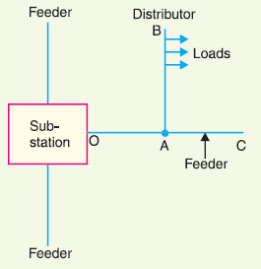

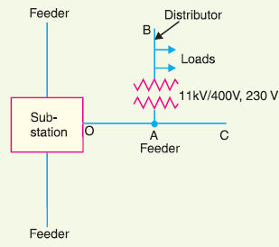

This is the simplest distribution circuit and has the lowest initial cost.

##### Drawbacks:

1. The end of the distributor nearest to the feeding point will be heavily loaded.
2. any fault on the feeder or distributor cuts off supply to the consumers who are on the side of the fault .
3. The consumers at the distant end of the distributor would be subjected to serious voltage fluctuations when the load on the distributor changes.
4. Due to these limitations, this system is used for short distances only.

##### RING MAIN SYSTEM:

* + - 1. In this system, the primaries of distribution transformers form a loop
      2. The loop circuit starts from the substation bus-bars, makes a loop through the area to be served, and returns to the substation.
      3. Fig. 12.9 shows the single line diagram of ring mainsystem for a.c. distribution where substation supplies to the closed feeder LMNOPQRS.
      4. The distributors are tapped from different points *M*, *O* and *Q* of the feeder through distribution transformers.

##### Advantages:

1. There are less voltage fluctuations at consumer‘s terminals.
2. The system is very reliable as each distributor is fed *via* *two feeders. In the event of fault on any section of the feeder, the continuity of supply is maintained.

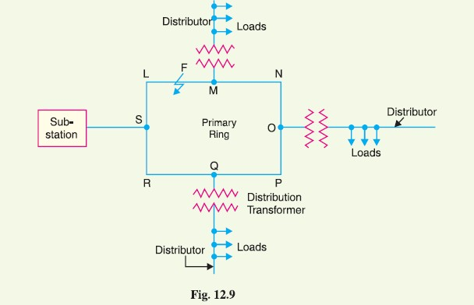

##### INTERCONNECTED SYSTEM:

1. When the feeder ring is energized by two or more than two generating stations or substations, it is called inter-connected system.
2. Fig. 12.10 shows the single line diagram of interconnected system where the closed feeder ring

*ABCD* is supplied by two substations *S*1 and *S*2 at points *D* and *C* respectively.

1. Distributors are connected to points *O*, *P*, *Q* and *R* of the feeder ring through distribution transformers.

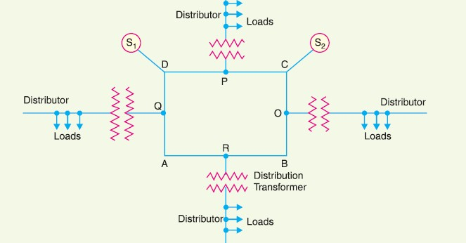

##### Advantages:

1. It increases the service reliability.
2. Any area fed from one generating station during peak load hours can be fed from the other generating station. This reduces reserve power capacity and increases efficiency of the system.

##### A.C. DISTRIBUTION VOLTAGE CALCULATIONS:

In A.C. distribution calculations, power factors of various load currents have to be considered since currents in different sections of the distributor will be the vector sum of load currents and not the arithmetic sum. The power factors of load currents may be given (*i*) *w.r.t*. receiving or sending end voltage or (*ii*)

*w.r.t*. to load voltage itself. Each case shall be discussed separately.

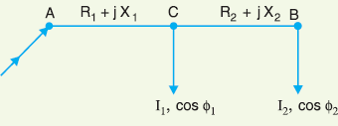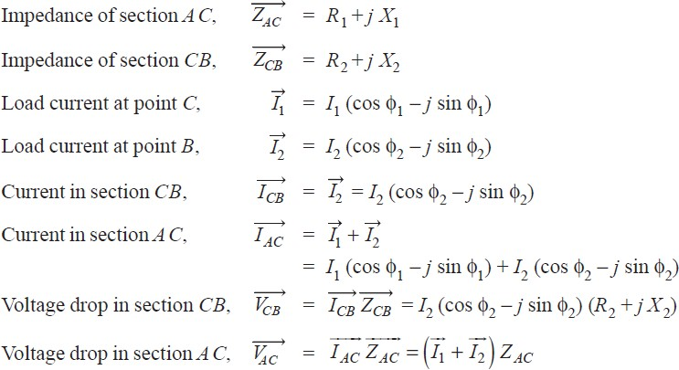**(*i*) Power factors referred to receiving end Voltage.** Consider an A.C. distributor *AB* with concentrated loads of *I*1 and *I*2 tapped off at points *C* and *B* as shown in Fig. Taking the receiving end voltage *VB* as the reference Let *R*1, *X*1 and *R*2, *X*2 be the resistance and reactance of sections *AC* and *CB* of the distributor.

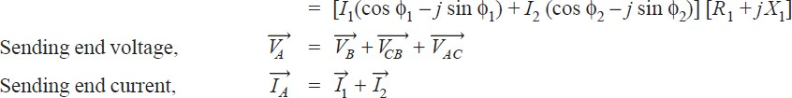

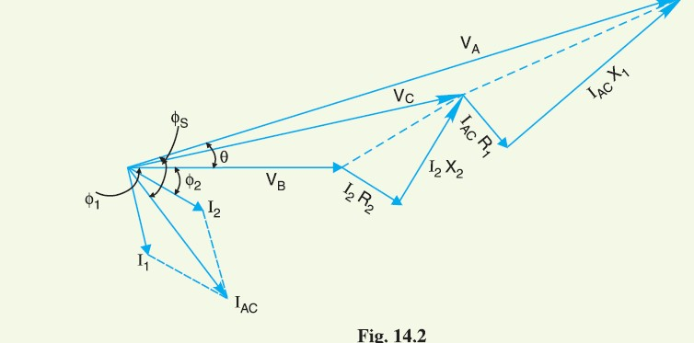

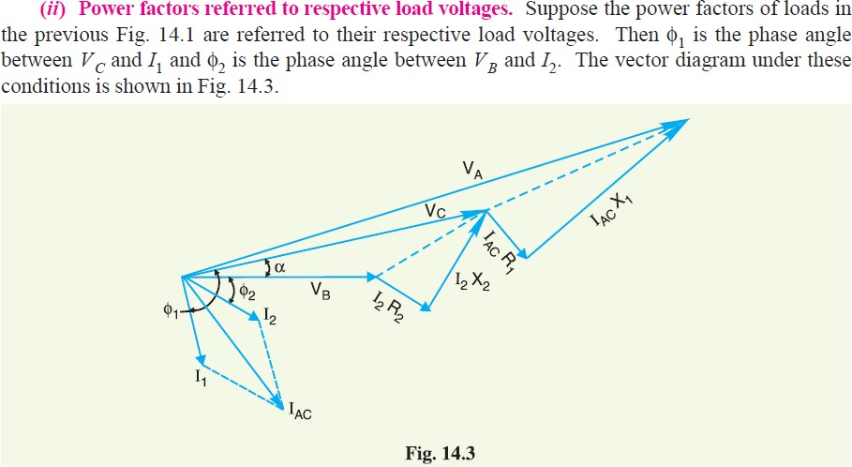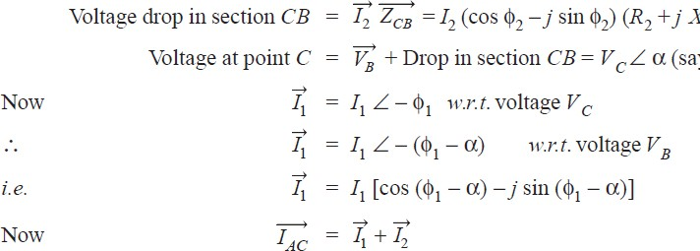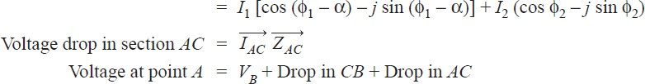

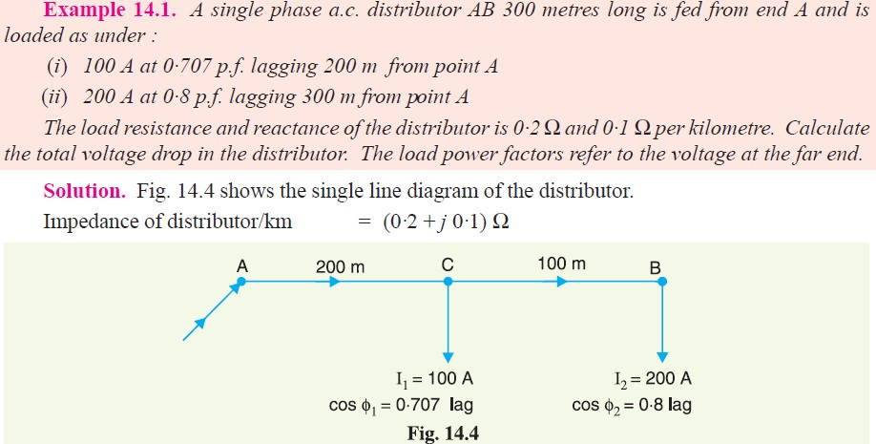

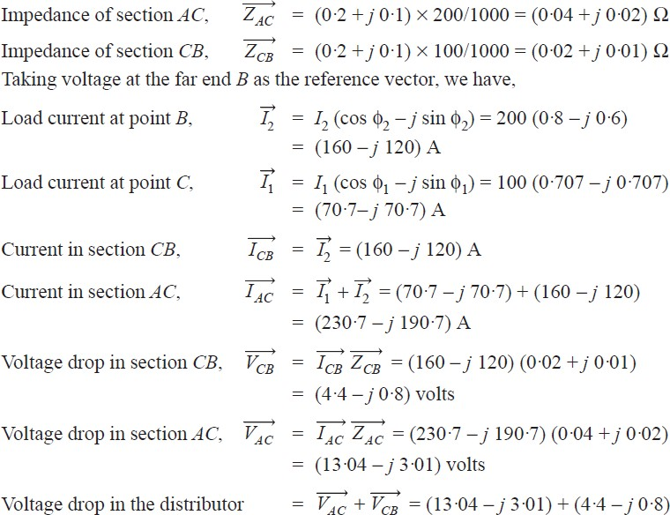





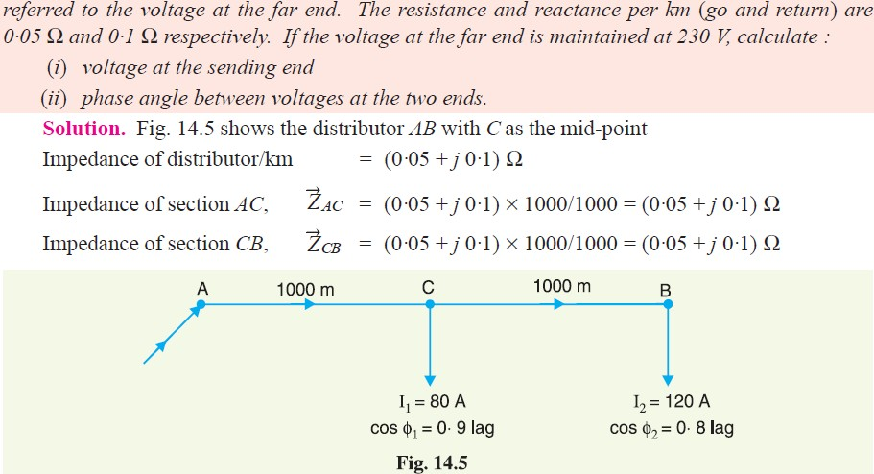

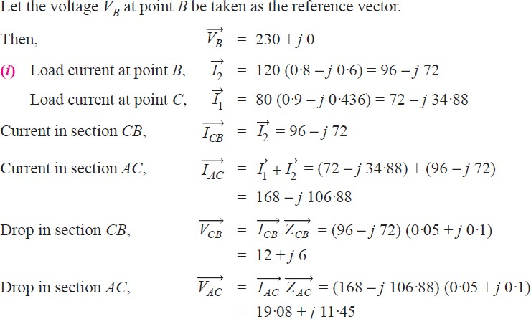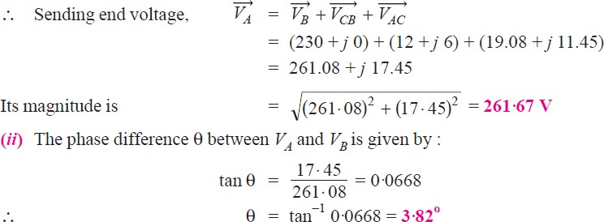

##### BASIC CONCEPT OF INTERCONNECTED SYSTEMS:

Electricity sector in India is growing at rapid pace. During the current year 2017-18 (Upto 30.11.2017), the Peak Demand is about 164.1 GW and the Installed Capacity is 330.8 GW with generation mix of Thermal (66.2%), Hydro (13.6%), Renewable 18.2%) and Nuclear (2.0%).

The natural resources for electricity generation in India are unevenly dispersed and concentrated in a few pockets. Hydro resources are located in the Himalayan foothills, North Eastern Region (NER). Coal reserves are concentrated in Jharkhand, Odisha, West Bengal, Chhattisgarh, parts of Madhya Pradesh, whereas lignite is located in Tamil Nadu and Gujarat. Also lot of power station, generating from Gas and renewable energy sources like Solar, Wind etc. have been installed in various parts of country.

Powergrid Corporation of India Limited (POWERGRID), a Central Transmission Utilities (CTU), is responsible for planning inter-state transmission system (ISTS). Similarly there are State Transmission Utilities (STU) (namely State Transco/ SEBs) responsible for the development of Intra State Transmission System.

An extensive network of Transmission lines has been developed over the years for evacuating power produced by different electricity generating stations and distributing the same to the consumers. Depending upon the quantum of power and the distance involved, lines of appropriate voltages are laid. The nominal Extra High Voltage lines in vogue are ± 800 kV HVDC & 765kV, 400 kV, 230/220 kV, 110 kV and 66kV AC lines. These have been installed by all the SEBs, and by Generation, Transmission & Distribution utilities including those in Central Sector.

13,820 circuit kilometres (ckm) of transmission lines have been commissioned during 2017-18 (April- November 2017). This is 59.9% of the annual target of 23,086 ckm fixed for 2017-18. Similarly, 50,805 MVA of transformation capacity of substations has been added during 2017-18 (April-November 2017) which constitutes 94.1% of the annual target of 53,978 MVA fixed for 2017-18.

The capacity of transmission system of 220 kV and above voltage levels, in the country as on 30th November 2017 was 3,81,671 ckm of transmission lines and 7,91,570 MVA of transformation capacity of Substations.

As on 30th November 2017, the total transmission capacity of the inter-regional links is 78,050 MW.

The transmission lines are operated in accordance with Regulations/standards of Central Electricity Authority (CEA) / Central Electricity Regulatory Commission (CERC) / State Electricity Regulatory Commissions(SERC).However, in certain cases, the loading on transmission lines may have to be restricted keeping in view the voltage stability, angular stability, loop flows, load flow pattern and grid security. Power surplus States have been inter-alia, able to supply their surplus power to power deficit State Utilities across the country except for some congestion in supply of power to Southern Region.

Power System Operation Corporation Limited (POSOCO), is managing the National and Regional grid from National Load Dispatch Centre (NLDC) and its five Regional Load Dispatch Centres (RLDC) through state-of-the-art unified load dispatch &communication facilities.

##### CENTRAL TRANSMISSION UTILITY(CTU):

Power Grid Corporation of India Limited (POWERGRID, the 'Central Transmission Utility (CTU)' of the country and a 'Navratna' Company operating under Ministry of Power, is engaged in power transmission business with the responsibility for planning, implementation, operation and maintenance of Inter-State Transmission System (ISTS). POWERGRID is a listed Company, with 57.90% holding of Government of India and balance by Institutional Investors & public.

POWERGRID, as on 30th September 2017, owns & operates around 1,42,989 ckm of Extra High Voltage (EHV) transmission lines spread over the length and breadth of the country and 226 EHV AC & HVDC Sub-stations with transformation capacity of more than 3,11,185 MVA. Its vast transmission network wheels more than 45% of the power in the country. The availability of this huge transmission network is consistently maintained over 99% through deployment of state-of-the-art operation & maintenance techniques at par with global standards.

During FY 2016-17, POWERGRID has achieved a turnover of about Rs. 26,581.46 Crore and Net Profit of Rs.7,520.15 Crore. As on 31.03.2017 Gross Fixed Assets of the company have also grown to Rs.1,49,730 Crore.

High Capacity Power Transmission Corridors (HCPTCs) have been implemented to meet bulk power evacuation requirement of various Independent Power Producers (IPPs) mainly coming up in resource rich and coastal areas such as Chhattisgarh, Odisha, Madhya Pradesh, Sikkim, Jharkhand, Tamil Nadu and Andhra Pradesh. Implementation of these corridors has been taken up in a phased manner matching with generation projects.

The total inter-regional transmission capacity (220kV and above) of country has been enhanced from 27,150 MW to 75,050 MW from XIth to XIIth plan. This Endeavour of POWERGRID under the guidance of Ministry of Power has enabled in moderation of the prices of electricity in Northern Region and ensured reliable supply of electricity.

POWERGRID has achieved a capital investment of about Rs.1,12,600 crore for development of inter-State transmission system during XII Plan against a target of Rs.1,10,000 Crore. During the XII plan it has added about 45,900 ckm of transmission line and about 1,64,000 MVA of transformation capacity against a target of 40,000 ckm and 1,00,000 MVA respectively.

The Company has an excellent credit rating with financial institutions, thereby, is placed in a comfortable position in terms of resource mobilization. POWERGRID is also playing a major role in facilitating grid interconnection of renewable generation across the country through implementation of portion of ISTS part of Green Energy Corridors.

Conserving Right-of-Way (RoW), minimizing impact on natural resources, coordinated development of cost effective transmission corridor, flexibility in up gradation of transfer capacity of lines matching with power transfer requirement are major areas of concern in development of transmission network in the country. In this direction, the Company has been working on higher transmission voltages of ±800 kV HVDC & 1200 kV UHVAC. The ±800 kV, 3000 MW HVDC Bi-pole line (CK-I) connecting Champa in Chhattisgarh to Kurukshetra in Haryana has been commissioned recently. This transmission system is further being upgraded to 6000 MW capacity with addition of 2nd HVDC Bipole (CK-2) of 3000MW,

±800kV HVDC Terminals which is expected to be completed by December 2018. Similarly, power flow through 1200 kV National Test Station (NTS) has commenced at Bina, Madhya Pradesh.

To shore up its revenue and create value for its stakeholders, POWERGRID diversified into telecom business, leveraging its country wide transmission infrastructure. Company is providing back-bone connectivity to all metros, major cities & towns including remote areas of J&K and North-Eastern States

etc. Total network coverage is more than 41,988 kms and numbers of Points of Presence (PoPs) locations are more than 662. Having Intra city network in 105 cities across India, the Telecom Backbone Availability for the year 2016-17 was about 99.9%.

POWERGRID has successfully completed the prestigious NKN (National Knowledge Network) project devised by Govt. of India, which connects all knowledge centres across the Country such as Indian Institutes of Technology (IITs), Indian Institute of Sciences (IISCs) etc., on a high speed connectivity Company has signed an agreement with Bharat Sanchar Nigam Limited (BSNL) to improve the telecommunication connectivity with the North-Eastern States including Sikkim. It envisages the provisioning of bandwidth on optical fibre media laid over existing high tension electric transmission network. After completion of the proposed connectivity, the reliability of the telecom services improves substantially in North-Eastern region including Sikkim.

As a part of Government of India plan to connect 250,000 Gram Panchayats (GP) in the Country, POWERGRID one of the implementing agencies for BharatNet project and has been entrusted with the task of development and maintenance of the National Optical Fibre Network in states, namely Andhra Pradesh, Telangana, Himachal Pradesh, Jharkhand and Odisha.

Further, POWERGRID is playing a significant role in carrying forward the distribution reforms through undertaking Deendayal Upadhyaya Gram Jyoti Yojana (DDUGJY) and Integrated Power Development Scheme (IPDS) works on behalf of the Govt. of India in the country.

POWERGRID has emerged as a strong player in South Asia and is playing an active role in formation of a strong SAARC grid for effective utilization of resources for mutual benefits. Presently, various electrical interconnections exist between India & Bhutan, India & Nepal and India & Bangladesh. Further, the interconnection between India & Bhutan, India & Nepal and India & Bangladesh are being strengthened for substantial exchange of power across the borders.

POWERGRID is offering consultancy services to various National clients & International clients, including many South Asian, African, and Middle East countries.

POWERGRID is implementing the prestigious and State of the Art, Renewable Energy Management Centres (REMC) for managing the renewable generation integration and operation which shall include a host of activities from renewable energy forecasting to energy balancing and generation scheduling. In Smart transmission, POWERGRID has been implementing Synchrophasor Technology in its Wide Area Measurement System (WAMS) Project through installation of PMUs (Phasor Measurement Units) at different locations in all regions across the country, which facilitates better visualization and situational awareness of the grid events such as grid robustness, oscillations, angle/ voltage instability, system margin etc. as well as decision support tools. POWERGRID also acts as 'nodal point' in prestigious "India Smart Grid Task Force" Secretariat for Government's activities related to Smart Grid.

##### INDIAN ELECTRICITY RULES:

* **Cut-out on consumer’s premises:**

1. The supplier shall provide a suitable cut-out in each conductor of every service-line other than an earthed or earthed neutral conductor or the earthed external conductor of a concentric cable within a consumer‘s premises, in an accessible position. Such cut-out shall be contained within an adequately enclosed fireproof receptacle.
2. Where more than one consumer is supplied through a common service-line, each such consumer shall be provided with an independent cut-out at the point of junction to the common service
3. Every electric supply line other than the earth or earthed neutral conductor of any system or the earthed external conductor of a concentric cable shall be protected by a suitable cut-out by its owner
4. No cut-out, link or switch other than a linked switch arranged to operate simultaneously on the earthed or earthed neutral conductor and live conductors shall be inserted or remain inserted in any earthed or earthed neutral conductor of a two wire-system or in any earthed or earthed neutral conductor of a multi-wire system or in any conductor connected thereto with the following exceptions:(a) A link for testing purposes, or (b) A switch for use in controlling a generator or transformer.

##### Danger Notices:

1. The owner of every medium, high and extra-high voltage installation shall affix permanently in a conspicuous position a danger notice in Hindi or English and the local language of the district, with a sign of skull and Bones on
   1. Every motor, generator, transformer and other electrical plant and equipment together with apparatus used for controlling or regulating the same;
   2. All supports of high and extra-high voltage overhead lines which can be easily climb-upon without the aid of ladder or special appliances.

##### Cables:

1. Flexible cables shall not be used for portable or transportable motors, generators, transformer rectifiers, electric drills, electric sprayers, welding sets or any other portable or transportable apparatus unless they are heavily insulated and adequately protected from mechanical injury.
2. Where the protection is by means of metallic covering, the covering shall be in metallic connection with the frame of any such apparatus and earth.
3. The cables shall be three core type and four-core type for portable and transportable apparatus working on single phase and three phases supply respectively and the wire meant to be used for ground connection shall be easily Identifiable
4. Where A.C. and D.C. circuits are installed on the same support they shall be so arranged and protected that they shall not come into contact with each other when live.

##### Safety:

1. Two or more gas masks shall be provided conspicuously and installed and maintained at accessible places in every generating station with capacity of 5 MW and above and enclosed

sub-station with transformation capacity of 5 MVA and above for use in the event of fire or smoke.

1. Provide that where more than one generator with capacity of 5 MW and above is installed in a power station, each generator would be provided with at least two separate gas masks in accessible and conspicuous position.

##### High Voltage Equipments installations

1. High Voltage equipments shall have the IR value as stipulated in the relevant Indian Standard.
2. At a pressure of 1000 V applied between each live conductor and earth for a period of one minute the insulation resistance of HV installations shall be at least 1 Mega ohm Medium and Low Voltage Installations- At a pressure of 500 V applied between each live conductor and earth for a period of one minute, the insulation resistance of medium and low voltage installations shall be at least 1 Mega ohm

##### Every switchboard shall comply with the following provisions, namely:

1. A clear space of not less than 1 meter in width shall be provided in front of the switchboard;
2. If there are any attachments or bare connections at the back of the switchboard, the space (if any) behind the switchboard shall be either less than 20 centimeters or more than 75 centimeters in width, measured from the farthest outstanding part of any attachment or conductor;
3. If the space behind the switchboard exceeds 75 centimeters in width, there shall be a passage- way from either end of the switchboard clear to a height of 1.8 meters.

##### Declared voltage of supply to consumer:

1. In the case of low or medium voltage, by more than 6 per cent, or;
2. In the case of high voltage, by more than 6 per cent on the higher side or by more than 9 per cent on the lower side, or;
3. In the case of extra-high voltage, by more than 10 per cent on the higher side or by more than

12.5 per cent on the lower side.

##### Declared frequency of supply to consumer

1. Except with the written consent of the consumer or with the previous sanction of the State Government a supplier shall not permit the frequency of an alternating current supply to vary from the declared frequency by more than 3 per cent.

##### Meters, maximum demand indicators and other apparatus on consumer’s premises

1. Any meter or maximum demand indicator or other apparatus placed upon a consumer‘s premises in accordance with section 26 shall be of appropriate capacity and shall be deemed to be correct if its limits of error are within the limits specified in the relevant Indian Standard Specification and where no such specification exists, the limits of error do not exceed 3 per cent above or below absolute accuracy at all loads in excess of one tenth of full load and up to full load Connection with earth Neutral conductor of a phase, 4 wire system and the middle conductor of a 2 phase, 3-wire system shall be earthed by not less than two separate and distinct connections with a minimum of two different earth electrodes of such large number as may be necessary to bring the earth resistance to a satisfactory value both at the generating

station and at the sub-station. The earth electrodes so provided, may be interconnected to reduce earth resistance. It may also be earthed at one or more points along the distribution system or service line in addition to any connection with earth which may be at the consumer‘s premises

1. In the case of a system comprising electric supply lines having concentric cables, the external conductor of such cables shall be earthed by two separate and distinct connections with earth.
2. The connection with earth may include a link by means of which the connection may be temporarily interrupted for the purpose of testing or for locating a fault.
3. All metal castings or metallic coverings containing or protecting any electric supply-line or apparatus shall be connected with earth and shall be so joined and connected across all junction boxes and other openings as to make good mechanical and electrical connection throughout their whole length.

##### Use of energy at high and extra-high voltage

|  |  |  |
| --- | --- | --- |
| Voltage | Ground clearance | Sectional clearance |
| 11KV | 2.75 Meter | 2.6 Meter |
| 33KV | 3.7 Meter | 2.8 Meter |
| 66KV | 4.0 Meter | 3.0 Meter |
| 132KV | 4.6 Meter | 3.5 Meter |
| 220KV | 5.5 Meter | 4.3 Meter |
| 400KV | 8.0 Meter | 6.5 Meter |

* **Transformer:**

1. Where transformer or transformers are used, suitable provision shall be made, either by connecting with earth a point of the circuit at the lower voltage or otherwise, to guard against danger by reason of the said circuit becoming Accidentally charged above its normal voltage by leakage from or contact with the circuit at the higher voltage
2. A sub-station or a switch station with apparatus having more than 2000 liters of oil shall not be located in the basement where proper oil draining arrangement cannot be provided.
3. Where a sub-station or a switch station with apparatus having more than 2000 liters of oil is installed, whether indoor or out-doors, the following measures shall be taken, namely: –
4. The baffle walls 4[of 4 hour fire rating] shall be provided between the apparatus in the following cases:
   1. Single phase banks in the switch-yards of generating stations and substations;
   2. On the consumer premises;
   3. Where adequate clearance between the units is not available.
5. Provisions shall be made for suitable oil soakpit and where use of more than 9000 litres of oil in any one oil tank, receptacle or chamber is involved, provision shall be made for the draining away or removal of any oil which may leak or escape from the tanks receptacles or chambers containing the same.
6. The transformer shall be protected by an automatic high velocity water spray system or by carbon dioxide or BCF (Bromo chlorodi feuromethane) or BTM (Bromo tri fluromethane) fixed installation system; and
7. Oil filled transformers installed indoors shall not be on any floor above the ground or below the first basement.
8. Isolators and the corresponding earthing switches shall be interlocked so that no earthing switch can be closed unless and until the corresponding isolator is in open position.
9. When two or more transformers are operated in parallel, the system shall be so arranged as to trip the secondary breaker of a transformer in case the primary breaker of that transformer trips.
10. Where two or more generators operate in parallel and neutral switching is adopted, inter-lock shall be provided to ensure that generator breaker cannot be closed unless one of the neutrals is connected to the earthing system.
11. Gas pressure type protection to given alarm and tripping shall be provided on all transformers of ratings 1000 KVA and above.
12. Transformers of capacity 10 MVA and above shall be protected against incipient faults by differential protection; and All generators with rating of 100 KVA and above shall be protected against earth fault/leakage. All generators of rating 1000KVA and above shall be protected against faults within the generator winding using restricted earth fault protection or differential protection or by both.

##### Connection with earth:

1. In case of the delta connected system the neutral point shall be obtained by the insertion of a grounding transformer and current limiting resistance or impedance wherever considered necessary at the commencement of such a system.
2. Where the earthing lead and earth connection are used only in connection with earthing guards erected under high or extra-high voltage overhead lines where they cross a telecommunication line or a railway line, and where such lines are equipped with earth leakage relays of a type and setting approved by the Inspector, the resistance shall not exceed 25 ohms.

##### Clearance above ground of the lowest conductor

1. No conductor of an overhead line, including service lines, erected across a street shall at any part thereof be at a height of less than:
2. For low and medium voltage lines 5.8 meters
3. For high voltage lines 6.1 meters
4. No conductor of an overhead line, including service lines, erected along any street shall at any part thereof be at a height less than:
5. For low and medium voltage lines 5.5 meters
6. For high voltage lines 5.8 meters
7. No conductor of in overhead line including service lines, erected elsewhere than along or across any street shall be at a height less than:
8. For low, medium and high voltages lines=4.6 meters.
9. For low, medium and high voltage=4.0 meters.
10. For high voltage lines above 11,000 volts=5.2 meters.
11. For extra-high voltage lines the clearance above ground shall not be less than 5.2 meters plus

0.3 meter for every 33,000 volts or part thereof by which the voltage of the line exceeds 33,000 volts.

##### VARIOUS VOLTAGE LEVELS OF TRANSMISSION SYSTEMS:

All Users, RLDC, SLDC, State Transmission Utility (STU), Central Transmission Utility (CTU) and NLDC will have to take all possible measures to ensure that the grid voltage always remains within the following operating range.

|  |  |  |  |
| --- | --- | --- | --- |
| **Sr.**  **No.** | **Nominal System Voltage (kV rms)** | **Maximum (kV rms)** | **Minimum (kV rms)** |
| **1.** | 765 | 800 | 728 |
| **2.** | 400 | 420 | 380 |
| **3.** | 220 | 245 | 198 |
| **4.** | 132 | 145 | 122 |
| **5.** | 110 | 121 | 99 |
| **6.** | 66 | 72 | 60 |
| **7.** | 33 | 36 | 30 |

The distribution segment continues to carry electricity from the point where transmission leaves off, that is, at the 66/33 kV level. The standard voltages on the distribution side are therefore 66kV, 33 kV, 22 kV, 11 kV and 400/230 volts, besides 6.6 kV, 3.3 kV and 2.2 kV. Depending upon the quantum of power and the distance involved, lines of appropriate voltages are laid. The main distribution equipment comprises HT and LT lines, transformers, substations, switchgears, capacitors, conductors and meters. HT lines supply electricity to industrial consumers while LT lines carry it to residential and commercial consumers.

Supply codes and Performance Standards lays down procedures for recovery of electricity charges, billing cycles, disconnections, and restoration of service and metering among other things. To protect consumer interests, the EA 2003 requires the SERCs to specify standards of performance for distribution license.