**LECTURE NOTES**

**ON**

CIRCUITS&NETWORKS

**UNIT-V&VI**

**I B. Tech II Semester (R20)**

**SYLLABUS**

**UNIT-V**

**Two port Network Parameters** - Open circuit parameters – Short circuit parameters – Transmission parameters - Hybrid parameters – Inter-relationships of different parameters-Interconnections of two port networks –Condition for reciprocity and symmetry of networks with different two port parameters - Terminated two port networks.

**UNIT – VI**

**Network Functions :** Single port &multi port networks - Immittance functions of two port networks – Necessary conditions for driving point functions & transfer function – Complex frequencies – Poles and zeros – Time domain response from pole zero plots – Restrictions on pole-zero locations.

|  |  |
| --- | --- |
|  |  |
|  | |
|  |  |
|  | |
|  |  |
|  | |
|  |  |
|  | |
|  |  |
|  | |
|  |  |
|  | |
|  | |
|  | |

**UNIT – V**

**TWO PORT NETWORK PARAMETERS**

# V.TWO PORT NETWORK PARAMETERS

### Introduction:

In general, it is easy to analyze any electrical network, if it is represented with an equivalent model, which gives the relation between input and output variables. For this, we can use **two port network** representations. As the name suggests, two port networks contain two ports. Among which, one port is used as an input port and the other port is used as an output port. The first and second ports are called as port1 and port2 respectively.

**One port network:** it is a two terminal electrical network in which, current enters through one terminal and leaves through another terminal. Resistors, inductors and capacitors are the examples of one port network because each one has two terminals. One port network representation is shown in the following figure.

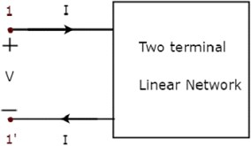

Here, the pair of terminals, 1 & 1‘ represents a port. In this case, we are having only one port since it is a one port network.

Similarly,

**Two port network:** it is a pair of two terminal electrical network in which, current enters through one terminal and leaves through another terminal of each port. Two port network representation is shown in the following figure.

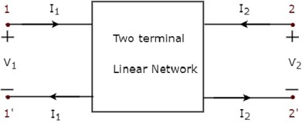

Here, one pair of terminals, 1 & 1‘ represents one port, which is called as **port1** and the other pair of terminals, 2 & 2‘ represents another port, which is called as **port2**.

There are **four variables** V1, V2, I1 and I2 in a two port network as shown in the figure. Out of which, we can choose two variables as independent and another two variables as dependent. So, we will get six possible pairs of equations. These equations represent the dependent variables in terms of independent variables. The coefficients of independent variables are called as **parameters**. So, each pair of equations will give a set of four parameters.

##### IMPEDANCE PARAMETERS (OR) Z PARAMETERS:

We will get the following set of two equations by considering the variables V1 & V2 as dependent and I1 & I2 as independent. The coefficients of independent variables, I1 and I2 are called as Z parameters.

Z parameters are also known as [impedance parameters.](https://www.electrical4u.com/impedance-parameter-or-z-parameter/) When we use Z parameter for analyzing two part network, the voltages are represented as the function of [currents](https://www.electrical4u.com/electric-current-and-theory-of-electricity/). So

https://www.electrical4u.com/images/2017/september17/1504344979.PNG

the input and output of a [two port network](https://www.electrical4u.com/two-port-network/) can either be [voltage](https://www.electrical4u.com/voltage-or-electric-potential-difference/) or [current](https://www.electrical4u.com/electric-current-and-theory-of-electricity/). If the network is voltage driven, that can be represented as shown below.

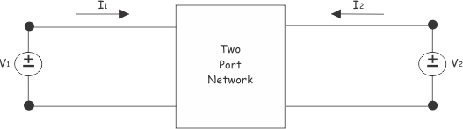

If the network is driven by current, that can be represented as shown below.

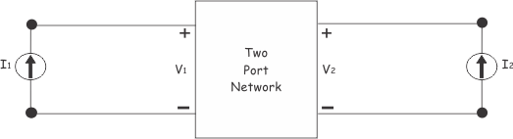

From, both of the figures above, it is clear that, there are only four variables. One pair of voltage variables V1 and V2 and one pair of current variables I1 and I2. Thus, there are only four ratio of voltage to [current](https://www.electrical4u.com/electric-current-and-theory-of-electricity/), and those are,

https://www.electrical4u.com/images/2017/september17/1504771982.PNG

These four rations are considered as parameters of the network. We all know, This is why these parameters are called either **impedance parameter** or **Z parameter**. The values of **Z parameter**s of a [two port network](https://www.electrical4u.com/two-port-network/), can be evaluated by making once

https://www.electrical4u.com/images/2017/september17/1504771791.PNG

This is why these parameters are called either **impedance parameter** or **Z parameter**. The values of these **Z parameter**s of a [two port network,](https://www.electrical4u.com/two-port-network/) can be evaluated by making once and another once

https://www.electrical4u.com/images/2017/september17/1504772333.PNG

https://www.electrical4u.com/images/2017/september17/1504772387.PNG

The [Z parameters](https://www.electrical4u.com/impedance-parameter-or-z-parameter/) are,

https://www.electrical4u.com/images/2017/september17/1504346255.PNG



https://www.electrical4u.com/images/2017/september17/1504345650.PNG

The [voltages](https://www.electrical4u.com/voltage-or-electric-potential-difference/) are represented as

https://www.electrical4u.com/images/2017/september17/1504347284.PNG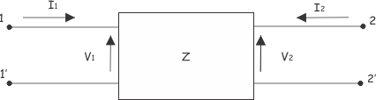

https://www.electrical4u.com/images/2017/september17/1504368230.PNG

**Admittance parameters or short circuit parameters(Y)**:We can represent current in terms of voltage bt

**admittance parameters** of a two port network. Then we will represent the current voltage relations as,

https://www.electrical4u.com/images/2017/september17/1504867297.PNG

This can also be represented in matrix form as,

https://www.electrical4u.com/images/2017/september17/1504867503.PNG

Here, Y11, Y12, Y21 and Y22 are **admittance parameter**. Sometimes these are called as **Y parameters**. We can determine the values of the parameters of a particular [two port network](https://www.electrical4u.com/two-port-network/) by making short-circuited output port and input port alternatively as follows. First let us apply [current source](https://www.electrical4u.com/ideal-dependent-independent-voltage-current-source/) of I1 at input port keeping the output port short circuited as shown below.

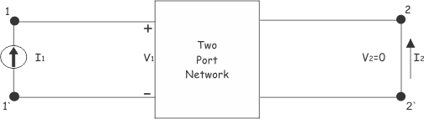

Now, the ratio of input current I1 to input voltage V1 while output voltage V2 = 0, is

https://www.electrical4u.com/images/2017/september17/1504868356.PNG

This is called short circuit input [**admittance**](https://www.electrical4u.com/admittance/). The ratio of output current I2 to input voltage V1 while output voltage V2 = 0, is

https://www.electrical4u.com/images/2017/september17/1504868781.PNG

This is referred as short circuit transfer [**admittance**](https://www.electrical4u.com/admittance/) from input port to output port. Now, let us short circuit the input port of the network and apply current I2 at output port, as shown below.

In this case,

https://www.electrical4u.com/images/2017/september17/1504869335.PNG

This is called short circuit output [**admittance**.](https://www.electrical4u.com/admittance/)

https://www.electrical4u.com/images/2017/september17/1504869547.PNG

This is called short circuit transfer admittance from input port to output port. So finally,

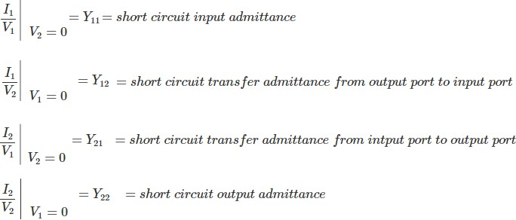

##### Hybrid Parameters or h Parameters:

**Hybrid parameters** are also referred as **h parameters**. These are referred as hybrid because, here [Z parameters](https://www.electrical4u.com/impedance-parameter-or-z-parameter/), [Y](https://www.electrical4u.com/admittance-parameters-or-y-parameters/) [parameters,](https://www.electrical4u.com/admittance-parameters-or-y-parameters/) voltage ratio, current ratio, all are used to represent the relation between voltage and current in a [two](https://www.electrical4u.com/two-port-network/) [port network.](https://www.electrical4u.com/two-port-network/) The relations of voltages and current in **hybrid parameters** are represented as,

https://www.electrical4u.com/images/2017/september17/1504969342.PNG

This can be represented in matrix form as,

https://www.electrical4u.com/images/2017/september17/1504933140.PNG

**Hybrid parameters** or **h parameters** are very much useful in analyzing electronics circuit where, [transistors](https://www.electrical4u.com/jfet-or-junction-field-effect-transistor/) like elements are connected. In those circuits, sometimes it is difficult to measure [Z parameters](https://www.electrical4u.com/impedance-parameter-or-z-parameter/) and [Y parameters](https://www.electrical4u.com/admittance-parameters-or-y-parameters/) but h parameters can be measured in much easier way.

##### Determining h Parameters

Let us short circuit the output port of a [two port network](https://www.electrical4u.com/two-port-network/) as shown below,

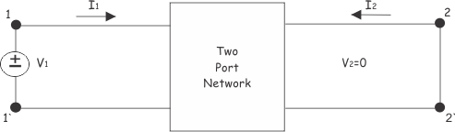

Now, ratio of input voltage to input current, at short circuited output port, is

https://www.electrical4u.com/images/2017/september17/1504933957.PNG

this is referred as short circuit input impedance. Now, the ratio of the output current to input current at short circuited output port, is

https://www.electrical4u.com/images/2017/september17/1504934133.PNG

This is called short circuit current gain of the network. Now, let us open circuit the port 1. At that condition, there will be no input current (I1=0) but open circuit voltage V1 appears across the port 1, as shown below

, 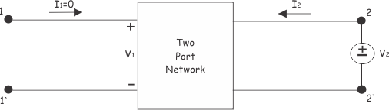

https://www.electrical4u.com/images/2017/september17/1505008580.GIF

This is referred as reverse voltage gain because, this is the ratio of input voltage to output voltage of the network, but voltage gain is defined as ratio of output voltage to input voltage of a network. Now,

https://www.electrical4u.com/images/2017/september17/1504935150.PNG

It is referred as open circuit output [admittance.](https://www.electrical4u.com/admittance/)

##### h Parameter Equivalent Network of Two Port Network

To draw **h parameter** equivalent network of a [two port network,](https://www.electrical4u.com/two-port-network/) first we have to write the equation of voltages and currents using h parameters. These are,

https://www.electrical4u.com/images/2017/september17/1504935479.PNG

clearly, the equation (i) can be represented as circuit based on [Kirchhoff Voltage Law.](https://www.electrical4u.com/kirchhoff-current-law-and-kirchhoff-voltage-law/)

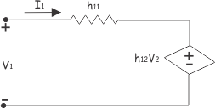

Clearly, the equation (ii) can be represented as circuit based on [Kirchhoff Current Law.](https://www.electrical4u.com/kirchhoff-current-law-and-kirchhoff-voltage-law/)

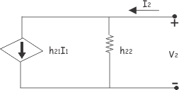

Combining these two parts of the network, we get,

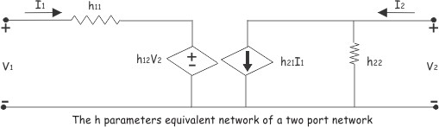

##### ABCD Parameters of Transmission Line parameters:

A major section of power system engineering deals in the [transmission of electrical power](https://www.electrical4u.com/electrical-power-transmission-system-and-network/) from one particular place (eg. generating station) to another like [substations](https://www.electrical4u.com/electrical-power-substation-engineering-and-layout/) or distribution units with maximum efficiency. So it's of substantial importance for power system engineers to be thorough with its mathematical modeling. Thus the entire transmission system can be simplified to a **two port network** for the sake of easier calculations.

The circuit of a 2 port network is shown in the diagram below. As the name suggests, a 2 port network consists of an input port PQ and an output port RS. In any 4 terminal network, (i.e. linear, passive, bilateral network) the input [voltage](https://www.electrical4u.com/voltage-or-electric-potential-difference/) and input current can be expressed in terms of output voltage and output current. Each port has 2 terminals to connect itself to the external circuit. Thus it is essentially a 2 port or a 4 terminal circuit, having

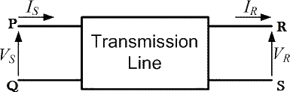

https://www.electrical4u.com/electrical/power-system-equations/transmission-equation/abcd-parameters-of-transmission-line-1.gif

Given to the input port PQ.

https://www.electrical4u.com/electrical/power-system-equations/transmission-equation/abcd-parameters-of-transmission-line-2.gif

Now the **ABCD parameters** or the transmission line parameters provide the link between the supply and receiving end voltages and currents, considering the circuit elements to be linear in nature.

Thus the relation between the sending and receiving end specifications are given using **ABCD parameters** by the equations below.

https://www.electrical4u.com/electrical/power-system-equations/transmission-equation/abcd-parameters-of-transmission-line-3.gif

Now in order to determine the ABCD parameters of transmission line let us impose the required circuit conditions in different cases.

##### ABCD Parameters, When Receiving End is Open Circuited

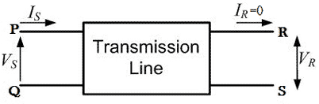

The receiving end is open circuited meaning receiving end [current](https://www.electrical4u.com/electric-current-and-theory-of-electricity/) IR = 0. Applying this condition to equation (1) we get,

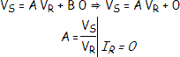

Thus its implies that on applying short circuit condition to ABCD parameters, we get parameter B as the ratio of sending end voltage to the short circuit receiving end current. Since dimension wise B is a ratio of voltage to current, its unit is Ω. Thus B is the short circuit [resistance](https://www.electrical4u.com/electrical-resistance-and-laws-of-resistance/) and is given by B = VS ⁄ IR Ω. Applying the same short circuit condition i.e VR = 0 to equation (2) we get

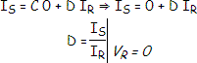

Thus its implies that on applying short circuit condition to ABCD parameters, we get parameter D as the ratio of sending end current to the short circuit receiving end current. Since dimension wise D is a ratio of current to current, it‘s a dimension less parameter.

Find the z parameters for network shown in figure

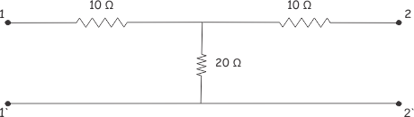

Let us put a [voltage source](https://www.electrical4u.com/voltage-source/) V1 at input,

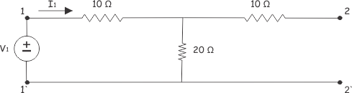https://www.electrical4u.com/images/2017/september17/1504778181.PNG

https://www.electrical4u.com/images/2017/september17/1504778372.PNG

Now, let us connect one voltage source V2 at output port and leave the input port as open as shown, below

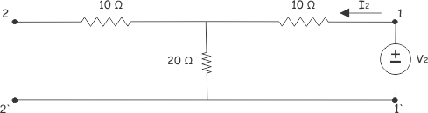

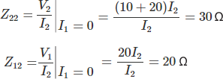

https://www.electrical4u.com/images/2017/september17/1504779287.PNG

Now,

Therefore the above network is symmetrical, reciprocal network

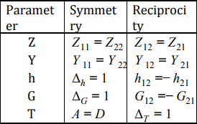

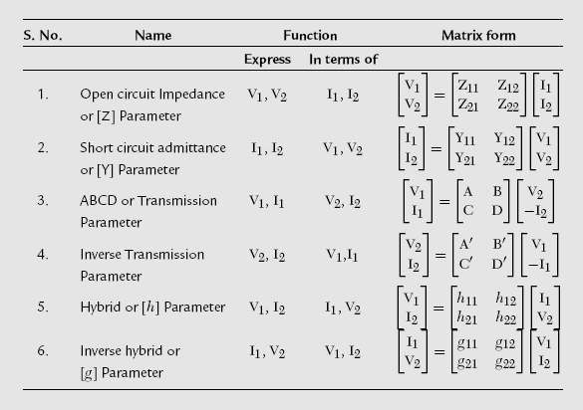

##### Procedure of two port parameter conversions

In the previous chapter, we discussed about six types of two-port network parameters. Now, let us convert one set of two-port network parameters into other set of two port network parameters. This conversion is known as two port network parameters conversion or simply, **two-port parameters conversion**.

Sometimes, it is easy to find one set of parameters of a given electrical network easily. In those situations, we can convert these parameters into the required set of parameters instead of calculating these parameters directly with more difficulty.

Now, let us discuss about some of the two port parameter conversions

* **Step 1** − Write the equations of a two port network in terms of desired parameters.
* **Step 2** − Write the equations of a two port network in terms of given parameters.
* **Step 3** − Re-arrange the equations of Step2 in such a way that they should be similar to the equations of Step1.
* **Step 4** − By equating the similar equations of Step1 and Step3, we will get the desired parameters in terms of given parameters. We can represent these parameters in matrix form.

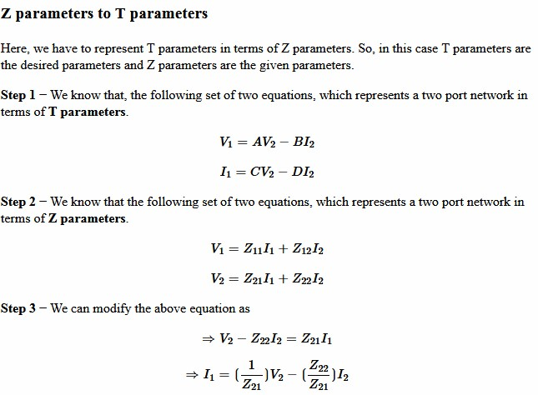

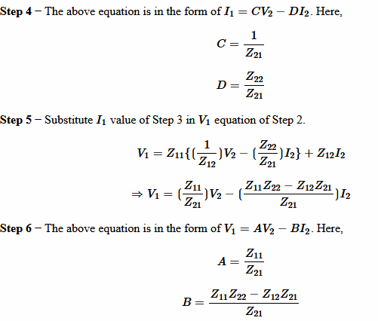

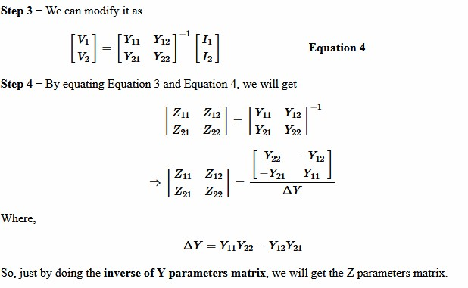

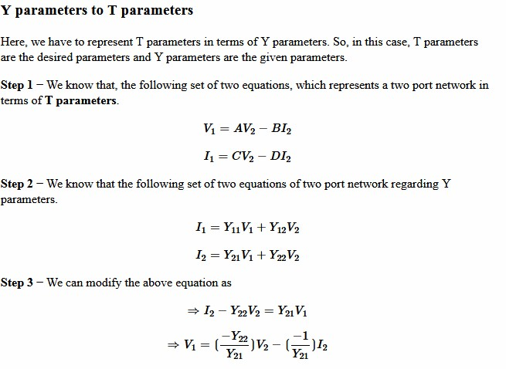

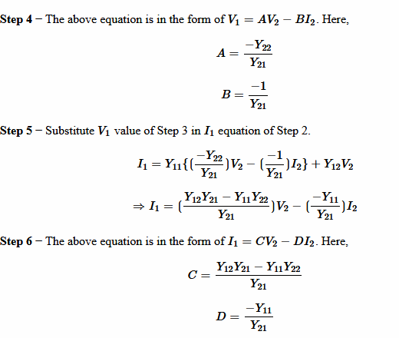

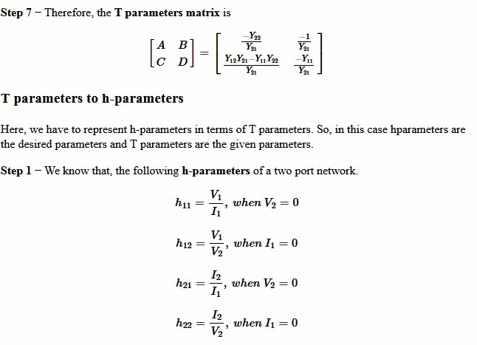

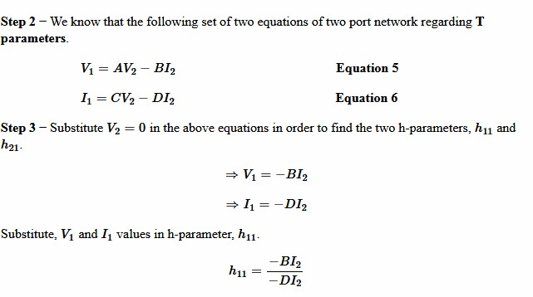

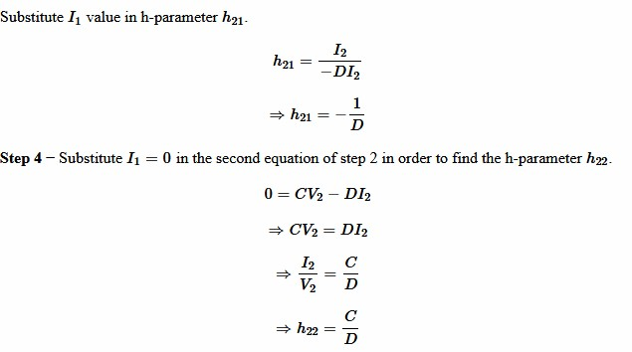

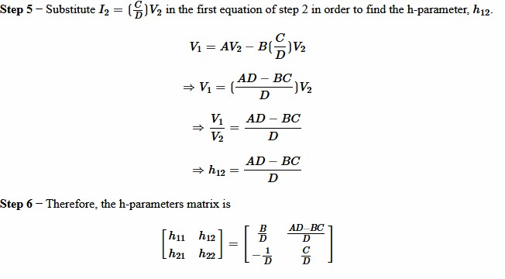

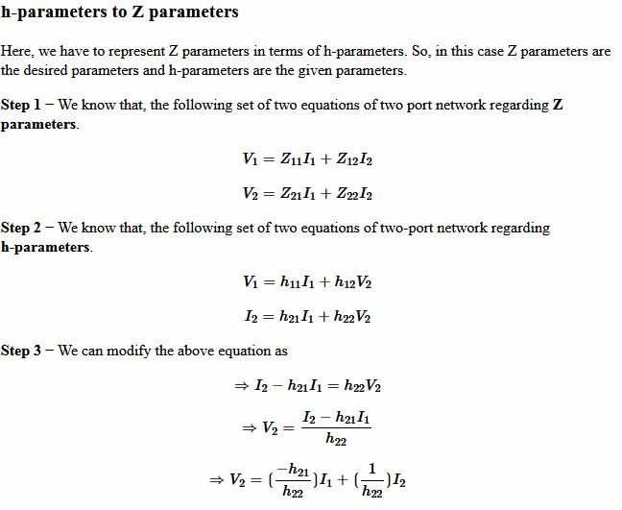

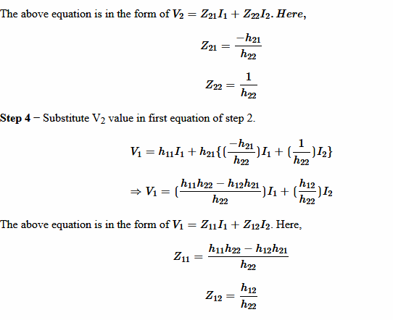

##### Interconnections of two-port networks

Two-port networks may be interconnected in various configurations, such as series, parallel, cascade, series- parallel, and parallel-series connections. For each configuration a certain set of parameters may be more useful than others to describe the network.

##### series connection

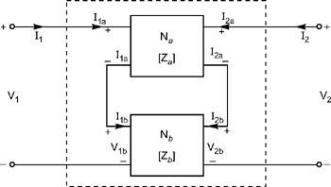

Series connection of two two-port networks For network N a,

http://images.books24x7.com/bookimages/id_24728/eqn580285_0_thm.jpghttp://images.books24x7.com/bookimages/id_24728/eqch10eqn63_0_thm.jpghttp://images.books24x7.com/bookimages/id_24728/eqch10eqn63_0_thm.jpg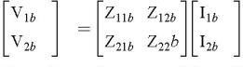http://images.books24x7.com/bookimages/id_24728/eqch10eqn65_0_thm.jpghttp://images.books24x7.com/bookimages/id_24728/eqch10eqn65_0_thm.jpg

The condition for series connection is

http://images.books24x7.com/bookimages/id_24728/eqch10eqn67_0_thm.jpg

Putting the values of V 1a and V 1b from Equation (10.62) and Equation (10.64), Putting the values of V 2a and V 2b

http://images.books24x7.com/bookimages/id_24728/eqn583900_0_thm.jpgfrom Equation (10.63) and Equation (10.65) into Equation (10.67), we get

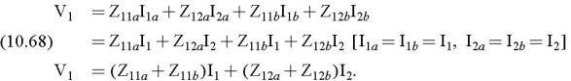

The Z-parameters of the series-connected combined network can be written as

http://images.books24x7.com/bookimages/id_24728/eqn583900_0_thm.jpg

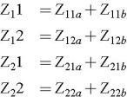http://images.books24x7.com/bookimages/id_24728/eqn584650_0_thm.jpg

The overall Z-parameter matrix for series connected two-port networks is simply the sum of Z-parameter matrices of each individual two-port network connected in series.

**Parallel Connection**

#### Parallel connection of two two-port networks N a and N b. The resultant of two admittances connected in parallel is Y 1 + Y 2. So in parallel connection, the parameters are Y-parameters.

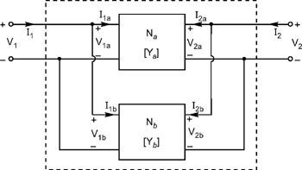

Parallel connections for two two-port networks For network N a

for a network,

http://images.books24x7.com/bookimages/id_24728/eqn584838_0_thm.jpghttp://images.books24x7.com/bookimages/id_24728/eqch10eqn71_0_thm.jpghttp://images.books24x7.com/bookimages/id_24728/eqch10eqn71_0_thm.jpg

for b network,

http://images.books24x7.com/bookimages/id_24728/eqn585647_0_thm.jpg

http://images.books24x7.com/bookimages/id_24728/eqch10eqn72_0_thm.jpg

http://images.books24x7.com/bookimages/id_24728/eqch10eqn73_0_thm.jpghttp://images.books24x7.com/bookimages/id_24728/eqn586442_0_thm.jpghttp://images.books24x7.com/bookimages/id_24728/eqch10eqn74_0_thm.jpghttp://images.books24x7.com/bookimages/id_24728/eqch10eqn75_0_thm.jpghttp://images.books24x7.com/bookimages/id_24728/eqn587047_0_thm.jpghttp://images.books24x7.com/bookimages/id_24728/eqch10eqn76_0_thm.jpghttp://images.books24x7.com/bookimages/id_24728/eqch10eqn77_0_thm.jpg

the Y-parameters of the parallel connected combined network can be written as

http://images.books24x7.com/bookimages/id_24728/eqn588162_0_thm.jpg

##### Cascade connection of two port networks:

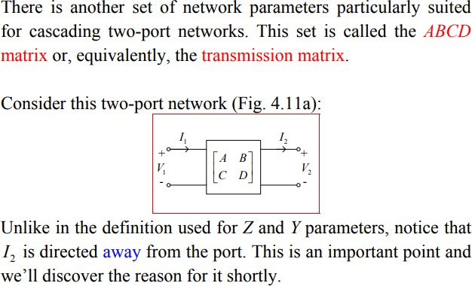

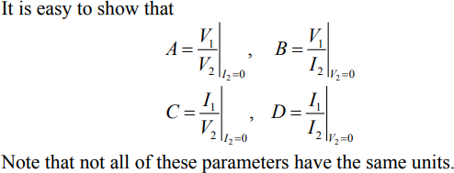

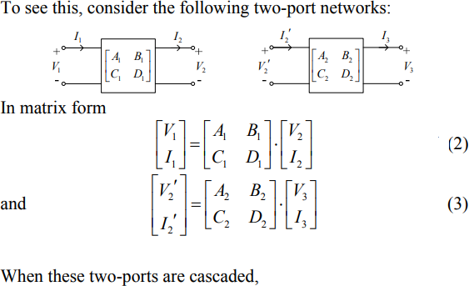

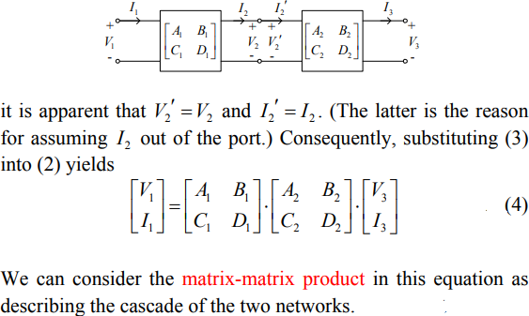

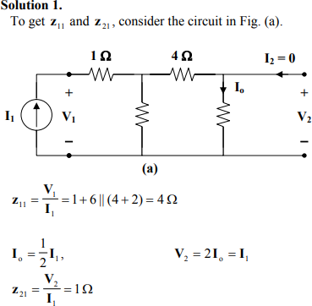

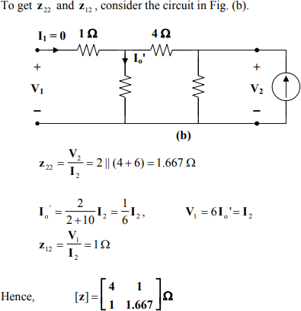

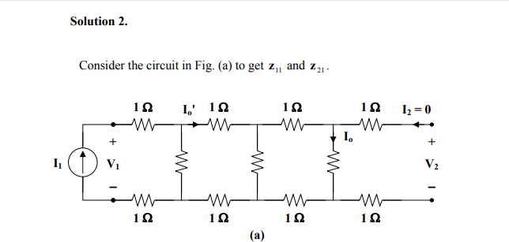

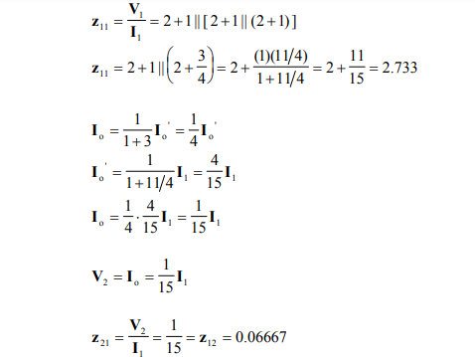

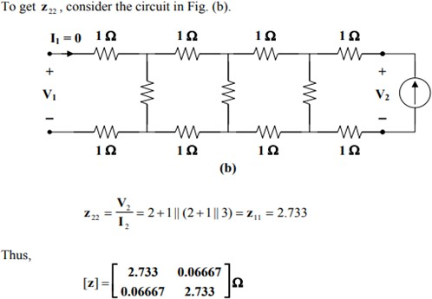

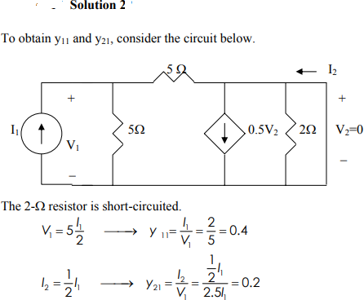

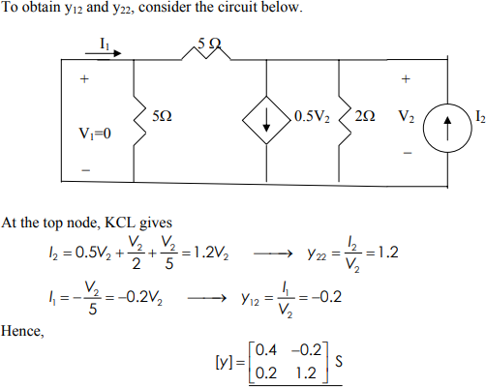

Find the y parameters for the network shown in figure below?

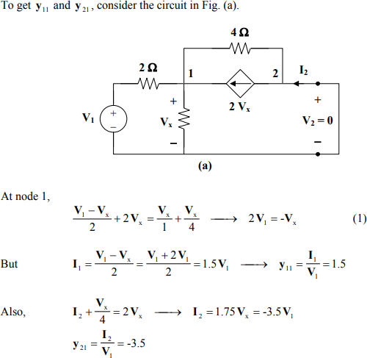

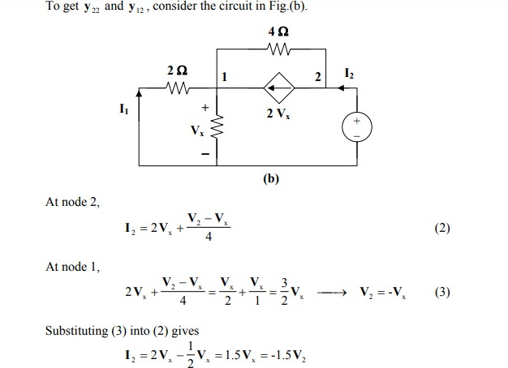

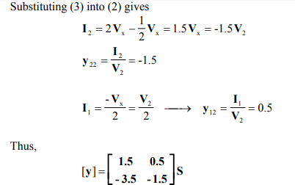

#### Determine the transmission parameters of the circuit in Fig. below

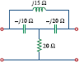

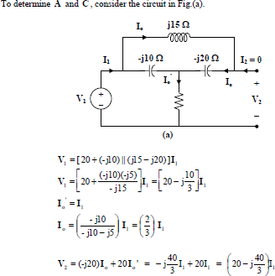

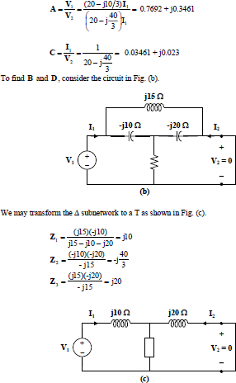

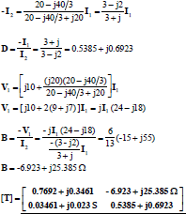

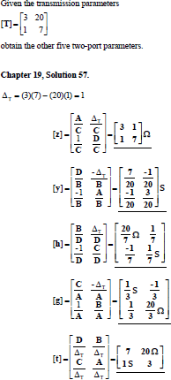

* Find the transmission parameters for z parameters of the network are Z=[25 20;24 30]

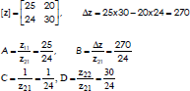

**UNIT- VI**

**Network Functions**

**A network function** is the Laplace transform of an impulse response. Its format is a ratio of two polynomials of the complex frequencies. Consider the general two-port network shown in Figure 2.2a. The terminal voltages and currents of the two-port can be related by two classes of network functions, namely, the driving point functions and the transfer functions.

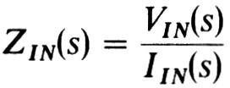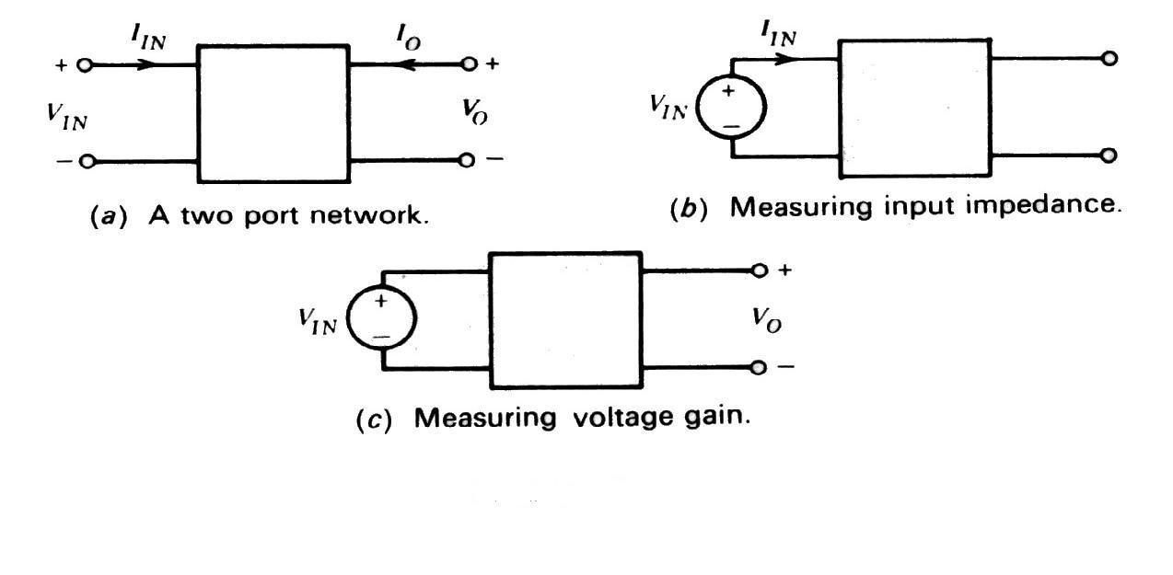

The driving point functions relate the voltage at a port to the current at the same port. Thus, these functions are a property of a single port. For the input port the driving point impedance function ZIN(s) is defined as:

This function can be measured by observing the current IIN when the input port is driven by a voltage source VIN (Figure 2.2b). The driving point admittance function YIN(s) is the reciprocal of the impedance function, and is given by:

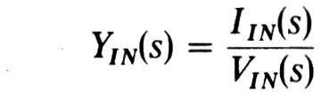

The output port driving point functions are denned in a similar way. The transfer functions of the two-port relate the voltage (or current) at one port to the voltage (or current) at the other port. The possible forms of transfer functions are:

* + 1. The voltage transfer function, which is a ratio of one voltage to another voltage.
    2. The current transfer function, which is a ratio of one current to another current.
    3. The transfer impedance function, which is the ratio of a voltage to a current.
    4. The transfer admittance function, which is the ratio of a current to a voltage. The voltage transfer functions are defined with the output port an open circuit, as:

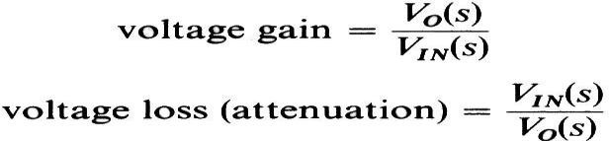

To evaluate the voltage gain, for example, the output voltage VO is measured with the input port driven by a voltage source VIN (Figure 2.2c). The other three types of transfer functions can be defined in a similar manner. Of the four types of transfer functions, the voltage transfer function is the one most often specified in the design of filters.

The functions defined above, when realized using resistors, inductors, capacitors, and active devices, can be shown to be the ***ratios of polynomials in s*** with real coefficients. This is so because the network functions are obtained by solving simple algebraic node equations, which involve at most the terms R, sL, sC and their reciprocals. The active device, if one exists, the solution still involves only the addition and multiplication of simple terms, which can only lead to a ratio of polynomials in s. In addition, all the coefficients of the numerator and denominator polynomials will be real. Thus, the general form of a network function is:

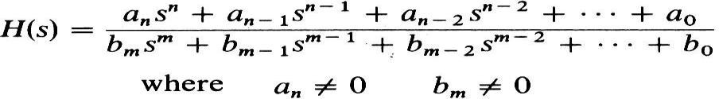

and all the coefficients ai and bi are real. If the numerator and denominator polynomials are factored, an alternate form of H(s) is obtained:

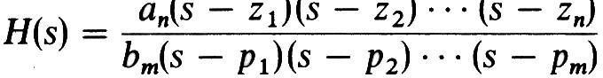

#### I

n this expression z1, z2, ..., zn are called the zeros of H(s), because H(s) = 0 when s = zi. The roots of the denominator pl, p2, ..., pm are called the poles of H(s). It can be seen that H(s) = ∞ at the poles, s

= pi.The poles and zeros can be plotted on the complex s plane (s = σ + jω), which has the real p art σ for the abscissa, and the imaginary part jω for the ordinate below

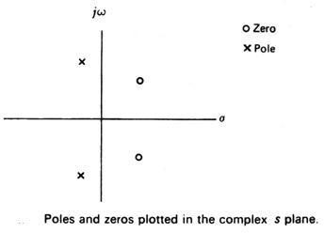

* 1. **Properties of all Network Functions:**

We have already seen that ***network functions are ratios of polynomials in s with real coefficients.*** A consequence of this property is that ***complex poles (and zeros) must occur in conjugate pairs.*** To demonstrate this fact consider a complex root at (s = -a – jb) which leads to the factor (s + a + jb) in the network function. The jb term will make some of the coefficients complex in the polynomial, unless the conjugate of the complex root at (s = -a + jb) is also present in the polynomial. The product of a complex factor and its conjugate is



Further important properties of network functions are obtained by restricting ***the networks to be stable***, by which we mean that a bounded input excitation to the network must yield a bounded response. Put differently, the output of a stable network cannot be made to increase indefinitely by the application of a bounded input excitation. Passive networks are stable by their very nature, since they do not contain energy sources that might inject additional energy into the network. Active networks, however, do contain energy sources that could join forces with the input excitation to make the output increase indefinitely. Such unstable networks, however, have no use in the world of practical filters and are therefore precluded from all our future discussions.

A convenient way of determining the stability of the general network function H(s)

is by considering its response to an impulse function, which is obtained by taking the inverse Laplace transform of the partial fraction expansion of the function.

* + - If the network function has a simple pole on the real axis, the impulse response due to it (for t >= 0) will have the form:

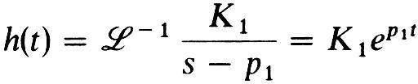

For p1 positive, the impulse response is seen to increase exponentially with time, corresponding to an unstable circuit. Thus, ***H(s) cannot have poles on the positive real axis.***

* Suppose H(s) has a pair of complex conjugate poles at s = a +/- jb. The contribution to the impulse response due to this pair of poles is

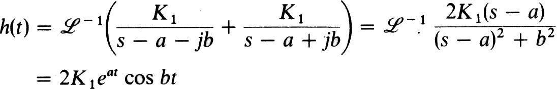

Now if a is positive, corresponding to poles in the right half s plane, the response is seen to be an exponentially increasing sinusoid (Figure 2.4b). Therefore, ***H(s) cannot have poles in the right half s plane.*** An additional restriction on the poles of H(s) is that ***any poles on the imaginary axis must be simple.***

Similarly, it can be shown that higher order poles on the jω axis will also cause the network to be unstable. From the above discussion we see that H(s) has the following factored form:

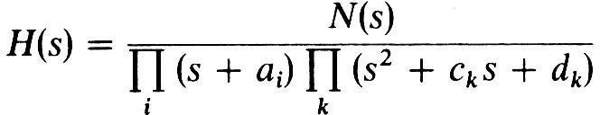

Where N(s) is the numerator polynomial and the constants associated with the denominator ai, ck, and dk are real and nonnegative. The (s + ai) terms represent poles on the negative real axis and the second order terms represent complex conjugate poles in the left half s plane. It is easy to see that the product of these factors can only lead to a polynomial, all of whose coefficients are real and positive; moreover, none of the coefficients may be zero unless all the even or all the odd terms are missing.

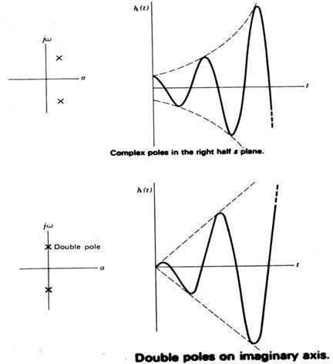

***In summary,*** the network functions of all passive networks and all stable active Must be rational functions in s with real coefficients.

* + May not have poles in the right half s plane.
  + May not have multiple poles on the jω axis.

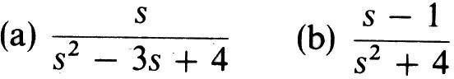Example: Check to see whether the following are stable network functions:

The first function cannot be realized by a stable network because one of the coefficients in the denominator polynomial is negative. It can easily be verified that the poles are in the right half s plane.

The second function is stable. The poles are on the jω axis (at s = +/- 2j) and are simple. Note that the function has a zero in the right half s plane; however, this does not violate any of the requirements on network functions.

### Properties of Driving Point (Positive Real) Functions:

These conditions are required to satisfy to be positive realness

* Y(s) must be a rational function in s with real coefficients, i.e., the coefficients of the numerator and denominator polynomials is real and positive.
* The poles and zeros of Y(s) have either negative or zero real parts, i.e., Y(s) not have poles or zeros in the right half s plane.
* Poles of Y(s) on the imaginary axis must be simple and their residues must be real and positive, i.e., Y(s) not has multiple poles or zeros on the jω axis. The same statement applies to the poles of l/Y(s).
* The degrees of the numerator and denominator polynomials in Y(s) differ at most by 1. Thus the number of finite poles and finite zeros of Y(s) differ at most by 1.
* The terms of lowest degree in the numerator and denominator polynomials of Y(s) differ in degree at most by 1. So Y(s) has neither multiple poles nor zeros at the origin.
* There be no missing terms in numerator and denominator polynomials unless all even or all odd terms are missing.

### Test for necessary and sufficient conditions:

* + Y(s) must be real when s is real.
  + If Y(s) = p(s)/q(s), then p(s) + q(s) must be Hurwitz. This requires that:

1. the continued fraction expansion of the Hurwitz test give only real and positive coefficients, and
2. the continued fraction expansion not end prematurely.
   * In order that Re [Y(jω)] >= 0 for all ω, it is necessary and sufficient that

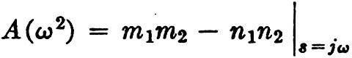

have no real positive roots of odd multiplicity. This may be determined by factoring

2

A (ω ) or by the use of Sturm's theorem.

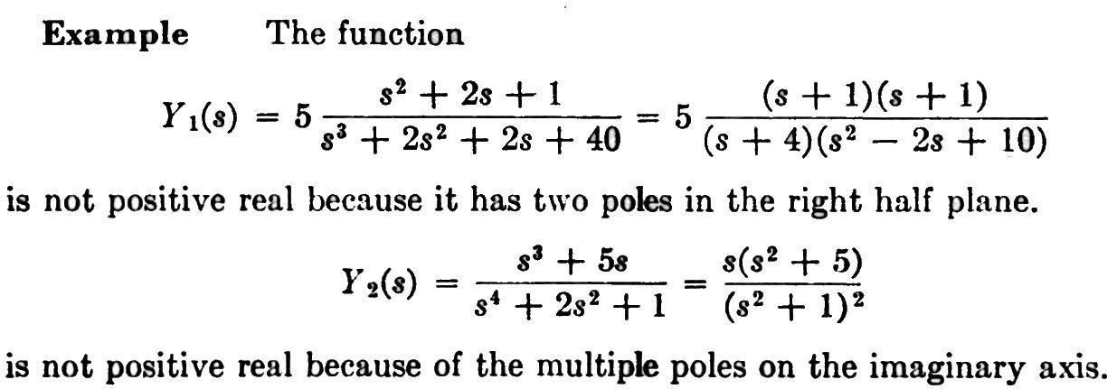

### System Poles and Zeros:

The transfer function provides a basis for determining important system response characteristics without solving the complete differential equation. As defined, the transfer function is a rational function in the complex variable *s* = *σ* + *jω*, that is



It is often convenient to factor the polynomials in the numerator and denominator, and to write the transfer function in terms of those factors



Where the numerator and denominator polynomials, *N*(*s*) and *D*(*s*), have real coefficients defined by the system‘s differential equation and *K* = *bm/an*. As written in Eq. (2) the *zi*‘s are the roots of the equation

N(s) =0

and are defined to be the system zeros, and the pi‘s are the roots of the equation

D(s) = 0,

and are defined to be the system *poles*. In Eq. (2) the factors in the numerator and denominator are written so that when *s* = *zi* the numerator *N*(*s*) = 0 and the transfer function vanishes, that is

lim *H* (*s*)  0

*s**zi*

and similarly when *s* = *pi* the denominator polynomial *D*(*s*) = 0 and the value of the transfer function becomes unbounded,

lim *H* (*s*) 

*s* *pi*

All of the coefficients of polynomials *N*(*s*) and *D*(*s*) are real, therefore the poles and zeros must be either purely real, or appear in complex conjugate pairs. In general for the poles, either *pi* = *σi*, or else *pi, pi*+1 = *σi+jωi*. The existence of a single complex pole without a corresponding conjugate pole would generate complex coefficients in the polynomial *D*(*s*). Similarly, the system zeros are either real or appear in complex conjugate pairs.

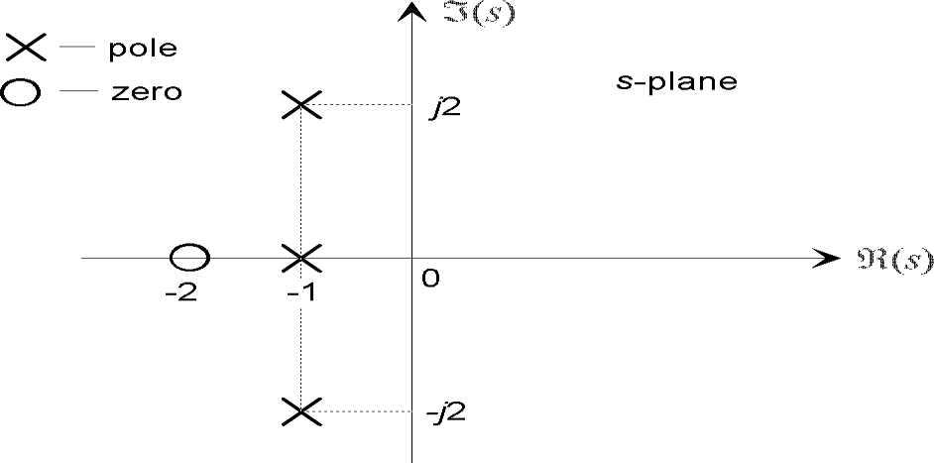

Figure 1: The pole-zero plot for a typical third-order system with one real pole and a complex conjugate pole pair, and a single real zero.

### Pole-Zero Plot:

A system is characterized by its poles and zeros in the sense that they allow reconstruction of the input/output differential equation. In general, the poles and zeros of a transfer function may be complex, and the system dynamics may be represented graphically by plotting their locations on the complex *s*-plane, whose axes represent the real and imaginary parts of the complex variable *s*. Such plots are known as *pole-zero plots*. It is usual to mark a zero location by a circle (*◦*) and a pole location a cross (*×*). The location of the poles and zeros provide qualitative insights into the response characteristics of a system.

##### System stability:

The stability of a linear system may be determined directly from its transfer function. An *n*th order linear system is asymptotically stable only if all of the components in the homogeneous response from a finite set of initial conditions decay to zero as time increases.

* **Poles** and **Zeros** of Transfer Function

**Poles** and **Zeros** of a transfer function are the frequencies for which the value of the denominator and numerator of transfer function becomes zero respectively. The values of the poles and the zeros of a system determine whether the system is stable, and how well the system performs.

Zeros are defined as the roots of the polynomial of the numerator of a transfer function and poles are defined as the roots of the denominator of a transfer function. For the generalized transfer function.

Generally a function can be represented to its polynomial form. For example,



Now similarly transfer function of a control system can also be represented as



Where, K is known as gain factor of the transfer function.  
Now in the above function if s = z1, or s = z2, or s = z3,....s = zn,the value of transfer function becomes zero. These z1, z2, z3,....zn, are roots of the numerator polynomial. As for these roots the numerator polynomial, the transfer function becomes zero, these roots are called zeros of the transfer function.

Now, if s = p1, or s = p2, or s = p3,....s = pm, the value of transfer function becomes infinite. Thus the roots of denominator are called the poles of the function.  
Now let us rewrite the transfer function in its polynomial form.



Now, let us consider s approaches to infinity as the roots are all finite number, they can be ignored compared to the infinite s.

Therefore

Hence, when s → ∞ and n > m, the function will have also value of infinity, that means the transfer function has poles at infinite s, and the multiplicity or order of such pole is n - m.  
Again, when s → ∞ and n < m, the transfer function will have value of zero that means the transfer function has zeros at infinite s, and the multiplicity or order of such zeros is m - n.

* **Restrictions on pole and zero locations for driving point functions**(or) **necessary conditions fordriving point functions**:

1. The coefficients in the polynomials in numerator and denominator must be real and positive.
2. The poles and zeros, if complex or imaginary, must occur in conjugate pairs.
3. The real part of all poles and zeros must be negative or zero, i.e., the poles and zeros must lie in left half of s plane.
4. If the real part of pole or zero is zero,then that pole or zero must be simple.
5. The polynomials of numerator and denominator may not have missing terms between those of highest and lowest degree, unless all even or all odd terms are missing.
6. The degree of numerator and denominator may differ by either zero or one only. This condition prevents multiple poles and zeros at s = ∞.
7. The terms of lowest degree in numerator and denominator may differ in degree by one at most. This condition prevents multiple poles and zeros at s = ∞.

* **Restrictions on pole and zero locations for transfer functions**(or) **necessary conditions for transfer functions:**

1. The coefficients in the polynomials in numerator and denominator must be real and positive.
2. The poles and zeros, if complex or imaginary, must occur in conjugate pairs.
3. The real part of all poles must be negative or zero, if the real part is zero, then that pole must be simple.
4. The polynomials of denominator may not have missing terms between that of highest and lowest degree, unless all odd terms are missing.
5. The polynomials of numerator may have missing terms of highest and lowest degree, and some of the coefficients may be negative.
6. The degree of numerator may be small as zero, independent of the degree of denominator.
7. For voltage and current transfer functions, the maximum degree of numerator is the degree of denominator.
8. The transfer impedance and admittance functions, the maximum degree of numerator is the degree of denominator plus one.