Armature Windings:
The armature winding is the main current-carrying winding in which the electromotive force or counter-emf of rotation is induced. The current in the armature winding is known as the armaturecurrent. The location of the winding depends upon the type of machine.
A d.c. machine (generator or motor) generally employs windings
distributed in slots over the circumference of the armature core. Each
conductor lies at right angles to the magnetic flux and to the direction of its
movement Therefore, the induced e.m.f. in the conductor is given by;
e = Bl v volts
where B = magnetic flux density in Wb/m2
l = length of the conductor in metres
v = velocity (in m/s) of the conductor

Types of Armature Winding
We have seen that there are number of armature conductors, which are connected in specific manner as per the requirements, which is called armature winding. According to the way of connecting the conductors, armature winding has basically two types namely,
a) Lap winding b) Wave winding

- Lap winding:
In this case, if connection is started from conductor in slot 1 then connections overlap each other as winding proceeds, till starting point is reached again.
Developed view of part of the armature winding in lap fashion shown in the Fig. 1.
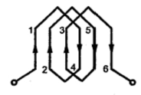
Fig. 1 Lap Winding

As seen from the Fig. 1, there is overlapping of coils while proceeding.
Note : Due to such connection, the total number of conductors get divided into 'P' number of parallel paths, where P = number of pole sin the machine.
Large number of parallel paths indicate high current capacity machine hence lap winding is preferred for high current rating generators.
2. Wave Winding
In this type of connection, winding always travels ahead avoiding overlapping. It travel like a progressive wave hence called wave winding. To get an idea of wave winding a part of armature winding in wave fashion is shown in the Fig. 2.
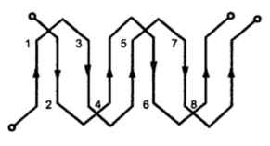
Fig. 2 Wave winding

Both coils starting from slot 1 and slot 2 are progressing in wave fashion.
Note : Due to this type of connection, the total number of conductors get divided into two number of parallel paths always, irrespective of number of poles of the machine. As number of parallel paths are less, it is preferrable for low current, high voltage capacity generators.
The number of parallel paths in which armature conductors are divided due to lap or wave fashion of connection is denoted as A. So A = P for lap connection and A = 2 for wave connection.

3. Comparison of Lap and Wave Type Winding:
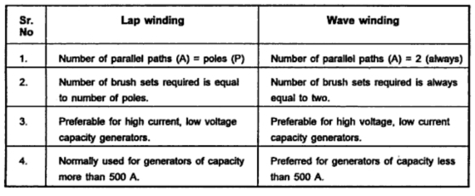
Winding Terminologies
a) Conductor : It is the actual armature conductor which is under the influence of the magnetic field, placed in the armature slot.
b) Turn : The two conductors placed in different slots when connected together,. forms a turn. While describing armature winding the number of turns may be specified from which, the number of conductors can be decided.
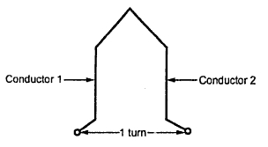
Fig. 1 Single Turn

Z = 2 x Number of turns.
c) Coil : For simplicity of connections, the turns are grouped together to form a coil. If coil contains only one one turn it is called single turn coil while coil more than one turn is called multiturn coil.
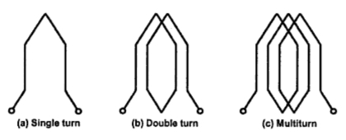
Fig. 2 Armature coils

Hence if number of coils, along with of number of turns per coil are specified, it is possible to determine the total number of turns and hence total number of armature conductors 'Z' required to calculate generated e.m.f.
Example :
A 4 pole, lap wound, d.c. generators has 42 coils with 8 turns per coils. It is driven at 1120 r.p.m. If useful flux per pole is 21 mWb, calculate the generated e.m.f. Find the speed at which it is to be driven to generate the same e.m.f. as calculate above, with wave wound armature.
Solution :
P = 4 Φ = 21 mWb = 21 x 10-3 Wb N = 1120 r.p.m.
Coils = 42 and turns / coil = 8
Total turns = coils x turns / coil = 42 x 8 = 336
Z = 2 x total turns = 2 x 336 = 672
i) For lap wound, A = P
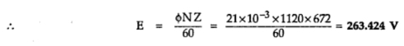

ii) For wave wound, A = 2
and E = 263.424 V
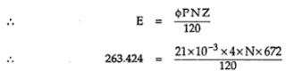

N = 560 r.p.m.

Single Layer and Double Layer Winding
Basically there are two physical types of the windings. These are i) Single layer winding ii) Double layer winding. The sequential arrangement of coils around the armature is different for both these types of windings.
1. Single Layer Winding
In this type of winding, the complete slot is containing only one coil side of a coil. This type of winding is not normally used for machines having commutators. It is shown in the Fig. 1.
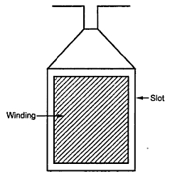
Fig. 1 Single layer winding
In single layer windings permit the use of semienclosed and closed types of slots. Also the coils can be pushed through the slots from one end of the core and are connected during the process of windings at the other end. Here the insulation can be properly applied and consolidated which is advantageous in large output machines with high voltage.
The single layer windings used in high voltage machines use small groups of concentrically placed coils. The interlinking between these coils is in such a way so as to minimize the space taken up outside the slot and in the overhang connections.
1.2 Double Layer Winding
It is shown in the Fig. 2. It consists of identical coils with one coilside of each coil in top half of the slot and the other coilside in bottom half of another slot which is nearly one pole pitch away.
In the Fig. 2(a) there are two coilsides per slot while in (b) there are eight coilsides per slot. Each layer may contain more than one coil side if large number of coils are required. For placing double layer windings, usually open slots are used.
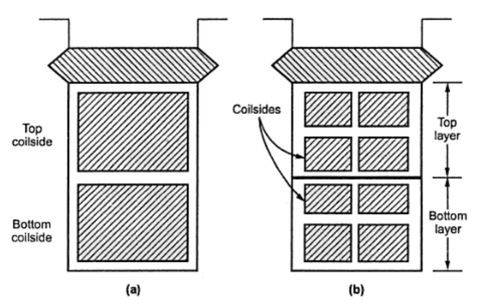
Fig. 2 Double layer winding

Advantages of Double Layer Winding
The double layer winding has following advantages,
1) It provides neat arrangement as all coils are identical.
2) Greater flexibility can be achieved with double layer winding as coil span can be easily selected.

Closed and Open Windings
Armature windings are classified into two different types namely i) Closed type winding ii) Open type winding.
1. Closed Type Winding
In this type of winding, a closed path is formed around the armature. The starting point of the winding is reached again after passing through all the turns. The current passing through closed type of winding is through brushes placed on commutator. The commutator segments are connected to various armature coils.
The armature current gets divided into different parallel paths. The current flowing through the coil changes continuously but from brush side the winding view remains same and polarity is maintained which is in effect due to use of commutator segments.
The closed type of winding is normally used in a.c. and d.c. commutator machines. This type of winding is usually double layer.
2.Open Type Winding
In case of a.c. machines, commutator is not used and hence closed winding is not required to be used. In such cases pen type winding is used. The armature is left open at one or more points.
The ends of each section of the winding can be brought at the terminals to do the required type of interconnection externally. The open type of winding is preferred over closed type as it gives better flexibility in design and freedom of connections.
These type of windings are either single layer type or double layer type and are mainly used in induction machines and synchronous machines.

Armature Winding in D.C. Machines
The armature winding used in d.c. machines are closed and double layer. Each of the coil has its upper coil side placed at the top of one slot and lower coilside placed at the bottom of another slot which is approximately one pole pitch away.
Normally the shape of the coils is like a diamond. These coils are made in special forming machines. The back and front ends are constructed in such a way that on coilside is on a circumferentially higher level than the other. Due to this, higher coilsides are plcaed in the top of a slot while lower coilsides can be placed in the bottom of a slot.
If each slot contains two coil sides then the number of coils equal the number of slots. One coilside is there in each of top and bottom layer. But in case of low speed and high voltage machines, there are large number of coils and hence the coilsides per slot may be 4, 6, 8 or more which means 2, 3, 4 or more coilsides per layer. This is due to the fact that the number of slots can not be increased as it is difficult.
In the Fig. 1 the winding having 4 coilsides per slot are shown.
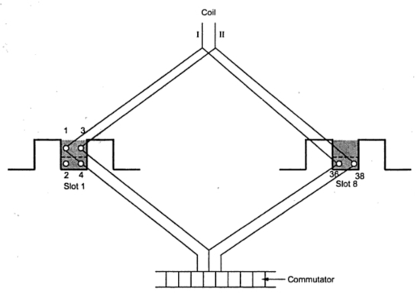
Fig. 1

Note : The numbering to the coilsides is done in such a way that all the coilsides at the top are numbered odd while all the coilsides at the bottom are numbered even.
The coilside 2 is under coilside 1 while coilside 4 is under coilside 3.
1. Coil Span
The two coilsides of a coil are embraced by number of teeth which is known as coil sapn. The coil span is normally equal to pole pitch interms of number of teeth embraced even after deliberated chording of coils in some cases while in few cases it is not possible to have the coil span exactly equal to pole pitch. This situation comes when the number of slots are not divisible by number of poles.
Let us consider number of slots to be 25 and number of poles are say 4. A pole pitch covers 25/4 = 6.25 = 6 and 1/4 slots. Thus coil span of either 6 or 7 may be selected. Normally the nearest whole number is selected which is 6 in present case. If coil span is 6 and if top coil side of a coil lies in slot 1 then the bottom coilside will lie in 1 + 7 = 7th slot.
1.2 Pole Pitch
It may defined as the distance between the two adjacent poles i.e. the periphery of the armature divided by the number of poles. It may also be defined as the number of armature conductors or number of armature slots per pole. For example if there are if there are 64 conductors and 8 poles then pole pitch is 64/8 = 8.
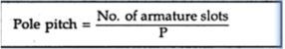

Winding Pitches
Now we will consider the definitions of different types of winding pitches, required in the design of the armature winding.
1. Back Pitch
The distance which is measured interns of armature conductors i.e. between top and bottom coil sides of a coil measured around the back of the armature i.e. away from the commutator is called back pitch and is denoted by . It is measured interms of coil sides.
Note : Since it is difference between odd and even number, it is always odd number.
The size of the coil is decided by the back pitch. The back pitch is normally equal to coilsides per pole. It is shown for lap and wave type of winding in the Fig. 1.
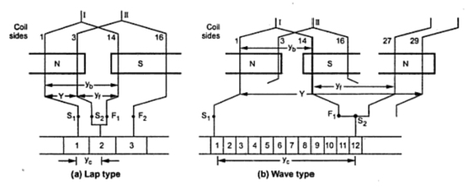
Fig. 1

The back pitch for the winding shown in the Fig. 1 is yb = 14 - 1 = 13 as coilsides 1and 14 are of coil number 1.
2. Front Pitch
It is defined as the distance measured between two coilsides which are connected to some commutator segment. It is denoted by yf. The front pitch for the winding shown in the Fig. 1 is yf = 14 - 3 = 11. This is front pitch for lap winding while for wave winding yf = 27 - 14 = 13. The front pitch for both lap and wave type winding is odd. If for a lap winding the connections are traced then the movement is backwards (coil side 14 to coil side 3). Hence the type of winding can be determined from front pitch and it does not affect the size of coils.
3. Winding Pitch
It is defined as the distance between the starts of two consecutive coils measured in terms of coil sides. It is denoted by Y.
For lap winding, Y = yb - yf
For Wave winding, Y = yb + yf
For the lap winding shown in the Fig. 1 the winding pitch is Y = 13 - 11 = 2 while for wave winding Y = 13 + 13 = 26. It is also the distance round the armature between two consecutive conductors. Practically, coil pitches or winding pitches as low as eight tenths of a pole pitch are employed without much reduction in emf.
Note : Fractional pitches windings are intentionally used so as to achieve saving in copper of the end connections and for improvement in commutation.
4. Commutator Pitch
It is defined as the distance between the two commutator segments to which the two ends i.e. starts and finish of a coil are connected. It is measured in terms of commutator segments and it is denoted by yc. For the windings shown in the Fig. 1.
yc = 2 - 1 = 1 for simplex lap winding
yc= 12 - 1 = 11 for simplex wave winding
For lap winding is the difference between yb and yf while for wave winding yc is the sum of yband yf. The number of bars between the coil leads is commutator pitch. In general yc is the 'plex' of lap wound armature. It is 1, 2, 3 for simplex, duplex, triplex lap windings respectively.
On tracing through simplex lap winding,a segment adjacent to the first one is reached after traversing through one coil. For simplex wave winding, the adjacent segment is reached after traversing through P/2 coils.
Progressive Winding
A progressive winding is one in which, as one traces through the winding, the connections to the commutator will progress around the machine in the same direction as is being traced along the path of each individual coil. Fig. (1.24) (i) shows progressive lap winding. Note that YB > YF and YC = + 1.
Retrogressive Winding
A retrogressive winding is one in which, as one traces through the winding, the connections to the commutator will progress around the machine in the opposite direction to that which is being traced along the path of each individual coil. Fig.(1.24) (ii) shows retrogressive lap winding. Note that YF > YB and YC =  1. A retrogressive winding is seldom used because it requires more copper.

E.M.F. Equation of D.C. Generator
Let P = Number of poles of the generator
Φ = Flux produced by each pole in webers (Wb)
N = Speed of armature in r.p.m.
Z = Total Number of Armature Conductors
A = Number of parallel paths in which the 'Z' number of conductors are divided
So A = P for lap type of winding
A = 2 for wave type of winding
Now e.m.f. gets induced in the conductor according to Faraday's law of electromagnetic induction. Hence average value of e.m.f. induced in each armature conductor is,
e = Rate of cutting the flux = dΦ/dt
Now consider one revolution of conductor. In one revolution, conductor will cut total flux produced by all the poles i.e. Φ x P. While time required to complete one revolution is 60/N seconds as speed is N r.p.m.
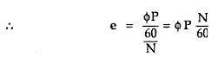

This is the e.m.f. induced in one conductor. Now the conductors in one parallel path are always in series. There are total Z conductor with A parallel paths, hence Z/A number of conductors are always in series and e.m.f. remains same across all the parallel paths.
... Total e.m.f. can be expressed as,
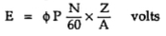

This is nothing but the e.m.f. equation of a d.c. generator.
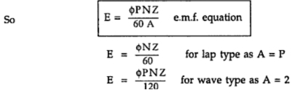

Example : A 4 pole, lap wound, d.c. generator has a useful flux of 0.07 Wb per pole. Calculate the generated e.m.f. when it is rotated at a speed of 900 r.p.m. with the help of prime mover. Armature consists of 440 number of conductors. Also calculate the generated e.m.f. if lap wound armature is replaced by wave wound armature.
Solution :
P = 4 Z = 440 Φ = 0.07 Wb and N = 900 r.p.m.
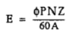

i) For lap wound, A = P = 4
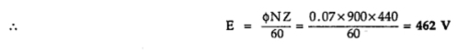

ii) For wave wound A = 2
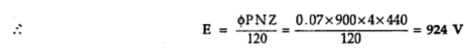

General Rules For D.C. Armature Windings :

In the design of d.c. armature winding (lap or wave), the following rules may be followed:
(i) The back pitch (YB) as well as front pitch (YF) should be nearly equal to pole pitch. This will result in increased e.m.f. in the coils.
(ii) Both pitches (YB and YF) should be odd. This will permit all end connections (back as well as front connection) between a conductor at the top of a slot and one at the bottom of a slot.
(iii) The number of commutator segments is equal to the number of slots or coils (or half the number of conductors).
No. of commutator segments = No. of slots = No. of coils
It is because each coil has two ends and two coil connections are joined at each commutator segment
(iv) The winding must close upon itself i.e. it should be a closed circuit winding.

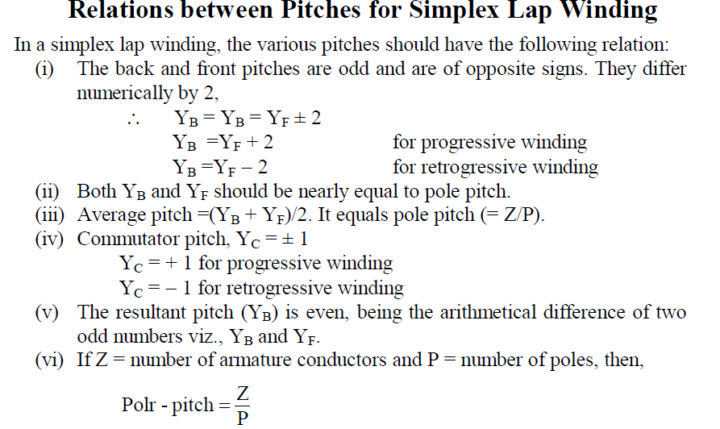
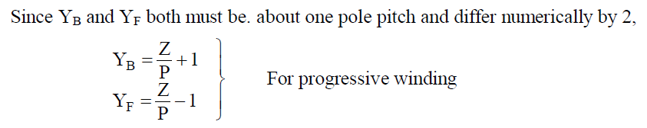
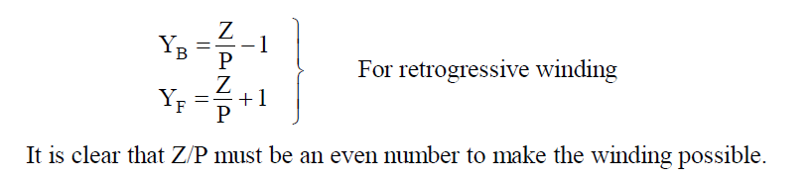
Dummy Coils :
In a simplex wave winding, the average pitch YA (or commutator pitch YC) should be a whole number. Sometimes the standard armature punching available in the market have slots that do not satisfy the above requirement so that more coils (usually only one more) are provided than can be utilized. These extra coils are called dummy or dead coils. The dummy coil is inserted into the slots in the same way as the others to make the armature dynamically balanced
but it is not a part of the armature winding.

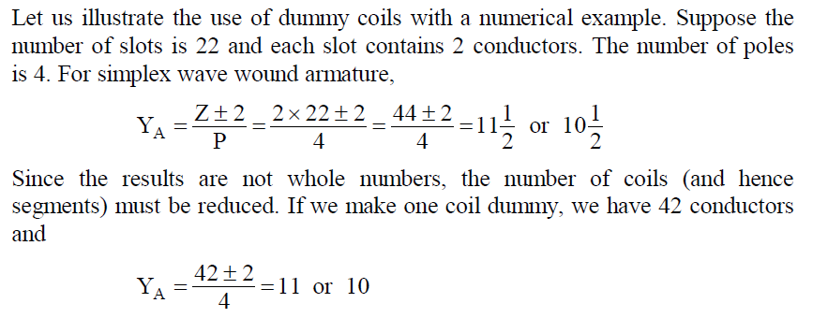
This means that armature can be wound only if we use 21 coils and 21 segments.The extra coil or dummy coil is put in the slot. One end of this coil is taped and the other end connected to the unused commutator segment (segment 22) for the sake of appearance. Since only 21 segments are required, the two (21 and 22 segments) are connected together and considered as one.

Introduction to Armature Reaction :
For the operation of any d.c. machine, presence of magnetic flux is essential. Whenever current flows through a field coil, it produces a flux which is called as field flux. Now suppose the d.c. machine is functioning as a generator, an e.m.f. will be induced in the armature when it is driven by a prime mover. If the generator is driving a load, the induced e.m.f. in the armature will cause current to flow through the load. Thus current will start flowing through the armature conductors. Now every current carrying conductor will set up its own magnetic field. All these armature conductors combine together to produce a flux which can be called armature flux.
Note : Thus the armature current will set up its own magnetic field. The effect of this armature flux on the distribution of main flux is called armature reaction.
The armature reaction will try to make the main field flux to be weakened. Also it will distort the main flux.
Note : These two effects of armature reaction will reduce the generated voltage and may cause sparking at the brushes.

Concept of Armature Reaction
To understand the concept of armature reaction, consider a two pole d.c.generator. For simplicity we will assume that the brushes are touching the armature conductors directly, although, they commutator segments in actual practice.
Assuming that the generator is not driving and load. So that there is no current in the armature conductors. The distribution of main field flux under this case is as shown in the Fig. 1. The flux is distributed symmetrically with respect to axis called polar axis which is line joining the centres of N and S poles. The direction of flux produced by field coil is from left to right through an armature core and lines of force through the core are parallel to field axis.
The axis along which there is no e.m.f. induced in the armature conductors is called Magnetic Neutral Axis (MNA). From the Fig. 1 it can be seen that magnetic neutral axis (MNA) and Geometric Neutral Axis (GNA) coincides with each other. The geometric neutral axis is nothing but the axis of symmetry between the poles.
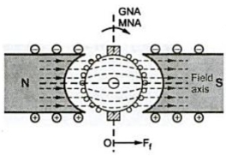
Fig. 1

The brushes are always kept along MNA.
Note : Thus MNA can also be called 'axis of commutation' since reversal pf current takes place along this axis.
As shown in the Fig. 1, vector OFf represents the m.m.f. producing the main flux both in magnitudes as well as in the direction. MNA is perpendicular to vector OFf.
Now we will consider that the field coils are unexcited whereas the armature conductors are carrying current. Under this case the field setup by the armature conductors is as shown in the Fig. 2.
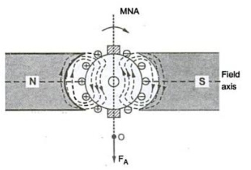
Fig. 2
The direction of current in armature conductors can be found by applying Fleming's right hand rule. The current will flow in the same direction if the generator is driving load. Under N pole, the current is flowing in downward direction whereas under S pole, the current is flowing in upward direction.
The direction of the flux produced by current carrying conductors is vertically downwards in the armature core. This flux is symmetrical about brush axis. In other words current carrying armature conductors try to magnetize the armature core along the brush axis.
The vector OFA shown in the Fig. 2. represents the armature m.m.f. both in magnitude and direction. This m.m.f. depends on the magnitude of the armature current.
Uptil we have considered the main m.m.f. and armature m.m.f. separately as if they are existing independently.
Note : In practice the two m.m.f.s exist simultaneously in the generator under load conditions.
Now the flux through the armature is not uniform and symmetrical. The flux gets distorted. Due to interaction of two fluxes, the resultant flux distribution is changed as shown in the Fig. 3.
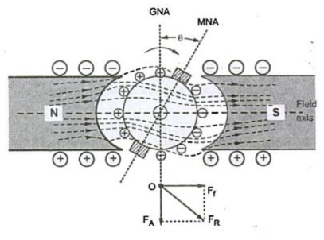
Fig. 3

The flux is crowded or concentrated at the trialing pole tips but weakened out at the leading pole tips.
Note : The pole tip which is met first during rotation by armature conductor is known as leading pole tip and other is known as trialing pole tip.
The resultant m.m.f. OFR can be found by vectorially combining OFf and OFA.
The new position of MNA is also shown which is perpendicular to the resultant m.m.f. vector OFR. The MNA gets shifted through an angle θ so that brushes are also shifted and are along new MNA.
Due to this brush shift, the armature conductors as well as armature current is redistributed. Some of the armature conductors which were earlier under the influence of S pole now come under N pole and vice versa.
This regrouping of armature conductors and armature current is as shown in the Fig. 4. It can also be seen that the brush shifts in the same direction as that of direction of rotation of armature.
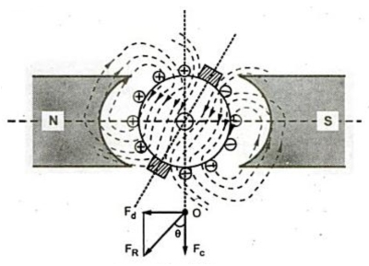
Fig. 4

The conductors on the left of new position of MNA carry current downwards and those to the right carry current upwards. The armature m.m.f. is now along new position of MNA represented by vector OFR in the Fig. 4. It is inclined at an angle θ to the left instead of being vertical.
The armature m.m.f. represented by vector OFR can be resolved into two components, OFdparallel to the polar axis and OFc perpendicular to the axis. The component OFR is in direct opposition with field m.m.f. vector OF. This will tend to reduce the total flux. Hence this component is called demagnetizing component of the armature reaction whereas the other component OFc is at right angles to vector OFf. This will produce distortion in the main field. Hence this component is called cross magnetizing component of the armature reaction.
It can be observed that both the components viz. demagnetizing and cross magnetizing, will increase with increase in armature current.

Demagnetising and Cross Magnetizing Conductors

The conductors which are responsible for producing demagnetizing and distortion effects are shown in the Fig.1.
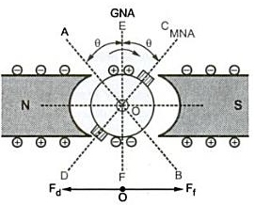
Fig. 1

The brushes are lying along the new position of MNA which is at angle θ from GNA. The conductors in the region AOC = BOD = 2θ at the top and bottom of the armature are carrying current in such a direction as to send the flux in armature from right to left. Thus these conductors are in direct opposition to main field and called demagnetizing armature conductors.
The remaining armature conductors which are lying in the region AOD and BOC carry current in such a direction as to send the flux pointing vertically downwards i.e. at right angles to the main field flux. Hence these conductors are called cross magnetizing armature conductors which will cause distortion in main field flux.
These conductors are shown in the Fig. 2
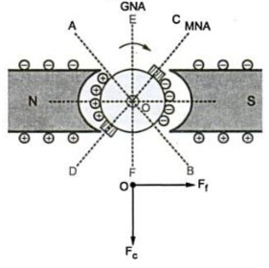
Fig. 2

Calculation of Demagnetizing and Cross Magnetizing Amp-Turns
Let us the number of demagnetizing and cross magnetizing amp-turns.
Let Z = Total number of armature conductors
P = Number of poles
I = Armature conductor current in Amperes
= Ia/2 for simplex wave winding
= Ia/P for simplex lap winding
θm = Forward lead of brush in mechanical degrees.
The conductors which are responsible for demagnetizing ampere-turns are lying in the region spanning 4 θm degrees. The region is between angles AOC and BOD, as shown in the Fig. 2.
... Total number of armature conductors lying in angles AOC and BOD.
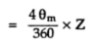
Since two conductors from one turn,
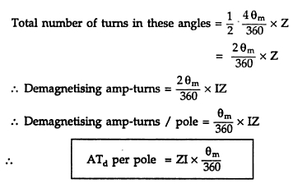

The conductor which are responsible fro cross magnetizing ampere turns are lying between the angles AOD and BOC, as shown in the Fig.2.
Total armature-conductors / pole = Z/P
From above we have found an expression for demagnetizing conductors per pole.
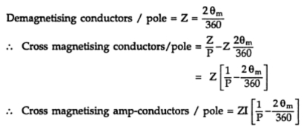

Since two conductors from one turn,
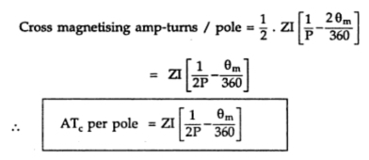

If the brush shift angle is given in electrical degrees then it should be converted into mechanical degrees by using the relation,
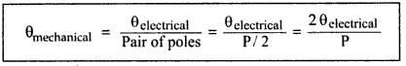

Example :
A wave wound 4 pole d.c. generator with 480 armature conductors supplies a current of 144 A. The brushes are given an actual lead of 10º. Calculate the demagnetizing and cross magnetizing amp turns per pole.
Solution :
P = 4, Z = 480, I_{a} = 144 A
For wave wound,
I = I_{a}/2
= 144/2 = 72 A
θ_{m} = 10º
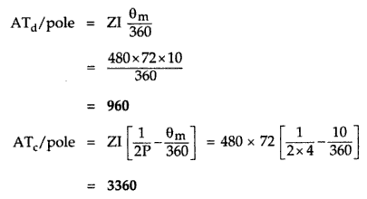

Effects of Armature Reaction
The various effects armature reaction can be summarised as,
1) The armature reaction always results in reduction of generated e.m.f. due to decrease in value of flux per pole.
2) The iron losses in the teeth and pole shoes are determined by the maximum value of flux density at which they work. Due to distortion in main field flux the maximum density at load increase above no load. Thus iron losses are observed to be more on load than on no load.
3) Due to the armature reaction the maximum value of gap flux density increases. This will increase the maximum voltage between adjacent commutator segments at load. If this voltage exceeds beyond 30 V the sparking may take place between adjacent commutator segments.
4) The armature reaction shifts brush axis from GNA. Thus flux density in the interpolar axis is not zero but having some value. Thus there will be an induced e.m.f. in the coil undergoing commutation which will try to maintain the current in original direction. This will make commutation difficult and will cause delayed commutation.

Reduction of Effects of Armature Reaction

In order to reduce the effect of armature reaction following methods are used.
1) The armature reaction causes the distortion in main field flux. This can be reduced if the reluctance of the path of the cross-magnetizing field is increased. The armature teeth and air gap at pole tips offer reluctance to armature flux. Thus by increasing length of air gap, the armature reaction effect is reduced.
2) If reluctance at pole tips is increased it will reduce distorting effect of armature reaction. By using special construction in which leading and trialing pole tip portions of laminations are alternately omitted.
3) The effect of armature reaction can be neutralized by use of compensating winding. It is always placed in series with armature winding. The armature ampere conductors under pole shoe must be equal to compensating winding ampere conductors which will compensate armature m.m.f. perfectly.
4) The armature reaction causes shifting the magnetic neutral axis. Therefore there will be some flux density at brush axis which produces e.m.f. in the coil undergoing commutation. This will lead to delayed commutation. Thus the armature reaction at brush axis must be neutralized. This requires another equal and opposite m.m.f. to that of armature m.m.f. This can be applied by interpoles which are placed at geometric neutral axis at midway between the main poles.
Out of the different methods mentioned above, used to reduce the effects of armature reaction, let us see the method of providing compensating winding in detail. This method is very popularly used in actual practice for d.c. machines.
Use of compensating Winding :
The compensating windings are basically used to neutralize the armature flux in the pole arc region which will otherwise cause sever distortion of main field flux. These windings are of concentric type and are placed in axial slots in the pole faces as sown in the Fig. 1.
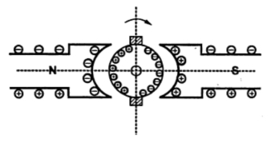
Fig. 1 Compensating winding

The symbolic representation of compensating winding is shown in the Fig. 2.
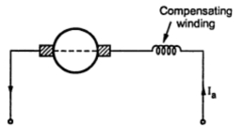
Fig. 2

The armature reaction causes the displacement of main field flux. It affects the waveform of main field flux and makes it non-uniform. The effect of armature reaction depends upon armature current which inturn depends on the load on the machine.
In case of machines having large fluctuations in load such as rolling mill motors or turbogenerators, the armature reaction will cause sudden shift of flux backward and forward direction depending on change in the load. This will cause statically induced e.m.f. in the armature coils whose magnitude depends upon how fast the load is changing and by what amount it is changing. There is dynamically induced e.m.f. in the armature coil also. Under worst conditions these two e.m.f.s may become additive. This will occur when load is increased on motor and decreased from generator. If this e.m.f. is more than the breakdown voltage across adjacent commutator segments, a sparkover may occur which can easily spread over as conditions near commutator are favourable for flashover. The maximum allowable voltage between the segment is 30 to 40 V. Thus there is always danger of short circuiting the whole armature if armature flux is not compensated.
This can be achieved by the use of compensating winding which will neutralize the effect of armture reaction. These windings are connected in series with the armature. The current in this windings flow in opposite direction to that in armature conductors below the pole shoes. This will counterbalance the cross magnetizing effect of armature reaction which may cause flashover between the segments.
Note : To have perfect neutralization of armature m.m.f. under the pole shoe, the ampere conductors of compensating winding must be equal to total armature ampere conductors under the pole shoe.
Ampere turns per pole for compensating winding
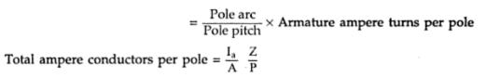

Since two conductors form one turn.
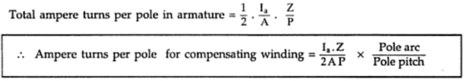

Since the distortion of armature m.m.f. and compensating winding m.m.f. is not identical the complete neutralization of armature m.m.f. can not be achieved by using compensating winding. The armature m.m.f. under the pole shoe is neutralized whereas there is incomplete neutralization in the interpolar region. There will be small flux density remaining unneutralized in GNA. This can be neutralized by using interpole windings.
Thus by using interpole as well as compensating windings, the armature reaction effect is completely neutralized over the entire armature periphery. The only flux present in the machine will be main field flux which will be an ideal situation.
Though compensating windings are very expensive they are provided in machines which carry heavy overloads or there is rapid change in the load. So that there will not by any possibility of flashover.
Example
Calculate the number of conductors on each pole piece in a compensating winding for a 10 pole d.c. generator which has lap wound armature containing 800 conductors. Assume ratio of pole arc to pole pitch to be 0.7.
Solution : P = 10 , Z = 800
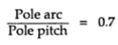

Ampere turns per pole for compensating winding
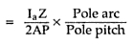

Number of turns per pole for compensating winding
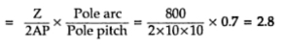
Since 2 conductors form one turn.
Compensating conductors / pole = 2 x 2.8 = 5.6 = 6

Action of Commutator
It is seen that, the e.m.f. induced in the conductors is always sinusoidal and commutator converts this sinusoidal e.m.f. to unidirectional e.m.f. Let us see, how it happens.
For simplicity of understanding the commutator action, consider commutator in its simplest form. Commutator is divided into number of copper segments insulated from each other. In its simplest form, it is assumed to be divided into two segments, each is nothing but the half of the entire commutator drum, separated by insulating material. So in its simplest form it is a ring with two halves separated by insulation as shown in the Fig. 1.
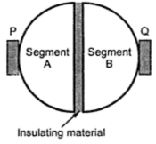
Fig. 1 Split ring

Such a ring is called split ring. The brushes P and Q are stationary and pressed on the surface of split ring. Split ring is mounted on the shaft and rotates as armature rotates.
Consider a single turn generator with conductors (1) and (2). These armature conductors are connected to the two segments of split ring. The external resistance R is connected across brushes P and Q. Under instant 1, the current flowing through resistance R is flowing from left to right as shown in the Fig. 2. This is by assuming the direction of current through conductor (1) downwards which is under N pole and through conductor (2) upwards which is under S pole, at the instant considered. At this instant brush P behaves as positive and Brush Q as negative.
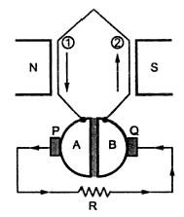
Fig. 2 Action of split ring

After a next half revolution, we have seen that direction of e.m.f. in the individual conductors reverses. Hence conductor (1) now will carry a current which will be upwards and due to half revolution it will be under S pole. Similarly conductor (2) individually will carry a current downwards now, and will be under N pole as shown in the Fig. 3.
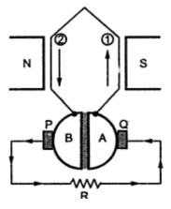
Fig. 3

Now split ring i.e. commutator is mounted on shaft and rotates with armature. So when conductors will reverse their positions, the split ring sections will also reverse their positions as shown in the Fig. 3.
But brushes P and Q are stationary and tapping the current from the commutator segments which are in contact with them.
Hence under instant 2, segment B will be in contact with brush P and segment A will be in contact with brush Q. Due to this, current through resistance R maintains its direction from left to right as shown in the Fig. 3. Brush P remains positive and Q remains as negative.
The Fig. 4 shows the waveforms of current in the individual conductor and current in external resistance R. Effectively one brush always taps those conductors. carrying a current which is in 180o opposite direction to the conductors under brush one. So one brush remains always positive and other always negative, and the load current is unidirectional.
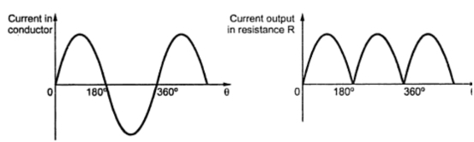
Fig. 4 Waveforms of current

Note : In the limiting case, number of segments of a commutator is equal to number of armature coils in a practical generator. Due to this, commutating action is very fast and almost straight line i.e. pure d.c. can be obtained across the load.
In a practical d.c. generator, the small poles in addition to the main poles, fixed to the yoke in between the main poles are used to improve the commutation. These poles are called interpoles.

Practical Commutation
The e.m.f. induced in each coil of armature is alternating in nature. If load is connected, the current flowing will also be alternating. But the flow of current in a d.c. generator must be undirectional. This can be achieved by the use of commutator. When the armature conductors are under the influence of one pole they carry current in one direction whereas the current is reversed when the conductors are under the influence of other pole. This reversal of current takes place along the magnetic neutral axis.
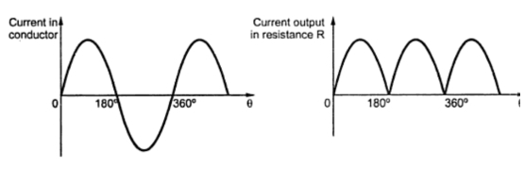
Fig. 1
Note : The reversal of current is likely to take place in short interval when a coil is short circuited by a brush so that transfer of current from one direction to other is carried out without any sparking. This process is called commutation.
Thus a process by which current in the short circuited coil is reversed while it crosses the MNA is called commutation. The time during which the coil remains short circuited is known as commutation period. This period is generally of the order of 0.0005 to 0.002 sec.
The commutation is said to be ideal when current changes fro +I to zero and zero to -I within the commutation period. The sparking is produced between the commutator and brush if current is not reversed by that time. This will lead to damage of commutator as well as brush. Hence for satisfactory operation of d.c. machine proper commutation is required i.e. transfer of current must be without sparking and losses and heating of brushes and the commutator.
Now we will see the process of commutation in detail with the help of the figures. Let us assume that the armature winding is ring type and the width of brush is equal to the width of one commutator segment and one mica insulation. In this case only one coil is short circuited at a time at each of these brushes whereas in actual practice width of brush is more than that of commutator so that more than two coils are simultaneously short circuited at each brush.
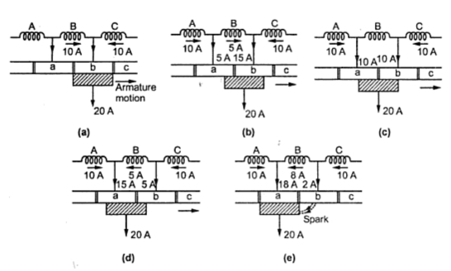
Fig. 2 Practical commutation

As shown in the Fig. 2(a), coil B is about to be short circuited. The brush is about to come in contact with commutator segment 'a'. Suppose that each coil is carrying current of 10 A so that total brush current is 20 A as every coil meeting at the brush supplies half the brush current independently of lap or wave wound armature.
Before coil B is short circuited, it is belonging to the group of coils lying left of the brush. It is carrying current 10 A from left to right.
As seen from the Fig. 2(b), coil B is entering short circuit period. The current in coil B has reduced from 10 A to 5 A as the other 5 A flows via segment 'a'. The total current is remaining same at 20 A. But area of contact of the brush is more with segment 'b' than with segment 'a'. Hence current of 15 A is from segment 'b' whereas 5 A from segment 'a'.
The coil B is in the middle of its short circuit period as shown in the Fig. 2(c). The current in coil B is reduced to zero. The current 10 A and 10 A pass to the brush directly from coils A and C. The total current is again20 A and the contact area of brush with the segments 'a' and 'b' are equal.
As shown in the Fig. 2(d), the coil B is now under group of coils to the right of brush. The contact area of brush with segment 'b' is decreasing whereas with segment 'a' is increasing. Coil B is now carrying 5 A in other direction. Thus current of 15 A is passed via. segment 'a' to the brush while the other 5 A is supplied by coil C and passes from segment 'b' to brush. Again the total current is 20 A.
If case of ideal commutation is assumed then current through coil B will reverse at the end of commutation or short circuit period. But as shown in Fig. 2(e) current flowing through coil B is only 8 A instead of 10 A. So the difference in coil currents i.e. 10 - 8 = 2 A jumps directly from segment 'b' to the brush through air and produces spark.
The variation in current during the process of commutation can be plotted with respect to time as shown in the Fig. 3.
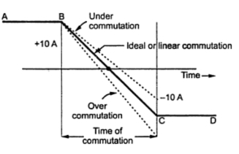
Fig. 3 Linear commutation

The current in the coil B is 10 A till commutation begins represented by horizontal line AB. After finishing commutation the current is again 10 A but in reverse direction represented by horizontal line CD. Thus current changes from +10 A to 0 and then to -10 A. The way in which this current changes is important. If current varies uniformly represented by straight line BC the commutation is said to be linear commutation. But it is observed that the self induced e.m.f. in the coil will try to maintain the current in the same direction and will cause delay for commutation. The commutation in this case is said to be retarded or under commutation. This is shown by the dotted part in the Fig. 3. If reversal of current in the coil is faster than ideal or linear commutation then also sparking may occur. The commutation in this case is said to be over commutation or accelerated commutation.
Thus it can be seen that if reversal of current is retarded or accelerated then value of current in the short circuited coil after the commutation period is over is different than that when linear commutation occurs. This will cause sparking at the brushes. This will lead to excessive wear and tear of commutator and ultimately lead to burning of commutator. Hence it is desired that the commutation must be as sparkless as possible.
Now let us see that why there is delayed or accelerated commutation. The main reason for non-linear commutation is the production of self induced e.m.f. in the coil undergoing commutation as the coil has significant amount of self inductance because it is embedded in the armature which is made up of high permeability material. This self induced e.m.f. though small in magnitude produces a large current through the coil whose resistance is small due to short circuit.
Expression for Reactance Voltage
The e.m.f. induced in the coil undergoing commutation can be calculated as follows.
Let Wb = Brush width
Wm = Width of mica insulation
v = Periphery velocity of commutator segment
The period of commutation is nothing but the time required by commutator to move a distance equal to circumferential thickness of the brush minus the thickness of one insulation plate.
If Tc is the time required for commutation then,
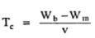

The total change in current during the process of commutation is 2I. Therefore self induced or reactance voltage is given by,
Self induced voltage = Coefficient of self inductance x Rate of change of current
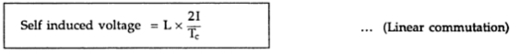

This self induced e.m.f. will oppose the change of direction of current. As stated earlier this will cause sparking at the brushes since current in the short circuited coil does not reach to its full value in the reversed direction by the end of commutation. Thus to avoid sparking and short circuit of whole machine due to arc producing around the commutator, commutation must be made sparkless by using some methods.
With retarded communication, the current density is excessive at trialing edge while it is small at leading edge. Whereas in accelerating commutation, the current density is small at trialing edge and excessive at leading edge. This indicates that it is desirable to retard the commutation during the initial moments and to accelerate it at later stage of commutation. This is known as sinusoidal commutation. Hence the self induced voltage or reactance voltage for sinusoidal commutation is given by,
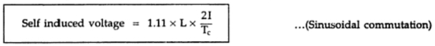

L = Coefficient of self inductance
Tc = Time of commutation
Example :
A 4 pole lap wound armature running at 1800 r.p.m. delivers a current of 150 A and has 64 commutator segments. The brush spans 1.2 segments and inductance of each armature coil is 0.06 mH.
Calculate the value of reactance voltage assuming i) Linear commutation
ii) Sinusoidal commutation. Neglect mica thickness.
Solution :
The given valued are,
I = 150 A N = 1800 r.p.m. W_{b} = 1.2 segments
W_{m} = 0 L = 0.06 mH 64 segments
There are total 64 segments on the entire periphery. It is necessary to calculate the peripheral speed in segments / second as W_{b} is given in segments.
Now the commutator speed is 1800 r.p.m. i.e.
n_{s} = 1800/60 = 30 r.p.s. i.e. revolutions per second
And in one revolution, 64 segments get covered. Hence
v = peripheral speed in segments / second
= No. of revolutions per second x Total segments on commutator
= 30 x 64 = 1920 segments / second
Note : If W_{b} is given in cm and commutator diameter D_{c} is given in cm then v is to be calculatedin cm/second as given below.
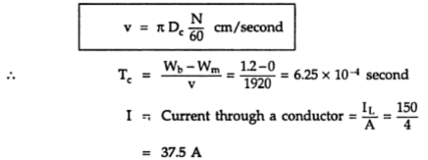

For linear commutation,
Self induced e.m.f.,
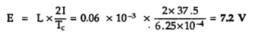
For sinusoidal commutation,
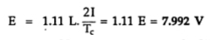

Methods of Improving Commutation
There are two practical ways by which commutation may be improved. These methods are, 1. Resistance commutation and 2. E.M.F. commutation.
Resistance Commutation
In this method of improving commutation, the low resistance copper brushes are replaced by high resistance carbon brushes.
From the Fig. 1 it can be seen that the current I from coil C when passing through commutator segment 'b' has two parallel paths. One is straight from 'b' to brush while the other is through short circuited coil B to segment 'a' and then to the brush. By using low resistance copper brush the current will not prefer second path as it will prefer first low resistance path.
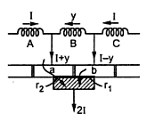
Fig. 1 Resistance Commutation

When carbon brushes having comparatively high resistance are used then current I through coil C will select the second path as resistance of first path will be increasing due to decrease in contact area of 'b' with brush and resistance r2 of second path will be decreasing due to increase in contact area of 'a' with brush.
Thus by increasing contact resistance between commutator segment and brushes, will limit short circuit current and reduce time constant (L/P) of the circuit which will help in quick reversal of current in the desired direction.
1.1.1 Advantages of Resistance Commutation
The advantages of resistance commutation are,
1) Upto some degree they are self lubricating and polish the commutator.
2) If sparking occurs, damage to commutator will be less as compared to when copper brushes are used.
1.1.2 Disadvantages of Resistance Commutation
The disadvantages of resistance commutation are,
1) There is a loss of approximately 2 volts due to high contact resistance. Hence this is not used in small machines.
2) If carbon brushes are used the commutator is required to be made somewhat larger for heat dissipation without rise in temperature which is not necessary for copper brushes.
3) Larger brush holders are required due to lower current density (about 7-8 A/cm).
1.2 E.M.F. Commutation
The method in which reactance voltage produced is neutralized by the reversing e.m.f. in short circuited coil is called e.m.f. commutation. If the value of this reversing e.m.f. is made equal to reactance voltage, the effect of reactance voltage will be completely nullified so that there will be fast reversal of current which will give sparkless commutation. There are two ways of proving e.m.f. commutation.
a) By giving a forward lead to the brushes
b) By using interpoles
1.2.1 Giving Brush Shift
If the brushes are shifted forward or backward depending on generator or motor, a little beyond to magnetic neutral axis, the short circuited coil will come under the influence of main pole of opposite polarity. This will partly neutralized the reactance voltage which will help in quick current reversal. This method is rarely used in practice as it will lead to many practical difficulties.
1.2.2 Interpoles
This method is more suitable and actually used in practice. In this method reversing e.m.f. required to neutralize reactance voltage is induced in the coil undergoing commutation by using small poles fixed to the yoke and placed in between the main poles i.e. along geometrical neutral axis. These poles are called interpoles. Practically interpoles are placed in between the main poles, as shown in the Fig. 2.
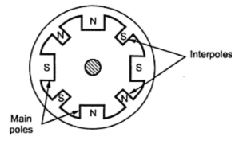
Fig. 2 Interpoles

On these interpoles few heavy gauge copper wire turns are wound and these are connected in series with the armature. The polarity of an interpoles is same as the next main pole ahead in the direction of rotation and in case of motor it is same as main pole behind as shown in the Fig. 3. The brushes are kept along the GNA so that coil sides lie directly under the interpoles.
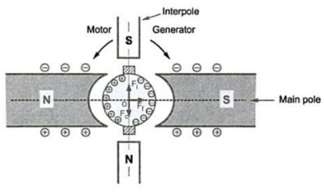
Fig 3 Use of interpoles

The polarity of interpoles is same as that of main pole ahead, the induced e.m.f. in them helps the quick reversal of current. The e.m.f. induced in the interpoles is called commutating or reversing e.m.f. which will neutralize the reactance voltage making sparkless commutation.
With interpoles sparkless commutation upto 20 to 30 percent overload with fixed brush position cam be obtained. Hence sparking limit is at same value as that of heating limit. So for given output the machine can be made smaller and will be cheaper than non-interpoles machine.
Also by using interpoles automatic neutralization of reactance voltage at all loads is ensured since it is connected in series with armature and reactance and reversing e.m.f.s are proportional to armature current.
Although interpoles mainly provide reversing e.m.f. opposite to that of reactance voltage, the other advantage of using interpoles is that they help in neutralizing cross magnetizing effect of armature reaction. As shown in the Fig. 3 OFf represents m.m.f. due to main poles whereas OFcrepresents cross magnetizing m.m.f. due to armature. The m.m.f. due to interpoles represented by OFi is in opposition to OFc so they cancel each other. Thus shifting of brush from original position is not required. Also automatic neutralization at all loads is ensured since armature field and interpoles are produced by same current.
But there is difference between compensating winding and interpoles. The two are connected in series and both will try to neutralize armature reaction effect. But interpoles in addition supply reversing e.m.f. to improve commutation. In addition to this, the action of interpoles is localized near the commutation area only. It has negligible effect on armature reaction occurring on the remaining part of the armature periphery,
Note : So armature reaction effect can be completely neutralized by using interpoles as well as compensating winding.

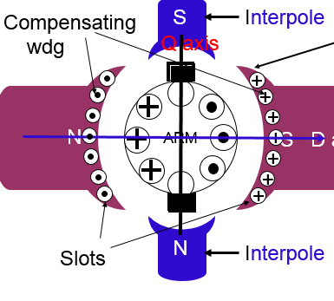

Types of DC Generators
Generally DC generators are classified according to the ways of excitation of their fields. There are three methods of excitation.
- Field coils excited by permanent magnets – Permanent magnet DC generators.
- Field coils excited by some external source – Separately excited DC generators.
- Field coils excited by the generator itself – Self excited DC generators.
A brief description of these type of generators are given below.

Permanent Magnet DC Generator
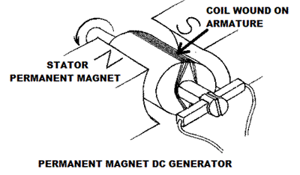
When the flux in the magnetic circuit is established by the help of permanent magnets then it is known as Permanent magnet DC generator.
It consists of an armature and one or several permanent magnets situated around the armature. This type of DC generators generates very low power. So, they are rarely found in industrial applications. They are normally used in small applications like dynamos in motor cycles.

Separately Excited DC Generator
These are the generators whose field magnets are energized by some external DC source such as battery.
A circuit diagram of separately excited DC generator is shown in figure.
I_{a} = Armature current
I_{L} = Load current
V = Terminal voltage
E_{g} = Generated emf 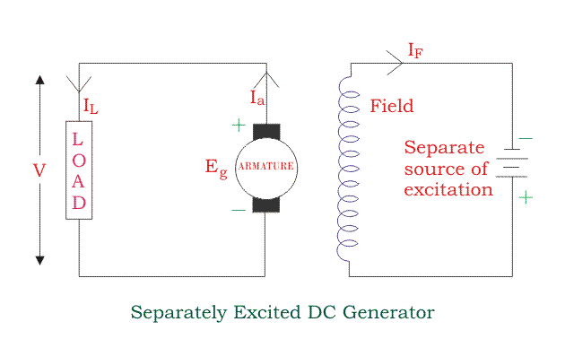Voltage drop in the armature = I_{a} × R_{a} (R/sub>a is the armature resistance)
Let, Then,
Power generated,
Power delivered to the external load,

Self-excited DC Generators
These are the generators whose field magnets are energized by the current supplied by themselves. In these type of machines field coils are internally connected with the armature. Due to residual magnetism some flux is always present in the poles. When the armature is rotated some emf is induced. Hence some induced current is produced. This small current flows through the field coil as well as the load and thereby strengthening the pole flux. As the pole flux strengthened, it will produce more armature emf, which cause further increase of current through the field. This increased field current further raises armature emf and this cumulative phenomenon continues until the excitation reaches to the rated value.
According to the position of the field coils the self-excited DC generators may be classified as…
- Series wound generators
- Shunt wound generators
- Compound wound generators

Series Wound Generator
In these type of generators, the field windings are connected in series with armature conductors as shown in figure below. So, whole current flows through the field coils as well as the load. As series field winding carries full load current it is designed with relatively few turns of thick wire. The electrical resistance of series field winding is therefore very low (nearly 0.5Ω ). Let,
R_{sc} = Series winding resistance
I_{sc} = Current flowing through the series field
R_{a} = Armature resistance
I_{a} = Armature current
I_{L} = Load current
V = Terminal voltage
E_{g} = Generated emf 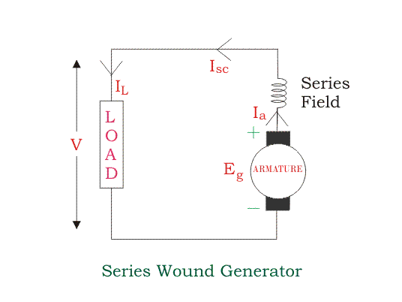
Then,
Voltage across the load,
Power generated,
Power delivered to the load,

Shunt Wound DC Generators
In these type of DC generators the field windings are connected in parallel with armature conductors as shown in figure below. In shunt wound generators the voltage in the field winding is same as the voltage across the terminal. Let,
R_{sh} = Shunt winding resistance
I_{sh} = Current flowing through the shunt field
R_{a} = Armature resistance
I_{a} = Armature current
I_{L} = Load current
V = Terminal voltage
E_{g} = Generated emf 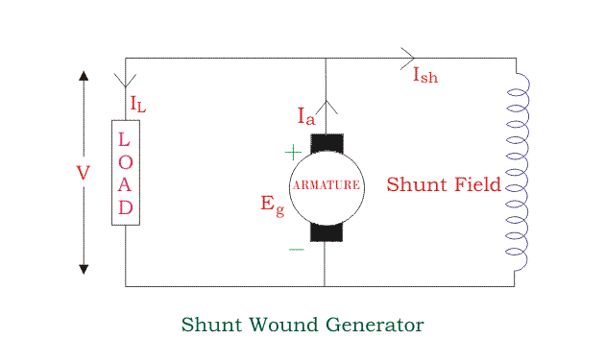Here armature current I_{a} is dividing in two parts, one is shunt field current I_{sh} and another is load current I_{L}.
So,
The effective power across the load will be maximum when I_{L} will be maximum. So, it is required to keep shunt field current as small as possible. For this purpose the resistance of the shunt field winding generally kept high (100 Ω) and large no of turns are used for the desired emf.
Shunt field current, 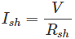
Voltage across the load,
Power generated,
Power delivered to the load,

Compound Wound DC Generator
In series wound generators, the output voltage is directly proportional with load current. In shunt wound generators, output voltage is inversely proportional with load current. A combination of these two types of generators can overcome the disadvantages of both. This combination of windings is called compound wound DC generator.
Compound wound generators have both series field winding and shunt field winding. One winding is placed in series with the armature and the other is placed in parallel with the armature. This type of DC generators may be of two types- short shunt compound wound generator and long shunt compound wound generator.

Short Shunt Compound Wound DC Generator
The generators in which only shunt field winding is in parallel with the armature winding as shown in figure. 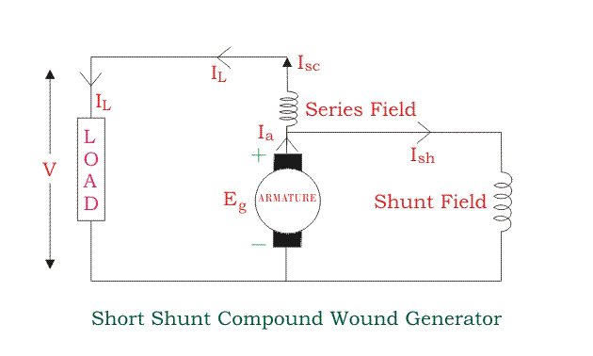Series field current,
Shunt field current, 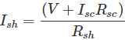
Armature current,
Voltage across the load,
Power generated,
Power delivered to the load,

Long Shunt Compound Wound DC Generator
The generators in which shunt field winding is in parallel with both series field and armature winding as shown in figure. 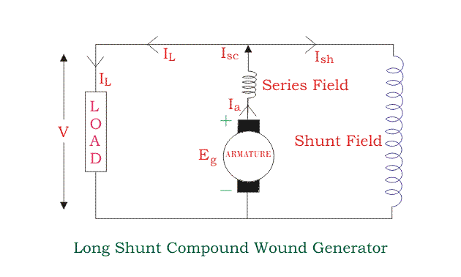Shunt field current,
Armature current, I_{a} = series field current,
Voltage across the load,
Power generated,
Power delivered to the load,
In a compound wound generator, the shunt field is stronger than the series field. When the series field assists the shunt field, generator is said to be commutatively compound wound. On the other hand if series field opposes the shunt field, the generator is said to be differentially compound wound.
