# Magnetization Curve of DC Generator

[DC generator](https://www.electrical4u.com/magnetization-curve-of-dc-generator/=%22https:/www.electrical4u.com/principle-of-dc-generator/%22) is that curve which gives the relation between field [current](https://www.electrical4u.com/electric-current-and-theory-of-electricity/) and the armature terminal [voltage](https://www.electrical4u.com/voltage-or-electric-potential-difference/) on open circuit.  
When the DC generator is driven by a prime mover then an emf is induced in the armature. The generated emf in the armature is given by an expression mcdcg-1mcdcg-0is constant for a given machine.it is replaced by K in this equation.

Here,  
φ is the flux per pole,  
P is the no. of poles,  
N is the no. of revolution made by armature per minute,  
Z is the no. of armature conductors,  
A is no. of parallel paths. 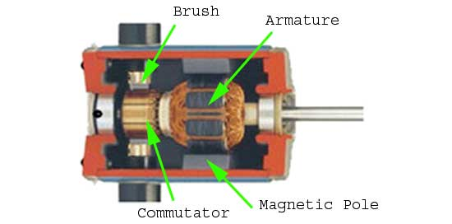

Now, from the equation we can clearly see that the generated emf is directly proportional to the product of flux per pole and the speed of the armature

. mcdcg-2

If the speed is constant, then the generated emf is directly proportional to the flux per pole.

mcdcg-3

It is obvious that, as the excitation current or field current (If) increases from its initial value, the [flux](https://www.electrical4u.com/what-is-flux-types-of-flux/) and hence generated emf is increased with the field current.

If we plot the generated voltage on the Y axis and field current on the X axis then the **magnetization curve** will be as shown in figure below.

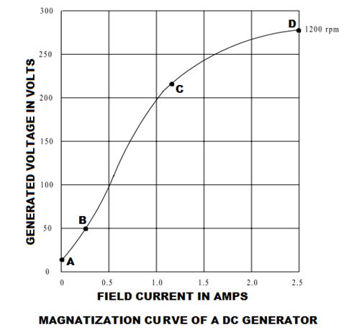

Magnetization curve of a DC generator has a great importance because it represents the saturation of the [magnetic circuit](https://www.electrical4u.com/what-is-magnetic-field/#Magnetic-Circuit). For this reason this curve is also called saturation curve.

According to the molecular theory of magnetism the molecules of a [magnetic material](https://www.electrical4u.com/what-is-magnetic-field/), which is not magnetized, are not arranged or aligned in definite order. When current passed through the magnetic material then its molecules are arranged in definite order. Up to a certain value of field current the maximum molecules are arranged. In this stage the flux established in the pole increased directly with the field current and the generated voltage is also increased. Here, in this curve, point B to point C is showing this phenomena and this portion of the magnetization curve is almost a straight line. Above a certain point (point C in this curve) the nu-magnetized molecules become very fewer and it became very difficult to further increase in pole flux.This point is called saturation point. Point C is also known as the knee of the magnetization curve. A small increase in magnetism requires very large field current above the saturation point. That is why upper portion of the curve (point C to point D) is bend as shown in figure.

Magnetization curve of a DC generator does not start from zero initially. It starts from a value of generated voltage due to residual magnetism.

## Residual Magnetism

In ferromagnetic materials, the magnetic power and the generated voltage increase with the increase of the current flow through the coils. When current is reduced to zero, there is still magnetic power left in those coils core. This phenomenon is called residual magnetism. The core of a DC machine is made of ferromagnetic material.

# Characteristic of Separately Excited DC Generator

In a [separately excited DC generator](https://www.electrical4u.com/types-of-dc-generators/#Separately_Excited_DC_Generator), the field winding is excited by an external independent source. There are generally three most important characteristic of DC generator:

## Magnetic or Open Circuit Characteristic of Separately Excited DC Generator

The curve which gives the relation between field [current](https://www.electrical4u.com/electric-current-and-theory-of-electricity/) (If) and the generated [voltage](https://www.electrical4u.com/voltage-or-electric-potential-difference/) (E0) in the armature on no load is called **magnetic or open circuit characteristic of a DC generator**. The plot of this curve is practically same for all [types of generators](https://www.electrical4u.com/types-of-dc-generators/), whether they are separately excited or self-excited. This curve is also known as **no load saturation characteristic curve of DC generator**.

Here in this figure below we can see the variation of generated emf on no load with field current for different fixed speeds of the armature. For higher value of constant speed, the steepness of the curve is more. When the field current is zero, for the effect residual magnetism in the poles, there will be a small initial emf (OA) as show in figure. 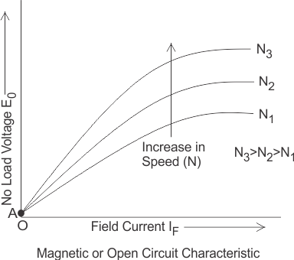

Let us consider a [separately excited DC generator](https://www.electrical4u.com/types-of-dc-generators/#Separately_Excited_DC_Generator) giving its no load voltage E0 for a constant field current. If there is no armature reaction and armature voltage drop in the machine then the voltage will remain constant. Therefore, if we plot the rated voltage on the Y axis and load current on the X axis then the curve will be a straight line and parallel to X-axis as shown in figure below. Here, AB line indicating the no load voltage (E0).When the generator is loaded then the [voltage drops](https://www.electrical4u.com/voltage-drop-calculation/) due to two main reasons-

1. Due to armature reaction,
2. Due to ohmic drop (IaRa).

### Internal or Total Characteristic of Separately Excited DC Generator

The **internal characteristic of the separately excited DC generator** is obtained by subtracting the drops due to armature reaction from no load voltage. This curve of actually generated voltage (Eg) will be slightly dropping. Here, AC line in the diagram indicating the actually generated voltage (Eg) with respect to load current. This curve is also called **total characteristic of separately excited DC generator**.

### External Characteristic of Separately Excited DC Generator

The **external characteristic of the separately excited DC generator** is obtained by subtracting the drops due to ohmic loss (Ia Ra) in the armature from generated voltage (Eg).  
Terminal voltage(V) = Eg - Ia Ra.  
This curve gives the relation between the terminal voltage (V) and load current. The **external characteristic curve** lies below the **internal characteristic curve**. Here, AD line in the diagram below is indicating the change in terminal voltage(V) with increasing load current. It can be seen from figure that when load current increases then the terminal voltage decreases slightly. This decrease in terminal voltage can be maintained easily by increasing the field current and thus increasing the generated voltage. Therefore, we can get constant terminal voltage. 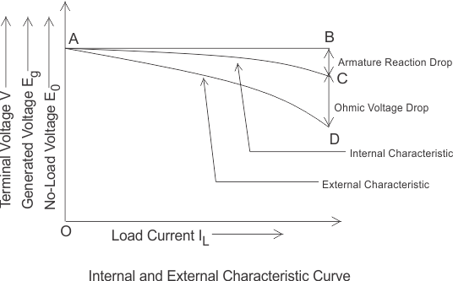

Separately excited DC generators have many advantages over [self-excited DC generators](https://www.electrical4u.com/self-excited-generators/). It can operate in stable condition with any field excitation and gives wide range of output voltage. The main disadvantage of these kinds of generators is that it is very expensive of providing a separate excitation source.

# Characteristics of Series Wound DC Generator

In these types of generators the field windings, [armature windings](https://www.electrical4u.com/armature-winding-pole-pitch-coil-span-commutator-pitch/) and external load circuit all

are connected in series as shown in figure below.

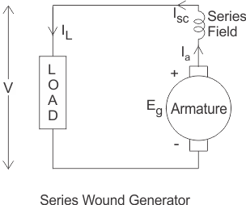

Therefore, the same [current](https://www.electrical4u.com/electric-current-and-theory-of-electricity/) flows through armature winding, field winding and the load.  
Let, I = Ia = Isc = IL  
Here, Ia = armature current  
Isc = series field current  
IL = load current  
There are generally three most important **characteristics of series wound DC generator** which show the relation between various quantities such as series field current or excitation current, generated voltage, terminal [voltage](https://www.electrical4u.com/voltage-or-electric-potential-difference/) and load current.

## Magnetic or Open Circuit Characteristic of Series Wound DC Generator

The curve which shows the relation between no load voltage and the field excitation current is called **magnetic or open circuit characteristic curve**. As during no load, the load terminals are open circuited, there will be no field current in the field since, the armature, field and load are series connected and these three make a closed loop of circuit. So, this curve can be obtained practically be separating the field winding and exciting the [DC generator](https://www.electrical4u.com/principle-of-dc-generator/) by an external source. Here in the diagram below AB curve is showing the magnetic **characteristic of** [series wound DC generator](https://www.electrical4u.com/types-of-dc-generators/#Series_Wound_Generator). The linearity of the curve will continue till the saturation of the poles. After that there will be no further significant change of terminal voltage of DC generator for increasing field current. Due to residual magnetism there will be a small initial voltage across the armature that is why the curve started from a point A which is a little way up to the origin O.

## Internal Characteristic of Series Wound DC Generator

The **internal characteristic** curve gives the relation between voltage generated in the armature and the load current. This curve is obtained by subtracting the drop due to the demagnetizing effect of armature reaction from the no load voltage. So, the actual generated voltage ( Eg) will be less than the no load voltage (E0). That is why the curve is slightly dropping from the open circuit characteristic curve. Here in the diagram below OC curve is showing the internal characteristic or total characteristic of the series wound DC generator.

## External Characteristic of Series Wound DC Generator

The external characteristic curve shows the variation of terminal voltage (V) with the load current ( IL). Terminal voltage of this type of generator is obtained by subtracting the ohomic drop due to armature [resistance](https://www.electrical4u.com/electrical-resistance-and-laws-of-resistance/) (Ra) and series field resistance ( Rsc) from the actually generated voltage ( Eg).  
Terminal voltage

V = Eg - I(Ra + Rsc)

The external characteristic curve lies below the internal characteristic curve because the value of terminal voltage is less than the generated voltage. Here in the figure OD curve is showing the external characteristic of the series wound DC generator.

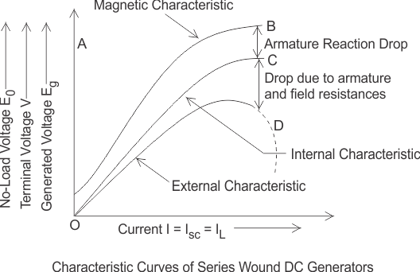

It can be observed from the characteristics of series wound DC generator, that with the increase in load (load is increased when load current increases) the terminal voltage of the machine increases. But after reaching its maximum value it starts to decrease due to excessive demagnetizing effect of armature reaction. This phenomenon is shown in the figure by the dotted line. Dotted portion of the characteristic gives approximately constant current irrespective of the external load resistance. This is because if load is increased, the field current is increased as field is series connected with load. Similarly if load is increased, armature current is increased as the armature is also series connected with load. But due to saturation, there will be no further significance raise of [magnetic field](https://www.electrical4u.com/what-is-magnetic-field/) strength hence any further increase in induced voltage. But due to increased armature current, the affect of armature reaction increases significantly which causes significant fall in load voltage. If load voltage falls, the load current is also decreased proportionally since current is proportional to voltage as per [Ohm’s law](https://www.electrical4u.com/ohms-law-equation-formula-and-limitation-of-ohms-law/) . So, increasing load, tends to increase the load current, but decreasing load voltage, tends to decrease load current. Due these two simultaneous effects, there will be no significant change in load current in dotted portion of external characteristics of series wound DC generator. That is why [series DC generator](https://www.electrical4u.com/types-of-dc-generators/#Series_Wound_Generator) is called constant current DC generator.

# Characteristic of Shunt Wound DC Generator

In [shunt wound DC generators](https://www.electrical4u.com/types-of-dc-generators/#Shunt_Wound_DC_Generators) the field windings are connected in parallel with armature conductors as shown in figure below. In these [type of generators](https://www.electrical4u.com/types-of-dc-generators/) the armature [current](https://www.electrical4u.com/electric-current-and-theory-of-electricity/) Ia divides in two parts. One part is the shunt field current Ish flows through shunt field winding and the other part is the load current IL goes through the external load.



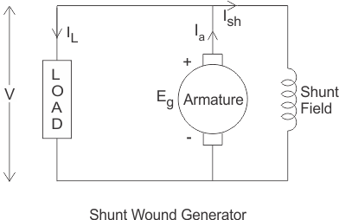

Three most important characteristic of shunt wound dc generators are discussed below:

## Magnetic or Open Circuit Characteristic of Shunt Wound DC Generator

This curve is drawn between shunt field current(Ish) and the no load [voltage](https://www.electrical4u.com/voltage-or-electric-potential-difference/) (E0). For a given excitation current or field current, the emf generated at no load E0 varies in proportionally with the rotational speed of the armature. Here in the diagram the magnetic characteristic curve for various speeds are drawn.

Due to residual magnetism the curves start from a point A slightly up from the origin O. The upper portions of the curves are bend due to saturation. The external load [resistance](https://www.electrical4u.com/electrical-resistance-and-laws-of-resistance/) of the machine needs to be maintained greater than its critical value otherwise the machine will not excite or will stop running if it is already in motion. AB, AC and AD are the slops which give critical resistances at speeds N1, N2 and N3. Here, N1 > N2 > N3.

### Critical Load Resistance of Shunt Wound DC Generator

This is the minimum external load resistance which is required to excite the shunt wound generator.

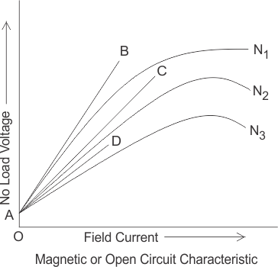

## Internal Characteristic of Shunt Wound DC Generator

The internal characteristic curve represents the relation between the generated voltage Eg and the load current IL. When the generator is loaded then the generated voltage is decreased due to armature reaction. So, generated voltage will be lower than the emf generated at no load. Here in the figure below AD curve is showing the no load voltage curve and AB is the internal characteristic curve.

## External Characteristic of Shunt Wound DC Generator

AC curve is showing the external characteristic of the shunt wound DC generator. It is showing the variation of terminal voltage with the load current. Ohmic drop due to armature resistance gives lesser terminal voltage the generated voltage. That is why the curve lies below the internal characteristic curve.



The terminal voltage can always be maintained constant by adjusting the of the load terminal.

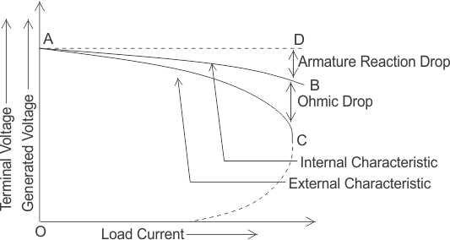

When the load resistance of a shunt wound DC generator is decreased, then load current of the generator increased as shown in above figure. But the load current can be increased to a certain limit with (upto point C) the decrease of load resistance. Beyond this point, it shows a reversal in the characteristic. Any decrease of load resistance, results in current reduction and consequently, the external characteristic curve turns back as shown in the dotted line and ultimately the terminal voltage becomes zero. Though there is some voltage due to residual magnetism.  
We know, Terminal voltage



Now, when IL increased, then terminal voltage decreased. After a certain limit, due to heavy load current and increased ohmic drop, the terminal voltage is reduced drastically. This drastic reduction of terminal voltage across the load, results the drop in the load current although at that time load is high or load resistance is low. That is why the load resistance of the machine must be maintained properly. The point in which the machine gives maximum current output is called breakdown point (point C in the picture).

**Characteristic of DC Compound Wound Generators**

In [compound wound DC generators](https://electricalstudy.sarutech.com/types-of-dc-generators/#Compound_Wound_DC_Generator) both the field windings are combined (series and shunt). This [type of generators](https://electricalstudy.sarutech.com/types-of-dc-generators/index.html) can be used as either long shunt or short shunt compound wound generators as shown in the diagram below. In both the cases the external characteristic of the generator will be nearly same. The compound wound generators may be cumulatively compounded or differentially compounded (discussed earlier in the [type of generators](https://electricalstudy.sarutech.com/types-of-dc-generators/index.html)). Differentially compound wound generators are very rarely used. So, here we mainly concentrate upon the characteristic of cumulatively compound wound generators.

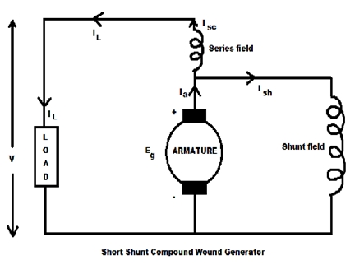

We all know that, in [series wound DC generators](https://electricalstudy.sarutech.com/types-of-dc-generators/#Series_Wound_Generator), the output [voltage](https://electricalstudy.sarutech.com/voltage-or-electric-potential-difference/index.html) is directly proportional with load current and in [shunt wound DC generators](https://electricalstudy.sarutech.com/types-of-dc-generators/#Shunt_Wound_DC_Generators), output [voltage](https://electricalstudy.sarutech.com/voltage-or-electric-potential-difference/index.html) is inversely proportional with load current. The [electric current](https://electricalstudy.sarutech.com/electric-current-and-theory-of-electricity/index.html) in the shunt field winding produces a flux which causes a fall in terminal [voltage](https://electricalstudy.sarutech.com/voltage-or-electric-potential-difference/index.html) due to armature reaction and ohmic drop in the circuit. But the [electric current](https://electricalstudy.sarutech.com/electric-current-and-theory-of-electricity/index.html) in the series field also produces a flux which opposes the shunt field flux and compensate the drop in the terminal [voltage](https://electricalstudy.sarutech.com/voltage-or-electric-potential-difference/index.html) and try to operate the machine at constant voltage.

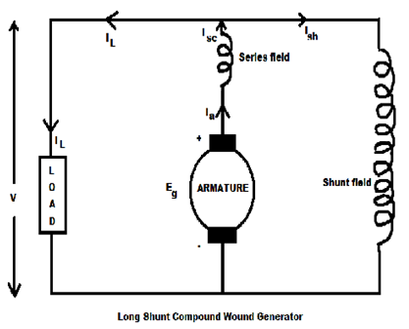

The combination of a series generator and a shunt generator gives the characteristic of a cumulative compound wound generator.

At no load condition there is no [electric current](https://electricalstudy.sarutech.com/electric-current-and-theory-of-electricity/index.html) in the series field because the load terminals are open circuited. But the shunt field [electric current](https://electricalstudy.sarutech.com/electric-current-and-theory-of-electricity/index.html) helps to produce field flux and excite the machine. When the [dc generator](https://electricalstudy.sarutech.com/principle-of-dc-generator/index.html) supplies load, the load current increases and [electric current](https://electricalstudy.sarutech.com/electric-current-and-theory-of-electricity/index.html) flows through the series field. Therefore, series field also provides some field flux and emf is also increased. The [voltage](https://electricalstudy.sarutech.com/voltage-or-electric-potential-difference/index.html) drop in the shunt machine is therefore compensated by the [voltage](https://electricalstudy.sarutech.com/voltage-or-electric-potential-difference/index.html) rise in the series machine.

External characteristic of DC compound wound generator is drawn between the terminal [voltage](https://electricalstudy.sarutech.com/voltage-or-electric-potential-difference/index.html) and the load current.By adjusting the no. of amp-turns in the series field winding we can get following external characteristics:

1. If the series turns are so adjusted that with the increase in load current the terminal [voltage](https://electricalstudy.sarutech.com/voltage-or-electric-potential-difference/index.html) also increases, then the generator is called over compounded. The curve AB in the figure showing this characteristic. When the load current increases then the flux provides by the series field also increases. It gives the additional generated voltage. If the increase in generated [voltage](https://electricalstudy.sarutech.com/voltage-or-electric-potential-difference/index.html) is greater than the [voltage](https://electricalstudy.sarutech.com/voltage-or-electric-potential-difference/index.html) drops due to armature reaction and ohmic drop then, terminal [voltage](https://electricalstudy.sarutech.com/voltage-or-electric-potential-difference/index.html) of the generator is increased.

2. If the series turns are so adjusted that with the increase in load current the terminal [voltage](https://electricalstudy.sarutech.com/voltage-or-electric-potential-difference/index.html) remains constant, then the generator is called flat compounded. The curve AC in the figure showing this characteristic. When the load current increases then the flux provides by the series field also increases and gives the additional generated voltage. If the increase in generated [voltage](https://electricalstudy.sarutech.com/voltage-or-electric-potential-difference/index.html) is equal to the [voltage](https://electricalstudy.sarutech.com/voltage-or-electric-potential-difference/index.html) drops due to armature reaction and ohmic drop then, rated terminal [voltage](https://electricalstudy.sarutech.com/voltage-or-electric-potential-difference/index.html) of the generator remains same as no load voltage.

3. If the series field winding has lesser no. of turns then the rated terminal [voltage](https://electricalstudy.sarutech.com/voltage-or-electric-potential-difference/index.html) becomes less than the no load voltage, then the generator is called under compounded. Because, the increase in generated [voltage](https://electricalstudy.sarutech.com/voltage-or-electric-potential-difference/index.html) is lesser than the [voltage](https://electricalstudy.sarutech.com/voltage-or-electric-potential-difference/index.html) drops due to armature reaction and ohmic drop. Curve AD in the figure is showing this characteristic.

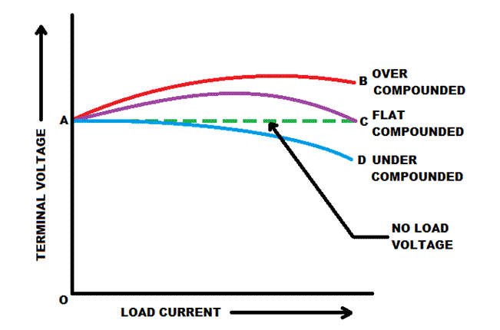

**Characteristics of DC Compound Generator**

For small distance operation the flat compounded generators are generally used because the length of the feeder is negligible. But to maintain constant [voltage](https://electricalstudy.sarutech.com/voltage-or-electric-potential-difference/index.html) over a long period, the over compounded generators are used. It works as a generator and a booster (boost the terminal voltage).

**Critical field resistance:**

Critical Field Resistance: It is that value of the field resistance at which the D.C. shunt generator will fail to excite.

The critical field resistance is defined as the maximum field circuit resistance (for a given [speed](https://en.wikipedia.org/wiki/Speed)) with which the shunt generator would excite. The shunt generator will build up voltage only if field circuit resistance is less than critical field resistance.

It is a [Tangent](https://en.wikipedia.org/wiki/Tangent) to the Open Circuit Characteristics of the Generator(at a given speed).

**Critical Speed:** It is that speed for which the given shunt field resistance becomes the critical field resistance.

# Commutation in DC Machine or Commutation in DC Generator or Motor

The [voltage](https://www.electrical4u.com/voltage-or-electric-potential-difference/) generated in the armature, placed in a rotating [magnetic field](https://www.electrical4u.com/what-is-magnetic-field/), of a [DC generator](https://www.electrical4u.com/principle-of-dc-generator/) is alternating in nature. The **commutation in DC machine** or more specifically **commutation in DC generator** is the process in which generated alternating [current](https://www.electrical4u.com/electric-current-and-theory-of-electricity/) in the [armature winding](https://www.electrical4u.com/armature-winding-pole-pitch-coil-span-commutator-pitch/) of a dc machine is converted into direct current after going through the commutator and the stationary brushes.  
Again in [DC Motor](https://www.electrical4u.com/working-or-operating-principle-of-dc-motor/), the input DC is to be converted in alternating form in armature and that is also done through commutation.

This transformation of current from the rotating armature of a DC machine to the stationary brushes needs to maintain continuously moving contact between the commutator segments and the brushes. When the armature starts to rotate, then the coils situated under one pole (let it be N pole) rotates between a positive brush and its consecutive negative brush and the current flows through this coil is in a direction inward to the commutator segments.  
Then the coil is short circuited with the help of a brush for a very short fraction of time (1⁄500 sec). It is called commutation period. After this short-circuit time the armature coils rotates under S pole and rotates between a negative brush and its succeeding positive brush. Then the direction is reversed which is in the away from the commutator segments. This phenomena of the reversal of current is termed as commutation process. We get direct current from the brush terminal.  
The commutation is called ideal if the commutation process or the reversal of current is completed by the end of the short circuit time or the commutation period. If the reversal of current is completed during the short circuit time then there is sparking occurs at the brush contacts and the commutator surface is damaged due to overheating and the machine is called poorly commutated.

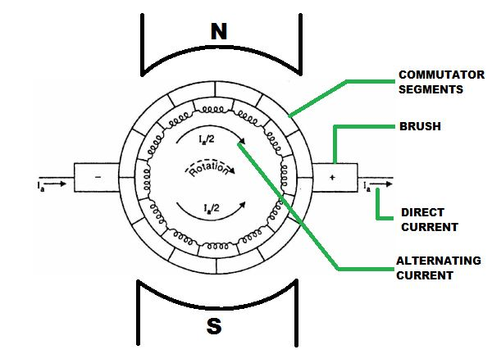

## Physical Concept of Commutation in DC Machine

For the explanation of commutation process, let us consider a DC machine having an [armature wound with ring winding](https://www.electrical4u.com/armature-winding-pole-pitch-coil-span-commutator-pitch/). Let us also consider that the width of the commutator bar is equal to the width of the brush and current flowing through the conductor is IC. Let the commutator is moving from left to right. Then the brush will move from right to left. At the first position, the brush is connected the commutator bar b (as shown in fig 1). Then the total current conducted by the commutator bar b into the brush is 2IC.

When the armature starts to move right, then the brush comes to contact of bar a. Then the armature current flows through two paths and through the bars a and b (as shown in fig 2). The total current (2IC) collected by the brush remain same. As the contact area of the bar a with the brush increases and the contact area of the bar b decreases, the current flow through the bars increases and decreases simultaneously. When the contact area become same for both the commutator bar then same current flows through both the bars (as shown in fig 3).

When the brush contact area with the bar b decreases further, then the current flowing through the coil B changes its direction and starts to flow counter-clockwise (as shown in fig 4).  
When the brush totally comes under the bar a (as shown in fig 5) and disconnected with the bar b then current IC flows through the coil B in the counter-clockwise direction and the short circuit is removed. In this process the reversal of current or the process of commutation is done.

# Methods of Improving Commutation

To make the commutation satisfactory we have to make sure that the [current](https://www.electrical4u.com/electric-current-and-theory-of-electricity/) flowing through the coil completely reversed during the commutation period attains its full value.  
There are three main **methods of improving commutation**. These are

1. Resistance commutation
2. E.M.F. commutation
3. Compensating windings

## Resistance Commutation

In this method of commutation we use high [electrical resistance](https://www.electrical4u.com/electrical-resistance-and-laws-of-resistance/) brushes for getting spark less commutation. This can be obtained by replacing low [resistance](https://www.electrical4u.com/electrical-resistance-and-laws-of-resistance/) copper brushes with high resistance carbon brushes.

We can clearly see from the picture that the current IC from the coil C may reach to the brush in two ways in the commutation period. One path is direct through the commutator segment b and to the brush and the 2nd path is first through the short-circuit coil B and then through the commutator segment a and to the brush. When the brush resistance is low, then the current IC from coil C will follow the shortest path, i.e. the 1st path as its electrical resistance is comparatively low because it is shorter than the 2nd path.

When high resistance brushes are used, then as the brush moves towards the commutator segments, the contact area of the brush and the segment b decreases and contact area with the segment a increases. Now, as the electrical resistance is inversely proportional to the contact area of then resistance Rb will increase and Ra will decrease as the brush moves. Then the current will prefer the 2nd path to reach to the brush. Thus by this **method of improving commutation**, the quick reversal of current will occur in the desired direction.



ρ is the [resistivity](https://www.electrical4u.com/electrical-resistance-and-laws-of-resistance/) of the [conductor](https://www.electrical4u.com/electrical-conductor/).  
l is the length of the conductor.  
A is the cross-section of the conductor (here is this description it is used as contact area).

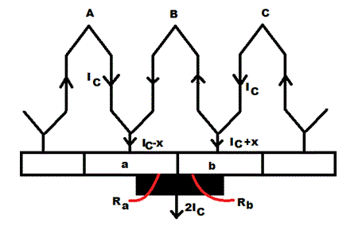

## E.M.F. Commutation

The main reason of the delay of the current reversing time in the short circuit coil during commutation period is the inductive property of the coil. In this type of commutation, the reactance [voltage](https://www.electrical4u.com/voltage-or-electric-potential-difference/) produced by the coil due to its inductive property, is neutralized by producing a reversing emf in the short circuit coil during commutation period.  
Reactance Voltage:   
The voltage rise in the short circuit coil due to inductive property of the coil, which opposes the current reversal in it during the commutation period, is called the reactance voltage.  
We can produce reversing emf in two ways

1. By brush shifting.
2. By using inter-poles or commutating poles.

### Brush Shifting Method of Commutation

In this method of improving commutation the brushes are shifted forward direction for the [DC generator](https://www.electrical4u.com/principle-of-dc-generator/) and in backward direction for the motor for producing the sufficient reversing emf for eliminating the reactance voltage. When the brushes are given the forward or backward lead then it brings the short circuit coil under the influence of the next pole which is of the opposite polarity. Then the sides of the coil will cut the necessary [flux](https://www.electrical4u.com/what-is-flux-types-of-flux/) form the main poles of opposite polarity for producing the sufficient reversing emf. This method is rarely used because for best result, with every variation of load, the brushes have to be shifted.

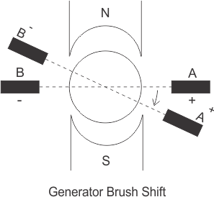

### Method Of Using Inter-Pole

In this method of commutation some small poles are fixed to the yoke and placed between the main poles. These poles are called inter-poles. Their polarity is same as the main poles situated next to it for the generator and for the motor the polarity is same as the main pole situated before it. The inter-poles induce an emf in the short circuit coil during the commutation period which opposes reactance voltage and give spark-less commutation.

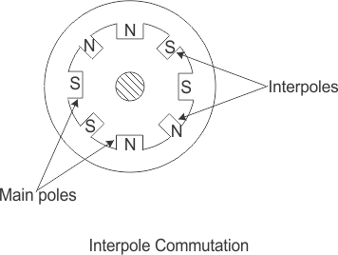

### Compensating Windings

This is the most effective mean of eliminating the problem of armature reaction and flash over by balancing the armature mmf. Compensating windings are placed in slots provided in pole faces parallel to the rotor (armature) conductors.   
The major drawback with the compensating windings is that they very costly. Their use is mainly for large machines subject to heavy overloads or plugging and in small motors subject to sudden reversal and high acceleration.

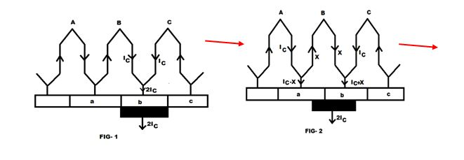

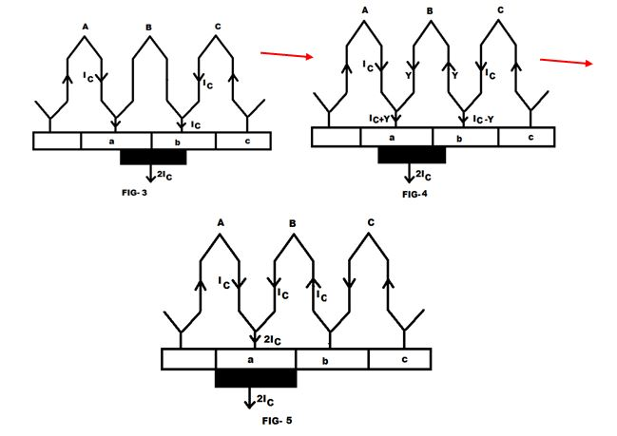

Parallel Operation of D.C. Generators

In this tutorial we going to discuss about parallel operation of [DC generators](http://www.electricaledition.com/2015/09/dc-machine-construction-motor-generator.html).We mostly do not go for  parallel operation for DC series generators ,but in some cases like electrical braking we go for it.Before going to deep discussion on **why? parallel operation of DC generators is needed.**

*In latest power generating system, power is usually supplied by many generators connected in parallel because due to lots of advantages.*

[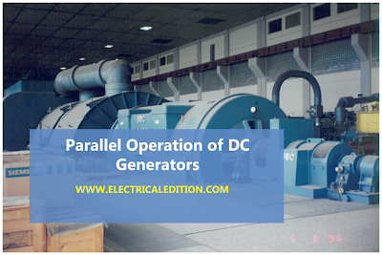](https://2.bp.blogspot.com/-uf_W8PZ3JW4/VsmfR16zOMI/AAAAAAAAA3Y/TwATBFoo2aE/s1600/DC-GENERATOR-PARALLEL-OPEARTION.png)

Advantages of Parallel Operation of DC Generators

The reasons for paralleling D.C. generators, (especially when it is recognized that this usage of the word parallel means duplicator or multiple) are enumerated below

**1. Reliability.**The sources of power such as generators are frequently primary safety items and are therefore duplicated or paralleled for reliability.

**2. Continuity of power supply.** If you are running only single generator,in case of breakdown the supply of power will get disrupted.So to avoid this problem we operate dc generators in parallel.

**3. To improve efficiency of dc generators.**Electrical machines run most efficiently when loaded on their rated capacity. DC generators also runs most efficiently at rated capacity and moreover power costs less per kWh when the generator producing it is efficiently loaded.In parallel operation of dc generators we have one more advantage that we can shutdown/start generator units as per power requirements.

**4. Easy to maintain and repair of DC generators.**Generators requires regular-maintenance and repair as like every machine. In case of parallel operation of dc generators the routine or emergency operations can be performed by isolating the only affected dc generator while load is being supplied by other units. This leads to both safety and economy.

**5. Non-availability of single required large generator.**It is hard to get single rated generator if concern efficiency and cost.So it is better to operate small generators in parallel in order to get desired power.

**6. To increasing plant capacity.** In the modern world of increasing population, the use of electricity is continuously increasing. To increase power capacity as it changes,we have flexibility in parallel operation that is,we can add a new unit   in parallel with the old units.

We have 3 [types of DC generators](http://www.electricaledition.com/2016/01/types-of-dc-machines-dc-generators-dc-motors.html).They are shunt,series,compound dc generators.So let us discuss about,

1.Parallel operation of shunt dc generators

2.Parallel operation of series dc generators

3.Parallel operation of compound dc generators

Conditions:Parallel Operation Of Shunt Generators

Below figure shows a circuit diagram for the parallel operation of two shunt generators. It is assumed that generator A is already operating and supplying a

particular load as per its capacity; that is why the switch SI and the circuit breaker CB, are shown closed in figure.

[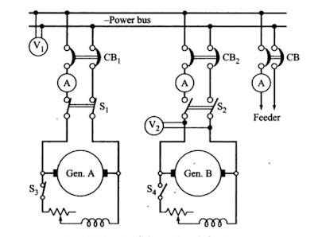](https://3.bp.blogspot.com/-C-0Mau9uvsg/VsmS-DbVziI/AAAAAAAAA2w/Bd4K-MfSN9Y/s1600/dc-shunt-generators-parallel-operation.PNG)

When the load on the station increases beyond the capacity of generator A. it is essential to connect the generator B to operate in parallel with A. in order to share the total load on the station. The procedure for paralleling generator B with generator A comprises following steps.

(i) The prime mover of the generator B is brought up to the rated speed.

(ii) Switch S4 provided in the generator field circuit is closed, as a result the generator will build up its voltage.

(iii) The circuit breaker CB2 is closed.

(iv) The excitation of the generator B is adjusted. so that it generates a voltage equal to the bus bar voltage, that is the reading of voltmeter V2 should be equal to V1

(v) Polarities of the generator B should be the same as those of the bus bars.

(vi) Now the main switch S2 is closed. thus putting generator B in parallel with generator A. However generator B is still running idle or floating (not supplying any load).

(vii) Adjust the field rheostats of generators A and B simultaneously. The field current of generators A should be reduced slowly. while that of generator B be increased. By this process. any amount of load can be shifted on to generator B. However. care should be taken that the incoming machine is not overload.

(viii) In case generator A is to be shut down. the whole load can be shifted onto generator B, provided it has a capacity to supply that load without over- loading. In that case reduce the current in the generator A to zero and then open switch S1.

Next the load sharing by the two generators running in parallel is discussed. Let us assume the following for the derivation of the equations showing the load sharing.

Load Sharing of DC Shunt Generators

Ea emf generated by generator A

Eb emf generated by generator B

V Terminal voltage at the load terminals

Ia Current supplied to the load by generator A

Ib Current supplied to the load by generator B

I Total load current

ra Armature resistance of generator A

rb Armature resistance of generator B

The external characteristic of the two generators can now be expressed as.

V=Ea-Iara ..........(1)

and V =Eb-Ibrb ..........(2)

Total load current, I = Ia + Ib..........(3)

Solving above equations for Ia,Ib

[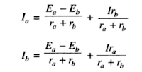](https://1.bp.blogspot.com/-PKpKJR75giY/VsmXdHeBmaI/AAAAAAAAA28/Ca_YjzFT7Q4/s1600/Capture.PNG)

Above equations  clearly indicate that the current supplied by each [generator](http://www.electricaledition.com/2016/02/construction-of-alternator-or-synchronous-generator.html)consists of two components (i) independent of load current (ii) dependent upon load current. First component exists when the generated emfs of two generators running in parallel are different, which certainly causes the circulating current to flow producing heat loss. This component would exist even at no load and can be avoided only when the [emfs generated](http://www.electricaledition.com/2016/01/emf-equation-of-dc-generator.html) by the two generators are equal. Second component shows clearly that the load current divides itself inversely as the [armature resistance of the generators](http://www.electricaledition.com/2016/01/armature-reaction-in-dc-machines.html).

If the load on the generators is a fixed resistance R. Equations ( 1 and 2) can be rewritten as,

Ea=Iara+(Ia + Ib)R  ..........(5)

Eb=Ibrb+(Ia + Ib)R   ..........(6)

Sovling equations (5) & (6)

[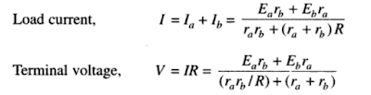](https://4.bp.blogspot.com/-BrdEAgJW3vI/VsmaOMI6AiI/AAAAAAAAA3I/9GDypJ0hq90/s1600/Capture.PNG)

Based on above equations which are obtained by parallel operation of shunt generators we get load shared by each generator operating In parallel can be ascertained depending upon the parameters of the generators.

D.C. Compound Generators in Parallel

Above we discussed why parallel operation of dc generators is necessary ?.Here we are going to discuss about  parallel operation of D.C. compound generators.

Let us have two compound dc generators,say generator 1 and generator 2 running in parallel as shown in the below figure.Assume each generator is taking proper share of load.

[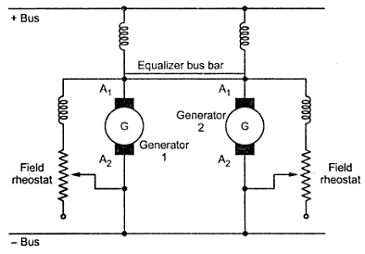](https://1.bp.blogspot.com/-PQL3ZNtpxEc/VsnWd2awFsI/AAAAAAAAA3o/uHfe2OWLuqA/s1600/ccc1126.jpeg)

Due to some reason,say the generator 1 taking more load slightly then the current passing through its series field winding increases strengthening its field to increase the generated e.m.f. This causes generator 1 to take still more load. If system load is assumed to be constant then the load on generator 2 will decrease weakening its series field due to less current passing through its field winding which results in further decrease in its load. This effect is cumulative which leads generator 1 to take the entire load and generator 2 will be driven as motor. The circuit breakers of at least one of the two generators will open to stop the parallel operation. The under compound generators show stable operation like shunt generators.

For stable parallel operation of over and level compound generators, equalizer bus bars are used. It is connected to the armature ends of the series coils of the generators. The equalizer bus bar is also a conductor which is not required is case of under compound generator as their characteristics are not rising.

Now consider that the same two compound generators are operating in parallel with equalizer bar between them. If for any reason, generator 1 starts taking more load than its proper share the its series field current is increased. But now this increased field current will partly pass through series field winding of generator 1 and partly through series field winding of generator 2 via equalizer bar. Thus the two generators are affected in similar way preventing generator 1 from taking extra load. To have proper division of load from no load to full load it is required that the regulation of each generator must be same. The series field resistances should be inversely proportional to the generator ratings.