Electromechanical Energy conversion -I

UNIT-I

An electrical machine is a device that can convert either mechanical energy to electrical energy or electrical energy to mechanical energy. When such a device is used to convert mechanical energy to electrical energy, it is called a generator.
When it converts electrical energy to mechanical energy, it is called a motor. Since any given electrical machine can convert power in either direction, any machine can be used as either a generator or a motor. Almost all practical motors and generators convert energy from one form to another through the action of a magnetic field, and only machines using magnetic fields to perform such conversions are considered.
The transformer is an electrical device that is closely related to electrical machines. It converts ac electrical energy at one voltage level to ac electrical energy at another voltage level. Since transformers operate on the same principles as generators and motors, depending on the action of a magnetic field to accomplish the change in voltage level, they are usually studied together with generators and motors.

These three types of electric devices are ubiquitous in modern daily life. Electric motors in the home run refrigerators, freezers, vacuum cleaners, blenders, air conditioners, fans, and many similar appliances. In the workplace, motors provide the motive power for almost all tools. Of course, generators are necessary to supply the power used by all these motors.

Principle of Electromechanical Energy conversion :

Electromechanical energy conversion is one device which is convert energy one form to another form. electromechanical device converts electrical energy into mechanical energy and vice versa. Energy conversation take place through the medium of electric field or magnetic field.

Electromechanical energy conversion devices with magnetic field as the coupling medium between electrical and mechanical systems are more common in commercial application. the energy storing capacity of the magnetic field is much greater about 25,000 greater than the electric field.electromechanical energy conversion is a reversible process except for the losses in the system. Here we use word reversible that means the energy can be transfer back and forward between mechanical and electrical system. during the process of energy conversion, some of the energy is converted into heat and it lost from the system.

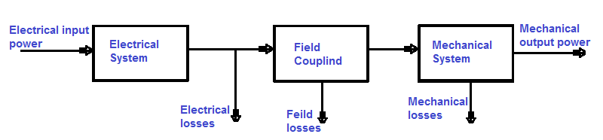

Electromechanical energy conversion devices may categorized in Various parts as under:-
- The first category of devices, involving small motion, processes only low-energy signals from electrical to mechanical or vice versa. These are microphones, gramophone pick-ups, loud speakers and low-signal transducers.
- The second category consists of force or torque-producing devices with limited mechanical motion. These are electromagnets , relays, moving-iron instruments etc..
- The third category includes continuous energy conversion devices like motors and generators these are used for bulk energy conversion and utilization.

Principal of energy conversion:-
Its state that the energy cannot be created or destroyed. it can only be converted from one form to the another form of energy.
If we consider electric Generator then its convert mechanical energy into electrical energy
If we consider electric Motor then its convert electrical energy into mechanical energy.
Electromechanical energy conversion system has basically divided in three parts,
- Mechanical system
- Field coupling system
- Electrical system
Principal of energy conversion is based on below equations.
Energy transfer equation for generator action can be written as,
Mechanical energy input = electrical energy output + losses in field + total energy losses
Energy transfer equation for motoring action can be written as,
Electrical energy input = mechanical energy output + stored energy by filed + total energy losses
During the energy conversation there are occur some Losses, which are following as,
- Core losses or iron losses
- Electrical losses or copper losses
- Mechanical losses
This all losses are called energy losses,
Energy losses equation can be written as,
Electrical energy input – copper loss = (mechanical energy output + mechanical losses) + ( core losses + energy stored in core)
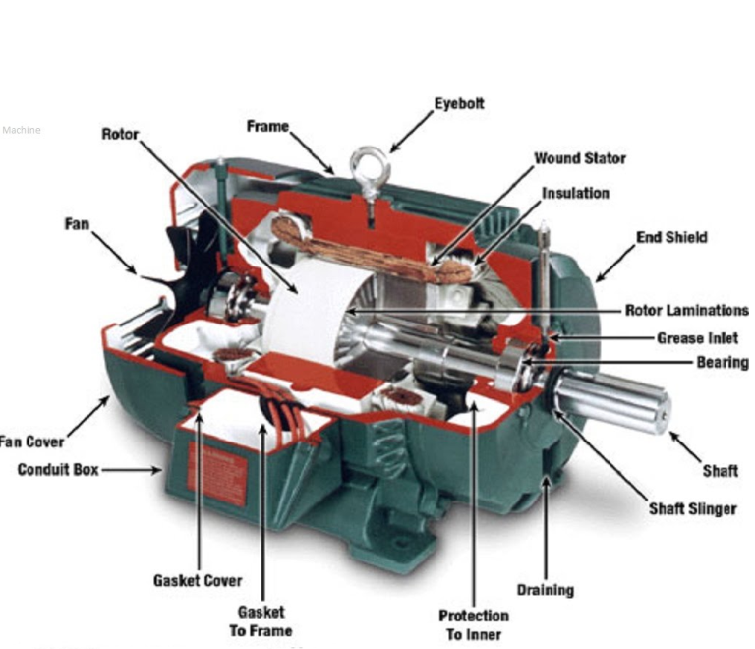
Wie – Wle = ( Wom + Wlm ) + ( Wfd + Wlf )
Where, Wie = input electrical energy
Wle=copper losse
Wom = output mechanical energy
Wlm = mechanical losses
Wfd = stored energy by core
Wlf = core losses

DC GENERATOR:
Magnetism is a property by virtue of which a piece of solid body attracts iron pieces and pieces of some other metals. Such a piece of solid body is called a natural magnet. The two ends of a magnet are called its poles. When such a magnet is suspended freely by a piece of a silk fiber, it turns and adjusts itself in the direction of North and South of the earth. The end adjusting itself in the direction of North is called N pole while other is called S pole.When such two magnets are brought near each other, their behaviour is governed by some laws called laws of magnetism.
1. Laws of Magnetism
Law 1 : It states that 'like' magnetic poles repel and 'unlike' poles attract each other.
When the two magnets are brought near each other, such that two like poles i.e. N and N or S and S are facing each other, then the two magnets experience a force of repulsion. As against this, if two unlike poles i.e. N and S or S and N are facing towards each other, then they experience a force of attraction and try to attract each other.
Law 2 : This law is experimentally proved by Scientist Coulomb and hence also known as coulomb's law.
The force (F) exerted by one pole on the other pole is,
1. Directly proportional to the product of the pole strengths.
2. Inversely proportional to the square of the distance between them and
3. Dependent on the nature of medium surrounding the poles.
Mathematically this law can be expressed as,
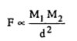
Where M₁ and M₂ are the pole strengths of the poles while 'd' is the distance between the two poles.
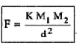
Where K is constant which depends on the nature of the surrounding.
2. Magnetic Field and Flux
The region around a magnet within which the influence of the magnet can be experienced is called its magnetic field. The presence of magnetic field is represented by imaginary lines around a magnet. These are called magnetic lines of force.
The total number of lines force existing in a particular magnetic field is called magnetic flux, denoted by a symbol ''. It is measured in a unit weber.
1 weber = 10⁸ lines of force
Key point : The lines of force never intersect each other and are like stretched rubber bands and always try to contract in length.
These properties of lines of force play an important role in the understanding of the working principle of the d.c. machines.
The lines of flux have a fixed direction. These flux lines start at N-pole and terminate at S-pole, external to the magnet. While the direction of flux lines is from S-pole to N-pole, internal to the magnet. The distribution and direction of such flux lines for a bar magnet is shown in the Fig. 1.
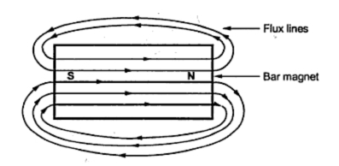
Fig. 1

Revision of Electromagnetism
Revision of Electromagnetism
When a conductor carries a current, it creates a magnetic field around it. The direction of such magnetic field depends on the direction of the current passing through the conductor. So electric current and magnetism are very closely related to each other. This relationship plays an important role in the d.c. machines.
Let us see in brief, the role to determine the direction of the flux produced by a current carrying conductor.
Right Hand Thumb Rule
It states that ''Hold the current carrying conductor in the right hand such that the thumb is pointing in the direction of current and parallel to the conductor, then curled fingers point in the direction of the magnetic field or flux around it''.
The Fig 1. explains the rule.
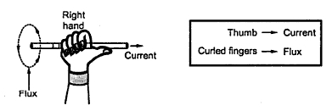
Fig. 1
Conventionally, such conductors are observed, assuming them to be placed perpendicular to the plane of the paper. So current moving away from the observer is denoted by a 'cross' while current coming towards the observer is denoted by a 'dot'. If now right hand is adjusted in such a way, that thew thumb is pointing in the direction of current denoted as 'cross' i.e. going into the paper, then curled fingers indicate the direction of flux as clockwise, as shown in the Fig.2(a). While if thumb of right hand is adjusted in the direction of current shown as 'dot' i.e. coming out of paper, then curled fingers indicate the direction of flux as anticlockwise as shown in the Fig. 2(b).
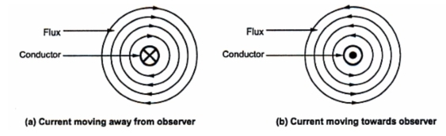
Fig. 2
Magnetic Field due to Circular Conductor
Consider an arrangement in which along conductor is wound with number of turns in a core, close together to form a coil. This is called a solenoid as shown in the Fig. 3. When such a conductor carries a current, the magnetic field gets produced around the core.
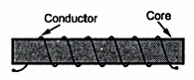
Fig. 3
Identifying the direction of flux and hence identifying the two ends of the core as N pole or S pole is important in understanding the principle of d.c. machine. The right hand thumb rule can be modified for such case as stated below,
The right hand thumb rule : Hold the solenoid in the right hand such that curled fingers point in the direction of the current through the curled conductor, then the outstretched thumb along the axis of the solenoid points to the North pole of the solenoid or points in the direction of flux lines inside the core.
This is represented in the Fig.4.
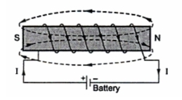
Fig. 4

Key Point : The direction of flux can be reversed either by changing direction of current through the conductor by reversing the polarities of the supply or by changing the direction of winding of the conductors around the core.
With this background, let us start the detail study of a d.c. generator.

Fleming's Right Hand Rule :
If three fingers of a right hand, namely thumb, index finger and middle finger are outstretched so that every one of them is at right angles with the remaining two, and if this position index finger is made to point in the direction of lines of flux, thumb in the direction of the relative motion of the conductor with respect to flux then the outstretched middle finger gives the direction of the e.m.f. induced in the conductor. Visually the rule can be represented as shown in the Fig.1.
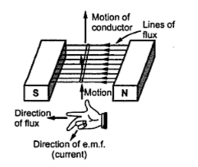
Fig. 1
This rule mainly gives direction of current which induced e.m.f. in conductor will set up when closed path is provided to it.
Verify the direction of the current through conductor in the four cases shown in the Fig. 2 by using Fleming's right hand rule.
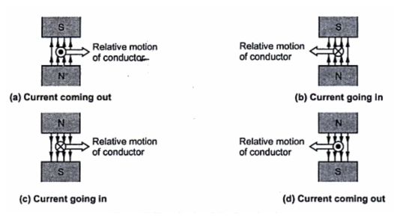
Fig. 2
Key Point : It can be observed from the Fig. 2. that if the direction of relative motion of conductor is reversed keeping flux direction same or if flux direction is reversed keeping direction of relative motion of conductor same then the direction of induced e.m.f. and hence direction of current it sets up in an external circuit gets reversed.
The magnitude of the induced e.m.f. is given by,l
E = B x l x v
where l = Active length of conductor in m.
v = Relative velocity component of conductor in m/s in the direction perpendicular to direction of the flux.
The active length means the length of conductor which is under the influence of magnetic field. In all the cases above, direction of motion of conductor is perpendicular to the plane of the flux.
But if it is not perpendicular then the component of velocity which is perpendicular to the plane of the flux, is only responsible for the induced e.m.f. in the conductor. This is shown in the Fig 3(a). In this Fig. 3(a), though the velocity is v, its component v which is perpendicular to the flux lines is only responsible for the induced e.m.f.
If the plane of the rotation of conductor is parallel to the plane of the flux, there will not be any cutting of flux and hence there can not be any induced e.m.f. in the conductor. This is shown in the Fig.3(b).
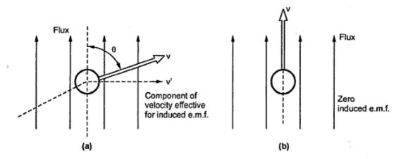
Fig. 3
Key Point : So to have an induced e.m.f. in the conductor not only the relative motion between the conductor and the flux is necessary but plane of rotation and plane of flux should not be parallel to each other.
If angle between the plane of rotation and the plane of the flux is 'θ' as measured from the axis of the plane of flux then the induced e.m.f. is given by,
E = B l (v sinθ) volts
Where v sinθ is the component of velocity which is perpendicular to the plane of flux and hence responsible for the induced e.m.f. This is shown in the Fig. 4.
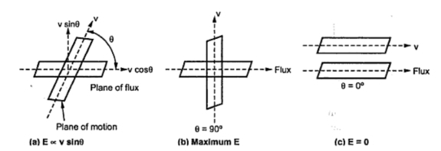
Fig. 4

From the equation of the induced e.m.f., it can be sen that the basic nature of the induced e.m.f in a d.c. generator is purely sinusoidal i.e. alternating. To have d.c. voltage, a device is used in a d.c. generator to convert the alternating e.m.f. to unidirectional e.m.f. This device is called commutator. An alternator is a machine which produces an alternating e.m.f. without a commutator. So an alternator with a commutator is the basic d.c. generator. Practically there is a difference between the construction of an alternator and a d.c. generator through the basic principle of working is same.
Generator Principle :

An electric generator is a machine that converts mechanical energy into electrical energy. An electric generator is based on the principle that whenever flux is cut by a conductor, an e.m.f. is induced which will cause a current to flow if the conductor circuit is closed. The direction of induced e.m.f. (and hence current) is given by Fleming’s right hand rule. Therefore, the essential
components of a generator are:
(a) a magnetic field
(b) conductor or a group of conductors
(c) motion of conductor w.r.t. magnetic field.
Simple Loop Generator :
Consider a single turn loop ABCD rotating clockwise in a uniform magnetic field with a constant speed as shown in Fig.(1.1). As the loop rotates, the flux linking the coil sides AB and CD changes continuously. Hence the e.m.f. induced in these coil sides also changes but the e.m.f. induced in one coil side adds to that induced in the other.
(i) When the loop is in position no. 1 [See Fig. 1.1], the generated e.m.f. is zero because the coil sides (AB and CD) are cutting no flux but are moving parallel to it
(ii) When the loop is in position no. 2, the coil sides are moving at an angle to the flux and, therefore, a low e.m.f. is generated as indicated by point 2 in Fig. (1.2).
(iii) When the loop is in position no. 3, the coil sides (AB and CD) are at right angle to the flux and are, therefore, cutting the flux at a maximum rate. Hence at this instant, the generated e.m.f. is maximum as indicated by point 3 in Fig. (1.2).
(iv) At position 4, the generated e.m.f. is less because the coil sides are cutting the flux at an angle.
(v) At position 5, no magnetic lines are cut and hence induced e.m.f. is zero as indicated by point 5 in Fig. (1.2).
(vi) At position 6, the coil sides move under a pole of opposite polarity and hence the direction of generated e.m.f. is reversed. The maximum e.m.f. in this direction (i.e., reverse direction, See Fig. 1.2) will be when the loop is at position 7 and zero when at position 1. This cycle repeats with each revolution of the coil.

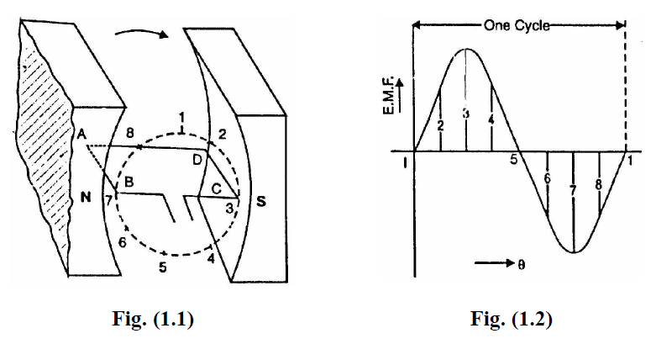
Note that e.m.f. generated in the loop is alternating one. It is because any coil side, say AB has e.m.f. in one direction when under the influence of N-pole and in the other direction when under the influence of S-pole. If a load is connected across the ends of the loop, then alternating current will flow through the load. The alternating voltage generated in the loop can be converted into direct voltage by a device called commutator. We then have the d.c. generator. In fact,
a commutator is a mechanical rectifier.
Basic Single Coil AC Generator :
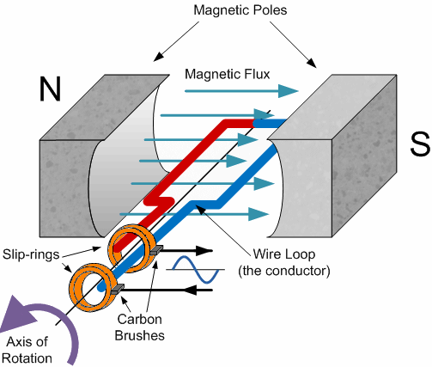

As the coil rotates anticlockwise around the central axis which is perpendicular to the magnetic field, the wire loop cuts the lines of magnetic force set up between the north and south poles at different angles as the loop rotates. The amount of induced EMF in the loop at any instant of time is proportional to the angle of rotation of the wire loop.
As this wire loop rotates, electrons in the wire flow in one direction around the loop. Now when the wire loop has rotated past the 180o point and moves across the magnetic lines of force in the opposite direction, the electrons in the wire loop change and flow in the opposite direction. Then the direction of the electron movement determines the polarity of the induced voltage.
So we can see that when the loop or coil physically rotates one complete revolution, or 360o, one full sinusoidal waveform is produced with one cycle of the waveform being produced for each revolution of the coil. As the coil rotates within the magnetic field, the electrical connections are made to the coil by means of carbon brushes and slip-rings which are used to transfer the electrical current induced in the coil.
The amount of EMF induced into a coil cutting the magnetic lines of force is determined by the following three factors.
- Speed – the speed at which the coil rotates inside the magnetic field.
- Strength – the strength of the magnetic field.
- Length – the length of the coil or conductor passing through the magnetic field.
We know that the frequency of a supply is the number of times a cycle appears in one second and that frequency is measured in Hertz. As one cycle of induced emf is produced each full revolution of the coil through a magnetic field comprising of a north and south pole as shown above, if the coil rotates at a constant speed a constant number of cycles will be produced per second giving a constant frequency. So by increasing the speed of rotation of the coil the frequency will also be increased. Therefore, frequency is proportional to the speed of rotation, ( ƒ ∝ Ν ) where Ν = r.p.m.
Also, our simple single coil generator above only has two poles, one north and one south pole, giving just one pair of poles. If we add more magnetic poles to the generator above so that it now has four poles in total, two north and two south, then for each revolution of the coil two cycles will be produced for the same rotational speed. Therefore, frequency is proportional to the number of pairs of magnetic poles, ( ƒ ∝ P ) of the generator where P = is the number of “pairs of poles”.
Then from these two facts we can say that the frequency output from an AC generator is:
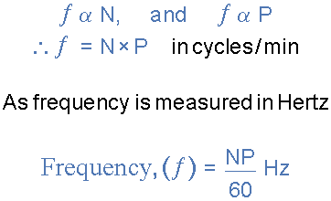

Where: Ν is the speed of rotation in r.p.m. P is the number of “pairs of poles” and 60 converts it into seconds.
Instantaneous Voltage
The EMF induced in the coil at any instant of time depends upon the rate or speed at which the coil cuts the lines of magnetic flux between the poles and this is dependant upon the angle of rotation, Theta ( θ ) of the generating device. Because an AC waveform is constantly changing its value or amplitude, the waveform at any instant in time will have a different value from its next instant in time.
For example, the value at 1ms will be different to the value at 1.2ms and so on. These values are known generally as the Instantaneous Values, or Vi Then the instantaneous value of the waveform and also its direction will vary according to the position of the coil within the magnetic field as shown below.
Displacement of a Coil within a Magnetic Field

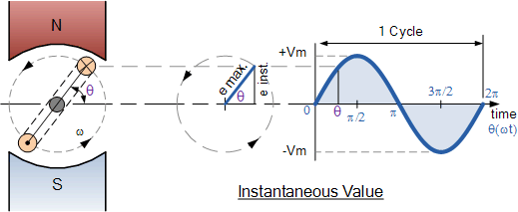

The instantaneous values of a sinusoidal waveform is given as the “Instantaneous value = Maximum value x sin θ ” and this is generalized by the formula.

Where, Vmax is the maximum voltage induced in the coil and θ = ωt, is the rotational angle of the coil with respect to time.
If we know the maximum or peak value of the waveform, by using the formula above the instantaneous values at various points along the waveform can be calculated. By plotting these values out onto graph paper, a sinusoidal waveform shape can be constructed.
In order to keep things simple we will plot the instantaneous values for the sinusoidal waveform at every 45o of rotation giving us 8 points to plot. Again, to keep it simple we will assume a maximum voltage, VMAX value of 100V. Plotting the instantaneous values at shorter intervals, for example at every 30o (12 points) or 10o (36 points) for example would result in a more accurate sinusoidal waveform construction.
Construction of a Practical D.C. Machine
As stated earlier, whether a machine is d.c. generator or a motor the construction basically remains the same as shown in the Fig. 1.
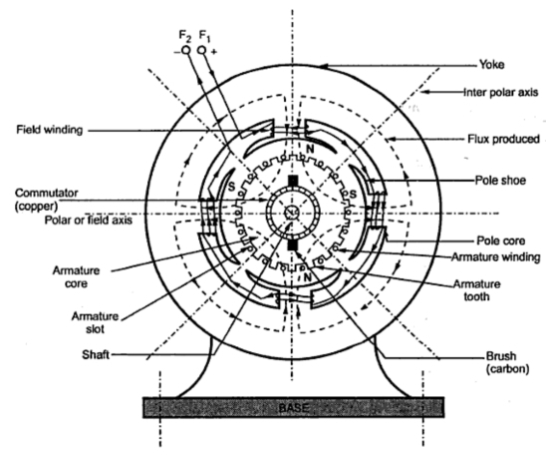
Fig.1 A cross section of typical d.c. machine

It consists of the following parts :
1. Yoke
a) Functions :
- It serves the purpose of outermost cover of the d.c. machine. So that the insulating materials get protected from harmful atmospheric elements like moisture, dust and various gases like SO2, acidic fumes etc.
- It provides mechanical support to the poles.
- It forms a part of the magnetic circuit. It provides a path of low reluctance for magnetic flux. The low reluctance path is important to avoid wastage of power to provide same flux. Large current and hence the power is necessary if the path has high reluctance, to produce the same flux.
b) Choice of Material : To provide low reluctance path, it must be made up of some magnetic material. It is prepared by using cast iron because it is cheapest. For large machines rolled steel, cast steel, silicon steel is used which provides high permeability i.e. low reluctance and gives good mechanical strength.
2. Poles
Each pole is divided into two parts namely, I) Pole core and II) Pole shoe.
This is shown in the Fig. 2.
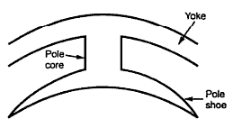
Fig. 2 Pole Structure

a) Functions of pole core and pole shoe :
Pole core basically carries a field winding which is necessary to produce the flux.
It directs the flux produced through air gap to armature core, to the next pole.
Pole shoe enlarges the area of armature core to come across the flux, which is necessary to produce larger induced e.m.f. To achieve this, pole shoe has been given a particular shape.
b) Choice of Material : It is made up of magnetic material like cast iron or cast steel. As it requires a definite shape and size, laminated construction is used. The laminations of required size and shape are stamped together to get a pole which is then bolted to the yoke.

3. Field Winding (F1-F2)
The field winding is wound on the pole core with a definite direction.
a) Functions : To carry current due to which pole core, on which the field winding is placed behaves as an electromagnet, producing necessary flux.
As it helps in producing the magnetic field i.e. exciting the pole as an electromagnet it is called Field winding or Exciting winding.
b) Choice of material : It has to carry current hence obviously made up of some conducting material. So aluminium or copper is the choice. But field coils are required to take any type of shape and bend about pole core and copper has good pliability i.e. it can bend easily. So copper is the proper choice.
Note : Field winding is divided into various coils called field coils. These are connected in series with each other and in such a direction around pole cores, such that alternate 'N' and 'S' poles are formed.
By using right hand thumb rule for current carrying circular conductor, it can be easily determined that how a particular core is going to behave as 'N' or 'S' for a particular winding direction around it. The direction of winding and flux can be observed in the Fig 3.
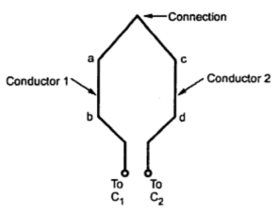
Fig. 3

4. Armature
It is further divided into two parts namely,
I) Armature core and II) Armature winding
I) Armature core : Armature core is cylindrical in shape mounted on the shaft. It consists of slots on its periphery and the air ducts to permit the air flow through armature which serves cooling purpose.
a) Functions :
Armature core provides house for armature winding i.e. armature conductors.
To provide a path of low reluctance to the magnetic flux produced by the field winding.
b) Choice of Material : As it has to provide a low reluctance path to the flux, it is made up of magnetic material like cast iron or cast steel.
It is made up of laminated construction to keep eddy current loss as low as possible. A single circular lamination used for the construction of the armature core is shown in the Fig. 4.
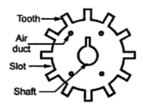
Fig. 4 Single Circular lamination of Armature core

II) Armature winding : Armature winding is nothing but the interconnection of the armature conductors, placed in the slots provided on the armature core periphery. When the armature is rotated, in case of generator, magnetic flux gets cut by armature conductors and e.m.f. gets induced in them.
a) Functions :
Generation of e.m.f takes place in the armature winding in case of generators.
To carry the current supplied in case of d.c. motors.
To do the useful work in the external circuit.
b) Choice of material : As armature winding carries entire current which depends on external load, it has to be made up of conducting material, which is copper.
Armature winding is generally former wound. The conductors are placed in the armature slots which are lined with tough insulating material.

5. Commutator
We have seen earlier that the basic nature of e.m.f. induced in the armature conductors is alternating. This needs rectification in case of d.c. generator, which is possible by a device called commutator.
a) Functions :
To facilitate the collection of current from the armature conductors.
To convert internally developed alternating e.m.f. to unidirectional (d.c.) e.m.f.
To produce unidirectional torque in case of motors.
b) Choice of material : As it collects current from armature, it is also made up of copper segments.
It is cylindrical in shape and is made up of wedge shaped segments of the hard drawn, high conductivity copper. These segments are insulated from each other by thin layer of mica. Each commutator segment is connected to the armature conductor by means of copper lug or strip. This connection is shown in the Fig. 5.
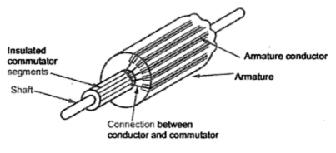
Fig. 5 Commutator

6. Brushes and Brush Gear
Brushes are stationary and resting on the surface of the commutator.
a) Function : To collect current from commutator and make it available to the stationary external circuit.
b) Choice of material : Brushes are normally made up of soft material like carbon.
Brushes are rectangular in shape. They are housed in brush holders, which are usually of box type. The brushes are made to press on the commutator surface by means of a spring, whose tension can be adjusted with the help of lever. A flexible copper conductor called pig tail is used to connect the brush to the external circuit. To avoid wear and tear of commutator, the brushes are made up of soft material like carbon.
7. Bearings
Ball-bearings are usually used as they are more reliable. For heavy duty machines, roller bearings are prederred.

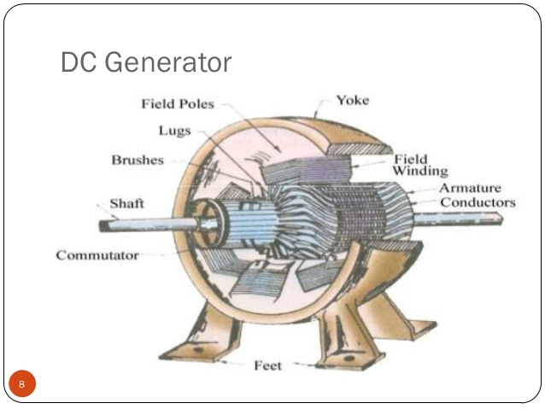
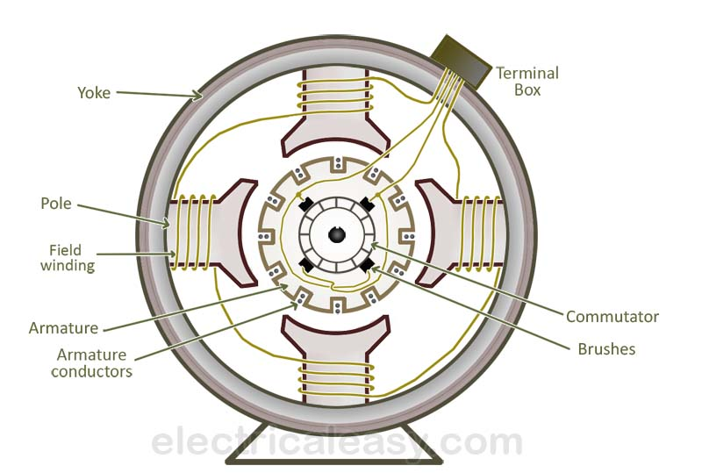

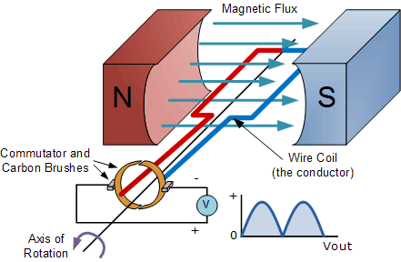

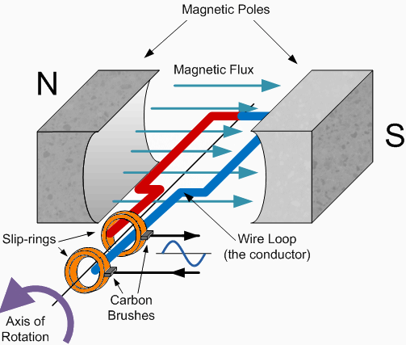
Action of Commutator:
If, somehow, connection of the coil side to the external load is reversed at the same instant the current in the coil side reverses, the current through the load will be direct current. This is what a commutator does. Fig. (1.3) shows a commutator having two segments C1 and C2. It consists of a cylindrical metal ring cut into two halves or segments C1 and C2 respectively separated by a thin sheet of mica. The commutator is mounted on but insulated from the rotor shaft.The ends of coil sides AB and CD are connected to the segments C1 and C2 respectively as shown in Fig. (1.4). Two stationary carbon brushes rest on the commutator and lead current to the external load. With this arrangement, the commutator at all times connects the coil side under S-pole to the +ve brush and that under N-pole to the -ve brush.
(i) In Fig. (1.4), the coil sides AB and CD are under N-pole and S-pole respectively. Note that segment C1 connects the coil side AB to point P of the load resistance R and the segment C2 connects the coil side CD to point Q of the load. Also note the direction of current through load. It is from Q to P.
(ii) After half a revolution of the loop (i.e., 180° rotation), the coil side AB is under S-pole and the coil side CD under N-pole as shown in Fig. (1.5).The currents in the coil sides now flow in the reverse direction but the segments C1 and C2 have also moved through 180° i.e., segment C1 is now in contact with +ve brush and segment C2 in contact with -ve brush.
Note that commutator has reversed the coil connections to the load i.e., coil side AB is now connected to point Q of the load and coil side CD to the point P of the load. Also note the direction of current through the load. It is again from Q to P.
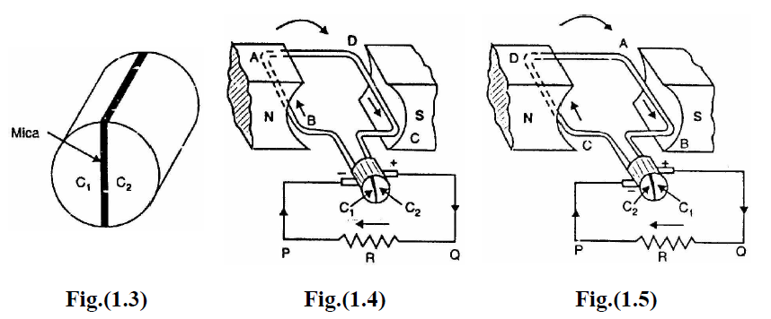
Thus the alternating voltage generated in the loop will appear as direct voltage across the brushes. The reader may note that e.m.f. generated in the armature winding of a d.c. generator is alternating one. It is by the use of commutator that we convert the generated alternating e.m.f. into direct voltage. The purpose of brushes is simply to lead current from the rotating loop or winding to the external stationary load.
The variation of voltage across the brushes with the angular displacement of the loop will be as shown in Fig. (1.6). This is not a steady direct voltage but has a pulsating character. It is because the voltage appearing across the brushes varies from zero to maximum value and back to zero twice for each revolution of the loop. A pulsating direct voltage such as is produced by a single loop is not suitable for many commercial uses. What we require is the steady direct voltage. This can be achieved by using a large number of coils connected in series. The resulting
arrangement is known as armature winding.
