NBKRIST
ELECTROMECHANICAL ENERGY CONVERSION – III
LECTURE NOTES
UNIT-2
DEPARTMENT OF ELECTRICAL AND ELECTRONICS ENGINEERING

Voltage Regulation of an Alternator
Under the load condition, the terminal voltage of alternator is less than the induced e.m.f. E_{ph}. So if load is disconnected , V_{ph} will change from V_{ph} to E_{ph}, if flux and speed is maintained constant. This is because when load is disconnected, I_{a} is zero hence there are no voltage drops and no armature flux to cause armature reaction. This change in the terminal voltage is significant in defining the voltage regulation.
Note : The voltage regulation of an alternator is defined as the change in its terminal voltage when full load is removed, keeping field excitation and speed constant, divided by the rated terminal voltage.,
So if V_{ph} = Rated terminal voltage
E_{ph} = No load induced e.m.f.
The voltage regulation is defined as,
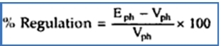

The value of the regulation not only depends on the load current but also on the power factor of the load. For lagging and unity p.f. conditions there is always drop in the terminal voltage hence regulation values are always positive. While for leading capacitive load conditions, the terminal voltage increases as load current increases. Hence regulation is negative in such cases. The relationship between load current and the terminal voltage is called load characteristics of an alternator. Such load characteristics for various load power factor conditions are shown in Fig. 2.1.
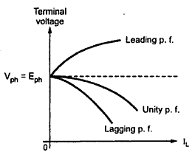
Fig. 2.1 Load characteristics of an alternator

Determination of Voltage Regulation
There are mainly two methods which are used to determine the regulation of voltage of a smooth cylindrical rotor type alternator. They are named as direct load test method and indirect methods of voltage regulation. The indirect method is further classified as Synchronous Impedance Method, Ampere-turn Method and Zero Power Factor Method.

Direct Load Test
The alternator runs at synchronous speed, and its terminal voltage is adjusted to its rated value V. The load is varied until the Ammeter and Wattmeter indicate the rated values at the given power factor. The load is removed, and the speed and the field excitation are kept constant. The value of the open circuit and no load voltage is recorded.
It is also found from the percentage voltage regulation and is given by the equation shown below.
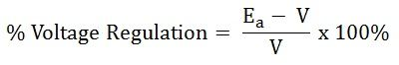
The method of direct loading is suitable only for small alternators of the power rating less than 5 kVA.

Indirect Methods of Voltage Regulation
  - Synchronous Impedance Method or EMF method.
  - Ampere-turn method or MMF method of Voltage Regulation.

Zero Power Factor method or Potier Method

Synchronous Impedance Method
The Synchronous Impedance Method or EMF Method is based on the concept of replacing the effect of armature reaction by an imaginary reactance. For calculating the regulation, the synchronous method requires the following data; they are the armature resistance per phase and the open circuit characteristic. The open circuit characteristic is the graph of the circuit voltage and the field current. This method also requires short circuit characteristic which is the graph of the short circuit and the field current.
For a synchronous generator following are the equation given below
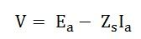
Where,
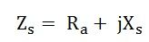

Measurement of Synchronous Impedance
The measurement of synchronous impedance is done by the following tests. They are

DC resistance test
In this test, it is assumed that the alternator is star connected with the DC field winding open as shown in the circuit diagram fig. 2.2.
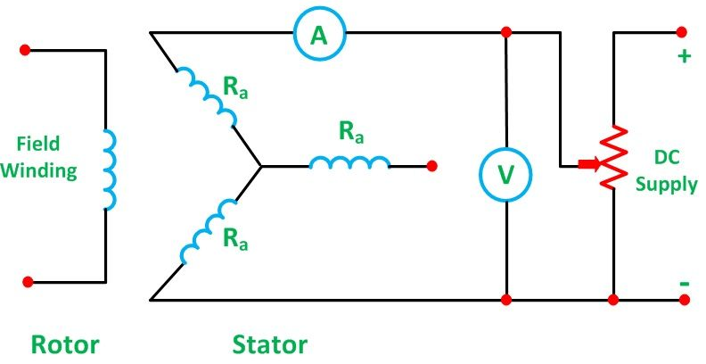
Fig. 2.2
It measures the DC resistance between each pair of terminals either by using an ammeter – voltmeter method or by using the Wheatstone’s bridge. The average of three sets of resistance value R_{t} is taken. The value of R_{t} is divided by 2 to obtain a value of DC resistance per phase. Since the effective AC resistance is larger than the DC resistance due to skin effect. Therefore, the effective AC resistance per phase is obtained by multiplying the DC resistance by a factor 1.20 to 1.75 depending on the size of the machine. A typical value to use in the calculation would be 1.25.

Open Circuit Test
In the open circuit test for determining the synchronous impedance, the alternator is running at the rated synchronous speed, and the load terminals are kept open. This means that the loads are disconnected, and the field current is set to zero. The circuit diagram is shown Fig. 2.3.
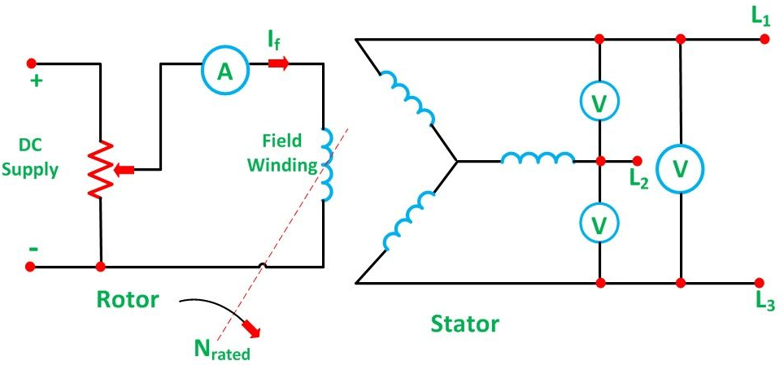.
Fig. 2.3
After setting the field current to zero, the field current is gradually increased step by step. The terminal voltage E_{t} is measured at each step. The excitation current may be increased to get 25% more than the rated voltage. A graph is drawn between the open circuit phase voltage E_{p} = E_{t}/√3 and the field current I_{f}. The curve so obtains called Open Circuit Characteristic (O.C.C). The shape is same as normal magnetisation curve. The linear portion of the O.C.C is extended to form an air gap line.
The Open Circuit Characteristic (O.C.C) and the air gap line is shown in the fig.2.3.

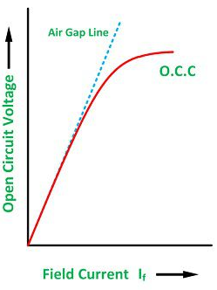
Fig. 2.3

Short Circuit Test
In the short circuit test, the armature terminals are shorted through three ammeters as shown in the fig. 2.4.
The field current should first be decreased to zero before starting the alternator. Each ammeter should have a range greater than the rated full load value. The alternator is then run at synchronous speed. Same as in an open circuit test that the field current is increased gradually in steps and the armature current is measured at each step. The field current is increased to get armature currents up to 150% of the rated value.
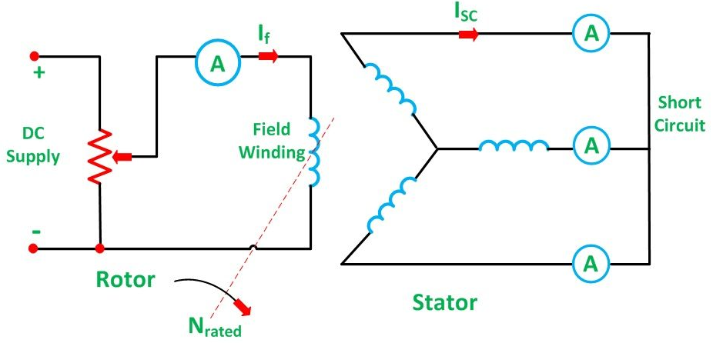
Fig. 2.4
The value of field current I_{f} and the average of three ammeter readings at each step is taken. A graph is plotted between the armature current Ia and the field current I_{f}. The characteristic so obtained is called Short Circuit Characteristic (S.C.C). This characteristic is a straight line as shown in the fig. 2.5.

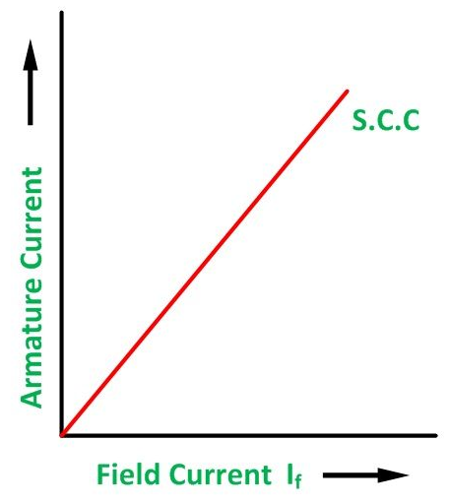
Fig. 2.5

Calculation of Synchronous Impedance
The following steps are given below for the calculation of the synchronous impedance.
- The open circuit characteristics and the short circuit characteristic are drawn on the same X-Y Plane(Graph).
- Determine the value of short circuit current I_{sc} and gives the rated alternator voltage per phase.
- The synchronous impedance Z_{S} will then be equal to the open circuit voltage divided by the short circuit current at that field current which gives the rated EMF per phase.
The synchronous reactance is determined as
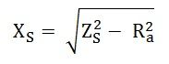
The graph is shown in fig.2.6.
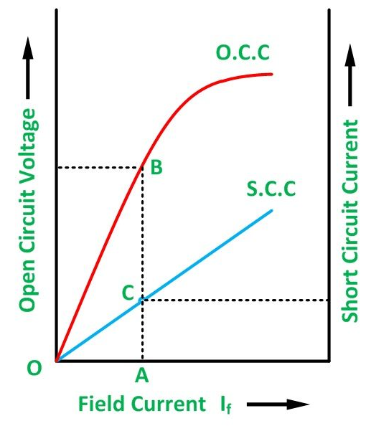
Fig. 2.6
From the above fig. 2.6 consider the field current I_{f} = OA that produces rated alternator voltage per phase. Corresponding to this field current, the open circuit voltage is AB
Therefore,
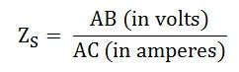

Assumptions in the Synchronous Impedance Method
The following assumptions made in the synchronous Impedance Method are given below.
- The synchronous Impedance is constant
The synchronous impedance is determined from the O.C.C and S.C.C. It is the ratio of the open circuit voltage to the short circuit current. When the O.C.C and S.C.C are linear, the synchronous impedance Z_{S} is constant.
- The flux under test conditions is the same as that under load conditions.
It is assumed that a given value of the field current always produces the same flux. This assumption introduces considerable error. When the armature is short circuited, the current in the armature lag the generated voltage by almost 90 degrees, and hence the armature reaction is almost completely demagnetizing.
- The effect of the armature reaction flux can be replaced by a voltage drop proportional to the armature current and that the armature reaction voltage drop is added to the armature reactance voltage drop.
- The magnetic reluctance to the armature flux is constant regardless of the power factor.
For a cylindrical rotor machine, this assumption is substantially true because of the uniform air gap. Regulation obtained by using a synchronous impedance method is higher than that obtained by actual loading. Hence, this method is also called the Pessimistic method.
At lower excitations, Z_{S} is constant, since the open circuit characteristics coincide with the air gap line. This value of Z_{S} is called the linear or Unsaturated Synchronous Impedance. However, with increasing excitation, the effect of saturation is to decrease Z_{S} and the values beyond the linear part of the open circuit called as Saturated Value of the Synchronous Impedance.

MMF Method of Voltage Regulation (Rothert’s MMF method)
MMF Method is also known as Ampere Turn Method. The synchronous impedance method is based on the concept of replacing the effect of armature reaction by an imaginary reactance the Magneto motive force (MMF). The MMF method replaces the effect of armature leakage reactance by an equivalent additional armature reaction MMF so that this MMF may be combined with the armature reaction MMF.
To calculate the voltage regulation by MMF Method, the following information is required. They are as follows:
- The resistance of the stator winding per phase
- Open circuit characteristics at synchronous speed.
- Short circuit characteristic

Step to Draw Phasor Diagram of MMF Method
The phasor diagram at a lagging power factor is shown in fig. 2.7.
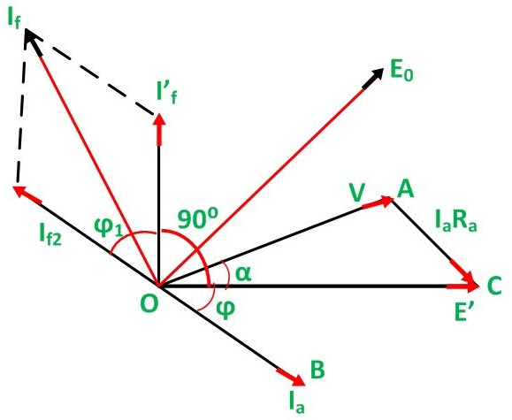
Fig. 2.7
- The armature terminal voltage per phase (V) is taken as the reference phasor along OA.
- The armature current phasor I_{a} is drawn lagging the phasor voltage for lagging power factor angle ϕ for which the regulation is to be calculated.
- The armature resistance drop phasor I_{a}R_{a} is drawn in phase with I_{a} along the line AC. Join O and C. OC represents the emf E’.
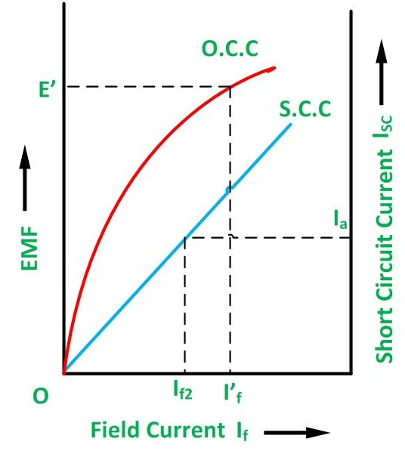
Fig. 2.8
- Considering the Open Current Characteristics shown in fig.2.8. The field current I’_{f} corresponding to the voltage E’ is calculated.
- Draw the field current I’_{f} leading the voltage E’ by 90 degrees. It is assumed that on short circuit all the excitation is opposed by the MMF of armature reaction. Thus,
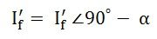
From the Short Circuit Current characteristics (SSC) shown above, determine the field current I_{f2} required to circulate the rated current on short circuit. This is the filed current required to overcome the synchronous reactance drop I_{a}X_{a}.
- Draw the field current I_{f2} in phase in opposition to the current armature current I_{a}. Thus,
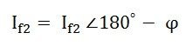
Determine the phasor sum of the field currents I_{f}¹ and I_{f2}. This gives the resultant field current If which would generate a voltage E₀ under no load conditions of the alternator. The open circuit EMF E₀ corresponding to the field current if is found from the open circuit characteristics
The regulation of the alternator is found from the relation shown below.
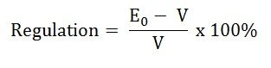

Potier Triangle or Zero Power Factor Method
The Potier triangle determines the voltage regulation of the machines. This method depends on the separation of the leakage reactance of armature and their effects. The graph of the Potier triangle is shown in the figure below. The triangle formed by the vertices a, b, c has shown below in the fig. 2.9 is called Potier Triangle.

Contents:
- Steps for Construction of Potier Triangle on ZPFC
- Assumptions for Potier Triangle

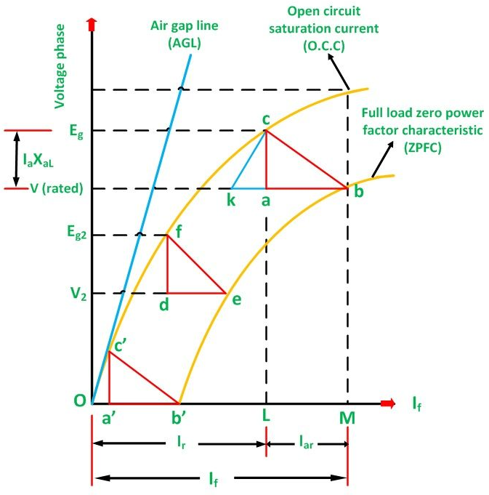
Fig. 2.9
Consider a point B on the Zero Power Factor Curve corresponding to rated terminal voltage V and a field current of OM = I_{f} = F_{f}/T_{f}. If, for this condition of operation the armature reaction MMF has a value expressed in equivalent field current will be given as
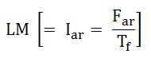
Then the equivalent field current of the resultant MMF would be represented as shown below.
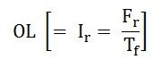
This field current OL would result in a generated voltage E_{g} = L_{c} from the no-load saturation curve. Since for lagging Zero Power Factor operation, the generated voltage will be
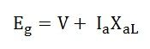
The vertical distance ac must be equal to the leakage reactance voltage drop I_{a}X_{aL} where I_{a} is the rated armature current.
Therefore,
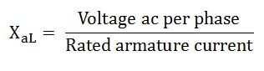
For Zero Power Factor operation with rated current at any other terminal voltage, such as V₂. As the armature current is of the same value, both the I_{a} and X_{aL} voltage and the armature MMF must be of the same value. Therefore, for all the conditions of operation with rated armature current at zero lagging power factor, the Potier Triangle must be located between the terminal voltage V, a point on the ZPFC and the corresponding Eg point on the O.C.C.
If the Potier triangle cab is moved downward so that the side ab is kept horizontal and b is kept on the ZPFC, the point c will move on the O.C.C. When the point b, reaches the point e, the Potier triangle cab will move on the position fde shown in the figure. The location of point f on the O.C.C will determine the voltage Eg2. When the point b, reaches the point b’, the Potier Triangle will be in the position c’a’b’. This is the limiting position which corresponds to short the circuit condition because the terminal voltage is zero at the point b’.
The initial part of the O.C.C is almost linear, another triangle Oc’b’is formed by the O.C.C. The hypotenuse of the Potier triangle and the baseline. A similar triangle such as ckb, can construct from the Potier triangle in any other location by drawing a line kc parallel to Oc’.

Steps for Construction of Potier Triangle on ZPFC
- Take a point b on the ZPFC preferably well upon the knee of the curve.
- Draw bk equal to b’O. (b’ is the point for zero voltage, full load current). Ob’ is the short circuit excitation Fsc.
- Through k draw, kc parallel to Oc’ to meet O.C.C in c.
- Drop the perpendicular ca on to bk.
- Then, to scale ca is the leakage reactance drop I_{a}X_{aL} and ab is the armature reaction MMF F_{aR} or the field current IfaR equivalent to armature reaction MMF at rated current.
The effect of field leakage flux in combination with the armature leakage flux gives rise to an equivalent leakage reactance Xp, known as the Potier Reactance. It is greater than the armature leakage reactance.
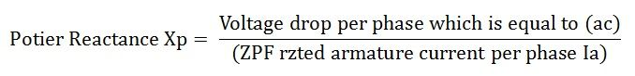
For cylindrical rotor machines, the Potier reactance X_{p} is approximately equal to the leakage reactance X_{aL}. in salient pole machine, X_{p} may be as large as 3 times X_{aL}.

Assumptions for Potier Triangle
The following assumptions are made in the Potier Triangle Method. They are as follows:-
- The armature resistance R_{a} is neglected.
- The O.C.C taken on no load accurately represents the relation between MMF and Voltage on load.
- The leakage reactance voltage I_{a} X_{aL} is independent of excitation.
- The armature reaction MMF is constant.
It is not necessary to plot the entire ZPFC for determining X_{aL} and F_{a}, only two points b and b’ are sufficient. Point b corresponds to a field current which gives the rated terminal voltage while the ZPF load is adjusted to draw rated current. Point b’ corresponds to the short circuit condition (V = 0) on the machine. Thus, Ob’ is the field current required to circulate the short circuit current equal to the rated current.

Zero Power Factor Characteristic (ZPFC)
Zero Power Factor Characteristic (ZPFC) of a generator is a curve of the armature terminal voltage and the field current. The machine is operated with constantly rated armature current at synchronous speed and zero lagging power factor. The Zero Power Factor Characteristic is also called as Potier Characteristic.
For maintaining very low power factor, the alternator is loaded by means of reactors or by an under excited synchronous motor. The shape of ZPFC is very much like that of the O.C.C. The phasor diagram corresponding to zero power factor lagging is shown fig. 2.10.
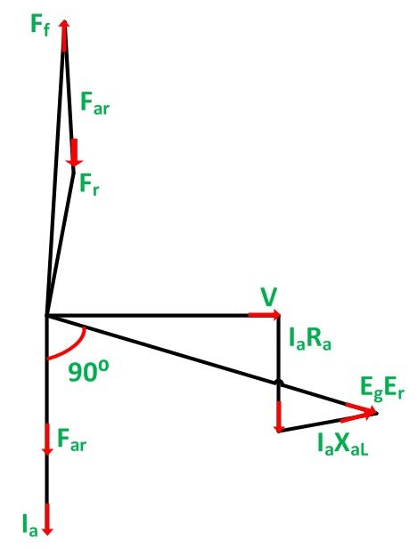
Fig. 2.10
In the phasor diagram shown Fig. 2.10 above, the terminal voltage V is taken as the reference phasor. At zero power factor lagging, the armature current Ia lags behind V by 90 degrees. I_{a}R_{a} is drawn parallel to I_{a} and I_{a}X_{aL} perpendicular to I_{a}.
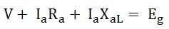
E_{g} is the generated voltage per phase.
The phasor diagram at ZPF lagging with the armature resistance R_{a} neglected is shown below Fig. 2.11.
.
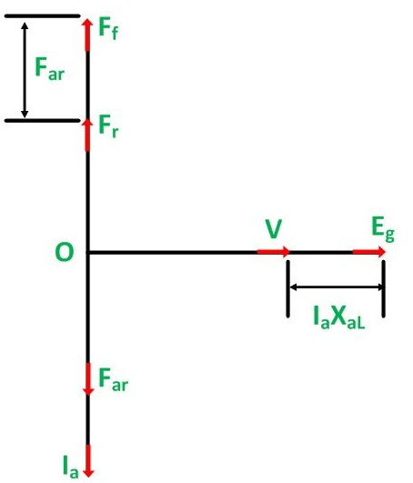
Fig. 2.11

Where,
- F_{ar} is the armature reaction MMF. It is in phase with the armature current Ia.
- F_{f} is the MMF of the main field winding (field MMF).
- F_{r} is the resultant MMF.
The field MMF F_{f} is obtained by subtracting F_{ar} from F_{r} so that
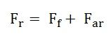
From the above phasor diagram Fig. 2.11, it is seen that the terminal voltage V, the reactance voltage drop I_{a}X_{aL} and the generated voltage E_{g} all are in phase. Therefore, V is practically equal to the arithmetical difference between E_{g} and I_{a}X_{aL}.
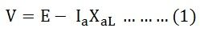
The three MMF phasor Ff, Fr and Far are in phase. Their magnitudes are related by the equation shown below
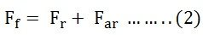
The above two equations, i.e. equation (1) and (2) forms the basis for the Potier triangle.
If the equation (2) is divided both sides by T_{f}, it is converted into its equivalent field current form. Here T_{f} is the effective number of turns per pole on the rotor field.
Therefore,
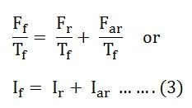
From the above equation, the sum of the resultant current and the armature reaction current gives the field current.

Short Circuit Ratio of a Synchronous Machine
The Short Circuit Ratio (SCR) of a synchronous machine is defined as the ratio of the field current required to generate rated voltage on an open circuit to the field current required to circulate rated armature current on short circuit. The short circuit ratio can be calculated from the open circuit characteristic (O.C.C) at rated speed and the short circuit characteristic (S.C.C) of a three-phase synchronous machine as shown in the Fig. 2.11.
From the Fig. 1.29, the short circuit ratio is given by the equation shown below.
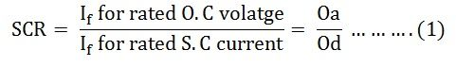
Since the triangles Oab and Ode are similar. Therefore,
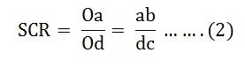
The direct axis synchronous reactance X_{d} is defined as the ratio of open circuit voltage for a given field current to the armature short circuit current for the same field current.

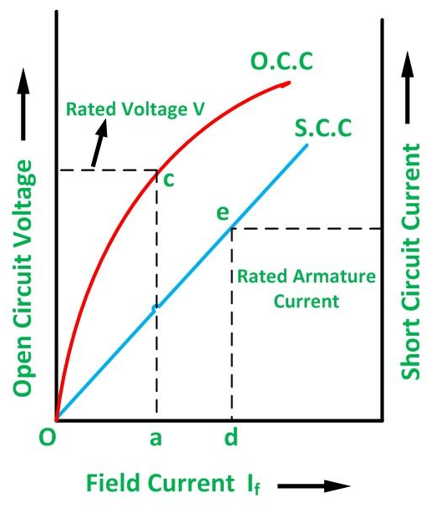
Fig. 2.11
For the field current equal to Oa, the direct axis synchronous reactance in ohms is given by the equation shown below.
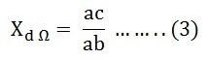
The per unit value of X_{d} is given as
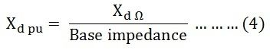
But, the base impedance is
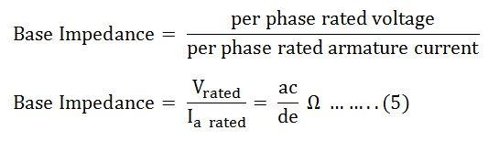
Therefore,
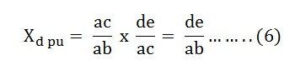
From the equation (1) and the equation (6) we get
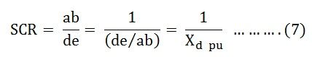
From the equation (7) it is clear that the short circuit ratio is equal to the reciprocal of the per unit value of the direct axis synchronous reactance.
In a saturated magnetic circuit, the value of X_{d} depends upon the degree of saturation.

Significance of Short Circuit Ratio (SCR)
Short Circuit Ratio is an important factor of the synchronous machine. It affects the operating characteristics, physical size and cost of the machine. The Large variation in the terminal voltage with a change in load takes place for the lower value of the short circuit ratio of a synchronous generator. In order to keep the terminal voltage constant, the field current (I_{f}) has to be varied over a wide range.
For the small value of the short circuit ratio (SCR), the synchronizing power is small. As the synchronizing power keeps the machine in synchronism, a lower value of the SCR has a low stability limit. In other words, a machine with a low SCR is less stable when operating in parallel with the other generators.
A synchronous machine with the high value of SCR had a better voltage regulation and improved steady state stability limit, but the short circuit fault current in the armature is high. It also affects the size and cost of the machine.
The excitation voltage of the synchronous machine is given by the equation.
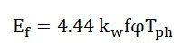
For the same value of Tph Excitation voltage is directly proportional to the field flux per pole.
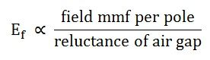
The synchronous inductance is given as
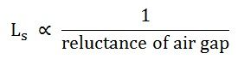
Therefore,
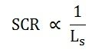
Hence, the short circuit ratio is directly proportional to the air gap reluctance or air gap length.
If the length of the air gap is increased, the SCR can be increased. With the increase in the air gap length, the field MMF is to be increased for the same value of excitation voltage (E_{f}). Hence, to increase the value of field MMF either field current or the number of field turns has to be increased. All this requires a greater height of field poles and, as a result, the overall diameter of the machine increases.
Thus, a conclusion is that the large value of SCR will increase the size, weight and the cost of the machine.
The typical values of the SCR for different types of machines are as follows:-
- For cylindrical rotor machine, the value of SCR lies between 0.5 and 0.9.
- In case of the Salient-pole machine, it lies between 1 to 1.5 and
- For synchronous compensators, it is 0.4.

