PROGRAM13

Aim:- To obtain Amplitude modulated versions of the given input and output arrays

Appartus:- MATLAB6P1 Software, Personal computer

Algorithm:-

Step1: Initialization of Input Array:- In this step, we are going to create an array(1-D matrix) having N number of elements, which starts from 1 to N

Step2:- Creation and Display of the output array:- in this step, we will create an output array corresponding to the given input array x and we will represent the obtained output arrays using Plot, bar, stem functions

Step3:- Creation of the Modulated version of the output array by multiplying output sequence with xam which is given by

Xam(t)= Vc cos(wct)+mvc/2[cos(wc-wm)t-cos(wc+wm)t]

Where Vc= carrier voltage, wc = carrier frequency in radians

Wm=modulating frequency in radians

m=modulating index

Program 13:- %program to obtain modulated version of the output array corresponds to the input array

N=input('enter the no of elements of array');

N=8;

m=input('enter the slope of the straightline');

m=0.5;

c=input('enter the intercept on yaxis');

c=2;

%Initialization of input array

for n=1:N

x(n)=input('enter the arrayx');

end

%Creation of output array

for n=1:N

y(n)=m.*x(n);

y1(n)=(m.*x(n))+c;

y2(n)=cos(x(n));

y3(n)=(x(n)).^2;

y4(n)=square(x(n));

end

fc=input('enter the carrier frequency');

fm=input('enter the modulating frequency');

vc=input('enter the carrier voltage');

u=input('enter the modulating index');

for t=1:N

xam(t)=vc.*cos(2*pi*fc*t)+((u*vc)./2).*(cos((2*pi*(fc-fm))*t)-cos((2*pi*(fc+fm)*t)));

end

y5=y.*xam;y6=y1.*xam;y7=y2.*xam;y8=y3.*xam;y9=y4.*xam;

subplot(11,1,11);plot(xam);

subplot(11,1,2);plot(y);

subplot(11,1,3);plot(y1);

subplot(11,1,4);plot(y2);

subplot(11,1,5);plot(y3);

subplot(11,1,6);plot(y4);

subplot(11,1,7);plot(y5);

subplot(11,1,8);plot(y6);

subplot(11,1,9);plot(y7);

subplot(11,1,10);plot(y8);

subplot(11,1,11);plot(y9);

enter the no of elements of array8

enter the slope of the straightline0.5

enter the intercept on yaxis2

enter the arrayx1

enter the arrayx0

enter the arrayx1

enter the arrayx0

enter the arrayx1

enter the arrayx0

enter the arrayx1

enter the arrayx0

enter the carrier frequency5000

enter the modulating frequency500

enter the carrier voltage20

enter the modulating index0.5

>> x

x = 1 0 1 0 1 0 1 0

>> y

y = 0.5000 0 0.5000 0 0.5000 0 0.5000 0

>> y1

y1 = 2.5000 2.0000 2.5000 2.0000 2.5000 2.0000 2.5000 2.0000

>> y2

y2 = 0.5403 1.0000 0.5403 1.0000 0.5403 1.0000 0.5403 1.0000

>> y3

y3 = 1 0 1 0 1 0 1 0

>> y4

y4 = 1 1 1 1 1 1 1 1

>> y5

y5 = 10 0 10 0 10 0 10 0

>> y6

y6 = 50 40 50 40 50 40 50 40

>> y7

y7 = 10.8060 20.0000 10.8060 20.0000 10.8060 20.0000 10.8060 20.0000

>> y8

y8 = 20 0 20 0 20 0 20 0

>> y9

y9 = 20 20 20 20 20 20 20 20

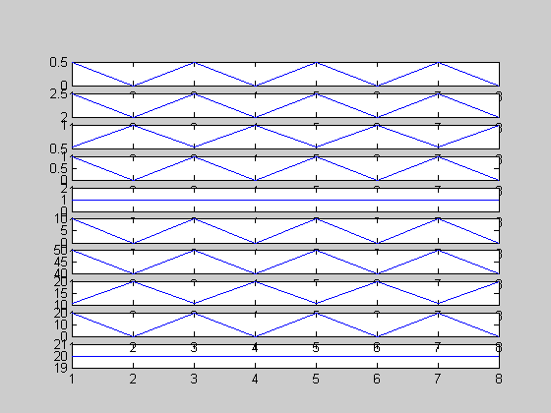

Program 13 a:-

%program to obtain modulated version of the output array corresponds to the input array

N=input('enter the no of elements of array');

N=8;

m=input('enter the slope of the straightline');

m=0.5;

c=input('enter the intercept on yaxis');

c=2;

%Initialization of input array

for n=1:N

x(n)=input('enter the arrayx');

end

%Creation of output array

for n=1:N

y(n)=m.*x(n);

y1(n)=(m.*x(n))+c;

y2(n)=cos(x(n));

y3(n)=(x(n)).^2;

y4(n)=square(x(n));

end

x1=y+y1;x2=y1-y2;x3=y2.*y3;x4=y3.*y4;x5=y4./y2;

fc=input('enter the carrier frequency');

fm=input('enter the modulating frequency');

vc=input('enter the carrier voltage');

u=input('enter the modulating index');

for t=1:N

xam(t)=vc.*cos(2*pi*fc*t)+((u*vc)./2).*(cos((2*pi*(fc-fm))*t)-cos((2*pi*(fc+fm)*t)));

end

y5=x1.*xam;y6=x2.*xam;y7=x3.*xam;y8=x4.*xam;y9=x5.*xam;

subplot(11,1,11);plot(xam);

subplot(11,1,2);plot(y);

subplot(11,1,3);plot(y1);

subplot(11,1,4);plot(y2);

subplot(11,1,5);plot(y3);

subplot(11,1,6);plot(y4);

subplot(11,1,7);plot(y5);

subplot(11,1,8);plot(y6);

subplot(11,1,9);plot(y7);

subplot(11,1,10);plot(y8);

subplot(11,1,11);plot(y9);

enter the no of elements of array8

enter the slope of the straightline0.5

enter the intercept on yaxis2

enter the arrayx1

enter the arrayx0

enter the arrayx1

enter the arrayx0

enter the arrayx1

enter the arrayx0

enter the arrayx1

enter the arrayx0

enter the carrier frequency5000

enter the modulating frequency500

enter the carrier voltage20

enter the modulating index0.5

>> x1

x1 = 3 2 3 2 3 2 3 2

>> x2

x2 = 1.9597 1.0000 1.9597 1.0000 1.9597 1.0000 1.9597 1.0000

>> x3

x3 = 0.5403 0 0.5403 0 0.5403 0 0.5403 0

>> x4

x4 = 1 0 1 0 1 0 1 0

>> x5

x5 = 1.8508 1.0000 1.8508 1.0000 1.8508 1.0000 1.8508 1.0000

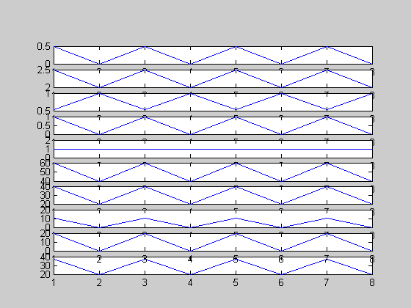

Program 13b:- %program to obtain modulated version of the output array corresponds to the input array

N=input('enter the no of elements of array');

N=8;

m=input('enter the slope of the straightline');

m=0.5;

c=input('enter the intercept on yaxis');

c=2;

%Initialization of input array

for n=1:N

x(n)=input('enter the arrayx');

end

%Creation of output array

for n=1:N

y(n)=m.*x(n);

y1(n)=(m.*x(n))+c;

y2(n)=cos(x(n));

y3(n)=(x(n)).^2;

y4(n)=square(x(n));

end

x1=and(y,y1);x2=or(y1,y2);x3=xor(y2,y3);x4=not(x3);x5=not(y2);

fc=input('enter the carrier frequency');

fm=input('enter the modulating frequency');

vc=input('enter the carrier voltage');

u=input('enter the modulating index');

for t=1:N

xam(t)=vc.*cos(2*pi*fc*t)+((u*vc)./2).*(cos((2*pi*(fc-fm))*t)-cos((2*pi*(fc+fm)*t)));

end

y5=x1.*xam;y6=x2.*xam;y7=x3.*xam;y8=x4.*xam;y9=x5.*xam;

subplot(11,1,11);plot(xam);

subplot(11,1,2);plot(y);

subplot(11,1,3);plot(y1);

subplot(11,1,4);plot(y2);

subplot(11,1,5);plot(y3);

subplot(11,1,6);plot(y4);

subplot(11,1,7);plot(y5);

subplot(11,1,8);plot(y6);

subplot(11,1,9);plot(y7);

subplot(11,1,10);plot(y8);

subplot(11,1,11);plot(y9);

enter the no of elements of array8

enter the slope of the straightline0.5

enter the intercept on yaxis2

enter the arrayx1

enter the arrayx0

enter the arrayx1

enter the arrayx0

enter the arrayx1

enter the arrayx0

enter the arrayx1

enter the arrayx0

enter the carrier frequency5000

enter the modulating frequency500

enter the carrier voltage20

enter the modulating index0.5

>> x1

x1 = 1 0 1 0 1 0 1 0

>> x2

x2 = 1 1 1 1 1 1 1 1

>> x3

x3 = 0 1 0 1 0 1 0 1

>> x4

x4 = 1 0 1 0 1 0 1 0

>> x5

x5 = 0 0 0 0 0 0 0 0

>> y5

y5 = 20 0 20 0 20 0 20 0

>> y6

y6 = 20 20 20 20 20 20 20 20

>> y7

y7 = 0 20 0 20 0 20 0 20

>> y8

y8 = 20 0 20 0 20 0 20 0

>> y9

y9 = 0 0 0 0 0 0 0 0

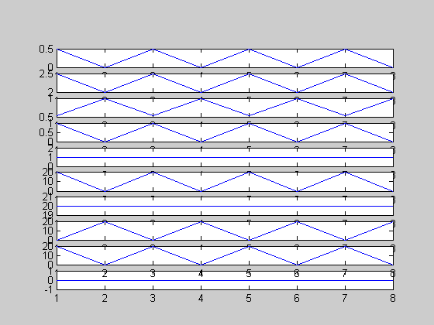

Program13c:- %program to obtain modulated version of the output array corresponds to the input array

N=input('enter the no of elements of array');

N=8;

m=input('enter the slope of the straightline');

m=0.5;

c=input('enter the intercept on yaxis');

c=2;

%Initialization of input array

for n=1:N

x(n)=input('enter the arrayx');

end

%Creation of output array

for n=1:N

y(n)=m.*x(n);

y1(n)=(m.*x(n))+c;

y2(n)=cos(x(n));

y3(n)=(x(n)).^2;

y4(n)=square(x(n));

end

for k=1:N

temp=0;

for n=1:N

temp=temp+x(n).*exp(-j*2*pi*k*(n./N));

end

x1(k)=temp;

end

for k=1:N

temp=0;

for n=1:N

temp=temp+y(n).*exp(-j*2*pi*k*(n./N));

end

x2(k)=temp;

end

for k=1:N

temp=0;

for n=1:N

temp=temp+y1(n).*exp(-j*2*pi*k*(n./N));

end

x3(k)=temp;

end

for k=1:N

temp=0;

for n=1:N

temp=temp+y2(n).*exp(-j*2*pi*k*(n./N));

end

x4(k)=temp;

end

for k=1:N

temp=0;

for n=1:N

temp=temp+y3(n).*exp(-j*2*pi*k*(n./N));

end

x5(k)=temp;

end

for k=1:N

temp=0;

for n=1:N

temp=temp+y4(n).*exp(-j*2*pi*k*(n./N));

end

x6(k)=temp;

end

fc=input('enter the carrier frequency');

fm=input('enter the modulating frequency');

vc=input('enter the carrier voltage');

u=input('enter the modulating index');

for t=1:N

xam(t)=vc.*cos(2*pi*fc*t)+((u*vc)./2).*(cos((2*pi*(fc-fm))*t)-cos((2*pi*(fc+fm)*t)));

end

y5=x1.*xam;y6=x2.*xam;y7=x3.*xam;y8=x4.*xam;y9=x5.*xam;y10=x6.*xam

subplot(11,1,1);plot(x1);

subplot(11,1,2);plot(x2);

subplot(11,1,3);plot(x3);

subplot(11,1,4);plot(x4);

subplot(11,1,5);plot(x5);

subplot(11,1,6);plot(x6);

subplot(11,1,7);plot(y5);

subplot(11,1,8);plot(y6);

subplot(11,1,9);plot(y7);

subplot(11,1,10);plot(y8);

subplot(11,1,11);plot(y9);

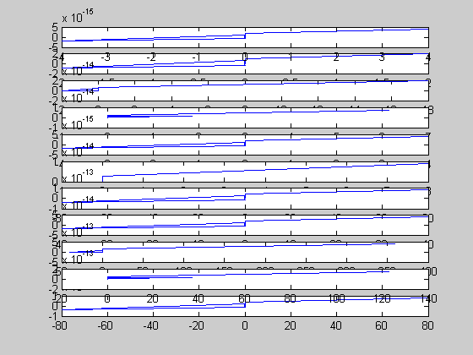

Program 13.d:- %program to obtain modulated version of the output array corresponds to the input array

N=input('enter the no of elements of array');

N=8;

m=input('enter the slope of the straightline');

m=0.5;

c=input('enter the intercept on yaxis');

c=2;

%Initialization of input array

for n=1:N

x(n)=input('enter the arrayx');

end

%Creation of output array

for n=1:N

y(n)=m.*x(n);

y1(n)=(m.*x(n))+c;

y2(n)=cos(x(n));

y3(n)=(x(n)).^2;

y4(n)=square(x(n));

end

for k=1:N

temp=0;

for n=1:N

temp=temp+x(n).*exp(-j*2*pi*k*(n./N));

end

x1(k)=temp;

end

for k=1:N

temp=0;

for n=1:N

temp=temp+y(n).*exp(-j*2*pi*k*(n./N));

end

x2(k)=temp;

end

for k=1:N

temp=0;

for n=1:N

temp=temp+y1(n).*exp(-j*2*pi*k*(n./N));

end

x3(k)=temp;

end

for k=1:N

temp=0;

for n=1:N

temp=temp+y2(n).*exp(-j*2*pi*k*(n./N));

end

x4(k)=temp;

end

for k=1:N

temp=0;

for n=1:N

temp=temp+y3(n).*exp(-j*2*pi*k*(n./N));

end

x5(k)=temp;

end

for k=1:N

temp=0;

for n=1:N

temp=temp+y4(n).*exp(-j*2*pi*k*(n./N));

end

x6(k)=temp;

end

p1=((abs(x1).^2)./(N+1));

p2=((abs(x2).^2)./(N+1));

p3=((abs(x3).^2)./(N+1));

p4=((abs(x4).^2)./(N+1));

p5=((abs(x5).^2)./(N+1));

p6=((abs(x6).^2)./(N+1));

fc=input('enter the carrier frequency');

fm=input('enter the modulating frequency');

vc=input('enter the carrier voltage');

u=input('enter the modulating index');

for t=1:N

xam(t)=vc.*cos(2*pi*fc*t)+((u*vc)./2).*(cos((2*pi*(fc-fm))*t)-cos((2*pi*(fc+fm)*t)));

end

y5=p1.*xam;y6=p2.*xam;y7=p3.*xam;y8=p4.*xam;y9=p5.*xam;y10=p6.*xam

subplot(11,1,1);plot(x1);

subplot(11,1,2);plot(x2);

subplot(11,1,3);plot(x3);

subplot(11,1,4);plot(x4);

subplot(11,1,5);plot(x5);

subplot(11,1,6);plot(x6);

subplot(11,1,7);plot(y5);

subplot(11,1,8);plot(y6);

subplot(11,1,9);plot(y7);

subplot(11,1,10);plot(y8);

subplot(11,1,11);plot(y9);

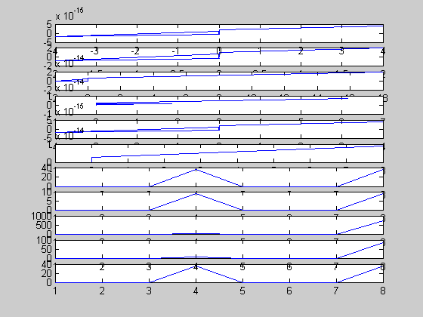

Program 13.e:- %program to obtain modulated version of the output array corresponds to the input array

N=input('enter the no of elements of array');

N=8;

m=input('enter the slope of the straightline');

m=0.5;

c=input('enter the intercept on yaxis');

c=2;

%Initialization of input array

for n=1:N

x(n)=input('enter the arrayx');

end

%Creation of output array

for n=1:N

y(n)=m.*x(n);

y1(n)=(m.*x(n))+c;

y2(n)=cos(x(n));

y3(n)=(x(n)).^2;

y4(n)=square(x(n));

end

fc=input('enter the carrier frequency');

fm=input('enter the modulating frequency');

vc=input('enter the carrier voltage');

u=input('enter the modulating index');

for t=1:N

xam(t)=vc.*cos(2*pi*fc*t)+((u*vc)./2).*(cos((2*pi*(fc-fm))*t)-cos((2*pi*(fc+fm)*t)));

end

y5=y.*xam;y6=y1.*xam;y7=y2.*xam;y8=y3.*xam;y9=y4.*xam;

subplot(11,1,11);bar(xam);

subplot(11,1,2);bar(y);

subplot(11,1,3);bar(y1);

subplot(11,1,4);bar(y2);

subplot(11,1,5);bar(y3);

subplot(11,1,6);bar(y4);

subplot(11,1,7);bar(y5);

subplot(11,1,8);bar(y6);

subplot(11,1,9);bar(y7);

subplot(11,1,10);bar(y8);

subplot(11,1,11);bar(y9);

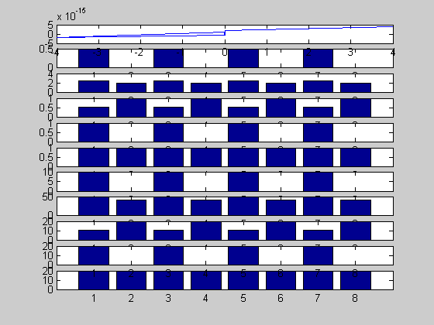

Program13.f:-

%program to obtain modulated version of the output array corresponds to the input array

N=input('enter the no of elements of array');

N=8;

m=input('enter the slope of the straightline');

m=0.5;

c=input('enter the intercept on yaxis');

c=2;

%Initialization of input array

for n=1:N

x(n)=input('enter the arrayx');

end

%Creation of output array

for n=1:N

y(n)=m.*x(n);

y1(n)=(m.*x(n))+c;

y2(n)=cos(x(n));

y3(n)=(x(n)).^2;

y4(n)=square(x(n));

end

fc=input('enter the carrier frequency');

fm=input('enter the modulating frequency');

vc=input('enter the carrier voltage');

u=input('enter the modulating index');

for t=1:N

xam(t)=vc.*cos(2*pi*fc*t)+((u*vc)./2).*(cos((2*pi*(fc-fm))*t)-cos((2*pi*(fc+fm)*t)));

end

y5=y.*xam;y6=y1.*xam;y7=y2.*xam;y8=y3.*xam;y9=y4.*xam;

subplot(11,1,11);stem(xam);

subplot(11,1,2);stem(y);

subplot(11,1,3);stem(y1);

subplot(11,1,4);stem(y2);

subplot(11,1,5);stem(y3);

subplot(11,1,6);stem(y4);

subplot(11,1,7);stem(y5);

subplot(11,1,8);stem(y6);

subplot(11,1,9);stem(y7);

subplot(11,1,10);stem(y8);

subplot(11,1,11);stem(y9);

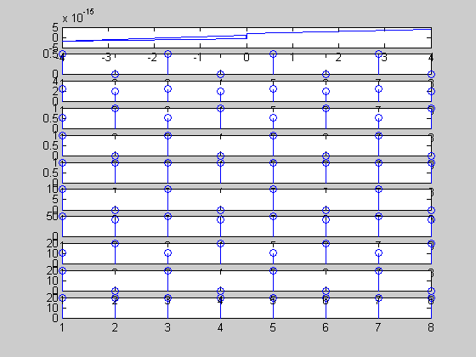

Program 13.g:-

%program to obtain modulated version of the output array corresponds to the input array

N=input('enter the no of elements of array');

N=8;

m=input('enter the slope of the straightline');

m=0.5;

c=input('enter the intercept on yaxis');

c=2;

%Initialization of input array

for n=1:N

x(n)=input('enter the arrayx');

end

%Creation of output array

for n=1:N

y(n)=m.*x(n);

y1(n)=(m.*x(n))+c;

y2(n)=cos(x(n));

y3(n)=(x(n)).^2;

y4(n)=square(x(n));

end

x1=y+y1;x2=y1-y2;x3=y2.*y3;x4=y3.*y4;x5=y4./y2;

fc=input('enter the carrier frequency');

fm=input('enter the modulating frequency');

vc=input('enter the carrier voltage');

u=input('enter the modulating index');

for t=1:N

xam(t)=vc.*cos(2*pi*fc*t)+((u*vc)./2).*(cos((2*pi*(fc-fm))*t)-cos((2*pi*(fc+fm)*t)));

end

y5=x1.*xam;y6=x2.*xam;y7=x3.*xam;y8=x4.*xam;y9=x5.*xam;

subplot(11,1,11);bar(xam);

subplot(11,1,2);bar(y);

subplot(11,1,3);bar(y1);

subplot(11,1,4);bar(y2);

subplot(11,1,5);bar(y3);

subplot(11,1,6);bar(y4);

subplot(11,1,7);bar(y5);

subplot(11,1,8);bar(y6);

subplot(11,1,9);bar(y7);

subplot(11,1,10);bar(y8);

subplot(11,1,11);bar(y9);

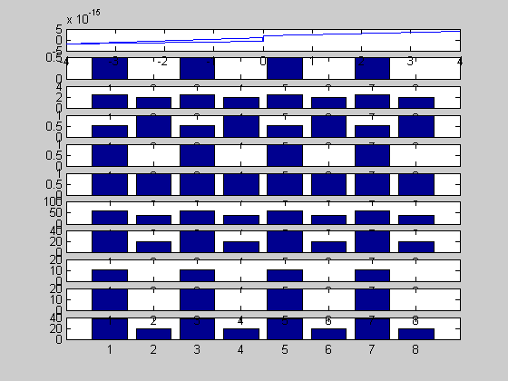

Program13.h:- %program to obtain modulated version of the output array corresponds to the input array

N=input('enter the no of elements of array');

N=8;

m=input('enter the slope of the straightline');

m=0.5;

c=input('enter the intercept on yaxis');

c=2;

%Initialization of input array

for n=1:N

x(n)=input('enter the arrayx');

end

%Creation of output array

for n=1:N

y(n)=m.*x(n);

y1(n)=(m.*x(n))+c;

y2(n)=cos(x(n));

y3(n)=(x(n)).^2;

y4(n)=square(x(n));

end

x1=y+y1;x2=y1-y2;x3=y2.*y3;x4=y3.*y4;x5=y4./y2;

fc=input('enter the carrier frequency');

fm=input('enter the modulating frequency');

vc=input('enter the carrier voltage');

u=input('enter the modulating index');

for t=1:N

xam(t)=vc.*cos(2*pi*fc*t)+((u*vc)./2).*(cos((2*pi*(fc-fm))*t)-cos((2*pi*(fc+fm)*t)));

end

y5=x1.*xam;y6=x2.*xam;y7=x3.*xam;y8=x4.*xam;y9=x5.*xam;

subplot(11,1,11);stem(xam);

subplot(11,1,2);stem(y);

subplot(11,1,3);stem(y1);

subplot(11,1,4);stem(y2);

subplot(11,1,5);stem(y3);

subplot(11,1,6);stem(y4);

subplot(11,1,7);stem(y5);

subplot(11,1,8);stem(y6);

subplot(11,1,9);stem(y7);

subplot(11,1,10);stem(y8);

subplot(11,1,11);stem(y9);

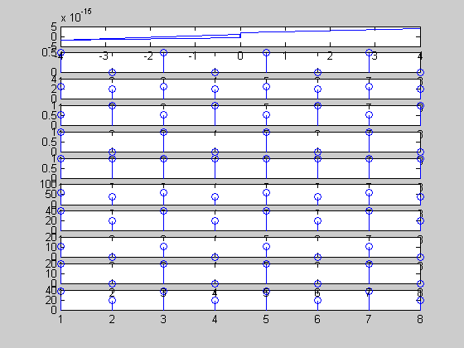

Program 13.i

%program to obtain modulated version of the output array corresponds to the input array

N=input('enter the no of elements of array');

N=8;

m=input('enter the slope of the straightline');

m=0.5;

c=input('enter the intercept on yaxis');

c=2;

%Initialization of input array

for n=1:N

x(n)=input('enter the arrayx');

end

%Creation of output array

for n=1:N

y(n)=m.*x(n);

y1(n)=(m.*x(n))+c;

y2(n)=cos(x(n));

y3(n)=(x(n)).^2;

y4(n)=square(x(n));

end

x1=and(y,y1);x2=or(y1,y2);x3=xor(y2,y3);x4=not(x3);x5=not(y2);

fc=input('enter the carrier frequency');

fm=input('enter the modulating frequency');

vc=input('enter the carrier voltage');

u=input('enter the modulating index');

for t=1:N

xam(t)=vc.*cos(2*pi*fc*t)+((u*vc)./2).*(cos((2*pi*(fc-fm))*t)-cos((2*pi*(fc+fm)*t)));

end

y5=x1.*xam;y6=x2.*xam;y7=x3.*xam;y8=x4.*xam;y9=x5.*xam;

subplot(11,1,11);bar(xam);

subplot(11,1,2);bar(y);

subplot(11,1,3);bar(y1);

subplot(11,1,4);bar(y2);

subplot(11,1,5);bar(y3);

subplot(11,1,6);bar(y4);

subplot(11,1,7);bar(y5);

subplot(11,1,8);bar(y6);

subplot(11,1,9);bar(y7);

subplot(11,1,10);bar(y8);

subplot(11,1,11);bar(y9);

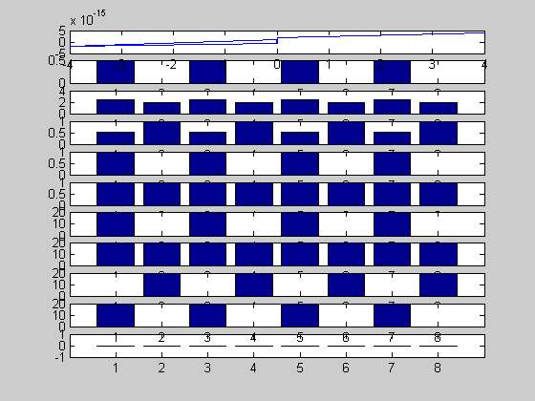

Program13.j:- %program to obtain modulated version of the output array corresponds to the input array

N=input('enter the no of elements of array');

N=8;

m=input('enter the slope of the straightline');

m=0.5;

c=input('enter the intercept on yaxis');

c=2;

%Initialization of input array

for n=1:N

x(n)=input('enter the arrayx');

end

%Creation of output array

for n=1:N

y(n)=m.*x(n);

y1(n)=(m.*x(n))+c;

y2(n)=cos(x(n));

y3(n)=(x(n)).^2;

y4(n)=square(x(n));

end

x1=and(y,y1);x2=or(y1,y2);x3=xor(y2,y3);x4=not(x3);x5=not(y2);

fc=input('enter the carrier frequency');

fm=input('enter the modulating frequency');

vc=input('enter the carrier voltage');

u=input('enter the modulating index');

for t=1:N

xam(t)=vc.*cos(2*pi*fc*t)+((u*vc)./2).*(cos((2*pi*(fc-fm))*t)-cos((2*pi*(fc+fm)*t)));

end

y5=x1.*xam;y6=x2.*xam;y7=x3.*xam;y8=x4.*xam;y9=x5.*xam;

subplot(11,1,11);stem(xam);

subplot(11,1,2);stem(y);

subplot(11,1,3);stem(y1);

subplot(11,1,4);stem(y2);

subplot(11,1,5);stem(y3);

subplot(11,1,6);stem(y4);

subplot(11,1,7);stem(y5);

subplot(11,1,8);stem(y6);

subplot(11,1,9);stem(y7);

subplot(11,1,10);stem(y8);

subplot(11,1,11);stem(y9);

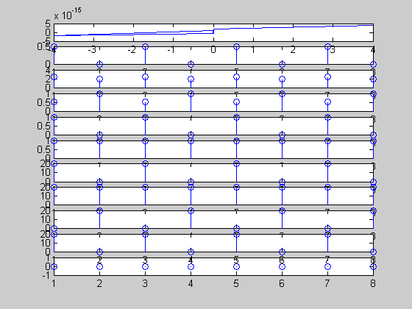

Program 13 k:-

%program to obtain modulated version of the output array corresponds to the input array

N=input('enter the no of elements of array');

N=8;

m=input('enter the slope of the straightline');

m=0.5;

c=input('enter the intercept on yaxis');

c=2;

%Initialization of input array

for n=1:N

x(n)=input('enter the arrayx');

end

%Creation of output array

for n=1:N

y(n)=m.*x(n);

y1(n)=(m.*x(n))+c;

y2(n)=cos(x(n));

y3(n)=(x(n)).^2;

y4(n)=square(x(n));

end

for k=1:N

temp=0;

for n=1:N

temp=temp+x(n).*exp(-j*2*pi*k*(n./N));

end

x1(k)=temp;

end

for k=1:N

temp=0;

for n=1:N

temp=temp+y(n).*exp(-j*2*pi*k*(n./N));

end

x2(k)=temp;

end

for k=1:N

temp=0;

for n=1:N

temp=temp+y1(n).*exp(-j*2*pi*k*(n./N));

end

x3(k)=temp;

end

for k=1:N

temp=0;

for n=1:N

temp=temp+y2(n).*exp(-j*2*pi*k*(n./N));

end

x4(k)=temp;

end

for k=1:N

temp=0;

for n=1:N

temp=temp+y3(n).*exp(-j*2*pi*k*(n./N));

end

x5(k)=temp;

end

for k=1:N

temp=0;

for n=1:N

temp=temp+y4(n).*exp(-j*2*pi*k*(n./N));

end

x6(k)=temp;

end

fc=input('enter the carrier frequency');

fm=input('enter the modulating frequency');

vc=input('enter the carrier voltage');

u=input('enter the modulating index');

for t=1:N

xam(t)=vc.*cos(2*pi*fc*t)+((u*vc)./2).*(cos((2*pi*(fc-fm))*t)-cos((2*pi*(fc+fm)*t)));

end

y5=x1.*xam;y6=x2.*xam;y7=x3.*xam;y8=x4.*xam;y9=x5.*xam;y10=x6.*xam

subplot(11,1,1);stem(x1);

subplot(11,1,2);stem(x2);

subplot(11,1,3);stem(x3);

subplot(11,1,4);stem(x4);

subplot(11,1,5);stem(x5);

subplot(11,1,6);stem(x6);

subplot(11,1,7);stem(y5);

subplot(11,1,8);stem(y6);

subplot(11,1,9);stem(y7);

subplot(11,1,10);stem(y8);

subplot(11,1,11);stem(y9);

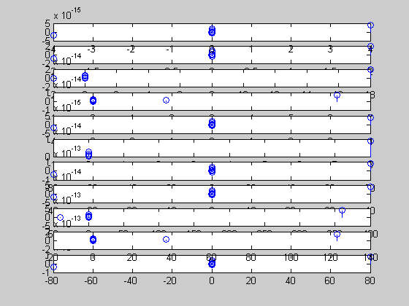

Program 13.l:- %program to obtain modulated version of the output array corresponds to the input array

N=input('enter the no of elements of array');

N=8;

m=input('enter the slope of the straightline');

m=0.5;

c=input('enter the intercept on yaxis');

c=2;

%Initialization of input array

for n=1:N

x(n)=input('enter the arrayx');

end

%Creation of output array

for n=1:N

y(n)=m.*x(n);

y1(n)=(m.*x(n))+c;

y2(n)=cos(x(n));

y3(n)=(x(n)).^2;

y4(n)=square(x(n));

end

for k=1:N

temp=0;

for n=1:N

temp=temp+x(n).*exp(-j*2*pi*k*(n./N));

end

x1(k)=temp;

end

for k=1:N

temp=0;

for n=1:N

temp=temp+y(n).*exp(-j*2*pi*k*(n./N));

end

x2(k)=temp;

end

for k=1:N

temp=0;

for n=1:N

temp=temp+y1(n).*exp(-j*2*pi*k*(n./N));

end

x3(k)=temp;

end

for k=1:N

temp=0;

for n=1:N

temp=temp+y2(n).*exp(-j*2*pi*k*(n./N));

end

x4(k)=temp;

end

for k=1:N

temp=0;

for n=1:N

temp=temp+y3(n).*exp(-j*2*pi*k*(n./N));

end

x5(k)=temp;

end

for k=1:N

temp=0;

for n=1:N

temp=temp+y4(n).*exp(-j*2*pi*k*(n./N));

end

x6(k)=temp;

end

p1=((abs(x1).^2)./(N+1));

p2=((abs(x2).^2)./(N+1));

p3=((abs(x3).^2)./(N+1));

p4=((abs(x4).^2)./(N+1));

p5=((abs(x5).^2)./(N+1));

p6=((abs(x6).^2)./(N+1));

fc=input('enter the carrier frequency');

fm=input('enter the modulating frequency');

vc=input('enter the carrier voltage');

u=input('enter the modulating index');

for t=1:N

xam(t)=vc.*cos(2*pi*fc*t)+((u*vc)./2).*(cos((2*pi*(fc-fm))*t)-cos((2*pi*(fc+fm)*t)));

end

y5=p1.*xam;y6=p2.*xam;y7=p3.*xam;y8=p4.*xam;y9=p5.*xam;y10=p6.*xam

subplot(11,1,1);stem(x1);

subplot(11,1,2);stem(x2);

subplot(11,1,3);stem(x3);

subplot(11,1,4);stem(x4);

subplot(11,1,5);stem(x5);

subplot(11,1,6);stem(x6);

subplot(11,1,7);stem(y5);

subplot(11,1,8);stem(y6);

subplot(11,1,9);stem(y7);

subplot(11,1,10);stem(y8);

subplot(11,1,11);stem(y9);

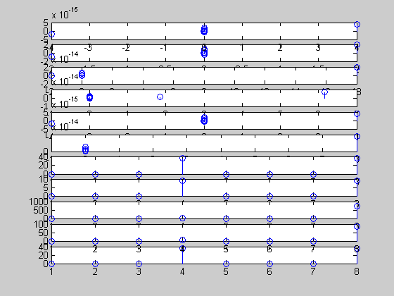

PROGRAM14

Aim:- To obtain Amplitude modulated versions of the given input and output arrays

Appartus:- MATLAB6P1 Software, Personal computer

Algorithm:-

Step1: Initialization of Input Array:- In this step, we are going to create an array(1-D matrix) having N number of elements, which starts from 1 to N

Step2:- Creation and Display of the output array:- in this step, we will create an output array corresponding to the given input array x and we will represent the obtained output arrays using Plot, bar, stem functions

Step3:- Creation of the Modulated version of the output array by multiplying output sequence with xam which is given by

Xam(t)= Vc cos(wct)+mvc/2[cos(wc-wm)t-cos(wc+wm)t]

Where Vc= carrier voltage, wc = carrier frequency in radians

Wm=modulating frequency in radians

m=modulating index

program 14 %program to obtain modulated version of the output array corresponds to the input array

N=input('enter the no of elements of array');

N=8;

m=input('enter the slope of the straightline');

m=0.5;

c=input('enter the intercept on yaxis');

c=2;

f_1 =125;A=8;

%Initialization of input array

for n=1:N

x(n) = A*sin(2*pi*f_1*n);

end

%Creation of output array

for n=1:N

y(n)=m.*x(n);

y1(n)=(m.*x(n))+c;

y2(n)=cos(x(n));

y3(n)=(x(n)).^2;

y4(n)=square(x(n));

end

fc=input('enter the carrier frequency');

fm=input('enter the modulating frequency');

vc=input('enter the carrier voltage');

u=input('enter the modulating index');

for t=1:N

xam(t)=vc.*cos(2*pi*fc*t)+((u*vc)./2).*(cos((2*pi*(fc-fm))*t)-cos((2*pi*(fc+fm)*t)));

end

y5=y.*xam;y6=y1.*xam;y7=y2.*xam;y8=y3.*xam;y9=y4.*xam;

subplot(11,1,11);plot(xam);

subplot(11,1,2);plot(y);

subplot(11,1,3);plot(y1);

subplot(11,1,4);plot(y2);

subplot(11,1,5);plot(y3);

subplot(11,1,6);plot(y4);

subplot(11,1,7);plot(y5);

subplot(11,1,8);plot(y6);

subplot(11,1,9);plot(y7);

subplot(11,1,10);plot(y8);

subplot(11,1,11);plot(y9);

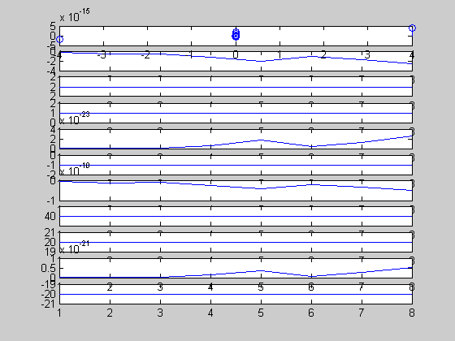

Program 14.a:-

%program to obtain modulated version of the output array corresponds to the input array

N=input('enter the no of elements of array');

N=8;

m=input('enter the slope of the straightline');

m=0.5;

c=input('enter the intercept on yaxis');

c=2;

f_1 =125;A=8;

%Initialization of input array

for n=1:N

x(n) = A*sin(2*pi*f_1*n);

end

%Creation of output array

for n=1:N

y(n)=m.*x(n);

y1(n)=(m.*x(n))+c;

y2(n)=cos(x(n));

y3(n)=(x(n)).^2;

y4(n)=square(x(n));

end

fc=input('enter the carrier frequency');

fm=input('enter the modulating frequency');

vc=input('enter the carrier voltage');

u=input('enter the modulating index');

for t=1:N

xam(t)=vc.*cos(2*pi*fc*t)+((u*vc)./2).*(cos((2*pi*(fc-fm))*t)-cos((2*pi*(fc+fm)*t)));

end

y5=y.*xam;y6=y1.*xam;y7=y2.*xam;y8=y3.*xam;y9=y4.*xam;

subplot(11,1,11);bar(xam);

subplot(11,1,2);bar(y);

subplot(11,1,3);bar(y1);

subplot(11,1,4);bar(y2);

subplot(11,1,5);bar(y3);

subplot(11,1,6);bar(y4);

subplot(11,1,7);bar(y5);

subplot(11,1,8);bar(y6);

subplot(11,1,9);bar(y7);

subplot(11,1,10);bar(y8);

subplot(11,1,11);bar(y9);

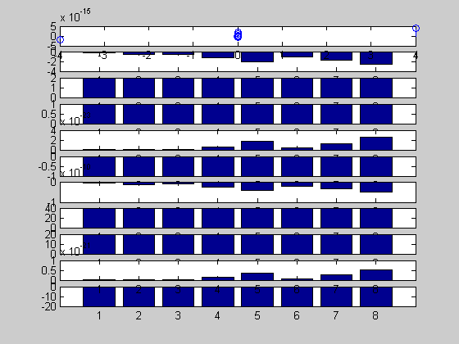

Program 14 b:-

%program to obtain modulated version of the output array corresponds to the input array

N=input('enter the no of elements of array');

N=8;

m=input('enter the slope of the straightline');

m=0.5;

c=input('enter the intercept on yaxis');

c=2;

f_1 =125;A=8;

%Initialization of input array

for n=1:N

x(n) = A*sin(2*pi*f_1*n);

end

%Creation of output array

for n=1:N

y(n)=m.*x(n);

y1(n)=(m.*x(n))+c;

y2(n)=cos(x(n));

y3(n)=(x(n)).^2;

y4(n)=square(x(n));

end

fc=input('enter the carrier frequency');

fm=input('enter the modulating frequency');

vc=input('enter the carrier voltage');

u=input('enter the modulating index');

for t=1:N

xam(t)=vc.*cos(2*pi*fc*t)+((u*vc)./2).*(cos((2*pi*(fc-fm))*t)-cos((2*pi*(fc+fm)*t)));

end

y5=y.*xam;y6=y1.*xam;y7=y2.*xam;y8=y3.*xam;y9=y4.*xam;

subplot(11,1,11);stem(xam);

subplot(11,1,2);stem(y);

subplot(11,1,3);stem(y1);

subplot(11,1,4);stem(y2);

subplot(11,1,5);stem(y3);

subplot(11,1,6);stem(y4);

subplot(11,1,7);stem(y5);

subplot(11,1,8);stem(y6);

subplot(11,1,9);stem(y7);

subplot(11,1,10);stem(y8);

subplot(11,1,11);stem(y9);

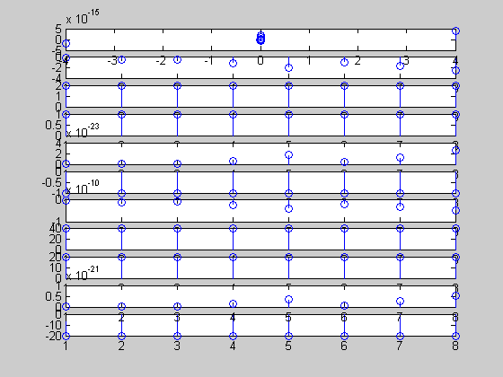

PROGRAM15

Aim:- To obtain Amplitude modulated versions of the given input and output arrays

Appartus:- MATLAB6P1 Software, Personal computer

Algorithm:-

Step1: Initialization of Input Array:- In this step, we are going to create an array(1-D matrix) having N number of elements, which starts from 1 to N

Step2:- Creation and Display of the output array:- in this step, we will create an output array corresponding to the given input array x and we will represent the obtained output arrays using Plot, bar, stem functions

Step3:- Creation of the Modulated version of the output array by multiplying output sequence with xam which is given by

Xam(t)= Vc cos(wct)+mvc/2[cos(wc-wm)t-cos(wc+wm)t]

Where Vc= carrier voltage, wc = carrier frequency in radians

Wm=modulating frequency in radians

m=modulating index

Program 15 %program to obtain modulated version of the output array corresponds to the input array

N=input('enter the no of elements of array');

N=8;

m=input('enter the slope of the straightline');

m=0.5;

c=input('enter the intercept on yaxis');

c=2;

f_1 =125;A=8;

%Initialization of input array

for n=1:N

x(n) = A*sin(2*pi*f_1*n)+A*cos(2*pi*f_1*n);

end

%Creation of output array

for n=1:N

y(n)=m.*x(n);

y1(n)=(m.*x(n))+c;

y2(n)=cos(x(n));

y3(n)=(x(n)).^2;

y4(n)=square(x(n));

end

fc=input('enter the carrier frequency');

fm=input('enter the modulating frequency');

vc=input('enter the carrier voltage');

u=input('enter the modulating index');

for t=1:N

xam(t)=vc.*cos(2*pi*fc*t)+((u*vc)./2).*(cos((2*pi*(fc-fm))*t)-cos((2*pi*(fc+fm)*t)));

end

y5=y.*xam;y6=y1.*xam;y7=y2.*xam;y8=y3.*xam;y9=y4.*xam;

subplot(11,1,11);stem(xam);

subplot(11,1,2);stem(y);

subplot(11,1,3);stem(y1);

subplot(11,1,4);stem(y2);

subplot(11,1,5);stem(y3);

subplot(11,1,6);stem(y4);

subplot(11,1,7);stem(y5);

subplot(11,1,8);stem(y6);

subplot(11,1,9);stem(y7);

subplot(11,1,10);stem(y8);

subplot(11,1,11);stem(y9);

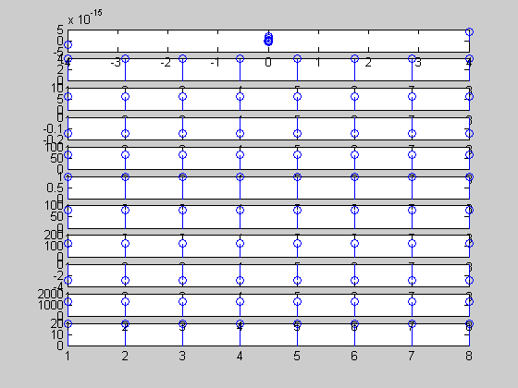

Program15 a:- %program to obtain modulated version of the output array corresponds to the input array

N=input('enter the no of elements of array');

N=8;

m=input('enter the slope of the straightline');

m=0.5;

c=input('enter the intercept on yaxis');

c=2;

f_1 =125;A=8;

%Initialization of input array

for n=1:N

x(n) = A*sin(2*pi*f_1*n)+A*cos(2*pi*f_1*n);

end

%Creation of output array

for n=1:N

y(n)=m.*x(n);

y1(n)=(m.*x(n))+c;

y2(n)=cos(x(n));

y3(n)=(x(n)).^2;

y4(n)=square(x(n));

end

fc=input('enter the carrier frequency');

fm=input('enter the modulating frequency');

vc=input('enter the carrier voltage');

u=input('enter the modulating index');

for t=1:N

xam(t)=vc.*cos(2*pi*fc*t)+((u*vc)./2).*(cos((2*pi*(fc-fm))*t)-cos((2*pi*(fc+fm)*t)));

end

y5=y.*xam;y6=y1.*xam;y7=y2.*xam;y8=y3.*xam;y9=y4.*xam;

subplot(11,1,11);bar(xam);

subplot(11,1,2);bar(y);

subplot(11,1,3);bar(y1);

subplot(11,1,4);bar(y2);

subplot(11,1,5);bar(y3);

subplot(11,1,6);bar(y4);

subplot(11,1,7);bar(y5);

subplot(11,1,8);bar(y6);

subplot(11,1,9);bar(y7);

subplot(11,1,10);bar(y8);

subplot(11,1,11);bar(y9);

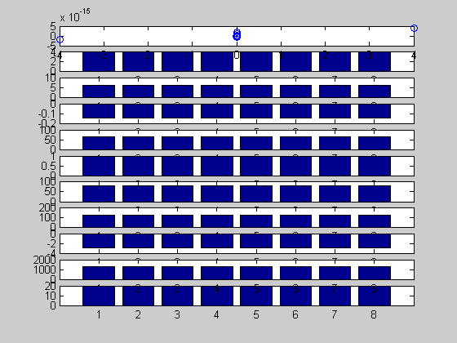

Program 15 b:- %program to obtain modulated version of the output array corresponds to the input array

N=input('enter the no of elements of array');

N=8;

m=input('enter the slope of the straightline');

m=0.5;

c=input('enter the intercept on yaxis');

c=2;

f_1 =125;A=8;

%Initialization of input array

for n=1:N

x(n) = A*sin(2*pi*f_1*n)+A*cos(2*pi*f_1*n);

end

%Creation of output array

for n=1:N

y(n)=m.*x(n);

y1(n)=(m.*x(n))+c;

y2(n)=cos(x(n));

y3(n)=(x(n)).^2;

y4(n)=square(x(n));

end

fc=input('enter the carrier frequency');

fm=input('enter the modulating frequency');

vc=input('enter the carrier voltage');

u=input('enter the modulating index');

for t=1:N

xam(t)=vc.*cos(2*pi*fc*t)+((u*vc)./2).*(cos((2*pi*(fc-fm))*t)-cos((2*pi*(fc+fm)*t)));

end

y5=y.*xam;y6=y1.*xam;y7=y2.*xam;y8=y3.*xam;y9=y4.*xam;

subplot(11,1,11);plot(xam);

subplot(11,1,2);plot(y);

subplot(11,1,3);plot(y1);

subplot(11,1,4);plot(y2);

subplot(11,1,5);plot(y3);

subplot(11,1,6);plot(y4);

subplot(11,1,7);plot(y5);

subplot(11,1,8);plot(y6);

subplot(11,1,9);plot(y7);

subplot(11,1,10);plot(y8);

subplot(11,1,11);plot(y9);

